Case report

Oral syphilitic lesions mimicking squamous cell carcinoma in a high-risk patient: A Case report

ABSTRACT

|  |
| --- |
| **Background**: Syphilis is a sexually transmitted infection that may manifest in the oral cavity, often mimicking malignant conditions such as oral squamous cell carcinoma (OSCC), particularly in patients with high-risk profiles for malignancy.  **Case Presentation**: This report describes a 45-year-old female patient with a history of chronic smoking and alcohol consumption who presented with an ulcerated lesion on the lateral border of the tongue, clinically suggestive of OSCC. Despite the initial suspicion of malignancy, histopathological and immunohistochemical evaluations revealed a diagnosis of secondary syphilis.  **Findings**: Microscopic analysis showed stratified parakeratinized epithelium with intraepithelial microabscesses and a dense perivascular lymphoplasmacytic infiltrate. Immunohistochemistry was strongly positive for Treponema pallidum, and serological testing (VDRL) confirmed active syphilitic infection.  **Conclusion**: This case underscores the need to consider infectious diseases in the differential diagnosis of suspicious oral lesions. A comprehensive diagnostic approach—including serology, histopathology, and immunohistochemistry—is essential to avoid misdiagnosis and to guide appropriate management. |

*Keywords: Syphilis; Diagnosis; Oral squamous cell carcinoma; Oral lesions*

1. INTRODUCTION

Syphilis is a sexually transmitted infection caused by the spirochete Treponema pallidum (Trujillo et al., 2018). In the early stages of the disease, particularly during the primary and secondary phases, the oral manifestations of syphilis may include painless ulcers, mucous patches, erythematous or whitish lesions, and areas of superficial necrosis (Medeiros et al., 2023).

This presentations can mimic a variety of conditions such as traumatic ulcers, granulomas, geographic tongue, tuberculosis, and even oral squamous cell carcinoma. (OSCC) (Jategaonkar et al., 2019; Smith et al., 2021), particularly in individuals with classical risk factors for malignancy, such as long-term tobacco and alcohol use. This clinical overlap may lead to misdiagnosis and delay in appropriate treatment, especially when syphilitic lesions develop in anatomical sites typically associated with malignant lesions, such as the lateral border of the tongue (Givony, 2020).

Here we describe a case of a patient with significant risk factors for OSCC who initially presented with a lesion highly suggestive of malignancy. However, histopathological and immunohistochemical analyses confirmed the diagnosis of secondary syphilis.

2. CASE PRESENTATION

A 45-year-old Black female patient, married, with a 20-year history of tobacco and alcohol use, initially sought care at a university dental clinic reporting the sensation of a “spine in the throat” (SIC). Extraoral and intraoral examinations were unremarkable at that time, and no therapeutic interventions were performed. The patient was advised to remain under observation and to return if symptoms persisted.

Seven days later, the patient contacted the clinic again, now complaining of discomfort in the lower lip. An in-person consultation was scheduled, and intraoral examination revealed two well-demarcated mucosal plaques on the buccal mucosa, measuring approximately 1.0 cm and 0.5 cm at their greatest dimensions. Both lesions presented an erythematous halo and a whitish eccentric area, in addition to presenting a pseudomembrane (Figure 1A). Biopsy was recommended at this stage; however, the patient declined the procedure.

After an additional 15-day interval, the patient agreed to undergo biopsy. Clinical reevaluation revealed enlargement of the lesion, possibly exacerbated by local trauma (Figure 1B). An incisional biopsy was then performed.

At the third clinical visit, performed 21 days after the initial visit, a new ulcerative lesion was observed on the left lateral border of the tongue. In addition to being asymptomatic, the lesion had raised and indurated margins, with a central area of necrosis (Figure 4), and the lesion measured approximately 1.0 cm in diameter.

Considering the evolution of the lesion, the clinical presentation, and the patient's behavioral risk factors, the initial differential diagnosis included SCC and secondary syphilis. In addition to histopathological analysis, immunohistochemical studies were requested. Given the suspicion of an infectious etiology, additional laboratory tests were requested, including a complete blood count (CBC), a venereal disease laboratory test (VDRL), and serology for human immunodeficiency virus (HIV).

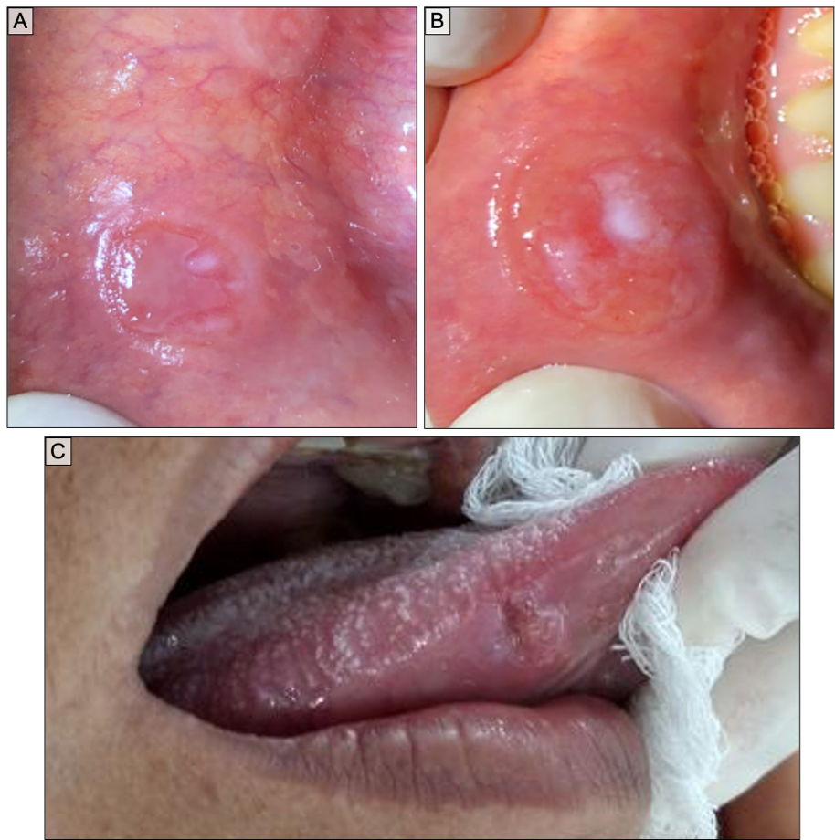

**Figure 1** – Clinical photographs of the lesions. A) Initial aspect of the lesion on the lower lip. B) Lower lip lesion after 15 days. C) Ulcerated lesion located on the lateral border of the tongue, showing a pseudomembranous center and raised edges.

Microscopic examination of the biopsy specimens revealed parakeratinized stratified squamous epithelium exhibiting signs of exocytosis and the presence of intraepithelial microabscesses (Figure 2A). In the underlying lamina propria, a dense lymphoplasmacytic inflammatory infiltrate with a predominantly perivascular distribution was observed. In addition, rare atypical mitotic figures were observed (Figure 2C). The definitive clarification came from immunohistochemical analysis with anti-Treponema pallidum antibodies, which demonstrated strong and diffuse positivity along the epithelial ridges and throughout the epithelium and underlying connective tissue (Figure 2D-E), confirming the presence of the syphilitic spirochete.

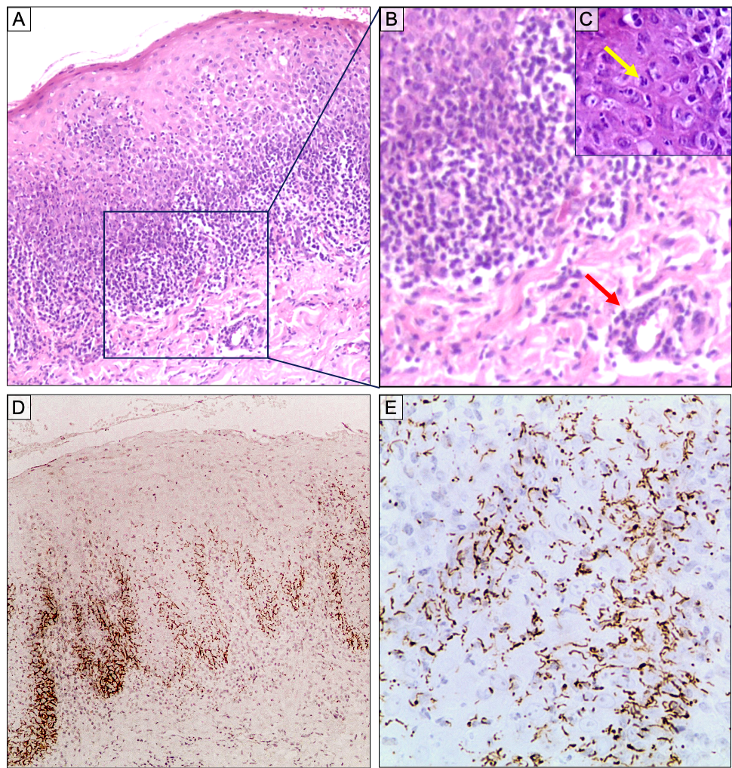

**Figure 2** – Histological images. A - Parakeratinized stratified squamous epithelium with exocytosis and microabscesses (H&E, 100x). B - Lamina propria permeated by lymphoplasmacytic inflammatory infiltrate, showing perivascular distribution (red arrow) (H&E, 200x). C - Atypical mitotic figure (yellow arrow) (H&E, 400x). D-E - Positive immunostaining for anti-Treponema pallidum antibody (100x-400x).

The VDRL test returned reactive, with a titer of 1:32, consistent with an active syphilitic infection. Upon confirmation of the diagnosis, the patient was promptly referred to a specialized center for tropical diseases to initiate systemic antibiotic therapy and receive multidisciplinary follow-up. Following completion of treatment, complete clinical resolution of the oral lesions was achieved.

3. discussion

Secondary syphilis involving the oral cavity can present a significant diagnostic challenge, particularly when lesions appear in patients with behavioral risk factors commonly associated with malignancy. In this case, a definitive diagnosis was only possible through the combined use of histopathological evaluation, immunohistochemical staining for Treponema pallidum, and serological testing, emphasizing the essential role of complementary diagnostic tools in distinguishing infectious diseases from neoplastic processes. These findings underscore the crucial importance of maintaining a broad differential diagnosis in patients presenting with lesions clinically suggestive of malignancy and reinforce the value of complementary diagnostic tools for accurate diagnosis and effective treatment.

The clinical course in this patient was particularly complex. The initial lesion, located on the lower lip mucosa, was painful and demonstrated progressive enlargement—a presentation not typical of OSCC, but persistent enough to justify close monitoring. Greater concern arose with the appearance of a second lesion on the lateral border of the tongue, which, in addition to being asymptomatic, exhibited indurated, elevated margins and a central area of necrosis, features highly suggestive of OSCC (Gregnanin Pedron, Carvalho Kadooka, and Magno Filho, 2024). Its location further reinforced this suspicion, as the lateral tongue is among the most affected sites in oral cancer (Levine and Stillman-Lowe, 2019).

Although oral manifestations of secondary syphilis are well documented, their presentation is often nonspecific and may mimic various conditions, including traumatic ulcers, necrotizing infections, hyperplasia, and malignant neoplasms (De Arruda et al., 2021). Lesions may appear as mucous patches, erosions, or superficial ulcerations, frequently painless and transient, making their identification reliant on the clinical context and thorough investigation. This mimetic potential has been highlighted in other case reports and small case series, in which oral syphilitic ulcers were initially misdiagnosed as OSCC, especially in patients with concurrent oncogenic risk factors (Jategaonkar et al. 2019; Kellermann et al. 2020; Magnaterra, Grandi, and Pisano, 2022).

Histologically, syphilitic lesions may show nonspecific inflammatory features, such as a dense plasma cell infiltrate and endothelial proliferation, which may not be sufficient for diagnosis without corroborative serology or specific immunohistochemical staining (Barrett et al., 2004; Flamm et al., 2015). In our case, the histological findings, supported by positive IHC for T. pallidum and a VDRL titer of 1:32, allowed the diagnostic closure and initiation of appropriate therapy. The complete resolution of the lesions after systemic antibiotic treatment reinforces the reversibility of syphilitic manifestations when promptly and properly managed.

This report reinforces the need to maintain a comprehensive diagnostic approach for persistent or atypical oral ulcers, particularly when involving anatomic regions classically linked to oral cancer.

4. Conclusion

This case highlights the diagnostic challenge posed by secondary syphilis when it presents with oral lesions that clinically resemble oral squamous cell carcinoma, particularly in patients with established risk factors. Accurate diagnosis was only possible through histopathological evaluation and confirmatory serological testing. The complete resolution of the lesions following antibiotic therapy reinforces the importance of considering infectious diseases in the differential diagnosis of persistent oral ulcers and underscores the critical role of complementary investigations in guiding appropriate clinical management.

Consent

All authors confirm that written informed consent was obtained from the patient for the publication of this case report and any related images. A signed copy of the consent form can be made available to the Editorial Office, Editor-in-Chief, or members of the Editorial Board upon request.

ETHICAL APPROVAL

As per international standards or university standards written ethical approval has been collected and preserved by the author(s).

Definitions, Acronyms, Abbreviations

**CBC**: Complete Blood Count

**H&E**: Hematoxylin and Eosin

**HIV**: Human Immunodeficiency Virus

**IHC**: Immunohistochemistry / Immunohistochemical

**OSCC**: Oral Squamous Cell Carcinoma

**SCC**: Squamous Cell Carcinoma

**VDRL**: Venereal Disease Research Laboratory

**T. pallidum**: *Treponema pallidum*

References

1. Trujillo R, Cervantes J, Hawley KL, Cruz AR, Babapoor S, Murphy M et al. Inflammation and immune evasion coexist in Treponema pallidum–infected skin. ***JAAD Case Rep***. 2018;4(5):462–464. doi:10.1016/j.jdcr.2018.03.011. PMID: 29984283.

2. Medeiros ABV, Silva RPD, Oliveira FADS, Morais LAFD, Guerra CLDB, Guerra ÂRO et al. Clinical manifestations of syphilis in the oral cavity — a review. ***J Bras Doenças Sex Transm***. 2023;35: e23351299. doi: 10.5327/DST-2177-8264-2023351299.

3. Jategaonkar A, Klimczak J, Agarwal J, Badhey A, Portnoy WM, Damiano A et al. Syphilis of the oropharynx: Case series of “The Great Masquerader”. ***Am J Otolaryngol***. 2019;40(2):143–146. doi: 10.1016/j.amjoto.2019.01.005. PMID: 30661890.

4. Smith MH, Vargo RJ, Bilodeau EA, Anderson KM, Trzcinska A, Canterbury CR et al. Oral manifestations of syphilis: a review of the clinical and histopathologic characteristics of a reemerging entity with report of 19 new cases. ***Head Neck Pathol***. 2021;15(3):787–795. doi: 10.1007/s12105-020-01283-4.

5. Givony S. Oral squamous cell carcinoma (OSCC): an overview. ***Int J Clin Oral Maxillofac Surg***. 2020;8:1–5.

6. Gregnanin Pedron I, Carvalho Kadooka MM, Magno Filho LC. The significance of clinical examination in diagnosing oral squamous cell carcinoma. ***SVOADE***. 2024;5:183–186. doi: 10.58624/SVOADE.2024.05.0189.

7. Levine R, Stillman-Lowe C. Oral cancers. In: The Scientific Basis of Oral Health Education. Cham: **Springer**; 2019. p. 57–62. doi:10.1007/978-3-319-98207-6_7.

8. De Arruda JAA, Do Valle IB, Mesquita RA, Silva TA. Oral syphilis. **J Am Acad Dermatol.** 2021;84(3):e101–e102. doi: 10.1016/j.jaad.2020.09.067.

9. Kellermann MG, Soutto-Mayor F, Tesseroli MAS, Menegassi J, Neto OVZ, Guollo A et al. Oral primary syphilis mimicking a gingival squamous cell carcinoma: case report. **Oral Surg. Oral Med. Oral Pathol. Oral Radiol.** 2020;129(2):e121–e122. doi: 10.1016/j.oooo.2019.06.529.

10. Magnaterra E, Grandi V, Pisano L. The Great Imitator: primary syphilis clinically mimicking oral squamous cell carcinoma. ***Am J Med***. 2022;135(9):1078–1079. doi: 10.1016/j.amjmed.2022.02.029. PMID: 35307358.

11. Flamm A, Parikh K, Xie Q, Kwon EJ, Elston DM. Histologic features of secondary syphilis: a multicenter retrospective review. ***J Am Acad Dermatol***. 2015;73(6):1025–1030. doi: 10.1016/j.jaad.2015.08.062.

12. Barrett AW, Villarroel Dorrego M, Hodgson TA, Porter SR, Hopper C, Argiriadou AS et al. The histopathology of syphilis of the oral mucosa. ***J Oral Pathol Med***. 2004;33(5):286–291. doi: 10.1111/j.0904-2512.2004.00099.x. PMID: 15078489.