**Systematic Review Article**

**The Burden of Substandard and Falsified Medicines in West and Central Africa: A Systematic Review of Prevalence, Detection Methods, and** **Regulatory Gaps**

**Abstract**

**Introduction:**

Substandard, falsified, unlicensed, and unregistered medicines pose a significant threat to public health, particularly in West and Central Africa, where weak regulatory frameworks and informal pharmaceutical markets facilitate their widespread distribution. This systematic review assesses the prevalence, dosage forms, analytical techniques, and regulatory challenges associated with poor-quality medicines in the West and Central African sub-region.

**Methods:**

A systematic review was conducted in accordance with the Medicine Quality Assessment Reporting Guidelines (MEDQUARG). A Medline, Embase, and PubMed search identified 467 articles published between January 2015 and December 2024. After abstract and title screening and full-text assessment, 17 studies met the inclusion criteria. Studies were evaluated based on methodological quality, sampling techniques, and analytical approaches.

**Results:**

The median prevalence of substandard and falsified medicines across the 17 studies is 26.9%, ranging from 0.5 % to 74.2%. The prevalence of substandard and falsified (SF) medicines was significantly higher in informal markets (up to 74.2%) compared to regulated pharmaceutical outlets (as low as 0.5 %). Tablet and capsule formulations were the most frequently analyzed dosage forms, particularly antimalarials, antibiotics, and maternal health medicines, with high failure rates in Active Pharmaceutical Ingredient (API) content and dissolution tests. Despite their lower sensitivity, high-performance liquid chromatography (HPLC) emerged as the most reliable analytical technique. In contrast, thin-layer chromatography (TLC) and Minilab screening were widely used in resource-limited settings. Significant challenges persist due to weak regulatory enforcement, inadequate supply chain monitoring, and insufficient post-market surveillance, resulting in substantial disparities in regulatory capacity across various West and Central African countries.

**Conclusions:**

This review underscores the pressing need for harmonized pharmacovigilance systems, stricter regulatory enforcement, and improved access to advanced screening technologies to combat the circulation of substandard and falsified (SF) medicines in West and Central Africa. Strengthening collaborations between governments, regulatory agencies, and global health organizations will ensure the integrity of medicine quality, patient safety, and the pharmaceutical supply chain in the subregion.

**Keywords:**

Substandard medicines, falsified medicines, pharmaceutical quality, regulatory enforcement, analytical techniques, West Africa, Central Africa, pharmacovigilance

**Introduction**

The proliferation of substandard, falsified, unlicensed, and unregistered pharmaceuticals presents a formidable public health challenge, particularly in low- and middle-income countries (LMICs) (1). The World Health Organization (WHO) estimates that approximately 10.5% of medicinal products circulating within LMICs fail to meet requisite pharmacopoeia standards, thereby contributing to suboptimal therapeutic outcomes, escalating antimicrobial resistance, and avoidable morbidity and mortality (2). Epidemiological investigations conducted in West and Central Africa have consistently demonstrated alarmingly high prevalence rates of substandard and falsified (SF) medicines, with notable concerns in antimalarials, antibiotics, and maternal health pharmacotherapies (3–5). Despite ongoing regulatory initiatives, the persistent proliferation of informal pharmaceutical markets exacerbates this issue, undermining the integrity of healthcare delivery systems and exacerbating the burden on national health infrastructures (1,3).

A critical limitation of existing literature is the paucity of comprehensive, region-wide analyses evaluating SF medicine prevalence in West and Central Africa. The methodological heterogeneity inherent in many studies significantly impedes inter-country comparability, thereby obstructing the formulation of cohesive regulatory and policy-driven interventions (6,7). Furthermore, while multiple analytical methodologies are employed to detect SF medicines, there remains a dearth of robust, comparative evaluations assessing the relative efficacy of these quality control techniques, particularly in resource-constrained settings (8–10). Consequently, the absence of standardized protocols for surveillance and enforcement continues to pose a significant impediment to effective pharmaceutical governance (7,11,12).

Considering these challenges, we hypothesize that the prevalence of SF medicines in West and Central Africa is disproportionately elevated in informal distribution channels relative to regulated pharmaceutical outlets. Moreover, we posit that High-Performance Liquid Chromatography (HPLC) constitutes the most precise and reliable analytical modality for SF medicine detection, owing to its superior sensitivity, specificity, and quantitative precision in Active Pharmaceutical Ingredient (API) characterization.

This study aims to undertake a systematic, evidence-based review to delineate the prevalence and distribution of substandard, falsified, unlicensed, and unregistered medicines across West and Central Africa. This review focuses on developing an empirical foundation for targeted interventions to mitigate the proliferation of SF medicines and ensure pharmaceutical supply chain integrity across the subregion.

**Methods**

**Search Strategy and Study Selection**

We conducted a systematic review of medicine quality studies focusing on West and Central Africa, following the methodology established by Almuzaini et al. Our literature search encompassed studies published between January 2015 and December 2024, utilizing search strategies focused on substandard, falsified, unlicensed, and unregistered medicines in West and Central Africa via PubMed, Embase, and Medline. Specific therapeutic areas, such as antimalarials, were identified and added as additional terms to increase sensitivity; however, the search was not limited to these categories. The search terms included: ‘fake’, 'counterfeit’, ‘substandard’ or ‘falsified’, and have been combined with ‘drugs’, 'medicines’, ‘pharmaceuticals’, ‘antimicrobials’, ‘antimalarials’, or ‘antibiotics’, and West and Central African countries. The review was registered in the International Systematic Review Registry (PROSPERO™) (13), which prospectively registers systematic reviews protocols and creates publicly available registration records. It was performed following the PRISMA™ (Preferred Reporting Items for Systematic reviews and Meta-Analyses) reporting guidelines (14,15). RAYYAN™ software (16) was used for this systematic review.

Whenever there was a disagreement on the inclusion or exclusion of studies by the reviewers during data extraction, the reviewers met to discuss the differing opinions and work towards a consensus. Sure! Here's a rephrased version of the selected text:

"This often entailed clarifying the criteria for inclusion and exclusion, collaboratively reviewing study details, or reassessing the data extraction process.

The search yielded 120 articles from Medline, 252 from PubMed, and 95 from Embase. After removing duplicates, a total of 240 articles remained for screening. Two articles were not retrieved. The titles and abstracts of 238 articles were assessed for relevance based on predefined eligibility criteria. A total of 221 studies were excluded due to the following reasons: 76 studies were excluded for titles and abstract, 73 studies were irrelevant to the research scope, 30 studies were review articles rather than original research, 25 studies were reports or commentaries without primary data, and 17 studies were opinion pieces lacking methodological rigor. Following this screening process, 17 full-text articles were retrieved for detailed assessment.

**Eligibility Criteria**

Studies were included if they:

1. Reported original research on medicine quality with clear methodologies for identifying substandard, falsified, unlicensed, or unregistered medicines.
2. Focused on West and Central African countries as per the World Bank.
3. Provided quantitative prevalence estimates of poor-quality medicines studies.
4. Assessed medicine samples using recognized analytical techniques (e.g., HPLC, TLC, Raman Spectroscopy, NIR, Minilab).

**Exclusion Criteria**

Studies were excluded if they:

1. Focused solely on analytical method development rather than prevalence.
2. Review articles, opinion pieces, commentaries, or letters.
3. Reported on data from Regions outside West and Central Africa.

**Data Extraction and Quality Assessment**

Data was extracted on the study location and setting, the types of medicines assessed, the sampling methods and sources (formal versus informal markets), the analytical techniques employed, the prevalence rates of substandard and falsified medicines, and the regulatory frameworks discussed. Stata® version 18.0 was used for data analysis.

To assess methodological rigor, all included studies were assessed against the MEDQUARG (Medicine Quality Assessment Reporting Guidelines), and only studies meeting a threshold score between 6 and 12 were included. Data extracted from these studies included geographical location, medicine types evaluated, sample sizes, prevalence of substandard or falsified medicines, dosage forms analyzed, chemical analysis methods used, and specific issues associated with poor-quality medicines. Figure 1 shows the detailed flow diagram of article selection for the systematic review.

**Figure 1: Flow chart of Articles selected for the study.**

**Results:**

**Studies on the prevalence of substandard and falsified medicines**

A total of 17 peer-reviewed studies were analyzed concerning the prevalence of SF medicines between 2015 and 2024. Studies included in the literature search were designed to select and test drug samples from a well-defined target geographical region. The distribution of medicine samples had a median Sample Size of 292 (range 68-3024). The study with the most extensive sample size was conducted in Nigeria (Antimalarials) by Kaur H *et al. (2015),* with 3024 samples analyzed Table 1.

|  |
| --- |
| **Table 1: List of studies included in the review**   1. Bekoe SO, Ahiabu MA, Orman E, Tersbøl BP, Adosraku RK, Hansen M, et al. Exposure of consumers to substandard antibiotics from selected authorised and unauthorised medicine sales outlets in Ghana. Trop Med Int Health TM IH. 2020 Aug;25(8):962–75. 2. Gabel J, Lächele M, Sander K, Gnegel G, Sunny-Abarikwu N, Ohazulike RE, et al. Quality of Essential Medicines from Different Sources in Enugu and Anambra, Nigeria. Am J Trop Med Hyg. 2024 Jul 3;111(1):179–95. 3. Frimpong G, Ofori-Kwakye K, Kuntworbe N, Buabeng KO, Osei YA, Boakye-Gyasi ME, et al. Quality Assessment of Some Essential Children’s Medicines Sold in Licensed Outlets in Ashanti Region, Ghana. J Trop Med. 2018;2018:1494957. 4. Kaur H, Allan EL, Mamadu I, Hall Z, Green MD, Swamidos I, et al. Prevalence of substandard and falsified artemisinin-based combination antimalarial medicines on Bioko Island, Equatorial Guinea. BMJ Glob Health. 2017;2(4):e000409. 5. Anyakora C, Oni Y, Ezedinachi U, Adekoya A, Ali I, Nwachukwu C, et al. Quality medicines in maternal health: results of oxytocin, misoprostol, magnesium sulfate and calcium gluconate quality audits. BMC Pregnancy Childbirth. 2018 Jan 30;18(1):44. 6. Redfern J, Kaur H, Adedoyin RA, Ofori S, Anchala R, Vamadevan AS, et al. Equivalence in Active Pharmaceutical Ingredient of Generic Antihypertensive Medicines Available in Nigeria (EQUIMEDS): A Case for Further Surveillance. Glob Heart. 2019 Sep;14(3):327–33. 7. Tivura M, Asante I, van Wyk A, Gyaase S, Malik N, Mahama E, et al. Quality of Artemisinin-based Combination Therapy for malaria found in Ghanaian markets and public health implications of their use. BMC Pharmacol Toxicol. 2016 Oct 28;17(1):48. 8. Antignac M, Diop BI, Macquart de Terline D, Bernard M, Do B, Ikama SM, et al. Fighting fake medicines: First quality evaluation of cardiac drugs in Africa. Int J Cardiol. 2017 Sep 15;243:523–8. 9. Batson JS, Bempong DK, Lukulay PH, Ranieri N, Satzger RD, Verbois L. Assessment of the effectiveness of the CD3+ tool to detect counterfeit and substandard anti-malarials. Malar J. 2016 Feb 25;15:119. 10. Osei YA, Oppong Boakye E, Bayor MT, Akuffo Owusu FW. Physicochemical Equivalence and Quality Assessment of Various Brands of Gastro-Resistant Omeprazole Capsules in the Kumasi Metropolis. ScientificWorldJournal. 2022;2022:7924600. 11. Waffo Tchounga CA, Sacré PY, Ciza Hamuli P, Ngono Mballa R, Nnanga Nga E, Hubert P, et al. Poor-Quality Medicines in Cameroon: A Critical Review. Am J Trop Med Hyg. 2021 Jun 14;105(2):284–94. 12. Waffo Tchounga CA, Sacré PY, Ravinetto R, Lieberman M, Hamuli Ciza P, Ngono Mballa R, et al. Usefulness of medicine screening tools in the frame of pharmaceutical post-marketing surveillance. PloS One. 2023;18(8):e0289865. 13. Visser BJ, Meerveld-Gerrits J, Kroon D, Mougoula J, Vingerling R, Bache E, et al. Assessing the quality of anti-malarial drugs from Gabonese pharmacies using the MiniLab®: a field study. Malar J. 2015 Jul 15;14:273. 14. Waffo Tchounga CA, Sacré PY, Ciza Hamuli P, Ngono Mballa R, De Bleye C, Ziemons E, et al. Prevalence of Poor Quality Ciprofloxacin and Metronidazole Tablets in Three Cities in Cameroon. Am J Trop Med Hyg. 2023 Feb 1;108(2):403–11. 15. Schäfermann S, Wemakor E, Hauk C, Heide L. Quality of medicines in southern Togo: Investigation of antibiotics and of medicines for non-communicable diseases from pharmacies and informal vendors. PloS One. 2018;13(11):e0207911. 16. Seitzer M, Klapper S, Mazigo HD, Holzgrabe U, Mueller A. Quality and composition of Albendazole, Mebendazole and Praziquantel available in Burkina Faso, Côte d’Ivoire, Ghana and Tanzania. PLoS Negl Trop Dis. 2021 Jan;15(1):e0009038. 17. Schäfermann S, Hauk C, Wemakor E, Neci R, Mutombo G, Ngah Ndze E, et al. Substandard and Falsified Antibiotics and Medicines against Noncommunicable Diseases in Western Cameroon and Northeastern Democratic Republic of Congo. Am J Trop Med Hyg. 2020 Aug;103(2):894–908. |

The prevalence varies significantly by country, medication type, and market sector. The median prevalence of substandard and falsified medicines across the 17 studies is 26.9%, ranging from 0.5% to 74.2% (Fig. 2).

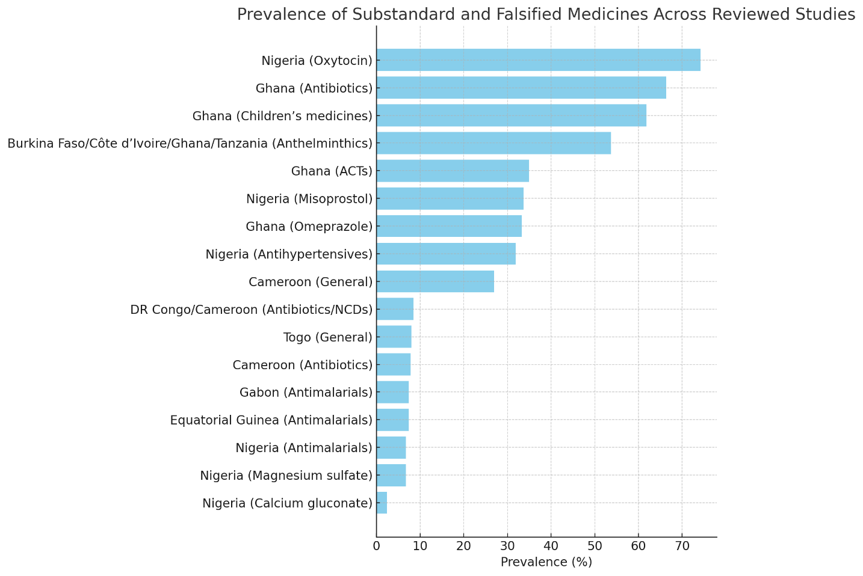

**Figure 2: The prevalence of substandard and falsified medicines across the 17 reviewed studies**

Substandard Active Pharmaceutical Ingredient (API) content was the most frequently (60%) reported issue across Cameroon, Nigeria, and Ghana, accompanied by poor dissolution profiles (54%) that indicate formulation inadequacies, especially notable in anthelminthics and maternal health medicines. Packaging and labeling deficiencies (35%) further compromised the integrity of the medicine, primarily observed in Cameroon and Ghana. Falsified medicines (20%) were notably documented in Cameroon, Nigeria, DR Congo, and Equatorial Guinea, posing critical risks to treatment efficacy and patient safety. Additionally, unauthorized sales contributed significantly to the distribution of poor-quality medicines, particularly in informal markets in Cameroon and Ghana (Fig. 3).

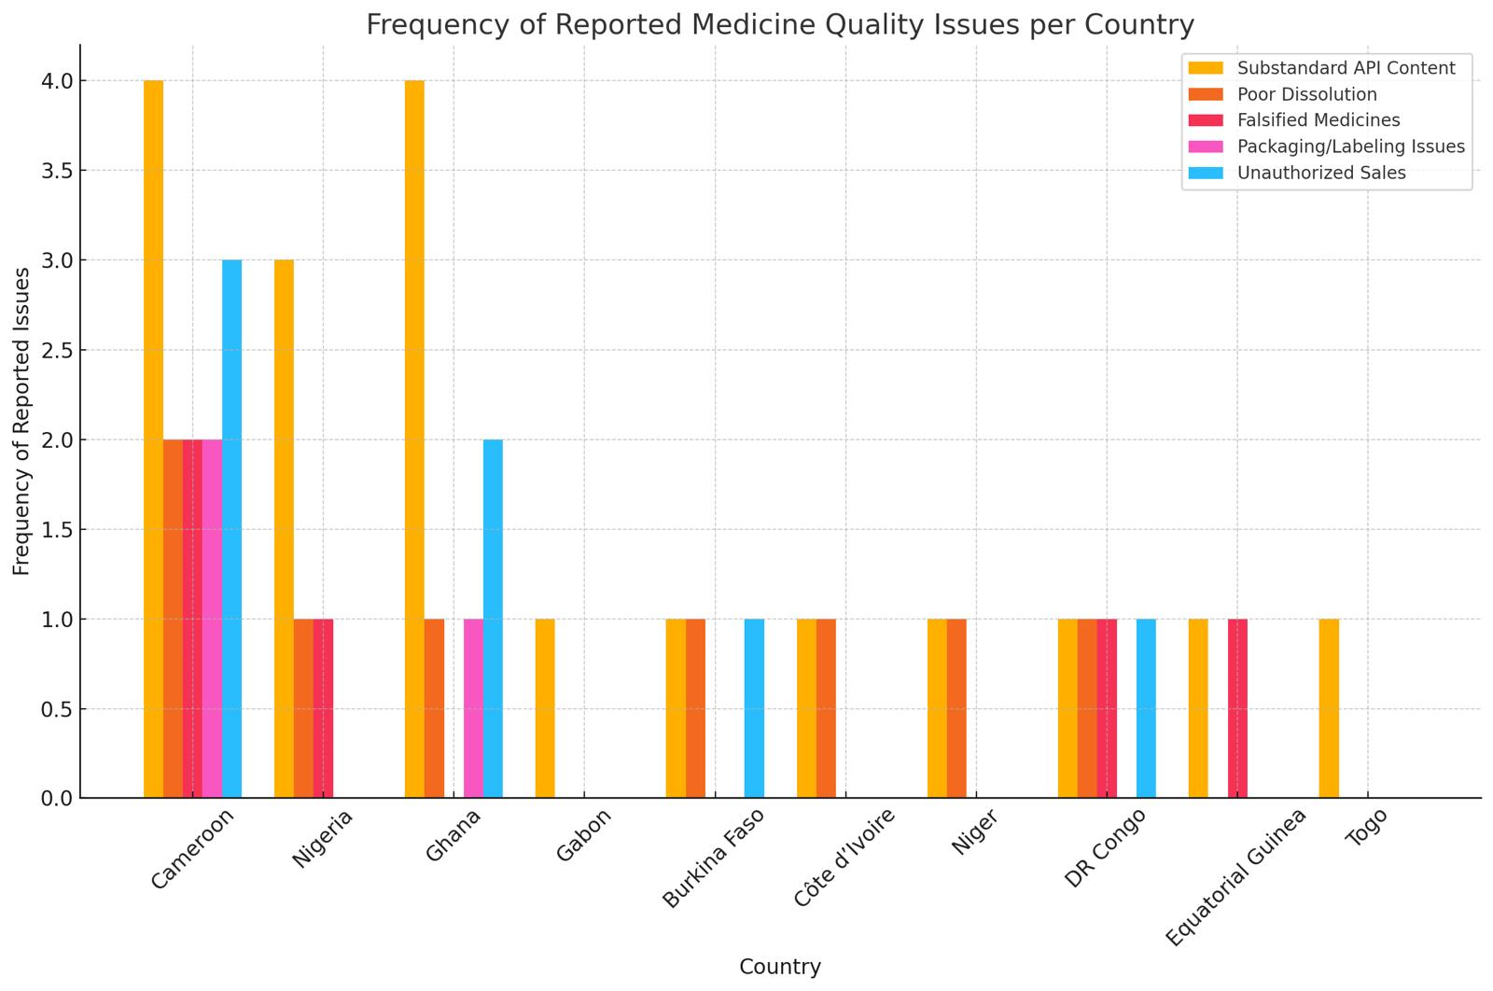

**Figure 3: Frequency of reported Medicine quality Issues per country**

The graph illustrates a stark contrast in the prevalence of substandard and falsified (SF) medicines between informal sources (e.g., street vendors, unauthorized markets) and regulated sources (e.g., licensed pharmacies, hospitals) across different countries. Notably, Nigeria and Ghana exhibit the highest SF medicine prevalence from informal sources, exceeding 74% and 66%, respectively, while their regulated sectors also show concerning rates, particularly in Ghana (35%). Cameroon and DR Congo demonstrate a tenfold increase in SF medicines from informal sources compared to regulated ones. Burkina Faso, Côte d'Ivoire, and Niger report relatively high SF prevalence in informal markets (over 50). Meanwhile, Gabon, Equatorial Guinea, and Togo show comparatively lower SF prevalence across both sectors. (Fig. 4)

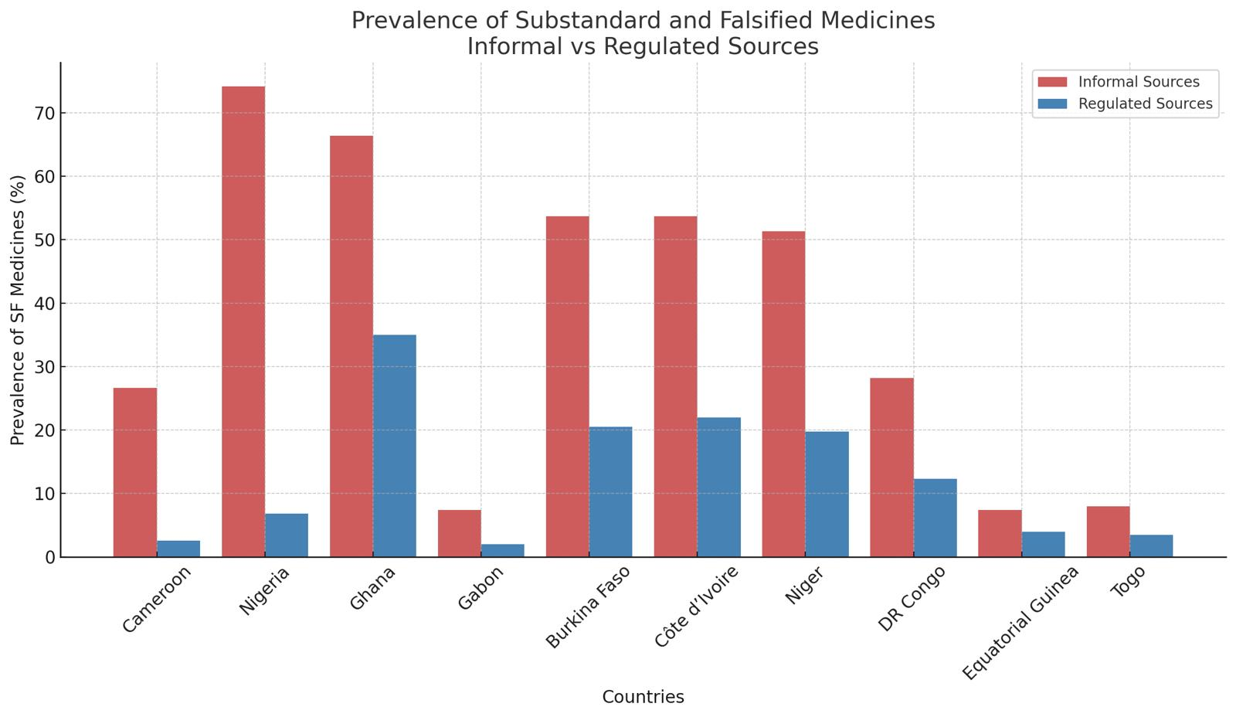

**Figure 4: Prevalence of Substandard and Falsified Medicines by Sector**

The box plot displays the distribution of methodological quality scores from published prevalence studies on substandard and falsified medicines. It highlights the central tendency and variability of the median quality score of 8.5, ranging from 6 - 12. (Fig. 5)

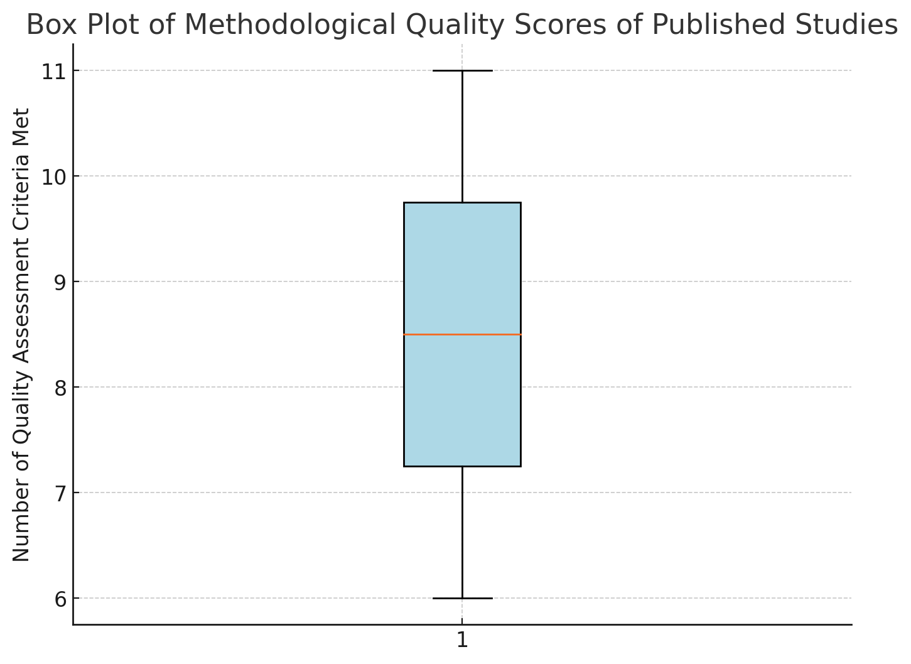

**Figure 5: Quality Scores of Published Data**

The left graph illustrates the distribution of dosage forms analyzed across the reviewed studies, highlighting tablets as the most frequently evaluated form, followed by capsules and injections. In contrast, suspensions, syrups, and ear/eye drops were examined less often, reflecting the research focus on solid oral dosage forms.

The right graph depicts the analytical techniques utilized to assess medicine quality. High-Performance Liquid Chromatography (HPLC) emerged as the most employed method (16/17 studies), valued for its precision and reliability in quantifying active pharmaceutical ingredients (APIs). Thin-Layer Chromatography (TLC) (5/17 studies) and Raman Spectroscopy (5/17 studies) were also widely used, particularly for rapid screening and field-based detection. Meanwhile, Visual Inspection (4/17 studies), Near-Infrared (NIR) Spectroscopy, and Titrimetric Methods were applied less frequently, primarily serving as preliminary screening tools in medicine quality assessments.

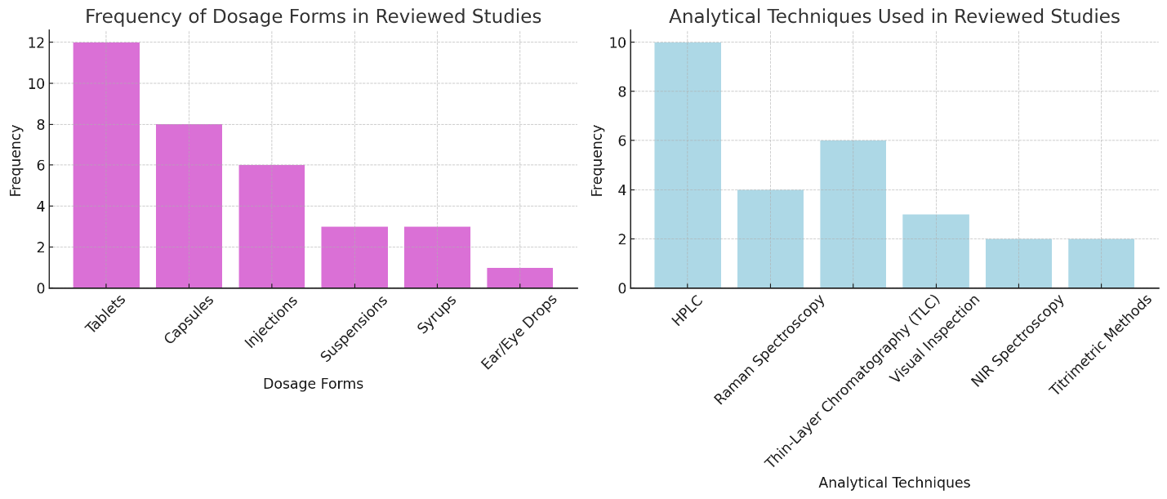

**Figure 6: Dosage Forms and Analytical Techniques in Reviewed Studies**

The summary of medicine quality studies included in the systematic review is summarized in table 2

**Table 2: Summary of Medicine Quality Studies Included in Systematic Review**

|  |  |  |
| --- | --- | --- |
| **Search** | **Query** | **Items found** |
| #1 | (("Counterfeit Drugs"[MeSH Terms] OR ("counterfeit"[Text Word] OR "counterfeited"[Text Word] OR "counterfeits"[Text Word] OR "fake"[Text Word] OR "fakes"[Text Word] OR "faked"[Text Word] OR "falsified"[Text Word] OR "false"[Text Word] OR "counterfeiting"[Text Word] OR "substandard"[Text Word] OR "spurious"[Text Word])) AND "medicine"[Text Word]) OR "medicines"[Text Word] OR "medication"[Text Word] OR "medications"[Text Word] OR "drug"[Text Word] OR "drugs"[Text Word] OR "pharmaceutical"[Text Word] OR "pharmaceuticals"[Text Word] OR "Pharmaceutical Preparations"[MeSH Terms] | 7,556,521 |
| #2 | (("Counterfeit Drugs"[MeSH Terms] OR (("counterfeit"[Text Word] OR "counterfeited"[Text Word] OR "counterfeits"[Text Word] OR "fake"[Text Word] OR "fakes"[Text Word] OR "faked"[Text Word] OR "falsified"[Text Word] OR "false"[Text Word] OR "counterfeiting"[Text Word] OR "substandard"[Text Word] OR "spurious"[Text Word]) AND ("medicine"[Text Word] OR "medicines"[Text Word] OR "medication"[Text Word] OR "medications"[Text Word] OR "drug"[Text Word] OR "drugs"[Text Word] OR "pharmaceutical"[Text Word] OR "pharmaceuticals"[Text Word] OR "Pharmaceutical Preparations"[MeSH Terms]))) NOT "false positive"[Text Word]) OR "false negative"[Text Word] OR "false transmitter"[Text Word] OR "false transmitters"[Text Word] OR "false result"[Text Word] OR "false results"[Text Word] | 60,929 |
| #3 | "Benin"[Text Word] OR "Burkina Faso"[Text Word] OR "Cameroon"[Text Word] OR "Cabo Verde"[Text Word] OR "Cape verde"[Text Word] OR "Central African Republic"[Text Word] OR "Chad"[Text Word] OR "Congo"[Text Word] OR "Cote d'Ivoire"[Text Word] OR "Djibouti"[Text Word] OR "Equatorial Guinea"[Text Word] OR "Gabon"[Text Word] OR "Gambia"[Text Word] OR "Ghana"[Text Word] OR "Guinea"[Text Word] OR "Liberia"[Text Word] OR "Mali"[Text Word] OR "Niger"[Text Word] OR "Nigeria"[Text Word] OR "Senegal"[Text Word] OR "Sierra Leone"[Text Word] OR "Togo"[Text Word] | 316,087 |
| #4 | (("Counterfeit Drugs"[MeSH Terms] OR (("counterfeit"[Text Word] OR "counterfeited"[Text Word] OR "counterfeits"[Text Word] OR "fake"[Text Word] OR "fakes"[Text Word] OR "faked"[Text Word] OR "falsified"[Text Word] OR "false"[Text Word] OR "counterfeiting"[Text Word] OR "substandard"[Text Word] OR "spurious"[Text Word]) AND ("medicine"[Text Word] OR "medicines"[Text Word] OR "medication"[Text Word] OR "medications"[Text Word] OR "drug"[Text Word] OR "drugs"[Text Word] OR "pharmaceutical"[Text Word] OR "pharmaceuticals"[Text Word] OR "Pharmaceutical Preparations"[MeSH Terms]))) NOT ("false positive"[Text Word] OR "false negative"[Text Word] OR "false transmitter"[Text Word] OR "false transmitters"[Text Word] OR "false result"[Text Word] OR "false results"[Text Word])) AND ("Benin"[Text Word] OR "Burkina Faso"[Text Word] OR "Cameroon"[Text Word] OR "Cabo Verde"[Text Word] OR "Cape verde"[Text Word] OR "Central African Republic"[Text Word] OR "Chad"[Text Word] OR "Congo"[Text Word] OR "Cote d'Ivoire"[Text Word] OR "Djibouti"[Text Word] OR "Equatorial Guinea"[Text Word] OR "Gabon"[Text Word] OR "Gambia"[Text Word] OR "Ghana"[Text Word] OR "Guinea"[Text Word] OR "Liberia"[Text Word] OR "Mali"[Text Word] OR "Niger"[Text Word] OR "Nigeria"[Text Word] OR "Senegal"[Text Word] OR "Sierra Leone"[Text Word] OR "Togo"[Text Word]) | 1242 |
| #5 | #2 AND (#3 OR 4) | 252 |

# Embase

|  |  |  |
| --- | --- | --- |
| **Search** | **Query** | **Items found** |
| #1 | 'counterfeit drug'/exp OR (counterfeit:ab,ti OR counterfeited:ab,ti OR counterfeits:ab,ti OR fake:ab,ti OR fakes:ab,ti OR faked:ab,ti OR falsified:ab,ti OR false:ab,ti OR counterfeiting:ab,ti OR substandard:ab,ti OR spurious:ab,ti AND (medicine:ab,ti OR medicines:ab,ti OR medication:ab,ti OR medications:ab,ti OR drug:ab,ti OR drugs:ab,ti OR pharmaceutical:ab,ti OR pharmaceuticals:ab,ti OR 'chemicals and drugs'/exp)) | 12,782 |
| #2 | ‘false positive' OR 'false negative' OR 'false transmitter' OR 'false transmitters' OR 'false result' OR 'false results' | 83,351 |
| # 3 | #1 NOT #2 | 8078 |
| #4 | 'lmic' OR 'lmics' OR 'low gdp' OR 'low gnp' OR 'low income economy' OR 'low income nation' OR 'low income nations' OR 'low income population' OR 'low income populations' OR 'lower gdp' OR 'lower gnp' OR 'lower gross domestic' OR 'lower income nations' OR 'lower income population' OR 'lower income populations' OR 'middle income countries' OR 'middle income country' OR 'middle income economies' OR 'middle income economy' OR 'middle income nation' OR 'middle income nations' OR 'middle income population' OR 'middle income populations' OR 'under developed countries' OR 'under developed country' OR 'under developed economies' OR 'under developed economy' OR 'under developed nation' OR 'under developed nations' OR 'under developed population' OR 'under developed populations' OR 'under developed world' OR 'under served countries' OR 'underserved nation' OR 'underserved nations' OR 'underserved population' OR 'underserved populations' OR 'underserved world' | 37.987 |
| #5 | ‘Benin OR “Burkina Faso” OR Cameroon OR “Cabo Verde” OR “Cape verde” OR “Central African Republic” OR Chad OR Congo OR “Côte d'Ivoire” OR Djibouti OR “Equatorial Guinea” OR Gabon OR Gambia OR Ghana OR Guinea OR “Guinea Bisau” OR Liberia OR Mali OR Niger OR Nigeria OR Senegal OR “Sierra Leone” OR Togo | 789 |
| #6 | #3 AND (#4 OR #5) | 95 |

**Global Health**

|  |  |  |
| --- | --- | --- |
| **Search** | **Query** | **Items Found** |
| S1 | TI ( ((counterfeit OR counterfeited OR counterfeits OR fake OR fakes OR faked OR falsified OR false OR counterfeiting OR substandard OR spurious) N3 (medicine OR medicines OR medication OR medications OR drug OR drugs OR pharmaceutical OR pharmaceuticals))) ) OR AB ( ((counterfeit OR counterfeited OR counterfeits OR fake OR fakes OR faked OR falsified OR false OR counterfeiting OR substandard OR spurious) N3 (medicine OR medicines OR medication OR medications OR drug OR drugs OR pharmaceutical OR pharmaceuticals))) ) OR SU ( ((counterfeit OR counterfeited OR counterfeits OR fake OR fakes OR faked OR falsified OR false OR counterfeiting OR substandard OR spurious) N3 (medicine OR medicines OR medication OR medications OR drug OR drugs OR pharmaceutical OR pharmaceuticals))) ) | 340 |
| S2 | TI ( ("false positive" OR "false negative" OR "false transmitter" OR "false transmitters" OR "false result" OR "false results") ) OR AB ( ("false positive" OR "false negative" OR "false transmitter" OR "false transmitters" OR "false result" OR "false results") ) OR SU ( ("false positive" OR "false negative" OR "false transmitter" OR "false transmitters" OR "false result" OR "false results") ) | 6099 |
| S3 | TI ((“Benin OR “Burkina Faso” OR Cameroon OR “Cabo Verde” OR “Cape verde” OR “Central African Republic” OR Chad OR Congo OR “Côte d'Ivoire” OR Djibouti OR “Equatorial Guinea” OR Gabon OR Gambia OR Ghana OR Guinea OR “Guinea Bisau” OR Liberia OR Mali OR Niger OR Nigeria OR Senegal OR “Sierra Leone” OR Togo))) | 290 |
| S4 | S1 AND (S2 OR S3) | 120 |
|  |  |  |

**Discussion**

The findings from the systematic review of 17 studies across West and Central Africa provide compelling evidence of the widespread presence of substandard, falsified, unlicensed, and unregistered medicines. The data reveals significant variations in prevalence rates, dosage forms, sources of medicines, and analytical techniques, highlighting the urgent need for regulatory intervention and enhanced pharmaceutical surveillance.

**1.Methodological Quality Score Assessment**

To ensure the robustness and reliability of the studies included in this systematic review, each study was assessed using the Medicine Quality Assessment Reporting Guidelines (MEDQUARG) criteria (17). Studies scoring 6 to 12 were considered methodologically sound, ensuring adherence to standardized survey and analytical techniques. Across the 17 studies, the methodological quality scores ranged from 6 to 12, with a median score of 9, indicating an overall moderate-to-high quality of included studies. Studies with higher scores (10–12) demonstrated comprehensive sampling strategies, robust analytical methods (e.g., HPLC or LC-MS), and clear definitions of substandard and falsified medicines. In contrast, studies with lower scores (6–8) often had limited sample sizes, lacked confirmatory analysis beyond screening tests (e.g., Minilab or TLC), or did not fully disclose supply chain tracking information. From our systematic Review Studies using multiple analytical techniques (HPLC, Raman Spectroscopy, and TLC) tended to score higher, as they provided more reliable and reproducible data. Surveys that incorporated post-market surveillance and supply chain analysis achieved higher scores due to their comprehensive approach to assessing medicine quality. Studies that relied solely on visual inspection or single-parameter screening tools (e.g., Minilab without confirmatory HPLC tests) tended to score lower due to the increased risk of false negatives or positives in medicine quality assessments. While our review emphasized rigorous methodological approaches, some studies in the literature reported findings with inconsistent definitions of SF medicines, lack of reference to internationally accepted pharmacopoeial standards, or unstandardized sampling methods (18). Similar studies conducted in resource-limited settings often had lower methodological scores, primarily due to constraints in access to high-precision analytical tools (e.g., HPLC, mass spectrometry) and funding limitations for large-scale surveys (19). Furthermore, research conducted in better-regulated settings or with international partnerships (e.g., WHO-backed studies) tended to score higher due to adherence to standardized reporting and testing methodologies (20).

2**. Prevalence of Substandard and Falsified Medicines**

The systematic review found a higher prevalence of substandard and falsified (SF) medicines in informal markets than in regulated pharmaceutical outlets. Nigeria (74.2%) and Ghana (66.4%) exhibited the highest SF medicine prevalence in informal markets, followed by Burkina Faso, Côte d’Ivoire, and Tanzania (over 50%). Cameroon and DR Congo demonstrated a 10-fold difference in prevalence between informal and formal outlets. Our findings are comparable to a study conducted by *Christele et al. 2020* in Cameroon, which reported an overall prevalence of SF medicines at 7.9%, with informal outlets having a prevalence of 26.7% compared to 2.6% in formal pharmacies, confirming the significantly higher risk in informal sales channels (18). Also, similar research in Equatorial Guinea by *Kaur H et al. 2017*, found 1.6% of antimalarial medicines substandard and 7.4% falsified, with falsified products more prevalent in certain sampling methods (5). Another study estimated the average prevalence of SF medicines in LMICs at 10.5%, but in Africa, it ranged up to 18.7%, supporting the findings from our review that SF medicines are persistent.

3**. Dosage Forms Most Affected by Poor Quality**

Our review identified solid oral formulations (tablets and capsules) as the most frequently analyzed and affected dosage forms, particularly antimalarials, antibiotics, and maternal health drugs. Injectable medications were also problematic, with oxytocin and magnesium sulfate failing quality tests due to low active pharmaceutical ingredient (API) content. Similar to a study assessing medicine quality in Cameroon, which found higher failure rates in ciprofloxacin and metronidazole tablets, with 4.5% failing disintegration tests and 2.1% failing API content assays (21). Furthermore, a review of medicine quality in Togo reported that 57.9% of artemisinin-based monotherapies and 83.7% of combination therapies failed to meet international pharmacopoeia standards (22)*.* Another study indicated that antiparasitics, antibiotics, and analgesics had failure rates of 34.4%, 20.4%, and 34.3%, respectively, reinforcing findings that infectious disease treatments are disproportionately affected by SF medicines (18).

**4. Effectiveness of Analytical Techniques**

Our review found that High-Performance Liquid Chromatography (HPLC) is the most sensitive and reliable analytical method for detecting SF medicine. Thin-Layer Chromatography (TLC) and Raman Spectroscopy were frequently used as rapid screening methods, while visual inspection and Near-Infrared (NIR) Spectroscopy served as preliminary screening tools. Our findings are in line with *Schafermann et al. 2018, who* reported that TLC was the most used technique (57.9%), followed by HPLC (42.1%), indicating widespread reliance on low-cost, field-applicable screening techniques (22). Another analysis showed that Minilab (TLC-based screening) could only detect 1 in 3 non-compliant samples, proving HPLC's superiority in quantitative drug analysis (20).Furthermore, research from Cameroon compared visual inspection, NIR spectroscopy, and paper analytical devices (PADs), concluding that multi-technique approaches are necessary for robust SF medicine detection (19).

**5. Regulatory Challenges in Pharmaceutical Quality Control**

Our systematic review indicated that weak regulatory frameworks, poor surveillance, and limited enforcement capacity contribute to the persistence of SF medicines in informal markets. The absence of standardized medicine quality control measures further hinders regulatory efficiency. Results are similar to a study on pharmaceutical regulation in resource-limited settings, which found that more than 70% of national regulatory systems lack sufficient capacity to ensure medicine quality, particularly due to inadequate laboratory infrastructure and limited technical expertise (3). Another review noted that African regulatory agencies struggle with enforcement due to high costs, insufficiently trained personnel, and fragmented policies (22). Furthermore, a WHO report emphasized the need for harmonization of regulatory standards across Africa to improve surveillance and post-marketing control (18).

**Study Limitations**

Despite the comprehensive nature of this systematic review, several limitations must be acknowledged. First, variability in study methodologies, sample sizes, and analytical techniques across the 17 reviewed studies may have introduced heterogeneity in the reported prevalence of substandard and falsified medicines. Secondly, differences in regulatory frameworks and enforcement levels across West and Central Africa limit the generalizability of findings, as some countries have stronger pharmaceutical governance than others. Third, reliance on published literature may have resulted in publication bias, as studies with significant findings are more likely to be published, potentially underrepresenting the actual burden of SF medicines. Additionally, resource constraints in some studies led to reliance on less-sensitive analytical techniques, such as TLC and Minilab, rather than HPLC or mass spectrometry, which may have led to misclassification of poor-quality medicines. Finally, limited data on the supply chains and sources of falsified medicines restricted the ability to assess the full scope of illegal pharmaceutical networks. Addressing these limitations in future research through standardized methodologies, broader geographic surveillance, and improved access to advanced analytical tools will be critical in strengthening pharmaceutical quality control in the region

**Conclusion**

This systematic review reveals the extensive presence of substandard, falsified, unlicensed, and unregistered medicines in West and Central Africa, with the highest risks in informal markets. Antimalarials, antibiotics, and maternal health medicines are particularly affected, posing significant threats to public health, increasing antimicrobial resistance, and negatively impacting treatment outcomes.

Although high-quality analytical techniques like HPLC and Raman Spectroscopy provide precise detection, many studies still depend on less-sensitive screening tools, which limits the accuracy of medicine quality assessments. Significant challenges persist due to weak regulatory enforcement, inadequate supply chain monitoring, and insufficient post-market surveillance, with substantial disparities in regulatory capacity across various West and Central African countries.

Harmonized pharmacovigilance frameworks enhanced regulatory enforcement, increased access to advanced screening and quality testing technologies, and public awareness initiatives are urgently needed to address this issue. Strengthening collaborations between governments, regulatory bodies, and global health organizations will ensure medicine quality, patient safety, and the integrity of pharmaceutical supply chains in the West and Central Africa subregions.

**References**

1. Bekoe SO, Ahiabu MA, Orman E, Tersbøl BP, Adosraku RK, Hansen M, et al. Exposure of consumers to substandard antibiotics from selected authorised and unauthorised medicine sales outlets in Ghana. Tropical Medicine and International Health [Internet]. 2020 Aug 1 [cited 2025 May 4];25(8):962–75. Available from: https://www.researchgate.net/publication/341445000_Exposure_of_consumers_to_substandard_antibiotics_from_selected_authorised_and_unauthorised_medicine_sales_outlets_in_Ghana

2. Jenei K, Aziz Z, Booth C, Cappello B, Ceppi F, de Vries EGE, et al. Cancer medicines on the WHO Model List of Essential Medicines: processes, challenges, and a way forward. Lancet Glob Health [Internet]. 2022 Dec 1 [cited 2025 May 5];10(12):e1860–6. Available from: https://www.thelancet.com/action/showFullText?pii=S2214109X2200376X

3. Gabel J, Lachele M, Sander K, Gnegel G, Sunny-Abarikwu N, Ohazulike RE, et al. Quality of Essential Medicines from Different Sources in Enugu and Anambra, Nigeria. Am J Trop Med Hyg [Internet]. 2024 Jul 1 [cited 2025 May 5];111(1):179. Available from: https://pmc.ncbi.nlm.nih.gov/articles/PMC11229646/

4. Frimpong G, Ofori-Kwakye K, Kuntworbe N, Buabeng KO, Osei YA, El Boakye-Gyasi M, et al. Quality Assessment of Some Essential Children’s Medicines Sold in Licensed Outlets in Ashanti Region, Ghana. J Trop Med [Internet]. 2018 [cited 2025 May 5];2018. Available from: https://pubmed.ncbi.nlm.nih.gov/29951101/

5. Kaur H, Allan EL, Mamadu I, Hall Z, Green MD, Swamidos I, et al. Prevalence of substandard and falsified artemisinin-based combination antimalarial medicines on Bioko Island, Equatorial Guinea. BMJ Glob Health [Internet]. 2017 [cited 2025 May 5];2(4). Available from: https://pubmed.ncbi.nlm.nih.gov/29082025/

6. Anyakora C, Oni Y, Ezedinachi U, Adekoya A, Ali I, Nwachukwu C, et al. Quality medicines in maternal health: Results of oxytocin, misoprostol, magnesium sulfate and calcium gluconate quality audits. BMC Pregnancy Childbirth [Internet]. 2018 Jan 30 [cited 2025 May 5];18(1). Available from: https://pubmed.ncbi.nlm.nih.gov/29382306/

7. Redfern J, Kaur H, Adedoyin RA, Ofori S, Anchala R, Vamadevan AS, et al. Equivalence in Active Pharmaceutical Ingredient of Generic Antihypertensive Medicines Available in Nigeria (EQUIMEDS): A Case for Further Surveillance. Glob Heart [Internet]. 2019 Sep 1 [cited 2025 May 5];14(3):327–33. Available from: https://pubmed.ncbi.nlm.nih.gov/31451241/

8. Tivura M, Asante I, van Wyk A, Gyaase S, Malik N, Mahama E, et al. Quality of Artemisinin-based Combination Therapy for malaria found in Ghanaian markets and public health implications of their use. BMC Pharmacol Toxicol [Internet]. 2016 Oct 28 [cited 2025 May 5];17(1):48. Available from: https://pmc.ncbi.nlm.nih.gov/articles/PMC5084396/

9. Antignac M, Diop BI, Macquart de Terline D, Bernard M, Do B, Ikama SM, et al. Fighting fake medicines: First quality evaluation of cardiac drugs in Africa. Int J Cardiol [Internet]. 2017 Sep 15 [cited 2025 May 5];243:523–8. Available from: https://pubmed.ncbi.nlm.nih.gov/28641892/

10. Batson JCS, Bempong DK, Lukulay PH, Ranieri N, Satzger RD, Verbois L. Assessment of the effectiveness of the CD3+ tool to detect counterfeit and substandard anti-malarials. Malar J [Internet]. 2016 Feb 25 [cited 2025 May 5];15(1):119. Available from: https://pmc.ncbi.nlm.nih.gov/articles/PMC4766612/

11. Osei YA, Oppong Boakye E, Bayor MT, Akuffo Owusu FW. Physicochemical Equivalence and Quality Assessment of Various Brands of Gastro-Resistant Omeprazole Capsules in the Kumasi Metropolis. The Scientific World Journal [Internet]. 2022 [cited 2025 May 5];2022:7924600. Available from: https://pmc.ncbi.nlm.nih.gov/articles/PMC9668445/

12. Robertson J, Magrini N, Barr R, Forte G, Ondari C. Medicines for cancers in children: The WHO model for selection of essential medicines. Pediatr Blood Cancer [Internet]. 2015 Oct 1 [cited 2025 May 5];62(10):1689–93. Available from: https://pubmed.ncbi.nlm.nih.gov/25929524/

13. PROSPERO [Internet]. [cited 2025 May 5]. Available from: https://www.crd.york.ac.uk/PROSPERO/myprospero

14. PRISMA 2020 statement — PRISMA statement [Internet]. [cited 2025 May 5]. Available from: https://www.prisma-statement.org/prisma-2020

15. Page MJ, McKenzie JE, Bossuyt PM, Boutron I, Hoffmann TC, Mulrow CD, et al. The PRISMA 2020 statement: an updated guideline for reporting systematic reviews. BMJ [Internet]. 2021 Mar 29 [cited 2025 May 5];372. Available from: https://www.bmj.com/content/372/bmj.n71

16. Rayyan: AI-Powered Systematic Review Management Platform [Internet]. [cited 2025 May 5]. Available from: https://www.rayyan.ai/

17. Almuzaini T, Choonara I, Sammons H. Substandard and counterfeit medicines: A systematic review of the literature. BMJ Open [Internet]. 2013 Aug 1 [cited 2025 May 5];3(8):e002923. Available from: https://bmjopen.bmj.com/content/3/8/e002923

18. Waffo Tchounga CA, Sacre PY, Hamuli PC, Mballa RN, Nga EN, Hubert P, et al. Poor-quality medicines in Cameroon: A critical review. American Journal of Tropical Medicine and Hygiene [Internet]. 2021 Aug 1 [cited 2025 May 5];105(2):284–94. Available from: https://pubmed.ncbi.nlm.nih.gov/34125703/

19. Tchounga CAW, Sacré PY, Ravinetto R, Lieberman M, Ciza PH, Mballa RN, et al. Usefulness of medicine screening tools in the frame of pharmaceutical post-marketing surveillance. PLoS One [Internet]. 2023 Aug 1 [cited 2025 May 5];18(8 August). Available from: https://pubmed.ncbi.nlm.nih.gov/37566594/

20. Visser BJ, Meerveld-Gerrits J, Kroon D, Mougoula J, Vingerling R, Bache E, et al. Assessing the quality of anti-malarial drugs from Gabonese pharmacies using the MiniLab®: A field study. Malar J [Internet]. 2015 Jul 15 [cited 2025 May 5];14(1). Available from: https://pubmed.ncbi.nlm.nih.gov/26169915/

21. Tchounga CAW, Sacré PY, Hamuli PC, Mballa RN, De Bleye C, Ziemons E, et al. Prevalence of Poor Quality Ciprofloxacin and Metronidazole Tablets in Three Cities in Cameroon. American Journal of Tropical Medicine and Hygiene [Internet]. 2023 Feb 1 [cited 2025 May 5];108(2):403–11. Available from: https://pubmed.ncbi.nlm.nih.gov/36535257/

22. Schäfermann S, Wemakor E, Hauk C, Heide L. Quality of medicines in southern Togo: Investigation of antibiotics and of medicines for non-communicable diseases from pharmacies and informal vendors. PLoS One [Internet]. 2018 Nov 1 [cited 2025 May 5];13(11). Available from: https://pubmed.ncbi.nlm.nih.gov/30496234/