***Original Research Article***

**Oral Pathologies Related to Major Mental Disorders: An Integrative Review**

.

**ABSTRACT**

|  |
| --- |
| **Aims:** This study aimed to analyze, through an integrative literature review, the relationship between oral diseases and major mental  disorders, in order to identify interdisciplinary strategies for comprehensive healthcare. **Study Design:** Integrative literature review. **Place and Duration of Study:** The review was conducted at the Universidade Federal dos Vales do Jequitinhonha e Mucuri (UFVJM), Brazil, between December 2024 and April 2025. **Methodology:** A bibliographic search was carried out using the databases PubMed, Web of Science and Scopus. The descriptors used were “Mental Disorder”, “Oral Health”, “Mental Health” and “Dental Care”. After applying inclusion and exclusion criteria, 26 studies were selected for analysis. Data were categorized according to study design, mental disorders addressed, oral manifestations, and proposed interventions. **Results:** **Cross-sectional studies were the most prevalent (n=12), followed by narrative reviews (n=7), systematic reviews (n=6), and one cohort study. Studies published between 1990 and 2024 were found.** **The most frequently reported mental disorders included depression, anxiety, schizophrenia, and bipolar disorder. Common oral health conditions associated with these disorders were xerostomia, mucosal lesions, dental caries, and periodontal diseases. Proposed interventions included preventive measures, artificial saliva use, restorative treatments, and oral health education actions. The findings suggest a strong association between mental health conditions and oral pathologies, often exacerbated by medication effects, lack of self-care, and limited access to dental services. Conclusion:** The review highlighted a scarcity of clinical approaches specifically targeted at individuals with mental disorders. This indicates the need for public policies and integrated therapeutic strategies that address the biopsychosocial needs of this population. Strengthening the connection between mental health and dentistry is essential for promoting inclusive and effective practices aimed at comprehensive care and reducing health disparities. |

*Keywords: Anxiety; depression; bipolar disorder; schizophrenia; oral health; mental health; dental care.*

**1. INTRODUCTION**

Mental health is a fundamental human right and as defined by the World Health Organization (WHO), is a state of well-being that enables individuals to cope with life's challenges, develop their skills, learn, work and contribute to society [1]. This concept highlights the importance of mental health for human prestige and well-being, not limited to psychosocial disabilities, but also encompassing various mental disorders that can significantly impact quality of life. Disorders such as depression, anxiety, bipolar disorder and schizophrenia are some of the most common disorders, affecting both people's daily functioning and their social and professional relationships [1] [2].

Mental disorders have a significant impact on the general health of patients, and it is important to highlight that these individuals constitute a higher risk group for developing oral pathologies compared to the general population [3]. This increased risk can be attributed not only to the side effects of the medications used, but also to factors such as gaps in self-care, difficulties in accessing health services, and resistance or little interest to dental treatments [3].

This integrative review aims to analyze the relationship between oral pathologies and the main mental disorders, focusing on the most common disorders among patients, namely: depression, schizophrenia, anxiety, and bipolar disorder [4] [5]. With the purpose of contributing to the development of multidisciplinary strategies, understanding, and prevention that integrate mental health and oral health.

Given the social and clinical relevance of the proposed topic, considering that mental health has a strong impact on the oral quality of individuals, the study is justified by the lack of research on this relationship.

**2.**  **METHODOLOGY**

This is an integrative review whose objective is to investigate the relationship between mental health and oral health, focusing on the mental disorders depression, anxiety, schizophrenia and bipolar disorder. For data collection, a bibliographic survey was carried out in electronic databases.

The search for studies was conducted without language restrictions in the Web of Science, Scopus and PubMed databases. To select the articles, descriptors and their combinations were used, extracted from the Medical Subject Headings (MeSH) and Health Sciences Descriptors (DeCS) vocabularies, in Portuguese and English. The terms used were: transtornos mentais (“Mental Disorder”), saúde bucal (“Oral Health”), saúde mental (“Mental Health”) e assistência odontológica (“Dental Care”). The search strategy was adapted for each database using the Boolean operators OR and AND.

The following inclusion criteria were defined: (i) studies that addressed the relationship between mental disorders (anxiety, depression, bipolar disorder and schizophrenia) and diagnosed oral pathologies; and (ii) studies that describe and discuss dental treatment strategies for patients with these disorders. Studies that did not directly address this relationship and those that only addressed the patient's self-perception of their oral health were excluded.

The identified manuscripts were imported into the Rayyan reference manager (https://www.rayyan.ai/), where duplicates were removed. Then, the titles and abstracts were screened by two independent researchers GMFS e LEOF, following the eligibility criteria. After this stage, the selected studies were analyzed in full to confirm their inclusion.

Finally, the selected studies were organized in a standardized spreadsheet in Google Docs, where information about the authors, year of publication, country of origin, study design, eligibility criteria, clinical condition of the participants, proposed treatments and main oral alterations were extracted. The collected data were analyzed descriptively, ensuring a clear systematization of the extracted information.

**3. RESULTS**

This integrative review included 26 studies published between 1990 and 2024. The article selection process is detailed in Figure 1, which presents the PRISMA 2020 flowchart. Initially, 1,027 records were identified in the PubMed (499), Web of Science (490), and Scopus (38) databases. After removing 248 duplicate records, the articles were screened by title and abstract, at which stage 729 studies were excluded because they did not meet the eligibility criteria. Then, after reading the texts in full, 8 articles were discarded due to the unavailability of the full text, while another 16 were excluded because they were not relevant to the objectives of the review. Thus, at the end of the selection process, 26 studies comprised the final research sample.

Table 1 summarizes the characteristics of the included studies. Most studies were Cross-Sectional (n=12), followed by Narrative Review (n=7), Systematic Review (n=6) and Cohort (n=1), as shown in Figure 2.

In addition to anxiety, depression, bipolar disorder and schizophrenia, some studies presented other conditions such as Dementia and Personality Disorder (n=3), Major Depressive Disorder, Organic Mental Disorders, Obsessive Compulsive Disorder, Mood Disorders (n=2), as illustrated in Figure 5 . While Major Depression, Affective Disorder, Mental Retardation, Atypical Psychosis, Anxiety Disorder, Post-Traumatic Stress Disorder, Developmental Disorders, Behavioral and Emotional Disorders, Disorders Related to the Use of Psychoactive Substances, Neurotic Disorders, Alexithymia, Adjustment Disorders, Attention Deficit Disorders, Conduct and Disruptive Behavior, Delusion, Dementia and other Cognitive Disorders, Impulse Control Disorders, Other Psychotic Disorders, Alcohol and Substance Related Disorders, Stress (n=1). Of the articles selected for the study, the majority were produced in the United States (n=6), India (n=3), Australia and Brazil (n=2), followed by Spain, Turkey, France, Italy, Malaysia, Nepal, Paraguay, Egypt, Romania, the Netherlands, Saudi Arabia, China, Switzerland, and the United Kingdom (n=1), as can be seen in Figure 3.

The temporal distribution of the articles analyzed indicates a significant concentration of recent publications, with the year 2024 highlighting the largest number of studies (n=6), followed by 2023 (n=4). In addition, the years 2010, 2014, 2015, 2017 and 2021 recorded two articles each, according to the data in Figure 4. While the years 1990, 1999, 2001, 2013, 2016, 2018 and 2019 had one article each.

**Figure 1. Diagram and Flowchart PRISMA 2020**

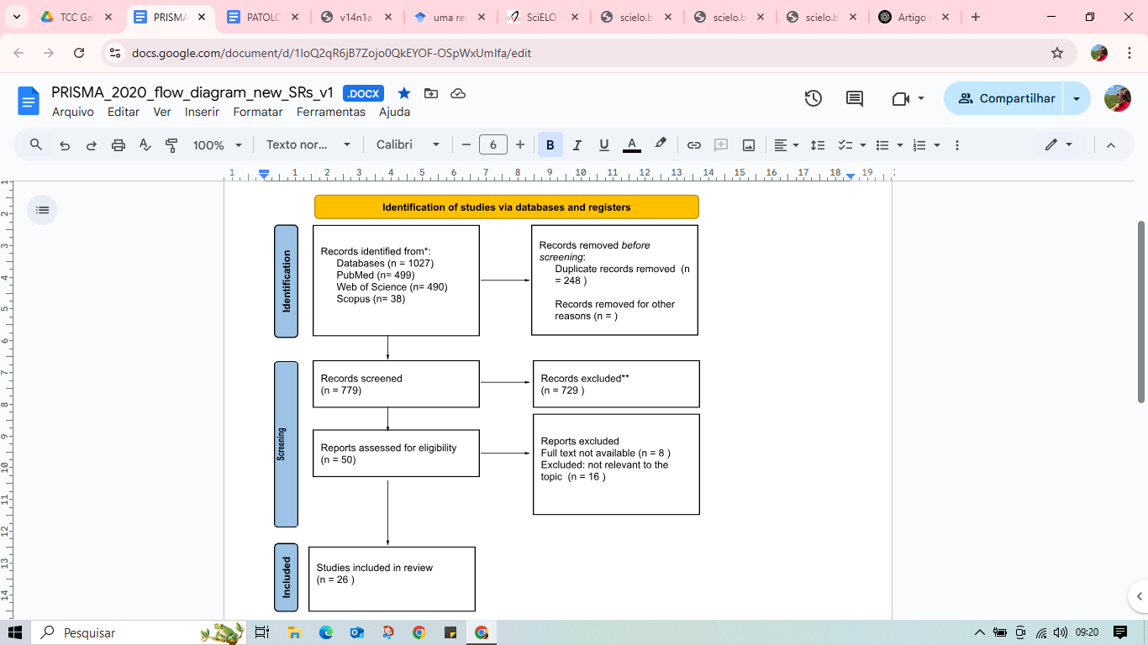

Adapted from: Page MJ, McKenzie JE, Bossuyt PM, Boutron I, Hoffmann TC, Mulrow CD, et al. The PRISMA 2020 statement: an updated guideline for reporting systematic reviews. BMJ 2021;372:n71. doi: 10.1136/bmj.n71 [6]

**Table 1. Presentation of the summary of the articles included in the integrative review.**

|  |  |  |  |  |  |
| --- | --- | --- | --- | --- | --- |
| Authors, year, country | Study Design | Eligibility criteria | Disorder | Suitable treatment | Present oral alterations |
| Stiefel *et al*.,1990, Estados Unidos [7] | Cross sectional | 18 to 65 years old; diagnosed with chronic mental illnesses such as schizophrenia, bipolar disorder, or major depression; patients who have not had dental treatment in the last 6 months; ability to give informed consent to participate in the study. | Schizophrenia, Bipolar Disorder, Major Depression. | Oral health prophylaxis and assessment, medication management, instructions on proper oral hygiene practices. | Gingivitis, periodontitis, caries, xerostomia, geographic tongue, mucositis. |
| Velasco e Bullbn, 1999, Espanha [8] | Cross sectional | Patients admitted to the Miraflores Psychiatric Hospital in Seville (Spain). | Schizophrenia, Affective Disorder, Dementia | Instruction in oral hygiene, scraping. | Periodontal disease, caries, edentulism. |
| Friedlander e Mahler, 2001, Estados Unidos [9] | Narrative review | NR | Major depressive disorder. | Oral health education, prophylaxis, scaling, salivary stimulation and use of artificial saliva, application of sealants and restorations, fluoride therapy and frequent dental consultations | Xerostomia, gingivitis and periodontitis. |
| Gurbuz *et al*., 2010, Turquia [10] | Cross sectional | All patients admitted to the chronic psychiatric clinics of Bakirkoy Training and Research Hospital for Psychiatry, Neurology and Neurosurgery in Istanbul.  Schizophrenia, Mental Retardation, Organic Mental Disorders, Atypical Psychosis. |  | Restorations, extractions, dental prostheses, oral health education, integration of oral hygiene into routine, provision of dental services. | Caries, xerostomia, edentulism, lesions in the oral mucosa and tongue, edentulism and root remnants. |
| Matevosyan, 2010, Estados Unidos [11] | Systematic review | Minimum 18 years for prevalence studies and 15 years for incidence studies, and outcomes such as oral dryness, dental caries, edentulism, extracted teeth, filled teeth, periodontal disease, malocclusion, oral cancer and pre-cancer. | Schizophrenia, Bipolar disorder, Anxiety disorder, Compulsive obsessive disorder, Depression, Post traumatic stress disorder. | Restorations, tooth extractions, dental prostheses, preventive oral health programs, integration of oral hygiene into patients' routines and provision of dental services. | Xerostomia, severe caries, periodontal diseases, edentulism, lesions in the oral mucosa and tongue, malocclusion and oral cancer. |
| Bertaud-Gounot *et al*., 2013, França [12] | cross sectional | Adult patients admitted to the Guillaume Regnier Hospital in February 2006 willing to participate and consent to the examination. | Schizophrenia, Mood Disorders, Organic Mental Disorders, Personality Disorders, Developmental Disorders, Conduct Disorder Emocionais, Disorders related to the use of psychoactive substances, Neurotic Disorders. | Restorative treatments, tooth extractions, production and installation of dental prostheses, implementation of preventive oral health programs, artificial saliva products, use of antiseptic mouthwashes. | Caries, edentulism, lesions in the oral mucosa, xerostomia. |
| Luca *et al*., 2014, Itália [13] | Cohort | Cases: PD patients referred to the psychiatric unit for consultation;  Controls: Healthy individuals without neurological or psychiatric disorders, recruited from the general population. | Depression, Anxiety, Alexithymia, Personality Disorders. | NR | Periodontitis. |
| Allareddy *et al*., 2014, Estados Unidos [14] | cross sectional | Hospitalized patients with a primary diagnosis of dental conditions, such as caries and periodontal disease, and a secondary diagnosis of mental disorders, identified by CCS codes. | Adjustment Disorders, Anxiety Disorders, Attention Deficit Disorders, Conduct and Disruptive Behavior, Delirium  Dementia and other cognitive disorders, Developmental disorders, Impulse control disorders, Mood disorders, Personality disorders, Schizophrenia, other psychotic disorders, Alcohol and substance-related disorders. | NR | Caries, pulp/periapical lesions, periodontal diseases, abscesses. |
| Wey *et al*., 2015, Austrália e Malásia [15] | cross sectional | Inclusion: Long-term inpatients diagnosed with schizophrenia; aged 18 to 65; not on sick leave; consent obtained directly or through a legal representative.  Exclusion: patients in the acute phase of schizophrenia or in the first episode of the disease; with chemical dependency or serious medical illnesses (e.g. epilepsy, stroke); severe intellectual disability or risk of self-harm/violence. | Schizophrenia. | Prevention and promotion of oral health, treatment of cavities, use of fluorides and minimally invasive restorative treatments. | Caries, gingivitis and periodontitis, xerostomia, tooth loss and edentulism. |
| Gupta *et al*., 2016, Nepal [16] | systematic review | NR | Esquizofrenia. | Oral health education, oral health programs, oral hygiene maintenance, prophylaxis, root scaling, surgeries, restorations and oral rehabilitation, consultation with the patient's doctor so that he can monitor oral health, training and updating of health professionals. | Xerostomia, periodontitis, caries. |
| Slack-Smith *et al*., 2017, Austrália [17] | Narrative review | Relevant literature on dental care and oral health for people with mental disorders, according to the authors. | Schizophrenia and Bipolar Disorder. | Oral health education, Regular oral hygiene, Prophylaxis, artificial saliva and salivation stimulators. | Xerostomia, caries. |
| Torales *et al*., 2017, Paraguai [3] | Narrative review | Original articles and reviews in Spanish and English that the authors considered useful for the purposes of the research. | Depression, Anxiety, Schizophrenia, Bipolar Disorder, Dementia. | Oral health education, use of artificial saliva, use of mouthwashes, topical fluoride applications, use of salivary stimulants, antifungal treatment, TMD therapies. | Caries, gingivitis, xerostomia, candidiasis, mucosal lesions, bruxism and disorders of the temporomandibular joint. |
| Barbosa *et al*., 2018, Brasil [18] | cross sectional | Inclusion: 15 years or older, registered with the FHU without gender or ethnicity restrictions, residing in Recife.  Exclusion: people with neurological disorders, history of tumor in the head and neck region, continuous use of anti-inflammatory or analgesic drugs, inability to understand and respond to questionnaires, and history of rheumatological pathologies. | Depression | Orthodontic evaluation and treatment, prophylaxis, scaling, oral health education. | TMD, periodontitis. |
| Coelho *et al*., 2019, Brasil [19] | cross sectional | Have a minimum of four teeth to validate measurements of periodontal status; not pregnant; absence of cancer or HIV-AIDS; not having used anti-inflammatory medications in the two months prior to the study; not having undergone periodontal treatment in the last 6 months. | Depression, Anxiety. | NR | Periodontitis |
| Albahli *et al*., 2021, Egito [20] | cross sectional | Patients who underwent an intraoral examination; presence of at least 20 teeth. | Schizophrenia | Strict oral hygiene, prophylaxis, scaling, frequent dental check-ups, attention to tooth loss and adaptation of the treatment plan. | Periodontitis |
| Szalontay *et al*., 2021, Romênia [21] | cross sectional | Hospitalized patients diagnosed with schizophrenia; aged 19 to 63; diagnosis according to the criteria of the fifth edition of the DSM-V. | Schizophrenia | Adequate oral hygiene, use of artificial salivary products, regular access to dental care, preventive interventions. | Caries, tartar, periodontal disease, xerostomia, Tardive Dyskinesia. |
| Kakde *et al*., 2023, Índia [22] | cross sectional | Han Chinese inpatients; 18 years or older; diagnosed with schizophrenia according to SCID criteria. | Depression, Anxiety. | Education about oral health and dental care. | Caries, TMD, periodontitis. |
| Skallevold *et al*., 2023, Holanda [2] | systematic review | Studies published between 1995 and 2023; English; original articles, systematic reviews and book chapters that address the relationship between mental disorders and oral health. | Depression, Anxiety, Bipolar Disorder, Schizophrenia | Oral health education, prophylaxis, scaling, orthodontic treatment, salivary stimulation and use of artificial saliva, application of sealants and restorations. | Caries, xerostomia, periodontitis and bruxism. |
| Abed *et al*., 2023, Arábia Saudita [23] | systematic review | Inclusion: Articles published in English between 1991 and 2021.  Exclusion: conference posters, letters to the editor, expert commentaries, and partial texts. | Schizophrenia, Obsessive Compulsive Disorder, Bipolar Disorder, Dementia. | Hydration and use of toothpaste with a high fluoride content, frequent visits to the dentist, preferably reversible treatments, such as fillings and scaling, instead of irreversible treatments, such as extractions. | Xerostomia, gingivitis, candidiasis, periodontitis, bruxism, ulcers and caries. |
| Yang *et al*., 2023, China [24] | cross sectional | Han Chinese inpatients; 18 years or older; diagnosed with schizophrenia according to SCID criteria. | Schizophrenia | Smoking cessation, proper management of antipsychotic medication use, regular dental intervention. | Caries and periodontal diseases. |
| Saxsena *et al*., 2024, Índia [25] | systematic review | Participants with MDD or related behaviors; performed in hospital settings; that used clinical diagnoses or diagnostic criteria for the diagnosis of MDD; outcome measures such as dental plaque index, gingival index, simplified oral hygiene index, clinical attachment loss; publications from 2000 to 2022 written in English and available as full text; interventions performed only by dental professionals. | Major Depressive Disorder | Strict oral hygiene, monitoring of xerostomia, treatment of cavities and periodontal diseases, frequent dental check-ups. | Cavities, tooth loss, periodontitis, dental erosion. |
| Abdul-Wasay, S., & Ouanounou, A., 2024, Estados Unidos [26] | narrative review | NR | Bipolar Disorder | wound management with corticosteroids; salivary substitutes (xylitol gum and sialogogues such as pilocarpine and cevimeline); rigorous oral hygiene. | Caries, xerostomia, periodontitis, dysphagia, increased risk of Sjögren's syndrome, parafunctions, agranulocytosis. |
| Chen *et al*., 2024, Suíça [27] | Narrative review | NR | Depression, Bipolar Disorder, Schizophrenia. | Fluoride application, education and reinforcement of oral hygiene, diet modification, prophylaxis, periodontal scraping, artificial saliva/salivary stimulants, hydration, replacement of xerostomic medications, gels, use of muscle relaxants, orofacial physiotherapy, dental monitoring, orthodontics. | Caries, periodontitis, xerostomia, bruxism, TMD, gingival hyperplasia, malocclusion and open bite. |
| Kang *et al*., 2024, Reino Unido [28] | Narrative review | NR | TMS: Bipolar Disorder and Schizophrenia. | Adequate oral hygiene, oral health education, physical exercise, treatment of systemic conditions, access to dental care. | Tooth loss, edentulism, tooth decay, periodontal disease. |
| Khairunnisa *et al*., 2024, Estados Unidos [29] | systematic review | Peer-reviewed publications between 2000 and 2024; accessible articles. | Depression, Anxiety, Bipolar Disorder, Schizophrenia. | Oral health education, regular oral hygiene, topical fluoride application. | Caries, periodontitis, xerostomia. |
| Priyadharshini *et al*., 2024, Índia [30] | Narrative review | NR | Depression, Anxiety and Stress, Schizophrenia, Bipolar Disorder. | Artificial saliva, increased water intake and adjustment of psychotropic medications, corticosteroids and vitamin supplementation, stress control, occlusal splints, physiotherapy and relaxation, reinforcement of oral hygiene, use of fluoride, dental, psychiatric and psychological monitoring, analgesia when necessary. | Xerostomia, recurrent aphthous stomatitis, lichen planus, bruxism, TMD, phantom toothache. |

**Legenda:** DTM= Disfunção temporomandibular; ATM= Articulação temporomandibular; NR= Não reportado; TMS= Transtorno mental severo, MDD= Transtorno Depressivo Maior; DMG= Doenças mentais graves; CCS= Clinical Classification Software; SCID= Structured Clinical Interview for the DSM-IV; DSM-V= Manual Diagnóstico e Estatístico de Transtornos Mentais; FHU= Unidades de Saúde da Família (Family Health Units, em inglês); HIV/AIDS= Human Immunodeficiency Virus/ Acquired Immune Deficiency Syndrome.

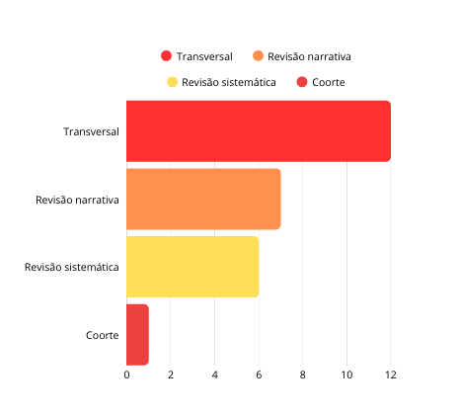

**Fig. 2. Methodological classification of the studies analyzed**

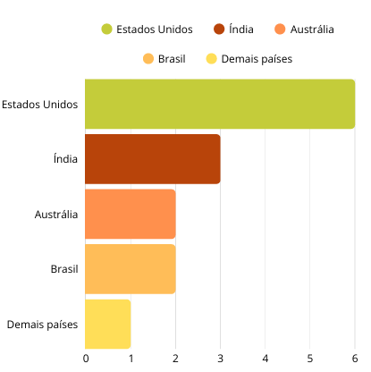

**Fig. 3. Geographical distribution of scientific publications**

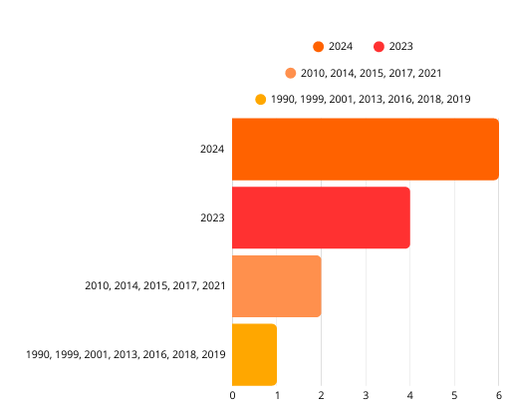

**Fig. 4. Temporal distribution of scientific publications**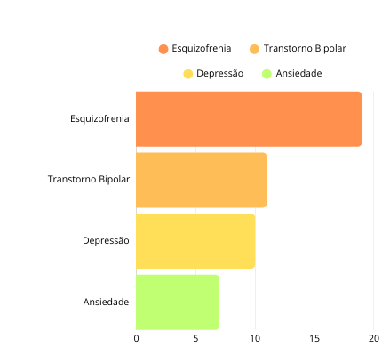

**Fig. 5. Mental disorders commonly cited in publications**

**4. DISCUSSION**

The findings of this study show that individuals with mental disorders have significantly impaired oral health, characterized by a high prevalence of periodontal disease, caries, and xerostomia [7] [11]. The results indicate that this relationship is multifactorial, influenced by factors such as prolonged use of psychotropic drugs, barriers to access to dental services, and limitations in oral hygiene practices due to motor or cognitive difficulties associated with psychological disorders [29] [3].

Such circumstances not only compromise access to and interest to dental care, but also increase the risk of developing and worsening oral diseases, negatively impacting their quality of life and clinical prognosis [29]. Individuals with severe mental disorders often have a worsening of their oral health, which can contribute to the worsening of their psychological problems [29].

In addition to specific pathologies predominant in each of the disorders, they all have oral alterations in common, such as caries, periodontal disease, gingivitis, and xerostomia [31]. These changes not only impact the patient's physical health, but also their emotional health, given that bad breath, resulting from periodontal problems, and cavities in teeth compromise self-esteem and can lead to social isolation, contributing to the worsening [32].

Periodontitis and caries are the result of the influence of several everyday factors in these patients, such as inadequate eating habits, alcohol and tobacco consumption, stress, trauma and poor oral hygiene [33].

The challenges faced by these psychiatric patients, such as medication administration, result in xerostomia [31]. Medication management requires caution, as antidepressants can interact with drugs used in dentistry. Selective serotonin reuptake inhibitors (SSRIs) interfere with the metabolism of medications such as codeine and benzodiazepines, while tricyclic antidepressants (TCAs) can potentiate the effects of vasoconstrictors such as levonordefrin, with epinephrine being preferred, but in controlled doses. Patients using monoamine oxidase inhibitors (MAOIs) should avoid meperidine and receive reduced doses of narcotic analgesics [9].

The presence of mental disorders significantly influences the way these individuals experience and relate to dental care [33]. Therefore, the dental approach should be continuous and multidisciplinary, with frequent consultations, reinforcement in preventive education and integration with mental health services, aiming at better adherence to treatment and general well-being [2]. Among the most prevalent mental disorders are depression, anxiety disorders, bipolar disorder and schizophrenia, which affect approximately 980 million individuals globally [2] [5]. Studies indicate that these individuals have a significantly higher risk of developing dental problems compared to the general population, not only due to harmful habits, such as excessive sugar consumption and smoking, but also due to barriers in accessing preventive and therapeutic care [18] [28]. In addition, prolonged use of antidepressants and mood stabilizers can compromise oral health by reducing salivary flow, predisposing to xerostomia and hindering the protective action of fluorides, thus increasing susceptibility to dental caries and other oral diseases [18] [29].

**4.1 Depression**

**Depression, which affects approximately 280 million individuals globally, including 23 million children and adolescents, is a disorder characterized by persistently depressed mood and anhedonia, with significant repercussions on functionality and quality of life [4] [2]. Among associated oral disorders, periodontitis is the most prevalent condition, favored by factors such as neglect of oral hygiene, smoking and immunological alterations [9].**

**The literature shows a bidirectional relationship between depression and periodontal health: the disorder can compromise self-care, while oral alterations, in turn, negatively impact self-esteem and aggravate psychological distress [13]. In this scenario, the relevance of oral health education as a central axis of care stands out, with a focus on guidance on hygiene techniques and adherence to specific clinical protocols [9]. Interventions such as subgingival scaling, root planing, control of carious lesions and restorations should be prioritized, always with the appropriate use of local anesthesia, considering the high prevalence of anxiety in these patients [9].**

**Dental care for depressed patients, therefore, must articulate an empathetic, confidential and interprofessional approach, including, when authorized by the patient, communication with the responsible psychiatrist for joint evaluation of the use of psychotropic drugs and possible associated comorbidities [9].**

**4.2 Anxiety**

Anxiety is an increasingly common psychological disorder in today's society. Around 301 million people worldwide had some type of anxiety disorder in 2019 [4]. This type of condition is generally marked by intense feelings of apprehension and fear in the face of situations that often do not represent a real risk. This constant state of tension causes a feeling of helplessness in the face of the future and can trigger symptoms such as excessive worry, nervousness, and insecurity [34].

Such emotional changes directly influence self-care, resulting in inadequate oral hygiene practices and neglect of oral health as a whole [35]. Anxiety can foster a set of harmful oral behaviors, such as bruxism. Practices often practiced by patients with anxiety, such as chewing objects and biting nails, can result in tooth wear and temporomandibular dysfunction (TMD) [36].

The management of temporomandibular disorders (TMD), especially in chronic cases such as in patients with anxiety, requires an interdisciplinary approach that mainly involves dentists and psychologists, among other professionals. The main objective of treatment is to restore compromised functions, reestablish neuromuscular and occlusal balance, promoting pain relief, in addition to acting to control anxiety [37].

**4.3 Bipolar Disorder**

In 2019, approximately 40 million people were diagnosed with bipolar disorder [4]. This condition is characterized by alternating depressive episodes and manic phases, in which the individual may present symptoms such as irritability or euphoria, excessive talking, increased energy and activity, high self-esteem and impulsive or risky behaviors [4].

Patients with bipolar disorder may avoid dental care due to their psychiatric condition, which increases the risk of caries and periodontal disease [26]. During depressive phases, oral hygiene is often neglected, while in the manic phase it is common for individuals to excessively intensify oral hygiene care, which can contribute to the development of abrasive lesions and gum recession [37].

As a group with a high prevalence of periodontal disease, prevention, diagnosis and treatment of this pathology are of utmost importance [38].

**4.4 Schizophrenia**

Schizophrenia is a chronic psychiatric disorder that affects approximately 24 million people worldwide [4]. Its clinical manifestations include delusions, hallucinations, behavioral changes, and persistent cognitive deficits that comprise social functioning and self-care [20]. This scenario favors the development of oral problems, with root caries being one of the main conditions observed, associated with xerostomia caused by the use of first-generation antipsychotics [15]. Dental care for patients with schizophrenia should prioritize building bonds and clear communication in order to reduce discomfort and promote interest to dental care [16]. The dentist's role should include providing guidance to caregivers, prophylaxis, restorations, rehabilitation of edentulous patients, and emergency management, always in conjunction with the multidisciplinary team [16].

**5. CONCLUSION**

This study aimed to investigate the relationship between oral pathologies and the main mental disorders, such as anxiety, schizophrenia and bipolar disorder, through an integrative review. The results show that individuals with mental disorders are more predisposed to oral pathologies, such as caries, periodontitis and xerostomia. These problems are related to several factors, such as difficulty in self-care, barriers to accessing dental services and the use of psychotropic drugs.

However, this review had some important limitations. There was a predominance of cross-sectional studies, which restricts the analysis of cause and effect. In addition, most of the publications originated in the United States, limiting cultural diversity and the generalization of the findings to other contexts. Another relevant point was the fact that all the selected articles were only available in English, which may have excluded relevant studies published in other languages, especially Portuguese.

The data points to the need for integration between mental health teams and oral health services, promoting truly integrated care, ensuring more complete, continuous care focused on the individual needs of each patient. After all, in the field of health, mind and mouth go hand in hand, and every smile carries a story that deserves to be heard.

**REFERENCES**

1. World Health Organization. (2022). Mental disorders. Retrieved from <https://www.who.int/news-room/fact-sheets/detail/mental-disorders>.
2. Skallevold HE, Ahmed B, Nordgarden H, Aass AM, Matre R, et al. (2023). Importance of oral health in mental health disorders: An updated review. *J Oral Biol Craniofac Res*, 13(5), 544–552. <https://doi.org/10.1016/j.jobcr.2023.06.003>.
3. Torales J, Barrios I, González I. (2017). Oral and dental health issues in people with mental disorders. *Medwave*, 17(8), e7045. https://doi.org/10.5867/medwave.2017.08.7045. PMID: 28937973.
4. Kisely S. (2016). Why do psychiatric patients have poor oral health? Australas Psychiatry, 24(4), 371–375.
5. World Health Organization (WHO). (2022). Mental disorders. Available at: <https://www.who.int/news-room/fact-sheets/detail/mental-disorders>
6. Page MJ, McKenzie JE, Bossuyt PM, Boutron I, Hoffmann TC, Mulrow CD, et al. The PRISMA 2020 statement: an updated guideline for reporting systematic reviews. BMJ 2021;372:n71. doi: 10.1136/bmj.n71
7. Stiefel, D. J., Truelove, E. L., Menard, T. W., Anderson, V. K., Doyle, P. E., & Mandel, L. S. (1990). A comparison of the oral health of persons with and without chronic mental illness in community settings. *Special Care in Dentistry*, 10(1), 6–12. https://doi.org/10.1111/j.1754-4505.1990.tb01079.x
8. Velasco E, Bullón P. (1999). Periodontal status and treatment needs among Spanish hospitalized psychiatric patients. Spec Care Dentist, 19(6), 254–258. https://doi.org/10.1111/j.1754-4505.1999.tb01394.x. PMID: 11833430.
9. Friedlander, A. H., & Mahler, M. E. (2001). Major depressive disorder. Psychopathology, medical management and dental implications. *Journal of the American Dental Association*, 132(5), 629–638. <https://doi.org/10.14219/jada.archive.2001.0240>
10. Gurbuz, O., Alatas, G., Kurt, E., Issever, H., & Dogan, F. (2010). Oral health and treatment needs of institutionalized chronic psychiatric patients in Istanbul, Turkey. *Community Dental Health*, 27(3), 151–157. PMID: 21046906
11. Matevosyan, N. R. (2010). Oral health of adults with serious mental illnesses: a review. *Community Mental Health Journal*, 46(6), 553–562. https://doi.org/10.1007/s10597-009-9280-x. PMID: 20039129
12. Bertaud-Gounot, V., Kovess-Masfety, V., Perrus, C., Trohel, G., & Richard, F. (2013). Oral health status and treatment needs among psychiatric inpatients in Rennes, France: a cross-sectional study. *BMC Psychiatry*, 13, 227. https://doi.org/10.1186/1471-244X-13-227. PMID: 24053587; PMCID: PMC3856526
13. Luca, M., Luca, A., Grasso, C. M., & Calandra, C. (2014). Nothing to smile about. *Neuropsychiatric Disease and Treatment*, 10, 1999–2008. https://doi.org/10.2147/NDT.S70127. PMID: 25364254; PMCID: PMC4211900
14. Allareddy, V., Lee, M. K., Da Silva, J. D., Rampa, S., Allareddy, V., & Nalliah, R. P. (2014). Prevalence estimates and outcomes of mental health conditions in those hospitalized owing to dental conditions. *Oral Surgery, Oral Medicine, Oral Pathology and Oral Radiology*, 118(3), 300–308. https://doi.org/10.1016/j.oooo.2014.06.007. PMID: 25085694
15. Wey, M. C., Loh, S. Y., Doss, J. G., Bakar, A. K. A., & Kisely, S. (2015). The oral health of people with chronic schizophrenia: a neglected public health problem. Australian & New Zealand Journal of Psychiatry, 49(10), 945–954. <https://doi.org/10.1177/0004867415615947>
16. Gupta, S., Pk, P., & Gupta, R. (2016). Necessity of oral health intervention in schizophrenic patients – A review. *Nepal Journal of Epidemiology*, 6(4), 605–612. https://doi.org/10.3126/nje.v6i4.17254. PMID: 28804672; PMCID: PMC5506385
17. Slack-Smith, L., Hearn, L., Scrine, C., & Durey, A. (2017). Barriers and enablers for oral health care for people affected by mental health disorders. *Australian Dental Journal*, 62(1), 6–13. https://doi.org/10.1111/adj.12429. PMID: 27164018
18. Barbosa, A. C. D. S., Pinho, R. C. M., Vasconcelos, M. M. V. B., Magalhães, B. G., Dos Santos, M. T. B. R., & de França Caldas Júnior, A. (2018). Association between symptoms of depression and oral health conditions. *Special Care in Dentistry*, 38(2), 65–72. https://doi.org/10.1111/scd.12278. PMID: 29509287
19. Coelho, J. M. F., et al. (2019). Common mental disorder is associated with periodontitis. *Journal of Periodontal Research*, 00, 1–8. <https://doi.org/10.1111/jre.12705>
20. Albahli, B. F., Alsughayyir, J., Alsulaiman, A. O., Alkadi, H. A., Alharbi, F. M., & Alamro, R. A. (2021). Association between schizophrenia and periodontal disease in relation to cortisol levels: an ELISA-based descriptive analysis. *Egypt. J. Neurol. Psychiatr. Neurosurg.*, 57(168).<https://doi.org/10.1186/s41983-021-00423-z>
21. Szalontay, A.-S., Molnar, B., Zrinyi, M., Rigo, A., & Bartha, P. (2021). The oral health care in patient with schizophrenia. *Rom. J. Oral Rehabil.*, 13(2), 78–82.
22. Kakde, K. V., Joshi, N., Deshmukh, A., Gaikwad, R., Patil, S., & Kulkarni, A. (2023). Evaluation of oral health status and temporomandibular joint in patients with various psychiatric disorders in a tertiary care center of Maharashtra, India. *J. Clin. Diagn. Res.*, 17(5), ZC01–ZC04. <https://doi.org/10.7860/JCDR/2023/58962.17856>
23. Abed, H., Ezzat, Y., Alsaadawi, L., Almarzouki, R., Aboulkhair, R., & Alqarni, A. et al. (2023). Negative impacts of psychiatric medications on oral health: A literature review. *Cureus*, 15(12), e49915. https://doi.org/10.7759/cureus.49915
24. Yang, M., Liu, H., Zhang, L., Wang, Y., Chen, X., & Zhou, J. et al. (2023). Sex-based influential factors for dental caries in patients with schizophrenia. *BMC Psychiatry*, 23(1), 713. <https://doi.org/10.1186/s12888-023-05143-z>
25. Saxsena, A., Menon, I., Kumar, G., Jha, K., & Singh, A. (2024). Association between major depressive disorder and oral health – A systematic review. *J. Indian Assoc. Public Health Dent.*, 22(3), 227–235.<https://www.jiaphd.org>
26. Abdul-Wasay, S., & Ouanounou, A. (2024). Dental and medical management of the patient with bipolar disorder. *Spec. Care Dentist.*, 44(1), 3–11. <https://doi.org/10.1111/scd.12841>
27. Chen, R. J., Lai, K. H., Lee, C. H., Lin, H. Y., Lin, C. C., & Chen, C. H. et al. (2024). Exploring the link between xerostomia and oral health in mental illness: Insights from autism spectrum disorder, depression, bipolar disorder, and schizophrenia. Healthcare (Basel), 12(20), 2018. <https://doi.org/10.3390/healthcare12202018>
28. Kang, J., Wu, J., Aggarwal, V. R., Shiers, D., Doran, T., & Palmier-Claus, J. (2024). Investigating the relationship between oral health and severe mental illness: Analysis of NHANES 1999–2016. *Dent. J. (Basel)*, 12(7), 191. https://doi.org/10.3390/dj12070191
29. Z, K., Siluvai, S., Kanakavelan, K., Agnes, L., Kp, I., & G, K. (2024). Mental and oral health: A dual frontier in healthcare integration and prevention. *Cureus*, 16(12), e76264.<https://doi.org/10.7759/cureus.76264>
30. G, P., Ramalingam, K., & Ramani, P. (2024). Unveiling the unspoken: Exploring oral manifestations of psychological disorders. *Cureus*, 16(1), e52967.<https://doi.org/10.7759/cureus.52967>
31. Barros, A. B. A., Alves, B. L. S., Mafra, G. C. R., & Villhena, A. T. (2024). Psychosomatic illnesses and their effects on oral health: evidence of a bidirectional relationship. JNT Facit Bus. J., 1(55), 74–92. <http://revistas.faculdadefacit.edu.br>
32. . Rocha, M. F., et al. (2021). The triggering of anxiety and depression in the academic environment: a literature review. Bol. Conjunt. (BOCA), 8(24).
33. Ramirez, L. J., Alcântara, R. A. A., Guedes, J. L. B., Brandão, V. S., Vanderlei, A. D., & Ribeiro, M. C. (2022). Dental treatments and mental disorders: an integrative review of contexts, barriers, and possibilities. Recima21, 6(3), e3122320. https://doi.org/10.47820/recima21.v3i12.2320
34. Gregório, A. C. N., Costa Júnior, F., & Pinto, E. V. (2024). Preventive dentistry, a study on the impacts of anxiety on individuals’ oral health. Rev. Iberoam. Humanid. Ciênc. Educ., 10(5), 2695–2716.https://periodicorease.pro.br/rease/article/view/13945/6986
35. Carvalho, E. M. C. (2016). Relevant aspects of the stomatognathic system and oral health of individuals with mental and behavioral disorders using typical antipsychotics [Master's Dissertation, Universidade Federal da Bahia]. UFBA Institutional Repository. <https://repositorio.ufba.br/handle/ri/20938>
36. Ribeiro Junior, C. A., et al. (2022). The role of dental pain and psychosocial factors on the relationship between dental caries and oral health-related quality of life in children. *BMC Oral Health*, 22(1). <https://doi.org/10.1186/s12903-022-02093-6>
37. Takemoto, M. M., Amaral Júnior, O. L. do, & Bonotto, D. M. V. (2023). Prevalence of temporomandibular dysfunction (TMD) associated with anxiety levels in dentistry students. Rev. Odontol. Univ. Passo Fundo, 28(1), 71–78. <https://seer.upf.br/index.php/rfo/article/view/15709/114117921>
38. Cunha, F. A., Costa, F. O., Cota, L. O. M., Cortelli, J. R., & Neves, F. S. (2016). Prevalence of periodontitis in individuals with bipolar affective disorder: a cross-sectional study. Debates in Psychiatry, 6(4), 14–26. https://revistardp.org.br/revista/article/view/124