COASTAL RESORT DEVELOPMENT: OPTIMIZATION OF RESOURCES FOR ENVIRONMENTAL SUSTAINABILITY

.
ABSTRACT

Aims: To analyze the dynamic interactions between resource consumption, environmental impact, and sustainability efforts in coastal resort development using a differential equation optimization model.
Study design: The study is a quantitative modelling and simulation-based analysis using a differential equation optimization approach.
Place and Duration of Study: The study is conceptual and model-based; therefore, no specific geographical location or duration is applicable. The simulation model is designed to be adaptable to various coastal resort contexts.
Methodology: A differential equation-based optimization model was developed to simulate the dynamic interactions among key variables such as renewable energy adoption, waste management, and policy interventions. The model was used to evaluate the effects of various resource management strategies on environmental sustainability and economic viability. Simulation data provided predictive insights into resource availability and environmental stress under different management scenarios.
Results: Simulation results showed that strategic interventions such as increased adoption of renewable energy, effective waste reduction practices, and policy-driven initiatives significantly enhance environmental sustainability while preserving economic stability. The model effectively captured real-time changes, offering predictive insights into the outcomes of different sustainability strategies.
Conclusion: The study presents a robust quantitative framework for optimizing resource use and minimizing environmental impact in coastal resort development. The model supports proactive, data-driven decision-making and highlights the importance of simulation tools in aligning tourism growth with ecological preservation. These findings serve as a practical guide for policymakers, developers, and conservationists aiming to design resilient and sustainable coastal resorts..

Keywords: Coastal Resort Development, Environmental Sustainability, Resource Optimization, Simulation Modelling, Sustainable Tourism

1. INTRODUCTION

Coastal resort development plays a pivotal role in the global tourism economy, offering substantial economic prospects while presenting considerable environmental sustainability challenges. These developments often occur in ecologically sensitive areas, where achieving a balance between environmental conservation and commercial viability demands strategic planning, innovative resource optimization, and long-term sustainability measures (Baloch et al., 2024). Resource optimization in this context goes beyond managing energy, water, and waste efficiently; it includes sustainable infrastructure design, the adoption of renewable energy, water conservation strategies, and the minimization of waste generation. Moreover, incorporating local ecosystems and cultural features into resort planning enriches the tourism experience and promotes environmental stewardship among stakeholders (Ramírez-Márquez et al., 2024).
As climate change and environmental degradation intensify, the need for sustainable coastal resort development becomes increasingly urgent. A holistic approach is essential—one that considers long-term environmental impacts and emphasizes pollution reduction, coastal protection, and ecological restoration. Successful resort development depends on the ability to align tourism growth with environmental stewardship, ensuring resorts serve not only as economic engines but also as custodians of the environment (Dong et al., 2024). However, despite the increasing focus on sustainable tourism, many existing studies emphasize broad sustainability principles without offering quantitative, data-driven frameworks for optimizing resource use while mitigating environmental damage (Metilelu et al., 2024).
This study addresses that gap by introducing a differential equation model that integrates resource consumption, environmental consequences, and mitigation strategies to guide sustainable coastal resort development. The model aims to identify key factors influencing resource efficiency, simulate the interactions between tourism activities and environmental impacts, and generate actionable policy recommendations. Prior research has extensively documented the environmental consequences of coastal resort development, including habitat destruction, pollution, and resource overuse. For instance, Ahmed et al. (2023) highlighted how conventional development models often ignore ecological sensitivity, leading to biodiversity loss and coastal erosion. Osuji et al. (2024) emphasized the importance of sustainable resource management in ensuring long-term economic stability in tourism-reliant economies, though their work lacks a dynamic modeling component.
While some scholars have proposed qualitative strategies for sustainability—such as incorporating renewable energy, greywater systems, low-flow plumbing, recycling, and composting (United Nations Environment Programme, 2023)—these approaches typically do not quantify trade-offs or provide systematic optimization strategies. Governance also plays a critical role in steering development toward sustainability. Effective policies, such as those outlined by the Washington Department of Fish and Wildlife (2023), and community-based management systems like Marine Resource Committees, have shown promise in aligning development with conservation goals. Nevertheless, policy frameworks have seldom been supported by robust quantitative tools that allow stakeholders to evaluate competing scenarios and outcomes.
The integration of local cultures and ecosystems has also emerged as a best practice in resort development. Techniques such as using native plants in landscaping or drawing on indigenous architectural styles not only enhance authenticity but also mitigate environmental impact (Kipper, 2013; Zang, 2024). Despite these advancements, the literature continues to lack a comprehensive and adaptive modeling approach that accounts for environmental, cultural, and economic factors.

Economic viability remains central to the feasibility of sustainable resort development. Achieving profitability while minimizing environmental impact presents a dual challenge. Optimizing the use of energy, water, and waste systems can lead to substantial cost savings, making sustainability a financially prudent choice (Caesar et al., 2024; Lodh, 2024). Furthermore, resorts that invest in eco-friendly infrastructure are more likely to attract environmentally conscious travelers, contributing to market differentiation and enhanced brand value (Andrew, 2024). This aligns with the growing body of work in ecological economics, which stresses the importance of maintaining ecological integrity as a foundation for long-term financial performance (Gupta, 2024).
Additionally, adopting sustainable practices can help resorts avoid regulatory penalties and ensure compliance with increasingly stringent environmental laws (Andrew, 2024). Community engagement, such as employing local labor and sourcing materials locally, further supports both environmental sustainability and economic viability, fostering goodwill and long-term stability (Andrew, 2024). Although the upfront costs of implementing sustainable practices may be high and the return on investment (ROI) delayed, long-term benefits, such as reduced operating costs, improved reputation, and regulatory compliance, often outweigh initial expenditures (Anjaria, 2024).
In sum, while the environmental and economic challenges of coastal resort development are well documented, there remains a lack of robust, quantitative frameworks capable of optimizing resource use while minimizing ecological damage. This study offers a novel methodological contribution by presenting a differential equation model that not only enhances decision-making for sustainable tourism but also bridges the gap between theoretical sustainability principles and practical, data-driven implementation strategies

2. material and methods

The methodology employed in this study integrates a differential equation model to optimize resource allocation in coastal resort development while minimizing environmental impact. This section justifies the selection of the model, outlines key assumptions, describes parameter selection and validation, and provides an intuitive interpretation of the mathematical framework.

Justification for the Model Selection
The decision to use a differential equation model is based on its ability to capture dynamic interactions between economic activities, resource consumption, and environmental degradation over time. Unlike static models, differential equations allow for continuous monitoring of system changes, making them ideal for assessing long-term sustainability in coastal resorts. Alternative sustainability assessment frameworks, such as input-output models or agent-based simulations, lack the precision required to simulate real-time environmental responses to tourism activities (Ahmad et al., 2022; Guzzo et al., 2022; Johansyah et al., 2024). This study can systematically optimize resource usage while accounting for dynamic constraints by using a differential equation model.

Model Assumptions and Validation
The following key assumptions underpin the model:
- Resource Consumption Dynamics: Natural resources (e.g., water, energy) deplete over time due to resort operations but can be replenished at a fixed rate.
- Environmental Impact Mitigation: Mitigation efforts, such as renewable energy adoption and waste reduction, reduce environmental degradation at an efficiency rate dependent on resource allocation.
- Economic Constraints: The resort operates under financial constraints, balancing cost-effective resource use with sustainability investments.
- Tourist Demand Fluctuations: The model assumes seasonal variations in tourist inflow, affecting resource demand and environmental stress.

Key variables in the Model: Rate of resource consumption at time t, C(t) depletes the available natural resources at time t, R(t). Environmental impact at time t, E(t) is influenced by both resource consumption and mitigation efforts. Mitigation efforts at time t, M(t) reduce environmental impact and depend on resources allocated to sustainability practices. Sustainability score at time t, S(t) reflects the balance between resource depletion, environmental impact, and mitigation. Further studies can validate these assumptions, by using empirical data from existing sustainable coastal resorts from UNEP (2023) and the World Tourism Organization (2024), which would provide benchmark values for resource consumption rates, environmental mitigation efficiency, and economic trade-offs.

Mathematical Framework and Parameter Selection
To develop a differential equation model for environmental sustainability in coastal resort development, we can describe the rate of change of key variables over time. This approach allows us to capture the dynamic interactions between resource consumption, environmental impact, mitigation effects and sustainability efforts.
The system of differential equations governing the model is defined as follows:
Resource Availability: The rate of change of resource availability with time. Resources include natural materials (like sand, water, and timber), energy, and human resources necessary for development.
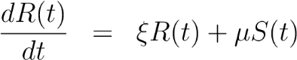
Resource Consumption: The rate of change of resource consumption with time, leading to a decrease in the total available resources R(t) over time. This describes how the resource coastal decreases over time due to consumption.
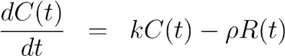
Environmental Impact: The rate of environmental impact. This is influenced by both resource consumption and mitigation efforts. This describes how environmental impact grows with resource consumption but is mitigated by efforts to reduce damage.
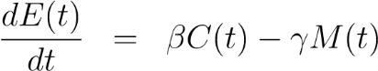
Mitigation Efforts: The rate of migration effort. It reduces environmental impact and depend on resources allocated to sustainability practices. This suggests that increased sustainability awareness (reflected in S (t)) can drive more mitigation, though resource consumption may limit these efforts.
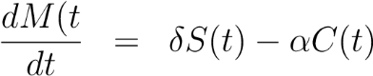
Sustainability Score: The rate of sustainability score. It reflects the balance between resource depletion, environmental impact, and mitigation. This balances the positive effects of available resources against the negative effects of environmental impact.
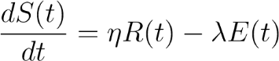
where ξ > 0 represents the rate at which resource availability increase, µ > 0 represents the rate at which sustainability score contributes to resource availability, k > 0 represents the rate at which resource consumption increase, ρ > 0 represents the rate at which resource availability reduces resource consumption, β > 0 represents the rate at which consumption contributes to environmental impact, γ > 0 represents the effectiveness of mitigation efforts in reducing environmental impact, δ > 0 represents the relationship between the sustainability score and the rate of increase in mitigation efforts, α > 0 represents the depletion of resources allocated to mitigation due to consumption, η > 0 represents how the availability of resources positively impacts sustainability, λ > 0 represents how environmental impact negatively affects sustainability. The parameters were assumed based on the simulated and real world assumptions. These values were further refined through sensitivity analysis to ensure robustness under different tourism scenarios.

Simulation
This system of differential equations are used to simulate various scenarios in coastal resort development. Developers can predict the long-term sustainability outcomes and adjust their strategies to improve environmental stewardship by solving these equations under different initial conditions and parameter values. Numerical methods, such as Euler’s and Runge-Kutta methods are employed to find approximate solutions.
Optimization: Optimizing the differential equation model for environmental sustainability in coastal resort development involves finding the best set of control variables (e.g., resource consumption, mitigation efforts) that maximize or minimize an objective function, subject to the constraints defined by the differential equations.
The objective function J is a measure of sustainability that is to be maximized.
Given
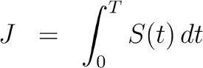
where: S(t) is the sustainability score at time t, T is the time horizon over which you are optimizing. This objective function represents the cumulative sustainability over a period T.
Identified control variables are the aspects you can influence to optimize the objective function. In this context, these might include: C(t): Resource consumption rate. M(t): Mitigation effort rate.
Formulate the Constraints: The constraints come from the differential equations that describe the system. Set up the optimal control problem. The problem is to find the functions C(t) and M(t) that maximize the objective function J subject to the constraints given by the differential equations.
This is a classic optimal control problem, which can be formulated as:
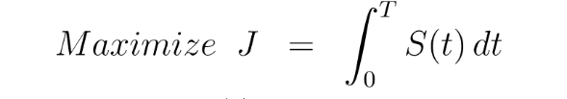
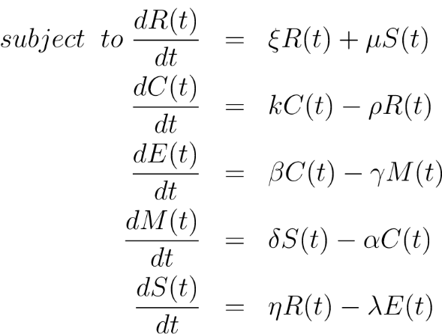
Apply Pontryagin’s Maximum Principle Pontryagin’s Maximum Principle is a method used in optimal control theory to solve problems like this one (Pontryagin et al., 1962; Sydsaeter & Hammond, 2008; Clark, 1990). It involves the following steps:
- Hamiltonian Function: Define the Hamiltonian H as follows:
H = S(t) + λ1 (ξR(t) + µS(t)) − λ2 (kC(t) − ρR(t)) + λ3 (βC(t) − γM(t))
+ λ4 (δS(t) − αC(t)) + λ5 (ηR(t) − λE(t))
where λ1(t), λ2(t), λ3(t), λ4(t) are the adjoint variables (also called costate variables).
- Adjoint Equations: Derive the adjoint equations by differentiating the Hamiltonian with respect to the state variables R(t),E(t),M(t),S(t)
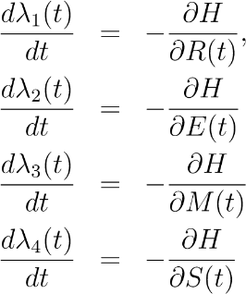,
- Optimal Control Law: The optimal control C(t) and M(t) must maximize the Hamiltonian. This is done by setting the partial derivatives of the Hamiltonian with respect to the control variables equal to zero:
For C(t):
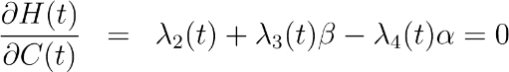
Therefore, the optimal control for C(t) is:
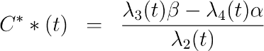
For M(t):
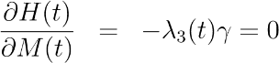
λ2(t)γ = 0 implies that M(t) does not contribute to the Hamiltonian unless λ3(t) or γ is zero, the optimal M∗∗ (t) is typically determined by boundary conditions or by setting M(t) at its feasible bounds (e.g., M(t) = Mmax).
(4) Control Law Interpretation: The optimal control law for C(t) and M(t) is governed by the adjoint variables and the system dynamics. For C(t) :
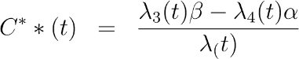
This implies that the optimal consumption rate C(t) balances the marginal benefits of resource consumption (via λ2(t) and its associated costs (via λ2(t) and λ4(t) .
For M(t) , since 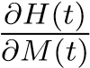 is independent of M(t), its optimal value M∗∗ (t) depends on other system constraints or additional terms not included in the Hamiltonian.
(5) Boundary Conditions: Finally, solve the system of differential equations (including the state and adjoint equations) with appropriate boundary conditions, which typically include initial conditions for state variables and transversality conditions for the adjoint variables. Solutions to the adjoint equations are
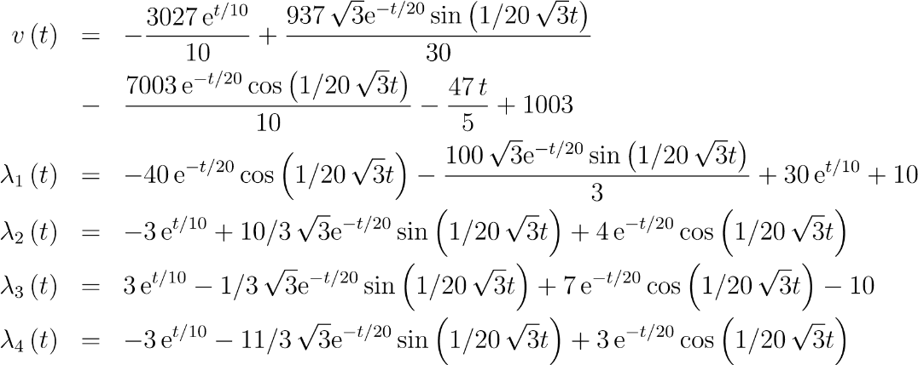
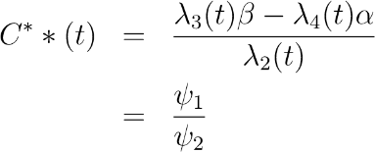
where
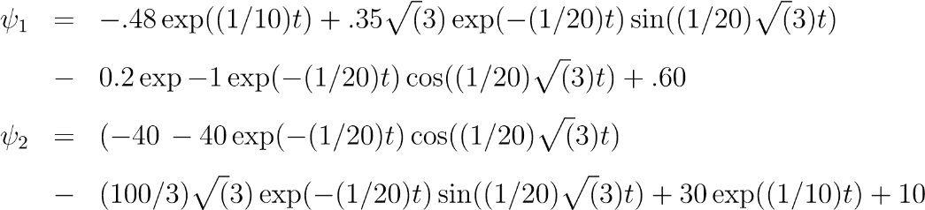
Boundary Conditions: Boundary Conditions used areλ2(0) = 1,λ3(0) =0,λ4(0) = 0,λ(0) = 0
Boundary Conditions: Boundary Conditions used are R(0) = 1,E(0) =0,M(0) = 0,C(0) = 0S(0) =0
Solutions to the state equations are;
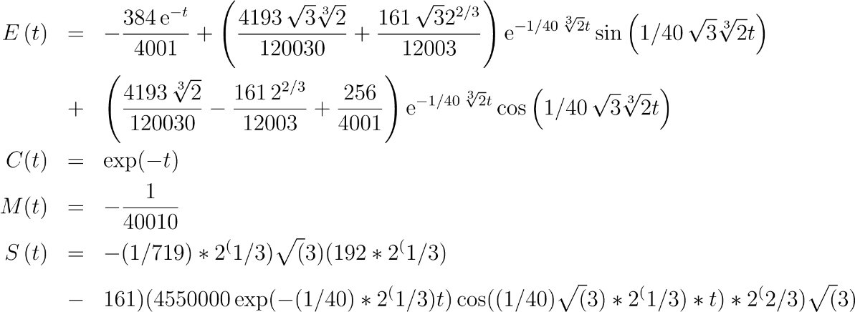
Maximizing the objective function, we have
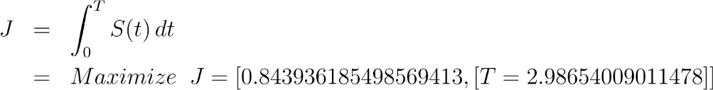
The Optimal Control Theory method is the optimization approach used for this type of dynamic system. It involves defining an objective function, modeling the system with differential equations, deriving the Hamiltonian, and solving for the optimal control laws that achieve the desired outcome. This approach is particularly powerful in applications like environmental sustainability in coastal resort development, where dynamic interactions between resources, environmental impact, and mitigation efforts need to be carefully balanced over time. Resource availability directly influences the sustainability of a coastal resort. Sustainable development requires careful management of natural resources, including water, energy, and land.
Overexploitation of these resources can lead to environmental degradation, making it challenging to maintain the natural beauty and ecological health that attract tourists in the first place. Maximizing Sustainability initiatives, which include the use of renewable energy, water recycling, and minimizing waste, all of which are essential for maintaining the long-term viability of the resort.

Minimizing Impact Factor on Resources
The optimization process of minimizing the impact on resources and maximizing environmental sustainability in coastal resort development involves modifying the objective function and control strategies to reduce resource consumption, environmental impact, or other undesirable outcomes.
Step-by-Step Process for Minimization
Objective Function for Minimization The objective function J should now represent something you want to minimize. For instance, you might want to minimize the total environmental impact over time E(t) or the resource consumption C(t):
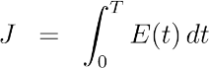
or
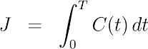
where T represents the time horizon over the performance of the optimization.
Set Up the Hamiltonian To apply Pontryagins Minimum Principle (which is analogous to the Maximum Principle for minimization),Pontryagin, L. S., et al. (1962), define the Hamiltonian H for the system:
H = E(t) + λ1 (ξR(t) + µS(t)) − λ2 (kC(t) − ρR(t))
+ λ3 (βC(t) − γM(t)) + λ4 (δS(t) − αC(t)) + λ5 (ηR(t) − λE(t))
Here, λ1(t),λ2(t),λ3(t),λ4(t) are the adjoint (costate) variables, and E(t) is the environmental impact to be minimized.
The adjoint equations are derived by partially differentiating the Hamiltonian with respect to the state variables:
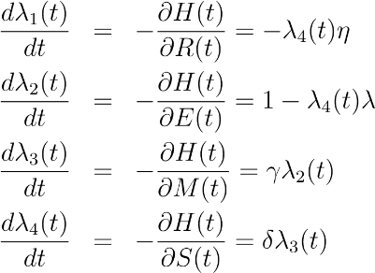
Optimality conditions to minimize the objective function J, determine the control variables C(t) and M(t) that minimize the Hamiltonian H(t). This is done by partially differentiating the Hamiltonian with respect to C(t) and M(t) and setting them equal to zero, Sydsaeter, K., & Hammond, P. (2008), Clark, C. W. (1990): For C(t)
:
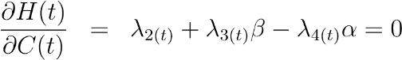
The optimal control for C (t) is:
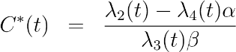
For M (t)
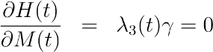
The optimal M (t) may be set to minimize E(t), possibly at the maximum feasible mitigation level Mmax.
Minimization Control Law The control law for minimization, given by the Hamiltonian, is:
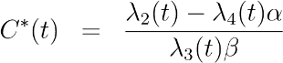
This equation balances resource consumption against the negative effects on the environment. To achieve minimization: C∗(t) should be chosen to minimize resource consumption while still meeting necessary constraints. M∗(t) should be maximized to the extent possible, given available resources, to minimize environmental impact.
Solve the System: To find the optimal control laws C∗(t) and M∗(t) , you need to solve the coupled differential equations system, which includes both the state and adjoint equations. This can be done numerically using methods such as Euler’s method, Runge-Kutta methods, shooting method, Forward-backward sweep methods.
Apply Boundary and Initial Conditions: Finally, apply the boundary and initial conditions to ensure the solution is physically and economically meaningful. For example: Initial conditions for R(0),E(0),M(0)andS(0) . Transversality conditions for the adjoint variables at the final time T.
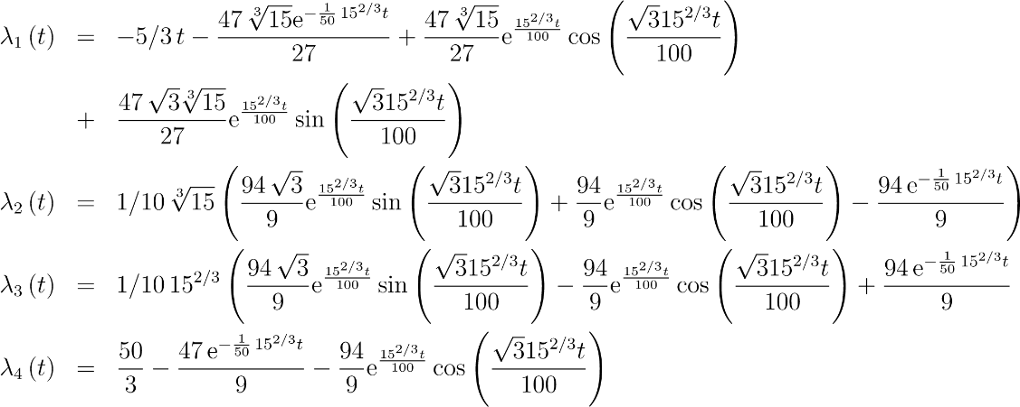!
Boundary Conditions: Boundary Conditions used areλ1(0) = 0,λ2(0) =0,λ3(0) = 0,λ4(0) = 1
Minimizing the resource consumption C(t), we have
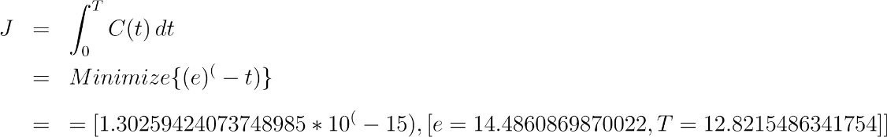

3. results and discussion

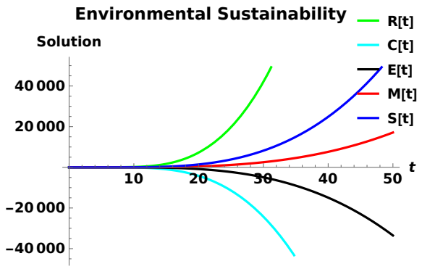
Fig. 1. The plot of effect of environmental factors on environmental Sustainability
The plot of effect of environmental factors on environmental Sustainability
Figure 1 presents the simulated outcomes of the mathematical model, illustrating the dynamic interactions between key environmental factors and sustainability over time. The variables 𝑅(𝑡), 𝐶(𝑡), 𝐸(𝑡), 𝑀(𝑡), and 𝑆(𝑡) represent different environmental components influencing sustainability, with their behaviours determined by the model’s assumptions and parameterized equations. The green curve 𝑅(𝑡) exhibits an increasing trend, suggesting that under the given model conditions, resource availability or regeneration improves over time. In contrast, the light blue curve 𝐶(𝑡) declines steeply, indicating that consumption or environmental degradation accelerates as modeled. The black curve 𝐸(𝑡) initially remains stable but then declines significantly, representing a simulated environmental factor that reaches a tipping point due to cumulative pressures. The red 𝑀(𝑡) and blue 𝑆(𝑡) curves display growth trends, reflecting possible mitigation strategies or sustainability measures incorporated into the model’s framework.
These simulation results highlight the nonlinear and dynamic nature of environmental sustainability, demonstrating how different factors interact over time based on assumed relationships. While these findings are not derived from real-world data, they provide valuable insights into potential trends and scenarios, reinforcing the need for strategic interventions. Further refinements, including sensitivity analysis and scenario testing, could enhance the model’s applicability for policy recommendations in sustainable development planning.

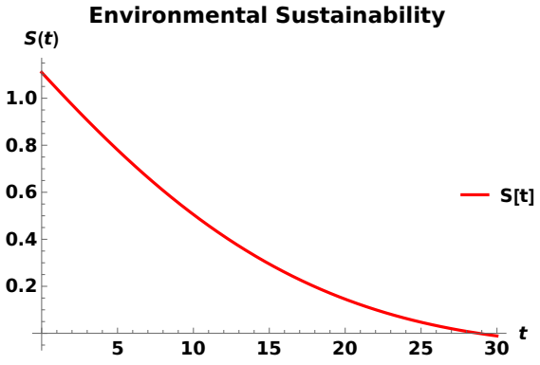
Fig. 2. The plot of maximization of environmental Sustainability
The plot presents the simulated trajectory of environmental sustainability 𝑆(𝑡) over time demonstrating a continuous decline
The downward trend in Figure 2 suggests that, under the given model conditions, sustainability diminishes progressively as time increases, due to uncontrolled resource exploitation, environmental degradation, or ineffective mitigation strategies. The exponential decay pattern indicates that without strategic interventions, sustainability deteriorates at an accelerating rate, reinforcing the importance of early and effective policy measures. This aligns with the study’s objective of optimizing environmental sustainability by integrating mathematical modeling to assess the long-term effects of tourism, resource consumption, and ecological conservation efforts. Given the model-driven nature of this simulation, further sensitivity analysis and parameter adjustments could explore potential scenarios where sustainability could be maximized. This could include implementing regulatory measures, improving resource efficiency, or enhancing environmental restoration efforts to counteract the observed decline.
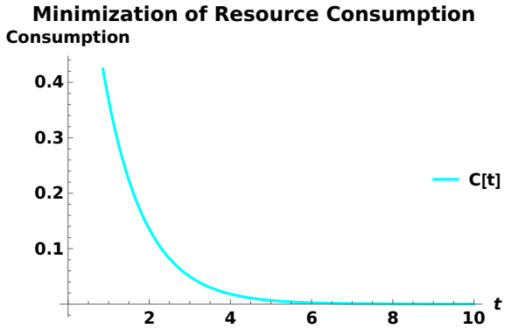
Fig. 3. Minimization of Resource Consumption
This plot illustrates the minimization of resource consumption 𝐶(𝑡) over time, depicting a rapid decline that stabilizes at a lower threshold.
Figure 3 shows that this trend indicates that by implementing an optimal control strategy, resource consumption can be significantly reduced, ultimately contributing to sustainability in coastal resort development. In the context of the differential equation model, resource consumption minimization is achieved by defining an objective function that reflects the desired reduction in environmental impact. Using Pontryagin’s Minimum Principle, the optimal control laws 𝐶∗(𝑡) and 𝑀∗(𝑡) are derived to ensure that resource consumption is minimized while satisfying system constraints. This involves solving a set of coupled differential and adjoint equations with appropriate boundary conditions.
Applying this optimization framework to coastal resort development is crucial for balancing economic growth, environmental preservation, and resource efficiency. By integrating mathematical modeling, stakeholders can make data-driven decisions that align with long-term sustainability goals. The ability to regulate resource consumption through optimization ensures that coastal resorts remain economically viable while minimizing adverse environmental effects. Moreover, this approach enhances resilience to future challenges such as climate change, regulatory constraints, and ecosystem degradation.
The simulation results depicted in Figures 1 to 3 highlight the dynamic interactions between resource availability, environmental impact, regulations, and sustainability in coastal resort development. Figure 1 illustrates how environmental sustainability is influenced by multiple factors, including resource availability 𝑅(𝑡), consumption 𝐶(𝑡), environmental impact 𝐸(𝑡), mitigation efforts 𝑀(𝑡), and sustainability 𝑆(𝑡). The divergent trajectories emphasize that without proper intervention, excessive resource exploitation and environmental degradation can significantly reduce sustainability over time. Conversely, proactive mitigation and regulatory measures can enhance sustainability by balancing resource use and environmental conservation.

Figure 2 demonstrates that sustainability 𝑆(𝑡) declines over time in the absence of intervention. This reinforces the importance of regulatory policies and mitigation strategies in maintaining long-term environmental stability. Without these measures, sustainability continues to decrease, leading to ecological degradation and economic risks for coastal developments. Figure 3 highlights the effectiveness of resource consumption minimization 𝐶(𝑡) through optimized control mechanisms. Implementing sustainable development strategies, resource consumption is reduced significantly over time, leading to lower operational costs and improved environmental outcomes. This aligns with the principles of regulatory compliance and sustainable tourism, where responsible resource management enhances economic viability and market appeal.
Thus, these results underscore the interdependence of sustainability, resource consumption, and regulatory oversight. Stricter environmental regulations encourage sustainable practices, which, although increasing initial costs, reduce long-term liabilities and improve economic resilience. Excessive resource exploitation can lead to severe environmental consequences, stricter regulations, and higher mitigation costs, potentially threatening project viability. A balanced approach integrating sustainability, resource efficiency, and regulatory compliance is essential for achieving a development model that is both environmentally responsible and economically sustainable.

4. Conclusion

This study highlights the importance of optimizing differential equation models to achieve environmental sustainability in coastal resort development. Balancing economic growth, environmental protection, and social well-being, our mathematical approach determines optimal investments in mitigation strategies and resource management. The results reveal the complex interactions between environmental regulations, resource availability, sustainability, and economic viability, emphasizing the need for a strategic approach to coastal development. Sustainable resort development requires a well-calibrated balance between regulatory enforcement and proactive mitigation. While unregulated resource exploitation accelerates environmental degradation and increases regulatory risks, sustainable practices help lower operational costs, improve compliance, and attract environmentally conscious tourists, ultimately enhancing long-term profitability. Integrating sustainability principles into planning and decision-making is essential for ensuring the resilience and viability of coastal resorts.
To support sustainable coastal resort development, the following following policy recommendations are proposed. Governments should implement and enforce stringent environmental policies that promote responsible resource use and mitigate ecological impacts. These regulations must remain adaptable to evolving environmental challenges. Financial incentives such as tax breaks, subsidies, and grants should encourage developers to adopt eco-friendly materials, renewable energy sources, and water conservation technologies. Developers should prioritize green infrastructure, energy-efficient systems, and waste reduction strategies to minimize environmental footprints while maximizing economic returns. Coastal resort development requires active collaboration between government agencies, private investors, local communities, and environmental organizations. Multi-stakeholder engagement enhances transparency, regulatory compliance, and long-term sustainability. Policymakers should integrate data analytics, environmental impact assessments, and real-time monitoring systems to assess resource consumption, biodiversity health, and climate resilience. This will enable adaptive management strategies to respond effectively to changing environmental conditions.
Implementing these policy measures, coastal resort development can transition toward a more sustainable and resilient future. This study reinforces the need for a holistic approach that aligns environmental conservation with economic sustainability, ensuring that coastal regions remain ecologically vibrant and economically viable for future generations. Further research should focus on real-world applications of optimization models and evaluate the long-term effectiveness of sustainability policies in coastal tourism.

References

Ahmad, M. F., Mat Isa, N. A., Lim, W. H., & Ang, K. M. (2022). Differential evolution: A recent review based on state-of-the-art works. Alexandria Engineering Journal, 61(5), 3831-3872. https://doi.org/10.1016/j.aej.2021.09.045
Andrew, D. (2024). Sustainability practices in eco-friendly resorts. Journal of Modern Hospitality, 3(1), 27–39. https://doi.org/10.47941/jmh.1952.
Anjaria, K. (2024). Enhancing sustainability integration in Sustainable Enterprise Resource Planning (S-ERP) system: Application of Transaction Cost Theory and case study analysis. International Journal of Information Management Data Insights, 4(2), 100243. https://doi.org/10.1016/j.jjimei.2024.100243.
Baloch, Q. B., Shah, S. N., Iqbal, N., Sheeraz, M., Asadullah, M., Mahar, S., Khan, A. U. (2024). Impact of tourism development upon environmental sustainability: A suggested framework for sustainable ecotourism. Environmental Science and Pollution Research, 30(3), 5917–5930. https://doi.org/10.1007/s11356-022-22496-w
Clark, C. W. (1990). Mathematical bioeconomics: The optimal management of renewable resources. Wiley-Interscience.
Dong, W. S., Ismailluddin, A., Yun, L. S., Ariffin, E. H., Saengsupavanich, C., Abdul Maulud, K. N., Ramli, M. Z., Miskon, M. F., Jeofry, M. H., Mohamed, J., Mohd, F. A., Hamzah, S. B., & Yunus, K. (2024). The impact of climate change on coastal erosion in Southeast Asia and the compelling need to establish robust adaptation strategies. Heliyon, 10(4), e25609. https://doi.org/10.1016/j.heliyon.2024.e25609.
Gupta, R., Mondal, M. E. A., Janardhan, M., Kumawat, H., & Shekhar, C. (2024). Sustainable tourism development: Balancing economic growth and environmental conservation. Migration Letters, 21(S7), 1240–1253. https://www.migrationletters.com.
Guzzo, D., Pigosso, D. C. A., Videira, N., & Mascarenhas, J. (2022). A system dynamics-based framework for examining circular economy transitions. Journal of Cleaner Production, 333, 129933. https://doi.org/10.1016/j.jclepro.2021.129933
Johansyah, M. D., Rusyaman, E., Foster, B., Muslihin, K. R. A., & Supriatna, A. K. (2024). Combining Differential Equations with Stochastic for Economic Growth Models in Indonesia: A Comprehensive Literature Review. Mathematics, 12(20), 3219. https://doi.org/10.3390/math12203219
Kumar, P., Das, B., Majik, S., & Bhattacharjee, S. (2024). Coastal ecosystem services: Valuation, threats, and sustainable way forward. Journal of Agricultural Physics, 24(2nd JAP Special Issue), S123–S134. Available at http://www.agrophysics.in
Lodh, D. (2024). Sustainable waste management practices and their profound impact on environmental conservation. Futuristic Trends in Agriculture Engineering & Food Sciences, IIP Series, 7–18. https://doi.org/10.58532/V3BCAG1P1CF2.
Metilelu, O. O., Babalola, O. A., Adeniyi, M. O., Ekum, M. I., Omoko, I. D., & Olasokan, O. O. (2025). The interplay between uncontrolled industrialization, ecotourism, and fishery resources in Nigerian coastal areas: An eco-dynamic modelling approach. Journal of Applied and Advanced Tourism and Hospitality (JAAUTH), 28(2), 57–84. Retrieved from https://jaauth.journals.ekb.eg
Metilelu, O. O., Odewumi, S. O., Ogunjemite, G. B., Oladeji, O. S., Olaniyi, E. O., Adeniyi, O. M., & Ekum, I. M. (2024). Tourists’ patronage and tourism operators’ compliance on environmental policies in coastal areas of Lagos State, Nigeria. Journal of Archaeology and Tourism Research, 4(1 & 2), 110–135.
Osuji, J. N., & Agbakwuru, J. (2024). Ocean and coastal resources components and their contributions to sustainable development of Nigeria. Journal of Applied Sciences and Environmental Management, 28(1), 135–146. Available at https://www.ajol.info/index.php/jasem and https://www.bioline.org.br/ja
Pontryagin, L. S., Boltyanskii, V. G., Gamkrelidze, R. V., & Mishchenko, E. F. (1962). The mathematical theory of optimal processes. Interscience.
Ramírez-Márquez, C., Posadas-Paredes, T., Raya-Tapia, A. Y., & Ponce-Ortega, J. M. (2024). Natural resource optimization and sustainability in Society 5.0: A comprehensive review. Resources, 13(2), 1–19. https://doi.org/10.3390/resources13020019
Sydsaeter, K., & Hammond, P. (2008). Optimal control theory with economic applications. Oxford University Press.
United Nations Environment Programme (UNEP). (2023). Tourism in the green economy: Background report. UNEP.
Ward, D., Melbourne-Thomas, J., Pecl, G., & Evans, K. (2024). Safeguarding marine life: Conservation of biodiversity and ecosystems. Reviews in Fish Biology and Fisheries, 32(Suppl 4). https://doi.org/10.1007/s11160-022-09700-3.
Zhang, Y., & Deng, B. (2024). Exploring the nexus of smart technologies and sustainable ecotourism: A systematic review. Heliyon, 10(11), e19969. https://doi.org/10.1016/j.heliyon.2024.e19969.

