Analysis of Flow and Thermal Characteristics in a Closed Domain Containing Heat Source-Sink Saturated with *Zn*-water Nanofluids

**Abstract:**

In this work, a closed geometric space filled with *Zn*-water nanofluid is used to analyze the thermal characteristics of the flow caused by the presence of a heat source and a heat sink. It is discussed how the zinc particle-rich nanofluid improves heat transfer efficiency. The study assesses how altering the density of nanoparticles, the number of Rayleigh, and the positions of the heat source and sink affects the temperature distribution and flow pattern. The effects of the geometric parameter volume percentage of nanoparticles in the range 0.01 ≤ φ ≤ 0.1 and the natural convection parameter Rayleigh number changed as 104 ≤ Ra ≤107 on the flow and thermal field as well as the rate of heat transfer were analyzed. Obtained results for flow and temperature field are exposed by the streamlines and isotherms. For better understanding of flow visualization and temperature behaviour velocity profiles, temperature profiles and temperature gradient magnitude profiles are also disclosed. The primary findings of the current study are displayed both tabularly and graphically. The findings demonstrate that *Zn*-water nanofluid greatly enhances heat transmission and is a viable option for thermal control. Advanced thermal management systems, electronic cooling, and other technical applications can be benefited greatly from this kind of study.

**Keyword:** Nanofluids, Rayleigh number, heat sink, heat source, nanoparticle volume fraction, Zn–water.

**Introduction:**

In many engineering applications, such as thermal insulation, electronic cooling, energy systems, and chemical processing, the study of heat transfer and fluid flow in enclosed systems is essential. The use of nanofluids, which are fluids created by distributing nanosized particles into a base fluid, has become a viable tactic to improve thermal performance in recent years. Zinc (Zn)-water nanofluids have demonstrated promise among the many kinds of nanofluids because of their advantageous thermal conductivity, stability, and affordability. The thermal behaviour and flow structure of a closed cavity are further complicated by the existence of interior heat sources and sinks. Heat sinks can mimic cooling processes or areas of energy absorption, whereas heat sources might symbolise energy-generating components like electrical chips. Designing effective thermal management systems requires an understanding of how these components interact with nanofluids in a limited space.  
  
In this thesis, the flow and thermal properties of a two-dimensional closed domain with a heat source and a heat sink filled with Zn-water nanofluids are examined. The analysis focusses on the effects of important factors on temperature distribution, flow patterns, and overall heat transfer performance, including the cavity's aspect ratio, heat source-sink location, Rayleigh number, and nanoparticle volume percent.

By concentrating on the analysis of flow and thermal properties inside a closed domain saturated with Zn-water nanofluids and including a heat source-sink, this thesis seeks to add to the expanding corpus of knowledge on nanofluid heat transfer. This work will use numerical simulations to examine how important characteristics, like the shape of the closed domain, the concentration of nanoparticles, and the strength of the heat source and sink, affect the ensuing fluid flow and heat transfer processes. It is anticipated that the results of this study will contribute to the development of more effective and compact thermal management technologies by offering important insights into the potential of Zn-water nanofluids for improving thermal performance in confined systems with localised thermal energy exchange.

Natural convection in enclosures has been the subject of much research due to its applications in electronic devices, cooling systems, and thermal management in a variety of industries. This article examines previous research on heat transport in cavities with different heating and cooling configurations, emphasising the effects of nanofluids, discrete heat sources, and thermal boundary conditions.

Melting and natural convection in PCM-filled cavities with bilateral and vertical flow boundary conditions were investigated numerically by Qin et al. [1] and Li et al. [2]. They saw how spontaneous convection cells and heat layers formed during the melting phase, which had a significant impact on melting speeds. This was extended to lauric acid PCMs in thin rectangular cavities by Qi et al. [4], who discovered that convective patterns during melting are greatly influenced by cavity shape.  
  
In their evaluation of the effects of heat source location on the melting process in nano-enhanced PCM systems, Bouzennada et al. [9] demonstrated that ideal placement may significantly improve melting uniformity and pace. To enhance heat transmission in differentially heated cavities, Thiers et al. [3] added local time-varying disturbances. Their findings demonstrated that secondary flows that enhance heat transmission might be induced by dynamic boundary conditions. Using nanofluids, Sheremet et al. [11] and Wang et al. [12] investigated the effects of sinusoidal and time-periodic boundary conditions. Their simulations highlighted how flow mixing and convective augmentation are facilitated by periodic heating. Natural convection in inclined enclosures was examined by Li and Tong [5], Elsherbiny and Ismail [7], and Sheremet et al. [11]. They discovered that the cavity tilt angle dramatically changes the intensity and symmetry of the flow. In their investigations of vertical and bottom-heated cavities, Calcagni et al. [17] and Dalal & Das [18] found that bottom heating promotes the stratification and growth of plume-like formations. Complex vortex formations resulting from discrete heating were highlighted by Sezai and Mohamad [19], who provided more information on localised heat sources at the cavity's bottom. In their investigations of nanofluid flow in lid-driven and differentially heated enclosures, Mansour and Ahmed [13] and Tiwari & Das [14] showed that nanoparticle suspension increased heat transmission.  
The thermophysical characteristics of hybrid nanofluids (such as CuO-ZnO and AlN-ZnO) were the focus of Malika & Sonawane [15], Çiftçi [16], and Kalsi et al. [20]. They demonstrated improved thermal conductivity and stability with ideal mixing ratios.  
Henein & Abdel-Rehim [22], Ali & Salam [23], and Porgar et al. [21] all offered thorough analyses of the performance, application, and manufacture of different nanofluids in thermal systems, such as heat pipes and solar collectors. Heat transport in magnetically stimulated cavities was investigated experimentally and numerically by Giwa et al. [6] and [8]. They found that using magnetic fields significantly improved thermal performance.  
  
In their study of ferromagnetic nanofluid flow across a dimpled cavity, Song et al. [24] discovered intricate relationships between cavity shape and magnetic forces that improved localised heat transmission. Rotating microchannels and three-dimensional flows incorporating hybrid nanofluids were studied by Mahmoodi et al. [25] and Acharya & Das [26] under conditions such as heat radiation and activation energy. These simulations show how nanofluids are being used in high-efficiency or miniature systems in the future.

The goal of the present work is to investigate the flow and thermal characteristics in a *U*-shaped cavity filled with water based *Zn* nanofluid having heat source-sink at bottom wall. From the researches cited above it is apparent that this study is unique based on specific nanoparticle, domain configuration along with boundary conditions.

**Formulation of the Problem:**

A *U*-shaped device filled with *Al2O3*-water nanofluid and having the same height and width as unity is shown in Figure 1. Both the "*X*" and "*Y*" axes are visible, indicating a two-dimensional representation labeled "Heat Source" and "Heat Sink," the figure shows that thermal energy transmission is present "Adiabatic wall" labels are also present, suggesting borders where no heat transmission takes place. The usage of the symbols "*Tc*" and "*Th*" for temperature indicators most likely denotes "Cold Temperature" and "Hot Temperature," respectively. These are displayed at various points in the figure. The presence of numerical numbers such as "0.2" and "0.6" may indicate distances or spatial dimensions inside the system. Variable "*h*", This variable, which typically stands for height. Variable "*w*", This variable, which typically stands for breadth. All solid boundaries are configured as hard, non-slip walls, indicating that velocity components *u* and *v* are zero. The Boussinesq approximation follows the density fluctuation of the nanofluid and other thermo-physical parameters. Table 1 lists the characteristics of base fluid and nanoparticle.

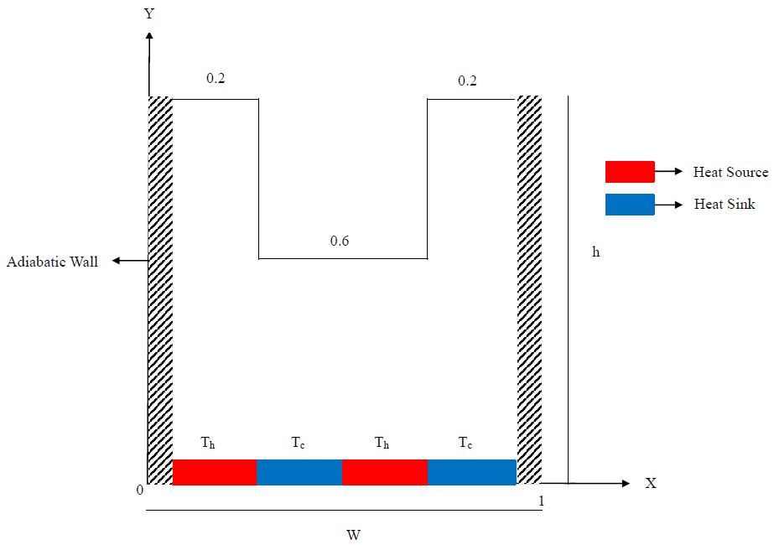

Figure 1: The studied geometry

The dimensionless version of the leading equations for steady state mixed convection flow is as follows:

$\frac{∂U}{∂X}+\frac{∂V}{∂Y}=0$ (1)

$U \frac{∂U}{∂X}+V\frac{∂U}{∂Y}=- \frac{∂P}{∂X}+\operatorname{Pr}\left(\frac{ρ_{f}}{ρ_{nf}}\right)\left(\frac{μ_{nf}}{μ_{f}}\right)\left(\frac{∂^{2}U}{∂X^{2}}+\frac{∂^{2}U}{∂Y^{2}}\right)$ (2)

$U \frac{∂V}{∂X}+V\frac{∂V}{∂Y}=- \frac{∂P}{∂Y}+\operatorname{Pr}\left(\frac{ρ_{f}}{ρ_{nf}}\right)\left(\frac{μ_{nf}}{μ_{f}}\right)\left(\frac{∂^{2}V}{∂X^{2}}+\frac{∂^{2}V}{∂Y^{2}}\right)+\left(\frac{{\left(ρβ\right)}_{nf}}{ρ_{nf}β_{f}}\right)RaPrθ$ (3)

$U \frac{∂θ}{∂X}+V\frac{∂θ}{∂Y}=\frac{α_{nf}}{α_{f}}\left(\frac{∂^{2}θ}{∂X^{2}}+\frac{∂^{2}θ}{∂Y^{2}}\right)$ (4)

Where $Pr=\frac{ϑ_{f}}{α_{f}}$, $Ra=\frac{gβ_{f}H^{3}\left(T_{h}-T_{c}\right)}{ϑ_{f}α_{f}}$, are the Prandtl number, and Rayleigh number respectively.

The equation (1) to (4) are made dimensionless by using the following relations

$X=\frac{x}{H}, Y=\frac{y}{H}, U=\frac{uH}{α_{f}}, V=\frac{vH}{α_{f}}, θ=\frac{T-T_{c}}{T_{h}-T_{c}} , P=\frac{pH^{2}}{ρ_{nf}α_{f}^{2}}$ (5)

Average Nusselt number at the heated wall of the enclosure is expressed as ${ Nu}_{av}=\frac{-k_{nf}}{k_{f}}(\int_{0}^{0.25}{\frac{∂θ}{∂X}dY+\int_{0.5}^{0.75}{\frac{∂θ}{∂X}dY)(.\frac{1}{0.25})}}$.

The imposed boundary conditions are given below:

On the cold rib of the cavity: $U=V=0,θ=0$

On the lower surface of the cavity: $U=V=0,θ=1$ (source), and $θ=0$ (sink)

On the two vertical wall and top portions of the cavity: $U=V=0,\frac{∂θ}{∂N}=0$

Table 1. Water and zinc's thermophysical characteristics at 20°C.

| Property | Water (20°C) | Zinc (20°C) |
| --- | --- | --- |
| Density | 998.2 kg/m³ | 7140 kg/m³ |
| Specific Heat Capacity (cp) | 4182 J/kg·K | 388 J/kg·K |
| Thermal Conductivity | 0.598 W/m·K | 116 W/m·K |
| Dynamic Viscosity | 1.002 × 10⁻³ Pa·s | – (not applicable for solid zinc) |
| Thermal Expansion Coefficient | ~207 × 10⁻⁶ 1/K | 30.2 × 10⁻⁶ 1/K |
| Boiling Point | 100 °C | 907 °C |
| Melting Point | 0 °C | 419.5 °C |
| Latent Heat of Fusion | 334 kJ/kg | 112 kJ/kg |
| Latent Heat of Vaporization | 2260 kJ/kg | ~1150 kJ/kg |
| Electrical Conductivity | ~5.5 μS/cm | ~16.6 × 10⁶ S/m |

Table 2. An applied model of some features of nanofluids

|  |  |
| --- | --- |
| Nanofluid properties | Applied model |
| Density | $$ρ_{nf}=\left(1-φ\right)ρ_{f}+φρ_{p}$$ |
| Specific heat | $${(ρC_{p})}_{nf}=\left(1-φ\right){(ρC_{p})}_{f}+φ{(ρC_{p})}_{p}$$ |
| Thermal diffusivity | $$α_{nf}=k_{nf}/{\left(ρC_{p}\right)}_{nf}$$ |
| Thermal expansion coefficient | $${(ρβ)}_{nf}=\left(1-φ\right){(ρβ)}_{f}+φ{(ρβ)}_{p}$$ |
| Dynamic viscosity based on Brinkman model | $$μ_{nf}=\frac{μ_{f}}{{\left(1-φ\right)}^{2.5}}$$ |
| Thermal conductivity, according to the Maxwell model | $$k_{nf}=k_{f}\frac{(k_{p}+2k_{f})-2φ(k_{f}-k_{p})}{(k_{p}+2k_{f})+φ(k_{f}-k_{p})}$$ |

**Method of Computation:**

The Galerkin weighted residual based finite element method is used to numerically solve the governing equations for the situation under investigation. This method first defines the problem as a two-dimensional cavity and then discretises the continuum domain into finite element meshes composed of non-uniform triangular elements. The Galerkin approach is used to convert the governing partial differential equations into a collection of integral equations. After boundary conditions are applied, these nonlinear algebraic equations are converted into linear algebraic equations using the Newton-Raphson iteration technique. The triangular factorisation method is then utilised to solve these equations.

**Grid Test:**

The results of what looks to be a "Grid Test," which probably assessed the effect of raising the "Number of elements" on a value represented by "*Nuav*" and its "Deviation," are shown in this table. The contents of the table are broken down as follows:  
Number of elements: The number of items utilised in each test is listed in this column. The numbers, which indicate a gradual growth, are 1440, 2108, 3295, 8493, 21966, and 28702.  
Nu: This column shows a measured or computed value that may be associated with an experimental outcome or a numerical simulation. Generally speaking, the values for "*Nuav*" rise from 8.7059 to 12.789 as the "Number of elements" grows.  
Deviation: This column shows how "*Nuav*" deviates from a prior value or reference point. There is nothing in the first entry. With numbers like 0.3505, 0.5513, 1.7593, and 1.419, as well as a very little deviation of 0.003 for the greatest number of components, subsequent entries exhibit a divergence.

Table 3 : The effect of raising the "Number of elements" on a value represented by "*Nuav*" and its "Deviation”

|  |  |  |  |  |  |  |
| --- | --- | --- | --- | --- | --- | --- |
| Number of elements | 1440 | 2108 | 3295 | 8493 | 21966 | 28702 |
| *Nuav* | 8.7059 | 9.0564 | 9.6077 | 11.367 | 12.786 | 12.789 |
| Deviation |  | 0.3505 | 0.5513 | 1.7593 | 1.419 | 0.003 |

**Code Validation:**

The new study's code is established by revealing a connection to Zemani et al.'s earlier analysis [4]. As shown below, Figure 2 illustrates the relationship between these works with acceptable conformity in flow and thermal fields.

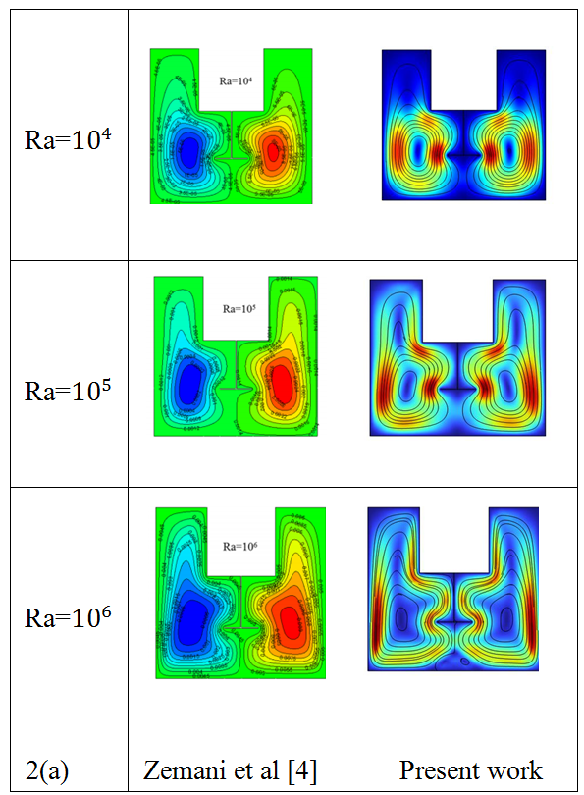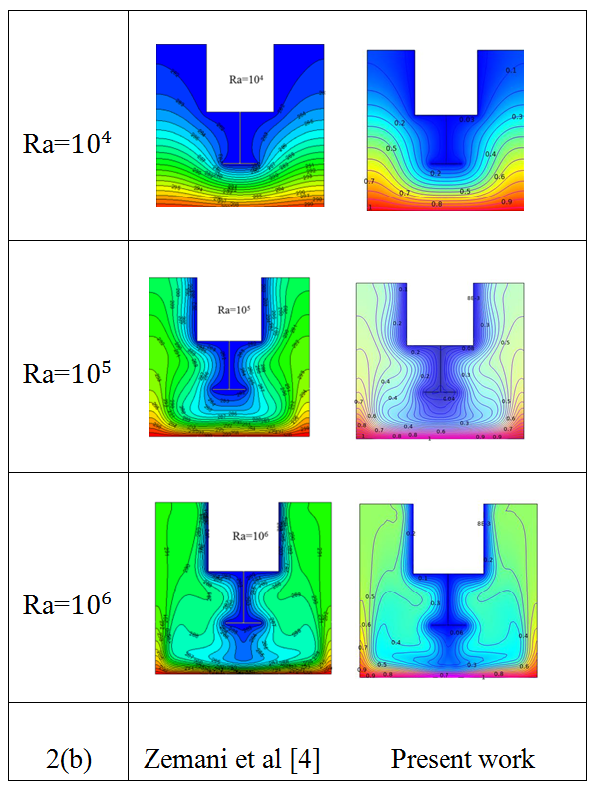

*Figure 2. Comparison of the streamlines and isotherms for Cuo-water nanofluid at φ = 0.05 and Pr = 7 changing Ra =10^4-10^6 between the work of Zemani et al. [4] and the present*

Results and Discussions:

In fluid dynamics and heat transfer, the Rayleigh number (Ra), a dimensionless measure, is used to predict when convection will start in a fluid layer. Essentially, it displays the ratio of buoyancy-driven flow to thermal and viscous diffusion in a fluid. The Rayleigh number is essential for determining whether heat transfer in a fluid occurs by convection or conduction. In addition to controlling whether convection occurs, its magnitude also dictates the nature of the flow, which can vary from fully turbulent regimes to stable, orderly patterns. Understanding and controlling the Rayleigh number is crucial for many thermal system designs and natural event research.

Effect of Rayleigh Number (*Ra*):

**Fig-3 Discussion:** Explain how the streamlines and isotherms are affected by the Rayleigh number. The isotherm lines approach the cold groove when the Rayleigh number, Ra=104, is determined, and the streamlines appear to be rather regular with minimal circulation. In Rayleigh numbers of Ra=105 and Ra=106, convection controls heat transport, resulting in stronger, more pronounced vortices. Heat transmission rises as buoyancy-driven motion takes over in a more dynamic flow. The isothermal lines climb away from the vertical wall, indicating significant variations in the isotherms as well. This behaviour is due to increased buoyant forces, which are associated with higher Rayleigh numbers. As the Rayleigh number rises, stronger fluid circulation results from greater buoyant forces.

Consequently, heat transmission is improved as the fluid more effectively moves heat from the hot surface to the cold surface. The cavity half that is closest to the heat source has a high temperature. Smaller Rayleigh numbers, such Ra=104, For increasing Rayleigh numbers, Ra=107, conductive heat transmission reduces as Ra increases. Stronger streamline circulation patterns and more complex isothermal distributions result from the takeover of convection.

|  |  |  |
| --- | --- | --- |
| Ra=104 |  |  |
| Ra=105 |  |  |
| Ra=106 |  |  |
| Ra=107 |  |  |
|  | Streamlines | Isothermas |

Figure-3: Streamlines and Isotherms for various Rayleigh number Ra

**Fig-4 Discussion:** (A), (B), and (C) show the effects of Ra = 104, Ra = 105, and Ra = 106 on the velocity profile. The arc length of the horizontal line runs from 0 to 1, and the velocity field y-component (m/s) of the vertical line extends from -3 to 5.5. The temperature profile is shown in (B), where the vertical line for Ra change varies from 0.12 to 0.42. on particular, example (C) shows the temperature gradient magnitude (k/m) of (0.25 to 1.1) on the vertical line, with the arc length (0 to 1) on the horizontal line and the fluctuation of Ra = 104, Ra = 105, and Ra = 106 on the vertical line.

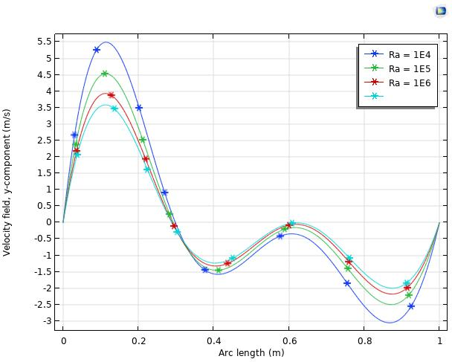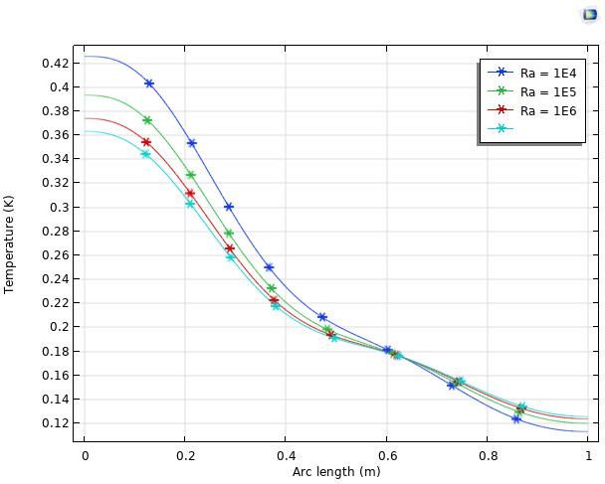

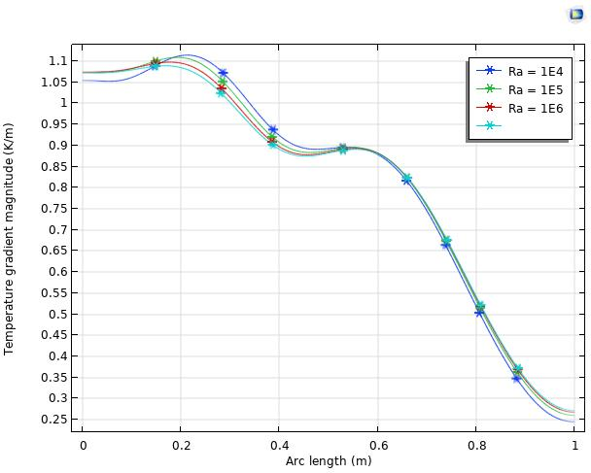

Figure – 4: The (A) velocity profile, (B) temperature profile and (C) temperature gradient profile for the variation of *Ra*

Table 4: Mean Nusselt number at heated wall for various Ra values when φ = 0.05 and Pr = 7

|  |  |  |  |  |
| --- | --- | --- | --- | --- |
| *Ra* | $${10}^{4}$$ | $${10}^{5}$$ | $${10}^{6}$$ | $${10}^{7}$$ |
| *Nuav* | 11.367 | 14.509 | 20.093 | 28.116 |

**Describe Table 4:** Keeping the volume fraction (ϕ) constant at 0.05 and the Prandtl number (Pr) at 7, the table displays the mean Nusselt number (𝑁𝑢𝑎𝑣) (Nu av) at the heated wall for various values of the Rayleigh number (Ra). The mean Nusselt number likewise rises noticeably as Ra does. This pattern suggests that greater natural convection currents cause convective heat transfer to improve with increasing Rayleigh numbers. With greater jumps in Nuav at higher Ra, the growth is nonlinear and reflects the growing predominance of convective heat transport over conduction.

**Effect of nanoparticle volume fraction (*φ*):**

**Fig-5 Discussion:** illustrates the effects of isotherms and streamlines. At φ = 0.1, the streamlines reach their peak intensity, exhibiting distinct vortex patterns, strong circulation, and isotherm lines that converge on the cold groove. The isotherms exhibit noticeable changes at φ = 0.05 and φ = 0.08, streamlines intensify, and nanoparticles enhance heat conductivity, which enhances circulation and heat transfer. The isothermal lines move and become more concentrated along the vertical wall, indicating increased heat convection. This suggests that flow powered by buoyancy has a greater effect, increasing the system's heat transfer

|  |  |  |
| --- | --- | --- |
| φ=0.01 |  |  |
| φ=0.05 |  |  |
| φ=0.08 |  |  |
| φ=0.1 |  |  |
|  | **Streamlines** | **Isothermas** |

Figure 5: Streamlines and Isotherms with varying nanoparticle volume percent values of φ

This phenomenon is caused by the greater buoyant pressures that result from a lower volume fraction. As it descends, buoyant forces rise, causing the fluid to circulate more vigorously. Improved heat transfer may result in a more efficient transmission of heat from the hot surface to the cold surface. For φ = 0.01 the streamlines are relatively weak, indicating a reduced convective impact. The isotherm lines being concentrated in the cavity's bottom region near the heat source and the fluid velocity staying sluggish are signs of a high-temperature zone. Higher values (φ = 0.1) have less conductive heat transmission than lower ones (φ = 0.01). When it falls from φ = 0.1 to φ = 0.01, convection takes control;

This leads to increased fluid circulation in the streamlines and more intricate isothermal patterns. The streamlined patterns reflect the kind and strength of convective currents, while the isothermal contours display the distribution of heat and temperature gradients. As a result, heat transmission efficiency has improved as it has reduced. These findings demonstrate the dynamic interplay between conductive and convective heat transfer mechanisms as well as the crucial role buoyant forces play in influencing the thermal behaviour of nanofluids.

**Fig-6 Discussion:** Figure 6 (A), (B), and (C) illustrate the impacts of φ = 0.01, φ = 0.05, φ = 0.08, and φ = 0.1 through temperature, velocity, and temperature gradient profile. The arc length of the horizontal line runs from 0 to 1, and the velocity field y-component (m/s) of the vertical line extends from -3 to 5.5. As changes in (B), the temperature (0.12 to 0.42) increases and decreases along the vertical line. Lastly, it is evident that the fluctuation of φ = 0.01, φ = 0.05, φ = 0.08, and φ = 0.1 values is present in (C), where the temperature gradient magnitude (k/m) is 0.25 to 1.1 on the vertical line and arc length (0 to 1) on the horizontal line.

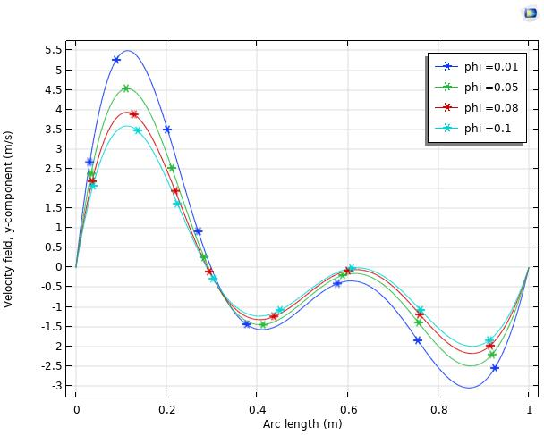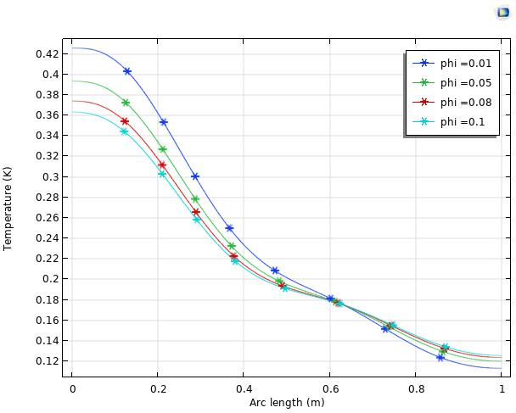

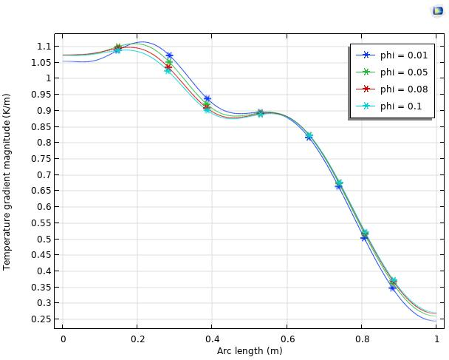

Figure – 6: shows the variation of φ along the temperature profile (C), velocity profile (A), and temperature gradient profile (B).

Table 5: Nusselt number average at heated wall for various φ values when Pr = 7 and Ra = 10^4

|  |  |  |  |  |
| --- | --- | --- | --- | --- |
| $$φ$$ | $$0.01$$ | $$0.05$$ | $$0.08$$ | $$0.1$$ |
| *Nuav* | 10.200 | 11.367 | 12.326 | 13.007 |

**Describe Table 5:** The table shows the mean Nusselt number (Nav) at the heated wall for various values of the nanoparticle volume fraction (Vf) (ϕ), while maintaining a fixed Rayleigh number (Ra) of 10^4 and a constant Prandtl number (Pr) of 7. The mean Nusselt number rises in tandem with the nanoparticle volume fraction (𝜙). According to this, increasing the number of nanoparticles improves thermal conductivity and encourages convective heat transfer. Over the range of φ values taken into consideration, the improvement in Nuav seems to be steady and almost linear. Between φ = 0.01 and φ = 0.05, the biggest boost is observed, with smaller incremental gains after that.

**Conclusion:**

The flow and thermal behaviour of *Zn*-water nanofluid in a closed domain with internal heat sources and sinks were thoroughly investigated numerically in this study. The objective of the study is to determine how heat transmission and fluid flow properties are impacted by the concentration of nanoparticles, Rayleigh number, and the positioning of thermal sources and sinks**.** According to the findings, adding zinc nanoparticles to the base fluid greatly increases thermal conductivity, which improves heat transfer rates inside the domain. Convective heat transmission becomes more prevalent as the volume percentage of *Zn* nanoparticle rises, particularly for increasing Rayleigh numbers. Furthermore, it is discovered that the internal heat source-sink configuration's location and intensity significantly affected the thermal and flow fields, changing the cavity's temperature gradients and streamlines.

Important conclusions include:

* The Nusselt number noticeably rises with increasing nanoparticle concentration, indicating improved thermal performance.  
  
* As Rayleigh numbers rises, the flow pattern becomes more intricate and robust, suggesting greater natural convection effects and hence more heat removal.

* The enclosure's temperature distribution and flow symmetry may be managed by carefully positioning the heat sources and sinks.

**References:**

[1] Qin, H., Wang, Z., Heng, W., Liu, Z., Li, P. ( 2021). Numerical study of melting and heat transfer of PCM in a rectangular cavity with bilateral flow boundary conditions. *Case Stud. Therm. Eng.*, *27*, 101183.

[2] Li, P., Wang, Z., Liu, Z., Heng, W., Qin, H. ( 2021). Convective heat transfer mechanisms of molten phase change material in a vertical slender rectangular cavity. A numerical case study. *Case Stud. Therm. Eng.* , *26*, 101139.

[3] Thiers, N., Gers, R., Skurtys, O. ( 2020). Heat transfer enhancement by localised time varying thermal perturbations at hot and cold walls in a rectangular differentially heated cavity. *Int. J. Therm. Sci.* , *151*, 106245.

[4] Qi, R., Wang, Z., Ren, J., Wu, Y. ( 2020) . Numerical investigation on heat transfer characteristics during melting of lauric acid in a slender rectangular cavity with flow boundary condition. *Int. J. Heat Mass Transf.* , *157*, 119927.

[5] Li, H., Tong, S. ( 2016). Natural convective heat transfer in the inclined rectangular cavities with low width-to-height ratios. *Int. J. Heat Mass Transf.*, *93*, 398–407.

[6] Giwa, S., Sharifpur, M. Meyer, J. (2020). Experimental investigation into heat transfer performance of water-based magnetic hybrid nanofluids in a rectangular cavity exposed to magnetic excitation. *Int. Commun. Heat Mass Transf.* , *116*, 104698.

[7] Elsherbiny, S.M., Ismail, O.I. (2015). Heat transfer in inclined air rectangular cavities with two localized heat sources. *Alex. Eng. J.*, *54*, 917–927.

[8] Giwa, S.O., Sharifpur, M., Meyer, J.P. (2020) . Effects of uniform magnetic induction on heat transfer performance of aqueous hybrid ferrofluid in a rectangular cavity. *Appl. Therm. Eng.*, *170*, 115004.

[9] Bouzennada, T., Mechighel, F., Ghachem, K., Kolsi, L. (2021) . Numerical Simulation of the Impact of the Heat Source Position on Melting of a Nano-Enhanced Phase Change Material. *Nanomaterials* , *11*, 1425.

[10] Alipourtarzanagh, E., Chinnici, A., Nathan, G.J., Dally, B.B. (2020). Experimental insights into the mechanism of heat losses from a cylindrical solar cavity receiver equipped with an air curtain. *Sol. Energy* , *201*, 314–322

[11] Sheremet, M., Pop, I., Mahian, O. (2018). Natural convection in an inclined cavity with time-periodic temperature boundary conditions using nanofluids: Application in solar collectors. *Int. J. Heat Mass Transf.* , *116*, 751–761.

[12] Wang, L., Huang, C., Yang, X., Chai, Z., Shi, B. (2018). Effects of temperature-dependent properties on natural convection of power-law nanofluids in rectangular cavities with sinusoidal temperature distribution. *Int. J. Heat Mass Transf.* , *128*, 688–699.

[13] Mansour, M.A., Ahmed, S.E. (2013). Mixed Convection in Double Lid-Driven Enclosures Filled with Al2O3–Water Nanofluid. *J. Thermophys. Heat Transf.* , *27*, 707–718.

[14] Tiwari, R.K., Das, M.K. (2007). Heat transfer augmentation in a two-sided lid-driven differentially heated square cavity utilizing nanofluids. *Int. J. Heat Mass Transf.* , *50*, 2002–2018.

[15] Malika M, Sonawane SS. (2020). Effect of nanoparticle mixed ratio on stability and thermo-physical properties of CuO-ZnO/water-based hybrid nanofluid. J Indian Chem Soc.;97(3):414–419.

[16] Çiftçi E. Distilled water-based AlN + ZnO binary hybrid nanofluid utilization in a heat pipe and investigation of its effects on performance. Int J Thermophys. 2021;42(3):1–21.

[17] B. Calcagni, F. Marsili, M. Paroncini. (2005). Natural convective heat transfer in square enclosures heated from below. Appl. Therm. Eng., 25, 1–17.

[18] A. Dalal, M.K. Das. (2006). Natural convection in a rectangular cavity heated from below and uniformly cooled from the top and both sides. Numer. Heat Transfer A, vol 49, article no 301–322.

[19] I. Sezai, A.A. Mohamad. (2000). Natural convection from a discrete heat source on the bottom of a horizontal enclosure. Int. J. Heat Mass Transfer, vol 43, article no 2257–2266,

[20] Kalsi, S., Kumar, S., Kumar, A., Alam, T. and Dobrotă, D. (2023). Thermophysical Properties of Nanofluids and Their Potential Applications in Heat Transfer Enhancement. vol. 16, article no 105272.,

[21] Porgar, S., Oztop, H. F. and Salehfekr, S., J. Mol. Liq. (2023). A comprehensive review on thermal conductivity and viscosity of nanofluids and their application in heat exchangers. vol. 386, article no 122213.,

[22] Henein, S. M. and Abdel-Rehim, A. A. (2022). The performance response of a heat pipe evacuated tube solar collector using MgO/MWCNT hybrid nanofluid as a working fluid. Case Stud. Therm. Eng., vol. 33, article no 101957.

[23] Ali, A. R. I. and Salam, B. (2020). A review on nanofluid: preparation, stability, thermophysical properties, heat transfer characteristics and application. SN Appl. Sci., vol. 2, pp 1–17.

[24] Z. Jun Song, Z. H. Khan, R. Ahmad, W. A. Khan, and Y. Wei. (2023). Thermal analysis of ferromagnetic nanofluid flow in a channel over a dimpled cavity. *J. Magnet Magn Mater*, vol. 573, pp. 170653, DOI: 10.1016/j.jmmm.2023.170653,

[25] M. Mahmoodi, A. Sohankar and A. Joulaei. (Jan. 2023). Investigations of nanofluid flow and heat transfer in a rotating microchannel using single- and two-phase approaches. *Numer Heat Transf Part A: Appl.*, vol. 83, no. 2, pp. 80–115, DOI: 10.1080/10407782.2022.2083886,

[26] N. Acharya and K. Das. (Nov. 2022). Three-dimensional rotating flow of Cu–Al2O3/kerosene oil hybrid nanofluid in presence of activation energy and thermal radiation. *Numer. Heat Transf. Part A: Appl.*, pp. 1–18, DOI: 10.1080/10407782.2022.2147111,