***Original Research Article***

**DESIGN OF A SOFTWARE BASED ON FCM AND THE COMBINATION OF FUZZY SVM, ANFIS AND NEFCON FOR THE DETECTION OF VIRAL HEPATITIS (TYPES A, B AND C /KINKOLE-RDC)**

**Abstract**

This article aims to develop soft computing based on fuzzy logic and machine learning techniques to reduce the time taken to screen for viral hepatitis using medical detection strips.

This work aims to improve the screening process for viral hepatitis using fuzzy artificial intelligence methods. Based on a study conducted at Kinkole Reference Hospital, we observed the slowness of traditional tests (45 minutes per patient for types A, B, C) with strips. The objective is therefore to propose an automatic system based on Python, combining several fuzzy classifiers (FCM, fuzzy SVM, ANFIS, NEFCON) to accelerate diagnosis while maintaining high reliability. The approach is based on a mathematical formalization of the problem as a supervised classification task, optimized by minimizing the squared error.

In particular, the use of **fuzzy SVM according to the ANYTA mukawa lukenzu approach** allowed us to integrate the degrees of belonging of patients to pathological classes, improving the robustness of the model in the face of uncertainty and imprecision of medical data.

This software provides a **more nuanced and progressive view** of diagnosis. It allows the expression of the probability of belonging to a pathological state, which is particularly suited to the real clinical context where the data are rarely clear-cut.

This research does not limit you to the implementation in Python, but it exposes the key steps of the mathematical reasoning of the fuzzy classifiers used.

One of the major strengths of this article is precisely the rigorous presentation of the mathematical foundations before the computational implementation. This reinforces the scientific credibility of our work.

Only first-order derivatives already provide enough information to guide the iterative optimization process of ANYTA's fuzzy FCM and SVM algorithms.

In practice, this softwarewas carried out with the implemented source codes of FCM segmentation of 63 observations knowing their following inputs: Age, Sex, GOT and GPT where GOT and GPT are the medical laboratory examinations with the aim of predicting the classes of viral hepatitis and their degrees of belonging.

According to the software results, Hepatitis A = class 1, Hepatitis B = class 2 and Hepatitis C = class 2.

**Keywords** : Squared error, function, membership degree, fuzzy classifiers, fuzzy inference, fuzzy constraint, fuzzy optimization, segmentation of fuzzy classifiers and combination of fuzzy classifiers.

**1. Introduction**

This paper is not the first to apply fuzzy classifiers in viral hepatitis screening.

1. **First aspect of the problem : Slowness of the screening process**

During our investigation at the Kinkole Reference Hospital laboratory, where we collected our data, we found that the viral hepatitis screening process is particularly lengthy. Indeed, after measuring a patient's GPT and GOT levels using a spectrophotometer, a detection strip must then be dipped into the blood and then waited 15 minutes for a result, and this only applies to a single type (e.g., type A). This process must therefore be repeated for types B and C.

On average, each complete screening (A, B, C) requires approximately 45 minutes per individual. Given that we analyzed 64 cases , this represents a total time of approximately 2,880 minutes for testing alone.

How can we reduce this examination time while maintaining the reliability of the results?

This article seeks to address precisely this problem by proposing an alternative based on fuzzy artificial intelligence.

1. **Second aspect of the problem: Lack of an automated tool in Python**

Although the literature abounds in works using fuzzy methods for hepatitis screening, we have not found a complete tool, developed in Python, which:

* Automatically performs data segmentation;
* Combines multiple fuzzy classifiers ;
* And emphasizes the mathematical foundations of the algorithms used before their implementation.

**Mathematical formalization of the problem**

Consider a data set:

* D={ $x_{1}$, $x_{2}$, $……..x_{p}$} , a set of p individuals defined by a vector of characteristics $x_{i}∈$ X .
* C, the set of target classes (expected outputs). The objective is to build a classification function:

*f : X → C such that f( $x_{i}$) = $y_{i}$*

In other words, it is about defining a function *f* , based on fuzzy reasoning, which transforms the input data $x_{i}$ into outputs or classes $y_{i}$ $∈$ C , by maximizing the accuracy of this prediction. This function is obtained by minimizing a cost function (also called squared error):



1. **Elements of Fuzzy Logic [1,2,3,4,5,6,7]**

In this article, fuzzy logic, also known as fuzzy logic, is defined as a mathematical approach that allows handling vague or imprecise concepts by emphasizing the notion of degree of membership.

Knowing that soft computing is the fusion of Artificial Intelligence algorithms with fuzzy logic to make complex calculations flexible, we recall the approach of Dubois and Prade **,** according to jomatopfe 2025.

**2.1. Approach of Dubois and Prade [8, 9, 10, 11, ]**

It is a fuzzy arithmetic which is based on the Zadeh extension principle with fuzzy operators Min (denoted AND) indicating the intersection and Max (denoted OR) indicating the union of fuzzy subsets.

In practice in artificial intelligence, it is this approach based on degrees and membership functions that is most often used in the definition of fuzzy inference systems (FIS) of fuzzy control models or fuzzy commands such as those of Mamdani, Sugeno, Takagi, having the following stages:

* Fuzzification
* Evaluation of rules
* Aggregation of rule outputs
* Defuzzification.

Among the fuzzy control models using the fuzzy inference-based approach, it is worth mentioning: NEFCON, PEDRYCZ, ANFIS, Fuzzy SVM, Fuzzy Decision Tree, FCM, etc.

**3. Mathematical functioning of fuzzy algorithms used in the construction of Soft computing**

**3.1. Fuzzy C-Means ( FCM) [9]**

The objective of FCM is to iterate the optimization process of the function cout , under the constraint of the degree of membership of the clusters,until the attributes of the points and the positions of the centroids converge to an optimal solution. The FCM problem is defined as follows:

Let U be the membership degree matrix



$∀_{j}∈\{1,…, m\}$; For j =1, …, n



We will explain each element of this function in the following lines

Under Constraint ( ${S/}_{C}$) For j= 1,… , n.

This is a constrained optimization in equality form. Since the first derivatives provide enough information to guide the iterative optimization process, we will use the Lagrangian. With the Lagrangian, the problem in min is defined as canonical when:

J(µ, v, λ)=

For j fixed we have:



From this, we calculate the derivative J with respect to µ, λ and V



Derivative of **J** with respect to **λ** :



Derivative of **J** with respect to **µ:**







Derivative of **J** with respect to **V** :







After finding the value of **µ** and $V_{k},$ we replace the value of the degree of membership in the formula of $V_{k}$. And we will have this:

**

**

So these iterative methods are based on the minimization of the objective function taken above:

**

With :

**U:** Universe of discourse

**V:** Cluster

**X:** Item to be classified

**n:** Total number of data to partition

**c:** Center of class i

**µ:** The degree of membership of data **k** to class **i**

**m:** The value that characterizes the blur in the partition (The parameter characterizing the random degree of blur).

**3.2. ANYTA MUKAWA'S FUZZY SVM**

Anyta Mukawa's fuzzy SVM is an adaptation basedonthe fusion of theSVM process and that of FCM in order to allow the fuzzy SVM system to recognize the degrees of membership $μ_{ik}$ of the point $x_{i}$**to the k classes, following the constraint $\sum_{k=1}^{k}{μ_{ik}=1}$, $∀i$ and $μ_{ik}∈[0 ,1]$, inspired by [18, 19, 20] and Laanaya 2006 .**

We start from the cost function defined as a weighted sum of fuzzy errors:

$$min \sum_{k=1}^{k}{\left\lceil \frac{1}{2}{\left\|w_{k}\right\|}^{2}+c \sum_{k=1}^{k}{μ_{ik}ε_{ik}}\right\rceil }$$

**Under the constraints $y_{ik}$ ( $w_{k }^{T}x_{i}$ + $b_{k}$) $≥1-ε_{ik}$, $ε_{ik}≥0 , ∀i,k$**

**with $y_{ik}$ $∈[-1 ,1]$ binary or $y_{ik}$ $∈[ 0 ,1]$**

**In the case** classification with fuzzy margins, overlapping data must be classified. **We also define $\left|w_{k }^{T}x_{i} +b_{k} -y_{ik}\right|$ as loss for class k**

**In a fuzzy environment it is better to write $perte=max⁡(0, 1-y_{ik} f_{k}(x_{i})$). With $f_{k}\left(x_{i}\right)=$ $w_{k }^{T}x_{i}$ + $b_{k}$ as the output of the SVM.**

**Since we also want to manage the sensitivity of fuzzy margins having minimal (very small) values, we work with the quadratic errors $L_{ik}$ = ${(\max\left(0, 1-y_{ik} f_{k}\left(x_{i}\right)\right))}^{2}$.**

**Thus the Lagrangian of the function to be optimized under the fuzzy constraint becomes:**

$L\left(μ ,λ \right)= \sum_{i=1}^{n}{\sum_{k=1}^{k}{μ_{ik}L_{ik}}}$**- $\sum_{i=1}^{n}{λ_{i}}$ $\left\lceil {(μ}_{ik}-1)\right\rceil$**

**At the optimum for each i, we have: $\frac{∂L\left(μ ,λ \right)}{∂μ_{ik}}$** = 0 $⇔ L_{ik}=λ_{i}$**which are all positive.**

**In this process, we interpret the distance to the boundary as an inverted resemblance center and the** fuzzy SVM system will follow the following steps:

Step 1: Calculating the distances to the class hyperplane

$$d_{ik}=\frac{\left|w_{k }^{T}x_{i} +b_{k} \right| }{\left\|w_{k}\right\|}$$

Step 2: Updated membership degrees

The update of the degrees of membership of the points to the k classes is done by the following relation:

$$μ_{ik}=\frac{1}{\sum_{j=1}^{k}{{\left(\frac{L_{ik}}{L_{ij}}\right)}^{\frac{1}{m-1}}}}$$

**If $L_{ij}$ = 0, we use $ε$ instead**

Step 3: Class assignment rule

**The rule for assigning the point to class k is: class ( $x_{i})=$ arg max $μ_{ik}$, i.e. we assign the observation to class k for which the degree of membership is the highest.**

Step 4: convergence criterion inspired by FCM alone $ε$

Step 5: Prediction for a new observation

We calculate the classification error $L_{ik}$**= ${(\max\left(0, 1-y_{ik} f_{k}\left(x_{i}\right)\right))}^{2}$**

**,for each SVM k; And the degree of membership by:**

$$μ_{k,new}=\frac{1}{\sum_{j=1}^{k}{{\left(\frac{L_{k},new}{L_{j},new}\right)}^{\frac{1}{m-1}}}}$$

**With m $>1$ (fuzzy parameter often equal to 2)**

**3.3.1 . Fuzzy neural networks**

**3.3.1. ANFIS [16, 17, 15, 12]**

* + - * 1. **Architecture of ANFIS**



**Vector**

**characteristic**

**The class of hepatitis.**

**Hidden Layer**

**Output Layer**

Fig 1. - The architecture of ANFIS

* + - * 1. ANFIS **works**

The ANFIS network architecture corresponding to this first-order Sugeno model.

Layers in the network are made up of nodes that have the same function for a given layer.

Its particularity is that its rule base uses a linear combination of inputs and fuzzy weights as output: for example:

If $x_{1 }$ is small AND $x_{2 }$ is small THEN f 1 = a 1 x + b 1 y + c 1

If is small AND $x_{2 }$ is large THEN f 2 = a 2 x + b 2 y + c 2

Here, and $x_{2}$ are the input values at node , and small and largeare the fuzzy sets associated with the node to produce the membership classes of the premise part. The membership functions for small i or large i can be any suitable parameterized membership function such as triangular, trapezoidal, Gaussian or bell-shaped.

The operation of ANFIS Sugeno can be summarized as follows:

1. Fuzzification:

For each entry, we define its functions (MF) and its membership degrees in order to define the fuzzy rules.

Each rule has a linear output (fuzzy combination of the outputs weighted by the fuzzy weights of the rules).

1. Defining weights of fuzzy rules

For any rule $R_{i}$, we have $W_{i}$ = $μ$ $\left(x_{1}\right) . μ$ $\left(x_{2}\right)$

1. Standardization

${\overline{W}}_{i}$ = $\frac{W_{i}}{\sum{W_{i}}}$

1. Calculation of ANFIS output

Output rule i is $y_{i}$ = $a_{i}x_{1}$ + $b_{i}x_{2}$ + $c_{i}$

1. Final output:

ANFIS (x) = $\sum_{i=1}^{n}{{\overline{W}}_{i} }y_{i}$

Being in fuzzy logic this system will recognize the degrees of membership of observation x to all classes and will assign it to the one with the highest degree.

##### **.3.2 .NEFCON (NEEuro-Fuzzy CONtrol)**

1. **NEFCON Architecture**

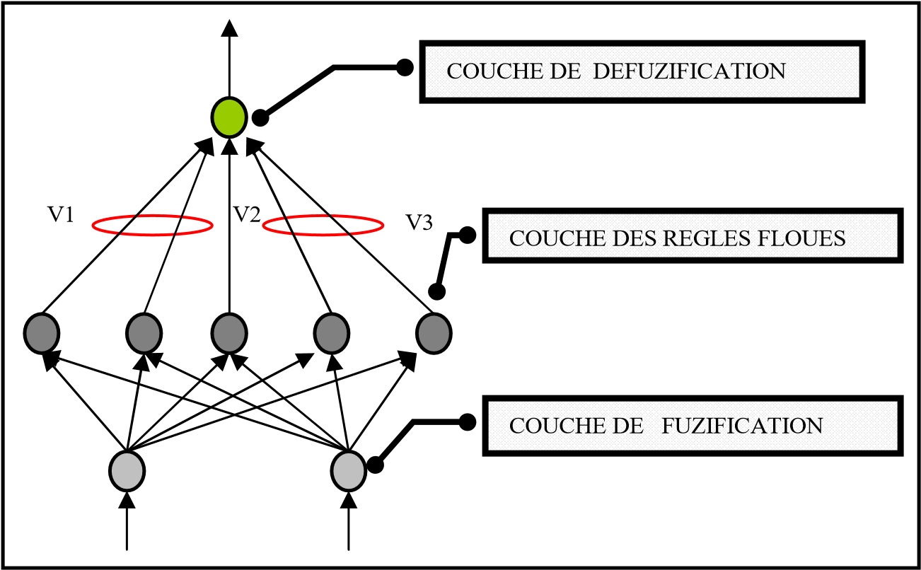

Fig 2. - The architecture of NEFCON

NEFCON is designed to implement the Mandani-type fuzzy inference system. Its architecture contains layers where weights are recognized as fuzzy sets and fuzzy rules to ensure process integrity. The input layer performs the task of the fuzzification interface, the inference logic is represented by the propagation and rule base functions, and the output layer is the defuzzification interface.

The training of the NEFCON model is based on a mixture of unsupervised and supervised (backpropagation) learning.

1. **How NEFCON Works [15, 13]**
2. Definition of membership functions (Triangular)

* For the entrance $(x_{i})$: $μ_{petit} (x_{i})$**, $μ_{moyen } (x_{i})$, $μ_{grand}(x_{i})$**

1. Blurry Rules (Nefcon Mamdani)

NEFCON's fuzzy rules are based on Mamdani

|  |  |
| --- | --- |
| Ruler | If $x_{1}$ is …..AND $x_{2}$ is ………….. |
| R1 | Small AND small |
| R2 | Medium AND Medium |
| R3 | Big AND Big |

1. MF Activation Rule Calculations
2. Activation of fuzzy rules

Only RIs with weight $≠$ 0 will be considered as activated rules.

1. Defuzzification (Mamdani center of gravity)

Defuzzification at the end of the process is done by:

CG $=\frac{\sum_{x=a}^{b}{μ_{A}\left(x\right).x}}{\sum_{x=a}^{b}{μ_{A}\left(x\right) }}$

Being in fuzzy logic this system will recognize the degrees of membership of observation x to all classes and will assign it to the one with the highest degree.

**4. Implementation of soft computing**

After understanding the mathematical working of the fuzzy algorithms above, we need to program them into the machine.

**4.1. Libraries operated**

Since the implementation of this Soft computing is done with the python language, the following libraries were useful to us.

* **pandas (import pandas as pd)**
* **Role** : Data manipulation and analysis.
* Allows you to easily work with data structures like DataFrames, ideal for managing tables of tabular data (rows and columns).
* Used to import, clean, transform and analyze data.
* **NumPy (import numpy as np)**
* Role: Numerical calculation and manipulation of multidimensional tables.
* Provides tools for fast calculations such as matrix or complex mathematical operations.
* Very efficient for working with digital data.
* **scikit-fuzzy (import skfuzzy as fuzz)**
* Role: Implementation of fuzzy logic.
* Used for processing and analyzing fuzzy data, which may include uncertainty or approximations often exploited in fuzzy logic-based decision-making systems.
* **matplotlib (import matplotlib.pyplot as plt)**
* Role: Data visualization.
* Allows you to create static charts such as line charts, bar charts, scatter plots, etc.
* Very useful for displaying the results of an analysis in a clear manner.
* **tkinter (from tkinter import filedialog, messagebox, Tk, Label, Button, Entry)**
* Role: Creation of graphical user interfaces (GUI).
* Allows you to design interactive applications with windows, buttons, input fields, dialog boxes and more.
* **bones (bone import)**
* Role: Interact with the operating system.
* Used to access system features, such as navigating directories, manipulating files, and executing system commands.
* **Orange (Orange import)**
* Role: Framework for data analysis and machine learning.
* Orange is useful for tasks like classification, regression and data visualization and visualization called FreeViz.
* Here it is used to check if the visualization method called FreeViz is available. If Orange3 is not installed, FreeViz cannot be used.

**4.2. Source codes, user interfaces and results**

Here are the implemented source codes of the FCM segmentation of 63 observations knowing their following inputs: Age, Sex, GOT and GPT where GOT and GPT are the medical laboratory examinations.

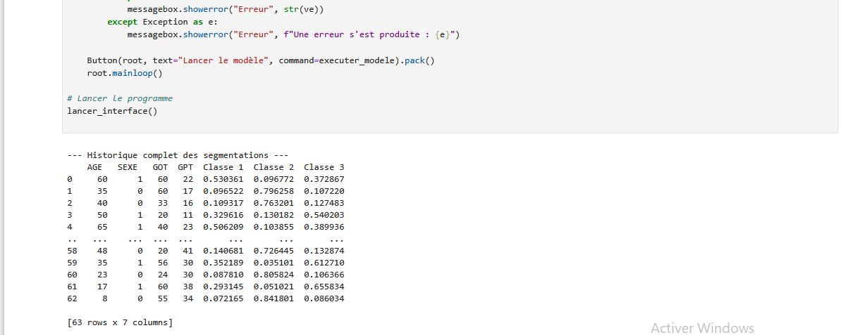

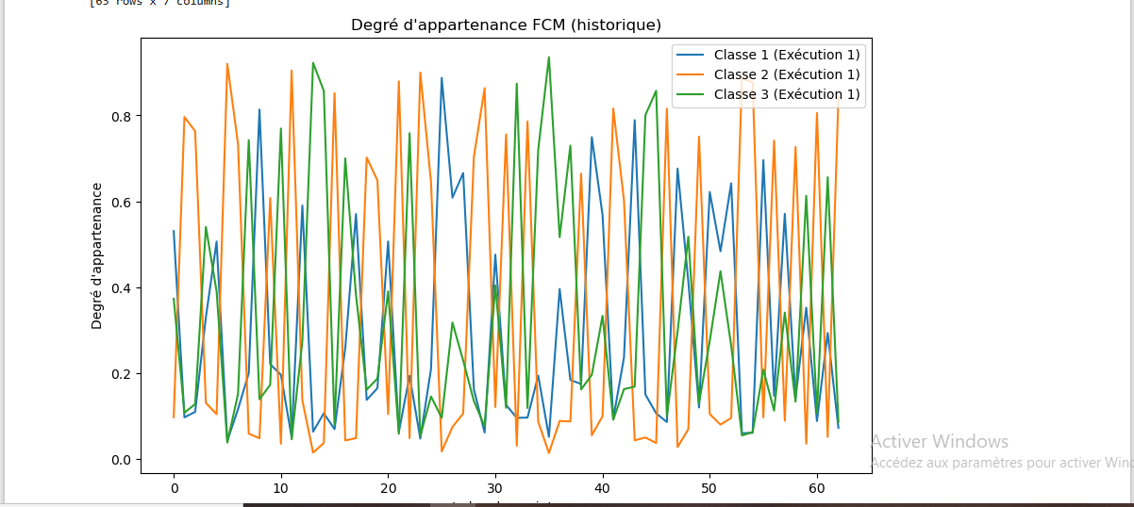

**Fig 3: Graph of degrees of membership**

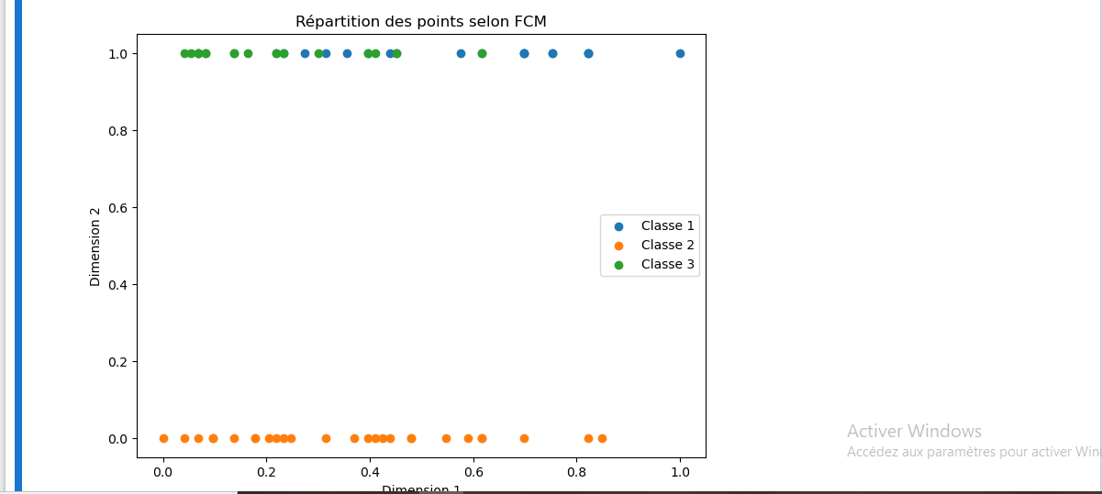

**Fig 4: FCM class graph**

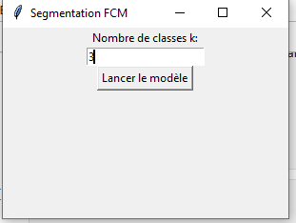

**FIG 5. FCM segmentation**

The interface above allows you to select the data set from Excel, in the computer. After importing the inputs, the software automatically segments the data and offers a prediction interface with the ranges where we enter the characteristics of the new observation.

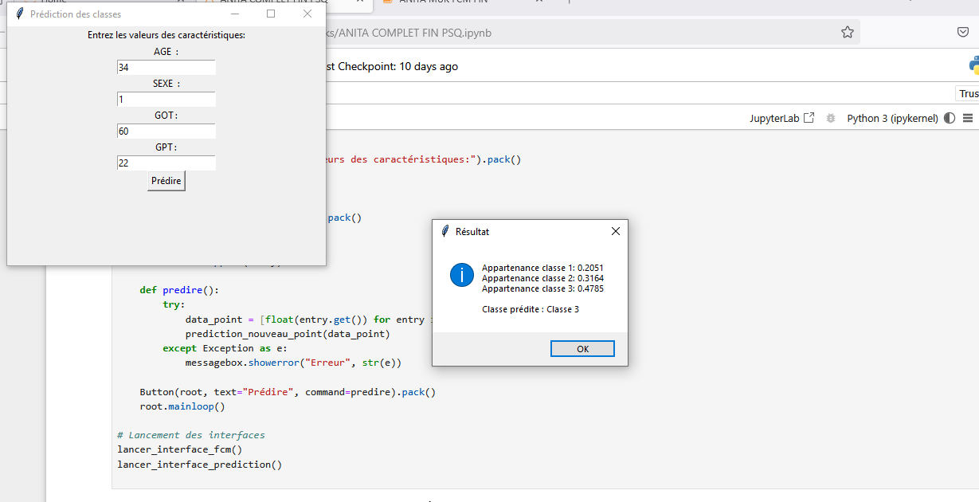

**FIG 6. Prediction interface**

### **Conclusion**

This work demonstrated the value of integrating fuzzy classifiers into the automated screening process for viral hepatitis using clinical data collected at Kinkole Reference Hospital. Experimental results show that the fuzzy approach improves diagnostic accuracy, particularly in medical settings where data are imprecise, incomplete, or subject to human interpretation.

The specific functions of the classifiers used are as follows:

* **FCM (Fuzzy C-Means)** : allows patients to be segmented according to their degree of belonging to different pathological classes, by identifying latent structures in the data.
* **Fuzzy SVM (ANITA)** : Strengthens supervised classification by taking into account uncertainties in the data, thanks to the integration of fuzzy weights into the cost function. The ANITA approach improves the robustness of the model, particularly in the face of ambiguous cases.
* **ANFIS (Adaptive Neuro-Fuzzy Inference System)** : Combines fuzzy logic and neural networks to automatically learn decision rules from training examples.
* **NEFCON (Neuro-Fuzzy Controller)** : builds a control-oriented fuzzy rule system, suitable for dynamic or uncertain environments such as medical diagnosis.

The results obtained on the dataset show high accuracy for all methods, with particularly remarkable performance of the **fuzzy SVM (ANITA)** and ANFIS **,** which offer both speed and reliability. These approaches pave the way for the implementation of a medical decision support system, capable of offering pre-diagnoses in real time, thus reducing the screening time from 45 minutes to a few seconds.

We are pleased to say that this research has brought a concrete, local and useful dimension to Congolese public health.

**COMPETING INTERESTS DISCLAIMER:**

Authors have declared that they have no known competing financial interests OR non-financial interests OR personal relationships that could have appeared to influence the work reported in this paper.

**References**

1. Gradi Kamingu, fuzzy set theory, properties and operations, lareg, 2016.
2. Baali Sabeur & Mahmoudi Messaoud, Temperature and humidity regulator for a chicken coop, 2022
3. P. Singhala1, DN Shah2, B. Patel, Temperature Control using Fuzzy Logic, 2014.
4. Dominique Longin, Reasoning and Uncertainty, 2016
5. **Zadeh, LA** - **“Fuzzy Logic = Computing with Words”,** (2018).
6. **Pedrycz, W., & Gomaa, A.** - **“Fuzzy Systems: A Comprehensive Introduction”,** (2020).
7. **Cox, EJ** - **“The Role of Fuzzy Logic in Decision Making”** , (2017)
8. Mazoni, GN, et al. Analysis of functional properties of fuzzy 𝐿 ̃ 𝑝 ( Ω ) spaces. Asian Research Journal of Mathematics, 20(9), 140-150, (2024).
9. Lukezu .AMet al ,Quantification of degree of hepatitis , (2024)
10. Lukezu .AMet al ,comparative study of fuzzy logic operators, (2024)
11. Opfointshi E. et al, New fuzzy approach to Jomatopfe, 2025.
12. Anass Zaidouni et al, A Sugeno ANFIS Model Based on Fuzzy Factor Analysis for IS/IT Project Portfolio Risk Prediction, Journal of Information and Communication Technology (JICT), Malaysia ,( 2024) .
13. Halim Mudia : Comparative Study of Mamdani-type and Sugeno-type Fuzzy Inference Systems for Coupled Water Tank , Indonesian Journal of Artificial Intelligence and Data Mining (2022).
14. Hafsaa Ouifak et al : On the performance and interpretability of Mamdani and Takagi-Sugeno-Kang based neuro-fuzzy systems for medical diagnosis (2023).
15. Aprinia Salsabila Roiqoh et al : Analisis Penggunaan Logika Fuzzy Mamdani dan Sugeno untuk Memprediksi Shade Foundation , Jurnal Nasional Teknologi Informasi dan Aplikasnya (JNATIA), Indonesia (2024).
16. Mary Pa, Amin Kazemi: ANFIS-based prediction of power generation for combined cycle power plant (2022).
17. Ayilobeni Kikon et al: ANFIS-based soft computing models for forecasting effective drought index over an arid region of India (2023).
18. M. Tanveer et al : Enhancing Imbalance Learning: A Novel Slack-Factor Fuzzy SVM Approach (2024).
19. Cui Fu, Shuisheng Zhou et al : Relative Density-Based Intuitionistic Fuzzy SVM for Class Imbalance Learning (2023).
20. Wiwi Widia Sukeiti et al : Fuzzy Support Vector Machine Using Function Linear Membership and Exponential with Mahalanobis Distance , Indonesia (2022).