*In vitro* efficacy of new generation fungicides for management of anthracnose of mungbean [*Vigna radiata* (L.) Wilczek]

ABSTRACT

|  |
| --- |
| Biotic stress has been a major constraint in the cultivation for mungbean growers throughout these years. *Colletotrichum* species complex, the causative agent of anthracnose in mungbean, results in severe yield loss mainly in Asia, South America, Australia and Sub-Saharan Africa. To address this issue, a methodical survey was carried out in major mungbean growing parts in Karnataka in 2023 to 2024. In the current study, new generation fungicides such as triazoles, strobilurins and combinations, at three concentrations *viz.,* 0.10, 0.15 and 0.20 per cent were evaluated *in vitro* to test the efficacy against the pathogen using poison food technique. Among the eight fungicides tested, Propiconazole 25% EC, Carbendazim 12% + Mancozeb 63% WP, Tebuconazole 50% + Trifloxystrobin 25% WG and Tricyclazole 18 % + Mancozeb 62 % WP showed cent per cent inhibition in the pathogen mycelium growth at all three concentrations. Fluxapyroxad 21.26 % + Pyraclostrobin 21.26 % SC showed cent per cent inhibition at 0.15 and 0.20 per cent concentration. The least efficacy was showed by Azoxystrobin 23% SC with 49.75 per cent mean inhibition. However, the targeted mechanism of action in case of single systemic fungicides increases the likelihood of resistance evolution in pathogen populations by mutations and adaptive selection. The combination fungicides will offer more effective control by targeting multiple biochemical pathways in the pathogen. Hence, it will be better for farmers to adopt combination fungicides such as Carbendazim 12% + Mancozeb 63% WP, Tebuconazole 50% + Trifloxystrobin 25% WG and Tricyclazole 18 % + Mancozeb 62 % WP which showed cent per cent inhibition in this study. Their dual mode of action, which not only improves disease suppression but also reduces the likelihood of resistance development, makes them a more reliable and effective option for long-term disease management. |

*Keywords: Mungbean; anthracnose; Colletotrichum* spp.*; fungicides, inhibition; management.*

1. INTRODUCTION

Pulses, often referred to as "poor man's meat" or "rich man's vegetable," are crucial to human nutrition. Mungbean (*Vigna radiata* [L.] R. Wilczek var. *radiata),* is the primary crop in cereal-based farming systems in South America, Australia, Asia, and Sub-Saharan Africa [1–3]. Due to its high nutritional content, it is often referred to as a "Golden Bean." As one of the most abundant plant-based protein sources in the world, mungbean dal is hailed as a superfood. In addition to having hepatoprotective and immunomodulatory properties, it has been shown to reduce hyperglycaemia, hyperlipemia and hypertension and to prevent cancer and melanogenesis [4]. With an average productivity of 0.5 t/ha, South Asia accounts for 90% of global mungbean production, with India being the region's major producer, producing 1.5 to 2 million tonnes from 3 to 4 million hectares yearly [5]. One of the most prevalent mungbean disease in worldwide and mainly in Asian continent is anthracnose, a fungal disease which is caused by many species of *Colletotrichum*. In India, this disease reduces crop yield by 30 to 70 per cent [1]. Anthracnose on mungbean in India was first reported in 1951 in Jorhat, Assam [6]. In developing nations, farmers often go for Carbendazim 50% WP and mancozeb 75% WP fungicides. Due to the continuous use of the same, fungicide resistance has been developed in pathogen and is a major cause of concern [7]. Hence, use of new generation fungicides is highly recommended for the management of anthracnose in mungbean. Despite the potential modes of action of new-generation fungicides, especially triazoles, strobilurins and their combinations, their practical usage is not much highlighted in disease management of anthracnose, hence it underscores the pressing need for these novel and optimized fungicide-based approaches. Therefore, with the above research gaps and facts mentioned, this current study was conducted with the main objective to identity the new generation fungicidal molecules for the management of mungbean anthracnose.

2. material and methods

Infected samples were collected from different mungbean growing parts of Karnataka, India during *kharif* 2023 and 2024 survey. The standard isolation procedure for pathogen was followed from the collected infected samples. The cultures were purified using single spore technique in Potato Dextrose Agar (PDA) medium and maintained in PDA agar slants at 4 ⁰C in fridge [8]. Koch’s postulates were also proved. The experiment was conducted in 2024 at the Department of Plant Pathology, College of Agriculture, Dharwad, Karnataka using a factorial Completely Randomized Design (CRD) under *in vitro* conditions.

**2.1 *In vitro* screening of modern fungicides**

New generation fungicides that are commercially available in the markets and are cost friendly to farmers were chosen in this study. The pathogen was screened using 3 triazoles (Difenconazole 25% EC, Propiconazole 25% EC and Hexaconazole 5% EC), one strobilurin (Azoxystrobin 23% SC) and four combination fungicides (Carbendazim 12% + Mancozeb 63% WP, Tebuconazole 50% + Trifloxystrobin 25% WG, Fluxapyroxad 21.26 % + Pyraclostrobin 21.26 % SC, Tricyclazole 18 % + Mancozeb 62 % WP). The efficacy of fungicides was evaluated using poison food technique given by Nene and Thapliyal (1993) at three concentrations (0.1%, 0.15% and 0.2%), each with three replications (Table 1).

**Table 1. New generation fungicides used in this study**

|  |  |  |  |
| --- | --- | --- | --- |
| **Sl. No.** | **Chemical name** | **Trade name** | **Target site** |
| 1. | Azoxystrobin 23% SC | Amistar 23% SC | QoI, strobilurin class |
| 2. | Hexaconazole 5% EC | Contaf 5% EC | DMI, triazole class |
| 3. | Propiconazole 25% EC | Tilt 25% EC | DMI, triazole class |
| 4. | Difenoconazole 25% EC | Score 25% EC | DMI, triazole class |
| 5. | Carbendazim 12% + Mancozeb 63% WP | Saaf 75% WP | Benzimidazole + Dithiocarbamate (multi-site) |
| 6. | Tebuconazole 50% + Trifloxystrobin 25% WG | Nativo 75% WG | DMI + QoI (dual action) |
| 7. | Fluxapyroxad 21.26 % + Pyraclostrobin 21.26 % SC | Merivon 42.52 % SC | SDHI + QoI (dual action) |
| 8. | Tricyclazole 18 % + Mancozeb 62 % WP | Merger 80 % WP | Melanin biosynthesis inhibitor + multi-site |

QOI: Quinone Outside Inhibitor, DMI: Demthylation Inhibitor,

SDHI: Succinate Dehydrogenase Inhibitor.

To perform the poisoned food technique, autoclaved molten PDA medium was first prepared and mixed with adequate concentration of each fungicide to create the medium suspensions. Approximately, 20ml of this amended medium was poured to sterile Petri dishes and allowed to solidify under sterile conditions. Three replications were maintained for each fungicide and control (without the fungicide). After solidification, using a sterile cork borer, five mm mycelial discs of actively growing margin of seven-day old culture were aseptically cut. Using a flame sterilized inoculation needle, the disc was carefully placed at the centre of the solidified amended medium to corroborate the growth rate. A control plate was also maintained for comparison. The inoculated Petri plates were wrapped and maintained under sterile condition at 28±1°C. Observations were taken when the pathogen mycelium reach full growth in control plate. Two orthogonal diagonal measurements (0° and 90° angles) of mycelium were taken in control and other inoculated plates and then the average values of these diameters were calculated. Lastly, the following equation by Vincent was used to calculate the per cent suppression of mycelial growth of pathogen [9].

$$I=\left[\left(C-T\right)÷C\right]×100$$

Where, I = Percent mycelial growth inhibition;

C = Mean diameter (cm) of mycelial growth in control

T = Mean diameter (cm) of mycelial growth in treatment

The statistical analysis was done using SPSS software and Duncan's multiple range test Duncan was also performed for interpretation of the results [10]. The heatmap was generated using python coding in Jupyter Notebook.

3. results and discussion

The *In vitro* evaluation was aimed for screening new generation fungicides using poison food technique. The fungicides Difenconazole 25% EC, Propiconazole 25% EC, Hexaconazole 5% EC, Azoxystrobin 23% SC, Carbendazim 12% + Mancozeb 63% WP, Tebuconazole 50% + Trifloxystrobin 25% WG, Fluxapyroxad 21.26 % + Pyraclostrobin 21.26 % SC and Tricyclazole 18 % + Mancozeb 62 % WP were evaluated at three different concentrations of 0.1, 0.15 and 0.2 per cent. It was observed that cent per cent significant inhibition of mycelium growth of pathogen was shown by three combi products (Carbendazim 12% + Mancozeb 63% WP, Tebuconazole 50% + Trifloxystrobin 25% WG and Tricyclazole 18 % + Mancozeb 62 % WP) and one systemic triazole fungicide Propiconazole 25% EC (FRAC Group 3) at all three concentrations (Fig. 1). The combi product Fluxapyroxad 21.26 % + Pyraclostrobin 21.26 % SC was the next effective fungicide (100%) at 0.15 and 0.20 per cent concentration followed by 93.33 per cent inhibition at 0.1 per cent concentration (Table 2 and Plate 1). The least inhibition per cent of pathogen mycelium was shown by the Azoxystrobin 23% SC (49.75%). The other two triazole fungicides showed 87.28 per cent inhibition by Difenconazole 25% EC and 81.85 per cent inhibition by Hexaconazole 5% EC. The results were illustrated in the form of heatmap which shows that there is an increasing per cent inhibition of pathogen mycelium with increase in concentration of fungicides. The fungicide Azoxystrobin 23% SC exhibited variability in per cent inhibition across all concentrations (Fig. 2). This findings align with the result by Patel et al. [11], which reported that have reported Propiconazole 25% EC at all concentrations and Carbendazim 12% + Mancozeb 63% WP at 0.20% gave cent per cent inhibition to *C. truncatum* in mungbean. Similarly, Purushotham et al. [12] evaluated the efficacy of six fungicides *in vitro* against *C. lindemuthianum* causing mungbean anthracnose and found that cent per cent inhibition was shown by propiconazole 25% EC at 500ppm. They reported that Carbendazim 12% + Mancozeb 63% WP showed better inhibition than single systemic products. Additionally, studies by Pruthviraj et al. [13] and Dev and Narendrappa [14] confirmed that Propiconazole 25% EC and Tebuconazole 50% + Trifloxystrobin 25% WG showed cent percent inhibition at all concentrations against *C. gloeosporioides* causing anthracnose of pomegranate. Cao et al [15] also confirmed that Propiconazole showed a strong effectiveness against *C. siamense* and *C. fructicola.*

**Table 2. *In vitro* evaluation of fungicides against *Colletotrichum* spp*.***

|  |  |  |  |  |  |
| --- | --- | --- | --- | --- | --- |
| **Sl. No.** | **Fungicides** | **Per cent mycelial growth inhibition\*** | | | **Mean** |
| **Concentration (%)** | | |
| **0.1** | **0.15** | **0.20** |
| 1. | Azoxystrobin 23% SC | 43.33  (41.17)** | 50.74  (45.42) | 55.19  (47.98) | **49.75**  (44.86) |
| 2. | Hexaconazole 5% EC | 80.37  (63.70) | 81.48  (64.51) | 83.70  (66.19) | **81.85**  (64.78) |
| 3. | Propiconazole 25% EC | 100.00  (90.00) | 100.00  (90.00) | 100.00  (90.00) | **100.00**  (90.00) |
| 4. | Difenoconazole 25% EC | 84.44  (66.77) | 88.15  (69.86) | 89.26  (70.87) | **87.28**  (69.11) |
| 5. | Carbendazim 12% +  Mancozeb 63% WP | 100.00  (90.00) | 100.00  (90.00) | 100.00  (90.00) | **100.00**  (90.00) |
| 6. | Tebuconazole 50% +  Trifloxystrobin 25% WG | 100.00  (90.00) | 100.00  (90.00) | 100.00  (90.00) | **100.00**  (90.00) |
| 7. | Fluxapyroxad 21.26 % + Pyraclostrobin 21.26 % SC | 93.33  (75.04) | 100.00  (90.00) | 100.00  (90.00) | **97.78**  (81.43) |
| 8. | Tricyclazole 18 % +  Mancozeb 62 % WP | 100.00  (90.00) | 100.00  (90.00) | 100.00  (90.00) | **100.00**  (90.00) |
| **Mean** | | **87.68**  (69.45) | **90.05**  (71.61) | **91.02**  (72.56) |  |
| **Source** | | **S. Em. ±** | **CD @ 1%** |  | |
| **Fungicide (F)** | | **0.17** | **0.63** |
| **Concentration (C)** | | **0.10** | **0.39** |
| **F X C** | | **0.29** | **1.09** |

*\****\***Mean of three replications

**\*\***Arc sine transformed values**, F-**Fungicide, **C-**Concentration, **F x C-** Interaction

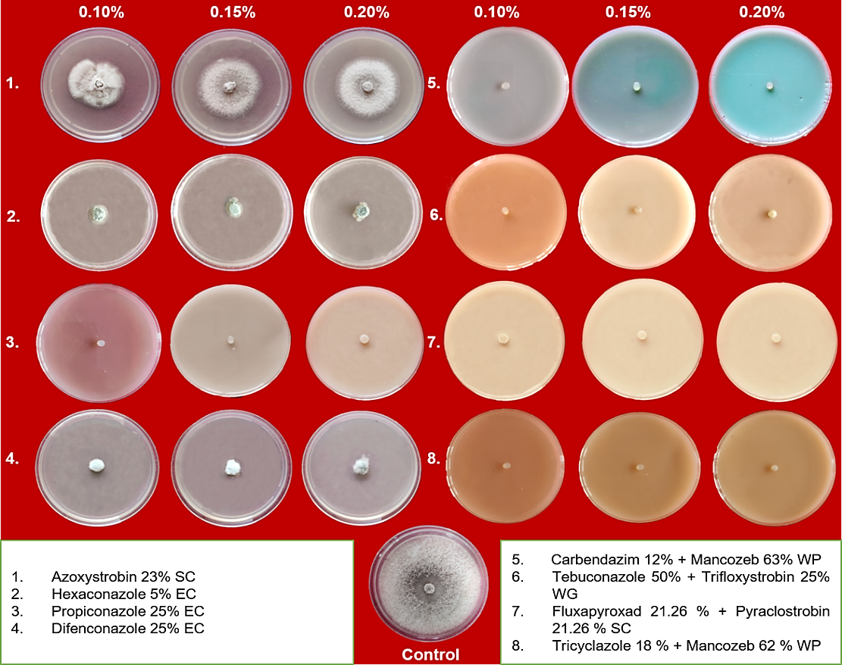

**Plate 1. *In vitro* evaluation of fungicides against *Colletotrichum* spp*.***

**Fig. 1. *In vitro* evaluation of fungicides against *Colletotrichum* spp*.***

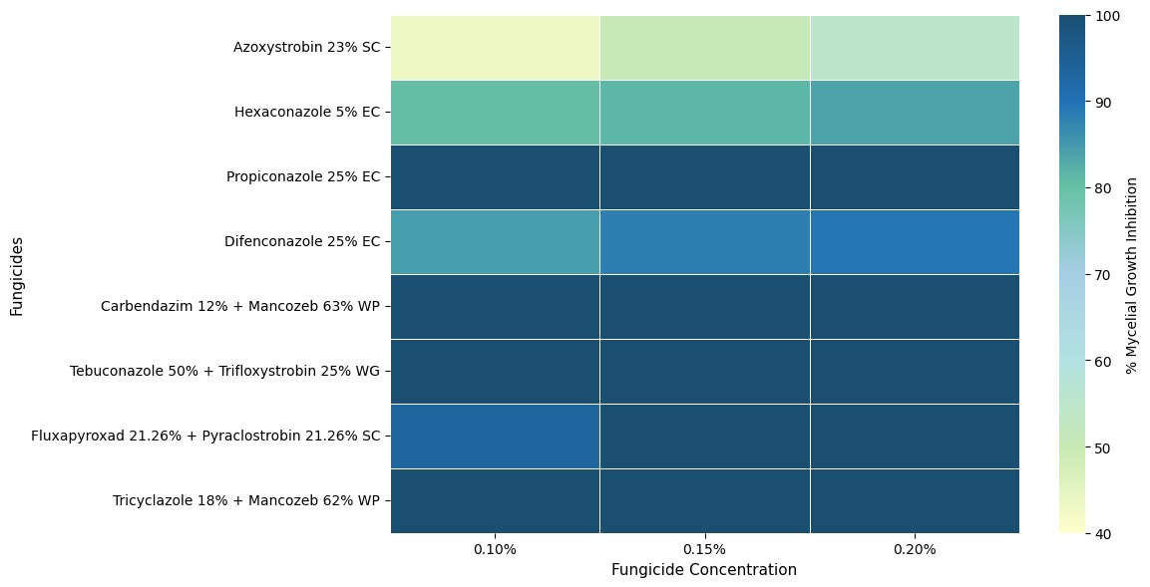

**Fig. 2 Heatmap illustrating the comparative *in vitro* efficacy of fungicides against *Colletotrichum* spp*.***

Propiconazole is a Demethylation Inhibitor (DMI) fungicide that belongs to FRAC (Fungicides Resistance Action Committee) code3. Chen et al. [16] have reported that among the DMI fungicides tested for sensitivity toward *C. truncatum, C. fructicola and* *C. siamense,* propiconazole and difenoconazole were the most effective. In *Colleotrichum* spp., the DMI fungicides, mainly propiconazole, primarily targets the ergosterol biosynthesis by inhibition of the cytochrome P450 enzyme CYP51 (lanosterol 14α-demethylase) [17]. However, the continuous use of systemic fungicides poses risk of fungicide resistance development with time, as they will be targeting one or two specific fungal functions, leaving them open to mutations or selection of resistant ones. Whereas combination fungicides used in this study such as Tebuconazole 50% + Trifloxystrobin 25% WG and Fluxapyroxad 21.26 % + Pyraclostrobin 21.26 % SC, which showed cent per cent inhibition, comprise of active ingredients that act synergistically to control the fungus through distinct biochemical pathways. They offer a long-term management of fungal pathogens as they have two different mechanism or mode of actions against the fungus that prevents or delays resistance development. These combinations often provide broad spectrum protection against fungus [18].

4. Conclusion

In the current study, among the fungicides tested against *Colletotrichum* species, Propiconazole 25% EC was found as the most effective among systemic and Carbendazim 12% + Mancozeb 63% WP, Tebuconazole 50% + Trifloxystrobin 25% WG and Tricyclazole 18 % + Mancozeb 62 % WP were found cent per cent effective among combination fungicides at all concentrations. While Propiconazole has exhibited high fungicidal activity, relying exclusively on it for long term management could be problematic. Its targeted mechanism of action, limits the spectrum and increases the likelihood of resistance evolution in pathogen populations. Repeated applications exert severe selection pressure, that will lead potentially to the emergence of resistant fungal strains, through adaptive selection or point mutations. Unlike this, combination fungicides will offer more effective control by targeting multiple biochemical pathways in the pathogen. They are more robust and efficient choice for long-term disease management because of their dual mode of action, which not only enhances disease suppression but also lowers the possibility of resistance development.

DISCLAIMER (ARTIFICIAL INTELLIGENCE)

Author(s) hereby declares that no generative AI technologies such as large language models (CHATGPT, COPILOT, etc) and text-to-image generators have been used during writing or editing of this manuscript.

References

[1] Pandey, A. K, Basandrai, A. K, Basandrai, D., Boddepalli, V. N., Rathore, A., Adapala, G., et al. (2021). Field-relevant new sources of resistance to anthracnose caused by *Colletotrichum truncatum* in a mungbean mini-core collection. Plant Disease, 105(7), 2001–2010.

[2] Nair, R. M., Pandey, A. K., War, A. R., Hanumantharao, B., Shwe, T., Alam, A., et al. (2019). Biotic and abiotic constraints in mungbean production—progress in genetic improvement. Frontiers in Plant Science, 10, 1340.

[3] Noble, T. J., Young, A. J., Douglas, C. A., Williams, B., & Mundree, S. (2019). Diagnosis and management of halo blight in Australian mungbeans: A review. Crop & Pasture Science, 70(3), 195-203.

[4] Hou, D., Yousaf, L., Xue, Y., Hu, J., Wu, J., Hu, X., et al. (2019). Mung bean (*Vigna radiata* L.): Bioactive polyphenols, polysaccharides, peptides, and health benefits. Nutrients,11(6),1238.

[5] Pratap, A., Douglas, C., Prajapati, U., Kumari, G., War, A. R., Tomar, R., et al. (2020). Breeding progress and future challenges: Biotic stresses. In: R. M. Nair, R. Schafleitner & S. H. Lee (Eds.), The mungbean genome (pp. 55–80). Springer International Publishing, Cham.

[6] Nandeesha, C. V., Akbari, L. F., Jaiswal, A., Harsha, B. R., Patil, B., Bhaliya, C. M., et al. (2023). Control efficacy and yield response of different fungicides evaluated against anthracnose of green gram. Crop Protection, 174(2), 106432.

[7] Chaudhari, K. A., & Gohel, N. M. Management of anthracnose disease of mungbean through new fungicidal formulations. (2016). Journal of Pure and Applied Microbiology, 10(1), 691-696.

[8] Dhingra, O. D., & Sinclair, J, B. (2017). Basic plant pathology methods (2nd ed.). CRC Press, Boca Raton.

[9] Vincent, J. M. (1947). Distortion of Fungal hyphæ in the presence of certain inhibitors, Nature, 159, 850–850.

[10] Duncan, D. B. (1955), Multiple range and multiple F tests. Biometrics, 11, 1.

[11] Patel, K., Yadav, A. L., Kumhar, D. R., Kumar, A., Acharya, V. S., Jakhar, M., et al. (2024). Evaluation of fungicides against anthracnose disease in green gram under *in vitro* and pot conditions, Agricultural Science Digest. https://doi.org/10.18805/ag.D-6043.

[12] Purushotham, P., Rakholiya, K. B., & Vanani, K. D. (2023). Effectiveness of fungicides against *Colletotrichum lindemuthianum* causing anthracnose of green gram [*Vigna radiata* (L.) Wilczek], Legume Research, https://doi.org/10.18805/LR-5137.

[13] Pruthviraj, Ekabote, S. D., Patil, B., Ramesh, A. N., & Onkarappa, S. (2024). *In vitro* and *in vivo* evaluation of fungicides against anthracnose disease on pomegranate (*Punica granatum* L.) caused by *Colletotrichum gloeosporioides*, Crop Protection, 178(2), 106598.

[14] Dev, D., & Narendrappa, T. (2016). *In vitro* evaluation of fungicides against *Colletotrichum gloeosporioides* (Penz.) Penz and Sacc. causing anthracnose of pomegranate (*Punica granatum* L.), Journal of Applied and Natural Sciences, 8(4), 2268–2272.

[15] Cao, X., Xu, X., Che, H., West, J, S., & Luo, D. (2017). Distribution and fungicide sensitivity of *Colletotrichum* species complexes from rubber tree in Hainan, China, Plant Disease, 101(10), 1774–1780.

[16] Chen, S. N., Luo, C. X., Hu, M. J., & Schnabel, G. (2016). Sensitivity of *Colletotrichum* species, Including *C. fioriniae* and *C. nymphaeae*, from peach to Demethylation Inhibitor Fungicides, Plant Disease, 100(12), 2434–2441.

[17] Wong, F. P., & Midland, S. L., Sensitivity distributions of california populations of *Colletotrichum cereale* to the DMI fungicides propiconazole, myclobutanil, tebuconazole, and triadimefon, Plant Disease, 91(12), 1547–1555.

[18] Hollomon, D. W. (2015). Fungicide resistance: facing the challenge - A review, Plant Protection Science, 51(4),170–176.