Evaluation of Antimicrobial activity of Begonia cucullata

Abstract
Background: Plant a Biological material stay always a domain source to overcome infections and illness on the Earth. Some secondary metabolites of the plants have curative property and these chemicals contribute to the herbal value of green flora [1]. In the present scenario illness and diseases have greatly extended and pathogens gaining resistance to antibiotics are raising therapeutic problems [2]. Herbal products of higher plants might have in them a novel source of germicidal properties with new action pattern [3, 4]. Hence there is requirement for the screening of the plants so as to confirm their use in traditional practices and to identify the bioactive principles by separation and identification of the phytoconstituents [6]. In the current analysis Begonia cucullata organic and aqueous extricate were evaluated for antimicrobial tests on 12 bacterial strains. The Begonia cucullata petroleum and chloroform extract did not show antimicrobial activity, but methanol and aqueous extract have shown antimicrobial activity against some organisms. The antimicrobial activities of Begonia cucullata plant were tested using Muller Hinton media at 37˚C. After 48 hours of incubation, the cultured plates were checked for the zone of inhibition. The cultured plates were observed after 48 hrs of incubation for microbial growth and clearance zone. The diameter of clearance area on plate was noted using standard scale.
Results: The Begonia cucullata methanol extract have been shown antibacterial effect against Escherichia coli, Klebsiella pneumonia and Proteus vulgaris with 10mg/mL of Begonia cucullata extract concentration and also shown antibacterial effect when tested with several infectious microbes including Enterobacter aerogenes and Proteus vulgaris with 50mg/mL of Begonia cucullata extract concentration. The Begonia cucullata aqueous extract has shown antimicrobial activity when tested with Klebsiella pneumonia, Escherichia coli, Bacillus cereus, and pseudomonas aerogenosa with 10mg/mL and 50mg/mL concentration of Begonia cucullata.
Conclusion: In the present, Begonia cucullata plant has shown to have various phytoconstituents which posses many pharmacological properties of which antimicrobial activity are one. To develop antimicrobial drugs further research is necessary to identify bioactive compounds.

Keywords: Begonia cucullata, Methanol extract, aqueous extract, antimicrobial activity, Enterobacter aerogenes, Klebsiella pneumonia, Bacillus subtilis

1. Background
Plant a Biological material stay always a domain source to overcome infections and illness on the Earth. The traditional practices, mainly the benefit of medicinal flora, continue to take the lead of the minimum medical necessities in less developed nations. The herbal property to medicinal flora is mainly with the availability of many active components which shows curative action on human health. The majority of these active phytoconstituents of biological material plant are bioflavonoids, steroidal glycoalkaloids, phenolic compounds and alkaloids [1]. In the today’s scenario illness and diseases have greatly extended and pathogens gaining resistance to antibiotics are raising therapeutic problems [2]. Herbal products of higher plants might have in them a novel source of germicidal properties with new action pattern [3,4]. They have curative properties and treat illness and diseases and also overcome the side effects exhibited by artificial antibiotics [5]. Hence there is requirement for the screening of the plants so as to confirm their use in traditional practices and to identify the bioactive principles by separation and characterization of the phytoconstituents. A standard method of screening, purification and identification of biochemicals might be resulted in the bringing new bioactive principles for beneficial purpose [6]. In addition the herbal plants are gift of nature to human beings, to take more benefit for health with the active principles, as followed in methods of traditional treatment practices since age old times. (Moglad, 2019) [7].
Anthocyanin is said to be stored in Begonia plants. Begonia, often called Wax begonia, are famous ornamental plants with height of range 22cm to 28 cm and leaves being typically greenish or brown colored. Carl Ludwig Willdenow first described them in 1805. With about 1800 species with the highest concentrations of endemics and hotspots in South Asian countries, Begonia may be a particularly diverse genus (Huges et al., 2018) [8]. In the nineteenth century, the main live plant in the Genus Begonia was introduced to Europe. Later, over 400 popular variations were introduced as gardening plants (Tebbitt, 2005)[9]. Begonias are highlighted for their medicinal properties and consumed as food, beverages and as flavoring agents in different countries. Begonia cucullata blooms are recognized by the Korean Federation of Drug and Administration (KFDA) as edible and suitable for use as culinary ingredients (Jung – Hua kwon et al., 2019). (Ramesh Londonkar and Hemalatha S.A, 2024.)[10]. The studies reveal the application of Begonia plants in reducing the blood sugar levels. The reports reveal that the Malasar clan belonging to India have utilized Begonia malabarica plant as curative agent for controlling blood sugar levels (Pandikumaret al., 2007 and Pandikumaret al., 2009) [11] authenticate the ancient usage of Begonia malabarica by the Malasar race in controlling the blood sugar levels. In order to limit the resistant infectious germs, plants in the Begonia genus may be suitable alternatives to traditional treatments. There have been prior reports of the antibacterial properties of a few Begonia plants. (Holtezet al., 2002; Indrakumaret al., 2014; Amutha and Sreedevikumari, 2016; Shrestha et al., 2016) [12, 13, 14, 15].
Many studies reveal these plants used as decorative plants cum air purifying plants since they check the microorganisms in air. Twenty-four Begonia species ' whole plants' volatile chemicals have been tested for their antibacterial properties against a variety of harmful pathogens.(karpova , et al ., 2009, Tsybulia et al,2011)[16]. Few studies have been conducted to describe the chemicals found in exudates and their location in Begonia grandis leaves, as well as to look into the antimicrobial properties of exudates and leaf extricate tested with specific pathogens. C-glycosylflavoneorientin is the main phenolic constituent found in the leaves of Begonia grandis. (Evgeniya karpova, et al., 2019) [17]. Studies reveal the antimicrobial activity of Begonia cordifolia leaf, organic and water extracts tested against pathogens namely Vibrio harvaiyie and Pseudomonas aerogenosa. The organic (acetone) and water extract of Begonia cordifolia resulted less activity against both reference strains and hexane and ethyl acetate extract gave more antimicrobial activity against the reference strains.(S Amutha et al 2016) [18]. The reports reveal the antimicrobial activity of organic leaf exudate of Begonia goegoensis using the reference strains of Pseudomonas aerogenosa (ATCC 27583) and β-lactamase producing Pseudomonas aerogenosa .
Ethanolic extract of Begonia goegoensis resulted maximum activity against Pseudomonas aerogenosa and methanolic leaf extract gave minimum activity. β-lactamase producing Pseudomonas aerogenosa was tested positive with the two organic extracts namely Begonia goegoensis ethanolic and methanolic extract (TkachenkoHalyna et al, 2017)[19]. Researchers reports reveal the germicidal property tests were carried out using the water alcohol extract (L) and of the alcohol extricate (E exudate) of Begonia grandis against the experimental cultures of Candida albicans, Staphylococcus aureus and Bacillus subtilis, .The extract L resulted positive for three strains , two bacteria and one fungal strain and exudates E for both microorganisms- one bacteria and one fungi. (Evgeniyakarpova, et al ., 2019) [20]. Few herbs of the Begonia genus were previously studied for the germicidal properties. The germicidal property of alcoholic extricate separated using the leaf samples of Begonia dregei, Begonia erythrophylla, Begonia foliosa, Begonia goegoensis, Begonia heracleifolia, Begonia Mexicana, Begonia peltata, Begonia solimutata and Begonia thiemei were tested on the reference cultures of Citrobacterfreundii . Maximum number of the alcoholic extricates purified from the leaves of Begonia plant species showed greater activity on Citrobacterfreundii (BuynLyudymula et al, 2019) [21].
2. Methods

Collection of plant and extract preparation: The experimental work was work carried out at the Department of Biotechnology, Gulbarga University, Kalaburagi from March 2022 to September 2022.
Plant collection: Begonia is a plant that is widely grown at nurseries in Pune, Maharashtra, India. Prof. Rajasamarsen Modi, Associate Professor and Head of the Department of Studies and Research in Botany at Autonomous Government College, Kalaburagi, verified the authenticity of the plant, which was purchased for the current study from nearby nurseries in Pune, Maharashtra, India in February 2022. Voucher No. HGUG.17 was attached to a conserved specimen from the Herbarium. (Fig No. 1).

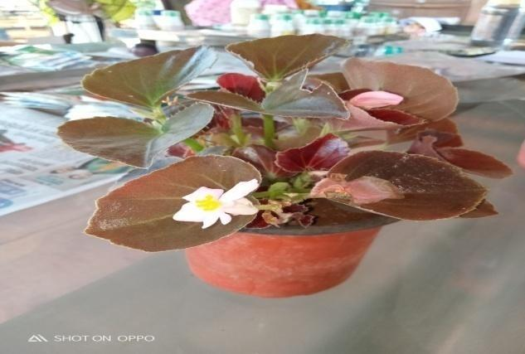
Fig 1: Begonia cucullata Plant

Extract preparation using Begonia cucullata plant: After being thoroughly cleansed with tap water, the entire plant was left to get dried in shade for 15 to 20 days. The Begonia cucullata plant was ground into a fine powder and extraction carried out using a variety of chemical solvents and pure water (distilled water) .The dried fine Begonia cucullata plant was extracted using three different organic chemicals, using a 1L Extraction device, and later decoction preparation by boiling in pure water. (Azwanida N N 2015) [21]. The Begonia cucullata plant extract was then used for additional analysis after the solvent containing the extract was allowed to evaporate. The process of aqueous extraction involved boiling the Begonia cucullata plant in 850 milliliters of distilled water up to two hours, letting it cool for a while, and then collecting the dried filtrate. (Ramesh Londonkar and Hemalatha S.A, 2024). The antimicrobial activity was evaluated with the organic extracts and aqueous extract (Fig 02). Methyl alcohol and aqueous extracts confirmed the antibacterial property for few organisms. Petroleum extract and chloroform extract did not show the antimicrobial activity for the selected strains.

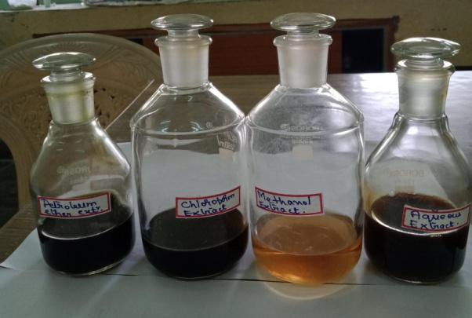
Fig 2: Begonia cucullata organic and aqueous extracts

Bacterial cultures: The antibacterial property against twelve microorganisms was tested. The below mentioned six organisms namely Escherichia coli, Bacillus cereus, Klebshella pneumonia, Pseudomonas aerogenosa, Staphylococcus aureus and Salmonella typhi were collected from the Department of Microbiology, Karnatak University, Dharwad. The following six organisms Bacillus subtilis Microbial type culture and collection (MTCC) (MTCC1427), Enterobacter aerogenes(MTCC2822) Micrococcus luteus(MTCC106) Proteus vulgaris (MTCC426) Shigella flexneri(MTCC1457) and Vibrio cholera (MTCC15025) were purchased from IMTEC, Chandigarh. The microbial cultures Bacillus cereus (MTCC 430), Escherichia coli (MTCC 443), and Klebsiella pneumoniae (MTCC 109) have been selected for the evaluation of the minimum inhibitory concentration. All three bacterial strains cultures have been preserved at storage temperature in refrigerator and retained in vials of solid microbial media. All the microorganisms have been suspended in the liquid broth medium and the inoculated vials transferred to incubator preset to 37˚C and left for 48 h of duration . The antibacterial property was tested using the Mueller Hinton agar as media.
Antimicrobial activity: The well plate method was used to test the antimicrobial property. The glass vials were labeled from 1 to 4 and organic plant extracts distributed in the first three glass vials and aqueous plant extricate dissolved in fourth glass vial .The procedures for the antimicrobial activity have been performed with standard micobiological methods. Hufford et al. (1975)[21] procedure was practiced to test the antibacterial activity of Begonia cucullata plant extract with minor alterations. The Mueller Hinton agar media was used for the antimicrobial activity. Twenty five ml of the mentioned media (45˚C) was aseptically transferred into autoclaved petriplates. Inocula containing 100µl of twenty four hours incubated cultures of have been uniformly spread upon media surface. After the solidification on molten agar, 8mm diameter holes have been made with the help of sterile borer. The plant extract of concentration 10mg/ml and 50mg/ml were used for the testing. In each plate 25µl, 50µl, 100µl of organic and water extract were loaded into the wells and the petriplates transferred to refrigerator for 60 to 90 minutes for the extract diffusion. For each microorganism as well as each for each plant extract, separate plates were prepared. After completion of 60 minutes the plates have been transferred to incubator set at 37˚C for overnight. Azithromycin (30mcg) standard disc served as positive control and solvent without plant extract to be considered negative control. The experiments were carried out as triplicates then average of all values were taken.
Minimum Inhibitory Activity: Minimum inhibitory activity was carried out with the Methanol extract of Begonia cucullata.
For the experiment antimicrobial screening the microwell plate with 96 wells attached by a lid was used. Mueller Hinton Broth was used in the test. Since the plant extract have been added by equivalent number organisms Mueller Hinton broth, it was made at a concentration double the intended final concentration. In rows P–R (in column 1), 0.2mL of the prepared plant extricate in Mueller Hinton broth has been added to the first wells. As a sterility control, column 12 contained 200 μL of the broth, while columns 2–11 in rows P–R contained 100 μL of the broth alone. Twofold serial dilutions were systematically performed starting from column 1and ending at column 10 with the help of micropipette. (From rows P–R). The process was repeated up to the last column (10) where the final 100 μL was disposed of after 100 μL was taken out of the initial concentrated broth ( 1–10 numbered columns inP–R rows) and moved to the following column with the 100 μL broth. To achieve the desired final inoculum load of 5x 10⁵ CFU/mL( Colony forming unit ) individually in a separate plate, 0.1 mL of the 1 × 10⁶Colony- forming units per milliliter microbial [Bacillus cereus labeled with accession number MTCC 430 ,Escherichia coli labeled with accession number MTCC 443, and Klebsiellapneumoniae labeled with accession number MTCC 109 ] inoculum was transferred into each well except the 12th column. Column 11 maintained as drug-free growth control column. The micro titer plates have been maintained at 37°C for 18 to 20 h, and the plant extract was prepared in several different concentrations ranging from 1000 µg/mL, 500µg/mL, 250µg/mL, 125µg/mL decreasing upto2 µg/mL. The lowest plant extract concentrations at which no bacterial growth was discernible to the unaided eye were identified visually as the Minimum Inhibition Concentrations (MIC) in the Muller Hinton broth dilutions [23].

3.Results

It may be concluded from the literature that not many studies have looked into Begonia cucullata's antibacterial properties.
The antimicrobial activity was tested with twelve different microorganisms using three organic solvent extracts and one water extract of Begonia cucullata. The extricate of chloroform and the extricate of petroleum ether prepared from powdered Begonia cucullata plant resulted in negative test with all twelve microorganisms selected to study antimicrobial activity. The microorganisms Escherichia coli, Klebsella pneumonia, Proteus vulgaris have shown Positive result with Methanol extract of Begonia cucullata at 10mg/ml concentration of plant extract (Table.1).

Table 1. Antimicrobial activity of Begonia cucullata methanol extract(10mg/ml)
Sl No. | Name of Microorganism | Methylalchohol extricate (10mg/ml)  25ul | Methylalchohol extricate (10mg/ml)  50ul | Methylalchohol extricate (10mg/ml)  100ul | Azithromycin  30mcg
1. | Bacillus cereus | - | - | - | -
2. | Bacillus subtilis (MTCC1427) | - | - | - | -
3. | Escherichia coli | - | 14 | 16 | 40
4. | Enterobacteraerogenes(MTCC2822) | - | - | - | -
5. | Klebshella pneumonia | 15 | 17 | 18 | 35
6. | Micrococcus luteus(MTCC106) | - | - | - | -
7. | Pseudomonas aerogenosa | - | - | - | -
8. | Proteus vulgaris (MTCC426) | - | - | 13 | -
9. | Staphylococcus aureus | - | - | - | -
10. | Salmonella typhi | - | - | - | -
11. | Shigellaflexneri(MTCC1457) | - | - | - | -
12. | Vibrio cholera(MTCC15025) | - | - | - | -

Escherichia coli and Klebsella pneumonia have tested positive with water extract of Begonia cucullata at 10mg/ml concentration of plant extract(Table.2 ) (Fig No3 and Fig 4)

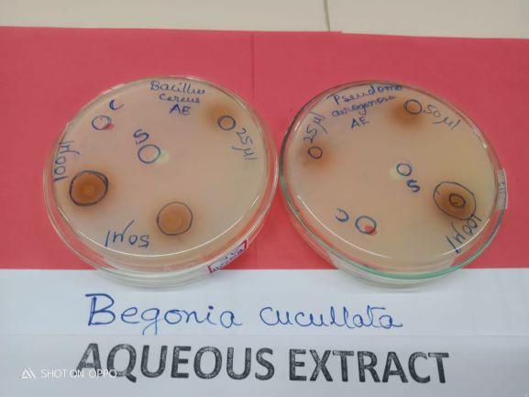
Fig 3: Antimicrobial activity of Begonia cucullata Aqueous extract (10 mg/ml)withBacillus cereus and Pseudomonas aerogenosa.

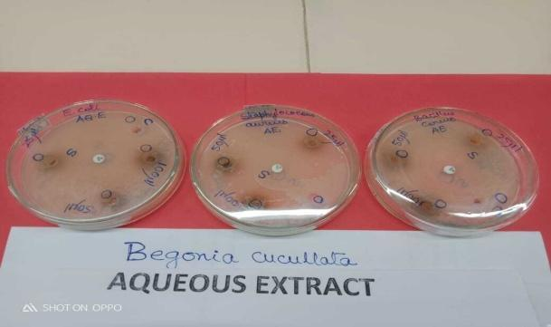
Fig 4: Antimicrobial activity of Begonia cucullataAqueous extract (10 mg/ml) with E coli, Staphylococcus aureus and Bacillus cereus.

Table 2.Antimicrobial activity of Begonia cucullata Aqueous extract.(10mg)
Sl No. | Name of Microorganism | Aqueous extract (10mg/ml)  25ul | Aqueous Extract  (10mg/ml)  50ul | Aqueous Extract  (10mg/ml)  100ul | Azithromycin  30mcg
1. | Bacillus cereus | - | 12 | 14 | 42
2. | Bacillus subtilis (MTCC1427) | - | - | - | -
3. | Escherichia coli | 13 | 18 | 18 | 40
4. | Enterobacteraerogenes(MTCC2822) | - | - | - | -
5. | Klebshella pneumonia |  | 14 | 17 | 35
6. | Micrococcus luteus(MTCC106) | - | - | - | -
7. | Pseudomonas aerogenosa | - | 14 | 14 | 08
8. | Proteus vulgaris (MTCC426) | - | - | - | -
9. | Staphylococcus aureus | - | - | - | -
10. | Salmonella typhi | - | - | - | -
11. | Shigellaflexneri(MTCC1457 | - | - | - | -
12. | Vibrio cholera(MTCC15025) | - | - | - | -

The microorganisms Klebsella pneumonia, Proteus vulgaris and other infection causing agents tested positive with methanol extract of Begonia cucullata at 50mg/ml concentration of plant extract (Table No.3).

Table 3.Antimicrobial activity of Begonia cucullata methanol extract.(50mg)
Sl No. | Name of Microorganism | Methanol extract (50mg/ml)  25ul | Methanol Extract  (50mg/ml)  50ul | Methanol Extract  (50mg/ml)  100ul | Azithromycin  30mcg
1. | Bacillus cereus | - | - | 12 | 42
2. | Bacillus subtilis (MTCC1427) | - | 18 | 18 | 32
3. | Escherichia coli | 10 | 11 | 13 | 29
4. | Enterobacteraerogenes(MTCC2822) | - | - | 12 | 15
5. | Klebshella pneumonia | 15 | 17 | 18 | 35
6. | Micrococcus luteus(MTCC106) | - | - | - | -
7. | Pseudomonas aerogenosa | - | - | - | -
8. | Proteus vulgaris (MTCC426) | - | 13 | 13 | 15
9. | Staphylococcus aureus | - | - | - | -
10. | Salmonella typhi | - | - | - | -
11. | Shigellaflexneri(MTCC1457) | - | - | - | -
12. | Vibrio cholera(MTCC15025) | - | - | - | -
Bacillus cereus and Pseudomonas aerogenosa have tested positive with water extract of Begonia cucullata at 50 mg/ml concentration (Table 4).

Table 4.Antimicrobial activity of Begonia cucullata Aqueous extract.(50mg)
Sl No. | Name of Microorganism | aqueous extract (50mg/ml)  25ul | Aqueous Extract  (50mg/ml)  50ul | Aqueous Extract  (50mg/ml)  100ul | Azithromycin  30mcg
1. | Bacillus cereus | - | 14 | 16 | 42
2. | Bacillus subtilis (MTCC1427) | - | - | - | -
3. | Escherichia coli | 13 | 18 | 18 | 40
4. | Enterobacteraerogenes(MTCC2822) | - | - | - | -
5. | Klebshella pneumonia |  | 14 | 17 | 35
6. | Micrococcus luteus(MTCC106) | - | - | - | -
7. | Pseudomonas aerogenosa | - | 16 | 16 | 08
8. | Proteus vulgaris (MTCC426) | - | - | - | -
9. | Staphylococcus aureus | - | - | - | -
10. | Salmonella typhi | - | - | - | -
11. | Shigellaflexneri(MTCC1457) | - | - | - | -
12. | Vibrio cholera(MTCC15025) | - | - | - | -

The microorganisms Bacillus subtilis, Enterobacter aerogenes, Micrococcus luteus, Pseudomonas aerogenosa, Staphylococcus aureus, Salmonella typhi, Shigella flexneri and Vibrio cholera have tested negative with methanol and water extract of Begonia cucullata at 10 mg/ml concentration. The microorganisms Escherichia coli, Bacillus subtilis, Enterobacter aerogenes, Klebsella pneumonia, Micrococcus luteus, Proteus vulgaris, Staphylococcus aureus , Salmonella typhi, Shigella flexneri, Vibrio cholera tested negative for antimicrobial activity with aqueous extract at 50mg/ml concentration. The microorganisms Micrococcus luteus, Pseudomonas aerogenosa, Staphylococcus aureus, Salmonella typhi, Shigella flexneri and Vibrio cholera tested negative with organic solvent extricate of Begonia cucullata at 50000 µg/ml concentration.
The three bacteria namely Bacillus cereus, Escherichia coli and Klebsiella pneumoniae were selected for the experiment minimum inhibitory concentration of Begonia cucullata plant extract and procedure followed was micro- broth dilution technique using microtitre plate of 96-wells (Figures 05-06).

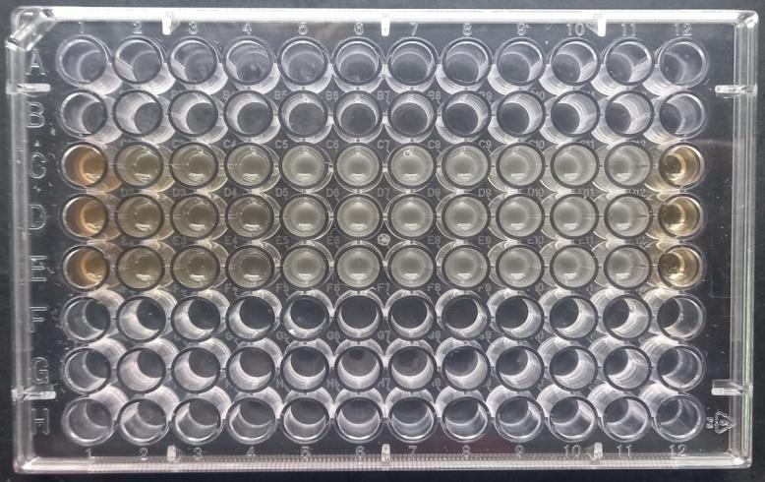
Fig 5: Determination of MIC against B. cereus

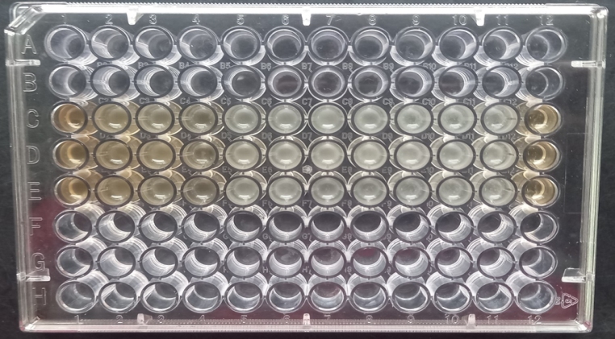
Fig 6: Determination of MIC against E. Coli

With observation it was understood that negative microbial growth appearance in columns one to four in maximum rows from P-R of concentration 1.0- 0.125 mg/mL treated against Escherichia coli and Bacillus cereus. Whilst, column 1-5 were showed no growth against Klebsiella pneumoniae(Table 5B). The tested bacteria Escherichia coli and Bacillus cereus was found to be inhibited at concentration 125µg/mL of Begonia cucullata extract (Table 5A)(Table 6). And confirmed as least concentration level to control the microbial population (Figures5-6). The MIC of plant extract against Klebsiella pneumoniae was achieved at concentrations of 62.5 µg/mL (Table No:6) and it was clearly seen in figure 5 (Table 5B, Fig 7,8,9 ) [23].

Table 5A. E coli: Begonia cucullata ME concentration and OD value.
Begonia cucullata ME conc. in µg/ml | Avg O.D at 625 nm
Medium control | 0.767
Begonia cucullata ME Conc. in µg/ml | 1.071
1000 | 1.071
500 | 1.092
250 | 1.087
125 | 1.068
63 | 1.267
31 | 1.353
16 | 1.416
8 | 1.433
4 | 1.412
2 | 1.439
0.00 | 1.303

Table 5B. KlebshellaPneumonia :Begonia cucullata ME concentration and OD value
Begonia cucullata ME conc. in µg/ml | Avg O.D at 625 nm
Medium control | 0.684
Begonia cucullata Conc. in µg/ml | 1.173
1000 | 1.173
500 | 0.843
250 | 0.857
125 | 0.810
63 | 0.920
31 | 1.816
16 | 1.244
8 | 1.261
4 | 1.264
2 | 1.248
0.00 | 1.307

Table 6: MIC determination of Begonia cucucllata Methanol Extract (ME) against various bacteria
Name of the organism | MIC (µg/mL)
Bacillus cereus | 125
Escherichia coli | 125
Klebshella pneumoniae | 62.5

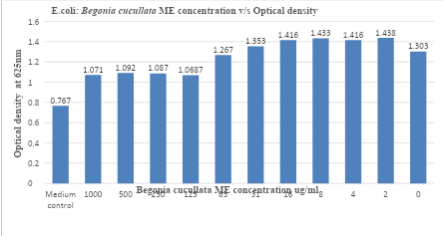
Fig 7: E.coli: Begonia cucullata ME concentration V/s Optical density
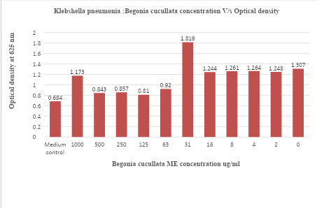
Fig 8: Klebshella pneumonia: Begonia cucullata ME concentration V/s Optical density

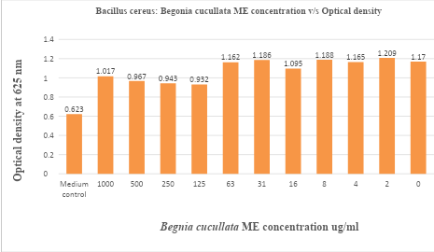
Fig 9: Bacillus cereus: Begonia cucullata concentration V/s Optical density

4. Discussion

With reference to the previous reports, the organic extracts of Begonia maculata leaf sample have shown intermediate antibacterial activity tested with reference strains like Klebsella pneumoniae and Escherichia coli . The extract of Begonia maculata leaves are resulted with high antibacterial activity (14.00mm , zone of inhibition) tested with Escherichia coli, has shown to be more susceptible to the extract of (14.00mm) with reference to to standard antimicrobial antibiotics gentamicin (CN). However, Begonia maculate extract resulted less antimicrobial property on testing with Pseudomonas aerogenosa and Klebsella pneumonia than with reference to antibiotics maintained as standard. The experiments resulted negative test for antimicrobial activity of Begonia maculata leaf sample extract with Pseudomonas aerogenosa organism. It was observed that there was no antibacterial effect found in Begonia maculata leaves extract against strain [24].
With reference to the previous reports Jeeva and Antonisamy (2012) [25] studies namely the germicidal properties and biochemical analysis of Begonia floccifera Bedd organic extract of flower sample tested with many reference microbial cultures . The germicidal property was experimented with the methanol extricate of Begonia flocciferra was tested using the reference microbial cultures resulted difference in the antimicrobial property. 28mm resulted with the Bacillus cereus was highest diameter of the zone of inhibition, 25mm resulted with the bacteria labeled as gram positive,15 mm measured with the strain designated as gram negative, 13mm for Proteus mirabilis, 7mm for Klebsella pneumonia. In addition several infectious microorganisms showed lesser susceptibility to inhibitory effect by extract tested. With comparing the results of Begonia cucullata methanolic extract antibacterial activity with the results of Begonia floccifera methanolic extract antibacterial activity (Jeeva and Antonisamy,2012) [25] similar results are observed with the microorganisms namely Escherichia coli, Bacillus cereus and Klebsella pneumonia with zone of inhibition for Escherichia coli was13mm, Bacillus cereus was 18mm and Klebsellapmeumonia was 14mm [25] .
With reference to the previous report, the experiments of antimicrobial property of Begonia cordifolia using organic and aqueous extract , methyl alchohol and and water extricates have been tested positive for the germicidal property with Vibrio harvayie and Pseudomonas aeroginosa. The Begonia cordifolia methanolic extract showed the largest zone of inhibition against Vibrio harvayie and aqueous extract shows minimum antimicrobial activity [18]. Compounds are frequently extracted using organic solvents like methyl alchohol, ethyl alchohol and acetone. (Elofff,1998) [27]. Begonia cordifolia methanolic extract demonstrated strong antibacterial activity against Vibrio harvayie and Escherichia coli.The Begonia cordifoliaextract efficiencymainly confirmed with the selection of solvent utilized[18]. When compared to aqueous extracts, the organic extracts of Begonia malabarica exhibited more antibacterial activity. All ten of the examined bacteria were susceptible to the effects of the chloroform and methanol extract (Ramesh et al 2002) [28].The antimicrobial property was shown by water extract of Begonia cucullata plant against the microorgansims Bacillus cereus, Escheresia coli, Klebsella pneumonia and Pseudomonas aerogenosa .The aqueous extract from Begonia cucullata exhibited antibacterial action against Pseudomonas aerogenosa and zone of inhibition was 16 mm and the standard shown the zone of inhibition of 8mm. Studies reveal that the water extract of Begonia cordifolia showed minimum antibacterial activity against pseudomonas aerogenosa with zone of inhibition 12mm [18]. The reports reveal that water extract from leaves of P. ocerifolium have resulted eminent antibacterial property with several disease causing microorganisms. (Thatoi et al 2008)[29].The organic and water extracts of Begonia cucullata were assessed in this study to determine their antibacterial activity against a variety of microorganisms. Reports explain that different extracts of of Begonia cordifolia were experimented for exploration of their antimicrobial activity against reference strains [18]. The present study may be helpful in the treatment of diseases and infections caused by several bacterial strains as both aqueous and methanol extracts of Begonia cucullata plant have been shown antimicrobial activity with four to eight microbial strains respectively , and can used in medication as an alternative to antibiotics. A few active compounds in plants identified as secondary metabolites may be the cause of the antibacterial activity found in a specific portion of a species. (Baladrin and Kloeke 1988)[26]. The limitation of the present research work is the antifungal activity of the Begonia cucullata plant extract is not included in the study.

5. Conclusion

The present study showed that Begonia cucullata contain potential antimicrobial components and could be reservoir of advanced active principles. For the development of antibacterial drugs, more research is needed to identify bioactive chemicals and understand how they work [18].

Abbreviations
KFDA Korean Federation of Drug and Administration
MTCC Microbial Type Culture Collection and Gene Bank.
IMTEC Institute of Microbial Technology
CFU Colony Forming Unit
MIC Minimum Inhibitory Concentration
ME Methanol Extract
CN Gentamicin

Data Availability Statement
Data sharing not applicable to this article as no datasets were generated or analyzed during the current study.

Declarations

Ethics approval and consent to participate
Not applicable

Consent of Publication
Not applicable

Plant details

The plant Begonia cucullata selected for thr present study is a cultivated variety and collected from the Nurseries of Pune, Maharashtra, India .

References

- EdiogalHO,okwuDE,MbaebieBO.Phytochemical constituents of some Nigerian medicinal plants Afr J Biotech 2005;4:685-688
- Mahesh B, Satish S. Antimicrobial activity of some important medicinal plants against plant and Human pathogens. World J Agri. Sci 2008;4:839-83.
- Ahmad I,AqilF.In vitro efficacy of Bioactive extracts of 15 medicicnal plants againstESbL- producing multidrug resistant enteric bacteria. Microbiol Res 2007;162:264-275.
- Batrbour EK, Al Sharif M,sagherianVK,Habre AN, Talhook RS. Screening of selected indigenous plants of Labanon for antimicrobial activity. J of ethanopharmacol 2004,93:1-7
- Iwu MW, Duncan AR,Okanji CO. New antimicrobials og plant origin In:Perspectives on new crops and new Uses,eds J Janick AS press, ASHS press, Alexandria VA , 1999;457-462.
- Tomoko N,Takashiet al, Antimicrobial activity of extracts prepared from tropical and subtropical plants on Methicillin-resistant Staphylococcus aureus J Health sci; 2002,48: 273-276.
- Moglad, E.H., Alhassan, M.S., Abdalkareem, E. A., Abdalla, A.N., Kuse, M, 2019. Ethyl acetate fraction of Solanumnigrum L: Cytotoxicity, induction of apoptosis, cell cycle in breast cancer cells, and gas chromatography-mass spectrometry analysis. Asian J. Pharm. 13(3), 246-251.
- Huges,M.,Peng,C.-1.,Lin,C.- W.,Rubite,R.R.,Blanc,P.,Chung,K.-F.(2018).Chloroplast and nuclear DNAexchanges among Begonia sect.Baryandra species( Begoniaceae) from Palawan Island, Philipines and descriptions of five new species. In Plos One Vol.13(5),eo194877.httos://doi.org/10.1371/journal.pone.019487.
- Tibbett, M.C., (2005).Begonias: Cultivation, Identification, and Natural History. Timber Press, Portland.
- Ramesh Londonkarand Hemalatha S.A.(2024)Preliminary Phytochemicals Investigation in Begonia cucullata.International Journal of Pharmaceutical and Bio -Medical Science; 2024,04:370-377.
- Pandikumar,et al., 2007, Medicina plants used by Malasam tribes of Coimbatore district, Tamil nadu. Indian J Tradit know,6 (4), 2007,579-582.
- Amutha S et al., (2016). Evaluation of Antimicrobial Activity of Different solvent extracts of Begonia cordifolia. International Journal of Zoology and Applied Biosciences; 2016, 1(3):144-147.
- Holetz., F.B., Pessini,G.L., sanches, N.R., Cortez., D.A.,Nakamura, C.V.,Filho,B.P.2002.Screening of somr plants used in Brazalian folk medicine for the treatment of infectious diseases. In Mem. Inst. Oswaldo Cruz, vol.97,p.1027-1031
- Indrakumar,I., Gomati,R.,Karpagam, S.2014. Antimicrobial and Invitro Antioxidant Potential of Begonia dipetala Graham. In Int. J. Pharm. Sci. Rev.Res.,vol.27(2),p.382-386
- Shrestha,N.,Itani, R., Khanal., D.P.2016. Pharmagnostic, phytochemical, antioxidant and antibacterial activity studies on Begonia Picta.In World Journal of Pharmaceutical research, volil.5(1),p.979-997.
- Karpova E .A.,et al., 2009. Flavonoids and ascorbic acid in representatives of the genus Begonia L, In Khimiyarastitel’nogosyrya(Chemistry of the raw material ) vol.2, p.105-110.
- Tsybulya,N .V., et al., 2010.Examination of the antimicrobial activity of some g, BegoniaL.species as a possible piece odphytodesign. In Aerokosmischeskayaiekologicheskayameditsina( Aerospace and Environmental Medicine),vol.44(1),p.47-50 (In Russian).
- Amutha S et al., (2016). Evaluation of Antimicrobial Activity of Different solvent extracts of Begonia cordifolia. International Journal of Zoology and Applied Biosciences; 2016, 1(3):144-147.
- TkachenkoHalynaet al., 2017. The Antimicrobial Properties of Extracts obtained from Begonia goegoensis N E Br leaf against Pseudomonas aerogenosa isolates. Agrobiodiversity 2017.2585-8246.454-460.
- Evgeniyakarpova, et al., (2019). Phenolic compounds and antimicrobial properties of BegonisgrandisDryand.subsp.grandisleaves.Botanica Pacifica. A Journal of Plant Science and conservation 2019.8(2):51-61
- BuynLyudymulaet al., 2019. Screening for antmicrobial activity of nine ethanolic extracts obtained from leaves of Begonia Plant: A possible alternative in the treatment of infections caused by Citrobacterfreundii.Agrobiodiversity. 2019.2585-8286.312-322.
- Azwanida, NN.,( 2015)A review on the extraction method use in medicinal plants, principle, strength and limitation. Medicinal and aromatic plants; 4(3): 1-6.
- Hufford,C.C., et al .,1975. Two antimicrobial alkaloids from heartwood of Liriodendron tolipifera L. Journal of Pharmaceutical Sciences 64, 789-792.
- Wiegand I., K. Hilpert, and R. E. W. Hancock, “Agar and broth dilution methods to determine the minimal inhibitory concentration (MIC) of antimicrobial substances,” Nature Protocols, vol. 3, no. 2, pp. 163–175, 2008.
- Bursalioglu EO (2020). Evaluation of antibacterial activity of Triticum monococcum seeds, Castanea sativa seeds and Begonia maculata leaves against several bacterial strains, Turk J Biod3(1): 9-11.
- Jeeva, S.,Antonisamy, J.M.2012. Antibacterial and phytochemical studies on methanolic extracts of Begonia flocciferaBedd. Flower. In Asian Pacific journal of Tropical Biomedicine, vol.2(1 suppl.)p.S151-S154.
- Baladrin, M.J. and Kloeke,J.A.,1988, Medicinal aromatic and industrial materials from plants. Springer, Verlog, Berlin, pp.1-36.
- Eloff,J.N., 1998. Which extractant should be used for the screening and isolation of antimicrobial components from plants? J. Ethnopharmacol.,60.1-8.
- Ramesh et al., 2002.Phytochemical and antimicrobial studies of Begonia malabarica. In J. Ethnopharmacol., vol79(1), P.129-132.
- Thatio,H.N.,Panda, S.K.and Dutta S.K.,2008. Antimicrobial activity and ethno medicinal uses of some medicinal plants from Similipal Biosphere reserve, Orissa. Asian Med J. Plant Science,(7)3,260-267.

