*Original Research Article*

Detection of Plasmid-Mediated Extended-Spectrum β-Lactamase genes (*bla* CTX-M) in Enterobacteriaceae Isolated from the Oral Cavity of Patients in a Dental Clinic in Abidjan (Côte d’Ivoire)

.

ABSTRACT

|  |
| --- |
| **Aims:** The oral cavity represents one of the most complex and densely colonized environments of the human body, harboring a diverse microbiota including bacterial and fungal communities. Antimicrobial resistance has emerged as a pressing global health concern, with particularly severe implications for low-resource settings. This study aimed to assess the antibiotic resistance profiles of extended-spectrum β-lactamase (ESBL)-producing Enterobacteriaceae strains isolated from the oral cavity.  **Methodology:** samples were collected from patients presenting with dental disorders for the isolation and characterisation of ESBL-producing Enterobacteriaceae from the oral cavity. Plasmid DNA was extracted using the phenol-chloroform method, and conventional PCR was employed to detect the presence of plasmid-borne resistance genes *bla CTX-M-2* , *bla CTX-M-8* , and *bla CTX-M-9*  **Results:** Four Enterobacteriaceae strains were successfully isolated and characterized, corresponding to an isolation rate of 5.40% (4/74). Among these, 60% harbored the *bla CTX-M-2* and *bla CTX-M-8* resistance genes. The *bla CTX-M-9* gene was not detected in any of the isolates.  **Conclusion:** Although uncommon in the oral cavity, the emergence of Enterobacteriaceae in this niche may represent a potential public health concern. The presence of ESBL-producing strains could contribute to therapeutic failures or limited treatment options, particularly if antibiotic prescribing guidelines are not adequately followed by healthcare professionals. |

*Keywords: [Antibiotic resistance, Oral cavity, ESBL-producing Enterobacteriaceae, Resistance genes)*

1. INTRODUCTION

From birth, humans are exposed to a diverse array of microorganisms including bacteria, archaea, viruses, and fungi which colonize various anatomical sites such as the skin, gastrointestinal tract, respiratory system, oral cavity, and urogenital tract. This complex microbial community, known as the microbiota, establishes a symbiotic relationship with the host, contributing to a dynamic state of equilibrium referred to as homeostasis (Langella, 2017; Doré, 2017). Studies have shown that this host–microbiota interaction plays a fundamental role in maintaining immune function, metabolic balance, and protection against pathogens (Lozupone et al., 2012; Burcelin, 2017; Candela et al., 2008)

The oral cavity, due to its anatomical position and physiological function, is one of the most septic sites in the human body. It harbours a dense and diverse microbial and fungal flora, with over 500 different species identified to date (Moore et al., 2000). Les affections bucco-dentaires, majoritairement infectieuses, comprennent les caries dentaires et les maladies parodontales graves. Les caries non traitées représentent la pathologie de santé la plus fréquente à l’échelle mondiale, affectant environ 2,5 milliards de personnes (Peres et al., 2019).

Antibiotics are widely used for the treatment and prevention of bacterial infections. However, antibiotic resistance arises when bacteria evolve in response to exposure to these drugs, resulting in infections that are increasingly difficult to treat in both humans and animals. Antimicrobial resistance (AMR) poses a significant threat to global health, particularly in low-resource settings, where access to effective treatment options is limited (O'Neill, 2016; Ventola, 2015)

In many African countries, antimicrobial use is poorly regulated, with self-medication and over-the-counter antibiotic sales contributing significantly to the rise of resistant infections (Ayukekbong et al., 2017; Essack, 2017). In Côte d’Ivoire, a clinical study in maxillofacial surgery highlighted pain, swelling, and suppuration as the main symptoms among infected patients (Chechom, 2010), with socio-economic factors such as low purchasing power and access to informal pharmaceutical markets exacerbating the spread of resistance (Okeke et al., 2005).

Over the past two decades, infections caused by multidrug-resistant Gram-negative bacteria have emerged as a major public health concern in developing countries (Shakibaie et al., 2012). In Côte d’Ivoire, the rising resistance of bacteria to antibiotics—particularly the emergence of extended-spectrum beta-lactamase (ESBL)-producing Enterobacteriaceae—represents a significant healthcare challenge (Dadié et al., 2003; Akoua-Koffi et al., 2004; Gbonon et al., 2007).

Several studies have documented the presence and dissemination of ESBL-producing strains in human-derived Enterobacteriaceae (Guessennd et al., 2008a), as well as in isolates of animal and environmental origin (Ouattara et al., 2014). Enzymes of the TEM, SHV, and CTX-M families have notably been identified in human strains (Toty et al., 2016; Guessennd et al., 2008b).

This study seeks to investigate whether Enterobacteriaceae isolated from the oral cavity harbour plasmid-encoded ESBL genes, to identify the types of ESBLs produced, and to characterise the genetic determinants involved.

2. material and methods

**2.1 Study Design and Setting**

This was a prospective, descriptive study conducted from August to October 2023 at the Private Catholic Hospital “Saints-Cœurs” in Abobo-Té, Abidjan. The investigation focused on the epidemiological, clinical, and bacteriological aspects of oral and dental infections. Patients were recruited from the dental surgery department of the hospital. All biological samples were processed at the Institut Pasteur of Côte d’Ivoire, specifically at the Clinical Bacteriology Unit in Cocody and the Molecular Biology Platform in Adiopodoumé.

**2.2 Sample Collection Procedures**

Samples were collected from all patients with suspected oral infections by seringe aspiration (closed purulent collections) or by sterile swab collection after cleansing the wound with diluted antiseptic soap and rinsing with sterile water.

**2.3 Bacteriological Analyses**

**2.3.1 Isolation and Purification of Colonies**

Upon reception, samples were promptly cultured to prevent contamination. The swab was streaked over MacConkey agar, a selective medium for Enterobacteriaceae.

After 24 hours of incubation, colonies were subcultured on fresh MacConkey agar to obtain pure isolates.

**2.3.2 Strain Identification**

Identification was conducted using the API 20E system (bioMérieux), designed for Enterobacteriaceae.

**2.4 Plasmid DNA Extraction Using Phenol-Chloroform Method**

Genomic DNA was extracted using a modified phenol–chloroform protocol. Briefly, 500 µL of the biological sample was incubated at 95 °C for 10 minutes to initiate cell disruption. Lysis was performed by adding 1 mL of lysis buffer and 50 µL of proteinase K, followed by incubation at 55 °C for 1 hour and then 97 °C for 10 minutes. After centrifugation (14,000 rpm, 6 min), the supernatant was transferred to a new tube. To remove proteins, 250 µL of phenol: chloroform:isoamyl alcohol (25:24:1) was added. The aqueous phase was then recovered and extracted once more using 250 µL of chloroform: isoamyl alcohol (24:1). DNA was precipitated by mixing the aqueous phase with 200 µL of absolute ethanol and 15 µL of 3 M sodium acetate, followed by incubation at −80 °C for 10 minutes. The DNA pellet was washed with 70% ethanol, centrifuged, and air-dried before being resuspended in 100 µL of elution buffer and incubated at 37 °C for 2 hours. DNA integrity was verified by 1% agarose gel electrophoresis, while purity and concentration were assessed using a NanoDrop™ One spectrophotometer. A 260/280 ratio of ~1.8 was considered indicative of pure DNA, whereas lower or higher values suggested protein or RNA contamination, respectively (Sambrook & Russell, 2001; Green, 2017).

* 1. **PCR Amplification of ESBL-Encoding Genes**

Detection of extended-spectrum beta-lactamase (ESBL) genes (*bla*CTX-M) was performed using conventional PCR (Table.1). The reaction mix included: 4 µL of 5X FirePol Master Mix (Solis Biodyne), 7 µL of nuclease-free water, 2 µL of each primer, and 5 µL of extracted DNA, totalling 20 µL. Amplification was carried out in an Eppendorf thermocycler. The PCR programme was as follows: Initial denaturation at 94°C for 5 minutes, denaturation at 94°C for 30 seconds (×35 cycles), Annealing at 55°C for 60 seconds, extension at 72°C for 60 seconds and final extension: 72°C for 10 minutes. The total PCR run lasted 92 minutes. Amplified products were separated on 1.5% agarose gels for 40 minutes and visualised using a Gel Doc imaging system (BIO-RAD)

**Table 1. Sequence of ESBL genes primers**

| **Target gene** | **Primers** | **Sequence (5′–3′)** | **Amplicon**  **Size (bp)** | **References** |
| --- | --- | --- | --- | --- |
| *blaCTX-M-2* | CTX-M2-F / CTX-M2-R | F: ATGATGACTCAGAGCATTCG  R: TTATTGCATCAGAAACCGTG | 884 | **Bauerfeind et al**., 1996; **Steward**, 2001 |
| *blaCTX-M-8* | CTX-M8-F / CTX-M8-R | F: ATGATGAGACATCGCGTTAAG  R:CGTGGACGATTTTTCCGCGGCAG | 864 | **Chmelnitski** et al., 2005 |
| *blaCTX-M-9* | CTX-M9-F / CTX-M9-R | F:ATGGTGACAAAGAGAGTGCA  R: CCCTTCGGCGATGATTCTC | 651 | **Eckert** et al., 2004 |

3. results and discussion

**3.1 Results**

**3.1.1 Epidemiological and clinical profile of patients**

Among the 74 patients presenting with oral and dental infections included in the study, 30 were male and 44 were female, yielding a sex ratio of 0.68.  
Participants ranged in age from 4 to 48 years (Table 2). Pain was the most common reason for consultation (100%), followed by swelling (4.05%), suppuration (4.05%), and fever (1.35%).  
Periodontitis was the most frequently observed condition, accounting for 67.56% of cases.

**Table 2. Patients epidemiological and clinical characteristic**

|  |  |  |  |
| --- | --- | --- | --- |
| **Variable** | **Category** | **Frequency (n)** | **Percentage (%)** |
| Age | 0 -15 | 3 | 4,05 |
| 16-31 | 45 | 60,81 |
| 32-47 | 25 | 33,78 |
| >48 | 1 | 1,35 |
| Sex | Male | 30 | 40 ,54 |
| Female | 44 | 59,46 |
| Dental pathology | Cellulitis | 3 | 4,05 |
| Periodontal abscess | 50 | 67,56 |
| Gingivitis | 21 | 28,37 |

**3.1.2 Microbiological Data**

Four samples tested positive, corresponding to a positivity rate of 5.40% for Enterobacteriaceae specifically isolated from the oral cavity (Table VII). The main species identified were *Klebsiella oxytoca*, *Enterobacter aerogenes*, *Enterobacter cloacae*, and *Klebsiella pneumoniae*. These isolates were primarily associated with cellulitis (40%) and periodontal abscesses (40%). The most frequently affected teeth were the first mandibular molars.

**III.1.4 Molecular Data**

Following DNA extraction, optical density measurements using a spectrophotometer were recorded, revealing that 80% of the extracted DNA was of acceptable purity.  
Prior to PCR, electrophoresis confirmed the presence of extracted DNA.  
post-PCR agarose gel electrophoresis enabled the detection of resistance genes in Enterobacteriaceae isolates, and electrophoretic profiles were visualised (Figures 1 and 2).

The genes (*Bla CTX-M-2 and Bla CTX-M-8*) were amplified in all the enterobacteria strains isolated; however, the *Bla CTX-M-9* gene was not amplified in any of the strains (Table 3).

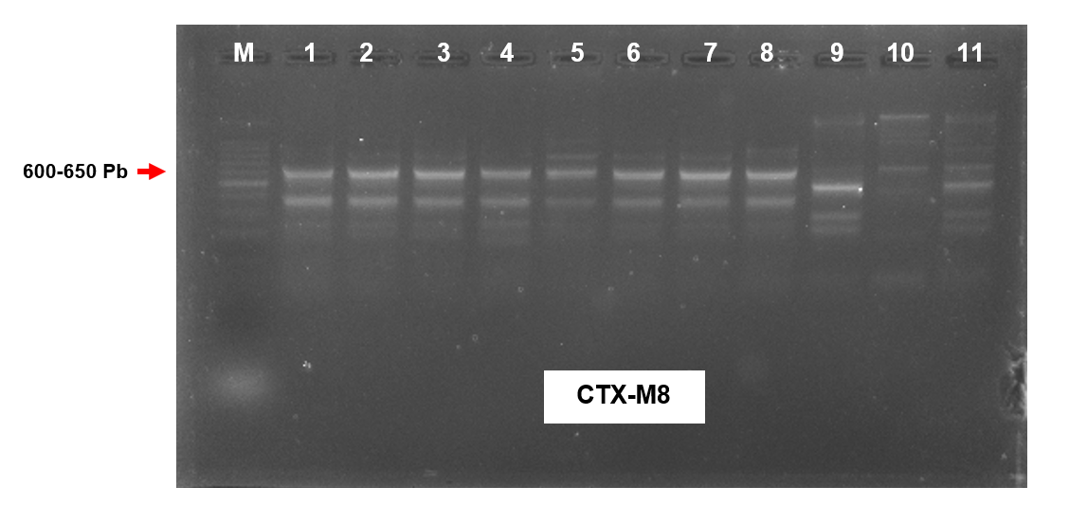.

**Fig. 1. Electrophoretic profile of CTXM 8 genes**

*M: Molecular weight marker; Samples (1, 2): Klebsiella oxytoca; Samples (3,4,5): Enterobacter aerogenes ; Samples (6,7,8,) :Klebsiella pneumoniae, samples (9,10,11) Enterobacter cloacae*

**M 1 2 3 4 5 6 7 8 9 10 11**

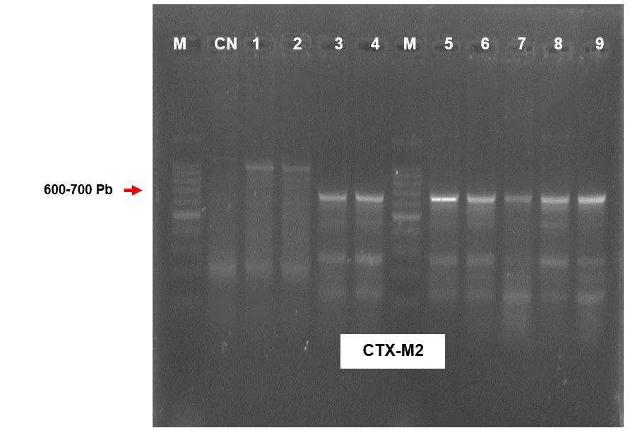

**Fig. 2. Electrophoretic profile of CTXM 2 genes**

*M: Molecular weight marker; Samples (1, 2)* Pseudomonas *aeruginosa; Samples (3, 4, 5,6):* Klebsiella*. oxytoca; Samples 7:* Enterobacter *aerogenes; Samples (8, 9): Klebsiella pneumoniae; CN : Negative Control*

**Table 3. Enterobacterial strains amplified genes**

|  |  |  |  |
| --- | --- | --- | --- |
| **Enterobacteria strains (n=4)** | **gene *bla* CTX-M2** | **gene *bla* CTX-M8** | **gene *bla* CTX-M9** |
| *Klebsiella oxytoca (n=1)* | Positive | Positive | Negative |
| *Enterobacter aerogenes (n=1)* | Positive | Positive | Negative |
| *Klebsiella pneumoniae (n=1)* | Positive | Positive | Negative |
| *Enterobacter cloacae (n=1)* | Positive | Positive | Negative |

**3.2 Discussion**

**Sex and Age Distribution**

Increased susceptibility to Enterobacteriaceae infections among females has been reported in multiple studies, although findings remain inconsistent. For instance, (Zrardi, 2020) noted a female predominance in oral infections, while (Gadegbeku et al,2000) found no statistically significant gender difference in stomatological infection prevalence. Age-related vulnerability was also evident, with studies such as (Dia et al, 2015) in Dakar reporting higher infection rates in individuals aged 35–60 years, consistent with our observations.

**Socioeconomic Factors and Oral Hygiene**

Limited financial means and unemployment may impede access to oral hygiene resources and dental care. (Gadegbeku et al. 2000) previously associated low socioeconomic status with increased incidence of oral infections, reinforcing our findings where 40.54% of patients were unemployed.

**Reasons for Consultation and Self-medication Practices**

Pain was the most commonly reported symptom (100%), followed by swelling and suppuration—findings echoed in (Chechom’s ,2010) study on maxillofacial infections in Abidjan. Self-medication was reported in 75% of our patients, aligning with a Brazilian study by (de Paula et al., 2014), which documented high rates of non-prescribed drug use. By contrast, studies in Burkina Faso (Kaboré et al., 2016) and Abidjan (Souaga et al., 2000) recorded lower frequencies (30.4% and 37.3%, respectively), indicating geographic and cultural variation in self-care behaviours.

**Enterobacteriaceae Isolation in the Oral Cavity**

Enterobacteriaceae were isolated in 5.4% of oral samples, a finding close to that of (Kaboré et al.,2016) in Burkina Faso (3.2%). While infrequent, the detection of these bacteria in the oral cavity supports the concept of microbial imbalance due to ecological and behavioural factors such as poor hygiene, reflux, or traditional medicine use.

**Antibiotic Resistance and ESBL Genes**

Our results confirm the circulation of ESBL-producing Enterobacteriaceae in the oral environment, with 60% of isolates carrying blaCTX-M-2 or blaCTX-M-8 genes, a trend also seen in Algeria (Lagha, 2015) and other regions. These genes confer resistance to third-generation cephalosporins and are often plasmid-mediated, facilitating horizontal gene transfer (Gassama, 2004; Rôcas et al.,2013).

In response to the global expansion of ESBL and carbapenemase-producing organisms, the (WHO, 2023) advocates for surveillance systems targeting resistance genes and the integration of rapid diagnostics to guide antimicrobial stewardship and infection control.

4. Conclusion

The primary objective of this study was to detect resistance genes in extended-spectrum β-lactamase (ESBL)-producing Enterobacteriaceae isolated from the oral cavity. Through this investigation, the prevalence of such isolates within the oral microbiota was established. Although infrequent, these bacteria represent a significant public health concern due to their potential to cause serious oral infections and contribute to antimicrobial resistance. A notable observation was the widespread practice of self-medication among patients, including the use of unregulated ‘street medicines’, often driven by limited access to healthcare services and financial constraints. Furthermore, molecular characterisation of the isolates revealed the presence of plasmid-mediated resistance genes, particularly *blaCTX-M-2* and *blaCTX-M-8.*

Consent

All authors declare that ‘written informed consent was obtained from the patient (or other approved parties) for publication of this case report and accompanying images. A copy of the written consent is available for review by the Editorial office/Chief Editor/Editorial Board members of this journal

Ethical approval

The study received formal approval from the Pasteur Institute of Côte d'Ivoire. Patient anonymity and the confidentiality of all collected data were strictly maintained throughout the research process, in accordance with ethical standards for biomedical research involving human participants. Each participant was informed about the study's objectives, data collection procedures, potential benefits, and associated risks. Informed consent was obtained from all participants prior to inclusion in the study.

References

Langella P. Host-microbiota interactions: from symbiosis to human health.

In: Microbiota and human health. MICALIS, INRAE. 2017. Available at: https://www.micalis.fr/equipe/probihote/

Doré J. Gut microbiota. Giens Workshop, 2017. Available at: https://www.collectif-schizophrenies.com/images/pdf/recherche/2017_Dore_Therapies_AtelierGiensMicrobiote_FR.pdf

Lozupone CA, Stombaugh JI, Gordon JI, Jansson JK, Knight R. Diversity, stability and resilience of the human gut microbiota. Nature. 2012.489(7415):220-230. https://doi.org/10.1038/nature11550

Burcelin R. Intestinal microbiota and immune crosstalk during metabolic disease.

Journal of Biology. 2017.1:1-10. Available at: https://www.biologie-journal.org/articles/jbio/pdf/2017/01/jbio170008.pdf

Candela M, et al. Interaction of probiotic Lactobacillus and Bifidobacterium strains with human intestinal epithelial cells. International Journal of Food Microbiology. 2008.125(3):286-292.

https://doi.org/10.1016/j.ijfoodmicro.2008.04.021

Moore, W. E. C., & Moore, L. V. (1994). The bacteria of periodontal diseases. Periodontology 2000, 5(1), 66-77.

World Health Organization. Global Research Agenda for Antimicrobial Resistance in Human Health. Geneva: fathers. 2023.

O’Neill, J. (2016). Tackling drug-resistant infections globally: final report and recommendations.

Ventola, C.L. (2015). The antibiotic resistance crisis: part 1: causes and threats. Pharmacy and therapeutics, 40(4), 277.

Ayukekbong JA, Ntemgwa M, Atabe AN. The threat of antimicrobial resistance in developing countries: causes and control strategies. Antimicrobial Resistance & Infection Control. 2017.6:47. https://doi.org/10.1186/s13756-017-0208-x

Essack, S. Y., Desta, A. T., Abotsi, R. E., & Agoba, E. E. (2017). Antimicrobial resistance in the WHO African region: current status and roadmap for action. Journal of Public Health, 39(1), 8-13.

Chechom N. Study of the bacteriological profile of infections in stomatology and maxillofacial surgery in Abidjan (Côte d'Ivoire). Doctoral thesis in Medicine, University of Cocody, Abidjan, 2010.

Okeke IN, Laxminarayan R, Bhutta ZA, Duse AG, Jenkins P, O'Brien TF, et al.

Antimicrobial resistance in developing countries. Part I: recent trends and current status.

Lancet Infect Dis. 2005 Aug.5(8):481–93. https://doi.org/10.1016/S1473-3099(05)70189-4

Shakibaie, M. R., Adeli, S., & Salehi, M. H. (2012). Antibiotic resistance patterns and extended-spectrum β-lactamase production among Acinetobacter spp. isolated from an intensive care Unit of a hospital in Kerman, Iran. Antimicrobial resistance and infection control, 1, 1-8.

Dadie A.T., Guessennd N., Tiekoura B., Faye-Kette H. & Dosso M (2003). Resistance to beta-lactams of Escherichia coli of food and human origin isolated in Abidjan. Journal of Pharmaceutical and Biological Sciences, 4: 62-69. 5:66-77.

Akoua-Koffi C., Guessennd N., Gbonon V., Faye-Ketté H. & Dosso M. (2004). Methicillin resistance of Staphylococcus in Abidjan 1998-2001: A new problem. Medicine and Infectious Diseases. 34: 132-136.

Gbonon V.C., Guessennd K.N., Kouassi M’bengue A., Kacou N’douba A., N’guessan K.R., Faye-Kette H., Dosso M. & Mignonsin D. (2007). Bacteriological controls of the operating room environment in a developing country: the case of Treichville University Hospital in Abidjan in 2000. Bio-Africa Review, 4: 7-11.

Guessennd N., Kacou-N’Douba A., Gbonon V., Yapi D., Ekaza E., Dosso M., Courvalin P (2008a) Prevalence and resistance profile of extended-spectrum beta-lactamase-producing Enterobacteriaceae in Abidjan from 2005 to 2006... Journal of Pharmaceutical and Biological Sciences, 9: 63-70.

Baguy, O. M., Nathalie, G. K., David, C. N. G., Daniel, S. N. G., Julien, C. K., Rose, K. N., ... & Mireille, D. (2014). First report of qnr genes in multidrug resistant (ESBL) enterobacteria isolated from different ecosystems in Abidjan, Ivory Coast. AMC, 21, 16.

Toty A.A., Guessennd N., Akoua-Koffi C., Otokoré D.A., Meex C., Mbengue G.V., Djaman A.J., Dosso M., Galleni M (2016). First Detection of TEM-116 and SHV-75-Producing Enterobacteria Isolated from Two Ivorian Teaching Hospitals: Case of Abidjan and Bouaké. International Journal of Current Microbiology and Applied Sciences 5: 1-9.

Guessennd N., Bremont S., Gbonon V., Kacou-NDouba A., Ekaza E., Lambert T., Dosso M. & Courvalin P (2008b). Resistance to QNR quinolones in Enterobacteriaceae producing extended-spectrum beta-lactamases in Abidjan, Côte d'Ivoire. Pathology Biology, 56: 439-446.

Sambrook J, Russell DW. Molecular Cloning: A Laboratory Manual. 3rd ed. Cold Spring Harbor Laboratory Press. 2001.

Green, M.R., & Sambrook, J. (2017). Isolation of high-molecular-weight DNA using organic solvents. Cold Spring Harbor Protocols, 2017(4), pdb-prot093450.

Bauerfeind, A., I. Stemplinger, R. Jungwirth, S. Ernst and J.M. Casellas (1996). Sequences of the β-lactamase genes encoding CTX-M-1 (MEN-1) and CTX-M-2 and r Relation of their amino acid sequences with those of other β-lactamases. Journal of Antimicrobial Agents and Chemotherapy 40: 509-513.

Chmelnitski I., Carmeli Y., Leavitt A., Schwaber MJ., and Navon-Venezia S (2005). CTX-M-2 and a novel enzyme CTX-M-39 are the major extended-spectrum β-lactamases in several Escherichia coli clones isolated in Tel Aviv, Israel. Journal of Antimicrobial Agents and Chemotherapy . 49(11): 4745-4750

Eckert, V. Gautier, M. Saladin-Allard, N. Hidri, C. Verdet, Z. Ould-Hocine, G. Barnaud, F. Delisle, A. Rossier, T. Lambert, A. Philippon, G. Arlet, (2004). Dissemination of CTX-M-type β-lactamases among clinical isolates of Enterobacteriaceae in Paris. 48(4):1249-55.

Zrardi N. Prevalence of oral bacterial infections linked to Enterobacteriaceae. Dissertation, Rabat. 2020.

Gadegbeku B, et al. Epidemiological aspects of oral infections in hospitals in Lomé. Med Afr Noire. 2000.47(5):240–244.

Dia I, et al. Oral infections of bacterial origin in Senegal. Odonto-Stomatol Trop. 2015.38(149):39–44.

De Paula EP, et al. Self-medication in dental pain: prevalence and associated factors. BMC Oral Health. 2014.14:96. https://doi.org/10.1186/1472-6831-14-96

Kaboré WAD, Konaté A, Dembélé R, Konaté K, Faye B, Ouédraogo D, et al., (2016) Occurrence and antibiotic susceptibility of Aerococcus and Enterococcus strains isolated from acute and chronic cellulites of dental origin in Ouagadougou, Burkina Faso. Journal of Dental Oral Care Medicine. 2:1–7.

Souaga K, et al. Self-medication in dental surgery in Abidjan. Odonto-Stomatol Trop. 2000.23(89):31–35.

Lagha R. Prevalence of ESBLs in Enterobacteriaceae in Algeria. Rev Med Microbiol. 2015.25(2):147–153.

Gassama AS (2004). Study of the role of integrons in multidrug resistance in enteropathogenic bacteria isolated in sub-Saharan Africa. Doctoral thesis, University of Limoges, France, 97p.

Rôcas IN, Siqueira Jr JF (2013). Detection of antibiotic resistance genes in samples from acute and chronic endodontic infections and after treatment. Archive Oral Biology. 58:1123–1128.

World Health Organization. (2023). Antimicrobial resistance surveillance in Europe 2023–2021 data. In Antimicrobial resistance surveillance in Europe 2023–2021 data.