**Clinical Spectrum of Melioidosis in Diabetic Patients: A Case Series from a Tertiary Care Center in India**

Abstract

Background  
Melioidosis, caused by Burkholderia pseudomallei, is an emerging infectious disease in Southeast Asia and the Indian subcontinent. Diabetes mellitus is the most significant predisposing factor. The disease presents a diagnostic challenge due to its wide clinical spectrum and mimicry of other common infections.

Case Summary  
We describe three cases of culture-confirmed Melioidosis in male patients with diabetes mellitus, each presenting with different manifestations — chronic soft tissue abscess, disseminated visceral abscesses with vascular complications, and rapidly progressive cellulitis. All cases required surgical or radiological intervention, prolonged intravenous antibiotic therapy, and a structured eradication phase with oral antibiotics. Each patient responded favourably to treatment with no early recurrence.

Conclusion  
This case series underscores the protean nature of Melioidosis in diabetic patients. A high index of suspicion, timely diagnosis through microbiological culture, and adherence to the two-phase treatment protocol are critical for favourable outcomes.

Keywords

Melioidosis, Burkholderia pseudomallei, Diabetes mellitus, Abscess, Tropical infections

Introduction

Melioidosis, also known as the great mimicker continues to be reported sporadically from many parts of Southern India. The causative pathogen is Burkholderia pseudomallei, a non-lactose fermenting Gram negative bacillus which is intrinsically resistant to pencillins, first and second generation cephalosporins and aminoglycosides. It can present mostly as pneumonia, fever and myalgias not responding to common antibiotics, liver and splenic abscesses although involvement of joints, bones, viscera, lymphnodes, skin and brain are also possible (Karunanayake P, 2022). Due to the varied presentation of this infection, the diagnosis is often delayed. Clinicians should have a high index of suspicion as it prevents unnecessary antibiotic exposure and associated morbidity.

Here we present 3 cases of Melioidosis reported over a span of 18 months at a tertiary care centre.

Case 1

A 68-year-old man with a 10-year history of type 2 diabetes mellitus presented with complaints of intermittent fever for five months, associated with generalized weakness, nausea, loss of appetite, and a weight loss of 10 kg. Fifteen days prior to admission, he developed bilateral lower leg pain and edema. He also reported burning micturition and four episodes of loose stools two days before admission.

On examination, the patient was conscious, coherent, cooperative, and oriented. A right leg abscess was noted, for which a fasciotomy was performed. Bilateral ankle swelling was present, and distal pulses were not palpable.

Initial investigations included a full fever workup under the provisional diagnosis of pyrexia of unknown origin (PUO). Blood cultures were sterile after 7 days, and extended incubation for 14 days to detect HACEK organisms also yielded no growth.

An ultrasound of the lower limbs revealed multiple soft tissue collections with thick internal echoes in the right ankle joint and mid to lower leg, the largest measuring 66 × 17 mm located below the gastrocnemius muscle. Aspiration of the collection was performed and sent for microbiological analysis.

Culture of the pus yielded growth of Burkholderia pseudomallei. A diagnosis of melioidosis was established. The patient was initiated on intravenous Ceftazidime 1 g three times daily for two weeks. Upon clinical improvement, he was transitioned to oral Cotrimoxazole for the eradication phase of therapy.

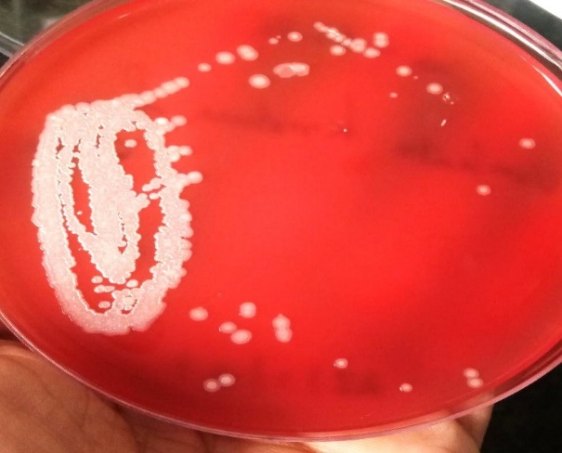

Fig1: Burkholderia pseudomallei on Blood agar - greyish white wrinkled colonies with metallic sheen.

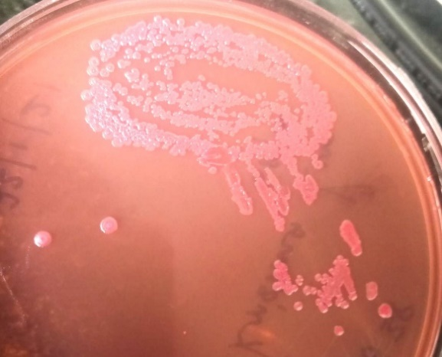

Fig 2: Burkholderia pseudomallei on Mac Conkey agar -Non-lactose fermenting, colourless and rugose colonies with metallic sheen.

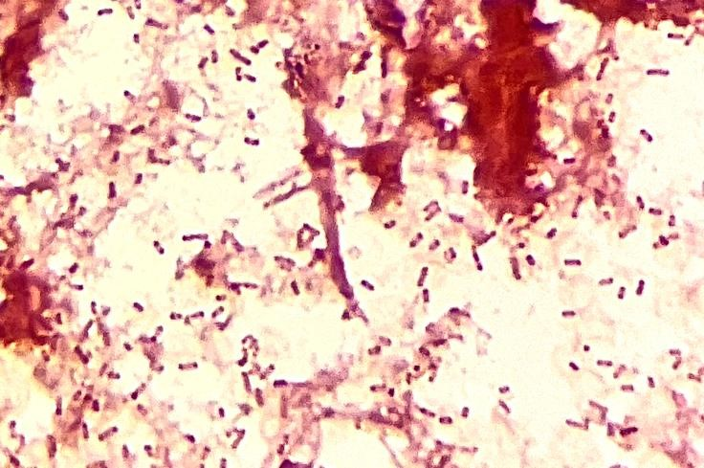

Fig3: Gram staining of the colonies showing the characteristic safety pin appearance/Bipolar staining of the organisms.

Case 2

A 54-year-old male with a 20-year history of diabetes mellitus and hypertension presented with intermittent fever and chills for two months, associated with generalized weakness, nausea, and a non-productive cough for one week. He also reported increased frequency of urination with burning micturition for three days.

On admission, he was febrile (104°F), tachycardic (PR 140/min), hypertensive (BP 160/80 mmHg), respiratory rate was 20/min, and SpO₂ was 97% on room air. Initial evaluation including CECT abdomen performed at an outside facility revealed splenomegaly with multiple hypodense hyperenhancing lesions suggestive of splenic abscesses or granulomas.He was started empirically on intravenous Meropenem (1 g TID) and Clindamycin (600 mg TID). Due to persistent fever by day 3, intravenous Artesunate (Falcigo 120 mg 12-hourly) was added.

A contrast-enhanced CT (CECT) of the whole abdomen was repeated, which showed hepatomegaly with focal areas of abnormal attenuation in segment IV of the liver, consistent with evolving liver abscesses. There was also splenomegaly with multiple small abscesses, thrombosis of splenic vein tributaries at the hilum, and collateral vessel formation.

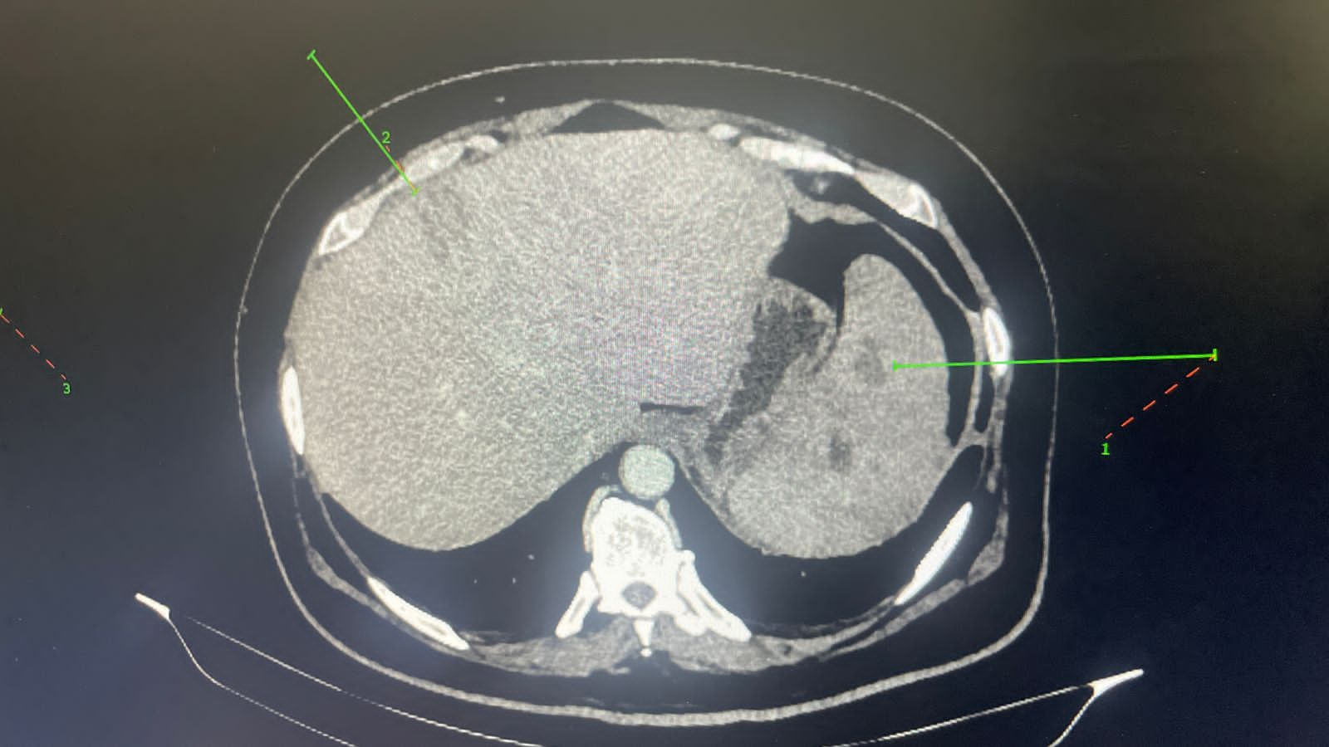

Fig 4: Axial CT scan of abdomen showing multiple small evolving abscesses in liver and spleen

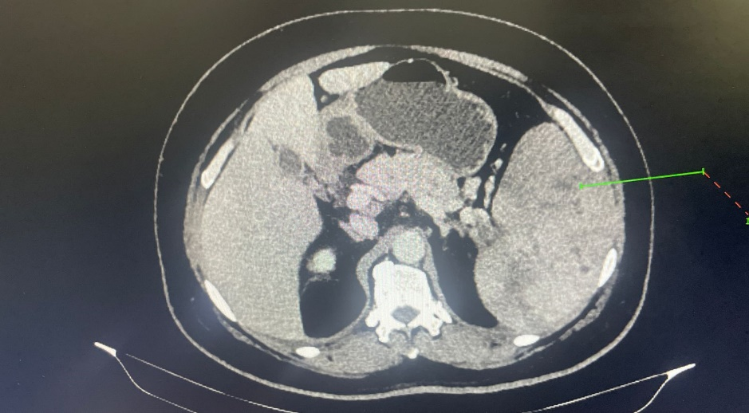

Fig 5: CECT of abdomen showing hepatomegaly with focal areas of abnormal attenuation and enhancement suggesting the possibility of evolving abscesses.

Blood and urine cultures were sent at admission. The blood culture later flagged positive for Burkholderia pseudomallei, confirming the diagnosis of melioidosis.

The patient was continued on IV Meropenem 1 g TID for a total duration of four weeks, after which he was transitioned to oral Cotrimoxazole for an eradication phase planned over three months. His clinical condition improved with resolution of fever and improvement in appetite and general well-being.

Case 3

A 50-year-old male presented to the emergency department with complaints of swelling, redness, and pain in the left foot for one week, with worsening symptoms over the past three days. He also reported fever for three days. He was a known case of type 2 diabetes mellitus and hypertension, on regular medications. He gave a history of recent trauma to the left foot.

On examination, the patient was conscious, coherent, and febrile. Systemic examination was unremarkable. Vitals on admission were: Temperature: 100.7°F, Pulse: 120/min, Blood Pressure: 175/116 mmHg, Respiratory Rate: 18/min.

Local examination of the left foot revealed redness and swelling, more prominent over the dorsum, particularly along the medial border and great toe. A provisional diagnosis of left foot cellulitis was made.

The patient was started on intravenous Cefoperazone-sulbactam (1.5 g BD) and Clindamycin (300 mg BD). Due to worsening local signs and suspicion of deeper involvement, he underwent fasciotomy and surgical debridement. He showed clinical improvement and was discharged on the third post-operative day (POD) with oral Amoxicillin-clavulanate (625 mg BID).

However, the patient was readmitted one day post-discharge with complaints of fever and increased pain in the left leg. Repeat investigations revealed:

Leukocytosis: WBC count 12,660/mm³

Elevated CRP: 379 mg/L

Hyponatremia

Deranged liver function tests (LFTs)

Blood and wound swab cultures were sent. Empiric antibiotic therapy was escalated to intravenous Meropenem and Clindamycin, given the severity of infection and risk of resistant organisms or anaerobic involvement. Blood cultures flagged positive after 48 hours and Burkholderia pseudomallei was isolated confirming the diagnosis of Melioidosis.

Table 1 : A comparision of pertinent Lab values is shown in the table.

|  |  |  |  |  |
| --- | --- | --- | --- | --- |
| Day of admission | Lab investigation | Case 1 | Case 2 | Case 3 |
| Day 1 | WBC count (cells/mm3) | 12200 | 11120 | 19240 |
|  | Platelet count (Lakhs/mm3) | 1.5 | 2.88 | 1.25 |
|  | CRP (mg/L) | 121 | 85.6 | 138.8 |
|  | HbA1C (%) | 8.6 | 10 | 12.1 |
|  | Urine protein | Nil | 1+ | 1+ |
|  | Urine Glucose | Nil | 3+ | 3+ |
|  | ALT (U/L) | 23 | 34 | 118 |
|  | AST (U/L) | 76 | 29 | 78 |
|  | ALP | 448 | 134 | 212 |
|  | Albumin | 2.1 | 3.1 | 3.0 |
|  | Blood culture | Sterile | Burkholderia pseudomallei | Burkholderia pseudomallei |
|  | Pus Culture | Burkholderia pseudomallei | Not sent | Sterile |

Table 2 : The susceptibility pattern of Burkholderia pseudomallei isolated from the patient samples is as follows

|  |  |  |  |  |  |  |  |  |  |  |  |  |  |
| --- | --- | --- | --- | --- | --- | --- | --- | --- | --- | --- | --- | --- | --- |
| Antimicrobial Agent | | Patient 1 | | Patient 2 | | Patient 3 | | CLSI Breakpoints | | | | | |
|  | | PUS culture | | Blood culture | | Blood culture | | Sensitive | | | Intermediate | Resistant | |
| Ceftazidime | | 2  Sensitive | | 2  Sensitive | | 2  Sensitive | | <=8 | | | 16 | >=32 | |
| Cefoperazone -sulbactam | | <=8  Sensitive | | 8  Sensitive | | <=8  Sensitive | | <=16 | | | 32 | >=64 | |
| Cefepime | | <=8  Sensitive | | <=4  Sensitive | | >=32  Resistant | | <=8 | | | 16 | >=32 | |
| Ciprofloxacin | | 2  Intermediate | | >=4  Resistant | | >=4  Resistant | | <1 | | | 2 | >4 | |
| Levofloxacin | | 2  Sensitive | | 2  Sensitive | | Intermediate | | <2 | | | 4 | >8 | |
| Imipenem | | <=2  Sensitive | | 2  Sensitive | | 1  Sensitive | | <=4 | | | 8 | >=16 | |
| Meropenem | | 2  Sensitive | | 1  Sensitive | | 1  Sensitive | | <=4 | 8 | | | >=16 | |
| Trimethoprim-Sulfamethoxazole | | <=20  Sensitive | | <=20  Sensitive | | <=20  Sensitive | | <=40 | - | | | >=80 | |

Table 3 : Treatment of Meliodosis (Dance D,2014 & Wiersinga et al., 2014)

|  |  |
| --- | --- |
| Antimicrobial Drug | Dose |
| Initial intensive Phase |  |
| Ceftazidime | 50 mg/kg of body weight (up to 2 g), every 6–8 hr |
| Meropenem (Drug of choice for Neuro-Melioidosis) | 25 mg/kg (up to 1 g), every 8 hr |
| Imipenem | 25 mg/kg (up to 1 g), every 6 hr |
| Oral Eradication Phase |  |
| Trimethoprim-Sulfamethoxazole (1st choice) | As per body weight every 12 hours with folic acid to prevent or reduce antifolate toxicity |
| Amoxycillin Clavulanic Acid | 625mg every 8hr |
| Doxycycline | 100mg  once daily ORevery 12 hours |

Melioidosis Discussion

Melioidosis, a significantly underdiagnosed and underreported disease prevalent in tropical regions, is caused by the non-fermenting, Gram-negative bacillus Burkholderia pseudomallei. Well-established risk factors for this infection include diabetes mellitus, chronic renal disease, and a history of trauma (Prasanta R et al., 2022). The clinical presentation of melioidosis is notably protean, ranging from jaundice, pneumonia, skin abscesses, and gastroenteritis to more severe manifestations such as meningitis, bacteremia, and disseminated disease (Karunanayake P, 2022).  
  
Isolation of B. pseudomallei through culture remains the gold standard for laboratory diagnosis. However, it is frequently misidentified as a contaminant or mistaken for Pseudomonas species due to morphological similarities. Although serological tests like the indirect hemagglutination assay (IHA) are commonly employed, they suffer from suboptimal sensitivity and specificity, limiting their diagnostic utility. (Prasanta R et al., 2022).

This case series reflects the diverse presentations of melioidosis in diabetic individuals:

* **Case 1** represents chronic localized disease, often misdiagnosed as tuberculosis or malignancy.
* **Case 2** shows disseminated visceral melioidosis with splenic vein thrombosis, a rare vascular complication.
* **Case 3** exemplifies rapidly progressive soft tissue infection, emphasizing the importance of suspecting melioidosis in diabetic trauma cases in endemic regions.

**Key Points:**

* All patients had type 2 diabetes mellitus, underscoring its role as a key risk factor.
* Diagnosis relied on culture positivity from either pus or blood.
* Early empiric therapy with ceftazidime or meropenem and eradication with Cotrimoxazole led to favourable outcomes.
* Surgical intervention was essential in two cases, supporting the need for a multidisciplinary approach.

Conclusion

Melioidosis should be considered in any diabetic patient with atypical infections, abscesses, or PUO, especially in endemic areas. A high index of suspicion, early culture-based diagnosis, and adherence to a biphasic treatment regimen are vital to prevent relapse and improve prognosis.

**Declarations**

**Patient Consent:** Informed consent was obtained from all patients.

**Conflict of Interest:** None declared.

**Funding:**  None.

**Ethical Approval:** Not required for a retrospective case series with de-identified patient data.

References

1. Karunanayake P. (2022). Melioidosis: clinical aspects. *Clin Med (Lond)*, 22(1), 6-8.
2. Dance D. (2014). Treatment and prophylaxis of melioidosis*. Int J Antimicrob Agents,* 43(4), 310-318.
3. Wiersinga WJ, Currie BJ, Peacock SJ.(2012). Melioidosis. *N Engl J Med*, 367(11), 1035-1044.
4. Mohapatra, Prasanta R., Baijayantimala Mishra. (2022).Burden of melioidosis in India and South Asia: Challenges and ways forward.*The Lancet Regional Health - Southeast Asia*, Volume 2, 100004.
5. Estes DM, Dow SW, Schweizer HP, Torres AG. Present and future therapeutic strategies for melioidosis and glanders. Expert Rev Anti Infect Ther. 2010 Mar;8(3):325-38.