**Correlation of Mutations in the hblA Gene with *Bacillus cereus* Disease Isolated from Loungwila, a Traditional Fermented Beverages in Republic of Congo**

**Abstract**

*Bacillus cereus* is a pathogenic bacterium recognized for triggering foodborne illnesses, particularly through its enterotoxins, which are linked to various gastroenteritis outbreaks. This study explores the relationship between mutations in the hblA gene, which encodes for the haemolysin BL toxin, and *B. cereus* strains isolated from Lougwila, a traditional fermented beverage in the Republic of Congo. A total of 145 *B. cereus* strains were obtained from Lougwila samples, and their hblA gene sequences were analyzed for mutations by using PCR, sequencing and *in silico* translation. In the hblA region 100-230, we identified deletion mutations of amino acids, as follows: HblA-S23∆KN, ∆YYE, ∆KEG, S28-∆KKQL, ∆QQNQ, and ∆ESD. Substitution mutations as follows: HblA-S23-A103K, N103R, S28-N222Q, Y223L, Y224E, K225S, Q226D, S52-Q169A, Q165Y, K212L S62-K112R, K114R, Q169A, Q170A, , S2-E174N, and Y224A. In the hblA region 250-330, we identified three substitution mutations in *B. cereus* S2, comprising: E290D, Q269L, and E265D. The results revealed a significant correlation between specific mutations in HblA 3D structures. This study underscores the need for further investigation into the genetic diversity of *B. cereus* strains in fermented foods, as well as the implementation of safety measures to mitigate foodborne outbreaks.

**Introduction**

*Bacillus cereus* is a Gram-positive, spore-forming bacterium widely distributed in the environment, including soil, water, and food products [1]. This bacterium is a well-known foodborne pathogen responsible for two distinct categories of gastrointestinal diseases: the diarrheal syndrome and the emetic syndrome [2-4]. The diarrheal type is caused by enterotoxins such as hemolysin BL (*hbl*) [5], non-hemolytic enterotoxin (*nhe*) [6, 7], and cytotoxin K, while the emetic type is associated with the production of cereulide [8], a heat-stable toxin [9].

Among these toxins, the *hbl* gene cluster, encoding hemolysin BL, plays a significant role in the diarrheal syndrome. This tripartite toxin complex consists of three components: A, B, and C, which together exhibit hemolytic and cytotoxic activity [10]. Mutations in the *hblA* gene, which encodes one of the essential components, may influence the pathogenicity of *B. cereus* strains, potentially altering their virulence profiles. The three-dimensional structure of HblB has already been documented. This structure shows the different parts of HblA. It has reported that the first structure of the B component of hemolysin BL from B. cereus, despite low sequence identity, resembles the structure of hemolysin E from *E. coli* [11].

Traditional fermented beverages, often produced under artisanal conditions, provide a favorable environment for bacterial growth due to their nutrient-rich composition and lack of stringent processing controls [12]. While these products are typically considered safe, contamination with pathogenic strains of *B. cereus* poses a public health risk, particularly in regions where such beverages are widely consumed [13].

Until the preparation of this document, few studies have been conducted on the possible mutations of the hblA gene of *B. cereus* and its ability to cause diarrheal disease or not This study aims to investigate the correlation between mutations in the *hblA* gene and the pathogenic potential of *B. cereus* strains isolated from four traditional fermented beverages. Understanding this relationship could provide valuable insights into the molecular mechanisms underlying *B. cereus* pathogenicity and inform strategies to mitigate foodborne risks associated with fermented products.

**Material and methods**

**Sample Collection**

From Loungwila beverages, a traditional fermented beverage, a total of 200 samples were selected for this study from 2022 to 2024. Samples were collected from local markets and households across Madingou, Bokosongo, Loutété, Nkayi and Loudima. The table below summarizes the number of samples by food type and by department. The samples were collected and then transported to the laboratories under aseptic conditions.

**Isolation of *Bacillus cereus***

Samples from Loungwila beverages were homogenised and distributed in sterile tubes. Then successive dilutions were performed, and the bacterial suspensions were inoculated in a mossel agar medium (10.0 g of peptone, 1.0 g of meat extract, 10.0 g of mannitol, 10% of egg yolk, 0.01 g of polymyxin B sulphate, 0.025 g of phenol red, 10.0 g of sodium chloride, 14.0 g of agar and pH 7.2) to promote the growth of *B. cereus*. The plates were incubated at 37 ° C for 24 hours and the colony count was carried out in triplicate. The purification of the isolates was carried out rigorously by successive subcultures using Luria-Bertani (10 g of peptone, 5 g of yeast extract, 10 g of NaCl with 0.01 g of polymyxin B sulphate). The morphological characteristics of the colonies, such as shape, size, and colour, were recorded. Morphological characterization was performed using a light microscope (OPTIKA, Italy), and Gram-staining was performed with a solution of 3% potassium hydroxide (KOH). For future experiments, all purified isolated cultures were stored at -20 ° C in Luria-Bertani (LB) broth containing 20% glycerol (v / v). The colonies were selected since *B. cereus* does not ferment mannitol. The colonies remain pink or red (no pH change). *B. cereus* produces an enzyme, lecithinase, which hydrolyzes the lecithin present in egg yolk. This is manifested by an opaque precipitate (white/cream halo) around the colonies.

**Genomic DNA Extraction, Molecular Identification and Bioinformatics analysis**

Isolates were subjected to genomic DNA extraction and purification. This experiment was carried out using the NucleoSpin Microbial DNA Kit (Macherey-NAGEL, Germany). Briefly, isolates were cultured in 5 ml of LB broth for 24 hours at 37 ° C with shaking. DNA purity was assessed by the UV absorbance ratio (260/280 nm). 1 μl of template DNA with concentrations equalling 10–20 ng/μl. Universal 16S rRNA primers fD1 (5'-AGAGTTTGATCCTGGCTCAG -3') and rP2 (5'- ACGGCTACCTTGTTACGACTT -3') were used to amplify the 16S RNA gene (Eurogentec). 5 µl of each amplification product was mixed with 2 μl of loading buffer (BIOKE, The Netherlands). The mixtures were then electrophoresed on a 1% (w/v) agarose gel. The molecular weight marker used was the 10-kb 2-Log DNA sample (BIOKE, The Netherlands). PCR products were purified using the Gel Extraction Kit (Omega Biotek), the purified products were subjected to Sanger sequencing (3130xl Genetic Analyser, Applied Biosystems). The sequences obtained were aligned with Bio Numerics 7.5 software (Applied Maths, Belgium) and manually corrected to resolve the discrepancies between the sense and antisense strands. The sequences were compared with homologous sequences contained in sequence databases through the NCBI portal using the BLASTn programme (<https://www.ncbi.nlm.nih.gov/>).

To evaluate food safety risks, isolates were screened for the presence of hblA, using PCR. A multiplex endpoint PCR assay was used to identify *B. cereus* enterotoxins: hemolysin BL (*hblA*) with Eurogentec primers HblA-S (5’ATGATAAAAAAAATCCCTTACAAATTACTCG3’) and Hbl-AS (5’CTATTTTTGTGGAGTAACAGTTTCCAC3’). HblA fragment has been sequenced and Swiss-model and I-Tasser have been used to predict 3D structures [14, 15].

**Results**

**Prevalence of Bacillus cereus**

Colonies suspected of belonging to the *B. cereus* group were isolated from all samples. The microbial load ranged from 102 to 8.103 CFU/ml. A total of 145 isolates have been obtained.

**HblA Genetic diversity**

To understand the non-pathogenicity of *B. cereus* strains, we investigate genetic diversity. The hblA gene was amplified in strains suspected to be B. cereus. The gene was detectable in 68% of the isolates. All fragments were sequenced, and the sequences were submitted to the NCBI platform to confirm the identity of B. cereus. Of the 51% (75/145) of the amplified hblA gene, 95% shared a 100% identity. To detect mutations (substitutions, deletions, or recombination), the remaining 5% were subjected to multiple sequence alignments with the wild-type sequence obtained from the B. cereus ATCC database.

In the *hblA* region 100-230, we identified deletion mutations of three and four amino acids as follows: HblA-S23∆KN at position 100, HblA-S23∆YYE at position 134, HblA-S23∆KEG at position 151, HblA-S28∆KKQL at position 114, HblA-S28∆QQNQ at position 162, HblA-S28∆ESD at position 228. Additionally, we observed substitution mutations of one or more amino acids in three strains, including HblA-S23-A103K, HblA-S23-N103R, HblA-S28-N222Q, HblA-S28-Y223L, HblA-S28-Y224E, HblA-S28-K225S, HblA-S28-Q226D, HblA-S52-Q169A, HblA-S62-K112R, HblA-S62-K114R, HblA-S52-Q165Y, HblA-S62-Q169A, HblA-S62-Q170A, HblA-S52-K212L, HblA-S2-E174N, and HblA-S2-Y224A (**Figure 1A**). In the *hblA* region 250-330, we identified three substitution mutations B. cereus S2 including HblA-S2-E290D, HblA-S2-Q269L and HblA-S2-E265D (**Figure 1B**). The sequences were submitted to the SwissModel software to compare the protein structures (**Figure 1C**).

**(A)**



**(B)**



**Figure 1:** A: Sequence alignment in the hblA region 100-230 and variants. HblA (Wild Type): Amplified from Bacillus cereus ATCC. HblA-S2: Gene amplified from strain S2. HblA-S23: Product of the gene amplified from strain S23. HblA-S28: Product of the gene amplified from strain S28. HblA-S52: Product of the gene amplified from strain S52. HblA-S62: Product of the gene amplified from strain S62. B: Sequence alignment in the hblA region 250-330.

To explain the toxicity or not of the selected strains, we predicted the three-dimensional structure using SwissModel of HblA variants including Hblwt, HblA-S2, S23; S28, S52, and S62 **(Figure 2A)**. The Analysis of 3D structures reveals differences in arrangements. The mutations have strongly impacted the secondary structures of the proteins. Highlighting aromatic amino acids reveals differences in protein folding predictions compared to the wild-Type variant **(Figure 2B).**

(A)

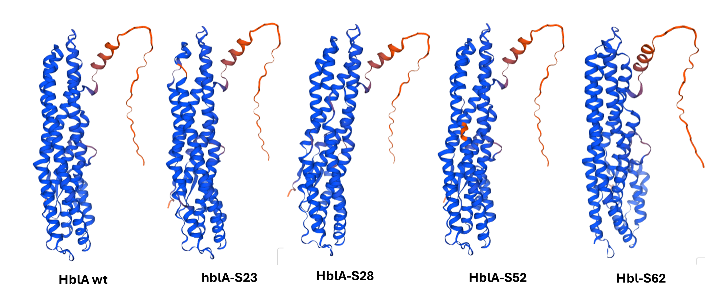

**(B)**

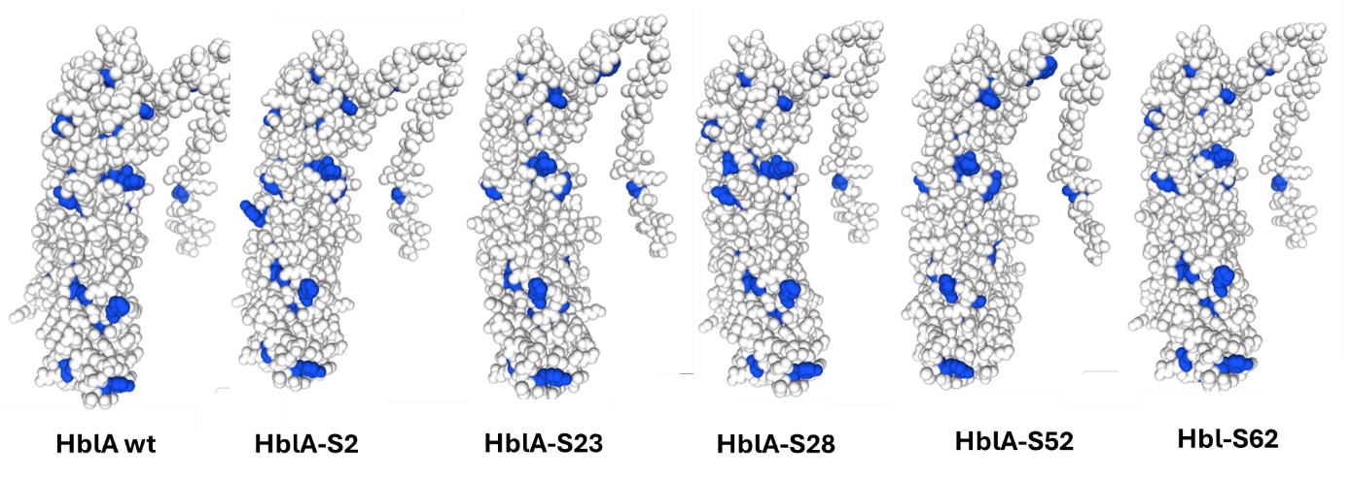

**Hbl-S62**

**HblA-S52**

**Figure 2: Predictions of 3D Structures of HblA Proteins (A and B). (A):** The 3D structure predictions of the following HblA proteins were conducted. (B): 3D Structures Highlighting Aromatic Amino Acids in Blue. HblA (Wild Type): Amplified from *Bacillus cereus* ATCC. HblA-S2: Gene amplified from strain S2. HblA-S23: Product of the gene amplified from strain S23. HblA-S28: Product of the gene amplified from strain S28. HblA-S52: Product of the gene amplified from strain S52. HblA-S62: Product of the gene amplified from strain S62. The 3D structures were obtained using the Swiss-Model program (<https://swissmodel.expasy.org/>).

**Discussion**

This study highlights the critical importance of valuing and understanding fermented foods. Local populations consume these products, such as Loungwila, without concern for potential associated risks. Unlike industrially processed foods, Loungwila is consumed in its traditional, non-industrial form, which may harbor health hazards [16].

The isolation of colonies presumed to belong to the *B. cereus* group from all tested samples underscores the widespread occurrence of this bacterial species [1]. The microbial load, ranging from 102 to 7.103CFU/ml, highlights variability in contamination levels among the samples [17]. From these analyses, 145 isolates were successfully obtained, providing a robust dataset for investigating the genetic and structural diversity of the *B. cereus* strains. One significant concern is the presence of *B. cereus*, a bacterium known for its resistance to gastric acidity [18]. This resistance allows it to survive the acidic environment of the stomach and potentially colonize the digestive tract [19, 20]. Once established, *B. cereus* can cause considerable damage by inducing diarrheal illnesses [1, 2, 17]. The isolates obtained in this study comprised both pathogenic and non-pathogenic strains. This diversity highlights the dual and versatile nature of *B. cereus* as both a benign environmental bacterium and a potential foodborne pathogen.

This work identified significant mutations in the HblA protein as they provide insights into the functional and structural diversity of *B. cereus* strains. Mutations, including deletions and substitutions, can have profound effects on the protein's folding, stability, and activity, ultimately influencing the pathogenic potential of the strains. HblA is a key component of the hemolysin BL toxin complex, which plays a role in the virulence of *B. cereus*. Mutations in this protein may alter its ability to assemble into functional toxin complexes, potentially reducing or enhancing its hemolytic activity and pathogenicity. This could easily justify the presence of non-pathogenic strains that underscore the importance of distinguishing between harmless and harmful isolates, particularly in the context of traditional beverages consumption. Pathogenic strains, on the other hand, pose significant health risks due to their ability to produce toxins that can lead to foodborne illnesses [2, 21]. Deletions of amino acids in key regions (100-230 and 250-330) could disrupt structural integrity or interaction sites critical for toxin activity. The structural modeling of HblA variants revealed differences in protein folding and arrangement, especially in regions where mutations were present. Changes in aromatic amino acid positioning, highlighted in the 3D structures, suggest altered stabilizing interactions such as aromatic stacking or hydrogen bonding. These structural deviations could compromise the protein's ability to perform its biological role effectively and its thermodynamic multistep transformation [22, 23]. The presence of mutations in non-pathogenic strains of *B. cereus* may explain their reduced virulence. These mutations could impair the formation or activity of the hemolysin BL toxin, thereby rendering these strains less harmful or entirely non-pathogenic.  
The diversity of mutations observed in HblA may reflect evolutionary adaptations of *B. cereus* to different environmental conditions or hosts. Such adaptations could influence the strain's ability to survive, persist, or cause disease in specific niches.

Understanding the functional consequences of these mutations could improve the classification of *B. cereus* strains based on their pathogenic potential. This knowledge would be invaluable for food safety assessments, allowing better distinction between harmful and harmless strains in fermented foods and other products.

Our findings emphasize the need for precise genetic and functional analyses to differentiate pathogenic from non-pathogenic strains in fermented foods and beverages. Such efforts are crucial for ensuring food safety while preserving the benefits of traditional dietary practices. In another way, our findings underline the need for raising awareness among local populations about the potential risks of consuming non-industrially processed fermented foods. Additionally, implementing measures to monitor and control microbial contamination in traditional food production could help mitigate these health risks while preserving the cultural and nutritional value of such foods.

Few studies have focused on the study of mutations in the enterotoxins of *B. cereus*, except for the one conducted on Hbl homologous in *B. anthracis* [24]. In the hblA regions between residues 100-230 and 250–330, mutations were identified. These mutations suggest substantial genetic variation that may influence protein functionality and structure. Comparative analysis revealed significant differences in protein arrangements, indicating that mutations effectively influenced secondary structure formation. Highlighting aromatic amino acids further demonstrated variations in protein folding between the wild-type and mutant variants. These differences likely arise from the combined effects of deletions and substitutions, which may alter hydrogen bonding, aromatic stacking, or other stabilizing interactions critical for maintaining the native conformation. The limit of our work shows that we could not observe structural deviations to explain the variation in toxicity among the strains. Mutations within the HblA protein could lead to disrupted functionality, potentially altering the hemolytic activity or other virulence-associated properties of *B. cereus*. Further experimental validation is needed to confirm the precise relationship between these structural changes and strain pathogenicity.

**Conclusion**

This study highlights the genetic and structural diversity of the HblA protein in *B. cereus* strains. The prevalence of mutations, particularly within critical regions of the hblA gene, underscores the dynamic evolution of this species. Predicted structural modeling provides valuable insights into how these mutations affect protein folding and potentially influence strain pathogenicity. These findings contribute to a deeper understanding of *B. cereus* biology and may inform strategies for mitigating risks associated with this ubiquitous bacterium.

**Ethics approval and consent to participate**

This study did not involve human participants, human data, or animals, and thus did not require ethical approval.

**Consent for publication**

This manuscript does not contain any individual person’s data in any form (including individual details, images, or videos) that would require consent for publication

**Availability of data and material**

The datasets generated during and/or analyzed during the current study are available from the corresponding author on reasonable request

**References**

1. Ehling-Schulz M, Lereclus D, Koehler TM: **The Bacillus cereus Group: Bacillus Species with Pathogenic Potential**. *Microbiol Spectr* 2019, **7**(3).

2. Enosi Tuipulotu D, Mathur A, Ngo C, Man SM: **Bacillus cereus: Epidemiology, Virulence Factors, and Host-Pathogen Interactions**. *Trends Microbiol* 2021, **29**(5):458-471.

3. Leong SS, Korel F, King JH: **Bacillus cereus: A review of "fried rice syndrome" causative agents**. *Microb Pathog* 2023, **185**:106418.

4. Woh PY, Ng C: **Bacillus cereus in rice: A review on food poisoning, antimicrobial resistance, and control measures**. *Trop Biomed* 2024, **41**(3):298-309.

5. Fagerlund A, Lindback T, Granum PE: **Bacillus cereus cytotoxins Hbl, Nhe and CytK are secreted via the Sec translocation pathway**. *BMC Microbiol* 2010, **10**:304.

6. Heilkenbrinker U, Dietrich R, Didier A, Zhu K, Lindback T, Granum PE, Martlbauer E: **Complex formation between NheB and NheC is necessary to induce cytotoxic activity by the three-component Bacillus cereus Nhe enterotoxin**. *PLoS One* 2013, **8**(4):e63104.

7. Lindback T, Fagerlund A, Rodland MS, Granum PE: **Characterization of the Bacillus cereus Nhe enterotoxin**. *Microbiology (Reading)* 2004, **150**(Pt 12):3959-3967.

8. Jovanovic J, Tretiak S, Begyn K, Rajkovic A: **Detection of Enterotoxigenic Psychrotrophic Presumptive Bacillus cereus and Cereulide Producers in Food Products and Ingredients**. *Toxins (Basel)* 2022, **14**(4).

9. Oltuszak-Walczak E, Walczak P: **PCR detection of cytK gene in Bacillus cereus group strains isolated from food samples**. *J Microbiol Methods* 2013, **95**(2):295-301.

10. Kim SA, Park HJ, Cho TJ, Rhee MS: **Toxic potential of Bacillus cereus isolated from fermented alcoholic beverages**. *Food Res Int* 2020, **137**:109361.

11. Madegowda M, Eswaramoorthy S, Burley SK, Swaminathan S: **X-ray crystal structure of the B component of Hemolysin BL from Bacillus cereus**. *Proteins* 2008, **71**(2):534-540.

12. Kayath AC, Nguimbi E, Goma Tchimbakala J, Mamonékéné SN, Lebonguy AA, Ahombo G: **Towards the Understanding of Fermented Food Biotechnology in Congo Brazzaville**. *Advance Journal of Food Science and Technology* 2016, **12** (11):593-602.

13. Kayath CA, Mokemiabeka SN, Makaya Dangui Nieko NP, Vouidibio Mbozo AB, Nguimbi E, Kéléké S, Kobawila SC, Louembé D: **Evolution of Fermented Food Products in the Republic of Congo: A Meta-Analytic Review**. *Journal of Advances in Microbiology* 2024, **24**(12):198-216.

14. Waterhouse A, Bertoni M, Bienert S, Studer G, Tauriello G, Gumienny R, Heer FT, de Beer TAP, Rempfer C, Bordoli L *et al*: **SWISS-MODEL: homology modelling of protein structures and complexes**. *Nucleic Acids Res* 2018, **46**(W1):W296-W303.

15. Zhou X, Zheng W, Li Y, Pearce R, Zhang C, Bell EW, Zhang G, Zhang Y: **I-TASSER-MTD: a deep-learning-based platform for multi-domain protein structure and function prediction**. *Nat Protoc* 2022, **17**(10):2326-2353.

16. Okouakoua YF, Mokémiabeka SN, Kayath A, C., Kaya-Ongoto MD, Nzaou SAE, Nkalla LN, Nguimbi E: **Molecular Profiling of Sugarcane Wine, a Traditional Fermented Beverage (Loungouila) from Madingou**. *American Journal of Molecular Biology* 2023, **13**(4).

17. Ehling-Schulz M, Fricker M, Scherer S: **Bacillus cereus, the causative agent of an emetic type of food-borne illness**. *Mol Nutr Food Res* 2004, **48**(7):479-487.

18. Duport C, Jobin M, Schmitt P: **Adaptation in Bacillus cereus: From Stress to Disease**. *Front Microbiol* 2016, **7**:1550.

19. Ceuppens S, Rajkovic A, Hamelink S, Van de Wiele T, Boon N, Uyttendaele M: **Enterotoxin production by Bacillus cereus under gastrointestinal conditions and their immunological detection by commercially available kits**. *Foodborne Pathog Dis* 2012, **9**(12):1130-1136.

20. Ceuppens S, Uyttendaele M, Drieskens K, Heyndrickx M, Rajkovic A, Boon N, Van de Wiele T: **Survival and germination of Bacillus cereus spores without outgrowth or enterotoxin production during in vitro simulation of gastrointestinal transit**. *Appl Environ Microbiol* 2012, **78**(21):7698-7705.

21. Ozdemir F, Arslan S: **Molecular Characterization and Toxin Profiles of Bacillus spp. Isolated from Retail Fish and Ground Beef**. *J Food Sci* 2019, **84**(3):548-556.

22. Shanthirabalan S, Chomilier J, Carpentier M: **Structural effects of point mutations in proteins**. *Proteins* 2018, **86**(8):853-867.

23. Kumirov VK, Dykstra EM, Hall BM, Anderson WJ, Szyszka TN, Cordes MHJ: **Multistep mutational transformation of a protein fold through structural intermediates**. *Protein Sci* 2018, **27**(10):1767-1779.

24. Gierczynski R, Zasada AA, Kaluzewski S, Jagielski M: **[Molecular characterisation of the haemolytic isolates of Bacillus anthracis originated in Poland]**. *Med Dosw Mikrobiol* 2006, **58**(4):339-346.