Original Research Article
In-silico Evaluation of Allium sativum-Derived Phytochemicals Reveals Promising Drug Candidates for p53-MDM2 Interaction in Osteosarcoma Therapy

ABSTRACT
Osteosarcoma is a rare but aggressive bone malignancy with poor prognosis due to chemoresistance and limited targeted therapies. Overexpression of MDM2, a key negative regulator of the p53 pathway, has been implicated in osteosarcoma progression and drug resistance. Due to the limitations in the safety and selectivity of existing inhibitors, there is increasing interest in exploring natural compounds as alternative drug candidates. This study aimed to identify and evaluate Allium sativum-derived phytochemicals as potential MDM2 inhibitors using an integrated computer-aided drug design approach.
A structure-based virtual screening of 154 phytochemicals identified through GC-MS analysis was conducted against MDM2 (PDB ID: 7AI0) using iGEMDock. Sixteen bioactive compounds exhibited stronger binding affinities than doxorubicin (−6.97 kcal/mol), with top scores ranging from −7.14 to −8.74 kcal/mol. Lipinski’s Rule of Five reduced these to nine drug-like candidates. ADMET screening further identified three lead compounds—gallic acid, cis-13,16-docosadienoic acid, and p-toluic acid heptadecyl ester—as pharmacokinetically favourable and non-toxic. MM-GBSA analysis confirmed their superior binding free energies (−8.67 to −8.74 kcal/mol) compared to doxorubicin. Interaction mapping revealed stable ligand engagement with key MDM2 residues.
Gallic acid, cis-13,16-docosadienoic acid, and p-toluic acid, heptadecyl ester, demonstrated improved binding affinity, pharmacokinetic safety, and structural stability over doxorubicin, establishing them as promising natural MDM2 inhibitors. These findings warrant further experimental validation for their potential application in osteosarcoma therapy.
Keywords: Allium sativum, Computer-aided Drug Design, Doxorubicin, MDM2, Osteosarcoma, Phytochemical

1.0 INTRODUCTION
Osteosarcoma is the most common and aggressive malignant bone tumour, predominantly affecting children and adolescents, and it remains a formidable clinical challenge despite advances in multimodal therapy [1]. It typically originates in the metaphyseal regions of long bones such as the femur and tibia and is marked by rapid tumour growth and early metastasis [2]. Because early symptoms can be nonspecific, many patients are diagnosed at advanced stages, which reduces the chances of successful treatment [3]. Although current treatment regimens—combining surgical resection with multi-agent chemotherapy using doxorubicin, methotrexate, and cisplatin—have modestly improved survival, relapse and drug resistance remain common [4]. The severe side effects of these therapies and their limited tumour specificity highlight the need for safer and more effective treatment options.
Recent insights into the molecular biology of osteosarcoma have revealed the pivotal oncogenic role of murine double minute 2 (MDM2), a critical E3 ubiquitin ligase that negatively regulates the tumour suppressor p53 [5]. Under normal physiological conditions, MDM2 binds to p53 and promotes its ubiquitination and proteasomal degradation, thereby maintaining cellular homeostasis [6]. It also inhibits p53’s transcriptional activity by binding to its activation domain, suppressing genes involved in apoptosis, DNA repair, and cell cycle arrest [7]. Aberrant overexpression or amplification of MDM2 has been widely reported in osteosarcoma and other malignancies, resulting in unchecked proliferation, impaired apoptosis, and chemoresistance [8]. As such, MDM2 has emerged as a promising therapeutic target for reactivating p53. Although synthetic MDM2 inhibitors like nutlin-3 and idasanutlin have shown potential, their clinical use is limited by toxicity, poor absorption, and lack of selectivity [9,10].
One promising alternative lies in the use of natural compounds, especially those derived from plants. These phytochemicals are known for their ability to act on multiple molecular targets with fewer systemic side effects [11,12]. Among these, Allium sativum (garlic) has attracted attention due to its rich content of organosulfur compounds—such as allicin, diallyl disulphide, and ajoene—which have demonstrated anticancer effects in various tumour models [13,14]. However, the potential of specific garlic-derived compounds to inhibit MDM2 remains underexplored, particularly through modern screening technologies.
Advances in computational drug discovery have transformed early-stage screening by enabling rapid and cost-effective evaluation of large compound libraries against disease-relevant targets [15]. Computer-aided drug design (CADD) techniques, including molecular docking, binding free energy estimation, and pharmacokinetic modelling, help predict ligand affinity, stability, bioavailability, and toxicity before experimental validation [16,17]. These integrated methods provide a valuable framework for identifying safe and potent natural MDM2 inhibitors.
This study applies a CADD-based approach to evaluate 154 bioactive compounds derived from Allium sativum and identified via gas chromatography–mass spectrometry (GC-MS). The compounds were screened against MDM2 using molecular docking, drug-likeness evaluation, ADMET profiling, and MM-GBSA energy calculation. The aim is to identify natural compounds capable of effectively inhibiting MDM2, with favourable pharmacokinetic properties, to offer novel therapeutic alternatives for the treatment of osteosarcoma.

2.0 METHODOLOGY
2.1 Protein Preparation and Active Site Prediction
The crystal structure of the human mouse double minute 2 homolog (MDM2) G443T RING domain homodimer (PDB ID: 7AI0; resolution: 1.56 Å) (https://doi.org/10.2210/pdb7AI0/pdb) was retrieved from the Protein Data Bank (PDB) (https://www.rcsb.org). This structure, comprising residues from chain A (Leu430 to Pro491), chain B (Ala2 to Met147), and chain C (Met1 to Gly76), was optimised using Biovia Discovery Studio 2021 to remove water molecules and correct bond geometries. The active binding pocket was predicted using the CASTp 3.0 web server, enabling site-specific docking by accurately mapping surface cavities and binding residues [18,19].

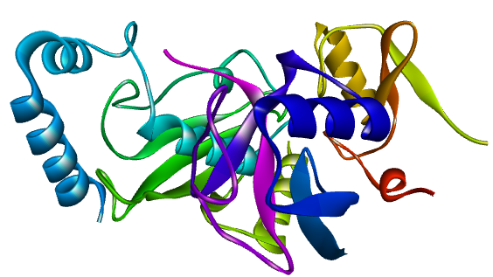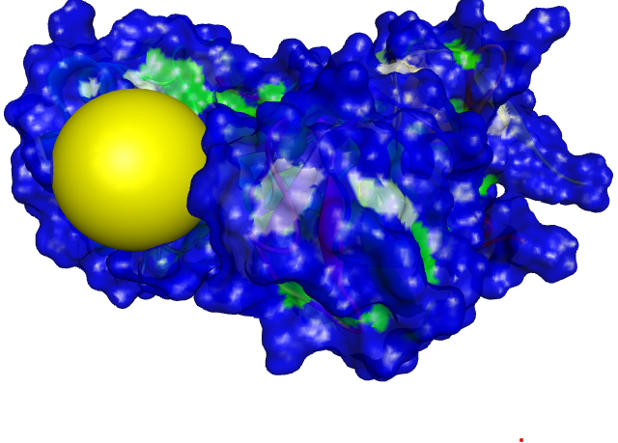
(a) Cartoon model (b) Surface model with the active site coloured in yellow

Figure 1: Visualisation of the Human MDM2-G443T RING Domain (PDB ID: 7AI0)

2.2 Ligand Selection and Preparation
In this study, GC-MS analysis of Allium sativum (garlic) phenolic extract revealed 154 bioactive compounds, whose 3D structures were downloaded from the PubChem database (https://pubchem.ncbi.nlm.nih.gov/). These compounds were initially provided in the SDF format and subsequently converted to PDB format using Open Babel GUI software for compatibility with molecular docking tools [20].
2.3 Molecular Docking
Molecular docking was conducted using iGEMDock version 2.1, utilising its "prepare binding site" feature for setting docking parameters. An 8.0 Å-sized grid was set up around the active site. The docking precision parameters were set with a population number of 800, 10 solutions for each run, and 80 generations for each ligand that was docked. This configuration allowed comprehensive exploration of both binding orientations and affinity, allowing for reliable validation of the docking outcomes [18,21].
2.4 Pharmacokinetic and Toxicological Prediction
2.4.1 Drug-likeness Prediction
Lipinski's Rule of Five (Ro5) was used to evaluate the drug-likeness properties of the compounds [22,23]. This evaluation was done using pkCSM and ADMETLab 3.0 [24,25]. The Ro5 considers essential molecular properties critical for oral bioavailability, including molecular weight, octanol-water partition coefficient (logP), and hydrogen bond acceptors and donors [23]. This criterion, a refinement of drug-likeness, aids in predicting whether a compound possesses the pharmacological or biological activity suitable for oral administration in humans.
2.5.2 Absorption, Distribution, Metabolism, Excretion, and Toxicity (ADMET) Prediction
The evaluation of small molecules in medicinal chemistry and pharmacokinetics necessitates critical ADMET studies [24, 25]. pkCSM and ADMETLab 3.0 were used to investigate the ADMET properties of possible therapeutic candidates. Key parameters such as Caco-2 permeability, human intestinal absorption, P-glycoprotein, blood-brain barrier, cytochrome P450 enzyme, half-life, total clearance, acute oral toxicity, genotoxicity, carcinogenicity, cytotoxicity, neurotoxicity, hepatotoxicity, haematotoxicity, nephrotoxicity, and cardiotoxicity were assessed [26,27,28]. This was done by entering the Simplified Molecular Input Line Entry System (SMILES) of the ligands from PubChem into the web servers pkCSM and ADMETLab 3.0, respectively.
2.6 Molecular Mechanics (MM-GBSA)
MM-GBSA analysis was performed using the Prime MM-GBSA tool in Maestro version 12.5 to calculate the relative binding free energies of each ligand. This method decomposes energy contributions (electrostatic interactions, van der Waals forces, hydrogen bonds, and solvation energies) to determine binding free energy [18]. The binding free energy (ΔG_bind) was calculated as:
ΔGbind = ΔEMM ​+ ΔGGB ​+ ΔGSA. ​
where ΔEMM equals Eele (electrostatic energy) + Evdw (van der Waals energy) + EHbond (hydrogen bond energy) + Eint (torsional angle energy) and represents molecular mechanical energy, ΔGGB is the polar solvation energy, and ΔGSA is the nonpolar solvation energy. The findings from this analysis provided insight into the stability of binding of each ligand [19,29].
3.0 RESULT AND DISCUSSION
3.1 Molecular Docking
Molecular docking was used to evaluate the binding potential of 154 bioactive compounds identified from Allium sativum via GC-MS analysis against the MDM2 (PDB ID: 7AI0) protein target. Using iGEMDock, all ligands were docked into the predicted active site of MDM2 to assess their binding affinities relative to the standard drug, doxorubicin. Following the initial screening, compounds with binding energies lower than that of doxorubicin (indicating stronger binding affinity) were selected. Sixteen compounds met this criterion and were advanced for further analysis, as shown in Table 1 and Figure 2.

Table 1: Binding Energies of Doxorubicin and the 16 Hit Bioactive Compounds on Igemdock.
S/N | Compound Identifier | Binding affinity  (iGEMDock) Kcal/mol)
1 | Doxorubicin (Standard Drug) | -6.97
2 | Gallic acid | -8.74
3 | cis-13,16-Docosadienoic acid | -8.71
4 | p-Toluic acid, heptadecyl ester | -8.67
5 | 1,6,10,18,22-tetracosahexaen-3-ol | -8.36
6 | Phosphine, tridodecyl | -8.32
7 | 4,4'-(5-Iodofurfurylidene)bis(antipyrine) | -8.29
8 | 7-Chloro-1-[(E)-heptylimino]-10-hydroxy-3-(3-trifluoromethyl-phenyl)-1,3,4,10-tetrahydro-2H-acridin-9-one | -8.26
9 | Sarcosine, N-isobutyryl-, octadecyl ester | -8.23
10 | 1,15-Di(1-phenylpropyl)-2,2,4,4,6,6,8,8,10,10,12,12,14,14-tetradecamethyl-1,3,5,7,9,11,13,15-octaoxa-2,4,6,8,10,12,14-heptasilapentadecane | -8.21
11 | 2-Bromo-1,3-bis(dicyclohexylaminomethyl)benzene | -8.09
12 | 4-Pyrrol3-[1-(2-carboxy-1-phenyl-ethyl)-2-oxo-pyrrolidin-3-ylcarbamoyl]-propionylmorpho-piperazine-1-carboxylic acid tert-butyl ester | -7.94
13 | Azastreptonigrin | -7.91
14 | Beta-Carotene | -7.67
15 | Cholestan-6-en-3-ol, O-acetyl-24-methyl-5,8-(tetrahydrofuran-2,5-dione-3,4-diyl) | -7.53
16 | Nonacos-1-ene | -7.39
17 | Octasiloxane, 1,1,3,3,5,5,7,7,9,9,11,11,13,13,15,15-hexadecamethyl | -7.14

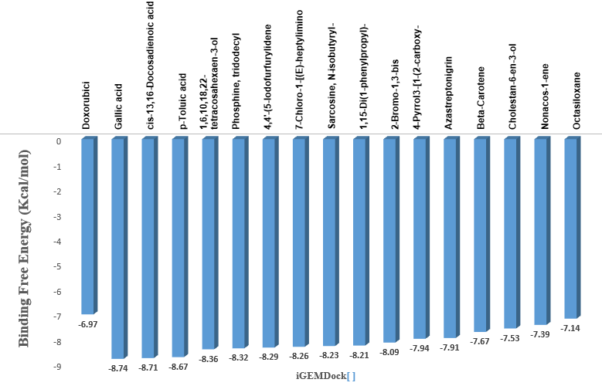
Figure 2: Binding Energies of Doxorubicin and the 16 Hit Compounds on iGEMDock.

As presented in Table 1, doxorubicin exhibited a binding affinity of −6.97 kcal/mol. In contrast, several compounds demonstrated stronger interactions. Gallic acid showed the highest binding affinity at −8.74 kcal/mol, followed closely by cis-13,16-docosadienoic acid (−8.71 kcal/mol) and p-toluic acid, heptadecyl ester (−8.67 kcal/mol). Other notable compounds included 1,6,10,18,22-tetracosahexaen-3-ol (−8.36 kcal/mol), phosphine, tridodecyl (−8.32 kcal/mol), and 4,4′-(5-iodofurfurylidene)bis(antipyrine) (−8.29 kcal/mol). The remaining selected ligands also displayed favourable docking scores, ranging from −8.26 to −7.14 kcal/mol (as shown in Appendix Table 6), indicating stronger receptor-ligand interactions compared to the reference compound. Figure 2 illustrates the comparative binding energies of these compounds, clearly demonstrating that all 16 hits outperformed doxorubicin.
The top three compounds—Gallic acid, cis-13,16-docosadienoic acid, and p-Toluic acid, heptadecyl ester—were prioritised as lead candidates due to their superior docking scores. These findings suggest strong interactions with the MDM2 active site, potentially attributable to enhanced structural complementarity and more stable ligand orientation within the binding pocket. These results are consistent with earlier studies reporting significant MDM2-inhibitory activity from natural compounds, particularly those of plant origin with established anticancer properties [5,21,30,31]. For instance, the 2022 study by Oyedele identified structurally diverse bioactives with strong affinity toward the MDM2 RING domain, aligning with the present observation that gallic acid and its analogues display favourable docking behaviour [21]. Furthermore, previous research by Biswas (2023) on phytochemicals supports the therapeutic potential of garlic in targeted cancer therapy, particularly through modulation of key oncogenic pathways [30].

3.2 Pharmacokinetic and Toxicological Prediction
3.2.1 Drug-likeness Prediction
The 16 hit bioactive compounds identified from the molecular docking analysis were screened for oral drug-likeness using Lipinski’s Rule of Five (Ro5). This evaluation was used to eliminate compounds with suboptimal physicochemical properties that may impair absorption or bioavailability. The results are summarised in Table 2.
Table 2: Drug-likeness (Rule of 5) evaluation and physicochemical properties of Doxorubicin and the 16 hit bioactive compounds.
Ligands | Molecular  Weight | H-bond donor | H-bond acceptor | Log p | Inference
Compound ID | < 500 | < 5 | < 10 | < 5 | MEET R05
Doxorubicin (Standard Drug) | 543.17 | 7.0 | 12.0 | 1.208 | Rejected
Gallic acid | 170.02 | 4.0 | 5.0 | 0.692 | Accepted
cis-13,16-Docosadienoic acid | 350.32 | 0.0 | 2.0 | 8.404 | Accepted
p-Toluic acid, heptadecyl ester | 374.32 | 0.0 | 2.0 | 9.253 | Accepted
1,6,10,18,22-tetracosahexaen-3-ol | 426.39 | 1.0 | 1.0 | 9.739 | Accepted
Phosphine, tridodecyl | 586.55 | 0.0 | 3.0 | 3.228 | Accepted
4,4’-(5-Iodofurfurylidene)bis(antipyrine) | 580.1 | 0.0 | 7.0 | 2.137 | Accepted
7-Chloro-1-[(E)-heptylimino]-10-hydroxy-3-(3-trifluoromethyl-phenyl)-1,3,4,10-tetrahydro-2H-acridin-9-ol | 519.19 | 1.0 | 5.0 | 4.095 | Accepted
Sarcosine, N-isobutyryl-, octadecyl ester | 411.37 | 0.0 | 4.0 | 6.556 | Accepted
1,15-Di(1-phenylpropyl)-2,2,4,4,6,6,8,8,10,10,12,12,14,14-tetradecamethyl-1,3,5,7,9,11,13,15-octaoxa-2,4,6,8,10,12,14-heptasilapentadecane | 772.3 | 0.0 | 8.0 | 8.757 | Rejected
2-Bromo-1,3-bis(dicyclohexylaminomethyl)benzene | 542.32 | 0.0 | 2.0 | 6.845 | Rejected
4-Pyrrol3-[1-(2-carboxy-1-phenyl-ethyl)-2-oxo-pyrrolidin-3-ylcarbamoyl]-propionyl | 516.26 | 2.0 | 11.0 | 1.018 | Rejected
Azastreptonigrin | 547.21 | 5.0 | 12.0 | 0.223 | Rejected
Beta-Carotene | 536.44 | 0.0 | 0.0 | 13.335 | Rejected
Cholestan-6-en-3-ol, O-acetyl-24-methyl-5,8-[tetrahydrofuran-2,5-dione-3,4-diyl | 540.38 | 0.0 | 5.0 | 7.763 | Rejected
Nonacos-1-ene | 406.45 | 0.0 | 0.0 | 9.834 | Accepted
Octasiloxane, 1,1,3,3,5,5,7,7,9,9,11,11,13,13,15,15-hexadecamethyl | 576.16 | 0.0 | 7.0 | 9.559 | Rejected

Out of the 16 compounds, only 9—gallic acid, cis-13,16-docosadienoic acid, p-toluic acid, heptadecyl ester, 1,6,10,18,22-tetracosahexaen-3-ol, phosphine, tridodecyl, 4,4′-(5-iodofurfurylidene)bis(antipyrine), 7-chloro-1-[(E)-heptylimino] -10-hydroxy-3-(3-trifluoromethyl-phenyl) -1,3,4,10-tetrahydro-2H-acridin-9-ol, sarcosine, N-isobutyryl-, octadecyl ester, and nonacos-1-ene—met the critical Ro5 criteria (as shown in Table 2). These compounds complied with the acceptable limits for molecular weight (<500 Da), hydrogen bond donors (<5), hydrogen bond acceptors (<10), and log P (<5), indicating favourable oral bioavailability.
In contrast, 7 compounds were excluded for violating one or more Ro5 thresholds. These rejections were primarily due to high molecular weight, excessive hydrogen bonding capacity, or log P values beyond optimal lipophilicity ranges. These findings align with previous studies that associate poor membrane permeability and low oral absorption with increased molecular size and polar surface area [32]. The remaining 9 compounds with acceptable physicochemical profiles were subjected to ADMET prediction to further assess their pharmacokinetic performance and safety potential.
3.2.2 ADMET Prediction
The 9 selected compounds that passed the drug-likeness screening were evaluated for ADMET properties using in silico prediction tools. The standard drug doxorubicin was included as a reference for comparison. The ADMET results are presented in Table 3.
Among the 9 compounds, gallic acid, cis-13,16-docosadienoic acid, and p-toluic acid, heptadecyl ester, demonstrated excellent pharmacokinetic profiles, exhibiting superior Caco-2 permeability and high human intestinal absorption (HIA) compared to doxorubicin, which showed poor absorption parameters. These three also displayed favourable blood–brain barrier permeability, and none were predicted to inhibit P-glycoprotein, indicating a lower risk of efflux-mediated drug resistance. Regarding metabolism, all three compounds showed no inhibitory effects on major cytochrome P450 enzymes—CYP2D6, CYP3A4, CYP1A2, CYP2C19, and CYP2C9—suggesting a minimal risk of metabolic drug–drug interactions. This is important for patients undergoing multi-drug regimens in cancer therapy. Their excretion profiles were also favourable, with moderate to excellent predicted clearance and acceptable half-lives (Gallic acid: 2.2 hours; cis-13,16-docosadienoic acid: 0.8 hours; p-Toluic acid, heptadecyl ester: 2.1 hours), suggesting efficient elimination with minimal accumulation potential.
Toxicological screening indicated that these three compounds were non-carcinogenic, non-genotoxic, and non-cytotoxic, with no predicted risks of hepatotoxicity, nephrotoxicity, neurotoxicity, or cardiotoxicity. In contrast, doxorubicin showed multiple predicted toxicities, including hepatotoxicity and cardiotoxicity, which correlate with its known clinical limitations [33]. Based on the overall ADMET profiles (as shown in Table 3), gallic acid, cis-13,16-docosadienoic acid, and p-toluic acid, heptadecyl ester, emerged as the most promising candidates for further optimisation. Their high absorption, metabolic safety, effective excretion,

and non-toxic profiles are in agreement with earlier studies supporting the therapeutic potential of plant-derived compounds in anticancer drug development [34]. These three compounds were therefore advanced to molecular mechanics analyses to evaluate their binding energy and structural stability with MDM2.

Table 3: ADMET properties of Doxorubicin and the 9 hit bioactive compounds.

Ligands | Absorption |  |  | Distribution | Metabolism |  |  |  |  | Excretion |  | Toxicity
Compound Identifier | Caco2 permeability | Human Intestinal absorption | P-glycoprotein Inhibitor | Blood Brain Barrier | CYP2D6 | CYP3A4 | CYP1A2 | CYP2C19  CYP2C19 | CYP2C9 | Half-life | Total Clearance | Acute oral toxicity | Cytotoxicity | Carcinogenicity | Cardiotoxicity | Genotoxicity | Hematoxicity | Hepatoxicity | Nephrotoxicity | Neurotoxicity
Doxorubicin (Standard Drug) | P | P | P | E | E | E | E | E | E | 3.8 | M | P | P | P | P | P | P | P | P | M
Gallic acid | E | E | E | E | E | E | E | E | E | 2.2 | E | E | E | E | E | M | E | E | E | E
cis-13,16-Docosadienoic acid | E | E | E | E | E | E | E | E | E | 0.8 | E | E | E | E | E | E | E | M | E | E
p-Toluic acid, heptadecyl ester | E | E | E | E | E | E | E | E | E | 2.1 | E | E | E | E | E | E | E | M | E | E
1,6,10,18,22-Tetracosahexaen-3-Ol,2,6,10,15,19,23-Hexamethyl | E | E | E | E | E | E | E | E | E | 0.7 | E | E | E | E | E | E | E | P | P | M
Phosphine, tridodecyl | E | M | E | E | M | M | E | M | M | 3.1 | M | E | E | P | P | E | E | P | P | E
4,4’-(5-Iodofurfurylidene)bis(antipyrine) | E | E | E | P | E | E | P | E | E | 1.0 | E | M | E | M | M | E | M | M | M | P
7-Chloro-1-[(E)-heptylimino]-10-hydroxy-3-(3-trifluoromethyl-phenyl)-1,3,4,10-tetrahydro-2H-acridin-9-o | E | E | E | P | E | E | E | E | E | 1.1 | E | P | M | E | P | M | E | P | P | P
Sarcosine, N-isobutyryl-, octadecyl ester | E | E | E | E | E | E | P | P | E | 0.8 | E | E | M | E | E | E | E | E | E | M
Nonacos-1-ene | E | P | E | E | E | E | P | P | E | 3.3 | M | E | E | E | P | E | E | M | E | E
Where E = Excellent M = Medium P = Poor

3.3 Molecular Mechanics
To further refine and validate the selection of lead compounds, MM-GBSA binding free energy calculations were performed for the top three ligands identified from ADMET analysis—gallic acid, cis-13,16-docosadienoic acid, and p-toluic acid, heptadecyl ester—in comparison to the standard drug, doxorubicin. The MM-GBSA values, including contributions from van der Waals

forces, covalent bonding, hydrogen bonding, and polar solvation, are summarised in Table 4, with corresponding graphical representations shown in Figure 3a and Figure 3b.
As shown in Table 4, Gallic acid exhibited the most favourable overall binding energy at −8.74 kcal/mol, followed by cis-13,16-docosadienoic acid (−8.71 kcal/mol) and p-Toluic acid, heptadecyl ester (−8.67 kcal/mol), all of which were superior to doxorubicin (−6.97 kcal/mol). These enhanced affinities are primarily driven by stronger van der Waals interactions (−48.92 kcal/mol for gallic acid, −40.11 kcal/mol for cis-13,16-docosadienoic acid, and −38.43 kcal/mol for p-toluic acid, heptadecyl ester) compared to −27.41 kcal/mol for doxorubicin. Furthermore, covalent interactions and polar solvation energies contributed significantly to ligand stability, with gallic acid showing the highest covalent bond energy (6.08 kcal/mol) and favourable polar solvation (38.17 kcal/mol), also outperforming doxorubicin in both categories (3.35 and 19.92 kcal/mol, respectively). Hydrogen bonding contributions also supported overall binding, particularly in gallic acid (−4.07 kcal/mol) versus doxorubicin (−2.83 kcal/mol).
Table 4: MM-GBSA binding free energies of Doxorubicin and the 3 lead bioactive compounds.
Ligands | MMGBSA ΔG  Bind H-bond  (Kcal/mol) | MMGBSA ΔG  Bind Covalent bond  (Kcal/mol) | MMGBSA ΔG  Bind Vander Waal Forces  (Kcal/mol) | MMGBSA ΔG  Bind Polar Solvation  (Kcal/mol) | MMGBSA ΔG  Overall Binding  Energy (Kcal/mol)
Doxorubicin | -2.83 | 3.35 | -27.41 | 19.92 | -6.97
Gallic acid | -4.07 | 6.08 | -48.92 | 38.17 | -8.74
cis-13,16-Docosadienoic acid | -1.36 | 7.09 | -40.11 | 25.67 | -8.71
p-Toluic acid, heptadecyl ester | -1.02 | 9.71 | -38.43 | 21.07 | -8.67

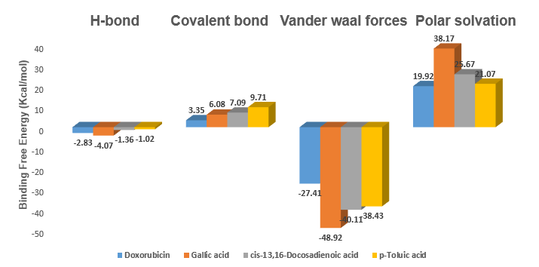Figure 3a: MMGBSAΔG Bind H-bond, Covalent bond, Vander waal forces, and Polar solvation of Doxorubicin and the 3 lead bioactive compounds in Maestro 12.5

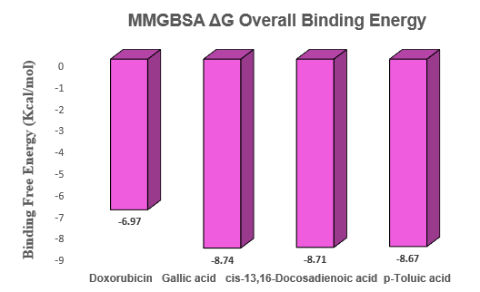
Figure 3b: MMGBSAΔG overall binding energy for Doxorubicin and the 3 lead bioactive compounds in Maestro 12.5.
Table 5: Binding affinities, interactions, and 3D structures of Doxorubicin and the three lead bioactive compounds.
Compound  Identifier | H-bond interaction | Other  Interactions | 3-D structure
Doxorubicin  (Standard Drug) | Lys6, Glu9, Cys11, Asp12, Arg15, Glu436. | Arg5, Lys8, Thr9, Gly10, Thr12, Leu13, Asp16, Thr98, Leu432, Asn433, Val439, Glu442. | 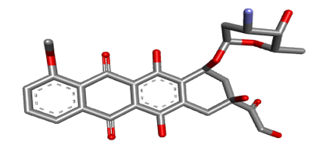
Gallic acid | Pro25. | Arg22, Ala23, Gly24, Val26, Gln34, Ala35, Thr36, Phe51. | 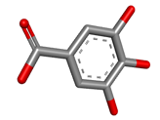
cis-13,16-Docosadienoic acid | Asp116 | Phe45, Ala46, Lys48, Gln49, Leu50, Tyr59, Asn60, Gln62, Arg74, Cys111, Asp112, Pro113, Asn114, Pro115, Asp116, Tyr127. | 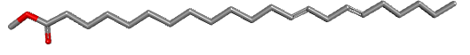
p-Toluic acid,  heptadecyl ester | - | Phe45, Ala46, Lys48, Gln49, Tyr59, Asp60, Gln62, Cys111, Asp112, Pro113, Arg74, Pro115, Asp116. | 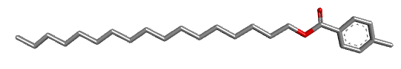

(4a) 7AI0_Doxorubicin

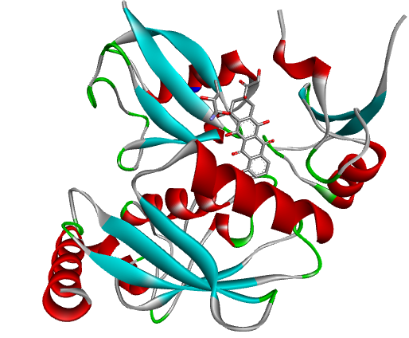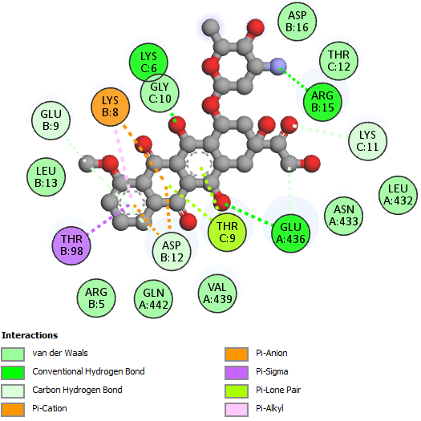

(4b) 7AI0_ Gallic acid

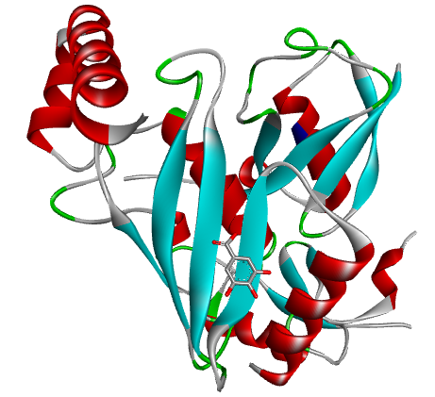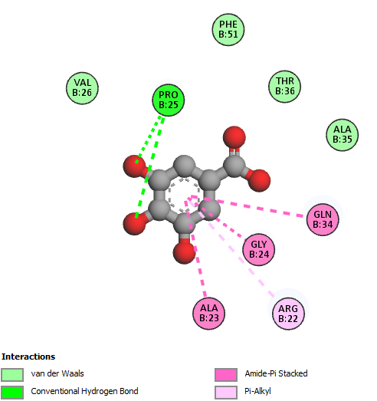

(4C) 7AI0_ Cis-13,16-Docosadienoic acid
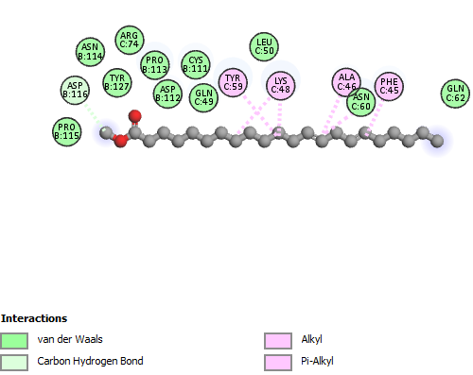

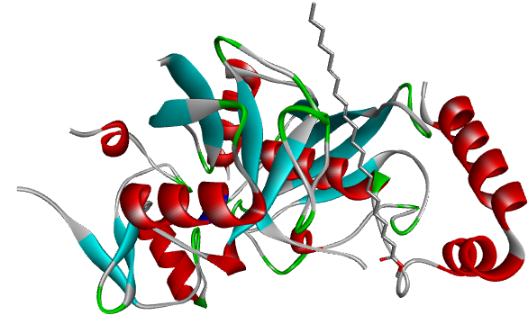

(4d) 7AI0_ p-Toluic acid, heptadecyl ester
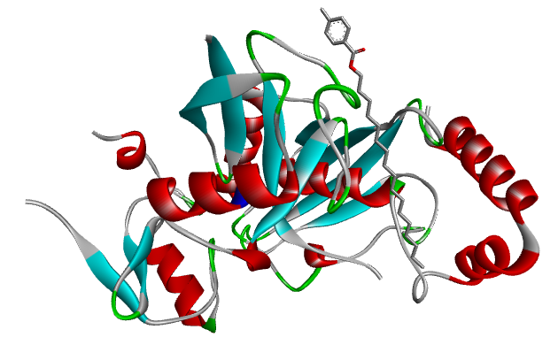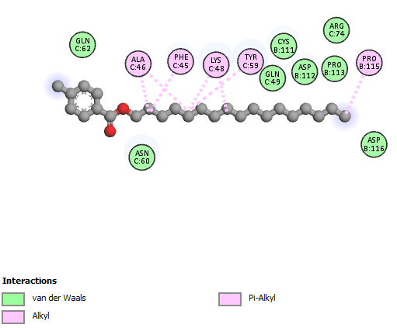

Figure 4: Molecular interaction between Doxorubicin and the 3 lead bioactive compounds at the active site of human mouse double minute 2 homolog (MDM2) G443T RING domain (7AI0) (A) Doxorubicin (Standard drug) (b) Gallic acid (c) Cis-13,16-Docosadienoic acid (d) p-Toluic acid, heptadecyl ester. The structures were rendered using Biovia Discovery Studio 2021.

Interaction analysis further revealed distinct amino acid contributions that account for these energy differences (Table 5 and Figure 4a–4d). Gallic acid formed a key hydrogen bond with Pro25 while engaging in additional non-bonded interactions with Arg22, Ala23, Gly24, Val26, Gln34, Ala35, Thr36, and Phe51, stabilising its position in the MDM2 binding pocket. Cis-13,16-docosadienoic acid exhibited hydrogen bonding with Asp116 and extensive van der Waals and electrostatic interactions with residues such as Phe45, Ala46, Lys48, Gln49, Leu50, Tyr59, Asn60, Gln62, Arg74, Cys111, Asp112, Pro113, Asn114, Pro115, Asp116, and Tyr127. P-Toluic acid, heptadecyl ester, did not form any hydrogen bonds but interacted strongly with multiple key residues, including Phe45, Ala46, Lys48, Gln49, Tyr59, Asp60, Gln62, Cys111, Asp112, Pro113, Arg74, Pro115, and Asp116. These stabilising contacts are essential for sustained binding affinity and specificity at the MDM2 active site.
In comparison, doxorubicin formed hydrogen bonds with Lys6, Glu9, Cys11, Asp12, Arg15, and Glu436 and additional non-covalent interactions with Arg5, Lys8, Thr9, Gly10, Thr12, Leu13, Asp16, Thr98, Leu432, Asn433, Val439, and Glu442 (Table 5, Figure 4a). While extensive, its interactions were energetically less favourable, resulting in a weaker overall binding affinity. These findings are consistent with prior computational studies that underscore the value of MM-GBSA in capturing solvation effects and enthalpic contributions for accurate prediction of ligand binding [37]. The significantly better energetic and structural stability of gallic acid, cis-13,16-docosadienoic acid, and p-toluic acid, heptadecyl ester, suggests their potential as lead MDM2 inhibitors in osteosarcoma therapy.
4.0 CONCLUSION
This study investigated 154 GC-MS-identified phytochemicals from Allium sativum for their inhibitory potential against MDM2, a validated oncogenic target in osteosarcoma. Using an integrated computer-aided drug discovery approach comprising molecular docking, physicochemical screening, pharmacokinetic and toxicity prediction, and MM-GBSA binding free energy estimation, gallic acid, cis-13,16-docosadienoic acid, and p-toluic acid, heptadecyl ester, were identified as the most promising MDM2 inhibitors. These compounds exhibited superior binding affinity, favourable pharmacokinetic profiles, and enhanced receptor-binding stability compared to the standard drug doxorubicin. The findings contribute to the development of safer, plant-derived therapeutic candidates for osteosarcoma and provide a rational basis for future experimental validation and preclinical optimisation.

GLOSSARY
Abbreviation | Meaning
2D | Two-Dimensional
3D | Three-Dimensional
ADMET | Absorption, Distribution, Metabolism, Excretion, and Toxicity
AMES | Ames Mutagenicity Test
BBB | Blood Brain Barrier
CADD | Computer-Aided Drug Design
CYP | Cytochrome P450
GC-MS | Gas Chromatography–Mass Spectrometry
HBA | Hydrogen Bond Acceptors
HBD | Hydrogen Bond Donors
hERG | Human Ether-à-go-go Related Gene
HIA | Human Intestinal Absorption
iGEMDock | Generic Evolutionary Method for Molecular Docking
LogP | Logarithm of Octanol–Water Partition Coefficient
MD | Molecular Dynamics
MDM2 | Murine Double Minute 2 Homolog
MM-GBSA | Molecular Mechanics Generalised Born Surface Area
MW | Molecular Weight
PDB | Protein Data Bank
pkCSM | Pharmacokinetics of Small Molecules
Ro5 | Rule of Five
SBDD | Structure-Based Drug Design

DECLARATION OF GENERATIVE AI AND AI-ASSISTED TECHNOLOGIES IN THE WRITING PROCESS
The authors acknowledge the use of generative AI technologies during the preparation and editing of this manuscript. Specifically, Grammarly’s paraphrasing and grammar-checking tools were utilized to enhance the clarity, coherence, and grammatical accuracy of the text. These tools were applied to refine sentence structure, streamline ideas, and ensure the manuscript adhered to high linguistic standards.
Details of AI Usage:
- Generative AI Tool Used: Grammarly Paraphrasing and Grammar Checking Tool
- Purpose of Usage: To improve paraphrasing, summarization, and grammatical accuracy throughout the manuscript.
- Prompts Used: The authors provided original content, particularly sections such as the Methodology and Results, for Grammarly to refine in terms of grammar and coherence.
Following the use of these tools, the authors meticulously reviewed and edited the content to ensure it met the scientific rigor and accuracy required for publication. The authors take full responsibility for the integrity, originality, and quality of the final manuscript.
AVAILABILITY OF DATA AND MATERIALS
The data are available on request.
ETHICS APPROVAL AND CONSENT TO PARTICIPATE
This study involved in-silico evaluation and did not require ethical approval or informed consent, as no human or animal subjects were involved. All secondary data utilized, including structural and pharmacokinetic information, were obtained from publicly accessible and peer-reviewed scientific databases and properly cited to ensure academic integrity.
CONSENT FOR PUBLICATION
Not applicable.
LIMITATIONS
As the study was computational and self-funded, no experimental validation using synthesis and characterization, in vitro and in vivo assays of Gallic acid, cis-13,16-docosadienoic acid, and p-Toluic acid heptadecyl ester could be performed.

DATA AVAILABILITY
The datasets analyzed during the research are available upon request.

REFERENCES
- Isakoff MS, Bielack SS, Meltzer P, Gorlick R. (2015). “Osteosarcoma: Current treatment and a collaborative pathway to success.” Journal of Clinical Oncology, 33(27):3029–3035. https://doi.org/10.1200/JCO.2014.59.4895
- Kansara M, Teng MW, Smyth MJ, Thomas DM. (2014). “Translational biology of osteosarcoma.” Nature Reviews Cancer, 14(11):722–735. https://doi.org/10.1038/nrc3838
- Marina N, Gebhardt M, Teot L, Gorlick R. (2004). “Biology and therapeutic advances for pediatric osteosarcoma.” Oncologist, 9(4):422–441. https://doi.org/10.1634/theoncologist.9-4-422
- Luetke A, Meyers PA, Lewis I, Juergens H. (2014). “Osteosarcoma treatment—Where do we stand? A state of the art review.” Cancer Treatment Reviews, 40(4):523–532. https://doi.org/10.1016/j.ctrv.2013.11.006
- Yao Y, Zhang Q, Li Z, Zhang H. MDM2: Current research status and prospects of tumor treatment. Cancer Cell Int. 2024;24(1). https://doi.org/10.1186/s12935-024-03356-8
- Arena G, Riscal R, Linares LK, Le Cam L. MDM2 controls gene expression independently of p53 in both normal and cancer cells. Cell Death Differ. 2018;25(9):1533–1535. https://doi.org/10.1038/s41418-018-0156-x
- Chou AJ, Geller DS, Gorlick R. (2008). “Therapy for osteosarcoma: Where do we go from here?” Paediatric Drugs, 10(5):315–327. https://doi.org/10.2165/00148581-200810050-00005
- Momand J, Zambetti GP, Olson DC, George D, Levine AJ. (1992). “The mdm-2 oncogene product forms a complex with the p53 protein and inhibits p53-mediated transactivation.” Cell, 69(7):1237–1245. https://doi.org/10.1016/0092-8674(92)90644-R
- Secchiero, P., Bosco, R., Celeghini, C., & Zauli, G. (2011). Recent Advances in the Therapeutic Perspectives of Nutlin-3. Current Pharmaceutical Design, 17(6), 569–577. https://doi.org/10.2174/138161211795222586
- Khurana, A., & Shafer, D. A. (2019). MDM2 antagonists as a novel treatment option for acute myeloid leukemia: Perspectives on the therapeutic potential of idasanutlin (RG7388). OncoTargets and Therapy, 12, 2903–2910. https://doi.org/10.2147/OTT.S172315
- Cragg GM, Grothaus PG, Newman DJ. (2009). “Impact of natural products on developing new anti-cancer agents.” Chemical Reviews, 109(7):3012–3043. https://doi.org/10.1021/cr900019j
- Aggarwal BB, Shishodia S. (2006). “Molecular targets of dietary agents for prevention and therapy of cancer.” Biochemical Pharmacology, 71(10):1397–1421. https://doi.org/10.1016/j.bcp.2006.02.009
- Bayan L, Koulivand PH, Gorji A. (2014). “Garlic: A review of potential therapeutic effects.” Avicenna Journal of Phytomedicine, 4(1):1–14. https://pubmed.ncbi.nlm.nih.gov/25050296/
- Amagase H. (2006). “Clarifying the real bioactive constituents of garlic.” Journal of Nutrition, 136(3 Suppl):716S–725S. https://doi.org/10.1093/jn/136.3.716S
- Lionta E, Spyrou G, Vassilatis DK, Cournia Z. (2014). “Structure-based virtual screening for drug discovery: Principles, applications and recent advances.” Current Topics in Medicinal Chemistry, 14(16):1923–1938. https://doi.org/10.2174/1568026614666140929124445
- Meng XY, Zhang HX, Mezei M, Cui M. (2011). “Molecular docking: A powerful approach for structure-based drug discovery.” Current Computer-Aided Drug Design, 7(2):146–157. https://doi.org/10.2174/157340911795677602
- Hospital A, Andrio P, Cugnasco C, Codo L, Becerra Y, Dans PD, et al. (2012). “MDWeb and MDMoby: An integrated web-based platform for molecular dynamics simulations.” Bioinformatics, 28(9):1278–1279. https://doi.org/10.1093/bioinformatics/bts139
- Atanda, O. E., Olaniyan, L. W. B., Fadare, O. A., Ehigie, A. F., Adisa, T. A., Odunitan, T. T., Alabi, O. T., Omonijo, B. A., Aloba, G. O., and Ehigie, L. O. (2024). “In-silico evaluation of phenylisocytosine and its analogs as potent inhibitors of Plasmodium falciparum transketolase: A strategic approach in anti-malarial drug discovery”. International Journal of Biochemistry Research and Review, 33 (6):616-36. https://doi.org/10.9734/ijbcrr/2024/v33i6941.
- Olaniyan, L. W. B., Ehigie, L. O., Ehigie, A. F., Atanda, O.E., Odunitan, T. T., and Fakuade, A. A. (2024). In silico investigation of indenoimidazole derivatives as promising arsenal against methicillin resistant staphylococcus aureus through staphylococcal protein A inhibition. European Journal of Biomedical, 11(6), 04-16. Issn 2349-8870
- O'Boyle, N. M., Banck, M., James, C. A., Morley, C., Vandermeersch, T., and Hutchison, G. R. (2011). Open babel: An open chemical toolbox. Journal of Cheminformatics, 3(1), 1-14. https://doi.org/10.1186/1758-2946-3-33
- Oyedele, A. Q. K., Adelusi, T. I., Ogunlana, A. T., Adeyemi, R. O., Atanda, O. E., Babalola, M. O., and Boyenle, I. D. (2022). Integrated virtual screening and molecular dynamics simulation revealed promising drug candidates of p53-MDM2 interaction. Journal of Molecular Modeling, 28(6), 142.https://doi.org/10.1007/s00894-022-05131-w
- Lipinski, C. A. (2004). Lead-and drug-like compounds: The rule-of-five revolution. Drug Discovery today: Technologies, 1(4), 337-341. https://doi.org/10.1016/j.ddtec.2004.11.007
- Chen, X., Li, H., Tian, L., Li, Q., Luo, J., and Zhang, Y. (2020). Analysis of the physicochemical properties of acaricides based on Lipinski's rule of five. Journal of Computational Biology, 27(9), 1397-1406. https://doi.org/10.1089/cmb.2019.0323
- Fu, L., Shi, S., Yi, J., Wang, N., He, Y., Wu, Z., ... and Cao, D. (2024). ADMETlab 3.0: An updated comprehensive online ADMET prediction platform enhanced with broader coverage, improved performance, API functionality and decision support. Nucleic Acids Research, gkae236. https://doi.org/10.1093/nar/gkae236
- Pires, D. E., Blundell, T. L., and Ascher, D. B. (2015). pkCSM: Predicting small-molecule pharmacokinetic and toxicity properties using graph-based signatures. Journal of Medicinal Chemistry, 58(9), 4066-4072. https://doi.org/10.1021/acs.jmedchem.5b00104
- Daoud, N. E. H., Borah, P., Deb, P. K., Venugopala, K. N., Hourani, W., Alzweiri, M., ... and Tiwari, V. (2021). ADMET profiling in drug discovery and development: Perspectives of in silico, in vitro and integrated approaches. Current Drug Metabolism, 22(7), 503-522. https://doi.org/10.2174/1389200222666210705122913
- Babalola, M. O., Ashiru, M. A., Boyenle, I. D., Atanda, E. O., Oyedele, A. Q. K., Dimeji, Y., ... and Imaga, N. A. (2022). In vitro analysis and molecular docking of gas chromatography-mass spectroscopy fingerprints of polyherbal mixture reveals significant antidiabetic miture. Nigerian Journal of Experimental and Clinical Biosciences, 10(4), 105-115. https://doi.org/10.4103/njecp.njecp_15_22
- Kehinde, O. A. Q., Boyenle, D. I., Ogunlana, A., Ayoola, M. A., Atanda, O.E., and Adelusi, T.I. (2022). Inhibitors of α-glucosidase and angiotensin-converting enzyme in the treatment of type 2 diabetes and its complications: A review on in silico approach. Pharmaceutical and Biomedical Research, 8(4), 237-258. http://dx.doi.org/10.32598/PBR.8.4.1052.1
- Ajao, F. O., Ehigie, A. F., Odunitan, T. T., Atanda, O. E., Ayoola, P. B., and Olaniyan, L. W. (2024). Computational exploration of psidii guajavae folium bioactive compounds as novel Dpp-Iv inhibitors for type 2 diabetes mellitus intervention. Issn 2394-3211
- Biswas, P., Bibi, S., Yousafi, Q., Mehmood, A., Shahzad, S., Ihsan, A., Dey, D., Hasan, N., Hasan, Md. N., Saleem, R. M., Awaji, A. A., Fahmy, U. A., and Abdel-Daim, M. M. (2023). Study of MDM2 as prognostic biomarker in brain-LGG cancer and bioactive phytochemicals inhibit the p53-MDM2 pathway: A computational drug development approach. Molecules, 28(7), 2977–2977. https://doi.org/10.3390/molecules28072977.
- Agu, P. C., Afiukwa, C. A., Orji, O. U., Ezeh, E. M., Ofoke, I. H., Ogbu, C. O., Ugwuja, E. I., and Aja, P. M. (2023). Molecular docking as a tool for the discovery of molecular targets of nutraceuticals in diseases management. Scientific Reports, 13(1). https://doi.org/10.1038/s41598-023-40160-2
- Negru, P. A., Miculas, D. C., Behl, T., Bungau, A. F., Marin, R. C., and Bungau, S. G. (2022). Virtual screening of substances used in the treatment of SARS-CoV-2 infection and analysis of compounds with known action on structurally similar proteins from other viruses. Biomedicine & Pharmacotherapy, 153, 113432. https://doi.org/10.1016/j.biopha.2022.113432
- Tian, S., Wang, J., Li, Y., Li, D., Xu, L., and Hou, T. (2015). The application of in silico drug-likeness predictions in pharmaceutical research. Advanced Drug Delivery Reviews, 86, 2–10. https://doi.org/10.1016/j.addr.2015.01.009
- Chen, X., Pan, S., Li, F., Xu, X., and Xing, H. (2022). Plant-derived bioactive compounds and potential health benefits: involvement of the gut microbiota and its metabolic activity. Biomolecules, 12(12), 1871. https://doi.org/10.3390/biom12121871
- Dong, L., Qu, X., Zhao, Y., and Wang, B. (2021). Prediction of binding free energy of Protein–Ligand complexes with a hybrid molecular mechanics/generalized born surface area and machine learning method. ACS Omega, 6(48), 32938–32947. https://doi.org/10.1021/acsomega.1c04996
- Forouzesh, N., and Mishra, N. (2021). An effective MM/GBSA protocol for absolute binding free energy calculations: A case study on SARS-CoV-2 spike protein and the human ACE2 receptor. Molecules, 26(8), 2383. https://doi.org/10.3390/molecules26082383

APPENDIX
Table 6: Binding energies of Doxorubicin and the 154 bioactive compounds on iGEMDock.
S/N | COMPOUND IDENTIFIER | Binding affinity  (iGEMDock) Kcal/mol)
1 | Doxorubicin (Standard Drug) | -6.97
2 | Gallic acid | -8.74
3 | cis-13,16-Docosadienoic acid | -8.71
4 | p-Toluic acid, heptadecyl ester | -8.67
5 | 1,6,10,18,22-tetracosahexaen-3-ol | -8.36
6 | Phosphine, tridodecyl | -8.32
7 | 4,4'-(5-Iodofurfurylidene)bis(antipyrine) | -8.29
8 | 7-Chloro-1-[(E)-heptylimino]-10-hydroxy-3-(3-trifluoromethyl-phenyl)-1,3,4,10-tetrahydro-2H-acridin-9-one | -8.26
9 | Sarcosine, N-isobutyryl-, octadecyl ester | -8.23
10 | 1,15-Di(1-phenylpropyl)-2,2,4,4,6,6,8,8,10,10,12,12,14,14-tetradecamethyl-1,3,5,7,9,11,13,15-octaoxa-2,4,6,8,10,12,14-heptasilapentadecane | -8.21
11 | 2-Bromo-1,3-bis(dicyclohexylaminomethyl)benzene | -8.09
12 | 4-Pyrrol3-[1-(2-carboxy-1-phenyl-ethyl)-2-oxo-pyrrolidin-3-ylcarbamoyl]-propionylmorpho-piperazine-1-carboxylic acid tert-butyl ester | -7.94
13 | Azastreptonigrin | -7.91
14 | Beta-Carotene | -7.67
15 | Cholestan-6-en-3-ol, O-acetyl-24-methyl-5,8-(tetrahydrofuran-2,5-dione-3,4-diyl) | -7.53
16 | Nonacos-1-ene | -7.39
17 | Octasiloxane, 1,1,3,3,5,5,7,7,9,9,11,11,13,13,15,15-hexadecamethyl | -7.14
18 | 2-Dodecen-1-yl-succinic anhydride | -5.31
19 | 5-Ethoxycarbonylamino-2,6-dimethylpyridin-3-yl)carbamic acid | -5.94
20 | (E)-1-(4-hydroxy-3-methoxyphenyl)dec-3-en-5-one | -6.72
21 | (E)-15,16-Dinorlabda-8(17),12-dien-14-al | -4.33
22 | 4-(4-Phenylthiazol-2-yl)piperazin-1-yl](O-tolyl)methanone | -4.75
23 | 1-(4-Hydroxy-3-methoxyphenyl)dec-4-en-3-one | -3.94
24 | 1-(Benzenesulfonyl)-2-methylaziridine | -6.48
25 | 1',1'-Dicarboethoxy-1beta,2beta-dihydro-3'H-cycloprop(1,2)cholesta-1,4,6-trien-3-one | -5.54
26 | 1,2,3,4-Tetrahydro-9-methyl-6-cyclohexyl-1-carbazolone | -4.73
27 | 1,2-Benzenediol, 3-[[(3,5-dichlorophenyl)imino]methyl | -6.81
28 | 1,2-Cinnolinedicarboxylic acid, 1,2,3,5,6,7,8,8a-octahydro-4-trimethylsilyloxy-diethyl ester | -6.72
29 | 1,3,5-Triazine-2,4,6(1H,3H,5H)-trione, 1,3,5-tris(2-chloroethyl) | -6.90
30 | 1,5-Dimethyl-2-vinylcyclohexanecarboxylic acid | -6.04
31 | 1,5-Methano-1H,7H,11H-furo[3,4-g]pyrano[3,2-b]xanthene-7,15-dione, 3,3a,4,5-tetrahydro-8-hydroxy-3,3,11,11-tetramethyl-1,13-bis(3-methyl-2-butenyl)-,[1R-(1.alpha.,3a.beta.,5.alpha.,14aS)] | -6.55
32 | 1-[2,6-Dinitro-4-(trifluoromethyl)phenyl]piperazine | -6.40
33 | 1-[4-(4-Fluoro-phenyl)-thiazol-2-yl]-4-methanesulfonyl-piperazine | -4.89
34 | 1-Benzazirene-1-carboxylic acid, 2,2,5a-trimethyl-1a-[3-oxo-1-butenyl] perhydro-methyl ester | -2.90
35 | 1-Butanol | -4.71
36 | 1H-1,2,3,4-Tetrazole-1,5-diamine, N(1)-[(2-ethoxy-3-methoxyphenyl)methyl] | -5.85
37 | 1-Hexene | -2.34
38 | 1H-Pyrazol-3(2H)-one | -3.89
39 | 1-Octadecene | -4.02
40 | 1-Pentene | -5.31
41 | 1-Undecene | -3.86
42 | 2-(2,4-Dichlorophenoxy)-n'-(4-ethoxybenzylidene)acetohydrazide | -6.06
43 | 2-(4-Chlorophenyl)-5,7-dimethylimidazo[1,2-a]pyridine-8-carbonitrile | -6.71
44 | 2,2-Dibromocholestanone | -4.23
45 | 2,3,4-Pyrrolidinetrione, 1,5,5-trimethyl-, 3-(4-bromophenyl)hydrazone 4-oxime | -6.82
46 | 2,4,6(1H,3H,5H)-Pyrimidinetrithione | -4.43
47 | 2,4-Diamino-6,8-bis[3,4-dichlorophenyl]-5,6-dihydro-8H-thiapyrano[4',3'-4,5]thieno[2,3-d]pyrimidine | -6.89
48 | 2,4-Diethoxybenzaldehyde | -6.14
49 | 2,5-Bis[trichloromethyl]-6-chlorophenyl-2,4,6-trichlorophenyl ether | -6.87
50 | 2,5-Cyclohexadien-1-one, 2,6-dichloro-4-[(4-methoxyphenyl)imino]- | -6.53
51 | 2,5-Cyclohexadiene-1,4-dione, 2-cyclohexyl | -5.80
52 | 2-Azetidinone | -4.91
53 | 2-Butanone, 4-(4-hydroxy-3-methoxyphenyl) | -2.78
54 | 2-Butenal, 2-methyl-4-[3a,4,5,7-tetrahydro-8-hydroxy-3,3,11,11-tetramethyl-13-(3-methyl-2-butenyl)-7,15-dioxo-1,5-methano-1H,3H,11H-furo[3,4-g]pyrano[3,2-b]xanthen-1-yl]-, [1R-[1alpha | -6.81
55 | 2-Formylamino-3-phenylpropionic acid, 1,7,7-trimethylbicyclo[2.2.1]hept-2-yl ester | -5.70
56 | 2-Furancarboxaldehyde | -3.08
57 | 2H-1,3-benzoxazine-7-carboxamide, 3,4-dihydro-6-hydroxy-3-methyl-N-octadecyl-5,8-dipropyl | -4.42
58 | 2H-Azepin-2-one | -3.92
59 | 2-Methyl-1-tridecene | -4.99
60 | 2-Pyrimidinamine | -5.67
61 | 2-t-Butyl-6-[2-hydroxy-2-(4-methoxyphenyl)ethyl]-[1,3]dioxin-4-one | -6.31
62 | 3-(6-Hydroxy-3,7-dimethyl-octa-2,7-dienyl)-4-methoxy-phenol | -5.82
63 | 3-(antipyrin-4-yl)-5-(5-nitrosalicylidene)rhodamine | -4.73
64 | 3,3-Dimethylbutylbis(trifluoromethyl)borane | -2.23
65 | 3,4-Dihydroxymandelic acid | -3.80
66 | 3,5-Dihydro-3-[[1-methylethyl]imino]-N,5-bis[4-[trifluoromethyl]phenyl]-2-phenazinamine | -6.48
67 | 3,5-Dimethylpiperidine | -1.89
68 | 3-[beta-Keto-gamma-[3-ethyl-5-methyl-2-oxazolidinone-4-yl]propyl]-4-quinazolone | -4.43
69 | 3-Bromo-4-methylphenol | -1.34
70 | 3H-pyrazol-3-one, 4-[2-(6-amino-5-hydroxy-2-pyridinyl)diazenyl]-1,2-dihydro-1,5-dimethyl-2-phenyl | -4.82
71 | 4-([3,3,3-Trifluoro-2-(trifluoromethyl)propanoyl]oxy)phenyl 2-bromo-3,3,3-trifluoro-2-(trifluoromethyl)propanoate | -1.95
72 | 4-(5-Methoxyindol-3-ylmethyleneamino)-2,3-dimethyl-1-phenyl-3-pyrazolin-5-one | -5.85
73 | 4-(5-Nitrofurfurylideneamino)antipyrine | -6.22
74 | 4-[(4-Nitrobenzylidene)amino]phenol | -4.89
75 | 4a,7a-Epoxy-5H-cyclopenta[a]cyclopropa[f]cycloundecen-4(1H)-one, 1a,6,7,10,11,11a-hexahydro-7,10,11-trihydroxy-1,1,3,6,9-pentamethyl | -6.07
76 | 4-Aminobenzoic acid | -3.21
77 | 5-(4-Chloro-phenyl)-2,4-dihydro-pyrazol-3-one | -5.23
78 | 5.beta.-Pregnane, 3.alpha.,11.beta.,17,20.alpha.,21-pentakis(trimeth ylsiloxy) | -6.79
79 | 5-Stannaspiro[4.4]nona-1,3-diene, 6,6,9,9-tetrakis(trimethylsilyl)- | -4.57
80 | 6-[N-Aziridyl]hexadiene-1,3 | -1.22
81 | 6-Octadecenoic acid | -3.87
82 | 7,7-Dimethyl-(5Z,8Z)-eicosadienoic acid | -4.66
83 | 7H-9,11b-Epoxy-5a,13a-propanophenanthro[2,1-f][1,4]oxazepin-3(4H)-one, 12-(acetyloxy)-14-[1-(acetyloxy)ethyl]dodecahydro-9-methoxy-2,11a-dimethyl | -6.94
84 | 7-Oxa-15,20,24,27-tetraazatetracyclo[13.9.6.2(8,11).1(2,6)]tritriaconta-2,4,6(33),8,10,12,31-heptaene-14,26-dione, 20-acetyl-5-methoxy-, [s-(Z)] | -6.91
85 | 7-Oxabicyclo[4.1.0]heptane, 1-(1,3-dimethyl-1,3-butadienyl}-2,2,6-trimethyl- (E) | -6.73
86 | 9,19-Cycloergost-24(28)-en-3-ol, 4,14-dimethyl-, acetate, (3.beta.,4.alpha.,5.alpha.) | -5.42
87 | 9-Desoxo-9-xi-hydroxy-3,7,8,9,12-pentaacetate ingol | -4.58
88 | Acetamide | -2.92
89 | Acetonitrile | -3.28
90 | Acrylophenone | -3.36
91 | Antipyrine | -2.11
92 | Benz[e]azulene-3,8-dione3a,4,6a,7,9,10,10a,10b-octahydro-3a,10a-di hydroxy-5-(hydroxymethyl)-2,10-dimethyl-,(3a.alpha.,6a.alpha.,10.be ta.,10a.beta.,10b.beta.)-(+)- | -6.49
93 | Benzamide | -1.35
94 | Benzenamine | -4.43
95 | Benzene, 1-methoxy-4-(2-cyano-2-phenylethenyl) | -4.89
96 | Benzo[1,2-b4,5-b']bisbenzofuran-6,12-dione, 2,3,8,9-tetrakis(acetyloxy) | -4.96
97 | Benzoic acid | -1.35
98 | beta-trans-Zearalenol | -1.98
99 | Boroxin | -3.24
100 | Butane, 1-(1-ethoxyethoxy) | -1.19
101 | Butanenitrile | -3.52
102 | Cholest-2-eno[2,3-b]quinoxaline, 6'-nitro | -5.99
103 | Cholest-6-en-3-ol | -6.28
104 | Colchicine | -6.56
105 | Cyclodecanone | -4.22
106 | Cycloheptasiloxane | -3.89
107 | Cyclohexanemethanol | -4.36
108 | Cyclohexene | -5.01
109 | Cyclopentadecanone | -3.30
110 | Cyclopentadienyl | -2.86
111 | Cyclopropyl-(2-nonyloxy-benzyl)-amine | -5.32
112 | Cyclotetradecanamine | -4.87
113 | D.B-Friedo-18,19-secolup-19-ene,,10-epoxy-, (3.beta.,10.beta) | -1.77
114 | Distannoxane | -4.56
115 | Di-tert-butyl peroxide | -2.45
116 | Estrone | -5.13
117 | Furfural | -5.88
118 | Germane, 3,4-pentadien-1-yne-1,3-diyl-5-ylidenetetrakis[trimethyl | -3.05
119 | Gibb-3-ene-1,10-dicarboxylic acid | -3.97
120 | Heptadecanoic acid | -6.22
121 | Hexadecanoic acid | -6.05
122 | Isopropyl 4-(4-dimethylaminophenyl)-3,4-dihydro-1,6-dimethyl-2(1H)-oxo-5-pyrimidinecarboxylate | -5.43
123 | Molybdenum | -2.23
124 | m-Toluic acid | -6.88
125 | Myristic acid | -2.60
126 | Nickel | -1.04
127 | N-Methyl-N-(4-(3,4,5-trimethoxyphenyl)methylidine)aminophenylacetamide | -6.23
128 | Octadec-9-enoic acid | -4.50
129 | Octadecanoic acid | -5.95
130 | Oleana-12-ene-29-oic acid | -4.61
131 | Oleic acid | -2.67
132 | Oxazol-2-thione[4,5-o]ergost-7,22-dien-3-ol | -3.48
133 | Pentadecane | -3.98
134 | Pentamethylcyclopentadiene | -5.22
135 | Pentanamide | -2.58
136 | Pentane | -1.76
137 | Phenanthrene | -4.35
138 | Phenol | -4.78
139 | Piperazine | -3.29
140 | Platinum | -1.34
141 | Pregn-5-en-18-ol | -2.46
142 | Propanenitrile | -3.35
143 | Propionamide | -3.27
144 | Pyridine | -1.95
145 | Pyrimido[4,5-d]pyrimidine-2,4(1H,3H)-dione | -5.53
146 | Sebacic acid | -4.73
147 | Silanamine | -4.39
148 | Silane | -2.67
149 | Tetracosapentaene | -5.79
150 | Thiocarbamic acid | -4.36
151 | trans-4-aminocyclohexanecarboxylic acid | -5.82
152 | trans-13-octadecenoic acid | -6.79
153 | Tricyclo[10.2.2.2(5,8)]octadeca-5,7,12,14,15,17-hexaene | -2.45
154 | Tris(3-acetyltetramsaeure)-gadolinium(iii) | -5.88
155 | Zinc, bis(dipentylcarbamodithioato-S,S')-, (T-4) | -2.94

