# Typology, Perceptions and Endogenous Control Methods of Cassava Root Rot among Producers in Ivory Coast

## ABSTRACT

|  |
| --- |
| Cassava is a crop of great socio-economic importance in Côte d'Ivoire. However, this crop faces major constraints, particularly tuber rot. The search for sustainable control methods requires an in-depth understanding of the factors responsible and producers' perceptions of this problem. The study is based on a survey conducted in 13 cassava-growing localities, including Aboisso, Abengourou, Adzopé, Agboville, Bouaké, Dabou, Toumodi, Yamoussoukro, Daloa, San Pédro, Man, Katiola and Ferkessédougoudin the main cassava-growing areas throughout Côte d'Ivoire. The questionnaire developed took into account the typology of producers. Questionnaires were submitted to 285 cassava growers. Cultivation practices were assessed during the survey by field observation in 320 plots with a view to describing the cultivation practices employed, their level of knowledge of the disease and endogenous control methods. The results showed that cassava is grown throughout Côte d'Ivoire, with a high proportion of women among producers. This crop is a very important source of income. From an organisational point of view, most producers are not grouped into cooperatives, have a very low level of education and do not receive any support. In terms of farming practices, the results showed that the cuttings used are mostly of variable quality and are not disinfected. Rot is widespread in the plots and the symptoms of the disease are well known to growers. There are no effective control methods. Supervising producers would be an effective and sustainable way of combating tuber rot and would help guarantee cassava production. |

*Keywords: Cassava; typology; producers' perceptions; endogenous control; root rot.*

**1. INTRODUCTION**

Cassava is a crop of great socio-economic importance in Côte d'Ivoire. However, this crop faces major constraints, notably tuber burps. Methodology and results. The search for sustainable control methods requires an in-depth understanding of the factors responsible and of growers' perceptions of this problem. This study was carried out in this context. It is based on a survey carried out in the main cassava-growing areas throughout Côte d’Ivoire. The questionnaire designed for this purpose took into account the typology of producers, the cultivation practices employed, their level of knowledge of the disease and endogenous control methods. The results revealed that cassava is grown throughout Côte d'Ivoire, with a high proportion of women among producers. This crop is a very important source of income. From an organizational point of view, most producers are not grouped into cooperatives, have a very low level of education and receive no supervision. With regard to farming practices, the results showed that the cuttings used are mostly of variable quality and are not disinfected. Rot is widespread in the plots and the symptoms of the disease are well known to growers. However, there are no effective control methods. Conclusion and application of results: Supervision of growers would be an effective and sustainable way of combating tuber rot, and would guarantee cassava production (Ahomadikpohou, 2022).

Cassava, Manihot esculenta Crantz (Euphorbiaceae), ranks fourth in the world in terms of crop production, reaching 277.9 million tonnes in 2017, of which 57% was in Africa, 33% in Asia and 20% in Latin America. In terms of production, Nigeria ranks first in the world with 55 million tonnes (N'Zué et al., 2013), followed by Ghana with 19 million tonnes, the Democratic Republic of Congo (DRC) with 14.5 million tonnes, and Mozambique with 10.9 million tonnesIn Côte d'Ivoire, cassava is the second food crop after yam in terms of quantity produced (FAO, 2017). Since some cassava by-products, such as gari and attiéké, have been exported to neighboring countries such as Mali and Burkina Faso, cassava cultivation has continued to grow in various production areas of the country. Cassava occupies a prominent place in the daily diet of Ivorians. Annual production in Côte d'Ivoire is constantly increasing, reaching 4.5 million tonnes per year, with an average yield of 6.5 tonnes per hectare (Diancoumba, 2008) and contributing 12 % of GDP according to the Ministry of Agriculture and Rural Development. In addition to being a popular food in rural and urban households, cassava and its derivatives are heavily traded in Côte d'Ivoire and neighboring countries (Yao, 2021). Due to its economic and nutritional importance, cassava has been the subject of several research programs aimed at improving local varieties or introducing new varieties by the National Center for Agronomic Research (CNRA) of Côte d'Ivoire. Despite these efforts, cassava production is subject to numerous constraints, including viral diseases, vascular bacterial blight (Affery et al., 2011; Momol & Aldwinckle, 2021), and root rots (Msikita et al., 2005; Bandyopadhyay et al., 2006; Kumulungui et al., 2012; Fargier, 2007). Among these diseases, root rot remains the least studied infection, although production losses it causes can reach up to 90% in West Africa (Msikita et al., 2005). As a staple food, diseases affecting cassava have an immediate impact on the food supply of populations. The search for sustainable control methods requires an understanding of the factors responsible and the endogenous methods applied by producers to address this constraint. The objective of this study is to understand cassava producers' perceptions of the disease and to identify the endogenous control methods used by producers.

**2. MATERIALS AND METHODS**

**Plant material:** The plant material used in this study consisted mainly of cassava plants from plots infested with root rot. For this purpose, all cassava varieties encountered during our survey among farmers, of production age, were evaluated.

**Study Area:** Cassava production areas covered the entire country and extended around major cities such as Aboisso, Abengourou, Adzopé, Agboville, Bouaké, Dabou, Toumodi, Yamoussoukro, Daloa, San Pedro, Man, Katiola and Ferkessédougou. The survey was carried out on 320 plots in 13 departments and plots were identified by ANADER on the basis of their cassava production capacity.

**Survey Conduct:** This study consisted of a survey of cassava producers and a visit to their cultivated plots. A total of 285 producers were taken into account on the basis of production area and the presence of the disease. These producers were subjected to a previously designed questionnaire covering three main points: the typology of producers, cultural practices, their knowledge of the causes of the disease and endogenous control methods. The proportion of producers was distributed equally across the localities, i.e. 20 per locality.

**Determining Producer Typology:** A survey was conducted among 285 producers to understand their typology. During this survey, producers were administered closed-ended questionnaires covering social, economic, institutional, and technical variables. Social variables included age, gender, marital status, and household size. Economic variables included the number of dependents and the producer's income. At the institutional level, the aim was to assess the level of organization of producers.

**Cassava Producers' Cultivation Practices:** Cultivation practices were assessed during the survey by field observation and questioning. The questionnaire covered the choice of plots and cassava varieties cultivated according to locality, the origin of cuttings and their treatment during planting, the cassava cultivation season and the harvest period. In addition, plot maintenance after cultivation was recorded, including the method and frequency of weeding, the use of fertilizers and the cassava cultivation system. At the end of this survey, cassava producers were classified according to the cultural practices used.

**Disease knowledge and endogenous control methods**: The survey of producers also took into account their knowledge on the causes of cassava tuber rot, the different types of rot, recognition of disease symptoms, the period of onset and the control methods used. All these parameters were recorded from direct field observations. Soil preparation, resistant cassava varieties grown, harvest date after planting, and root harvesting and storage methods were noted. The data collected made it possible to identify the control methods used by farmers against cassava tuberous root rot. This survey made it possible to classify producers according to the endogenous control methods used.

**Producer monitoring and support:** Access to support was assessed during this study. To this end, the number of producers who received support was recorded and the rate of producers benefiting from this support was calculated.

**Analysis:** The collected data were corrected, coded, and entered. The statistical analyst was selected based on their experience in data collection and analysis, and conducting similar studies. Data processing was carried out using the SPHINX application. The data thus entered was analyzed.

**3. RESULTS**

**3.1 Typology of Cassava Producers in the Prospected Areas**

**Educational Level :** Five educational levels were identified from the producer surveys. Data analysis revealed that over 43.85% of producers are illiterate and about 29.4% have a primary education level. A low proportion was noted for the higher education level (2.4%) and for the Quranic level (6.9%). Regarding the secondary education level, the analysis revealed a proportion of 17.65% (Fig. 1).

**Experience level of cassava producers:** The survey results allowed producers to be divided into four groups according to the number of years of experience in cassava cultivation (Table 1). Approximately 20.32% of producers have 1 to 5 years of experience in cassava cultivation. The majority of producers (69%) have between 6 and 20 years of experience in cassava production, distributed as follows: 33.6% with 6 to 10 years of experience, 32.08% with 11 to 20 years of experience, and 13.9% with more than 21 years of experience.

**Table 1. Level of experience of cassava producers**

|  |  |
| --- | --- |
| **Years of experience** | **Proportion of peasants (%)** |
| 1 to 5 | 20.32 |
| 6 to 10 | 33.68 |
| 11 to 20 | 32.09 |
| 21 and over | 13.90 |

**Marital status of cassava producers:** Analysis of marital status revealed that more than 84% of producers are “married” (in a couple). However, a small proportion estimated at 13% of producers are single and 3% are widowed (Fig. 2).

**Number of dependents of producers:** Data analysis reveals that most producers have at least one dependent and the majority (82%) have at least 4 dependents. Also, about 60% of them have more than 6 dependents (Table 2).

**Table 2. Number of dependents of producers**

|  |  |
| --- | --- |
| **Dependents** | **Proportion (%)** |
| None | 0 |
| 1 to 3 | 20.42 |
| 4 to 5 | 20.43 |
| 6 and over | 59.55 |

**Distribution of producers by gender:** In the 14 cassava production areas surveyed during this study, men represent a proportion of 59% compared to 41% of women of the total population of cassava producers listed. This crop therefore constitutes an important source of income which contributes to the empowerment of women in rural areas (Fig. 3).

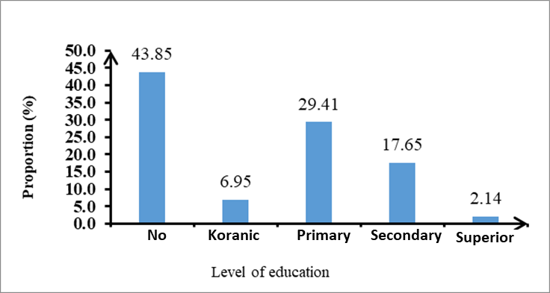

**Fig. 1. Level of education of cassava producers in the surveyed localities**

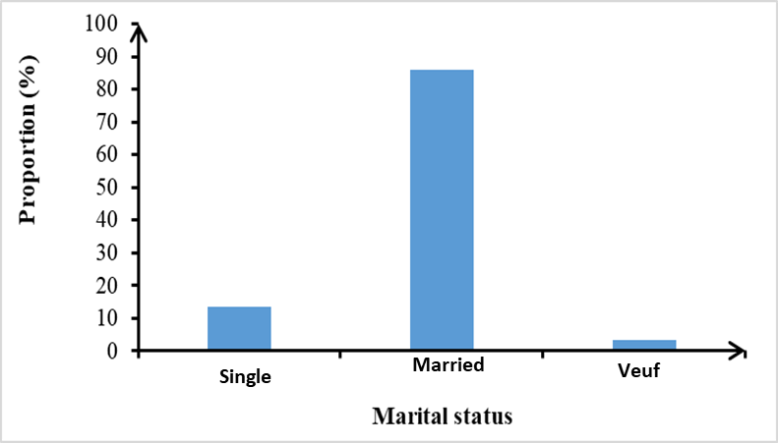

**Fig. 2. Marital status of cassava producers**

**F: Female; M: Male**

**Fig. 3. Proportions of producers by gender**

**Producer Organization Level** : Regarding the level of producer organization, data analysis revealed that more than 61.50% of cassava producers do not belong to any cooperative. On the other hand, 38.50% are members of an agricultural association platform (Table 3).

**Table 3. Producer organization**

|  |  |
| --- | --- |
| **Status of producers** | **Proportions of producers (%)** |
| Membership in a Cooperative | 38.50 |
| No Membership in a Cooperative | 61.50 |

***Classification of producers according to their socio-economic situations:*** Sociological data, including educational level, number of years of experience, number of dependents and membership in an organization, are positively correlated with factor 2 (axis 1), which contributes 25.57% of the total variance of individuals. Marital status and gender are negatively correlated with factor 1, which contributes 33.54% of the total variance of individuals. The PCA individual dispersion plan for producers highlighted four groups (Fig. 4).

**Group 1:** Composed of male individuals, living as a couple, with more than three dependents and more than five years of experience in cassava cultivation. These producers belong to an associative platform and have at least a primary level of education .

**Group 2:** Composed of female individuals with at least primary education, not living as a couple, with fewer than three dependents, and less than five years of experience in cassava cultivation. These producers also belong to an associative platform.

**Group 3:** Composed of male individuals with no formal education, living as a couple, with more than three dependents, and more than five years of experience in cassava cultivation. These producers belong to an associative platform.

**Group 4:** Composed of male producers, with no formal education, some living with a partner and others single, with fewer than three dependents and less than five years of experience in cassava cultivation. These producers do not belong to any associative platform.

**Plot selection :** Cassava producers mainly use two types of land clearing: forest and fallow (Fig. 5). Analyses show that 95% of cassava fields are planted on fallow plots or plots with previous cultivation. However, a small proportion of cassava fields are planted on plots newly cleared from forest. This type of practice is very underrepresented and estimated at 5.5% of the plots surveyed.

**Reason for choosing varieties:** The survey revealed that the choice of cassava varieties in the surveyed areas is motivated by various reasons (Table 4). For the majority of producers (60%), the choice is motivated by the selling price of the variety. The harvest yield of the varieties influenced approximately 21% of producers. Approximately 16% of producers chose certain cassava varieties because of their importance in their diet (subsistence). Only 2% of the producers surveyed did not express an opinion on the issue.

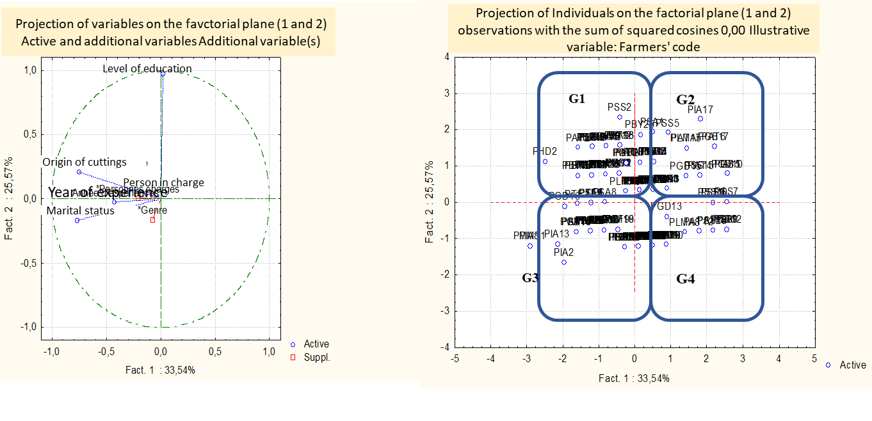

**(a) Circle of correlations and (b) dispersion of treatments**

**Fig. 4. Distribution of producers according to socio-economic data**

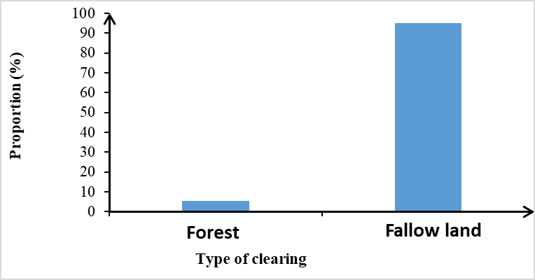

**Fig. 5.** Proportion of choices according to the types of clearing

**Table 4. Proportion of farmers according to the reason for choosing varieties**

|  |  |
| --- | --- |
| **Reason for choosing cassava varieties** | **Proportion (%)** |
| Food | 16.01 |
| Yield | 21.00 |
| Sale (Price) | 60.92 |
| No opinion | 02.07 |

**Cassava varieties cultivated by location:** The survey results revealed the varieties used by producers (Table 5). In the Bouaké area, four cassava varieties were identified in the plots visited. The Agbablé (30%) and Bonoua (40%) varieties are mainly cultivated by producers in this area. The Bondoukou and Yavo varieties are cultivated at a proportion of 10% and 20% respectively. Producers in Yamoussoukro mainly use four cassava varieties. The Yacé (37%), Bonoua (30%), and Yavo (27%) varieties are the most widely used. However, the Sika variety is used at a low proportion of 6%. The Foutou (33%), Yacé (20%), and Agbablé (33%) varieties are frequently cultivated in the San-Pedro area. On the other hand, Bocou 1 and 2 are still poorly cultivated by the producers surveyed with a proportion of 7%. In the locality of Adzopé, the Manawa variety and an "Unknown" variety are mainly cultivated by producers with proportions of 44% and 25% respectively. The Attiéké, Ahoua and Yacé varieties are cultivated at relatively low proportions of 6 and 19% respectively. Five cassava varieties were recorded among the producers of Daloa. Yavo and Yacé were the most cultivated with rates of 45 and 32% respectively. As for the Agbablé, Sika and Bocou 5 varieties, they are cultivated at proportions of between 6 and 10%. In the locality of Agboville, three cassava varieties were recorded. Yacé occupies 50% of production, Foutou and the "Unknown" variety are cultivated at 30 and 20% respectively. In Abengourou, six varieties were identified. Producers mainly cultivate Yacé (44%) and Zamaka (33%). The cassava varieties Sika, Foutou, Anader and Inconnue are cultivated by cassava producers in proportions ranging from 5% to 6%. In the locality of Man, four cassava varieties were identified by producers. The Yacé and Bonoua varieties are mainly cultivated with respective proportions of 37% and 45%. As for the varieties, Yavo (11%) and Sika (6%), they occupied a small proportion in this locality. Producers mainly cultivate two varieties in Dabou, Sapelle and Inconnue with proportions of 45% and 46% respectively, while the Sika variety is cultivated at 9%; In Aboisso, five varieties are cultivated by the cassava producers surveyed. The Accra-Banchi, Diarrassouba and the “Unknown” variety and another unidentified variety “Unknown” were the most cultivated by producers with rates of 33, 20 and 27% respectively. As for the “Yacé (7%)” and “Bonoua” (13%) varieties, they are cultivated in small proportions. In Toumodi, five varieties are cultivated by producers, with the Agbablé varieties leading the production (47%). Yavo, Kaman, Yacé and Bonoua occupy small shares between 10 and 21%. In the locality of Ferkessédougou, the Diarrasouba variety is predominantly (100%) cultivated by producers (Table 4).

**Table 5. Distribution of the proportion of cassava varieties cultivated by locality**

|  |  |  |  |
| --- | --- | --- | --- |
| **Cassava varieties in Bouaké** | **Proportion (%)** | **Cassava varieties in Yamoussoukro** | **Proportion (%)** |
| Bonoua | 40 | Bonoua | 30 |
| Yavo | 20 | Yavo | 27 |
| Agbable | 30 | Yacé | 37 |
| Bondoukou | 10 | Sika | 6 |
| **Cassava varieties in San Pedro** | **Proportion (%)** | **Cassava varieties in Adzopé** | **Proportion (%)** |
| Agbable | 33 | Yacé | 19 |
| Yacé | 20 | Ahoua | 6 |
| Bocou 2 | 07 | Mamanwa | 44 |
| Bocou 1 | 07 | Unknown | 25 |
| Foutou | 33 | Cassava attiéké | 6 |
| **Cassava varieties in Daloa** | **Proportion (%)** | **Cassava varieties in Agboville** | **Proportion (%)** |
| Agbable | 10 | Yacé | 50 |
| Sika | 6 | Foutou | 30 |
| Yacé | 32 | Unknown | 20 |
| Bocou 5 | 7 |
| Yavo | 45 |
| **Cassava varieties in Abengourou** | **Proportion (%)** | **Cassava varieties in Katiola** | **Proportion (%)** |
| Sika | 5 | Bonoua | 47 |
| Yacé | 44 | Yavo | 21 |
| Foutou | 6 | Diarrassouba | 11 |
| Zamaka | 33 | Yacé | 21 |
| Anader | 6 |  |  |
| Unknown | 6 |  |  |
| **Cassava varieties in Man** | **Proportion (%)** | **Cassava varieties in Dabou** | **Proportion (%)** |
| Bonoua | 45 | Sika | 09 |
| Yavo | 11 | Unknown | 46 |
| Sika | 7 | Sapelle | 45 |
| Yacé | 37 |  |  |
| **Cassava varieties in Aboisso** | **Proportion (%)** | **Cassava varieties in Toumodi** | **Proportion (%)** |
| Accra-Banchi | 33 | Agbable | 47 |
| Yacé | 7 | Yavo | 21 |
| Diarassouba | 27 | Kaman | 11 |
| Unknown | 20 | Yacé | 11 |
| Bonoua | 13 |  |  |
| Cassava varieties in Ferkéssedougou | Proportions (%) |  |  |
| Diarrassouba | 100 |  |  |

**Origin of the Cuttings:** The analysis of the survey data showed that producers have three main sources of supply of cassava cuttings (Table 6): cuttings of various origins (random, neighboring field and old field) which represent 58.80% of the supply; cuttings from selected varieties estimated at 13.93% of the supply; producers who obtain selected cuttings of various origins (Mixed), constituting 27.27% of the people surveyed.

**Table 6. Proportion of farmers according to the origin of the cuttings**

|  |  |  |
| --- | --- | --- |
| **Type of supply** | **Origins (%)** | |
| All-Comers (58.80%) | Old Field | 47.59 |
| Neighboring Field | 11.21 |
| Selected (13.93%) | CNRA | 02.67 |
| FIRCA | 11.26 |
| Mixed (27.27%) | All-Comers + Selection | 27.27 |

**Sanitation of cuttings at the time of planting:** Sanitation of cassava cuttings before planting is rarely practiced by producers. Only 10.69% of them provide prior care to the cuttings before planting. The vast majority, 89.31%, proceed directly to planting the cuttings without any form of treatment (Table 7).

**Table 7. Proportion of producers practicing cutting sanitation**

|  |  |
| --- | --- |
| **Condition of cassava cuttings** | **Proportions of producers (%)** |
| Treated | 10.69 |
| Untreated | 89.31 |

**Cassava growing season:** The establishment of cassava fields is done during four (4) different periods. The majority of producers plant cuttings at the beginning (45.45%) or during the rainy season (50.80%). A small proportion of producers carry out the establishment of plantations after the harvest (1.07%) and during the dry season, i.e. 2.67% (Fig. 6).

**3.2 Plot Maintenance Methods**

**Weeding Method:** The survey revealed that farmers practice three (3) weeding methods (Table 8):

* chemical weeding is practiced exclusively by 2.6% of producers;
* manual weeding of cassava fields is practiced by 69.51% of farmers;
* the combination of manual weeding and herbicide application is used by 27.8% of producers.
* Chemical weedkillers are mainly composed of Glyphosate and 2-4 D.

**Table 8. Distribution of farmers according to weeding methods**

|  |  |
| --- | --- |
| **Weed control methods** | **Usage**  **proportions (%)** |
| Exclusive chemical | 2.67 |
| Manual | 69.51 |
| Mixed (Chemical + Manual) | 27.80 |

**Field cleaning frequency:** Cassava producers mostly weed 3 to 4 times a year (Table 9). Those who do it less than 3 times a year represent 35.82% of the surveyed population. Weeding, at a frequency of more than 5 times, is very rarely practiced, i.e. by approximately 2.60% of producers.

**Table 9. Cassava field cleaning frequencies**

|  |  |
| --- | --- |
| **Frequency of weeding** | **Proportion of populations surveyed (%)** |
| 1 to 2 | 35.81 |
| 3 to 4 | 61.49 |
| 5 and more | 02.60 |

**Fertilizer Use in Cassava Production:** Most cassava producers, 97.33%, do not use fertilizer during the production cycle. Only a small proportion, representing 2.67% of the population surveyed, uses fertilizer (Table 10).

**Table 10. Proportion of fertilizer use for cassava production**

|  |  |
| --- | --- |
| **Producer category** | **Proportion of producers** |
| Use of fertilizers | 2.67 |
| No use of fertilizers | 97.33 |

**Cassava cultivation system:** Three different cassava cultivation systems are practiced by producers, among which monoculture occupies a predominant place with 68% of the plots visited. The association of cassava with other crops is practiced by approximately 32% of producers, of which 26% associate it with a single crop (rice, banana, chili, okra, beans, yam, etc.) and 6% with more than two crops (Fig. 7).

**Monitoring and supervision of producers:** The results revealed that the majority of cassava producers interviewed (66%) do not benefit from guidance on good agricultural practices. However, 33% reported benefiting from guidance from ANADER, FIRCA or cassava processing companies (Table 11).

**Table 11. Level of supervision of producers**

|  |  |
| --- | --- |
| **Management** | **Proportion of populations (%)** |
| ANADER and FIRCA | 33.68 |
| None | 66.32 |

**Crop harvest age:** Different harvest periods were reported by producers depending on the age of the crop. Most producers (60%) harvest cassava between 9 and 13 months after planting the cuttings. While 35% of producers wait until 14 to 21 months to harvest (late harvest). Only a small proportion, 5% of producers, harvest cassava after 6 to 8 months of cultivation (Fig. 8).

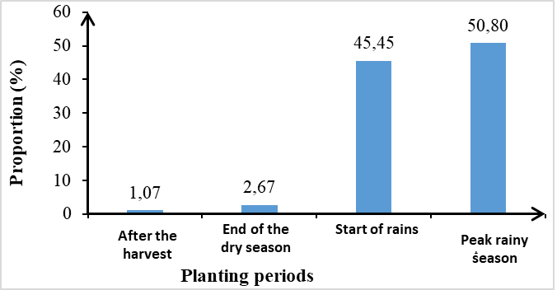

**Fig. 6. Proportion of producers according to cultivation periods**

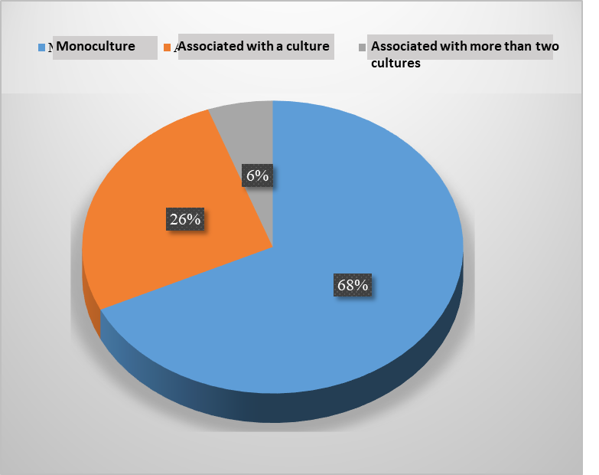

**Fig. 7. Proportion of cassava cultivation systems**

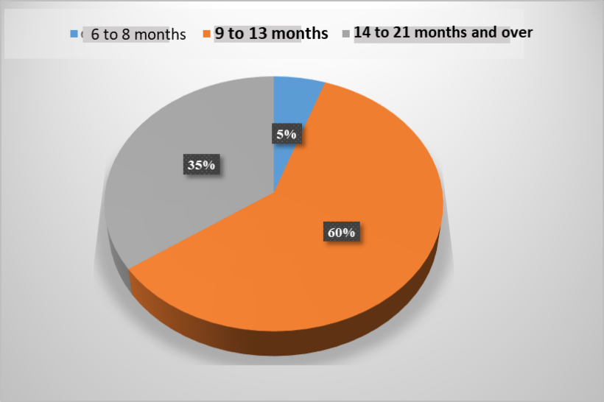

**Fig. 8. Producer rate according to harvest age**

**G3**

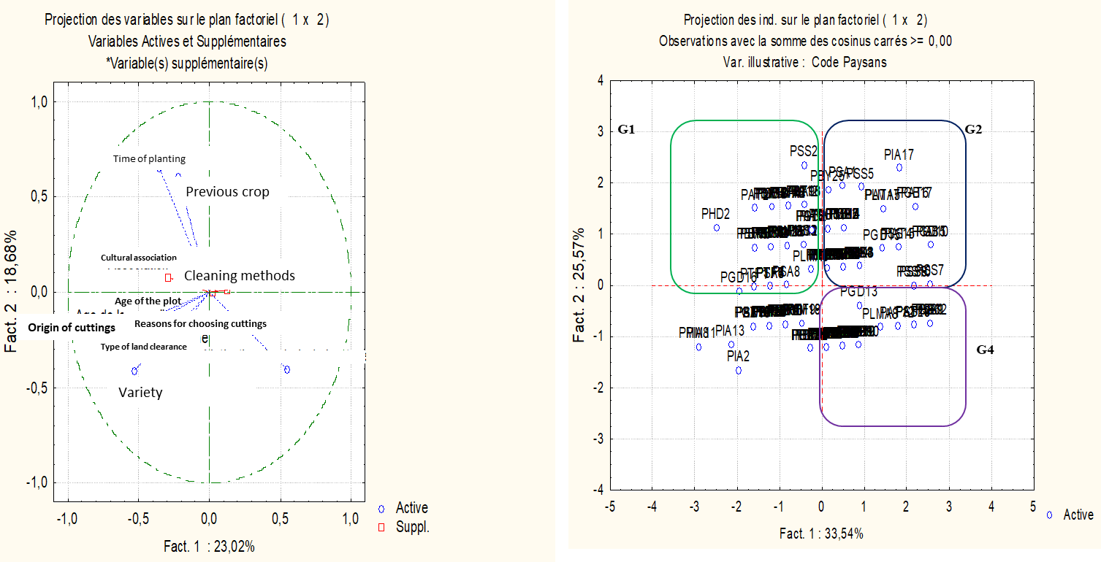

**Circle of correlations (a) and dispersion of treatments (b)**

**Fig. 9. Distribution of producers according to the ACP of cultural practices**

**Classification of producers according to cultivation practices:** The ACP individuals' dispersal plan for the various producers revealed three major groups of producers (Fig. 9):

* **Group 1** is made up of producers who grow cassava during the rainy season, on fallow land. These producers practice intercropping with low weeding frequency. Their choice of cutting is motivated by the commercial aspect, but above all by the concern for subsistence;
* **Group 2** is characterized by producers with a high frequency of weeding and the choice of varieties focused on profit aspects. They have plots established on new clearings, and use all-comer cuttings and practice an early harvest of cassava;
* Group 3 consists of producers characterized only by the choice of varieties based on profit aspects;
* **Group 4:** These producers are characterized primarily by a high frequency of weeding. They practice cassava monoculture only and can plant at any time of year. When they harvest, they plant cuttings to replace the harvested plants. For these producers, the choice of varieties is based solely on profit.

**3.3 Determination of Endogenous Control Methods**

**Recognizing the Symptoms of Root Rot:** A high proportion of farmers (68%) recognize the external symptoms of the disease, compared to 32% who do not recognize the symptoms (Table 12). Among those who recognize the symptoms of cassava root rot, approximately 40% describe the disease by the yellowing of the leaves. Only 9.6% recognize it by the appearance of the deformed stems and 18.3% identify the disease by the symptoms of rot at the root collar.

**Table 12. Proportion of producers for the recognition of rot symptoms**

|  |  |
| --- | --- |
| **Type of symptoms** | **Proportions of producers (%)** |
| Yellowing of the leaves | 40.00 |
| Deformation of the Stems | 09.62 |
| Collar rot | 18.30 |
| None | 32.08 |

**Period of Occurrence of Cassava Root Rot:** According to the majority of producers, root rot is observed in both the rainy and dry seasons. Thus, 65% of producers stated that they observe the disease in all periods (dry and rainy), while 29% observe it in the rainy season and 5.35% in the dry season (Fig. 10).

**Cassava Harvest period:** Analysis of the survey results revealed that cassava producers have two main harvesting periods. A large proportion, 59.36% of producers, harvest roots late, compared to 40.64% who harvest early (Fig. 11). These two harvest periods are highly dependent on market demand for cassava.

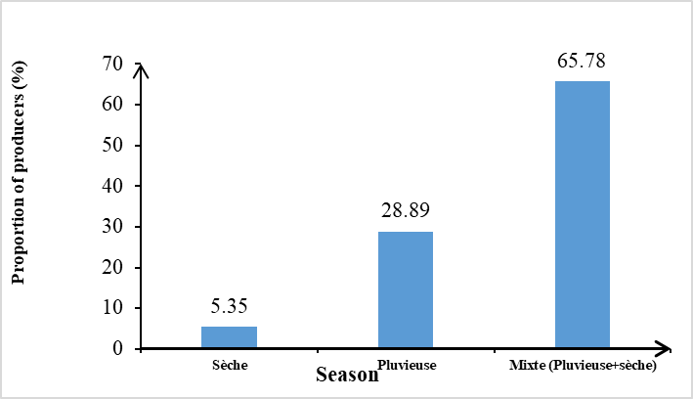

**Fig. 10. Period of manifestation of rot according to the seasons**

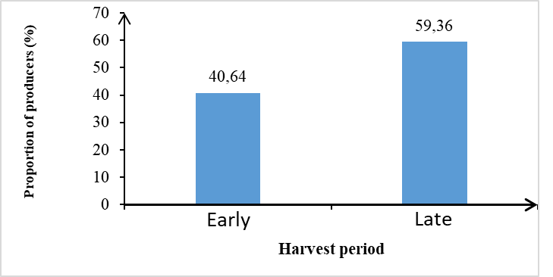

**Fig. 11. Harvest period for cassava roots**

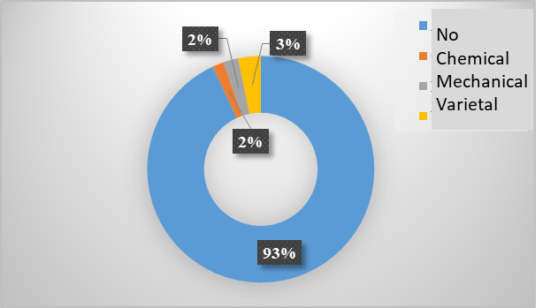

**Fig. 12. Endogenous control methods against cassava root rot**

**Control methods used by producers:** The majority of producers surveyed, 93%, have no means of controlling cassava root rot (Fig. 12). On the other hand, a small proportion of producers (7%) reported practicing:

* a prophylactic control method (elimination of diseased plants and roots from the plot (2% of producers);
* a chemical control method based on the use of fungicides such as Mancozeb (2% of producers);
* an agronomic method based on the use of tolerant varieties (3% of producers).

**Classification of producers regarding endogenous control methods:** Parameters such as disease incidence, crop age, origin of cuttings, technical supervision and crop association are strongly correlated with factors 1 and 2 (axes 1 and 2) which contribute respectively to 42.5 and 21.4% (or 63.9%) of the total variance of the individuals subject to the analysis (the producers). The dispersion plan revealed three groups of producers (Fig. 13):

* **Group G1** includes farmers who do not have control methods and who benefit from more or less technical support. They plant cassava cuttings from organizations such as CNRA, FIRCA, or ANADER. These producers harvest cassava late, and their fields are characterized by a medium or intermediate incidence of the disease;
* **Group 2** is similar to Group 1, but differs from it by the origin of the cuttings, which are of all-purpose origin. The producers in this group, although benefiting from the supervision of ANADER, have plots with a very high incidence of rot. They do not practice any method of control against the disease;

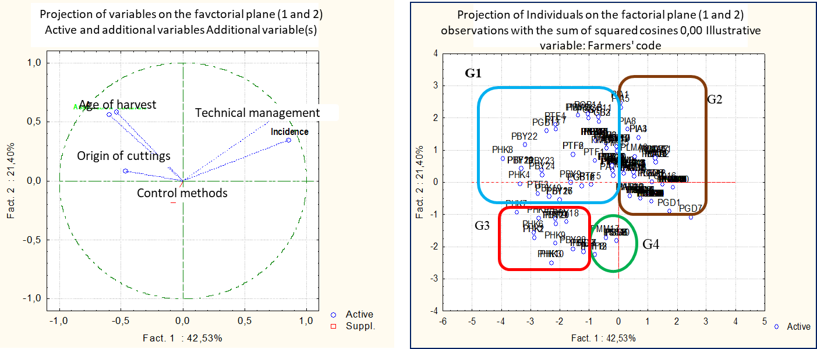

**(a) Circle of correlations and (b) dispersion of treatments**

**Fig. 13. Dispersion of producers according to the PCA of the parameters influencing endogenous control methods against cassava root rot**

* **Group 3** is mainly characterized by the use of agronomic control methods, although it does not benefit from technical supervision. The incidence of rot is low, unlike the two previous groups;
* **Group 4** is characterized by producers using agronomic control methods to deal with root rot. Although they do not receive technical support and use all-purpose cuttings, these producers harvest their cassava between 6 and 12 months and their cassava plots have very low incidences of root rot.

**4. DISCUSSION**

The study of the producer typology revealed that cassava is cultivated by both men and women. Thus, this crop constitutes a substantial source of income for women, playing a crucial role in their empowerment in rural areas. In addition, the income generated by cassava cultivation allows producers to support large families. This is all the more relevant since the majority of producers (more than 84%) are married (in a couple) and 82% of them have at least four dependents. These results are consistent with the observations of Ahomadikpoho (2022) during a survey conducted in Pobè. According to this author, cassava production is profitable for 96% of respondents. Thus, one hectare of cassava sells for 600,000 FCFA, against an expenditure of 212,500 FCFA, generating an average profit of 387,500 FCFA per hectare. Similarly, Bamba and Kouadio (2022), through surveys carried out in Daloa as part of the fight against poverty in Côte d'Ivoire, and Yao (2021) in Zuénoula, showed that cassava cultivation is profitable.

The survey revealed that cassava cultivation is widespread throughout Côte d'Ivoire. Cassava fields are planted either at the beginning of the rainy season (45.45%), during the rainy season (50.80%), after harvest (1.07%), or during the dry season (2.67%). However, the rainy season is preferred by producers. These results show that cassava is a fairly flexible plant that adapts well to the different climates of Côte d'Ivoire. Thus, like some food crops, cassava is not very demanding regarding the natural conditions related to its growth. It can even be grown on degraded soil (N'Zué et al., 2013).

The survey results revealed that cassava cultivation is mainly practiced on fallow land and plots already cultivated for many years and with a cultural history. It is not done on new clearings and therefore does not contribute to deforestation. For plot maintenance, manual weeding is the most widespread method for eliminating weeds, with a frequency of 3 to 4 times per year. Increasingly, some producers are applying chemical herbicides such as glyphosate and 2,4-D. Regarding the fertilization of cassava fields, it is very rarely practiced by all producers.

These results show that cassava cultivation is less polluting for the environment and does not negatively affect the health of producers and consumers. The choice of varieties used by producers is mainly guided by demand and economic profitability. However, very few producers obtain supplies from specialized structures such as CNRA, FIRCA and ANADER, and cassava cuttings are transferred from one field to another without any prior sanitation. These results can be explained by the lack of supervision of cassava producers on good agricultural practices. Although they have extensive experience in cultivation, they are guided by ancestral farming habits and are not informed of available innovations. Furthermore, the majority of producers have no formal education or have a primary education, which also constitutes a limitation in the search for information and the application of new agricultural practices. Hence the imperative to provide these producers with agricultural supervision and support to get them out of the agricultural routine.

The success of this agricultural framework could be facilitated by grouping producers into cooperatives. Indeed, according to Roussary et al. (2013) and Di Bianco (2018), cooperatives, at the heart of the sectors, can influence production standards and appear to be key players in transforming farmers' practices. The survey revealed that cassava tuber rot is a widespread disease in Côte d'Ivoire. Indeed, a high proportion of farmers (68%) surveyed recognize at least one of the external symptoms of the disease. However, most producers are powerless in the face of the spread of root rot, which is becoming increasingly widespread. These results highlight the limitations of producers and the need for support from specialized structures capable of diagnosing and finding an effective solution to the difficulties they encounter.

The spread of cassava tuber rot could be attributed, on the one hand, to the transfer of cuttings from one field to another and the lack of prior sanitation. According to the work of Manon Soulier (2020), seed treatment helps protect seeds and the crop against the development of pathogens. On the other hand, the spread of cassava tuber rot could be attributed to the cultivation of susceptible varieties. Indeed, the quality of seeds used by farmers is very important for satisfactory production. Similarly, seed treatment helps eliminate seed-borne pathogens and protect them against further attacks (Affery et al., 2018). Thus, taking into account and harmoniously combining the level of technicality, the right choice of plot and variety, seed quality, phytosanitary protection, identification of crop enemies and their outbreak periods, as well as control methods, can lead to better and more profitable production at lower cost (FAO, 2013).

**5. CONCLUSION**

This survey of producers highlighted the impact of cassava root rot on producers. Although the crop plays an important role in people's lives, producers are not well organized into cooperatives, do not have a high level of education, and do not receive agricultural training. Cassava cuttings require treatment before being transferred to the field. However, the majority of producers remain powerless against this disease. It is therefore necessary to implement control methods and train producers in good agricultural and innovative practices to ensure cassava production.

**DISCLAIMER (ARTIFICIAL INTELLIGENCE)**

Author(s) hereby declare that NO generative AI technologies such as Large Language Models (ChatGPT, COPILOT, etc) and text-to-image generators have been used during writing or editing of this manuscript.

**Competing interests**

Authors have declared that no competing interests exist.

**REFERENCES**

Affery, A. M., Abo, K., N Aya, C., Wonni, I., Bomisso, E. L., Kouamé, K. D., Tuo, S., Bolou Bi, B. A., Koné, M., & Koné, D. (2018). Pathogenic diversity of *Xanthomonas axonopodis* pv. *manihotis* strains in Côte d'Ivoire, susceptibility of cassava varieties and control approach. *Journal of Applied Biosciences*, *130*, 13187–13198. https://doi.org/10.35759/JABs.130.6

Ahomadikpohou, L. D. (2022). Cassava processing techniques and its socio-economic effects in the commune of Pobe. *International Journal of Progressive Sciences and Technologies*, *31*(1), 323–332.

Bamba, V., & Kouadio, K. E. (2022). Fight against poverty in Côte d'Ivoire: An economic and financial analysis of the cassava sector in Daloa. *French Review of Economics and Management*, *3*(7), 332–348.

Bandyopadhyay, R., Aigbe, S. O., & Leslie, J. F. (2006). *Fusarium* species from the cassava root rot complex in West Africa. *Pathology*, *59*, 673–676.

Di Bianco, S. (2018). Reframing advice through ecologically intensive agriculture. *Journal of the Anthropology of Knowledge*, *12*(2), 171–197.

FAO. (2013). *Integrated production and pest management of vegetable crops: Facilitator's guide for farmer field schools* (113 p.).

FAO. (2017). *Agricultural statistics*. Food and Agricultural Organization of the United Nations.

Fargier, E. (2007). The study of the pathology of *Xanthomonas campestris*  and the genetic structure of its pathovars has enabled the improvement of pathogen detection in Brassicaceae seeds. *Angers Doctoral School*, 236 p.

Kumulungui, B., Ondo-Azi, A., Madinda, N., & Mouaragadja, I. (2012). Isolation of microorganisms involved in tuberous root rot of cassava (*Manihot esculenta* Crantz) in Gabon. *African Agronomy*, *24*(3), 171– 181.

Momol, M. T., & Aldwinckle, H. S. (2000). Genetic diversity and host range of *Erwinia amylovora*. In Vanneste, J. L. (Ed.), *Fire blight: The disease and its causative agent, Erwinia amylovora* (pp. 55–72). CABI Publishing.

Msikita, W., James, B. D., Bissang, B., Baimey, H., Wilkinson, H. T., & Ahounou, M. R. (2005). Prevalence and severity of *Nattrassia mangiferae* root and stem rot pathogen of cassava in Benin. *Plant Disease*, *89*(1), 12–16.

N'Zué, B., Zohouri, G. P., Djedji, C., & Tahouo, O. (2013). Growing cassava well in Ivory Coast. *Technical Sheet of the National Center for Agronomic Research (CNRA)*, 4 pp.

Roussary, A., Busca, D., Salles, D., Dumont, A., & Carpy-Goulard, F. (2013). Phytosanitary practices in agriculture and the environment: Irreconcilable tensions? *Rural Economy*, *333*, 67–80.

Soulier, M. (2020). *Characterization and optimization of a plasma source for seed treatment in the agri-food sector (Doctoral dissertation, Université Paul Sabatier-Toulouse III).*

Yao, K. E. (2021). The socio-economic and environmental impact of cassava valuation in Zuenoula (Center-West, Ivory Coast). *International Journal of Humanities and Social Science Invention*, *10*(9), 15–29.