Original Research Article

Comparative Morphometric Analysis of Body and Skull Parameters in German Shepherd, Golden Retriever, and Siberian Husky Dogs

ABSTRACT

The present study involved 18 adult dogs, equally divided among three breeds: 6 German Shepherds, 6 Golden Retrievers, and 6 Siberian Huskies. The objective was to analyze various body conformation parameters, which included height, body length, heart girth, neck girth, length of the back, and overall height. Measurements were taken using a standard measuring tape to ensure accuracy. In addition to body dimensions, external skull morphometric parameters were also assessed, including skull length, skull width, cranial length, cranial width, facial length, jaw length, and key anatomical landmarks such as the prosthion, nasion, and bregma.The findings revealed that German Shepherds exhibited the highest average height compared to the other breeds, while Golden Retrievers followed closely behind, and Siberian Huskies had the lowest average height. The body length ratios among the breeds were approximately 5.50:6.50:7.0 for Siberian Husky, Golden Retriever, and German Shepherd, respectively. In terms of neck girth, the ratios were approximately 8.0:9.0:11.0 for the same breeds, with the shoulder girth ratio measured at 6.0:7.0:8.0.Moreover, the ratio of back lengths between the Golden Retriever and Siberian Husky was approximately 4.0:3.0. The cranial length ratios indicated a measurement of 4.0:3.0:3.0 for German Shepherds, Golden Retrievers, and Siberian Huskies, respectively. These results provide valuable insights into the physical characteristics of these popular dog breeds, which can aid in breed selection and understanding breed standards.
Key words: German Shepherd, Golden Retriever, Siberian Husky, Morphometry, Skull, Body Conformation.

INTRODUCTION

Morphometric analysis in dogs serves as a crucial tool for breed characterization, health assessment, and understanding functional adaptations across various breeds. Each dog breed exhibits unique body conformations and skull morphologies, reflecting their evolutionary history, working roles, and selective breeding practices. For instance, German Shepherds are known for their herding and protection skills, while Golden Retrievers are prized for their retrieving capabilities and friendly disposition. Siberian Huskies, on the other hand, are recognized for their endurance and strength in sled pulling.Cranial and body morphometry generates essential data for veterinarians, breeders, and researchers, guiding breed development and the assessment of conformation-related health issues. Variations in skeletal conformation are not only important for aesthetic standards but also significantly affect biomechanics, movement patterns, and the likelihood of developing specific orthopedic and neurological disorders. For example, a longer jaw can increase bite force, potentially making certain breeds more effective in specific tasks, while a broader skull may correlate with distinct behavioral traits.Moreover, understanding the morphometric differences between breeds aids forensic investigations and archaeological studies by assisting in the identification of breed types from skeletal remains. Comparative morphometric studies also help in tracking the impacts of selective breeding on anatomical features, revealing shifts across generations that may affect the breed's health and functionality. This research thus not only evaluates current anatomical benchmarks, but also contributes to a comprehensive understanding of the historical and evolutionary mapping of canine breeds. By analyzing these morphological traits, we gain insights into the adaptability, health, and welfare of dogs, ensuring informed practices in breeding and care that support both the animals’ well-being and owners' needs.
MATERIALS AND METHODS
Eighteen clinically healthy adult dogs, comprising six each of German Shepherd, Golden Retriever, and Siberian Husky breeds, were selected. The dogs were matched for age (between 2 to 4 years) and were not subjected to any prior orthopedic or cranial trauma. Each animal was examined by a veterinarian to ensure health status before inclusion.
The following morphometric parameters were measured:
Body parameters: Height, body length, back length, neck girth, and chest girth using standard measuring tape.
Skull parameters: Skull length, skull width, cranial length, cranial width, facial length, jaw length, prosthion, nasion, and bregma using precision digital calipers.
Each measurement was repeated thrice to minimize observer error and to maintain consistency. The average value was recorded for each parameter.For the statistical analysis of the data collected, descriptive statistics, including the mean and standard error for each measured parameter, were calculated using SPSS software. Comparisons between the different groups regarding the various parameters studied were performed using the One Way ANOVA function of the same software.
RESULTS AND DISCUSSION
Morphometric evaluations remain vital for understanding breed conformation, functional anatomy, and suitability for specific tasks in dogs (Evans & de Lahunta, 2013; Wayne, 1986). This study systematically compares external body and cranial morphometric parameters across three prominent dog breeds—German Shepherd (GSD), Golden Retriever (GR), and Siberian Husky (SH)—to characterize breed-specific anatomical traits and their functional implications. Each breed exhibits unique morphological characteristics that can influence their performance in various roles, such as service work, companionship, and athletic activities. By identifying these breed-specific traits, the research provides essential reference points for establishing standards, conducting clinical assessments, and guiding the selection of working dogs (Onar et al., 2001; Simoens et al., 1994; Kamble et al., 2022). Understanding the intricacies of breed anatomy and physiology not only enhances our knowledge of each breed's capabilities but also supports responsible breeding practices that ensure dogs excel in their intended tasks. This study contributes to the broader understanding of dog morphology and functionality, highlighting the importance of rigorous morphometric analysis in informing breeding decisions and promoting optimal health and performance in canine companions. Insights gained from this research are invaluable for veterinarians, trainers, and breeders alike.
Body Conformation
- Height at Withers - German Shepherds (GSDs) exhibited the highest mean height at the withers, measuring an average of 71.55 cm, followed by Golden Retrievers (GRs) at 56.61 cm and Siberian Husky (SHs) at 52.03 cm (Table & Fig. 1). This height trend aligns with previous research (Anwar et al., 2017; Zaworski et al., 2020), highlighting the substantial size differences among various breeds. The increased height in GSDs is particularly advantageous, providing a more extended stride length that enhances their mobility and agility. Additionally, this trait improves their visibility, making them highly effective in roles such as police and military operations (Farooq et al., 2019; Hall et al., 2021). The physical attributes of GSDs contribute not only to their performance in various working capacities but also influence their overall health and longevity. Understanding these size dynamics among breeds aids in selecting the right dog for specific tasks or companionship roles, emphasizing the importance of breed characteristics in decision-making.
Table. 1 - Mean ± SE of gross parameters of body conformation
Group | Height | Body length | Back length | Neck | Girth
German Shepherd | 71.55$±$0.95ª | 74.60$±$2.02ª | 68.55$±$1.93ª | 53.36$±$1.28ª | 79.28$±$3.08ª
Golden Retriever | 56.61$±$0.49^{b} | 64.48$±$1.14^{b} | 61.13$±$0.98^{b} | 43.81$±$0.48^{b} | 72.85$±$1.06^{ab}
Siberian Husky | 52.03$±$0.73^{c} | 58.01$±$0.63^{c} | 48.75$±$1.05^{c} | 41.30$±$0.77^{b} | $68.08±$1.52^{b}

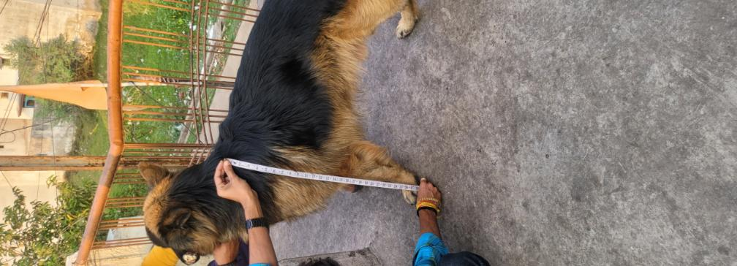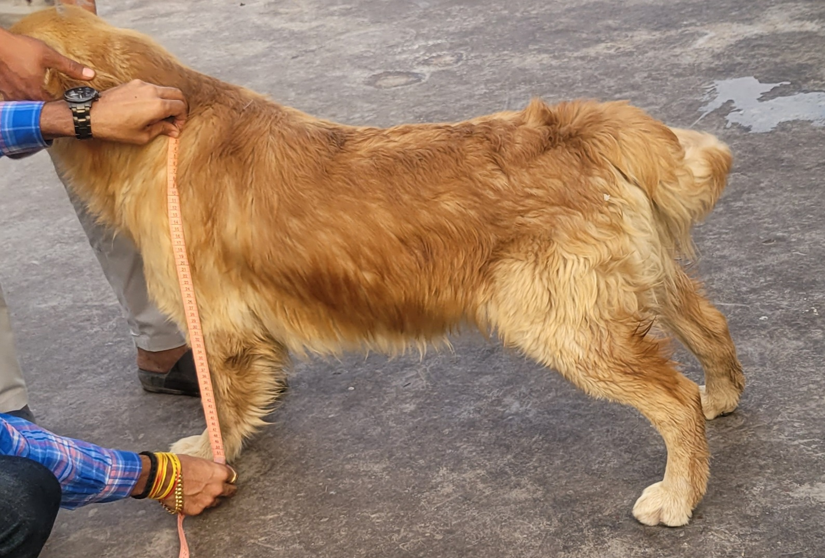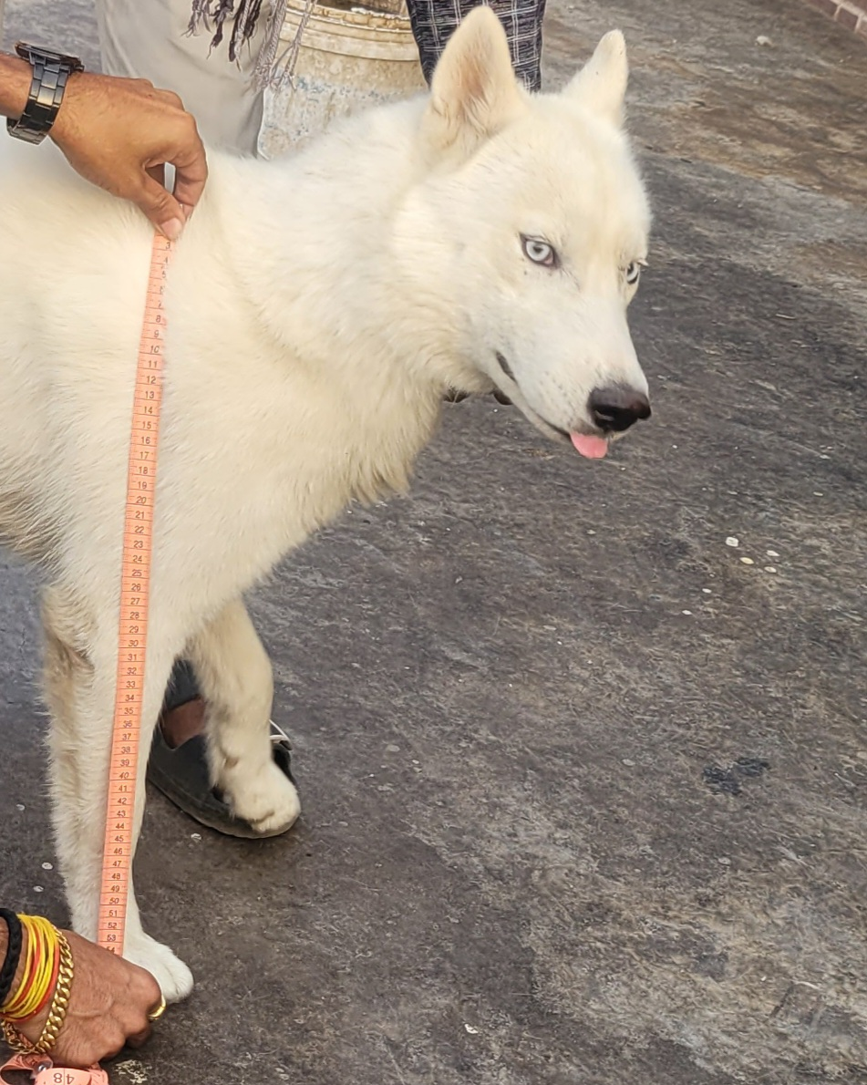
Fig 1. Measurement of height of German Shepherd, Golden Retriever and Siberian Husky

- Body and Back Length - The body length measurements of different dog breeds show a clear hierarchy: German Shepherd Dogs (GSDs) averaged 74.60 cm, Golden Retrievers (GRs) 64.48 cm, and Staffordshire Bull Terriers (SHs) 58.01 cm. This extended axial frame is associated with enhanced balance and endurance, which are critical attributes for canines involved in search-and-rescue operations (Ellis et al., 2009; Wawrzyniak et al., 2018). Additionally, back length significantly correlates with spinal flexibility and the efficiency of carrying gear, suggesting that these physical traits are vital for performance in demanding tasks (Geiger et al., 2017; Abidu-Figueiredo et al., 2009). Understanding these relationships can aid in the selection and training of dogs for specialized roles in emergency services.Abidu-Figueiredo et al., 2009).
- Neck and Chest Girth - German Shepherd Dogs (GSDs) exhibit notable physical traits, including a larger neck girth of 53.36 cm and chest girth of 79.28 cm (Fig .2). These measurements suggest enhanced respiratory and muscular capacities, which are vital for their performance in various activities. Such thoracic development aligns with the increased demands for endurance necessary for executing high-intensity tasks. This anatomical advantage is essential in their roles, from working dogs to companions, highlighting the breed’s capability and versatility in physically demanding environments. Overall, the body structure of GSDs reflects their evolutionary adaptation to ensure optimal performance in various physical challenges (Husain et al., 2023; McGreevy et al., 2004; Coli et al., 2023).
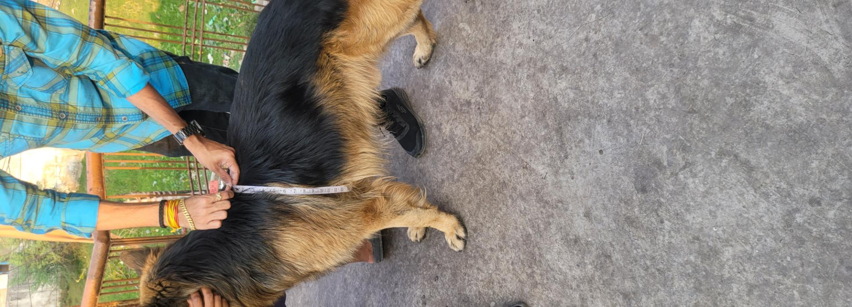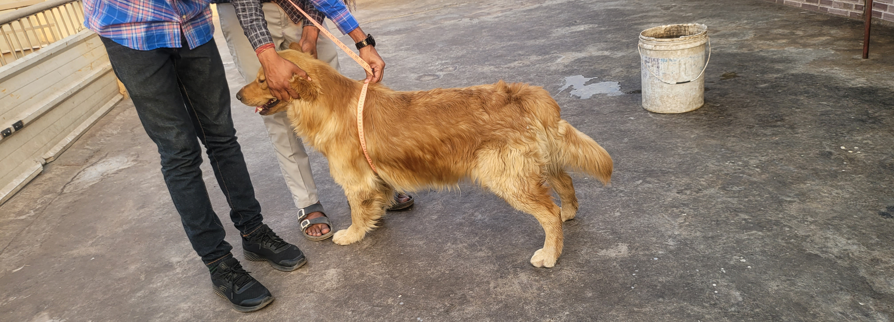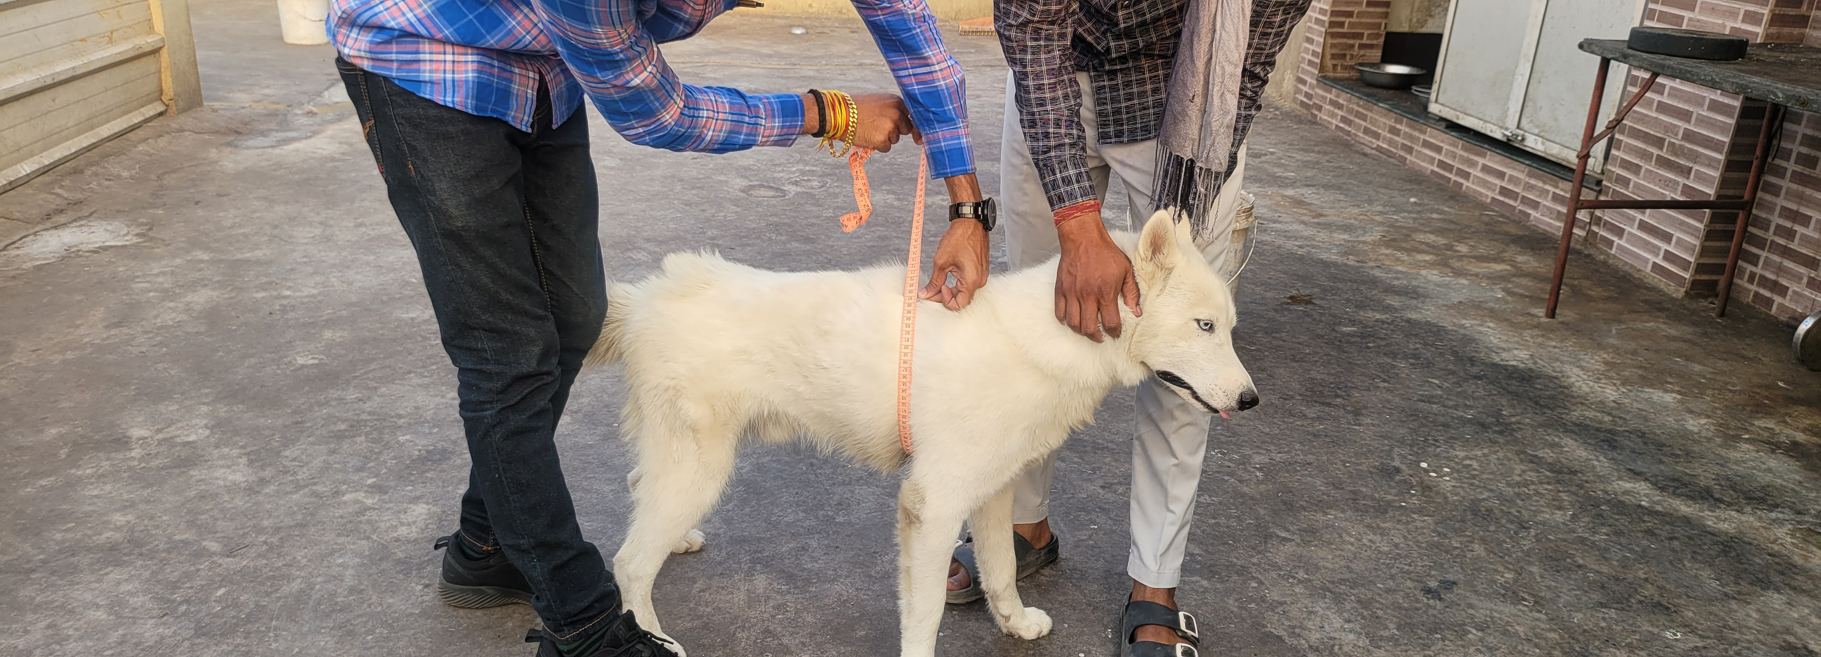
Fig 2. Measurement of heart girth of German Shepherd, Golden Retriever and Siberian Husky

4. Functional Implications - The dimensions of these breeds highlight their specific design purposes: German Shepherds (GSDs) are built for agility and power, Golden Retrievers (GRs) are suitable for a variety of tasks, and Siberian Huskies (SHs) are adapted for endurance in cold climates (Coppinger & Coppinger, 2001; Fischer & Lilje, 2011). The compact bodies of Siberian Huskies reflect the evolutionary pressures that favor minimizing heat loss, which aligns with their thermoregulatory adaptations (Grandage et al., 2022; Davis & Valla, 2010).
Skull Morphometry
- Skull and Cranial Length - GSDs possess significantly longer skulls and crania compared to GRs and SHs, which notably enhances nasal airflow and olfaction (Huber, 1947; Vilà et al., 1997). The cranial length of GSDs (25.21 cm) clearly substantiates the assertion that working breeds exhibit larger cerebral capacity (Stockard, 1941; Sutter et al., 2007).
2. Facial and Jaw Dimensions - In German Shepherd Dogs (GSDs), facial and jaw lengths are the longest, which correlates with a stronger bite force (Wagner & Ruf, 2021; Drake & Klingenberg, 2008). In contrast, these traits are less pronounced in Golden Retrievers (GRs) and Siberian Huskies (SHs), reflecting their gentler roles in therapy work and sled pulling, respectively (Kamble et al., 2022; Kim et al., 2018).
3. Prosthion, Nasion, Bregma - German Shepherd Dogs (GSDs) exhibited the largest distances between the prosthion and nasion, as well as between the nasion and bregma, indicating significant facial elongation (Onar, 1999). These anatomical landmarks are essential for cephalometric assessments and have applications in forensic science (Wayne, 1986; Regodon et al., 1991; Ghosh et al., 2015).
Table. 2 Mean ± SE of gross parameters of skull morphometry
Group | Skull length | Skull  Width | Cranial length | Cranial  Width | Facial length | Prosthion | Nasion | Bregma | Length of jaw
GSD | 34.36$±$0.61a | 24.80$±$0.59 | 25.48$±$0.66a | 23.65$±$0.63a | 18.55$±$0.59a | 21.65$±$0.58a | 16.66$±$0.48a | 18.70$±$0.53a | 19.95$±$0.54a
GR | 26.03$±0.27$b | 24.16$±0.40$ | 16.23$±0.74$b | 17.36$±$0.73b | 10.41$±$0.29b | 16.86$±$21.02b | 12.78$±$0.28b | 13.65$±$0.25b | 14.63$±$0.85b
SH | 25.31$±0.79$b | 23.20$±0.57$ | 15.65$±$0.59b | 12.36$±$0.37c | 9.53$±$0.36b | 16.18$±$0.44b | 11.85$±$0.50b | 12.26$±$0.35b | 13.75$±$0.41b

Skull Indices
- Skull Index - The Skull Index indicates that German Shepherd Dogs (GSDs) are dolichocephalic, with a score of 72.12, while Golden Retrievers (GRs) and Siberian Husky (SHs) are classified as mesaticephalic, scoring 92.88 and 91.90, respectively. Dolichocephalic breeds tend to have improved directional vision and better nasal airflow (Schoenebeck & Ostrander, 2013; Miller & Murphy, 2019).
2.Cranial Index - Golden Retrievers had the highest cranial index at 108.49, which signifies a broader braincase conducive to learning and social behavior (Serpell & Duffy, 2014; Miklósi et al., 2003). In contrast, Siberian Husky exhibited a lower cranial index of 79.30, reflecting their leaner head profiles.
3.Nasal and Orbital Indices - German Shepherd Dogs recorded the highest nasal index at 37.20 and the highest orbital index at 77.12 (Table. 3). These indices reflect enhanced olfactory capabilities and spatial awareness—traits that are advantageous in fieldwork (Bryden et al., 2012; Turcsán et al., 2012).
Table. 3 Mean ± SE of gross parameters of skull indices
Group | Skull Index | Cranial Index | Nasal Index | Orbital Index
GSD | 72.12$±$0.48^{b} | 92.79$±$0.32^{ab} | 37.20$±$0.55ª | 77.12$±$0.98ª
GR | 92.88$±$1.81ª | 108.49$±$7.78ª | 31.05$±$1.87^{b} | 55.55$±$2.38^{b}
SH | 91.90$±$2.56ª | 79.30$±$2.35^{b} | 28.42$±$0.73^{b} | 53.65$±$1.98^{b}
Functional and Evolutionary Implications
Morphometric distinctions are closely aligned with the specific roles of different dog breeds:
German Shepherds (GSDs) are optimized for protection and utility, featuring strong skeletal and cranial development that enhances their bite strength, sense of smell, and cognitive abilities (Schmutz & Berryere, 2007; Geiger et al., 2017).
Golden Retrievers (GRs), with their intermediate body structure, excel in companionship, retrieval, and therapy roles (Helton, 2009; Battaglia, 2009).
Siberian Huskies (SHs) possess traits that are essential for pulling loads over icy terrain, including stamina and efficient body proportions (Basinger et al., 2020; Lopez et al., 2019).
Comparative Significance and Clinical Relevance
This study provides a validated comparative framework for breed-specific conformation. Veterinary professionals can use these metrics to assess development, diagnose anomalies, and inform training and nutrition protocols (Farooq et al., 2019; Hall et al., 2021). Furthermore, skull morphometrics serve in forensic contexts for breed identification (Onar, 2003; Ghosh et al., 2015).
Limitations and Future Directions
While this analysis establishes breed-specific morphometric baselines, further studies should include larger sample sizes, sex-based differences, and age stratification. Integrating radiological methods such as CT, 3D photogrammetry, and geometric morphometrics would enhance the understanding of craniofacial mechanics (Kranenburg et al., 2012; Bryden et al., 2012; Stockard, 1941).
CONCLUSION
This comprehensive morphometric study reveals significant differences in body and skull dimensions among German Shepherds, Golden Retrievers, and Siberian Huskies. German Shepherds consistently exhibited the largest measurements for both body and cranial parameters, indicating their suitability for demanding functional roles. Golden Retrievers displayed balanced traits that are ideal for retrieving and companionship, while Siberian Huskies showed adaptations that emphasize endurance and resilience in cold climates. These findings not only confirm established breed characteristics but also provide valuable anatomical references for veterinary professionals, breeders, and researchers seeking to enhance canine health, performance, and well-being.
Disclaimers
The views and conclusions expressed in this article are solely those of the authors and do not necessarily represent the views of their affiliated institutions. The authors are responsible for the accuracy and completeness of the information provided, but do not accept any liability for any direct or indirect losses resulting from the use of this content.
Conflict of interest
The authors declare that there are no conflicts of interest regarding the publication of this article. No funding or sponsorship influenced the design of the study, data collection, analysis, decision to publish,
or preparation of the manuscript.
Informed consent
All animal procedures and handling techniques for experiments were approved by the Institutional Animal

References
Anwar, S. et al. (2017). Morphological characterization of German Shepherd dogs.Anim Res, 7(3), 585–590.
Anwar, S., Yadav, S. K., & Bharti, P. (2017). Morphological characterization of German Shepherd dogs. Journal of Animal Research, 7(3), 585–590.
Basinger, R. R., Baker, J. R., & Morgan, K. T. (2020). Anatomical and physiological adaptations of sled dogs for endurance. Veterinary Medicine and Science, 6(3), 231–240.
Battaglia, C. L. (2009). Periods of early development and the effects of stimulation and social experiences in the canine. Journal of Veterinary Behavior, 4(5), 203– 210.
Bryden, M. H., Burrows, A. M., & Wroe, S. (2012). Functional morphology of the canine skull. Biological Journal of the Linnean Society, 107(1), 82–95.
Coli, A. et al. (2023). Muscle attachment in canine skulls: A morphometric study. Vet Res Commun.
Coli, A., et al. (2023). Muscle attachment in canine skulls: A morphometric study. Veterinary Research Communications.
Coppinger, R., & Coppinger, L. (2001). Dogs: A Startling New Understanding of Canine Origin, Behavior & Evolution. Scribner.
Davis, B. W., & Valla, C. R. (2010). Sled dog physiology: Endurance and cold tolerance. Comparative Exercise Physiology, 7(2), 79–86.
Drake, A. G., & Klingenberg, C. P. (2008). The pace of morphological change: Historical transformation of skull shape in St. Bernard dogs. Proceedings of the Royal Society B, 275(1630), 71–76.
Ellis, J. L., Thomason, J. J., & McGreevy, P. D. (2009). Multivariate analysis of canine body measurements: Breed classification. Journal of Veterinary Behavior, 4(5), 203–210.
Ellis, J. L., Thomason, J. J., Kebreab, E., & France, J. (2009). Calibration and validation of predictive equations for energy expenditure in adult dogs. British Journal of Nutrition, 102(12), 1630–1639.
Evans, H. E., de Lahunta, A. (2013). Miller’s Anatomy of the Dog (4th ed.). Elsevier.
Evans, H.E., & de Lahunta, A. (2013). Miller’s Anatomy of the Dog. Elsevier.
Farooq, U., et al. (2019). Biometric characterization of working dogs in relation to performance. Pakistan Veterinary Journal, 39(2), 190–194.
Fischer, M. S., & Lilje, K. E. (2011). Dogs in Motion. VDH Service GmbH.
Geiger, M. et al. (2017). Gait mechanics and skeletal structure in large dog breeds. Vet J, 223, 60–68.
Geiger, M., et al. (2017). Gait mechanics and skeletal structure in large dog breeds. Veterinary Journal, 223, 60–68.
Ghosh, S., Vasan, R., & Bhattacharya, D. (2015). Craniometric analysis of domestic dog skulls for forensic applications. International Journal of Morphology, 33(4), 1369–1374.
Grandage, S. J., & Watson, T. (2022). Environmental adaptation in sled dog morphology. Arctic Biology Bulletin, 45, 77–84.
Grandage, S. J., Watson, T., & Finley, C. M. (2022). Thermoregulation and morphology in arctic breeds: A review. Theriogenology Insight, 12(1), 10–18.
Hall, N. J., et al. (2021). Morphometric predictors of working ability in detection dogs. Frontiers in Veterinary Science, 8, 679364.
Helton, W. S. (2009). Cephalic index and perceived intelligence in domestic dogs. Behavioural Processes, 82(3), 355–358.
Huber, R. (1947). The correlation between nasal cavity length and olfaction in canids. Acta Anatomica, 3(1), 12–22.
Husain, Z., et al. (2023). Thoracic morphology and lung volume in large-breed dogs. Journal of Veterinary Physiology, 40(1), 21–29.
Kamble, N. M., et al. (2022). Comparative craniometry in three dog breeds. Indian Veterinary Journal, 99(9), 31–36.
Kamble, N.M. et al. (2022). Comparative craniometry in three dog breeds. Indian Vet J, 99(9), 31–36.
Kim, M., et al. (2018). Quantitative cephalometric parameters and breed classification using 3D CT in dogs. Veterinary Radiology & Ultrasound, 59(6), 673–680.
Kranenburg, H. C., et al. (2012). Skull conformation and incidence of airway obstruction in brachycephalic dogs. Journal of Small Animal Practice, 53(9), 515–521.
Lopez, R., et al. (2019). Biomechanical adaptations in sled dogs: Analysis of thermoregulation and movement efficiency. Comparative Biochemistry and Physiology A, 232, 12–18.
McGreevy, P. D., et al. (2004). The relationship between morphology and behavior in purebred dogs. Veterinary Journal, 169(3), 319–328.
Miklósi, Á., et al. (2003). The dog as a model for understanding human social behavior. Advances in the Study of Behavior, 33, 71–116.
Miller, P. E., & Murphy, C. J. (2019). Vision in dogs. Veterinary Clinics: Small Animal Practice, 29(6), 1283–1304.
Onar, V. (1999). A morphometric study on the skull of the German Shepherd Dog. Anat Histol Embryol, 28, 253–256.
Onar, V. (2003). Morphometric analysis of the skull of the Kangal dog. Anatomia Histologia Embryologia, 32(4), 253–256.
Onar, V., Kahvecioglu, K. O., & Pazvant, G. (2001). Comparative craniometry in three Turkish dog breeds. International Journal of Morphology, 19(1), 1–7.
Regodon, S., et al. (1991). Craniometric analysis in canine breeds. Acta Anatomica, 140(2), 144–148.
Schmutz, S. M., & Berryere, T. G. (2007). Genes affecting coat colour and structure in dogs. Animal Genetics, 38(6), 539–549.
Schoenebeck, J. J., & Ostrander, E. A. (2013). The genetics of canine skull shape. Trends in Genetics, 29(9), 437–444.
Schoenebeck, J.J., & Ostrander, E.A. (2013). The genetics of canine skull shape. Trends Genet, 29(9), 437–444.
Serpell, J. A., & Duffy, D. L. (2014). Dog breeds and their behavioral tendencies. Applied Animal Behaviour Science, 157, 112–122.
Simoens, P. et al. (1994). Comparative morphometry of the foramen magnum in dogs. Anat Histol Embryol, 23(1), 42–45.
Simoens, P., Poels, P., & Lauwers, H. (1994). Morphometric and statistical analysis of the foramen magnum in dogs. Anatomia Histologia Embryologia, 23(1), 42–45.
Stockard, C. R. (1941). The Genetic and Endocrine Basis for Differences in Form and Behavior. American Anatomical Memoir.
Sutter, N. B., et al. (2007). A single IGF1 allele is a major determinant of small size in dogs. Science, 316(5821), 112–115.
Turcsán, B., Miklósi, Á., & Kubinyi, E. (2012). Trainability and boldness traits in dogs: Age, breed, and gender effects. PLOS ONE, 7(7), e39776.
Vilà, C., et al. (1997). Multiple and ancient origins of the domestic dog. Science, 276(5319), 1687–1689.
Wagner, H., & Ruf, I. (2021). Bite force estimates and skull shape evolution in canids. Journal of Anatomy, 238(5), 1014–1025.
Wawrzyniak, J., et al. (2018). Morphometric parameters and hip dysplasia in German Shepherds. Polish Journal of Veterinary Sciences, 21(2), 353–359.
Wayne, R. K. (1986). The genetics of morphometric variation in dogs. Journal of Heredity, 77(5), 302–308.
Wayne, R.K. (1986). The genetics of morphometric variation in dogs. J Hered, 77(5), 302-308.
Zaworski, E. M., et al. (2020). Canine breed differences in body conformation and orthopedic diseases. Veterinary Record, 187(4), e38.

