**Influence of IBA and rooting media on rooting of stem cuttings of dragon fruit [*Hylocerous undatus* (Haworth) Britton & Rose)**

**ABSTRACT**

The present investigation was carried out at Fruit Research Station, Madhadibagh, Department of Horticulture, College of Agriculture, Junagadh Agriculture University, Junagadh during the year 2018-19 to study the effect of different concentration of IBA (500, 1000, 1500 ppm), different type of rooting media (i.e. soil, sand, soil + sand, soil + cocopeat, sand + cocopeat, soil + sand + cocopeat) and the interaction of these in different combination on rooting characteristics of dragon fruit. The result revealed that Indole butyric acid (IBA) had significant effect on rooting and shooting performance. The exogenous application of IBA 1500 ppm with media combination of soil + sand + cocopeat (I3M6) significantly increased days taken for root initiation (13.67 days), number of roots per cutting (65.67), fresh weight of roots (3.07 g), dry weight of roots (1.70 g), length of longest roots (31.17 cm), days taken for initiation of sprouts (17.17 dyas), sprout length (16.27, 25.10 and 34.43 cm), number of sprouts per cuttings (2.70, 3.20 and 3.97) at 30, 60 and 90 DAP, respectively, rooting percentage (89.20%) and survival percentage (87.00%) over the other treatments.

**Key words:** Dragon fruit, *Hylocerous undatus,* stem cutting, rooting media, IBA (Indole-3-butyric acid)

**INTRODUCTION**

Dragon fruit (*Hylocereus undatus* Haworth) is a member of the cactaceae family which is a perennial, climbing cactus with triangular green stem. It is believed to be originated from tropical and subtropical America (Zee *et al*., 2004). It is commonly called as strawberry pear, night blooming cereous, pitaya, queen of night, honorable queen etc. (Andrade *et al*., 2005).

It has been cultivated in tropical and subtropical regions of the world viz., Australia, China, Indonesia, Israel, Japan, Malaysia, Mexico, Peru, Spain, Srilanka, Thailand and USA. The European Union and Asia, especially China are the largest importer of dragon fruit. (Le Bellec *et al*., 2006). In India, it is believed that the area under this crop is less than 900 -1000 hectares and is grown in some parts of Gujarat, Maharashtra, Kerala, Tamil Nadu and Karnataka (NHB 2015). The plant may grow up to a height of about 6 to 10 metre. It is a fruit crop as well as an ornamental plant. The flower is so beautiful, large and fragrant and it is nick named as “noble women” or “queen of the night”. The fruit is non-climacteric fleshy berry which is oblong and about 10-12 centimetre thick with red or yellow peel with scales. The pulp may be white, red, yellow or magenta and juicy depending on the species. The smooth and shiny seeds are distributed in large numbers throughout the fruit and have a diameter of approximately 3 mm, a dark colour, and an obovate shape (Andrade *et al*., 2005).

Fruit is suitable for everyone to eat. The juicy flesh of fruit is delicious in taste when eaten fresh where the juicy flesh with small seeds are edible and this fruit can be processed into various value added products like juice, sherbets, jam, jelly, ice-cream, preserve, candy and pastries etc. Several studies have shown that dragon fruits are a good source of vitamins, minerals, glucose, fructose and dietary fibre. It contains good amount of calcium (6 mg), phosphorous (19 mg) and ascorbic acid (25 mg) per 100 g pulp (Mortan, 1987).

Dragon fruits consist of phytoalbumins, which may have anti-oxidant qualities which help to stop the development of cancer cells. It is also a good source of natural pigments in food processing, due to their high content of betalains and used in food industries to extract natural colours and in cosmetic industries to prepare facial and hydrating creams (Le Bellec *et al.,* 2006).

Dragon fruit can be propagated both sexually by seed and asexually by grafting and stem cutting. Seedlings become ready for field planting by 9-10 months after sowing. This method is very simple and can be practised with the objectives of obtaining variability in improvement program and to meet the demand of large planting material in new areas as a single fruit contains more than 1000 seeds. But the fruit and stem characteristics are variable due to cross pollination and seedlings grow very slowly and the time taken for bearing will be usually 3-4 years which is longer than the plants propagated by stem cutting.

Dragon fruit is adoptable to wide range of environmental conditions from rainforests to deserts. It is considered a promising crop to be grown commercially in dry regions (Vaillant *et al*., 2005). This species is found to have high water-use efficiency. The dragon fruit has mechanisms to secure water requirement by developing aerial roots from the sides of the stem to collect water from the surroundings (Nobel *et al.,* 2004).

The plants developed from stem cutting start flowering one to two years after planting. Cuttings can be obtained throughout the year. However, it is preferable to collect the cuttings after fruiting season of mother plants. In propagation by cutting, the entire stem segment or 5-60 cm cutting could be used. The longer the cutting, faster is the regeneration rate of new roots which is probably associated with the amount of stored food. Mature cuttings are better as they are resistant to insect and snail damage and contain more stored food than immature ones. In general, cuttings from mature branches which have ceased growth root better than those taken from younger branches. The difference in the rooting ability of cuttings taken from different parts of a plant is considered to be due to a difference in their physiological age. Cuttings with high carbohydrate content root better than those with low carbohydrates content. The ability of cuttings to regenerate varies also with the plant species and their varieties.

Dragon fruit is a climbing vine cactus species which has received worldwide recognition, by cuttings to meet the demand of large planting material in new areas as cuttings can be obtained throughout the year. Dragon fruit cultivation is good candidate for development of sustainable agroforestry system which would avoid risks and therefore increase farmer’s income particularly in dry and arid zones areas. The easiest, cheapest and convenient method of propagating dragon fruit vegetatively is by stem cutting.

Dragon fruit cultivation could be asset to small holders as well as entrepreneurs of medium and large scale plantation. Dragon fruit is suitable for growing in region that have spells of dry weather with supplementary irrigation. This species is found to have high water-use efficiency. One of the pitaya (dragon fruit) mechanisms to secure water requirement is developing aerial roots from the sides of the stem to collect water from the surroundings. In addition, pitaya (dragon fruit) is characterized by a crassulacean acid metabolism (CAM) pathway that improves water-use efficiency. Not only low moisture requirement, but also early ripening of the fruits increased interest in pitaya production. Cutting may permit the production of plants with identical characteristics to the parent plant. Furthermore, cuttings reach production earlier. Limiting the cutting material of pitaya (dragon fruit) when it is introduced as a new crop has generated interest in small cuttings for asexual propagation. Dragon tree cuttings can be used for further propagation/resale, and also fruits have excellent demand in local & export markets. Considering the above fact, the present experiment was undertaken as “Effect of IBA and rooting media on stem cuttings of dragon fruit (*Hylocereus undatus* Haworth)” with the following objectives. To know the effect of IBA on rooting of stem cutting of dragon fruit, to know the effect of media on rooting of stem cutting of dragon fruit, to know the interaction effect of rooting media and IBA treatments on stem cuttings of dragon fruit.

**MATERIALS AND METHODS**

The present investigation was conducted at Fruit Research Station, Madhadibagh, Department of Horticulture, College of Agriculture, Junagadh Agriculture University, Junagadh during the year 2018-19. The experiment was laid out in Completely Randomized Design (Factorial) with eighteen treatment combinations and three replications. The treatment consists of six types of rooting media M1 (soil), M2 (sand), M3 [soil + sand (1:1)], M4 [soil + cocopeat (1:1)], M5 [sand + cocopeat (1:1)], M6 [soil + sand + cocopeat (1:1:1)]. three type of IBA concentration I1 (500 ppm), I2 (1000 ppm), I3 (1500 ppm) and the different treatment combinations (I1M1- IBA 500 ppm + Soil, I1M2- IBA 500 ppm + Sand, I1M3- IBA 500 ppm + Soil + Sand (1:1), I1M4- IBA 500 ppm + Soil + Cocopeat (1:1), I1M5- IBA 500 ppm + Sand + Cocopeat (1:1), I1M6- IBA 500 ppm + Soil + Sand + Cocopeat (1:1:1) , I2M1- IBA 1000 ppm + Soil, I2M2- IBA 1000 ppm + Sand, I2M3- IBA 1000 ppm + Soil + Sand (1:1), I2M4- IBA 1000 ppm + Soil + Cocopeat (1:1), I2M5- IBA 1000 ppm + Sand + Cocopeat (1:1), I2M6- IBA 1000 ppm + Soil + Sand + Cocopeat (1:1:1), I3M1- IBA 1500 ppm + Soil, I3M2- IBA 1500 ppm + Sand, I3M3- IBA 1500 ppm + Soil + Sand (1:1), I3M4- IBA 1500 ppm + Soil + Cocopeat (1:1), I3M5- IBA 1500 ppm + Sand + Cocopeat (1:1), I3M6- IBA 1500 ppm + Soil + Sand + Cocopeat (1:1:1). The cuttings were collected from one year stem with having a 2 to 3 nodes. The length of cuttings used for planting 15 cm long cuttings was taken. The cuttings was treated with IBA by quick dip methods and for this a required amount of IBA was weighed and dissolved in few ml of 80% ethanol and then volume was made up to 1 liter using distilled water and the cuttings was dipped in solution for 10 second and planted in polybag. Rooting percentage was find out by of cuttings number of cuttings rooted over total number of cuttings multiplied by hundred and survival percentage can be find out by number of cuttings survived 3 months after planting over total number of cuttings planted multiplied by hundred. The observation were taken for days taken for root initiation, number of roots per cutting, fresh weight of roots, dry weight of roots, days taken for initiation of sprouts, length of longest roots, sprout length, number of sprouts per cuttings at 30, 60 and 90 DAP respectively, rooting percentage and survival percentage 90 days after planting.

The data recorded on various growth parameters of stem cutting of dragon fruit were statistically analyzed by adopting the Factorial Completely Randomized Design as suggested by Panse and Sukhatme (1967).

**RESULTS AND DISCUSSION**

The results obtained from the present investigation as well as relevant discussion have been summarized under following heads:

**Days taken for root initiation**

The days taken for root initiation in dragon fruit stem cuttings as influenced by IBA and rooting media and their interaction with different concentration and different combination are presented in (Fig 1)

The result indicated that IBA concentration, rooting media and their interaction exhibited significant effect on minimum (15.33) days taken for root initiation in dragon fruit stem cuttings I3 IBA at 1500 ppm with rooting media combination of M6 Soil + Sand + Cocopeat (1:1:1) (17.33) and their interaction of I3M6 IBA 1500+ Soil + Sand + Cocopeat (1:1:1) (13.67) with maximum days (22.39) taken for root initiation in I1 at 500 ppm with rooting media of M1 soil (20.67) and their interaction of with I1M1 containing IBA at 500 ppm+ soil (24.67). This may be due to the exogenous application of auxin which breaks starch into simple sugars. This is needed to a greater extent for the production of new cells and increased respiratory activity in the regeneration of tissue at the time of initiation of new primordial, the results are in conformity with Nanda, (1975)

**Fig: 1 Interaction effect for IBA and rooting media treatments for days taken for roots initiation of stem cutting of dragon fruit**

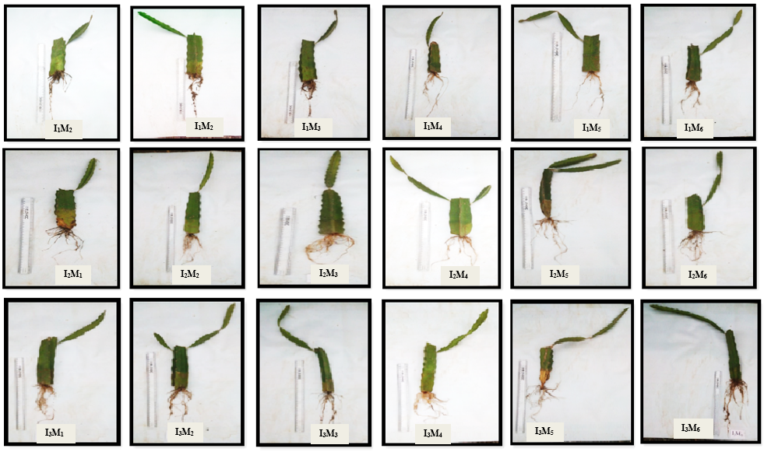**Length of longest roots**

**Fig: 2 Root length of dragon fruit cutting at 90 DAP**

The I3 IBA concentration of 1500 ppm was recorded significantly increased the length of roots (27.14 cm). Whereas minimum length of roots (14.23 cm) was recorded in I1- IBA at 500 ppm with rooting media combination of soil + sand + cocopeat (1:1:1) M6 significantly increased the length of longest roots (22.06 cm). Similarly M6 found at par with M5 (21.50 cm) containing sand + cocopeat. Minimum length of roots (17.11 cm) was recorded with M1 containing soil. Interaction effect of IBA and rooting media treatment for maximum length of longest roots (31.17 cm) was recorded at 90 DAP cuttings treated with I3M6 IBA at 1500 ppm+ soil+ sand+ cocopeat (1:1:1). Similarly I3M6 is found at par with I3M5 (30.33 cm) contains IBA at1500 ppm+ sand+ cocopeat (1:1). Whereas minimum length (13.67 cm) of roots was recorded with I1M1 containing IBA at 500 ppm+ soil (Fig 2& 3). This might be due to rapid hydrolysis of starch stored in the cuttings into physiologically active sugars, which provide energy through respiratory activity to the root primordia and helps in rapid elongation of the meristematic cells there by initiate the longest roots per cutting. Similar results were reported by Srivastava *et al.,* (2005) in Kiwi fruit.

**Fig: 2 Root length of dragon fruit cutting at 90 DAP**

**Fig: 3. Interaction effect for IBA and rooting media treatments for length of longest roots (cm) at 90 DAP of per stem cutting of dragon fruit**

**Number of roots per cutting**

Significant differences were observed among the rooting media, IBA treatments as well as their interactions on number of roots per cutting presented in (fig 4).

Among different IBA treatments I3 - IBA at 1500 ppm application significantly influenced the maximum number of roots per cutting (58.00) with rooting media M6 containing soil+ sand+ cocopeat (1:1:1) (50.78). Which was found at par with M5 containing sand+ cocopeat (1:1). In interaction maximum number (65.67) of roots per cutting observed with I3M6 containing IBA at 1500 ppm+ soil+ sand+ cocopeat (1:1:1) at 90 DAP and the minimum number of roots per cutting showed in I1- IBA at 500 ppm (30.61), M1 containing soil (38.44) and in interaction I1M1 containing IBA at 500 ppm+ soil (23.67). This might be due to the presence of the reserved food materials present in the cuttings. Initial internal sugar concentration and their metabolism are important during the early period of rooting process Denaxa *et al.,* (2001) and accelerated rooting in the cuttings with the increased IBA concentration might be due to increased water uptake and cell wall elasticity which further may have accelerated cell division and in turn increased number of roots to a certain level. These results are corroborated by the findings of Bhosale *et al.,* (2010) in Pomegranate.

**Fig: 4. Interaction effect for IBA and rooting media treatment for number of roots per cutting at 90 DAP of stem cutting of dragon fruit**

**Fresh weight of roots**

In I3 IBA 1500 (2.34 g). In M6 soil+ sand+ cocopeat (1:1:1) (2.11 g) and in interaction of I3M6 containing IBA at 1500 ppm+ soil+ sand+ cocopeat (1:1:1) (3.07 g) the maximum fresh weight of roots was recorded at 90 DAP. The minimum fresh weight of roots I1- IBA at 500 ppm (1.27 g) in M1 contains soil (1.50 g). In interaction of I1M1 containing 500 ppm+ soil (1.00 g) as presented in (Fig 5). It could be attributed to the rapid hydrolysis of polysaccharides stored in the cuttings into physiologically active sugars by activation of hydrolytic enzymes. These sugars provide energy for the meristematic tissue through respiratory activity leads to initiate more number of adventitious roots which helps in early establishment of cuttings and subsequently increased the uptake of more nutrients and water from the growing media resulted in an increase in root fresh weight. The present findings are in conformity with the results of Singh *et al*. (2013) in lemon and Seran and Thiresh (2015) in dragon fruit.

**Fig: 5 Interaction effect for IBA and rooting media treatments for fresh weight of roots (g) of stem cutting of dragon fruit**

**Dry weight of roots**

The dry weight of roots recorded highest (1.10 g) was at 90 DAP cuttings treated with I3- IBA at 1500 ppm in M6 containing soil+ sand+ cocopeat (1:1:1) and in interaction I3M6 containing IBA at 1500 ppm+ soil+ sand+ cocopeat (1:1:1) (1.70 g) recorded at 90 DAP whereas lower fresh weight of roots (0.07 g) was recorded in I1- IBA at 500 ppm (0.84 g). In M1 (0.34 g) containing soil and in interaction was recorded with I1M1 (0.04 g) containing 500 ppm+ soil was recorded at 90 DAP as presented in (Fig 6). It could be due to enhancement of hydrolysis of polysaccharides stored in stem cuttings by the hydrolytic enzymes activated by plant growth regulators into physiologically active sugars. Its helps in formation of more number of roots per cutting which leads to an increase in dry weight of roots. Similar findings were also reported by Porghorban *et al.* (2014) in olive and Rahad *et al.* (2016) in dragon fruit.

**Fig: 6. Interaction effect for IBA and rooting media treatments for dry weight of roots (g) of stem cutting of dragon fruit**

**Days for initiation of sprouts**

The results indicate that IBA concentration, rooting media and their interaction exhibited a significant effect on growth parameters (Fig 7). The days for initiation of sprouts which was found significantly less number of days (18.38) in cuttings treated with I3-IBA at 1500 ppm. In case maximum number of days (27.60) taken in which cuttings treated with I3- IBA at 500 ppm. In rooting media combination also found significant and less number of days (21.15) taken for initiation of sprouts after planting in rooting media M6 containing soil+ sand+ cocopeat (1:1:1). In case maximum number of days taken in days (25.19) taken in rooting media M1 containing soil. This result might be due to the high nutrient content of cocopeat, sand which have macrospores for good aeration and soil which balance the decomposition of lignin present in coir pith results in the formation of humic fraction. Similar result was supported by Kadalli *et al.* (2001). In interaction effect of IBA and rooting media treatment less number of days (17.17) taken for initiation of sprouts after planting recorded in treatment combination I3M6 containing IBA at 1500 ppm+ soil+ sand+ cocopeat (1:1:1). Which was at par with I3M5 (17.67) containing IBA at 1500 ppm sand+ cocopeat (1:1). Where as maximum number of days taken sprout initiation was recorded with I1M1 (30.67). This might be due to sprouting is mainly attributed to the quantum of stored carbohydrate in the cuttings. However, with auxin application to the cutting is an increase in sprouting, highlighting the role of certain material produced in the rooting media, which are responsible for sprouting. This result was agreement with finding of Sulaiman *et al*. (2015) in citurs.

**Fig: 7. Interaction effect for IBA and rooting media treatments on days taken for initiation of sprout of stem cutting of dragon fruit**

**Number of sprouts per cutting**

Number of sprouts per cutting is recorded with I3- IBA at 1500 ppm found significantly maximum number of sprouts (2.05, 2.73, and 3.55). Whereas minimum sprouting per cutting (1.45, 1.53 and 1.70) recorded with I1- IBA at 500 ppm at 30, 60 and 90 DAP, respectively. In rooting media combination M6 containing soil+ sand+ cocopeat (1:1:1) was found maximum on number of sprouts per cutting (1.96, 2.34 and 2.83). Whereas M6 at 60 DAP was found at par with M5 containing sand+ cocopeat (1:1). The minimum number of sprouts (1.69, 1.77 and 2.22) recorded at 30, 60 and 90 DAP in M1 containing soil (Fig 8). This might be due to auxin enhancement of physiological functions in the cuttings favorably. This result was also close conformity by Manan *et al.* (2002) in guava. Whereas media was porous material and presence of decomposed nutrient which increase the sprouts. This result also supported by Rymbai *et al*. (2012) in guava. Interaction effect of IBA and rooting media treatment showed maximum number of sprouts (2.70, 3.20 and 3.97) in I3M6 containing IBA at 1500 ppm+ soil+ sand+ cocopeat (1:1:1). Which was found at par with I6M5 (soil+ sand) at 60 DAP and 90 DAP respectively. The minimum number of sprouts (1.83, 1.33 and 1.60) recorded at 30, 60 and 90 DAP in I1M1 containing IBA 500ppm+ soil. This might be due to growth regulating substance auxine and growth promoting substance present in coco peat, sand and soil which balance the media for growth. This result were also close conformity by Singh *et al*. (2014) in mulberry.

**Fig: 8. Interaction effect for IBA and rooting media treatments for number of sprouts per stem cutting of dragon fruit at 30, 60, 90 DAP**

**Sprout length**

The effect of IBA treatment showed maximum sprout length (13.34, 20.27 and 30.16 cm) with I3- 1500 at 30, 60 and 90 DAP and minimum sprout length (4.37, 9.76, and 16.69 cm) recorded in I1- IBA at 500 ppm. In rooting media combination showed maximum sprout length (10.07, 17.69 and 26.98 cm) with M6 containing soil+ sand+ cocopeat (1:1:1). The minimum sprout length was recorded with M1 containing soil (6.21, 12.22, 21.01 cm) at 30, 60 and 90 DAP (Fig 9). This might be due to rooting media containing growth promoting substance. This result agreement supported by Sabir *et al*. (2004) in grape. In IBA contains auxine substance helps to promote the growth of the sprout. This was agreement with by Kakon *et al.* (2008) in guava. In interaction effect significantly maximum sprouts length (16.27, 25.10, and 34.43 cm) obtained of IBA and rooting media treatment at 30, 60, and 90 DAP respectively, with I3M6 containing IBA at 1500 ppm+ soil+ sand+ cocopeat (1:1:1). Whereas minimum sprouts length (3.67, 7.30 and 13.30 cm) I1M1 containing IBA at 500 ppm+ soil. This is might be due to co-effect of auxine, cocopeat, soil and sand contains growth substances enhance the length of sprout. These findings were close confirmity of Malik and Harnard (2013) in orange.

**Fig: 9. Interaction effect for IBA and rooting media treatments for sprouts length (cm) of stem of cutting dragon fruit at 30, 60, 90 DAP**

**Rooting percentage (%)**

Thepercentage of rooting in stem cuttings of dragon fruit at 90 days after planting was significantly higher (81.2%) cuttings treated with I3 IBA at 1500 ppm in rooting media treatment for maximum rooting percentage (73.22%) was recorded with M6 containing soil+ sand+ cocopeat (1:1:1). and in interaction was recorded with IBA and rooting media treatment for maximum rooting percentage (89.20%) I3M6 containing IBA at 1500 ppm+ soil+ sand+ cocopeat (1:1:1). Similarly I3M6 is found at par with I3M5 (87.00%) contains IBA at 1500 ppm+ sand+ cocopeat (1:1) and also with I3M4 (86.10%) contains IBA at 1500 ppm+ soil+ cocopeat (1:1). Whereas minimum rooting percentage (55.03%) was recorded in I1 IBA at 500 ppm, in rooting media (63.94%) was recorded in M1 contains soil. Whereas in interaction minimum rooting percentage (53.07%) was recorded with I1M1 containing IBA at 500 ppm+ soil was recorded at 90 DAP as presented in (Fig 10). This might be due to the fact that rapid hydrolysis of polysaccharides stored in stem cuttings into physiologically active sugars which provide energy to meristematic tissues and activate the root primodia to initiate formation of more number of roots in stem cuttings. This result were supported by findings of Prabhakar *et al*. (2006) in fig. In cocopeat released of phenolic compounds (Lokesha *et al*. 1988) and also can be attributed to the beneficial physical characteristics of coir pith (Smith, 1995) like aeration and water holding capacity.

**Fig: 10. Interaction effect for IBA and rooting media treatments for rooting percentage (%) of stem cutting of dragon fruit**

**Survival percentage (%)**

There were found significant result in respect of survival percentage of rooted stem cuttings of dragon fruit among the different rooting media and IBA treatments as well as their interactions are presented in (Fig 11). The maximum survival percentage recorded in I3- IBA at 1500 ppm (75.61%), in rooting media treatment showed significant at M6 (71.00%) soil+

sand+ cocop eat (1:1:1). Which was found at par with M5 (68.67%) containing sand+ cocopeat (1:1). And in interaction I3M6 (87.00%) containing IBA at 1500 ppm+ soil+ sand+ cocopeat (1:1:1) recorded at 90 DAP cuttings with was recorded at 90 DAP. While the minimum survival percentage (54.94%) was recorded in I1- IBA at 500 ppm, in M1 (59.89%) containing soil and also in interaction I1M1 (51.33%) containing IBA at 500 ppm+ soil. This might be due to the fact that, aeration is necessary for the gaseous exchange between the soil and atmosphere to remove CO2 released by roots and microorganisms in the soil to external atmosphere and supply of O2 from the external atmosphere to the growing roots leading to better respiration and survival of plants and their differential behavior in different growth parameters and also due to the presence of differential levels of endogenous rooting cofactors and carbohydrates The results are in agreement with the findings of Hartmann and Kester, (1989) and Jeyaseeli and Paul Raj (2010).

**Fig:11 Interaction effect for IBA and rooting media treatments for survival percentage (%) of stem cutting of dragon fruit**

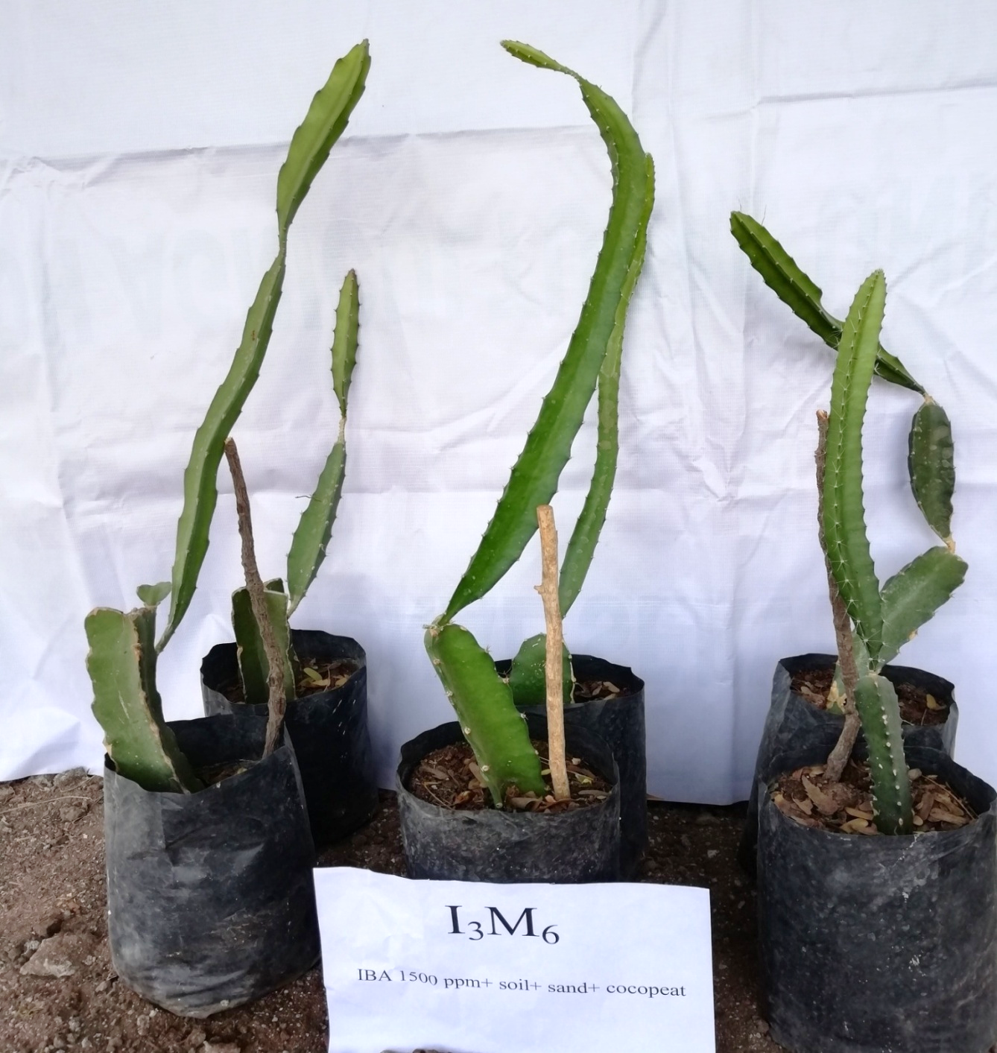

**Fig: 12 Effect of IBA 1500 ppm and rooting media (soil +**

**sand + cocopeat) on growth of dragon fruit cutting at 90 DAP**

**Plate: 8 Effect of IBA 1500 ppm and rooting media (soil +**

**sand + cocopeat) on growth of dragon fruit cutting**

**at 90 DAP**

**Plate: 8 Effect of IBA 1500 ppm and rooting media (soil +**

**sand + cocopeat) on growth of dragon fruit cutting**

**at 90 DAP**

**CONCLUSION**

From the present study, it can be concluded that vegetative propagation by stem cuttings in dragon fruit root formation was significantly influenced by the application of IBA 1500 ppm+ soil+ sand+ cocopeat (1:1:1)] The IBA 1500 ppm application with rooting media [soil+ sand+ cocopeat (1:1:1)] was found better for all the shoot and root parameter of growth *viz*., days taken for root initiation, number of roots per cutting, fresh weight of roots, dry weight of roots, days taken for initiation of sprouts, length of longest roots, sprout length, number of sprouts per cuttings, rooting percentage and survival percentage of cutting. So, we can be recommended for commercial cutting of dragon fruit should be planted in media soil+ sand+ cocopeat (1:1:1) with dipping in 1500 ppm IBA

**REFERENCES**

Andrade, R. A., Oliveira, I. V. and Martins, A. B. (2005). Influence of condition and storage period in germination of red pitaya seeds. *R. Bras. Frutic.,* 27(1): 168-170.

Bhosale, V. P., Jadav, R. G., Masu, M. M. (2010) Response of different media and PGR’s on rooting and survival of air layers in pomegranate (*Punica granatum* L.) *Cv*. Sindhuri. *Asian J Hort.*, 4(2):194-197.

Denaxa, N. K., Vemmos, S. N. and Roussos, P. A. (2001) Effect of IBA, NAA and carbohydrate on rooting capacity of leafy cuttings in three olive cultivars (*Olea europaea* L.). *Acta Hort.,* 924:101-109.

Jeyaseeli, D. M. and Paul Raj, S. (2010) Chemical characteristics of coir pith as a function of its particle size to be used as soilless medium*. Int. J. Environ. Sci.,* 4(2&3): 163-169.

Hartmann, H.T. and Kester, D. E. (1989). Plant propagation, principles and practices. Prentice Hall, New Delhi, India.

Kadalli, G. G. Suseela, D. L. Siddararn, R. and John, E. (2001). Characterization of humic fractions extracted from coir dust based composts. *J. lndian Soc. Soil Sci,*. 48: 51-55.

Kakon, A. J., Haque, M. A. and Mohsin, M. G. (2008). Effect of three growth regulators on mound layering in the three varieties of guava. SAARC. *J. Agri.*, 6(2): 39-47.

Khayyat, M., Nazari, F. and Salehi, H. (2007). Effects of different pot mixtures on pothos (*Epipremnum aureum* Lindl. and Andre ‘Golden Pothos’) growth and development. *Am. Eurasian J. Agric. Environ. Sci.,* 2: 341-348.

Le Bellec F., Vaillant, F. and Imbert, E. (2006). Pitahaya (*Hylocereus* spp.): a new fruit crop, a market with a future. *Fruits*, 61: 237–250.

Lokesha, R., Mahishi, D. M. and Shivashankar, G. (1988). Studies on the use of coconut coir dust as a rooting media. *Curr. Res.,* 17(12): 157-158.

Malik, M. A., Muhammad, K. R., Muhammad, A. J., Saeed, A., Sitwat, R. and Javaid, I. (2013). Production of true-to-type guava nursery plants via application of IBA on soft wood cuttings. *Agric. Res*., 51(3): 1-8.

Manan, A., Khan, M. A., Ahmed, W. and Sattar, A. (2002). Clonal propagation of guava (*Psidium guajava* L.). *Int. J. Agric. Bio*., 4(1): 143-144.

Mirzahi, Y. and Nerd, A. (1996). New crops as a possible solution for the troubled Israeli export market*. Wanatca Yearbook*, 20: 41-51.

Morton, J. F. (1987). Fruits of warm climates. Strawberry pear. Florida Flair Books, Miami. 347- 48 pp.

Nanda, K. K. (1975) Physiology of adventitious root formation. *Indian J Pl. physiol*., 18:80-89

NHB (2015). Indian Horticulture Database, 2014-15. National Horticulture Board, New Delhi. [www.nhb.gov.in](http://www.nhb.gov.in).

Nobel, P. and De La Barrera, E. (2004). CO2 uptake by the cultivated hemi epiphytic cactus, *Hylocereus undatus*. *Annl. Appl. Biol*., 144: 1–8.

Obeidy A. A. E. (2006). Mass propagation of pitaya (dragon fruit). *Fruits*, 61: 313-319.

Panse, V.G. and Sukhatme, P.V. (1967). Statistical methods for Agricultural workers, ICAR, New Delhi, India. 381 pp.

Porghorban, M., Moghadam, E. G. and Asgharzadeh, A. (2014). Effect of media and indole butyric acid (IBA) concentrations on rooting of russian olive (*Elaeagnus angustifolia* L.) semihard wood cuttings. *Indian J. Fundamental & Appl. Life Sci*., 4 (3): 517-22.

Prabhakar, S., Singh, A. K. and Savitha, T. (2006). Propgation of fig (*Ficus carica*) cv. Daulatabad through cuttings with aid of IBA under mist. Scientific Horticulture, 10: 179-86.

Rahad, MABK, Islam, M. A., Rahim, M. A. and Monira, S. (2016). Effects of rooting media and varieties on rooting performance of dragon fruit cuttings (*Hylocereu sundatus* Haw.). *Res. Agric. Livest. Fish*., 3 (1): 67-77.

Rymbai, R. H., Reddy, G. S. and K. C. (2012). Effect of cocopeat and sphagnum moss on guava air layers and plantlets survival under open and polyhouse nursery. *Agri. Sci. Digest,* 32(9): 241-243.

Singh, K. K., Choudhary, T. and Kumar, P. (2013). Effect of IBA concentrations on growth and rooting of *Citrus limon* cv. Pant Lemon cuttings. *Biol. sci. Agric. Advancement Soc*., 2(3):268-270.

Singh, K. K., Chaudhary, T. and Kumar, A. (2014). Effect of various concentrations of IBA and NAA on the rooting of stem cuttings of mulberry (*Morus alba* L.) under polyhouse condition. *Ind. J. Hill Farming*, 27(1): 125-131.

Seran, T. H. and Thiresh, A. (2015). Root and shoot growth of dragon fruit (*Hylocereus undatus*) stem cutting as influenced by IBA. *Agric. and Biological Sci. J*., 1(2):27-30.

Srivastava, K, Biswajit, D. K. and Bhatt, K. M. (2005) Effect of indolebutyric acid and variety on rooting of leafless cutting of kiwifruit under zero energy-humidity chamber. *Himalayan Ecol*., 14(1):31-34.

Vaillant, F., Perez, A., Davila, I., Dornier, M. and Reynes, M. (2005). Colorant and antioxidant properties of red-purple pitaya (*Hylocereus* sp.) *Fruit*, 60: 3-12.

Zee, F., Yen, C. and Nishina, M. (2004). Pitaya (Dragon fruit, Strawberry pear), Fruits and Nuts, 9, Univ. Hawaii, Coll. *Trop. Agric. Hum. Resour. Coop. Ext. Serv.,* USA.