Original Research Article

ASSESSMENT OF STAND STRUCTURE, COMPOSITION AND DIVERSITY OF WOODY FLORA IN THE BIODIVERSITY HERITAGE (BHS) OF GKVK, UAS, BENGALURU

ABSTRACT
An inventory study was conducted to quantify the stand structure, composition and diversity of the woody plants in the Biodiversity Heritage Site of GKVK, UAS, Bengaluru. It is divided into three patches and further divided into 14 areas. Random quadrat sampling was used to assess the parameters. A total of 96 species belonging to 27 families were documented. Fabaceae was the most dominant family covering a total of 32 tree species. The diversity indices of the study area were 3.32, 0.93 and 0.73 for Shannon-Wiener index (H'), Simpson diversity index (1-D) and Evenness index (J') respectively. Area E4 and C showed 39% of similarity of tree species according to Jaccard’s similarity index. Stand density and basal area of the study area was 356 stems ha^{–1} and 20.58 m² ha^{–1} respectively. Mangifera indica was dominant species among all the tree species in the study area with an IVI value of 56.57 and with a density of 47.54 stems ha^{–1}. Girth class distribution showed inverse J shape pattern for all three patches and even for the entire study area. Botanical Garden (Area D) showed greater diversity with better distribution of species, stem density and with good population structure (reverse J shape) and composition with a greater number of individuals at higher girth classes compared to the other patches.
Keywords: Diversity, stand structure, composition, Scrub Forest, Heritage Site.
1. INTRODUCTION
Biodiversity means the diversity of all forms of life, including the variation in genes, species and functional traits. This biodiversity is essential for ecosystem functioning and stability and also for human survival and economic well-being. India, with its rich biodiversity, contains 45 Biodiversity Heritage Sites (BHS). BHS are well-defined areas that are unique, ecologically fragile ecosystems in terrestrial, coastal and inland waters and, marine region having rich biodiversity comprising of wild and domesticated species or intra-specific categories, high endemism, presence of rare and threatened species, keystone species, species of evolutionary significance and wild ancestors of domestic/cultivated species and presence of past pre-eminence of biological components represented by fossil beds. GKVK, Bengaluru is one among those heritage sites with great floristic wealth spread over 167 hectares. The entire site is divided into 14 areas, which comprise 40 ha of Scrub Forest, 28 ha of Botanical Garden and 99 ha of plantation and orchards.
Woodland ecosystems in tropical countries host rich biodiversity and sustain a larger number of animal and plant communities in addition to delivering various other ecosystem services (Sathish et al., 2022). Trees are the highest functional and prevalent component of a terrestrial ecosystem. It provides the most beneficial functions by accumulating carbon dioxide from atmosphere and is considered to be the highest reservoir of carbon and helps in maintaining carbon cycle (Deb et al., 2016). Many efforts are on-going nationally to identify, quantify, conserve and sustainably use the biodiversity in these ecosystems as these are essential for human sustenance and ecosystem stability. Knowledge of floristic composition, community structure and diversity patterns are important which helps in under- standing the ecosystem dynamics and its sustainable utilization (Malik et al., 2021).
Monitoring long-term changes in structure and tree species composition in any ecosystem is essential for an assessment of its response to climate change and global warming and is also useful for understanding the vegetation, carbon dynamics and conservation needs. Such studies will allow us to address key questions such as changes in forest structure and composition, richness and the extent of biomass or carbon that could be stored over a period of time. The effects of climate change on biodiversity loss depend on understanding the various biotic and abiotic regulators of these ecosystems (Sullivan et al., 2017). In this context, this study was taken up in the heritage site with the following objectives: 1) Assessment of diversity and composition of woody species in the heritage site and 2) Evaluation of the stand structure in the heritage site.
2. MATERIAL AND METHODS
2.1 Study site
The study was carried out in the Biodiversity Heritage Site at University of University of Agricultural Sciences, GKVK, Bangalore, Karnataka which spreads over 559 hectares. It is located within the coordinates 13.0801° North Latitude and 77.5785° East Longitude with an altitude of 924 m (above mean sea level) and with an average annual rainfall of the campus is 920 mm. Campus has a tropical climate with distinct wet and dry seasons with mean maximum air temperature ranges from 26.3 to 33.8ºC.
The entire BHS is divided into 14 areas viz., A (16 ha), B (8 ha), C (16 ha), D (28 ha), E1 (7 ha), E2 (14 ha), E3 (6 ha), E4 (16 ha), E5 (8 ha), E6 (13 ha), E7 (14 ha), E8 (12 ha), E9 (3 ha) & E10 (6 ha) which spreads over 167 hectares. These areas are again grouped into three patches i.e., Scrub Forest (Areas-A, B & C), Botanical Garden (Area-D) and Plantation & Orchards (Areas-E1 to E10) (Karnataka Biodiversity Board notification, 2009). Area A, B and C are the last natural forest fragments left in the campus area. Area D is the Botanical Garden and E7 is tree arboretum of the campus. Among the areas E1 to E10, areas viz., E4, E6 and E7 comes under plantations and areas E1, E2, E3, E5, E8, E9 and E10 are under orchards (Fig. 1).
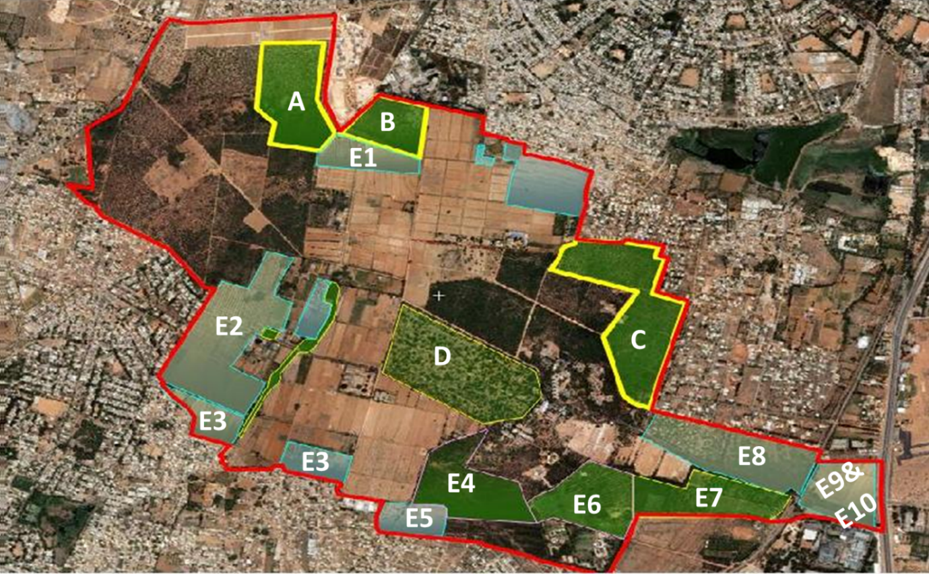
Fig. 1. Map of 14 different areas of Biodiversity Heritage Site, GKVK
2.2 Sampling design and data collection
A total of 104 random quadrats with 20x20m size were laid in all 14 areas covering an area of 2.5% (i.e., 4.175 ha) of the total study area. 4, 4, 6, 11, 7, 13, 6, 9, 6, 7, 11, 12, 2 and 6 quadrats were laid in the A, B, C, D, E1, E2, E3, E4, E5, E6, E7, E8, E9 and E10 area respectively. Trees with girth ≥ 30cm were measured for their girth at breast height (GBH) and height using measuring tape and altimeter respectively within each quadrat.
2.3 Data analysis
A total of 1481 trees were enumerated for stand structure, species diversity and composition from the entire study area. For diversity and composition- Species richness (S) (Colwell and Robert, 2009), Shannon-Wiener index (H') (Magurran, 2003), Simpson diversity index (1-D) (Magurran, 2003), Evenness index (J') (Pielou, 1966) and Jaccard’s index of similarity (Real and Vargas, 1996) were calculated. For the stand structure in BHS Important Value Index (IVI) (Curtis and Mointosh, 1950), girth class distribution, basal area and stand density were calculated.
3. RESULTS AND DISCUSSION
3.1 Species diversity indices
The results indicate that the BHS, GKVK is a diversified area with greater biodiversity. A total of 96 tree species were documented in all 104 quadrats which belong to 27 families. Fabaceae is the most dominant family recording 33.33% (32 species) of the species followed by Moraceae (8.33%) (8 species) and Combretaceae (6.25%) (6 species) (Fig. 2). Species richness was more in the Botanical Garden (Area D) followed by E7 (Tree Arboretum), because of maintenance and conservation of more species in garden and arboretum and lowest number of species were recorded in E1, E5, E8, E9 & E10 areas (Table 1). This could because of monoculture of only Mango orchards. Mouna et al. (2021) also recorded 98 tree species belonging to 33 families in Dharwad campus, Karnataka. The results from Joshi and Khadka’s (2013) study also recorded 53 tree species in the Churia region in Dhanusha and Mahottari District, Nepal which is less when compared to our study area. Gopalakrishna et al. (2015) reported 128 tree species belonging to 45 families in Scrub Forest of Bannerghatta National Park which means a greater richness of species compared to our study area.
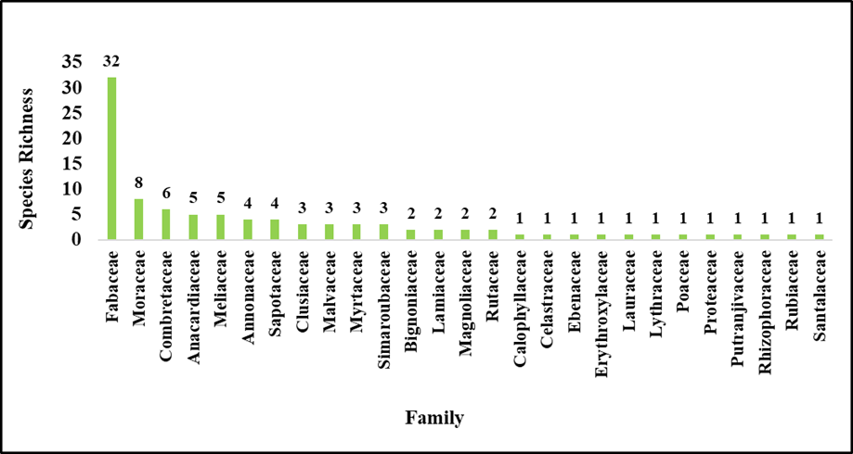
Fig. 2. Species richness with respective to family distribution in the Biodiversity Heritage Site, GKVK
Shannon-Wiener Index and Simpson’s Diversity Index showed that BHS has greater diversity with a value of 3.32 and 0.97 respectively. The diversity was more in area D (3.82, 0.962), followed by E7 (2.65, 902), respectively, which indicates that these areas contain a greater number of tree species due to conservation of different species (Table 1). Both diversity indices were 0 in the areas of E5, E8, E9 and E10 because these areas are under Mango cultivation. The Shannon-Wiener Index of 3.07 was recorded by Sharma and Kant (2014) in the subtropical scrub forest, which is less when compared to our results. Bharathi and Prasad (2016) also reported the comparable results in the sacred grooves of Kushalnagara, Karnataka where the overall Simpson’s index value of all four sacred grooves was 0.87 (Table 1).
Evenness index showed that BHS of species were less evenly distributed (0.73) though the diversity was more because of uneven distribution of trees in the study area. Area E2 (0.92) is more evenly distributed though the richness was low when compared to the Area D (0.90) and E7 (0.80). However, our results (0.73) are less compared to the open scrub vegetation patches of Dachigam National Park, Kashmir (index value 1.034) indicating comparatively having less evenly distributed species (Malik et al., 2021). But Sahoo et al. (2017) reported similar values of 0.71 in Nayagarh Forest Division, Odisha.
According to Jaccard’s similarity index, areas E4 and C (0.39) showed greater similarity followed by E6 and E4 (0.36) for the entire study area. Among the scrub forest patch, Areas A and B (0.25) showed more similarity. Subashree et al. (2021) also reported beta diversity of 0.396 among the seven study sites in Kanyakumari Wildlife Sanctuary, Western Ghats and Sahoo et al. (2017) reported a similarity of more than 53% between the tree species in seven forest ranges of Nayagarh Forest Division in Odisha state in the Eastern Ghats. A total of seven species were common in all three patches of the heritage site viz., Albizia lebbeck, Azadirachta indica, Delonix regia, Eucalyptus globulus, Grevillea robusta, Pongamia pinnata and Tamarindus indica. Similarly, three species (Hardwickia binata, Santalum album and Senna siamea) were found only in between garden and forest patches, five species (Acacia auriculiformis, Bambusa vulgaris, Leucaena leucocephala, Senna spectabilis and Swietenia macrophylla) were found between plantations and forest patches and fourteen species (Ailanthus triphysa,, Anacardium occidentale, Aphanamixis polystachya, Artocarpus hirsutus, Cassia fistula, Dalbergia sissoo, Kingiodendron pinnatum, Peltophorum pterocarpum, Psidium guajava, Pterocarpus marsupium, Syzygium cumini, Terminalia arjuna and Terminalia bellirica) between plantations (area E7, tree arboretum) and Botanical Garden. A total of 4, 45 and 18 tree species were found exclusively in the patches of scrub forest, Botanical Garden and plantations and orchards, respectively (Fig. 3).
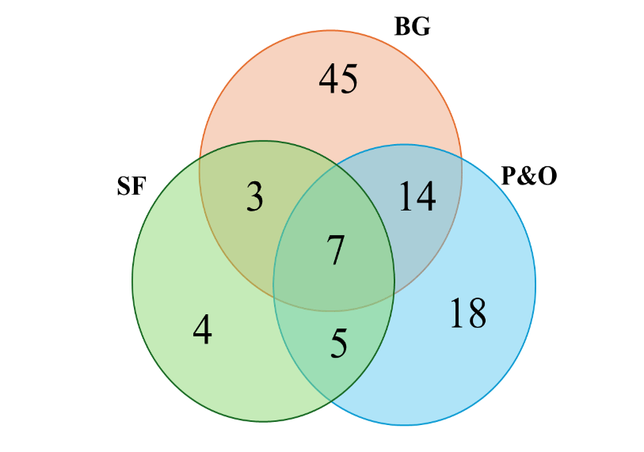
Fig. 3. Common tree species distribution among three patches of Biodiversity Heritage site, GKVK
[SF=Scrub Forest, BG=Botanical Garden, P&O=Plantations and Orchards]
3.2 Stand density and Basal area
The average tree density of the entire heritage site of GKVK was 356±31.31 stems per hectare and varied among different areas from117±6.41 to 957±102.64 stems per hectare. The highest tree density was recorded in the area E7 (Tree arboretum;957±102.64 stems ha^{–1}) followed by area E6 (843±115.43 stems ha^{–1}), area C (646±75.39 stems ha^{–1}) and area E3 (346±19.81 stems ha^{–1}). The lowest was recorded in area E8 (117±6.41 stems ha^{–1}) followed by area E1 (146±6.52 stems ha^{–1}). Among scrub forest patches, area A (194±18.75 stems ha^{–1}) had a low tree density followed by area B (269±6.25 stems ha^{–1}). The tree density in the Botanical Garden was 316±25.06 stems ha^{–1} (Table 1).
Basal area was also recorded differently for different areas ranging from 8.40±1.76 to 33.57±3.77 m² ha^{–1}. The average basal area for the entire GKVK was 20.58±1.15 m² per hectare. The highest was recorded in area D (Botanical Garden; 33.57±3.77 m² ha^{–1}) as they are more mature trees with higher girth class. The lowest was recorded in area A (8.40±1.76 m² ha^{–1}). Among plantations and orchards highest was recorded by area E7 (32.30±2.78 m² ha⁻¹) followed by area E8 (26.01±2.32 m² ha^{–1}) and area E6 (23.84±3.71 m² ha^{–1}). Area C was recorded highest (21.33±5.95 m² ha^{–1}) in the scrub forest patches (Table 1).
Table 1. Consolidated details of woody flora inventory in different areas of BHS, GKVK
Area | Species Richness (S) | Family | Shannon-Wiener index (H') | Simpson diversity index (1-D) | Evenness index (J') | Stand Density  (stems ha^{–1})  (Average±SE) | Basal Area  (m² ha^{–1})  (Average±SE)
A | 6 | 4 | 1.53 | 0.755 | 0.85 | 194±18.75 | 8.40±1.76
B | 4 | 3 | 0.76 | 0.409 | 0.55 | 269±6.25 | 13.15±2.00
C | 15 | 5 | 1.84 | 0.711 | 0.68 | 646±75.39 | 21.33±5.95
D | 69 | 20 | 3.82 | 0.962 | 0.90 | 316±25.06 | 33.57±3.77
E1 | 3 | 3 | 0.77 | 0.504 | 0.70 | 146±6.52 | 15.26±3.17
E2 | 6 | 4 | 1.65 | 0.781 | 0.92 | 198±19.91 | 13.25±2.07
E3 | 13 | 10 | 2.31 | 0.881 | 0.90 | 346±19.81 | 18.88±4.41
E4 | 10 | 4 | 1.58 | 0.680 | 0.68 | 217±48.41 | 10.49±2.46
E5 | 1 | 1 | 0 | 0 | NA | 163±14.07 | 15.13±2.98
E6 | 9 | 5 | 1.19 | 0.545 | 0.54 | 843±115.43 | 23.84±3.71
E7 | 27 | 11 | 2.65 | 0.902 | 0.80 | 957±102.64 | 32.30±2.78
E8 | 1 | 1 | 0 | 0 | NA | 117±6.41 | 26.01±2.32
E9 | 2 | 2 | 0.21 | 0.105 | 0.31 | 225±0.00 | 19.00±1.33
E10 | 1 | 1 | 0 | 0 | NA | 158±13.94 | 17.78±1.17
Overall | 96 | 27 | 3.32 | 0.93 | 0.73 | 356±31.31 | 20.58±1.15
[SE = Standard Error]
The results are also in line with the studies conducted by Panda et al. (2013) in tropical deciduous forests of Eastern Ghats where the stand density ranged from 268 to 655 stems ha^{–1} while basal area varied from 6.65 to 22. 28 m²ha^{–1}. Similar results were reported by Ao et al. (2021) in sub-tropical forest of Nagaland, where tree density and basal area ranged from 313 to 330 stems ha^{–1} and 22.95 to 38.03 m²ha^{–1}, respectively.
3.3 Important Value Index (IVI)
Species composition and dominance can be calculated by the Important Value Index (IVI), which considers the relative density, relative dominance and relative frequency of species. Mangifera indica was dominant among all the tree species for the entire study area with an IVI value of 56.57 and with a density of 47.54 stems ha^{–1}, which is followed by Tectona grandis, Eucalyptus globulus, Acacia auriculiformis and Pterocarpus marsupium with an IVI value of 23.95, 20.42, 20.07 and 11.49 and density of 55.05, 29.81, 24.28 and 19.23 stems ha^{–1}, respectively. This is due to a huge plantation being done in the view of commercial importance. Though the number of individuals of Teak were more than Mango, its IVI value was comparatively very low because of the greater frequency and basal area of Mango species. This is because 6 out of 14 areas of the heritage site are under Mango orchards (Table 2).
The results were on par with the findings of Tamang et al. (2018) where they reported Mangifera indica (9.19%), Terminalia arjuna (6.66%), Gmelina arborea (6.27%), Tectona grandis (5.23%) and Heavea brasiliensis (5.17%) were dominated by number of stems in Uttar Banga Krishi Viswavidyalaya, West Bengal. Singh et al. (2017) also reported dominant species with maximum IVI value recorded by Dendrocalamus strictus (41.66) followed by Tectona grandis (40.19), with being highest density by Tectona grandis (209.09 stems ha^{–1}) and more basal cover by Dendrocalamus strictus (24.72 m² ha^{–1}) in Tropical Forest Research Institute (TFRI) campus.
Eucalyptus globulus was the most dominant species in the scrub forest with an IVI value of 99.95, with a stand density of 173.21 stems ha^{–1} and basal area of 2.96 m² ha^{–1}. This could be because more plantation was done long years ago by the forest department. The second most dominant tree species was Acacia auriculiformis (IVI = 62.68) followed by Tamarindus indica (IVI = 19.25) with stand density of 89.29 and 28.57stems ha^{–1} and basal area of 2.18 and 0.39 m² ha^{–1}, respectively. In Botanical Garden i.e., area D Pongamia pinnata (IVI = 28.98) was the most dominant tree species followed by Azadirachta indica (IVI = 28.48) and Albizia lebbeck (IVI = 20.57), with stem density of 36.36, 31.82 and 15.91 stems ha^{–1}, respectively. This is because, these species were not removed during the designing of family blocks of the Botanical Garden. The basal area was more for Albizia lebbeck (1.69 m² ha^{–1}) followed by Pongamia pinnata (1.68 m² ha^{–1}) and Azadirachta indica (1.66 m² ha^{–1}). Mangifera indica (IVI = 84.66) was the most dominated tree species in plantations and orchards patch followed by Tectona grandis (IVI = 34.06) and Acacia auriculiformis (IVI = 18.27). This could be because more planation was done based on economic importance of Mango and Teak species. The tree density and basal area was 62.97, 72.47 and 16.14 stems ha^{–1} and 27.31, 4.94 and 3.34 1.66 m² ha^{–1} for Mangifera indica, Tectona grandis and Acacia auriculiformis, respectively (Table 2).
Table 2. Important Value Index of top ten dominant trees in different patches of Biodiversity Heritage site, GKVK
Species Name | Family | Stand Density  (Stems ha^{–1}) | Basal Area  (m² ha^{–1}) | IVI
Entire Heritage Site
Mangifera indica | Anacardiaceae | 47.84 | 6.57 | 56.57
Tectona grandis | Lamiaceae | 55.05 | 1.19 | 23.95
Eucalyptus globulus | Myrtaceae | 29.81 | 1.01 | 20.42
Acacia auriculiformis | Fabaceae | 24.28 | 1.33 | 20.07
Pterocarpus marsupium | Fabaceae | 19.23 | 0.83 | 11.49
Azadirachta indica | Meliaceae | 9.86 | 0.69 | 10.53
Manilkara zapota | Sapotaceae | 12.26 | 0.73 | 9.71
Albizia lebbeck | Fabaceae | 4.57 | 0.62 | 8.02
Gmelina arborea | Lamiaceae | 13.46 | 0.66 | 8.01
Pongamia pinnata | Fabaceae | 5.29 | 0.49 | 7.29
Scrub Forest
Eucalyptus globulus | Myrtaceae | 173.21 | 2.96 | 99.95
Acacia auriculiformis | Fabaceae | 89.29 | 2.18 | 62.68
Tamarindus indica | Fabaceae | 28.57 | 0.39 | 19.25
Grevillea robusta | Proteaceae | 17.86 | 0.29 | 15.48
Delonix regia | Fabaceae | 26.79 | 0.56 | 16.98
Albizia lebbeck | Fabaceae | 7.14 | 0.48 | 11.23
Pongamia pinnata | Fabaceae | 7.14 | 0.31 | 11.11
Albizia odoratissima | Fabaceae | 1.79 | 0.39 | 6.86
Senegalia chundra | Fabaceae | 8.93 | 0.15 | 7.73
Senna siamea | Fabaceae | 10.71 | 0.14 | 8.05
Botanical Garden
Pongamia pinnata | Fabaceae | 36.36 | 1.68 | 28.98
Azadirachta indica | Meliaceae | 31.82 | 1.66 | 28.48
Albizia lebbeck | Fabaceae | 15.91 | 1.69 | 20.57
Anacardium occidentale | Anacardiaceae | 18.18 | 1.13 | 17.50
Terminalia bellirica | Combretaceae | 4.55 | 0.97 | 10.03
Albizia amara | Fabaceae | 6.82 | 0.65 | 8.61
Tamarindus indica | Fabaceae | 6.82 | 0.23 | 6.75
Khaya grandifoliola | Meliaceae | 6.82 | 0.52 | 6.68
Peltophorum pterocarpum | Fabaceae | 6.82 | 0.47 | 6.38
Ficus virens | Moraceae | 2.27 | 0.58 | 5.67
Plantations and Orchards
Mangifera indica | Anacardiaceae | 62.97 | 27.31 | 84.66
Tectona grandis | Lamiaceae | 72.47 | 4.94 | 34.06
Acacia auriculiformis | Fabaceae | 16.14 | 3.34 | 18.27
Manilkara zapota | Sapotaceae | 16.14 | 3.03 | 15.01
Pterocarpus marsupium | Fabaceae | 24.37 | 3.26 | 14.93
Gmelina arborea | Lamiaceae | 17.72 | 2.75 | 11.53
Simarouba glauca | Simaroubaceae | 16.14 | 2.00 | 10.57
Eucalyptus globulus | Myrtaceae | 7.59 | 1.14 | 8.84
Azadirachta indica | Meliaceae | 8.23 | 1.18 | 7.70
Terminalia bellirica | Combretaceae | 13.29 | 1.51 | 6.90
3.4 Girth class distribution and population structure
Tree species distribution among different girth classes in different patches is presented in figure 4. All three patches showed Inverse J shape distribution pattern, which indicates a good regeneration of species in the Heritage site of GKVK. In the Botanical Garden (Area D) patch larger girth class showed a little increase in terms of individuals due to maintenance of more mature trees in the garden over years. Even the entire study area also showed the same distribution pattern of population. A total of 232 stems ha^{–1}i.e., 65 per cent, 90 stems ha^{–1} (25%), 19 stems ha^{–1} (5%), 8 stems ha^{–1} (2%), 3 stems ha^{–1} (1%) and 4 stems ha^{–1} (1%) was recorded in 30-60, 60-90, 90-120, 120-150, 150-180 and >180 cm girth classes, respectively in the Heritage site (Fig. 4). More than 50 percent of the tress are present in the lower girth classes in all the patches of BHS. Much of the basal area was also contributed by the lower girth classes only except in area D (Botanical Graden) due to presence of greater girth to trees (11.6 m²ha^{–1} for >180 cm girth class) (Table 3).
Similar distribution pattern was recorded by Pradhan et al. (2019) in five sacred forests of western Odisha, where four out of five sacred forests showed relative decreasing trends of tree density with an increasing girth class, which showed a reverse J pattern population structure indicating an evolving or expanding population. In any stand, it is important to have greater and smaller girth trees, as they sequester more carbon per tree and they grow fast and sequester more carbon in future, respectively (Lal and Singh, 2000).
Table 3 Girth class distribution of trees in Biodiversity Heritage Site, GKVK with respect to Density (D) (stems ha^{–1}) and Basal area (BA) (m²ha^{–1})
Girth class (cm) | Entire Heritage site |  | Scrub Forest |  | Botanical Garden |  | Plantations and Orchards
Girth class (cm) | D | BA | D | BA | D | BA | D | BA
30-60 | 232 | 8.24 | 134 | 5.17 | 57 | 4.32 | 775 | 9.33
60-90 | 90 | 6.69 | 82 | 6.6 | 33 | 5.31 | 258 | 6.9
90-120 | 19 | 2.09 | 9 | 1.5 | 15 | 3.93 | 55 | 1.94
120-150 | 8 | 1.24 | 2 | 0.51 | 13 | 4.4 | 18 | 0.93
150-180 | 3 | 0.69 | 0 | 0 | 9 | 4.56 | 4 | 0.28
>180 | 4 | 1.62 | 2 | 1.51 | 12 | 11.06 | 3 | 0.32
Total | 356 | 20.58 | 229 | 15.29 | 139 | 33.57 | 1113 | 19.71
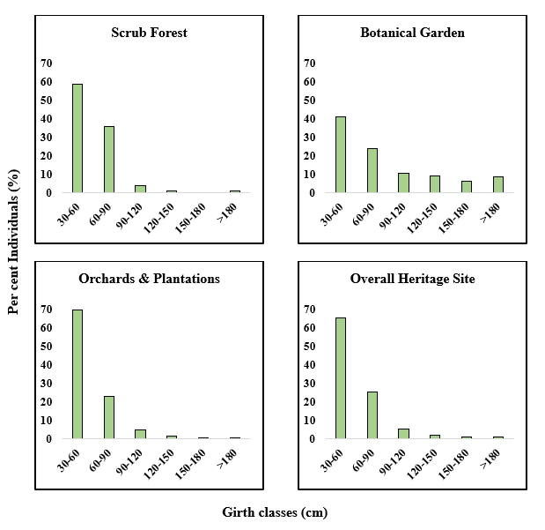
Fig. 4. Girth class distribution of trees in three land use systems of Biodiversity Heritage site, GKVK
4. CONCLUSION
Our study indicated that Heritage Site exhibited greater biodiversity with diversified tree species with less even distribution of them. The stand structure was very complex, with a tree density of 356 stems ha^{–1} and a basal area of 20.58 m² ha^{–1}. The entire study area and individual patches showed an Inverse J shape distribution of population structure, indicating a good regeneration status. Species composition and dominance area based on IVI values indicate that Mangifera indica was dominant among all species followed by Tectona grandis, Eucalyptus globulus and Acacia auriculiformis. Dominant tree in scrub forest and Botanical Garden is Eucalyptus globulus and Pongamia pinnata, respectively. By understanding ecosystem diversity and structure, we can set the conservation priorities and also repeated and continuous monitoring of changes in a habitat provides a platform to investigate concurrent variation in the structure, function and species composition of that particular area. This study helps us to understand where to implement conservation and management strategies across the campus and maintain good ecosystem services in the campus area. It is important to conserve biodiversity and prioritise areas for conservation to achieve sustainability in the campus surroundings for future purposes.
DISCLAIMER (ARTIFICIAL INTELLIGENCE)
Author(s) hereby declares that NO generative AI technologies such as Large Language Models (ChatGPT, COPILOT, etc.) and text-to-image generators have been used during the writing or editing of this manuscript.
REFERENCES
Ao, A., Changkija, S., & Tripathi, S. K. (2021). Stand structure, community composition and tree species diversity of sub-tropical forest of Nagaland, Northeast India. Tropical Ecology, 62(4), 549-562.
Bharathi, S., & Devi Prasad, A. G. (2017). Diversity, population structure and regeneration status of arboreal species in the four sacred groves of Kushalnagar, Karnataka. Journal of forestry research, 28(2), 357-370.
Colwell, R. K. (2009). Biodiversity: concepts, patterns, and measurement. The Princeton guide to ecology, 663, 257-263.
Curtis, J. T., & McIntosh, R. P. (1950). The interrelations of certain analytic and synthetic phytosociological characters. Ecology, 31(3), 434-455.
Deb, D., Deb, S., Debbarma, J., & Datta, B. K. (2016). Tree species richness and carbon stock in Tripura University Campus, Northeast India. Journal of Biodiversity Management & Forestry, 5(4), 1-7.
Gopalakrishna, S. P., Kaonga, M. L., Somashekar, R. K., Suresh, H. S., & Suresh, R. (2015). Tree diversity in the tropical dry forest of Bannerghatta National Park in Eastern Ghats, Southern India. European Journal of Ecology, 1(2), 12-27.
Joshi, M. D., & Khadka, M. K. (2013). Floristic composition and species diversity: A case study of Churia region in Dhanusha and Mahottari District, Journal of Department of. Plant Resources, 35, 28-35.
karnataka.gov.in., 2009, Brief details of Gandhi Krishi Vignana Kendra Biodiversity Heritage Site, Karnataka.
Lal, M., & Singh, R. (2000). Carbon sequestration potential of Indian forests. Environmental monitoring and assessment, 60, 315-327.
Magurran, A. (2003). Measuring biological diversity. Blackwell Science Ltd. UK, pp. 102-106.
Malik, A. Y., Singh, D. P., Yunus, M., Bhat, G. A., Shukla, G., Bhat, J. A., ... & Chakravarty, S. (2021). Diversity and structure of plant assemblages in open scrub vegetation patches of Dachigam National Park at Kashmir Himalayas. Trees, Forests and People, 3, 100060.
Mouna, S., Ningaraj, S. M., & Kotresha, K. (2021). Estimation of tree biomass and carbon sequestration in Karnataka college campus, dharwad. Karnataka. J. Biosci, 10(11), 9092-9108.
Panda, P. C., Mahapatra, A. K., Acharya, P. K., & Debata, A. K. (2013). Plant diversity in tropical deciduous forests of Eastern Ghats, India: A landscape level assessment. Int J Biodivers Conserv, 5(10), 625-639.
Pielou, E. C. (1966). The measurement of diversity in different types of biological collections. Journal of theoretical biology, 13, 131-144.
Pradhan, A., Ormsby, A., & Behera, N. (2019). Diversity, population structure, and regeneration potential of tree species in five sacred forests of western Odisha, India. Ecoscience, 26(1), 85-97.
Real, R., & Vargas, J. M. (1996). The probabilistic basis of Jaccard's index of similarity. Systematic biology, 45(3), 380-385.
Sahoo, T., Panda, P. C., & Acharya, L. (2017). Structure, composition and diversity of tree species in tropical moist deciduous forests of Eastern India: a case study of Nayagarh Forest Division, Odisha. Journal of Forestry Research, 28, 1219-1230.
Sathish, B. N., Bhavya, C. K., Kushalappa, C. G., Nanaya, K. M., Dhanush, C., Devagiri, G. M., & Gajendra, C. V. (2022). Dynamics of native tree structure and diversity in coffee agroforest: a case study from Central Western Ghats. Agroforestry Systems, 96(1), 161-172.
Sharma, N., & Kant, S. (2014). Vegetation structure, floristic composition and species diversity of woody plant communities in sub-tropical Kandi Siwaliks of Jammu, J & K, India. International Journal of Basic and Applied Sciences, 3(4), 382.
Singh, S., Verma, A. D., & Naik, R. (2017). Study on regeneration of tree species in TFRI campus plantations, Jabalpur, Madhya Pradesh. Indian Journal of Tropical Biodiversity, 25(1), 20-30.
Subashree, K., Dar, J. A., Karuppusamy, S., & Sundarapandian, S. (2021). Plant diversity, structure and regeneration potential in tropical forests of Western Ghats, India. Acta Ecologica Sinica, 41(4), 259-284.
Sullivan, M. J., Talbot, J., Lewis, S. L., Phillips, O. L., Qie, L., Begne, S. K., ... & Zemagho, L. (2017). Diversity and carbon storage across the tropical forest biome. Scientific reports, 7(1), 39102.
Tamang, B., Sarkar, B. C., Pala, N. A., Shukla, G., Patra, P. S., Bhat, J. A., ... & Chakravarty, S. (2019). Uses and ecosystem services of trees outside forest (TOF)-A case study from Uttar Banga Krishi Viswavidyalaya, West Bengal, India. Acta Ecologica Sinica, 39(6), 431-437.

