***“In Vitro* Efficacy of Different Bioagents Against *Alternaria porri* Causing Purple Blotch in Onion (*Allium cepa* L.)”**

**Abstract**

India, a primarily agrarian country, is experiencing significant changes in land use and cropping patterns due to rapid urbanization, alongside a growing population that demands increased agricultural productivity. Vegetables, especially onion (*Allium cepa* L.), play a crucial role in enhancing nutritional security and contributing to the national economy. Despite being the second-largest onion producer globally, India faces considerable yield losses from biotic stresses, notably purple blotch disease caused by *Alternaria porri*. This foliar disease severely affects onion crops during the kharif season, causing yield reductions up to 80% under epidemic conditions. Conventional chemical control methods pose environmental and resistance challenges, necessitating sustainable alternatives. This study evaluates the in vitro efficacy of various bioagents against *A. porri* to identify promising biological control agents. Among the tested bioagents, *Trichoderma asperellum* and *Pseudomonas fluorescens* demonstrated the highest antagonistic activity, inhibiting pathogen growth by 88.14% and 83.14%, respectively. These findings highlight the potential of specific bioagents as effective components of integrated disease management strategies for sustainable control of purple blotch in onions.

**KEYWORDS:** *In vitro,* Onion, *Allium cepa*, Purple blotch, *Alternaria porri*

***Introduction***

India, a predominantly agrarian nation, is undergoing significant transitions in its land use and cropping patterns driven by rapid urbanization and an expanding population. This growing demand for food has placed increased emphasis on enhancing agricultural productivity in a sustainable manner. Vegetables, in particular, play a dual role in this transformation supporting the nutritional needs of the population while also contributing substantially to the nation's agricultural economy.

Among vegetable crops, onion (*Allium cepa* L.) is a key horticultural commodity, cultivated extensively for its culinary and medicinal properties. Recognized as one of the oldest cultivated vegetables, onion is grown in over 175 countries (Mehta, 2017), with its primary center of origin being Central Asia and secondary centers in the Mediterranean and Near East (Vavilov, 1951). In India, onion cultivation spans diverse agro-climatic zones, with major producing states including Maharashtra, Madhya Pradesh, and Karnataka. As per recent statistics, the country ranks second globally in onion production, with 12.85 lakh hectares under cultivation and an annual yield of approximately 232 lakh tonnes (Anonymous, 2020).

Despite its economic and nutritional significance, onion cultivation faces persistent challenges from a range of biotic stresses. One of the most destructive diseases affecting onions is purple blotch, caused by the fungal pathogen *Alternaria porri* (Ellis) Cif. The disease primarily affects the foliage, manifesting as purplish concentric lesions that expand rapidly under favourable environmental conditions typically 25–30°C temperature and relative humidity above 90% (Shahanaz et al., 2007; Kumar et al., 2021). In severe cases, purple blotch can lead to necrosis and premature death of the plant, resulting in yield losses ranging from 30% to as high as 80% under epidemic conditions (Dar et al., 2020).

Chemical fungicides are commonly employed for managing the disease; however, their long-term use has led to several drawbacks, including the development of fungicide-resistant strains of *A. porri*, environmental pollution, and residue accumulation in the produce. These concerns underscore the need for eco-friendly and sustainable disease management strategies, particularly the use of biological control agents as part of integrated disease management (IDM) programs.

Biological control, using naturally occurring beneficial microorganisms or bioagents, offers a promising alternative. Several bioagents such as *Trichoderma spp.*, *Pseudomonas spp.*, *Bacillus subtilis*, *Paecilomyces lilacinus*, and *Metarhizium anisopliae* have demonstrated antagonistic potential against various plant pathogens through mechanisms including mycoparasitism, antibiosis, competition, and induction of host resistance.

In this context, the present study was undertaken to evaluate the *in vitro* antagonistic efficacy of different bioagents against *Alternaria porri*, the causal organism of purple blotch in onion. The objective was to identify potent biocontrol agents that could be incorporated into IDM strategies for the effective and sustainable management of this economically important disease.

**MATERIALS AND METHODOLOGY**

The present investigation was carried out in the laboratory of the Department of Plant Pathology, Vasantrao Naik Marathwada Krishi Vidyapeeth (VNMKV), Parbhani, with the primary objective of assessing the in vitro efficacy of selected bioagents against *Alternaria porri*, the causal organism of purple blotch in onion. The experimental materials, including bioagents, Potato Dextrose Agar (PDA) medium, laboratory-grade glassware, and other essential apparatus, were procured from the departmental facilities. Diseased onion plants exhibiting characteristic symptoms of purple blotch such as elliptical to oval lesions with concentric rings surrounded by chlorotic halos were collected from the field for pathogen isolation. The pathogen was successfully isolated on PDA medium under aseptic conditions and was identified as *Alternaria porri* based on morphological characteristics.

For the *in vitro* antagonistic assay, seven bioagents, namely *Trichoderma asperellum*, *Trichoderma harzianum*, *Pseudomonas fluorescens*, *Pseudomonas striata*, *Metarhizium anisopliae*, *Paecilomyces lilacinus*, and *Bacillus subtilis*, were evaluated using the dual culture technique. In this method, a 5 mm mycelial disc of *A. porri* was placed at one end of the Petri dish containing PDA medium, while an equal-sized disc or loopful of the respective bioagent was inoculated at the opposite end, equidistant from the center. The experiment was laid out in a Completely Randomized Design (CRD) with three replications for each treatment. The plates were incubated at a temperature of 28±2°C and observed daily. The radial growth of the pathogen was recorded once the control plates (without bioagents) were fully colonized by *A. porri*. The percent inhibition of mycelial growth in the presence of bioagents was calculated using Vincent’s formula:

C - T

Percent Inhibition= **………...**  x 100

C

where **C** represents the colony diameter in the control, and **T** is the colony diameter in the treatment. This methodology facilitated a comparative evaluation of the antagonistic potential of the selected bioagents against *A. porri*, thereby providing insight into their suitability for integrated disease management strategies in onion cultivation.

**RESULTS AND DISCUSSION**

The *in vitro* evaluation of different bioagents against *Alternaria porri*, the pathogen responsible for purple blotch in onion, yielded significant variation in their antagonistic efficacy. The detailed results are presented in Table 1, Plate 1 and graphically illustrated in figure 1. The experiment revealed marked differences among treatments in their ability to suppress the radial growth of the pathogen, indicating variable levels of bioefficacy.

Among the tested bioagents, *Trichoderma asperellum* (T₁) demonstrated the highest antagonistic potential. It significantly reduced the mycelial growth of *A. porri*, with a minimum mean colony diameter of 10.66 mm and a maximum percent inhibition of 88.14%, thereby emerging as the most effective treatment. This was closely followed by *Pseudomonas fluorescens* (T₃), which recorded a colony diameter of 15.16 mm and an inhibition percentage of 83.14%. The performance of T₃ was statistically at par with T₁, underscoring its comparable efficacy in inhibiting pathogen growth.

*Trichoderma harzianum* (T₂) also exhibited notable antagonism, resulting in a colony diameter of 20.83 mm and percent inhibition of 76.85%. Although statistically lower than T₁ and T₃, its performance remained significantly superior to the remaining treatments. *Pseudomonas striata* (T₄) and *Bacillus subtilis* (T₇) displayed moderate efficacy, registering colony diameters of 28.83 mm and 30.66 mm, and inhibition percentages of 67.96% and 65.92%, respectively. These two treatments were statistically at par.

**Table No. 1.** ***In vitro* bio-efficacy of the bioagents against *Alternaria porri* causing onion purple blotch**

|  |  |  |  |
| --- | --- | --- | --- |
| **Tr. No** | **Treatment details** | **Colony Diam. of test pathogen * (mm)** | **% Inhibition** |
| T₁ | *Trichoderma asperellum* | 10.66 | 88.14  (69.84) |
| T₂ | *Trichoderma harzianum* | 20.83 | 76.85  (61.23) |
| T₃ | *Pseudomonas fluorescens* | 15.16 | 83.14  (65.75) |
| T₄ | *Pseudomonas striata* | 28.83 | 67.96  (55.51) |
| T₅ | *Metarhizium anisopliae* | 41.16 | 54.25  (47.42) |
| T₆ | *Paecilomyces lilacinus* | 35.83 | 60.18  (50.85) |
| T₇ | *Bacillus subtilis* | 30.66 | 65.92  (54.26) |
| T₈ | Control (untreated) | 90.00 | 100  (90.00) |
|  | **S.E. (m) ±** | **0.81** | **0.90** |
|  | **C.D. at 1%** | **2.47** | **2.74** |

*\*Mean of three replications. Figure in parenthesis are arcsine transformed values.*

Among the entomopathogenic fungi, *Paecilomyces lilacinus* (T₆) and *Metarhizium anisopliae* (T₅) recorded relatively higher colony diameters of 35.83 mm and 41.16 mm, with corresponding inhibition percentages of 60.18% and 54.25%, respectively. These values were statistically lower compared to those recorded for *Trichoderma* and *Pseudomonas* species, indicating comparatively weaker antagonistic interactions with *A. porri*.

As expected, the untreated control (T₈) displayed the maximum radial mycelial growth of 90.00 mm, with 0% inhibition, confirming the virulence of the pathogen in the absence of any antagonistic organism.

The statistical analysis confirmed the high significance of treatment differences, with a Critical Difference (CD) at 1% level of 2.47 mm for colony diameter and 2.74% for percent inhibition. The Standard Error of the Mean (SEm ±) was 0.81 mm and 0.90%, respectively, indicating a high level of precision in the experimental design and data collection.

These results clearly establish that *Trichoderma asperellum* and *Pseudomonas fluorescens* are the most potent antagonists against *Alternaria porri* under in vitro conditions, followed closely by *T. harzianum*. The remaining bioagents, though exhibiting some inhibitory effect, were significantly less effective and could be considered of moderate to low bioefficacy. These findings support the potential integration of specific bioagents, particularly *T. asperellum* and *P. fluorescens*, into sustainable and eco-friendly management strategies for controlling purple blotch disease in onion.

**REFERENCES**

Chaithanya, G., Kumar, A., Vijay, D., Basu, S., & Lal, S. K. K. (2023). Efficacy of nanoparticles against purple blotch (*Alternaria porri*) of onion. *Indian Phytopathology, 76*(3), 845–852. https://doi.org/10.1007/s42360-023-00632-x

Chaithanya, G., Vijay, D., & Lal, S. K. K. (2023). Efficacy of zinc-oxide nanoparticles against *Alternaria porri* on seed-primed onion using nano-priming technique. *Indian Phytopathology, 76*(3), 860–866.

Chethana, B. S., Ganehan, G., Rao, A. S., & Bellishree, K. (2012). *In vitro* evaluation of plant extracts, bioagents and fungicides against *Alternaria porri* (Ellis) Cif. causing purple blotch disease of onion. *Pest Management in Horticultural Ecosystem*, 18(2), 194–198.

Devi, T. J., & Lal, A. A. (2024). Eco-friendly management of purple blotch (*Alternaria porri*) of onion (*Allium cepa* L.). *International Journal of Environment and Climate Change, 14*(8), 519–526. https://doi.org/10.9734/ijecc/2024/v14i84372

Fayzalla, S. A., Metwally, A. H., & Sadat, M. M. (2011). Effect of some fungicides, bioagents and essential oils for controlling purple blotch disease of onion. *Journal of Plant Protection*, 2(7), 663–675.

Hariprasad, K., Palakshappa, M. G., Dinesh, K., & Iliger, S. K. (2021). Efficacy of biocontrol agents under in vitro against *Alternaria porri* (Ellis) Cifferi causing purple blotch in onion. *The Pharma Innovation*, 10(4), 81–84.

Kumar, D., Godara, S. L., & Sheshma, M. K. (2023). Physiological studies on *Alternaria porri* caused purple blotch of onion under in vitro conditions. *Journal of Agriculture and Ecology, 17*, 109–112. https://doi.org/10.58628/JAE-2317-320

Meena, R. P. (2023). Bio-efficacy of plant extracts for management of purple blotch disease of onion (*Allium cepa*). *Indian Phytopathology, 76*(2), 159–163.

Mishra, R. K., & Gupta, R. P. (2008). Screening of antagonists against *Alternaria porri* causing purple blotch in onion. *Journal of Mycology and Plant Pathology*, 38(3), 645–646.

Mishra, R. K., & Gupta, R. P. (2012). In vitro evaluation of plant extracts, bioagents and fungicides against purple blotch and Stemphylium blight of onion. *Journal of Medicinal Plants Research*, 6(45), 5658–5661.

Mohan, K., Ebenezer, E. G., & Seetharaman, K. (2001). Management of leaf blight disease of onion caused by *Alternaria porri* by plant extracts, plant oils and bio-control agents. *NHRDF Newsletter*, 21/22(1,3/4), 11–14.

Mohan, K., Ebenezer, E. G., & Seetharaman, K. (2002). Efficacy of biocontrol agents against onion leaf blight. *NHRDF Newsletter*, 22, 11–14.

Mustafijur, S., Rahman, M., Sikder, M., Nusrat, S., & Khair, A. (2015). *In vitro* evaluation of botanical extract, bioagents and fungicides against purple blotch disease of bunch onion in Bangladesh. *Advances in Zoology and Botany*, 3(4), 179–183.

Nainwal, D., & Vishunavat, K. (2023). Management of purple blotch and Stemphylium blight of onion in Tarai and Bhabar regions of Uttarakhand, India. *Journal of Applied and Natural Science, 15*(1), 62–68.

Pal, V., Rathore, G. S., & Godara, S. L. (2008). Evaluation of fungicides, neem product and bio-agents against *Alternaria* leaf spot of date palm. *Indian Phytopathology*, 62(3), 363–364.

Patel, S., & Arsia, S. K. (2024). Survey for purple blotch of onion incited by *Alternaria porri* and evaluation of new generation fungicides for management. *International Journal of Advanced Biochemistry Research, 8*(8), 750–754. https://doi.org/10.33545/26174693.2024.v8.i8j.1861

Prakasam, V., & Sharma, P. (2023). *Trichoderma harzianum* (Th-3): A potential strain to manage purple blotch of onion under North Indian plains. *Journal of Agricultural Science*. https://doi.org/10.5539/jas.v15n9p57

Pramodkumar, T., & Palakshappa, M. G. (2008). Management of purple blotch of onion through bioagents. *Karnataka Journal of Agricultural Sciences*, 21(2), 306–308.

Sangari, D., Zacharia, S., & Giri, A. (2024). Effect of *Trichoderma harzianum* with selected botanical extracts against purple blotch (*Alternaria porri*) of onion. *International Journal of Advanced Biochemistry Research, 8*(11), 605–610. https://doi.org/10.33545/26174693.2024.v8.i11h.2922

Shahanaz, E., Razdan, V. K., & Raina, P. K. (2007). Effect of fungicides and biocontrol agent on foliar disease intensity of onion. *Journal of Mycology and Plant Pathology*, 37(2), 213–214.

Sharma, R., Mishra, R., & Joshi, R. K. (2024). A highly contiguous genome sequence of *Alternaria porri* isolate Apn-Nashik causing purple blotch disease in onion. *BMC Genomic Data, 25*, Article 95. https://doi.org/10.1186/s12863-024-01276-0

Srivastava, K. J., Tiwari, B. K., & Pandey, U. B. (1991). Studies on biological control of onion plant pathogens. *Newsletter of Associated Agricultural Development Foundation*, 11(4), 5–6.

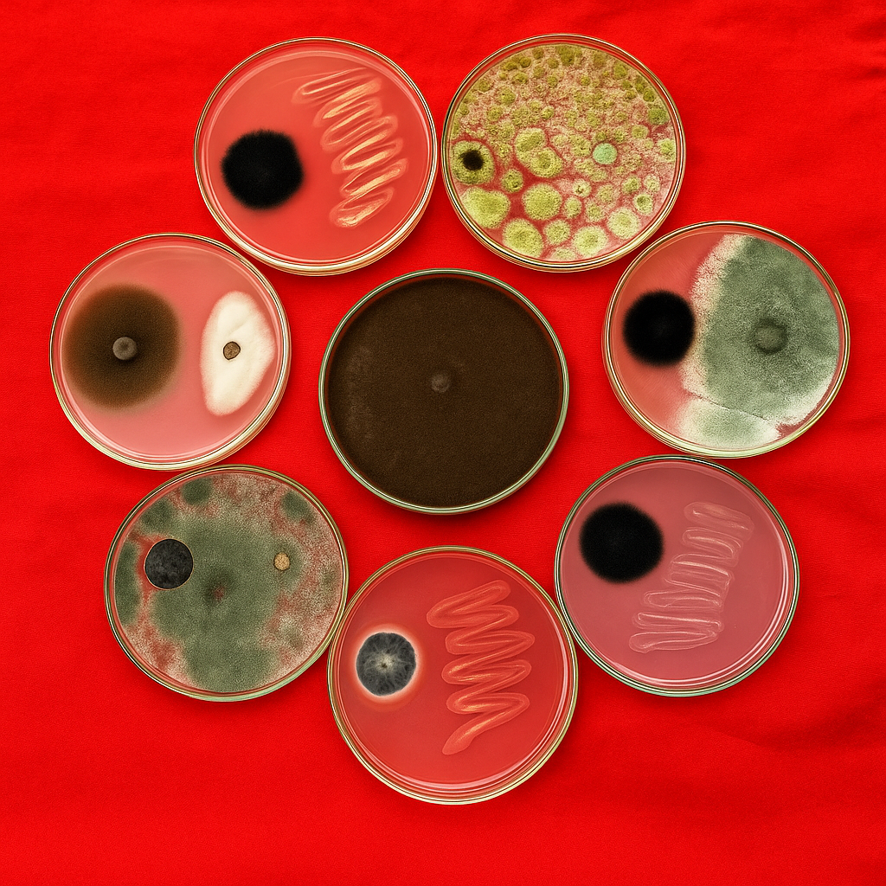

**PLATE 1. Inhibition of *Alternaria porri by* different bioagents**

|  |  |  |  |
| --- | --- | --- | --- |
| T₁ | *Trichoderma asperellum* | T₅ | *Metarhizium anisopliae* |
| T₂ | *Trichoderma harzianum* | T₆ | *Paecilomyces lilacinus* |
| T₃ | *Pseudomonas fluorescens* | T₇ | *Bacillus subtilis* |
| T₄ | *Pseudomonas striata* | T₈ | Control (untreated) |

**Fig 1. Graphical representation of the Colony diameter of the pathogen and per cent inhibition achieved by each bioagent.**