Anastomosis grouping of Rhizoctonia solani isolates causing Rice Sheath Blight disease in Andhra Pradesh

Abstract
Thirty isolates of Rhizoctonia solani collected from different regions across five districts of Andhra Pradesh were observed for variation and identification of anastomosis group causing sheath blight of rice in Andhra Pradesh. Based on the hyphal anastomosis test results indicated that all the isolates belong to single anastomosis group AG1-1A. Further, anastomosis reactions were grouped into three categories where YSR Kadapa isolates showed C1: hyphae contact only (same/different AG); Nellore and Chittoor isolates showed C2: killing reaction which represents a vegetative incompatibility response between genetically different individuals (same AG) and West and East Godavari isolates have shown C3: perfect fusion (same AG) of vegetative hyphal cells between two isolates that suggestive of genetically similar. The distribution pattern of AG categories in different districts of Andhra Pradesh found the correlation with geographical region where the pathogen isolate was collected and the data also correlated with the genetic variatioin analysis where the grouping of isolates were based on geographical origin.
Key Words :Anastamosis groups, Rhizoctonia solani, sheath blight

1.Introduction
Sheath blight of rice caused by Rhizoctonia solani [Perfect stage: Thanatephorus cucumeris (Frank) Donk] is considered to be one of the most important diseases of rice occurring throughout the temperate and tropical rice production areas, being most prominent where rice is grown under intense, high fertility production system (Eizenga et al., 2002) .Rice sheath blight, caused by the fungus Rhizoctonia solani, is a significant economic concern in Andhra Pradesh, a leading rice producer in India. The disease can result in yield losses ranging from 20-50 per cent (Rajan, 1987). The disease can lead to a drastic reduction in grain yield and quality, impacting farmers' incomes and the overall agricultural economy of Andhra Pradesh.. The existence of few or many races or strains of a pathogen in a given geographical area can also explain failure or success in management strategies for any disease. Many different criteria have been used to delineate sub-groups of R. solani. Earlier methods of sub-grouping included differences in colony morphology, host range, virulence and other characters but perhaps the most widely used method of sub diving R. solani into smaller more homogenous groups is based on hyphal anastomosis (Carling and Summer, 1992). The sheath blight pathogen (R.solani) has been divided into 14 anastomosis groups (AGs) (Ogoshi, 1987, Carling et al., 1994) and many intra specific groups (ISGs) based on cultural, morphological and other characters. The present investigations were carried out to study the variability of R. solani isolates based on identification of anastomosis group(s) of the fungal pathogen and its correlation with the genetic variation analysis data prevalent in Andhra Pradesh.

2.Materials and Methods
2.1. Isolation and identification of pathogen
The causal organism, R. solani was isolated from the rice plants showing typical sheath blight symptoms under field conditions by tissue segment method (Rangaswami and Mahadevan, 1999).
Leaf sheath showing typical symptoms was washed in tap water for few minutes and leaf bits of 3-8 mm size were surface sterilized with 1% sodium hypochlorite for one minute and then rinsed with sterile distilled water to remove the traces of sodium hypochlorite and dried on two folds of sterilized filter blotting papers to remove excess moisture under aseptic conditions. After drying these bits were transferred aseptically to Petriplates containing PDA and incubated at 28 ± 1°C. When the growth of fungus from leaf bits was seen on PDA surface, the hyphal bits from the periphery of culture growing in the Petri plates was transferred to PDA in culture tubes. The culture was purified by hyphal tip method and pure culture was maintained on PDA by regular sub culturing at frequent intervals.
Pathogen was also isolated from sclerotial bodies by placing sclerotial bodies on Petri plate containing sterilized PDA medium after sterilization with 70% ethanol followed by three washings in sterile distilled water. Plates were incubated at 28 ± 1°C and observed periodically for growth of the fungus. The culture was purified by single hyphal tip method and maintained on PDA by periodical transfer throughout the present investigation
The test pathogen R. solani was identified based on its mycelial and sclerotial characters described by Lee and Rush, (1983). Young colonies on media have some shade of brown, right angle branching of mycelium, sclerotial bodies are irregular in shape and large in size (1.5-2 mm dia.). Overall 30 isolates were collected from the fields of different mandals in West Godavari, East Godavari, Nellore, Y.S.R. Kadapa and Chittoor districts.
2.2 Proving pathogenecity of the pathogen R. solani
Rice cultivar NLR 34449 (Nellore Mahsuri) was sown in the pots under green house conditions. Pathogen was inoculated at maximum tillering to stem elongation stage with fungal culture grown on Typha angustata pieces (Bhaktavatsalam et al.,1978). The isolates of R. solani were grown for 10 days on autoclaved Typha stem cutting (Typha angustata; an aquatic weed) soaked with a solution containing 2% sucrose and 1% peptone . R. solani isolates were inoculated at the maximum tillering stage by placing 4–5 Typha stem cuttings colonized with the pathogen inside each hill. The humid conditions were created by covering the plants in pots with plastic covers. The pathogen was re-isolated from artificially inoculated plants. Cultures which were found similar to the original culture were maintained to carry out further studies.
2.3. Anastomosis Grouping of R. solani isolates
All the isolates were subjected to hyphal tip anastomosis pairing with AG 1A tester isolate . The 5mm diameter hyphal-agar discs of the R. solani isolates, to be tested for anastomosis, were placed 3 cm apart on sterilized glass slide coated with two per cent water agar. These slides were placed inside sterilized Petri plates containing moist blotter paper and incubated for 2 days at 28±2 ºC. After growth, when both the test isolates come in contact with each other, the slides were stained with 0.1 per cent aniline blue in lactophenol and observed under microscope (Singh et al., 1999). The anastomosis of each pairing isolates was repeated at least twice. The anastomosis group was also confirmed on the basis of pathogenicity of isolates on rice, maize and wheat as per Ogoshi (1987).

3. Results and Discussion
3.1 Isolation of the pathogen
Rice plants showing typical sheath blight disease symptoms were collected from the fields of different mandals in West Godavari, East Godavari, Nellore, Y.S.R. Kadapa and Chittoor districts and pathogen was isolated from samples by tissue segment method (Rangaswamy and Mahadevan, 1999). A total of thirty pathogen isolates were obtained from the disease samples. Pathogen isolates isolated from the disease samples collected during survey in major rice growing areas of Andhra Pradesh are presented in Fig 1 and 2.

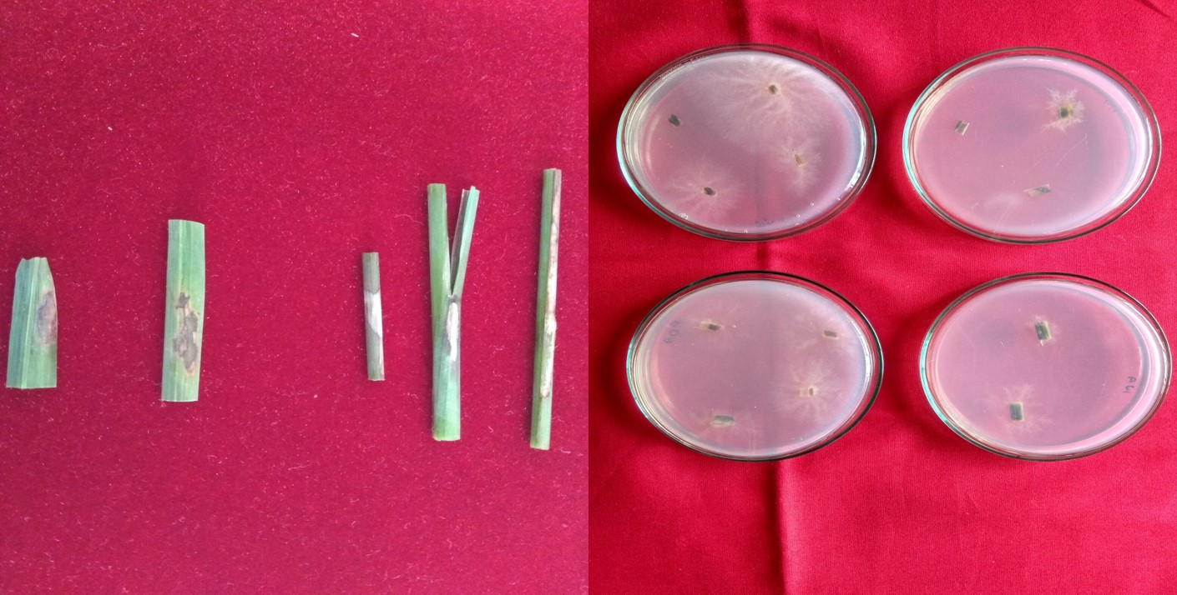
Fig.1a. Rice sheath blight disease samples | 1b. Isolation of pathogen pureculture
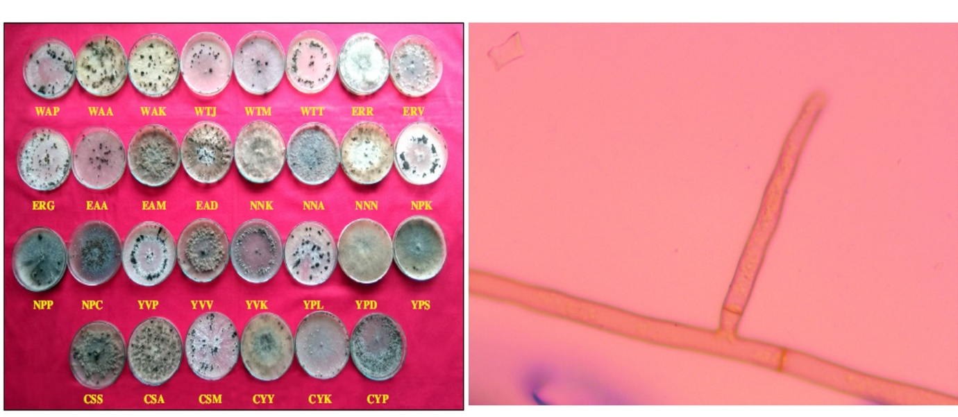
Fig. 2a. Pure cultures of 30 pathogen isolates | 2b. Typical branching of R.solani at right angles to the main hyphal axis

3.2. Pathogenicity of R. solani in pot culture
Koch’s postulates were proved for all the isolates in pot culture studies during kharif -2019 by using typha bit inoculation method (Bhaktavatsalam et al.,1978).
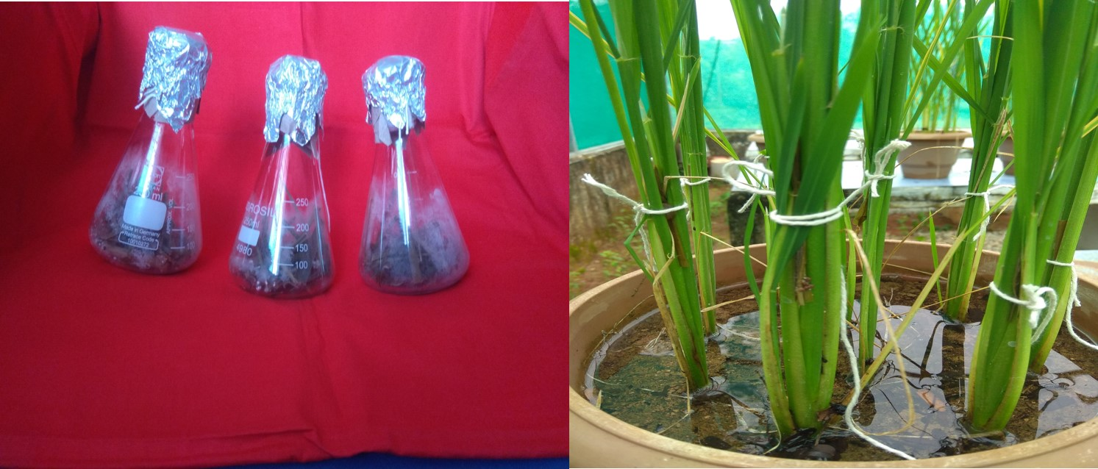
Fig. 3a. Multiplication of pathogen on typha bits | 3b. Inoculation of typha bits in between the tillers

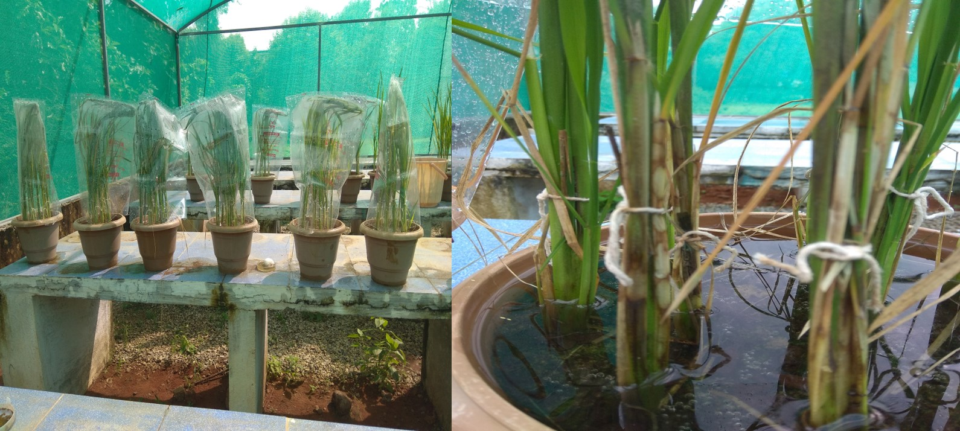
Fig. 4a. Incubation of plants | 4b. Appearance of typical sheath blight symptoms

3.3. Hyphal anastomosis
In the hyphal anastomosis test, results indicated that all the isolates belong to single anastomosis group AG 1-1A. Further, anastomosis reactions were grouped into three categories (Ganeshamoorthi, P and Sunil C. Dubey., 2013 ) where YSR Kadapa isolates showed C1: hyphae contact only (same/different AG); Nellore and Chittoor isolates showed C2: killing reaction which represents a vegetative incompatibility response between genetically different individuals (same AG) and West and East Godavari isolates have shown C3: perfect fusion (same AG) of vegetative hyphal cells between two isolates that suggestive of genetically similar.

Table 1. List of Pathogen isolates from the samples collected during survey in major rice growing areas of Andhra Pradesh and their anastomosis reaction.
S.No | District | Mandal | Village | Pathogen Isolate | Anastamosis Reaction
1 | West Godavari | Achanta | Penumanchili | WAP | C3
1 | West Godavari | Achanta | Achanta | WAA | C3
1 | West Godavari | Achanta | Koderu | WAK | C3
 |  | Tadepalligudem | Jagannadapuram | WTJ | C3
 |  | Tadepalligudem | Madhavaram | WTM | C3
 |  | Tadepalligudem | Tadepalligudem | WTT | C3
2 | East Godavari | Ravulapalem | Ravulapalem | ERR | C3
2 | East Godavari | Ravulapalem | Vubalanka | ERV | C3
2 | East Godavari | Ravulapalem | Gopalapuram | ERG | C3
 |  | Alamuru | Alamuru | EAA | C3
 |  | Alamuru | Modukuru | EAM | C3
 |  | Alamuru | Madiki | EAD | C3
3 | Nellore | Nellore | Kakupalli | NNK | C2
3 | Nellore | Nellore | Ambapuram | NNA | C2
3 | Nellore | Nellore | Amancherla | NNN | C2
 |  | Pellakur | Kothuru | NPK | C2
 |  | Pellakur | Pellakur | NPP | C2
 |  | Pellakur | Chembedu | NPC | C2
4. | YSR Kadapa | Valluru | Padikalva | YVP | C1
4. | YSR Kadapa | Valluru | Valluru | YVV | C1
4. | YSR Kadapa | Valluru | Koppolu | YVK | C1
 |  | Porumammila | Lachampalle | YPL | C1
 |  | Porumammila | Dammanapalle | YPD | C1
 |  | Porumammila | Siddavaram | YPS | C1
5. | Chittoor | Srikalahasthi | Srikalahasti | CSS | C2
5. | Chittoor | Srikalahasthi | Akkurthi | CSA | C2
5. | Chittoor | Srikalahasthi | Ammapalem | CSM | C2
 |  | Yerpedu | Yerpedu | CYY | C2
 |  | Yerpedu | Kandadu | CYK | C2
 |  | Yerpedu | Pangur | CYP | C2

Where C1= hyphae contact only (same/different AG); C2: killing reaction which represents a vegetative incompatibility response between genetically different individuals (same AG)
; C3: perfect fusion (same AG)

The isolates belonging to different geographical region groups were subjected to hyphal anastomosis in all possible combinations self as well as cross combinations. The results indicated that they belong to same anastomosis group but reaction category is different and were formed according to the difference in their geographical location. The details were given in the Table 2.

Table 2. List of Pathogen isolates from different geographical regions and their cross anastomosis reaction
S.No | Pathogen Isolate | Anastamosis Reaction
1 | WAP×WAA | C3
1 | WAP×ERR | C3
1 | WAP×NNK | C2
1 | WAP×YVP | C1
1 | WAP×CSS | C2
2 | ERR×ERV | C3
2 | ERR×NNK | C2
2 | ERR×YVP | C1
2 | ERR×CSS | C2
3 | NNK×NNA | C3
3 | NNK× YVP | C1
3 | NNK× CSS | C2
4. | YVP×YVV | C3
4. | YVP×CSS | C1
5. | CSS×CSA | C3

Where C1= hyphae contact only (same/different AG); C2: killing reaction which represents a vegetative incompatibility response between genetically different individuals (same AG)
; C3: perfect fusion (same AG)

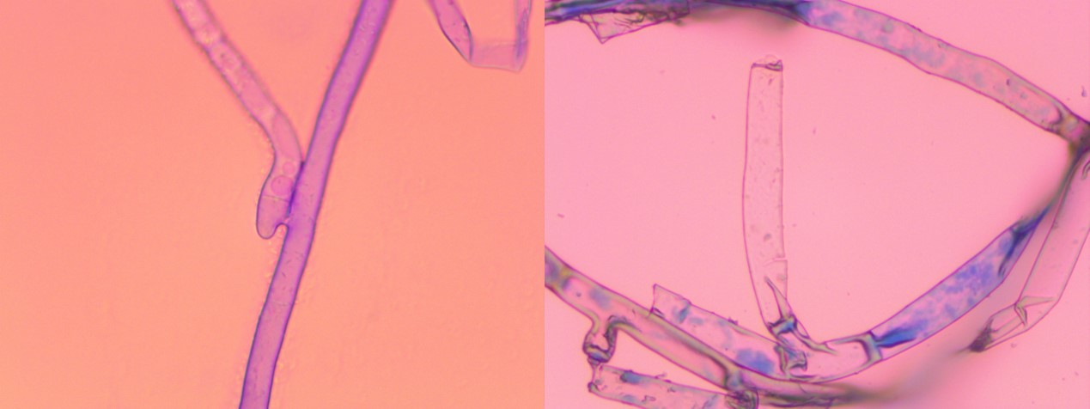
Fig. 5a. C1 reaction : Hyphal contact only(same/different AG) | 5b. C1 reaction : Hyphal contact only(same/different AG)

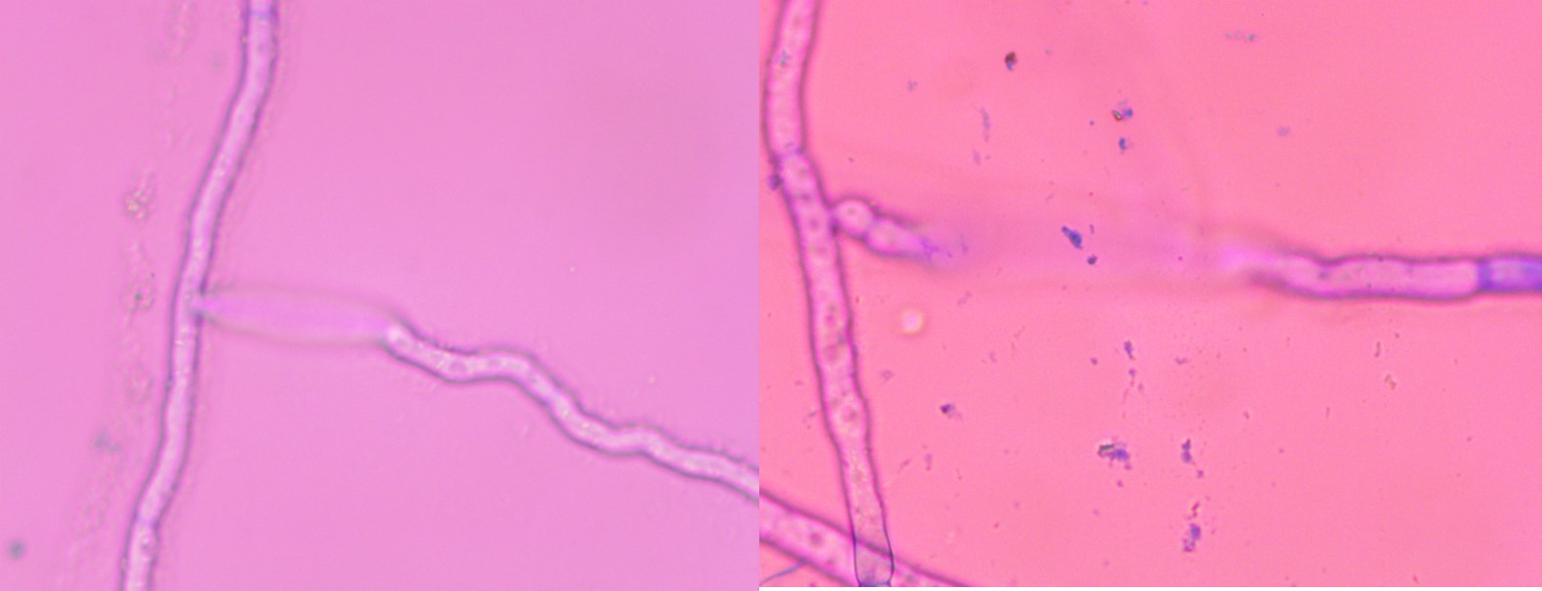
Fig. 6a. C2 reaction : C2: killing reaction(same AG) | 6b. C2 reaction : C2: killing reaction(same AG)

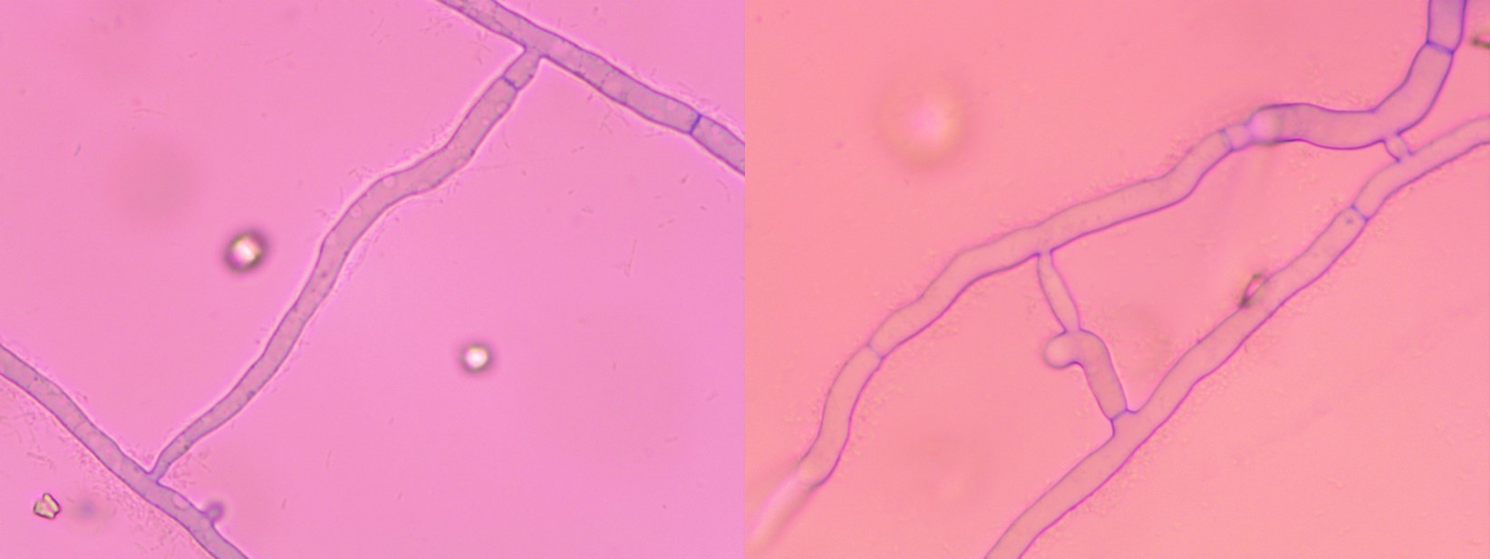
Fig. 7a. C3 reaction : perfect fusion (same AG) | 7b. C3 reaction : perfect fusion (same AG)

Inoculation of rice, corn and wheat plants with the 30 pathogen isolates under poly house conditions produced typical sheath blight symptoms on rice, banded leaf and sheath disease symptoms on corn, and there was no disease reaction observed on wheat plants suggesting the presence of anastomosis group AG-1-1A. The reaction details were presented in the Table 3.

Table 3: The disease reaction of the 30 pathogen isolates on test crops
S.No | Pathogen Isolate | Disease Reaction on
S.No |  | Rice | Corn | Wheat
1 | WAP | Sheath Blight | Banded sheath blight | -
2 | WAA | Sheath Blight | Banded sheath blight | -
3 | WAK | Sheath Blight | Banded sheath blight | -
4 | WTJ | Sheath Blight | Banded sheath blight | -
5 | WTM | Sheath Blight | Banded sheath blight | -
6 | WTT | Sheath Blight | Banded sheath blight | -
7 | ERR | Sheath Blight | Banded sheath blight | -
8 | ERV | Sheath Blight | Banded sheath blight | -
9 | ERG | Sheath Blight | Banded sheath blight | -
10 | EAA | Sheath Blight | Banded sheath blight | -
11 | EAM | Sheath Blight | Banded sheath blight | -
12 | EAD | Sheath Blight | Banded sheath blight | -
13 | NNK | Sheath Blight | Banded sheath blight | -
14 | NNA | Sheath Blight | Banded sheath blight | -
15 | NNN | Sheath Blight | Banded sheath blight | -
16 | NPK | Sheath Blight | Banded sheath blight | -
17 | NPP | Sheath Blight | Banded sheath blight | -
18 | NPC | Sheath Blight | Banded sheath blight | -
19 | YVP | Sheath Blight | Banded sheath blight | -
20 | YVV | Sheath Blight | Banded sheath blight | -
21 | YVK | Sheath Blight | Banded sheath blight | -
22 | YPL | Sheath Blight | Banded sheath blight | -
23 | YPD | Sheath Blight | Banded sheath blight | -
24 | YPS | Sheath Blight | Banded sheath blight | -
25 | CSS | Sheath Blight | Banded sheath blight | -
26 | CSA | Sheath Blight | Banded sheath blight | -
27 | CSM | Sheath Blight | Banded sheath blight | -
28 | CYY | Sheath Blight | Banded sheath blight | -
29 | CYK | Sheath Blight | Banded sheath blight | -
30 | CYP | Sheath Blight | Banded sheath blight | -
(-) = No disease reaction

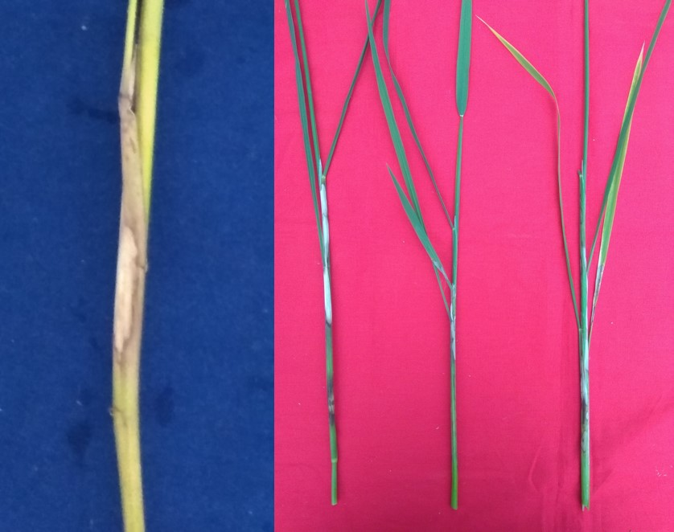
Fig. 8a. Banded leaf and sheath blight on corn | 8b. Sheath blight on rice plants

The isolates belonging to different geographical regions were subjected to hyphal anastomosis with tester isolate as well as with in all possible combinations representing their geographical region. All the isolates exhibited the categories indicating the presence of a single anastomosis group but their categories were different according to the difference in their geographical location and also similar grouping was observed when the isolates were subjected to the genetic variability analysis by using RAPD Markers suggesting that there is variability in their genes according to their geographical location where they were adapted.
Inoculation of rice and maize plants with all the 30 isolates under poly house conditions produced typical sheath blight symptoms on rice and banded sheath blight disease on corn, suggesting the presence of anastomosis group AG-1-1A. The presence of anastomosis group AG-1-1B was ruled out because only typical sheath blight symptoms with macrosclerotia were observed on inoculated rice plant while the absence of disease on inoculated wheat plants negated the presence of anastomosis group AG-1-1C in isolates (Ogoshi, 1987).
Singh et al., (1999) while studying the relationship among morphological characteristics, anastomosis behaviour of R. solani on rice found that all the isolates of R. solani belonged to AG-1-1A. Anastomosis group, AG-1-1A was characterized on the reaction of the sheath blight isolates to maize, soybean, wheat and rice in accordance with Ogoshi (1987). Research workers across the country also identified AG-1-1A of R. solani as causal organism of rice sheath blight in India.
4.Conclusions
Hyphal anastomosis test results indicated that all the 30 isolates belong to single anastomosis group AG1-1A. Further, anastomosis reactions were grouped into three categories where YSR Kadapa isolates showed C1: hyphae contact only (same/different AG); Nellore and Chittoor isolates showed C2: killing reaction which represents a vegetative incompatibility response between genetically different individuals (same AG) and West and East Godavari isolates have shown C3: perfect fusion (same AG) of vegetative hyphal cells between two isolates that suggestive of genetically similar. The pattern of AG categories in different districts of Andhra Pradesh was in correlation with geographical region where the pathogen isolate has been collected.

Conflict of Interest
I read the statement of policy pertaining to the conflict of interest.

To the best of my knowledge and belief, except as disclosed here with, neither I nor any person with whom I had a personel or business relationship has an indirect or direct interest in any organization or individual which proposes to enter into a transaction with the affiliate.

If I find any direct or indirect interest in any individual or organization which proposes to enter into a transaction with the Affliate, I will make full disclosure of such interest before any negotiation of such transaction and shall not be present for any discussion of or vote in connection with the matter.

References
Bhaktavatsalam, G., Satyanarayana, K., Reddy, A.P.K and John, V.T. (1978). Evaluation for sheath blight resistance in rice. International Rice Research Newsletter.3:9–10.
Carling, D.E. and Summer., D.R. (1992). Rhizoctonia. In: Methods of Research on Soil borne Phytopathogenic Fungi (Eds. L.L. Singleton, J.D. Mihail and C.M. Rush). American Phyto pathological Society, pp 157-165.
Carling, D.E., Rothrock, C.S., Macnish, G.S., Sweetingham, M.W., Brainard, K.A. and Winters, S.W.(1994). Characterization of anastomosis group 11 of Rhizoctonia solani. Phytopathology 84: 1387-1392
Eizenga, G.C., Lee, F.N. and Rutger., J.N. (2002). Screening Oryza species plants for rice sheath blight resistance. Plant Disease 66: 808-812.
Ganeshamoorthi, P and Sunil C. Dubey. (2013).Anastomosis grouping and genetic diversity analysis of Rhizoctonia solani isolates causing wet root rot in chickpea. African Journal of Biotechnology :12(43), 6159-6169. DOI: 10.5897/AJB2013.12439
Lee, F.N and Rush, M.C. (1983). Rice Sheath Blight: A major Rice Disease. Plant Disease. 67(7): 829-832.
Ogoshi, A. (1987). Ecology and pathogenicity of anastomosis and intraspecific groups of Rhizoctonia solani Kuhn. Annual Review of Phytopathology 25: 125-143
Rajan, C.P.D. (1987). Estimation of yield losses due to sheath blight disease of rice. Indian Phytopathology 40: 174177.
Rangaswamy, G and Mahadevan, A. (1999). Diseases of crop plants in India. (4th edition) Prentice Hall of India Pvt. Ltd. New Delhi, pp. 607.
Singh, A., Singh, U.S., Willorquet, L., Savary, S. and Singh, A. (1999.) Relationship among cultural/ morphological characteristics, anastomosis behaviour and pathogenecitiy of Rhizoctonia solani Kühn on rice. Journal of Mycology and Plant Pathology 29(3): 306-316.

