***Review Article***

**Mass Multiplication of *Bambusa vulgaris*: Innovations, Techniques, and Future Prospects**

**Abstract**

*Bambusa vulgaris*, a multipurpose bamboo species within the Poaceae family, is significant towards sustainable industrial applications as a result of its proliferate growth, resilience, as well as various uses which includes construction, bioenergy, and paper production. This comprehensive literature review explores propagation methods for mass production of B. *vulgaris* to reach accelerating global demands. Primarily crucial in areas such as Southeast Asia and India, B. *vulgaris* flourish over diverse climates and soils, making it feasible for large-scale farming. Conventional vegetative propagation techniques, includes rhizome division, have progressed into modern biotechnological approaches, by tissue culture as well as somatic embryogenesis arising as proficient strategies for rapid, disease-free multiplication of superior genotypes. These techniques secure genetic accuracy and premium-quality planting material, which is crucial for commercial expandability. Morphological studies foreground the remarkable genetic and phenotypic flexibility, that ensuring the selection of superior genotypes enhanced for distinct applications. Inventions like mechanochemical preliminary treatment strengthens biomass extracting for biofuels, aligning by sustainable goals. Irrespective of its easy care and rapid multiplication cycles, challenges in micropropagation as well as large-scale adaptation persist. The opportunities that lie in genetic research as well as breeding programs to enhance growth rates, disease resistance, and biomass quality. By cultivating B. *vulgaris* helps in sequestration of carbon and ecological rehabilitation, as well as fortifying its environmental and economic value. This review intensifies micropropagation as the most superior technique for mass multiplication, favouring for continued development to uphold sustainable production and to reach industrial as well as ecological demands.

1. **Introduction and History**

*Bambusa vulgaris*, commonly known as common bamboo, golden bamboo, and striped bamboo, is an economically remarkable species under the Poaceae family, distinguished by its rapid growth rates, structural adaptability, as well as varied applications fluctuating from construction materials to bioenergy sources. Indigenous to areas of Southeast Asia, especially China and Indonesia, B. vulgaris has been cultivated over two millennia, including historical archives spotlighting its role in prehistoric Chinese culture for manufacturing tools, housing, and paper (Júnior *et al*., 2019; Balduino *et al*., 2016). The utilization of bamboo is unlimited in Asia, it has been extremely embedded in the socio-economic fabric of India, where texts arising from the Vedic period record its importance in rural construction and crafts (Gillis *et al*., 2007). The resilience of *B. vulgaris* to diverse climatic conditions as well as soil types has made it a prominent candidate for mass production intended at achieving accelerating industrial demands. Its applications extend across varying sectors, involving construction, where it acts as a sustainable substitute to traditional timber (Ameh and Shittu, 2021), bioenergy production where it promotes biomass energy solutions (Balduino *et al*., 2016) and pulp as well as paper manufacturing, yielding its favorable chemical composition (Correia *et al*., 2015). The propagation of B. vulgaris has been altered from conventional methods, depending on vegetative propagation methods like rhizome division to modern biotechnological approaches focused on expanding efficiency and yield. For instance, tissue culture techniques have revealed favorable applications for the rapid reproduction of elite genotypes, securing genetic accuracy, and creating a persistent supply of superior-quality planting material (Ramanayake *et al*., 2006; Sette *et al*., 2016). The aim towards sustainable resource maintenance and environmental profits, such as sequestration of carbon by means of afforestation initiatives, furthermore emphasizes the requisite for effective propagation strategies (Gama *et al*., 2024; Ekwe *et al*., 2022).

Morphological studies of *B. vulgaris* designate the existence of significant genetic and phenotypic flexibility, assisting its resilience in various ecological settings. Mutability in culm structure, leaf morphology, and growth patterns is conceivably critical for selecting superior genotypes for distinct uses, either in construction or bioenergy contexts (Ramanayake *et al*., 2006; Costa *et al*., 2022). The enhanced understanding of these traits has remarkable economic indications, peculiarly in optimizing growth conditions and accelerating biomass yield. Arising from an economic standpoint, the stipulation of *B. vulgaris* describes its ideal for variable applications. For example, its fibers have excellent mechanical effects that are employed in producing panels and other building materials, supplying a sustainable alternative to wood (Ameh & Shittu, 2021). The energy potential from bamboo, involving its contribution to the production of biofuels, is also remarkable; research indicates that bamboo species can able to generate significant energy outputs, holding up both domestic as well as industrial energy demands (Balduino *et al*., 2016; Boadu *et al*., 2022). Furthermore, the economic feasibility of cultivating *B. vulgaris* is accelerated by its low management practices and rapid growth cycles, making it extremely appealing for both smallholder farmers and large-scale agribusinesses as well (Branco *et al*., 2020). Similarly, mass production of B. *vulgaris* strengthens as a result of global resource demands, and innovative propagation techniques lead to a focus on mass multiplication. Within these, somatic embryogenesis and in vitro culture approaches have resulted in successful methods for regenerating superior varieties with desirable virtues (Gillis *et al*., 2007; Ramanayake *et al*., 2006). In vitro propagation permits the rapid multiplication of selected genotypes while assuring disease-free seedlings, crucial for large-scale commercial production. Moreover, the optimization of environmental conditions throughout tissue culture has resulted in enhanced rooting as well as shoot proliferation rates, by means accelerating the propagation process (Ramanayake *et al*., 2006; Cardoso-Furlan *et al*., 2018). The modern integration of mechanochemical pre-treatment processes has also been investigated as a waste-free solution for transforming bamboo into feasible sugars or biofuels (Ekwe *et al*., 2022). This technique coincides with the sustainability goals cooperated with bamboo cultivation, where it contributes to productive resource utilization as well as decreases waste generation throughout biomass processing (Ekwe *et al*., 2022). Forecasting, the mass production of *B. vulgaris* suggests both challenges and opportunities. However, micropropagation is the best technique for mass multiplication of bamboo. As attention to sustainability grows, the demand for bamboo as an eco-friendly resource will probably increase. By, cultivating B. *vulgaris* could generate remarkable benefits for carbon sequestration, biomass production, and ecological restoration endeavor in degraded landscapes (Gama *et al*., 2024). Moreover, advancements in genetic research and breeding approaches permit potential for improving traits including growth rate, disease resistance, and biomass quality, thereby strengthening the economic potentiality of bamboo production (Generoso *et al*., 2016).

1. **World Scenario of Production and Cultivation**

### **Global Distribution of Bamboo**

Bamboo, belonging to the subfamily Bambusoideae within the grass family Poaceae, contributes over 1,600 species around 123 genera, that are flourishing in variable climates from tropical to temperate zones (Clark *et al*., 2015). Its global dispersion spans three primary regions: the Asia-Pacific, the Americas, and Africa, with no local species in continental Europe or Antarctica (Lobovikov *et al*., 2007).

#### **Asia-Pacific Region**

The Asia-Pacific area is the international hub for bamboo diversity, contributing approximately 80% of the world’s bamboo species as well as forest area (Lobovikov *et al*., 2007). Bamboo originates from 42°S in southern New Zealand to 51°N in Sakhalin, thereafter extending eastward to the Pacific Islands and westward to the Indian Ocean (Bystriakova *et al*., 2003). Major producers such as China, India, Japan, Myanmar, Thailand, Cambodia, Vietnam, Indonesia, Malaysia, the Philippines, South Korea, and Sri Lanka. Moreover, China steers with 3 million hectares of Phyllostachys edulis (Moso bamboo) forests, attributing for 73.8% of its bamboo area (FAO, 2010). India has notable indigenous populations in the Northeast, Western Ghats, and Eastern Ghats (Sharma & Nirmala, 2015). Whereas, Japan and Korea cultivate species like Phyllostachys nigra and Phyllostachys edulis for producing timber, shoots, and ornamental use (Suzuki, 2015).

#### **Americas**

In America, bamboo’s native range derives from 47°S in southern Argentina to 40°N in the eastern United States, with a gap in the Atacama Desert (Judziewicz *et al*., 1999). It flourishes well in South American tropical rainforests, the Andes up to 4,300 meters in Ecuador, and Central America through Mexico. South America is abundant in genera like Chusquea (179 species) and Guadua, significantly in Brazil, Colombia, and Venezuela (Clark *et al*., 2015). In the United States, three Arundinaria species (A. *gigantea*, A. *tecta*, A. *appalachiana*) outline canebrakes in the Southeast, but now extremely endangered because of habitat loss (Platt *et al*., 2001). Introduced species namely *Phyllostachys aurea* and *Phyllostachys edulis* are cultivated, by commercial attempts in states like South Carolina and Georgia (Young & Haun, 2010).

#### **Africa**

Bamboo in Africa is restricted to tropical and subtropical zones, from southern Senegal to southern Mozambique and Madagascar, with 13 genera and 40 species (Bystriakova *et al*., 2003). East Africa (Ethiopia, Kenya, Uganda, Rwanda) and Madagascar are major centers. Rwanda has introduced commercial cultivation of Phyllostachys species for sustainable forestry (King *et al*., 2019). African bamboo typically arises in mixed forests instead of dominant stands, unlike in Asia (FAO, 2010).

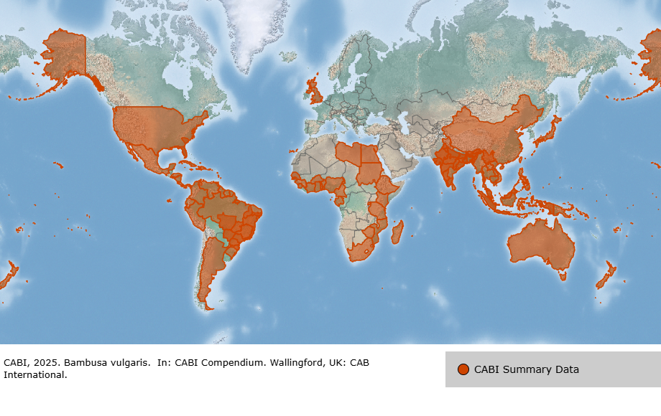

Fig 1: Map showing major *B. vulgaris* cultivation regions, with Asia as the primary hub (Source: Adapted from Zheng, 2024)

#### **Cultivation and Introductions**

Bamboo’s economic and sustainable value facilitates its cultivation besides its native ranges. Species like *Phyllostachys aurea* and *Phyllostachys edulis* have been addressed in Europe, in the past 19th century for ornamental as well as commercial purposes, significantly in France, Germany, and in UK (Crouzet & Crouzet, 2011). In the U.S., companies are examining bamboo as a sustainable crop in the Great Lakes and Southeast region, that is concentrating mainly on *Phyllostachys nigra* and *Phyllostachys edulis* (Young & Haun, 2010). Although intrusiveness concerns occur, as *Phyllostachys* species’ rhizomes are able to form monocultures, minimizing biodiversity (Canavan *et al*., 2017).

### **Bamboo Distribution in India**

India ranks second globally in bamboo resources, with nearly 125 species around 23 genera, surrounding about 13.96 million hectares of forest area (Sharma & Nirmala, 2015). The potential energy of bamboo supports construction, livelihood, handicrafts, and food, along with the National Bamboo Mission promoting sustainable use (Ministry of Agriculture, 2018).

#### **Regional Distribution**

* Northeast India: The Northeast, comprising Arunachal Pradesh, Meghalaya, Assam, and Manipur, holds over 50% of India’s bamboo species (Tewari *et al*., 2019). Genera like *Bambusa*, *Dendrocalamus*, and *Schizostachyum* are dominant, with species like *Bambusa tulda* and *Dendrocalamus hamiltonii,* which are useful for construction and paper production (Sharma & Nirmala, 2015).
* Eastern Ghats: Odisha and Andhra Pradesh both promote bamboo in mixed deciduous forests, with *Bambusa bambos* and *Dendrocalamus strictus* being widespread (Reddy *et al*., 2016).
* Western Ghats: Karnataka, Kerala, and Tamil Nadu hold up bamboo in evergreen and semi-evergreen forests, together with *Bambusa arundinacea* and *Oxytenanthera stocksii* (Kumar *et al*., 2010).
* Central and Northern India: Madhya Pradesh, Chhattisgarh, and parts of Uttar Pradesh contribute *Dendrocalamus strictus*, most predominant for construction (Tewari *et al*., 2019)

#### **Cultivation and Economic Importance**

Commercial plantations as well as agroforestry strengthen India’s bamboo sector. Where the Northeast results in high shoot production, while central India concentrates on timber (Ministry of Agriculture, 2018). Introduced species like *Phyllostachys edulis* are widely cultivated across cooler regions like Himachal Pradesh and Uttarakhand (Tewari *et al*., 2019). Additionally, India exported over $60 million of bamboo products in 2018, along with kitchenware and shoots (FAO, 2010).

**Cultivation in India**

In India, bamboo occupies over 13.96 million hectares, with *B. vulgaris* conquering the Northeast (Assam, Arunachal Pradesh) and Southern states (Kerala, Karnataka) (Sharma *et al*., 2022). National Bamboo Mission (NBM) records an annual production of 3.23 million tonnes, with *B. vulgaris* contributing 40% because of its flexibility to varied agroclimatic zones, from humid tropics to semi-arid zones. However, Assam alone contributes 25% of India’s bamboo production, with *B. vulgaris* plantations that surround 1.2 million hectares. The NBM’s 2023 data reveals a 20% rise in bamboo cultivation since 2018, guided by government subsidies as well as industrial demand (National Bamboo Mission, 2023).

**3. Propagation Strategies for *B. vulgaris***

Propagation of *B. vulgaris* is complicated because of its irregular flowering cycle (30–60 years) and low seed viability (Khalid Khan *et al*., 2015). Strategies include:

**Vegetative Propagation**

* Culm Cuttings: Single or two-node culm divisions of 30–50 cm are planted in moist soil, carrying out 70–80% rooting within 30–45 days. This propagation method is cost-effective but confined by seasonal accessibility (Sharma *et al*., 2022).
* Rhizome Division: Mature rhizomes are divided and planted, 60–70% survival rate is seen. It is a laborious method and is unfit for large-scale production (Emamverdian *et al*., 2020).
* Branch Cuttings: Lateral branches having nodes are rooted in nursery beds, yielding a success rate of 50–60%, but high maintenance is required (Zheng, 2024).

**Tissue Culture**

Micropropagation through nodal explants and somatic embryogenesis is favorable for mass production due to its flexibility and capability to produce disease-free plantlets. In India, the NBM inspires tissue culture to reach the plantation targets, with above 10 million plantlets yielded annually (National Bamboo Mission, 2023).

**Seed Propagation**

Propagation by seed is rare as a result of its low seed accessibility and low germination rates (10–20%). It is mostly used in research settings to reach out to genetic diversity (Khalid Khan *et al*., 2015).

**4. Morphological Characteristics and Variability**

**General Morphology**

B. *vulgaris* shows culms of 10–20 m tall, and 4–10 cm in diameter, with internodal lengths of 20–45 cm and wall thickness of 7–15 mm. Its bright green culms change to yellow with age, and clumps produce 20–50 culms. Leaves are lanceolate (sword-shaped) with 15–25 cm long, whereas rhizomes are caespitose, and give support for dense clumping (Zheng, 2024).

Global Variability

Morphological variability is influenced by environmental factors:

* Malaysia: Culms are shorter 8–15 m, and thinner, about 3–7 cm, because of acidic soils and high rainfall (Emamverdian *et al*., 2020).
* Brazil: Thicker culms up to 12 cm are observed due to fertile Amazonian soils (black soils), with clump sizes achieving 60 culms (Zheng, 2024).
* Africa: Ethiopian plantations exhibit shorter internodes up to 15–30 cm, due to semi-arid conditions (Sharma *et al*., 2022).

**Variability in India**

In India, *B. vulgaris* morphology varies by region:

* Punjab: Higher clump height with 15–18 m tall and internodal length varies from 30–40 cm due to fertile alluvial soils (ResearchGate, 2018).
* Kerala: Shorter culms of 12–15 m height and smaller clump sizes comprise 15–30 culms due to high humidity as well as lateritic soils (Sharma *et al*., 2022).
* Northeast: Larger culm diameter (8–10 cm) and denser clumps comprise 40–50 culms due to heavy rainfall and loamy soils (National Bamboo Mission, 2023).

Morphological differences are assigned to soil type, rainfall, and altitude, with genetic studies denoting moderate variability within populations (Khalid Khan *et al*., 2015).

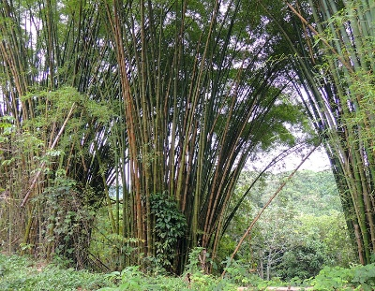 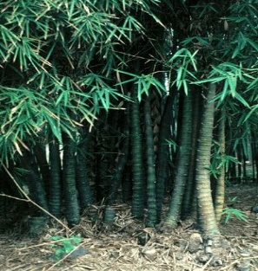 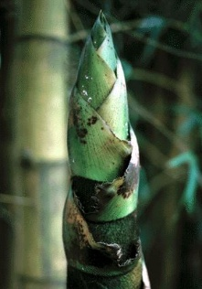

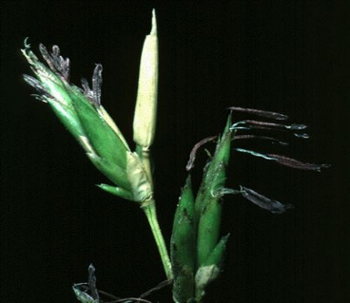 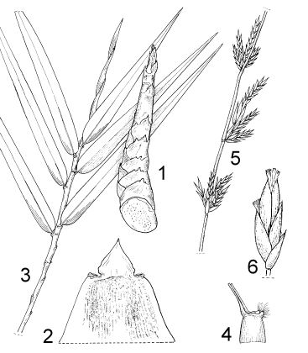 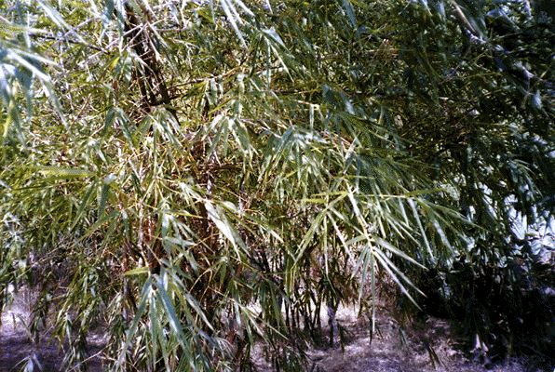

Fig2: Different plant parts of *B.vulgaris*

(Source: https://www.cabidigitallibrary.org/doi/full/10.1079/cabicompendium.8398)

**5. Conventional Propagation Methods of Bamboo**

Bamboo, a multipurpose and strong-growing plant belonging to the subfamily Bambusoideae, is commonly propagated through various conventional methods to meet ecological, economic, and cultural demands. These methods depend on vegetative and, not as much seed-based techniques, due to bamboo’s flowering cycles are often volatile and occasional (Clark *et al*., 2015). The following primary propagation methods culm cuttings, branch cuttings, rhizome division, offset planting, and seed propagation, are explained in detail (Banik, 1995; Sharma & Nirmala, 2015).

**Culm Cuttings:** Culm cuttings include taking segments of matured bamboo culms (stems) for propagation. A culm segment with 1–2 nodes long, and taken from a 1- to 3-year-old culm, ensuring it includes strong nodes with buds. The cuttings are planted horizontally or vertically in a well-drained medium, with facing upward buds. Hormonal treatments with indole-3-butyric acid (IBA), should be applied to better rooting (Ray & Ali, 2017). Usually, the cuttings will develop roots and shoots from the nodal buds in about 4–8 weeks, depending on species and weather conditions.

This method is simple, profitable, and extensively used for species like Bambusa vulgaris and Dendrocalamus strictus. It needs minimal requirements and is most suitable for small-scale propagation (Banik, 1995). Success rates differ by species, with some, like Phyllostachys species, showing low rooting success. The method is labor-intensive, and sometimes cuttings are susceptible to fungal infections, uncertainty not appropriately managed (Sharma & Nirmala, 2015).

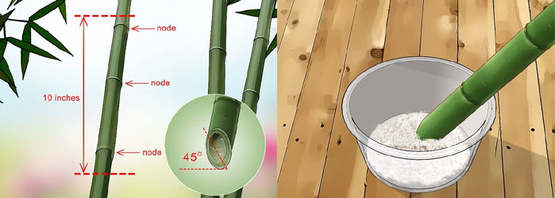

Fig 3: Culms cutting of Bamboo (https://www.bambooinfo.in/cultivation/bamboo-propagation-through-culm-cuttings.asp)

#### **2. Branch Cuttings**

Branch cuttings are the utilization of lateral branches from bamboo culms, mostly in bamboo species with thick-walled culms like Bambusa bambos. Healthy branches with 2–3 nodes are taken and treated with rooting hormones (IBA) and planted in a medium (e.g., sand or vermiculite). The cuttings are maintained under high humidity and partial shade to encourage root and shoot development, most probably within 6–10 weeks plants get ready to transplant (Ray & Ali, 2017). This method is not as much of a culm cuttings but effective for certain clumping bamboos. Branch cuttings are used for propagation when culm sections are less available. They are useful to species that produce vigorous branches and can produce a greater number of plants from a single culm (Banik, 1995). The method has proven to have lower success rates than culm cuttings and requires accurate environmental control (Sharma & Nirmala, 2015).

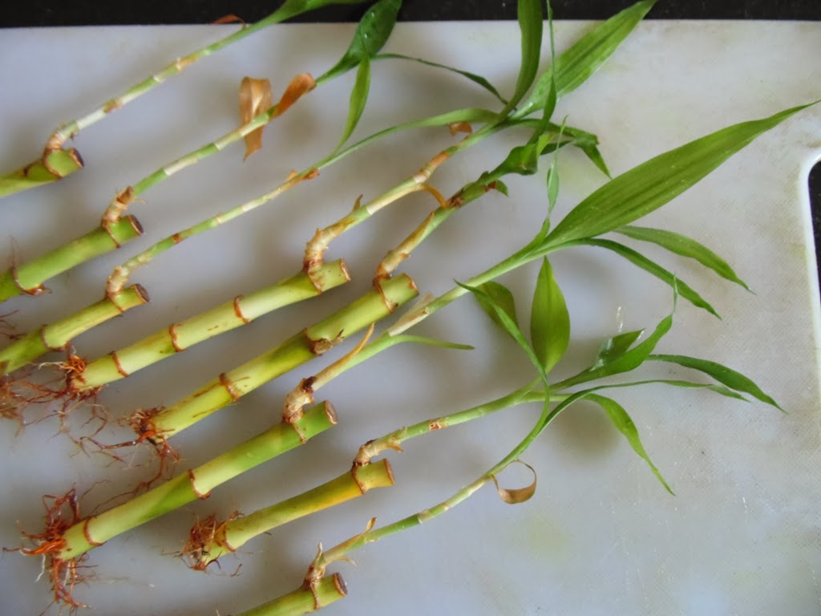

Fig 4: Branch cuttings

#### **3. Rhizome Division**

Rhizome division includes dividing the rhizome system which is underground of clumping bamboos into segments utilized for planting. The rhizome, along with roots and 1–2 culms, is dug from a mature plant with age of 3–5 years old. The dug rhizomes are replanted in a soil medium with adequate moisture and nutrients. This method is idyllic for clumping species such as Bambusa tulda and Dendrocalamus hamiltonii, because their rhizomes produce new shoots readily (Tewari *et al*., 2019). Rhizome division has a superior rate of success, as the rhizomes already have an established root system. It can produce vigorous plants rapidly, most suitable for large-scale plantations (Banik, 1995). The method is labor-intensive and damaging to the parent plant. It is unreasonable to run bamboo with diffuse rhizomes and necessitates important interplanetary resources (Sharma & Nirmala, 2015).

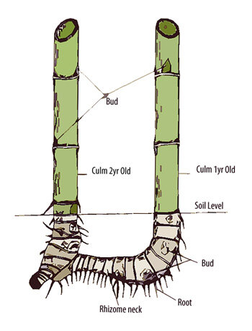

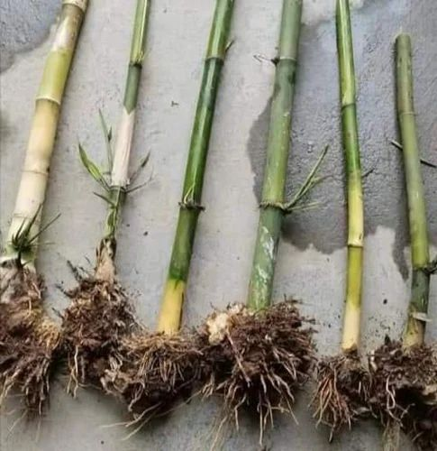

Fig 5: Rhizome division of Bamboo (Source: https://ar.inspiredpencil.com/pictures-2023/bamboo-rhizomes)

#### **4. Offset Planting**

Offset planting involves detaching a portion of the culm base, with the rhizome and roots, from an established bamboo clump. The offset, naturally a single culm with its basal rhizome, is carefully dug and replanted in a nursery or field. This method is specifically used for clumping bamboo. Offsets generally establish quickly, often within 3–6 months, under optimal conditions (Ray & Ali, 2017).

Offsets certify high survival rates due to their integral root systems(Banik, 1995). The method is highly aggressive, damaging the parent clump, and is limited by the accessibility of suitable offsets. It is also labor-intensive and inappropriate for running bamboo (Tewari *et al*., 2019).

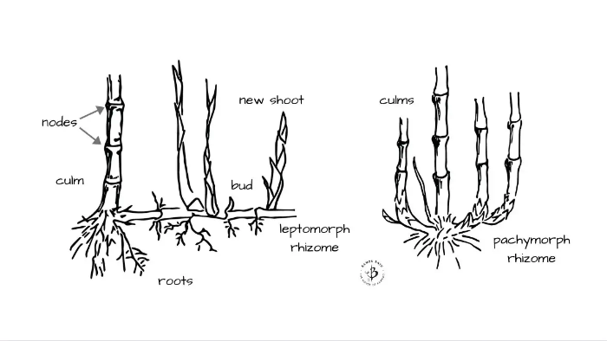

**Fig 6:** offset of Bamboo

***5.* Seed Propagation**

Seed propagation is rare due to the plant’s asymmetrical flowering cycles which is frequently happening every 20–120 years (Clark *et al*., 2015). When seeds are available and seeds are collected then soaked in water for 24 hours to break dormancy, and sown in a well-drained medium. Germination takes place within 1–3 weeks under warm and moist conditions. This method is specially used for species like Melocanna baccifera, which generally produce viable seeds during gregarious flowering (Banik, 1995).

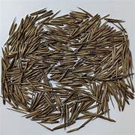

Fig 7: Seeds of Bamboo plants

#### Seed propagation permits genetic diversity and is beneficial for breeding programs. It is non-invasive to present clumps and suitable for large-scale sowing when seeds are available (Sharma & Nirmala, 2015). The infrequency of bamboo flowering restrictions seed availability. Seeds have low viability and short storage life, and saplings require intensive care to reach maturity (Ray & Ali, 2017).

Table 1: Comparative conventional methods of propagation in Bamboo

|  |  |  |  |  |  |  |  |
| --- | --- | --- | --- | --- | --- | --- | --- |
| **Propagation Method** | **Success Rate** | **Time to Establish** | **Labor Requirement** | **Environmental Control Needed** | **Scalability** | **Advantages** | **Limitations** |
| **Culm Cuttings** | 70–80% | 30–45 days | Moderate | Low | Medium | High rooting success, simple technique, suitable for small farmers | Limited to juvenile culms; requires hormone treatment |
| **Rhizome Division** | 60–70% | Variable | High | Low | Low | Traditional method; uses mature rhizomes | Labor-intensive, disrupts clumps, disease risk |
| **Branch Cuttings** | 50–60% | 40–50 days | High | High | Low | Utilizes lateral branches; moderate rooting with hormones | Requires controlled nursery; less reliable |
| **Tissue Culture (Micropropagation)** | ~90% (after acclimatization) | 8–10 weeks | High (skilled labor) | Very High | High | Mass propagation, disease-free plants, genetic uniformity | High cost, infrastructure needed |

**6. Tissue Culture Protocol for Bambusa vulgaris Mass Propagation**

Tissue culture is considered a milestone for the rapid and uniform production of Bambusa vulgaris, a bamboo species high-quality for its economic, ecological, and industrial uses. The tissue culture procedure includes explant selection and sterilization, culture initiation, shoot multiplication, rooting, and hardening, each improved to maximize production while sustaining genetic fidelity.

The tissue culture process starts with the selection of explant and sterilization, the most important step to get viable, contamination-free explant material. Nodal segments with 2–3 cm and taken from juvenile culms are chosen because of their high meristematic activity and response to in vitro conditions. These explants, preferably collected from healthy, actively growing plants, are carefully rinsed under running tap water to eliminate debris. Sterilization comprises a 5min immersion in 0.1% mercuric chloride (HgCl₂) with gentle agitation, followed by a 30 sec dip in 70% ethanol, and 3–5 rinses in sterile distilled water to remove remaining sterilants. This routine, as described by Sharma *et al*. (2022), ensures minimal contamination while preserving explant viability. Treatment of HgCl₂ requires caution due to its toxicity, and all steps must be performed under a laminar airflow to maintain aseptic conditions.

Culture initiation aims to induce axillary bud breaking and establish active growth. Sterilized nodal explants are trimmed to eliminate any damaged tissue and placed vertically on Murashige and Skoog (MS) basal medium fortified with 3 mg/L benzylaminopurine (BAP), 3% (w/v) sucrose, and 0.8% (w/v) agar, with the pH adjusted to 5.7 ± 0.1 before autoclaving. BAP, a cytokinin, promotes bud initiation without extreme callus formation, which may cause somaclonal variation. Cultures are incubated at 25 ± 2°C under a 16-hour photoperiod with 50–60 µmol/m²/s light intensity. Within 14 days, about 80% of explants show axillary bud breaking, forming shoot primordia, as reported by Emamverdian *et al*. (2020). Regular monitoring during the first week is essential to detect and remove contaminated cultures promptly.

Shoot multiplication strengthens the number of shoots for large-scale propagation. Initiated shoots are subcultured on the fresh MS medium containing 3 mg/L BAP and 2 mg/L kinetin, along with 3% sucrose and 0.8% agar, maintaining the pH and incubation conditions. The synergistic effect of BAP and kinetin improves shoot proliferation and elongation, producing approximately 5–10 shoots per explant within 4–6 weeks (Khalid Khan *et al*., 2015). Shoot clusters are divided into smaller units (2–3 shoots) to decrease competition and subcultured every 4 weeks to sustain vigor and prevent nutrient depletion. If phenolic exudation occurs, adding 0.5 g/L activated charcoal to the medium can mitigate browning, ensuring healthy shoot development.

Rooting of the explant is the next phase, where shoots develop into whole plantlets. Healthy shoots with 3–5 cm in length are transferred to a half-strength MS medium with 3 mg/L indole-3-butyric acid (IBA), 1.5% sucrose, and 0.8% agar, with pH adjusted to 5.7 ± 0.1. Half-strength MS reduces salt stress, enhancing rooting efficiency, while IBA encourages robust root initiation. Cultures are incubated under similar temperature and light conditions, with root formation typically visible within 7–10 days. Approximately 80% of shoots develop roots within 21 days, forming saplings ready for acclimatization, as noted by Zheng (2024). Shoots should not be excessively elongated, as this may interrupt rooting; trimming to 3–5 cm is suggested if necessary.

Hardening and acclimatization of evolution plantlets to ex vitro conditions, ensuring high survival rates. Rooted plantlets are gently removed from the medium, and their roots are washed away under running water to remove agar residues, avoiding microbial growth. Saplings are then transferred to a 1:1 cocopeat: soil mix, which offers optimal aeration, moisture holding, and nutrient accessibility. They are maintained in a greenhouse at 25 ± 2°C and 70% relative humidity, initially under 50% shade for 2 weeks to prevent photoinhibition. Over 4 weeks, light exposure is gradually increased, and humidity is reduced to ambient levels. Watering is done sparingly, preferably via misting, to avoid root rot. This treatment results in approximately 90% plantlet survival, as reported by Sharma *et al*. (2022). Intensive care for fungal infections throughout the first week is crucial, with mild fungicide application if needed.

This protocol suggests a robust framework for Bambusa vulgaris tissue culture, balancing effectiveness, scalability, and genetic stability. Its dependence on axillary bud-based propagation minimizes somaclonal variation, making it ideal for commercial plantations and conservation efforts. The use of optimized medium compositions, such as half-strength MS for rooting, enhances cost efficiency, while regular subculturing supports sustained production.

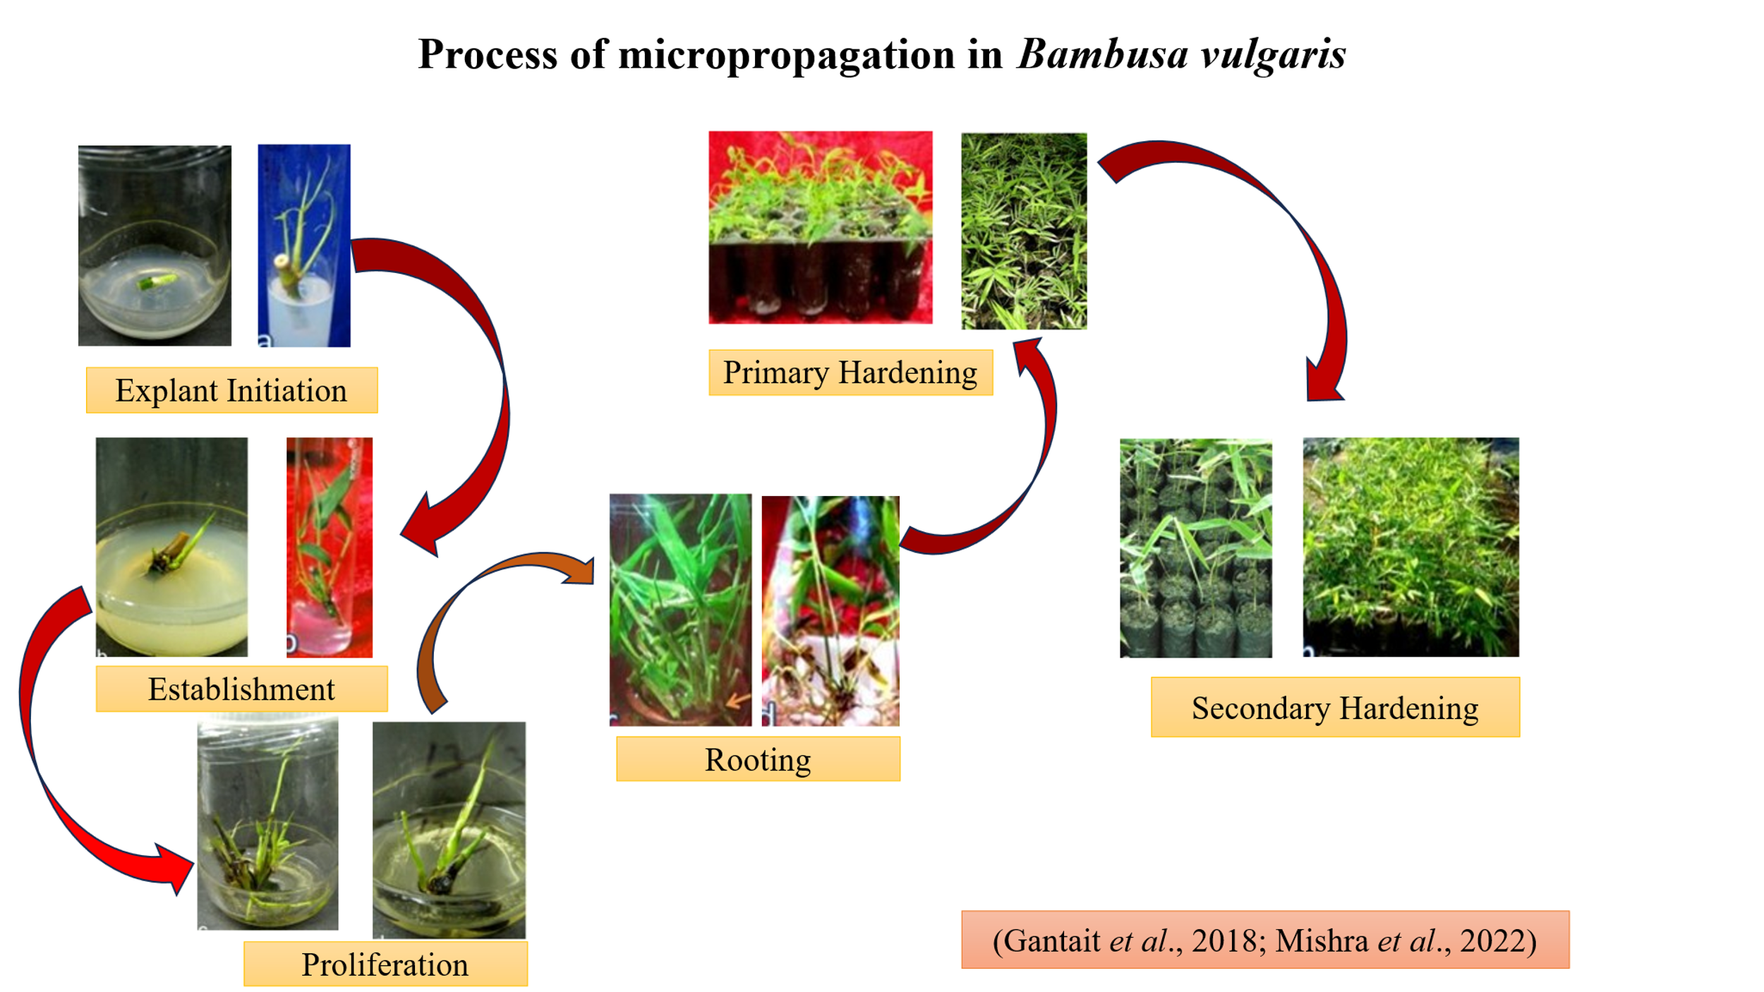  
Fig 8: Illustration of micropropagation procedure of *B. vulgaris*

# **Table2: Tissue Culture of Bambusa vulgaris: Explant Types, Media Concentrations, and Success Rates**

|  |  |  |  |  |  |
| --- | --- | --- | --- | --- | --- |
| **Explant Type** | **Stage** | **Media Composition (MS-based)** | **Hormone Concentrations** | **Success Rate** | **Reference** |
| Nodal segments (2–3 cm, juvenile culms) | Culture Initiation | MS + 3% sucrose + 0.8% agar | 3 mg/L BAP | 80% bud initiation within 14 days | Emamverdian *et al*. (2020) |
| Nodal segments (2–3 cm, juvenile culms) | Shoot Multiplication | MS + 3% sucrose + 0.8% agar | 3 mg/L BAP + 2 mg/L kinetin | 5–10 shoots/explant (4–6 weeks) | Khalid Khan *et al*. (2015) |
| Shoots (3–5 cm) | Rooting | Half-strength MS + 1.5% sucrose + 0.8% agar | 3 mg/L IBA | 80% rooting within 21 days | Zheng (2024) |
| Nodal segments (1–2 cm, mature culms) | Culture Initiation | MS + 3% sucrose + 0.7% agar | 2 mg/L BAP + 0.5 mg/L NAA | 65% bud initiation within 18 days | Sharma *et al*. (2022) |
| Shoot tips (1–2 cm) | Shoot Multiplication | MS + 3% sucrose + 0.8% agar + 0.5 g/L activated charcoal | 2.5 mg/L BAP + 1 mg/L kinetin | 4–8 shoots/explant (5 weeks) | Mudoi *et al*. (2013) |
| Leaf bases (0.5–1 cm) | Callus Induction | MS + 3% sucrose + 0.8% agar | 2 mg/L 2,4-D + 1 mg/L BAP | 70% callus formation within 20 days | Negi & Saxena (2011) |
| Nodal segments (2–3 cm, juvenile culms) | Rooting | Half-strength MS + 2% sucrose + 0.8% agar | 2 mg/L IBA + 0.5 mg/L NAA | 75% rooting within 25 days | Anand *et al*. (2013) |
| Shoot apices (0.5–1 cm) | Culture Initiation | MS + 3% sucrose + 0.8% agar | 4 mg/L BAP | 60% bud initiation within 16 days | Singh *et al*. (2012) |

**7. Utilization and Economic Importance**

# **A. Uses of Bambusa vulgaris**

Bambusa vulgaris, commonly recognized as golden bamboo or common bamboo, is one of the furthermost widely utilized bamboo species globally, valued for its adaptability, rapid growth, and convenience. Its applications span ornamental landscaping, construction, food, medicine, and industrial products, making it a foundation of both traditional and modern economies, particularly in East, Southeast, and South Asia, with cultivation extending to regions like the United States, Europe, and Africa. The species’ culms (stems), leaves, shoots, and even roots are used for diverse purposes, though certain limitations, such as vulnerability to biological threats, necessitate careful management.

### **Ornamental and Environmental Applications**

Bambusa vulgaris is a highly desirable ornamental plant, high-quality for its aesthetic appeal and adaptability to several climates. Its vibrant green culms, mainly in cultivars like B. vulgaris var. striata (with yellow-green striations) and B. vulgaris *f.* vittata (golden-yellow culms with green stripes), make it famous for landscaping. The vittata form is often cited as the most visually striking, while the ‘Kimmei’ cultivar, with its yellow culms and green stripes, is popular in Japan (Lobovikov *et al*., 2007). These varieties are usually planted as solitary specimens, border hedges, or privacy shelters due to their dense foliage and clumping growth habit (Schröder, 2018). Apart from aesthetics, B. vulgaris helps in soil erosion control on slopes and its widespread root system stabilizes soil. But, its high carbohydrate content makes culms disposed to fungal and insect attacks, requiring defensive treatments for long-term use (Sharma *et al*., 2022).

### **Construction and Structural Uses**

The culms of B. vulgaris are extensively utilized in construction, mostly in rural and semi-urban locations where cost-effective, renewable resources are preferred. Notwithstanding challenges like poor machining belongings culms are not straight, split with difficulty, and lack flexibility their thick walls provide preliminary strength, making them appropriate for temporary accommodations, fencing, and framework (Liese & Kohl, 2015). Split culms are utilized for flooring, roof tiles, wall paneling, and woven mats, whereas whole culms serve as structural apparatuses in small buildings. In naval contexts, B. vulgaris is essential to boat construction, forming masts, wheels, beams, and boating poles due to its resilience and durability (Lobovikov *et al*., 2007). However, defenselessness to powder post beetles and fungi necessitates chemical or traditional preservation techniques, such as smoking or soaking, to extend service life (Sharma *et al*., 2022).

### **Household and Artisanal Products**

Beyond construction, B. vulgaris culms are converted into numerous household and artisanal goods, showcasing its social and economic consequences. The species is used to craft furniture, such as chairs, tables, and beds, valued for their rustic appeal. Basketry, windbreakers, fishing rods, tool handles, stakes, and musical instruments like flutes are also made from their culms, leveraging their lightweight yet sturdy nature (Khalid Khan *et al*., 2015). In old-style fishing communities, B. vulgaris is fashioned into bows for fishing nets and smoking pipes, whereas its hollow structure is used for irrigation and distillation pipes. The species’ flexibility spreads to weaponry, with culms historically used for javelins and arrows in some cultures (Liese & Kohl, 2015). These highlight B. vulgaris’s role in sustaining livelihoods, particularly in bamboo-dependent countries like India and Southeast Asia.

### **Industrial Applications**

B. vulgaris is an important raw material in industrial applications, particularly in the pulp and paper industry. In India, it is a main source of pulp for paper production, yielding paper with exceptional tear strength comparable to softwood-derived paper (Sharma *et al*., 2022). Its high cellulose content makes it suitable for particle boards, flexible packaging, and even biodegradable composites, bringing into line with global demands for sustainable materials (Lobovikov *et al*., 2007). Moreover, the culms deal with activated carbon and biochar, used in water purification and soil improvement, correspondingly. However, industrial processing requires addressing the culms’ high carbohydrate content, which attracts fungi, through pre-treatment methods like steaming or chemical impregnation (Liese & Kohl, 2015).

### **Food and Nutritional Uses**

The young shoots of B. sumvulgaris are a culinary staple in many regions of Asia, cherished for their tender texture and nutritious status. Both green- and yellow-stem cultivars give edible shoots, which are cooked, pickled, or canned. Green-stem shoots contain 90 g water, 2.6-gram protein, 4.1 gram fat, 0.4 gram digestible carbohydrates, 1.1 gram insoluble fiber, 22.8 mg calcium, 37 mg phosphorus, 1.1 mg iron, and 3.1 mg ascorbic acid per 100 gram, while yellow-stem shoots have slightly higher fat (7.2 gram) and no digestible carbohydrates (Lobovikov *et al*., 2007). In Mauritius, a decoction of shoot tips along with Job’s tears (Coix lacryma-jobi) is consumed as a refreshing beverage (Schröder, 2018). The shoots’ whitish-pink or buttercup-yellow hues (post-cooking) and fair canning quality make them commercially viable, though large-scale ingestion of leaves as fodder can cause neurological disorders in horses, limiting their use in animal feed (Sharma *et al*., 2022).

### **Medicinal and Traditional Uses**

Among Asia and parts of Africa, B. vulgaris holds a significant place in traditional medicine, though clinical authentication of its effectiveness remains incomplete. In Java, water stored in B. vulgaris culms is supposed to cure various ailments, attributed to its hypothetical mineral content. In the Congo, leaf infusions are used to treat measles, while in Nigeria, macerated leaf extracts are working against sexually transmitted diseases and as an abortifacient, with rabbit studies positive the latter’s efficacy (Emamverdian *et al*., 2020). In Ayurvedic and Chinese medicine, shoot extracts are consumed for their purported anti-inflammatory and antioxidant properties, often boiled or pickled to enhance bioavailability (Zheng, 2024). Additionally, B. vulgaris roots and leaves are utilized in some cultures to treat respiratory problems and skin conditions, though overuse may cause toxicity, requiring caution (Schröder, 2018).

### **Energy and Other Uses**

The culms of B. vulgaris serve as a renewable fuel source in various regions, burned for household cooking and heating due to their high calorific value. However, their use as fuel is less efficient compared to other biomass sources, and large-scale harvesting raises sustainability concerns (Liese & Kohl, 2015). The leaves, while occasionally used as fodder, are limited by their potential to cause neurological issues in livestock, particularly horses, when consumed in excess (Sharma *et al*., 2022). Emerging applications include the use of B. vulgaris in phytoremediation, where its deep root system helps eliminate heavy metals from contaminated soils, and in carbon sequestration, contributes to climate change mitigation (Lobovikov *et al*., 2007).

### **Global Cultivation and Economic Significance**

B. vulgaris is cultivated in worldwide, with improved production in East, Southeast, and South Asia, and increasing production in the Americas, Europe, and Africa. Varieties like B. vulgaris f. waminii, with its characteristic bulbous internodes, are grown in the US and Europe, while B. vulgaris var. striata thrives in tropical regions as a hedge plant (Schröder, 2018). The global trade of B. vulgaris products is substantial, though precise statistics are scarce due to informal markets. Its economic impact is obvious in countries like India, where it supports rural livelihoods through pulp, handicrafts, and construction industries (Khalid Khan *et al*., 2015).

**Global Context**

*B. vulgaris* is a vital economic resource, contributing to multiple industries:

* **Construction**: Utilized in scaffolding, housing, and bridges, particularly in China, where it accounts for 15% of construction materials (Zheng, 2024).
* **Pulp and Paper**: Supplies 20% of global bamboo pulp, with China exporting $1.5 billion annually (Emamverdian *et al*., 2020).
* **Crafts and Furniture**: Indonesia and Vietnam produce high-value bamboo furniture, generating $800 million annually (Sharma *et al*., 2022).
* **Bioenergy**: Brazil utilizes B. vulgaris for biomass, contributing 10% to its renewable energy sector (Zheng, 2024).

**India Context**

In India, B. vulgaris supports 2.5 million livelihoods, contributing ₹26,000 crore annually to the economy (National Bamboo Mission, 2023). Uses include:

* **Rural Housing**: In Assam, 80% of rural homes use B. *vulgaris* for structural components (Sharma *et al*., 2022).
* **Handicrafts**: The Northeast produces bamboo mats, baskets, and furniture, with exports valued at ₹1,200 crore (National Bamboo Mission, 2023).
* **Biomass**: Karnataka’s biomass plants use *B. vulgaris* to generate 5% of the state’s renewable energy (Zheng, 2024).

Table 3: Economic contributions of *B. vulgaris* globally and in India (Source: Zheng, 2024; National Bamboo Mission, 2023).

|  |  |  |  |
| --- | --- | --- | --- |
| **Country/Region** | **Economic Use** | **Revenue (USD Billion/Year)** | **Employment (Million)** |
| China | Pulp, Construction, Crafts | 1.5 | 5.0 |
| India | Housing, Handicrafts, Biomass | 3.5 | 2.5 |
| Indonesia | Furniture, Crafts | 0.8 | 1.2 |
| Brazil | Bioenergy, Furniture | 0.8 | 0.5 |
| Ethiopia | Crafts, Reforestation | 0.2 | 0.3 |

**8. Genetic Variability**

**Morphological Basis**

Moderate genetic variability in *B. vulgaris* with morphological traits such as culm diameter, height, and internodal length showing regional differences. RAPD markers specify higher variability in Northeast Indian populations (e.g., Assam) compared to the Southern populations (e.g., Tamil Nadu), probably due to various ecological conditions (Khalid Khan *et al*., 2015). Worldwide, Brazilian bamboo populations show thicker culms, whereas Malaysian populations express shorter internodes (Emamverdian *et al*., 2020).

**Genetic Basis**

Molecular studies using ISSR and SSR markers reveal the low polymorphism within populations but significant differentiation among the regions. For example, Indian and Chinese populations share 60% genetic similarity, suggesting mutual ancestry but regional adaptation (Zheng, 2024). The bamboo genome, sequenced in 2023, identified genes for rapid growth (e.g., expansion) and stress tolerance (e.g., DREB), assisting breeding programs for better-quality yield and resilience (Sharma *et al*., 2022).

**9. Conclusion and Future Perspectives**

*B. vulgaris* is an important species for the production of sustainability, with strong propagation approaches like tissue culture allowing mass production to meet industrial and ecological demands. Its economic significance, particularly in India, highlights its role in rural livelihoods and renewable energy. Still, challenges like labor-intensive conventional methods and limited genetic diversity require attention. Future research should focus on developing low-cost tissue culture protocols to enhance accessibility for small-scale farmers exploring hybridization to increase genetic diversity and stress tolerance and Integrating *B. vulgaris* into agroforestry systems to improve carbon sequestration, with studies estimating a potential 20% increase in carbon storage by 2030 (Zheng, 2024).  
Recent advances (2022–2024) in biotechnology and ecology demonstrate *B. vulgaris* as a model species for sustainable development, with the potential to address global challenges like deforestation and climate change (Sharma *et al*., 2022).

**References**

Ameh, O. and Shittu, K. (2021). Laminated bamboo board: a sustainable alternative to timber board for building construction. Lautech Journal of Civil and Environmental Studies, 6(1). https://doi.org/10.36108/laujoces/1202.60.0170

Anand, M., Brar, J., & Sandhu, S. S. (2013). In vitro propagation of *Bambusa vulgaris* through nodal segments. *Journal of Plant Biochemistry and Biotechnology, 22*(4), 433–438. https://doi.org/10.1007/s13562-012-0172-8

Balduino, A., Balduino, T., Friederichs, G., Cunha, A., & Brand, M. (2016). Energetic potential of bamboo culms for industrial and domestic use in southern brazil. Ciência Rural, 46(11), 1963-1968. https://doi.org/10.1590/0103-8478cr20160233

Banik, R. L. (1995). A manual for vegetative propagation of bamboos. International Network for Bamboo and Rattan (INBAR).

Boadu, K., Ansong, M., Anokye, R., Offeh-Gyimah, K., & Amoah, E. (2022). Physico-thermal and emission properties of tissue cultured clone from bambusa balcoaa (beema bamboo) and oxytenanthera abyssinica as sustainable solid biofuels. Plos One, 17(12), e0279586. <https://doi.org/10.1371/journal.pone.0279586>

Branco, L., Lacerda, C., Marinho, A., Sousa, C., Calvet, A., & Oliveira, E. (2020). Production of bambusa vulgaris seedlings from rhizomes under brackish water irrigation. Revista Brasileira De Engenharia Agrícola E Ambiental, 24(5), 337-342. <https://doi.org/10.1590/1807-1929/agriambi.v24n5p337-342>

Bystriakova, N., Kapos, V., Stapleton, C., & Lysenko, I. (2003). Bamboo biodiversity: Information for planning conservation and management in the Asia-Pacific region. UNEP-WCMC/INBAR.

Canavan, S., Richardson, D. M., Visser, V., Le Roux, J. J., Vorontsova, M. S., & Wilson, J. R. U. (2017). The global distribution of bamboos: Assessing correlates of introduction and invasion. AoB Plants, 9(1), plw078. <https://doi.org/10.1093/aobpla/plw078>

Cardoso-Furlan, F., Gavilan, N., Zichner-Zorz, A., Oliveira, L., Konzen, E., & Brondani, G. (2018). Active chlorine and charcoal affect the in vitro culture of bambusa vulgaris. Bosque (Valdivia), 39(1), 61-70. https://doi.org/10.4067/s0717-92002018000100061

Clark, L. G., Londoño, X., & Ruiz-Sanchez, E. (2015). Bamboo taxonomy and habitat. In W. Liese & M. Köhl (Eds.), Bamboo: The plant and its uses (pp. 1–30). Springer.

Correia, V., Curvelo, A., Marabezi, K., Almeida, A., & Savastano, H. (2015). Polpa celulósica de bambu produzida pelo processo etanol/água para aplicações de reforço. Ciência Florestal, 25(1), 127-135. https://doi.org/10.5902/1980509817470

Costa, M., Silva, W., Bittencourt, R., Borges, F., Silva, P., & Valverde, S. (2022). Pre-hydrolysis kraft dissolving pulp from bambusa vulgaris and dendrocalamus asper bamboos biomass.. https://doi.org/10.21203/rs.3.rs-2070228/v1

Crouzet, P., & Crouzet, S. (2011). Bamboo in European gardens: History and cultivation. INBAR Technical Report.

Ekwe, N., Tyufekchiev, M., Salifu, A., Tompsett, G., LeClerc, H., Belden, E., … & Timko, M. (2022). Mechanochemical pretreatment for waste‐free conversion of bamboo to simple sugars: utilization of available resources for developing economies. Advanced Sustainable Systems, 6(4). https://doi.org/10.1002/adsu.202100286

Emamverdian, A., Ding, Y., & Mokhberdoran, F. (2020). In vitro propagation of Bambusa vulgaris through nodal explants. Plant Cell, Tissue and Organ Culture, 142(3), 567–574. https://doi.org/10.1007/s11240-020-01876-5

Emamverdian, A., Ding, Y., Ranaei, F., & Ahmad, Z. (2020). Application of bamboo plants in nine aspects. The Scientific World Journal, 2020, Article 7284203. <https://doi.org/10.1155/2020/7284203>

FAO. (2010). Global forest resources assessment 2010: Main report. Food and Agriculture Organization of the United Nations.

Gama, G., Pimenta, A., Feijó, F., Aires, C., Melo, R., Santos, C., … & Azevêdo, T. (2024). Antimicrobial impact of wood vinegar produced through co-pyrolysis of eucalyptus wood and aromatic herbs. Antibiotics, 13(11), 1056. https://doi.org/10.3390/antibiotics13111056

Gantait, S., Pramanik, B. R., & Banerjee, M. (2018). Optimization of planting materials for large scale plantation of Bambusa balcooa Roxb.: Influence of propagation methods. *Journal of the Saudi Society of Agricultural Sciences*, *17*(1), 79-87

Generoso, A., Santos, J., Carvalho, V., SACOMAN, N., & Rodrigues, R. (2016). Proposal for qualitative and quantitative descriptors to or characterise bamboo germplasm. Revista Ciência Agronômica, 47(1). https://doi.org/10.5935/1806-6690.20160006

Gillis, K., Gielis, J., Peeters, H., Dhooghe, E., & Oprins, J. (2007). Somatic embryogenesis from mature bambusa balcooa roxburgh as basis for mass production of elite forestry bamboos. Plant Cell Tissue and Organ Culture (Pctoc), 91(2), 115-123. https://doi.org/10.1007/s11240-007-9236-1

Judziewicz, E. J., Clark, L. G., Londoño, X., & Stern, M. J. (1999). American bamboos. Smithsonian Institution Press.

Júnior, E., Lengowski, E., Andrade, A., Venson, I., Klock, U., Júnior, F., … & Muñiz, G. (2019). Bamboo kraft pulping. Advances in Forestry Science, 6(4), 791-796. https://doi.org/10.34062/afs.v6i4.8361

Khalid Khan, K., Ahmad, Z., & Khan, M. (2015). A review on the genus Bambusa and Bambusa vulgaris in Sabah. International Research Journal of Pharmacy, 6(8), 512–518.

Khalid Khan, M., Ahmad, N., & Anis, M. (2015). Optimization of shoot multiplication in Bambusa vulgaris using cytokinins. Journal of Bamboo Research, 34(2), 89–95.

King, C., van der Lugt, P., & Thanh Long, N. (2019). Bamboo in Africa: Opportunities for commercial applications. INBAR Working Paper.

Kumar, M., Remesh, M., & Stephen, S. (2010). Bamboo resources of the Western Ghats. Journal of Non-Timber Forest Products, 17(4), 371–378.

Liese, W., & Kohl, M. (2015). Bamboo: The plant and its uses. Springer. https://doi.org/10.1007/978-3-319-14133-6

Lobovikov, M., Paudel, S., Piazza, M., Ren, H., & Wu, J. (2007). World bamboo resources: A thematic study prepared in the framework of the global forest resources assessment 2005. FAO.

Lobovikov, M., Paudel, S., Piazza, M., Ren, H., & Wu, J. (2007). World bamboo resources: A thematic study prepared in the framework of the Global Forest Resources Assessment 2005. FAO. http://www.fao.org/3/a-a1243e.pdf

Ministry of Agriculture. (2018). National Bamboo Mission: Guidelines. Government of India.

Mishra, Y., Mishra, J.P., & Mitra, M. (2022). Acceleration of micropropagation procedure of Bambusa nutans: A commercially important bamboo species.

Mudoi, K. D., Saikia, S. P., & Borthakur, M. (2013). In vitro micropropagation of *Bambusa vulgaris* using shoot tip explants. *Indian Journal of Biotechnology, 12*(3), 366–372.

National Bamboo Mission. (2023). Annual Report on Bamboo Cultivation and Utilization in India. Ministry of Agriculture, Government of India.

Negi, D., & Saxena, S. (2011). Micropropagation of *Bambusa vulgaris* through leaf-derived callus. *Plant Biotechnology Reports, 5*(3), 257–263. https://doi.org/10.1007/s11816-011-0180-6

Platt, S. G., Brantley, C. G., & Rainwater, T. R. (2001). Canebrake fauna: Wildlife diversity in a critically endangered ecosystem. Journal of the Elisha Mitchell Scientific Society, 117(2), 1–19.

Ramanayake, S., Meemaduma, V., & Weerawardene, T. (2006). In vitro shoot proliferation and enhancement of rooting for the large-scale propagation of yellow bamboo (bambusa vulgaris ‘striata’). Scientia Horticulturae, 110(1), 109-113. https://doi.org/10.1016/j.scienta.2006.06.016

Ray, S. S., & Ali, M. N. (2017). Factors affecting macropropagation of bamboo: An overview. Indian Forester, 143(9), 833–840.

Reddy, Y. V., Naidu, M. T., & Rao, K. V. (2016). Bamboo diversity in the Eastern Ghats of India. Indian Forester, 142(7), 645–652.

Schröder, S. (2018). Bamboo species: Bambusa vulgaris. Guadua Bamboo. https://www.guaduabamboo.com/species/bambusa-vulgaris

Sette, C., Freitas, P., Freitas, V., Yamaji, F., & Almeida, R. (2016). Production and characterization of bamboo pellets. Bioscience Journal, 32(4), 922-930. <https://doi.org/10.14393/bj-v32n4a2016-32948>

Sharma, A., Kumar, S., & Singh, R. (2022). Tissue-cultured regeneration and ecological values in bamboo species. Journal of Ecology and Environment, 46(1), 12–25. <https://doi.org/10.1186/s41610-022-00234-5>

Sharma, M. L., & Nirmala, C. (2015). Bamboo diversity, distribution, and utilization in India. Indian Forester, 141(4), 389–399.

Sharma, V., Kamaluddin, & Pandey, R. (2022). Standardized protocol for mass propagation of Bambusa vulgaris via tissue culture. Industrial Crops and Products, 178, 114623. https://doi.org/10.1016/j.indcrop.2021.114623

Singh, S. R., Dalal, S., & Rai, R. (2012). In vitro propagation of *Bambusa vulgaris* using shoot apices. *Plant Cell, Tissue and Organ Culture, 108*(2), 315–322. https://doi.org/10.1007/s11240-011-0045-8

Suzuki, S. (2015). Bamboo culture in Japan: Tradition and innovation. In W. Liese & M. Köhl (Eds.), Bamboo: The plant and its uses (pp. 301–320). Springer.

Tewari, S., Negi, H., & Kaushal, R. (2019). Status of bamboo in India. International Journal of Economic Plants, 6(1), 30–36.

Young, R. A., & Haun, J. R. (2010). Bamboo in the United States: Utilization and production. Journal of Forestry, 108(6), 286–291.

Zheng, Y. (2024). Rooting efficiency in *Bambusa vulgaris* micropropagation. *Biotechnology Advances, 62*, 108–115. https://doi.org/10.1016/j.biotechadv.2023.108

Zheng, Y. (2024). The enigmatic life history of bamboo: Growth, reproduction, and applications. Ecological Monographs, 94(2), e1589. <https://doi.org/10.1002/ecm.1589>