Original Research Article
In vitro Optimization of Protocol for Micropropagation in Cordyline (Cordyline terminalis (L.) Kunth)
ABSTRACT
Investigation on “In vitro Optimization of Protocol for Micropropagation in Cordyline (Cordyline terminalis (L.) KUNTH)” was accomplished at the Biotechnology-cum-Tissue Culture Centre in Baramunda, Floriculture and Landscaping Department, College of Agriculture, Odisha University of Agriculture and Technology, Bhubaneswar. Explants were collected from nodal segments and shoot tips, out of which nodal segments of Cordyline were found to be an ideal explant for enhanced released of axillary buds, direct organogenesis and indirect organogenesis. The best sterilization treatment was 0.1% HgCl₂ for 10 minutes(T₈) recording low fungal contamination (3.33%), no percentage of bacterial infection (0.00 %), low death (3.33%), significantly higher aseptic percentage (96.67%) and significantly higher survival percentage (93.33%). The nodal segment explants collected in drier months (November and December) recorded highest survival rate (95%). Full MS medium resulted in direct organogenesis in all the 8 treatments of 0.1% HgCl₂ with less duration for bud emergence (19.00 days), less time for shoot growth (28.33 days), significant length of shoot (3.10 cm) and leaves number (9.00) producing greenish leaves and shoots. In vitro rooting was seen successfully in full MS medium with better root formation in 47.33 to 54.67 days, number of roots/explant (2.67 to 5.33) and root length (5.07-7.67) giving rise to lateral, long, slender, creamish roots. Indirect organogenesis was seen in all 11 treatments of MS media supplemented with BAP, NAA and 2,4-D. Best treatment for callus growth was MS medium + BAP 1.0 mg/l + NAA 0.5 mg/l recording maximum callus percentage (83.33%) in a short duration of time (11.33 days) with callus intensity (4.40), callus index (367.00) and produced best result with soft and creamy white callus. Besides, NAA in the medium induced callus formation at the base before root induction giving rise to thick, short and creamish colour roots. Hardening methods involved planting of micropropagated plants in cocopeat + sand followed by regulation of light intensity, humidity, temperature resulting in 50% survival after 4 weeks. This study will encourage for large-scale plantlets production in the future and will benefit hi-tech farmers and entice entrepreneurs for commercialization.
Keywords: Cordyline, Nodal segments, Explants, Indirect organogenesis, MS medium, Callus
ABBREVIATIONS
% | : | Percentage
& | : | And
2, 4-D | : | 2, 4-Dichlorophenoxyacetic acid
ANOVA | : | Analysis of variance
BAP | : | 6-Benzyl Aminopurine
CD (5%) | : | Critical difference with significance level of 5%
CRD | : | Completely Randomized Design
DF | : | Degree of Freedom
GA₃ | : | Gibberellic Acid
HgCl₂ | : | Mercuric Chloride
MS | : | Murashige and Skoog Medium
NAA | : | Naphthalene Acetic Acid

1. INTRODUCTION Foliage plants are ‘tropical exotics’ that includes all the plants grown primarily for their foliage and utilized for interior decoration, interior landscape, rooftop gardening, vertical gardening, under shade landscaping as well as outdoor landscaping as border plants to add aesthetic value and creating green space. Cordyline is an excellent ornamental foliage plant with colored foliage, as focal point in gardens, floor plants, as a pot plant in its juvenile state and is also suitable for growing in borders and shrubberies under a mild climate, for shade gardens and greenhouse. The genus Cordyline was first reported by Adanson (1763) and later separated from the closely related Dracaena (Commerson, 1789). The name Cordyline, is derived from the Greek "Kordule" meaning "club" and is said by Kemp and Robb (1962) to refer to the form of the flower buds. Also, its general name, cabbage palm, comes from the Greek word 'Kordyle,' which means club or cudgel, referring to root shape (Pal, 2006). Bailey (1910), however, attributed the origin to the club like form of the stem. Cordyline was placed in the Liliaceae family by Bentham and Hooker (1883). More recently Hutchinson (1959) placed Cordyline in the family Agavaceae and this classification was adopted by Melchior (1964). It consists of about 20 species of evergreen trees and shrubs. It is indigenous to the tropical and subtropical parts of the earth, including China, Malaysia, the East Himalayas, and North Australia. Important ornamental species of Cordyline are Cordyline terminalis, C. australis, C. rubra and C. indivisa. Among these, Cordyline terminalis is the most important and commercially exploited species. Little economic importance has been attached to the genus Cordyline with the possible exception of C. terminalis which is a potential source of fructose. Of all the species of Cordyline the most widely distributed and most extensively investigated is C. terminalis which is found throughout the Pacific area and in some Asiatic countries. Important varieties under cultivation are Baby doll, Lily put, Kiwi, Hawaiian flag and Mahatma. Cordyline is quite similar to dracaena and differs only in the anatomy of the ovary. Several cordyline species are usually referred to as dracaena (Randhawa and Mukhopadhyay, 2004). It is a long, thin bush that can reach 3m in height and is valued for its vibrantly colored foliage, including variegated varieties. Most of the species are extensively used for table decorations while they are young. The plant is widely found in homes, workplaces, stores, banks, hotels, restaurants, clubs, hospitals and schools and numerous plants are occasionally gathered and grown as exquisite table decorations in terrariums, bottles, bowls, plates, troughs and aquarium cases (Beura et al., 2007). It has attractive color of the foliage, hardiness, ease of cultivation, suitability to interior conditions and resistance to pests and diseases contribute to its popularity in urban agriculture and landscaping.
Cordyline is propagated by seeds, stem sections and suckers (Beckett, 1987). Commercially, it is propagated vegetatively via sucker division in species that produce suckers, or more usually by air layering and node or terminal cuttings of the stem. The old stems are cut into bits, each containing one node and then placed horizontally in seed pans containing moist sands with the bud pointing upwards. The sand is kept moist and the cuttings develop roots. As a single plant is produced by terminal cutting, the rate of multiplication is extremely sluggish. The conventional method produces a smaller number of plants from a single plant and also takes more time. Micro propagation technique overcomes this bottle neck in production procedure by giving a greater number of plants within a short period of time.
Micropropagation is a particularly cost-effective method of multiplying ornamental plant species when time, space, and manpower are limited in commercial production. It produces disease-free, homogenous propagules in the needed quantity and at the right time of year. The use of tissue cultured planting material can rationalize foliage culture by allowing direct planting into pots without extra manipulation for a significant propagule yield. Khan et al. (2004) stated that conventional propagation allows us to create just four daughter plants from a single mother plant. As a result, micro propagation by in vitro optimization is critical for increasing propagation rates and decreasing the demand for mother plants (George and Sherrington, 1984). The reported works in Cordyline is less, so it is vital to develop a proper protocol for mass multiplication of Cordyline so that good quality plants can be available to grower at a reasonable price in adequate number. The present in vitro regeneration study was thus undertaken to study the response of explants of Cordyline like shoot tip and nodal segments and to identify the most suitable sterilant timing, media concentration for callus mediated and direct organogenesis. So, keeping these into consideration, the current research was carried out with the following objectives of Standardization of surface sterilant timing for in vitro culture establishment of Cordyline terminalis, Standardization of media for direct and indirect organogenesis of Cordyline terminalis, to study the effect of plant bioregulators concentrations on in vitro regeneration and shoot proliferation of Cordyline terminalis, to study the efficacy of plant bioregulators on rooting and hardening of Cordyline terminalis
2. MATERIALS AND METHODS The present investigation was undertaken during the year 2022 and 2023 at the Biotechnology-cum-Tissue Culture Centre in Baramunda, Floriculture and Landscaping Department, College of Agriculture, Odisha University of Agriculture and Technology, Bhubaneswar. The chemicals employed in the investigation were analytical reagents of excel and Himedia Laboratories Ltd. (India), Auxins, Cytokinins were supplied (USA) and Agar from Ranbaxy Laboratories Ltd. MS medium (Murashige and Skoog, 1962) was employed as a base media throughout the investigation. The stock solution for macro and micro nutrients was prepared separately by carefully dissolving the aforementioned salt in sterile distilled water against each stock. During the media preparation, Na₂EDTA.2H₂O, FeSO₄.7H₂O, Myo-inositol and Sucrose were immediately added. Glycine (200 mg), Nicotinic acid (50 mg), Pyridoxine-HCl (50 mg) and Thiamine-HCl (10 mg) were dissolved separately in 100 ml of sterile distilled water. 1 ml of each solution was added to the medium during preparation. The prepared stock solution was kept in the refrigerator at low temperatures ranging from 4°C to 20°C. To prepare the needed culture medium, all of the stock solutions of macronutrients, micronutrients, iron compounds, vitamins and plant bioregulators were mixed in little amount of distilled water. The required amount of sugar dissolved in water was added to the media fresh. 0.1 N NaOH or 0.1 N HCI were used to modify the pH of the medium to 5.7 ± 0.1. The remaining capacity was filled with sterile distilled water. Agar (0.8% w/v) was added to the medium and heated in a beaker until completely dissolved. The sterilized culture tubes were then filled with hot medium and plugged with non-absorbent cottons. Plugged culture tubes with culture medium were sterilized in an autoclave for 20 minutes at 121°C and 15 psi (1.05 kg/cm² pressure). The autoclaved medium was then placed in a laminar air flow cabinet to cool before being utilized for culturing after a 2-3 day waiting period to check for contamination in the culture media. All glassware was soaked in a detergent solution and treated with chromic acid overnight before being rinsed under running tap water. The glassware was cleaned again with distilled water and dried in an oven at 150°C for two hours. Petri dishes, forceps, scalpel, and blade were carefully cleaned with alcohol, wrapped in paper and stored in a clean sterilized base before being sterilized in an autoclave at 15 pressure and 121°C for 30 minutes. The working chamber of the laminar air flow cabinet was thoroughly cleaned with pure ethyl alcohol. Filtered air (80-100 Cft/min) was blown for around 5 minutes to eliminate dust particles from the working area. The sterilized materials to be employed (excluding living tissue) were kept within the chamber and subjected to the UV lights for around 30 minutes. The filter air flow was continually fed through the laminar air flow cabinet while working. The plant materials required for the study was collected by selecting young, healthy plants having 4-5 leaves and free from any foliar diseases available in bulk at Biotechnology-cum-Tissue Culture Centre under protected condition.

Table 1. Morphological and Economic traits of Cordyline terminalis
Sl. No. | Characters | Descriptions
01. | Type of plant | Monocot, evergreen
02. | Plant height | 1-2 m
03. | Growth habit | Profusely spread at a particular axis from the base, mostly shrub
04. | Length and width of leaves | 25-50 × 5-10 cm
05. | Leaf colour | Red, pink, purple, maroon, greenish shade
06. | No of leaves/plant | 4-5
07. | No of nodes/Plant | 6-7

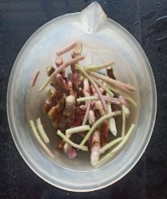
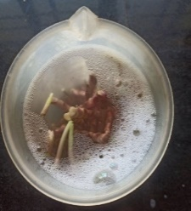
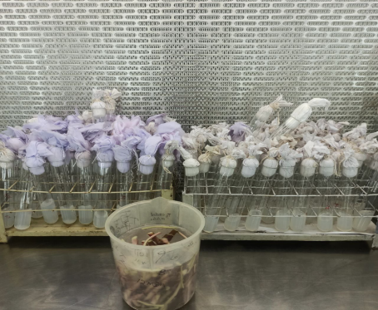
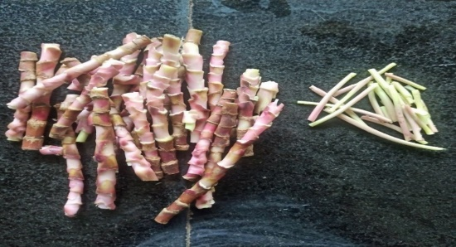

b
aaa
Fig. 1 Explants (a. Nodal segment, b. Shoot tip) Fig. 2 Explants undergoing 0.02% Bavistin sterilization & Surface sterilization with HgCl₂(0.1%)

In the present research, the response of selected explants to in vitro micropropagation was carried out through enhanced release of axillary buds and organogenesis (Direct and Callus- mediated). The stages and detailed protocol involved are illustrated in Fig. 2.
Selection of an elite mother plant
(Maintenance of mother material)
Explant
Stage 1
(Establishment)
Standardization of surface sterilization
Stage 2
(Proliferation)
Culture establishment
Direct organogenesis
Direct adventitious shoot formation
Single shoot and multiple shoots
Callus-mediated
Sub-cultured
Shoot proliferation
Axillary bud proliferation
Single node
Shoot tip
Primary culture
Single node leads to axillary shoot proliferation
Stage 3
(Rooting and Harding)
In vitro rooting
Post planting treatment
Rooted plants
Potted plants

Fig. 3 Flow chart of experimental work carried out for micropropagation in Cordyline

2.1 Stages and steps undertaken for in vitro culture

Explants: The explants selected were nodal segments and shoot tips.
Route | Explant
Enhanced release of axillary buds | Nodal segments
Organogenesis
1) Direct | Nodal segments
2) Callus- mediated | Nodal segments, shoot tips
- Collection and preparation of explants: The explants were collected from one year old cordyline plants maintained in the shade house attached to the tissue culture laboratory. The plants were given prophylactic sprays (0.2% carbendazim) against microbial contamination. Mature and immature stems were used for taking nodal segments and shoot tips. The method of preparation of explant varied with type of explant. After collecting the stem segments, the leaves were removed along with petioles and washed with running tap water for 1-2 min, then with distilled water to remove all soil particles and dirt and then dried at room temperature to eliminate any water droplets. Stem segments were cut into pieces of 5-10 cm each (Fig. 1).
- Sterilization of explants: The explants were placed in a 500 ml beaker of water. 2-3 drops of Labolene liquid detergent were poured to it and left for 15 minutes before thoroughly washing in running tap water. Following that, the explants were immersed in a 0.02% Bavistin (50% WP) solution for about 30 minutes (Fig. 2). They were then removed and gently rinsed with running tap water, followed by distilled water. Further sterilization procedure was carried under laminar flow.
- Standardization of surface sterilization: The explants were surface sterilized for 4 to 10 minutes in a laminar air flow chamber with 0.1% HgCl₂ (Fig. 2). After surface sterilization, the explants were rinsed 3 to 4 times in sterilized distilled water and dried on autoclaved filter paper. Nodal segments were then reduced to sizes of 1 to 1.5 cm. Shoot tips were reduced to size of 1.0 cm.
- Explant inoculation: Inoculation was performed in a laminar air flow cabinet under rigorous aseptic conditions. Sterilized forceps, surgical blades, petridishes and blotting papers were used. The explants, after cutting to required sizes with a sterile knife, were transferred into the test tubes filled with MS media. The test tube stands filled with cultured media was then transferred to culture rooms, where they were incubated at a temperature of 27 ± 2°C. Artificial illumination of intensity 2400 Lux was provided using cool white fluorescent lamps. Photoperiod was maintained as 16 hr per day. (Fig.4)
- The routes of micropropagation (Fig. 3)
Stage I
A) Explant choice
The explants used for the enhanced release of axillary buds were nodal segments. Observations were recorded on the response from 10 cultures.
B) Culture establishment
The culture establishments trials were carried out using nodal segments in MS medium supplemented with different concentrations of cytokinin (BAP) and auxin (NAA, 2, 4-D). Observations on the number of days taken for shoot bud emergence, number of shoots and number of days taken for shoot elongation were recorded up to three weeks of culturing.
Stage II
C) Shoot proliferation and elongation
The elongated buds in the stage I from nodal segments were separated carefully under aseptic condition and cultured to induce shoot proliferation (Fig. 10). Trials were conducted in MS medium supplemented with cytokinin (BAP) and in combination with NAA and 2, 4-D. Nature of response of elongated buds from nodal segments as influenced by cytokinin were recorded on the formation of multiple axillary buds, callus growth, shoot formation and root formation.
In callus mediated organogenesis, callus index was worked out as below:
CI = P × I, where, P is the percentage of Cultures and I is the Callus intensity
Stage III
D) In vitro rooting
Studies on in vitro rooting were carried on elongated shoots from stage II in MS basal medium.
Stage IV
E) Planting out and hardening
Sterile water was added to the culture vessels after removing the cotton plugs and kept as such for 5-10 min. The rooted plantlets were taken with the help of forceps and the media adhering to the roots were completely removed by thoroughly washing with running tap water.
The plantlets were treated with 0.02% Bavistin (50% WP) solution for 30 min before planting in portrays filled with coco pit having good drainage and porosity.
F) Post transfer treatments
- Keeping the plantlets in open.
- Covering the plantlets in low polytunnels with holes under polyhouse for 2 weeks.
- Intermittent watering to prevent desiccation.
- Spraying of Blitox @ 0.2% (50% WP) once in a week.
Experimental data
- For surface sterilization timing study: Observation recorded within 45 days of inoculation during culture establishment up to direct organogenesis.
Fungal contamination (%)
Total fungal infection observed in each test tube/Treatment | × 100
Total number of cultured test tube/Treatment
Fungal growth appears as a fuzzy growth (either whitish or black). The infection was recorded at weekly interval.
b) Bacterial contamination (%)
Total bacterial infection observed in each test tube/Treatment | × 100
Total number of cultured test tube/Treatment
Bacterial growth appears as slimy brownish layer at bottom of media. The infection was observed at weekly intervals.
c) Death (%)
It is complete necrosis or death of the explant cultured in test tube. The explant turns brown or dries up inside media. The death percentage was noted at weekly intervals.
d) Aseptic (%)
Test tube cultures free from any microbial contamination percentage of aseptic culture was maintained.
e) Survival (%)
Survival percentage was recorded.
- For direct organogenesis of nodal segment explants in MS media: Observation recorded 45 days of inoculation during culture establishment up to direct organogenesis.
2.2 Observation recorded for direct organogenesis includes:
- Number of cultures showing direct organogenesis (It is total number of cultures in a treatment showing direct shoot growth from explant without callus formation phase in media.)
- Time taken for organogenesis (days): It is the time interval between explant inoculation and direct shoot regeneration.
- Time taken for bud emergence (days): It is the time that elapses between explant inoculation and bud initiation.
- Time taken for shoot elongation (days): It is the time between inoculation of mass to complete shoot elongation.
- Shoot length (cm): It is the length of shoots after development.
- Number of leaves/shoots: It is the total number of leaves formed after entire proliferation.
- Number of shoots/explants: It is the total number of multiple shoots developed from the date of inoculation.
- Time taken for root initiation (days): It is the time taken for initiation of root.
- Root length (cm): Length of the roots developed in each cultured media.
- Number of roots/explants: Total number of roots primordia formed in each test tube during growth period.
- Nature of roots: It is nature of roots during entire growth phase.
- Colour of the leaves: It is the colour of leaves during entire growth phase.
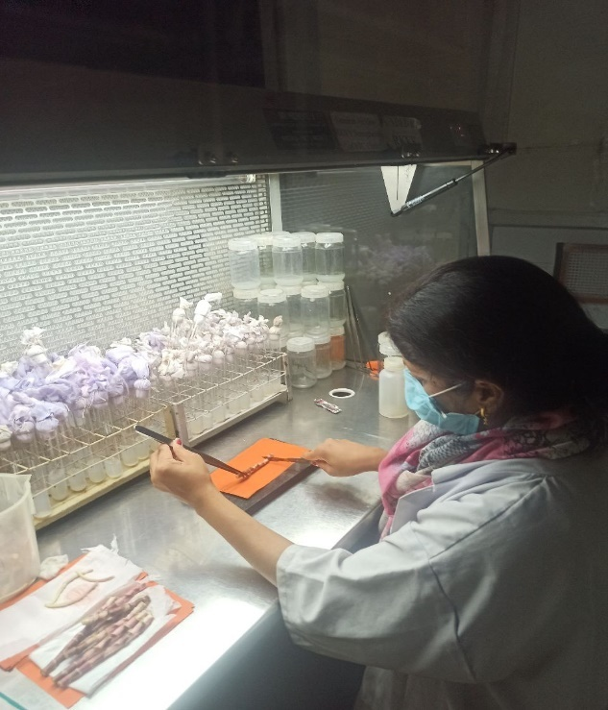

Fig. 4 Inoculation of explants
- For in vitro regeneration and shoot proliferation data: Observation recorded within 21 days of inoculation during culture establishment up to callus and 28 days for shoot proliferation.
- Percentage of cultures callusing: Number of cultures showing callusing after explant inoculation.
Number of explants producing callus | × 100
Number of explants cultured
- Days taken for callusing: It is the time elapsed between explant inoculation and callus formation.
- Callus intensity: Length of callus (E-W) cm × breadth of callus (N-S) cm i.e, Volume of callus (Callus spread).
- Callus index (CI): CI = P × I, where, P is the percentage of Cultures and I is the Callus intensity i.e., Mean ± SE.
- Callus texture: Texture of callus in entire growth phase.
- Callus colour: Colour of callus in entire growth phase.
- Number of days taken for callus differentiation: It is the duration from calli mass initiation to callus differentiation through sub culture for shoot proliferation
- Number of shoots primordia: It is the time between the inoculation of the calli mass and the start of the shoot.
The data was subjected to statistical analysis as per Gomez & Gomez (1984) utilizing one way ANOVA in a Completely Randomized Design (CRD) with three replications each consisting of ten cultures. There were 8 treatments for surface sterilization timing and 11 treatments for in vitro regeneration & shoot proliferation. The treatment effects were tested by 'F' test at 5% level of significance. The appropriate standard error of mean S.E.(m) and the critical difference (CD) were calculated at 5% level of probability.
3. RESULTS
3.1 Standardization of surface sterilant timings on nodal segment and shoot tip explants of Cordyline terminalis: Nodal segments and shoot tips were taken as explants to conduct the experiment. But shoot tip explants did not performed well, as a result all explants were contaminated and withered. Nodal segment explants showed less contamination and more survival rate, as a result it was taken for further study. The growth of shoot tip explants was terminated and was dropped further for the experiment. Nodal segment explants responded well and was further used for the study of the experiment.
Table 2 Effect of surface sterilant timings on in vitro microbial contamination and survival of nodal segment explant of Cordyline terminalis
Average of 10 cultures Duration: 45 days Basal medium: MS medium
Treatment No. | Treatments concentration | Time | Fungal (%) | Bacterial (%) | Death (%) | Aseptic (%) | Survival (%)
T₁ | Control (tap water) | - | 23.33  (28.88) | 6.67  (14.96) | 6.67  (14.96) | 63.33  (52.73) | 63.33  (52.73)
T₂ | 0.1% HgCl₂ | 4 min | 6.67  (14.96) | 0.00  (0.00) | 3.33  (10.52) | 93.33  (75.03) | 90.00  (71.56)
T₃ | 0.1% HgCl₂ | 5 min | 20.00  (26.56) | 6.67  (14.96) | 10.00  (18.43) | 60.00  (50.77) | 60.00  (50.76)
T₄ | 0.1% HgCl₂ | 6 min | 6.67  (14.96) | 0.00  (0.00) | 3.33  (10.52) | 90.00  (68.58) | 90.00  (68.58)
T₅ | 0.1% HgCl₂ | 7 min | 16.67  (24.09) | 6.67  (14.96) | 6.67  (14.96) | 70.00  (56.79) | 70.00  (56.79)
T₆ | 0.1% HgCl₂ | 8 min | 10.00  (18.43) | 6.67  (14.96) | 13.33  (21.42) | 70.00  (56.79) | 70.00  (56.79)
T₇ | 0.1% HgCl₂ | 9 min | 20.00  (26.56) | 3.33  (10.52) | 10.00  (18.43) | 66.67  (54.73) | 66.67  (54.73)
T₈ | 0.1% HgCl₂ | 10 min | 3.33  (10.52) | 0.00  (0.00) | 3.33  (10.52) | 96.67  (79.48) | 93.33  (75.03)
SE(m)± |  |  | 5.65 | 6.21 | 5.67 | 6.45 | 5.72
CD (5%) |  |  | 13.63 | 14.96 | 13.69 | 15.56 | 13.80
Values in parenthesis are arc sine transformed values
- Fungal contamination (%): In the present study, mercuric chloride (0.1%) with different exposure periods was used to establish surface sterilization of Cordyline terminalis (Fig. 2). The data presented in Table 1 revealed that the nodal segment explants of Cordyline terminalis surface sterilized with 0.1% mercuric chloride (HgCl₂) for 10 minutes, 6 minutes and 4 minutes have shown least fungal contamination of 3.33%, 6.67% and 6.67% respectively. Maximum percentage of fungal infection (23.33%) was observed in control (T₁), where the explants were surface sterilized with tap water. The fungal contamination is much easier to differentiate, based on visible spore-bearing structures, whitish black fuzzy growth on surface of media or fruiting bodies surrounding the explant and growth medium (Fig. 7).
- Bacterial contamination (%): The data formulated in Table 2 depicted that the nodal segments explants of Cordyline terminalis, Surface sterilized with 0.1% mercuric chloride (HgCl₂) for 10 minutes, 6 minutes and 4 minutes in (T₈), (T₆) and (T₂) were free from bacterial infection showing 0.00% each respectively. Maximum percentage of bacterial infection of 6.67% was seen in T₁ (control), T₃ (5 minutes, T₅ (7 minutes) and T₆ (8 minutes) respectively. The explants surface sterilized in T₇ (9 minutes) recorded lowest bacterial infection of 3.33%. Bacterial contamination is marginally visible as a tiny faint halo around the base or roots of the in vitro plant. The bacteria do not grow well in tissue culture medium and may only be visible as a dark color of nodal explant (Fig. 8).
- Death (%): The explants surface sterilized with 0.1% HgCl₂ for 4 minutes (T₂), 6 minutes (T₄), 10 minutes (T₈) have sown some percentage of death but are significantly free from bacterial infection. Highest death (%) was seen in T₃ and T₇ surface sterilized with 0.1% HgCl₂ for 5 min and 9 minutes recording 10.00% respectively (Fig. 5).
- Aseptic (%): The data presented in Table 2 showed that the nodal segment explants of Cordyline terminalis recorded significantly maximum aseptic percentage (96.67%), when explants were surface sterilized with 0.1% mercuric chloride (HgCl₂) for 10 minutes. The treatment T₁ (Control), T₃ and T₇ when surface sterilized with 0.1% HgCl₂ for 5 minutes and 9 minutes recorded lowest (63.33%, 60.00%, 66.67%) aseptic percentage respectively. Treatment T₂ and T₄ when surface sterilized with 0.1% HgCl₂ for 4 min and 6 min recorded 93.33% and 90.00% aseptic percentage respectively.
- Survival (%): The data documented in Table 2 revealed that the nodal segment explants of Cordyline terminalis recorded significantly maximum survival percentage (93.33%), when explants were surface sterilized with 0.1% mercuric chloride (HgCl₂) for 10 minutes. The treatment T₁ (Control), T₃ and T₇ when surface sterilized with 0.1% HgCl₂ for 5 minutes and 9 minutes recorded lowest (63.33%, 60.00%, 66.67%) survival percentage respectively. Treatment T₂ and T₄ when surface sterilized with 0.1% HgCl₂ for 4 min and 6 min recorded 90.00% survival percentage. T₂ and T₈ when surface sterilized with 0.1% HgCl₂ shows aseptic percentage of 96.67% and 93.33% respectively but survival percentage of 93.33% and 90.00%. The sterile or aseptic nodal was the explant free from any culture contamination. The viable explant is the aseptic explant which shows regeneration response or survival percentage. 3.34% and 3.33% decrease in survival percentage in T₂ and T₈ may be due to tissue culture lab environmental condition, mis-handling and pre-hardening factors.
Considering the above-mentioned data, it has been concluded that explants surface sterilized with 0.1% HgCl₂ for 10 minutes recorded least fungal contamination (3.33%), no bacterial infection (0.00%), least death percentage (3.33%), significantly higher aseptic culture percentage (96.67%) and significantly higher survival percentage (93.33%). Hence surface sterilization for 10 minutes with 0.1% HgCl₂ is found to be the best for the experiment and thus nodal segments as explants of Cordyline terminalis were used for further research.

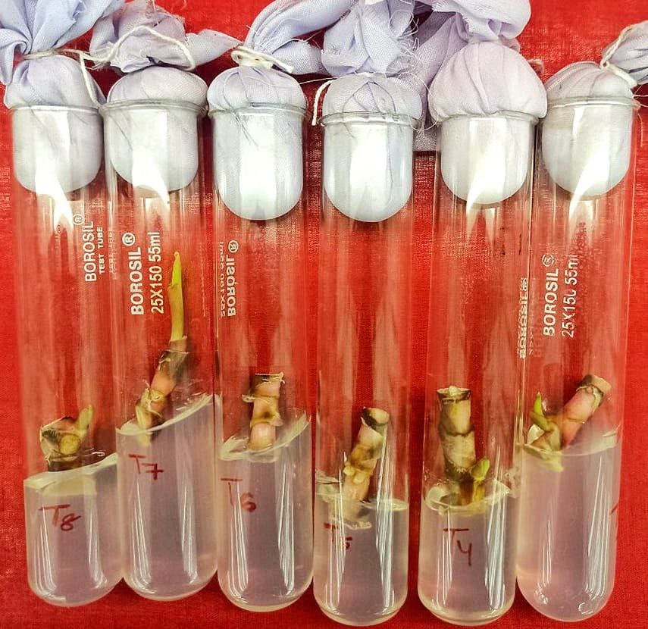

Fig. 6 Initial growth of nodal segment explant of in MS media
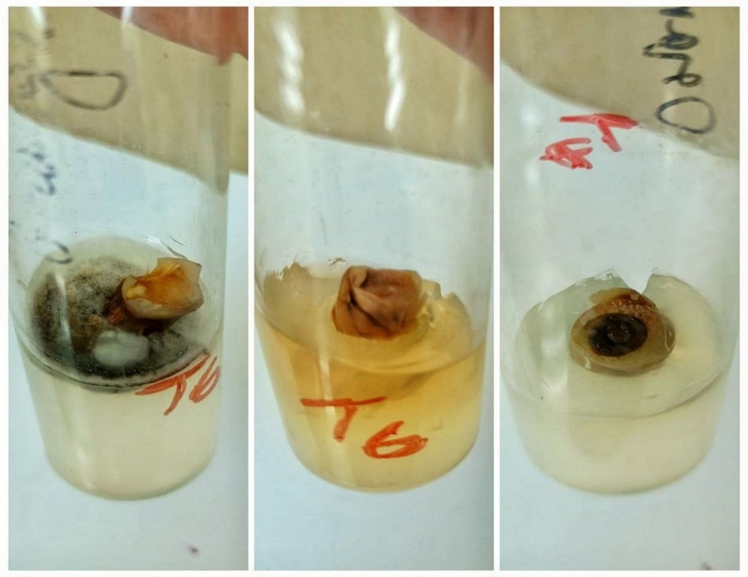

a: Fungal contamination of explant

b: Bacterial contamination of explant

c: Death of explant

c
b
a

Fig. 7 Contamination of nodal segment explant of Cordyline terminalis

3.2 Seasonal influence on the in vitro nodal segment explants of Cordyline terminalis: Data on the influence of season of explant collection on culture establishment on nodal segments explant of Cordyline are presented in Table 3 and Fig.8. Maximum survival percentage of the nodal segments was obtained during the month of November and December (95% each) and minimum rate of survival during the month of June and July (45% each).

Table 3. Seasonal influence on the in vitro establishment of explants of Cordyline
Month | Nodal segments
 | Contamination (%) | Survival (%)
November | 5.00 | 95.00
December | 5.00 | 95.00
January | 10.00 | 85.00*
February | 10.00 | 90.00
March | 10.00 | 90.00
April | 30.00 | 70.00
May | 35.00 | 60.00*
June | 55.00 | 45.00
July | 55.00 | 45.00

* The remaining explants dried inside the test tube

3.3 Standardization of media for direct and indirect organogenesis of Cordyline terminalis: The result of the trial was conducted to find out the response of nodal segment explant of Cordyline on direct organogenesis in MS medium without any growth regulators. It is illustrated in Table 4 and Table 5. Results were found to be significant for the parameter of number of cultures showing direct organogenesis. All the cultures from treatment T₁ to treatment T₈ showed direct organogenesis. The average time taken for direct organogenesis in MS medium varied from 51 to 58 days. The minimum period was taken by the treatment T₁ (51.67 days) and was significantly different from all other treatments. Maximum time taken for organogenesis was taken by treatment T₈ (58.00 days). The average number of days taken for bud emergence varied from 18.67 to 20.33 days. The minimum period was taken by the treatment 0.1% HgCl₂ for 9 min (18.67 days) and was significantly different from all other treatments. Maximum days (20.33) for bud emergence was taken by the treatment 0.1% HgCl₂ for 4 min and 5 min which were significantly at par. The average number of days taken for shoot elongation varied from 28.33 to 31.67 days and differed significantly. Minimum days (28.33) were taken by the treatment 0.1% HgCl₂ for 9 min which was significantly at par with treatment 0.1% HgCl₂ for 8 min (28.67 days). Maximum number of days were taken by the treatment 0.1% HgCl₂ for 4 min (31.67 days) followed by treatment 0.1% HgCl₂ for 5 min (30.67 days). Maximum shoot length (3.10 cm) was produced in treatment T₅ (0.1% HgCl₂ for 7 min) which was significantly at par with treatment T₈ (0.1% HgCl₂ for 10 min), T₂ (0.1% HgCl₂ for 4 min), T₄ (0.1% HgCl₂ for 6 min) having shoot length 3.07 cm, 3.03 cm and 3.00 cm respectively. In treatment T₃ (0.1% HgCl₂ for 5 min) has resulted in lowest shoot length (2.70 cm) which was significantly at par with control (T₁) having shoot length of 2.73 cm. Number of leaves ranged from 7.33 to 9.00. Maximum number of leaves were observed in treatment T₈ (0.1% HgCl₂ for 10 min) with 9.00 leaves in number per shoots. Treatment T₁ and treatment T₇ were significantly at par having 8.67 leaves/shoots. Least number of leaves were found in treatment T₅ with 7.33. Different treatments varied significantly with respect to the production of shoots which varied from 4.00 to 6.00. Multiple shoots were induced in almost all treatments. The data presented in Table 5 & Fig. 10, suggests that MS media surface sterilized with 0.1% HgCl₂ for 10 min (T₈) significantly produced higher number of healthy shoots/explants (6.00). It was significantly at par with treatment T₂ (0.1% HgCl₂ for 4 min) and T₄ (0.1% HgCl₂ for 6 min) producing 5.67 and 5.33 number of shoots respectively. The time taken for root initiation ranged from 47.33 days to 54.67 days. The shortest time (47.33 days) was taken by MS media sterilized with 0.1% HgCl₂ for 10 min (T₈) and maximum days for root initiation was taken by treatment T₂ (0.1% HgCl₂ for 4 min) with 54.67 days. Rooting was seen in Treatment T₂, T₄, T₈ with days for root initiation as 54.67, 50.00 and 47.33 days respectively in full MS media. Root length ranged from 5.07 cm in Treatment T₂ (MS media with 0.1% HgCl₂ for 4 min) to 7.67 cm in Treatment T₈ (MS media with 0.1% HgCl₂ for 10 min). Treatment T₂ (5.07 cm) was at par with treatment T₄ (5.53 cm) significantly. Number of roots produced differed significantly and varied from 2.67 to 5.33.

Table 4 Effect of MS media on the culture establishment of nodal segments for direct organogenesis
Culture period: 9 weeks Basal medium: MS Average of 10 cultures
Treatment No. | Treatments | Number of cultures showing direct organogenesis | Time taken for organogenesis (days) | Time taken for bud emergence (days) | Time taken for shoot elongation (days) | Shoot length (cm) | Number of leaves/ shoots
T₁ | Control (tap water) | 5.33 | 51.67 | 20.00 | 30.00 | 2.73 | 8.67
T₂ | 0.1% HgCl₂ for 4 min | 5.67 | 53.33 | 20.33 | 31.67 | 3.03 | 8.00
T₃ | 0.1% HgCl₂ for 5 min | 5.33 | 53.67 | 20.33 | 30.67 | 2.70 | 8.33
T₄ | 0.1% HgCl₂ for 6 min | 6.00 | 53.00 | 20.00 | 29.00 | 3.00 | 7.67
T₅ | 0.1% HgCl₂ for 7 min | 6.33 | 54.33 | 19.33 | 29.33 | 3.10 | 7.33
T₆ | 0.1% HgCl₂ for 8 min | 6.00 | 57.33 | 19.67 | 28.67 | 2.97 | 8.33
T₇ | 0.1% HgCl₂ for 9 min | 6.33 | 57.67 | 18.67 | 28.33 | 2.80 | 8.67
T₈ | 0.1% HgCl₂ for 10 min | 6.67 | 58.00 | 19.00 | 29.33 | 3.07 | 9.00
SE(m)± |  | 0.56 | 32.55 | 0.72 | 0.59 | 0.16 | 0.71
CD (5%) |  | 14.36 | 1.41 | 1.75 | 1.37 | 0.22 | 1.72

Table 5. Effect of MS media on the culture establishment of nodal segments for direct organogenesis
Duration: 9 Weeks MS Basal Medium
Treatment No. | Treatments | Number of shoots/ explants | Time taken for root initiation (days) | Root length (cm) | Number of roots/ explants | Nature of roots | Color of leaves
T₁ | Control (tap water) | 5.00 | NC | NC | NC | NC | Light green
T₂ | 0.1% HgCl₂ for 4 min | 5.67 | 54.67 | 5.07 | 2.67 | Long, creamy white root with root hairs | Light green
T₃ | 0.1% HgCl₂ for 5 min | 4.00 | NC | NC | NC | NC | Whitish green
T₄ | 0.1% HgCl₂ for 6 min | 5.33 | 50.00 | 5.53 | 3.33 | Long, creamy white root with root hairs | Light green
T₅ | 0.1% HgCl₂ for 7 min | 3.67 | NC | NC | NC | NC | Whitish green
T₆ | 0.1% HgCl₂ for 8 min | 4.33 | NC | NC | NC | NC | Light green
T₇ | 0.1% HgCl₂ for 9 min | 4.67 | NC | NC | NC | NC | Light green
T₈ | 0.1% HgCl₂ for 10 min | 6.00 | 47.33 | 7.67 | 5.33 | Long, creamy white root with root hairs | Light green
SE(m)± |  | 0.73 | 0.53 | 0.23 | 0.28
CD (5%) |  | 1.76 | 1.28 | 0.54 | 0.70
NC- No change

Long, creamy white roots with root hairs were produced in MS medium of treatment T₂ (0.1% HgCl₂ for 4 min), T₄ (0.1% HgCl₂ for 6 min), T₈ (0.1% HgCl₂ for 10 min) (Fig.11 & Fig.12). Colour of leaves ranged from whitish green to light green in all treatments done in MS media at various surface sterilized timings. Considering the above data in both Table 4 and Table 5, the MS media sterilized with 0.1% HgCl₂ for 2 min to 10 min and in control (tap water) showed good results significantly on parameters like number of cultures showing direct organogenesis, Time taken for organogenesis (days), time taken for bud emergence (days), Time taken for shoot elongation (days), shoot length and number of leaves/shoots & number of shoots/explants. However, parameters like time taken for root initiation (days), root length (cm) and number of roots/explants i.e, rooting in MS media without any rooting hormone were only found in treatment T₂, T₄ and T₈ significantly. Rest treatments showed no results of in vitro rooting.
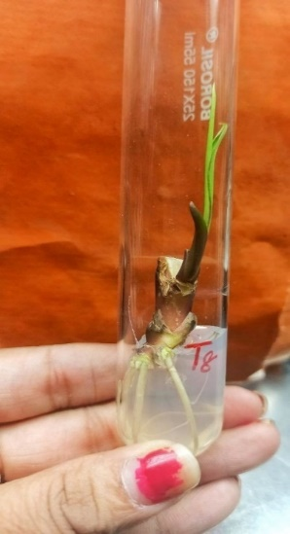
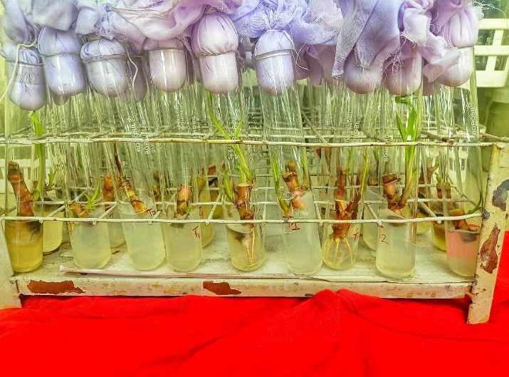

Fig. 11 Shoot growth and slender root growth of nodal segment explant of Cordyline in MS media

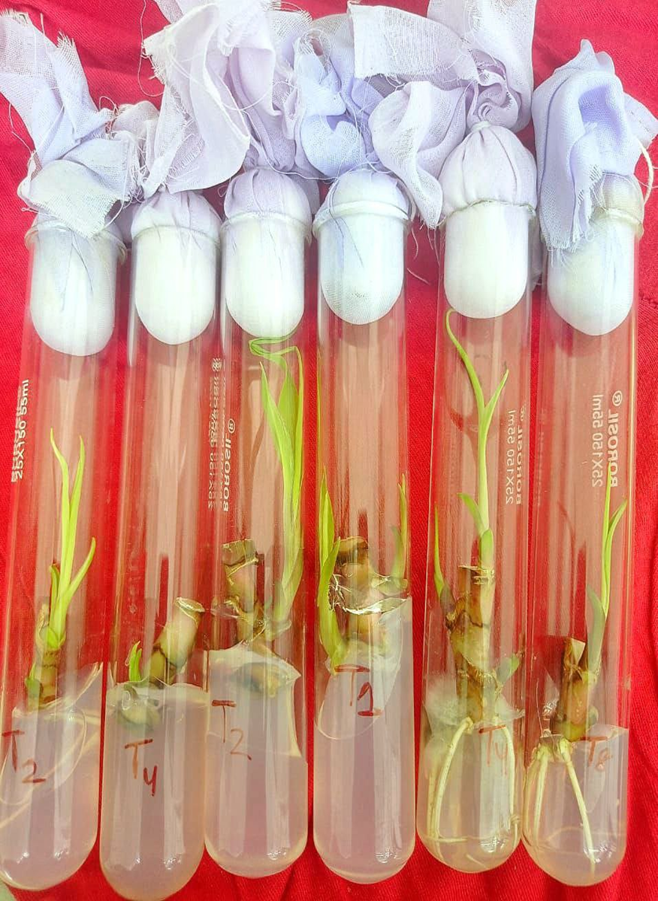
T₁
T₄
T₈
T₄
T₂
T₂

Fig. 12 Shoot and root proliferation of Cordyline nodal segments in MS media

3.4 To study the effect of plant bioregulators concentrations on in vitro regeneration and shoot proliferation of Cordyline terminalis: The nodal segment was used as the explants for the experiment (Fig. 1). All the data presented significantly influence the parameters (Table 6, Fig. 13). The data presented in Table 6 showed significant impact of percentage of cultures callusing and varied from 33.33 (T₆) to 83.33 (T₃). All the cultures originating from immature and young nodal segment responded well to callusing except treatment T₁ (Control-tap water). Highest percentage of callusing and best result was seen in treatment T₃ (MS + BAP 1.0 mg/l + NAA 0.5 mg/l) with callusing percentage at 83.33 and differed significantly with rest (Fig. 13 ). Number of days taken for callusing ranged from 11.33 to 16.00 and differed significantly. Treatment T₃ (MS + BAP 1.0 mg/l + NAA 0.5 mg/l) showed minimum days (11.33) for callus induction followed by T₇ (MS + BAP 3.0 mg/l + NAA 0.5 mg/l) and T₁₁ (MS + 2, 4-D 2.0 mg/l) with 12.00 days which was significantly at par. Maximum days for callusing was seen in treatment T₉ (MS + 2, 4-D 1.0 mg/l) with 16.00 days. Highest callus intensity was found in treatment T₃ (MS + BAP 1.0 mg/l + NAA 0.5 mg/l) with 4.40 which differed significantly from rest (Fig. 14). Lowest callus intensity was seen in treatment T₅ (MS + BAP 2.0 mg/l + NAA 0.5 mg/l) with 1.5. Callus index ranged from 66.67 to 367.00 in different treatments. The highest callus index was obtained in treatment T₃ (MS + BAP 1.0 mg/l + NAA 0.5 mg/l) followed by the treatment T₂ (MS + BAP 0.5 mg/l + NAA 0.5 mg/l) with callus index at 221.67. Callus index was minimum in the MS medium supplemented with BAP 2.5 mg/l and NAA 0.5 mg/l. Results were found to be significant for the parameter of number of days taken for callus differentiation. Since treatment T₃ gave best result with higher callus intensity, callus index and percentage of culture callusing, it was taken as base media for subculturing for differentiation. All the cultures from Treatment T₂ to T₁₁ were sub cultured in treatment T₃ (MS + BAP 1.0 mg/l + NAA 0.5 mg/l). Number of days taken for callus differentiation ranged from 19.00 to 27.00. Minimum number of days was taken by treatment T₃ (MS + BAP 1.0 mg/l + NAA 0.5 mg/l) which was at par with treatment T₇ (MS + BAP 3.0 mg/l + NAA 0.5 mg/l) with 19.00 days. Maximum number of days for differentiation was taken by treatment T₆ (MS + BAP 2.5 mg/l + NAA 0.5 mg/l) with 27.00 days. Results were found to be significant for the parameter of number of shoots primordia after differentiation through sub culturing (Table 7 and Fig. 18). Number of shoots primordia ranged between 0.33 (MS + BAP 1.5 mg/l + NAA 0.5 mg/l) to 2.33 (MS + BAP 1.0 mg/l + NAA 0.5 mg/l) (Fig.17). No shoot primordia growth was observed in MS media supplemented with BAP 2.5 mg/l and NAA 0.5 mg/l. Maximum shoot primordia was observed in treatment T₃ (2.33) followed by treatment T₅ (MS + BAP 2.0 mg/l + NAA 0.5 mg/l), T₉ (MS + 2,4-D 1.0 mg/l), T₁₀ (MS + 2, 4-D 1.5 mg/l), T₁₁ (MS + 2, 4-D 2.0 mg/l) which were significantly at par with 1.33. Considering the above data in both Table 6 and Table 7, the MS medium when supplemented with BAP 1.0 mg/l and NAA 0.5 mg/l (T₃) advanced the percentage of culture callusing (83.33), days taken for callusing (11.33), callus intensity (4.40) and callus index (367.00). As a result, after subculturing, it showed significant decrease in number of days taken for differentiation (19.00), and an increase in number of shoots primordia (2.33) producing soft friable and cream colour callus (Fig.15) giving rise to multiple shoot growth (Fig. 19) and 60% of the culture showing rhizogenesis.
Table 6. Effect of plant bioregulators concentration on in vitro regeneration of Cordyline terminalis
Culture period: 4 weeks Basal medium: MS
Treatment No. | Treatment details | Percentage of cultures callusing | Days taken for callusing | Callus intensity | Callus index | Callus texture | Callus colour
T₁ | Control (MS media) | NC | NC | NC | NC | NC | NC
T₂ | MS + BAP 0.5 mg/l + NAA 0.5 mg/l | 63.33 | 14.33 | 3.50 | 221.67 | Soft-friable | Cream
T₃ | MS + BAP 1.0 mg/l + NAA 0.5 mg/l | 83.33 | 11.33 | 4.40 | 367.00 | Soft-friable | Cream
T₄ | MS + BAP 1.5 mg/l + NAA 0.5 mg/l | 60.00 | 15.00 | 2.00 | 120.00 | Soft-friable | Cream
T₅ | MS + BAP 2.0 mg/l + NAA 0.5 mg/l | 53.33 | 14.00 | 1.50 | 78.33 | Soft-friable | Light green
T₆ | MS + BAP 2.5 mg/l + NAA 0.5 mg/l | 33.33 | 13.00 | 2.0 | 66.67 | Loose-friable | Whitish-green
T₇ | MS + BAP 3.0 mg/l + NAA 0.5 mg/l | 50.00 | 12.00 | 3.00 | 150.00 | Soft-friable | Cream
T₈ | MS + 2, 4-D 0.5 mg/l | 46.67 | 13.00 | 2.00 | 93.33 | Dense-glossy | Cream
T₉ | MS + 2, 4-D 1.0 mg/l | 50.00 | 16.00 | 2.00 | 100.00 | Soft-friable | Cream
T₁₀ | MS + 2, 4-D 1.5 mg/l | 56.67 | 13.00 | 2.00 | 113.33 | Soft-friable | Cream
T₁₁ | MS + 2, 4-D 2.0 mg/l | 56.67 | 12.00 | 2.50 | 141.67 | Dense-glossy | Light green
SE(m)± |  | 5.03 | 0.14 | 0.17 | 16.38
CD (5%) |  | 12.12 | 0.35 | 0.42 | 39.49
NC- No change

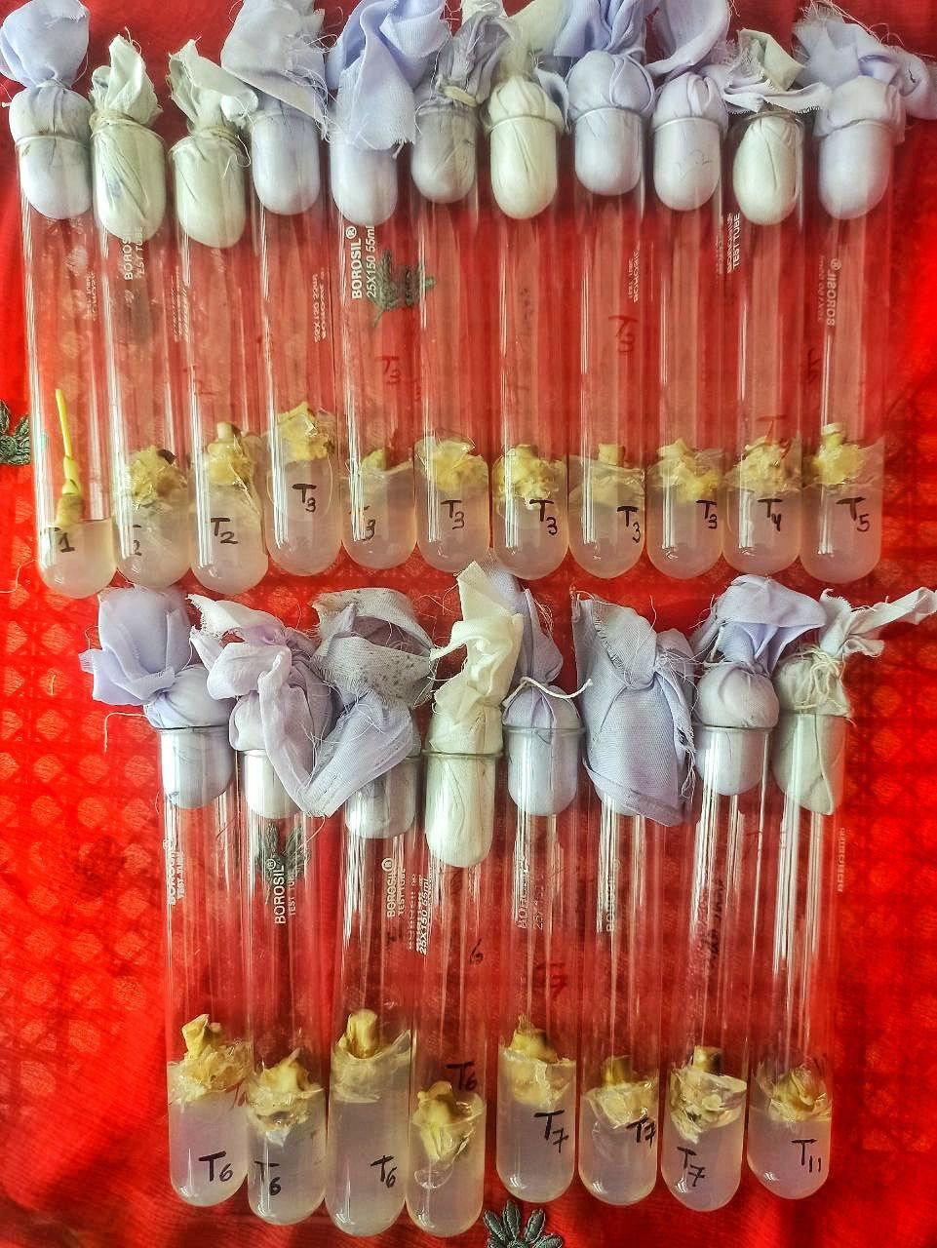
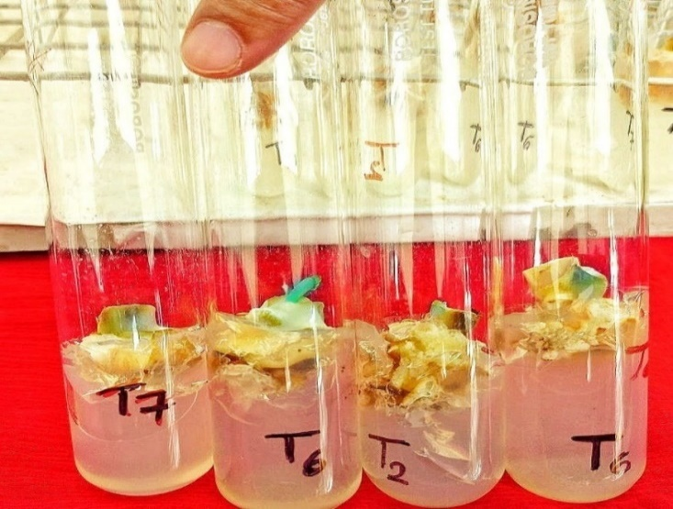
T₄
T₃
T₃
T₃
T₃
T₃
T₅
T₃
T₂
T₂
T₁

T₁₁
T₇
T₇
T₇
T₆
T₆
T₆
T₆
Fig. 15 Callus showing green colour

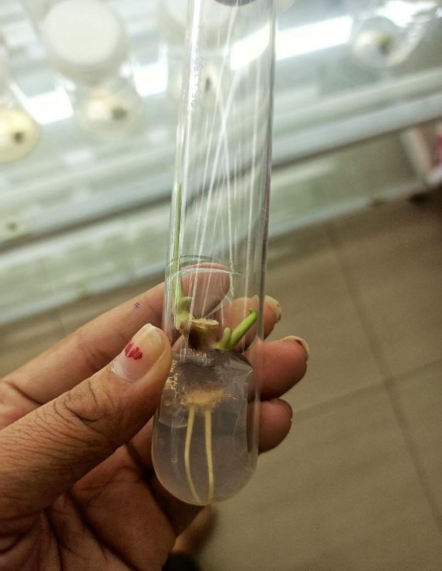
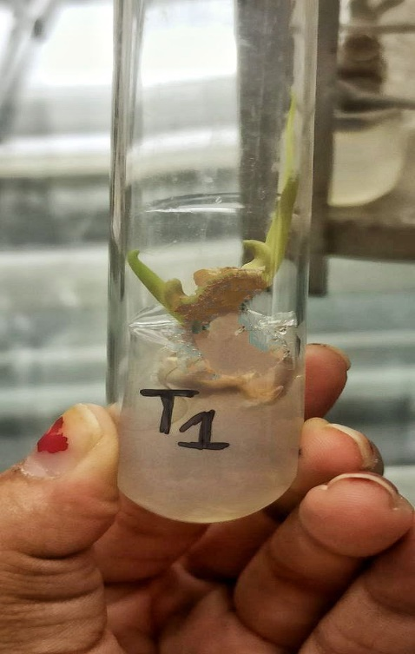
T₃
Sub-cultured media (T₁)

Fig. 14: Callus initiation on MS media supplemented with BAP and NAA
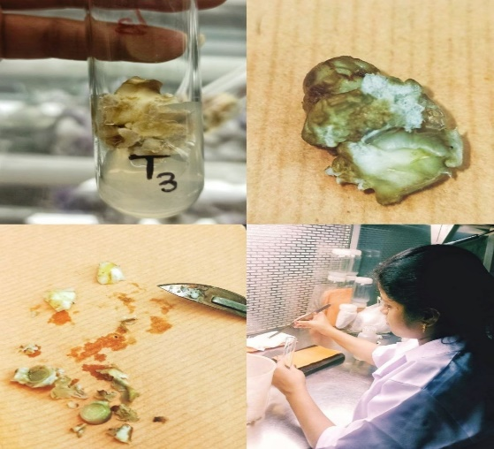

Fig. 16 Cream colour and soft-friable callus mass of nodal segment explant in treatment T₃: MS + BAP 1.0 mg/l + NAA 0.5 mg/l

Fig. 17 Shoot initiation on MS media followed by rhizogenesis supplemented with BAP 1.0 mg/l and NAA 0.5 mg/l

Table 7. Effect of media on different treatments for shoot proliferation of Cordyline by sub-culturing
Culture period: 4 weeks
Treatment No. | Treatment details | Sub-cultured media(T₁) | Number of days taken for callus differentiation | No of shoots primordia | Nature of response
T₂ | MS + BAP 0.5 mg/l + NAA 0.5 mg/l | MS + BAP 1.0 mg/l + NAA 0.5 mg/l | 21.00 | 1.00 | Callus mediated, shoot proliferation, slight rhizogenesis
T₃ | MS + BAP 1.0 mg/l + NAA 0.5 mg/l | MS + BAP 1.0 mg/l + NAA 0.5 mg/l | 19.00 | 2.33 | Callus proliferation, multiple shoot growth, 60% of cultures showed rhizogenesis
T₄ | MS + BAP 1.5 mg/l + NAA 0.5 mg/l | MS + BAP 1.0 mg/l + NAA 0.5 mg/l | 22.33 | 0.33 | Callus mediated, shoot proliferation, slight rhizogenesis
T₅ | MS + BAP 2.0 mg/l + NAA 0.5 mg/l | MS + BAP 1.0 mg/l + NAA 0.5 mg/l | 22.33 | 1.33 | Callus mediated, shoot proliferation but no rhizogenesis
T₆ | MS + BAP 2.5 mg/l + NAA 0.5 mg/l | MS + BAP 1.0 mg/l + NAA 0.5 mg/l | 27.00 | 0 | Callus turned green, no shoot growth
T₇ | MS + BAP 3.0 mg/l + NAA 0.5 mg/l | MS + BAP 1.0 mg/l + NAA 0.5 mg/l | 19.00 | 0.67 | Callus mediated, shoot proliferation but no rhizogenesis
T₈ | MS + 2, 4-D 0.5 mg/l | MS + BAP 1.0 mg/l + NAA 0.5 mg/l | 20.00 | 1.67 | Callus mediated, shoot proliferation but no rhizogenesis
T₉ | MS + 2, 4-D 1.0 mg/l | MS + BAP 1.0 mg/l + NAA 0.5 mg/l | 22.67 | 1.33 | Callus mediated, shoot proliferation but no rhizogenesis
T₁₀ | MS + 2, 4-D 1.5 mg/l | MS + BAP 1.0 mg/l + NAA 0.5 mg/l | 19.33 | 1.33 | Callus mediated, shoot proliferation but no rhizogenesis
T₁₁ | MS + 2, 4-D 2.0 mg/l | MS + BAP 1.0 mg/l + NAA 0.5 mg/l | 19.67 | 1.33 | Callus mediated, shoot proliferation but no rhizogenesis
T₁ | Control (MS media) | MS + BAP 1.0 mg/l + NAA 0.5 mg/l | NC | 1.00 | Direct organogenesis, shoot regeneration and rhizogenesis
SE(m) ± |  |  | 1.13 | 0.37
CD (5%) |  |  | 2.70 | 0.91
NC- No change

Effect of BAP: Data on the organogenic responses of elongated shoots as influenced by BAP (0.5, 1.0, 1.5, 2.0, 2.5, 3.0 mg/l) in combination with NAA (0.5 mg/l) in MS medium are given in Table 8. A very high rate of axillary bud proliferation was observed when MS medium was supplemented with BAP 1.0 mg/l + NAA 0.5 mg/l (Treatment 3). High rate of axillary bud proliferation was observed in the treatment MS medium + BAP 2.0 mg/l + NAA 0.5 mg/l. medium rate of axillary bud production was observed in MS medium supplemented with BAP 0.5 mg/l and NAA 0.5 mg/l. Low rate of axillary bud production was observed in MS medium supplemented with BAP 1.5 mg/l and BAP 3.0 mg/l. The treatment MS medium + BAP 2.5 mg/l + NAA 0.5 mg/l couldn’t produce any axillary buds. Callus production was very high in treatments involving BAP 1.0 mg/l + NAA 0.5 mg/l. High rate of callus growth was seen in MS medium supplemented with BAP 0.5 mg/l + NAA 0.5 mg/l, treatments involving BAP 1.5 mg/l + NAA 0.5 mg/l, BAP 2.0 mg/l + NAA 0.5 mg/l, BAP 3.0 mg/l + NAA 0.5 mg/l. Low rate of callus production was seen in MS medium supplemented with BAP 2.5 mg/l + NAA 0.5 mg/l. Callus production was observed in all treatments involving BAP and NAA.
Effect of 2, 4-D: Data on the organogenic responses of callus formation elongated shoots as influenced by 2, 4-D (0.5, 1.0, 1.5, 2.0 mg/l) in MS medium are given in Table 8. Low rate of axillary bud proliferation was observed when MS medium was supplemented with 2,4-D at 0.5, 1.0, 1.5, 2.0 mg/l. High rate of callus formation was observed in treatments involving 2,4-D 1.5 mg/l and 2.0 mg/l. However, medium rate of callus formation was observed in treatments involving 2, 4-D 0.5 mg/l and 1.0 mg/l. Callus production was observed in all treatments involving 2, 4-D. Considering both the effect of growth hormones, Full strength MS medium when supplemented with BAP at 1.0 and NAA 0.5 gave better results with callusing percentage of more than 80%.

Table 8. Response of nodal segments as influenced by BAP, NAA and 2, 4-D in Cordyline

Culture period: 4 weeks Basal medium: MS
Treatments |  |  | Nature of response
BAP (mg/l) | NAA (mg/l) | 2, 4-D (mg/l) | Multiple axillary buds | Callus growth | Others
0.5 | 0.5 | 0.0 | ++ | ++++ | Bulging of the base, rhizogenesis
1.0 | 0.5 | 0.0 | ++++ | +++++++ | Shoot base bulging, callusing & rhizogenesis
1.5 | 0.5 | 0.0 | + | ++++ | Bulging of the base, callusing & rhizogenesis
2.0 | 0.5 | 0.0 | +++ | +++ | Callusing
2.5 | 0.5 | 0.0 | - | + | Bulging of the base, callusing
3.0 | 0.5 | 0.0 | + | +++ | Bulging of the base, callusing
0.0 | 0.0 | 0.5 | + | ++ | Callusing
0.0 | 0.0 | 1.0 | + | ++ | Bulging of the base, callusing
0.0 | 0.0 | 1.5 | + | +++ | Bulging of the base, callusing
0.0 | 0.0 | 2.0 | + | +++ | Callusing

- No response

+ Low rate of production (up to 10 buds)

++ Medium rate of production (11-20 buds)

+++ High rate of production (21-30 buds)

++++ Very high rate of production (≥ 31 buds)

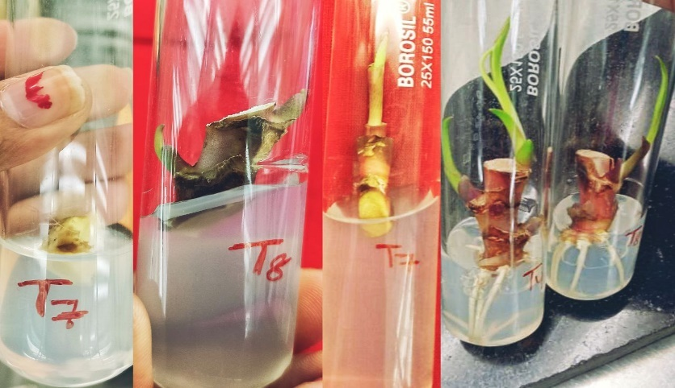
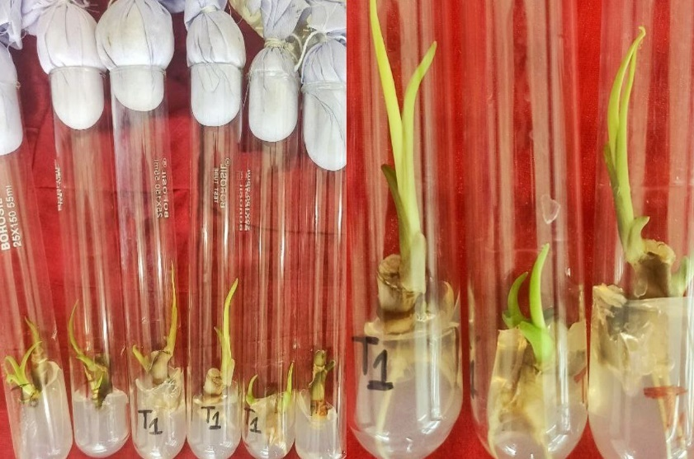

Fig. 20 Different stages of micropropagation of Cordyline from nodal segment explants through direct and indirect organogenesis

Fig. 19 Shoot proliferation and multiple shoot growth

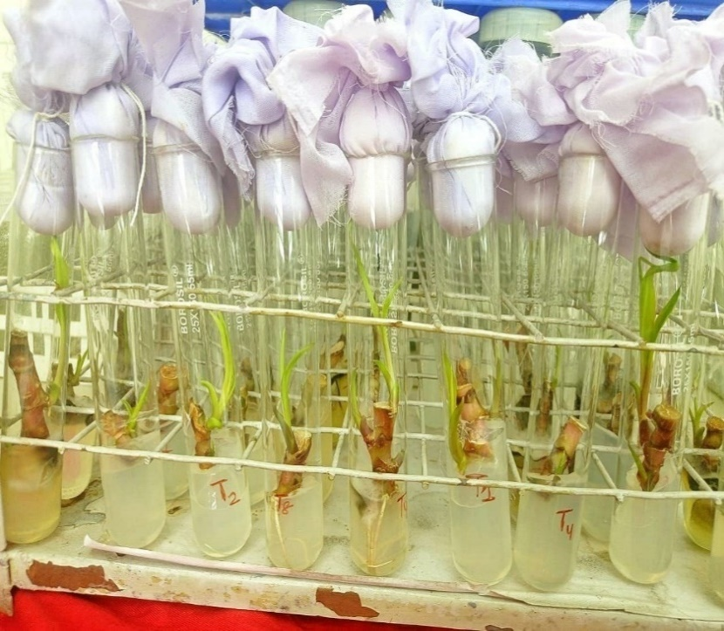
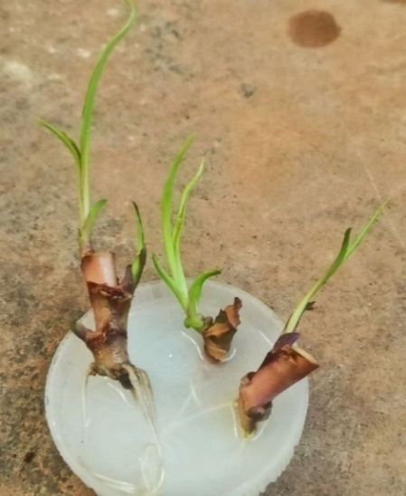
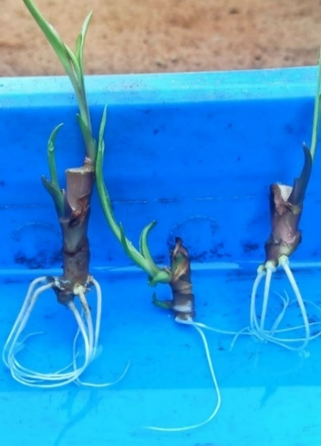

Fig. 22 Pre-planting treatments of micropropagated plants with 0.1% bavistin
Fig.21 Numerous shoots and roots of Cordyline terminalis in 1/2 MS and full MS basal medium

3.5 To study the efficacy of plant bioregulators on rooting and hardening of Cordyline terminalis
a) In vitro rooting: Elongated shoots from stage II produced in vitro roots without any rooting hormones. The results are presented in Fig. 21. Callus formation was observed in all the treatments except treatment T₁ (control MS media) (Fig.14). Young slender white roots to thick brownish white roots were observed in media with half MS basal medium, full MS basal medium, full MS + BAP 0.5 mg/l + NAA 0.5 mg/l, full MS + BAP 1.0 mg/l + NAA 0.5 mg/l, and full MS + BAP 1.5 mg/l + NAA 0.5 mg/l (Table 9).
Table 9. Effect of Growth regulators on nodal segment explants of Cordyline
Media | Response
Full MS Basal medium | Direct organogenesis and rhizogenesis
Half MS Basal medium | Direct organogenesis and rhizogenesis
Full MS + BAP 0.5 mg/l + NAA 0.5 mg/l | Browning of callus, slight rhizogenesis
Full MS + BAP 1.0 mg/l + NAA 0.5 mg/l | Browning of callus and rhizogenesis
Full MS + BAP 1.5 mg/l + NAA 0.5 mg/l | Browning of callus, slight rhizogenesis
Full MS + BAP 2.0 mg/l + NAA 0.5 mg/l | Browning of callus
Full MS + BAP 1.0 mg/l + NAA 0.5 mg/l | Browning of callus
Full MS + BAP 2.5 mg/l + NAA 0.5 mg/l | Browning of callus
Full MS + BAP 3.0 mg/l + NAA 0.5 mg/l | Browning of callus
Full MS + 2,4-D 0.5 mg/l | Browning of callus
Full MS + 2,4-D 1.0 mg/l | Browning of callus
Full MS + 2,4-D 1.5 mg/l | Browning of callus
Full MS + 2,4-D 2.0 mg/l | Browning of callus
b) Planting out and acclimatization (Stage IV)

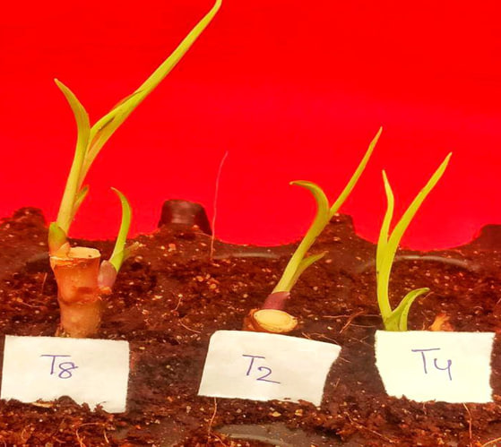
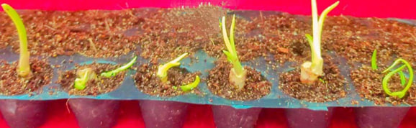

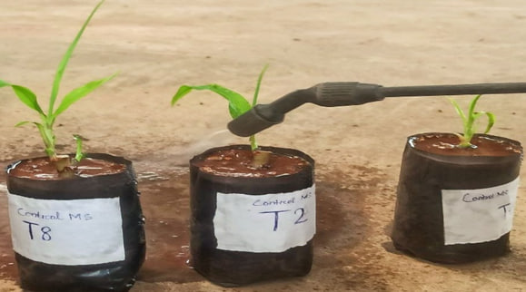

Fig. 23 Hardening of tissue cultured plantlets of Cordyline

The rooted plants were carefully removed from the test tubes and morphological observations were done. The height of plantlets at the time of planting out ranged from 3.0 to 5.5 cm with a mean height of 4.25 cm. The number of leaves per shoots ranged from 7.00 to 9.00 with a mean value of 8.00. The number of roots ranged from 3.00 to 5.00 with a mean value of 4.00. The length of the roots ranged from 5.00 to 8.00 cm with a mean value of 6.5 cm.

The plantlets were treated with 0.2% bavistin solution for 10 minutes. These plantlets were then subjected to acclimatization treatments and the results were observed. When the plants were kept in portrays with coco peat as the media under polytunnels covered greenhouse maintaining optimum environmental conditions, 100% survival rates were observed for 2 weeks. It was watered at 2 days interval. After 2 weeks, it was planted in fine sand treated with 0.2% carbendazim (50% WP) and 50% survival was recorded. When plantlets were kept in shade net house, survival percentage of 50.00%, 30.00% and 10.00% were recorded up to 8 weeks in the media fine sand (Fig. 23).
4. DISCUSSION

This study was carried out to find out the regeneration potential through direct and indirect organogenesis via micropropagation, to know the effect of culture media supplemented with plant regulators for shoot and root formation, and to design a protocol for micropropagation of Cordyline terminalis.
4.1 Standardization of surface sterilant timing for in vitro culture establishment of Cordyline terminalis
- Explant selection: Selection of suitable explant is very important which will yield true to type plant and will not increase the cost. Shoot tip and nodal segments was taken as an explant out of which nodal segment performed well which is in conformity with the results of the studies by Kunisaki (1975) in Cordyline, Vinterhalter (1989) in D. fragrans, Khan et al. (2004) in Cordyline terminalis and Beura et al. (2007) in Dracaena. One node cutting as an explant gave better results by increasing the survival percentage which was in accordance with Youssef (2012) in Cordyline fruticosa. Though in literature, use of shoot tips as an explant is more common in findings of Badawy et al. (2005) in Dracaena fragrans cv. Massangeana and Ray et al. (2013) in Cordyline terminalis, but in present study, it was found to be less efficient on various trials conducted. Considering the survival rates, regeneration ability and cost-factor, nodal stem segment was considered as an ideal explant for in vitro culture.
- Surface sterilization: The most important step in beginning of micropropagation is sterilization. In majority of the cases, plants that are growing outdoors have microorganisms on them. These microbes might simply be present on the plant's surface, or they might also live inside the plant as endophytic microbes. Main purpose of sterilization is to improve culture success by reducing explant contamination loss. Specific sterilization techniques have been developed depending on the explants being used, even though general sterilizing processes have been defined by many workers (Dodds and Roberts, 1982; George and Sherington, 1984). As a result, the sterilization process was standardized in the current investigation with regards to the sterilant, its concentration, and the length of exposure. Mercuric chloride (0.1%) was noticed to be ideal. Although in literature, the surface sterilization of Cordyline terminalis (Kunisaki, 1975 and Khan et al., 2004) with sodium hypochlorite is more common. In the present investigation, 0.1% mercuric chloride was taken for surface sterilization of nodal segment explants of Cordyline. Explants were treated with laboline for 10 minutes followed by 0.02% Bavistin (50% WP) solution for about 30 minutes and followed by a final surface sterilization using HgCl₂ (0.1%) for 4 min, 5 min, 6 min, 7 min, 8 min, 9 min and 10 minutes. Thereafter, the study discloses that mercuric chloride (0.01%) at 10 min gave the best combination with 96.67% aseptic culture, 93.33% survival, 3.33% death of culture, 3.33% fungal infection and no bacterial infections. The result as in accordance to the findings of Ray et al. (2013) who surface sterilized the explants of Cordyline terminalis with 0.1% HgCl₂ for 10 min.
Similarly, Kobza and Vachunova (1989) used chlorinated lime at 10% concentration and 0.2% HgCl₂ for sterilization of Dracaena and Binh et al. (1990) sterilized Agave explants in 0.05% mercuric chloride for 10 minutes. Maity et al. (1994) surface sterilized Cordyline explants by treating with 0.1% mercuric chloride containing 1-2 drops of Tween-20 for 4-10 min. Sanjeeva et al. (2011) investigated that explant of Cordyline terminalis cv. Gold compacta and C. terminalis cv. Red compacta when undergo sterilization in 1 g HgCl₂ for 10 min, 2 g HgCl₂ for 5 min, 100 mg streptomycin solution for 10 min gave better results than conventional sterilization procedure by NaOCl for 10 min. Beura et al. (2007) surface sterilized the explants of Dracaena. Ekanayake et al. (2016) surface sterilized the explants of Agave angustifolia with 0.1% HgCl₂ for 10 min or dip in 70% ethanol followed by 20% sodium hypochlorite for 20 min and found them equally effective.
- Influence of season: Survival rate of more than 95% and less than 5% contamination free was supposed to be due to season of explant collection on culture establishment. During the month of November and December maximum survival of nodal segment explants (95% each) was recorded and minimum rate of survival during the month of June and July (45% each) was found.
It may be also due to optimum environmental conditions maintained in the tissue culture lab with optimum temperature maintained at 25-30°C, Relative humidity of 60-70%, low light intensity which resulted in green and tall shoots in test tubes indicating confirmation with findings of Ray et al. (2013) who investigated and found that the culture environment should be maintained under white fluorescent light for 16 hr photoperiod at 25 ± 2°C with 55-60% relative humidity until explants of Cordyline gradually swell, become enlarged in size and turn light greenish.

4.2 Standardization of media for direct and indirect organogenesis of Cordyline terminalis
Evans et al. (1981) suggested that organogenesis may be direct or callus-mediated.
- Direct organogenesis: Direct morphogenesis from nodal segment explant without callus formation was reported during the experiment in full MS medium without any plant growth regulators in all the trials conducted with more than 90% survival rate. The average time taken for direct organogenesis in MS medium varied from 51 to 58 days, with shoot length in between 2.73 to 3.10 cm, whitish green to light green leaves where leaves number per shoot ranged from 7.33 to 9.00 and number of shoots/explant were found in between 4.00 to 6.00 in all the 8 treatments undertaken in full MS media without any application of growth regulators which indicates that foliage plants like Cordyline, propagation through tissue culture is cost effective as it excludes use of growth regulators and can generate disease-free, true to type, large quantity of planting material in a short period of time.
- Callus mediated organogenesis: Callus initiation: This study discloses that nodal segment explants produced highest percentage of callus in the MS medium supplemented with lower levels of BAP and 2, 4-D, both in 10 hr photoperiod and in a very short duration of time with less contamination.11 treatments were done taking different concentration of BAP (0.5, 1.0, 1.5, 2.0, 2.5, 3.0 mg/l), NAA (0.5 mg/l) and 2, 4-D (0.5, 1.0, 1.5, 2.0 mg/l) in MS media. Percentage of cultures callusing ranged from 33.33 to 83.33% in a short duration of time between 11 to 16 days. Highest percentage of callus formation (83.33%) was seen in treatment where MS media was supplemented by BAP 1.0 mg/l and NAA 0.5 mg/l. It was observed that all the treatments supplemented with growth hormones produced callus except the media devoid of growth hormones showed only direct organogenesis. Treatment T₃ where MS media was supplemented with BAP 1.0 mg/l and NAA 0.5 mg/l gave best result in terms of callus intensity (4.40), callus index (367.00) and produced best result with soft and creamy white callus.
Similar results were obtained by Kobza and Vachunova (1991) who could proliferate callus from stem explants of Dracaena on MS medium supplemented with 2, 4-D 0.5 mg/l. Maity et al. (1994) also found that in MS baseline nutrition agar medium enriched with 2, 4-D (0.1 mg/l - 0.5 mg/l), stem segments of Cordyline terminalis exhibited strong proliferation of soft and creamy white callus. The results were also in confirmation with Meshkova et al. (1999) where he studied that lower concentration of BAP and 2, 4-D induced callus in Cordyline.

4.3 To study the effect of plant bioregulators concentrations on in vitro regeneration and shoot proliferation of Cordyline terminalis
Callus differentiation and shoot proliferation: MS media fortified with BAP 1.0 mg/l and NAA 0.5 mg/l was found to be the most potent combination and used as sub-cultured media for further callus differentiation. In the present study, MS medium supplemented with BAP 1.0 mg/l (T₃) and BAP 3.0 mg/l (T₇), both showed early differentiation of callus into shoot buds in 19 days, whereas, highest number of shoots primordia of 2.33 in media supplemented with BAP 1.0 mg/l. MS media supplemented with 2, 4-D 1.5 mg/l and 2, 4-D 2.0 mg/l also showed callus differentiation in 19.33 days and 19.67 days respectively and shoots primordia of 1.33 indicating that callus differentiation into shoot buds take place at higher dose of 2, 4-D. Shoot proliferation was seen in all the treatments supplemented with BAP, NAA and 2, 4-D.
Paek et al. (1985) found that shoot tips of Cordyline terminalis can multiply successfully on a solid MS medium with IAA at 1.0 mg/l, KIN at 3.0 mg/l, adenine sulphate at 100 mg/l and 150 mg/l Na₂H₂PO₄ and every 6 weeks of subculturing was advised for rapid multiplication. However, it was found that repeated sub-culturing could reduce the regenerative capacity of callus giving less callus mass and it agrees with Debergh and Maene (1981) who explained that adventitious organogenesis would generally be the preferred way of multiplication because it allows for a significantly faster rise in propagules and noted that extended proliferation by repeated sub-culture will reduce the regenerative capacity of callus. As this study can undergo shoot proliferation without use of adenine sulphate, Na₂H₂PO₄, any other media supplements and in a low concentration of BAP (1.0 mg/l), it can be seen as a cost-effective way for in vitro regeneration and shoot proliferation of Cordyline terminalis.
This study is in confirmation with works of Maity et al. (1994) who could also differentiate callus derived from stem segments of Cordyline terminalis by transferring the callus to MS medium supplemented with 2, 4-D or NAA (0.01 mg/l -1.0 mg/l) and BAP (10 mg/l-20 mg/l). Alla et al. (1996) managed to grow numerous shoots of Cordyline terminalis using MS media supplemented with 2.0 mg/l BA + 0.1 mg/l NAA. Similarly, Sanjeeva et al. (2011) investigated that axillary bud development took place after 3 weeks and was highest in media containing 0.5-1.0 mg/l of BAP. Callus inoculation after 2 weeks of inoculation of stem explants was effective in 1-2 mg/l of 2, 4-D.

4.4 To study the efficacy of plant bioregulators on rooting and hardening of Cordyline terminalis
- In vitro rooting: An essential step in micropropagation is the rooting of the micro shoots. In in vitro rooting, the earliest induction of roots and the physical characteristics of the roots are of utmost importance.
The present study revealed that in vitro root formation took place in hormone free MS medium with more than 90% survival and free from contamination. Direct rhizogenesis was seen in MS medium sterilized with 0.1% HgCl₂ for 4 min, 6 min and 10 min. Time taken for root initiation varied from 47.33 to 54.67 days, number of roots/ explants ranged from 2.67 to 5.33 and root length of 5.07-7.67 cm giving rise to lateral roots with long, slender, creamy white root having root hairs. This may be due to well-balanced macronutrient salt concentration of MS medium, environment factors, especially light etc that contributed to in vitro rooting. This is in line with findings of Binh et al. (1990) in Agave, Welander (1988) in Cordyline, Sakr et al. (1999) in Yucca where shoots were rooted on hormone free MS medium. Vinterhalter and Vinterhalter (1992) experimented that by reducing the concentration of all 5 macronutrient salts, it was possible to overcome the inhibition of lateral root growth in Dracaena. Valenzuela et al. (2006) observed in vitro rooting in hormone free MS medium in Agave tequilana. Eltorky et al. (2018) studied in vitro rooting stage in Cordyline terminalis cv. Red top by culturing newly formed shoots from multiplication stage on MS PGRs -free medium gelled with 2% (w/v) gelrite.
Root formation was also seen in MS medium supplemented with 0.5 mg/l NAA + 1.0 mg/l BAP after subculturing. Roots induced in MS medium supplemented with NAA were thick, short and creamish in colour. Besides, NAA in the medium induced callus formation at the base before root induction. This was in accordance to work of Kunisaki (1975) who noted the occurrence of callus on plantlets rooted on medium with NAA.
However, there was no root formation in medium supplemented with 2, 4-D. This is in conformity with works of Mee (1978) who found that the addition of NAA increased root growth in Cordyline terminalis, while roots were not generated by 2, 4-D.
- Hardening and acclimatization: The plants will be heterotrophs under in vitro conditions. Establishing plants grown in vitro under natural conditions is essential for tissue culture to succeed. During first day of transplanting tissue cultured plants to greenhouse condition, acclimatization to humidity range is important. Hu and wang (1983) recommended a period of humidity acclimatization for micropropagated plants. The use of polythene tents, misting and fogging are ways for regulating relative humidity.
In the present investigation, micropropagated plants with average height (4.25 cm), average number of leaves per shoots (8.00), average number of roots (4.00) and average length of the roots (6.5 cm) were removed from the cultured vessels and treated with 0.2% Bavistin (50% WP) for 10 min. This is in accordance to Balachandran (1993) who modified the techniques of hardening of in vitro banana plants and observed that better results were obtained when the roots of the plantlets were dipped in 0.2% Bavistin for 5 min and the plantlets covered with microscope cover after planting.
These plantlets were then subjected to acclimatization treatments and the results were observed. When the plants were kept in portrays with coco peat as the media under polytunnels covered greenhouse maintaining optimum environmental conditions, 100% survival rates were observed for 2 weeks. It was watered at 2 days interval. After 2 weeks, it was planted in fine sand treated with Blitox @ 0.2% (50% WP) spray and 50% survival were recorded. When plantlets were kept in green house, survival % of 50.00, 30.00, 10.00 were recorded up to 8 weeks in the media fine sand. This study agrees with Ziaullah et al. (1999) who investigated that the optimal media for cordyline was pine bark + garden soil + sand (1:1:1). Similarly, Wainwright (1998) noted that a tissue culture container has an environment with extremely high humidity, little light and typically consistent temperature. Because of this, leaves, shoots, or plantlets emerging from the environment have relatively poor resistance to the low relative humidity, high amounts of light and more fluctuating temperature seen in vivo. The main variables that need to be regulated during acclimatization are light, temperature and relative humidity.

SUMMARY AND CONCLUSION

Cordyline is an excellent ornamental plant with colored foliage and has wide landscaping utility. The conventional method through cuttings produces a smaller number of plants from a single plant and also takes more time. Micropropagation technique overcomes the bottle neck in production procedure by giving a greater number of plants within a short period of time producing diseased-free and uniform propagules. Also, to restore environmental degradation and limit the use of chemical fertilizer, study of bioenzymes is essential as they improve growth and development parameters of foliage crops.

In the current investigation, a protocol was optimized which suggests that nodal segments when surface sterilized with 0.1% HgCl₂ for 10 minutes resulted in higher survival percentage thereby lowering contamination and death. The best treatment observed for direct organogenesis was full MS medium which resulted in more than 90% survival. The best treatment with maximum callusing percentage for callus mediated organogenesis was MS medium fortified with BAP 1.0 mg/l and NAA 0.5 mg/l. However, callus formation was seen in all treatments supplemented with plant growth regulators like BAP, NAA and 2, 4-D. The media taken for sub-culture was MS medium + BAP 1.0 mg/l + NAA 0.5 mg/l. In vitro rooting was seen successfully in Full MS medium. However, medium supplemented with NAA 0.5 mg/l also showed rooting. Hardening method involved planting of micropropagated plants in cocopeat + sand followed by regulation of light intensity, humidity, temperature in greenhouse condition resulting in 50% survival after 4 weeks.

The protocol for mass multiplication of Cordyline derived from the current investigation is provided below (Fig. 3 & Fig. 20):
Nodal segment (1-5 nodes from apex of shoots)
↓
0.1% HgCl₂ Sterilization for 10 min
↓
Inoculate onto MS medium + BAP (0.5, 1.0, 1.5, 2.0, 2.5, 3.0 mg/l) + NAA (0.5 mg/l) or MS medium + 2, 4-D (0.5, 1.0, 1.5, 2.0 mg/l)
(Callus formation is seen in all the combination but maximum percentage of callusing is seen in MS + BAP 1.0 mg/l + NAA 0.5 mg/l)
↓
Subculture onto MS medium + BAP 1.0 mg/l + NAA 0.5 mg/l
↓
Transfer to MS basal medium for elongation and rooting
↓
Planting out in coco peat + sand media, following hardening treatments and 50% shading

As a result, findings of this study will be positive, paving the way for large-scale plantlet production in the future. It will benefit hi-tech farmers and entice entrepreneurs for commercialization.

Future line of work
- Cordyline is ornamental foliage plant and meagre work in India has been done in foliage plants to encourage its cultivation for landscaping or to build a database for it.
- Cordyline requires special attention in order to boost future genetic studies such as inter-specific hybridization, innovations, variety evaluation and so on.
- More emphasis should be placed in boosting in vitro mutagenesis and transgenic Cordyline varieties.
- Somatic embryogenesis and soma clonal variants offer fresh path for further investigation in areas of high-quality research.

DISCLAIMER (ARTIFICIAL INTELLIGENCE)

Author(s) hereby declares that NO generative AI technologies such as Large Language Models (ChatGPT, COPILOT, etc.) and text-to-image generators have been used during the writing or editing of this manuscript.

REFERENCES
Adanson M. 1763. Familles des plantes par M. Adanson, chez Vincent, 2: 9-54
Alla AH and Van SJ. 1996. Somatic embryogenesis from leaves of Yucca aloifolia L, J. Southern Afr. Soc. hort. Sci., 6(1): 4-7
Badawy A, Habib A, El-Ban A and Yosry G. 2005. Propagation of Dracaena fragrans plants by tissue culture technique, Arab J. Biotech, 8(2): 329-342.
Bailey LH. 1910. Cyclopedia of American Agriculture: Farms (Vol. 1). Macmillan.
Balachandran M. 1993. Induction of genetic variability in Musa sp. var. Nendran in vitro methods (Doctoral dissertation, Department of pomology and floriculture, College of horticulture, Vellanikkara).
Beckett KA and Jahn V. 1987. The RHS encyclopedia of house plants, including greenhouse plants, Swallow editions Ltd.
Bentham G and Hooker JD: General Plantarum, Vol. III, London (1883).
Beura S, Samal P and Jagadev PN. 2007. Preliminary studies of in vitro cloning of Draceana sanderiana Acta Hort., 760: 241-245.
Binh LT, Muoi LT, Oanh HTK, Thang TD and Phong DT. 1990. Rapid propagation of Agave by in vitro tissue culture, Pl. Cell tissue organ cult., 23(1): 67-70.
Commerson, in de Junica, AL: Genera plantarum, p.41. Paris. 1789.
Dodds JH and Roberts LW. 1985. Experiments in plant tissue culture, International Potato Center.
Debergh P. 1975. Intensified vegetative multiplication of Dracaena deremensis, In Symposium on Propagation in Arboriculture, 54: 83-92.
Ekanayake EMEGP, Attanayake AMKB, and Perera PIP. 2016. Optimization of sterilization and regeneration protocol in micropropagation of Agave angustifloia.
Eltorky MG, Elmahrouk ME, Elmokadem H and El-Sammak H. 2018. Micropropagation and Genetic Variations of Cordyline terminalis cv. Red Top, Journal of the Advances in Agricultural Researches, 23(2): 328-349.
Evans DA, Sharp WR and Flick CE. 1981. Growth and behavior of cell cultures: embryogenesis and organogenesis, Plant tissue culture, 45-113.
George EF and Sherrington PD. 1984. Plant propagation by tissue culture. Exegetics Ltd.
Gomez KA and Gomez AA. 1984. Statistical procedures for agricultural research. John wiley & sons.
Hutchinson J. 1959. The families of flowering plants, Vol. II, Monocotyledons, The families of flowering plants, Vol. II, Monocotyledons, (2nd Ed).
Hu CY and Wang PJ. 1983. Meristem, shoot tip and bud cultures, Handbook of plant cell culture (USA), pp. 177-227.
Kemp EB and Robb FD. 1962. Cordyline terminalis, Quarterly Journal of Crude Drug Research, 2(4): 299-307.
Khan S, Naz S and Saeed B. 2004. In vitro production of Cordyline terminalis for commercialization, Pak. J. Bot, 36(4): 757-761.
Kobza F and Vachunova J. 1989. Propagation of Dracaena in vitro, Propagation of Dracaena deremensis, Acta University Agric. Faculty of Hort, 4: 33-37.
Kunisaki JT. 1975. In vitro Propagation of Cordyline terminalis (L.) Kunth., HortScience, 10(6): 601-602.
Maity I, Ghosh PD, Jana BK and Bose T .1994. Micropropagation of some house plants, Floriculture Technology, Trades and Trends (ed. Prakash, J. and Bhandary, K.R.) Oxford and IBH Publishing Co., Bombay, pp. 357-366.
Mee, GW. 1978. Propagation of Cordyline terminalis from Callus Culture, Hort Science, 13(6): 660-660.
Melchior H. 1964. A. Engler's Syllabus der Pflanzenfamilien , Angiospermen., 2: 666.
Meshkova NV, Makarova RV, Borisova TA and Lapotyshkina LI. 1999. The role of exogenous auxins and cytokinins at different stages of the in vitro propagation of Cordyline terminalis, Biotekhnologiya 15 (1): 71-79.
Paek KY, Oh MO and Choi JK. 1985. Mass propagation of Cordyline and Scindapsus in vitro, J. Korean Soc. hort. Sci., 26(1): 83-92.
Pal AK. 2006. Ornamental plants with attractive foliages, Advances in ornamental horticulture, Pointer publishers, India, 2: 273-343.
Randhawa GS and Mukhopadhyay A. 2004. Floriculture in India, Allied publishers Pvt Limited, pp. 258-259.
Ray T, Saha P and Roy SC. 2006. Commercial production of Cordyline terminalis (L) Kunth. from shoot apex meristem and assessment for genetic stability of soma clones by isozyme markers, Scientia horticulturae, 108(3): 289-294.
Ray T, Saha P and Roy SC. 2013. Micropropagation of Cordyline terminalis, Protocols for Micropropagation of Selected Economically-Important Horticultural Plants, 269-277.

Sakr SS, El-Khateeb MA and El-Kareim AHA. 1999. In vitro production of Yucca elephantipes, Bulletin-Faculty of Agriculture University of Cairo, 50: 265-282.
Sanjeewa T and Peiris SE. 2011. In Vitro Propagation of Cordyline terminalis CV' Gold-Compacta' and CV' Red-Compacta'.
Valenzuela-Sánchez KK, Juárez-Hernández RE, Cruz-Hernández A, Olalde-Portugal V, Valverde ME and Paredes-Lopez O. 2006. Plant regeneration of Agave tequilana by indirect organogenesis, In Vitro Cellular & Developmental Biology-Plant, 42: 336-340.
Vinterhalter DV. 1989. In vitro propagation of green-foliaged Dracaena fragrans Ker. Plant cell, tissue and organ culture, 17: 13-19.
Wainwright H. 1988. Overcoming problems in establishing micropropagules- guidelines for growers, Prog. Hort., 2(3): 67-72.
Welander T. 1988. Micropropagation of Cordyline terminalis cv. Atom-a European cooperation project, Rapport Institutionen for Tradgardsvetenskap, 54:13.
Youssef H. 2012. Production cordyline fruticosa, l. By using tissue culture, Egyptian Journal of Agricultural Research, 90(2): 747-758.
Ziaullah A, Asghar N, Amin N and Arshad M. 1999. Genotypic variation in two Cordyline species and their performance in different growth media, Sarhad J. Agric., 15(3): 177-179.

