Original Research Article
Integrated Virtual Screening of NPACT-Derived Phytochemicals as Potential FGFR1 Inhibitors for Cholangiocarcinoma Therapy: Molecular Docking, ADMET, MM-GBSA, and Molecular Dynamics.

ABSTRACT
Bile duct cancer (cholangiocarcinoma) is a rare but aggressive malignancy with poor prognosis and limited treatment options. Fibroblast growth factor receptor 1 (FGFR1), a key regulator of tumor growth and angiogenesis, has been identified as a plausible therapeutic target. Due to the limitations in the safety and selectivity of existing inhibitors, there is a growing interest in exploring natural compounds as alternative drug lead candidates. This study aimed to identify and evaluate plant-derived phytochemicals as potential FGFR1 inhibitors for the treatment of cholangiocarcinoma using an integrated computer-aided drug design approach.
A structure-based virtual screening of 67 phytochemicals from the NPACT database was conducted. Molecular docking against FGFR1 (PDB ID: 7WCL) using iGEMDock and Molecular Operating Environment (MOE) identified 17 hit compounds with binding energies ranging from −12.3 to −9.8 kcal/mol (iGEMDock) and −9.7 to −8.0 kcal/mol (MOE), outperforming Pemigatinib (−9.7 and −7.5 kcal/mol). Lipinski’s Rule of Five narrowed them down to seven drug-like candidates. ADMET screening further identified four compounds as pharmacokinetically acceptable. MM-GBSA analysis revealed that 10-Hydroxytrilobacin (-47.63 kcal/mol) and Mosin B (-45.09 kcal/mol) had superior binding free energies than Pemigatinib (-31.01 kcal/mol). These two lead compounds were subjected to 100 ns molecular dynamics simulation to confirm their interaction behavior and structural stability.
Mosin B and 10-hydroxytrilobacin both surpassed pemigatinib across key structural metrics, establishing them as promising FGFR1 inhibitors with strong binding affinity, pharmacokinetic safety, and dynamic stability, and thus warranting further experimental validation for cholangiocarcinoma therapy.
Graphical abstract
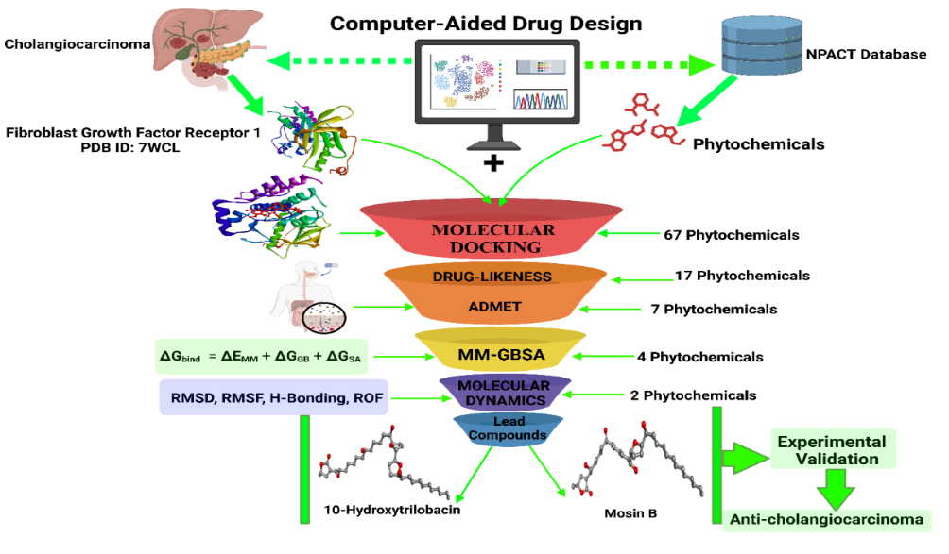

Keywords: 10-Hydroxytrilobacin, Cholangiocarcinoma therapy, Computer-aided Drug Design, FGFR1, Mosin B, Pemigatinib, Phytochemicals.
- INTRODUCTION
Bile duct cancer, also known as cholangiocarcinoma, is an aggressive and rare malignancy that originates from the epithelial lining of the biliary tract [1]. It is anatomically classified into intrahepatic, perihilar, and distal cholangiocarcinomas, of which perihilar cholangiocarcinoma is the most common [2,3]. Because of its deep anatomical location and nonspecific initial presentation, including pruritus, jaundice, and unexplained weight, diagnosis is usually delayed, and this is further causing poor clinical outcomes [4,5]. While improved diagnostic methods like MDCT and MRI have increased the precision of diagnosis, treatment with clear surgical margins remains the mainstay of curative treatment [6,7]. The surgical approaches, such as extended hepatectomy or pancreaticoduodenectomy, also vary according to tumor location. However, even with surgery, high recurrence and resistance to chemotherapy still mar long-term survival [8,9]. These challenges indicate the urgent need for improved and targeted treatment modalities.
Recent studies at the molecular level have identified fibroblast growth factor receptor 1 (FGFR1) as a potent oncogenic driver in a number of different cancers, including cholangiocarcinoma [10]. FGFR1, a receptor tyrosine kinase, is responsible for governing basic cellular functions such as proliferation, differentiation, and angiogenesis. Abnormality in its function—attributable to gene amplification, mutation, or ligand-independent receptor activation—has been found liable for tumor growth, chemoresistance, and poor clinical outcomes of bile duct cancer [11]. Consequently, inhibiting FGFR1 signaling is an attractive target for therapy. Synthetic FGFR1 inhibitors such as pemigatinib have been identified, but high cost, potential toxicities, and poor selectivity are challenges for long-term clinical use [12,13,14]. This has generated interest in the quest for safer, natural, plant-based alternatives that can modulate FGFR1 function with improved tolerability.
Phytochemicals, naturally occurring bioactive compounds found in medicinal plants, have historically been investigated for anticancer properties since they have been shown to modulate intricate cell signaling, including tumor growth and metastasis-critical signaling pathways [15,16,17]. They are structurally diverse, have minimal systemic toxicity, and their traditional usage further enhances their potential as viable drug candidates. However, not all phytochemicals are safe or effective, and high-throughput screening is an essential tool for discovering those having high therapeutic potential [16]. It is in this context that research on phytochemicals with FGFR1-inhibitory potential represents a compelling direction in cholangiocarcinoma, with the promise of developing cost-effective and biologically acceptable treatments [18].
Computational methods in drug design now provide an effective channel for the identification of candidates of this sort. In silico techniques have proven to be valuable tools for rational drug design [19]. These techniques offer efficient screening of large libraries of compounds to predict binding affinity, molecular stability, and pharmacokinetics and toxicology, followed by experimental validation. The NPACT (Naturally Occurring Plant-Based Anti-Cancerous Therapeutics) database is one such repository that consists of experimentally determined plant-based compounds with known anticancer activities [20,21]. Utilizing this database in combination with structure-based modeling allows for the systematic identification of phytochemicals that are capable of specifically inhibiting FGFR1 enzymatic activity.
This research uses computer-aided drug design (CADD) to evaluate 67 phytochemicals, sourced from the NPACT database, as potential inhibitors of FGFR1. Through an integrated molecular docking, molecular mechanics generalized born surface area (MM-GBSA) energy calculation, pharmacokinetics and toxicological evaluation, and molecular dynamics simulation, the study aims to identify potential lead compounds of therapeutic potential. By targeting the FGFR1 kinase domain, this research seeks to contribute to the discovery of novel, plant-based therapeutics for bile duct cancer treatment.
2.0 METHODOLOGY
2.1 Protein Preparation and Active Site Prediction
The crystal structure of the FGFR1 kinase domain (PDB ID: 7WCL; resolution: 2.50 Å) (https://doi.org/10.2210/pdb7WCL/pdb) was retrieved from the Protein Data Bank (PDB) (https://www.rcsb.org). This structure, comprising residues Gly456 to Asn763, was optimized using Biovia Discovery Studio 2021 to remove water molecules and correct bond geometries. The active binding pocket was predicted using the CASTp 3.0 web server, enabling site-specific docking by accurately mapping surface cavities and binding residues [19,23].
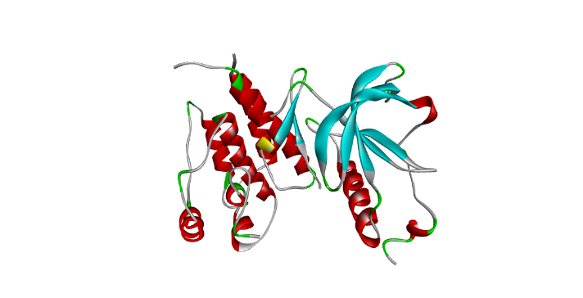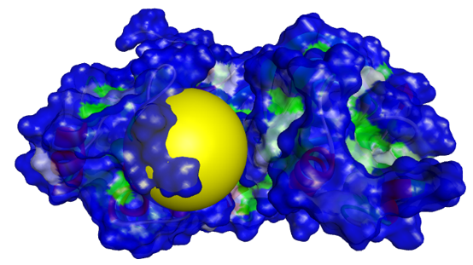
(a) cartoon model (b) surface model with the active site coloured in yellow

Figure 1: Visualization of fibroblast growth factor receptor 1 kinase domain (PDB ID: 7WCL).

2.2 Ligand Selection and Preparation
For this research, the NPACT database (http://crdd.osdd.net/raghava/npact/), which comprises 1,574 phytochemicals, was utilized. This database provides in-depth information on phytochemicals, including their structure, experimental data, inhibitory values, properties, cancer types, cell lines, target proteins, and drug-likeness values [21]. From the dataset, 67 bile duct cancer-specific phytochemicals were identified and retrieved. These compounds were initially provided in the SMILES format and subsequently converted to PDB format using Open Babel GUI software for compatibility with molecular docking tools [24].
2.3 Molecular Docking Validation
To obtain accurate predictions of potential drug effectiveness, the reliability of virtual screening was enhanced through consensus scoring by utilizing AutoDock Vina, iGEMDock, and Molecular Operating Environment (MOE), each employing different algorithms [25,26,27]. The tools calculated the binding energies and interaction of the co-crystallized ligand, pemigatinib, in the kinase-domain active site of fibroblast growth factor receptor 1. iGEMDock and MOE generated similar binding scores and structural conformations, making them appropriate for the primary docking phase. This consensus scoring reduced false positives and negatives, ensuring reliable predictions of potential drug effectiveness [19,23].
2.4 Molecular Docking
For this research, in silico molecular docking was utilized with iGEMDock and MOE to analyze the binding interactions of pemigatinib and 67 plant-based anticancer compounds with FGFR1.
2.4.1 iGEMDock
Molecular docking was conducted using iGEMDock version 2.1, utilizing its "prepare binding site" feature for setting docking parameters. An 8.0 Å-sized grid was set up around the active site. The docking precision parameters were set with a population number of 800, 10 solutions for each run, and 80 generations for each ligand that was docked. This configuration allowed comprehensive exploration of both binding orientations and affinity, allowing for reliable validation of the docking outcomes [19,28].
2.4.2 Molecular Operating Environment (MOE)
The MOE platform was also employed to predict ligand binding affinity with FGFR1. The protein was preprocessed by the Structure Preparation module with the AMBER 99 force field for docking simulations [29]. Additionally, bioactive compounds were optimized by AMBER 10, including the addition of hydrogen, partial charges, and minimization of the energy for peptides. The target protein structure was protonated by the Protonate 3D module, which was designated as the receptor. The Site Finder module was used to recognize the active binding sites in the protonated receptor protein. Ligand docking was done by superimposing ligand atoms with receptor site points in triplets, generating five conformations for each compound. These conformers were ranked using the London dG scoring function in order to compute the binding free energy of each pose. The pose with the lowest binding score was selected as the final conformation, and binding interactions were carefully examined for precision and relevance [19,27,29].
2.5 Pharmacokinetic and Toxicological Prediction
2.5.1 Drug-likeness Prediction
Lipinski's Rule of Five (Ro5) was used to evaluate the drug-likeness properties of the compounds [30,31]. This evaluation was done using pkCSM and ADMETLab 3.0 [32, 33]. The Ro5 considers essential molecular properties critical for oral bioavailability, including molecular weight, octanol-water partition coefficient (logP), and hydrogen bond acceptors and donors [31]. This criterion, a refinement of drug-likeness, aids in predicting whether a compound possesses the pharmacological or biological activity suitable for oral administration in humans.
2.5.2 Absorption, Distribution, Metabolism, Excretion, and Toxicity (ADMET) Prediction
The evaluation of small molecules in medicinal chemistry and pharmacokinetics necessitates critical ADMET studies [32]. pkCSM and ADMETLab 3.0 were used to investigate the ADMET properties of possible therapeutic candidates. Key parameters such as Caco-2 permeability, human intestinal absorption, P-glycoprotein inhibition, cytochrome P450 enzyme inhibition, half-life, total clearance, acute oral toxicity, Ames toxicity, carcinogenicity, hepatotoxicity, hematotoxicity, nephrotoxicity, and human ether-a-go-go related gene (hERG) inhibition were assessed [33-35]. This was done by entering the Simplified Molecular Input Line Entry System (SMILES) of the ligands from PubChem into the web servers pkCSM and ADMETLab 3.0, respectively.
2.6 Molecular Mechanics (MM-GBSA)
MM-GBSA analysis was performed using the Prime MM-GBSA tool in Maestro version 12.5 to calculate relative binding free energies of each ligand. This method decomposes energy contributions (electrostatic interactions, van der Waals forces, hydrogen bonds, and solvation energies) to determine binding free energy [19]. The binding free energy (ΔG_bind) was calculated as:
ΔGbind ​ = ΔEMM ​+ ΔGGB ​+ ΔGSA. ​
where ΔEMM equals Eele (electrostatic energy) + Evdw (van der Waals energy) + EHbond (hydrogen bond energy) + Eint (torsional angle energy) and represents molecular mechanical energy, ΔGGB is the polar solvation energy, and ΔGSA is the nonpolar solvation energy. The findings from this analysis provided insight into the stability of binding of each ligand [23,29].
2.7 Molecular Dynamic (MD) Simulation
MD simulations were conducted in order to evaluate the protein-ligand binding stability, conformational dynamics, and binding modes of the protein-ligand complexes [36]. These simulations provide a powerful approach for investigating atomic-level alterations within the complexes in dynamic conditions [19,23]. The GROMACS software version 2022, widely accepted for its precision in simulating proteins, lipids, and nucleic acids, was employed for the conduct of the simulations. The topologies of the protein and ligands were generated with CHARMM36 force fields and optimized according to protocols offered by GROMACS and CGenFF [28]. The protein-ligand complex was embedded in a dodecahedron box with counterions and simple point charge (SPC) water, with the use of the 'genion' tool for creating a neutralized, solvated condition for simulation purposes [35].
To maintain system stability, iterative energy minimization was performed until the maximum force decreased below 100 kJ/mol/nm with the use of optimization methods such as the steepest descent and conjugate gradient methods [37]. Once a stable conformation at 5000 steps was established with the steepest descent approach, the system was equilibrated by employing the Verlet algorithm, from 0 to 300 K, for a duration of 100 picoseconds (ps) with a 2 femtoseconds (fs) time step for the NVT ensemble (constant number of particles, volume, and temperature) [38,39]. This was followed by additional equilibration through the Berendsen algorithm with a 2 fs time step for 100 ps with NPT conditions (constant number of particles, pressure, and temperature). The MD simulations were then conducted for a 100-nanosecond (ns) production run of the protein-ligand complexes [23]. Post-simulation analysis was performed using Xmgrace, focusing on key parameters such as Root Mean Square Deviation (RMSD), Root Mean Square Fluctuation (RMSF), Radius of Gyration (RoG), and Intermolecular Hydrogen Bonds. [35,36]. These analyses provided valuable insights into the stability and dynamic behavior of the protein-ligand complexes, allowing for a comprehensive understanding of their interaction mechanisms and stability under physiological conditions [23,29].
3.0 RESULTS AND DISCUSSION
3.1 Molecular Docking
Molecular docking was used to evaluate the binding potential of 67 phytochemicals obtained using the NPACT database against the FGFR1 kinase domain, using the standard inhibitor pemigatinib. Using both iGEMDock and MOE, the ligands were docked into the FGFR1 active site, targeting key binding residues His717, Ser723, and Asp720, reported previously as crucial for maintaining ligand-receptor stability [40,41,4242]. These findings are summarized in Table 1 and Figure 2.

Table 1: Binding energies of Pemigatinib and the 67 ligands on iGEMDock and Molecular Operating Environment.
S/N | COMPOUND IDENTIFIER | Binding affinity  (iGEMDock) Kcal/mol) | Binding affinity  (MOE) Kcal/mol)
1 | Pemigatinib  (Standard Drug) | -9.7 | -7.5
2 | 10-Hydroxytrilobacin | -12.3 | -9.7
3 | Mosin B | -12.1 | -9.8
4 | Rollinecins B | -11.3 | -9.7
5 | Glacins B | -11.1 | -9.4
6 | Muricapentocin | -10.8 | -9.3
7 | Annoglaxin | -10.7 | -9.4
8 | Annomuricine E | -10.6 | -9.2
9 | Rollinecins A | -10.6 | -9.5
10 | Longimicins C | -10.1 | -8.8
11 | Alpha-hederin | -9.9 | -8.0
12 | Annonacin A | -9.9 | -9.7
13 | Asitrilobins B | -9.9 | -8.9
14 | Longimicins A | -9.9 | -9.0
15 | Bullatetrocin | -9.8 | -9.4
16 | Goniothalamicin | -9.8 | -9.0
17 | Longimicins D | -9.8 | -8.5
18 | Mosin C | -9.8 | -9.3
19 | Meliavolkinin | -9.8 | -6.3
20 | (2,4-cis and trans)-gigantecinone | -9.7 | -9.5
21 | 4-deoxygigantecin | -9.6 | -8.9
22 | Muricatetrocin C | -9.4 | -8.7
23 | Muricoreacin | -9.4 | -8.8
24 | 10-Hydroxyasimicin | -9.3 | -9.1
25 | Membranacin | -9.3 | -8.9
26 | Murihexocin C | -9.3 | -9.2
27 | (2,4-cis and trans)-squamoxinone | -9.2 | -9.3
28 | Rollidecin A | -9.2 | -8.5
29 | Asitrilobins A | -9.1 | -9.1
30 | Purpuracenin | -9.1 | -7.0
31 | Uvaribonin | -9.1 | -9.3
32 | 22-epicalamistrin | -9.0 | -9.5
33 | Rollidecin B | -8.9 | -9.8
34 | Xanthone V1 | -8.9 | -6.3
35 | (+)-tylophorinidine | -8.8 | -6.5
36 | Annoglaucin | -8.8 | -9.0
37 | Desacetyluvaricin | -8.8 | -9.0
38 | Purpurenin | -8.8 | -8.9
39 | 20-hydroxy-12-deoxyphorbol angelate | -8.7 | -6.5
40 | 27-hydroxybullatacin | -8.5 | -9.2
41 | Longimicins B | -8.5 | -8.6
42 | Melianin B | -8.5 | -7.8
43 | 12-Deoxyphorbol 20-acetate 13-phenylacetate | -8.4 | -7.0
44 | Mosinone A | -8.4 | -9.2
45 | Resiniferol 20-(4-hydroxy-3-methoxyphenylacetate) 9,13,14-ortho-phenylacetate | -8.4 | -5.9
46 | 1,3-diacetylvilasinin | -8.3 | -6.0
47 | 12-Deoxyphorbol 20-acetate 13-angelate | -8.3 | -6.9
48 | Tylophoridicine C | -8.3 | -6.2
49 | Cis-4-deoxyannoreticuin | -8.2 | -8.6
50 | Melianin C | -8.2 | -7.0
51 | Tylophoridicine F | -8.2 | -6.5
52 | 12-Deoxyphorbol 13-(9,10-methylene)undecanoate | -8.1 | -8.1
53 | Annoreticuin-9-one | -8.0 | -8.9
54 | Fisetin | -7.8 | -5.6
55 | Purpurediolin | -7.8 | -9.6
56 | 2',4'-Dihydroxy-6'-methoxy-3',5'-dimethylchalcone-0 | -7.7 | -5.6
57 | Glacins A | -7.6 | -9.3
58 | 1,2,4-trihydroxyheptadec-16-ene | -7.5 | -6.3
59 | Naringenin | -7.5 | -5.5
60 | 1,2,4-trihydroxyheptadec-16-yne | -7.4 | -6.3
61 | 3'-formyl-2',4',6'-trihydroxy-5'-methyldihydrochalcone | -7.4 | -5.9
62 | 1,2,4-trihydroxynonadecane | -7.3 | -6.7
63 | 2-acetylfuro-1,4-naphthoquinone | -7.0 | -5.4
64 | Goniotetracin | -7.0 | -7.8
65 | 20-hydroxyresiniferol 9,13-14-orthophenylacetate | -6.9 | -7.2
66 | 4-deoxyannoreticuin | -6.2 | -8.7
67 | Matrine | -6.2 | -5.4
68 | Thymoquinone | -5.5 | -4.7

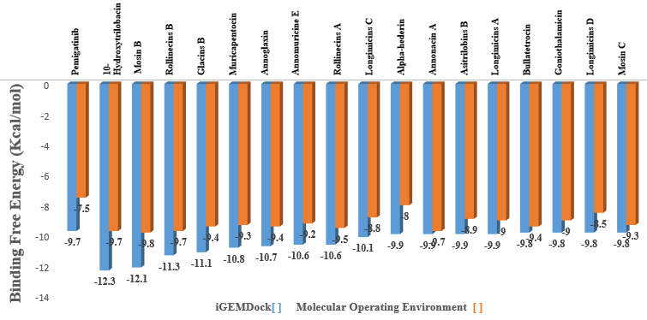
Figure 2: Binding energies of Pemigatinib and the 17 hit compounds on iGEMDock and Molecular Operating Environment.
As shown in Table 1, pemigatinib exhibited a binding energy of −9.7 kcal/mol in iGEMDock and −7.5 kcal/mol in MOE, establishing a benchmark for comparative purposes. Of 67 screened phytochemicals, 17 compounds demonstrated better inhibitory activity, with binding energy scores less than Pemigatinib in both docking systems. Notably, 10-Hydroxytrilobacin showed the strongest binding affinity at −12.3 kcal/mol (iGEMDock) and −9.7 kcal/mol (MOE), followed by Mosin B, which had −12.1 kcal/mol and −9.8 kcal/mol, respectively. High-scoring ligands also included Rollinecins B (−11.3/−9.7 kcal/mol), Glacins B (−11.1/−9.4 kcal/mol), and Muricapentocin (−10.8/−9.3 kcal/mol), as shown in Figure 2. These findings suggest that the top 17 phytochemicals have stronger binding affinities for the FGFR1 active site than Pemigatinib, indicating a greater inhibitory effect. In both docking tools, these ligands showed stable conformations with favorable interactions at key amino acid residues, demonstrating high affinity but also structural compatibility between the ligand and the kinase pocket.
The superior binding affinities for 10-hydroxytrilobacin and mosin B are consistent with previous studies on the antitumor activity of acetogenins and flavonoids derived from Annonaceae, which have been reported to interact with FGFR-related pathways with high affinities [10,43]. These findings also corroborate findings from Agu et al. 2023 [40], which highlighted the properties of ligand efficiency and pharmacophore orientation for distinguishing potent FGFR inhibitors among phytoconstituents. Moreover, consistent docking outcomes between iGEMDock and MOE further reinforce the reliability of the selected compounds. The convergence from multiple algorithms reduces false positives and validates the strength of interaction. Although pemigatinib maintained a desirable binding, it was persistently outscored by a subset of phytoconstituents, highlighting the potential of these naturally derived compounds as alternative FGFR1 inhibitors.
3.2 Pharmacokinetic and Toxicological Prediction
3.2.1 Drug-likeness Prediction
Lipinski’s Rule of Five (Ro5) was used to predict oral drug-likeness for the 17 hit compounds identified through molecular docking. According to Ro5, compounds with MW < 500 Da, HBD < 5, HBA < 10, and log P < 5 are more likely to exhibit favorable oral bioavailability and membrane permeability [31]. The evaluation results are summarized in Table 2.
Table 2: Drug-likeness (Rule of 5) evaluation and physicochemical properties of Pemigatinib and the 17 hit bioactive compounds.
Ligands | Molecular  Weight | H-bond donor | H-bond acceptor | Log p | Inference
Compound ID | < 500 | < 5 | < 10 | < 5 | MEET R05
Pemigatinib  (Standard Drug) | 487.2 | 1 | 9 | 1.5 | Accepted
2,4-cis and trans)-gigantecinone | 638.9 | 3 | 5 | 5.1 | Rejected
-4-deoxygigantecin | 622.48 | 3 | 7 | 5.9 | Rejected
-10-Hydroxytrilobacin | 638.48 | 4 | 8 | 4.2 | Accepted
Alpha-hederin | 750 | 7 | 12 | 2.4 | Rejected
Annoglaxin | 610.44 | 4 | 8.0 | 4.2 | Accepted
Annomuricine E | 612.46 | 5.0 | 8.0 | 4.7 | Accepted
Asitrilobins B | 596.47 | 4.0 | 7.0 | 5.1 | Rejected
Glacins B | 638.48 | 4.0 | 8.0 | 4.5 | Accepted
Goniothalamicin | 596.47 | 4.0 | 7.0 | 5.3 | Rejected
Longimicins A | 622.48 | 3.0 | 7.0 | 5.6 | Rejected
Longimicins C | 594.45 | 3.0 | 7.0 | 5.2 | Rejected
Longimicins D | 622.48 | 3.0 | 7.0 | 5.8 | Rejected
Mosin B | 594.45 | 3.0 | 7.0 | 4.9 | Accepted
Mosin C | 594.45 | 3.0 | 7.0 | 5.3 | Rejected
Muricapentocin | 612.46 | 5.0 | 8.0 | 3.6 | Accepted
Rollinecins A | 624.5 | 4.0 | 7.0 | 5.2 | Rejected
Rollinecins B | 624.5 | 4.0 | 7.0 | 5.0 | Accepted

Pemigatinib, used as the standard drug, was acceptable based on these criteria and served as a comparative standard. Among the 17 hit compounds, only seven—10-Hydroxytrilobacin, Glacins B, Mosin B, Rollinecins B, Annomuricine E, Annoglaxin, and Muricapentocin—were acceptable, showing good physicochemical properties. These compounds had molecular weights between 594.4 and 638.4 Da and log P values between 3.6 and 4.9, reflecting an optimal balance between hydrophilic and lipophilic properties, which favors effective intestinal absorption.
In contrast, compounds like alpha-hederin, asitrilobins B, and longimicins A-D (group members) were rejected based on exceeding one or more Ro5 cutoffs. For instance, alpha-hederin exhibited a 750-Da molecular weight and an excessive number of hydrogen bond acceptors and donators, both of which are predictors of poor oral absorption. These observations are consistent with previous findings relating high molecular weight and high hydrogen bonding capacity to poor membrane permeability and bioavailability [34,44]. The use of Ro5 thus served as a preliminary filter, reducing the pool of drug candidates to seven compounds with optimum physicochemical properties. These compounds were subsequently subjected to pharmacokinetic and toxicity evaluations, since their physicochemical structures indicate a likelihood for success in oral drug development.
3.2.2 ADMET Prediction
To evaluate the pharmacokinetics and safety of the seven compounds that passed Lipinski’s Rule of Five, ADMET prediction was performed. Pemigatinib, being the standard drug, was used as a reference. This evaluation was done to identify compounds with optimal drug-like behavior suitable for oral administration

and systemic activity. Predictions were generated with a focus on key drivers that influence drug absorption, bioavailability, metabolic interaction, clearance, and toxicological safety. The results are shown in Table 3.

Table 3: ADMET properties of Pemigatinib and the 7 hit bioactive compounds.
Ligands | Absorption |  |  | Distribution | Metabolism |  |  |  |  | Excretion |  | Toxicity
Compound Identifier | Caco2 permeability | Human Intestinal absorption | P-glycoprotein Inhibitor | Blood Brain Barrier | CYP2D6 | CYP3A4 | CYP1A2 | CYP2C19  CYP2C19 | CYP2C9 | Half-life | Total Clearance | Nephrotoxicity | Acute oral toxicity | AMES toxicity | Carcinogenicity | HERG inhibitor | Hepatoxicity | Hema toxicity
Pemigatinib  (Standard Drug) | R | G | G | B | G | B | G | G | B | 1.3 | B | R | R | R | R | R | R | B
-10-Hydroxytrilobacin | G | G | G | G | G | G | G | G | G | 0.9 | G | G | G | B | G | G | G | G
Annoglaxin | R | G | G | G | G | R | G | R | G | 1.4 | B | R | G | G | B | B | R | G
Annomuricine E | R | G | G | G | G | G | G | G | G | 1.1 | B | R | G | B | B | B | R | G
Glacins B | G | G | G | G | G | G | G | G | G | 1.1 | B | G | G | B | B | B | R | G
Mosin B | G | G | G | G | G | G | G | G | G | 1.0 | G | G | G | G | B | G | B | G
Muricapentocin | R | G | G | G | G | B | G | G | G | 1.1 | B | R | G | G | G | B | R | G
Rollinecins B | G | G | G | G | G | G | G | G | G | 1.2 | B | B | G | G | B | B | B | G
Where G = Excellent B = Medium R = Poor

In terms of absorption and distribution, four compounds—10-Hydroxytrilobacin, Glacins B, Mosin B, and Rollinecins B—exhibited excellent Caco-2 permeability and high human intestinal absorption (HIA), suggesting strong potential for oral bioavailability potential. On the contrary, reduced Caco-2 permeability was observed for Annoglaxin, Annomuricine E, and Muricapentocin, which indicates that their passive diffusion across intestinal membranes may be restricted. However, they still exhibited acceptable HIA, but less than optimal. No compound was found to be predicted to be an inhibitor of P-glycoprotein, which means they are likely to be less subject to rapid efflux, which is desirable for effective intracellular retention.
Metabolism profiling for interaction between the compounds and major cytochrome P450 (CYP) enzymes, specifically CYP2D6, CYP3A4, CYP1A2, and CYP2C19, was carried out. None of the seven hit compounds and pemigatinib inhibited the isoenzymes, indicating low potential for metabolic drug-drug interactions. This is significant for cancer treatment, as it is common for patients to be administered multiple drugs. For excretion, half-life and total clearance were employed to predict the rate of elimination. All compounds had moderate to excellent clearance values, with 10-Hydroxytrilobacin and Mosin B having desirable half-lives between 0.9 and 1.0, which indicates balanced activity and little chance for accumulation. Muricapentocin and Annoglaxin had slightly longer predicted half-lives, suggesting a slower rate for elimination, but still within acceptable limits.
Toxicological screening showed that 10-Hydroxytrilobacin, Glacins B, Mosin B, and Rollinecins B consistently presented low toxicity profiles, having no predicted nephrotoxicity, hepatotoxicity, hematotoxicity, or mutagenicity (AMES test negative). These compounds also lacked carcinogenic potential and had no human ether-a-go-go-related gene (hERG) inhibition, which minimized concerns for cardiac toxicity. In comparison, Annoglaxin and Muricapentocin showed borderline hepatotoxicity and nephrotoxicity, warranting cautious interpretation. Annomuricine E showed mild risks for hematotoxicity but was non-mutagenic and non-carcinogenic. Pemigatinib, while generally safe, showed mild concerns for hepatotoxicity and hematotoxicity, which aligns with previously reported side effects observed in clinical use [41]. While pharmacokinetics and safety profiles for the seven hit compounds uniformly showed acceptability, 10-Hydroxytrilobacin, Glacins B, Mosin B, and Rollinecins B emerged as the most promising candidates. Their high absorption, low risk for efflux, safe metabolism, effective excretion, and low toxicity are consistent with existing literature highlighting the therapeutic role for plant-derived FGFR1 inhibitors [33,45].
3.3 Molecular Mechanics
To further validate and narrow down the choice of lead compounds, MM-GBSA calculations were conducted. The four identified hit compounds from ADMET screening—10-Hydroxytrilobacin, Mosin B, Rollinecins B, and Glacins B—were further evaluated using MM-GBSA, along with Pemigatinib, to determine which compounds have the best energetic profiles for FGFR1 inhibition. As shown in Table 4 and Fig. 3b, 10-Hydroxytrilobacin and Mosin B exhibited the best overall MM-GBSA binding free energy values at −47.63 kcal/mol and −45.09 kcal/mol, respectively, better than Pemigatinib (−31.01 kcal/mol). The superior binding energies can largely be attributed to strong van der Waals interactions (−52.36 kcal/mol for 10-Hydroxytrilobacin and −56.34 kcal/mol for Mosin B) and favorable polar solvation energies (40.61 and 49.00 kcal/mol, respectively). Rollinecins B and Glacins B also exhibited significant binding energy values at −41.82 kcal/mol and −33.04 kcal/mol, indicating considerable ligand-receptor stability. In comparison to pemigatinib, which had lower van der Waals interaction (−44.84 kcal/mol) and higher destabilizing solvation energy (31.77 kcal/mol), the phytochemicals demonstrated enhanced binding suitability.
Table 4: MM-GBSA binding free energies of Pemigatinib and the 4 hit bioactive compounds.
Ligands | MMGBSA ΔG  Bind H-bond  (Kcal/mol) | MMGBSA ΔG  Bind Covalent bond  (Kcal/mol) | MMGBSA ΔG  Bind Vander Waal Forces  (Kcal/mol) | MMGBSA ΔG  Bind Polar Solvation  (Kcal/mol) | MMGBSA ΔG  Overall Binding  Energy (Kcal/mol)
Pemigatinib | -1.11 | 3.36 | -44.84 | 31.77 | -31.01
10-Hydroxytrilobacin | -3.62 | 10.42 | -52.36 | 40.61 | -47.63
Mosin B | -2.36 | 7.84 | -56.34 | 49.00 | -45.09
Rollinecins B | -2.01 | 5.96 | -52.77 | 50.27 | -41.82
Glacins B | -1.47 | 2.13 | -46.40 | 53.44 | -33.04

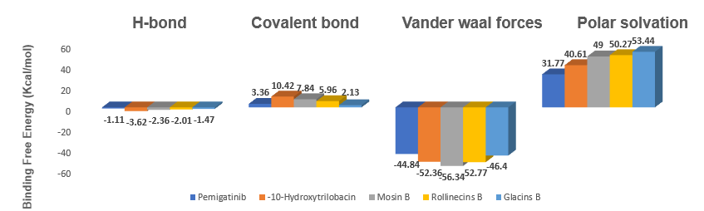
Figure 3a: MMGBSAΔG Bind H-bond, Covalent bond, Vander waal forces, and Polar solvation of Pemigatinib and the 4 hit bioactive compounds in Maestro 12.5
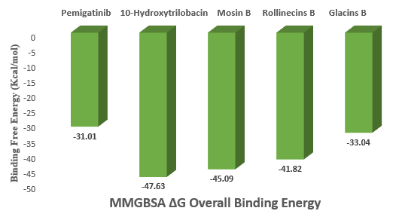
Figure 3b: MMGBSAΔG overall binding energy for Pemigatinib and the 4 hit bioactive compounds in Maestro 12.5.
Detailed interaction mapping between each ligand with the FGFR1 kinase domain (PDB ID: 7WCL) further substantiates the binding energy findings. As illustrated in Table 5 and Figure 4, 10- Hydroxytrilobacin established key hydrogen bonds with Gly567 and Asn628 and further interactions through Leu484, Tyr563, Ala564, Ser565, Asn568, Glu571, and Arg627, thus its position within the active site. Mosin B formed hydrogen bonds with Glu57 and Arg576 and extensive hydrophobic and polar interactions through residues like Leu484, Val492, Lys514, Tyr572, Gln574, Arg577, and Ala640. Rollinecins B formed a hydrogen bond interaction through Gly487 and additional van der Waals and polar contact with residues including Cys488, Lys514, Ala575, and Asp641, among others. Glacins B formed a hydrogen bond with Ser723, alongside interactions with Trp691, Asp720, Lys721, Pro722, and Cys725, most of which overlap those observed in Pemigatinib binding. Pemigatinib formed hydrogen bonds with His717 and Ser723, in addition to hydrophobic interactions through Arg577, Gly580, Thr695, and Asp720, confirming its modest binding affinity. These findings are consistent with previous research demonstrating that MM-GBSA enhances computational/experimental binding data correlation through solvation effects and enthalpic incorporation [47,48].
Table 5: Binding affinities, interactions, and 3D structures of Pemigatinib and the 4 lead bioactive compounds.
Compound  Identifier | H-bond interaction | Other  Interactions | 3-D structure
Pemigatinib | His 717,  Ser 723. | Arg577, Pro578, Pro579, Gly580, Trp691, Thr695, Leu696, Gly698, Ser699, Pro702, Met719 Asp720, Pro722. | 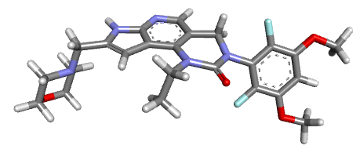
-10-Hydroxytrilobacin | Gly567, Asn 628. | Leu484, Tyr563, Ala564, Ser565, Asn568, Glu571, Asp623, Arg627, Leu630, Lys655, Lys656, Thr657, Thr658, Pro663. | 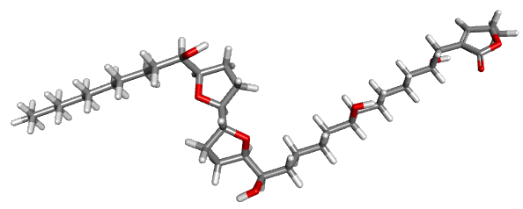
Mosin B | Glu57, Arg576. | Leu484, Glu486, Val492, Lys514, Ile545, Val561, Lys566, Gly567, Tyr572, Gln574, Ala575, Arg577, Pro578, Pro579, Leu630, Ala640, Asp641. | 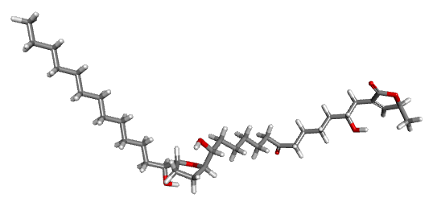
Rollinecins B | Gly 487. | Leu484, Glu486, Cys488, Ala512, Lys514, Glu531, Ile545, Val561, Gly567, Asn568, Glu571, Gln574, Ala575, Arg577, Val592, Leu630, Ala640, Asp641, Gly698, Ser699, Pro702. | 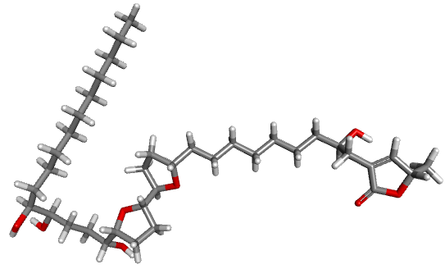
Glacin B | Ser723. | Ser597, Leu600, Trp691, Phe694, Thr695, Leu696, Asp720, Lys721, Pro722, Asn724, Cys725. | 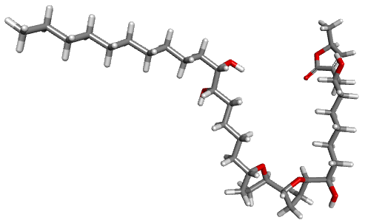

(4a)
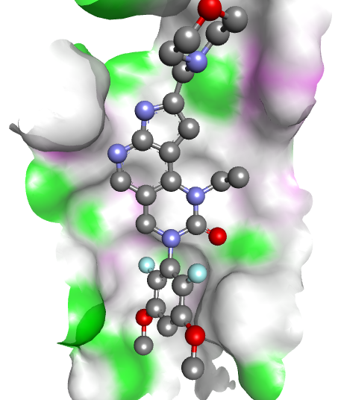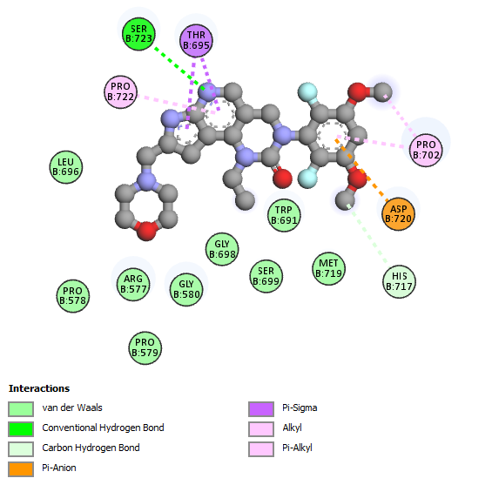

7WCL_PEMIGATINIB

(4b)

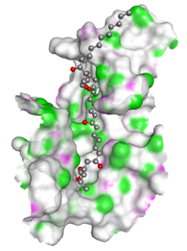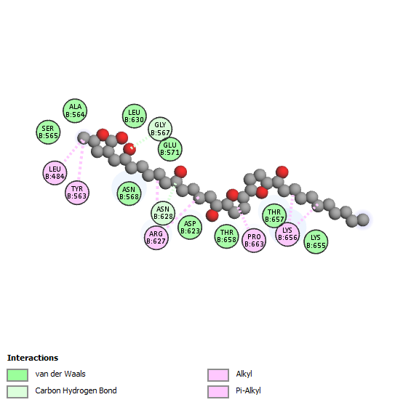

7WCL_10-HYDROXYTRILOBACIN
(4c)
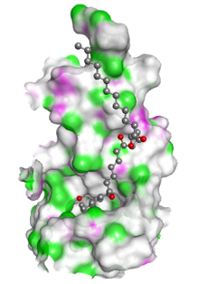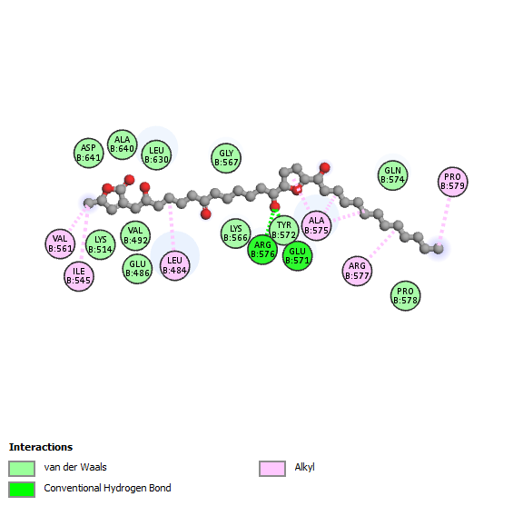

7WCL_MOSIN B

(4d)
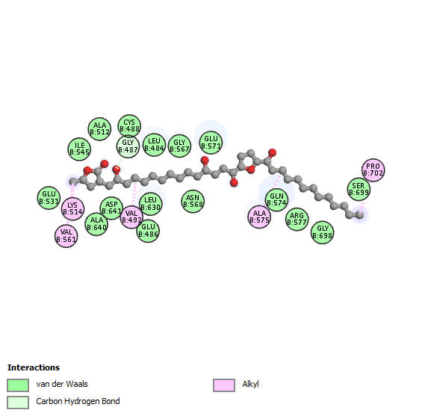

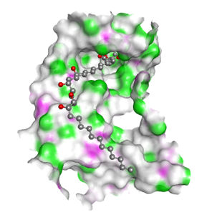

8R3Q_ ROLLINECINS B
(4e)
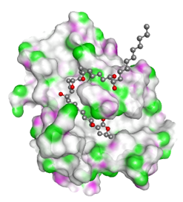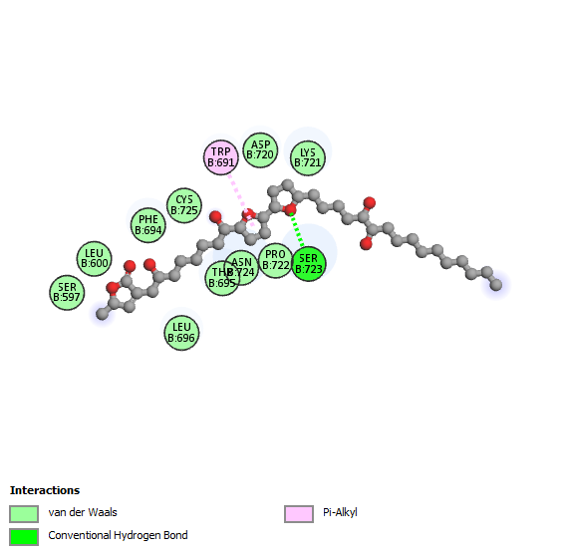

7WCL_GLACIN B

Figure 4. Molecular interaction between Pemigatinib and the 4 hit bioactive compounds at the active site of fibroblast growth factor receptor 1 (7WCL) (A) Pemigatinib (Standard drug) (b) 10-hydroxytrilobacin (c) Mosin B (d) Rollinecins B (e) Glacin B. The structures were rendered using Biovia Discovery Studio 2021.

3.4 Selection of Lead Compounds for Molecular Dynamics Simulation
Following comprehensive structure- and ligand-based virtual screening, involving molecular docking, MM-GBSA binding energy calculations, drug-likeness filtering based on Lipinski’s Rule of Five, and ADMET prediction, 10-Hydroxytrilobacin and Mosin B, two phytochemicals, were prioritized for Molecular Dynamics (MD) simulation. These compounds exhibited exceptional pharmacokinetics, potent FGFR1 binding affinities, and strong network interactions, surpassing the standard, Pemigatinib, across multiple in silico evaluations. These compounds were further justified by favorable MM-GBSA scores, most notably derived through van der Waals and polar solvation interactions.
3.5 Molecular Dynamics (MD)
MD simulation was conducted over a 100 ns trajectory using GROMACS to estimate the structural stability, flexibility, compactness, and binding interactions of Pemigatinib, 10-Hydroxytrilobacin, and Mosin B within the FGFR1 kinase domain. The complexes' stability was examined using crucial metrics: RMSD, RMSF, hydrogen bonds, and RoG.
Table 6: Average values of RMSD, RMSF, H-bond, and RoG of all simulated complexes
Compound Identifier | Average RMSD  values (nm) | Average RMSF  values (nm) | Average  RoG  values (nm) | Average  H-bond  values (nm)
Pemigatinib | 0.385 | 0.155 | 2.077 | 0.729
10-Hydroxytrilobacin | 0.392 | 0.168 | 2.065 | 1.039
Mosin B | 0.387 | 0.159 | 2.048 | 1.669

3.5.1 RMSD
RMSD measures the average deviation in atomic positions of the protein–ligand complex over time and is a direct indicator of structural stability. From the data presented in Table 6 and Figure 5a, all three compounds maintained stable RMSD values from 20 ns to 100 ns simulation. Mosin B had an average RMSD of 0.387 nm, which was more than Pemigatinib (0.385 nm) and slightly lower than 10-Hydroxytrilobacin (0.392 nm). These low values indicate that all the ligand–protein complexes were structurally stable. Such minimal deviations indicate high binding affinity and structural stability, as observed with molecular docking as well as MM-GBSA analysis.
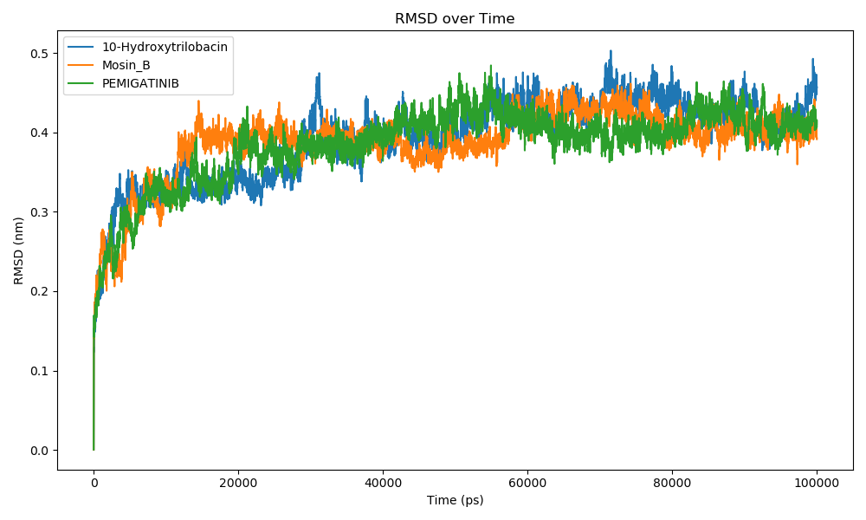
Figure 5a: RMSD Plot Showing the Stability of Pemigatinib, 10-Hydroxytrilobacin, and Mosin B Over 100 ns of Molecular Dynamics Simulation
3.5.2 RMSF
RMSF evaluates the flexibility of individual amino acid residues during simulation, providing insight into the effect of ligand binding on the local protein movement. From Table 6 and the graphical data shown in Figure 5b, Mosin B showed the lowest average RMSF (0.159 nm), followed by Pemigatinib (0.155 nm) and 10-Hydroxytrilobacin (0.168 nm). Notably, reduced mobility was observed at key binding site residues, particularly Gly567 and Arg576, within the Mosin B complex. This indicates that these residues are well-stabilized by the ligand, which supports Mosin B’s strong and reliable binding interaction with FGFR1.
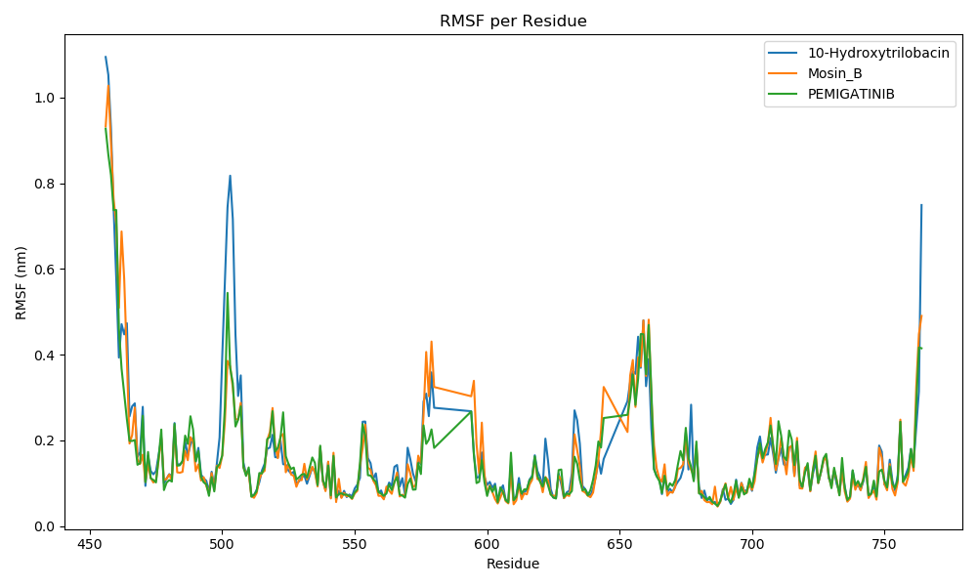
Figure 5b: RMSF Plot Showing the Stability of Pemigatinib, 10-Hydroxytrilobacin, and Mosin B Over 100 ns of Molecular Dynamics Simulation
3.5.3 H-bonding
Hydrogen bonding contributes significantly to the strength of ligand binding and overall stability of the complex. As illustrated in Table 6 and Figure 5d, the highest average number of hydrogen bonds was formed by Mosin B (1.669), followed by 10-Hydroxytrilobacin (1.039) and Pemigatinib (0.729). The higher number of stable hydrogen bonds for Mosin B and 10-Hydroxytrilobacin indicates a stronger and more persistent interaction with FGFR1 during the 100 ns simulation. This observation is further supported by MM-GBSA analysis, which identified numerous key polar contacts, including interactions involving Arg576, Tyr572, and Glu57 residues. Stable hydrogen interaction is usually associated with higher inhibitory activity and lower conformational drift.
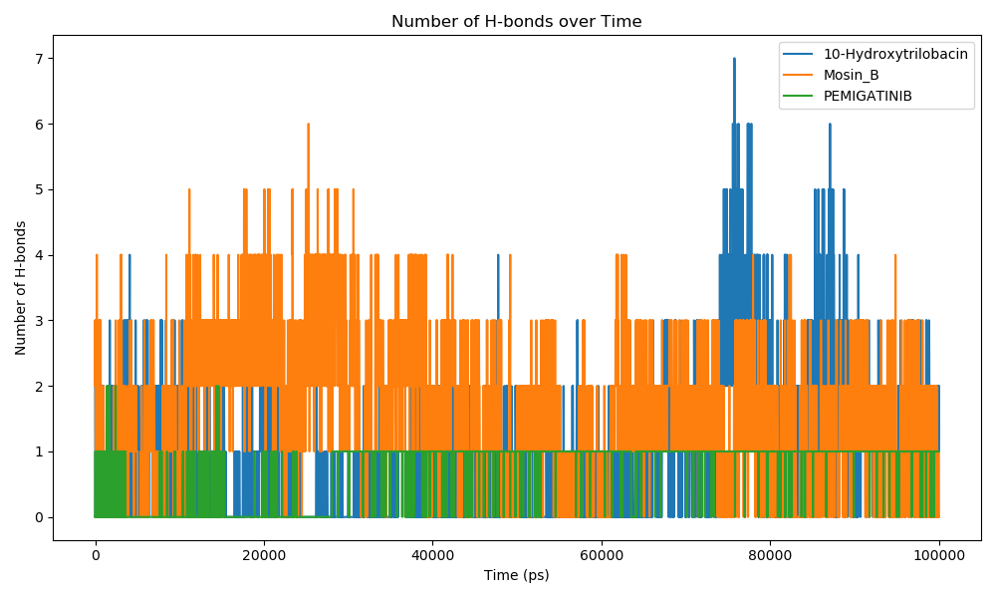
Figure 5c: H-bonding Plot Showing the Stability of Pemigatinib, 10-Hydroxytrilobacin, and Mosin B Over 100 ns of Molecular Dynamics Simulation
3.5.4 RoG
RoG measures the compactness of a protein–ligand complex; a lower RoG indicates a more tightly packed and stable complex. Figure 5c and Table 6 indicate that the three complexes had RoG values consistent throughout the 100 ns simulation. Mosin B had the lowest average RoG (2.048 nm), followed by 10-Hydroxytrilobacin (2.065 nm) and Pemigatinib (2.077 nm). Lower RoG values for the two lead compounds (phytochemicals) indicate that their presence in the binding pocket contributes to a more compact and stable FGFR1 conformation than pemigatinib.
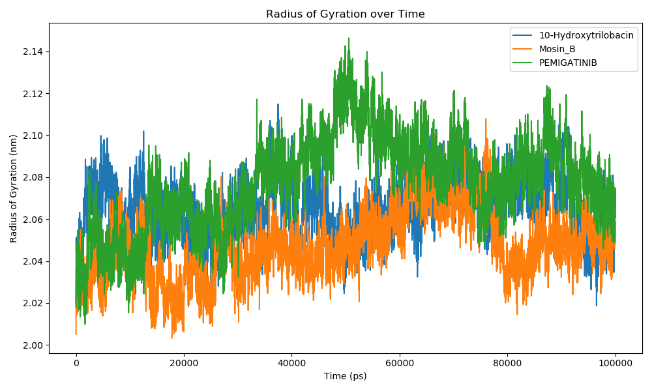
Figure 5d: RoG Plot Showing the Stability of Pemigatinib, 10-Hydroxytrilobacin, and Mosin B Over 100 ns of Molecular Dynamics Simulation

4.0 CONCLUSION
This study evaluated 67 plant-derived phytochemicals sourced from the NPACT database for their inhibitory potential against fibroblast growth factor receptor 1 (FGFR1), a key therapeutic target in bile duct cancer therapy. Through a comprehensive in silico pipeline involving molecular docking, drug-likeness screening, ADMET profiling, MM-GBSA, and MD simulations, 10-Hydroxytrilobacin and Mosin B emerged as lead phytochemical FGFR1 inhibitors. These bioactive compounds showed better binding affinity, enhanced dynamic stability, and acceptable pharmacokinetic and safety profiles compared to the standard drug Pemigatinib. Their strong hydrogen bonding, minimal conformational drift, and compact binding mode within the kinase domain further support their potential as therapeutic candidates. These findings provide a strong foundation for future experimental validation and optimization, potentially contributing to the development of novel, plant-based therapeutics for bile duct cancer treatment.

HIGHLIGHTS
- Bile duct cancer is an aggressive malignancy with limited treatment options
- FGFR1 serves as a key oncogenic driver in bile duct cancer progression
- 67 phytochemicals were screened as FGFR1 inhibitors using in-silico approaches
- 7 compounds showed better inhibitory and pharmacokinetic profiles than Pemigatinib
- Mosin B and 10-Hydroxytrilobacin are promising leads for bile duct cancer therapy

DECLARATION OF GENERATIVE AI AND AI-ASSISTED TECHNOLOGIES IN THE WRITING PROCESS
The authors acknowledge the use of generative AI technologies during the preparation and editing of this manuscript. Specifically, Grammarly’s paraphrasing and grammar-checking tools were utilized to enhance the clarity, coherence, and grammatical accuracy of the text. These tools were applied to refine sentence structure, streamline ideas, and ensure the manuscript adhered to high linguistic standards.
Details of AI Usage:
- Generative AI Tool Used: Grammarly Paraphrasing and Grammar Checking Tool
- Purpose of Usage: To improve paraphrasing, summarization, and grammatical accuracy throughout the manuscript.
- Prompts Used: The authors provided original content, particularly sections such as the Methodology and Results, for Grammarly to refine in terms of grammar and coherence.
Following the use of these tools, the authors meticulously reviewed and edited the content to ensure it met the scientific rigor and accuracy required for publication. The authors take full responsibility for the integrity, originality, and quality of the final manuscript.

AVAILABILITY OF DATA AND MATERIALS
The data are available on request.
ETHICS APPROVAL AND CONSENT TO PARTICIPATE
This study involved in-silico evaluation and did not require ethical approval or informed consent, as no human or animal subjects were involved. All secondary data utilized, including structural and pharmacokinetic information, were obtained from publicly accessible and peer-reviewed scientific databases and properly cited to ensure academic integrity.
CONSENT FOR PUBLICATION
Not applicable.
LIMITATIONS
As the study was computational and self-funded, no experimental validation using synthesis and characterization, in vitro and in vivo assays of Mosin B and 10-Hydroxytrilobacin, could be performed.
DECLARATION OF COMPETING INTEREST
The authors declare no known competing financial interests or personal relationships that could have influenced the work reported in this study.
DATA AVAILABILITY
The datasets analyzed during the research are available upon request.

GLOSSARY
Abbreviation | Meaning
2D | Two-Dimensional
3D | Three-Dimensional
ADMET | Absorption, Distribution, Metabolism, Excretion, and Toxicity
AMBER | Assisted Model Building with Energy Refinement (Force Field)
AMES  BBB | Ames Mutagenicity Test  Blood Brain Barrier
CASTp | Computed Atlas of Surface Topography of Proteins
CADD | Computer-Aided Drug Design
CHARMM36 | Chemistry at HARvard Macromolecular Mechanics (Force Field)
CYP | Cytochrome P450
FGFR1 | Fibroblast Growth Factor Receptor 1
GROMACS | Groningen Machine for Chemical Simulations
HBA | Hydrogen Bond Acceptors
HBD | Hydrogen Bond Donors
hERG | Human Ether-à-go-go Related Gene
iGEMDock | Generic Evolutionary Method for Molecular Docking
LogP | Logarithm of Octanol-Water Partition Coefficient
MD | Molecular Dynamics
MM-GBSA | Molecular Mechanics Generalized Born Surface Area
MOE | Molecular Operating Environment
MW | Molecular Weight
NPACT | Naturally Occurring Plant-Based Anti-Cancerous Therapeutics
NPT | Constant Number of Particles, Pressure, and Temperature (Ensemble)
NVT | Constant Number of Particles, Volume, and Temperature (Ensemble)
PDB | Protein Data Bank
pkCSM | Pharmacokinetics of Small Molecules
RoG | Radius of Gyration
RMSD | Root Mean Square Deviation
RMSF | Root Mean Square Fluctuation
Ro5 | Rule of Five
SBDD | Structure-Based Drug Design
SPC | Simple Point Charge (Water Model)
REFERENCES
[1] Brindley, P. J., Bachini, M., Ilyas, S. I., Khan, S. A., Loukas, A., Sirica, A. E., ... and
Gores, G. J. (2021). Cholangiocarcinoma. Nature Reviews Disease Primers, 7(1), 65.
https://doi.org/10.1038/s41572-021-00300-2
[2] Vij, M., Puri, Y., Rammohan, A., Rajalingam, R., Kaliamoorthy, I., and Rela, M. (2022).
Pathological, molecular, and clinical characteristics of cholangiocarcinoma: A
comprehensive review. World Journal of Gastrointestinal Oncology, 14(3), 607.
https://dx.doi.org/10.4251/wjgo.v14.i3.607
[3] Abou-Alfa, G. K., Jarnagin, W., El Dika, I., D'Angelica, M., Lowery, M., Brown, K., ...
and O'Reilly, E. M. (2020). Liver and bile duct cancer. In Abeloff's Clinical Oncology (pp.
1314-1341). Elsevier. https://doi.org/10.1016/B978-0-323-47674-4.00077-3
[4] Lauterio, A., De Carlis, R., Centonze, L., Buscemi, V., Incarbone, N., Vella, I., and De
Carlis, L. (2021). Current surgical management of peri-hilar and intra-hepatic
cholangiocarcinoma. Cancers, 13(15), 3657. https://doi.org/10.3390/cancers13153657
[5] de Meira Júnior, J. D., and Rosado, I. D. (2024). Perihilar cholangiocarcinoma.
In Illustrative Handbook of General Surgery (pp. 487-497). Cham: Springer Nature
Switzerland. https://doi.org/10.1007/978-3-031-63878-7_40
[6] Wang, K., Jin, X., Zhou, J., Wang, Z., and Zhang, X. (2024). Differences in the diagnosis
and treatment of patients with early-stage hepatocellular liver cancer by multi-row spiral
CTMDCT and Gd-EOB-DTPA-enhanced MRI. Alternative Therapies in Health and
Medicine, 30(1). https://doi.org/10.3892/ol.2024.14729
[7] Lee, D. H., Kim, B., Lee, J. M., Lee, E. S., Choi, M. H., and Kim, H. (2022). Multidetector
CT of extrahepatic bile duct cancer: Diagnostic performance of tumor resectability and
interreader agreement. Radiology, 304(1), 96-105. https://doi.org/10.1148/radiol.212132
[8] Fancellu, A., Sanna, V., Deiana, G., Ninniri, C., Turilli, D., Perra, T., and Porcu, A. (2021).
Current role of hepatopancreatoduodenectomy for the management of gallbladder cancer
and extrahepatic cholangiocarcinoma: A systematic review. World Journal of
Gastrointestinal Oncology, 13(6), 625. https://doi.org/10.4251/wjgo.v13.i6.625
[9] Melo-Alvim, C., Neves, M. E., Santos, J. L., Abrunhosa-Branquinho, A. N., Barroso, T.,
Costa, L., and Ribeiro, L. (2022). Radiotherapy, chemotherapy and immunotherapy—
current practice and future perspectives for recurrent/metastatic oral cavity squamous cell
carcinoma. Diagnostics, 13(1), 99. https://doi.org/10.3390/diagnostics13010099
[10] Goyal, L., Kongpetch, S., Crolley, V. E., and Bridgewater, J. (2021). Targeting FGFR
inhibition in cholangiocarcinoma. Cancer Treatment Reviews, 95, 102170.
https://doi.org/10.1016/j.ctrv.2021.102170
[11] Krook, M. A., Reeser, J. W., Ernst, G., Barker, H., Wilberding, M., Li, G., ... and
Roychowdhury, S. (2021). Fibroblast growth factor receptors in cancer: Genetic
alterations, diagnostics, therapeutic targets and mechanisms of resistance. British Journal
of Cancer, 124(5), 880-892. https://doi.org/10.1038/s41416-020-01157-0
[12] Marseglia, G., Lodola, A., Mor, M., and Castelli, R. (2019). Fibroblast growth factor
receptor inhibitors: Patent review (2015–2019). Expert Opinion on Therapeutic
Patents, 29(12), 965-977. https://doi.org/10.1080/13543776.2019.1688300
[13] Agrawal, S., Maity, S., AlRaawi, Z., Al-Ameer, M., and Kumar, T. K. S. (2021). Targeting
drugs against fibroblast growth factor(s)-induced cell signaling. Current Drug
Targets, 22(2), 214-240. https://doi.org/10.2174/1389450121999201012201926

[14] Wang, H., Chen, M., Sang, X., You, X., Wang, Y., Paterson, I. C., ... and Yang, X. (2020).
Development of small molecule inhibitors targeting TGF-β ligand and receptor:
Structures, mechanism, preclinical studies and clinical usage. European Journal of
Medicinal Chemistry, 191, 112154. https://doi.org/10.1016/j.ejmech.2020.112154
[15] Asma, S. T., Acaroz, U., Imre, K., Morar, A., Shah, S. R. A., Hussain, S. Z., ... and Ince,
S. (2022). Natural products/bioactive compounds as a source of anticancer
drugs. Cancers, 14(24), 6203. https://doi.org/10.3390/cancers14246203
[16] Shukla, S., and Mehta, A. (2015). Anticancer potential of medicinal plants and their
phytochemicals: A review. Brazilian Journal of Botany, 38, 199-210.
https://doi.org/10.1007/s40415-015-0135-0
[17] Paul, J. K., Azmal, M., Haque, A. S. N. B., Talukder, O. F., Meem, M., and Ghosh, A.
(2024). Phytochemical-mediated modulation of signaling pathways: A promising avenue
for drug discovery. Advances in Redox Research, 100113.
https://doi.org/10.1016/j.arres.2024.100113
[18] Chaachouay, N., and Zidane, L. (2024). Plant-derived natural products: A source for drug
discovery and development. Drugs and Drug Candidates, 3(1), 184-207.
https://doi.org/10.3390/biomedicines12010201
[19] Atanda, O. E., Olaniyan, L. W. B., Fadare, O. A., Ehigie, A. F., Adisa, T. A., Odunitan, T.
T., Alabi, O. T., Omonijo, B. A., Aloba, G. O., and Ehigie, L. O. (2024). “In-silico
evaluation of phenylisocytosine and its analogs as potent inhibitors of Plasmodium
falciparum transketolase: A strategic approach in anti-malarial drug discovery”.
International Journal of Biochemistry Research and Review, 33 (6):616-36.
https://doi.org/10.9734/ijbcrr/2024/v33i6941.
[20] Almoyad, M. A. A., Wahab, S., Ansari, M. N., Ahmad, W., Hani, U., and Chandra, S.
(2024). Predictive insights into plant-based compounds as fibroblast growth factor
receptor 1 inhibitors: A combined molecular docking and dynamics simulation
study. Journal of Biomolecular Structure and Dynamics, 1-10.
https://doi.org/10.1080/07391102.2024.2335297
[21] Mangal, M., Sagar, P., Singh, H., Raghava, G. P., and Agarwal, S. M. (2013). NPACT:
Naturally occurring plant-based anti-cancer compound-activity-target database. Nucleic
Acids Research, 41(D1), D1124-D1129. https://doi.org/10.1093/nar/gks1047
[22] Kim, Y., Song, J., Kim, N., and Sim, T. (2025). Recent progress in emerging molecular
targeted therapies for intrahepatic cholangiocarcinoma. RSC Medicinal Chemistry.
https://doi.org/10.1039/D4MD00881B
[23] Olaniyan, L. W. B., Ehigie, L. O., Ehigie, A. F., Atanda, O.E., Odunitan, T. T., and
Fakuade, A. A. (2024). In silico investigation of indenoimidazole derivatives as promising
arsenal against methicillin resistant staphylococcus aureus through staphylococcal protein
A inhibition. European Journal of Biomedical, 11(6), 04-16. Issn 2349-8870
[24] O'Boyle, N. M., Banck, M., James, C. A., Morley, C., Vandermeersch, T., and Hutchison,
G. R. (2011). Open babel: An open chemical toolbox. Journal of Cheminformatics, 3(1),
1-14. https://doi.org/10.1186/1758-2946-3-33
[25] Huey, R., Morris, G. M., and Forli, S. (2012). Using AutoDock 4 and AutoDock vina
with AutoDockTools: A tutorial. The Scripps Research Institute Molecular Graphics
Laboratory, 10550(92037), 1000. http://vina.scripps.edu.
[26] Hsu, K. C., Chen, Y. F., Lin, S. R., and Yang, J. M. (2011). iGEMDOCK: A graphical
environment of enhancing GEMDOCK using pharmacological interactions and post-
screening analysis. BMC Bioinformatics, 12, 1-11.
https://doi.org/10.1186/1471-2105-12-S1-S33
[27] Scholz, C., Knorr, S., Hamacher, K., and Schmidt, B. (2015). DOCKTITE A highly
versatile step-by-step workflow for covalent docking and virtual screening in the
molecular operating environment. Journal of Chemical Information and
Modeling, 55(2), 398-406. https://doi.org/10.1021/ci500681r
[28] Oyedele, A. Q. K., Adelusi, T. I., Ogunlana, A. T., Adeyemi, R. O., Atanda, O. E.,
Babalola, M. O., .. and Boyenle, I. D. (2022). Integrated virtual screening and molecular
dynamics simulation revealed promising drug candidates of p53-MDM2 interaction.
Journal of Molecular Modeling, 28(6), 142.https://doi.org/10.1007/s00894-022-05131-w
[29] Ajao, F. O., Ehigie, A. F., Odunitan, T. T., Atanda, O. E., Ayoola, P. B., and Olaniyan, L.
W. (2024). Computational exploration of psidii guajavae folium bioactive compounds as
novel Dpp-Iv inhibitors for type 2 diabetes mellitus intervention. Issn 2394-3211
[30] Lipinski, C. A. (2004). Lead-and drug-like compounds: The rule-of-five revolution. Drug
Discovery today: Technologies, 1(4), 337-341.
https://doi.org/10.1016/j.ddtec.2004.11.007
[31] Chen, X., Li, H., Tian, L., Li, Q., Luo, J., and Zhang, Y. (2020). Analysis of the
physicochemical properties of acaricides based on Lipinski's rule of five. Journal of
Computational Biology, 27(9), 1397-1406. https://doi.org/10.1089/cmb.2019.0323
[32] Fu, L., Shi, S., Yi, J., Wang, N., He, Y., Wu, Z., ... and Cao, D. (2024). ADMETlab 3.0:
An updated comprehensive online ADMET prediction platform enhanced with broader
coverage, improved performance, API functionality and decision support. Nucleic Acids
Research, gkae236. https://doi.org/10.1093/nar/gkae236
[33] Pires, D. E., Blundell, T. L., and Ascher, D. B. (2015). pkCSM: predicting small-molecule
pharmacokinetic and toxicity properties using graph-based signatures. Journal of
Medicinal Chemistry, 58(9), 4066-4072. https://doi.org/10.1021/acs.jmedchem.5b00104
[34] Daoud, N. E. H., Borah, P., Deb, P. K., Venugopala, K. N., Hourani, W., Alzweiri, M., ...
and Tiwari, V. (2021). ADMET profiling in drug discovery and development: Perspectives
of in silico, in vitro and integrated approaches. Current Drug Metabolism, 22(7), 503-
522. https://doi.org/10.2174/1389200222666210705122913
[35] Babalola, M. O., Ashiru, M. A., Boyenle, I. D., Atanda, E. O., Oyedele, A. Q. K., Dimeji,
I. Y., ... and Imaga, N. A. (2022). In vitro analysis and molecular docking of gas
chromatography-mass spectroscopy fingerprints of polyherbal mixture reveals significant
antidiabetic miture. Nigerian Journal of Experimental and Clinical Biosciences, 10(4),
105-115. https://doi.org/10.4103/njecp.njecp_15_22
[36] Kehinde, O. A. Q., Boyenle, D. I., Ogunlana, A., Ayoola, M. A., Atanda, O.E., and Adelusi,
T.I. (2022). Inhibitors of α-glucosidase and angiotensin-converting enzyme in the
treatment of type 2 diabetes and its complications: A review on in silico
approach. Pharmaceutical and Biomedical Research, 8(4), 237-258.
http://dx.doi.org/10.32598/PBR.8.4.1052.1
[37] Shukla, R., and Tripathi, T. (2020). Molecular dynamics simulation of protein and protein–
ligand complexes. Computer-aided Drug Design, 133-161.
https://doi.org/10.1007/978- 981-15-6815-2_7
[38] Majewski, M., and Barril, X. (2020). Structural stability predicts the binding mode of
protein–ligand complexes. Journal of Chemical Information and Modeling, 60(3), 1644-
1651. https://doi.org/10.1021/acs.jcim.9b01062
[39] Komarov, I. V., Bugrov, V. A., Cherednychenko, A., and Grygorenko, O. O. (2024).
Insights into modeling approaches in chemistry: Assessing ligand‐protein binding
thermodynamics based on rigid‐flexible model molecules. The Chemical Record, 24(2),
e202300276. https://doi.org/10.1002/tcr.202300276
[40] Agu, P. C., Afiukwa, C. A., Orji, O. U., Ezeh, E. M., Ofoke, I. H., Ogbu, C. O., ... and
Aja, P. M. (2023). Molecular docking as a tool for the discovery of molecular targets of
nutraceuticals in diseases management. Scientific Reports, 13(1), 13398.
https://doi.org/10.1038/s41598-023-40160-2
[41] Liu, P. C., Koblish, H., Wu, L., Bowman, K., Diamond, S., DiMatteo, D., ... and Hollis,
G. (2020). INCB054828 (pemigatinib), a potent and selective inhibitor of fibroblast
growth factor receptors 1, 2, and 3, displays activity against genetically defined tumor
models. PloS one, 15(4), e0231877. https://doi.org/10.1371/journal.pone.0231877
[42] Modh, D. H., Modi, S. J., Deokar, H., Yadav, S., and Kulkarni, V. M. (2022). Fibroblast
growth factor receptor (FGFR) inhibitors as anticancer agents: 3D-QSAR, molecular
docking and dynamics simulation studies of 1, 6-naphthyridines and pyridopyrimidines.
Journal of Biomolecular Structure and Dynamics, 41(8), 3591–3606.
https://doi.org/10.1080/07391102.2022.205320
[43] Osunnaya, S. A., Ndarawit, W. K., Aderibigbe, I., Omolopo, I. A., Aribisala, P. O.,
Oluwasegun, E. A., ... and Bodun, D. S. (2025). Identification and exploration of novel
FGFR-1 inhibitors in the lotus database for cholangiocarcinoma (CCA)
treatment. Aspects of Molecular Medicine, 100085.
https://doi.org/10.1016/j.amolm.2025.100085
[44] Jia, L., and Gao, H. (2022). Machine learning for in-silico ADMET prediction. Methods
of Molecular Biology, 2390, 447–460. https://doi.org/10.1007/978-1-0716-1787-8_20
[45] Padhi, A. K., Janežič, M., and Zhang, K. Y. (2022). Molecular dynamics simulations:
Principles, methods, and applications in protein conformational dynamics. In Advances
in Protein Molecular and Structural Biology Methods (pp. 439-454). Academic Press.
https://doi.org/10.1016/B978-0-323-90264-9.00026-X.
[46] Kumar, A., and Ojha, K. K. (2023). Molecular dynamics simulation methods to study
structural dynamics of proteins. In Protein Folding Dynamics and Stability: Experimental
and Computational Methods (pp. 83-106). Singapore: Springer Nature Singapore.
https://doi.org/10.1007/978-981-99-2079-2_5
[47] Genheden, S., and Ryde, U. (2015). The MM/PBSA and MM/GBSA methods to estimate
ligand-binding affinities. Expert Opinion on Drug Discovery, 10(5), 449–461.
https://doi.org/10.1517/17460441.2015.1032936
[48] Zhang, X., Pérez-Sánchez, H., and Lightstone, F. C. (2017). A Comprehensive docking
and MM/GBSA rescoring study of ligand recognition upon binding antithrombin. Current
Topics in Medicinal Chemistry, 17(14), 1631–1639.
https://doi.org/10.2174/1568026616666161117112604
[49] Singh, S., and Singh, V. K. (2020). Molecular dynamics simulation: Methods and
application. In Frontiers in Protein Structure, Function, and Dynamics (pp. 213-238).
Singapore: Springer Singapore. https://doi.org/10.1007/978-981-15-5530-5_9
[50] Fu, Y., Zhao, J., and Chen, Z. (2018). Insights into the molecular mechanisms of protein‐
ligand interactions by molecular docking and molecular dynamics simulation: A case of
oligopeptide binding protein. Computational and Mathematical Methods in
Medicine, 2018(1), 3502514. https://doi.org/10.1155/2018/3502514

