Original Research Article
Management of Stem Gall (Protomyces macrosporus) Disease of Coriander (Coriandrum sativum L.) by Triazole Group Fungicides

ABSTRACT
Coriander is important spices crop in apiaceae family and attack of many diseases on coriander crop during cultivation. The cultivation of seed spice crop suffers from major disease like stem gall (Protomyces macrosporus Unger). In this investigation the effect of seed treatment and foliar spray of hexaconazole 5% SC, propiconazole 25% EC and tebuconazole 25.9% EC were tested against Protomyces macrosporus Unger. The trial was conducted in a Randomized Block Design with three (3) replications and twenty-one (21) treatments including check. Seed treatment and foliar spray at 45, 60 and 75 days after sowing (DAS) by hexaconazole and tebuconazole were found most effective against stem gall disease with minimum incidence of 24.67 and 31.67 per cent respectively and with maximum per cent disease reduction (68.51% and 59.57%) under sick field conditions over control. Seed treatment and foliar spray of hexaconazole and tebuconazole were found most effective against with minimum stem gall disease intensity of 17.33 and 19.83 per cent at 45, 60 and 75 DAS, respectively, over stem gall intensity in control (50.17%). The yield was also higher in these treatments over other treatments. Maximum per cent seed deformation was found in T₀ control (14.33%) and highest total yield, marketable yield and per cent increase over control were obtained from hexaconazole 223.33 gram per plot, 215.19 gram per plot and 74.03. The highest B:C ratio was found in T₁₈ seed treatment by Tebuconazole @ 2 ml/kg seed and foliar spray of tebuconazole 25.9% EC (4.09) @ 0.5 ml/L at 45, 60 & 75 DAS.

KEY WORDS- Stem gall disease, Coriander, Disease, Hexaconazole, Propiconazole, Tebuconazole

INTRODUCTION
Coriander, known as cilantro or Chinese parsley, is scientifically labeled as Coriandrum sativum L. and India is known as the “Bowl of Spices” and its spices are considered to be best in quality in the world. Coriander (Coriandrum sativum L.) is an annual herbaceous plant (2n = 22), which belongs to the family Apiaceae and is generally grown in winter season as main crop of Rabi season in India (Singh and Verma., 2015). This herb is an annual plant native to Egypt, Turkey, and the eastern Mediterranean Sea. Coriander is cultivated as a profitable cash crop, predominantly in arid and semi-arid areas of Egypt during the winter season. The major global producers of coriander include India, Morocco, Pakistan, Bulgaria, Romania, Canada, the former Soviet Union, Ukraine, and Syria. Additional producers encompass Iran, Turkey, Israel, Egypt, China, the USA, Argentina, and Mexico. Notably, India contributes to over 80 percent of the total coriander production. It is a highly cross-pollinated crop (Leharwan and Gupta., 2019).
It is probably one of the first spices used by mankind, having been known as early as 5000 BC. Globally, it is cultivated in India, Malaysia, UAE, Singapore, United Kingdom, South Africa, and Indonesia. India is the largest producer, consumer and exporter of coriander (Saxena and Gandhi., 2015) with Madhya Pradesh occupying the first place in area and production among all states followed by Gujarat, Rajasthan, Assam and Andhra Pradesh (Tiwari and Agarwal, 2014). Coriander cultivated area is about 628624 ha & 822210 t production in India (Anonymous 2020-21). In Rajasthan, coriander has been cultivated area of about 124286 ha and production of 182705 t. In Hadouti region area is 118030 ha and production of 173764 t (Source: DOA, Rajasthan 2021-22). In Rajasthan, the humid south-eastern plain zone (zone V) occupies not only the highest area but also contributes the highest production in the state, to the range of as high as 98 per cent.
Pandey (2010) reported that coriander is an important source of chemicals like alpha-pinene, gamma-terpinene, limonene, cymene, various non-linalool alcohols, esters, flavonoids, cumarines, isocoumarins, phthalides, and phenolic acids. Coriander oil contains coriandrol, gireniol and vebriniol. Linalool and linalool-rich essential oils are known to exhibit various biological activities such as antimicrobial, anti-inflammatory, anticancer, anti-oxidant properties and several in vivo studies have confirmed various effects of linalool on the central nervous system. Coriander is a rich source of niacin, vitamin A, vitamin K, vitamin C, and minerals such as calcium, iron and also includes proteins, carbohydrates, fibre, fats and also provides energy. Its seed contains about 0.1-1 per cent of volatile oil, as an active ingredient. The most important constituents of its seeds are essential oil and fatty oil (Coskuner and Karababa, 2007).
Both its leaves and seeds of coriander have a variety of uses, such as cooking, perfumes, cosmetics, and medicine (Bhuivan et al., 2009). Several fungal pathogens are responsible for causing leaf spot diseases on coriander plants worldwide, such as Ulocladium oblongoobovoideum, Alternaria alternata, Colletotrichum gloeosporioides, Colletotrichum capsica, Cercospora corianderi, Phoma multirostrata, and Cladosporium tenuissimum (Zhang and Zhang, 2002). Protomyces macrosporus Unger is an ascomycete fungus that cause galls on Aegopodium podagraria, Anthriscus sylvestris, Angelica sylvestris, Daucus carota and some other members of the family Umbelliferae or Apiaceae, commonly known as umbellifers (Margaret and Shirley., 2002).
The family Umbelliferae which is susceptible to Protomyces spp. such as Aegopodium, Ammi, Angelica, Anthriscus, Archangezica, Athamanta, Canopodium, Carum, Caucazis, Chaerophyzzum, Coriandrum, Feruza, Heraczeum, Hydrocotyze, Laserpitiwn, Ligusticum, Meum, Onanthe, Pancicia, Parum, Peucedanum, Pimpineua, Seseli, Silaus, Thapsia and Trinia reported by Reddy and Kramer (1975).
The fungus Protomyces macrosporus was first described by Unger (1883). In India, stem gall disease of coriander was first reported from Pusa (Bihar) by Sydow and Butler (1911). Gupta (1954) reported this disease to be very common in the northern part of Madhya Pradesh and adjoining districts of Rajasthan and Uttar Pradesh. The disease appears continuously every year in field of coriander grown on high soil pH, moisture, and adverse ecological and edaphic factors (Saxena et al., 2002). It is the most common, widespread, and damaging disease affecting almost every cultivar irrespective of geographical and ecological differences (Khare et al., 2017). The stem gall of coriander appears continuously every year in Hadoti when grown in a field having high soil pH and congenial or favourable environmental conditions (Verma et al., 2017).
The stem gall disease of coriander symptoms first appears in the form of galls on lower part of stem which gradually extend upwards and finally, whole plant becomes infected. The infected seeds become hypertrophied depending upon stage of infection which ultimately lowers crop yield and quality of coriander (Khan and Parveen., 2016). Gupta, (1954) reported stem gall disease of coriander intensity 23 per cent in coriander fields in Gwalior which results in 15 per cent coriander yield loss. The disease manifests itself in the form of galls on stems, branches, leaves, petioles and fruits, causing 15-20 per cent yield loss (Pandey and Dange, 1998). Malhotra et al., (2016) observed 15 per cent coriander seed yield loss when 23 per cent of plants of coriander were infected with stem gall disease. Mishra and Pandey, (2017) also reported 33-36% yield loss of coriander due to stem gall. A preliminary survey has shown that more than 50% loss in yield occurs due to this disease in Kota, Bharatpur, Dholpur, Sawai Madhopur and adjoining areas in Rajasthan (Jain, 2018).
MATERIALS AND METHOD
3.1 General
3.1.1 Experimental Site
The laboratory experiments were conducted at the Laboratory of Plant Pathology, College of Agriculture, Agricultural Research Station, Kota and field experiment was conducted in the sick field of Agriculture Research Station, Ummedganj, Kota. Kota was situated at latitude 25.2” N, the longitude of 75.86” E and altitude of 271 meters above MSL (mean sea level). The region falls under Humid South-Eastern Plain Zone – V of Rajasthan.
3.1.2 Climate
The rainy season normally starts in the middle of June after the beginning of the south-west monsoon and lasts up to September. Maximum precipitation of rains occurred in the month of July and August. The Winter season runs from November to mid-February, which precedes the hot summer season from mid-February to mid-June.
3.1.3 Soil
The soil of the experiment site was black soil with pH of 7.51. This soil comes under vertisol order and sand, silt and clay were 14%, 36.5% and 49.5%, respectively. The available nitrogen, phosphorus and potassium were medium, low and high, respectively. The water holding capacity of soil is also high. The average normal rainfall of the University jurisdiction varies from 732-1005 mm and the major source of irrigation was canal through rivers viz; Chambal, Kalisindh and Parvan etc. and tube wells.
3.1.4 Fungicides
Three fungicides (hexaconazole, propiconazole and tebuconazole) were used in the present investigation.
3.1.5 Seed
Healthy fresh seeds of a susceptible genotype (JCr 13-7) were used in the investigation and were obtained from the AICRP on Spices, Agricultural Research Station, Agriculture University, Kota (Rajasthan).
3.2 Raising of crop
The field was prepared before sowing by cross ploughing with tractor drawn disc harrow and planked. The field experiments were conducted genotype JCr 13-7 of coriander in Rabi 2021-2022. The crop was raised in plots of 1 X 1 m keeping plant to plant and row to row distance of 30 X 10 cm. The irrigation was applied as per the recommendations for the crop in this zone. One weeding and hoeing were done as per recommendation.
3.3 Management of stem gall disease of coriander by fungicides
The present investigations were carried out during Rabi 2021-2022 at Agricultural Research Station, Agriculture University, Kota (Rajasthan). The effectiveness of chemicals such as hexaconazole 5% SC, propiconazole 25% EC and tebuconazole 25.9% EC were tested against Protomyces macrosporus Unger. The treated seed was sown in the sick plots. The seed of coriander susceptible genotype (JCr 13-7) was sown. All recommended agronomical practices were followed. The details of the experiments are as follows-
3.7 Treatments Detail
Table 1. Treatments detail of fungicides application
Treatments Detail | Dosage
T₀ ₋ control (water spray) | -
T₁ - hexaconazole (seed treatment) | 2 ml/kg seed
T₂ - propiconazole (seed treatment) | 2 ml/kg seed
T₃ - tebuconazole (seed treatment) | 0.5 ml/kg seed
T₄ - T₁ + Foliar spray by hexaconazole at 45 days after sowing (DAS) | 2 ml/lit
T₅ - T₂ + Foliar spray by propiconazole at 45 DAS | 2 ml/lit
T₆ - T₃ + Foliar spray by tebuconazole at 45 DAS | 0.5 ml/lit
T₇ - T₁ + Foliar spray by hexaconazole at 60 DAS | 2 ml/lit
T₈ - T₂ + Foliar spray by propiconazole at 60 DAS | 2 ml/lit
T₉ - T₃ + Foliar spray by tebuconazole at 60 DAS | 0.5 ml/lit
T₁₀ - T₁ + Foliar spray by hexaconazole at 75 DAS | 2 ml/lit
T₁₁ - T₂ + Foliar spray by propiconazole at 75 DAS | 2 ml/lit
T₁₂ - T₃ + Foliar spray by tebuconazole at 75 DAS | 0.5 ml/lit
T₁₃ - T₁ + Foliar spray by hexaconazole at 45 & 60 DAS | 2 ml/lit
T₁₄ - T₂ + Foliar spray by propiconazole at 45 & 60 DAS | 2 ml/lit
T₁₅ - T₃ + Foliar spray by tebuconazole at 45 & 60 DAS | 0.5 ml/lit
T₁₆ - T₁ + Foliar spray by hexaconazole at 45, 60, & 75 DAS | 2 ml/lit
T₁₇ - T₂ + Foliar spray by propiconazole at 45, 60, & 75 DAS | 2 ml/lit
T₁₈ - T₃ + Foliar spray by tebuconazole at 45, 60, & 75DAS | 0.5 ml/lit
T₁₉ - T₁ + Foliar spray by hexaconazole at 45 & 75 DAS | 2 ml/lit
T₂₀ - T₂ + Foliar spray by propiconazole at 45 & 75 DAS | 2 ml/lit
T₂₁ - T₃ + Foliar spray by tebuconazole at 45 & 75 DAS | 0.5 ml/lit
3.6 Experiment Details
Year of experiment | : | Rabi 2021-22
Design | : | RBD (Randomized block design)
Replications | : | 3
Treatments | : | 22
Crop | : | Coriander
Spacing | : | 30 X 10 cm²
Plot size | : | 1 X 1 m
RESULTS AND DISCUSSION
4.1 Germination percentage
The effect of fungicide application on the germination percentage of coriander seeds was observed under field conditions. The per cent germination in Table 2 was found non-significant in experiment but highest germination per cent (83%) was recorded in case seed treatment by hexaconazole 5% SC @ 2 ml/kg seed followed by seed germination in control 76.00 per cent. The minimum seed germination of 74 per cent was observed in seed treatment with Tebuconazole 25.9% EC followed by seed germination of 75 per cent in seed treatment with Propiconazole 25% EC. (Fig. 1)
4.2 Per cent stem gall disease incidence
Results of the present study revealed that per cent stem gall disease incidence was significantly influenced by application of fungicide in Rabi 2021-22 in sick field. The maximum stem gall disease incidence (78.33%) was recorded in control followed by in T₂ seed treatment by propiconazole @ 2 ml/kg seed (71.67%) and T₁₁ seed treatment by propiconazole @ 2 ml/kg seed and foliar sprays at 75 days after sowing (DAS) @ propiconazole 25% EC @ 2 ml/ lit (70.67%). All the treatments are significantly superior except T₂ and T₃ as compared to control. Minimum stem gall disease incidence (24.67%) was recorded in T₁₆ seed treatment by hexaconazole @ 2ml/ kg seed and foliar sprays hexaconazole 5% SC at 45, 60 & 75 DAS @ 2 ml/L. followed by disease incidence in T₁₈ (31.67%) and seed treatment by tebuconazole @ 0.5 ml/kg seed and foliar spray at 45, 60 & 75 DAS @ tebuconazole 25.9% EC @ 0.5 ml/L and disease incidence (39.33%) in T₁₇ seed treatment by propiconazole @ 2 ml/kg seed and foliar sprays at 45. 60 & 75 DSA @ propiconazole 25% EC @ 2 ml/L, respectively.
4.3 Per cent stem gall disease intensity (SGDI)
Results in present investigation revealed that all the treatments were significantly effective against stem gall of coriander under artificial inoculation conditions (Table 2). The first disease initiation was recorded at 48 days after sowing ranging from 17.33 to 50.17 per cent. All the treatments showed a statistically significant reduction in stem gall disease of coriander as compared to control. Minimum mean stem gall disease intensity (SGDI) was recorded in T₁₆ seed treatment by hexaconazole @ 2ml/ kg seed and foliar sprays hexaconazole 5% SC at 45, 60 & 75 days after sowing (DAS) @ 2 ml/L (17.33%) followed by T₁₈ seed treatment by tebuconazole @ 0.5 ml/kg seed and foliar spray at 45, 60 & 75 DAS @ tebuconazole 25.9% EC @ 0.5 ml (19.83%), T₁₇ seed treatment by propiconazole @ 2 ml/kg seed and foliar sprays at 45. 60 & 75 DAS @ propiconazole 25% EC @ 2 ml/L (24.63%) T₄ seed treatment by hexaconazole @ 2ml/ kg seed and foliar sprays hexaconazole 5% SC at 45 DAS @ 2 ml, T₁₃ i.e., seed treatment by hexaconazole @ 2ml/ kg seed and foliar sprays hexaconazole 5% SC at 45 & 60 DAS @ 2 ml/L (32.50%). Maximum SGDI was recorded in T₀ control (50.17%) followed by T₂ seed treatment by propiconazole 25% EC @ 2 ml/seed (39.33%), T₈ seed treatment by propiconazole @ 2 ml/kg seed and foliar sprays @ propiconazole 25% EC @ 2 ml/L (38.33 %) at 60 DAS and T₁₁ seed treatment of propiconazole @ 2 ml/kg seed and foliar sprays @ propiconazole 25% EC @ 2 ml/L at 75 DAS (38.33%).
4.4 Effect of fungicide on total yield
All the fungicide application treatment significantly increased coriander yields as compared to control. Total highest coriander seed yield was recorded in T₁₆ seed treatment by hexaconazole @ 2ml/ kg seed and foliar sprays hexaconazole 5% SC (223.33 g per plot) @ 2 ml/L at 45, 60 & 75 DAS which is statistically at par with T₁₈ seed treatment by tebuconazole @ 0.5 ml/ kg seed and foliar sprays tebuconazole 25.9% EC (221.00 g per plot) @ 0.5 ml/L at 45, 60 & 75 DAS and T₁₇ seed treatment by propiconazole @ 2 ml/ kg seed and foliar sprays propiconazole 25% EC (206.67 g per plot) @ 2 ml/L at 45, 60 & 75 DAS. Minimum total yield recorded in T₀ control (128.33 g per plot) followed by T₂ seed treatment of propiconazole 25% EC (161.67 g per plot) @ 2 ml / kg seed and T₈ seed treatment propiconazole @ 2 ml/ kg seed (165.67 g per plot) and foliar sprays propiconazole 25% EC @ 2 ml/L at 60 DAS.
4.5 Effect of fungicide on infected seed
Various shapes and sizes like as elongated type seeds were present in coriander lots. Then remove infected seeds from lots and count infected seeds per 100 seeds. Maximum infected seeds were recorded in T₀ control (14.45 %) followed by T₁₂ seed treatment by tebuconazole @ 0.5 ml/kg seed and foliar spray (8.67%) of tebuconazole 25.9 % EC @ 0.5 ml/L at 75 days after sowing (DAS) and T₁ (8.00 %) seed treatment by hexaconazole @ 2 ml / kg seed. The minimum infected seeds were found in T₁₆ seed treatment by hexaconazole @ 2 ml / kg seed and foliar spray by hexaconazole 5% SC (3.67 %) @ 2 ml/L at 45, 60 & 75 DAS followed by T₁₈ seed treatment by tebuconazole @ 0.5 ml / kg seed and foliar spray of tebuconazole 25.9% EC (4.67 %) @ 0.5 ml/L at 45, 60 & 75 DAS and T₇ seed treatment by hexaconazole @ 2 ml / kg seed and foliar spray of hexaconazole 5% SC (5.33%) @ 2 ml/L at 60 DAS, T₁₄ seed treatment by propiconazole @ 2 ml / kg seed and foliar spray of propiconazole 25% EC (5.33%) @ 2 ml/L at 45 and 60 DAS and T₁₅ seed treatment by tebuconazole @ 0.5 ml / kg seed and foliar spray after sowing by tebuconazole 25.9 % EC (5.33%) @ 0.5 ml/L at 45 and 60 days, T₂₀ seed treatment by propiconazole @ 2 ml / kg seed and foliar spray by propiconazole 25% EC @ 2 ml/L 5.33 % at 45 and 60 DAS.
4.6 Effect of fungicide on marketable yield of coriander
After removing of infected seeds from the total yield remaining yield was marketable yield. Maximum marketable yield was found in T₁₆ seed treatment by hexaconazole @ 2 ml / kg seed and foliar spray of hexaconazole 5% SC @ 2 ml (215.19 g per plot) at 45, 60 & 75 days after sowing (DAS) followed by T₁₈ seed treatment by tebuconazole @ 0.5 ml / kg seed and foliar spray of tebuconazole 25.9% EC @ 0.5 ml/L (210.67 g per plot) at 45, 60 & 75 DAS and T₁₃ seed treatment by hexaconazole @ 2 ml / kg seed and foliar spray of hexaconazole 5% SC @ 2 ml/L (194.25 g per plot) at 45 & 60 DAS. Minimum marketable yield was recorded in T₀ control (109.78 g per plot) followed by T₂ propiconazole 25% EC @ 2 ml/L per kg of seed treatment (150.90 g per plot) and T₈ seed treatment by propiconazole @ 2 ml/kg seed and foliar spray by propiconazole 25% EC (155.63 g per plot) @ 2 ml/L at 60 DAS. (Table 2 and Fig. 1)
4.7 Economics of fungicide treatments used for stem gall disease management
The yield data of all treatments were recorded and economics of incremental benefit cost ratio was calculated for all fungicides tested which are presented in (Table 2). The highest B:C ratio was found in T₁₈ seed treatment by Tebuconazole @ 2 ml/kg seed and foliar spray of tebuconazole 25.9% EC (4.09) at 45, 60 & 75 days after sowing(DAS) @ 0.5 ml/L followed B:C ratio in T₁₆ seed treatment by hexaconazole @ 0.5 ml/kg seed foliar spray by Hexaconazole 5 % SC (4.08) @ 0.5 ml/L at 45, 60 & 75 DAS. The lowest B:C ratio found in T₀ control (2.36) followed by B:C ratio in seed treatment with propiconazole @ 2 ml/kg seed and foliar spray of propiconazole 25% EC (3.04) @ 2 ml/L at 60 DAS.
Table 2. Effect of fungicides on stem gall disease of coriander against various treatments under sick plot
Treatments | Stem gall incidence (%) | Reduction over control (%) | Disease intensity (%) | Reduction over control (%) | Total yield (g/ plot) | Increase over control (%) | Marketable yield (g/plot) | Increase over control (%) | Infected seeds (%) | B: C  Ratio
T₀ ₋ control (water spray) | 78.33 | - | 50.17 | - | 128.33 | 0.00 | 109.94 | 0.00 | 14.33 | 2.36
T₁ - Hexaconazole (seed treatment) | 68.33 | 12.77 | 36.67 | 26.91 | 177.33 | 38.18 | 163.14 | 48.38 | 8.00 | 3.63
T₂ - Propiconazole (seed treatment) | 71.67 | 8.51 | 39.33 | 21.59 | 161.67 | 25.97 | 149.26 | 35.76 | 7.67 | 3.21
T₃ - Tebuconazole (seed treatment) | 70.00 | 10.64 | 38.00 | 24.25 | 173.00 | 34.81 | 160.31 | 45.81 | 7.33 | 3.51
T₄ - T₁ + Foliar spray by Hexaconazole at 45 DAS | 56.67 | 27.66 | 32.50 | 35.22 | 198.33 | 54.55 | 184.44 | 67.76 | 7.00 | 3.93
T₅ - T₂ + Foliar spray by Propiconazole at 45 DAS | 66.67 | 14.89 | 36.83 | 26.58 | 175.00 | 36.36 | 163.92 | 49.09 | 6.33 | 3.27
T₆ - T₃ + Foliar spray by Tebuconazole at 45 DAS | 68.33 | 12.77 | 35.00 | 30.23 | 170.33 | 32.73 | 159.54 | 45.11 | 6.33 | 3.25
T₇ - T₁ + Foliar spray by Hexaconazole at 60 DAS | 60.00 | 23.40 | 36.67 | 26.91 | 181.33 | 41.30 | 171.66 | 56.13 | 5.33 | 3.51
T₈ - T₂ + Foliar spray by Propiconazole at 60 DAS | 69.00 | 11.91 | 38.33 | 23.59 | 165.67 | 29.09 | 154.07 | 40.13 | 7.00 | 3.04
T₉ - T₃ + Foliar spray by Tebuconazole at 60 DAS | 66.67 | 14.89 | 37.50 | 25.25 | 177.33 | 38.18 | 163.72 | 48.91 | 7.67 | 3.43
T₁₀ - T₁ + Foliar spray by Hexaconazole at 75 DAS | 61.67 | 21.28 | 36.00 | 28.24 | 192.33 | 49.87 | 181.42 | 65.01 | 5.67 | 3.78
T₁₁ - T₂ + Foliar spray by Propiconazole at 75 DAS | 70.67 | 9.79 | 38.33 | 23.59 | 181.33 | 41.30 | 168.03 | 52.84 | 7.33 | 3.43
T₁₂ - T₃ + Foliar spray by Tebuconazole at 75 DAS | 69.00 | 11.91 | 35.83 | 28.57 | 188.00 | 46.49 | 171.70 | 56.17 | 8.67 | 3.70
T₁₃ - T₁ + Foliar spray by Hexaconazole at 45 & 60 DAS | 51.67 | 34.04 | 32.50 | 35.22 | 200.00 | 55.84 | 186.00 | 69.18 | 7.00 | 3.76
T₁₄ - T₂ + Foliar spray by Propiconazole at 45 & 60 DAS | 61.67 | 21.28 | 36.67 | 26.91 | 198.00 | 54.29 | 187.44 | 70.49 | 5.33 | 3.55
T₁₅ - T₃ + Foliar spray by Tebuconazole at 45 & 60 DAS | 60.00 | 23.40 | 35.83 | 28.57 | 202.33 | 57.66 | 191.54 | 74.22 | 5.33 | 3.85
T₁₆ - T₁ + Foliar spray by Hexaconazole at 45, 60, & 75 DAS | 24.67 | 68.51 | 17.33 | 65.45 | 223.33 | 74.03 | 215.13 | 95.68 | 3.67 | 4.08
T₁₇ - T₂ + Foliar spray by Propiconazole at 45, 60, & 75 DAS | 39.33 | 49.79 | 24.63 | 50.90 | 206.67 | 61.04 | 194.26 | 76.69 | 6.00 | 3.48
T₁₈ - T₃ + Foliar spray by Tebuconazole at 45, 60, & 75 DAS | 31.67 | 59.57 | 19.83 | 60.47 | 221.00 | 72.21 | 210.67 | 91.61 | 4.67 | 4.09
T₁₉ - T₁ + Foliar spray by Hexaconazole at 45 & 75 DAS | 56.67 | 27.66 | 35.83 | 28.57 | 198.00 | 54.29 | 186.77 | 69.88 | 5.67 | 3.71
T₂₀ - T₂ + Foliar spray by Propiconazole at 45 & 75 DAS | 64.00 | 18.30 | 37.50 | 25.25 | 187.33 | 45.97 | 177.34 | 61.30 | 5.33 | 3.30
T₂₁ - T₃ + Foliar spray by Tebuconazole at 45 & 75 DAS | 63.33 | 19.15 | 36.83 | 26.58 | 190.67 | 48.57 | 179.85 | 63.58 | 5.67 | 3.57
SEm± | 4.734 |  | 2.868 |  | 7.819 |  | 5.726 |  | 0.819
CD @ 0.05% | 9.568 |  | 5.797 |  | 15.802 |  | 11.572 |  | 1.654
C.V. (%) | 9.590 |  | 10.060 |  | 5.142 |  | 4.028 |  | 14.970

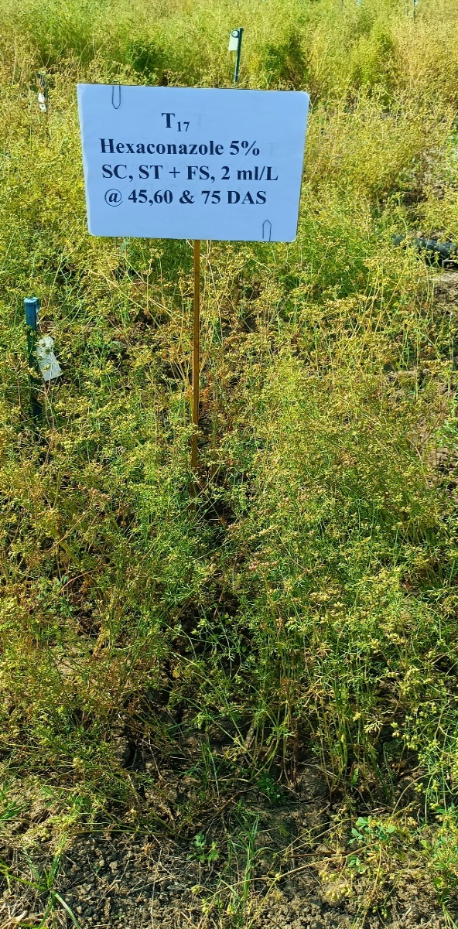 | 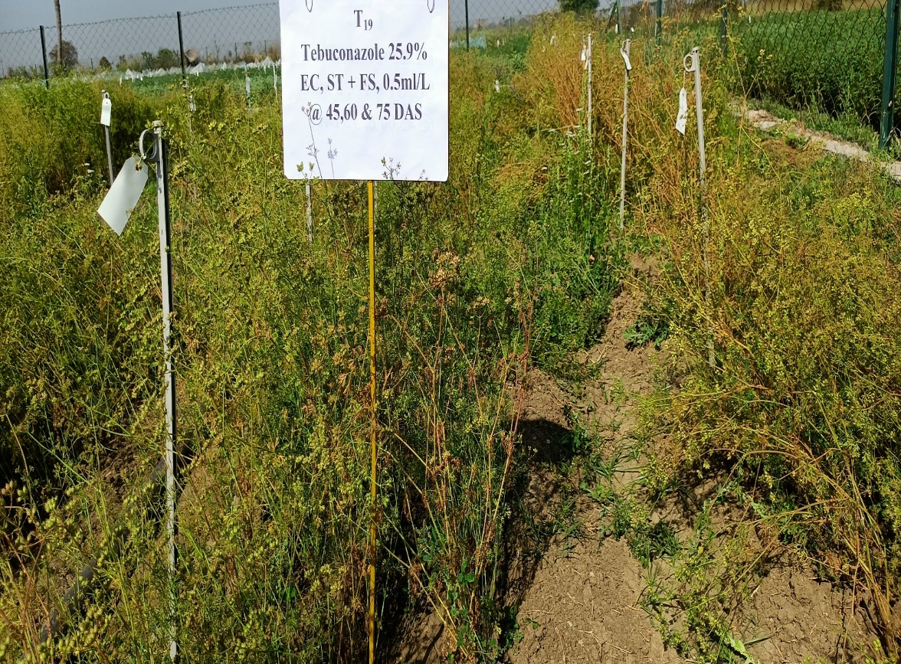
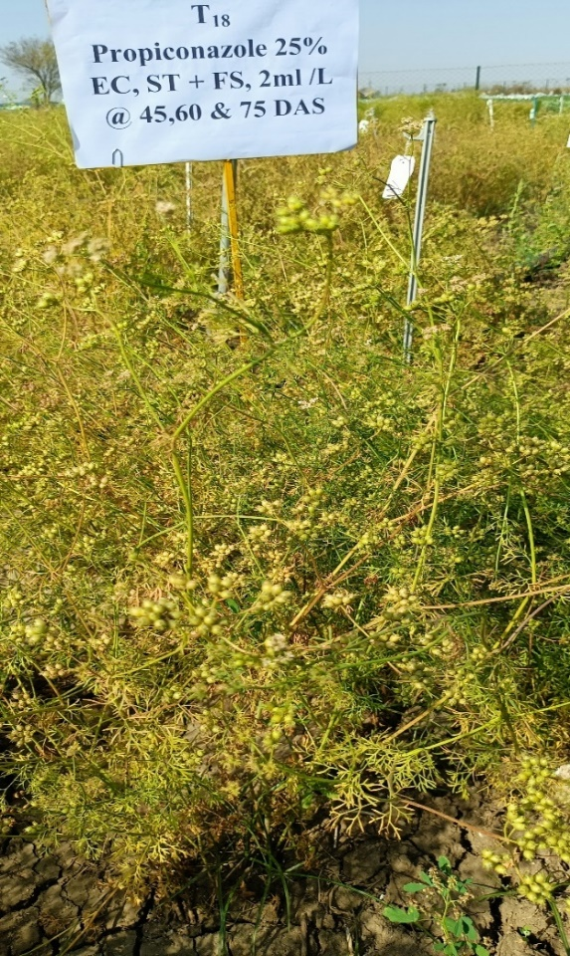 | 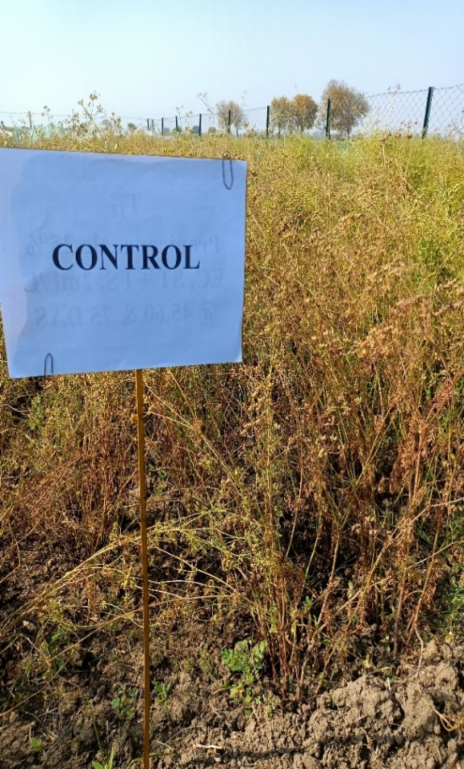
Figure 1. Effect of seed treatment and foliar spray of fungicides A. hexaconazole 5% SC B. tebuconazole 25.9% EC C. propiconazole 25% EC D. Control
CONCLUSION
The yield data of all treatments were recorded and economics of incremental benefit cost ratio was calculated for all fungicides tested which are presented in Tables. The highest B:C ratio was found in T₁₈ seed treatment by Tebuconazole @ 2 ml/kg seed and foliar spray of tebuconazole 25.9% EC (4.09) at 45, 60 & 75 days after sowing(DAS) @ 0.5 ml/L followed B:C ratio in T₁₆ seed treatment by hexaconazole @ 0.5 ml/kg seed foliar spray by Hexaconazole 5 % SC (4.08) @ 0.5 ml/L at 45, 60 & 75 DAS. The lowest B:C ratio found in T₀ control (2.36) followed by B:C ratio in seed treatment with propiconazole @ 2 ml/kg seed and foliar spray of propiconazole 25% EC (3.04) @ 2 ml/L at 60 DAS.

DISCLAIMER (ARTIFICIAL INTELLIGENCE)
Author(s) hereby declare that NO generative AI technologies such as Large Language Models (ChatGPT, COPILOT, etc) and text-to-image generators have been used during writing or editing ofthis manuscript.
COMPLIANCE WITH ETHICAL STANDARDS
The article does not contain any studies with human participants or animals performed by any of the authors.

REFERENCES
Anonymous, (2020-21). Spices Board India. (adv.est) Statistics http// www.indianspices.com
Anonymous 2021-22. Department of Agriculture, Govt. of Rajasthan. 2021-22. https://agriculture.rajasthan.gov.in
Bhuiyan, N.I. & Begum, J. (2009). Sultana, M. Chemical composition of leaf and seed essential oil of Coriandrum sativum L. from Bangladesh. Bangladesh Journal of Pharmacology (4), 150–153.
Coskuner, Y. & Karababa, E. (2007). Physical properties of coriander seeds (Coriandrum sativum L.). Journal of Food Engineering, 80: 408-416.
Gupta, J. S. (1954). Disease appraisal of stem gall of coriander. Indian Phytopathology, 7:53-60.
Jain, S. (2018). In vitro studies on dual culture of Protomyces macrosporus on Coriandrum sativum. International Research Journal of Natural and Applied Sciences, 5(4): 118-132.
Khan, M. R. & Parveen, G. (2016). Screening of some recently developed coriander varieties against stem gall disease caused by Protomyces macrosporus. Journal of Plant Pathology and Microbiology, 7: 1-3.
Khan, M. R. & Parveen, G. (2016). Screening of some recently developed coriander varieties against stem gall disease caused by Protomyces macrosporus. Journal of Plant Pathology and Microbiology, 7: 1-3.
Khare, M. N., Tiwari, S. P. & Sharma, Y. K. (2017). Disease problems in the cultivation of coriander (Coriandrum sativum L.) and their management leading to production of high-quality pathogen free seed. International Journal of Seed Spices, 7(1): 1-7.
Leharwan, M. & Gupta, M. (2019). Stem Gall of Coriander: A Review. Agricultural Reviews, 40(2): 121-128.
Malhotra, S. K., Kakani, R. K., Sharma, Y. K. & Singh, D. K. (2016). Ajmer coriander- 1 (NRCSS, ACR-1) resistant to stem gal disease- an innovative farming technology. Indian Journal of Arecanut, Spices and Medicinal Plants, 18: 1-7.
Margaret, R. & Shirley, P. (2002). British Plant Galls. Identification of Galls on Plants & Fungi. Shrewsbury: Field Studies Council, 222 pp.
Mishra, R. S. & Pandey, V. P. (2017). Effect of organic treatment on stem gall disease, growth and yield of coriander. Academy of Agriculture Journal, 2(8): 79-89.
Pandey, R. N. & Dange, S. R. S. (1998). Disease of coriander and fennel-a review. Agriculture Review, Karnal, 19 (2):120-125.
Pandey, S. (2010). Coriander (Coriandrum sativum L), a biological description and its uses in the treatment of various diseases. International Journal of Pharmacy and Life Sciences, 1: 119-126.
Reddy, M. S. & Kramer, C. L. (1975). A taxonomic revision of the Protomycetales. Mycotaxon, 3: 1-50.
Saxena, M. & Gandhi, C. P (eds). (2015). Indian Horticulture Database. National Horticulture Board, Ministry of Agriculture, Government of India, New Delhi, India, 248p.
Saxena, R. P., Dixit, S., Pandey, V. P. & Singh, V. K. (2002). Germplasm screening for stem gall disease in coriander. In: National Symposium on Integrated Management of Plant Disease of mid-Eastern India with a Cropping System Perspective, held at NDUAT, Faizabad during 5-7 December.
Singh, R. K. & Verma, S. S. (2015). Characterization of coriander (Coriandrum sativum) based on the morphological traits. Journal of Agricultural Research, 2: 221-224.
Sydow, H. & Butler, E. J. (1911). Fungi India orientalis. Annals of Mycology, 9: 372-421.
Tiwari, R. S. & Agarwal, A. (2014). Production technology of Spices. International book Distribution Company, pp. 254-271.
Unger, F. 1833. Die. Exanthame der Pflanzen, 344 pp.
Verma, P., Meena, D. S., Jadon, C. & Singh, D. K. (2017). Effect sowing time and management practices on incidence of stem gall and seed yield of coriander (Coriandrum sativum L.). International Journal of Seed Spices, 7: 79-81.
Zhang, X.G. & Zhang, T.Y. (2002). Studies on the genus Ulocladium Preuss from China. Mycosystema. 21, 25–26.

