**Extraction and characterization of phytochemicals from the leaves of different citrus species (*Citrus species*)**

**ABSTRACT**

The lab experiment was conducted during 2019-2021 to extract and characterize the phytochemicals from the leaves of different citrus (*Citrus species*) in the laboratories of Sri Guru Granth Sahib world University, Fatehgarh. The leaves of different citrus species were procured from the orchard of Department of Agriculture, Sri Guru Granth Sahib world University, Fatehgarh Sahib, Punjab. GC-MS was conducted at Advanced Instrumental Research Facility (JNU), New Delhi-110067. Extraction was done by using the methodology wherein methanol (10 mL) was added to 3g of dried citrus leaves samples and mixed intensely using a vortex mixture for 25 s. The samples were further purified by using filter paper and stored at 4°C before analysis. The extracts were analyzed using gas chromatography and mass chromatography. Each compound was identified by comparing their mass spectra with the mass spectra from the National Institute of Standards and Technology (NIST) library and WILEY library. The results of lab analysis revealed that in the phytochemicals analysis, 5 volatile compounds were obtained in all six citrus species viz. phytol, vitamin E, n- hexadecanoic acid, squalene and neophytadiene. This variability in the results may have been due to the several factors, among them particular varieties or species studied, season, the geographical location, and environmental factors, such as climate and soil type, genetic factors processing and extraction method. This it leads to a better understanding of volatile compounds present in leaves of six different citrus species which could be utilized subsequently by food ingredients industries for various applications and innovation, specifically related to flavour compounds.

**Keywords:** Phytochemicals, Phytol, Vitamin E, Gas chromatography-mass and Citrus.

**1. Introduction:**

Citrus belonging to family *Rutaceae* family having chromosome no. 2n=18 (Kahn *et al.,* 2001) grown in both tropical and subtropical regions of the world (Wu *et al.,* 2018). In India, citrus fruit is cultivated in an area of 1,034 thousand hectares with an annual production of 13,200 thousand tons and in Punjab, it is cultivated in an area of 59,980 hectares with an annual harvest of 13,49,523 tonnes (NHB, 2018-2019). Citrus fruits is an essential dietary supplements used in several countries around the world and it is taken in the form of processed juice, beverages and fresh fruit (Kumar *et al.,* 2013). Citrus have a potent source of significant bioactive secondary metabolites having antioxidant, lipid anti-peroxidation activities and anti-inflammatory activities. The main phytonutrients described in citrus plants are flavonoids, ascorbic acid and phenolic compounds (Mohammadian *et al.,* 2011; Ramful *et al*., 2010; Arora *et al.,* 2013; Sah *et al.,* 2011). The main flavonoids in citrus fruits which are commonly responsible for the sensory quality of the citrus fruits are naringenin, flavone-O-glycosides, naringin, poncirin and neohesperidin (Hasan, 2018).

Citrus is not only the source of phenolic compounds and flavonoids but it is also a vast source of minerals, vitamins including macronutrients and micronutrients (Buachan *et al.,* 2014 and Dureja and Dhiman, 2012 and Pandey *et al.,* 2019). Moreover, citrus leaves are a significant source of bioactive compounds including antioxidants such as ascorbic acid, phenolic and flavonoid compounds that have assumed great significance, and recently proposed the use of antioxidant vegetable extracts both as an alternative to food preservation technology and as prophylactic agents for certain human diseases (Aruoma, 1997; Kamran *et al.,* 2009). Previous study by Khatua *et al.,* 2013 and Xu and Chang 2008 showing that flavonoid and phenolic content could be correlated to their antioxidant activities. Plant include citrus contain flavonoid and phenolic compounds (Mashkor, 2014; Souri *et al.,* 2008), Zielinski *et al.,* 2014; Fidrianny *et al.,* 2014). In recent years GC-MS studies have been increasingly applied for the analysis of medicinal plants as this technique has proved to be a valuable method for the analysis of non-polar components and volatile essential oil, lipids and fatty acids (Jie *et al.,* 1991) and alkaloids (Betz *et al.,* 1997;Sermakkani and Thangapandian, 2012). The bioactive phytochemicals present in the lime leaves include flavonoids such as quercetin, rutin, kaempferol, essential oils and nobiletin. These chemicals are capable of functioning as antioxidant and thus can play a significant role in avoidance of degenerative diseases such as Alzheimer, Parkinson’s disease caused by oxidative stress and cancer (Dongmo *et al.,* 2009; Uttara *et al.,* 2009; Namani *et al.,* 2018). Additionally, several studies were done on the leaves of citrus species by GC-MS which observed that there were numerous volatile components were present in leaves. Similarly, GC-MS of *C.* *aurantifolia* leaves observed that the presence of terpenes and fatty acids as major components. Limonene, linalyl acetate and linalool were the main terpenes recognized in all n-hexane fractions (Loizzo *et al* 2012). Furthermore, In the GC-MS analysis of leaves of Citrus the identification of phytochemical compounds is based on the retention time, peak area, molecular formula and molecular weight (Pandian and Thajun, 2019). Leaves from citrus species have health benefits and presents excellent options for treating or management of an infection due to its bioactive secondary metabolites that display significant activities for developing new pharmaceutical products. Thus, keeping the above fact in view, an experiment was conducted for extraction and characterization of phytochemicals from the leaves of different citrus species.

**2. Materials and Method**

For the extraction and characterization of phytochemicals in leaves, leaves of different citrus species were procured from the orchard of Department of Agriculture at Sri Guru Granth Sahib World University, Fatehgarh Sahib, Punjab. GC-MS was conducted at Advanced Instrumental Research Facility (JNU), New Delhi-110067. Extraction was done by using the methodology wherein methanol (10 mL) was added to 3g of dried citrus leaves samples and mixed intensely using a vortex mixture for 25 s. The samples were further purified by using filter paper and stored at 4°C before analysis. The extracts were analyzed using gas chromatography-mass spectrometry (GC-MS, Shimadzu QP 2010 Plus, Tokyo, Japan). An Omega SPTm column (30 m×0.25 mm ID, film thickness 0.25 µm) was used with helium as a carrier gas. The column oven temperature was programmed as 60 to 210°C at 3°C min–1, then programmed from 210 to 240°C at 20°C min–1, held at 240°C for 8 min, injector temperature 280°C; detector temperature, 290°C. The flow rate of the helium carrier was 1 μL min–1. A sample of 1.0 µL was injected in the split mode system with a split ratio of 1:50. Mass spectra were collected over the range of m/z 40–650. Each compound was identified by comparing their mass spectra with the mass spectra from the National Institute of Standards and Technology (NIST) library and WILEY library. Wherever available, the identification was further confirmed by comparing the retention times of the analytes with those from the literature.

**Statistical analysis**

Each compound was identified by comparing their mass spectra with the mass spectra from the National Institute of Standards and Technology (NIST) library and WILEY library. Wherever available, the identification was further confirmed by comparing the retention times of the analytes with those from the literature. Furthermore, for Principal Component analysis (PCA), the complete data set comprising all replicates was considered. For both type of analysis, the ratio of the signal relative to that of the average in the varieties was log 2 transformed. For PCA, the program SIMCA-P version 11 (Umetrics, Umea, Sweden) was used with the centered data. For the Hierarchical Cluster analysis, the program Acuity 4.0 (Axon Instruments) was used, with the distance measures based on the Pearson correlation. Pearson correlation coefficients were calculated with the SPSS version 15.0 software (SPSS Inc., Chicago, USA). Data from the correlation matrix was represented as a heat map by means of the Acuity 4.0 program.

**3. Results and discussion**

**Gas chromatography- Mass spectrometry (GC-MS) analysis of leaves of six selected citrus species:**

The chemical composition of the leaves extracts of different citrus species were analyzed by GC-MS. The relative content of each component was calculated by the peak area normalization method. The compounds were identified according to retention time and the NIST mass spectral library.The data presented in Table 1 lists the volatile compounds of leaf extracts from the six citrus Species (lemon (*Citrus* *limon*), grapefruit (*Citrus paradisi*), mandarin (*Citrus* *reticulata*), pummelo (*Citrus* *maxima*), lime (*Citrus aurantifolia*) and sweet orange (*Citrus* *sinensis*) which has been studied by GC-MS analysis. One hundred fourteen components were profiled which contains 27 alcohols, 20 esters, 19 ketones, 18 terpenes, 9 acids, 4 furans, 3 alkanes, 3 aldehydes, 1 carbohydrate, 1 Monoterpene cyclic ether and 9 other components (Table 1). The total amount of alcohols ranged from 0 to 38.44 % and it was determined and reported as relative amount of those compounds which present in the leaves of six different citrus species. Phytol was the primary component in this study and among all the citrus species, it was the most abundant in lemon leaf extract. The total amount of esters ranged from 0 to 5.56 % in leaves extracts. The Stigmasterol acetate was the most abundant compound among grapefruit, pummelo and lime leaves extract. The total amount of ketone in leaves extract ranged from 0 to 11.56% and 2-Hydroxycholestan-3-one# was the most abundant compound among the sweet orange. The total amount of terpenes ranged from 0 to 18.84 % Among, all the six citrus species grapefruit and sweet orange had the highest terpenes in the extracts of leaves. The total amount of acids ranged from 0 to 10.61 % (Table 1). Among, all the six different citrus species lime had the highest acids in the leaves extracts. The total amount of furan ranged from 0 to 7.75 % (Table 2). lemon and lime had the highest furan whereas there was no furan present in the mandarin, pummelo and sweet orange. The total amount of aldehyde and alkane ranged from 0 to 1.76% and 0 to 0.58 % f. The most abundant compound in aldehyde was alpha-Sinensal which were founded in mandarin and sweet orange whereas, most abundant compound compound in alkane was 1-bromo-6-chlorohexane which was showed by lemon. The total amount of carbohydrates and monoterpene cyclic ether ranged from 0 to 17.62% and 0 to 0.92%. L-manose was founded in lime while 3-tert-Butyl-4-hydroxyanisole was identified in both pummelo and lime.There were 5 volatile compounds (Table 1) which were obtained in all six different citrus species (lime, lemon, pummelo, mandarin, grapefruit and sweet orange) *viz.* phytol (ranged from 2.16-38.44%), vitamin E (ranged from 4.28-24.68%), n- hexadecanoic acid (ranged from 0.76-2.29%), squalene (ranged from 0.45-7.92%) and neophytadiene (ranged from 1.14-3.58%). Similar results were reported by Zhang *et al* (2020)whichresulted that a total of 196 volatile compounds were tentatively detected in the leaves of 62 citrus germplasms and the compounds could be classified into 16 groups, including 72 sesquiterpenes, 19 monoterpenes, 16 sesquiterpene alcohols, 15 monoterpene alcohols, 15 aldehydes, 6 monoterpene esters, 5 monoterpene aldehydes, 5 alcohols, 5 acids, 5 esters, 5 monoterpene ketones, 5 monoterpene oxides, 4 ketones, 2 sesquiterpene aldehydes, 1 sesquiterpene oxide and 16 other compounds.These finding corroborated with the findings ofDarjazi *et al* (2011), Tomer *et al* (2010)**.**

**Table 1: Major Volatile compounds detected from the extract of leaves of six different citrus species (lime, lemon, pummelo, mandarin, grapefruit and sweet orange) along with their retention time and area percentage. This table also represents the family code and identification of these volatile compounds**

|  |  |  |  |  |  |  |  |  |  |  |  |  |  |  |  |
| --- | --- | --- | --- | --- | --- | --- | --- | --- | --- | --- | --- | --- | --- | --- | --- |
| **S. No. (1)** | **Compound name (2)** | **F.C. /No. (3)** | **R. time** | | | | | | **Area (%)** | | | | | | **Ident. (16)** |
| **L.L.E. (4)** | **G.F. L. E. (5)** | **M.L.E. (6)** | **P.L.E. (7)** | **L.L.E. (8)** | **S.O.LE. (9)** | **L.l.E. (10)** | **G.F.L.E. (11)** | **M.L.E. (12)** | **P.L.E. (13)** | **L.L.E. (14)** | **S.O.L.E. (15)** |
| 1 | Phytol | Alc/1 | 20.581 | 20.583 | 20.581 | 20.581 | 20.576 | 20.587 | 38.44 | 15.66 | 14.45 | 10.42 | 15.59 | 2.16 | MS,RT |
| 2 | vitamin E | Alc/2 | 30.433 | 30.438 | 30.482 | 30.447 | 30.445 | 30.44 | 4.28 | 6.45 | 24.68 | 16.84 | 11.59 | 10.69 | MS,RT |
| 3 | .gamma.-sitosterol | Alc/3 | 34.339 | 34.267 | - | 34.286 | - | 34.285 | 3.58 | 13.17 | - | 0.74 | - | 1.82 | MS,RT |
| 4 | 2-methoxy-4-vinylphenol | Alc/4 | 11.717 | 11.792 | 11.707 | - | 11.729 | 11.947 | 4.31 | 5.01 | 6.65 | - | 2.22 | 2.14 | MS,RT |
| 5 | 1- heptacosanol | Alc/5 | - | 25.442 | - | - | - | - | - | 3.09 | - | - | - | - | MS,RT |
| 6 | .gamma.- tocopherol | Alc/6 | - | 29.247 | 29.25 | 29.25 | 29.248 | 29.244 | - | 1.73 | 2.3 | 0.67 | 0.4 | 1.07 | MS,RT |
| 7 | Stigmasterol | Alc/10 | 32.98 | 32.949 | - | - | 32.897 | - | 1.05 | 1.88 | - | - | 1.41 | - | MS,RT |
| 8 | ergost-5-en-3-ol | Alc/11 | 32.45 | 32.409 | - | - | 32.382 | - | 0.59 | 1.56 | - | - | 0.71 | - | MS,RT |
| 9 | 14-methyl-8-hexadecyn-1-ol | Alc/12 | 20.404 | 20.913 | - | - | - | - | 0.11 | 1.94 | - | - | - | - | MS,RT |
| 10 | 3,7,11-trimethyl-1-dodecanol | Alc/17 | 16.678 | 16.68 | - | 16.681 | - | - | 0.17 | 0.5 | - | 0.21 | - | - | MS,RT |
| 11 | 3,7,11,15-tetramethyl-2-hexadecen-1-ol | Alc/18 | 20.91 | 21.479 | 20.914 | - | - | - | 0.4 | 0.29 | 0.45 | - | - | - | MS,RT |
| 12 | phytol, tms derivative | Alc/24 | 21.068 | 21.071 | 21.074 | 21.074 | - | - | 0.27 | 0.2 | 0.13 | 0.17 | - | - | MS,RT |
| 13 | Epicurzerenone | Ket/3 | - | - | 15.373 | - | - | - | - | - | 0.24 | - | - | - | MS,RT |
| 14 | farnesyl acetone B | Ket/4 | - | - | 18.667 | - | - | - | - | - | 0.08 | - | - | - | MS,RT |
| 15 | Cyclodecanone | Ket/5 | - | 22.45 | - | - | - | - | - | 0.47 | - | - | - | - | MS,RT |
| 16 | 2-dodecylcyclobutanone | Ket/6 | 22.378 | 22.383 | - | - | - | - | 0.38 | 0.41 | - | - | - | - | MS,RT |
| 17 | 13-hexyloxacyclotridec-10-en-2-one | Ket/8 | 20.196 | 20.203 | 20.201 | 20.202 | - | - | 0.42 | 0.74 | 0.12 | 0.2 | - | - | MS,RT |
| 18 | hexahydrofarnesyl acetone | Ket/16 | 17.923 | 17.933 | 17.933 | 17.932 | 17.927 | - | 1.22 | 4.33 | 0.49 | 1.18 | 1.22 | - | MS,RT |
| 19 | Herniarin | Ket/17 | 17.025 | - | - | - | - | - | 8.19 | - | - | - | - | - | MS,RT |
| 20 | 2-(3,4-dimethoxyphenyl)-5-hydroxy-6,7,8-trimethoxy-4h-chromen-4-one | Ket/18 | - | - | 34.515 | 34.533 | - | 34.561 | - | - | 2.59 | 2.71 | - | 0.6 | MS,RT |
| 21 | 5-methyl-5-(4,8,12-trimethyltridecyl)dihydro-2(3h)-furanone# | Ket/19 | 22.704 | 22.705 | 22.706 | 22.704 | 22.703 | - | 0.21 | 0.86 | 0.46 | 1.3 | 0.8 | - | MS,RT |
| 22 | stigmasterol acetate | Est/1 | 29.606 | 29.612 | 29.611 | 29.615 | 29.611 | - | 0.93 | 5.56 | 0.37 | 1.41 | 1.96 | - | MS,RT |
| 23 | 3-cyclopentylpropionic acid, 2-dimethylaminoethyl ester | Est/2 | 23.59 | 23.594 | 23.594 | 23.59 | 23.591 | - | 1.44 | 2.3 | 0.5 | 0.57 | 1.85 | - | MS,RT |
| 24 | 9,12,15-octadecatrienoic acid, methyl ester | Aci/5 | - | 20.47 | 20.472 | 20.468 | - | 20.467 | - | 0.96 | 0.5 | 1.09 | - | 1.86 | MS,RT |
| 25 | hexadecanoic acid, methyl ester | Aci/6 | - | 18.776 | 18.777 | 18.779 | 18.772 | 18.777 | - | 0.45 | 0.25 | 0.52 | 0.3 | 1.41 | MS,RT |
| 26 | n- hexadecanoic acid | Aci/8 | 19.215 | 19.216 | 19.217 | 19.229 | 19.205 | 19.222 | 1.23 | 2.29 | 0.76 | 1.24 | 1.89 | 2.36 | MS,RT |
| 27 | 1,2-benzenedicarboxylic acid | Aci/9 | 24.155 | 24.157 | - | - | 24.159 | 24.159 | 0.35 | 0.92 | - | - | 0.47 | 1.21 | MS,RT |
| 28 | 2, 3 - dihydro-benzofuran | Fur/1 | 10.656 | - | - | - | 10.72 | - | 7.75 | - | - | - | 5.12 | - | MS,RT |
| 29 | Methoxsalen | Fur/2 | - | - | - | - | 20.197 | - | - | - | - | - | 2.52 | - | MS,RT |
| 30 | 4-aminopyridino-9-borabicyclo[3.3.1] nonan | Fur/3 | 21.418 | - | - | - | - | - | 0.18 | - | - | - | - | - | MS,RT |
| 31 | 3,7,7-trimethyl-1-[1,3-pentadienyl]-2-oxabicyclo[3.2.0]hept-3-ene | Ter/2 | 21.204 | 21.207 | - | 21.216 | 21.204 | - | 0.65 | 1.39 | - | 0.13 | 0.3 | - | MS,RT |
| 32 | .beta.-caryophyllene | Ter/14 | 13.12 | 13.125 | 13.128 | - | 13.125 | 13.124 | 0.1 | 0.48 | 0.28 | - | 0.25 | 4.52 | MS,RT |
| 33 | 24- norursa-3,12-diene | Ter/15 | - | - | 36.448 | - | - | 36.428 | - | - | 10.26 | - | - | 18.84 | MS,RT |
| 34 | Squalene | Ter/16 | 26.398 | 26.4 | 26.407 | 26.402 | 26.404 | 26.402 | 0.9 | 0.49 | 3.39 | 4.97 | 0.45 | 7.92 | MS,RT |
| 35 | Neophytadiene | Ter/17 | 17.852 | 17.858 | 17.86 | 17.859 | 17.855 | 17.858 | 1.16 | 1.14 | 1.35 | 3.58 | 1.32 | 2.95 | MS,RT |

**GC-MS of different citrus leaves extract for phytochemical analysis**

The GC-MS analysis of lemon revealed that the major component of leaf extract was phytol (38.44%). The composition of the volatile compounds was analyzed by GC-MS analysis. Forty-eight constituents were detected from the leaves extract of grapefruit. Two major compounds eluted at RT 20.583 and 34.267 mins were acknowledged as phytol (15.66) and gamma-Sitosterol (13.17%) respectively. Thirty Eight compounds were identified from the leaf extract of mandarin. The major compounds were vitamin E (24.68%), phytol (14.45%), 24- norursa-3,12-diene (10.26%), 2-methoxy-4-vinylphenol (6.65%), 4',5,6,7,8-pentamethoxyflavone (5.83%), 3',4',5,6,7,8 hexamethoxyflavone (4.91%), squalene (3.39%), 2-(3,4-dimethoxyphenyl)-5-hydroxy-6,7,8-trimethoxy-4h-chromen-4-one (2.59%), benzoic acid (2.45%), .gamma.- tocopherol (2.30%), stigmast-5-en-3-ol,(3.beta.)- (2.05%), santonox (1.70%), neophytadiene (1.35%), .alpha.-sinensal (1.21%), stigmasta-5, 23-dien-3-ol, (3.beta.)- (1.16%).

The GC-MS analysis of pummelo resulted that the three major components of leaf extracts were lupeol (20.96%), vitamin E (16.84%) and phytol (10.42%). GC-MS of lime revealed that three main compounds eluted at RT 17.431, 20.576 and 30.445 mins were identified as L-mannose (17.62%), phytol (15.66) and vitamin E (11.59) respectively. GC-MS of sweet orange (*Citrus sinensis*) extract for phytochemical analysis revealed that thirty-two compounds were recognized from the leaf extract of sweet orange. The major compounds were 24-norursa-3,12-diene (18.84%), 2-hydroxycholestan-3-one# (11.56%), vitamin E (10.69%). Similar results were reported by Adamu *et al* (2020)**,** Siddique *et al* (2012), Yang *et al* 2014 and Bhatia *et al* 2008).

**Table 2: This table indicates the values of eigenvectors of leaves of six different citrus species with clusters of these varieties.**

|  |  |  |  |  |  |  |  |
| --- | --- | --- | --- | --- | --- | --- | --- |
| **Eigenvectors** | | | | | | | |
|  | | **clu1** | **clu2** | **clu3** | **clu4** | **clu5** | **clu6** |
| **Lemon leaf** | Lemon-leaf | 0.404787 | -.458448 | 0.357986 | -.137445 | 0.370868 | 0.584281 |
| **Grapefruit_** | Grape-fruit | 0.453608 | -.389327 | 0.330384 | -.111665 | -.308663 | -.652509 |
| **Mandarin** | Mandarin | 0.394067 | 0.486764 | 0.118111 | -.233356 | -.628211 | 0.380418 |
| **Pummelo** | Pummelo | 0.449163 | 0.258563 | -.484465 | -.500663 | 0.447738 | -.213444 |
| **Lime** | Lime | 0.425882 | -.245547 | -.585327 | 0.605578 | -.180597 | 0.127999 |
| **Sweet orange** | Sweet orange | 0.303274 | 0.523604 | 0.414039 | 0.544791 | 0.373431 | -.161825 |

PCA analysis in different citrus species showed the correlations between the three dimensions and compound variables (Fig 1).The first component, explained 29.52% of the variance while the second component explained about 21.77% of the variance and both components separated the citrus species from one another. Moreover, the third component explained about 14.62% of the variance. All these three principal components were obtained by the PCA analysis. The volatile compounds of leaves of six different citrus species were also analyzed by using PCA analysis. Similarly, Principal component analysis has been done in order to differentiate citrus plants based on their flavonoid profile Kawaii *et al* (2000). KMP and LTN were excluded from PCA, because no leaf sample contained these flavonoids. The data for the 23 flavonoids, including an unidentified flavonoid (UF1), were used to perform PCA, which can reduce the dimensionality of a set of data. The eigenvalues are 5.20, 2.50, 2.27, 2.04, 1.67, 1.27, 1.22, and 1.01. Choosing only eigenvalues >1 led to the reduction of 23 variables to 8 principal components (PC), according 74.7% of the total variability. The percentages of variance for the four principal components are 22.6% for the first one, 10.9% for the second one, 9.9% for the third one, and 8.9% for the last one. Moreover, Hosni *et al* (2013)worked on PCA analysis and indicated huge variability in the essential oil chemical composition, with 78.85% cumulative variance in the first factorial plan. Beside the principal component 1 (PC1), accounting for 50.99% of overall variance, cis- and trans-rose oxide, isoborneol, a-fenchene, nerol, a-terpineol, terpinolene, hexan-1-ol, a-pinene, g-terpinene, sabinene, a-phellandrene, b-pinene, b-elemene, b-myrcene, germacrene-D, (E)-nerolidol, epi-cedrol, b-bisabolol, epi-cubenol, bisabol-1-one and a-cadinol were positively related. In contrast, they were negatively associated to the rest of compounds. Likewise, Lamine *et al* (2018)studied on PCA revealed that the first two principal components describe by themselves nearly 95% of the variance and clearly differentiate among the four species. Although the first component (53.3%) differentiates *C. reticulata* and *C. aurantium* from *C*. *sinensis* and *C. limon*, the second explains almost 41.7% of the variance and separates *C. sinensis* and *C. reticulata* from *C. aurantium* and *C. limon*. These consequences showed that the rate of volatile components of leaves differs according to the type of citrus fruits as described earlier for several tissues (Parastar *et al.,* 2012; Cuevas *et al.,* 2017; Chen *et al.,* 2012 and Andrade *et al.,* 2015).

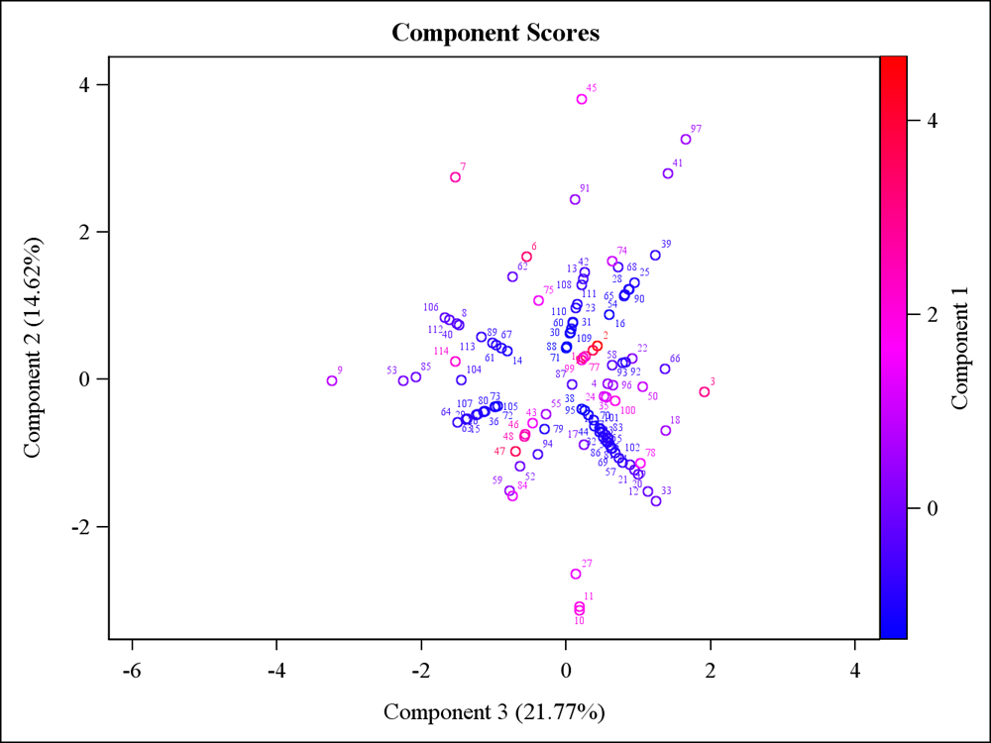

**Fig. 1:** Principal Component analysis (PCA) of volatile compounds of leaf extracts of different citrus species (lime, lemon, pummelo, mandarin, grapefruit and sweet orange). Variables plot of PC1, PC2 and PC3

**Hierarchical cluster analysis (Heat map)**

In order to understand the utility of volatile compounds of leaves of different citrus species. Different citrus species were arranged on the basis of heat map. The diversity in the volatile compound predicts that there were difference among all these citrus species. In heat map, dark red colour showed the highest chromatographic area of volatile compounds, followed by light red, light green while the dark green colour showed the lowest chromatographic area.

In the leaves extract of sweet orange, seven compounds showed highest chromatographic area *viz.* methyl(7e)-7-hexadecenoate, 1-nonadecene, carbonic acid, pentadeca fluorooctanoic acid, octadecyl ester, 2-hydroxycholestan-3-one, 7-ethyl-6-tridecanone, 1-pentadecanol whereas, four compounds showed least chromatographic area including 3-cyclopentylpropionic acid, stigmasterol acetate, hexahydrofarnesyl acetone, 5-methyl-5-(4,8,12-trimethyltridecyl) dihydro-2(3h)-furanone. In the leaves extract of mandarin, 12 compounds represented the highest chromatographic area which were included, pyrrolidine, 14-beta-h-pregna, n-benzoyl-l-proline, santonox, phenoxyethene, benzoic acid, diethyl phthalate, 3’,4',5,6,7,8-hexamethoxyflavone, farnesyl acetone b, epicurzerenone, stigmasta-5,23-dien-3-ol, solanesol while in 4 compounds viz.3,7,11-trimethyl-1-dodecanol, gamma-sitosterol, isopropyl palnitate, 1,2-benzenedicarboxylic acid had the lowest chromatographic area. In the leaves extract of pummelo, eight compounds had the maximum chromatographic area *viz.* oxirane, betulin, 1,e-8,z-10-hexadecatriene, z-13octadecenal, glutaric acid, lupenone, lupeol, 3,7,11,15-tetramethylhexadec-2-en-1-ol while two compounds had the minimum chromatographic area *viz.* 2-methoxy-4-vinylphenol and beta-caryophyllene. In the leaves extract of lemon, the highest chromatographic area shown by eleven compounds which were 1-bromo-6-chlorohexane, eicosane, laurene, pentadecanoic acid, adenosine, 2-methyl-10-

undecenal, heptadecafluorononanoic acid,nonyl ester, octadecanoic acid,2,3-dihydroxypropyl ester, herniarin, 2-pyrrolidinone, pyranone while 2 compounds shown the least chromatographic area which were gamma- tocopherol and hexadecanoic acid. In the leaves extract of lime, eleven compounds showed maximum chromatographic area *viz.* isopimpinellin, L-manose, methoxsalen, tetradecanoic acid, 9-octadecenoic acid, henicosyl formate, palmitic acid, 17-methylandrostan-16-one, cyclononanone, 6-cyclohexylidene-1-hexyn-3-ol, 9-bromo-1-nonanol while six compounds shown minimum chromatographic area *viz.* 9,12,15octadecatrienoic acid, gamma-sitosterol, isopropyl palnitate, octocrylene, phytol,tms derivative, 13-hexyloxacyclotridec-10-en-2-one. In the leaves extract of grapefruit, Nine compounds showed highest chromatographic area including copaene, auraptene, hexanoic acid, methyl commate B, 3-[(2E)-2-pentenyl]-1,2,4-cyclopentanetrione, cyclodecanone, duvatriendiol, 1- heptacosanol, 8-methyl-decahydro-naphthalene-1,8-diol whereas, 3 compounds shown the least chromatographic area including, stigmast-5-en-3-ol, 2-(3,4-dimethoxyphenyl)-5-hydroxy-6,7,8-trimethoxy-4h-chromen-4-one,1,8,11 heptadecatriene.

Similarly, Durand-Hulak *et al* (2015)worked on the heat map summarizes quantitative data on metabolite distribution in four citrus tissues and concluded that Sixty-four metabolites were analyzed and 45 were quantified across the four targeted tissues and 11 cultivars. A colour was associated with the amount of metabolites: from blue for little concentrations to red for great concentrations. Two classifications were obtained: the first displayed relations between metabolites and the second displayed similarities between observations. A heat map with metabolites grouped by chemical classes. The 45 metabolites belonged to six classes: flavanones, flavones, anthocyanins, flavonols, furanocoumarins and coumarins. Anthocyanins, flavones and flavonols clustered in the similar group, whereas furanocoumarins, coumarins and most of the flavanones were associated in a second group. Similarly, Luro *et al* (2020)in order to disclose possible signatures of biochemical profiles the cultivars were organized in the heat maps. The proportion of each compound was centered and compact according to the proportions from the two geographical locations. This illustration highlights the major changes in both geographical cultivation locations of the same citrus cultivars, and the diversity structure of the compound that supports this varietal diversity organization. The maximum striking geographical markers were octanal and isogeranial for citron, p-cymene for orange and clementine, p-cymenene for “Dancy” mandarin and “Tahiti” lime, neryl acetate for lemons, citronellol for “Nasnaran” mandarin and 1-8, cineole for “Sunki” mandarin. The chemical signature was extremely distinct in mandarin hybrids such as orange, “Page”, “Murcott” and clementine, with higher proportions found in Corsican hybrids for a specific group of compounds (δ-elemene, α-sinensal, α-terpinene, myrcene, terpinen-4-ol, β-sinensal, sabinene, terpinolene, and (E)-β-ocimene). “Granito” sour orange was the only citrus fruit with a very comparable chemical profile at the two geographical cultivation locations.

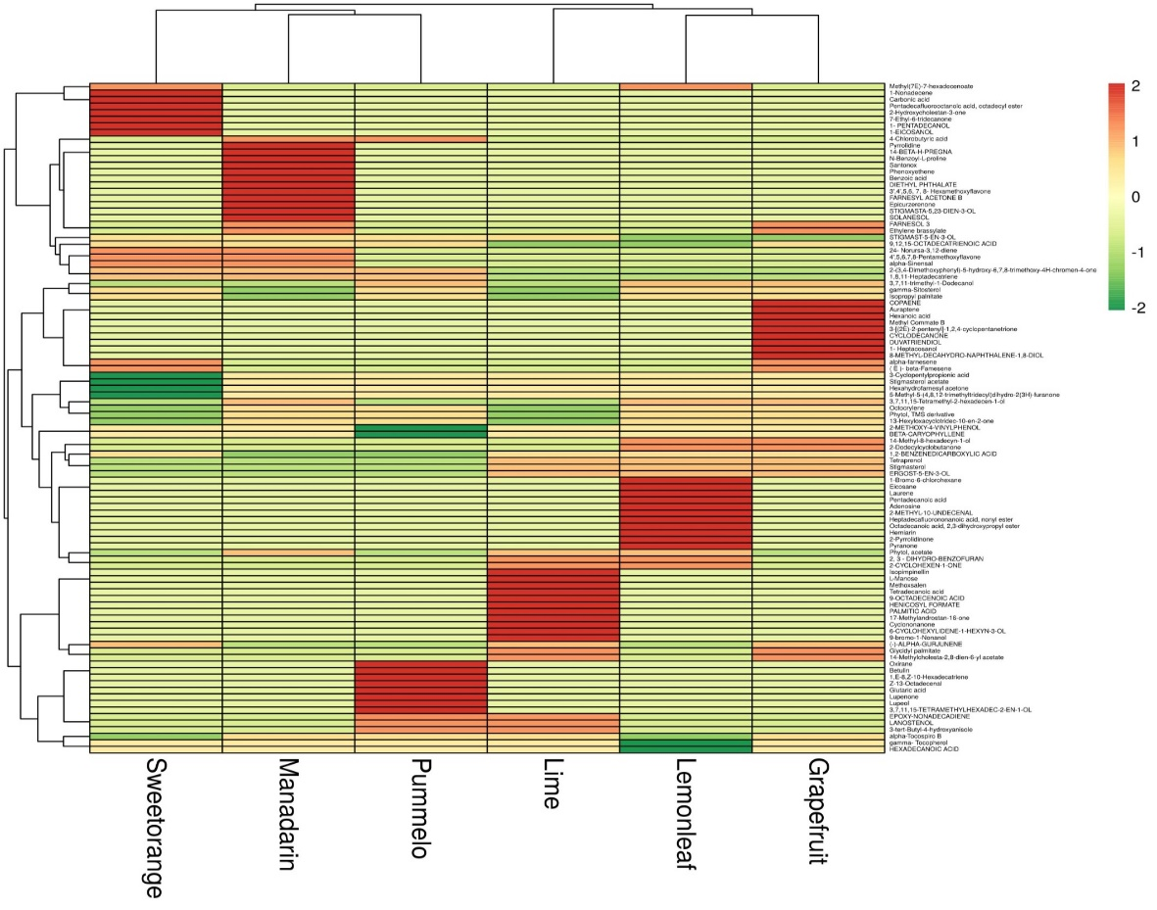

**Fig. 2: It represents the Hierarchical cluster analysis (heat map) of different citrus species.**

**Conclusion:**

On the basis of one year experiment, it can be concluded that in the phytochemicals analysis, 5 volatile compounds were obtained in all six citrus species viz. phytol, vitamin E, n- hexadecanoic acid, squalene and neophytadiene. This variability in the results may have been due to the several factors, among them particular varieties or species studied, season, the geographical location, and environmental factors, such as climate and soil type, genetic factors processing and extraction method. This also leads to a better understanding of volatile compounds present in leaves of six different citrus species which could be utilized subsequently by food ingredients industries for various applications and innovation, specifically related to flavour compounds.

**5. References:**

Adamu U, Yusha’u M, Bahauddeen S and Hussain A M (2020). Phytochemical screening, antibacterial potentials and gas chromatography-mass spectrometry analysis (GC-MS) of *Citrus sinensis* leaves extracts. *Microbes Infectious Diseases*: Article In Press, DOI: 10.21608/MID.2020.32010.1019.

Andrade M D S, Ribeiro L P, Borgoni P C, Silva M F G F, Forim M R, Fernandes J B, Vieira P C, Vendramin J D and Machado M A (2016). Essential oil variation from twenty two genotypes of Citrus in brazil- chemometric approach and repellency against diaphorina citri kuwayama. *Molecules* **21**(6): 1-10.

Arora M and Kaur P (2013). Antimicrobial & antioxidant activity of orange pulp and peel. *International Journal of Science and Research* **2**(1): 412-415.

Aruoma AO (1997). Extracts as antioxidant prophylactic agents. *Information* **8**(12): 1236-1242.

Betz J M, Gay M L, Mossoba M M, Adams S and Portz B S (1997). Chiral gas chromatographic determination of ephedrine-type alkaloids in dietary supplements containing Má Huáng. *Journal AOAC International* **80**(2): 303-315.

Bhatia S P, Mcginty D, Letiziz C S and Api A M (2008). Fragrance material review on carveol. *Food Chemical Toxicology* **46**(11): 85-7.

Buachan P, Chularojmontri L and Wattanapitayakul S (2014). Selected activities of *Citrus maxima* merr. Fruits on human endothelial cells: enhancing cell migration and delaying cellular aging. *Nutrients* **6**(4):1618-1634.

Chen J, Zhou L, Zhang X, Lu X, Cao R, Xu C and Xu G (2012). Urinary hydrophilic and hydrophobic metabolic profiling based on liquid chromatography-mass spectrometry methods: differential metabolite discovery specific to ovarian cancer. *Electrophoresis* **33**(22): 3361–3369.

Cuevas F J, Moreno-Rojas J M and Ruiz-Moreno M J (2017). Assessing a traceability technique in fresh oranges (*Citrus sinensis* L. Osbeck) with an HS-SPME-GC-MS method. Towards a volatile characterization of organic oranges. *Food Chemistry* **221**:1930-1938.

Darjazi B B (2012). A comparison of volatile components of flower, leaf and peel of *Citrus reticulata* Blanco (*Citrus nobilis* var. deliciosa Swingle). *Journal of Medicinal Plants Research* **6**(12): 2365-2372.

Durand-Hulak M, Dugrand A, Duval T, Bidel L P, Jay-Allemand C, Froelicher Y, [Bourgaud](https://www.ncbi.nlm.nih.gov/pubmed/?term=Bourgaud%20F%5BAuthor%5D&cauthor=true&cauthor_uid=25757470) F and Fanciullino A-L (2015). Mapping the genetic and tissular diversity of 64 phenolic compounds in *Citrus* species using a UPLC-MS approach. *Annals of Botany* **115**(5): 861-877.

Dongmo P M J, Tatsadjieu L N, Sonwa E T, Kuate J, Zollo P H A and Menut C (2009). Essential Oils of *Citrus aurantifolia* from Cameroon and their antifungal activity against *Phaeoramularia angolensis*. *African Journal of Agricultural Research* **4**(4): 354-358.

Dureja A and Dhiman K (2012). Free radical scavenging potential and total phenolic and flavonoid content of Ziziphus mauritiana and Ziziphus nummularia fruit extracts. *International Journal of Green Pharmacy* **6**(3): 187-192.

Fidrianny I, Harnovi M and Insanu M (2014). Evaluation of antioxidant activities from various extracts of sweet orange peels using DPPH. *Asian Journal of Pharmaceutical and Clinical Research* **7**(3): 186-190.

Hasan K N (2018). Phytochemical screening, antimicrobial and antioxidant activity determination of *Citrus maxima* peel. *Pharmacy & Pharmacology International Journal* **6**(4): 279-285.

Hosni K, Hassen I, M’Rabet Y, Sebei H and Casabianca H (2013). Genetic relationships between some Tunisian Citrus species based on their leaf volatile oil constituents. *Biochemical Systematics and Ecology* **50**: 65–71*.*

Jie M S F and Choi C Y C (1991). Characterization of picolinyl and methyl ester derivatives of isomeric thia fattyacids. J*ournal of the International Federation Clinical Chemistry* **3**: 122.

Kahn T L, Krueger R R, Gumpf D J, Roose M L, Arpaia M L, Batkin T A, Bash J A, Bier O J, Clegg M T and Cockerham S T (2001). Citrus genetic resources in California: Analysis and recommendations for long-term conservation. Report no.22. Univ. of Calif. Division of Agric. and Natural Resources, Genetic Resources Conservation Program, Davis, CA, USA.

Kamran G, Youcef G, Ebrahimzadeh M A (2009). Antioxidant activity, phenol and flavonoid contents of 13 *Citrus* species peels and tissues. *Pakistan Journal of Pharmaceutical Sciences* **22:** 277–281.

Kaur M, Hari SK, Ahmed SH, Kaur M and Singh H (2024). Antioxidant activity from the leaves of different citrus (*Citrus species*) under sub-tropical conditions of Punjab. *Journal of advances in biology and biotechnology* **27**(12): 548-555.

Kaur M, Hari SK, Singh J, Sharma A and Aman (2024). Morphological characterization of citrus leaves (citrus species) under sub-tropical conditions of Punjab. *International Journal of Plant and Soil Science* **36**(12):530-536.

Kawaii S, Tomono Y, Katase E, Ogawa K, Yano M, Koizumi M, Ito C and Furukawa H (2000). Quantitative study of flavonoids in leaves of Citrus plants*. Journal of Agricultural and Food Chemistry* **48**(9): 3865–3871.

Khatua S, Roy T and Acharya K (2013). Antioxidant and free radical scavenging capacity of phenolic extract from *Russula laurocerasi*. *Asian Journal of Pharmaceutical and Clinical Research* **6**(4): 156-160.

Kumar M, Parthiban S, Sarala Devi D and Ponnuswami V (2013). Genetic diversity analysis of acid lime (*Citrus aurantifolia* Swingle) cultivars. *The Bioscan* **8**(2): 481-484.

Lamine M, Rahali F Z, Hammami M and Mliki A (2018). From differentially accumulated volatiles to the search of robust metabolic classifiers: Exploring the volatome of Citrus leaves. *Microchemical Journal* **138**: 321–327.

Lozano-Grande M A, Gorinstein S, Espitia-Rangel E, Dávila-Ortiz G and Martínez-Ayala A L (2018)*.* Plant sources, extraction methods and uses of squalene. *International Journal of Agronomy*: 2018.

Luro F, Garcia Neves C, Costantino G, da Silva Gesteira A, Paoli M, Ollitrault P, Tomi F, Micheli F and Gibernau M (2020). Effect of environmental conditions on the yield of peel and composition of essential oils from citrus cultivated in Bahia (Brazil) and Corsica (France). *Agronomy* **10**(9):1256.

Mashkor A L (2014). Phenolic content and antioxidant activity of fenugreek seeds extract. *International Journal of Pharmacognosy and Phytochemical Research* **6**(4): 841-844.

Mohammadian M A, Mobrami Z and Sajedi R H (2011). Bioactive compounds and antioxidant capacities in the flavedo tissue of two citrus cultivars under low temperature. *Brazilian Journal of Plant Physiology* **23**(3): 203-208.

Namani Al J, Baqir E, Abri Al A, Hubaishi T Al, Husain A and KHAN S A (2018). Phytochemical screening, phenolic content and antioxidant activity of *Citrus aurantifolia* L. Leaves grown in two regions of Oman. *Iranian Journal of Pharmaceutical Sciences* **14**(1): 27-34.

NHB. (2018-2019). Fruit Production Database *National Horticulture Board*, New Delhi: India (Available online: [www.nhb.in](http://www.nhb.in)).

Pandey B P, Thapa R and Upreti A (2019). Total phenolic content, flavonoids content, antioxidant and antimicrobial activities of the leaves, peels and fruits of locally available citrus plants collected from Kavre district of Nepal. *International Journal of Pharmacognosy and Chinese Medicine* **3**(3): 2576-4772.

Pandian R S and Thajun N A (2019). GC-MS analysis of phytochemical compounds present in the leaves of *Citrus medica* L. *Research Journal of Pharmacy and Technology* **12**: 1823-1826.

Parastar H, Jalali-Heravi M, Sereshti H and Mani-Varnosfaderani A (2012). Chromatographic fingerprint analysis of secondary metabolites in citrus fruits peels using gas chromatography–mass spectrometry combined with advanced chemometric methods. *Journal of Chromatography* A **1251**:176–187.

Ramful D, Bahorun T, Bourdon E, Tarnus E and Aruoma O I (2010). Bioactive phenolics and antioxidant propensity of flavedo extracts of Mauritian citrus fruits: Potential prophylactic ingredients for functional foods application. *Toxicology* **278**(1): 75-87.

Sah A, Juyal V and Melkani A (2011). Antimicrobial Activity of Six Different Parts of the Plant *Citrus medica* Linn. *Pharmacognosy Journal* **3**(21): 80-83.

Sermakkani M and Thangapandian V (2012). GC-MS analysis of *Cassia* *Italica* leaf methanol extract. *Asian Journal of Pharmaceutical and Clinical Research* **5**(12): 90-94.

Siddique S, Javed S, Nawaz S, perveen Z, Khan R A, khanum R and Shahzad K (2012). Volatile components and antimicrobial activity of *Citrus sinensis* var. Mosambi leaves oil. *Journal of Medicinal Plants Research* **6**(11): 2184-2187.

Souri E, Amin G, Farsan H and Barazandeh TM (2008). Screening antioxidant activity and phenolic content of 24 medicinal plants extracts. *DARU J Pharmaceutical Sciences* **16(2)**: 83 -87.

Tomer K, Sethiya N K, Shete A and Singh V (2010). Isolation and characterization of total volatile components from leaves of *Citrus Limon* linn. *Journal of Advanced Pharmaceutical Technology and Research* **1**(1): 49-55.

Uttara B, Singh A V, Zamboni P and Mahajan R T (2009). Oxidative stress and neurodegenerative diseases: a review of upstream and downstream antioxidant therapeutic options. *Current Neuropharmacology* **7**(1): 65–74.

Wu G A, Terol J, Ibanez V, López-García A, Pérez-Román E, Borredá C, Domingo C, Tadeo F R, Carbonell-Caballero J, Alonso R and Curk F (2018). Genomics of the origin and evolution of Citrus. *Nature* **554**(7692): 311-6.

Xu B J and Chang S K (2008). Total phenolic content and antioxidant properties of eclipse black beans (*Phaseolus vulgaris* L.) as affected by processing methods. *Journal of Food Science* **73**(2):19-27.

Yang J Y, Kim M G, Lee S E and Lee H S (2014).Acaricidal activity against house dust mites of spearmint oil and its constituents. *Planta Medica* **80**(2-3): 165-70.

Zhang H, Chen M, Wen H, Wang Z, Chen J, Fang L, Zhang H, Xie Z, Jiang D, Cheng Y and Xu J (2020). Transcriptomic and metabolomic analyses provide insight into the volatile compounds of citrus leaves and flowers. *BMC Plant Biology* **20**(1): 1-4.

Zielinski A A F, Haminiuk C W I, Alberti A, Nogueira A, Demiate I M and Granato D (2014). A comparative study of the phenolic compounds and the *in vitro* antioxidant activity of different Brazilian teas using multivariate statistical techniques. *Food Research International* **60**: 246–254.