Original Research Article

Integrated Enzymatic and Spectroscopic Evaluation of Congo Red Dye Decolorization by White Rot Fungal Isolates

.
ABSTRACT

Aims: To evaluate the Congo red dye decolorization and biodegradation potential of native fungal isolates.
Study design: Fungal isolates were obtained from naturally occurring fruiting bodies on tree trunks and agricultural field soil. The isolates were screened for their Congo Red degradation potential using both qualitative (plate assay) and quantitative (broth decolorization) methods. Enzymatic activity and spectral analyses were performed to elucidate the mechanisms of dye removal.
Place and Duration of Study: Soil sample and fungal fruiting bodies were collected from the Agro-Forestry Research Centre (AFRC), Govind Ballabh Pant University of Agriculture and Technology, Pantnagar, Uttarakhand, India. All experiments were conducted in the Department of Microbiology, Govind Ballabh Pant University of Agriculture and Technology, Pantnagar, from January 2025 to March 2025.
Methodology: Two fungal isolates, WFP 1 and WDP 2, were selected based on their decolorization zones on low nitrogen basal medium plates supplemented with 100 mg/L Congo Red and ligninolytic enzyme production on mineral salt medium agar plates supplemented with specific substrates. Enzyme assays were performed to quantify laccase, azo-reductase, and lignin peroxidase (LiP) under dye-free and dye-induced conditions. Quantitative decolorization was evaluated in liquid medium over 24 hours. Structural modifications in the dye were analyzed using UV-Visible and Fourier Transform Infrared (FTIR) spectroscopy.
Results: Both WFP 1 and WDP 2 exhibited high decolorization efficiency, achieving 89.20 ± 1.028% and 89.96 ± 0.904% decolorization within 24 hours, respectively. Enzymatic profiling revealed higher laccase production in WDP 2, indicating superior oxidative capacity. UV-Visible spectra showed significant absorbance reduction in the 200–300 nm range, suggesting degradation of azo and aromatic structures. FTIR analysis revealed alterations in hydroxyl, amine, and aromatic functional groups, confirming both biosorption and enzymatic degradation.
Conclusion: White-rot fungi isolated from fruiting bodies on tree trunks demonstrate significant potential for Congo Red decolorization through combined biosorption and enzymatic mechanisms. These findings support their application in eco-friendly treatment of industrial dye effluents.

Keywords: Bioremediation, Congo red biosorption, fungal laccase enzyme, White rot fungi

1. INTRODUCTION

Water is essential for sustaining life on Earth, yet freshwater constitutes less than 1% of the total global water volume. Increasing water contamination, particularly from synthetic dyes, has become a significant environmental concern. These dyes are extensively used in industries such as textiles, paper, plastics, pharmaceuticals, and leather processing. Approximately 7 × 10⁵ tons of dyes are produced annually, with a significant portion discharged into aquatic ecosystems as industrial effluent (Khan et al., 2023). Synthetic dye pollution threatens aquatic biodiversity by blocking sunlight penetration, inhibiting the photosynthetic activity of aquatic plants and algae (Yusuf, 2019). Many synthetic dyes are toxic, carcinogenic, and mutagenic, raising concerns about their long-term impact on both ecosystems and human health (Zafar et al., 2022). Moreover, dyes accumulate in sediments where wastewater is continuously discharged, disrupting the ecological balance and eventually contaminating groundwater reserves (Liu et al., 2023).
Azo dyes, which account for 60–70% of global dye production, are among the most persistent pollutants in industrial wastewater. These dyes, due to their complex aromatic structures and azo (-N=N-) bonds, are highly resistant to light, moisture, and oxidation. This stability renders them difficult to biodegrade, leading to their accumulation in aquatic environments, which poses serious ecological and health hazards (Mnif et al., 2016). Congo red, a widely used azo dye in the textile industry, is particularly problematic due to its high solubility, recalcitrant nature, and potential toxicity. Metabolized into benzidine—a human carcinogen and mutagen—Congo red has been banned in several countries due to its harmful effects (Liu et al., 2015). If untreated, it can disrupt aquatic ecosystems and inhibit photosynthetic activity, leading to long-term biodiversity loss.
Conventional physicochemical treatment methods, such as coagulation, activated carbon adsorption, photocatalysis (Daneshvar et al., 2004), and advanced oxidation processes (Caicedo-Montoya et al., 2022), are often costly, generate excessive sludge, and may not completely degrade dyes. These limitations highlight the need for eco-friendly, sustainable, and cost-effective alternatives for dye remediation.
Microbial treatment methods have emerged as promising solutions, offering flexibility, simplicity, and reduced environmental impact. Microorganisms can biodegrade, biosorb, and bioaccumulate dyes, making them valuable tools for reducing contamination (Chaney et al., 1997). Among microorganisms, fungi, particularly white rot fungi (WRF), have shown great potential for dye removal. WRF possess a robust enzymatic system that includes lignin peroxidase (LiP), Mn-dependent peroxidase (MnP), and laccase (Lac), enabling them to degrade complex xenobiotic pollutants, including synthetic dyes (Herath et al., 2024). In addition to enzymatic degradation, WRF also utilize biosorption via their fungal cell wall components, enhancing dye removal efficiency (Alam et al., 2023).
This study investigates the Congo red decolorization potential of two white-rot fungal isolates from decaying tree trunks. Using qualitative plate assays, enzyme activity tests, spectroscopic analysis, and decolorization efficiency measurements, the research aims to understand the fungal-mediated degradation mechanisms. By profiling enzymatic activity and assessing dye removal efficiency, the study highlights the potential of these fungi as eco-friendly, cost-effective agents for the bioremediation of industrial dye effluents, offering an alternative to traditional wastewater treatment methods.
2. material and methods
2.1 Microbial cultures
Three fungal cultures were isolated from field soil samples collected from the Agroforestry Research Centre (AFRC), Pantnagar. Additionally, a white-rot fungal strain used in this study was previously isolated from its fruiting body found on a decaying tree trunk at the Agroforestry Research Centre (AFRC), Pantnagar. All fungal isolates were cultured on potato dextrose agar (PDA) medium adjusted to pH 5.5 and incubated at 30 ± 1°C for 7 days. Cultures were preserved at 4°C and sub-cultured monthly to maintain viability.
A reference culture of Lenzite elegans WDP2, known for lignolytic enzyme production, was obtained from the Department of Microbiology, College of Basic Sciences and Humanities (C.B.S.&H.), Govind Ballabh Pant University of Agriculture and Technology (GBPUA&T), Pantnagar. This culture was maintained on PDA slants and stored at 4°C.
2.2 Qualitative screening for in vitro Congo red decolorization potential
Preliminary screening for dye decolorization potential was performed using nitrogen-limited basal medium supplemented with 100 mg L⁻¹ Congo red dye. A 5 mm agar disc of actively growing fungal mycelium was inoculated onto sterile medium plates and incubated at 30 ± 2 °C for 3–5 days. After incubation, the plates were examined for visual decolorization, indicated by the formation of a halo zone around the fungal colony (Fareed et al., 2022).
2.3 In Vitro Plate Assay for Extracellular Dye-Degrading Enzyme Production
To assess the biodegradation potential of the selected white-rot fungal isolates, qualitative screening for the extracellular production of key dye-degrading enzymes—laccase, lignin peroxidase (LiP), and azoreductase—was carried out using substrate-based agar plate assays.
2.3.1 Laccase Activity
Laccase enzyme production was detected using guaiacol-amended agar plates. The fungal isolates were inoculated centrally on sterile potato dextrose agar (PDA) plates supplemented with 0.01% (v/v) guaiacol as a redox mediator. The inoculated plates were incubated under static conditions at 30 ± 2 °C for a period of 5–7 days. Laccase activity was visually indicated by the development of a reddish-brown to brick-red coloration in the medium surrounding the fungal colony. This color change results from the oxidative polymerization of guaiacol catalyzed by the secreted laccase enzymes. The intensity and diameter of the colored zone were considered qualitative indicators of laccase production levels by different fungal isolates. This method provides a rapid and efficient means for preliminary screening of ligninolytic potential, particularly for isolates with applications in dye degradation and bioremediation (Pandey et al., 2018).
2.3.2 Lignin Peroxidase enzyme activity
Lignin peroxidase (LiP) production by the selected fungal isolates was qualitatively assessed using glucose-malt extract salt agar medium. The medium was prepared and poured into sterile Petri dishes, followed by inoculation at the center with fungal plugs (5 mm diameter) obtained from actively growing margins of the fungal cultures. Inoculated plates were incubated at 30 ± 2 °C for 5–10 days to allow sufficient mycelial growth.
Post-incubation, LiP activity was detected using the ABTS-H₂O₂ overlay method. Briefly, 3 mL of ABTS solution (1.7 mM) and 3 mL of hydrogen peroxide (H₂O₂, 2.5 mM) were mixed and carefully poured onto the surface of each fungal plate, ensuring uniform coverage. Plates were incubated in the dark at room temperature (25 ± 2 °C) for 5 minutes to avoid light-induced oxidation of ABTS. The development of a bluish-green halo around the fungal colony indicated positive LiP activity due to the oxidation of ABTS in the presence of H₂O₂, catalyzed by lignin peroxidase enzymes secreted by the fungal isolate. The intensity and diameter of the color zone were qualitatively noted as an indicator of enzymatic activity. This method is based on previously established protocols for rapid and sensitive screening of ligninolytic enzymes in fungi (Pointing, 1999; Arora, & Gill, 2001; Wesenberg et al., 2003).
2.3.3 Azoreductase enzyme activity
The qualitative detection of azoreductase enzyme production was performed by observing the decolorization of an azo dye (Congo red) incorporated into agar medium. The assay was conducted by supplementing low nitrogen basal medium (LNBM) agar plates with 100 mg/L Congo red, which served as the chromogenic substrate for azoreductase (Nigam et al., 1996).
Fungal isolates were inoculated onto the dye-containing plates and incubated at 30 ± 2 °C for 5–7 days. Azoreductase activity was indicated by the formation of a clear or discolored zone surrounding the fungal colony, demonstrating enzymatic reduction of the azo bonds in the dye. The extent of decolorization was visually assessed and recorded. Plates without fungal inoculation served as controls to rule out abiotic dye degradation.This assay provided a rapid and effective method for screening the potential of fungal isolates to produce azoreductase and participate in azo dye degradation through enzymatic activity.
2.4 Quantitative Estimation of Extracellular Dye-Degrading Enzyme Production
The production of extracellular laccase and lignin peroxidase by selected fungal cultures was evaluated under in vitro broth culture conditions. Four 5 mm discs of actively growing fungal mycelium were inoculated into 100 mL of nitrogen-limited basal medium in 250 mL Erlenmeyer flasks. The cultures were incubated at 30 ± 2 °C in a shaking incubator at 120 rpm for 24 hours. At predetermined time intervals (0, 6, 12, 18, and 24 hours), 2 mL aliquots were withdrawn and centrifuged at 10,000 rpm for 15 minutes. The resulting supernatants (crude enzyme extracts) were used for quantitative estimation of laccase and lignin peroxidase activities.
2.4.1 Laccase Activity Assay
Quantitative estimation of laccase activity was performed using 2,2′-azino-bis(3-ethylbenzothiazoline-6-sulfonic acid) (ABTS) as the chromogenic substrate, following the method described by Niku-Paavola et al. (1990), with minor modifications to suit experimental conditions. The reaction mixture (total volume: 3 mL) consisted of 1 mL of crude fungal enzyme extract and 2 mL of 500 µM ABTS prepared in 50 mM citrate buffer (pH 4.5). The enzymatic oxidation of ABTS was monitored spectrophotometrically by measuring the increase in absorbance at 420 nm, corresponding to the formation of the ABTS•⁺ radical cation (ε = 36,000 M⁻¹ cm⁻¹), using a UV-Visible spectrophotometer. One unit of laccase activity was defined as the amount of enzyme catalyzing the oxidation of 1 µmol of ABTS per minute under the assay conditions. All assays were conducted in triplicate, and the results are expressed as the mean ± standard error.
2.4.2 Lignin Peroxidase (LiP) Activity Assay
Lignin peroxidase activity was determined by employing veratryl alcohol as the substrate, in accordance with the method of Tien and Kirk (1988), with slight modifications. The reaction mixture contained 0.8 mM veratryl alcohol in 0.1 M citrate buffer (pH 3.0) and 1 mL of crude enzyme extract. The reaction was initiated by the addition of 150 mM hydrogen peroxide (H₂O₂). The formation of veratraldehyde, a product of veratryl alcohol oxidation, was monitored spectrophotometrically by measuring the increase in absorbance at 310 nm (ε = 9,300 M⁻¹ cm⁻¹) for 1 minute at 30 ± 2 °C. Enzyme activity was calculated based on the change in absorbance, and all assays were conducted in triplicate to ensure reproducibility.
Enzyme activity was calculated using the following equation:

Enzyme activity (U) = $\frac{(∆E⁄∆t)×V}{ɛ×v×t}$ (1)
Where:
ΔE/Δt = change in absorbance per minute
V = total volume of the assay mixture (mL)
ε = molar extinction coefficient (M⁻¹ cm⁻¹)
v = volume of enzyme used (mL)
t = time in minutes
2.4.3 Azoreductase Activity Assay
Azoreductase activity in the culture filtrate was determined using a spectrophotometric method based on the NADH-dependent reduction of an azo dye substrate, following the method described by Chen et al. (2005) with slight modifications. The assay was conducted in a quartz cuvette with a total reaction volume of 1.0 mL. The reaction mixture consisted of 400 µL of 50 mM phosphate buffer (pH 7.2), 200 µL of crude enzyme extract, and 200 µL of Congo red solution (100 mg/L final concentration). The reaction was initiated by the addition of 200 µL of NADH (prepared at 7.09 mg/mL, resulting in a final concentration of 2 mM).
The reduction of Congo red was monitored by measuring the decrease in absorbance at 497 nm using a UV-Visible spectrophotometer. The initial linear decrease in absorbance (ΔA/min) was used to calculate enzyme activity. A control (blank) without NADH was run in parallel to correct for non-enzymatic dye reduction. Azoreductase activity was expressed in units per milliliter (U/mL), where one unit (U) is defined as the amount of enzyme required to reduce 1 µmol of Congo red per minute under the assay conditions in the presence of NADH. The enzyme activity was calculated using the following formula:
U/mL enzyme=$\frac{(ΔA/ min){Test sample-(ΔA/ min⁡) Blank }}{ε×v}$ (2)
Where:
ΔA/ min= change in absorbance per minute
ε = molar extinction coefficient (6.26×10⁴ M⁻¹ cm⁻¹)
v = total volume of reaction mixture (mL)
All experiments were performed in triplicate, and results were expressed as the mean ± standard error.
2.5 Congo Red Decolorization Coupled with Dye-Degrading Enzyme Production
The decolorization potential of selected fungal isolates was assessed using Congo red as a model dye. Each 250 mL Erlenmeyer flask containing 100 mL of nitrogen-limited basal medium supplemented with 100 mg L⁻¹ Congo Red was inoculated with four 5 mm fungal discs and incubated at 30 ± 2 °C, 120 rpm. At 0, 6, 12, 18, and 24 hours, 4 mL samples were withdrawn, centrifuged at 10,000 rpm for 15 minutes, and the supernatants analyzed for residual dye concentration by measuring absorbance at 495 nm using a UV-Vis spectrophotometer (Biomate 3S, Thermo Scientific). The percent decolorization was calculated using the formula:
Decolorization rate (%) = $\frac{A0 - A1}{A0}$×100 (3)
Where:
A₀ = initial absorbance of the dye
A₁ = absorbance after treatment
The simultaneous production of extracellular laccase and lignin peroxidase by the selected fungal cultures was evaluated. At predetermined intervals (0, 6, 12, 18, and 24 h), 2 mL aliquots were aseptically withdrawn from each culture, centrifuged at 10,000 rpm for 15 min, and the supernatants (crude enzyme extracts) were collected. The activities of laccase, lignin peroxidase and azo-reductase enzyme were subsequently quantified following the methods described in Sections 2.4.1, 2.4.2 and 2.4.3.
2.6 UV-Visible and Fourier Transform Infrared (FTIR) Spectroscopic Analyses
To confirm structural alterations in Congo red dye following fungal treatment, both UV-Visible spectrophotometry and Fourier Transform Infrared (FTIR) spectroscopy were employed (Chung, & Stevens,1993).
UV-Visible spectral analysis was conducted using a UV-Vis spectrophotometer across a wavelength range of 200–800 nm. Absorbance profiles of control (untreated) and experimental (fungal-treated) dye solutions were compared to detect any shifts or reduction in peak intensities, particularly around the characteristic λ max of Congo red. A decline or shift in absorbance peak was interpreted as evidence of dye degradation through breakdown of the chromophoric azo group and aromatic rings.
For FTIR spectroscopy, samples of both uninoculated dye medium (control) and decolorized fungal-treated samples were dried and ground with spectroscopic-grade potassium bromide (KBr) to form pellets. The spectra were recorded in the mid-infrared region between 4000–400 cm⁻¹ using an FTIR spectrophotometer. Changes in functional groups were evaluated by comparing peak positions and intensities, focusing on bands corresponding to azo (-N=N-), amine (-NH₂), hydroxyl (-OH), and aromatic C=C groups. Disappearance, shift, or reduction in these peaks indicated chemical modification of dye structure by biosorption and/or enzymatic degradation.
These combined spectroscopic techniques provided qualitative confirmation of the degradation pathways involved in fungal-mediated decolorization of Congo red.
2.7 Statistical Analysis
All experimental data were subjected to statistical analysis using the OPSTAT software (https://www.opstat.org). A two-way analysis of variance (ANOVA) was employed to evaluate the significance of differences between treatments, specifically considering the effects of fungal isolates and incubation time on dye decolorization and enzyme activities. The results were expressed as mean ± standard error (SE) from three independent replicates. Differences were considered statistically significant at P < .001.

3. results and discussion

3.1 In vitro determination of Congo red decolorization potential
The preliminary screening of fungal isolates for their ability to decolorize synthetic dye was conducted using an agar plate assay. Low Nitrogen Basal Medium (LNBM) supplemented with Congo red (CR) at a concentration of 100 mg/L was employed to mimic dye-contaminated conditions. This nitrogen-limited medium promotes the production of ligninolytic enzymes, particularly in white rot fungi, enhancing their dye-degrading capabilities.
Among the five fungal isolates tested, two white rot fungi, designated as WFP1 and WDP2, demonstrated notable growth on CR-amended plates, along with the formation of decolorization halos around the fungal colonies (Plate 1). These visible zones of discoloration indicate the potential of these isolates to degrade Congo red, likely through the secretion of extracellular lignin-modifying enzymes capable of cleaving azo bonds such as azoreductase which target the azo bond of toxic azo dyes.
Agar plate-based qualitative assays serve as a rapid and effective method for the preliminary screening of dye-degrading microorganisms. This approach has been widely adopted in studies involving wood-decaying fungi, such as Ganoderma sp. (Arulmani et al., 2005), and more recently, Trametes versicolor, Pleurotus ostreatus, and Phanerochaete chrysosporium have been identified using similar methods (Zhang et al., 2021; Rajeswari et al., 2023).
This initial screening step is critical for identifying promising fungal candidates for subsequent quantitative analysis in liquid media, as well as for investigating the enzymatic pathways involved in dye degradation.
3.2 In Vitro Plate Assay for Extracellular Dye-Degrading Enzyme Production
Qualitative plate assays for extracellular ligninolytic enzyme activity revealed that both fungal isolates, WFP1 and WDP2, tested positive for laccase and lignin peroxidase (LiP) production (Plate 1). LiP activity was indicated by the appearance of green to dark bluish zones surrounding the fungal colonies on glucose malt extract salt agar plates. In contrast, laccase activity was evidenced by the formation of reddish-brown halos on potato dextrose agar (PDA) plates supplemented with guaiacol, a specific substrate for laccase. These distinct color changes result from oxidative reactions catalyzed by the respective enzymes.
The concurrent detection of laccase and LiP in both isolates suggests a well-developed ligninolytic enzyme system, equipping them with the biochemical tools necessary for the breakdown of complex aromatic structures present in synthetic dyes such as Congo red. These enzymes play key roles in dye degradation by generating reactive intermediates that cleave azo bonds and disrupt aromatic ring structures (Rajeswari et al., 2023).
White rot fungi are widely recognized for producing an array of oxidative enzymes, including laccase, manganese peroxidase (MnP), and lignin peroxidase, which act synergistically to degrade lignin and structurally similar xenobiotics (Zhang et al., 2021). The dual expression of laccase and LiP by WFP1 and WDP2 highlights their potential for application in the bioremediation of dye-contaminated wastewater. Previous studies have shown that fungal strains expressing multiple ligninolytic enzymes tend to exhibit enhanced decolorization efficiencies and broader substrate specificity (Kaushik & Malik, 2019).
These findings are consistent with earlier reports on ligninolytic activity in fungi such as Ganoderma lucidum, Pleurotus ostreatus, and Phanerochaete chrysosporium, which also demonstrated strong correlations between enzyme production and dye decolorization performance (Chhaya & Gupte, 2020). Thus, the observed enzymatic activity in WFP1 and WDP2 not only corroborates their initial decolorization potential but also supports their selection for further kinetic, enzymatic, and biochemical characterization in dye degradation studies
Plate 1. In vitro dye decolourization and lytic enzyme production by fungal cultures
Isolates |  | Growth on potato dextrose agar plate | Congo red decolourization | Laccase production assay | Lignin peroxidase production assay | Congo red dye decolourization in broth medium
WFP 1 |  | 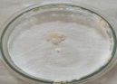 | 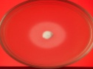 | 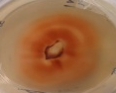 | 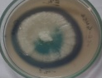 | 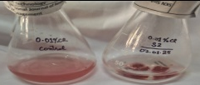
 | WDP 2 | 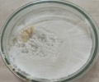 | 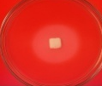 | 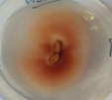 | 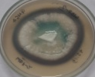 | 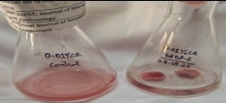

3.3 Decolourization of Congo Red in broth by Fungal Isolates
The Congo Red (CR) decolourization potential of white rot fungal isolates WFP 1 and WDP 2 was assessed in liquid medium over a 24-hour incubation period. Both isolates exhibited a time-dependent increase in decolourization efficiency. At 24 hours, WFP 1 achieved 89.20 ± 1.03% decolourization, while WDP 2 reached 89.96 ± 0.90% (Table 1).
Statistical analysis confirmed that culture type (p < .001), incubation time (p < .001), and their interaction (p < .001) had significant effects on decolourization performance. Interestingly, WFP 1 exhibited faster decolourization during the initial 6-hour period, whereas WDP 2 showed a more sustained increase and surpassed WFP 1 between 12 to 24 hours. These trends suggest differential responses to dye exposure and variations in the onset and intensity of enzymatic activity between the two isolates.
These results are consistent with earlier reports on the rapid and effective CR decolourization by white rot fungi. For example, Oudemansiella canarii decolourized approximately 80% of CR (50 mg/L) within 24 hours at 30 °C and pH 5.5, largely via laccase activity (Syed et al., 2022). Similarly, Ceriporia lacerata exhibited over 90% CR removal within 48 hours through a combination of biosorption and enzymatic degradation (Zhang et al., 2023). Such high decolourization efficiencies underscore the potential of white rot fungi as effective bioremediation agents for azo dye-contaminated wastewater.
Table 1 Congo red decolourization by white rot fungal isolates (WFP1 and WDP2) in dye amended LNBM
Time period | % Decolourization of CR
Time period | WFP 1 | WDP 2
6 h | 76.64±0.013 | 72.06±0.967
12 h | 83.70±1.214 | 86.50±1.574
18 h | 87.61±0.949 | 87.38±0.77
24 h | 89.20±1.028 | 89.96±0.904
SEm± | a(cultures) =0.540 ; b( time period) =0.764; a*b (interaction)= 1.081
CD (5%) | a(cultures) =1.634 ; b( time period)=2.311; a*b (interaction)= 3.268

Although, white-rot fungi typically exhibit significant ligninolytic enzyme activity after three days of incubation however, to align this study with the dye decolorization experiments, enzymatic activity was quantified within the first 24 hours of incubation, at 6-hour intervals. The assays were conducted under both dye-free and dye-containing conditions to assess the impact of Congo red on enzyme production. This comparative analysis is crucial for understanding the role of ligninolytic enzymes in the decolorization of dye-contaminated media.
3.3 Estimation of lignolytic enzyme activity in absence of dye (CR)
Laccase activity, a key indicator of oxidative potential involved in dye degradation, was evaluated under dye-free conditions to determine the baseline enzymatic capacity of the fungal isolates during the initial 24-hour incubation period. Both isolates, WFP 1 and WDP 2, exhibited a time-dependent increase in laccase production (Table 2). Notably, WDP 2 demonstrated significantly higher laccase activity (1.0125 ± 0.0620 U/mL at 24 hours) compared to WFP 1 (0.5415 ± 0.0220 U/mL), suggesting a stronger inherent oxidative capability.
Statistical analysis revealed that culture type (p < .001), incubation time (p < .001), and their interaction (p < .001) had significant effects on laccase production. The superior laccase output by WDP 2 indicates its enhanced potential for dye degradation, in agreement with previous studies showing a positive correlation between elevated laccase activity and improved decolorization efficiency.

Time period | Laccase enzyme activity (U/mL)in absence of CR
Time period | WFP 1 | WDP 2
6 h | 0.2852±0.0130 | 0.1847±0.0040
12 h | 0.3867±0.0140 | 0.7767±0.0120
18 h | 0.5158±0.0100 | 0.6689±0.0180
24 h | 0.5415±0.0220 | 1.0125±0.0620
SEm± | a(cultures) =0.013; b( time period) =0.018; a*b (interaction)= 0.026
CD (5%) | a(cultures) = 0.039; b( time period)=0.055; a*b (interaction)= 0.078
Table 2: Laccase enzyme activity of white rot fungal isolates (WFP 1and WDP 2) in LNBM broth

Early production of ligninolytic enzymes, particularly laccase, has been observed in several white rot fungi. In our study, significant laccase activity was detected within the first 24 hours of incubation, suggesting early expression of ligninolytic potential. Although lignin peroxidase and azo reductase activities were not detected in the liquid medium at this stage, positive results in plate assays confirm that the isolates possess the genetic capacity to produce these enzymes, likely during later growth phases. While early induction of laccase is not widely emphasized in literature, previous reports have documented laccase expression within 24 hours in Trametes versicolor (Baldrian, 2004), Phanerochaete chrysosporium (Yadav & Yadav, 2018), and Pycnoporus cinnabarinus (Eggert et al., 1996), indicating that certain white rot fungi are capable of initiating laccase production early under suitable conditions. This rapid enzymatic response highlights the role of laccase in the initial stages of dye decolourization.
3.4 Estimation of lignolytic enzyme activity in presence of dye (CR)
In the presence of Congo Red (CR), distinct temporal patterns of laccase activity were observed in the two fungal isolates. WFP 1 showed a transient increase in laccase activity, peaking at 0.4583 ± 0.0150 U/mL at 12 hours, followed by a sharp decline to 0.1565 ± 0.0130 U/mL at 24 hours (Table 3). This reduction could be attributed to enzyme inhibition or feedback repression caused by toxic dye metabolites (Palmieri et al., 2005). In contrast, WDP 2 exhibited a consistent rise in laccase activity, reaching 0.8016 ± 0.0140 U/mL at 24 hours, suggesting a more efficient enzymatic response and greater resilience to CR-induced stress.
Statistical analysis revealed that time (p < .001) and the interaction between culture and time (p < .001) significantly influenced laccase activity. However, the effect of culture type alone was marginally significant (p = 0.064), indicating that the dynamic changes in enzyme production over time were more critical than isolate differences per se.
The sustained laccase activity in WDP 2 under dye exposure is in line with earlier studies showing that certain white rot fungi can enhance or maintain laccase production in the presence of synthetic dyes, facilitating continued degradation (Strong & Claus, 2011; Elisashvili et al., 2008). This robustness makes WDP 2 a promising candidate for CR bioremediation, as its laccase activity correlates strongly with the observed decolourization efficiency.
Time period | Laccase enzyme activity (U/mL) in presence of CR
Time period | WFP 1 | WDP 2
6 h | 0.3541±0.0310 | 0.2585±0.0150
12 h | 0.4583±0.0150 | 0.6673±0.0090
18 h | 0.2125±0.0100 | 0.6564±0.0120
24 h | 0.1565±0.0130 | 0.8016±0.0140
SEm± | a(cultures) =0.008; b( time period) =0.011; a*b (interaction)= 0.016
CD (5%) | a(cultures) = N/A ; b( time period)=0.034; a*b (interaction)= 0.048
Table 3: Laccase enzyme activity in dye amended LNBM broth by fungal isolates (WFP 1and WDP 2)

No significant activity of lignin peroxidase or azo-reductase enzymes was detected under the tested conditions (in the presence of 100 mg/mL congo red), suggesting that these enzymes were not induced during the early incubation period in liquid medium or may be produced at later stages or under specific environmental triggers.
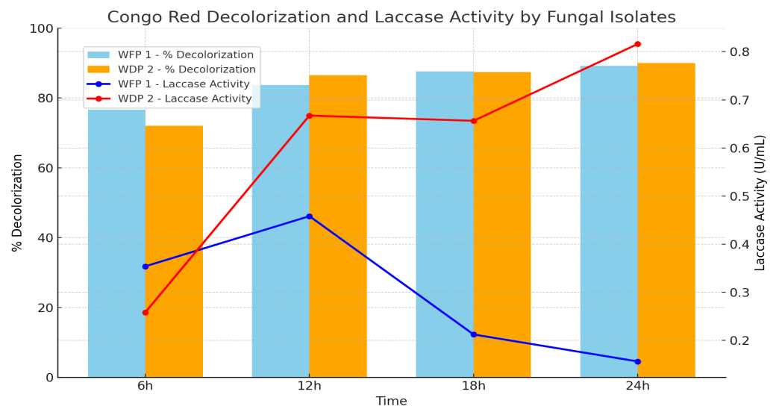
Fig. 1. Simultaneous Congo red decolorization and laccase enzyme activity by fungal isolates over time. Isolate WDP 2 exhibited a time-dependent increase in both decolorization efficiency and laccase activity, suggesting a strong enzymatic role in dye degradation. In contrast, isolate WFP 1 showed high decolorization despite declining laccase activity, indicating that biosorption may be the predominant mechanism in this isolate.
The graph (Fig 1.) illustrates the comparative analysis of Congo red decolorization (%) and laccase enzyme activity (U/mL) by two fungal isolates, WFP 1 and WDP 2, over a 24-hour incubation period. Both isolates showed a progressive increase in decolorization efficiency with time, reaching above 89% at 24 hours, indicating strong dye removal capabilities. WFP 1 exhibited a steady increase in decolorization from 76.64% at 6h to 89.2% at 24h, while WDP 2 followed a similar trend from 72.06% to 89.96%. In contrast, laccase activity showed differential trends between the isolates. WFP 1 displayed a peak in enzyme activity at 12h (0.4583 U/mL), followed by a gradual decline, suggesting early enzyme induction. Conversely, WDP 2 showed a consistent increase in laccase activity, peaking at 24h (0.816 U/mL), indicating a prolonged enzymatic response. The data suggest that while both biosorption and enzymatic degradation contribute to dye removal, laccase production, particularly in WDP 2, plays a significant role in enhancing decolorization efficiency.
3.5 UV-Visible Spectral Analysis of Congo Red Decolourization
The UV-Visible absorption spectra of Congo Red (CR) before and after treatment with fungal isolates WFP 1 and WDP 2 were analyzed in the range of 200–700 nm to monitor structural changes in the dye molecules and presented as fig 2. The control (untreated CR) exhibited a characteristic sharp absorption peak around 225 nm and a broad shoulder extending up to 500 nm, corresponding to the presence of aromatic rings, azo bonds (–N=N–), and auxochromic groups in the CR molecule (Saratale et al., 2011).
After 24 hours of incubation with fungal cultures, a marked decrease in absorbance was observed for both isolates, particularly in the 200–300 nm region. The sharp decline at ~225 nm indicates disruption of the dye’s aromatic and azo structures—confirming the enzymatic breakdown of CR. This spectral change reflects the cleavage of conjugated chromophores and degradation of the dye backbone, primarily facilitated by ligninolytic enzymes such as laccases.
Among the two isolates, WFP 1-treated samples showed slightly greater reduction in absorbance than those treated with WDP 2, suggesting comparatively higher degradation efficiency. These findings correlate well with earlier observations on % decolourization and laccase activity, reinforcing the role of oxidative enzymes in dye mineralization.
Importantly, no new peaks appeared in the post-treatment spectra, implying that the dye was not merely decolorized but also degraded into non-aromatic, non-chromophoric, or low molecular weight metabolites, rather than transformed into stable intermediate compounds. This supports the hypothesis of complete or near-complete biodegradation.
These results are in agreement with previous studies reporting the spectral flattening and disappearance of absorbance maxima following fungal degradation of azo dyes. For instance, Revankar and Lele (2007) demonstrated the effective decolourization and breakdown of CR by Decolorizing Basidiomycetes, accompanied by the disappearance of UV-visible peaks. Similarly, Singh et al. (2015) observed that the enzymatic treatment of azo dyes with fungal laccases led to significant reductions in absorption intensity, indicating oxidative cleavage of dye structures.
Overall, the UV-Visible spectral analysis substantiates the effective biodegradation of Congo Red by both WFP 1 and WDP 2, highlighting their potential as promising agents for the bioremediation of dye-contaminated effluents.
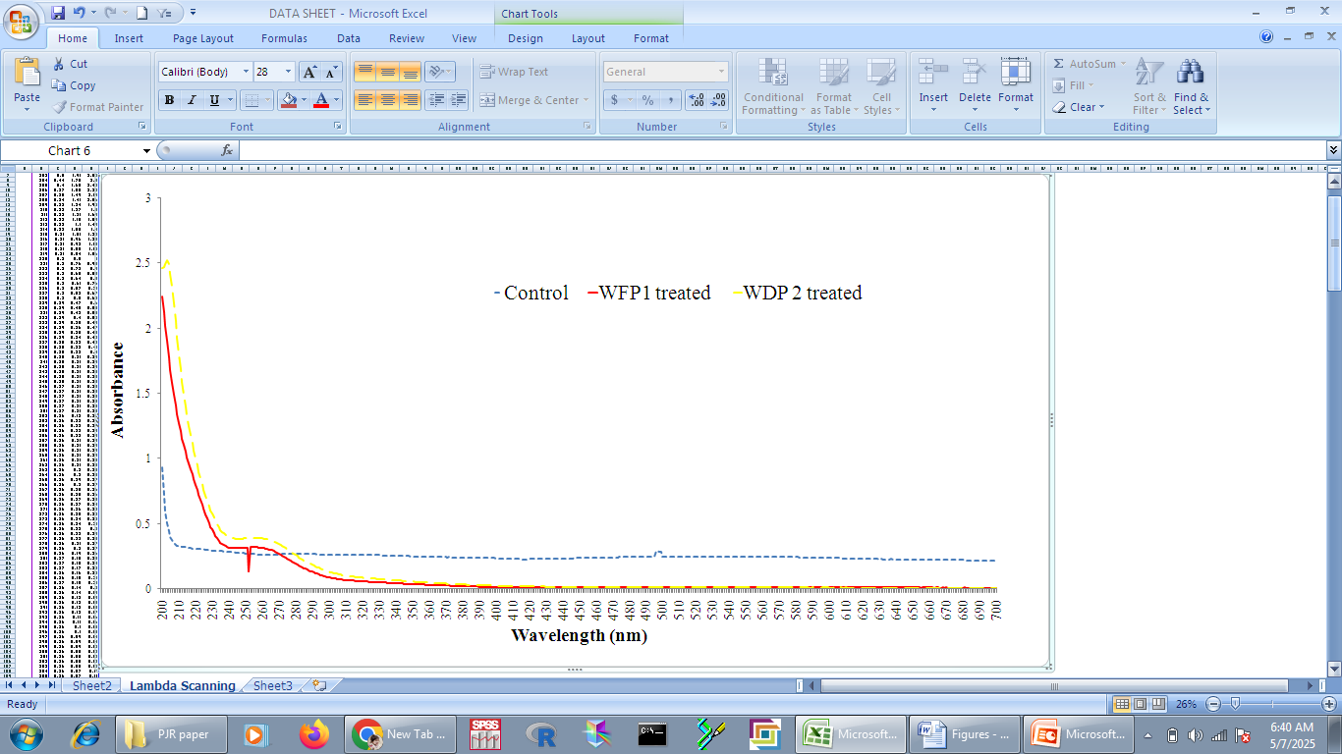
Fig 2. UV-Visible scanning of untreated dye containing medium and treated dye containing medium
3.5 FTIR Analysis of Congo Red After Fungal Treatment
Fourier Transform Infrared (FTIR) spectroscopy was employed to examine the structural modifications in Congo Red (CR) following 24 hours of treatment with fungal isolates WFP 1 and WDP 2. The objective was to identify changes in functional groups that may indicate biosorption and/or biodegradation of the dye by fungal biomass.
The FTIR spectrum of untreated CR (control) displayed prominent peaks at 3306.26 cm⁻¹ (O–H/N–H stretching), 2125.14 cm⁻¹ and 1898.54 cm⁻¹ (C≡N or C≡C stretching), 1634.06 cm⁻¹ (C=C stretching in aromatic rings), and 587.46 cm⁻¹ (C–H bending or out-of-plane deformation) (Fig 3 a). These characteristic bands are consistent with the aromatic and azo structural features of CR (Saratale et al., 2011; Crini, 2006).
After treatment with WFP 1, notable spectral changes were observed. The O–H/N–H stretching peak shifted slightly to 3307.88 cm⁻¹, while the C≡N/C≡C stretching band appeared at 2137.01 cm⁻¹. Additional peaks at 402.68, 415.62, and 428.20 cm⁻¹ emerged in the fingerprint region, suggesting new bond formations or chemical modifications likely induced by enzymatic action (Fig 3 b). The aromatic C=C peak at 1634.06 cm⁻¹ remained, although with altered intensity, indicating partial structural modification of the aromatic framework (Jackson et al., 2021).
Similarly, the WDP 2 treated sample exhibited the O–H/N–H stretching band at 3305.94 cm⁻¹, and the C≡N/C≡C region was marked by a peak at 2136.75 cm⁻¹. Additional peaks at 403.23, 411.94, and 585.83 cm⁻¹ reflected molecular interactions between CR and the fungal biomass (Fig 3 c). These spectral changes suggest the involvement of cell wall-associated functional groups such as hydroxyl, amine, and carboxyl groups in CR binding (Lavanya et al., 2018; Batana et al., 2022).
The shifts in absorption bands and the appearance of new peaks indicate successful binding and possible enzymatic degradation of CR. The disappearance or attenuation of azo-related and aromatic bands suggests cleavage of chromophoric groups, in agreement with previous studies on dye degradation by ligninolytic fungi (Wesenberg et al., 2003; Katheresan et al., 2018). The absence of new absorption peaks in the visible region implies complete or near-complete breakdown of chromophoric structures rather than the formation of colored intermediates.
Overall, FTIR results confirm the potential of WFP 1 and WDP 2 to interact with and transform CR dye through biosorption and enzymatic biodegradation, consistent with UV-Visible spectral findings and known mechanisms of fungal dye decolourization.
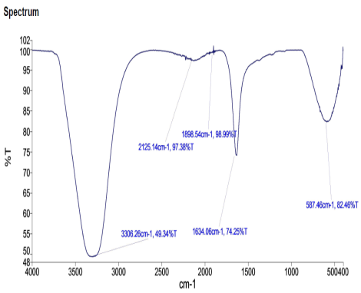 | 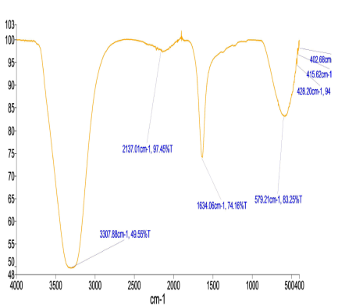 | 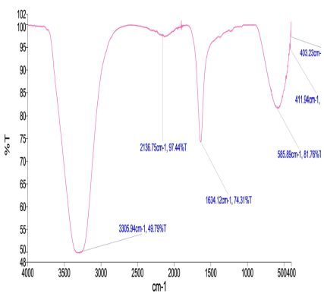
- Control | - WFP 1 treatment | - WDP 2 treatment
Fig. 3 FTIR analysis of Congo red dye (100mg/L) amended LNBM broth after 24 hour of fungal treatment. a) uninoculated (control) broth; b)WFP 1 treated broth; c) WDP 2 inoculated broth

4. Conclusion

This study provides compelling evidence of the biodegradation and decolorization capacity of white-rot fungal isolates WFP 1 and WDP 2 against the recalcitrant azo dye Congo red. Through a combination of plate-based qualitative screening and liquid culture quantitative analysis, both isolates were shown to effectively produce extracellular oxidative enzymes, including laccase and lignin peroxidase (LiP), which are instrumental in the breakdown of complex dye structures.
The high decolorization efficiencies (over 89% within 24 hours) observed in both isolates point toward a rapid and efficient degradation process. Importantly, WDP 2 displayed superior laccase production in both the presence and absence of dye, highlighting its resilience under dye-induced oxidative stress and its potential for sustained enzymatic activity. These enzymatic patterns closely paralleled the observed decolorization kinetics, suggesting a strong correlation between enzyme secretion and dye degradation efficiency.
Advanced spectral analyses reinforced these biochemical findings. UV-Vis absorption data confirmed the disruption of the dye's conjugated aromatic system, while FTIR spectroscopy revealed shifts in functional group regions indicative of dye-mineralization pathways involving hydroxyl, amine, and aromatic structures. The disappearance or transformation of specific vibrational bands associated with azo linkages suggests complete or partial biodegradation, rather than mere physical adsorption.
Overall, the results validate WFP 1 and WDP 2 as promising fungal candidates for the bioremediation of dye-polluted wastewater. Their combined biosorption capacity and enzymatic degradation efficiency offer a sustainable and low-cost alternative to conventional physicochemical treatment methods. Future work may focus on kinetic modeling, metabolite identification, and scaling up the process in bioreactor systems for industrial applications.

References
- Khan, M. D., Singh, A., Khan, M. Z., Tabraiz, S., & Sheikh, J. (2023). Current perspectives, recent advancements, and efficiencies of various dye-containing wastewater treatment technologies. Journal of Water Process Engineering, 53, 103579.
- Yusuf, M. (2019). Synthetic dyes: a threat to the environment and water ecosystem. Textiles and Clothing, 19, 11–26.
- Zafar, S., Bukhari, D. A., & Rehman, A. (2022). Azo dyes degradation by microorganisms – An efficient and sustainable approach. Saudi Journal of Biological Sciences, 29(12), 103437.
- Liu, T., Aniagor, C. O., Ejimofor, M. I., Menkiti, M. C., Wakawa, Y. M., Li, J., Akbour, R. A., et al. (2023). Recent developments in the utilization of modified graphene oxide to adsorb dyes from water: A review. Journal of Industrial and Engineering Chemistry, 117, 21–37.
- Mnif, I., Maktouf, S., Fendri, R., Kriaa, M., Ellouze, S., & Ghribi, D. (2016). Improvement of methyl orange dye biotreatment by a novel isolated strain, Aeromonas veronii GRI, by SPB1 biosurfactant addition. Environmental Science and Pollution Research, 23, 1742–1754.
- Liu, X., Li, W., Chen, N., Xing, X., Dong, C., & Wang, Y. (2015). Ag-ZnO heterostructure nanoparticles with plasmon-enhanced catalytic degradation for Congo red under visible light. RSC Advances, 5(43), 34456–34465.
- Daneshvar, N., Salari, D., & Khataee, A. R. (2004). Photocatalytic degradation of azo dye acid red 14 in water on ZnO as an alternative catalyst to TiO₂. Journal of Photochemistry and Photobiology A: Chemistry, 162(2–3), 317–322.
- Caicedo-Montoya, C., Copete-Pertuz, L. S., Correa-Londono, G. A., Mora-Martínez, A. L., Yepes-Pérez, M. (2022). Decolorization of colored wastewaters with Turquoise Blue dye by the Leptosphaerulina sp. native Colombian fungus – Influence of operational parameters. Dyna, 89(221), 121–131.
- Chaney, R. L., Malik, M., Li, Y. M., Brown, S. L., Brewer, E. P., Angle, J. S., et al. (1997). Phytoremediation of soil metals. Current Opinion in Biotechnology, 8(3), 279–284. https://doi.org/10.1016/S0958-1669(97)80004-3
- Herath, I. S., Udayanga, D., Jayasanka, D. J., & Hewawasam, C. (2024). Textile dye decolorization by white rot fungi–A review. Bioresource Technology Reports, 25, 101687.
- Alam, R., Mahmood, R. A., Islam, S., Ardiati, F. C., Solihat, N. N., Alam, M. B., Lee, S. H., et al. (2023). Understanding the biodegradation pathways of azo dyes by immobilized white-rot fungus, Trametes hirsuta D7, using UPLC-PDA-FTICR MS supported by in silico simulations and toxicity assessment. Chemosphere, 313, 137505. https://doi.org/10.1016/j.chemosphere.2022.137505
- Fareed, A., Zaffar, H., Bilal, M., Hussain, J., Jackson, C., & Naqvi, T. A. (2022). Decolorization of azo dyes by a novel aerobic bacterial strain Bacillus cereus strain ROC. PLOS ONE, 17(6), e0269559. https://doi.org/10.1371/journal.pone.0269559
- Pandey, R. K., Tewari, S., & Tewari, L. (2018). Lignolytic mushroom Lenzites elegans WDP2: Laccase production, characterization, and bioremediation of synthetic dyes. Ecotoxicology and environmental safety, 158, 50–58. https://doi.org/10.1016/j.ecoenv.2018.04.003
- Pointing, S. B. (1999). Qualitative methods for the determination of lignocellulolytic enzyme production by tropical fungi. Fungal Diversity, 2, 17–33.
- Arora, D. S., & Gill, P. K. (2001). Comparison of two assay procedures for lignin peroxidase. Enzyme and Microbial Technology, 28(7-8), 602–605. https://doi.org/10.1016/S0141-0229(01)00310-5
- Wesenberg, D., Kyriakides, I., & Agathos, S. N. (2003). White-rot fungi and their enzymes for the treatment of industrial dye effluents. Biotechnology Advances, 22(1–2), 161–187. https://doi.org/10.1016/j.biotechadv.2003.08.002
- Nigam, P., Banat, I. M., Singh, D., & Marchant, R. (1996). Microbial process for the decolorization of textile effluent containing azo, diazo and reactive dyes. Process Biochemistry, 31(5), 435–442. https://doi.org/10.1016/0032-9592(95)00090-9
- Niku-Paavola, M.L., Karhunen, E., Kantelinen, A., Viikari, L., Lundell, T., Hatakka, A., 1990. The effect of culture conditions on the production of lignin modifying enzymes by the white-rot fungus Phlebia radiata. J. Biotechnol. 13 (2–3), 211–221.
- Tien, M., Kirk, T.K., 1988. Lignin peroxidase of Phanerochaete chrysosporium. In. Methods in Enzymology 161. Academic Press, pp. 238–249.
- Chen, H., Hopper, S. L., & Cerniglia, C. E. (2005). Biochemical and molecular characterization of an azoreductase from Staphylococcus aureus RN4220. Applied and Environmental Microbiology, 71(11), 6907–6910. https://doi.org/10.1128/AEM.71.11.6907-6910.2005
- Chung, K. T., & Stevens, S. E. (1993). Decolorization of azo dyes by environmental microorganisms and helminths. Environmental Toxicology and Chemistry, 12(11), 2121–2132. https://doi.org/10.1002/etc.5620121126
- Arulmani, M., Ravindranath, M., & Rani, K. S. (2005). Decolorization of synthetic dyes by white rot fungus Ganoderma lucidum. Indian Journal of Experimental Biology, 43(3), 264–269.Zhang, X., Meng, Y., He, Z., Zhang, J., Li, Y., Liu, Z., et al. (2021). Research advances on degradation of azo dye by fungal strains. Frontiers in Microbiology, 12, 760528. https://doi.org/10.3389/fmicb.2021.760528
- Zhang, C., Liu, J., Wang, Z., & Li, B. (2021). Biodegradation of azo dyes by fungi: Mechanisms and influential factors. Journal of Environmental Chemical Engineering, 9(1), 104986. https://doi.org/10.1016/j.jece.2020.104986
- Rajeswari, M., Ramesh, M., & Senthilkumar, M. (2023). Screening of ligninolytic fungi for azo dye decolorization and their enzyme production potential. Bioresources and Bioprocessing, 10, 45. https://doi.org/10.1186/s40643-023-00627-9
- Kaushik, P., & Malik, A. (2019). Fungal dye-decolorization: recent advances and future potential. Environmental Technology & Innovation, 13, 336–352. https://doi.org/10.1016/j.eti.2018.12.001
- Chhaya, U., & Gupte, A. (2020). Biodegradation of synthetic dyes using ligninolytic enzymes produced by white-rot fungi. Biocatalysis and Agricultural Biotechnology, 24, 101537. https://doi.org/10.1016/j.bcab.2020.101537
- Syed, S., Khan, N., & Ali, S. (2022). Biodegradation of azo dyes by white rot fungi: mechanisms and recent advances. Biotechnology Reports, 33, e00725. https://doi.org/10.1016/j.btre.2022.e00725
- Zhang, Y., Liu, X., & Wang, H. (2023). Biodegradation and detoxification of Congo red by white-rot fungus Ceriporia lacerata: performance and mechanism. Environmental Technology & Innovation, 30, 102995. https://doi.org/10.1016/j.eti.2023.102995
- Baldrian, P. (2004). Purification and characterization of laccase from the white rot fungus Trametes versicolor. Enzyme and Microbial Technology, 34(1), 24–28.
- Yadav, S., & Yadav, K. D. S. (2018). Laccase: production and applications for degradation of xenobiotics. Environmental Chemistry Letters, 16(2), 397–418
- Eggert, C., Temp, U., & Eriksson, K. E. L. (1996). The ligninolytic system of the white rot fungus Pycnoporus cinnabarinus: purification and characterization of the laccase. Applied and Environmental Microbiology, 62(4), 1151–1158.
- Palmieri, G., Giardina, P., Bianco, C., Fontanella, B., & Sannia, G. (2005). Copper induction of laccase isoenzymes in the ligninolytic fungus Pleurotus ostreatus. Applied and Environmental Microbiology, 71(11), 6364–6370. https://doi.org/10.1128/AEM.71.11.6364-6370.2005
- Strong, P. J., & Claus, H. (2011). Laccase: a review of its past and its future in bioremediation. Critical Reviews in Environmental Science and Technology, 41(4), 373–434. https://doi.org/10.1080/10643380902945706
- Elisashvili, V., Kachlishvili, E., & Wasser, S. P. (2008). Carbon and nitrogen sources influence the ligninolytic enzyme activity of white-rot fungi. Bioresource Technology, 99(3), 548–553. https://doi.org/10.1016/j.biortech.2007.01.011
- Saratale, R. G., Saratale, G. D., Chang, J. S., & Govindwar, S. P. (2011). Bacterial decolorization and degradation of azo dyes: A review. Journal of the Taiwan Institute of Chemical Engineers, 42(1), 138–157. https://doi.org/10.1016/j.jtice.2010.06.006.
- Revankar, M. S., & Lele, S. S. (2007). Synthetic dye decolorization by white rot fungus, Ganoderma sp. WR-1. Bioresource Technology, 98(4), 775–780. https://doi.org/10.1016/j.biortech.2006.02.027
- Singh, R. L., Singh, P. K., & Singh, R. P. (2015). Enzymatic decolorization and degradation of azo dyes – A review. International Biodeterioration & Biodegradation, 104, 21–31. https://doi.org/10.1016/j.ibiod.2015.04.027
- Crini, G. (2006). Non-conventional low-cost adsorbents for dye removal: A review. Bioresour. Technol., 97(9), 1061–1085.
- Jackson, D., et al. (2021). FTIR analysis of dye–biomass interactions during fungal biodegradation. Environ. Sci. Pollut. Res., 28, 19264–19275.
- Lavanya, A., et al. (2018). FTIR analysis of azo dye degradation by fungi. Int. J. Environ. Sci. Technol., 15(10), 2089–2098.
- Batana, C., et al. (2022). Fungal biosorption of dyes using Fusarium oxysporum: Mechanistic insights from FTIR and SEM. Journal of Environmental Management, 307, 114476.
- Katheresan, V., Kansedo, J., & Lau, S. Y. (2018). Efficiency of various recent wastewater dye removal methods: A review. Journal of Environmental Chemical Engineering, 6(4), 4676–4697. https://doi.org/10.1016/j.jece.2018.06.060.

