***In Vitro* Evaluation of *Trichoderma harzianum* (Th4d) for the management of foliar and soil borne pathogens of castor**

**ABSTRACT**

The present study entitled “*In Vitro* Evaluation of *Trichoderma harzianum* (Th4d) for the management of foliar and soil borne pathogens of castor”**,** evaluated the biocontrol efficacy of Trichoderma harzianum isolate Th4d against key fungal pathogens affecting castor (Ricinus communis), including Fusarium oxysporum f. sp. ricini, Macrophomina phaseolina and Amphobotrys ricini. Through the use of the poisoned food technique, Th4d consistently shown better antifungal effectiveness than chemical fungicides in *in vitro*, dramatically lowering mycelial growth across infections. It was able to successfully suppress the growth of *F. oxysporum* (54.44 per cent) and attain a maximum inhibition of 76.66 per cent against *A. ricini* and 56.66 per cent against *M. phaseolina*. As established by seedling tests by paper towel method, Th4d increases biomass, seed vigor and root and shoot length while lowering the incidence of disease. Other *in vitro* evaluation method including detachable capsule further shown that Th4d is just as effective as Propiconazole at suppressing gray mold. The broad-spectrum antagonistic ability of Th4d and its potential as an environmentally benign substitute for synthetic fungicides in the treatment of castor disease are highlighted by these findings.

**INTRODUCTION**

Castor (Ricinus communis L.), a key non-edible oilseed crop from the Euphorbiaceae family, is primarily cultivated in arid and semi-arid regions. India castor production in 2022-23 is at 15.08 lakh tonnes with an area of 22.03 lakh acres (*https://desagri.gov.in*). Approximately 86 per cent of castor seed production in India is concentrated in Gujarat followed by Andhra Pradesh (Patel *et* *al*., 2016). However, castor cultivation faces a major threat from wilt disease caused by Fusarium oxysporum f. sp. ricini, a soil and seed-borne pathogen responsible for significant economic losses. The disease manifests through progressive yellowing, wilting and plant death, especially under warm and humid conditions and can cause yield losses up to 77 per cent depending on the growth stage at infection (Nanda and Prasad, 1974). The fungus colonizes the vascular tissues, leading to rapid plant decline with symptoms including root degeneration, necrotic streaks and chlorosis (Naik, 1994). Yield reductions of 10–40 per cent, seed weight losses of 8–14 per cent and oil content declines of 1–2 per cent have been reported due to this disease (Pushpavathi *et al*., 1997). Traditional chemical and cultural control measures have limited effectiveness, mainly because of the pathogen persistence in soil and its systemic spread within the plant. Recent studies highlight the potential of biological control, such as seed treatment with Trichoderma harzianum, which has shown significant reduction in disease incidence.

More than 500 plant species are impacted by the damaging soil-borne pathogen *Macrophomina phaseolina* (Loffalinezhad *et al*., 2013), which causes damping-off, charcoal rot, and seed rot, particularly when drought stress is present. By infecting plant vascular systems and generating poisons that kill tissue (Vasebi *et al*., 2013), it thrives in soil as heat-tolerant microsclerotia that germinate at 28 to 35°C and low moisture. The usage of biocontrol agents like *Trichoderma* species has expanded as a result of resistance to conventional fungicides and environmental concerns (Preeti and Sharma, 2013 and Howell, 2003).

By producing enzymes, mycoparasitism, and competition, *Trichoderma viride* and *Trichoderma harzianum* manage infections (Soares, 2012). When castor is exposed to humid, moderate temperatures, *Amphobotrys ricini*-caused gray mold can cause up to 100per cent yield loss by seriously damaging inflorescences and racemes (Harman *et al*., 2004). There is little resistance breeding, however management consists of fungicides, resistant cultivars, and cultural methods. For sustainable disease management and the promotion of plant health, *Trichoderma* species are crucial since they both directly and indirectly inhibit infections (Lorito *et al*., 2010).

The yields of castor can be reduced by up to 77per cent due to foliar diseases like gray mold and soil-borne infections like wilt and root rot. In addition to being expensive and environmentally dangerous, chemical control approaches can cause disease resistance. On the other hand, *T. harzianum* Th4d has shown broad-spectrum antagonistic activity, considerably reducing the severity of the disease under lab trails. Through the synthesis of chitinase and glucanase, Th4d not only stops the growth of pathogens but also causes systemic resistance in castor plants, as demonstrated by the overexpression of important defense genes and a 93per cent decrease in the severity of seedling blight, according to *in vitro* research. Additionally, Th4d-based seed treatments are more economical and ecologically benign, and they have enhanced seed germination and seedling vigor. Th4d formulations' demonstrated scalability, safety, and efficacy highlight the significance of conducting a controlled scientific evaluation of this strain in order to lay the groundwork for its wider use in integrated disease management of castor.

**MATERIALS AND METHODS**

**Maintenance of culture**

**Biocontrol agent:** *Trichoderma harzianum* Th4d strain was collected from ICAR- IIOR Plant Pathology section and maintained by subculturing on PDA plates throughout the studies. Triguard Th- Wettable Powder (Th4d 1.5 % WP) and Triguard Th-Liquid (Th4d 20 % SC) are recommended commercial solid and liquid formulations collected from ICAR-IIOR Plant Pathology section.

**Pathogen:** Castor *Fusarium oxysporum* f. sp. *ricini*, *Macrophomina phaseolina* and *Amphobotrys ricini* were collected from ICAR-IIOR Plant Pathology section and maintained by sub culturing on PDA plates throughout the studies.

***In vitro* evaluation of *Trichoderma harzianum* against soil borne and foliar pathogens.**

**Poisoned food technique**

The tests were performed using the agar medium assay described by Tatsadjieu *et al.* (2009). *Trichoderma harzianum* and recommended fungicides *viz*., Vitavax (Carboxin 37.5 % + Thiram 37.5 % WS) and Evergol xtend (Penflufen 13.28 % w/w+ trifloxystrobin 13.28 % w/w FS) were evaluated against *Fusarium oxysporum* f. sp*. ricini* and *Macrophomina phaseolina*. *Trichoderma* and fungicides were added in to the PDA media before pouring plates with poisoned media. After solidification of media mycelial disc of 5 mm dia. of *Fusarium oxysporum* f. sp*. ricini* and *Macrophomina phaseolina* was placed at the center. Five replications were maintained for each treatment. PDA plates served as control. After inoculation Petri plates were incubated at 25 ± 2 ℃ temperature. Per cent mycelial inhibition was calculated by using the formula given by Vincent (1947).

$$\text{I= }\frac{\text{C-T}}{\text{C}}\text{ ×100}$$

Where, I= Per cent inhibition,

C= Mycelial growth in control,

T= Mycelial growth in treatment.

**Rolled paper towel method**

Effect of *Trichoderma* seed coating of castor seeds against wilt and root rot infection was evaluated by rolled paper towel method (ISTA, 1996). Further, influence of seed coating with *Trichoderma* on seed quality parameters were also recorded. Castor seeds were surface sterilized with 2 per cent sodium hypochlorite solution for 1 min followed by three subsequent washings in sterile distilled water. The castor seeds were treated as per the treatments based on the results obtained from *in vitro* studies and then treated with conidial suspension/ microsclerotial suspension. Treatments details are given in the Table 1. In each paper towel (autoclaved), 10 seeds were placed and then rolled carefully without disturbing the seed placement. After inoculation rolled paper towels were kept in growth chamber at 25 ± 2 ℃ temperature with 90 per cent relative humidity. For each treatment three replications were maintained. Data on seed germination, seedling vigour and per cent disease incidence were recorded after 15 days. The germination percentage, vigour index and disease incidence were calculated by using the formulae mentioned below;

## Germination Percentage (GP)

$$\text{GP= }\frac{\text{Number of germinated seeds}}{\text{Total number of seeds}}\text{ ×100}$$

## Vigour Index

$\text{Vigour}\text{ Index-Ⅰ=Per cent germination ×Seedling length}$

## 

## (Seedling length (cm) = Shoot length + Root length)

$\text{Vigour}\text{ Index-II=Per cent germination ×Seedling dry weight (g)}$

## 

## Per cent disease incidence

$\text{Per cent disease incidence=}\frac{\text{Number of infected plants}}{\text{Total number} \text{of} \text{plants}}\text{ ×100}$

## 

***In vitro* evaluation of *Trichoderma harzianum* against foliar pathogen, *Amphobotrys ricini* in detached capsule technique**

**Detached capsule technique**

**Preparation of Inoculum**

Pathogen inoculum was prepared using six-day-old culture of *Amphobotrys ricini* grown on oat meal agar. Conidia of pathogen were harvested by flooding sporulating cultures with sterile distilled water and gently scraping the surface with a sterile needle. The resultant suspension was filtered through a sterile muslin cloth and the conidial concentration was adjusted to 106 conidia ml-1 using a haemocytometer.

**Inoculation**

The conidial suspension (106 conidia ml-1) were sprayed on capsules of castor plants in detached capsules in humid chamber and detached spikes in glasshouse for screening purpose.

Ten capsules from 15-20 day old spike for each replication of single treatment presented in Table 3 (5 replications were maintained) were collected from the susceptible check (DCH-519).The capsules were surface sterilized using one per cent Sodium hypochlorite (NaOCl) for 30s and thoroughly washed with sterile distilled water to remove any traces of NaOCl. The capsules were dried to removes excess water and were spray inoculated with spore suspension of *A. ricini* (106 conidia/ ml) and then treated with different treatments and placed in plastic boxes (humid chambers) containing wet germination paper towels at the bottom to maintain relative humidity. These trays were placed in growth chamber maintained at 23 ±2º C temperature and 90 per cent relative humidity. The wetness on capsules was maintained by spraying water at 12 h intervals. Symptoms appeared on capsules at 3-4 DAI and by 7th day capsules were fully covered with mycelium (Prasad *et al*., 2016). Based on the reaction of castor capsules to *A. ricini*, the disease incidence was scored.

**RESULTS AND DISCUSSION**

***In vitro* antifungal activity of *Trichoderma harzianum* against soil borne pathogens, *Fusarium oxysporum* f. sp. *ricini* and *Macrophomina phaseolina***

**Table 1.a Inhibitory effect of *Trichoderma* against mycelial growth of *Fusarium oxysporum* f. sp. *ricini* using Poisoned food technique.**

|  |  |  |
| --- | --- | --- |
| **Treatments** | **Mycelial growth (mm)** | **Inhibition (%)** |
| Th4d | 41.00 (6.44) a | 54.44 (47.54) d |
| Carboxin 37.5 % + Thiram 37.5 % WS | 56.13 (7.52) c | 37.77 (37.91) b |
| Penflufen 13.28 % w/w+ trifloxystrobin 13.28 % w/w FS | 49.00 (7.03) b | 45.5 (42.41) c |
| Control | 90.00 (9.51) d | 0.00 (0.00) a |
| S. Em ± | 0.81 | 0.83 |
| C.D (*P* ≤ 0.05) | 2.52 | 2.58 |
| C.V.(%) | 3.75 | 3.09 |

*Mean values of five replications.

Values in parenthesis are square root transformed (Mycelial growth) and arc sine transformed (Inhibition %).

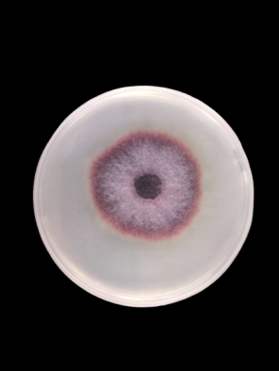 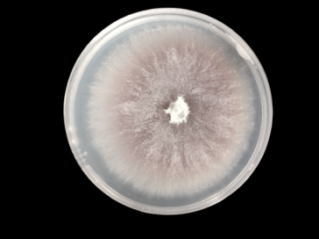 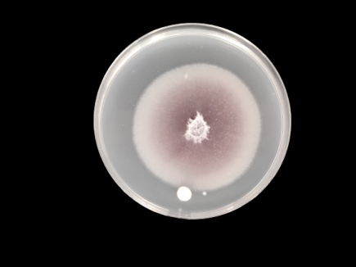 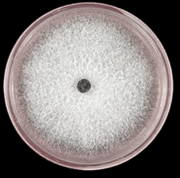

**T1- Th4d  T2- Carboxin 37.5 % T3- Penflufen 13.28 % w/w+ T4- Control**

**+ Thiram 37.5 % WStrifloxystrobin 13.28 % w/w FS**

**Fig 1: Inhibitory effect of *Trichoderma* against mycelial growth of *Fusarium oxysporum* f. sp. *ricini* using Poisoned food technique.**

The Th4d treatment, which represents a *Trichoderma* *harzianum* isolate, showed the best inhibitory effect on the mycelial growth of *Fusarium oxysporum* f. sp. *ricini*, according to the Poisoned Food technique presented in Table 1 and Fig 1. Th4d achieved a 54.44 per cent inhibition rate, significantly greater than the chemical fungicides tested, and decreased the mycelial growth to 41.00 mm. Comparatively, Penflufen + Trifloxystrobin produced 49.00 mm of growth and 45.5 per cent inhibition, whereas Carboxin + Thiram permitted 56.13 mm of growth with 37.77 per cent inhibition. At 90.00 mm, the control treatment showed complete pathogen development without any inhibition. These findings demonstrate that *Trichoderma* (Th4d) has a greater antagonistic capability than chemical therapies for inhibiting *Fusarium oxysporum* f. sp. *ricini* under *in vitro* conditions. Although it falls within the same range of efficacy, Vahunia *et al*. (2017) found that *T. harzianum* inhibited *F. oxysporum* f. sp. *ricini* up to 72.22per cent in vitro, which is even higher than your Th4d finding. The most effective *Trichoderma* species were consistently *T. harzianum*, however other species as *T. viride* and T. *longibrachiatum* also demonstrated considerable antagonism. According to Abhiram and Masih (2018), *T. harzianum* had a mean inhibition of 68.16per cent and inhibited different strains of *F. oxysporum* by 54.16 per cent to 77.77 per cent. This strongly matches your measured inhibition rate, confirming the validity of your results. Because *T. harzianum* produces antibiotics and lytic enzymes that prevent the growth of pathogens, it has been shown to dramatically reduce the mycelial growth and wilt incidence *of F. oxysporum* in tomatoes (Akalazu, 2023).

**Table 1.b Inhibitory effect of *Trichoderma* against mycelial growth of *Macrophomina phaseolina* using Poisoned food technique.**

|  |  |  |
| --- | --- | --- |
| **Treatments** | **Mycelial growth (mm)** | **Inhibition (%)** |
| Th4d | 39.00 (6.28) a | 56.66 (48.82) d |
| Carboxin 37.5 % + Thiram 37.5 % WS | 51.00 (7.17) c | 43.33 (41.16) b |
| Penflufen 13.28 % w/w+ trifloxystrobin 13.28 % w/w FS | 46.00 (6.81) b | 48.88 (44.35) c |
| Control | 90.00 (9.51) d | 0.00 (0.00) a |
| S. Em ± | 0.66 | 0.89 |
| C.D (*P* ≤ 0.05) | 1.98 | 2.75 |
| C.V. (%) | 2.61 | 3.03 |

*Mean values of five replications.

Values in parenthesis are square root transformed (Mycelial growth) and arc sine transformed (Inhibition %).

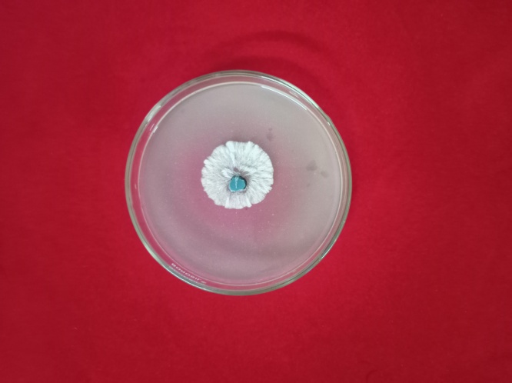 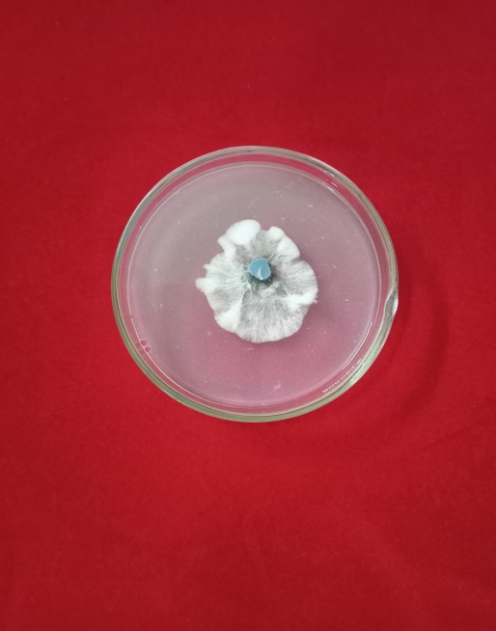 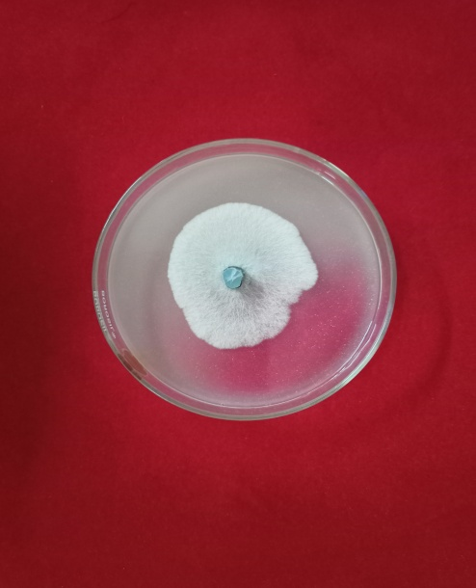 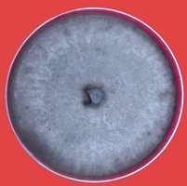

**T1- Th4d  T2- Carboxin 37.5 % T3- Penflufen 13.28 % w/w+ T4- Control**

**+ Thiram 37.5 % WStrifloxystrobin 13.28 % w/w FS**

**Fig 2.** **Inhibitory effect of *Trichoderma* against mycelial growth of *Macrophomina phaseolina* using Poisoned food technique.**

Among all treatments, the Th4d *Trichoderma* strain had the strongest antifungal efficacy against *Macrophomina phaseolina* *in vitro*, limiting mycelial development to 39.00 mm and attaining the maximum inhibition of 56.66 per cent presented in Table 2 and Fig 2. The suppression from chemical fungicides was less pronounced with Penflufen + Trifloxystrobin allowed 46.00 mm growth (48.88 per cent inhibition), whereas Carboxin + Thiram allowed 51.00 mm growth (43.33 per cent inhibition). In untreated samples, unchecked pathogen growth reached 90.00 mm. These findings highlight *Trichoderma'*s potential as a biocontrol agent against pathogens that cause charcoal rot by placing Th4d as noticeably more effective than both synthetic fungicide combinations. Th4d's broad-spectrum antagonistic properties are demonstrated by its persistent superiority over other fungal targets.

According to Sreedevi *et al*. (2011), *T. viride* and *T. harzianum* shown the strongest antifungal efficacy against *M. phaseolina* in dual culture experiments, resulting in a notable decrease in mycelial development when compared to controls and other isolates. In line with the current findings, the antagonistic activity was ascribed to antibiotic synthesis and overgrowth.Cherkupally *et al*. (2016) also verified that a study was conducted to assess the antagonistic activity of two Penicillium species and seven Trichoderma species against the pathogen Macrophomina phaseolina (Tassi) Goid, which causes brinjal root rot, using the dual culture plate technique in vitro. T. harzianum achieved the highest inhibition (77.77per cent) among tested antagonists, surpassing even other Trichoderma species and *Penicillium* isolatesThe pathogen's growth was significantly inhibited by all of the biocontrol agents. From this study, *T. harzianum* may be extremely hostile to the test pathogen.

**Table 3. Efficacy of biological and chemical treatments of castor seed against**

***Fusarium oxysporum* f.sp. *ricini* through rolled paper towel method.**

|  |  |  |  |  |  |  |  |  |  |
| --- | --- | --- | --- | --- | --- | --- | --- | --- | --- |
|  | **Germination per centage (%)** | **Seed viability** | **Seed vigour index -1** | **Seed vigour index-2** | **Average Root length (cm)** | **Average Shoot length (cm)** | **Fresh weight (g)** | **Dry weight**  **(g)** | **Disease Incidence (%)** |
| **T1** | 100 | 100 | 3493(a) | 134.0 (c) | 24.8  (5.03)a | 11.2  (3.41)a | 12.6  (3.61)a | 1.26  (1.33)a | 26.1  (30.71)a |
| **T2** | 100 | 100 | 3390(a) | 133.3 (c) | 23.7  (4.91)a | 10.1  (3.25)bc | 12.5  (3.60)a | 1.25  (1.32)a | 36.7  (37.27)d |
| **T3** | 100 | 100 | 3460(a) | 123.3 (b) | 23.9  (4.94)a | 10.7  (3.34)ab | 12.3  (3.57)a | 1.23  (1.31)a | 32.4  (34.69)c |
| **T4** | 100 | 100 | 3116(b) | 106.6 (a) | 20.7  (4.60)b | 9.4  (3.14)c | 10.1  (3.25)b | 1.07  (1.25)b | 100.0  (90.00)e |
| S. Em ± | | | 57.09 | 1.62 | 0.26 | 0.12 | 0.16 | 0.02 | 0.74 |
| C.D (*P* ≤ 0.05) | | | 154.27 | 4.58 | 0.77 | 0.34 | 0.47 | 0.06 | 2.13 |
| C.V. (%) | | | 3.87 | 3.52 | 1.86 | 1.84 | 3.62 | 3.69 | 3.85 |

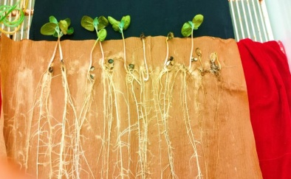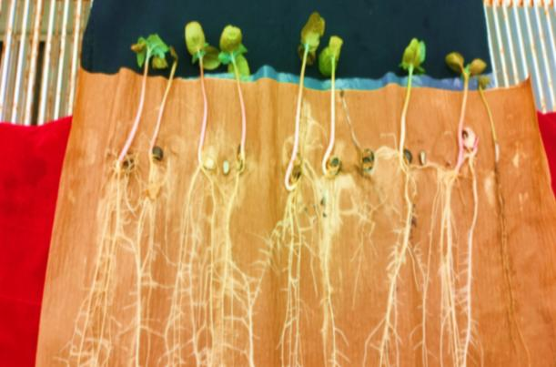 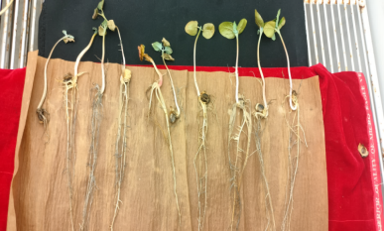

**T1  T2 T3 T4**

**Fig 3. Efficacy of biological and chemical treatments of castor seed against *Fusarium oxysporum* f.sp. *ricni* through rolled paper towel method.**

T1 -Th4d 1.5% WP @ 10.0 g kg-1, T2 - Carboxin 37.5 % + Thiram 37.5 % WS @ 3.0 g kg-1, T3- Penflufen 13.28 % w/w+ trifloxystrobin 13.28 % w/w FS @1.0 ml kg-1 ,T4 - Pathogen control @ *Fusarium oxysporum* f. sp*. ricni* as presented in Fig 3. and Table-3.

Th4d-based treatments continuously showed better results than other treatments when tested for castor seed protection against *Fusarium oxysporum* f. sp. *ricini* utilizing the rolled paper towel method mentioned in Table 3 and Fig 3. Th4d-treated seeds, particularly those in T1, showed the best seed vigor indices (3493 and 134.00), the longest root (24.8 cm) and shoot lengths (11.2 cm), and the lowest disease incidence (26.1 per cent). Although full germination and viability were maintained by all treatments, Th4d treatments performed better in growth and disease suppression measures than chemical and untreated controls. T2 recorded a disease incidence of 36.7%, a root length of 23.7 cm, a shoot length of 10.1 cm, a seed vigor index-I of 3390 and an index-II of 133.3. With a disease incidence of 32.4per cent, a root length of 23.9 cm, a shoot length of 10.7 cm, a seed vigor index-I of 3460, and an index-II of 123.33, T3 came in second. On the other hand, the untreated control (T4) exhibited the highest disease incidence (100 per cent) as well as the shortest root and shoot lengths and the lowest vigor indicators. These results demonstrate that Th4d is an important part of the management of castor disease since it not only improves seedling growth and health but also acts as an efficient biocontrol against wilt.

Rakesh *et al*. (2017) found that seed treatments combining *Trichoderma harzianum* with polymers and fungicides significantly improved germination, seedling length, and vigor while reducing disease incidence in castor seeds. This is consistent with the improvement in seed vigor and growth parameters by Th4d.

**Table 4.Efficacy of biological and chemical treatments of castor seed against**

***Macrophomina phaseolina* through rolled paper towel method.**

|  |  |  |  |  |  |  |  |  |  |
| --- | --- | --- | --- | --- | --- | --- | --- | --- | --- |
|  | **Germination per centage (%)** | **Seed viability** | **Seed vigour index -1** | **Seed vigour index-2** | **Average Root length (cm)** | **Average Shoot length (cm)** | **Fresh weight (g)** | **Dry weight**  **(g)** | **Disease Incidence (%)** |
| **T1** | 100 | 100 | 3492(c) | 143.3 (d) | 25.7  (3.40)c | 11.1  (3.74)d | 13.5  (3.60)a | 1.31  (1.34)d | 31.6  (34.19)a |
| **T2** | 100 | 100 | 3185(b) | 114.0 (b) | 21.8  (4.72)b | 9.2  (3.17)b | 9.6  (3.61)a | 0.63  (1.31)c | 46.1  (42.76)c |
| **T3** | 100 | 100 | 3260(b) | 133.3 (c) | 23.9  (4.93)c | 10.7  (3.57)c | 12.3  (3.57)a | 1.23  (1.06)b | 42.4  (40.62)b |
| **T4** | 100 | 100 | 3016(a) | 96.6 (a) | 19.7  (4.49)a | 7.4  (2.93)a | 8.1  (3.25)b | 0.57  (1.03)a | 100.0  (90.00)a |
| S. Em ± | | | 58.03 | 1.23 | 0.41 | 0.17 | 0.20 | 0.01 | 0.60 |
| C.D (*P* ≤ 0.05) | | | 4.00 | 3.71 | 1.23 | 0.52 | 0.61 | 0.05 | 1.80 |
| C.V. (%) | | | 174.00 | 3.10 | 3.05 | 3.09 | 3.18 | 3.47 | 2.44 |

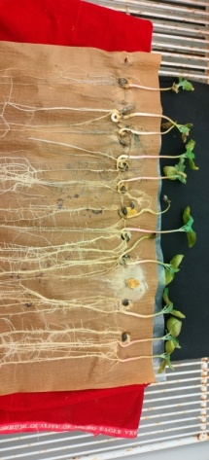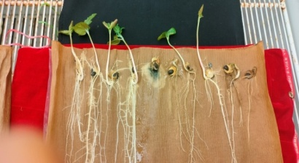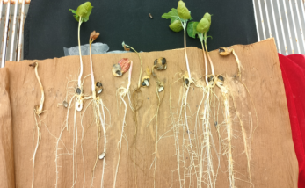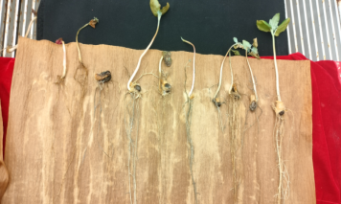

**T1  T2 T3 T4**

**Fig 4. Efficacy of biological and chemical treatments of castor seed against *Macrophomina phaseolina* through rolled paper towel method.**

T1 -Th4d 1.5% WP @ 10.0 g kg-1, T2 - Carboxin 37.5 % + Thiram 37.5 % WS @ 3.0 g kg-1T3- Penflufen 13.28 % w/w+ trifloxystrobin 13.28 % w/w FS @1.0 ml kg-1 ,T4 - Pathogen control @ *Fusarium oxysporum* f. sp*. ricni* as presented in Fig 3 and Table-3.

With the lowest disease incidence (31.6per cent) and the highest seed vigour index-I (3492), seed vigour index-II (143.3), average root length (25.7 cm), shoot length (11.1 cm), fresh weight (13.5 g), and dry weight (1.31 g), T1, which represents the *Trichoderma* based biological treatment produced the best overall results mentioned in Table 4 and Fig 4. T3 with a seed vigor index-I of 3260, index-II of 133.33, fresh weight of 12.3 g, dry weight of 1.23 g and disease incidence of 42.4per cent, and root and shoot lengths of 23.9 cm and 10.7 cm, respectively. T2 showed a moderate improvement with a seed vigor index-I of 3185, index-II of 114.00, fresh weight of 9.6 g, dry weight of 0.63 g, disease incidence of 46.1per cent, and root and shoot lengths of 21.8 cm and 9.2 cm, respectively.

In contrast, the pathogen control (T4) showed the weakest performance, with the lowest vigour indices (3016 and 96.67), shortest root (19.7 cm) and shoot (7.4 cm) lengths, lowest weights (8.1 g fresh, 0.57 g dry), and the highest disease incidence (100per cent).

According to our research, the Th4d treatment produced the longest root and shoot lengths as well as the highest seed vigor indices, both of which are signs of improved seedling establishment. The well-established ability of *Trichoderma* spp. to promote growth is responsible for the better growth performance of Th4d-treated seeds (Harman, 2006). The effectiveness of Th4d as a biocontrol is further demonstrated by the noticeably lower disease incidence in Th4d-treated seeds (26.1per cent) when compared to the untreated control (100 per cent) seed.

**Table 5.a Inhibitory effect of *Trichoderma* against mycelial growth of *Amphobotrys ricini* using Poisoned food technique.**

|  |  |  |
| --- | --- | --- |
| **Treatments** | **Mycelial growth (mm)** | **Inhibition (%)** |
| Th4d | 21.00 (4.63) b | 76.66 (61.15) b |
| Propiconazole | 19.00 (4.41) a | 78.88 (62.66) b |
| Control | 90.00 (9.51) c | 0.00 (0.00) a |
| S. Em ± | 0.30 | 1.18 |
| C.D (*P* ≤ 0.05) | 0.94 | 2.45 |
| C.V. | 1.58 | 3.02 |

*Mean values of five replications. Values in parenthesis are square root transformed (Mycelial growth) and arc sine transformed (Inhibition %).

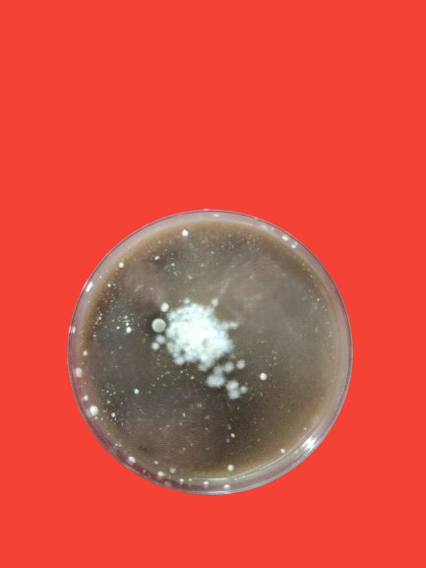 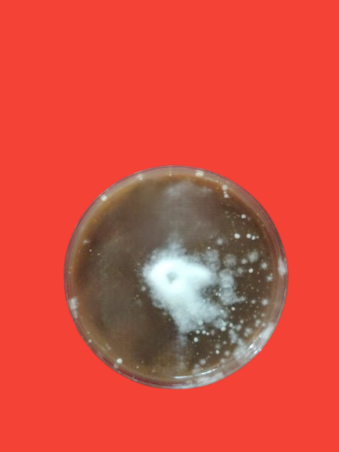 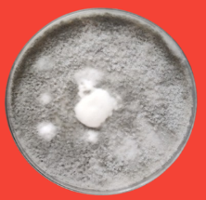

**T1-Th4d T2-Propiconazole T3-Pathogen control**

**Fig 5.a Inhibitory effect of *Trichoderma* against mycelial growth of *Amphobotrys ricini* using Poisoned food technique.**

By lowering the mycelial growth of *Amphobotrys ricini* to 21.00 mm and attaining a 76.66 per cent inhibition rate, the *Trichoderma* treatment Th4d was shown to significantly suppress the growth using the poisoned food technique presented in Table 5.a and Fig 5.a. Th4d and Propiconazole differed just marginally, despite Propiconazole exhibiting a somewhat higher inhibition percentage of 78.88 per cent with 19.00 mm mycelial growth. On the other hand, the untreated control showed complete fungal growth without any inhibition at 90.00 mm. In addition to chemical fungicides, these results demonstrate the significant antagonistic capability of Th4d, which makes it a viable biological option for controlling *Amphobotrys ricini*.

The study's conclusions demonstrate the potential of *Trichoderma* treatment (Th4d) as a successful biocontrol agent against the fungal disease *Amphobotrys ricini*, which damages castor plants. The findings show that Th4d strongly suppresses *A. ricini* mycelial growth, with an inhibition rate of 76.66 per cent, which is similar to but marginally less effective than the pharmaceutical fungicide Propiconazole (78.88per cent). These results are consistent with earlier studies that found *Trichoderma* species, especially *Trichoderma harzianum*, to have potent antifungal qualities, which makes them useful tools for integrated pest management (IPM) plans (Vinale *et al*., 2008; Shoresh *et al*., 2010).

A complete 90.00 mm mycelial growth was observed in the untreated control in this study, highlighting the pathogenicity and the harm that *A. ricini* can inflict on crops. The significance of creating sustainable and efficient control strategies is further highlighted by this. In order to improve *Trichoderma's* efficacy in field settings, future research could concentrate on refining its application techniques and assessing its long-term effects on plant growth and soil health (Shoresh *et al*., 2010).

**Table 5.b Inhibitory effect of *Trichoderma harzianum* against gray mold of castor through detached capsule technique.**

|  |  |  |  |
| --- | --- | --- | --- |
| **Sl.No** | **Treatments** | **DI (%)** | **DR (%)** |
| T1 | Th4d 20 % SC | 21.67 (27.73) b | 78.33 (61.95) b |
| T2 | Propiconazole | 21.10 (27.34) b | 78.9 (62.69) c |
| T3 | Pathogen control | 100.0 (90.00) c | 0 (0.00) a |
| T4 | Healthy control | 0 (0.00) a | - |
| S. Em ± | | 0.02 | 0.26 |
| C.D (*P* ≤ 0.05) | | 0.06 | 0.79 |
| C.V. | | 0.13 | 1.23 |

*Mean values of five replications, Inhibition (%) - values are arc sine transformed values.

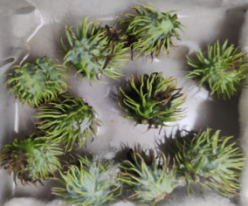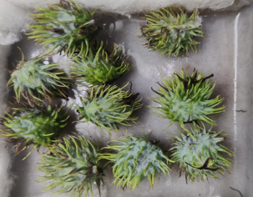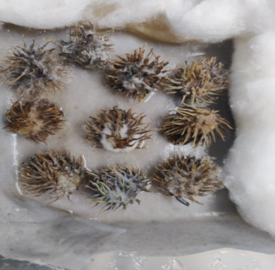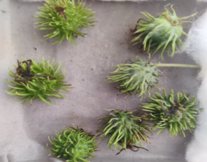

**T1-Th4d 20 % SC T2-Propiconazole T3-Pathogen control T4-Healthy control**

**Fig 5.b Inhibitory effect of *Trichoderma harzianum* against gray mold of castor through detached capsule technique.**

The effectiveness of *Trichoderma harzianum* (Th4d 20 % SC) against gray mold in castor was evaluated using the detachable capsule technique mentioned in Table 5.b and Fig 5.b. According to the results, Th4d treatment (T1) led to a high disease reduction of 78.33 per cent and a significant decrease in disease incidence to 21.67 per cent. With a DI of 21.10 per cent and a DR of 78.9 per cent, the chemical fungicide Propiconazole (T2) performed almost as well as this one. On the other hand, the healthy control (T4) shown no symptoms of the disease, while the pathogen control (T3) displayed 100 per cent disease incidence with no decline. These results show that Th4d is a powerful biological alternative that is on par with conventional chemical control for reducing gray mold when applied via the detachable capsule technique.

The ability of Trichoderma species, such as T. harzianum, to suppress pathogens like B. cinerea can be attributed to several well-documented mechanisms, including direct antagonism, production of hydrolytic enzymes, and the induction of plant defense responses (Howell, 2003; Harman, 2006). Trichoderma species have been shown to produce a range of enzymes, such as chitinases, glucanases, and cellulases, which degrade the cell walls of fungal pathogens, thereby inhibiting their growth and spread (Shoresh et al., 2010). Moreover, Trichoderma can out compete pathogens for space and nutrients, further contributing to its antagonistic activity.

**CONCLUSION**

In summary,The Th4d strain performs on par with or better than chemical fungicides, demonstrating exceptional biocontrol potential against important castor fungal diseases. It dramatically decreased disease incidence and pathogen-induced mycelial growth in a variety of bioassays, such as gray mold suppression, seedling protection through poisoned food technique. Th4d improved plant growth indices like biomass, root and shoot length, and seed vigor in addition to controlling disease. Its adaptability and dependability are highlighted by its performance against F. oxysporum, M. phaseolina, and A. ricini. The uniformity of outcomes between *in vivo* and *in vitro* methods lends credence to its suitability for integrated disease control in castor farming. Crucially, Th4d offers a biologically based, sustainable alternative that lessens need on chemical fungicides. In terms of castor crop protection, its use is consistent with environmentally benign farming methods and holds potential for commercialization.

**References:**

1. Abhiram P, Masih H. (2018). In vitro evaluation of *Trichoderma viride* and *Trichoderma harzianum* against *Fusarium oxysporum* strains. *J Pharmacogn Phytochem*, 7(2):2838–41.
2. Akalazu JN. (2023). Evaluation of biocontrol efficacy of *Trichoderma harzianum* against *Fusarium oxysporum* in tomatoes. *J Plant Pathol*, 21(2):191–202.
3. Aravind K, Prasad SL, Sagar V, Naik DS, Pushpavalli SNCVL. (2024). Assessing pathogenicity and cultural characteristics of *Fusarium oxysporum* f. sp. *ricini* isolates from major castor growing regions of India. *J Sci Res Rep*, 30(11):678–88.
4. Arutselvan R, Devi UG, Prasad RD, Sarada C. (2020). Effect of temperature and culture media on mycelial growth and sporulation of *Botryotinia ricini* causing gray mold of castor. *J Res PJTSAU*, 48(1–2):21–7.
5. Cherkupally R, Amballa H, Narasimha RB. (2016). In vitro antagonistic activity of *Trichoderma* and *Penicillium* species against *Macrophomina phaseolina* (Tassi) Goid. *J Agric Technol*, 7(9):34–8.
6. Godfrey GH. (1923). Gray mold of castor bean. *J Agric Res*, 23(9):679–715.
7. Harman GE. (2006). Overview of mechanisms and uses of *Trichoderma* spp. *Phytopathology*, 96(2):190–4.
8. Harman GE, Howell CR, Viterbo A, Chet I, Lorito M. (2004). *Trichoderma* species—opportunistic, avirulent plant symbionts. *Nat Rev Microbiol*, 2:43–56.
9. Howell CR. (2003). Mechanisms employed by *Trichoderma* species in the biological control of plant diseases: the history and evolution of current concepts. *Plant Dis*, 87:4–10.
10. Lorito M, Woo SL, Harman GE, Monte E. (2010). Translational research on *Trichoderma*: From omics to the field. *Annu Rev Phytopathol*, 48:395–417.
11. Lotfalinezhad E, Mehri Z, Sanei SJ. (2013). Temperature response of *Macrophomina phaseolina* isolates from different climates in Iran. *Annu Rev Res Biol*, 3(4):724–34.
12. Marquez N, Giachero ML, Declerck S, Ducasse DA. (2021). *Macrophomina phaseolina*: General characteristics of pathogenicity and methods of control. *Front Plant Sci*, 12:634397.
13. Naik MK. (1994). Seed-borne nature of *Fusarium* in castor. *Indian J Mycol Plant Pathol*, 24:62.
14. Nanda S, Prasad N. (1974). Wilt of castor: A new record. *Indian J Mycol Plant Pathol*, 4:103–5.
15. Navaneetha T, Prasad RD, Venkateswar RL. (2015). Liquid formulation of *Trichoderma* species for management of gray mold in castor. *Int J Plant Pathol*, 6(1):1–11.
16. Preeti N, Kumari, Sharma V. (2013). Detached leaf assay for resistance to *Macrophomina phaseolina* and isolation of toxin from infected leaves and its analysis by TLC. *J Biol Chem Res*, 30(1):254–63.
17. Pushpavathi B, Sarwar HAK, Raoof MA, Ravindra Babu R. (1997). Management of wilt disease in castor. *Indian J Plant Prot*, 26:177–80.
18. Sreedevi B, Charitha DM, Saigopal DVR. (2011). Isolation and screening of effective *Trichoderma* spp. against the root rot pathogen *Macrophomina phaseolina*. *J Agric Technol*, 7(3):623–35.
19. Soares DJ. (2012). Gray mold of castor: A review. In: Cumagan CJRC, ed. *Plant Pathology*. 219–40.
20. Shoresh M, Harman GE, Mastouri F. (2010). Induced systemic resistance and plant responses to fungal biocontrol agents. *Phytopathology*, 100(3):1214–21.
21. Vahunia B, Singh P, Patel NY, Rathava A. (2017). Management of *Fusarium* wilt of castor (*Ricinus communis* L.). *Int J Curr Microbiol Appl Sci*, 6(9):390–5.
22. Vasebi Y, Safaie N, Alizadeh A. (2013). Biological control of soybean charcoal root rot disease using bacterial and fungal antagonists in vitro and greenhouse conditions. *J Crop Prot*, 2(2):139–50.
23. Vinale F, Sivasithamparam K, Ghisalberti EL. (2008). *Trichoderma* species as biocontrol agents. *Soil Biol Biochem*, 40(1):1–10.
24. Viterbo A, Ramot O, Chemin L, Chet I. (2002). Significance of lytic enzymes from *Trichoderma* spp. in the biocontrol of fungal plant pathogens. *Mycol Res*, 81:549–56.
25. Yamuna, et al. (2020). Management of castor gray mold using *Trichoderma* species. *Indian J Pure Appl Biosci*, 8(3):199–208.