***Original Research Article***

**Harnessing the Biotechnological Power of Biodigester-Derived Bacteria**

# **ABSTRACT**

|  |
| --- |
| **Aims**: The present study aimed to isolate and characterize bacterial strains from bovine biodigester sludge collected in western Paraná, Brazil, with potential biotechnological applications.  **Study design:** A total of six isolates (belonging to the genera *Brucella*, *Microbacterium*, and *Brevibacillus*)were previously isolated from swine and bovine sludge samples collected from an Upflow Anaerobic Sludge Blanket (UASB) reactor fed with bovine manure, located in western Paraná, Brazil.  **Place and Duration of Study**: Bacterial isolates from biodigester collection were used in this study. Research activities were conducted at Labiogen (Laboratory of Biochemistry and Genetics), UFPR/Sector Palotina, between June 2023 and July 2024**.**  **Methodology:** The microbiological composition was obtained by 16sRNA genetic characterization, as well as, phosphate and potassium solubilization capacity, catalase and oxidase, fungal antagonism, and enzymatic capacity.  **Results:** Enzymatic assays revealed significant production of amylase, protease, cellulase, and lipase, with *Microbacterium mangrovi* and *M. arabinogalactanolyticum* exhibiting the highest enzyme indices. Three isolates demonstrated potassium solubilization, although none showed phosphate solubilizing capacity. Partial antifungal activity was detected exclusively in *M. arabinogalactanolyticum*. Biofilm formation was strain-dependent and influenced by carbon sources and incubation times, with several isolates showing consistently low biofilm production-an advantageous trait for industrial applications.  **Conclusion:** These findings highlight the untapped microbial potential of biodigester sludge and support its exploration as a source of bacteria with promising applications in biotechnology and sustainable agriculture. |

*Keywords: biodigesters, biofilm, enzymatic capacity*

# **INTRODUCTION**

Microorganisms represent a vast natural resource found in all habitats. Swine and bovine biodigester sludge can harbor a wide range of bacterial genera capable of performing anaerobic fermentation, resulting in methane production and the generation of organic fertilizers for use in rural areas [1,2]. Despite this diversity, only a small fraction has been explored to date [3].

Bioprospecting refers to the systematic identification, evaluation, and utilization of biological diversity to discover genetic resources [4]. It is the first step in valorizing biodiversity [5]and enables the development of biotechnological innovations in fields such as biofuels, medicine, pharmaceuticals, and agriculture [6–8].

Bacterial genera are considered valuable sources of species with biotechnological potential [9], as they can produce a wide range of versatile biomolecules used in industrial, pharmaceutical, and agronomic applications. This is largely due to their enzymatic stability, catalytic efficiency, and ease of production and optimization for plant and animal enzyme applications [10,11]. Many bacterial genera are known to produce enzymes such as amylases, proteases, pectinases, lipases, cellulases, and xylanases, which are widely used in industries including detergent, textile, chemical, food and beverage, biofuels, animal feed, and personal care [12,13]. These enzymes offer advantages such as high performance and ease of modification and optimization due to biochemical diversity. Bacteria are also amenable to genetic manipulation, and selected strains can produce large-scale, purified, and well-characterized enzymes, antibiotics, and other bioactive compounds [14,15].

Biofilms are structured communities of bacterial cells embedded in a self-produced extracellular polymeric matrix, primarily composed of exopolysaccharides (EPS), DNA, and proteins. Biofilm formation occurs in moist environments where nutrients are available and surfaces are present for attachment, offering protection to bacterial cells [16–19]. While biofilms can be problematic in medical, dental, and food industries [20,21], recent research suggests they may also have industrial applications, such as in the development of new materials, chemical and biological products [22,23], agriculture [24], wastewater treatment and bioremediation [25], and corrosion prevention [20].

The objective of this study was to identify and characterize bacterial isolates with potential biotechnological applications, specifically in terms of their ability to degrade starch, casein, proteins, cellulose, and lipids. The isolates were obtained from bovine biodigester sludge in the western region of Paraná, Brazil. Additional evaluations included their ability to solubilize phosphorus and potassium, form biofilms, and exhibit antifungal activity.

# **MATERIAL AND METHODS**

## **BIOCHEMICAL CHARACTERIZATION OF ISOLATES**

### **Detection of Enzymatic Activity in Solid Media**

Protease, caseinolytic, lipolytic, amylolytic, and cellulolytic activities of the bacterial isolates were evaluated using the agar diffusion method on modified Basal Medium (MM), composed of 2.5 g yeast extract, 1 g glucose, and 14 g agar, following the methodology of [26]. Bacteria were inoculated in the center of Petri dish quadrants and incubated at 30 °C for 48 hours. Three plates were used per isolate, totaling 12 replicates.

Protease activity was assessed in MM supplemented with 6.2 g.L-1 of skim milk protein. A clear halo around the colony indicated positive protease activity. Caseinolytic activity was evaluated in MM with 1% casein. A white halo around the colony indicated casein degradation. Amylolytic activity was tested in MM supplemented with 1% soluble starch. Cellulolytic activity was assessed in MM with 7.5% cellulose biomass (2.5 g of shredded paper in 75 mL of water). Plates were flooded with iodine solution (1% iodine and 2% KI), and clear halos around colonies indicated starch and cellulose degradation.

Lipolytic activity was determined using Tween Agar Medium (10 g peptone, 0.1 g CaCl₂·2H₂O, 5 g NaCl, 10 mL Tween 80, and 15 g agar, pH 7–7.4), as described by [27]. A white precipitate around the colony, formed by calcium salts of released fatty acids, indicated lipase activity after 15 days of incubation at 30 °C.

All enzymatic activities were quantified using the Enzyme Index (EI), calculated as the ratio of the total halo diameter (zone of hydrolysis, in mm) to the colony diameter (mm): All enzyme activities were quantified in terms of Enzyme Index (EI), which was expressed by the ratio between the average diameter of the halo and the average diameter of the colony growth (IE = DMH/DMC), where DMH = total diameter of the hydrolysis zone (hydrolysis halo /Diameter of the Bacterial Colony, measured in mm); DMC = Diameter of the Bacterial Colony (measured in mm). Measurements were taken using a graduated ruler [28,29].

### **Catalase and Oxidase Activity**

Catalase activity was confirmed by bubble formation after applying a drop of 3% hydrogen peroxide (H₂O₂) onto the bacterial colony. Oxidase activity was tested by placing a colony on filter paper, followed by the addition of 1% TEMED (tetramethylethylenediamine) solution. A purple color indicated a positive reaction. Both tests followed the procedures of [30].

### **Potassium and Phosphate Solubilization Capacity**

Potassium solubilization was evaluated using the solid Aleksandrov medium, which contains 5 g.L-1 glucose, 0.005 g.L-1 MgSO₄·7H₂O, 0.1 g.L-1 FeCl₃, 2 g.L-1 CaCO₃, 3 g.L-1 K₂SiO₃, 2 g.L-1 Ca₃(PO₄)₂, and 20 g.L-1 agar, following the protocol described by [31]. Plates were incubated at 30 °C for 3 days. After incubation, the formation of a clear halo around the colonies indicated potassium solubilization activity. Each isolate was tested in three separate plates. Each plate was divided into four quadrants, and one quadrant was inoculated per repetition, totaling twelve replicates per isolate.

Phosphate solubilization was assessed using NBRIP medium [30], also plated in quadrants. Plates were incubated at 30 °C for 6 days. After incubation, the diameter of the solubilization halo and colony was measured using a graduated ruler. The Solubilization Indexes (IS) were obtained using the formula: IS = fHalo (mm) / fColony (mm), where f is the diameter of the halo or colony [32].

### **Antagonistic or Anti-Fungal Capacity**

The antagonistic potential of the bacterial isolates was evaluated using the dual culture method, by direct confrontation between each bacterial isolate and two phytopathogenic fungi: *Fusarium* spp. and *Curvularia lunata*, following the protocol described by [33]. The fungi were first cultivated on Sabouraud Agar in Petri dishes and incubated at 28 °C for 7 to 14 days to ensure sufficient fungal growth.

After this period, bacterial isolates were inoculated laterally, at an appropriate distance from the fungal colony, to allow for interaction during co-culture. The inoculated Petri dishes were incubated in triplicate at 30 °C for 10 days. Fungal inhibition or antagonistic activity was assessed visually, by observing the presence or absence of an inhibition zone between the bacterial and fungal colonies, or changes in fungal growth patterns near the bacterial inoculation site.

### **Biofilm Production and Quantification**

To evaluate the influence of media composition (carbon sources) and incubation time on biofilm formation by biodigester isolates, growth tests were conducted under static conditions following a modified version of the methodology proposed by [34]. Initially, isolates were pre-inoculated in LB broth supplemented with various carbon sources (no sugar, fructose, glucose, or lactose) and incubated with agitation for 12–16 h. Subsequently, 1 mL of a 1:100 dilution of the inoculum was transferred to 2 mL microtubes. These tubes were incubated at 30 °C in a BOD chamber for 24, 48, and 72 h.

After each incubation period, the medium was discarded, and the tubes were gently rinsed twice with distilled water to remove non-adherent cells. The tubes were then tapped on absorbent paper and left to dry at room temperature for 15 min. Next, 1.25 mL of 0.1% crystal violet solution (0.1 g in 100 mL distilled water) was added to each tube and allowed to stain the biofilm for 10–15 min. After staining, the tubes were washed four times with distilled water to remove excess dye and left to dry at room temperature. For biofilm quantification, 1.25 mL of 30% acetic acid was added to each tube to solubilize the retained crystal violet. After 10–15 min, the optical density (OD) was measured using a UV spectrophotometer at 550 nm. All assays were performed in six replicates.

### **Statistical Analysis**

The data obtained from the enzymatic, solubilization, and biofilm production assays were subjected to analysis of variance (ANOVA). Means were compared and grouped using the Scott-Knott test at a 5% significance level. All statistical analyses were performed using the GENES software package [35].

# **RESULTS AND DISCUSSION**

## **Molecular Characterization of Isolates**

The genetic characterization of the isolates is shown in Table 1. The isolates were classified as *Brucella* (Pseudomonadota) – isolates UFPR04 and UFPR05; *Microbacterium* (Actinomycetota) – isolates UFPR13, UFPR20, and UFPR28; and *Brevibacillus* (Bacillota). As expected, the genera *Brucella* [36], *Microbacterium* [37], and *Brevibacillus* [38] have been previously associated with bovine manure.

*Microbacteriaceae* play a significant role in soil ecosystems, acting as both decomposers and nutrient mobilizers. They enhance plant nutrient uptake by solubilizing phosphates and mobilizing other essential nutrients, thereby promoting plant growth. Additionally, their ability to produce enzymes and biopolymers has led to their application in various industries, including food, pharmaceuticals, and agriculture. For instance, *Microbacterium arabinogalactanolyticum* produces d-arabinofuranosidases that degrade the complex d-arabinan core structure of lipoarabinomannan and arabinogalactan [39]. Moreover, *Microbacterium esteraromaticum* has shown salt tolerance [40].

*Brevibacillus laterosporus* is known to produce antimicrobial peptides for use in animal feed. It enhances crop growth by secreting hydrolases to improve nutrient uptake, synthesizing growth hormones, and producing proteins that inhibit the reproduction of harmful organisms, thus functioning as a probiotic [41].

Although the genus *Brucella* is typically associated with brucellosis—a zoonotic disease caused by *B. melitensis*, *B. suis*, and *B. abortus* that affects livestock and humans [42]. The isolates used in this study did not exhibit pathogenicity. All isolates, including *Brucella*, tested negative in biosafety tests using blood agar plates (5% v/v sheep blood).

**Table 1.** **Probable taxonomic classification of biodigester bacterial isolates.**

|  |  |  |  |  |  |
| --- | --- | --- | --- | --- | --- |
| **Isolate** | **Classification** | **Fragment Size** | **E value** | **% Identity** | **Genbank Access** |
| UFPRBD04 | *Brucella pseudogrignonensis* | 1387 | 1,00E-119 | 83.19% | NR_042589.1 |
| UFPRBD05 | *Brucella grignonensis* | 1407 | 6,00E-103 | 87.82% | NR_114149.1 |
| UFPRBD13 | *Microbacterium arabinogalactanolyticum* | 1462 | 0 | 92.24% | NR_044932.1 |
| UFPRBD20 | *Microbacterium mangrovi* | 1463 | 0 | 93.67% | NR_026468.1 |
| UFPRBD22 | *Brevibacillus laterosporus* | 1486 | 0 | 93.09% | NR_112212.1 |
| UFPRBD28 | *Microbacterium esteraromaticum* | 1463 | 6,00E-76 | 83.18% | [NR_026468.1](https://www.ncbi.nlm.nih.gov/nucleotide/NR_026468.1?report=genbank&log$=nucltop&blast_rank=1&RID=GV63GVX7016) |

Fragment Size: Sequence size. E Value: probability of randomly finding the same alignment between two sequences. Identity %: percentage of identity between the isolate's sequence and the related organism. GenBank Access: Sequence accession number of the related organism.

**Table 2**. **Enzymatic activity and solubilization capacity of isolates**

|  |  |  |  |  |  |  |
| --- | --- | --- | --- | --- | --- | --- |
| **Essays** | ***B. pseudogrignonensis*** | ***B. grignonensis*** | ***M. arabinogalactanolyticum*** | ***M. mangrovi*** | ***B. laterosporus*** | ***M. esteraromaticum*** |
| **EI (cm)** | | | | | | |
| Amylase | - | - | - | 2.41 ± 0.39 a | 1.93 ± 0.73 b | - |
| Cellulase | 1.33 ± 0.17 c | - | - | 3.13 ± 0.22 a | 2.96 ± 0.16 a | 2.61 ± 0.30 b |
| Proteinase | - | - | 2.72 ± 0.50 b | 4.23 ± 0.57 a | 4.15 ± 0.91 a | 2.79 ± 0.43 b |
| Caseinase | - | - | - | - | - | - |
| Lipase | - | - | 1.37 ± 0.61 a | - | - | - |
| K | - | - | - | 7.31 ± 2.32 a | 6.85 ± 1.10 a | 2.45 ± 0,.56 b |
| P | - | - | - | - | - | - |

The enzymatic index represents the halo diameter of degradation/diameter of colony in cm. Averages followed by the same letter did not differ among themselves (Scott-Knott, p< 0.05).

## **Biochemical Characterization of Isolates**

The biochemical characterization results are presented in Table 2. None of the isolates tested positive for oxidase activity. Catalase activity was detected in only two species of *Microbacterium*: *M. arabinogalactanolyticum* and *M. esteraromaticum*. Partial antifungal activity was observed in the isolate *M. arabinogalactanolyticum* against *Curvularia lunata*.

Enzymatic assays revealed that five out of six isolates (83%) exhibited hydrolytic activity in at least one assay (Table 2). The visual appearance of halos around bacterial colonies, indicative of enzymatic activity, is shown in Table 2. Four of the six isolates demonstrated multi-enzymatic activity (positive in two or more assays), suggesting a greater ability to degrade and utilize various substrates for growth and adaptation [26].

Amylase activity was observed in isolates *M. mangrovi* and *B. laterosporus*, with *M. mangrovi* exhibiting the highest enzymatic index (EI). Cellulase activity was found in four isolates (*B. pseudogrignonensis*, *M. mangrovi*, *M. esteraromaticum*, and *B. laterosporus*), with *M. mangrovi* again showing the highest EI (3.13 cm). Protease production was noted in four isolates, with EI values ranging from 2.72 to 4.23 cm. The highest protease activity was observed in *M. mangrovi* and *B. laterosporus* (EI: 4.15 - 4.23 cm). None of the isolates showed caseinase activity. Lipase activity was detected only in *M. arabinogalactanolyticum*, with maximum production after 72 h. In contrast, [43] reported maximum lipase activity after 48 h in *Microbacterium* spp.

Intermediate amylase and protease activity were also noted in *Microbacterium* spp. by [44]. Although *B. laterosporus* did not produce caseinase in our study, it has been reported to do so in previous research [44,45]. It is important to note that isolates from the same genus did not always display the same enzymatic profiles (Table 2). This variation could be due to gene gain and loss via horizontal gene transfer, which contributes to bacterial genome plasticity [46].

Potassium solubilization was detected in *M. mangrovi*, *M. esteraromaticum*, and *B. laterosporus*, with *M. mangrovi* showing the highest solubilization index (7.31 cm). None of the isolates demonstrated the ability to solubilize phosphate (Table 2), nor did they exhibit antifungal activity against *Fusarium spp.* or *Curvularia lunata*, except for *M. arabinogalactanolyticum*, as mentioned earlier.

Another relevant feature for industrial use is biofilm production. The ability to form biofilms can hinder the use of certain strains in industrial reactors. The results showed variation among isolates in response to growth time, carbon source, and biofilm production (Figure 1). The highest biofilm formation was observed after 72 h of incubation for *B. pseudogrignonensis* and *M. esteraromaticum* across all tested conditions, especially when fructose and sucrose were added as carbon sources.

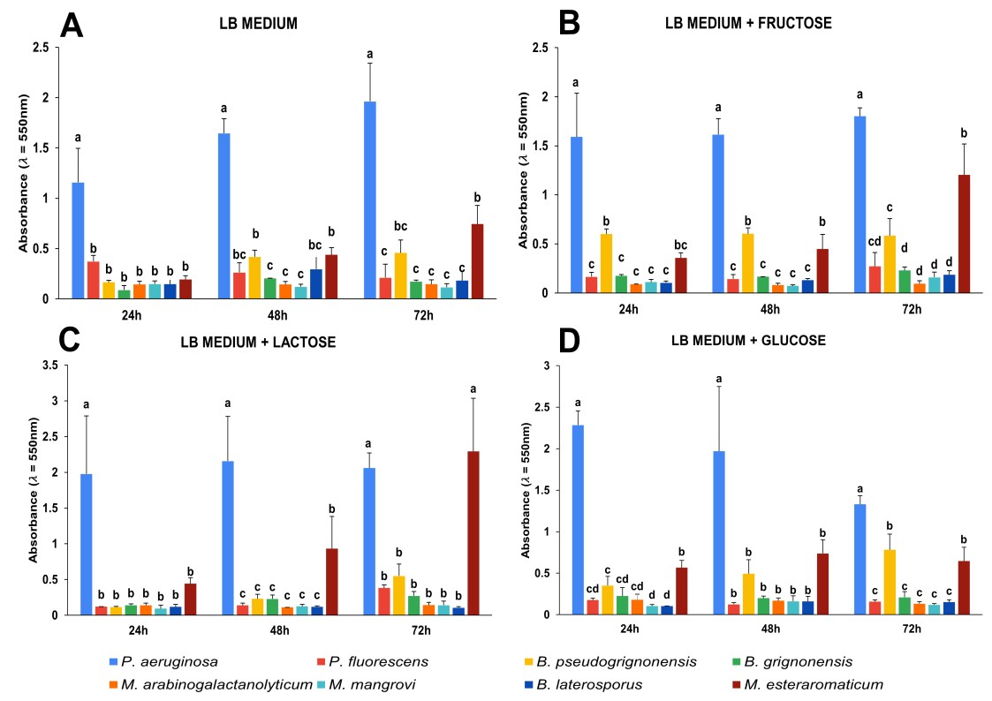

**Fig 1. Bacteria biofilm formation using different carbon sources in the growth medium**. **A**. LB medium (control) **B**.LB medium added fructose. **C**. LB medium added lactose and **D**. LB medium added glucose. Averages followed by the same letter did not differ among themselves (Tukey test, p < 0.05).

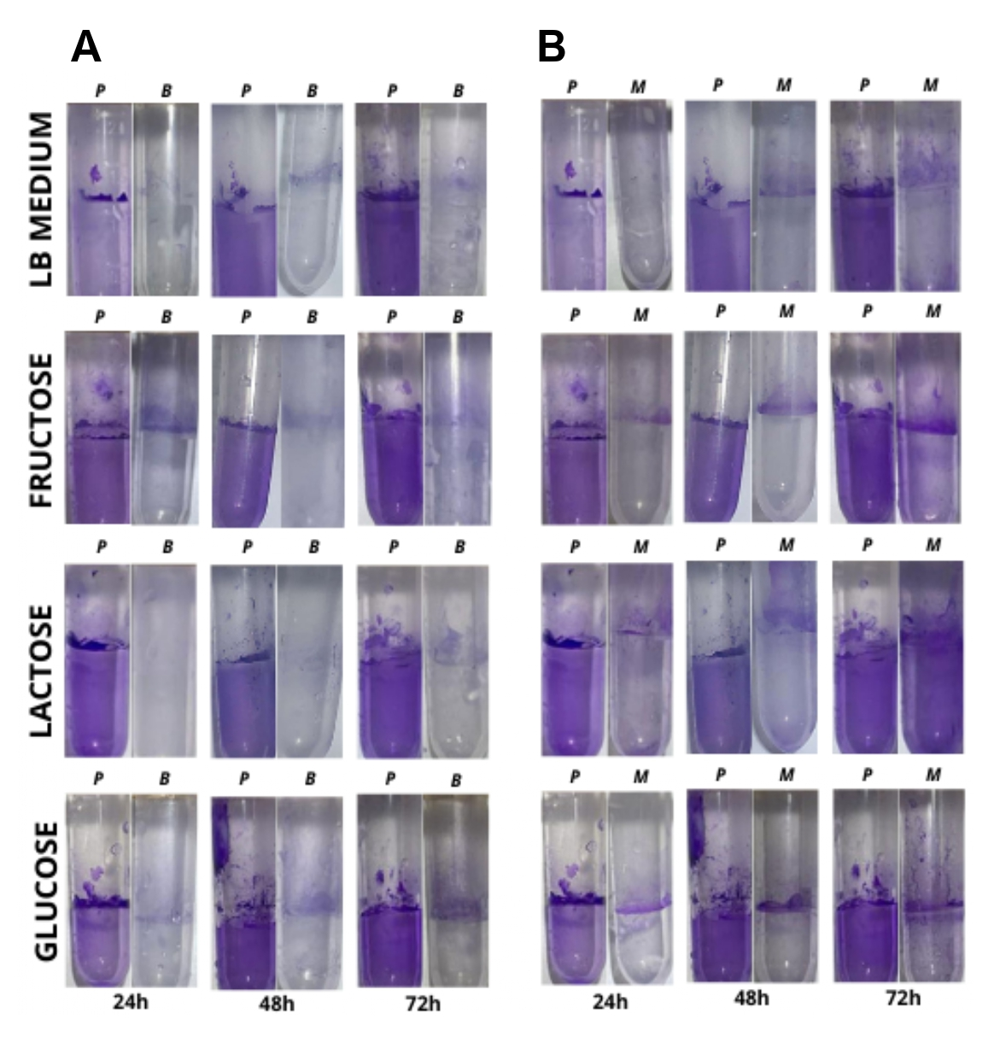

**Fig 2. Visual aspect of the biofilm evaluation.** **A.** Biofilm production using Pseudomonas aeruginosa (P) as control and *B. pseudogrignonensis* (B) **B.** Biofilm production using Pseudomonas aeruginosa (P) as control and *M. esteraromaticum* (M).

Similar findings were reported by [47], who showed that fructose and sucrose promoted the highest levels of biofilm formation in *Pseudomonas aeruginosa* and *Staphylococcus aureus*. [48] also noted that high concentrations of carbon sources, particularly glucose and maltose, stimulated biofilm formation in *Bacillus* spp. In our experiment, all carbon sources were tested at 1%, while [49] observed optimal biofilm production at 2.5% concentrations for glucose, maltose, lactose, and sucrose.

Conversely, *M. arabinogalactanolyticum* and *M. mangrovi* exhibited low biofilm production compared to *M. esteraromaticum*. [18] identified different gene clusters responsible for biofilm formation in various *Microbacterium* strains, which may explain the observed differences in biofilm production among the isolates.

# **CONCLUSIONS**

Exploring bacterial diversity for biotechnological applications remains a critical first step in the development of new industrial technologies. In this study, we evaluated the enzymatic potential and biofilm-forming capacity of six bacterial isolates obtained from bovine biodigester sludge. The isolates were identified as belonging to the genera *Brucella*, *Microbacterium*, and *Brevibacillus*, all commonly associated with bovine sludge environments. Among the isolates, *Microbacterium arabinogalactanolyticum* and *M. mangrovi* emerged as promising candidates for semi-industrial trials. These strains demonstrated the ability to produce important enzymes such as protease, amylase, and cellulase, showed potassium solubilization capacity, and exhibited low biofilm production - an important feature for industrial scalability. However, none of the isolates exhibited significant phosphate solubilization or antagonistic activity against the tested fungal species. Despite these limitations, our findings highlight bovine biodigester sludge as a valuable and underexplored source of bacterial genera with potential applications in agriculture and industry.

# **REFERENCES**

[1] Manyi-Loh CE, Mamphweli SN, Meyer EL, Okoh AI, Makaka G, Simon M. Microbial anaerobic digestion (bio-digesters) as an approach to the decontamination of animal wastes in pollution control and the generation of renewable energy. Int J Environ Res Public Health 2013;10:4390–417. https://doi.org/10.3390/ijerph10094390.

[2] Vendruscolo ECG, Mesa D, Rissi DV, Meyer BH, de Oliveira Pedrosa F, de Souza EM, et al. Microbial communities network analysis of anaerobic reactors fed with bovine and swine slurry. STOTEN 2020;742:140314. https://doi.org/10.1016/j.scitotenv.2020.140314.

[3] Sharma SK, Saini S, Verma A, Sharma PK, Lal R, Roy M, et al. National Agriculturally Important Microbial Culture Collection in the Global Context of Microbial Culture Collection Centres. Proceedings of the National Academy of Sciences, India Section B: Biological Sciences 2019;89:405–18. https://doi.org/10.1007/s40011-017-0882-8.

[4] Almeida. J. R. M., Collares DG, Barbosa PFD. MICROBIAL BIOPROSPECTING. 2015.

[5] Sawarkar Scholar A, Sawarkar A, Sharma R, Gautam V. Bioprospecting: Creating value for biodiversity. ~ 256 ~ The Pharma Innovation J. 2019;8:256–65.

[6] Maester TC, Gomes ES, Pereira MR, Sierra EGM, Lemos MVF, de Macedo Lemos EG. Bioprospecting Studies: Transforming the Natural Genetic Heritage into Biotechnological Richness. The Brazilian Microbiome, Cham: Springer International Publishing; 2017, p. 87–109. https://doi.org/10.1007/978-3-319-59997-7_6.

[7] Maciel FL, Souza CBS de, Vieira CBRC, Salbego ÉL da S, Balzan GD, Ré Í Da, et al. Microrganismos com Potencial Biotecnológico. 1st ed. Bento Gonçalves: 2020.

[8] Sekurova ON, Schneider O, Zotchev SB. Novel bioactive natural products from bacteria via bioprospecting, genome mining and metabolic engineering. Microb Biotechnol 2019;12:828–44. https://doi.org/10.1111/1751-7915.13398.

[9] Cortez SC, Cherri AC, Jugend D, Jesus GMK, Bezerra BS. How Can Biodigesters Help Drive the Circular Economy? An Analysis Based on the SWOT Matrix and Case Studies. Sustainability 2022;14:7972. https://doi.org/10.3390/su14137972.

[10] Singh RS, Singh T, Pandey A. Microbial Enzymes—An Overview. Advances in Enzyme Technology, First Edition, Elsevier; 2019, p. 1–40. https://doi.org/10.1016/B978-0-444-64114-4.00001-7.

[11] Rani A, Saini KC, Bast F, Varjani S, Mehariya S, Bhatia SK, et al. A Review on Microbial Products and Their Perspective Application as Antimicrobial Agents. Biomolecules 2021;11:1860. https://doi.org/10.3390/biom11121860.

[12] Adrio JL, Demain AL. Microbial enzymes: tools for biotechnological processes. Biomolecules 2014;4:117–39. https://doi.org/10.3390/biom4010117.

[13] Nigam PS. Microbial enzymes with special characteristics for biotechnological applications. Biomolecules 2013;3:597–611. https://doi.org/10.3390/biom3030597.

[14] Mahdizade Ari M, Dadgar L, Elahi Z, Ghanavati R, Taheri B. Genetically Engineered Microorganisms and Their Impact on Human Health. Int J Clin Pract 2024;2024. https://doi.org/10.1155/2024/6638269.

[15] Yang P, Condrich A, Lu L, Scranton S, Hebner C, Sheykhhasan M, et al. Genetic Engineering in Bacteria, Fungi, and Oomycetes, Taking Advantage of CRISPR. DNA 2024;4:427–54. https://doi.org/10.3390/dna4040030.

[16] Flemming H-C, Wingender J. The biofilm matrix. Nat Rev Microbiol 2010;8:623–33. https://doi.org/10.1038/nrmicro2415.

[17] Fessia A, Sartori M, García D, Fernández L, Ponzio R, Barros G, et al. In vitro studies of biofilm-forming Bacillus strains, biocontrol agents isolated from the maize phyllosphere. Biofilm 2022;4:100097. https://doi.org/10.1016/j.bioflm.2022.100097.

[18] Kim B, Gurung S, Han S-R, Lee J-H, Oh T-J. Comparative Genomic Analysis of Biofilm-Forming Polar Microbacterium sp. Strains PAMC22086 and PAMC21962 Isolated from Extreme Habitats. Microorganisms 2023;11:1757. https://doi.org/10.3390/microorganisms11071757.

[19] Singh R, Paul D, Jain RK. Biofilms: implications in bioremediation. Trends Microbiol 2006;14:389–97. https://doi.org/10.1016/j.tim.2006.07.001.

[20] Muhammad MH, Idris AL, Fan X, Guo Y, Yu Y, Jin X, et al. Beyond Risk: Bacterial Biofilms and Their Regulating Approaches. Front Microbiol 2020;11. https://doi.org/10.3389/fmicb.2020.00928.

[21] Thi MTT, Wibowo D, Rehm BHA. Pseudomonas aeruginosa biofilms. Int J Mol Sci 2020;21:1–25. https://doi.org/10.3390/ijms21228671.

[22] Flemming H-C, Neu TR, Wozniak DJ. The EPS Matrix: The “House of Biofilm Cells.” J Bacteriol 2007;189:7945–7. https://doi.org/10.1128/JB.00858-07.

[23] Shineh G, Mobaraki M, Perves Bappy MJ, Mills DK. Biofilm Formation, and Related Impacts on Healthcare, Food Processing and Packaging, Industrial Manufacturing, Marine Industries, and Sanitation–A Review. Appl Microbiol 2023;3:629–65. https://doi.org/10.3390/applmicrobiol3030044.

[24] Li Y, Narayanan M, Shi X, Chen X, Li Z, Ma Y. Biofilms formation in plant growth-promoting bacteria for alleviating agro-environmental stress. STOTEN 2024;907:167774. https://doi.org/10.1016/j.scitotenv.2023.167774.

[25] Chattopadhyay I, J RB, Usman TMM, Varjani S. Exploring the role of microbial biofilm for industrial effluents treatment. Bioengineered 2022;13:6420–40. https://doi.org/10.1080/21655979.2022.2044250.

[26] Mazzucotelli CA, Ponce AG, Kotlar CE, Moreira M del R. Isolation and characterization of bacterial strains with a hydrolytic profile with potential use in bioconversion of agroindustial by-products and waste. Food Sci. Technol. 2013;33:295–303. https://doi.org/10.1590/S0101-20612013005000038.

[27] Harrigan WF, McCane EM. Laboratory Methods in Microbiology. 3rd ed. London: Academic Press; 1998.

[28] Jussara A, Carrim I, Barbosa C, Daniel J, Vieira G. BRAZILIAN ARCHIVES OF BIOLOGY AND TECHNOLOGY Enzymatic Activity of Endophytic Bacterial Isolates of Jacaranda decurrens Cham. (Carobinha-do-campo). Brazilian Arch. Biol. Technol. 2006;49:353–9.

[29] Oliveira AN de, Oliveira LA de, Andrade JS, Chagas Júnior AF. Atividade enzimática de isolados de rizóbia nativos da Amazônia Central crescendo em diferentes níveis de acidez. Ciência e Tecnologia de Alimentos 2006;26:204–10. https://doi.org/10.1590/S0101-20612006000100032.

[30] Nautiyal CS, Bhadauria S, Kumar P, Lal H, Mondal R, Verma D. Stress induced phosphate solubilization in bacteria isolated from alkaline soils. FEMS Microbiol Lett 2000;182:291–6. https://doi.org/10.1111/j.1574-6968.2000.tb08910.x.

[31] Sun F, Ou Q, Wang N, Guo Z xuan, Ou Y, Li N, et al. Isolation and identification of potassium-solubilizing bacteria from Mikania micrantha rhizospheric soil and their effect on M. micrantha plants. Glob Ecol Conserv 2020;23:e01141. https://doi.org/10.1016/j.gecco.2020.e01141.

[32] Berraquero FR, Baya AM, Cormenzana AR. ARS Pharmaceutica Consejo de Redacción. Granada: 1976.

[33] Freitas J, Mônico A, Lírio E, Sarnaglia-Jnr V, Bonadeu F, Silva J, et al. Inoculation of Bradyrhizobium japonicum (Kirchner, 1896) Jordan (1982) (Bradyrhizobiaceae) on Inga edulis Mart. (Leguminosae, Mimosoideae). Greener J. Agricult. Sci. 2016;6:087–92. https://doi.org/10.15580/GJAS.2016.3.063014287.

[34] O’Toole GA. Microtiter dish biofilm formation assay. J Vis Exp 2011. https://doi.org/10.3791/2437.

[35] Cruz CD. GENES - a software package for analysis in experimental statistics and quantitative genetics. Acta Sci Agron 2013;35. https://doi.org/10.4025/actasciagron.v35i3.21251.

[36] Morales-Estrada AI, Hernández-Castro R, López-Merino A, Singh-Bedi J, Contreras-Rodríguez A. Isolation, identification, and antimicrobial susceptibility of Brucella spp. cultured from cows and goats manure in Mexico #. Arch Med Vet 2016;48:231–5. https://doi.org/10.12.2015.

[37] Jaafarzadeh N, Jorfi S, Mirzaiy A, Ghaedrahmat Z. Bovine Manure as a Rich Source for Isolation of Halo-Tolerant Bacterial Strains Capable of PAHs Biodegradation in Slurry Bioreactor. Biointerface Res Appl Chem 2021;11:14964–73. https://doi.org/10.33263/BRIAC116.1496414973.

[38] Aiysha D, Latif Z. Insights of organic fertilizer micro flora of bovine manure and their useful potentials in sustainable agriculture. PLoS One 2019;14. https://doi.org/10.1371/journal.pone.0226155.

[39] Shimokawa M, Ishiwata A, Kashima T, Nakashima C, Li J, Fukushima R, et al. Identification and characterization of endo-α-, exo-α-, and exo-β-d-arabinofuranosidases degrading lipoarabinomannan and arabinogalactan of mycobacteria. Nat Commun 2023;14. https://doi.org/10.1038/s41467-023-41431-2.

[40] Bhambure AB, Mahajan GR, Kerkar S. Salt Tolerant Bacterial Inoculants as Promoters of Rice Growth and Microbial Activity in Coastal Saline Soil. Proceedings of the National Academy of Sciences, India Section B: Biol. Sci. 2018;88:1531–8. https://doi.org/10.1007/s40011-017-0901-9.

[41] Liu X, Kokare C. Microbial Enzymes of Use in Industry. Biotechnology of Microbial Enzymes, Elsevier; 2017, p. 267–98. https://doi.org/10.1016/B978-0-12-803725-6.00011-X.

[42] Ferrero MC, Alonso Paiva IM, Muñoz González F, Baldi PC. Pathogenesis and immune response in Brucella infection acquired by the respiratory route. Microbes Infect 2020;22:407–15. https://doi.org/10.1016/j.micinf.2020.06.001.

[43] Tripathi R, Singh J, Bharti R kumar, Thakur IS. Isolation, Purification and Characterization of Lipase from Microbacterium sp. and its Application in Biodiesel Production. Energy Procedia 2014;54:518–29. https://doi.org/10.1016/j.egypro.2014.07.293.

[44] Battisti R, Junkerfuerbom A, Machado KN, Mesa D, Santos MF, Vendruscolo ECG. Determination of biotechnological potential of poultry litter isolated bacteria. Biosci. J. 2024;40:e40030. https://doi.org/10.14393/BJ-v40n0a2024-69345.

[45] Hussein NNA, Ibrahim AI, Kamar FH, Nechifor AC. Caseinase Production and Media Optimization from Bacillus subtilis. Rev. Chimie 2020;71:1–9. https://doi.org/10.37358/RC.20.11.8368.

[46] Lee IPA, Eldakar OT, Gogarten JP, Andam CP. Bacterial cooperation through horizontal gene transfer. Trends Ecol Evol 2022;37:223–32. https://doi.org/10.1016/j.tree.2021.11.006.

[47] Haney E, Trimble M, Cheng J, Vallé Q, Hancock R. Critical Assessment of Methods to Quantify Biofilm Growth and Evaluate Antibiofilm Activity of Host Defence Peptides. Biomolecules 2018;8:29. https://doi.org/10.3390/biom8020029.

[48] Zhou J, Wu Y, Liu D, Lv R. The effect of carbon source and temperature on the formation and growth of Bacillus licheniformis and Bacillus cereus biofilms. LWT 2023;186:115239. <https://doi.org/10.1016/j.lwt.2023.115239>.

[49] Zou M, Liu D. Effects of carbon sources and temperature on the formation and structural characteristics of food-related Staphylococcus epidermidis biofilms. Food Sci. Human Wellness 2020;9:370–6 https://doi.org/10.1016/j.fshw.2020.05.007.