**Impact of Milking Hygiene Practices on Microbiological Quality of Raw Milk in Rural Dairies**

**Abstract**

This study was conducted to assess the microbiological quality and safety of raw milk across various sampling points. Given that milk is a nutrient-dense medium highly vulnerable to microbial contamination, particularly during the milking process, the investigation focused on evaluating raw milk samples collected from multiple rural dairy locations. The primary objective was to examine the influence of milking hygiene practices on microbial quality, with specific emphasis on Standard Plate Count (SPC) and Total Coliform Count (TCC) in these rural dairy settings. Milk samples were collected from 5 rural dairies practicing different levels of hygiene (categorized as good, moderate, and poor) based on predefined parameters such as udder washing, equipment sterilization, and milker hygiene. The samples were analyzed using standard microbial techniques for SPC and TCC. The results indicated a significant correlation between hygiene practices and microbial load. Our samples of milk found various bacterial strain such as *Staphylococcs aureus., Bacillus spp. Streptococcus. uberis, Klebsiella spp, Listeria monocytogenes* and *E.coli* other *coliforms* that pose a threat to mortal health. So the poor hygiene approach in dairy products resulted in SPC and TCC value that were higher than allowed, indicating an inflated risk of ruining and promise health issues. The study emphasizes the need for awareness and implementation of hygienic milking protocols to ensure milk safety and shelf life.

**Keywords:** Microbial Contamination, Standard Plate Count, Total Coliform Count, Hygienic practices, Sterilization

**Introduction**

Milk and Milk products are considered as highly nutritious food sources [1,2]. However, they are particularly susceptible to microbial contamination [3]. These products provide a favorable environment for the growth and proliferation of both pathogenic and non-pathogenic bacteria, which can result in spoilage, infection, or intoxication [4,5]. The safety and quality of milk and its derivatives are influenced by multiple factors, including hygiene and sanitation protocols, farm management practices, milking and milk handling procedures, storage conditions, transportation methods, the health status of lactating animals, and the quality of water used for cleaning milking equipment, udders, and teats. These elements represent critical control points for minimizing microbial contamination and safeguarding public health against milk-borne diseases [6–10].

In developing countries, milk and dairy products represent a major source of foodborne illnesses [6]. Raw milk and its by-products may harbor various pathogenic microorganisms, including *Staphylococcus aureus*, bacterium is responsible for a number of respiratory disease [11] *Escherichia coli*, *Campylobacter* spp., *Salmonella* spp., and *Listeria monocytogenes*, all of which pose significant health hazards when consumed by humans [12,13]

Fecal contamination—introduced through water, feed, or environmental exposure—can lead to the presence of coliforms, *E. coli*, and other enteric bacteria in milk and dairy products, thereby increasing the likelihood of foodborne infections [7,13,14]. Moreover, mastitis, an inflammatory disease of the udder often caused by pathogens such as *S. aureus*, negatively affects both animal health and the safety and quality of milk [6]. In addition, non-pathogenic psychrotrophic bacteria can contribute to rapid spoilage of milk, resulting in economic losses for producers and reduced quality for consumers [15,16].

Effectively mitigating the risks associated with milk-borne diseases necessitates a comprehensive, multi-pronged strategy. This includes the enforcement of stringent hygiene and sanitation measures, optimal management of dairy livestock, the implementation of standardized milking and milk handling protocols and consistent microbiological surveillance and testing [9,17]. Strengthening infrastructure for water quality control and promoting educational initiatives targeted at both dairy farmers and consumers are also critical components in reducing the public health burden posed by contaminated milk.

The absence of governmental oversight and regulation in the distribution. of fresh raw milk represents a significant public health concern [13]. The lack of established hygienic standards, regulatory enforcement, and uniform policy frameworks undermines efforts to ensure milk safety, leading to inconsistencies in product quality. Additionally, poor transportation infrastructure and the common practice of delivering raw milk directly to households contribute to elevated risks of microbial contamination, thereby increasing the incidence of foodborne illnesses among the population [18–20]. Addressing these challenges demands collaborative action from governmental bodies, stakeholders in the dairy industry and local communities alike.

The implementation of regulatory frameworks and enforcement mechanisms is essential to ensure adherence to hygiene standards and quality control protocols. In addition, investments in infrastructure enhancement, training initiatives for dairy farmers and vendors, and public awareness campaigns can significantly contribute to promoting safer practices in milk production and distribution [21].

**Materials and Methods**

**Work place and study period**

All these experiments of this study were carried out in the Microbiology lab of Meerut institute of Engineering and Technology, Meerut from December 2025 to May 2025.

### Sample Collection Methods

### Samples of raw milk were aseptically gathered from ten nearby dairy farms, vendors, cafeterias, and open markets in sterile screw capped bottles. Samples were collected straight from each farms separate udder quarters and from milking containers as soon as the cow was milked. Before tasting, cafeteria milk was combined. Each source (container, udder or cafeteria) provided a 250 ml volume that was labeled, kept in iceboxes at 4 0C, and then quick brought to the MIET microbiological lab for further testing.

**Microbiological Test**

**Standard Plate Count (SPC)**

The SPC of raw-milk samples obtained from producers is a quantitative measure of the total aerobic bacterial load present at the time of collection. To perform this assessment, milk samples were inoculated onto a solid nutrient medium and incubated at 37°C for 48 hours to facilitate bacterial growth. Individual bacterial cells or small groupings—such as clusters, chains, or clumps—develop into visible colonies, which were subsequently enumerated. The bacterial load was quantified in terms of colony-forming units per milliliter (cfu/mL). Milk collected aseptically from healthy cows under hygienic conditions generally presents SPC values of less than 1,000 cfu/mL.

**To determine the total viable bacterial count, SPC was conducted using Nutrient Agar (NA) as the growth medium.**

**Procedure**: Serial dilutions of the raw milk samples were prepared up to 10⁻⁶ using sterile 0.1% peptone water. From the selected dilutions, 1 mL was aseptically transferred into sterile Petri dishes and overlaid with nutrient agar cooled to approximately 45°C. The plates were subsequently incubated at 37°C for 48 hours. After incubation, the resulting colonies were counted, and the microbial load was expressed as cfu/mL.

**Total Coliform Count** **(TCC)**

**The TCC procedure is a valuable tool for assessing milk quality and identifying potential sources of contamination. By selectively cultivating coliform bacteria on Violet Red Bile Agar (VRBA), this method allows for the detection and quantification of these indicator organisms. The results of TCC analysis can provide crucial insights into milking hygiene practices, equipment cleanliness, and overall dairy farm management, helping to ensure the safety and quality of milk products.**

## Results and Discussion

**Standard Plate Count**

The SPC is a well-established method used for assessing the microbiological quality of milk by quantifying the total number of viable aerobic bacteria. This evaluation plays a critical role in determining the milk's freshness and its suitability for consumption. In our analysis, the SPC values observed ranged from 2.3 × 10⁶ to 6.17 × 10⁷colony-forming units per milliliter (cfu/mL), indicating that the milk was contaminated rendering the milk unsafe for consumption. These values fall well within the acceptable limits, as regulatory standards typically set the maximum allowable SPC for raw milk at 100,000 cfu/mL.

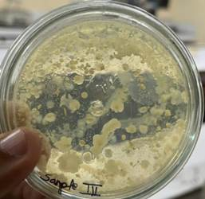High SPC values can result from various factors, including environmental contamination, inadequate refrigeration, delays in processing, and poor sanitation practices during milking and handling.

**Fig-1 Shows colonies of total bacterial count grown on N.A plates after 48 hrs**

**Total Coliform Count**

The TCC was found to be 1.2x103-CFU/mL-1.90×104, which reflects the level of fecal contamination and hygiene status of the milk sample. Coliform bacteria are indicators of possible pathogenic contamination and poor sanitation. A low TCC value is indicative of good milk hygiene and proper handling, whereas elevated levels suggest potential risks for milk-borne infections. The TCC values observed here are consistent with poor sanitary conditions during milking and storage. Controlling coliform contamination is crucial to prevent the transmission of diseases and ensure consumer safety.

Both SPC and TCC results provide complementary insights into milk quality. While SPC assesses the overall microbial load, TCC specifically highlights fecal contamination and hygiene lapses. The findings underline the importance of maintaining strict hygiene practices during milking, storage, and transportation to minimize microbial contamination. Regular monitoring using SPC and TCC methods is essential for ensuring milk safety, extending shelf 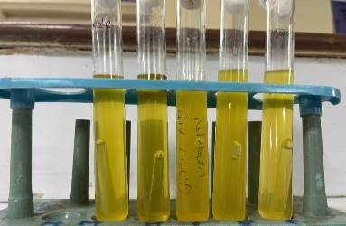life, and protecting public health.

**Fig-2: Shows the TCC contamination level in different raw milk samples**

These bacteria found in raw milk Escherichia coli, -Staphylococcus aureus, Campylobacter *spp.* and Listeria monocytogenes, *Bacillus spp. Strep. uberis, Klebsiella spp*

Most likely, persistent herd mastitis caused the elevated colony counts, and environmental contamination caused the sudden and extreme increases in Gram-positive and negative counts. It is theoretically possible that the elevated numbers were due to contamination with fecal and bedding material because used bedding can contain 106 to 107cfu/ml. Coliform bacteria, known to be causative agents of mastitis, are commonly present in fecal matter, bedding materials, and inadequately sanitized milk handling and storage equipment.These organisms can proliferate rapidly in residual milk left on equipment following insufficient cleaning. During subsequent milking sessions, these residues may be flushed into the bulk tank, significantly elevating the SPC. An increase in SPC may, in part, be attributed to coliform-mastitis, as cows affected by mastitis have shown to shed high concentrations of *Escherichia coli* in their milk.

**Microbial count of milk sample collected from different area in Meerut X axis And Y axis Microbial count cfu/ml**

|  |  |  |  |
| --- | --- | --- | --- |
| S. No | Raw Milk location | SPC (Cfu/ml) | TCC (Cfu/ml) |
| **1** | **Jani** | 2.30x106 | 1.2x103 |
| **2** | **Rohta** | 2.40x106 | 1.4×103 |
| **3** | **Panchli** | 3.10x106 | 1.25x103 |
| **4** | **Modipuram** | 6.20×107 | 1.82x104 |
| **5** | **Maliyana** | 7.17×107 | 1.90×104 |
| **6** | **Partapur** | 5.17×107 | 1.62×104 |

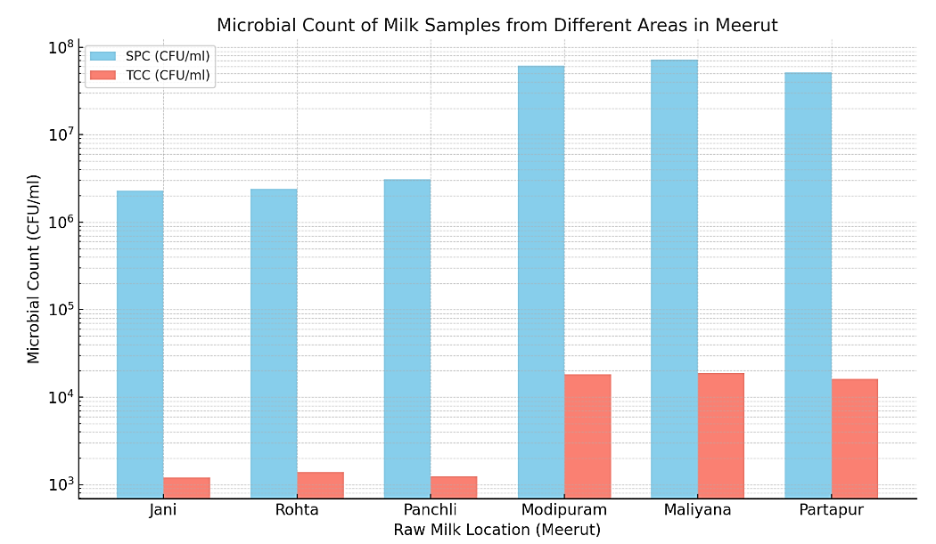

**Fig.3: Microbial count of raw milk samples collected from different area in Meerut**

From the bar graph, we observe the following trends in the microbial quality of raw milk samples:

Jani and Rohta show the lowest microbial load, with SPC values around 2.3–2.4 × 10⁶ CFU/ml and TCC values between 1.2–1.4 × 103 CFU/ml, indicating relatively better quality. Partapur, Modipuram and Maliyana exhibit significantly higher SPC and TCC, especially Maliyana with the highest counts: SPC equal to 6.17 × 10⁷ and TCC equal to 1.90 × 104 CFU/ml, suggesting poor hygienic conditions during milking or storage. The increase in TCC correlates with higher SPC, indicating possible fecal contamination and unsanitary practices. Jani and Rohta samples are microbiologically safer compared to the rest. Immediate corrective actions in milk handling and sanitation are required in Partapur, Modipuram, and Maliyana to ensure milk safety.

**Conclusion**

Our research found that the milk quality in the area was poor due to high level of standard plate count (SPC) and the total coliform count in the tested samples,exceeding international standards. This elevated bacterial load indicates microbial contamination present at different stages of handling of milk at our daily life. To mitigate such contamination and ensure the production of high-quality milk, it is imperative to maintain the health of dairy animals and implement hygienic practices throughout the processes of milking, storage and transportation. Routine testing of bulk-milk quality should be carried out, and appropriate quality standards must be enforced. Furthermore, educational initiatives should be undertaken to raise awareness among dairy farmers and milk producers regarding safe milk handling practices. Maintaining low SPC levels is crucial for preserving milk quality, extending its shelf life, and protecting consumer health. The implementation of strict hygiene protocols, effective cooling systems, and minimizing delays in milk processing are vital steps to control bacterial growth and ensure milk safety.

## References

1. Paraffinn A. S., Zindove T. J., Chimonyo M. Effect of Structural Condition of Milk Processing Facilities and Food Safety Systems on Escherichia coli and Coliforms Presence in Cultured Buttermilk. Journal of Food Quality. 2019;8 doi: 10.1155/2019/7365.
2. Regasa S., Mengistu S., Abraha A. Milk Safety Assessment, Isolation, and Antimicrobial Susceptibility Profile of Staphylococcus aureus in Selected Dairy Farms of Mukaturi and Sululta Town, Oromia Region, Ethiopia. Veterinary Medicine International. 2019 doi: 10.1155/2019/3063185.
3. Oliver S. P., Boor K. J., Murphy S. C., Murinda S. E. Food Safety Hazards Associated with Consumption of Raw Milk. Foodborne Pathogens and Disease. 2009;6(7):793–806. doi: 10.1089/fpd.2009.0302.
4. Ayele Y., Gutema F. D., Edao B. M., et al. Assessment of Staphylococcus aureus along Milk Value Chain and Its Public Health Importance in Sebeta, Central Oromia, Ethiopia. BMC Microbiology. 2017;17(1): p. 141. doi: 10.1186/s12866-017-1048-9.
5. Costanzo N., Ceniti C., Santoro A., Clausi M. T., Casalinuovo F. Foodborne Pathogen Assessment in Raw Milk Cheeses. International Journal Food Science. 2020;8 doi: 10.1155/2020/36167.
6. Deddefo A., Mamo G., Asfaw M., Amenu K. Factors Affecting the Microbiological Quality and Contamination of Farm Bulk Milk by Staphylococcus aureus in Dairy Farms in Asella, Ethiopia. BMC Microbiology. 2023;23(1): p. 65. doi: 10.1186/s12866-022-02746-0.
7. Reta M. A., Bereda T. W., Alemu A. N. Bacterial Contaminations of Raw Cow’s Milk Consumed at Jigjiga City of Somali Regional State, Eastern Ethiopia. International Journal of Flow Control. 2016;3(1): p. 4. doi: 10.1186/s40550-016-0027-5.
8. Zastempowska E., Grajewski J., Twaru˙zek M. Food-borne Pathogens and Contaminants in Raw Milk - a Review. Annals of Animal Science. 2016;16(3):623–639.
9. Tegegne B., Tesfaye S. Bacteriological Milk Quality: Possible Hygienic Factors and the Role of Staphylococcus aureus in Raw Bovine Milk in and Around Gondar, Ethiopia. International Journal of Flow Control. 2017;4(1) doi: 10.1186/s40550-016-0046-2.
10. Garedew L., Berhanu A., Mengesha D., Tsegay G. Identification of Gram-Negative Bacteria from Critical Control Points of Raw and Pasteurized Cow Milk Consumed at Gondar Town and its Suburbs, Ethiopia. BMC Public Health. 2012;12(1): p. 950. doi: 10.1186/1471-2458-12-950.
11. Rajni, Sharma Gaurav, Sahrawat Rinni. In vitro Antimicrobial Potential and Phytochemical Screening of Albizzia lebbeck Benth. Bark against Respiratory Tract Pathogens. *Journal of Advances in Biology & Biotechnology*, 2025, 28 (5), pp.48-55.
12. Fadaei A. Bacteriological Quality of Raw Cow Milk in Shahrekord, Iran. Veterinary World. 2014;7(4):240–243. doi: 10.14202/vetworld.2014.240-243.
13. Fereja A. B., Aboretugn N. F., Bulti N. Q. Determination of Microbial Hygiene Indicators of Raw Cow Milk in Assosa District, Ethiopia. Journal of Food Quality. 2023; 2023:1–6. doi: 10.1155/2023/6769108.
14. Conte F., Panebianco A. Potential Hazards Associated with Raw Donkey Milk Consumption: A Review. International Journal Food Science. 2019;7 doi: 10.1155/2019/578.
15. Estrada-Anzueto M., Martinez B., Stratton J., Bianchini A. Identification of Spoilage Bacteria Present in Laboratory Heat Treated and Commercially Pasteurized Milk: A Case Study Involving Milk Production Chain in Nebraska. Research and Reviews: J. Food Diary Technology. 2017;5(2):22–29.
16. Mohamed A. F., Fourreh A. E., Okieh A. A., Said C. N., Mérito A., Yagi S. Evaluation of Microbiological Quality of Raw Milk from Farmers and Dairy Producers in Six Districts of Djibouti. Journal Food Microbiology Safety. 2017;2: p. 124. doi: 10.4172/2476-2059.
17. Godefay B., Molla B. Bacteriological Quality of Raw Cow’s Milk from Four Dairy Farms and a Milk Collection Center in and Around Addis Ababa. Berl Munch Tierarztl Wochenschr. 2000; 113:1–3.
18. Abebe B., Mohammed Y. K., Zelalem Y. Handling, Processing and Utilization of Milk and Milk Products in Ethiopia: A Review. World Journal of Dairy and Food Science. 2014;9(2):105–112.
19. Haile W., Zelalem Y., Yosef T. Hygienic Practices and Microbiological Quality of Raw Milk Produced Under Different Farm Size in Hawassa, Ethiopia. Journal of Agricultural Research. 2012;1(4):132–142.
20. Keba A., Rolon M. L., Tamene A., et al. Review of the Prevalence of Foodborne Pathogens in Milk and Dairy Products in Ethiopia. International Dairy Journal. 2020;109: p. 104762. doi: 10.1016/j.idairyj.2020.104762.
21. Yenew C., Tadele F., Minuye B., et al. Raw Cow Milk Nutritional Content and Microbiological Quality Predictors of South Gondar Zone Dairy Farmers in Ethiopia. Heliyon. 2022;8(10): p. e11020. doi: 10.1016/j.heliyon. 2022.e11020.