Review Article

A review on the nutritional profile, therapeutic potential, and industrial utilization of asparagus

ABSTRACT:
Asparagus, scientifically known as Asparagus officinalis, belongs to the family Asparagaceae. It can be found in Asia, Europe, Africa, Australia, and India, although it is predominantly cultivated in India. A group of flavonoids, quercetin, steroidal saponins, sarsa sapogenins, Kaempferol, rutin, and polyphenols are the main bioactive ingredients that give the asparagus plants their medicinal significance. Because of its remarkable potential, the tuberous and other plant parts like stem, and leaves are widely used in the pharmaceutical industries in the creation of numerous herbal medicines. The asparagus plants are rich in nutrients and the extracts that are prepared from roots have been shown to have pharmacological properties such as antioxidant, rejuvenator, antibacterial, antiviral, antidiabetic, antifungal, antitumor, and anticancerous. Asparagus is also known as shatavari or satavar, but in ayurveda, it is known as ‘rasayana’ due to its therapeutic properties. The present review explores the nutritional, phytochemical constituent, therapeutic and pharmaceutical properties of asparagus that provide the plant medicinal significance.
KEYWORDS: Asparagus officinalis, phytochemicals, therapeutics, antioxidants
1. INTRODUCTION:
Asparagus, a member of the Asparagaceae family, includes around three hundred species of plants native to Asia, Europe, and Africa. In India, two species of asparagus namely Asparagus officinalis L. and Asparagus racemosus are the most cultivated. Asparagus is cultivated for the tender shoots, commonly known as spears, which have an agreeable flavor after it has been boiled. The most economically, nutritionally, and medicinally important species is garden asparagus (Asparagus officinalis L.) (Negi et al., 2010). A. officinalis is also known as Halgun, Halyun, Hillua, and Shatawar. It is grown for its tender shoots. Asparagus is one of the most delicate, nutritious, and appealing home garden vegetables. It generates an economic return after three years and continues to increase for many more years. It also contains bioactive compounds in its aerial parts, roots, and seeds, such as saponins, vitamins, flavonoids, steroids, glutathione, and spirostanol glycoside, which have various biological properties such as antioxidant, anti-inflammatory, antihepatotoxic, antimicrobial, antidiarrheal, antiulcerogenic, and anticancer effects. (Klanrit et al., 2023). The chromosomal count for asparagus is 2n=20. The actual origin of asparagus is still unknown, however garden asparagus is thought to have originated in the Eastern Mediterranean region, while remains of some wild types have been identified in Africa. The name asparagus is said to have originated from the ancient Greeks, who used it to denote any delicate shoots. Over 2000 years ago, the Romans and Greeks cultivated this shrub, which may still be found growing wild in Britain, Europe, and Central Asia. Global production of A. officinalis is predicted to reach 10.7 million metric tons by 2026. The biggest producers of asparagus are China, Japan, Europe (Germany, Spain, France, Italy), America, Canada, Australia, and India. (Drost et al., 2023). The tender shoots or spears of asparagus are generally used for making juices or cooked as a vegetable. It may be eaten raw as salad whereas the starchy tuberous roots are used for the preparation of soups. Large quantities of asparagus spears are canned and frozen. Asparagus is also preserved in cans or bottles, but the homegrown products thus dealt with are far exceeded in quantity by canned asparagus. It is a good diuretic and is used especially in cardiac dropsy and chronic gout. Asparagine is a white, crystalline chemical that is used specifically for its diuretic qualities and is obtained from the juice of young shoots. (Manisha et al., 2023) Asparagus is a perennial herbaceous plant that reaches a height of 100-150 cm when fully grown. Its root system is adventitious, with fasciculate roots. The plant has a succulent, edible, and stout stem with branched feathery foliage. The main stem's leaves are small scales, smooth in texture, and resemble needle-like cladodes, which are modified stems. These grouped leaves measure approximately 6-32 mm in length and 1 mm in width. Blooms emerge at the junctions of branchlets, appearing singly or in clusters of two or three. These bell-shaped blooms range in color from greenish white to yellow and are solitary at nodes. The six tepals partially fused at the base, resulting in a length of 4.5-6.5 mm. It is predominantly dioecious, with male and female flowers found on separate plants but occasionally produces hermaphrodite flowers. It is propagated using the crown, comprised of roots and rhizomes, while the aerial stem, referred to as the spear, emerges from a bud on the rhizomes. The fruit of the plant consists of berries. (Kaur et al., 2018) Asparagus is a vegetable that thrives in temperate to sub-tropical climates. It grows best in cool and humid weather, and spear production is directly linked to these conditions. During the winter months, the upper portion of the plant dries up, but it sprouts again when spring arrives. For optimal germination of seeds, the temperature should not be lower than 8°C, while a temperature range of 15-25°C is required for good spear development. The plant goes into a dormant state for 60-90 days each year, during which a lower temperature is necessary. To achieve economic yields, it should be grown at an altitude of over 1000m. Although asparagus can withstand cold to some extent, prolonged freezing can be damaging. Asparagus is propagated via seeds or crowns. Sowing takes place in the the hills from March to May and in the plains from July to November.Asparagus is a versatile vegetable that has many medicinal benefits. It is known for its anti-inflammatory, diaphoretic, and demulcent properties. It is a great aid in stimulating and strengthening kidney function and has a diuretic effect on the body. Asparagus can help to revitalize bladder function, reduce inflammation in joints, and prevent small blood vessels from rupturing. Asparagus has also been used as an aphrodisiac. It is particularly useful for people who have issues with keeping fluids, as it has strong antioxidant qualities and high dietary fiber content, which makes it a useful laxative. These benefits have been published in various journals. It applies to both the prevention and treatment of various kinds of cancers. Additionally, it can help prevent neural tube problems in newborns, increase fertility, and regulate female hormone levels. In this review, we would like to emphasize the significance of asparagus. It is a highly valued crop due to its versatile uses in the preparation of different types of medicines in Ayurveda. The stems and roots of the plant hold great importance and are widely employed in the pharmaceutical industry to produce various drugs that can aid in preventing several diseases.
2. Nutritional and Phytoconstituents of A. officinalis:
Asparagus is very rich in carbohydrates, proteins, calcium, iron, dietary fiber, and vitamin C. Asparagine is a white crystalline chemical derived from the juice of new shoots. The edible portion contains:
Table 1: Chemical composition of Asparagus officinalis (Kaur et al., 2018)
Compound name | Quantity
Moisture | 93.0%
Fats | 0.2%
Calcium | 0.21%
Fiber | 0.7%
Starch | 0.4%
Protein | 2.2%
Ash | 0.6%
Total carbohydrate | 3.9%
Sugar | 1.3%
Iron | 0.0012%
lignin | 10.64%
The asparagus plant has various useful bioactive chemicals; however, these compounds are predominantly concentrated in the bottom parts of the spears and are usually removed during industrial processing. Asparanin, protodioscin, yamogenin, and sarsasapogenin are the primary saponins found in both white and green types of Asparagus officinalis.
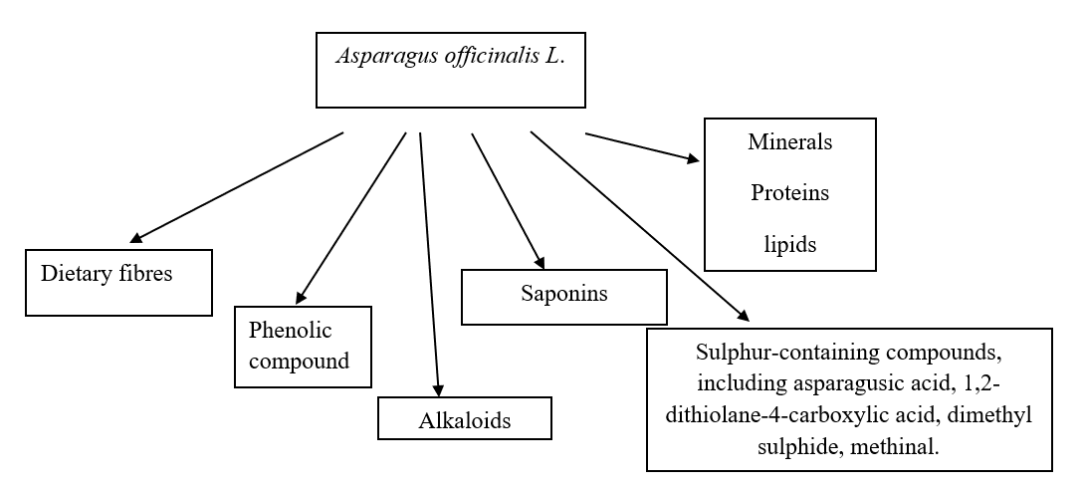
Figure 1: Main bioactive constituents of Asparagus officinalis L.
According to Al-Snafi et al., 2015 A. officinalis contains a range of steroid saponins, including bitter steroid saponins, as well as asparagosides A, B, D, F, H, and I. It is noteworthy that rutin is the most abundant phenolic component discovered in A. officinalis. Commonly, dried A. officinalis roots are used to extract various acids including fumaric, citric, caffeic, malic, isoferulic, ferulic, and asparagusic acids.
Table 2: Chemical composition of fresh weight of stem (100 g of food) of Asparagus officinalis L. (Iqbal et al., 2017)
Compound Name | Quantity
Water | 91.70%
Carbohydrates | 5g
Fiber | 0.7g
Mineral  Ca  Phosphorus  Iron  Sodium  Potassium | 22 mg  62 gm  1 mg  2 mg  278 mg
Protein | 2.5g
Fats | 0.2g
Vitamins | A (540 mg), B1: Thiamin (0.18 mg), B2: Riboflavin (0.2 mg)
(Redondo-Cuence et al., 2023) found that the byproducts of A. officinalis have high nutritional and functional significance. The study found that the non-edible components have a significant nutritional value and may be employed as prebiotics. The spear byproducts can be utilized to grow commensal or probiotic Lactobacillus strains and bifidobacteria. The spear leftovers have much more dietary fiber (58.1 ± 0.35 g/100 g dry matter) than the edible portion (23.8 ± 0.85 g).
Vitamin E, which is also a potent antioxidant, may be found in asparagus. Vitamin E supports immune system function and shields cells from damage caused by free radicals. Green asparagus has a high content of protodioscin, a saponin. This compound found in plants gives asparagus its bitter flavor. Asparagus is a good source of vitamin K, which is a blood-clotting vitamin. It also has anti-inflammatory and antioxidant effects. It is a natural diuretic and a rich source of fiber. Asparagus can help fight cancer. Thiamine, a form of vitamin B1, is abundant.
Table 3: Chemical constituent of Asparagus officinalis (L.) (Iqbal et al., 2017)
Plant parts | Name of compounds
Roots | Steroidal saponins, sarsasapogenin, galactogogue , quercetin, rutin.
Shoot | Thiazole, ketone vanillin, thiophene, aldehyde, asparagusic acid, and methyl esters
Leaves | Diosgenin and quercetin-3-glucuronide
Flower | Quercetin, rutin (2.5% dry basis), and hyperoside
Mature Fruits | Quercetin, rutin (2.5% dry basis), and hyperoside
Other important compounds (present in roots, shoots, leaves, flower and mature fruits) | Inorganic compounds (Mg, P, Ca, Fe and folic acid), Vitamins ( A,B,C,E), essentials oils , amino acids ( asparagine , arginine, tyrosine)
(Tabaszewska et al., 2018) conducted a study to evaluate the microbiological quality of fermented asparagus. They explored how the fermentation process and the preservation of fermented products can impact their nutritional value and physiologically active components. The researchers found that the dry matter, total protein, and lipid content of asparagus remained largely unchanged during fermentation. However, the fermentation process did lead to an increase in the ash content while reducing the total sugar content.
Furthermore, the study observed a decline in the levels of B-group vitamins, polyphenolic compounds, and dehydroascorbic acid following fermentation. Interestingly, it was noted that fermented white asparagus exhibited an enhanced ability to remove iron ions. However, after storage, the vitamin content in fermented asparagus decreased. Despite these changes, the radical scavenging activity against DPPH and ABTS, along with the quantities of total polyphenols and flavonoids, remained unaffected by both fermentation and storage.
Asparagus spears provide substantial nutritional value, serving as a significant source of essential nutrients. They contain approximately 2% protein, 0.12% fat, and 2% carbohydrates consisting of glucose, fructose, and sucrose. Additionally, asparagus is abundant in various minerals like calcium, magnesium, potassium, phosphorus, and iron (ferrum), as well as trace amounts of zinc, copper, manganese, and selenium. Furthermore, this vegetable boasts a remarkable array of vitamins, including B1, B2, C, PP, A, and E. These nutritional attributes make asparagus not only a healthy choice but also a flavorsome addition to your diet. (Salunkhe et al., 1998); (Lopez et al., 1999).
A study has revealed that different asparagus cultivars exhibit varying levels of vitamin C within their spears. Among the tested varieties, including the standard cultivar 'Mary Washington' (used as the control), as well as the male cultivars 'Ranger,' 'Ramada,' and 'Gartner Saat,' the vitamin C content was relatively low, ranging from 84.4 to 90 mg/kg. Conversely, spears from various cultivars consistently demonstrated higher vitamin C levels, with the standards 'Schwetzinger Meisterschuss' and 'Schneekopf' exhibiting the highest concentrations, measuring 127.2 and 129.9 mg/kg, respectively. This finding emphasizes the variation in vitamin C content among different asparagus cultivars, as revealed by (Žebrauskienė et al., 2013) in their study.
3. MEDICINAL USE:
Saponins, which are glycosides with high molecular weight, comprise an oligosaccharide linked to either a triterpene or a steroid aglycone. Found naturally in plants, they are frequently linked to medicinal benefits. Extracted from asparagus shoots, saponins have shown in vitro properties with potential antitumor and antifungal effects.
In India, extracts derived from the root of asparagus have been traditionally employed to enhance the resilience of the female reproductive system, stimulate fertility, and augment the production of breast milk. This natural remedy has been valued for its purported ability to support women's health and well-being, particularly in matters concerning reproductive functions and lactation (Winter et al., 2009).
Throughout ancient Eastern and Greek medical traditions, asparagus extracts were utilized as a tonic believed to prevent and treat various health issues, such as kidney and bladder problems, rheumatism, liver diseases, asthma, and even cancer. Despite these longstanding traditional uses, they have never received approval from the FDA for medicinal purposes. Consequently, their pharmacological use beyond traditional medicine remains limited due to the lack of substantial clinical evidence supporting their effectiveness.
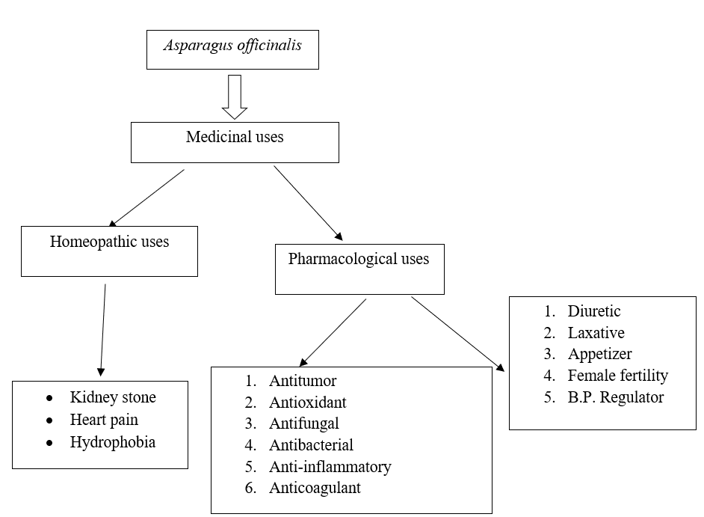
Figure 2: Uses (Edible, Homeopathic, and Pharmacological) of Asparagus officinalis L. (Iqbal et al., 2017)
(Erfan et al., 2020) Reported that various bioactive compounds can be derived from asparagus officinalis for the preparation of diverse herbal products. The stem of the A. officinalis plant was specifically utilized to extract methanol, which possesses healing properties and can serve as an effective intraoral mouthwash.
Based on the results, (Al-Sheddi et al., 2018) AoAgNPs were shown to induce apoptosis and G2/M cell cycle arrest in SiHa cells. These findings indicate that the synthesized AoAgNPs have potential antibacterial and anticancer characteristics and might be used as a viable therapeutic treatment.
(Vital et al., 2020) Reported that non-commercial asparagus flour is abundant in bioactive compounds and exhibits antioxidant properties. Its inclusion in pasta not only boosts the pasta's antioxidant capacity and bioactive compound content but also enhances its protein content while imparting a distinct yellow-green color. As a result, asparagus flour derived from non-commercial plants (residues) shows great potential as a valuable ingredient for enhancing the nutritional value of food. It can serve as a viable substitute for asparagus residue, thereby adding value to the final product.
4.Bioactive compounds in asparagus
Polyphenols are present in plants and have a variety of physiological effects, including antiatherogenic, antiallergenic, antibacterial, anti-inflammatory, antithrombotic, vasodilator, and cardioprotective properties. (Xu et al., 2022). Plants that contain polyphenols are of great interest due to their antioxidant activity, which provides various health benefits (Ahmad et al., 2022) (Fathalipour et al., 2020). Flavonoids are the most often eaten polyphenols in the human diet. They have the fundamental structure of a flavan nucleus, comprised of three rings with 15 carbon atoms (C6, C3, and C6). (Shahrajabian et al., 2022). Flavonoids are classified into five subgroups based on the oxidation state of their core C ring: flavones, flavonols, flavanones, flavanols, and anthocyanins.
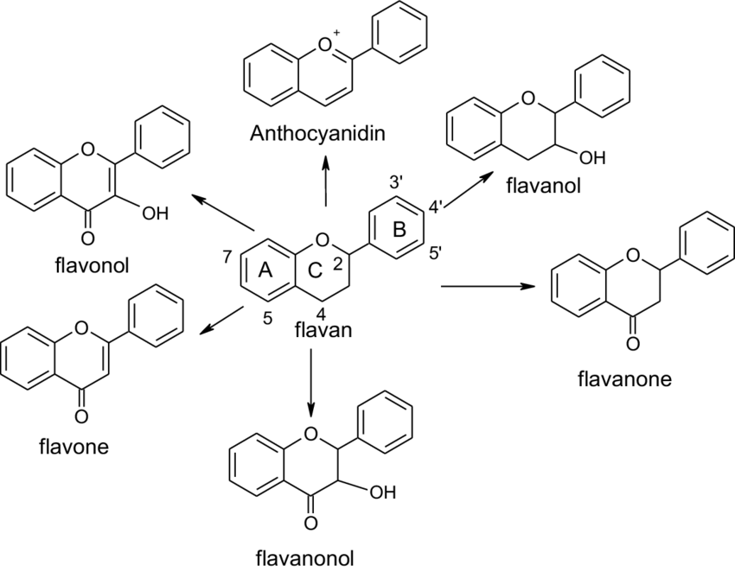
Figure 3: Different major subclasses of flavonoids (Balasundram et al., 2006).
4.1 Polyphenols and flavonoids in asparagus:
The literature has investigated the phenolic and flavonoid contents of asparagus. HPLC analysis has determined moderate amounts of hydroxycinnamic and ferulic acids, among other polyphenols (Alan O et al., 2022). In this context, (Nile et al., 2014) Asparagus roots (ARs) were shown to have a greater polyphenol concentration of 28.17 GAE/100 g than other therapeutic plants such as Butea monosperma, Withania somnifera, Tephrosia purpurea, Vitex negudo, and Plumbago zeylanica. Polyphenol contents for these medicinal plants are 24.07 GAE/100 g, 24.02 GAE/100 g, 18.02 GAE/100 g, 12.45 GAE/100 g, and 10.21 GAE/100 g, respectively. As a result, asparagus roots may be considered high in polyphenols. (Solana et al., 2015) conducted a study on the flavonoid and phenolic compounds present in the entire A. officinalis plant. The study revealed that the most abundant phenolic compound in the plant is rutin. Rutin is also referred to as sophorin, quercetin-3-rutinoside, and ruthenium. Due to its aromatic configuration, it bears a resemblance to saponin structures. Rutin is a glycoside that is broken down into aglycone and quercetin by enzymes in the human gut microbiota (Amaretti A. et al., 2015). Rutin has been shown to improve colitis, modulate the signaling of tumor necrosis factor-alpha and nuclear factor kappa B activity, reduce myeloperoxidase activity, and modulate the levels of proinflammatory cytokines (Rabiskova et al., 2012).
4.2 Lignans, isoflavones, and saponins:
(Shahrajabian et al., 2022) Phytonutrients in AR, including lignans, isoflavones, and saponins, have been shown to provide health advantages such as cancer prevention, lower blood pressure, lower risk of stomach ulcers, and slowing down cell degeneration. ARs include phytoestrogens, polycyclic phenols that occur naturally. ARs include two types of phytoestrogens: isoflavones and lignans. Flavonoids may have a role in breast cancer prevention because of their antiestrogenic characteristics. (Huang X et al., 2007). Asparagus roots (ARs) also offer opportunities to create value-added food products that promote health benefits. According to (Li et al., 2015), The roots of Asparagus officinalis contain 3.6 times more total saponin than its spears. Saponin glycosides, known as Shatavarin, are found in these roots and have been shown to provide moderate protection against Cu+-induced oxidation of human low-density lipoprotein (LDL). The suppression of lipid peroxidation was assessed using the Thiobarbituric Acid Reactive test.(Onlom et al., 2017).
4.2.1 Saponin health properties:
Saponins can act as anti-carcinogens by inducing apoptosis in cancerous cells (Zhu XI et al., 2019). Apoptosis is a natural process of cell death that happens when a cell is programmed to self-destruct. This process differs from necrosis, which is triggered by external stimuli and has negative consequences. Saponins are regarded as good cancer treatments since they have been demonstrated to prevent a variety of malignancies. Saponins possess antioxidant, anti-inflammatory, and anti-osteogenic properties.
5. Pharmacological activities:
5.1. Insulin secretory activity (antidiabetic activity): Herbal treatments can be more cost-effective than synthetic pharmaceuticals when it comes to treating common ailments. Currently, herbal plants are being evaluated for their potential to cure diabetes. According to (Hannan et al., 2007) An ethanol extract from A. racemosus root greatly increases insulin production in the perfused pancreas. This indicates that A. racemosus root might be a good choice for treating diabetes in clinical settings.(Folane et al., 2020).
5.2. Effect on diuretic activity:
Asparagus roots have an acute toxicity and diuretic effect (Kumar et al., 2010). Historically, a decoction made from asparagus roots was used to treat urinary tract infections (Ratnam et al., 2011).
5.3. Anti-dyspepsia activity: Asparagus racemosus is utilized in Ayurveda for the treatment of dyspepsia and has an effect similar to the allopathic drug metoclopramide. Metoclopramide improves gastric emptying in dyspepsia patients. (Goyal et al., 2003).
Table 4 Health benefits of Asparagus plant
Plant species | Asparagus plant part used | Health benefits
- officinalis | Roots | Anti-diabetic effect. Hafizur et al. (2015)
- racemosus | Roots | Anticancer activity. Sharma et al. (2020)
- racemosus | Shoots | Prevent liver cancer  Galactagogic effect.
- cochinchinensis | Roots | Prevent liver cancer.  Anti-inflammatory properties.

6. Conclusion:
Asparagus (Asparagus officinalis) is a versatile and nutritionally rich plant and holds significant medicinal value along with its culinary appeal. It is Rich in bioactive compounds like saponins, flavonoids, and polyphenols, it also offers various health benefits such as antioxidant, anti-inflammatory, and anti-cancer effects. Traditionally used in Ayurveda and other ancient medical traditions, asparagus has been associated with promoting kidney health, improving fertility, and aiding in digestive issues. . Moreover, recent research highlights its potential in diabetes management, cancer prevention, and as a natural diuretic. With its abundance of vitamins, minerals, and phytoconstituents, asparagus stands as a valuable addition to both traditional herbal remedies and modern pharmacology, offering a holistic approach to wellness.
References:
Ahmad, S., Pandey, A. R., Singh, S. P., Singh, S., Sashidhara, K. V., & Tamrakar, A. K. (2022). Antiglycation activity of β-glucogallin from Asparagus racemosus. Natural product research, 36(24), 6329-6335.
Alan, O., Turk, B., & Sen, F. (2022). A comparative study on the quality attributes, phenolic content and antioxidant activity of cultivated and wild asparagus as influenced by seasonal variations. The Journal of Agricultural Science, 160(6), 483-492.
Al-Sheddi, E. S., Farshori, N. N., Al-Oqail, M. M., Al-Massarani, S. M., Saquib, Q., Wahab, R., ... & Siddiqui, M. A. (2018). Anticancer potential of green synthesized silver nanoparticles using extract of Nepeta deflersiana against human cervical cancer cells (HeLA). Bioinorganic Chemistry and Applications, 2018.
Al-Snafi, A. E. (2015). The pharmacological importance of Asparagus officinalis-A review. Journal of Pharmaceutical Biology, 5(2), 93-98.
Amaretti, A., Raimondi, S., Leonardi, A., Quartieri, A., & Rossi, M. (2015). Hydrolysis of the rutinose-conjugates flavonoids rutin and hesperidin by the gut microbiota and bifidobacteria. Nutrients, 7(4), 2788-2800.
Balasundram, N., Sundram, K., & Samman, S. (2006). Phenolic compounds in plants and agri-industrial by-products: Antioxidant activity, occurrence, and potential uses. Food chemistry, 99(1), 191-203.
Drost, D. (2023). Asparagus breeding: Future research needs for sustainable production. Frontiers in Plant Science, 14, 1148312.
Fathalipour, M., Delnavazi, M. R., Safa, O., Zarifinia, N., & Rafiee, B. (2020). Antioxidant and antinociceptive effects of hydroalcoholic root extract of Asparagus officinalis L. Physiology and Pharmacology, 24(4), 322-330.
Folane P, Unhale S, Kale P, Shelke S, Biyani KR. Antidiabetic activity of polyherbal formulation containing Citrullus colocynthis, Piper nigrum, Asparagus racemosus, Cinnamomum tamala (cpac) in alloxan induced diabetic rats. World J Pharm Pharm Sci. (2020) 9:1174–88.
Goyal RK, Singh J, Lal H. Asparagus racemosus-an update. Indian J Med Sci. (2003) 57:408–14
Hafizur RM, Fatima N, Shaukat S. Immunohistochemical evidence of pancreatic [beta]-cell regeneration in streptozotocin-induced type 2 diabetic rats treated with Gymnema sylvestre extract. J Cytol Histol. (2015) 6:342. doi: 10.4172/ 2157-7099.1000342
Hannan JMA, Marenah L, Ali L, Rokeya B, Flatt PR, Abdel-Wahab YH. Insulin secretory actions of extracts of Asparagus racemosus root in perfused pancreas, isolated islets, and clonal pancreatic β-cells. J Endocrinol. (2007) 192:159–68. doi: 10.1677/joe.1.07084
Hostettmann, K. (1980). Saponins with molluscicidal activity from Hedera helixL. Helvetica Chimica Acta, 63(3), 606-609.
Iqbal, M., Bibi, Y., Raja, N. I., Ejaz, M., Hussain, M., Yasmeen, F., ... & Imran, M. (2017). Review on therapeutic and pharmaceutically important medicinal plant Asparagus officinalis L. J Plant Biochem Physiol, 5(180), 2.
Kaur, Dr & Jaidka, Manpreet & Sepat, Seema. (2018). Scientific Cultivation of Asparagus.
Klanrit, P., Lila, K., Netsawang, P., Siangsanor, P., Thanonkeo, P., & Thanonkeo, S. (2023). Effect of Organic Additives on the Micropropagation of Asparagus officinalis. Horticulturae, 9(11), 1244.
Kumar MCS, Udupa AL, Sammodavardhana K, Rathnakar UP, Shvetha U, Kodancha GP. Acute toxicity and diuretic studies of the roots of Asparagus racemosus Wild in rats. West Indian Med J. (2010) 59:3–5.
Li, J., Nie, L., Liu, M., & Hu, S. (2015). The study of asparagus different parts’ active ingredients. Food Res Technol, 15(006).
López, M. A., Rojas, R. M., Cosano, G. Z., & Segarra, P. S. (1999). Nutritional changes in the essential trace elements content of asparagus during industrial processing. Food research international, 32(7), 479-486.
Manisha, Manisha. (2023). Production Technology of Asparagus (Asparagus officinalis L.).
Negi, J. S., Singh, P., Joshi, G. P., Rawat, M. S., & Bisht, V. K. (2010). Chemical constituents of Asparagus. Pharmacognosy reviews, 4(8), 215.
Nile, S. H., & Park, S. W. (2014). HPTLC analysis, antioxidant and antigout activity of Indian plants. Iranian Journal of Pharmaceutical Research: IJPR, 13(2), 531.
Olas, B. (2024). A Review of the Pro-Health Activity of Asparagus officinalis L. and Its Components. Foods, 13(2), 288.
Onlom, C., Phrompittayarat, W., Putalun, W., Waranuch, N., & Ingkaninan, K. (2017). Immunoaffinity Knockout of Saponin Glycosides from Asparagus racemosus to Assess Anti‐lipid Peroxidation. Phytochemical analysis, 28(4), 316-323.
Pegiou, E., Mumm, R., Acharya, P., de Vos, R. C., & Hall, R. D. (2019). Green and white asparagus (Asparagus officinalis): A source of developmental, chemical and urinary intrigue. Metabolites, 10(1), 17. Iqbal, M., Bibi, Y., Raja, N. I., Ejaz, M., Hussain, M., Yasmeen, F., ... & Imran, M. (2017). Review on therapeutic and pharmaceutically important medicinal plant Asparagus officinalis L. J Plant Biochem Physiol, 5(180), 2.
Rabišková, M., Bautzová, T., Gajdziok, J., Dvořáčková, K., Lamprecht, A., Pellequer, Y., & Spilková, J. (2012). Coated chitosan pellets containing rutin intended for the treatment of inflammatory bowel disease: in vitro characteristics and in vivo evaluation. International journal of pharmaceutics, 422(1-2), 151-159.
Ratnam KV, Ravishankar K, Kiranmayi GVN. Evaluation of diuretic and antiurolithiatic activities of ethanolic root extracts of Curculigo orchioides. Int J Biol Pharm Res. (2011) 4:12.
Redondo-Cuenca, A., García-Alonso, A., Rodríguez-Arcos, R., Castro, I., Alba, C., Rodríguez, J. M., & Goni, I. (2023). Nutritional composition of green asparagus (Asparagus officinalis L.), edible part and by-products, and assessment of their effect on the growth of human gut-associated bacteria. Food Research International, 163, 112284.
Salunkhe, D. K., & Kadam, S. S. (1998). Handbook of vegetable science and technology: production, compostion, storage, and processing. CRC press.
Shahrajabian MH, Sun WL. Asparagus (Asparagus officinalis L.) and pennyroyal (Mentba pulegium L.) impressive advantages with wondrous health-beneficial phytochemicals. Not Sci Biol. (2022) 14: 11212.
Shahrajabian, M. H., & Wenli, S. U. N. (2022). Asparagus (Asparagus officinalis L.) and pennyroyal (Mentha pulegium L.), impressive advantages with wondrous health-beneficial phytochemicals. Notulae Scientia Biologicae, 14(2), 11212-11212.
Shamsoddin, E., Bashash, D., Zarei, M., & Houshmand, B. (2020). Asparagus Officinalis: An Herbal Candidate for an Intraoral Healing Mouthwash. Journal of Dental School, Shahid Beheshti University of Medical Sciences, 38(1), 31-36.
Sharma A, Kumar A, Jaitak V. Pharmacological and chemical potential of Cassia fistula L- a critical review. J Herb Med. (2020) 26:100407.
Solana, M., Boschiero, I., Dall’Acqua, S., & Bertucco, A. (2015). A comparison between supercritical fluid and pressurized liquid extraction methods for obtaining phenolic compounds from Asparagus officinalis L. The Journal of Supercritical Fluids, 100, 201-208.
Tabaszewska, M., Gabor, A., Jaworska, G., & Drożdż, I. (2018). Effect of fermentation and storage on the nutritional value and contents of biologically-active compounds in lacto-fermented white asparagus (Asparagus officinalis L.). Lwt, 92, 67-72.
Vital, A. C. P., Itoda, C., Crepaldi, Y. S., Saraiva, B. R., & Matumoto-Pintro, P. T. (2020). Use of asparagus flour from non-commercial plants (residue) for functional pasta production: Asparagus flour for functional pasta production. Journal of Food Science and Technology, 57, 2926-2933.
Winter, R. (2009). A consumer's dictionary of cosmetic ingredients: complete information about the harmful and desirable ingredients found in cosmetics and cosmeceuticals. Harmony.
Xu, N., Zhang, H., Jia, J., Li, H., Zhu, Z., Fu, S., & Wang, Y. (2022). Assessment of contents and health impacts of four metals in Chongming Asparagus—geographical and seasonal aspects. Foods, 11(5), 624.
Xuefeng, H., Jun, L., Yong, Z., & Lingyi, K. (2010). Studies on lignan components of Asparagus officinalis.
Žebrauskienė, A., Paulauskienė, A., & Abramavičienė, R. (2013). Investigation of Chemical Composition of Introduced Cultivars of Asparagus (Asparagus officinalis L.) Spears. RURAL DEVELOPMENT 2013, 280.
Zhu, X., Zhang, W., Gao, Y., & Zhang, G. (2019). The hypoglycaemic activity of saponins from Asparagus officinalis L. by-products in diabetic rats. Acta Nutrimenta Sinica, 41(3), 270-275.

