*Original Research Article*

Evaluate Growth Performance of Chocolate Mahseer (Neolissochilus hexagonolepis) Fed Supplemented Diet with Clerodendrum colebrookianum Leaves and Black Soldier Fly Larvae

**ABSTRACT:**

This study investigated the efficacy of a specially formulated fish feed incorporating *Clerodendrum colebrookianum* leaves and dehydrated Black Soldier Fly (BSF) larvae in promoting the growth of Chocolate Mahseer (*Neolissochilushexagonolepis*). A total of sixty fingerlings were equally allocated into control and experimental groups and were maintained over a period of 90 days. The control group received a traditional feed comprised of rice bran and mustard oil cake, whereas the treatment group was given a diet supplemented with BSF larvae and *C. colebrookianum*, along with the same base components. The dietary formulation was calibrated utilizing the Pearson Square method to achieve a crude protein level of 35%. Fish that were provided the enhanced diet exhibited significantly improved results regarding body weight increase (49g –55 g), growth efficiency (SGR: 1.12–1.20), and feed conversion ratio (FCR: 1.37–1.54). Both groups exhibited complete survival throughout the duration of the experiment. These results endorse the incorporation of local plant and insect protein sources as viable and sustainable feed constituents aimed at enhancing aquaculture productivity for Chocolate Mahseer.

**KEYWORDS:** *Chocolate Mahseer, Clerodendrum colebrookianum, Black Soldier Fly, growth performance*

**1.INTRODUCTION**

Aquaculture is the key to global food security, and interest is growing in producing nutritionally balanced and environmentally friendly feeds to help fish achieve their maximum growth and health (**Tacon & Metian, 2008**). One such species of concern is the Chocolate Mahseer (*Neolissochilushexagonolepis*), a native freshwater fish of the Himalayas, specifically Northeast India, for which it is greatly valued in terms of food and recreational sport fishing. Although it has a promising potential for commercial aquaculture due to its sizeable body, good palate, and environmental adaptability, its slow growth under culturing conditions is a major hindrance (Laskar *et al.* 2009). This constraint emphasizes the need to create nutrient-optimized feed formulations specific to the species' nutritional requirements.

Historically, fishmeal has dominated the use as the main protein source in aquafeeds. Issues with its increasing price, scarcity of supply, and environmental footprint have prompted the quest for more environmentally friendly and affordable sources (**Makkar *et al.* 2014; Sánchez *et al.* 2014**). Substitutes under consideration include plant-based and insect-based ingredients. *Clerodendrum colebrookianum*, a Northeast Indian endemic medicinal plant, has been reported to possess antioxidant, anti-inflammatory, and hypolipidemic activities (Syiem*et al.* 2002) and has been found to have approximately 27% crude protein content (Seal, 2011), suggesting it as a potential plant-based protein source. Similarly, Black Soldier Fly larvae (*Hermetiaillucens*) are known for having high protein levels (37% to 63%), full amino acid composition, positive fatty acids like lauric acid, and they can transform organic waste into nutrient-dense biomass (**Barroso *et al.* 2014; Rumpold& Schlüter, 2013; Zulkifli *et al.* 2022**).

A number of studies have validated the performance of BSF larvae as a potential alternative to fishmeal without any negative impact on fish growth or health. For instance, **Kroeckel *et al.*(2012)** illustrated that BSF pre-pupae meal could replace fishmeal in the juvenile turbot diet without affecting growth performance. Moreover, the application of BSF larvae facilitates the establishment of circular bioeconomy systems because it can recover nutrients from organic waste and minimize the environmental impact of aquaculture (**Newton *et al.* 2005; Müller *et al.* 2017**).

Secondly, conventional feed ingredients such as mustard oil cake (MOC) and rice bran have also been found to boost survival and growth in some species including Ompokpabda and Tor tor under pond culture systems (**Singh *et al.* 2017**). **Seal (2011)** also pointed out the nutritional and antioxidant potential of plant-based feed ingredients in formulating balanced diets. Incorporating indigenous knowledge into innovative aquaculture practices has also been found to lead to sustainable farming. For example, the War Khasi people of Meghalaya employ ecologically friendly and culture-based traditional fishing practices (**Tynsong& Tiwari, 2008**), which, when integrated with scientific methods, can assist in more sustainable and locally adapted aquaculture systems.

To address issues of nutritional sufficiency, the Pearson Square principle will be used in this research to calculate suitable ratios of high and low protein feed mixtures. This method offers a straightforward yet efficient means of coming up with feeds that satisfy the specific dietary protein needs of the target species (**Catacutan, 2002; Hardy, 1980**). It will be employed to create a diet for Chocolate Mahseer based on *Clerodendrum colebrookianum* leaves and BSF larvae as main ingredients so that the designed feed is according to the nutritional needs of the species.

**2. MATERIALS AND METHODOLOGY**

**2.1 Experimental site and location:**

The research work was done in the PA.Khongnoh Fishingpond, Nongmadanshadsngi P.O Pynursla,793110,East Khasi Hills, Shillong, Meghalaya, India

* 1. **Experimental setup:**

A total of 60 fingerlings (average initial weight: 28 g) were assigned to six enclosure (three control and three treatment groups), with uniformly distribution of 10 fishes in each. The experimental duration was 90 days. Six enclosures (6 ft x 4 ft)were built in the pond using bamboo and mosquito nets to rear the fish.Selective species: Chocolate mahseer (*Neolissocheilus hexagonolepis*) ([McClelland](https://en.wikipedia.org/wiki/John_McClelland_(doctor)), 1839). The control diet was composed of rice bran and mustard oil cake, whereas the experimental diet was formulated utilizing Pearson's Square method to incorporate *C. colebrookianum,* BSF dry larvae, along with minimal amounts of rice bran and mustard oil cake, achieving a crude protein concentration of 35% in both diets.

The fish were fed bi-daily for 90 days at a rate of 3% of body weight. Important growth parameters such as weight gain, mean body weight, specific growth rate (SGR), feed conversion ratio (FCR), and survival rate were recorded systematically. Water quality parameters were maintained at optimal levels to prevent any impact of environmental conditions on the outcome.

* 1. **Experimental diet:**

Utilizing the Pearson Square formula to make feed incorporating ingredients like *Clerodendrum colebrookianum*, and black soldier fly dry larvae. Adjusted ingredients incorporated in the diet, like rice bran and mustard oil cake,achieved a crude protein concentration of 35%.The Pearson square method was an effective technique to find the exact amounts of these ingredients in order to have the optimal nutrient compositions in the experimental diets**(Catacutan, 2002)** and also provides a useful first step in controlling the total protein or energy level utilizing two main ingredients**(Hardy, 1980)**.

8

5

Black soldier-fly dry larvae(40%)

*C. colebrookianum* (27%)

35%

**Fig1: A Pearson’s Square for formulating a 35% crude protein diet using *Clerodendrum colebrookianum*leaves and Black Soldier Fly larvae.**

**Table 1: *C. Colebrookianum* and black soldier fly dry larvae composition for a 35% protein content requirement by Pearson’s square method**.

|  |  |  |
| --- | --- | --- |
| **Ingredients** | **Crude protein (%)** | **Composition (%)** |
| *C. colebrookianum* | 27 | 38.46 |
| Black soldier fly dry larvae | 40 | 61.53 |

**Table 2: Adjusted ingredients of *C. colebrookianum* and black soldier fly dry larvae at 90% were utilized, with rice bran and mustard oil cake at 5% each as diet for treatment in the experimental study.**

|  |  |  |
| --- | --- | --- |
| **Ingredients** | **Crude protein (%)** | **Composition (%)** |
| ***C. colebrookianum*** | 27 | 34.61 |
| **Black soldier-fly dry larvae** | 40 | 55.39 |
| **Rice bran** | 14 | 5 |
| **Mustard oil cake** | 30 | 5 |

**3.0 RESULT:**

The feeding trials significantly contributed to the growth performance of *Neolissochilushexagonolepis* during the 90-days feeding test. The test groups receiving feed with *Clerodendrum colebrookianum* leaves and Black Soldier Fly larvae (T1, T2, and T3) showed improved growth in comparison to control groups (C1, C2, and C3) receiving rice bran and mustard oil cake.The treatment groups gained significantly more weight. The mean weight gain of T1, T2, and T3 was 49 ± 0.557, 55 ± 0.515g, and 49 ± 0.557 g, respectively, whereas the control groups (C1, C2, C3) gained weight was 30 ± 0.595 g, 36 ± 0.515g and 34 ± 0.515g, respectively.The Specific Growth Rate was much greater in the treatment groups, with values ranging from 1.12 to 1.2, than in the control groups, with SGR values ranging from 0.8 to 0.91. This reflects a greater growth rate in fish that were fed the experimental diet.Feed Conversion Ratio, an indicator of feed efficiency, was lower in the treatment groups (1.37 to 1.54) compared to the control groups (2.1 to 2.52). Lower FCR indicates better utilization of feed and fewer feed units to obtain unit weight gain.Total survival rates of 100% were seen in all experimental groups, indicating that neither diet had any adverse effects on survival of *Neolissochilushexagonolepis* under the conditions of this experiment.

**Table 3. Growth parameters and survival rates observed during the entire experiment.**

|  |  |  |  |  |  |  |  |
| --- | --- | --- | --- | --- | --- | --- | --- |
| **Groups** | **Initial Average Weight (g) ± SE** | **Final Average Weight (g) ± SE** | **Mean Weight Gain (g) ± SE** | **Specific Growth Rate** | **FCR** | **Mean Weight Gain (g)** | **Survival Rates (%)** |
| **C1** | 28 ± 0.332 | 58 ± 0.493 | 30 ± 0.595 | 0.8 | 2.52 | 30 | 100 |
| **C2** | 28 ± 0.297 | 64 ± 0.421 | 36 ± 0.515 | 0.91 | 2.1 | 36 | 100 |
| **C3** | 28 ± 0.281 | 62 ± 0.515 | 34 ± 0.588 | 0.88 | 2.22 | 34 | 100 |
| **T1** | 28 ± 0.281 | 81 ± 0.364 | 53 ± 0.459 | 1.18 | 1.42 | 53 | 100 |
| **T2** | 28 ± 0.332 | 83 ± 0.395 | 55 ± 0.515 | 1.2 | 1.37 | 55 | 100 |
| **T3** | 28 ± 0.332 | 77 ± 0.446 | 49 ± 0.557 | 1.12 | 1.54 | 49 | 100 |

**Table 4. Water parameters observed during the experimental study.**

|  |  |
| --- | --- |
| **Parameters** | **Observation** |
| pH | 7.4 - 8 |
| Dissolved oxygen (ppm) | 6 - 8 |
| Water temperature (oC) | 20 - 24 |
| Alkalinity (mg/L CaCO3) | 120 - 125 |
| Total dissolved solids (mg/l) | 250 - 270 |

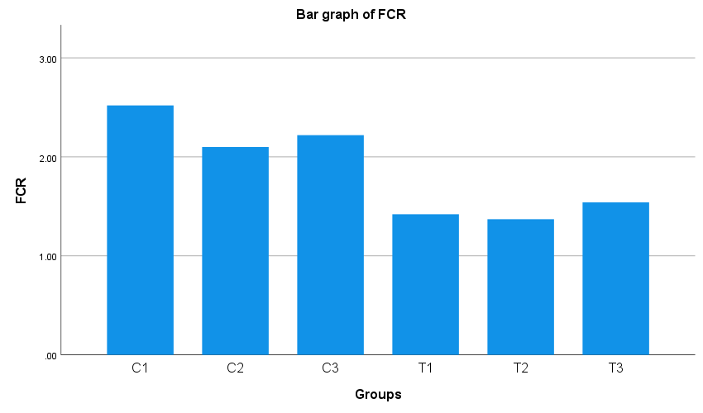

**Fig 2: Feed Conversion Ratio (FCR) of Control (C) and Treatment (T) groups**

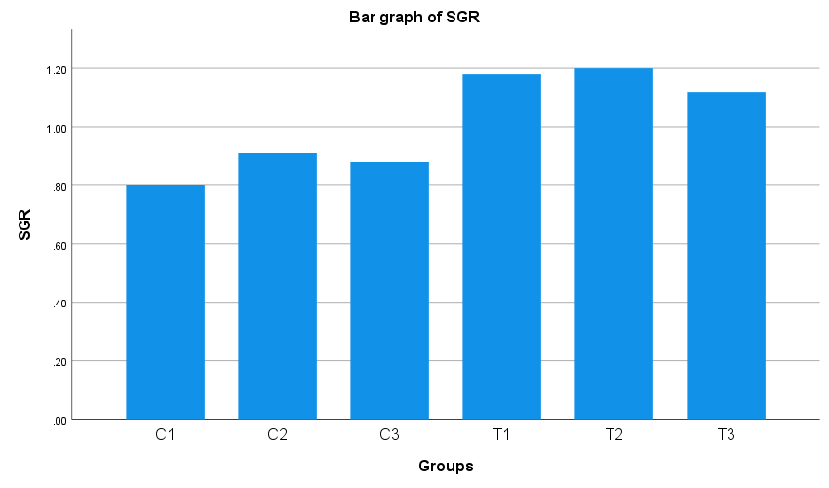

**Fig 3: Specific Growth Rate (SGR) of Control (C) and Treatment (T) Groups.**

**Fig 4: Mean Weight Gain of Control (C) and Treatment (T) Groups.**

**4.0 DISCUSSION :**

The growth performance proved by experimental results indicated that the addition of *Clerodendrum colebrookianum* leaves and Black Soldier Fly (BSF) larvae to Chocolate Mahseer (*Neolissochilushexagonolepis*) diet positively impacted. The fish fed with the supplemented feed exhibited significant progress in significant parameters like weight gain, specific growth rate (SGR), and feed conversion ratio (FCR). Additionally, all the test groups recorded a uniform 100% survival during the experimental period.The treatment groups (T1, T2, T3) realized significantly higher mean weight gains—49 ± 0.557 g, 55 ± 0.515 g, and 49 ± 0.557 g, respectively—than the control groups (C1, C2, C3), which realized 30 ± 0.595 g, 36 ± 0.515 g, and 34 ± 0.515 g, respectively. This growth promotion can be attributed to the higher protein content and well-balanced amino acid composition of BSF larvae, according to Makkar et al. (2014), as well as the contribution in terms of nutrients provided by *C. colebrookianum*. With a known content of around 27% crude protein and having antioxidant properties (**Syiem*et al.* 2002**), *C. colebrookianum* most probably facilitated improved nutrient metabolism and absorption.SGR values in the treatment groups varied from 1.12% to 1.20%, far above those of the control groups (0.80%–0.91%), reflecting enhanced feed use and biomass accumulation. Likewise, the FCR in treatment diets varied between 1.37 and 1.54, far lower than control values (2.10–2.52), indicating improved feed utilization.These results correlate with earlier research wherein BSF meal was found to enhance digestion and growth performance in aquatic animals like turbot (**Kroeckel *et al.* 2012**) and Nile Tilapia, wherein enhanced immunity and growth were achieved by **Tippayadara et al. (2021).** The 100% survival rate in all groups further supports the non-toxicity and health-safeness of the two feed additives. Secondly, both ingredients are flavour-some and safe for human consumption, supporting their potential as sustainable substitutes in aquafeed.*C. colebrookianum* is specifically prized for its phytochemical richness, such as flavonoids and polyphenols, with associated anti-inflammatory, antibacterial, and immunostimulatory properties (Syiem*et al.* 2002). Although utilized locally in traditional medicine, its function here was to add protein content to the feed to ensure that 35% crude protein could be achieved in order to enhance fish growth and enzyme activity. Due to its ubiquitous availability and ease of application, it is a likely local plant protein source.BSF larvae contain 40%–45% crude protein and are rich in favourable fatty acids such as lauric acid. The established position of BSF larvae as a replacement for fishmeal in aquaculture (Kroeckel *et al.* 2012) and their cultivation on organic waste also adds to sustainable feed alternatives.In summary, the blend of BSF larvae and *C. colebrookianum* provides a nutritionally strong and eco-friendly feed solution. BSF larvae assist in decreasing reliance on traditional fishmeal—a significant sustainability issue (**Tacon & Metian, 2008**)—while *C. colebrookianum*, as an indigenous species of Northeast India, promotes local, cost-efficient, and environmentally friendly aquaculture activities. This hybrid strategy is complementary to the concept of a circular bioeconomy, with the goal of decreasing the cost of feeds while reducing the environmental footprint.

**CONCLUSION:**

This research was able to effectively show that a diet containing *Clerodendrum colebrookianum*leaves and Black Soldier Fly (BSF) dried larvae markedly improves the growth performance of Chocolate Mahseer (*Neolissochilushexagonolepis*). The treatment diet, prepared to address a 35% crude protein requirement through Pearson's Square method, resulted in enhanced weight gain, specific growth rate (SGR), and feed conversion ratio (FCR) without negatively affecting fish survival and water quality. The nutritional complementarity of the plant- and animal-based components presents a cost-effective, sustainable alternative to traditional feeds, particularly in resource-poor aquaculture systems. The results support the viability of using locally accessible, underutilized materials in designing efficient and environmentally friendly aquafeeds. It is suggested that further study should be conducted to evaluate long-term outcomes on reproduction, immunity, and commercial viability.

**REFERENCES:**

Barroso, F. G., de Haro, C., Sánchez-Muros, M. J., Venegas, E., Martínez-Sánchez, A., & Pérez-Bañón, C. (2014). The potential of various insect species for use as food for fish. *Aquaculture, 422-423,* 193–201.

Catacutan, M. R. (2002). Formulation of aquafeeds. In O. M. Millamena, R. M. Coloso, & F. P. Pascual (Eds.), *Nutrition in Tropical Aquaculture: Essentials of fish nutrition, feeds, and feeding of tropical aquatic species* (pp. 99–123).

Hardy, R., (1980). Fish feed formulation. In: Aquaculture development and coordination programme: Fish feed technology. University of Washington, Seattle, Washington.

Kroeckel, S., Harjes, A. G. E., Roth, I., Katz, H., Wuertz, S., Susenbeth, A., & Schulz, C. (2012). When a turbot catches a fly: Evaluation of a pre-pupae meal of the Black Soldier Fly (*Hermetiaillucens*) as fish meal substitute—Growth performance and chitin degradation in juvenile turbot (*Psetta maxima*). *Aquaculture, 364-365,* 345–352.

Laskar, B. A., Das, D. N., & Tyagi, B. C. (2009). Growth performance of the chocolate mahseer *Neolissocheilushexagonolepis* (McClelland) in pond systems in Arunachal Pradesh. *Indian Journal of Fisheries, 56*(1), 55–59

Makkar, H. P. S., Tran, G., Heuzé, V., & Ankers, P. (2014). State-of-the-art on use of insects as animal feed. *Animal Feed Science and Technology, 197,* 1–33.

Müller, A., Wolf, D., & Gutzeit, H. O. (2017). The black soldier fly, *Hermetiaillucens*—A promising source for sustainable production of proteins, lipids, and bioactive substances. *Bioresource Technology, 225,* 24–30.

Roy, D. C., & Tamang, L. (2020). Evaluation of protein requirement in Chocolate Mahseer (*Neolissochilushexagonolepis*). *Int. J. Fish. Aquat. Stud.*, 8(2), 12–15.

Rumpold, B. A., & Schlüter, O. K. (2013). Nutritional composition and safety aspects of edible insects. *Molecular Nutrition & Food Research, 57*(5), 802–823.

Sánchez-Muros, M. J., Barroso, F. G., & Manzano-Agugliaro, F. (2014). Insect meal as renewable source of food for animal feeding: A review. *Journal of Cleaner Production, 65,* 16–27.

Seal, T. (2011). Determination of nutritive value, mineral contents, and antioxidant activity of some wild edible plants from Meghalaya State, India. *Asian Journal of Applied Sciences, 4*(3), 238–246.

Singh, P., Nayak, S. K., Reang, D., & Singh, R. (2017). To study the survivability of *Ompokpabda* (Hamilton 1822) fingerlings fed with different ingredients under earthen ponds like rice bran, mustard oil cake, fish meal, and floating feed. *International Journal of Fisheries and Aquaculture Sciences, 7*(1), 23–32.

Singh, R., Singh, P., Nayak, S. K., Reang, D., & Tripathi, G. (2017). To study the acceptability of different feed ingredients like rice bran, fish meal, mustard oil cake, and floating feed in earthen pond fed via *Tor tor* (Hamilton 1822) fingerlings. *International Journal of Fisheries and Aquatic Studies, 5*(5), 135–139.

Syiem, D., Syngai, G. G., Kharbuli, B., Kayang, H., &Khongwir, B. S. (2002). Hypolipidemic and anti-oxidant properties of *Clerodendroncolebrookianum* leaves in rats fed with high fat diet. *Journal of Ethnopharmacology*, 83(3), 305–308.

Tacon, A. G. J., & Metian, M. (2008). Global overview on the use of fish meal and fish oil in industrially compounded aquafeeds: Trends and future prospects. *Aquaculture, 285*(1–4), 146–158.

Tynsong, H., & Tiwari, B. K. (2008). Traditional knowledge associated with fish harvesting practices of War Khasi community in Meghalaya. *Indian Journal of Traditional Knowledge, 7*(4), 618–623.

Tippayadara, N., Dawood, M. A. O., Krutmuang, P., Hoseinifar, S. H., Doan, H. V., & Paolucci, M. (2021). Replacement of Fish Meal by Black Soldier Fly (Hermetiaillucens) Larvae Meal: Effects on Growth, Haematology, and Skin Mucus Immunity of Nile Tilapia, Oreochromis niloticus. *Animals*, *11*(1), 193.

Zulkifli, N. F. N. M., Seok-Kian, A. Y., Seng, L. L., Mustafa, S., Kim, Y. S., &Shapawi, R. (2022). Nutritional value of black soldier fly (*Hermetiaillucens*) larvae processed by different methods. *Plos one*, *17*(2), e0263