***Review Article***

**Rapid Pebrine Detection in Sericulture: Unveiling the Potential of** **Nucleic acid Lateral Flow Assay Strips**

**ABSTRACT**

Pebrine, a destructive disease in silkworms caused by the microsporidian *Nosema bombycis*, continues to pose a significant threat to global sericulture. Traditional detection methods, such as female moth microscopy (FMM), are often time-consuming, labor-intensive, and prone to inaccuracies, particularly in detecting low-level infections. To address these limitations, nucleic acid-based lateral flow assays (NALFAs) have emerged as a promising alternative, offering rapid, accurate, and field-deployable diagnostic capabilities. This review explores the development and application of NALFA strips for pebrine detection, detailing their underlying principles, technical configuration, and diagnostic performance. NALFAs combine PCR amplification with lateral flow immunoassay principles, enabling the sensitive and specific detection of *N. bombycis* DNA, with detection limit as low as 10² spores per 50 eggs. These assays offer significant advantages, including high accuracy, portability, speed, and cost-effectiveness. Nonetheless, challenges remain, such as limited multiplexing capacity, reliance on modified DNA, and the absence of integrated signal amplification. Future improvements may involve the incorporation of automated micro fluidic systems to streamline sample preparation, amplification, and detection. Additionally, developing multiplex diagnostics for simultaneous detection of multiple silkworm pathogens could enhance disease management. Overall, NALFAs represent a significant breakthrough in sericulture disease diagnostics, offering an efficient tool for early pebrine detection and contributing to a more resilient and sustainable silk industry.

*Keywords:* ***Pebrine, Nosema bombycis, Nucleic acid lateral flow assay (NALFA),*** *molecular diagnostics, rapid detection, disease surveillance, multiplex detection*

1. **INTRODUCTION**

Silkworms are specialized organisms that go through several developmental stages before becoming adult moths (Esvaran *et al.,* 2020). They, like all organisms, are susceptible to diseases and pests, both of which pose significant threats to sericulture. *Nosema*, a type of microsporidia, is a major pathogen responsible for "pebrine" disease (also called as pepper disease) in silkworms, resulting in significant crop losses (Esvaran *et al.,* 2020).This disease spreads through spores both horizontally and vertically, making it difficult to eradicate from the sericulture industry. *Nosema bombycis* was the first known microsporidian pathogen in silkworms, capable of infecting offspring transovarially.

In 1870, Louis Pasteur conducted research on the disease's origins and transmission, and developed the "mother moth examination" as a preventive measure. However, this traditional method for detecting *N. bombycis* in silkworm eggs, known as female moth microscopy (FMM) is slow and prone to error (Sokolova*et al.*, 2004). Furthermore, Han and Watanabe's (1988) research shows that not all microsporidia that affect silkworms are transmitted vertically through eggs, as a result, relying solely on female moth infection status to determine egg infection may not always be accurate (Han and Watanabe, 1988).To address these challenges, rapid, reliable detection methods with high sensitivity and specificity are required. Recent developments include polymerase chain reaction (PCR), multiplex PCR, nest PCR, quantitative PCR, loop-mediated isothermal amplification (LAMP), and Nucleic Acid Lateral Flow Assay Strips (Fu *et al*., 2016;Hamiduzzaman*et al*., 2010; Liu *et al*., 2004, 2015;Ptaszynska*et al*., 2014; Rubio *et al.*, 2014; Yan *et al.*, 20140). NALFS, in particular, combines immunological and molecular techniques, which provide benefits such as accuracy, simplicity, speed, cost-effectiveness, storage stability, and portability (Choi *et al.*, 2016; Gao *et al*., 2014; Rohrman *et al*., 2012).

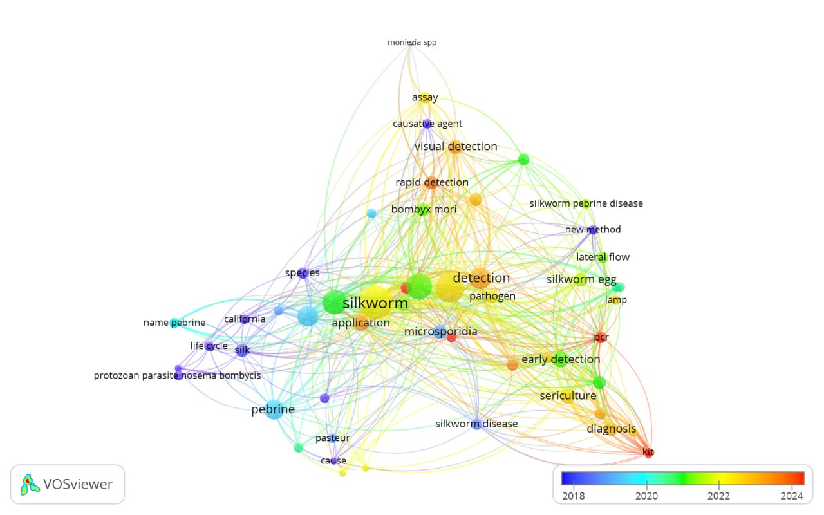

**Fig. 1. Keyword Co-Occurrence Network on Silkworm Disease Detection and Diagnosis Research (2018–2024)**

1. **CONVENTIONAL PEBRINE DETECTION METHOD**

The examination of mother moths for the detection of pebrine, which is caused by the microsporidian parasite *N. bombycis*, is a common practice in the silkworm industry (Fig. 2). However, this approach has significant limitations. Firstly, it is labour-intensive and time-consuming, as each female moth must be individually examined under a microscope for the presence of parasite spores. Moreover, there is a risk of error due to mismatches between female moths and their eggs, which could result in false negatives. Additionally, this method may fail to detect light infections, which reduces its accuracy. Furthermore, not all infected moths transmit the parasite to their eggs, making it unsuitable for widespread detection. While mother moth examination has been a longstanding practice, its limitations highlight the need for more efficient and dependable detection methods in the silkworm industry.

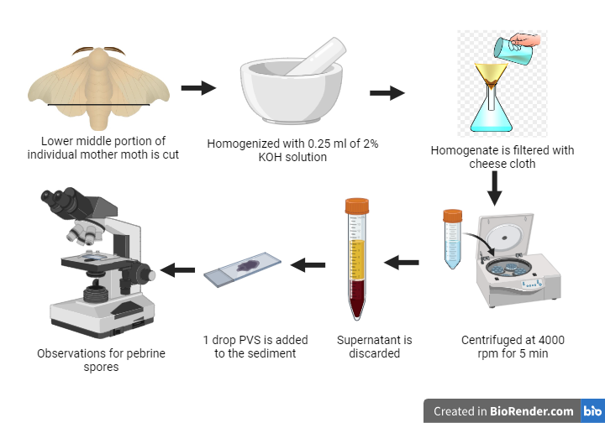

**Fig. 2. Conventional Mother moth examination For Pebrine spore detection**

1. **NUCLEIC ACID LATERAL FLOW ASSAY STRIPS FOR PEBRINE DETECTION**

Nucleic acid detection seeks to identify or quantify specific nucleic acid sequences within a biological sample. Nucleic acids are used as biomarkers for a variety of diseases, pathogens, and food contaminants (Niemz *et al*., 2011; Zhang *et al*., 2019; Hu *et al*., 2020). In contrast to proteins or living cells, nucleic acids are more resistant to integrity loss in harsh environments, and their signals can be significantly amplified using nucleic acid amplification techniques. Thus, nucleic acid detection is more accurate than traditional immunoassays and culturing methods (Zhang *et al*., 2020). Currently, this technique is widely used for rapid coronavirus diagnostic testing, producing highly precise and robust results (Esbin*et al*., 2020).

Traditional nucleic acid detection methods, such as gel electrophoresis (Gardella *et al*., 1984), enzyme-linked immunosorbent assay (ELISA) (Stokes *et al*., 1982; Zeng *et al*., 2017), and real-time polymerase chain reaction (PCR) (Yelin *et al*., 2020; Nagakubo *et al*., 2019), necessitate skilled operators and sophisticated equipment, with signal readout and detection often taking several hours. However, with the growing need for diagnostics in resource-limited settings, lateral flow assays (LFAs) for nucleic acid testing have received increased attention because of their affordability and user-friendliness.

Rapid diagnostic testing for the presence of particular nucleic acids, such as DNA or 1the principles of nucleic acid amplification methods with lateral flow immunoassay (LFIA) methods. Pregnancy testing and other point-of-care (POC) tests are commonly performed using the LFIA approach.

The method of detecting nucleic acids has changed from employing tagged probes on certain targets, such as *N. bombycis* DNA, to PCR, which amplifies target DNA using particular primers and an enzyme (Chandrakanth *et al*.,2021).The most recent method for *identifying N. bombycis* is the creation of a nucleic-acid-based lateral-flow strip (NALFS) that visualizes the reaction products in the capture zone by combining biotin and carboxyfluorescein labels with PCR amplification of the Large Subunit (LSU) rRNA (He *et al*., 2019).

The NALFS system was developed with four main components: a sample pad, a conjugate pad, a nitrocellulose membrane, and an absorbent pad (Fig.2). The working process of NALFS involved using Anti-FAM rabbit monoclonal antibody (mAb) coupled with gold nanoparticles which were applied to the conjugate. Streptavidin (SA) and goat-anti-rabbit antibody were placed on the nitrocellulose membrane to create a test line (T line) and a control line (C line). A 5-μL sample of PCR amplification product mixed with extension buffer (10 mM Tris, 1% BSA, 137 mM NaCl, 2.7 mM KCl, 10 mM Na2HPO4, and 2 mM KH2PO4) was deposited on the sample pad (He *et al*., 2019). When the product contains the intended fragments, SA captures the complex, resulting in a red line in the T line, signifying a positive outcome. Conversely, the absence of a red signal in the T line indicates a negative result. If the C and T lines are not visible, the test is invalid or was executed incorrectly. Results can be observed visually or with a colloidal gold detector TSR3000 using the “Gold Bio strip reader” software to assess the grayscale of the red bands on the T and C lines, with T/C ≥ 0.05 considered positive (He *et al*., 2019).

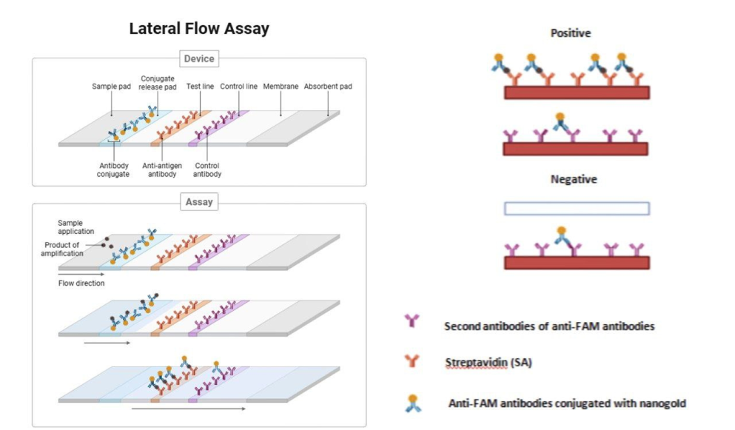

**Fig. 3. Nucleic Acid Lateral Flow Assay Strips for Pebrine Detection**

1. **PERFORMANCE EVALUATION OF NALFA STRIPS**

NALF strips provide a rapid and user-friendly alternative for nucleic acid detection, particularly in the context of pebrine detection in sericulture. Their effectiveness, however, hinges on evaluating critical parameters such as sensitivity, specificity, accuracy, and limit of detection (LOD). Notably, studies have demonstrated that NALF strips can detect pebrine spores at concentrations as low as 102 to 103 spores per 50 silkworm eggs. This underscores the method's remarkable sensitivity in identifying *Nosema bombycis*, making it a highly efficient tool for detecting even trace amounts of the pathogen within silkworm populations. By carefully assessing these key parameters, researchers and sericulturists can ensure that NALF strips offer a reliable and efficient solution for the rapid diagnosis of pebrine, ultimately supporting healthier and more productive sericulture operations.

**Fig. 4. Key Performance Parameters of NALF Strip-Based Diagnostic Assays**

1. **DIAGNOSTIC POTENTIAL AND CONSTRAINTS OF NALFA KITS FOR Nosema bombycis DETECTION**

Nucleic acid lateral flow assay (NALFA) kits have emerged as a promising tool for the rapid and specific detection of Nosema bombycis, the causative agent of pebrine disease in silkworms. These assays combine the simplicity of lateral flow formats with the high specificity of nucleic acid recognition, enabling the detection of target sequences without the need for complex instrumentation. NALFAs are particularly advantageous in field settings due to their speed, ease of use, and potential for early diagnosis, even at low pathogen loads. However, despite these benefits, there are notable limitations that constrain their broader application. These include challenges related to sensitivity, limited multiplexing capability, and the need for advanced modifications to enhance signal output. Table 1 summarizes the key advantages and limitations of NALFA kits for pebrine detection, along with supporting literature references.

**Table 1. Advantages and limitations of Nucleic Acid Lateral Flow Assay kits in pebrine detection**

|  |  |
| --- | --- |
| **Advantages and Limitations** | **References** |
| **ADVANTAGES** | |
| Speedy and simple detection capabilities, one-step assays that don't need complex equipment | - |
| It bears resemblance to lateral flow assays (LFAs), which are extensively employed for a range of targets, such as toxins, infections, and health biomarkers | (Javani*et al*., 2017) |
| It provides clear benefits over antibody-based LFAs, which have a short shelf life because of irreversible denaturation. Nucleic acids can be detected quickly because they fold back into their functional state when rehydrated | (Javani*et al*., 2017) |
| In nucleic acid-based detection method lower infection level could also be determined utilizing specific DNA sequence of *N. bombycis* | (Chandrakanth *et al*.,2021). |
| NALFS method can detect N. bombycis in various life-cycle stages with a sensitivity of 1 pg genomic DNA (approximately 102 spores) through PCR amplification | (He *et al*., 2019) |
| **LIMITATIONS** | |
| It is limited in their sensitivity because they frequently require a large number of particles to agglomerate before they alter or generate color | (Xu *et al.,* 2014) |
| NALFAs typically have a limited capacity for multiplexing | (Xu *et al.,* 2014) |
| Due to complicated conjugation processes, developing NALFAs with fluorescent probes or other advanced features can be difficult. | (Xu *et al.,* 2014) |
| Certain NALFAs require altered DNAs, which raises the potential expense of development | (Javani*et al.,* 2017). |
| Despite being simple, NALFAs don't have built-in signal amplification techniques. Researchers have looked into a number of methods to increase the strength of the signal, such as modifying gold nanoparticles (GNPs) and enhancing color with enzymes | (Ghosh *et al.,*2023) |

Even though NALFAs are easy to use and have a quick detection time, reliable pebrine detection requires resolving their limitations. To get beyond these obstacles and enhance the functionality of NALFAs in diagnostic applications, researchers are still looking into creative solutions (Javani*et al.,* 2017, Xu *et al.,* 2014 and Ghosh *et al.,*2023).

1. **FUTURE DIRECTIONS AND CONCLUSION**

He *et al*. (2019) highlights NALFS's significant advantages in detecting various microorganisms, including its high accuracy, simplicity, speed, cost-effectiveness, long-term stability, and portability. Nonetheless, they emphasize the importance of improving sensitivity and cost control, as well as developing sampling procedures and quality evaluation standards for silkworm eggs.Similarly, Zheng *et al*. (2021) emphasize the importance of integrating the entire nucleic acid detection process, including sample preparation, extraction, amplification, and LFAs, in order to address future challenges in lateral flow nucleic acid tests. In many studies, these steps are separated into different reaction containers, and pipetting is required during the testing process. As a result, they propose combining these steps into a single microfluidic system that requires no human intervention, a promising avenue for future research.Further research should be conducted to improve NALF strip sensitivity, shelf life, and cost-effectiveness for widespread use by sericulturists in India. Furthermore, investigating the multiplex detection of pebrine and other common silkworm diseases using NALF strips could be an important area of future research.

To summarize, the development of rapid pebrine detection methodologies, particularly nucleic acid lateral flow assay (NALFA) strips, represents a transformative step forward in sericulture management. Pebrine disease is a major threat to silk production, and traditional detection methods have often been time-consuming, labour-intensive, and inaccurate.

However, the introduction of NALFA strips has transformed the landscape of pebrine detection by providing a quick, simple and highly sensitive diagnostic tool. The reviewed literature demonstrates the remarkable potential of NALFA strips for early and precise detection of Nosema bombycis, the causative agent of pebrine disease. Their simplicity, portability, and cost-effectiveness make them ideal for incorporating into sericulture practices. Furthermore, the ability to obtain results within minutes, as opposed to traditional methods that may take daysor weeks for traditional methods, provides sericulturists with timely information to implement targeted management strategies and reduce the spread of pebrine.

The successful development and implementation of NALF strips can provide sericulturists with a powerful tool for disease surveillance and management, resulting in a more sustainable and profitable Indian sericulture industry.

**REFERENCES**

Esvaran, V., Jagadish, A., Terenius, O., Suraporn, S., Mishra, R. K., &Ponnuvel, K. M. (2020). Targeting essential genes of Nosema for the diagnosis of pebrine disease in silkworms. Annals of Parasitology, 66(3), 303-310. doi:<http://dx.doi.org/10.17420/ap6603.268>

Sokolova, Y. Y., Sokolov, I. M., &Fuxa, J. R. (2004). Identification of Microsporidia infections in nature: light microscopy or PCR?. Protistology, 3(4), 273-281.

Han, M. S., & Watanabe, H. (1988). Transovarial transmission of two microsporidia in the silkworm, Bombyx mori, *and* disease occurrence in the progeny population. Journal of Invertebrate Pathology, 51(1), 41-45. doi: <https://doi.org/10.1016/0022-2011(88)90086-9>.

Fu, Z., He, X., Cai, S., Liu, H., He, X., Li, M., & Lu, X. (2016). Quantitative PCR for detection of Nosema bombycis in single silkworm eggs and newly hatched larvae. Journal of microbiological methods, 120, 72-78. doi: <http://dx.doi.org/10.1016/j.mimet.2015.12.003>

Hamiduzzaman, M. M., Guzman-Novoa, E., & Goodwin, P. H. (2010). A multiplex PCR assay to diagnose and quantify Nosema infections in honey bees (*Apis mellifera*). Journal of Invertebrate Pathology, 105(2), 151-155. doi: <http://dx.doi.org/10.1016/j.jip.2010.06.001>

Liu, J. P., Cao, Y., Smith, J. E., & Xu, X. (2004). Studies on the application of PCR molecular diagnosis to silkworms with simulated pebrine disease. Scientia Agricultura Sinica, 37(12), 1925-1931.

Liu, J., Cheng, W., Yan, Y., Wei, J., & Yang, J. (2015). Detection of pebrine disease in Bombyx mori eggs with the loop-mediated isothermal amplification (LAMP) method based on EB1 gene. Acta EntomologicaSinica, 58(8), 846-855.

Ptaszyńska, A. A., Borsuk, G., Woźniakowski, G., Gnat, S., &Małek, W. (2014). Loop-mediated isothermal amplification (LAMP) assays for rapid detection and differentiation of *Nosema apis* and *N. ceranae* in honeybees*.* FEMS microbiology letters, 357(1), 40-48. doi: <http://dx.doi.org/10.1111/1574-6968.12521>

Rubio, J. M., Lanza, M., Fuentes, I., & Soliman, R. H. (2014). A novel nested multiplex PCR for the simultaneous detection and differentiation of *Cryptosporidium spp*., *Enterocytozoon bieneusi* and *Encephalitozoon intestinalis*. Parasitology international, 63(5), 664-669. doi: <http://dx.doi.org/10.1016/j.parint.2014.05.002>

Yan, W., Shen, Z., Tang, X., Xu, L., Li, Q., Yue, Y., Xiao, S. and Fu, X. (2014). Detection of *Nosema bombycis* by FTA cards and loop-mediated isothermal amplification (LAMP). Current microbiology, 69, 532-540. doi: <http://dx.doi.org/10.1007/s00284-014-0619-3>

Choi, J. R., Hu, J., Feng, S., Abas, W. A. B. W., Pingguan-Murphy, B., and Xu, F. (2016). Sensitive biomolecule detection in lateral flow assay with a portable temperature–humidity control device. Biosensors and Bioelectronics, 79, 98-107, doi: <https://doi.org/10.1016/j.bios.2015.12.005>.

Gao, X., Xu, H., Baloda, M., Gurung, A. S., Xu, L. P., Wang, T., Zhang, X., and Liu, G. (2014). Visual detection of microRNA with lateral flow nucleic acid biosensor. Biosensors and Bioelectronics, 54, 578-584. doi: <https://doi.org/10.1016/j.bios.2013.10.055>.

Rohrman, B. A., Leautaud, V., Molyneux, E., & Richards-Kortum, R. R. (2012). A lateral flow assay for quantitative detection of amplified HIV-1 RNA. PLoS ONE 7(9): e45611. doi:<https://doi.org/10.1371/journal.pone.0045611>

Niemz, A., Ferguson, T. M., & Boyle, D. S. (2011). Point-of-care nucleic acid testing for infectious diseases. Trends in biotechnology, 29(5), 240-250.

Zhang, J., Cao, J., Zhu, M., Xu, M., & Shi, F. (2019). Loop-mediated isothermal amplification-lateral-flow dipstick (LAMP-LFD) to detect *Mycoplasma ovipneumoniae*. World Journal of Microbiology and Biotechnology, 35, 1-10. doi: <https://link.springer.com/article/10.1007/s11274-019-2601-5>

Hu, J., Wang, Y., Su, H., Ding, H., Sun, X., Gao, H., Geng, Y., and Wang, Z. (2020). Rapid analysis of *Escherichia coli* O157: H7 using isothermal recombinase polymerase amplification combined with triple-labeled nucleotide probes*. Molecular and cellular probes, 50,* 101501. doi: <https://doi.org/10.1016/j.mcp.2019.101501>

Zhang, M., Ye, J., He, J. S., Zhang, F., Ping, J., Qian, C., & Wu, J. (2020). Visual detection for nucleic acid-based techniques as potential on-site detection methods. A review. Analytica Chimica Acta, 1099, 1-15. doi: <https://doi.org/10.1016/j.aca.2019.11.056>

Esbin, M. N., Whitney, O. N., Chong, S., Maurer, A., Darzacq, X., &Tjian, R. (2020). Overcoming the bottleneck to widespread testing: a rapid review of nucleic acid testing approaches for COVID-19 detection. Rna, 26(7), 771-783. doi: <http://dx.doi.org/10.1261/rna.076232.120>

Gardella, T., Medveczky, P., Sairenji, T., & Mulder, C. (1984). Detection of circular and linear herpesvirus DNA molecules in mammalian cells by gel electrophoresis. Journal of virology, 50(1), 248-254. doi: <http://dx.doi.org/10.1128/JVI.50.1.248-254.1984>

Stokes, R. P., Cordwell, A., & Thompson, R. A. (1982). A simple, rapid ELISA method for the detection of DNA antibodies. Journal of clinical pathology, 35(5), 566-573.

Zeng, W., Yao, W., Wang, Y., Li, Y., Bermann, S. M., Ren, Y., Shi, C., Song, X., Huang, Q., Zheng, S., and Wang, Q. (2017). Molecular detection of genotype II grass carp reovirus based on nucleic acid sequence-based amplification combined with enzyme-linked immunosorbent assay (NASBA-ELISA). Journal of virological methods, 243, 92-97. doi: <http://dx.doi.org/10.1016/j.jviromet.2017.02.001>

Yelin, I., Aharony, N., Tamar, E. S., Argoetti, A., Messer, E., Berenbaum, D., Shafran, E., Kuzli, A., Gandali, N., Hashimshony, T., Mandel-Gutfreund, Y., Halberthal, M., Geffen, Y., Szwarcwort-Cohen, M., and Kishony, R. (2020). Evaluation of COVID-19 RT-qPCR test in multi sample pools. Clinical Infectious Diseases, 71(16), 2073-2078. doi: <http://dx.doi.org/10.1093/cid/ciaa531>

Nagakubo, Y., Hirotsu, Y., Amemiya, K., Oyama, T., Mochizuki, H., andOmata, M. (2019). Accurate detection of KRAS, NRAS and BRAF mutations in metastatic colorectal cancers by bridged nucleic acid-clamp real-time PCR. BMC Medical Genomics, 12(1), 162. doi: <https://bmcmedgenomics.biomedcentral.com/articles/10.1186/s12920-019-0610-8>

Chandrakanth, N., Makwana, P., Satish, L., Rabha, M., and Sivaprasad, V. (2021). Molecular approaches for detection of pebrine disease in sericulture. In Methods in microbiology, 49, 47-77. Academic Press.

He, Z., Ni, Q., Song, Y., Wang, R., Tang, Y., Wu, Y., Liu, L., Bao, J., Chen, J., Long, M., Wei, J., Li, C., Li, T., Zhou, Z.,and Pan, G. (2019). Development of a nucleic acid lateral flow strip for rapid, visual detection of *Nosema bombycis* in silkworm eggs. Journal of invertebrate pathology, 164, 59-65, doi: <https://doi.org/10.1016/j.jip.2019.04.004>.

Javani, A., Javadi-Zarnaghi, F., &Rasaee, M. J. (2017). Development of a colorimetric nucleic acid-based lateral flow assay with non-biotinylated capture DNA. Applied biological chemistry, 60, 637-645. doi: <http://dx.doi.org/10.1007/s13765-017-0321-9>

Xu, Y., Liu, Y., Wu, Y., Xia, X., Liao, Y., & Li, Q. (2014). Fluorescent probe-based lateral flow assay for multiplex nucleic acid detection. Analytical chemistry, 86(12), 5611-5614. doi: <http://dx.doi.org/10.1021/ac5010458>

Ghosh, A., Banerjee, A., & Srivastava, R. (2023). Nanomaterial-Based Lateral Flow Assays for Point-of-Care Diagnostic Tests. In Surface Engineering and FunctionalNanomaterials for Point-of-Care Analytical Devices, 323-344. Singapore: Springer Nature Singapore. doi: <http://dx.doi.org/10.1007/978-981-99-3025-8_14>

Zheng, C., Wang, K., Zheng, W., Cheng, Y., Li, T., Cao, B., Jin, Q., and Cui, D. (2021). Rapid developments in lateral flow immunoassay for nucleic acid detection. Analyst, 146(5), 1514-1528. doi: <http://dx.doi.org/10.1039/D0AN02150D>

Ivanov, A. V., Safenkova, I. V., Zherdev, A. V., &Dzantiev, B. B. (2020). Nucleic acid lateral flow assay with recombinase polymerase amplification: Solutions for highly sensitive detection of RNA virus. Talanta, 210, 120616. doi: <http://dx.doi.org/10.1016/j.talanta.2019.120616>

Wang, X., Wang, X., Shi, C., Ma, C., & Chen, L. (2020). Highly sensitive visual detection of nucleic acid based on a universal strand exchange amplification coupled with lateral flow assay strip. Talanta, 216, 120978. doi: <http://dx.doi.org/10.1016/j.talanta.2020.120978>

Wang, Z., Li, T., Yu, W., Qiao, L., Yang, S., & Chen, A. (2020). A low-cost novel lateral flow nucleic acid assay (LFNAA) for yak milk authentication. Lwt, 122, 109038. doi: <http://dx.doi.org/10.1016/j.lwt.2020.109038>