***Original Research Article***

**EXPLORING THE HEXAPOD NATURAL ENEMY COMPLEX OF WEST BENGAL'S TERAI RICE ECOSYSTEM**

**ABSTRACT**

**Aims:** Rice (Oryza sativa L.) serves as a staple food for nearly half of the global population, rendering its cultivation critical for global food security. However, rice is highly susceptible to pest attack which causes substantial yield losses every year. Rice ecosystem is also a reservoir of natural enemies which play key role in natural control of different pests. The aim of this study is to investigate into the hexapod natural enemy fauna prevailing in the rice ecosystem under the Terai agro-ecological region of West Bengal.

**Study design:** The study was conducted using the rice variety MTU 1153, cultivated under standard agronomic practices without any plant protection measures to allow natural pest and predator interactions. To assess the hexapod natural enemy complex, sweeping net sampling was employed. Sampling was performed at five predetermined 1 m² plots within the experimental field.

**Place and duration of study:** Field study was carried out at the Instructional Farm of Uttar Banga Krishi Viswavidyalaya (UBKV), Pundibari, Coochbehar for consecutive two seasons viz. Kharif rice (2022) and Boro rice (2023).

**Methodology:** Collection of predators and parasitoids was started at 15 days after transplanting and continued at regular intervals until crop maturity. At each designated 1 m² sampling site, 20 sweeps were conducted per sampling session to standardize collection effort and ensure consistency. The collected natural enemies from the samples were categorized and classified based on their taxonomic orders.

**Results:** Study revealed a diverse range of natural enemy fauna with a record of thirteen predatory and parasitic insect species belonging to seven families and three orders. Correlation coefficient (r) between the weekly captured predator/ parasitoids and the weather parameters were calculated. The population build-up *Micraspis* sp was correlated negatively and significantly with minimum temperature (r = -0.775) during kharif and was positively and significantly correlated with GDD (r = 0.573) during both kharif and rabi season. Population of cardiochilinae wasp has shown a significant and positive correlation with maximum (r = 0.625) and minimum relative humidity (r = 0.622) during kharif season. Different diversity indices for kharif and rabi such as Shannon-Wiener index (2.32,2.174), Simpson’s index (0.892,0.866), Pielou’s index (0.932,0.875) and Margalef index (1.992,1.967) revealed moderately rich biodiversity of natural enemies in the rice ecosystem.

**Conclusion:** The experiment has revealed a remarkable level of richness and diversity of natural enemies in rice ecosystem. The predators and parasitoids recorded during the experiment are well known for their multifaceted valuable role in maintaining ecological equilibrium by regulating pest population.

*Key words: Natural enemy, Rice ecosystem, Predators, Parasitoids, Terai region, Diversity*

**INTRODUCTION**

Rice (*Oryza sativa* L.) is a primary staple food for almost half of the world's population, making it a crucial global food grain (Prasad *et al.,* 2017) and worldwide nearly 3.5 billion people are relying on rice as a dietary intake (Gadal *et al.,* 2019). India emerges as the second-largest producer and a significant exporter of rice on the global stage contributing around 44.6 million hectares to rice cultivation, yielding approximately 104.32 million tonnes annually at an average rate of 2.34 tonnes per hectare (Rajasekar and Jeyakumar 2014). The eastern part of India comprises 60% of rice growing area of the country and West Bengal is a main rice producing state where rice crop occupies nearly 66% of the gross cropped area (Acharjee *et al.,* 2020).The crop is attacked by 100 different insect species, among them 20 are identified as primary pests (Atwal and Dhaliwal 2005). Some of the notable pests are stem borers, rice leafhoppers, plant hoppers, rice gall midge, rice leaf folders, and various grain sucking insects such as the rice bug and stink bug. Every year, rice insect pests target almost all parts of the rice crop, resulting in significant yield losses. In India, insect pests reduce rice production's yield by about 25% per season (Dhaliwal *et al.,* 2010). The average yield loss in rice have been accounted for 30% by stem borers, while plant hoppers can cause up to 20%, gall midge 15%, leaf folder 10% and other pests 25% (Krishnaiah, 2015) if they are not controlled in a timely manner.

For million years, natural enemies have coexisted with pests in natural ecosystem. Globally, these natural enemies are responsible for controlling approximately many of the rice insect pests. Imbalance in the relationship between pests and their natural enemies in agro ecosystem often leads to pest outbreaks. The challenge with insect pests has intensified with the adoption of contemporary agricultural methods. IPM programmes include a significant amount of biological control through predators and parasitoids (Islam 1990, Kalode 2005). Natural enemies provide an eco-friendly and cost-effective method of pest control in rice fields, benefiting both crop and environmental health. Their role is critical in lowering dependency on synthetic pesticides and supporting sustainable agriculture methods. The rice ecosystem, being dynamic, serves as a reservoir for these beneficial organisms, which are integral component to the Bio Intensive Pest Management (BIPM) system. Knowing about the natural enemy complex of any region becomes a prerequisite for basic understanding of the functioning of ecosystem.

**MATERIALS AND METHODS**

***Experimental details:***

Field study was carried out at the instructional farm of Uttar Banga Krishi Viswavidyalaya (UBKV) in Pundibari, Coochbehar, in Kharif rice (2022) and Boro rice (2023). The rice variety MTU 1153 was cultivated using standard agricultural practices, without employing any plant protection measures. To capture the predators and parasitoids present in the rice fields, a sweeping net was used. Five specific spots measuring 1 square meter each were identified within the experimental field. Four of these locations were positioned at the corners, while the fifth was centrally located within the field. The process of collecting predators and parasitoids commenced 15 days post-transplanting and continued until the crop reached maturity. Sampling activities involved using a hand-mounted circular net with a fine cloth mesh. Each sample comprised of 10 sweeps done in the each sampling site comprising of 1 square meter area.

**Table -1: Details of the experiment conducted in Kharif rice (2022) and Boro rice (2023)**

|  |  |  |  |
| --- | --- | --- | --- |
| **No. of Entry** | : | One (MTU 1153) | |
| **Seasons** | : | Kharif | Boro |
| **Time of sowing** | : | First fortnight of June | First fortnight of January |
| **Time of transplanting** | : | First fortnight of July | First fortnight of March |
| **Plot size** | : | 50m × 50m | |
| **Spacing** | : | 20 cm × 20 cm | |
| **Number of sweeps in each sampling** | : | 10 | |
| **Time of sampling** | : | Early morning | |
| **Frequency of observations** | : | Weekly | |
| **Specification of sweep net** | : | 30 cm diameter with 75cm long handle | |
| **Plant Protection measures** | : | No measure | |

***Collection, preservation and identification of predators and parasitoids:***

Natural enemies collected from each sampling unit were kept into separate polythene bags. These bags were then brought to the laboratory, Department of Agricultural Entomology, UBKV. Specimens were examined using a stereomicroscope Zoomstar-II-BR. The collected natural enemies from the samples were categorized and classified based on their taxonomic orders. From the collected sample, number of individuals was recorded genus wise and species wise. Few of the insects were identified up to the generic level using available database (ICAR-NBAIR 2013). Subsequently, few of the samples (braconidae, chalcididae and libellulidae) were sent to ZSI Kolkata for identification. High-resolution images were captured using a ZEISS Stemi 508 stereo zoom microscope.

**Table-2: Calculation of diversity indices:**

|  |  |
| --- | --- |
| **Simpson’s index:** | **D = Σn (n-1)/N (N-1)** |
| **Shannon-Wiener index** | **H’ = – Σ Pi ln (Pi)** |
| **Margalef index** | **α = (S–1)/ln (N)** |
| **Pielou’s evenness index** | **E1=H’/ ln(S)** |

***Observation on macroclimate data:***

Macroclimate data (maximum and minimum temperature, maximum and minimum relative humidity, rainfall and bright sunshine hours) were collected from, Gramin Krishi Mausam Sewa Kendra, UBKV, Pundibari. Correlation coefficient (r) between the numbers of weekly captured natural enemy and weather parameters were calculated only in case of three most dominant natural enemies.

**RESULTS AND DISCUSSION:**

From the comprehensive field study, a diverse array of predatory and parasitic insects was recorded. In total, 13 distinct species of beneficial insects belonging to seven families and three orders were identified and documented.

**Table – 3: Different natural enemies collected from kharif rice 2022 and Boro rice 2023**

|  |  |  |
| --- | --- | --- |
| **NATURAL ENEMY** | **FAMILY** | **ORDER** |
| *Micraspis discolor* | **Coccinellidae** | **Coleoptera** |
| *Propylea dissecta* |
| *Propylea japonica* |
| *Ophionea sp.* | **Carabidae** |
| *Cardiochilinae wasp* | **Braconidae** | **Hymenoptera** |
| *Brachymeria sp.* | **Chalcididae** |
| *Xanthopimpla sp.* | **Ichneumonidae** |
| *Rhyothemis variagata* | **Libellulidae** | **Odonata** |
| *Crocothemis servilla* |
| *Orthetrum sabina* |
| *Agriocnemis sp.* | **Coenagrionidae** |
| *Ischnura sp.* |

**Table-4: Relative abundance of natural enemies collected by making 10 sweeps/ 1 sq.mt area from kharif rice (2022) and boro rice (2023).**

|  |  |  |  |
| --- | --- | --- | --- |
| **Natural Enemy** | **Kharif rice 2022** | **Boro rice 2023** | **Average relative abundance (%)** |
| *Micraspis discolor* | 40 | 62 | 19.69 |
| *Propylea dissecta* | 25 | 19 | 8.49 |
| *Propylea japonica* | 20 | 9 | 5.60 |
| *Ophionea sp.* | 16 | 38 | 10.42 |
| *Cardiochilinae wasp* | 44 | 41 | 16.41 |
| *Brachymeria sp.* | 8 | 8 | 3.09 |
| *Xanthopimpla sp.* | 13 | 11 | 4.63 |
| *Rhyothemis variagata* | 9 | 6 | 2.90 |
| *Crocothemis servilla* | 4 | 3 | 1.35 |
| *Orthetrum sabina* | 16 | 9 | 4.83 |
| *Agriocnemis sp.* | 32 | 42 | 14.29 |
| *Ischnura sp.* | 23 | 20 | 8.30 |

**Fig-01: Relative abundance of predators and parasitoids prevailing in the rice ecosystem.**

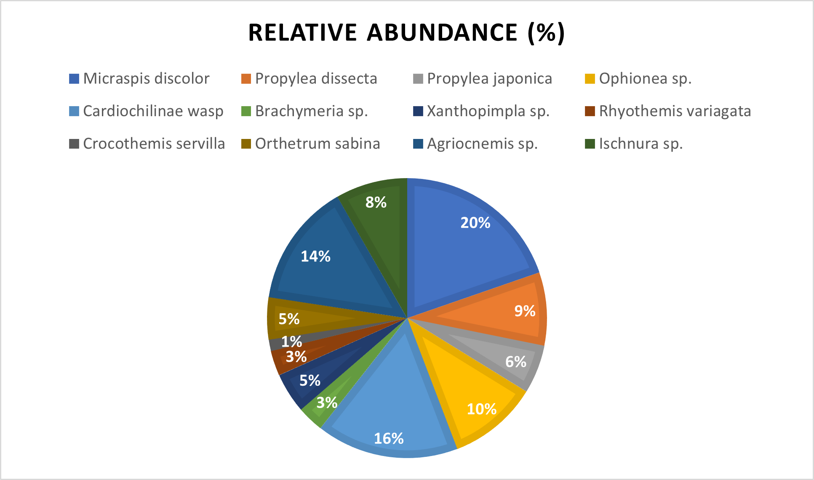

The order Coleoptera stood out as prominent one being represented by two families: Coccinellidae and Carabidae. Within the Coccinellidae family, three distinct beetles were found, namely *Micraspis discolor*, *Propylea dissecta*, and *Propylea japonica*. These beetles, well-known as general predators, play a pivotal role in maintaining ecological balance by preying on different insect pests of rice. On the other hand, the family Carabidae was slightly more restrained in its diversity, with only one member, *Ophionea* sp., being observed during the study. Among the coleopteran predators *Micraspis sp* was the most dominant one with a relative abundance of 19.69% followed by *Ophionea sp* (10.42%).

Another significant order that emerged from the study was Hymenoptera, which has given a vibrant diversity with representatives from three distinct genera, each belonging to unique families. Among the parasitoids documented, most abundant one was an unidentified parasitic wasp from the subfamily cardiochilinae of family braconidae, Other two were *Brachymeria sp* from chalcididae family and *Xanthopimpla* sp. from the ichneumonidae family. These parasitic species are instrumental in regulating pest populations, thereby ensuring the health and productivity of rice crops. Among the hymenopterans, unidentified cardiochilinae wasp was the predominant one with relative abundance 16.41% followed by *Xanthopimpla* sp. (4.63%).

Furthermore, the Odonata order, predominantly known for its representation by dragonflies and damselflies, exhibited a fascinating diversity within the rice fields and number of damselflies are more in number when compared to dragon flies (Parsappa*et al.,* 2017). Specifically, in the present study, this order was represented by five distinctive genera that could be categorized into two primary families such as libellulidae and coenagrionidae. Among the dragonflies, the identified species included *Rhyothemis variegata*, *Crocothemis servilia*, and *Orthetrum sabina*. These aerial predators offer significant ecological benefits by preying on a variety of insect pests. The damselflies, identified as *Agriocnemis* sp. and *Ischnura* sp., added another layer of biodiversity, resulting the intricate balance and coexistence of multiple species within this dynamic ecosystem.The relative abundance of the most predominant one in dragonflies is *Orthretum sabina* (4.83%) and among damselflies, *Agriocnemis* sp. (14.29%) was the most abundant one.

Studies conducted by several researchers also support that rice field are rich reservoir of natural enemies. Devi *et al*., 2018 conducted surveys on predators and parasitoids during kharif season (2012-2014) in Manipur and a total 33 species of predators from 26 genera and 15 families as well as 15 species of parasitoids from 5 families were collected. Likewise, Madhukar 2011 in rice ecosystem in eastern Vidarbha of Maharashtra, recorded predatory natural enemy complex consisting of 23 insects belonging to 7 orders and 18 families in both the kharif (wet) and rabi (dry) seasons. Mondal *et al.* (2017)examined the relative abundance of various natural enemies in rice from Murshidabad, West Bengal, India and documented that lady bird beetles were the most abundant one (51.06%) followed by long jawed spider (18.91%), carabid beetle (7.47%), damsel fly (6.54%), wolf spider (6.32%), lynx spider (3.86%), dragon fly (2.96%) and wasps (2.85%). The present experiment also revealed that lady bird beetles are very important group of predators in rice with *Micaspis* sp as the most dominant one. But in our study, a parasitic wasp identified up to family level as cardiochilinae wasp was found as the 2nd most dominant natural enemy in rice ecosystem. Among dragon flies and damselflies, members representing two families such as libellulidae and coenagrionidae were found which supports the finding of Arulprakash *et. al* (2017)who documented occurrence of three families of odonates such as lestidae (one species), libellulidae (12 species), and coenagrionidae (6 species) in rice.

**Table-5: Different diversity indices for natural enemies in kharif rice and boro rice.**

|  |  |  |
| --- | --- | --- |
| **Diversity indices** | **Kharif rice** | **Boro rice** |
| Shannon-Wiener index | -Σ Pi ln (Pi) = 2.32 | -Σ Pi ln (Pi) = 2.174 |
| Simpson’s index | Σ (ni(ni - 1)) / (N(N - 1)) = 0.108  SID=1-Σ (ni (ni - 1)) / (N (N - 1))  = 0.892 | Σ (ni (ni - 1)) / (N (N - 1)) = 0.134  D=1-Σ (ni (ni - 1)) / (N (N - 1))  = 0.866 |
| Pielou’s evenness index | E1=H’/ ln(S) = 0.932 | E1=H’/ ln(S) = 0.875 |
| Margalef index | α=(S–1)/ln (N) =1.992 | α=(S–1)/ln (N) =1.967 |

Different indices were also calculated to understand the level of diversity of the natural enemy complex visiting rice ecosystem. Shannon- wiener index, Simpson diversity index, Margalef and Pielou’s index were calculated as 2.32, 0.892, 1.99 and 0.932 respectively for kharif rice and 2.13, 0.856, 1.96 and 0.857 respectively for boro rice. Study conducted on different diversity indices by Daniel and Ramaraju (2019) from Tamil Nadu revealed that Shannon-Wiener index (H’) ranged from 0.97 to 1.02, Simpson’s Diversity Index (SDI) ranged from to 0.83-0.87, and Pielou’s Evenness Index (E1) ranged from 0.30- 0.33 in the three rice growing zones. Similarly, Gnanakumar *et al* (2012) recorded Simpson’s Diversity Index (SDI) for organic paddy as 0.977 and 0.898 for conventional paddy ecosystem. Busniah *et al* (2019) showed that the diversity index in rice ecosystem was high (4.675) and the evenness index was also high (0.887). The result of the present study also revealed that rice ecosystems of the present experimental area is moderately rich in diversity of predators and parasitoids.

***Seasonal incidence of natural enemies in relation to weather parameters and growing degree days:***

The population build-up of the most dominant predator and parasitoids from each order were correlated with prevailing weather parameter and growing degree days. The population of coleopteran predator *Micraspis* sp was found to be correlated significantly and negatively with minimum temperature (r = -0.775) and was significantly and positively correlated with Growing Degree Days (r = 0.573) during kharif Season. Whereas in boro rice, *Micraspis* sp. has shown positive and significant correlation only with GDD. Population of the unidentified cardiochilinae wasp has shown a significant and positive correlation with maximum (r = 0.625) and minimum relative humidity (r = 0.622) in kharif rice but has not revealed any significant correlation with any of abiotic factors in boro rice. The population of damselfly *Agriocnemis* sp. has not shown any significant correlation with any of the abiotic factors in any of the seasons.

A study conducted by Selvam et al. (2021) was found to have similar type of observation. The correlation coefficients of trap catch of natural enemies showed positive correlation with minimum temperature (0.644, 0.137), and sunshine hours (0.352, 0.214) whereas rainfall showed a negative correlation (-0.252, -0.048).

**Fig-2: Population of Micraspis and Cardiochilinae wasp as influenced by weather parameters and GDD in kharif rice (2022)**

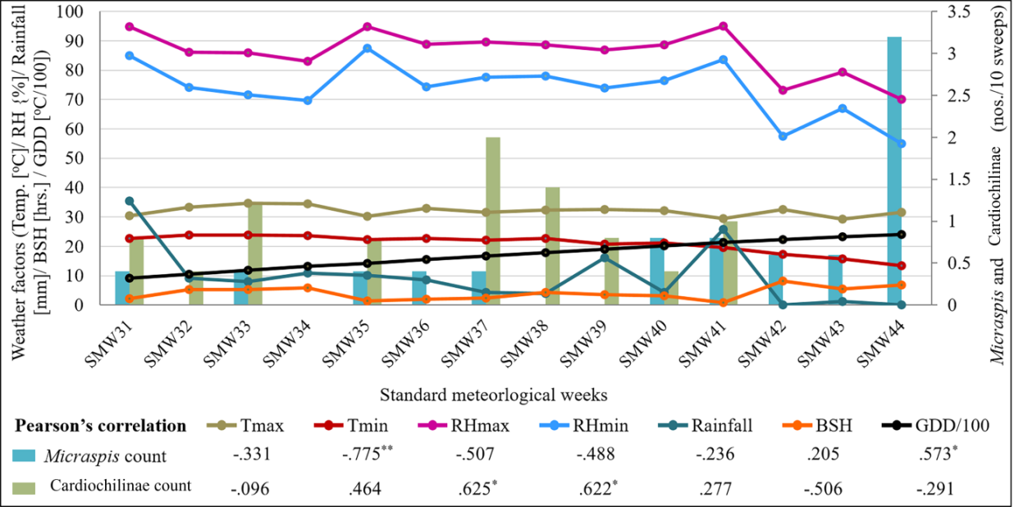

**Fig-3: Population of Micraspis and Cardiochilinae wasp as influenced by weather parameters and GDD in boro rice (2023)**

Rabi

**CONCLUSIONS:**

The experiment has revealed a remarkable level of richness and diversity of natural enemies in rice ecosystem for both kharif as well as boro season. The predators and parasitoids recorded during the experiment are well known for their multifaceted valuable role in maintaining ecological equilibrium by regulating pest population. Presence of this diverse group of natural enemies in the experimental region is a ray of hope for natural enhancement of biological control mechanism, which can ultimately contribute to sustainable and resilient rice cultivation ensuring long term agricultural productivity and food security.

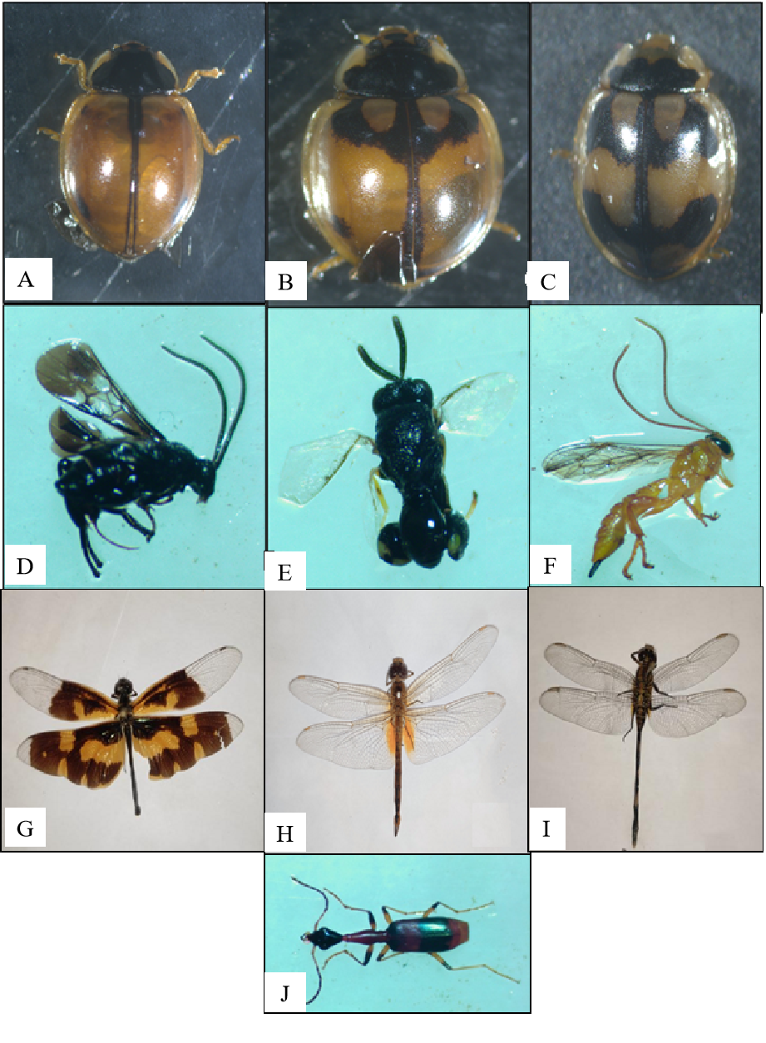

**Figure 4**: Different natural enemies of rice ecosystem. (A) *Micraspis discolor*, [B] *Propylea dissecta*, [C] *Propylea japonica*, [D] Cardiochilinae wasp, [E] *Brachymeria* sp., [F] *Xanthopimpla* sp.; [G] *Rhyothemis variegata*, [H] *Crocothemis servilia*,[I] *Orthetrum Sabina*; [J] *Ophionea* sp.

**References:**

Acharjee, P.,Satpathi, C. R., and Modak, M. K. (2020). Long term studies on role of parasitic nematode *Hexamermis*sp. in controlling brown planthopper in farmer’s rice field of West Bengal. International Journal of Current Research and Review,12, 7-11.

Arulprakash, R., Chitra, N., and Gunathilagaraj, K. (2017). Biodiversity of Odonata in Rice at Pattukkottai in Tamil Nadu. Indian Journal of Entomology,79 (4), 498-502.

Atwal, A. S., and Dhaliwal, G. S. (2005). Agricultural pests of South Asia and their management. Kalyani publishers, New Delhi, pp 181-82.

Busniah, M., Hakiki, A., and Martinius, M., (2019). Diversity of Hymenopteran parasitoid in agricultural and primary forest in LubukKilangan, Padang, West Sumatera, Indonesia.IOP Conf. Series: Earth and Environmental Science**, 497,**012034. IOP Publishing doi:10.1088/1755-1315/497/1/012034.

Daniel, A. J., and Ramaraju, K., (2019). Diversity of parasitic Hymenoptera in three rice- growing tracts of Tamil Nadu, India. Journal of Threatened Taxa,**11**(13), 14681– 14690. htps://doi.org/10.11609/jot.4529.11.13.14681-14690.

Dhaliwal, G. S., Jindal, V., and Dhawan, A. K. (2010). Insect pest problems and yield losses: Changing trends. Indian Journal of Ecology**,**37,1-7.

Gadal, N., Shrestha, J., Poudel, M. N. and Pokharel, B. (2019). A review on production status and growing environments of rice in Nepal in the world.Archives of Agriculture and Environmental Science, 4(1), 83-87.

Gnanakumar, M., Rajmohana, K. C., Bijoy, D., Balan, and Nishi, R., (2012). Diversity of Hymenopteran Egg Parasitoids in Organic and Conventional Paddy Ecosystems. Tropical Agricultural Research*,* 23(4), 300–308.

Islam, Z., (1990). Influence of *Scirpophaga incertulas* (Lepidoptera: Pyralidae) on deep-water rice. Bulletin of Entomological Research**,**80 (3), 301-308.

Kalode, M. B. (2005). Insect pest of rice and their management in Rice in Indian Perspective edited by S.D.Sharma and B.C.Nayak. Today and tomorrow printers and publishers (India), 819-854.

Krishnaiah., Varma, N. R. G. (2015). Changing Insect Pest Scenario in the Rice Ecosystem – A National Perspective. IRRIBook, 31-42.

Madhukar, F. J. (2011). A preliminary study of the predatory natural enemy complex of rice ecosystem in Vidarbha region of Maharashtra, India. International Referred Research Journal,2(22), 25-27.

Mondal, H. I. and Chakraborty, K., (2017). Observation on the impact of environmental parameters on rice yellow stem borer, *Scirpophaga incertulas* (Walker) and its natural enemies at Murshidabad, West Bengal, India. Journal of Entomology and Zoology Studies,5(6), 1656-1663.

Parasappa, H.H. and Reddy, N.G., (2017). Rice insect pests and their natural enemies complex in different rice ecosystem of Cauvery command areas of Karnataka. Journal of Entomology and Zoology Studies, 5(5), 335-338.

Prasad, R., Shivay, Y. S. and Kumar, D. (2017). Current status, challenges, and opportunities in rice production. (In) Rice DOI: <https://doi.org/10.1007/978-3-319-47516-5_1>

Rajasekar, N., and Jeyakumar, P., (2014). Differential response of trifloxystrobin in combination with tebuconozole on growth, nutrient uptake and yield of rice (*Oryza sativa* L.). International Journal of Agriculture, Environment and Biotechnology 6(1), 87-93.

Ranjeeta, Devi, M., Singh, K. I. and Ray, D. C. (2018). Predators and Parasitoids of rice insect pests under rice ecosystems of Manipur Valley. Indian Journal of Entomology**,**80(3).

Selvam, K., Archunan, K., Pavitra, devi, P., Mary, Floret. F. and Kannan, R., (2021). Population Dynamics of Insects and their Natural Enemies in Rice Ecosystem Assessed with Light Traps. DOI: 10.55446/IJE.2021.308.