**ENHANCING SILKWORM PUPAE NUTRITION BY FERMENTATION: PROXIMATE AND AMINO ACID ANALYSIS**

**ABSTRACT:**

Silkworm pupae (SWP) are recognized for their potential as a protein source in animal feeds, and their nutritional value can be further enhanced through fermentation. This study investigated the effects of fermentation using *Lactobacillus casei* and *Saccharomyces cerevisiae* on the nutritional profile of silkworm pupae. We compared the nutritional composition of three types of silkworm pupae: non deoiled, deoiled, and fermented. The analysis revealed that fermentation significantly increased protein content by 33% compared to non deoiled silkworm pupae and by 15% compared to deoiled silkworm pupae. Beyond protein enhancement, fermentation also induced changes in other nutrient levels and the amino acid composition of the pupae. These results indicate that fermented silkworm pupae could serve as a valuable alternative protein source in aquaculture and poultry feeds, potentially boosting the nutritional quality and efficiency of feed formulations and thus reducing the cost.

***KEYWORDS:* *Fermentation, fermented silkworm pupae, nutritional content, alternative protein.***

1. **INTRODUCTION**

Silkworms are renowned for their efficiency in large-scale silk thread production. Among the various silkworm species, the mulberry silkworm (Bombyx mori L.) is predominantly used in sericulture. These insects are economically significant due to their role as primary producers of silk (cocoon). However, the by-product of this process, silkworm pupae, which are collected after the silk threads are reeled from the cocoons, is not widely recognized by consumers. Despite being typically discarded, these pupae are highly valuable due to their rich content of amino acids, oil, carbohydrates, and minerals. The substantial volume of waste generated during the silk reeling process in India presents an opportunity to repurpose this by-product as a high-value raw material for various applications, including animal nutrition.

India is the second-largest producer of silk globally, trailing only China. According to the Central Silk Board of India's Annual Report for 2021-22, the production of raw mulberry silk was 34,903 metric tons, resulting in approximately 20,941 metric tons of silkworm pupal waste. Effective utilization of this by-product could provide a substantial source of silkworm pupal protein, which is suitable for fortifying animal and human feeds, given its amino acid profile meets FAO/WHO/UNO standards.

Silkworm pupae are rich in proteins and fats, and contain notable amounts of moisture, fiber, and ash. Recent research indicates that fermentation of insects can break down large molecules into smaller components through diverse oxidation/reduction processes (Agyei et al., 2019; Yadav et al., 2011). This fermentation process enhances the production of valuable compounds, such as essential amino acids, digestible proteins, essential fatty acids, alcohols, and vitamins (Mishra et al., 2017; Srivastava, 2018). Additionally, fermentation eliminates the fishy odor associated with pupae, thereby increasing their value in the feed industry (Yang et al., 2021; Zhou et al., 2017). This process significantly broadens the application potential of fermented edible insects across various sectors (Castro-López et al., 2020).

The primary aim of this study is to evaluate the proximal composition of fermented silkworm pupae (FSWP) and explore their potential applications in the feed industry.

1. **MATERIALS AND METHODS**
2. ***Sample preparation:***

SWP were sourced from a reeling center in Coimbatore District, where they were typically discarded post-silk reeling. The collected pupae were thoroughly cleaned and sundried until reaching a constant weight. The weight of the SWP got reduced by 80%. Subsequently, the dried pupae were ground into a fine powder using a blender (Figure 1). The powdered samples were subjected to deoiling using n-hexane as the solvent in a Soxhlet extractor.

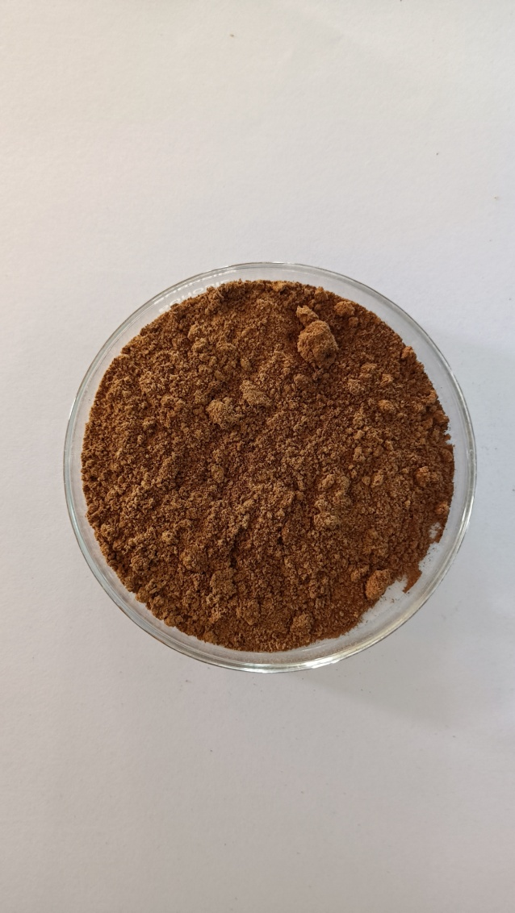

FIG 1 Silkworm pupal powder

Fermentation of deoiled silkworm pupae (DSWP) was conducted following the protocol outlined by Siddik *et al*. (2018). Specifically, 100 g/kg of baker's yeast (Instant Dried Yeast, *Saccharomyces cerevisiae*, Angel Yeast, China) and 50 g/kg *of Lactobacillus casei* (Yakult Danone India Pvt.; cell density of 0.1 × 10^9 cells/ml) were added to the weighed DSWP. Approximately 700 ml/L of distilled water was then incorporated into the mixture. The combined ingredients were thoroughly mixed and the mixture was covered securely. Fermentation was allowed to proceed for 3 days under controlled conditions, with the temperature and pH monitored and maintained at 29°C and 6.2, respectively (Figure 2).

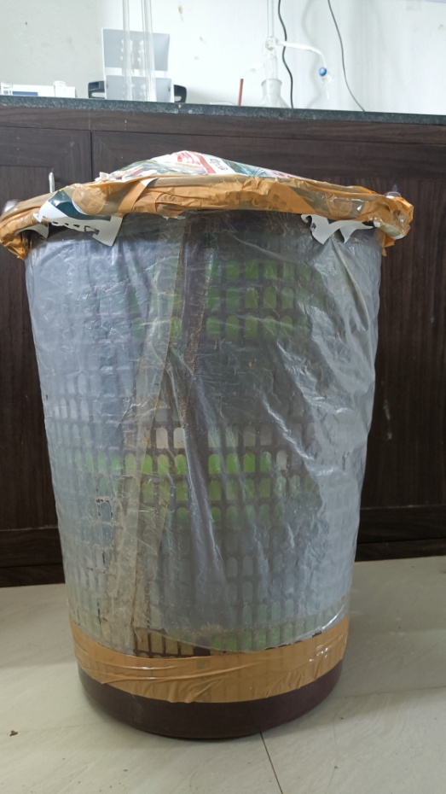

FIG 2 Fermentation condition of the silkworm pupal powder

Upon completion of the fermentation period, the fermented silkworm pupae (FSWP) were dried in a hot air oven at 40°C for 48 hours. The dried FSWP (Figure 3) were subsequently stored in an airtight container for further analysis. Biochemical analyses, including assessments of crude protein, carbohydrate content, amino acid profile, ash content, and moisture content, were performed on the sample.

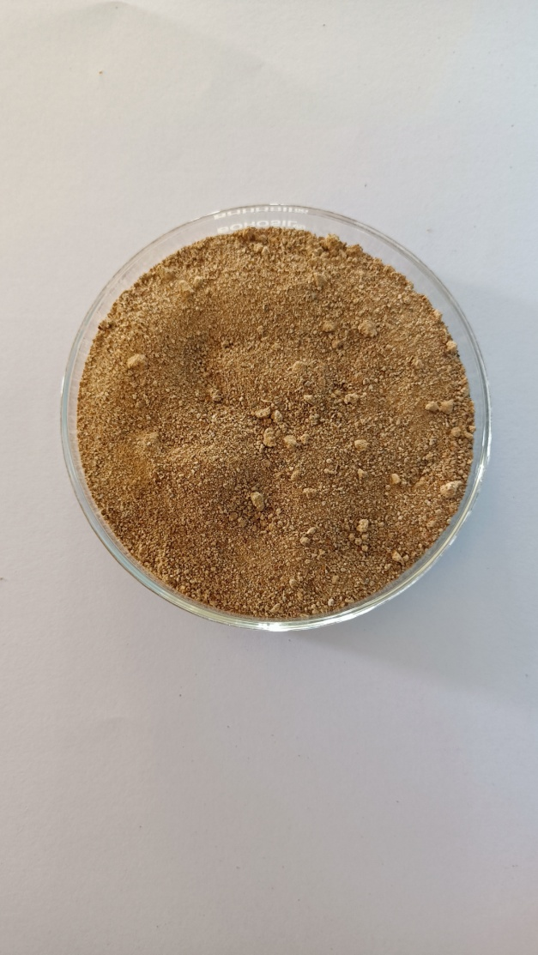

FIG 3 Dried fermented silkworm powder

1. ***Proximate composition:***

The proximate composition of the samples was determined using standard analytical methods. The crude protein content was measured spectrophotometrically according to Lowry et al. (1951). Ash content was quantified by incinerating the samples in a muffle furnace at 600°C until a constant weight was achieved, following method 942.05 of the AOAC (2005). Crude fiber content was determined through dilute acid and alkali hydrolysis, as outlined in method 978.10 of the AOAC (2005). Lipid content was assessed using Soxhlet extraction with n-hexane. The nitrogen-free extract (NFE) was calculated by subtracting the sum of moisture, crude protein, crude lipid, ash, and crude fiber from 100% (Castell and Tiews, 1980). These analysis was performed in triplicate form and the results were written as mean±SD.

1. ***Amino acid analysis:***

Silkworm pupal powder was mixed with ethanol and stirred using an agitator. The mixture was then filtered to collect the particles. These particles underwent triple extraction with ethyl acetate. The resulting extracts were dissolved in hexane, and the oil was extracted using a Soxhlet apparatus. The oil extract was hydrolyzed with 6 N hydrochloric acid (HCl) at 110°C for 22 hours. Post-hydrolysis, amino acid analysis was conducted using high-performance liquid chromatography (HPLC).

1. ***Statistical analysis:***

All the measurements were performed in triplicate. Mean values ± standard deviations (SD) were calculated. The data were subjected to one way analysis of variance (ANOVA) following Tukey’s honestly significant difference post hoc analysis. The significance of variance (p<0.05) between means was calculated using IBM SPSS 23 software. DMRT test was done to check the best sample.

**3. RESULTS:**

The proximate composition of mulberry silkworm pupae (SWP) exhibited notable differences across non-deoiled, deoiled, and fermented treatments (*Table 1*). Non-deoiled SWP had a crude protein content of 46.51% ± 0.63%, which significantly increased to 59.01% ± 1.39% in deoiled SWP and further to 69.88% ± 0.42% in fermented SWP, with these differences being statistically significant (SE(d) = 0.74; CD(0.05) = 1.85). Conversely, non-deoiled SWP had the highest crude fat content at 27.35% ± 0.07%, which decreased markedly in deoiled SWP to 4.16% ± 0.82% and further to 3.81% ± 0.72% in fermented SWP, with the reductions being statistically significant (SE(d) = 0.51; CD (0.05) = 1.28). Moisture content was highest in non-deoiled SWP at 7.59% ± 0.06%, dropping to 4.10% ± 0.11% in deoiled SWP and 5.16% ± 0.04% in fermented SWP, with these changes being statistically significant (SE(d) = 0.063; CD(0.05) = 0.158). The ash content was significantly higher in deoiled SWP (6.28% ± 0.56%) compared to non-deoiled SWP (4.10% ± 0.18%) and fermented SWP (6.58% ± 0.35%), with differences being statistically significant (SE(d) = 0.323; CD(0.05) = 0.805). Crude fiber content was lowest in fermented SWP (3.02% ± 0.02%) and non-deoiled SWP (3.03% ± 0.02%), while it was significantly higher in deoiled SWP (6.33% ± 0.11%), with the variations being statistically significant (SE(d) = 0.054; CD(0.05) = 0.134). These results underscore the significant impacts of deoiling and fermentation on the nutritional profile of mulberry SWP, affecting key components such as protein, fat, moisture, ash, and fiber content.

The amino acid profile of mulberry SWP reveals significant differences between non-deoiled, deoiled, and fermented samples (*Table 2*). The fermentation process generally resulted in increased concentrations of essential amino acids such as methionine, lysine, isoleucine, leucine, phenylalanine, threonine, and histidine compared to both non-deoiled and deoiled SWP. For instance, methionine increased from 3.43% ± 0.06% in non-deoiled to 4.07% ± 0.21% in fermented SWP, and lysine rose from 6.93% ± 0.06% to 7.53% ± 0.06%. Similarly, other essential amino acids, including isoleucine and leucine, also exhibited notable increases in fermented SWP. The fermentation process also enhanced non-essential amino acids, with significant increases in glutamic acid, aspartic acid, and glycine, compared to non-deoiled and deoiled samples.

**4. DISCUSSION:**

The *Lactobacillus casei* and *Saccharomyces cerevisiae* have been reported to enhance the nutritional composition of feed ingredients (Dawood, et al., 2020; Samaddar et al., (2015); Siddik et al., (2019). Research on FSWP is relatively sparse. Rangacharyulu et al. (2003) reported that fermentation led to a decrease in protein content from 25.5% to 22.9%, moisture from 61.3% to 60.2%, and fat from 9.7% to 9.5%, while noting an increase in ash content. Similarly, Sathishkumar et al. (2021) observed that in the fermentation of poultry by-products, protein, ash, and moisture concentrations increased, whereas lipid and fiber contents degraded. Zhang et al. (2023) found that fermentation of soybean meal resulted in reduced crude fiber and ash content. This shows a change in the nutrient profile after fermentation.

Overall, FSWP demonstrated a superior amino acid profile, with higher levels of both essential and non-essential amino acids, suggesting that fermentation not only improves protein content but also enhances the nutritional quality of silkworm pupae. This aligns with findings from other studies where fermentation using various microorganisms improved the amino acid profiles of feed ingredients, such as *Saccharomyces cerevisiae* and *Bacillus subtilis* in sunflower meal (Hassaan et al., 2018), *Aspergillus niger* in groundnut oil cake (Jannathulla et al., 2018), and *Saccharomyces cerevisiae* in soybean meal (Sharawy et al., 2016).

**5. Conclusion and future prospects:**

The study demonstrates that fermentation significantly enhances the nutritional profile of silkworm pupae (SWP), a typically discarded by-product of the silk industry. The fermentation process increased the crude protein content from 46.51% in non-deoiled SWP to 69.88% in fermented SWP, while reducing crude fat and moisture content. Notably, the fermentation process also decreased crude fiber and increased ash content. Additionally, the amino acid profile improved substantially, with increased concentrations of essential amino acids such as methionine, lysine, and leucine, as well as non-essential amino acids like glutamic acid and glycine. These improvements highlight the potential of fermented silkworm pupae as a valuable protein source for animal and human feeds, with an enhanced amino acid profile meeting FAO/WHO/UNO standards. The findings support the repurposing of silkworm pupae through fermentation, providing an effective strategy to reduce waste and improve feed quality, aligning with broader sustainability goals in the feed industry.

Table1: Proximate composition of SWP, DSWP and FSWP:

|  |  |  |  |  |  |
| --- | --- | --- | --- | --- | --- |
| **Mulberry SWP** | **Crude protein (%)** | **Crude fat (%)** | **Moisture (%)** | **Ash (%)** | **Crude Fibre (%)** |
| Non deoiled | 46.51± 0.63c | 27.35± 0.07a | 7.59± 0.06a | 4.1 ± 0.18c | 3.03± 0.02b |
| Deoiled | 59.01± 1.39b | 4.16± 0.0.82b | 4.10± 0.11c | 6.28 ± 0.56a | 6.33± 0.11a |
| Fermented | 69.88± 0.42a | 3.81± 0.72c | 5.16± 0.04b | 6.58 ± 0.35a | 3.02± 0.02b |
| **SE(d)** | 0.74 | 0.51 | 0.063 | 0.323 | 0.054 |
| **CD(0.05)** | 1.85 | 1.28 | 0.158 | 0.805 | 0.134 |

Note: Values are expressed in mean ± SD with three replications (n=3).

Means followed by different small superscript in a Column are statistically different at

p<0.05

*Table2: Amino acid composition (g/16g N) of SWP*

|  |  |  |  |
| --- | --- | --- | --- |
| **AMINO ACID** | **Mulberry Silkworm** | | |
| **Non deoiled** | **Deoiled** | **Fermented** |
| Methionine | 3.43±0.06 | 3.00±0.10 | 4.07±0.21 |
| Lysine | 6.93±0.06 | 6.04±0.12 | 7.53±0.06 |
| Isoleucine | 5.13±0.06 | 3.73±0.21 | 6.47±0.06 |
| Leucine | 7.50±0.10 | 5.84±0.06 | 8.50±0.35 |
| Phenylalanine | 5.13±0.06 | 4.30±0.10 | 7.70±0.35 |
| Threonine | 5.33±0.06 | 4.80±0.10 | 7.37±0.15 |
| Tryptophan | 0.90±0.10 | 1.40±0.10 | 0.97±0.12 |
| Histidine | 2.53±0.12 | 2.60±0.09 | 3.23±0.06 |
| Valine | 5.40±0.10 | 4.83±0.06 | 5.90±0.30 |
| Glutamic acid | 13.83±0.06 | 8.30±0.10 | 15.53±0.35 |
| Alanine | 5.77±0.07 | 4.20± 0.10 | 5.93±0.15 |
| Arginine | 5.63±0.06 | 5.13±0.06 | 5.80±0.10 |
| Aspartic acid | 10.37±0.08 | 7.81±0.01 | 13.37±0.15 |
| Cystine | 1.03±0.15 | 0.70±0.10 | 1.07±0.15 |
| Proline | 5.23±0.06 | 5.23±0.06 | 5.67±0.12 |
| Serine | 5.10±0.10 | 4.50±0.10 | 5.83±0.40 |
| Glycine | 4.77±0.06 | 3.67±0.06 | 5.77±0.15 |
| Tyrosine | 5.73±0.15 | 5.50±0.10 | 6.30±0.20 |

Note: Values are expressed in mean ± SD with three replications (n=3).

**REFERENCES:**

1. Agyei, D., Owusu-Kwarteng, J., Akabanda, F., & Akomea-Frempong, S. (2019). Indigenous African fermented dairy products: Processing technology, microbiology and health benefits. Critical Reviews in Food Science and Nutrition, 60(6), 991–100621. <https://doi.org/10.1080/10408398.2018.1555133>
2. Castro-López, C., Santiago-López, L., Vallejo-Cordoba, B., González-Córdova, A.F., Liceaga, A.M., García, H.S., and Hernández-Mendoza, A., 2020. An insight to fermented edible insects: A global perspective and prospective. Fd. Res. Int., 137: 109750. https:// doi.org/10.1016/j.foodres.2020.109750.
3. Dawood, M. A. O., Magouz, F. I., Mansour, M., Saleh, A. A., Asely, A. M. E., Fadl, S. E., Ahmed, H. A., Al- Ghanim, K. A., Mahboob, S., & Al- Misned, F. (2020). Evaluation of yeast fermented poultry by- product meal in Nile tilapia (Oreochromis niloticus) feed: Effects on growth performance, digestive enzymes activity, innate immunity, and antioxidant capacity. Frontiers in Veterinary Science, 6, 516. https://doi.org/10.3389/fvets.2019.00516
4. Hassaan, M. S., Soltan, M. A., Mohammady, E. Y., Elashry, M. A., El- Haroun, E. R., & Davies, S. J. (2018). Growth and physiological responses of Nile tilapia, Oreochromis niloticus fed dietary fer mented sunflower meal inoculated with Saccharomyces cerevisiae and Bacillus subtilis. Aquaculture, 495, 592– 601.
5. Jannathulla, R., Dayal, J. S., Ambasankar, K., & Muralidhar, M. (2018). Effect of Aspergillus niger fermented soybean meal and sunflower oil cake on growth, carcass composition and haemolymph indices in Penaeus vannamei Boone, 1931. Aquaculture, 486, 1– 8. https://doi. org/10.1016/j.aquac ulture.2017.12.005.
6. Lowry, O. H., Rosebrough, N. J., Farr, A. L., & Randall, R. J. (1951). Protein measurement with the Folin phenol reagent. *J biol Chem*, *193*(1), 265-275.
7. Mishra, S. S., Ray, R. C., Panda, S. K., & Montet, D. (2017). Technological innovations in processing of fermented foods. An overview. In R. C. Ray, & D. Montet (Eds.), Fermented Foods Part II: Technological Intervention (pp. 21–45). Florida, USA: CRC Press, Taylor & Francis Group.
8. Rangacharyulu, P. V., Giri, S. S., Paul, B. N., Yashoda, K. P., Rao, R. J., Mahendrakar, N. S., ... & Mukhopadhyay, P. K. (2003). Utilization of fermented silkworm pupae silage in feed for carps. *Bioresource technology*, *86*(1), 29-32.
9. Samaddar, A., Kaviraj, A., & Saha, S. (2015). Utilization of fermented animal by- product blend as fishmeal replacer in the diet of Labeo rohita. Aquaculture Reports, 1, 28– 36. https://doi.org/10.1016/j.aqrep.2015.03.004
10. Sathishkumar, G., Felix, N., & Prabu, E. (2021). Effects of dietary protein substitution of fish meal with bioprocessed poultry by‐product meal on growth performances, nutrient utilization, whole‐body composition and haemato‐biochemical responses of GIFT tilapia reared in floating cages. *Aquaculture Research*, *52*(11), 5407-5418.
11. Sharawy, Z., Goda, A.- M.- S., & Hassaan, M. S. (2016). Partial or total replacement of fish meal by solid state fermented soybean meal with Saccharomyces cerevisiae in diets for Indian prawn shrimp, Fenneropenaeus indicus, Postlarvae. Animal Feed Science and Technology, 212, 90– 99. [https://doi.org/10.1016/j.anife edsci.2015.12.009](https://doi.org/10.1016/j.anife%20edsci.2015.12.009)].
12. Siddik, M. A., Chungu, P., Fotedar, R., & Howieson, J. (2019). Bioprocessed poultry by- product meals on growth, gut health and fatty acid synthesis of juvenile barramundi, Lates calcarifer (Bloch). PLoS One, 14(4), e0215025. https://doi.org/10.1371/journ al.pone.0215025.
13. Siddik, M. A., Howieson, J., Ilham, I., & Fotedar, R. (2018). Growth, biochemical response and liver health of juvenile barramundi (*Lates calcarifer*) fed fermented and non-fermented tuna hydrolysate as fishmeal protein replacement ingredients. *PeerJ*, *6*, e4870.
14. Srivastava, R. K. (2018). Enhanced shelf life with improved food quality from fermentation processes. Journal of Food Technology and Preservation, 2(3), 1–7 Accessed 15 February 2020.
15. Yadav, H., Jain, S., Rastamanesh, R., Bomba, A., Catanzaro, R., & Marotta, F. (2011). Fermentation technology in the development of functional foods for human health: Where we should head. Fermentation Technology, 1, 1–2. <https://doi.org/10.4172/2167-7972.1000e102>.
16. Yang, L.J., Zeng, X.F., and Qiao, S.Y., 2021. Advances in research on solid-state fermented feed and its utilization: The pioneer of private customization for intestinal microorganisms. Anim. Nutr., 7: 905916. <https://doi.org/10.1016/j.aninu.2021.06.002>
17. Zhang, Q., Guo, M., Li, F., Qin, M., Yang, Q., Yu, H., Xu, J., Liu, Y., & Tong, T. (2023). Evaluation of fermented soybean meal to replace a portion fish meal on growth performance, antioxidant capacity, immunity, and mTOR signaling pathway of coho salmon (Oncorhynchus kisutch). *Aquaculture Nutrition*, *2023*(1), 2558173.
18. Zhou,J.S., Chen, Y.S., Ji, H., and Yu, E.M., 2017. The effect of replacing fish meal with fermented meal mixture of silkworm pupae, rapeseed and wheat on growth, body composition and health of mirror carp (Cyprinus carpio var. Specularis). Aquac. Nutr., 23: 741-754. <https://doi.org/10.1111/anu.12441> ).