***Original Research Article***

**Comparative microbiome of groundnut (*Arachis hypogaea* L.) rhizosphere soil in relation to dry root rot disease**.

**Abstract**

The microbial population varied depending on the plant's health and the environment. The plant pathogens can also be managed by means of hostile microorganisms.Using next-generation sequencing technologies, a microbiome investigation of the groundnut rhizosphere associated to root rot disease was conducted. Both culture-dependent and culture-independent metagenomics were employed to investigate the root rot infection infected and healthy GG-20 groundnut rhizosphere soil. Ten samples' worth of metagenomics provided 2.5 gigabytes of data, totaling 1,07,68,140 reads with a 233 bp mean length. A soil sample from the rhizosphere with *Macrophomina phaseolina* infection exhibits greater Alpha-diversity than the healthy soil sample. More than 60% of the variation in microbial communities between samples was explained by beta diversity at the family, genus, and species level community composition two axes. In healthy metagenomes, the four major phylum Actinobacteria (20–40%), Proteobacteria (15–20%), Firmicutes (5–12%), and Bacteroidetes (1-3%) constituted the majority of the bacterial communities. The remaining 34-51% of the sequences were unclassified originated from bacteria. Actinobacteria, Proteobacteria, Firmicutes, and Bacteroidetes are the four major phyla (frequency >3%) that accounted for more than 75% of the recovered sequences in each library. 136 genus OTU of bacteria that are prevalent in a healthy sample from five different places. 5 sites' worth of infected samples had bacteria belonging to the 168 genus OTU. The 43 genus OTU is only found in the healthy sample, while the 73 genus OTU is only present in the infected sample. The 342 genus OTU common means are present in both samples. There were 476 total species in the healthy sample and 533 in the infected sample. It was discovered that 90 species were unique in the healthy sample and 147 species were unique in the infected sample, with 386 species present in both the healthy and infected samples.

**Key words :** Microbiome, Metagenomics, OUT, Grountnut, Rhizosphere, Root rot

**Importance of the study**

Rhizospheric metagenomics, which focuses on the study of the microbial communities in the rhizosphere is particularly important in understanding plant diseases and improving plant health. The rhizosphere is a dynamic environment where complex interactions between plants, soil, and microbes occur. Some microbial communities in the rhizosphere naturally suppress plant diseases, a phenomenon known as "soil suppressiveness." Metagenomics can help identify the specific microbial species or functional genes responsible for this suppression.

Metagenomics can help assess how different farming practices impact microbial communities in the rhizosphere and, consequently, plant health. in present study No. of OTU of *Arthrobacter sp, Bacillus badius, Bacillus funiculus, Geodermatophilus obscurus, Lysobacter sp.,, Pseudonocardia sp.* and *Ramlibacter* high in healthy sample compare to infected sample. These species have characteristics to PGP activities and control the plant pathogens.

**Introduction**

Finding new alternatives to feed the world's expanding population is imperative in a world where food supplies are limited and population growth is worrying. The key to improving plant health and productivity is to recognize and take advantage of the positive interactions that occur between plants and the microbiota in their rhizosphere. Gaining knowledge of the mechanisms governing these interactions is crucial to improving the production and health of plants.

India frequently experiences a variety of fungal-caused root rot and wilt illnesses affecting its groundnut and other crops. Of them, *Macrophomina phaseolina* (Tassi) Goid's dry root rot has been found to be responsible for 23.80% post-emergence mortality and 33.33 percent seed rotting [13]. To prevent plant diseases, the population of microorganisms in the rhizosphere will be altered or manipulated by adding microbes of one type by artificial means.

Groundnut (*Arachis hypogaea* L.) is a significant crop that is grown all over the world for food and oil. due to its high oil content, presence of vital nutrients, proteins, and minerals (calcium, phosphorus, zinc, riboflavin, magnesium, iron, thiamine, potassium, and vitamins), as well as its high dietary fiber content, it is an important oilseed crop in tropical and subtropical regions of the world and is ranked as the third most important food crop globally [25]. The states of Andhra Pradesh, Telangana, Gujarat, Tamil Nadu, and Karnataka are the nation's top producers of groundnuts. [2].

*Macrophomina phaseolina* is a soil borne fungus causing the root rot disease in Groundnut and more than 500 plants different species from more than 100 families [21,36]. distributed worldwide and is one of the global fungi.

Plants live with microbes in close association that inhabit the soil in which plants grow. Soil microbial communities represent the largest reservoir of biological diversity known in the world so far [5,8,11,34].

The rhizosphere, which is the narrow zone of soil that is influenced by root secretions, can contain up to 1011 microbial cells per gram root [9]. and more than 30,000 prokaryotic species [21].

The intricate relationship that exists between plants and their environment has long been the subject of extensive study. More of this research concentrated on the plants, paying less attention to the advantageous interactions between plants and microbes [3]. Microbes and plants can cohabit because of the close ties that have developed between them [24].Numerous studies have been carried out to address these problems by reducing the interactions to a single plant-microbe link, but the results of all of these studies indicate that these interactions are far more complex.

Typically, approaches based on culture are used to study the microorganisms associated with plants. Unfortunately, the real microbial makeup of the environment could not be accurately represented by the culture-based approaches. Most frequently, it is recognized that culture-based techniques are biased toward specific bacterial groups. Direct nucleic acid extraction from samples can be used to research microbes that are not able to thrive on artificial media. High-throughput methods have been developed recently to reveal the interactions that occur between intricate microbial populations and their hosts. In prokaryotes, the most popular technique for differentiating between strains and species is 16S rRNA gene sequencing. Different bacteria can be taxonomically grouped by examining the 16S rRNA gene [29].

The soil microbiome not only boosts plant productivity but also plays a significant role in keeping diseases at bay in soils. When assessing soil productivity, a soil's capacity to inhibit disease is crucial [18]. Many PGPRs help reduce illness by releasing chemicals that are antibacterial or antifungal and discourage plant pathogens [12,37]. High functional redundancy, resulting from elevated levels of species richness and variety, enables the soil microbiome to recuperate rapidly in the face of stress [23,39] Protection against soil-borne diseases is also provided by the high functional redundancy found in soil microbial variety [4,12,21,23].

**Materials and methods**

**Sample collection**

Groundnut variety GG-20 rhizosphere soil was gathered from several regions in Saurashtra, Gujarat, India. For the purpose of studying the microbiome, samples were taken from certain locations with various types of soils (table no. 1) that were cultivated GG-20 groundnut varieties with either healthy or dry root rot affected plants. A total of five distinct collecting sites yielded fifty (50) samples. Five infected and five healthy samples were taken from each site. In the same way that five healthy samples were blended to create one sample, five diseased soil samples were combined to create one sample. Two samples would therefore be taken from each location of collection. Ten samples in all (five infected and five healthy groundnut plant rhizospheric soil samples) were prepared. These 10 samples were used for further studies. All the samples were stored at -200 C. DNA was extracted from all 10 samples using The Power Soil® DNA Isolation Kit with minor modification and accordance to manufacture's instruction by MoBio laboratories Inc.

**Table 1 :** Rhizospheric soil samples sites indicating coordinates for sample collected from five different location in Saurashtra region of Gujarat (India) on the basis of soil type and agro climatic zones.

|  |  |  |
| --- | --- | --- |
| **Sr. No.** | **Area of Collection** | **Geographic Location** |
| 1 | Salt affected soil area near to coastal region. Veraval, Gujarat. | 20° 54' 51.192'' N  70° 22' 8.868'' E |
| 2 | Very Shallow soil. Gir region have this types of soil- Village-Bhojde near to Sasan Gir. Gujarat, India | 21° 5' 25.872'' N  70° 50' 8.952'' E |
| 3 | Shallow medium black calcareous soil. Amreli, Gujarat, India | 21° 36' 35.028'' N  71° 13' 32.0556'' E |
| 4 | Medium black soil- Junagadh district area have this types of soil. Junagadh Agricultural University, Junagadh | 21° 31' 19.8624'' N  70° 27' 28.3608'' E |
| 5 | Organic soil. Samples were collected from farmer's organic at Bhesan, District-Junagadh, Gujarat, India | 21° 33' 14.796'' N  70° 42' 16.452'' E |

**Metagenomic Library preparation**

Each sample requires 1-3 ng of microbial DNA input to provide enough amplified material for library construction. Two reactions (one for each of the two primer sets) are generated using the 16STM Metagenomics kit reagents, and the samples are kept on ice. each PCR cycle had a single positive and one negative control. Purify the amplification products using the dynamagTM-96 before employing an aliquot of each reagent (Agencourt® ampure® xp reagent). then nick repair and Ligate, Clean up the nick-repaired and adapter-ligated DNA.

**Determine library concentration using qPCR**

Ion Control Library of *E. Coli* DH10B on ice. Before taking aliquots, vortex and spin down for a little while. Four consecutive 10-fold dilutions were made from the *E. Coli* DH10B Ion Control Library (68 pM; included in the Ion Universal Library Quantization Kit). Before aliquoting each standard for the subsequent dilution, vortex and spin it down for a little while. Store on ice and label the standards.

**Dilute the sample library**

At a minimum, prepare three technical replicate qPCR reactions of each individual dilution. For a standard 20-μl qPCR reaction, prepare 5 μl of each library dilution per reaction.

**Amplify the library**

5 μl of Low TE to the ~20 μl of purified, adapter-ligated library using PCR condition holding denature at 95 0C for 5 minutes, Cycle 5-7 cycles denature at 95 0C for 15 sec., anneal 580C for 15 sec, extended 700C for 1 minutes and Holding at 40C for 1 hour. Then purify the library.

**Template preparation and sequencing**

Diluted 6-8μl of 100pM library with Nuclease-free Water in a 1.5-ml Eppendorf LoBind™ Tube to gave a total volume of 100 μl. Vortex the diluted library for 5 seconds, centrifuge for 2 seconds, then placed the diluted library on ice. Vortex the ISPs at maximum speed for 1 minute, centrifuge for 2 seconds, pipette the ISPs up and down to mixed; then immediately proceed to the next step.To the tube containing 2 ml of Ion S5™ Reagent Mix at 15°C to 30°C. Run the Ion One Touch™ 2 Instrument, after 16 hrs recover the template-positive ISPs. Enriched the template-positive ISPs with the Ion OneTouch™ES". While the sequencer is initializing, prepared the ISPs for sequencing and loaded the chip. Slowly dispensed 40μl of the sample directly into the chip loading port of the chip, then dispensed the remaining ~20μl into the chip loading well. Sequencing chip 530v1 (ChipBarcode:**DAEF01520**) was used for the instrument S5-00310 (NGS).

**Bioinformatic analysis**

Reads from the sequencer translated to Fastq and BAM files for the Ion torrent server. The machine's in-built software performs primary quality control to minimize confusing reads, and the final fastq file is utilized for secondary quality checking with the CLC genomics workbench 20.0. Duplicate readings are filtered and eliminated in the CLC processing for the primer, adapter, barcodes, and ambiguity.

For the 16S region, reads are mapped using the databases RDP, Greengen, and SILVA. MG-RAST (https://www.mg-rast.org/) and QIIME (http://qiime.org/) were the platforms used for the binning procedure. Utilizing QIIME software, 16S rDNA sequencing data was analyzed. describe QIIME as a complete software package that includes tools and techniques such as Fast Tree for heuristic-based maximum-likelihood phylogeny inference [29]. Ion Reporter (<https://ionreporter.thermofisher.com/ir/>) tool were used to identify the genus or species level of microbes present in complex polybacterial research samples, using both Greengenes and premium MicroSEQ ID 16S rRNA reference databases. Data of QIIME and MG RAST were processed using MEGAN (https://bio.tools/megan) and STAMP (https://beikolab.cs.dal.ca/software/STAMP) tools and data was further process and selection for OTU were narrow down manually. Selected OTU shorted on the base of abundance and uniqueness [27].

Selected Data/OTU were compared on the basis of sample site variation and status of groundnut (Healthy/Infected). Data also analyzed manually for selected genus and species richness in the samples/sites.

**Result and Discussion**

Using The Power Soil® DNA isolation kit, total DNA was directly isolated from each of the ten rhizosphere soils, and the metagenomics approach was used to study the microbial community. Following the extraction of the DNA, use the primer set (16S primer set V2-4-8, 16S primer set V3-6, 7-9) included in the Thermo Fisher 16STM Metagenomics kit to create the amplicon. 2.5 GB of fastQ formatted data in total, including 1,07,68,140 raw readings with a mean length of 233 bp. (Table 2)

**Table 2:** Untrimmed raw data representing no. of reads and Mean length present in samples

|  |  |  |  |  |
| --- | --- | --- | --- | --- |
| **S.N.** | **Sample** | **Bases in MB** | **Reads** | **Mean Read length** |
| 1 | Healthy-1 | 241.32 | 1022740 | 235 |
| 2 | Infected-1 | 507.05 | 1245313 | 236 |
| 3 | Healthy-2 | 149.48 | 635376 | 235 |
| 4 | Infected-2 | 155.23 | 658089 | 235 |
| 5 | Healthy-3 | 275.30 | 1125961 | 244 |
| 6 | Infected-3 | 242.10 | 1073193 | 225 |
| 7 | Healthy-4 | 264.10 | 1154472 | 228 |
| 8 | Infected-4 | 186.61 | 827429 | 225 |
| 9 | Healthy-5 | 198.11 | 863458 | 229 |
| 10 | Infected-5 | 211.36 | 921298 | 229 |

The MG-RAST (Metagenomics RAST: metagenomics.anl.gov) server version 3.5 was used to analyze all sequencing reads. The pipeline is programmed in Perl and makes use of a number of open source components, such as Sun Grid Engine, SQLite, NCBI Blast [13]. and the SEED framework [1]. Each sequencing data set's GC content Based on the CLC analysis results, all of the sample sequencing data had a GC content of 50–65%, which indicates that the sequencing data should have adequate coverage. The majority of the sequences had a PHERD score of 30, and all samples had scores ranging from 17 to 32. As a result, it indicated that the data have excellent quality.

The following read findings were acquired via further data analysis utilizing the Integrated Microbial Genomes and Microbiomes (IMG/M). Here, IMG/M analyzed the read data and provided the outcome of the reads that were there. Classified readings for each of the ten metagenome samples as table.3.

**Table 3:** Sample wise total number of reads, valid reads, reads ignored, mapped and unmapped reads with reference database for the 16S and IMG/M database

|  |  |  |  |  |  |  |  |  |  |  |
| --- | --- | --- | --- | --- | --- | --- | --- | --- | --- | --- |
| **Sample** | **H1** | **I1** | **H2** | **I2** | **I3** | **H3** | **H4** | **I4** | **H5** | **I5** |
| **Total number of reads** | 1022740 | 2145313 | 635376 | 658089 | 1073193 | 1125961 | 1154472 | 827429 | 863458 | 921298 |
| **Number of valid reads** | 802879 | 1693904 | 502689 | 519096 | 834268 | 893674 | 900992 | 645858 | 673207 | 720130 |
| **Number of reads ignored (due to low number of copies <10)** | 458997 | 855761 | 296661 | 301691 | 404585 | 409829 | 411172 | 311410 | 303943 | 390032 |
| **Mapped reads in sample** | 332825 | 809371 | 201247 | 215198 | 420035 | 478039 | 481866 | 325684 | 366968 | 325480 |
| **Un-Mapped reads in sample** | 11057 | 28772 | 4781 | 2207 | 9648 | 5806 | 7954 | 8764 | 2296 | 4618 |

The estimated α-diversity of annotated samples is derived from the distribution of annotations at the species level. The results indicate that the infected soil sample had more diversity than the healthy soil sample. Quantitative Insights Into Microbial Ecology (QIIME) is an open-source bioinformatics pipeline that is used to further process sequence data in order to conduct microbiome analysis from raw DNA sequencing data [7, 20]. the number of valid reads submitted in QIIME from each of the 10 metagenomes.We obtained the number of OTU for the family, genus, and species as indicated in Table 4, using the QIIME pipeline.

**Table 4:** Family, Genus and Species no. of (operational taxonomic unit) OTU presented in all 10 metagenomes.

|  |  |  |  |  |
| --- | --- | --- | --- | --- |
| **Sr. No.** | **Sample** | **Family OTU** | **Genus OTU** | **Species OTU** |
| 1 | H1 | 336361 | 113208 | 38262 |
| 2 | I1 | 817965 | 271234 | 90693 |
| 3 | H2 | 201247 | 60035 | 19225 |
| 4 | I2 | 215198 | 81489 | 26290 |
| 5 | H3 | 478039 | 225603 | 99773 |
| 6 | I3 | 420035 | 163045 | 53588 |
| 7 | H4 | 481866 | 207818 | 78772 |
| 8 | I4 | 325684 | 136267 | 46115 |
| 9 | H5 | 366968 | 156751 | 55638 |
| 10 | I5 | 325480 | 129548 | 41767 |

Based on the relative abundance of sequences, prokaryotic communities were examined. Bacterial assemblages accounted for 95–98% of all sequences, whereas Archaea comprised 0.01-0.24%. Unassigned sequences accounted for 0.03–0.25% of the entire metagenome, whereas Eukaryotic sequences comprised an average of 1-5% of all sequences detected across all locations. MG-RAST processing of the data produced the community composition.

**Comparison of bacterial diversity between healthy plant rhizosphere soils from the different location.**

Bacterial communities in all 5 healthy metagenomes were predominantly represented by 4 major Phylum comprising of Actinobacteria (20-40%), Proteobacteria (15-20%), Firmicutes (5-12%), Bacteroidetes (1-3%) and unclassified sequences derived from bacteria was 34-51%. The abundance of four predominant phyla (frequency >3%) namely Actinobacteria, Proteobacteria, Firmicutes and Bacteroidetes collectively counted for >75% of the recovered sequences in each library. These bacterial classes were described to form core soil bacteriome by other studies (Aslam *et al*., 2013; Tian and Gao, 2014). As shown in figure 1 the Actinobacteria (20-40%) and Proteobacteria (15-20%) jointly constituted over 40 % of the sequence reads in the all rhizosphere samples.

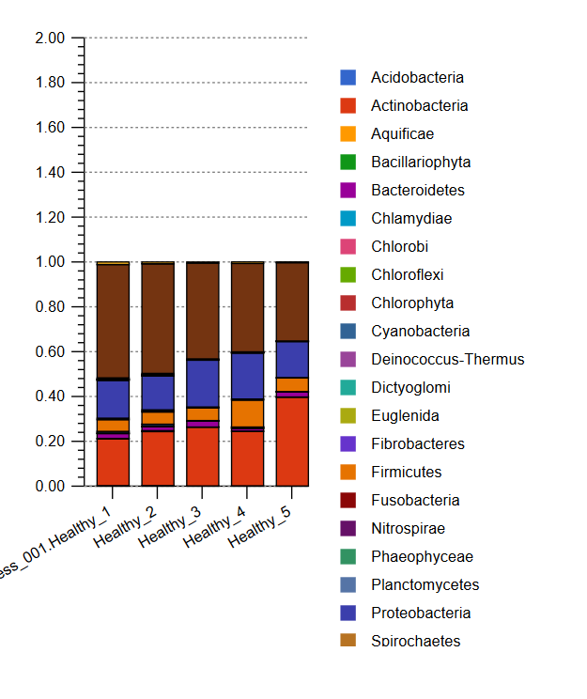

**Fig. 1: Bacterial communities found healthy in Groundnut variety GG-20 rhizosphere of five sampling sites The x-axis represents the different sampling locations, whereas the y-axis show the abundance counts of each of the different bacterial phyla**

The analysis of genera present in samples was carried out using the Genus OTU obtained from QIIME pipeline. Number of OTU was different from sample to samlple. Using the vein diagram (http://bioinformatics.psb.ugent.be/webtools/Venn) compare the Genus OTU each other samples. Figure 2. show the no. of genus OTU common and unique to each of five samples. It was founded that 136 genus of bacteria common to all 5 locations means all healthy samples.while H1, H2,H3, H4 and H5 having 17,6, 22, 17 and 23 genus were present unique to respective samples.

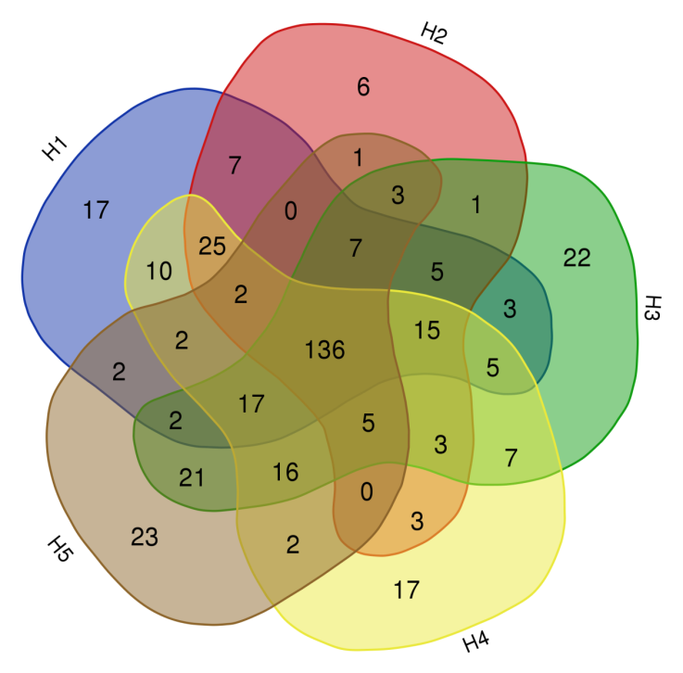

**Fig. 2:** **Bacterial communities represented by genus numbers found in healthy Groundnut variety GG-20 rhizosphere from different sampling locations. (H1, H2, H3, H4 and H5)**

**Community Composition comparision of infected plant soil.**

Prokaryotic communities in infected plant soil samples were analyzed based on relative sequence abundance, of which bacterial assemblages represented an average of 98.56 -99.27% of total sequences while Archaea made up 0.04-0.25%. Unclassified reads sequences occupied approximately 0.5-0.9% of the overall metagenome, while another 0.2-0.6% comprised of sequences belonging to Eukaryota.

Bacterial communities in all 5 metagenomes (I1, I2, I3, I4 and I5) were predominantly represented by 4 major Phylum comprising of Actinobacteria (20-32%), Proteobacteria (14-21%), Firmicutes (4-11%), Bacteroidetes(0.1-6%) and unclassified sequences derived from bacteria was 39-47%. (Fig. 3).

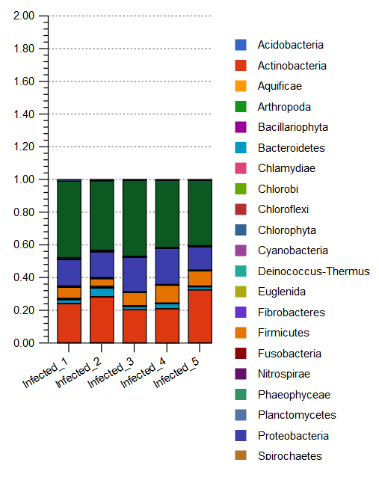

**Fig. 3:Bacterial communities found in infected with *Macrophomina phaseolina* Groundnut variety GG-20 rhizosphere of five sampling sites The x-axis represents the different sampling locations, whereas the y-axis show the abundance counts of each of the different bacterial phyla**

The analyses of Genus present in samples were carried out using the Genus OTU obtained from QIIME pipeline. Number of OTU was different from sample to samlple. using the vein diagram (http://bioinformatics.psb.ugent.be/webtools/Venn) compare the Genus OTU each other samples. Fig.4 represents the present OTU in common, common to each other and unique genus present in samples. Result founded that 168 genus of bacteria common to all 5 locations. I1, I2, I3, I4 and I5 having 38,7, 11, 15 and 16 genus were present unique to respective samples.

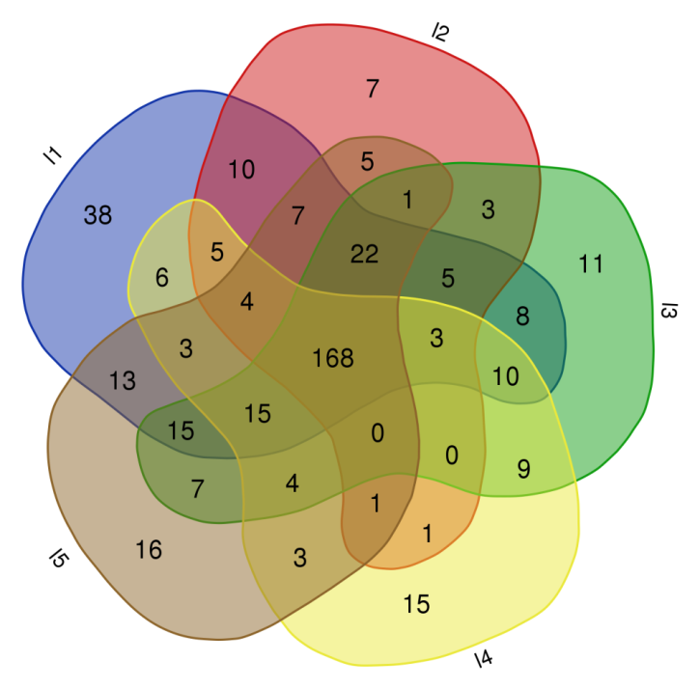

**Fig. 4:** **Bacterial communities represented by genus numbers found in healthy Groundnut variety GG-20 rhizosphere from different sampling locations. (I1, I2, I3, I4 and I5)**

**Community comparison of Healthy *Vs* Infected groundnut rhizosphere soil**

Bacterial communities in all 10 metagenomes were predominantly represented by 4 major Phylum comprising of Actinobacteria 20-40 and 20-32% , Proteobacteria 15-20% and 14-21%, Firmicutes 5-12% and 4-11%, Bacteroidetes 1-3% and 0.1-6% and unclassified sequences derived from bacteria was 34-51% and 39-47% founde in healthy and infected sample respectively.

Proteobacteria is a relatively abundant phylum that is commonly found in soil [30] and its relative abundance is much higher than those of other phyla in this study. Acidobacteria is a phylum that widely exists in the plant rhizosphere, can degrade polysaccharides, and may play an important role in carbon cycling [36]. Actinobacteria in rhizosphere is likely to be determined by several different selective factors that influence the growth and the size of different Actinobacterial structures [25]. Actinobacteria phylum was consistently associated with disease suppression, since they have higher abundances in many disease-suppressive soils than in disease-conducive soils [10, 15, 17]. so in our study show that the diversity of actinobacteria high in helathy sample compare to infected sample. Proteobacteria near about sme to both of the samples while Bacteroidetes composition high in infected sample compare to healthy samples.

Comparison at genus level by GenusOTU sort out and compare the all genus OTU present in healthy plant soil with the OTU present the infected plant soil. The no. of genus OTU present in the healthy soil sample was 385 while 415 OTU found in infected soil sample. Using venn diagrams (http://bioinformatics.psb.ugent.be/ webtools/Venn) compare the genus OTU. It was found that the 342 OTU common means present in both samples, while the 43 OTU present in only healthy plant soil and 73 OTU present in only infected plant soil. Following Venn diagram Figure 5, show the OTU comparison. Unique Genus found more in infected sample than the healthy sample this is due to the more genus recruted the pathogen during the infection. Total 43 unique genus found in healthy sample. It may be participated in the protection against infection of root rot in groundnut.

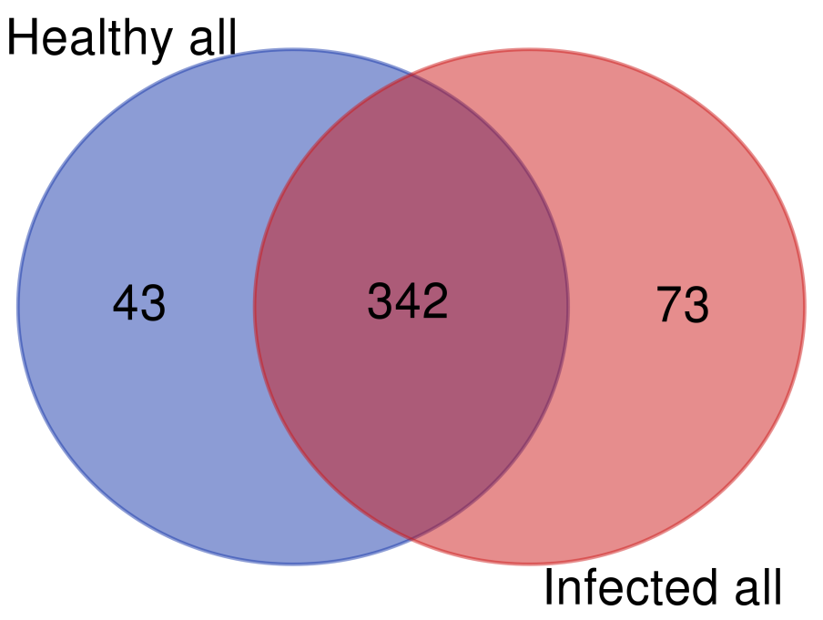

**Fig. 5: Venn diagram show bacterial communities represented by OTU numbers found in healthy and infected Groundnut variety GG-20 rhizosphere from different sampling locations.**

Genus comparison result founded that *Bacillus, Sphingomonas, Geodermatophilus, Azohydromonas, Arthrobacter, Chitinophaga, Pseudonocardia, Ramlibacter, Cystobacter* genera present more number in healthy sample compare to infected sample. while *Nocardioides, Agromyces, Streptomyces, Microbacterium, Chryseobacterium, Variovorax, Novosphingobium and Sphingobacterium* genera more number in infected sample compare to healthy samples. Previous studies have shown that *Sphingomonas* has a strong ability to degrade environmental pollutants and can promote the absorption and growth of plants. It has also been shown that *Sphingomonas* is the primary antimicrobial agent in soil communities and that this group has an inhibitory effect on plant pathogenic fungi. *Bradyrhizobium* is a common soil microorganism that can establish mutually beneficial symbiotic relationships with plant roots and fix nitrogen.

The genus *Arthrobacter* represents one of the most divergent heterotrophic bacterial groups of actinobacteria, because of their metabolic versatility they are reported to exist in a diverse range of environments like soils, plants, freshwater, clinical specimens and marine habitats [5, 16]. Numerous studies have revealed the association of diverse strains of *Arthrobacter* with different plants by both culture-dependent and -independent methods [35].

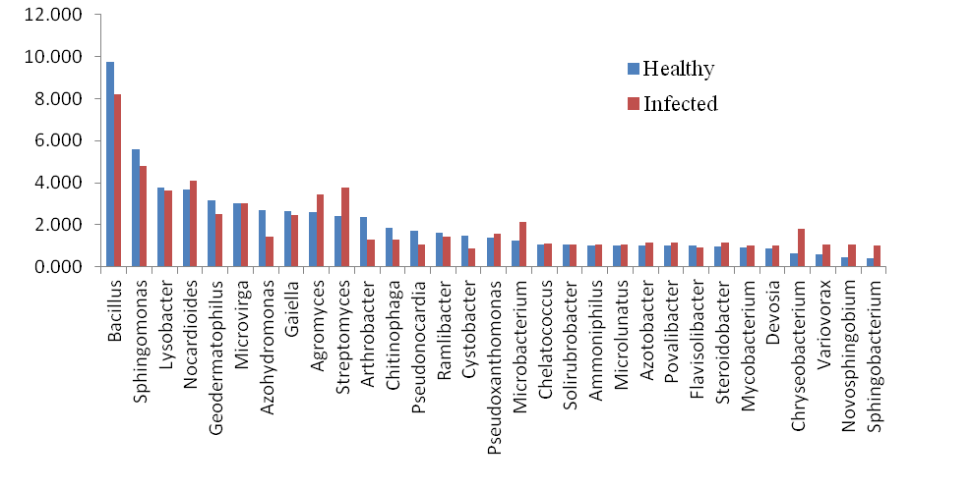

**Figure 6 Comparative of species diversity in Healthy *Vs* Infected samples.**

Combine all healthy sample spp. OTU and removed the duplicate spp., The total no. of species in healthy sample were 476 and in infected sample 533. Comparision of speceies using the ven diagram Figure 7 and it was founded that 386 spp. present common to both healthy and infected sample while 90 spp. unique in healthy sample and 147 spp. unique in infected samples.

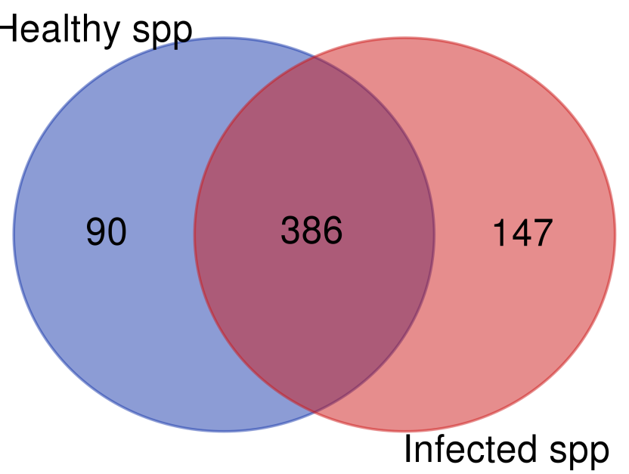

**Fig. 7:** **Venn diagram show bacterial communities represented by total OTU numbers found in healthy and infected Groundnut variety GG-20 rhizosphere representing common and unique species.**

Total 35 Spp. selected based on the persentage perent in the database it was obsereved that *Sphingomonas* sp. high in both the sample but more in healthy sample compare to infected sample. The species *Arthrobacter crystallopoietes, Arthrobacter sp. Azohydromonas australica, Bacillus badius,Bacillus funiculus, Chitinophaga filiformis, Geodermatophilus obscurus, Lysobacter sp.,Methylibium petroleiphilum, Methylotenera mobilis, Pseudonocardia sp.* and *Ramlibacter sp.* Founded high number of OTU in healthy sample compare to infected sample. while *Agromyces subbeticus, Ammoniphilus oxalaticus, Enhydrobacter aerosaccus, Microbacterium arthrosphaerae,Microvirga sp. Povalibacter uvarum, Steroidobacter agariperforans Streptomyces sp., Virgisporangium ochraceum, Nocardioides aestuarii, Novosphingobium sp.* and  *Pseudorhodoferax aquiterrae* founded high number OTU in infected sample compare to healthy sample. The remaining speceies *Blastococcus saxobsidens, Chelatococcus sp., Chitinophaga sp. Lysobacter bugurensis, Lysobacter dokdonensis, Nocardioides sp. Phenylobacterium sp., Pseudonocardia alaniniphila, Rubellimicrobium aerolatum* and *Rubrivivax gelatinosus* founded no more difference between the healthy and infected samples.

*Bacillus subtilis* and *Bacillus amyloliquefaciens* has been described as potential biocontrol agents against *Aspergillus parasiticus* and stem rot disease [19, 32].

No. of OTU of *Arthrobacter sp, Bacillus badius, Bacillus funiculus, Geodermatophilus obscurus, Lysobacter sp.,, Pseudonocardia sp.* and *Ramlibacter* high in healthy sample compare to infected sample. These species have characteristics to PGP activities and control the plant pathogens.

**Conclusion**

The microbial population was divers from location to location and the status of plant health. The antagonistic microorganisms such as bacteria and fungi are an alternative source for controlling the plant pathogens. Some bacterial species form healthy samples have plant growth promoting activities. While some bacterial species have characteristics to suppress the growth of plant pathogen or to protect the plant from the pathogen. Microbiome of rhizosphere manipulation will be useful to control the plant disease. microbiome manipulated by adding of the some beneficial microbes into the rhizosphere.

**References**

1. Anderson, I., Sorokin, A., Kapatral, V., Reznik, G., Bhattacharya, A., Mikhailova, N., Burd, H., Joukov, V., Kaznadzey, D., Walunas, T., Markd’Souza, Larsen, N., Pusch, G., Liolios, K., Grechkin, Y., Lapidus, A., Goltsman, E., Chu, L., Fonstein, M. and Ivanova, N. (2005). Comparative genome analysis of *Bacillus cereus* group genomes with *Bacillus subtilis*. *FEMSMicrobiology* Letter*.* 250: 175–184.
2. Anonymous. (2015). Status paper on oil seeds. Department of Agriculture and Cooperation, Ministry of Agriculture, Govt. of India.
3. Berg, G. and Smalla, K. (2009). Plant species and soil type cooperatively shape the structure and function of microbial communities in the rhizosphere. *FEMSMicrobiology Ecology.* 68(1):1-13.
4. Brussaard, L., de Ruiter, P.C. and Brown, G.G. (2007). Soil biodiversity for agricultural sustainability. *Agriculture*, *Ecosystems* *and* *Environment.* 121:233–244.
5. Buée, M., De Boer, W., Martin, F., van Overbeek, L. and Jurkevitch, E. (2009). The rhizosphere zoo: An overview of plant-associated communities of microorganisms, including phages, bacteria, archaea, and fungi, and of some of their structuring factors. *Plant soil.* 321:198-212
6. Busse, H. J., Wieser, M. and Buczolits, S. (2012). Genus III. Arthrobacter In. Whitman WB, Parte A, Goodfellow M, Kampfer P, Busse HJ, *et al.* editors. *Bergey's Manual of Systematic Bacteriology*. 5: 578–625.
7. Caporaso, J. G., Kuczynski, J., Stombaugh, J., Bittinger, K., Bushman, F.D., Costello, E.K., Fierer, N., Peña, A. G, Goodrich, J. K., Gordon, J. I., Huttley, G.A., Kelley,S. T., Knights, D., Koenig, J. E., Ley, R. E., Lozupone, C. A., McDonald, D., Muegge, B. D., Pirrung, M., Reeder, J., Sevinsky, J. R., Turnbaugh, P. T., Walters, W. A., Widmann, J., Yatsunenko,T., Zaneveld, J. and Knight, R. (2010). QIIME allows analysis of high-throughput community sequencing data*. Nature Methods.* 7 (5):335-336.
8. Curtis, T. P., Sloan, W. T. and Scannell, J. W. (2002). Estimating prokaryotic diversity and its limits. *Proceedings of the National Academy of Sciences of the United States of America*. 99(16): 10494–10499.
9. Egamberdieva, D., Kamilova, F., Validov, S., Gafurova, L., Kucharova, Z. and Lugtenberg, B. (2008). High incidence of plant growth stimulating bacteria associated with the rhizosphere of wheat grown on salinated soil in Uzbekistan. *Environment Microbiology*. 10(1): 1–9.
10. Fu, L., Ruan, Y. Z., Tao, C. R., Li, R. and Shen, Q. (2016). Continuous application of bioorganic fertilizer induced resilient culturable bacteria community associated with banana *Fusarium* wilt suppression, *Scientific Reports*. 6:27731.
11. Gams, W. (2007). Biodiversity of soil-inhabiting fungi. *Biodivers. Conserv*. 6:69–72.
12. Garbeva, P., van Veen, J.A. and van Elsas, J.D. (2004). Microbial diversity in soil: selection microbial populations by plant and soil type and implications for disease suppressiveness. *Annual Review of Phytopathology*. 42:243-70.
13. Gopalakrishnan, S., Humayun, P., Kiran, B. K., Kannan, I. G. K., Vidya, M. S., Deepthi, K. and Rupela, O. (2011). Evaluation of bacteria isolated from rice rhizosphere for biological control of charcoal rot of sorghum caused by *Macrophomina phaseolina* (Tassi) Goid*. World Journal of Microbiology and Biotechnology*. 27(6): 1313– 1321
14. Gupta, S. C. and Kolte, S. J. (1981). Cultural characteristics of leaf and root isolates of *M. phaseolina* (Tassi) Goid from groundnut. *Indian Journal of Medical Microbiology.* 21(4) : 345-346.
15. Han, Z. L., Li, W.N., Wang, Y., Feng, J. and Zhang, X. (2019). *Bacillus amyloliquefaciens* B1408 suppresses *Fusarium* wilt in cucumber by regulating the rhizosphere microbial community, *Applied Soil Ecology*.136: 55–66.
16. Huang, Z., Bao, Y. Y., Yuan, T.T., Wang, G.X., He, L.Y. and Sheng, X.F. (2015). *Arthrobacter nanjingensis* sp. nov., a mineral weathering bacterium isolated from forest soil. *International Journal of Systematic and Evolutionary Microbiology.* 65(Pt 2):365–369.
17. Hunter, P. J., Petch, G. M., Calvo-Bado L. A., Pettitt, T. R., Parsons, N. R., Alun, J.,Morgan, W. and Whipps, J. M. (2006). Differences in microbial activity and microbial populations of peat associated with suppression of damping-off disease caused by *Pythium sylvaticum*. *Applied and Environmental Microbiology*. 72(10): 6452–6460.
18. Janvier, C., Villeneuve, F., Alabouvette, C., Edel-Hermann, V., Mateille, T. and Steinberg,C. (2007). Soil health through soil disease suppression: which strategy from descriptors to indicators?, *Soil Biology and Biochemistry*. 39:1–23.
19. Le C. N., Hoang T. K., Thai T. H., Tran T. L., Phan T. P. N. and Raaijmakers, J. M. (2018). Isolation, characterization and comparative analysis of plant-associated bacteria for suppression of soil-borne diseases of field-grown groundnut in Vietnam. *Biological Control.*121: 256–262.
20. McPherson, M. R., Wang, P., Marsh, E. L., Mitchell, R. B. and Schachtman, D. P. (2018). Isolation and analysis of microbial communities in soil, rhizosphere, and roots in perennial grass experiments. *Journal of Visualized Experiments.* 24(137): 1–11.
21. Mendes, R.,  Kruijt, M., de Bruijn, I., Dekkers, E., van der Voort, M., Schneider, J. H., Piceno, Y. M., De Santis, T. Z., Andersen, G. L., Bakker, P.A. and Raaijmakers, J. M. (2011). Deciphering the rhizosphere microbiome for disease-suppressive bacteria. *Science*. 332 (6033): 1097–1100.
22. Mihail, J. D. (1992). *Macrophomina*.Pp. 134-136. In: L.L.Singleton, J.D. and C.M Rush (Eds.) Methods for Research on soil borne phytopathogenic fungi. APS press, USA.
23. Nannipieri, P., Ascher, J., Ceccherini, M.T., Landi, L., Pietramellara, G. and Renella, G. (2003). Microbial diversity and soil functions. *European Journal of Soil Science.* 54:655–670.
24. Nihorimbere V., Ongena, M., Smargiassi, M. and Thonart, P. (2011). Beneficial effect of the rhizosphere microbial community for plant growth and health. *Biotechnology, Agronomy, Society and Environment.*15(2):327–337.
25. Nimnoi, P., Pongsilp, N. and Lumyong, S. (2011). Actinobacterial community and diversity in rhizosphere soils of *Aquilaria crassna* Pierre ex Lec assessed by RT-PCR and PCR-DGGE, *Biochemical Systematics and Ecology*. 39(4-6):509–519.
26. Ntare, B. R., Diallo, A. T., Ndjeunga, A. T. and Waliyar, F. (2008). Groundnut Seed Production Manual. Patancheru 502324, Andhra Pradesh, India. *International Crops Research institute for the Semi-Arid Tropics (ICRISAT).*:20.
27. Parakhia, M. V. and Golakia, B. A. (2021). Microbiome of Groundnut (*Arachis hypogae*a L.) Rhizosphere Infected with *Macrophomina pheseolina* Root Rot. *Int.J.Curr.Microbiol.App.Sci*. 10(2): 141-149.
28. Parakhia, M. V., and Golakiya, B. A. (2018). Manipulation of phytobiome: a new concept to control the plant disease and improve the productivity. *J Bacteriol Mycol Open Access.* 6:322–324
29. Price, M.N., Dehal, P.S. and Arkin, A.P. 2010. Fasttree 2–approximately maximum-likelihood trees for large alignments. *PLoS One*. 5(3):e9490.
30. Quoreshi, A. M., Suleiman, M. K., Kumar, V., manuval A. J, Shivdasan, M. T., Islam, M. A. and Khasa, D. P. (2019). Untangling the bacterial community composition and structure in selected Kuwait desert soils. *Applied Soil Ecology*. 138: 1–9.
31. Sanguin, H., Remenant, B., Dechesne, A., Thioulouse, J., Vogel, T.M., Nesme, X., Moenne-Loccoz, Y. and Grundman, G.L. (2006). Potential of a 16S rRNA based taxonomic microarray for analyzing the rhizosphere affect of maize on *Agrobacterium* spp. and bacterial community. *Applied and Environmental Microbiology*. 72: 4302-4312.
32. Siahmoshteh, F., Hamidi-Esfahani, Z., Spadaro, D., Shams-Ghahfarokhi, M. and Razzaghi-Abyaneh, M. (2018). Unraveling the mode of antifungal action of *Bacillus subtilis* and *Bacillus amyloliquefaciens* as potential biocontrol agents against aflatoxigenic *Aspergillus parasiticus*. *Food Control.* 89: 300–307.
33. Status Paper on Oil Seeds. Department of Agriculture and Cooperation, Ministry of Agriculture, Govt., 2015.
34. Torsvik, V., Ovreas, L. and Thingstad, T. F. (2002). Prokaryotic diversity – magnitude, dynamics, and controlling factors. *Science.* 296 (5570): 1064–1066.
35. Van Overbeek, L. and van Elsas, J. D. (2008). Effects of plant genotype and growth stage on the structure of bacterial communities associated with potato (*Solanum tuberosum* L.). *FEMS Microbiology Ecology.*64(2): 283–296.
36. Ward, N. L., Challacombe, J. F. and Janssen, P. H., (2009). Three genomes from the phylum *Acidobacteria* provide insight into the lifestyles of these microorganisms in soils, *Applied and Environmental Microbiology*,.75(7): 2046–2056.
37. Weller, D.M., Raaijmakers, J.M., Gardener, B.B. and Thomashow, L.S. (2002). Microbial populations responsible for specific soil suppressiveness to plant pathogens. *Annuals Reviews of Phytopathology*. 40: 309-48.
38. Wyllie, T. D. (1988). Charcoal rot of soyabean-current status. *In*: I. D. wyllie and K. H Scott, (Eds.). Soyabean Diseases of the North Central Region. *The American Phytopathology Society, St. Paul . MN.* pp. 106-113.
39. Yin, B., Crowley, D., Sparovek, G., De Melo, W.J. and Borneman, J. (2000). Bacterial functional redundancy along a soil reclamation gradient. *Applied and Environmental Microbiology*. 66:4361–4365.