*Original Research Article*

Establishment and characterization of primary culture of mammary epithelial cells of Bakarwali sheep

.

ABSTRACT

|  |
| --- |
| **Aims: T**he present study was aimed to establish primary culture of mammary epithelial cell of Bakarwali sheep of Jammu was done.  **Place and Duration of Study:** All experimental procedures of this study were performed at Cell culture lab, Division of LPM, F.V.SC&A.H, SKUAST-Jammu, India.  **Methodology:** Mammary gland tissue obtained from slaughter house was cleaned and transported to laboratory. Whole mammary gland was rinsed with Phosphate buffer saline (PBS) containing antibiotics and then small tissue was taken for mincing. Minced tissue was treated with enzymes. The minced tissues were further dissociated with trypsin- EDTA for 30 minutes at 37˚C and then filtered through a cell strainer. The ovine mammary epithelial cell preparation was suspended in growth medium and antibiotics. The mixed population of cells were subjected to selective trypsinization to remove the fibroblast cells from the primary culture of mammary epithelial cells. After establishment of cell culture, cells were characterized by partial amplification of Keratin 18 (Krt18), β-casein (Csn2), and Vimentin (Vim).  **Results:** The heterogeneous population of cells was obtained at day 6 which consists of epithelial and mesenchymal cells (fibroblast- like) by enzymatic digestion method. Further passaging and selective trypsiniszation of cells resulted in removal of fibroblast like cells and formed a homogenous layer of epithelial cells. To differentiate epithelial cells from other cells in the heterogenous population partial amplification of Keratin 18 (Krt18), β-casein (Csn2), and Vimentin (Vim) were done. The amplification products yielded 196 bp, 177 bp and 151 bp product size respectively for Vim, Krt18 and Csn2 genes  **Conclusion:** In the present study we demonstrated primary culture of mammary epithelial cells of Bakarwali sheep of Jammu region. The primary cell culture can be used for transfection and expression studies, as mastitis model, immune response study involving infection and host response replacing experiments. |

*Keywords: Cell culture, Sheep, Mammary epithelial cell, Selective Trypsinization*

1. INTRODUCTION

Cell culture has been evolved as an important in vitro technology for biological branches of science. The application of cell culture includes production of biologicals viz vaccines, monoclonal antibodies, biopesticide, growth factors; gene therapy, recombinant DNA technology and tissue engineering (Chandra et al. 2022). Animal cell culture includes series of process starting from collection of tissue from animal and growing in artificially controlled environment with suitable media and growth factors (Jedrzejczak-Silicka, 2017).

The mammary gland is characteristic of all mammals. It is a compound, branched, tubo-alveolar structure which supports post-natal survival of offspring. Mammary tissue cells are extensively used as model to understand physiological function of mammary gland (Hu et al. 2009). Furthermore, mammary epithelial cells are also used as a model for in-vitro studies on mastitis, transfection and expression studies and immune response (Sharma et al. 2022). The Mammary epithelial cells (MEC’s) used in in-vitro studies are broadly of two types, primary cells and cell lines. The primary MEC`s are isolated from mammary gland of mammals by enzymatic treatment mainly by collagenase. Primary MEC`s are transformed to establish cell lines which have uniform characteristics and unrestricted proliferation potential (Kobayashi, 2023).

The establishment of mammary epithelial cell line, primary and organ culture is useful for understanding the complexity of mammary gland. (Bissel et al. 1987 and Ip et al. 1996). The mammary gland is made up of two main important parts the first one is parenchyma which consists of epithelial and myoepithelial cells. The second part stroma consists of duct system, collagen and elastin as cellular components (Nickel et al. 1981). The mammary epithelial cells (MECs) are the important key milk producing cells in the udder. They are located in the acini of lobules and plays an important role in lactation (Brisken et al. 2006). Establishment of mammary epithelial cell line in small ruminants like sheep could help in studying the physiology and development of udder (Akers et al. 1990). So, in the present study establishment of primary culture of mammary epithelial cell in sheep of Jammu was done.

2. material and methods

**2.1 Sheep Mammary Epithelial Cells Isolation and Culture**

All experimental procedures of this study were performed at Cell culture lab, Division of LPM, F.V.SC&A.H, SKUAST-Jammu, India. The sheep mammary epithelial cells were isolated and cultured by the method of Ahn et al., 1995 with slight modifications. Mammary gland of sheep was obtained from local slaughter house of Jammu municipality. After washing with water the mammary gland, was transported to laboratory under sterile conditions in Hank’s Balanced Salt Solution (HBSS) having antibiotics (penicillin and streptomycin). Whole mammary gland was rinsed with Phosphate buffer saline (PBS) containing penicillin and streptomycin and then small tissue pieces were taken for mincing. Minced tissue with sterile surgical blade were then subjected to dissociation with 0.05% collagenase (Sigma, USA) and hyaluronidase (Sigma, USA) for 2 hours at 37˚C. The minced tissues were further dissociated with trypsin- EDTA (0.25%) for 30 minutes at 37˚C and then filtered through a cell strainer (40µ). The cells were collected by centrifugation at 1200 rpm for 5 minutes.

To establish primary culture of mammary epithelial cell by explant method the procedure described by Jernej et al (2018) was followed. The fine mechanical minced tissues were cut into small pieces and fixed in 12 well culture plates. Growth medium containing (DMEM with 10% FBS) was added in the plate and plates were incubated for seven days at 37°C and 5% CO₂. Fresh medium was added after two days discarding the old one.

The ovine mammary epithelial cell preparation was suspended in growth medium containing Dulbecco’s Modified Eagle Medium (DMEM F-12) with foetal bovine serum (FBS; 10%), ITS liquid media supplement (10µg/ml) (containing 1mg/ ml insulin, 0.55mg/ ml transferrin and 0.5 µg/ ml sodium selenite) pencillin (100 U/ml), streptomycin (5µg/ml) and amphotericin (50 ng/ml). The cells were seeded and cultured in T-25 (Nunc) culture dishes and for explant method 12 well culture plate used, then incubated at 37˚C under 5% CO₂. The mixed population of cells were subjected to selective trypsinization to remove the fibroblast cells from the primary culture of mammary epithelial cells. Trypsin–EDTA (0.25%; Sigma, USA) for three minutes at 37˚C was used for heterogeneous population of cells. The trypsinization process was stopped by adding fresh media to remove fibroblast cells. Mammary epithelial cells were subjected to five continuous passages for obtaining homogenous layer of cells. For cryopreservation of cells (106 cells/ml) DMEM F-12 (70%), FBS (20%) and DMSO (1%) freezing medium used.

**2.2 Characterization of Sheep Mammary epithelial cells**

mRNA Expression and cDNA Synthesis

The following primers (Table 1) were used for partial amplification of β-casein (Csn2), Keratin 18 (Krt18) and Vimentin (Vim) genes.

Table 1: Partial amplification of β-casein (Csn2), Keratin 18 (Krt18) and Vimentin (Vim) genes

|  |  |  |  |
| --- | --- | --- | --- |
| Gene | Primer Sequence (5′-3′) |  | Product Size |
| β-casein (Csn2) | Forward | GAAAGCCTTTCAAGCAGTGAGGAATCTATTAC | 151bp |
| Reverse | GAGTAAGAGGCAGGATGTTTTGTGGGAGG |  |
| Keratin 18 (Krt18) | Forward | GTACTGGTCCCAGCAGATTGAGGAGAG | 177bp |
| Reverse | TCCACTTCCCTCAGGCTGTTCTCCAAG |  |
| Vimentin (Vim) | Forward | TACGAGGAGGAGATGCGAGAGCTGC | 196bp |
| Reverse | CCAAAGAGGCATTGTCAACATCCTGTCTG |  |

These primers designed by EST sequences at NCBI database and used in previous studies by Sharma et al. (2022). TRIzol method (Invitrogen, USA) was used to isolate mRNA from primary cells, for the cDNA synthesis total RNA from the primary mammary epithelial cell culture was used. The isolated RNA was checked by agarose gel (1.5%) electrophoresis. Commercially available kit (Maxima H Minus Double Stranded cDNA synthesis kit; Thermo Fisher Scientific Inc., USA) was used to convert RNA to cDNA. The PCR reaction consists of 2.5 μl 10× buffer, 200 μM of dNTPs, 0.5 μl of each primer (10 pM/μl), 0.5 U of Taq DNA polymerase, about 100 ng of template cDNA and nuclease free water to bring the total volume to 25 μl. The time-temperature followed for PCR reaction: 95˚C for 3 min, 95˚C for 30 secs, 55˚C for 30 secs (CSN2)/58˚C for 30 secs (KRT18) /58˚C for 30 secs (VIM)/ 58˚C for 30 secs), 72˚C for 1 min for 35 cycles and 72˚C for 10 min was done in thermocycler (Bio-Rad, USA) PCR machine.

3. results and discussion

**3.1 Ovine Mammary Epithelial cells characteristics**

The heterogeneous population of cells was obtained at day 6 which consists of epithelial and mesenchymal cells (fibroblast- like) (Figure 1a) by enzymatic digestion method. Further passaging and selective trypsinization (Figure 1b) of cells resulted in removal of fibroblast like cells and formed a homogenous layer of epithelial cells. The ovine mammary epithelial cells formed island (figure 1e). The epithelial cells formed aggregation of cells with characteristics cobblestone morphology (Figure 1c). Continuous passaging of cells resulted in much faster growth of cells compared to initial week. Net- like structures were formed (Figure 1d).

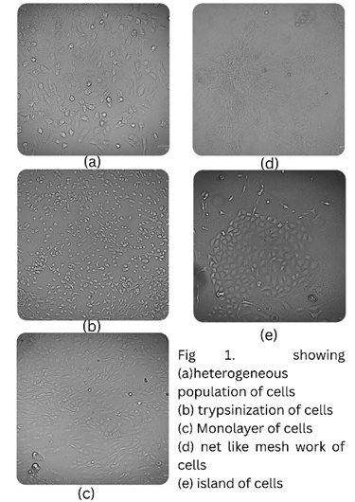

Figure 1: Growth of the cells. (a) Heterogenous population of cells (Day 6). (b) Trypsinization of cells. (c) Monolayer of cells. (d) Net like meshwork of cells. (e) Island of cells.

Explant tissue was cultured in 12 well plate. At day 5 few cells appeared from the explant there after their number start increasing at day 7 (Figure 2). Initially mixed population of cells were seen that formed a monolayer in the plate. Spindle like fibroblasts cells appeared surrounding the cobble stone morphology epithelial cells. Cells were subjected to passaging and selective trypsinization results in homogenous layer of epithelial cells. In the present study we have passaged upto five passages that resulted in round cobble stone like epithelial cells.

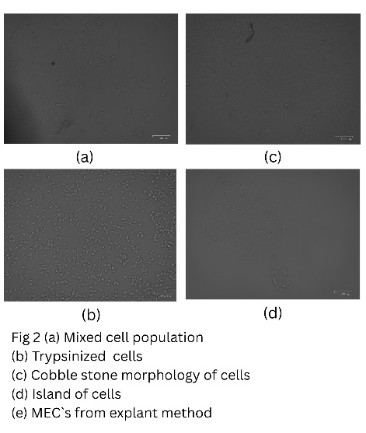

Figure 2: (a) Mixed population of cells (b) Trypsinized cells (c) Cobble stone morphology (d) island of cell by explant method

**3.2 Expression of markers Keratin 18, β casein and Vimentin**

Cells express specific genes that are important for characterization for different markers. So as to differentiate epithelial cells from other cells in the heterogenous population. For this partial amplification of Keratin 18 (Krt18), β-casein (Csn2), and Vimentin (Vim) were done by the above described primers. For the expression of genes, we used cells from the fifth passage. The amplification products yielded 196 bp, 177 bp and 151 bp product size respectively for Vim, Krt18 and Csn2 genes (Figure 3).

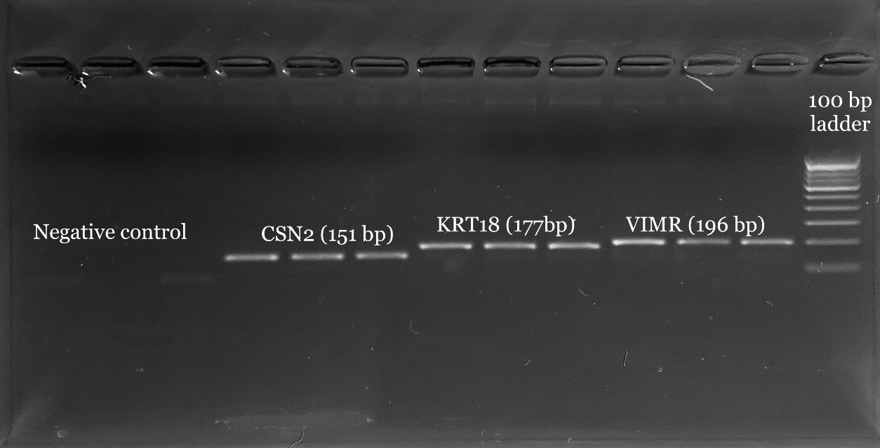

Figure 3: Partial amplification of β casein, Keratin 18 and Vimentin.

The objective of the present study was to establish the primary culture of ovine mammary epithelial cells. Mammary epithelial cell culture has advantageous in studying the mammary gland function (Rose and McConochie, 2006). For the better understanding of the mammary gland structure and biology several mammary epithelial cells cell cultures have been developed in different species ovine (Ilan et al., 1998), bovine (Rose et al 2002), buffalo (Anand et al. 2012), rodents Karantza- Wadsworth and White 2008), porcine (Sun et al. 2006), human (Stampfer et al. 2002) and yak (Fu et al. 2014). The morphological characteristics of ovine mammary epithelial cells shared similarity with bovine by Ahn et al, (1995), buffalo by Anand et al, (2012) and caprine (Pantschenko et al. 2000). Zheng et al (2005), reported growth of mammary epithelial cell from the explant required collagen coated. Wicha et al, (1979) reported use of collagen for growth and attachement of mammary epithelial cells to the surface of culture flask. However, in the present study we have not used collagen coated plates for the growth of ovine mammary epithelial cells. Zheng et al, (2005) observed extravasation of cells at day 5, in the present study also extravasation of cells observed at day 5 in explant method. Ouyang and Qian, 1999 also observed extravasation of larger number epithelial cells from explant at day 5.

Basal media and supplements are required for the growth reported from the previous studies. Sun et al, (2005) used basal media consists of DMEM/F12 containing 10% fetal calf serum, insulin (10 mg/ml), hydrocortisone (1 mg/ml) and antibiotics for the growth of epithelial cells in porcine MEC. Duo et al, (2006) uses hydrocortisone, insulin and prolactin in the basal media of bovine MEC. German and Barash, (2002); Hu et al, (2009) used Epidermal growth factor or transferrin in basal media of bovine MEC. Mammary epithelial cell established in lactating dairy goat by Tong et al, (2012), using EGF, insulin and ITS in the growth medium. EGF promotes proliferation of epithelial cells and ITS helps in slowing down the aging of cells (Tong et al, 2012). For the establishment of primary culture of ovine mammary epithelial cells we have used growth media with DMEM F-12, FBS 10%, 10µg/ ml ITS liquid media, 1 µg/ ml hydrocortisone and 10ng/ ml EGF similarly Colmb et al, (1991) used EGF in the growth medium for the in vitro culture of human breast cells.

The sub culturing of cells was performed up to sixth passage in our study. For the partial amplification we used markers VIM, KRT18 and CSN2 with the similarity with Jernej et al (2018), they used cytokeratins (KRT) 14 and 18 and vimentin (VIM) as markers for goat primary mammary cell cultures characterization. The passaged cells (sixth) showed normal expression of the above markers.

4. Conclusion

Present study reports establishment and characterization of primary MEC`s of Bakarwali sheep. These MEC’s can be used as model to understand physiological functions of mammary gland, pathology caused by micro-organism and immune response of animal.

References

Ahn J. Y., Aoki, N., Adachi, T., Mizuno, Y., Nakamura, R., and Matsuda, T. (1995). Isolation and culture of bovine mammary epithelial cells and establishment of gene transfection conditions in the cell. Bioscience, Biotechnology and Biochemistry 59: 59-64.

Akers, R. M. (1990). Lactation physiology: a ruminant animal perspective. Protoplasma. 159:96-111.

Anand, V., Dogra, N., Singh, S., Kumar, S. N., Jena, M. K., Malakar, D., Dang, A. K., Mishra, B. P., Mukhopadhyay, T. K., Kaushik, J. K., and Mohanty, A. K. (2012). Establishment and characterization of a buffalo (Bubalus bubalis) mammary epithelial cell line. PLoS ONE 7: e40469

Bissell, M. J., and Hall, H. G. (1987). Form and function in the mammary gland: the role of extracellular matrix. In: Neville, M. C.; Daniel, C. W., ed. The mammary gland---development, regulation and function. New York: Plenum Press; 97-146.

Brisken, C., Rajaram, R. D. (2006). Alveolar and lactogenic differentiation. Journal of Mammary Gland Biology Neoplasia. 11 (3-4): 239-48.

Chandra, V., Tiwari, A., Pant, K. K., & Bhatt, R. (2022). Animal cell culture: basics and applications. In Industrial Microbiology and Biotechnology (pp. 691-719). Singapore: Springer Singapore.

Colomb, E., Berthon, P., Dussert, C., Calvo, F., and Martin, P. M. (1991). Estradiol and EGF requirements for cell-cycle progression of normal human mammary epithelial cells in culture. International Journal of Cancer 49: 932-937.

Duo, S., Wu, Y., Luo, F., Bou, S. (2006). Isolation, culture and biological characteristics of bovine mammary epithelial cells. Zoological Research 27(3):299–305.

Fu, M., Chen, Y., Xiong, X., Lan, D., and Li, J. (2014). Establishment of mammary gland model: culture in vitro and evaluation of a yak mammary epithelial cell line. PLoS ONE 9:e113669.

German, T and Barash, I. (2002) Characterization of an epithelial cell line from bovine mammary gland. In Vitro Cellular and Developmental Biology Animal 38: 282–92.

Hu, H., Wang, J., Bu, D., Wei, H., Zhou, L., Li, F., & Loor, J. J. (2009). In vitro culture and characterization of a mammary epithelial cell line from Chinese Holstein dairy cow. PloS one, 4(11), e7636.

Ilan, N., Barash, I., Gootwine, E., Shani, M. (1998). Establishment and initial characterization of the ovine mammary epithelial cell line NISH. In Vitro Cell. Dev. Biol. Anim. 34(4): 326–332.

Ip, M. M., Darcy, K. M. (1996). Three-dimensional mammary primary culture model systems. J. Mammary Gland Biol. Neopl. 1:91-110.

Jedrzejczak, M and Szatkowska, I. (2014). Bovine mammary epithelial cell cultures for the study of mammary gland functions. Cellular and Developmental Biology - In Vitro Animal 50:389-398.

Jedrzejczak-Silicka, M. (2017) Chapter 1: History of cell culture. In: Gowder SJ (ed) New insights into cell culture technology. IntechOpen, London. https://doi.org/10.5772/66905

Jernej, O., Zorc, M., and Dovc, P. (2018). Development of an in vitro goat mammary model: Establishment, Characterization and Applications of Primary Goat Mammary Cell Cultures. Intech Open, 69: 10-18.

Karantza-Wadsworth, V., White, E. (2008) A mouse mammary epithelial cell model to identify molecular mechanisms regulating breast cancer progression. Methods Enzymol. 2(446): 61–76.

Kobayashi, K. (2023). Culture models to investigate mechanisms of milk production and blood-milk barrier in mammary epithelial cells: a review and a protocol. Journal of Mammary Gland Biology and Neoplasia, 28(1), 8.

Nickel, R., Schummer, A., Schummer, A, E. (1981). Anatomy of the mammary gland in ruminants and non-ruminants. In: Anatomy of Domestic Animals. Verlag Paul Parey. p. 350-365.

Ouyang, W. Q., and Qian, J, F. (1999). Establishment of goat mammary epithelial cell line. Chinese Journal of Veterinary Medicine,19: 561-562.

Pantschenko, A. G., Woodcock-Mitchell, J., Bushmich, S. L., Yang, T. J. (2000). Establishment and characterization of a caprine mammary epithelial cell line (CMEC) In Vitro Cellular Developmental Biology Animal ;36(1):26–37

Rose, M. T., Aso, H., Yonekura, S., Komatsu, T., Hagino, A., Ozutsumi, K., Obara, Y. (2002) In vitro differentiation of a cloned bovine mammary epithelial cell. J Dairy Res 69(3): 345–55.

Rose M. T., McConochie H. (2006). The long road to a representative in vitro model of bovine lactation. *JIFS* 3(3): 67–72.

Sharma, V., Kour, G., Ahmed, J. A., Nashiruddullah, N., Khan, A., Konwar, D., & Brahma, B. (2022). Establishment of primary culture of mammary epithelial cell in Bakarwali goat of Jammu region. Ruminant Science. 11(2), 261-265

Stampfer, M. R., Yaswen, P., and Taylor-Papadimitriou, J. (2002). Culture of human mammary epithelial cells. In: R.I. Freshney and M.G. Freshney (Eds.), Culture of the Epithelial Cells, Wiley-Liss Inc, New York, pp 95-135.

Sun Y. L., Sun, C. S., Lin, and Y., C. Chou. (2005). Gene transfection and expression in a primary culture of mammary epithelial cells isolated from lactating sows. Cell Biology International 29: 576-582.

Sun, Y. L., Lin, S. C., Chou, Y, C. (2006). Establishment and characterization of a spontaneously immortalized porcine mammary epithelial cell line. Cell Biology International.;30(12):970–976.

Tong, H. L., Li, Q. Z., Gao, X. J., and Yin, D. Y. (2012). Establishment and characterization of a lactating dairy goat mammary gland epithelial cell line. Cellular In Vitro and Developmental Biology -Animal 48: 149-155.

Wicha, A. M., L, A. Liotta., S, Garbisa., and W, R. Kidwell. (1979). Basement membrane collagen requiremnets for attachement and growth of mammary epithelium. Experimental Cell Research., 124:181-190.

Zheng, Y.M., Z.X. An, X.R. Peng, Y.Q. Shi and Y. Zhang, 2005. Establishment of goat mammary epithelial cell line and expression of EGFP gene. J. Agric. Biotechnol., 13: 322-325.