*Original Research Article*

Effect of Dietary Consumption of *Garcinia kola* Seed and Honey Mixture on Liver Function Parameters of Wistar Rats

.

ABSTRACT

|  |
| --- |
| **Aim:** to assessthe effect of dietary consumption of *Garcinia kola* seed and honey mixture on liver function parameters of Wistar rats.  **Study design:** Experimental study  **Place and Duration of Study:** Department of Human Physiology, University Port Harcourt, June, 2015 to July 2015.  **Methodology:** This study comprised of 2 Wistar rats. In total, there are four (4) groups consisting each of five (5) Wistar rats were used for each group giving a total of twenty (20) Wistar rats, that is Fifteen (15) Wistar rats for the groups and five (5) Wistar rats for the control). *Garcinia kola* seed mixed with honey preparation was done by weighing 20g of powdered *Garcinia kola* seed and 80g of honey, this mixture was diluted with distilled water at a weight/volume ratio of 1:4. Different groups of the animals were fed *Garcinia kola* seed, Honey or a mixture of both (50mg/100g body weight) in solution of distilled water and normal saline only(control) was given for 14 days. Liver function test profile was assessed by the determination of plasma Total Bilirubin, Conjugated Bilirubin, Aspartate aminotransaminase (AST), Alanine aminotransaminase (ALT) and Gamma Glutamyl transferase (GGT). Histological studies on the Liver were done for one Wistar rat in each group using the Haematoxylin and Eosin stain (H & E stain) and the pictograph reported (×400 magnification). The results were analyzed using SPSS Version 18. Results were presented as Mean ± SEM. ANOVA and Post hoc test (Tukey, LSD, Sheffe and Duncan) were used for multiple comparisons and p value was set at P<0.05.  **Results:** The results obtained showed that *Garcinia kola* seed, Honey or a mixture of both exhibited a nutritious and highly beneficial role. They have a good effect on the Liver. From the result, there was a significant increase in the plasma levels of total bilirubin, conjugated bilirubin, AST and ALT for the groups fed *Garcinia kola* seed and Honey only, while the group fed a mixture of *Garcinia kola* seed and Honey, there was a significant rise of the Total bilirubin, AST, ALT and GGT at P<0.05. The histological findings for the groups fed *Garcinia kola* seed and honey only showed normal cellular architecture and matrix, while the Group fed a mixture of *Garcinia kola* seed and honey showed normal cellular architecture with the cellular content filled with debris. Although, there was cellular activity in the group fed with a mixture of GKS and Honey. Cellular activity is not significant. This is because the hepatocytes were clear.  **Conclusion:** Thus, the mixture GKS + Honey is rich supplement to the liver that can be taken singly or in combination. |

*Keywords: Garcinia kola Seed, Honey Mixture, Liver Function Parameters, Wistar Rats*

1. INTRODUCTION

Herbal Medicine, also called Botanical Medicines, Vegetable Medicine or phytomedicine, as defined by the World Health Organization (WHO) refers to herbs, herbal materials, herbal preparations and finished herbal products that contain whole plants, parts of plants or other plants materials, including leaves, bark, berries, flowers and roots and/or their extracts as active ingredients intended for human therapeutics use for other benefits in human and sometimes animals [1]. Taking herbal supplements is a common practice in many parts of the world. According Prete at. al. [2], herbal medicine is the practice of Medicine of the use of plant materials, fluids and supplements for the cure, protection and treatment of disease and illnesses.

*Garcinia kola* (Heckel), commonly called bitter kola is a highly valued ingredient in African ethnomedicine because of its varied and numerous uses which are social and medicinal; thus, making the plant an essential ingredient in folk Medicine. Medicinal plants such as *Garcinia kola* are believed to be an important source of new chemical substances with potential benefits [3]. The alkaloid and bioflavonoid extracts of *Garcinia kola* seed exhibited the following effects: dose-dependent spasmolytic effects on uterine and gastrointestinal smooth [4], deterioration of reproductive function [4] anti-inflammatory and antipyretic effects antihepatotoxic effect [4,5,6].

Honey is a sweet and viscous fluid produced by honeybees (and some other species) and derived from the nectar of flowers. Honey is a mixture of sugars and other compounds. With respect to carbohydrates, honey is mainly fructose (about 38.5%) and glucose (about 31.0%), making it like the synthetically produced inverted sugar syrup which is approximately 48% fructose, 47% glucose, and 5% sucrose. Honey’s remaining carbohydrates include maltose, sucrose and other complex carbohydrates [7]. Honey has played an important role in nutrition since man’s earliest days. The perceived potential health benefits of consumption have been exploited in many cultures for almost as long, but it is not until recently that scientists have sought to understand if there is evidence to support this. Therefore, the aim of this study was to assessthe effect of dietary consumption of *Garcinia kola* seed and honey mixture on liver function parameters of Wistar rats.

2. materialS and methods

**2.1 Experimental Animals**

A total of 20 albino rats were purchased and included for this study. The rats comprised of a mixture of males and females at discrete combination. The rats were of weight 120- 180g and were obtained and kept in the animal house of the Department of Human Physiology, University Port Harcourt. They were kept in a spacious and well-ventilated cage at room temperature; under 12 hours light and dark cycle and acclimatize for 21days. The cages were specially designed laboratory cages, and they were fed with a commercial rat diet (Top feed limited, Sapele, Nigeria) and clean drinking water *ad libitum*.

All the animals received humane care according to the criteria outlined in the Guide for the Care and the Use of Laboratory Animals prepared by the National Academy of Science published by the National Institute of Health. The ethical regulations in accordance with National and Institutional guidelines for the protection of animals’ welfare were strictly adhered to during the experiment [8]. All animals were conducted in accordance with NIH guidelines for Care and Use of Laboratory Animals (Pub No 85-23, Revised 1985).

**2.2 Honey**

The honey used was a pure commercial honey (Havillah Natural Forest honey, NAFDAC Number 007654) bought from a local trader (Mr Gabriel) in Choba, Port Harcourt, Nigeria. It was diluted before use with distilled water on a weight/volume ratio of 1:4, that is 25g honey: 100ml of distilled water. The Honey was correctly identified and authenticated by a worker in the Department of Human Physiology, University of Port Harcourt, Rivers State, Nigeria.

**2.3 Plant Material**

Seeds of *Garcinia kola* seed were purchased from a local market at Choba, Port Harcourt, Nigeria. It was purchased from Malam Musa, a local trader. It was correctly identified and authenticated in the Herbarium Unit of the Department of Plant Science and Technology, University of Port Harcourt by a worker. After removing the brown testa, the seeds were cut into small pieces, air- dried and then ground into fine powder using an electric blender with mill (Qasa SD 230 series). Twenty-five grammes (25g) of the pulverized seeds were mixed with 100ml of distilled water at a weight/ volume ratio of 1:4.

For the preparation of Honey and *Garcinia kola* seed mixture, 20g of the powdered seed was added to 80g of Honey. The mixture was diluted with distilled water at a weight/volume ratio of 1:4.

**2.4 Chemicals**

Cadmium acetate was used to induce toxicity in the rats. The cadmium acetate was obtained from the postgraduate research Laboratory, Dept. of Biochemistry, University of Port Harcourt. All other chemicals used were of analytical grade.

**2.5 Experimental Design**

Rats were kept in a wooden cage barriered by a barbed wire during the experimental period. Three (3) weeks acclimatization period was allowed before initiation of the experiment. On the start of the 3rd week, rats were divided into eight (8) equal groups of five (5) rats each.

**2.5.1 Control Group**

Rats in this received orally 0.5ml/100g body weight of Normal Saline once a day.

**2.5.2 Group I**

Rats were fed with *Garcinia kola* Seed orally 50mg/ 100 g body weight at a constant volume of 0.2ml/100g of body weight for 14 days throughout the process.

**2.5.3 Group II**

Rats received orally honey (50mg/100g of body weight), at a constant volume of 0.2ml/100g of body weight throughout the process for 14 days.

**2.5.4 Group III**

Rats were fed with *Garcinia kola* Seed mixed with honey orally 50mg/100g body weight at a constant volume of 0.2ml/100g body weight for 14 days.

**2.6 Blood Collection**

At the end of the experimental period, the animal was fasted for 6hours and then sacrificed under chloroform anesthesia. After each sacrifice, blood was collected by cardiac puncture. Blood samples were collected into a Lithium Heparin bottle and the Plasma obtained by centrifuging at 3,000rpm for 5mins in an automated centrifuge (Model AU 380). Then the plasma obtained were put in a dry bijou bottle for storage in a fridge and for research use. The plasma obtained was used for hepatoprotective study.

**2.7 Collection of Organs**

Three rats from each group were sacrificed at the end of this study and the Liver of each rat were collected via abdomino-thoracic dissection into plain bottles containing formalin for Histological studies, stained using Hematoxylin and Eosin, and the pictograph reported.

**2.8 Laboratory Analysis**

Blood samples (about 7 mls) were collected in a lithium heparin bottle and spun at 3.000 rpm for 5mins, then the plasma pooled and stored in a bijou bottle and the bottle clearly labeled for proper identification.

**2.8.1 Hepatoprotective Study**

The liver function profile includes Plasma Bilirubin (Total Bilirubin and Conjugated Bilirubin), Alanine transaminase (ALT), Aspartate transaminase (AST), and Gamma Glutamyl transferase (GGT). Plasma Bilirubin was analyzed using the Jendrassik and Grof method [9]. The principle states that Bilirubin reacts with sulphanilic acid to yield a blue colour (Azobilirubin), and the intensity of colour is proportional to amount/ concentration of bilirubin. The absorbance is read at 600nm for Total, and 540nm for conjugated Bilirubin. Alanine and Aspartate transaminase was analyzed using Frankel and Reitman Automated Method [10]. It is an end point enzymatic reaction using coultel Automated machine system. Alkaline Phosphatase using King and Kings Method [11]. This method has been improvised into the coulter Automated machine system. Gamma Glutamyl transferase was analyzed using the Somongyi Method [12], this method was done using the automated system.

**2.8.2 Histology Study**

The harvested liver which was collected into plain bottles filled with formalin was sent to the Histology Laboratory, Department of Anatomy, University of Port Harcourt. The organs were fixed, processed, sectioned, stained using Haematoxylin and eosin and where their photomicrographs were prepared and interpreted. The objective of the pictomicrograph is ×400 objective.

**2.9 Statistical Analysis**

The results were analyzed using SPSS Version 18. Results were presented as Mean ± SEM. ANOVA and Post hoc test (Tukey, LSD, Sheffe and Duncan) were used for multiple comparisons and p value was set at P<0.05.

3. results and discussion

**Table 1: Effect of GKS only on Liver function parameters**

|  |  |  |  |
| --- | --- | --- | --- |
| **Parameters/ Grps** | **Normal Ctrl** | **GKS only** | **Remark** |
| **TB µmol/L** | 6.60 ± 0.40 | 9.20 ±0.37 | S |
| **CB µmol/L** | 0.0000 | 0.40±0.40 | NS |
| **AST IU/L** | 344.0 ±41.55 | 1016.4±45.29 | S |
| **ALT IU/L** | 124.0±15.03 | 410.80±42.86 | S |
| **GGT IU/L** | 4.42±0.11 | 2.72±0.20 | NS |

***Key:*** *GKS: Garcinia kola seed, HM: Honey mixture, TB: Total Bilirubin, CB: Conjugated Bilirubin, AST: Aspartate amino transaminase, ALT: Alanine amino transaminase, ALP: Alkaline Phosphatase, GGT: Gamma Glutamyl transferase*

**Table 2: Effect of Honey only on Liver function parameters**

|  |  |  |  |
| --- | --- | --- | --- |
| **Parameters/ Grps** | **Normal Ctrl** | **GKS only** | **Remark** |
| **TB µmol/L** | 6.60 ± 0.40 | 9.40 ± 0.25 | S |
| **CB µmol/L** | 0.0000 | 0.60 ±0.40 | NS |
| **AST IU/L** | 344.0 ±41.55 | 791.0 ± 124.28 | S |
| **ALT IU/L** | 124.0±15.03 | 446.60 ± 104.56 | S |
| **GGT IU/L** | 4.42±0.11 | 2.98 ± 0.63 | NS |

***Key****: GKS: Garcinia kola seed, HM: Honey mixture, TB: Total Bilirubin, CB: Conjugated Bilirubin, AST: Aspartate amino transaminase, ALT: Alanine amino transaminase, ALP: Alkaline Phosphatase, GGT: Gamma Glutamyl transferase*

**Table 3: Effect of GKS plus Honey on Liver function parameters**

|  |  |  |  |
| --- | --- | --- | --- |
| **Parameters/ Grps** | **Normal Ctrl** | **GKS only** | **Remark** |
| **TB µmol/L** | 6.60 ± 0.40 | 8.60 ± 0.40 | S |
| **CB µmol/L** | 0.0000 | 0.20 ± 0.20 | NS |
| **AST IU/L** | 344.0 ± 41.55 | 895.00 ± 161.24 | S |
| **ALT IU/L** | 124.0 ± 15.03 | 371.0 ± 108.25 | S |
| **GGT IU/L** | 4.42 ± 0.11 | 10.89 ± 2.37 | S |

***Key****: GKS: Garcinia kola seed, HM: Honey mixture, TB: Total Bilirubin, CB: Conjugated Bilirubin, AST: Aspartate amino transaminase, ALT: Alanine amino transaminase, ALP: Alkaline Phosphatase, GGT: Gamma Glutamyl transferase*

**Liver histological studies in the various groups.**

Plate 1 and 2 (Group 1 rats – Normal Saline, Control Group).

The rats received Normal Saline.

The liver cell showed the normal arrangement of the parenchymal of the Liver. The sinusoids are radially arranged from the central vein. Hexagonal shape of the Hepatocytes is maintained with viable hepatic cells. The controls liver showed a normal architecture. There is also visibly evident a well-aligned cellular matrix. There is no infiltration or cellular distortion. The portal tract was devoid of debris and immune cells.

The Liver cells are intact and showed normal outline and maintained cellular integrity.

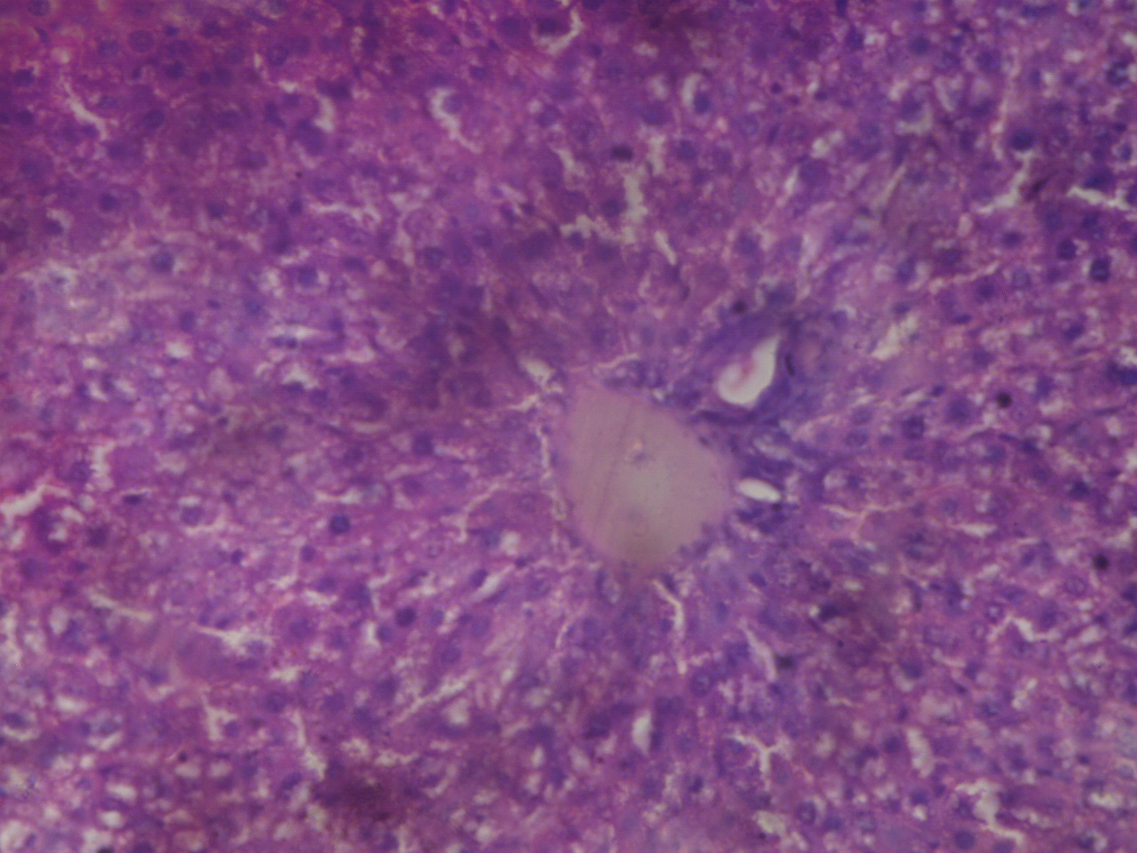

Normal Hepatic parenchymal and cellular integrity.

Plate 1. Photo micrographic slide of liver organ of group 5 (Saline-treated *control*).

H & E stain × 400 objective micrograph.

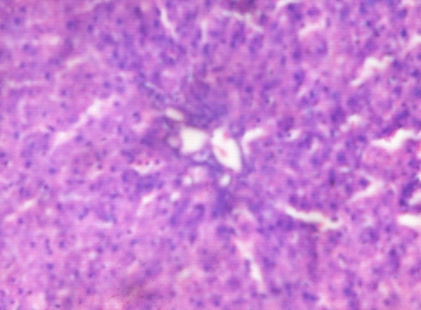

Well aligned cellular matrix and with visible evidence of distortion or disruption.

Plate 2. Photo micrographic slide of liver organ of group 5 (Saline-treated *control*).

H & E stain × 400 objective micrograph.

Plates 3 and 4 (Group 1 rats -*Garcinia kola* Seed only).

The rats were fed *Garcinia kola* seed only.

The Livers showed normal lobular architecture with central vein. The cytoplasm showed eosinophilic presentation. The portal tract was clear and free from any debris. There was no apparent degeneration of the Hepatocytes. There is also a clear encroached space of disse. The mitochondria and liver cell structure were intact and stable. The hepatocytes are large and polyhedral in shape with slightly acidophilic granular cytoplasm. The hepatocytes are large, rounded, vesicular nuclei with prominent nucleoli.

Plates 3 and 4 are shown below;

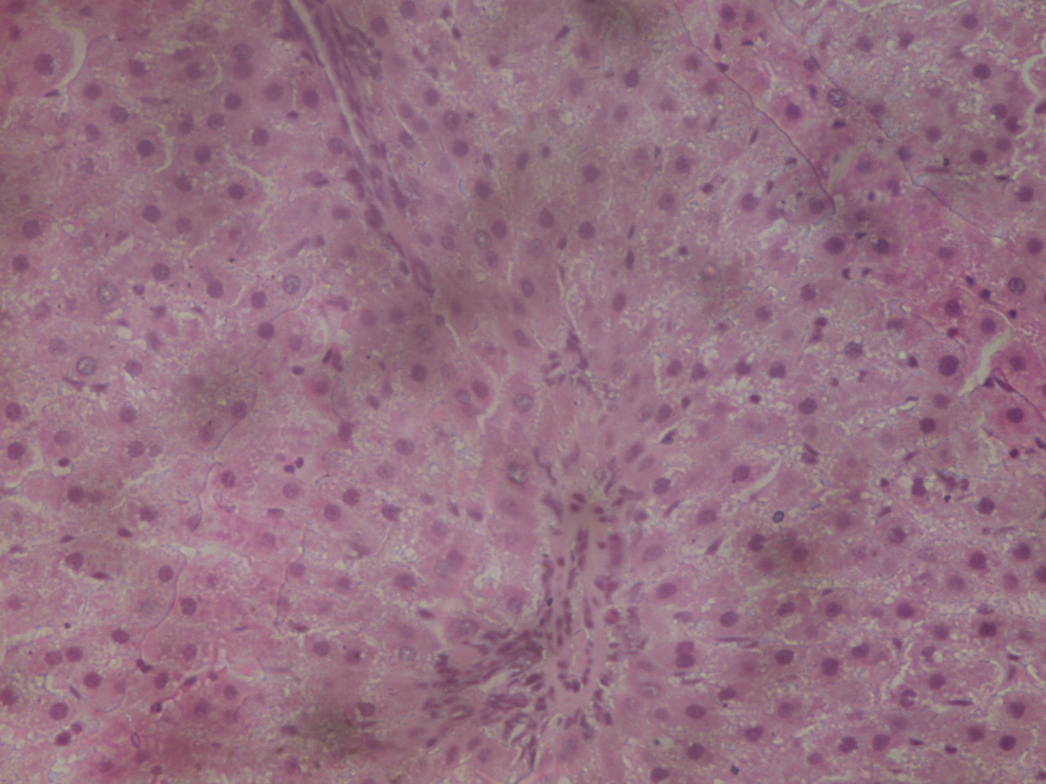

Normal Cellular Architecture

Plate 3. Photo micrographic slide of liver organ of group 1(*Garcinia kola* only-treated)

H & E stain × 400 objective micrograph.

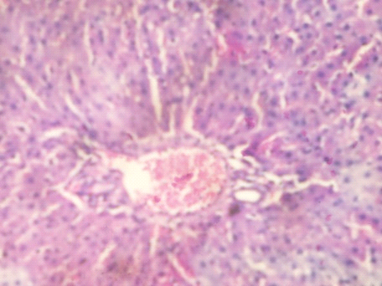

Normal Cellular Structure.

Cellular Debris filled with Eosinophils and cellular content.

Plate 4. Photo micrographic slide of liver organ of group 1(*Garcinia kola* only-treated)

H & E stain × 400 objective micrograph.

Plate 5 and 6 (Group 2 rats- Honey only).

Rats were fed Honey only.

The hepatocytes were intact and stable. The Liver cells showed no visible degeneration, cell destruction or necrosis. There was a rich nucleated sinusoids with a clear portal tract free from all debris. The Liver cell structure was intact and stable. The liver cells showed enrichment due to the Honey diet. This showed that Honey is a rich agent for the hepatocytes.

Plates 5 and 6 are shown below;

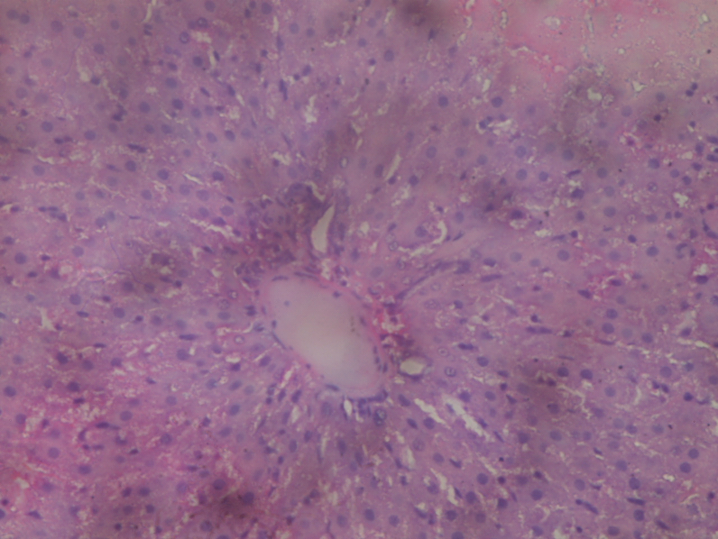

Normal Cellular Matrix and Architectural structure.

Plate 5. Photo micrographic slide of liver organ of group 2 (*Honey* only-treated).

H & E stain × 400 objective micrograph.

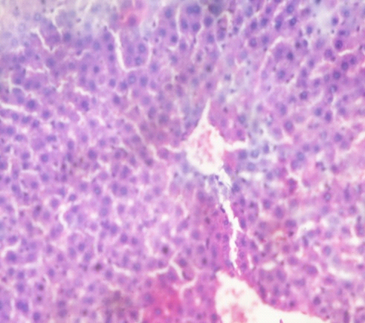

Cellular Debris.

Normal Cell Structure.

Plate 6. Photo micrographic slide of liver organ of group 2 (*Honey* only-treated).

H & E stain × 400 objective micrograph.

Plate 7 and 8 (Group 3-*Garcinia kola* Seed mixed with Honey).

The rats received a mixture of *Garcinia kola* Seed and Honey.

The Hepatocytes showed an encroached portal tract with cellular debris. The liver cells expressed the Presence of Collagen. Collagen formation occurs in the Liver and other organelle. Collagen are formed during the process of evolution of multicellular organelle. Collagen is a collected group of Proteins. However, in this Histological study, the Liver cells were intact and stable.

Plates 7 and 8 are shown below;

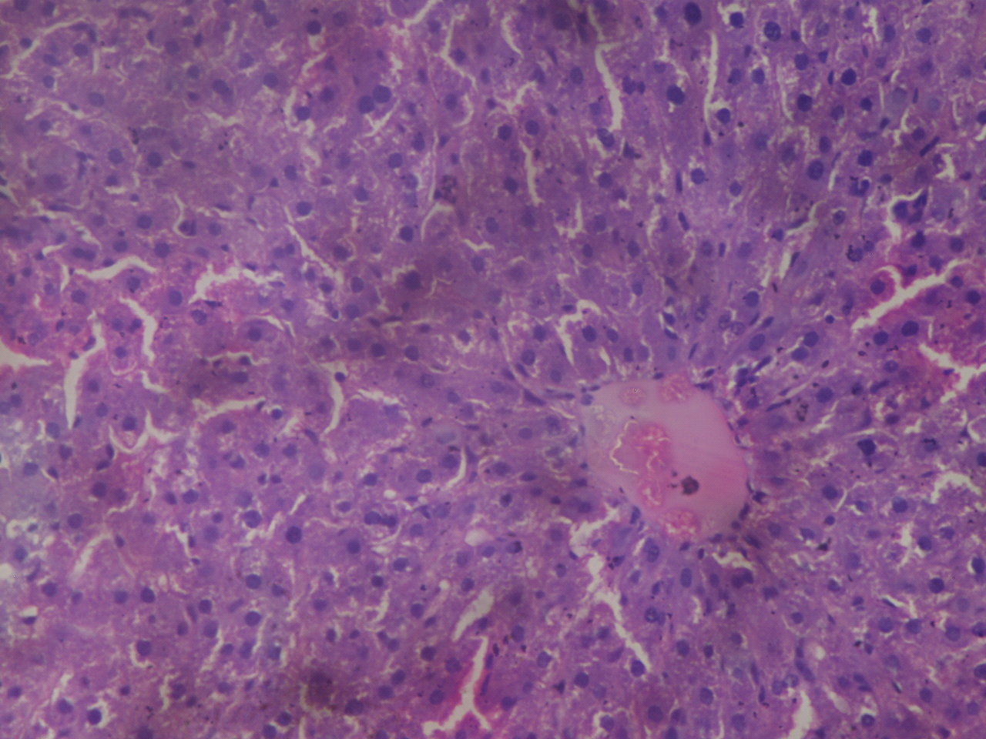

Normal Cellular matrix.

Cellular content filled with Debris

Plate 7. Photo micrographic slide of liver organ of group 3 (*Garcinia kola* + Honey only-treated). H & E stain × 400 objective micrograph.

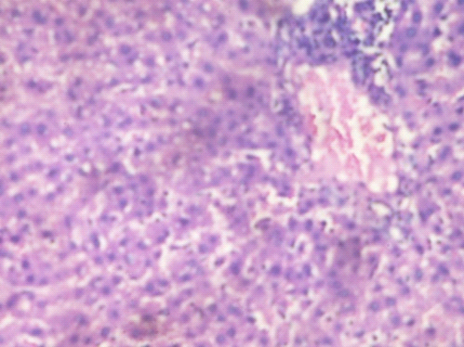

Cellular content filled with Debris.

Normal Cellular structure and architecture.

Plate 8. Photo micrographic slide of liver organ of group 3 (*Garcinia kola* + Honey only-treated). H & E stain × 400 objective micrograph.

According to Adesuyi et. al. [13], From their research, it’s been established through the Nutritional screening that *Garcinia kola* can be used as a good source of Carbohydrate and Protein. Also, a good source of Minerals necessary for metabolic activities in the body despite the trace amounts of Anti-nutrients. The phytochemical composition also shows that the *Garcinia kola* can be useful in Pharmaceutical and Medical science to make vaccine and supplements that can prevent diseases”. This finding is the same as what I observed from the records available to me.

From the data I got from my research, from the group that were fed *Garcinia kola* only, the results showed that there was a significant increase in the Total Bilirubin, AST and ALT levels in comparison to the control, while there was a slight decrease in the Conjugated Bilirubin and GGT although it was not significant as compared to the normal control. The Histology review showed the normal arrangement of the parenchymal of the Liver and normal cellular architecture. This result showed that *Garcinia kola* seed is a Nutritious fruit seed that is highly beneficial to the liver cells. This is because it showed no toxicological effect to the Liver cells. Hence, feeding on *Garcinia kola* seed is of no negative effect to the Liver cells. This report is like the findings of Tamuno-Emine and Anyia [14].

From the group that were fed Honey only, there was a slight rise in total protein, AST and ALT levels in comparison to Normal control. Also, there is a decrease in the mean values of the Conjugated bilirubin and GGT in comparison to the normal control. But this is not significant. The Histological study showed a well delineated cell of the liver. Also, there is a normal architecture and cellular matrix in the Liver. These findings are in contrast with that of Wilson et. al. [15] who reported that was a distortion of the radial arrangement of the sinusoids from the central vein, the distortion of the hexagonal shape of the hepatocytes with evidence of hepatic necrosis characterized by karyolitic and karyorrhexis cells and the desquamation of the wall of the central vein of the liver may be due to the sialidase from the hemoglobin-free erythrocytes, plasma and the liver, this exposing the liver to damaged noticed. But the findings from our research are uniform with that of Erguder et. al. [16,17] who suggested that honey supplement might give beneficial results in the prevention of hepatic damage induced by obstruction of the common bile duct. From our findings, honey consumption is seen to be highly beneficial and nutritious to the liver cells. Its consumption is of great importance and potential to the liver. However, the duration of consumption of honey and the dose may play a role in the outcome of the results. As stated by Wilson et. al. [15], the damage to the liver by honey was dose dependent. Chronic use of honey may increase the risk of hepatic damage, especially at higher doses.

For the group fed *Garcinia kola* seed mixed with honey, there was a significant rise in the Total Bilirubin, AST, ALT and GGT as compared to the normal control, while there was decrease in the conjugated bilirubin, but it was not significant when compared to the normal control. For the Histological study, the liver cells are stable and intact but there is a visible cellular content filled with debris. This shows that the mixture of *Garcinia kola* seed and honey has minor toxicological effect on the liver cells. This herbal combo is not very well researched yet. I will advise further research into the toxicological effect of this mixture (*Garcinia kola* and honey).

4. Conclusion

From the study, it has been established that *Garcinia kola* seed and Honey are highly beneficial, of great pharmacological effects and very of health relevant to the liver cells. So, it can be useful in pharmaceutical and biomedical companies in making vaccines and supplement for the human usage especially regarding the liver health. For the mixture, *Garcinia kola* seed and honey. It will be necessary that further research is done to cross-check on the toxicological effect on the liver.

Ethical approval

In Nigeria, there is no ethical committee approved for studies involving animal experimentation, so consent and ethical approval for the rats is not appropriate here. Although all the ethical regulations in accordance with National and Institutional guidelines for the protection of animals’ welfare were strictly adhered to during the experiment (PHS, 1996). A formal approval was duly gotten from the Head of Department, department of Chemical Pathology, University of Port Harcourt Teaching Hospital (UPTH) where the laboratory analysis was done.

References

1. Mintah, S.O., Asafo-Agyei., Archer, M., Atta-Adjei, P., Boamah, D., Kumadoh, D., Appiah, A., Ocloo, A. Boakye, Y.D. and Agyare, C. Medicinal plants for treatment of prevalent Diseases. *Pharmacognosy-Medicinal Plants,* 2019 (DOI: 10. 5772. 82-49)
2. Prete, A.D., Scalera, A., Ladevaia, M.D., Miranda, A., Zulli, C., Gaeta, L., Tuccillo, C., Federico, A. and Loguerico, C. Herbal benefits, Limits and applications in chronic liver Diseases: Benefits, Limits and applications in Chronic Liver Diseases. *Evidence Based Complementary and Alternate Medicine*. 2012: 837. (DOI: 10.1155/2012/837939).
3. Eisner, T. Chemical prospecting. A call for action. In: Borman, F.H and S.R. Keller (Eds), Ecology, economics and Ethics: The Broken circle. Yale University Press, New Haven, pp: 105-110. 1990.
4. Braide, V.P. Antihepatotoxic Biochemical effects of kola viron, a Bioflavonoid of Garcinia kola seed. *Phytotherapy Research*, 2003; 5: 35-37.
5. Akintonwa, A. and Essien, A.R. Protective effects of Garcinia kola seed extract against Paracetamol-induced hepatotoxicity in rats. *Journal of Ethnopharmacology,* 1990; 29: 207-211.
6. Iwu, M.M. Garcinia kola: a new adaptogen with remarkable immunostimulant, anti-infective and anti-inflammatory properties. Abstract of the international conference on Ethnomedicine and Drug discovery, Siver Spring, Maryland, USA, pp 1-26, 1999.
7. Riddle, J.A. NOSB Apiculture Task Force Report draft Organic Apiculture Standards, Addendum I: Definition of Honey and Honey Products, 2001.
8. PHS Policy on Humane care and Use of Laboratory Animals. Office of Laboratory Animal Welfare. National Institute of Health, 1996.
9. Jendrassik, L. and Grof, P. Determination of Bilirubin using the Azo bilirubin method *Biochemistry,* 1938; 297: 81-9.
10. Reitman, S. and Frankel, S. A Colorimetric method for the determination of serum glutamic oxaloacetic and glutamic pyruvic transaminases. American Journal of Clinical Pathology, 1957; 28, 56-63.
11. Kings, P.R. M and King, E.J. Estimation of Alkaline Phosphatase (ALP). Clinical Pathology, 1949, 7: 322-8.
12. Somongyi, N. Estimation of Gamma Glutamyl transpeptidase (Gamma GT). Clinical Pathology, 1955; 221, 4-9.
13. Adesuyi, A.O., Elumm, I.K., Adaramola, F.B and Nwokocha, A.G.M. Nutritional and Phytochemical screening of Garcinia kola. *Advanced Journal of Food science and Technology,* 2012; 4(1): 9-14.
14. Tamuno-Emine, D.G. and Anyia, F.A. Protective effect of Garcinia kola seed and honey mixture against Cadmium-induced hepatotoxicity in wistar albino rats*. International Journal of Science and Research*, 2016; 5(5): ISSN 2319-7064.
15. Wilson, J.I., George, B.O. and Umukoro, G.E. Effects of honey on the histology of liver in adult wistar rats. *Biology and Medicine*, 2011; 3(1): 1-5.
16. Erguder, B.I., Kilicoglu, S.S., Namuslu, M., Kilicoglu, B. Devrim, E., Kismet, K. and Durak, I. Honey prevents hepatic damage induced by obstruction of the common bile ducts. *World Journal of Gastroenterology*, 2008; 14(23): 3729-32.
17. 17. Marvin, I. Assessment of the therapeutic role of Arabic Gum as antioxidants on Cadmium induced kidney dysfunction in male albino rats. *International Journal of Innovation and Scientific Research,* 2014. ISSN 2351-8014. Vol 11. No 2, pp 322-329.