***Case report***

**"CBCT: A Novel Perspective in Detecting Large Salivary Duct Calculus – A Case Report and Literature Review"**

**Abstract:** Sialolithiasis or salivary duct calculus are the most common salivary gland pathologies affecting major salivary gland particularly the submandibular gland. It can occur in wide age range of patients with male predilection. The usual size is 5-10mm, salivary stones that measures greater than 15mm are considered giant sialolith. Various imaging modality are used in the diagnosis of salivary duct calculus. However, the role of CBCT in the diagnosis of salivary stones has received little research attention. We report a case of sialolith in the submandibular duct measuring 19.5 × 8 mm using CBCT as the first-line imaging modality.

**Keywords:** Giant sialolith, salivary gland, CBCT, sialolithiasis

Introduction:

Sialolith, also termed as salivary calculus or salivary stones, are the most common type of salivary gland disorder. These are formed within the secretory system of the major salivary gland. Submandibular gland has the highest predilection for sialolithiasis with 80% occurrence rate, followed by the parotid (19%) and the sublingual (1%) glands.[1]

The giant sialoliths, which are also called megaliths and are defined as stones with a maximum dimension greater than 15 mm, have rarely been reported. The diagnosis can easily be made by detailed history and clinical examination. However, further investigation with imaging such as CBCT, CT and/or MRI scans may be helpful. Especially in small stones that are difficult to appreciate on palpation.[2]

Here, we present a rare case of a giant sialolith within Wharton’s duct, uniquely diagnosed using CBCT, which provided detailed imaging for precise assessment and management.

Case Presentation:

A 30-year-old male patient reported with the complaint of intermittent, dull aching pain, and swelling below tongue for 1 week. These symptoms occurred during meal and he noted that sour foods were more likely to produce symptoms than were other types of food.

Extraoral examination revealed no facial asymmetry. On bimanual palpation right submandibular gland was firm and tender. A single tender right submandibular lymph node was palpated. Intraoral examination, he was found to have a firm mass of approximately 1 cm × 1 cm on the floor of his mouth, along the course of the right submandibular duct. The right submandibular duct opening was inflamed and erythematous along with a diffuse swelling. Salivary flow was negligible from right submandibular duct orifice. (Fig 1)

Reconstructed panoramic OPG showed radiopacity resembling horizontally impacted canine in lower right premolar and molar region. (Fig 2) A 5*10 CBCT scan was performed and it shows a roughly oval elongated radiopacity noted on the right submandibular duct region seen extending from mesial aspect of 45 to mesial aspect of 47 measuring approximately 19.5mm*8mm in greatest dimensions. (Fig 3)

On the basis of clinical and radiological findings, we diagnosed the case as a right submandibular sialolithiasis.

The calculus was removed intraorally and duct opening was transposed into the floor of mouth under local anaesthesia.

Discussion:

Sialolithiasis can occur in a wide age range of patients and has been reported in children. The average age of sialolithiasis in the submandibular glands is 40.5 years, 47.8 years in the parotid gland, and 50 years for the minor salivary gland. It occurs commonly in males. The recurrence rate reported at around 20% due to the unknown and uncorrected underlying cause. [3]

The submandibular gland is susceptible to salivary calculi; its saliva is far more alkaline and has a greater concentration of calcium and phosphate. Also, it is known that it has greater mucin content compared to parotid and sublingual gland. [4]

The clinical presentation depends on the extent of salivary duct obstruction and the presence of secondary infection. Sialolithiasis is commonly associated with repeated episodes of pain and swelling in the affected salivary gland. The pain and swelling are usually associated with eating. The involved gland is often enlarged and tender on palpation. [5]

Sialolith usually measures from 1-10 mm. Giant sialoliths are classified as those exceeding 15 mm in any one dimension. In literature, large sialoliths or megalith (>15 mm) of Wharton’s duct have rarely been reported. A large sialolith has been described in the body of salivary gland they are rarely found in the salivary ducts. [6] A review of the recent literature revealed cases of large sialoliths of various sizes. Specifically, there were reports of sialoliths measuring 10 × 18 mm , 41 × 31 × 26 mm , 35 × 25 × 15 mm and largest The largest sialolith reported in the literature was 70 mm in length in Wharton’s duct and was described as having a “hen’s egg” size.[7]

Current diagnostic imaging tools used in the imaging of salivary stones are conventional radiography, sialography, ultrasonography, computed tomography, magnetic resonance sialography, sialoendoscopy CBCT. [8] The role of CBCT in the diagnosis of salivary stones has received little research attention. CBCT offers superior sensitivity and specificity, comparable to the best outcomes achieved with 3D imaging techniques like medical CT and MRI sialography. [5]

van der Meij et al retrospectively assess the value of cone beam computed tomography (CBCT) in the detection of salivary stones in patients with signs and symptoms of salivary gland obstruction. The result of the study showed the accuracy of CBCT in the diagnosis of salivary gland calculi is 92% . [9]

[David Schwarz MD](https://onlinelibrary.wiley.com/authored-by/Schwarz/David) et al analyze the potential of cone beam computed tomography (CBCT) for the diagnosis of sialolithiasis and compare the results with those of sonography and sialendoscopy. Result of the study showed that each diagnostic tool showed an excellent specificity and positive predictive value. Sensitivity and negative predictive value were best in sialendoscopy (94% resp. 83%), followed by CBCT (79% resp. 56%) and then sonography (70% resp. 47%). [10]

Therefore, combining CBCT and sialography with injection of radio-opaque contrast agent into the ductal system before imaging improves diagnostic value by allowing visualization of the ductal system.

Conclusion:

The variety of radiographic modality are available in the diagnosis of giant salivary duct calculus. However, makes CBCT a promise as a supplementary non-invasive diagnostic tool in patients with signs and symptoms of obstructed major salivary glands due to its high accuracy combined with low costs, good availability, and limited radiation exposure.

References:

1. Pachisia S, Mandal G, Sahu S, Ghosh S. Submandibular sialolithiasis: A series of three case reports with review of literature. Clin Pract. 2019 Jan 29;9(1):1119.

2. Chaidas K, Lialiaris S, Pavlou AV, Katotomichelakis M, Papouliakos S. A Rare Case of a Giant Sialolith Within Wharton’s Duct. Cureus. 2023 Mar;15(3):e35969.

3. Michael Glick. Burket’s Oral Medicine. 12th edition. People's publishing house -USA shelton, connecticut. 2015

4. Gupta A, Rattan D, Gupta R. Giant sialoliths of submandibular gland duct: Report of two cases with unusual shape. Contemp Clin Dent. 2013 Jan;4(1):78–80.

5. Indu PS, Aravind MS, Renju Jose BV, Priya K, Kumar KS. Diagnostic imaging of a huge salivary gland calculi. IP International journal of maxillofacial imaging. 2021;7(4):183–185

6. Omezli MM, Ayranci F, Sadik E, Polat ME. Case report of giant sialolith (megalith) of the Wharton’s duct. Niger J Clin Pract. 2016;19(3):414–7.

7. Rai M, Burman R. Giant submandibular sialolith of remarkable size in the comma area of Wharton’s duct: a case report. J Oral Maxillofac Surg. 2009 Jun;67(6):1329–32.

8. Rzymska-Grala I, Stopa Z, Grala B, Gołębiowski M, Wanyura H, Zuchowska A, et al. Salivary gland calculi - contemporary methods of imaging. Pol J Radiol. 2010 Jul;75(3):25–37.

9. van den Akker HP, Sokole EB, van der Schoot JB. Origin and location on the oral activity in sequential salivary gland scintigraphy with 99mTc-pertechnetate. J Nucl Med. 1976 Nov;17(11):959–64.

10. Schwarz D, Kabbasch C, Scheer M, Mikolajczak S, Beutner D, Luers JC. Comparative analysis of sialendoscopy, sonography, and CBCT in the detection of sialolithiasis. Laryngoscope. 2015 May;125(5):1098–101.

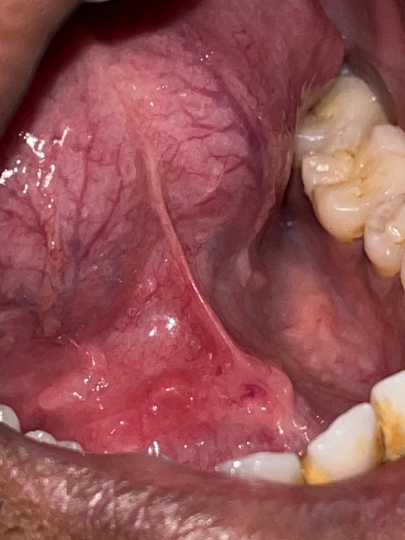

Fig 1: Intraoral Examination



Fig 2: Reconstructed Panoramic radiograph



Fig 3: 5*10 CBCT scan