Case report

Kissing Canines: Maxillary Impacted and Migrated Canines — A Rare Case Report

ABSTRACT
Aims: This case aims to present a rare clinical situation involving bilateral transmigration of maxillary canines, termed "kissing canines," and its successful surgical management.
Study design: Case Report.
Place and Duration of Study: Department of Oral & Maxillofacial Surgery, C.S.M.S.S Dental College and Hospital, Chhatrapati Sambhajinagar, India, over a period of 6 months.
Methodology: A 18 -year-old female presented with a complaint of anterior malalignment. OPG and CBCT revealed horizontally impacted maxillary canines converging at the midline. Prophylactic RCT of anterior teeth was performed, followed by surgical removal of impacted canines under local anesthesia with PRF placement in sockets.
Results: Postoperative recovery was uneventful with excellent healing observed in follow-ups at 1 week, 1 month, 3 months, and 6 months. CBCT aided precise localization and planning. PRF enhanced healing outcomes.
Conclusion: Bilateral "kissing canines" are extremely rare. Accurate diagnosis using CBCT and a multidisciplinary surgical-orthodontic approach ensure optimal esthetic and functional outcomes.
Keywords: Canine Impaction, Transmigration, Maxillary Canine, Kissing Canines, Orthodontics, CBCT, PRF Therapy

1. INTRODUCTION
Canine impaction and transmigration, particularly of maxillary canines, are rare clinical entities. Maxillary canines rank second after third molars in frequency of impaction[1][2]. Transmigration, especially bilateral and converging at the midline, is even more unusual and often discovered incidentally through radiographic assessments. [3][5]The term "kissing canines" denotes this convergence and is associated with aesthetic, anatomical, and psychological considerations. Early diagnosis and interdisciplinary treatment planning are crucial to avoid complications.[4][6][7]
2. Case Presentation
2.1 Clinical Evaluation A 18-year-old female patient presented with anterior teeth malalignment. Intraoral examination revealed good hygiene, bilateral class I molar relationships, and retained primary canines (FDI 53 and 63).
2.2 Radiographic Assessment OPG showed bilateral horizontally impacted canines converging at midline. CBCT confirmed buccal impaction and facilitated planning.

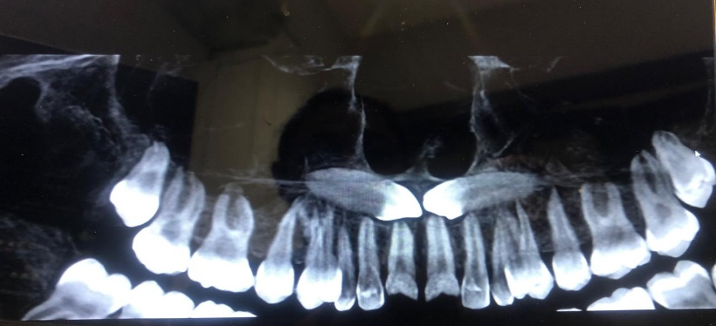
Figure 1 Radiograph showing bilateral impacted maxillary canine

2.3 Pre-surgical Phase Prophylactic RCTs were carried out for teeth 11, 12, 21, 22, 53, and 63 to prevent vitality loss in adjacent teeth.
2.4 Surgical Procedure Under local anesthesia (2% Lignocaine with 1:200,000 adrenaline), bilateral infraorbital and nasopalatine nerve blocks were administered. A crevicular incision from tooth 14 to 24 enabled flap reflection. Buccal bone was shaved to access crowns. Bone guttering permitted atraumatic removal of impacted 13 and 23 with follicles. PRF was packed in sockets and closure done using 3-0 Mersilk sutures.

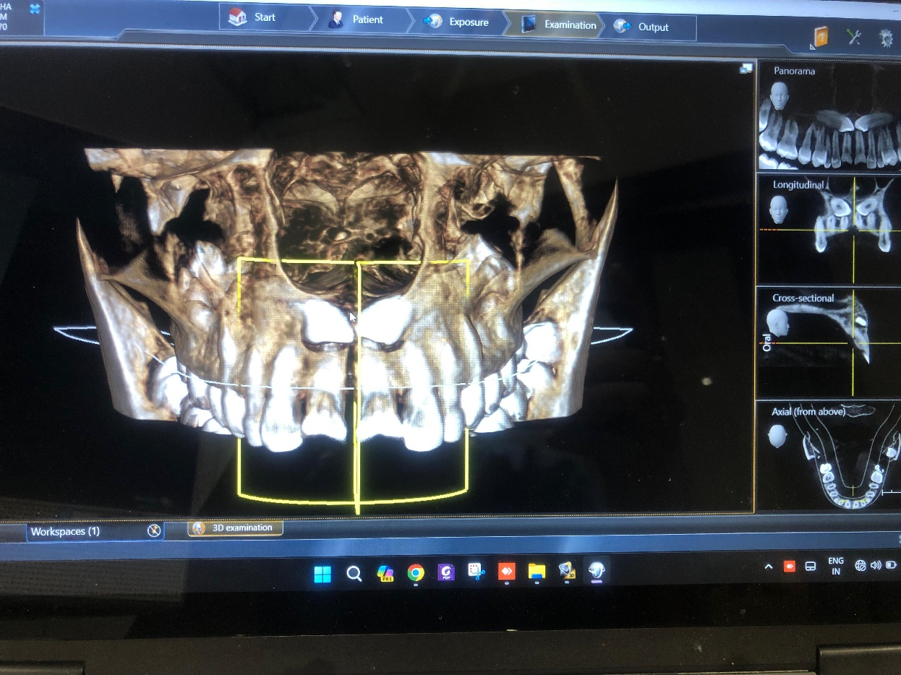  Figure 2 a | 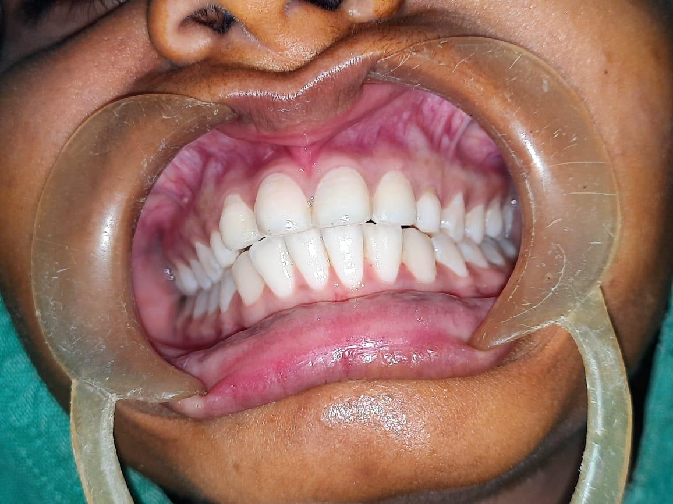  Figure 2 b
Figure 2 (a) CBCT showing buccally impacted maxillary canine, (b) Preoperative intraoral picture
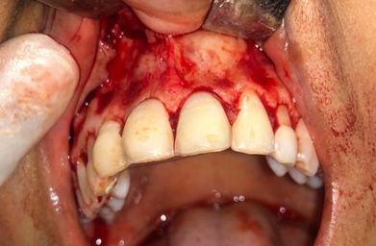  Figure 3 a | 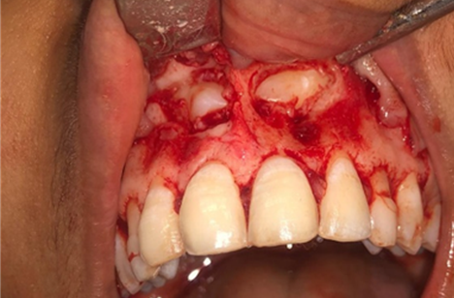  Figure 3 b
Figure 3 (a) Incision and Full thickness mucoperiosteal flap reflected , (b) exposure of impacted canine
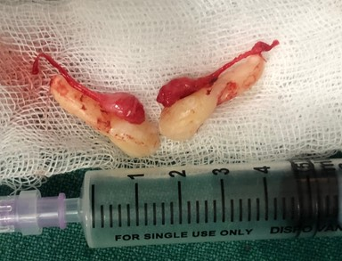  Figure 4 a | 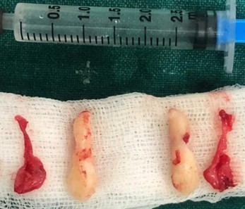  Figure 4 b
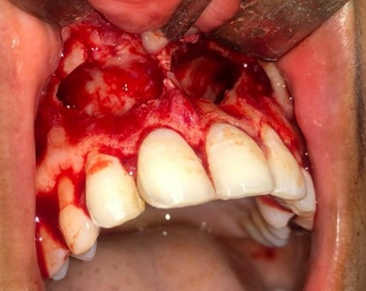  Figure 4 c | 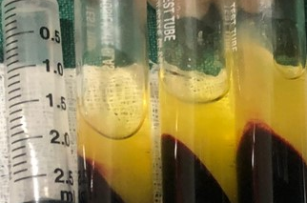  Figure 4 c
Figure 4 (a) (b) surgical removal of 13 , 23 in tooth , with germinal follicle (c) extraction socket of impacted 13, 23 ; (d) PRF
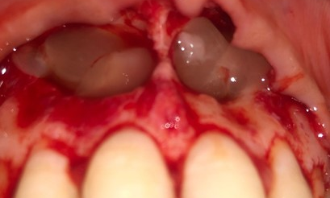  Figure 5 a PRF placed in extraction socket of 13 , 23 | 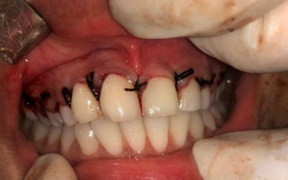  Figure 5 b closure obtained with 3.0 mersilk
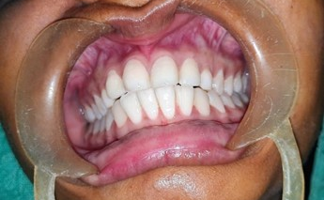  Figure 5 c postoperative 7 days. | 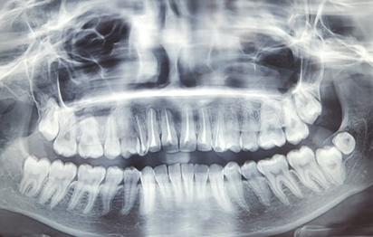  Figure 5 c postop OPG after 6 months
Figure 5 Postoperative follow-ups

3. DISCUSSION
3.1 Outcome of Surgery Healing was excellent, confirmed through routine follow-ups. PRF contributed to socket regeneration. No complications observed.
3.2 Etiology and Radiographic Relevance Etiological factors include retained primary teeth, aberrant eruption paths, and genetics. CBCT provided crucial data on proximity to nasal spine and incisive canal, enabling safe extraction.[7][8]
3.3 Classification and Literature According to Muparappu's classification, this case falls under Type 1 transmigration. Though mandibular cases dominate literature, bilateral maxillary instances like this are seldom recorded.[1][3][[6]

Figure 6 flowchart explains treatment options for transmigrated canine teeth [1]

3.4 Role of Multidisciplinary Approach Combined endodontic, surgical, and orthodontic planning yielded favorable results. PRF significantly accelerated healing and minimized complications.[15]
4. CONCLUSION
Bilateral maxillary "kissing canines" represent a rare anomaly. Timely diagnosis with CBCT, strategic planning, and surgical expertise supported by PRF leads to favorable clinical and esthetic outcomes. Documenting such cases expands clinical insight for evidence-based protocols.[1][9][10[11]

CONSENT
All authors declare that written informed consent was obtained from the patient for publication of this case report and accompanying images. A copy of the written consent is available for review by the editorial office.
ETHICAL APPROVAL
All authors hereby declare that all procedures were performed in accordance with institutional guidelines and the Declaration of Helsinki. Ethical clearance was granted by the institutional ethics committee.
REFERENCES
- Sajnani AK, King NM. Ectopic eruption of maxillary canines: A review and update. J Investig Clin Dent. 2014;5(1):38–44. doi:10.1111/jicd.12015
- Manne R, Gandikota C, Juvvadi SR, Rama HR, Anche S. Impacted canines: Etiology, diagnosis, and orthodontic management. J Pharm Bioallied Sci. 2012;4(Suppl 2):S234–S238. doi:10.4103/0975-7406.100273
- Mazinis E, Zouloumis L, Karathanasis A, Lambrianidis T, Tesseromatis C. Factors associated with the presence of palatally impacted canines: A retrospective study. Clin Oral Investig. 2012;16(2):625–632. doi:10.1007/s00784-011-0544-4
- Bishara SE. Impacted maxillary canines: A review. Am J Orthod Dentofacial Orthop. 1992;101(2):159–171. doi:10.1016/0889-5406(92)70008-X
- Ando S, Aizawa K, Nakashima T, Shibasaki Y. Studies on the incidence of impacted maxillary canines. J Nihon Univ Sch Dent. 1964;6:66–71. doi:10.2334/josnusd1959.6.66
- Sharma S, Nagpal A, Karapure SS, Thakkar PR. Bilateral transmigration of mandibular canines: A rare case report. J Indian Acad Oral Med Radiol. 2014;26(1):82–84. doi:10.4103/0972-1363.141661
- Qaradaghi IF. Transmigration of mandibular canines: A case report and review. Int J Dent Oral Health. 2016;2(3):1–4.
- Ericson S, Kurol J. Radiographic assessment of maxillary canine eruption in children with clinical signs of eruption disturbance. Am J Orthod Dentofacial Orthop. 1987;91(6):483–492. doi:10.1016/0889-5406(87)90206-0
- Counihan K, Al-Ali S, Butler J, Fleming PS. Palatally ectopic canines: radiological predictors of eventual eruption. Dent Update. 2013;40(9):770–775.
- Muparappu M. Transmigration of mandibular canines: Report of four cases and review of literature. Oral Surg Oral Med Oral Pathol Oral Radiol Endod. 2002;93(3):329–334. doi:10.1067/moe.2002.119110
- Nisar S, Dany M, Sami A. Management of impacted maxillary canine using open and closed eruption technique. J Dent Res Dent Clin Dent Prospects. 2020;14(2):139–145. doi:10.34172/joddd.2020.027
- Nourwali I. Impacted maxillary canines: A radiographic and clinical analysis of cases in a Saudi population. J Taibah Univ Med Sci. 2021;16(4):521–528. doi:10.1016/j.jtumed.2021.03.011
- Vadane A, Kazi H. Transmigration of mandibular canines: An uncommon finding. Int Dent J Students Res. 2019;7(1):22–23.
- Kiyumi HA, Viswapurna PS, Zeinalddin M. Bilateral transmigration of impacted maxillary canines—Kissing canines: A case study. Int J Dent Res. 2021;6(2):30–32. doi:10.31254/dentistry.2021.6202
- AnantulaK, AnnareddyA .Platelet-richfibrin(PRF) as an autologous biomaterial after an endodontic surgery: Case reports. J NTR Univ Health Sci 2016;5:49-54

