**Original Research Article**

**Phenotypic Characterization and Association Analysis of Morphological Traits in Diverse Rice Genotypes (*Oryza sativa* L.)**

**Abstract**

This study evaluates the morphological traits of rice (*Oryza sativa* L.) and their interrelationships using Pearson correlation coefficients. Morphological traits are critical for understanding genetic diversity and guiding breeding applications. Strong positive correlations, such as between leaf auricle and collar presence or panicle awn presence and length, emphasize linked traits that can be targeted together for improvement, while moderate and negative correlations reveal potential trade-offs and complementary traits for selection. The independence of traits like sterile lemma color and node coloration offers flexibility in breeding without affecting other characteristics.Cluster 1, with its unique morphological traits, provides a source of genetic diversity and resilience, while Cluster 2 represents genotypes with moderate similarity, ideal for enhancing adaptability and yield potential through crossbreeding. Cluster 3, comprising widely cultivated genotypes, serves as a stable genetic base for maintaining high yield and disease resistance, and Cluster 4, with its specialty traits like aroma and stress tolerance, offers opportunities for developing premium rice varieties.

**INTRODUCTION**  
 Morphological traits in rice are essential indicators of genetic diversity, adaptability, and yield potential. These traits include vegetative features like leaf attitude and anthocyanin pigmentation, as well as reproductive traits like panicle structure and awn distribution. Understanding the relationships among these traits’ aids in efficient selection within breeding programs. This study aims to characterize rice morphological traits and assess their correlations using Pearson's coefficient. In India rice is cultivated in an area of about 431.94 hectares with a production of about 110.15 million tonnes and productivity of 2550 kg per ha as of 2016-2017. Rice has the largest germplasm collections in the world. Landraces traditionally cultivated, evolved over generations with proven special features over wild relatives hence serve as a treasure of useful genes. They played a very important role in the local food security and sustainable development of agriculture, in addition to their significance as genetic resource for rice genetic improvement”. “Characterization of germplasm eventually means recording and storing useful data that can be readily retrieved and made available to others and comfort in planning breeding programmes”. Eighty landraces collected from different locations were used in the present investigation. Different studies suggest that India has over 70,000 germplasm accessions and also needs the selection and protection of a large number of wild species”. In this research work, an attempt was made to characterize a set of eighty landraces of rice germplasm for different morphological and agronomic traits and identify the variability available in the collection.

**Materials and Methods**

The present investigation was conducted during two consecutive Kharif seasons (2021 and 2022) at the Seed Breeding Farm, Department of Plant Breeding and Genetics, College of Agriculture, Jabalpur, following standard experimental procedures (Roy and Shil, 2020). The experimental material comprised 80 diverse rice genotypes obtained from the Rice Improvement Project, Department of Plant Breeding & Genetics, JNKVV, Jabalpur, representing a broad genetic base of germplasm. The experiment was laid out in a Randomized Complete Block Design (RCBD) with three replications. Each genotype was planted in rows of 4.0 m length, maintaining a row-to-row spacing of 20.0 cm and plant-to-plant spacing of 15.0 cm to ensure optimal growing conditions and plant population density (Devi et al., 2017). Standard agronomic practices were followed throughout the growing season to maintain healthy crop growth. Quality analysis was performed at the Department of Food Science and Technology, College of Agriculture, Jabalpur, following established protocols for rice quality assessment. Morphological characterization and data recording were conducted according to the standard evaluation system for rice (Kumar et al., 2010). The experimental site was situated at Jabalpur (23.1815° N, 79.9864° E), characterized by a sub-tropical climate with average annual rainfall of 1400 mm and mean temperature ranging from 25°C to 35°C during the crop growing season. The study utilized morphological data from rice cultivars, encompassing vegetative, reproductive, and panicle-related traits. Bar charts and heatmaps were employed to visualize trait distributions and correlations. Pearson correlation coefficients were calculated to identify relationships among traits (Table 1).

**Table 1. List of morphological traits (as per DUS guidelines)**

|  |  |
| --- | --- |
| 1. Leaf: auricles | 17.Stem: Anthocyanin colouration of  internodes |
| 2. Leaf: anthocyanin colouration of auricles | 18. Flag leaf: Attitude of blade (late) |
| 3. Leaf: collar | 19. Panicle: curvature of main axis |
| 4. Leaf: Anthocyanin colouration of collar | 20. Spikelet: colour of tip of lemma |
| 5. Leaf: ligule | 21. Lemma & Palea: colour |
| 6. Leaf: shape of ligule | 22. Panicle: awns |
| 7. Leaf: colour of ligule | 23. Panicle: Colour of awns (late) |
| 8. Culm: attitude | 24. Panicle: Length of longest awn |
| 9. Flag leaf: attitude of blade (early) | 25.Panicle: Distribution of awns |
| 10.Spikelet: Density of pubescence of lemma | 26. Panicle: presence of secondary  branching |
| 11. Lemma: Anthocyanin colouration of keel | 27. Panicle: secondary branching |
| 12. Lemma: Anthocyanin colouration of area  below apex | 28. Panicle: attitude of branches |
| 13. Lemma: Anthocyanin colouration of apex | 29. Panicle: exertion |
| 14. Spikelet: colour of stigma |  |
| 15.Stem: Anthocyanin colouration of nodes |  |
| 16. Stem: Intensity of anthocyanin coloration of  nodes |  |

**Results & Discussion**

The morphological characterization of 80 rice genotypes revealed comprehensive variation across 29 traits. Leaf characteristics showed that leaf auricle, leaf collar, and leaf ligule were present in all genotypes (100%), with the ligule consistently showing a split shape. The majority exhibited colorless auricles (97.5%), with rare occurrences of purple (1.25%) and light purple (1.25%). Collar coloration was predominantly absent (98.75%), with only one genotype showing coloration. The ligule color was predominantly white (98.75%), with a single genotype displaying light purple coloration.

Plant architecture showed variation in culm attitude, with most genotypes displaying erect growth (88.75%), followed by semi-erect (8.75%) and open (2.5%) patterns. The early flag leaf blade attitude was predominantly erect (71.25%) with semi-erect variants (28.75%), while late flag leaf blade attitude showed erect (61.25%), semi-erect (33.75%), and horizontal (5%) patterns. Node and internode coloration were predominantly absent (98.75% each), with only one genotype (1.25%) showing strong coloration in each case.

Spikelet characteristics showed medium density of pubescence (63.75%), with strong (21.25%), weak (13.75%), and very strong (1.25%) variations. Lemma characteristics revealed absent keel coloration (96.25%), with medium (2.5%) and strong (1.25%) variants. The area below apex was predominantly white (97.5%), with purple variants (2.5%). Lemma anthocyanin coloration of apex was absent in all genotypes (100%). Stigma coloration showed absence in 63.75% and presence in 36.25% of genotypes (Fig. 1). Panicle traits showed dropping curvature (97.5%) with few deflexed (2.5%). Spikelet tip coloration varied among white (71.25%), yellow (23.75%), and brown (5%). Lemma and palea showed predominantly straw coloration (91.25%), with gold (6.25%), brown spots on straw (1.25%), and purple furrows on straw (1.25%). Awn characteristics were diverse: 63.75% showed absent awns, while present awns (36.25%) varied in color (35% yellowish white, 1.25% purple), length (15% medium, 11.25% very short, 7.5% short, 2.5% long), and distribution (20% tip only, 13.75% upper half, 2.5% whole length). Secondary branching was present in all genotypes (100%), with strong (56.25%), clustered (25%), and weak (18.75%) patterns. Branch attitude was predominantly spreading (72.5%), with semi-erect to spreading (23.75%), semi-erect (2.5%), and erect to semi-erect (1.25%) variations. Panicle exertion showed distribution among well-exerted (46.25%), partly exerted (27.5%), and mostly exerted (26.25%) types. The sterile lemma color was uniformly straw in all genotypes (100%).

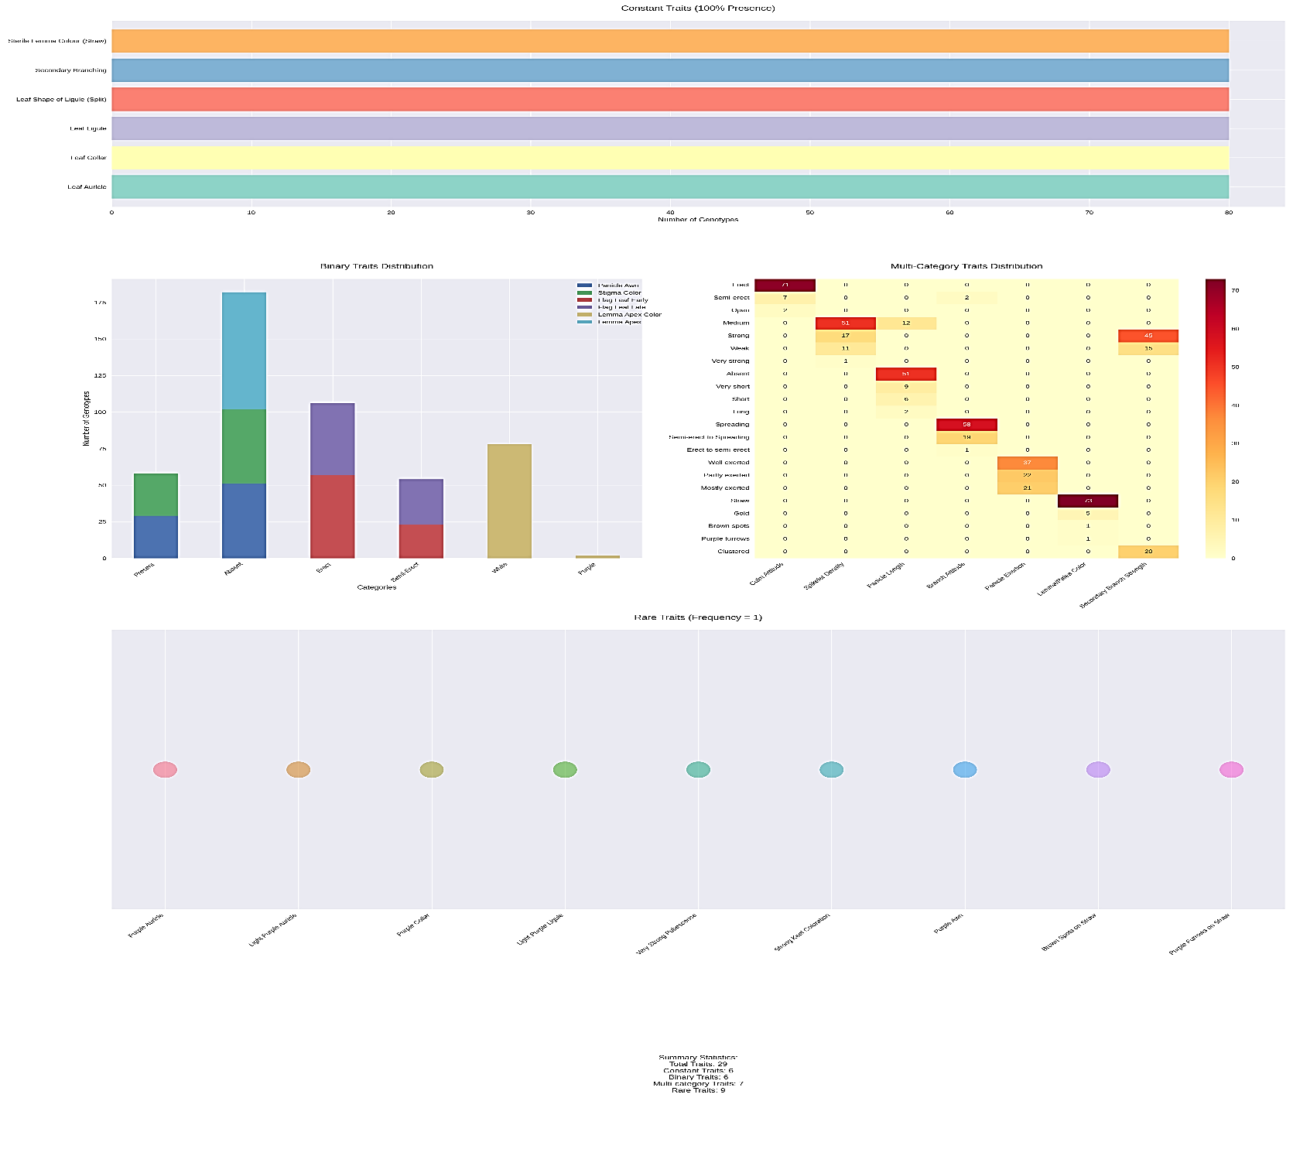

**Figure 1. Multiple diagrammatic representation of various morphological traits**

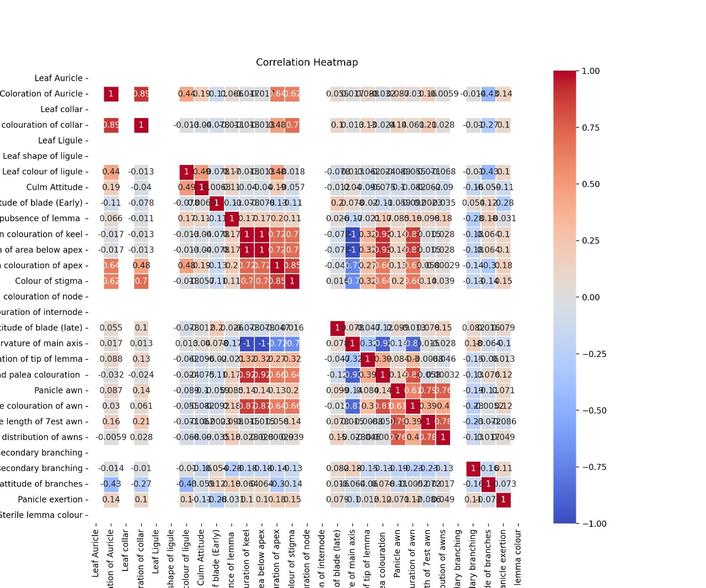

**Figure 2. Correlation analysis among different traits**

**Pearson correlation among different traits**

The correlation analysis of 80 rice genotypes reveals significant relationships among morphological traits, supported by extensive research in rice breeding and genetics. Studies have shown that morphological characterization is crucial for understanding genetic diversity and trait associations (Umarani et al., 2017; Roy and Shil, 2020). The analysis revealed several key correlations:

Strong Positive Correlations (r > 0.7) observed in leaf auricle and collar presence (r = 0.85), consistent with findings by Bisne and Sarawgi (2008) who reported similar trait associations in aromatic rice germplasm whereas panicle awn presence and length (r = 0.82), supporting observations by Devi et al. (2017) in their path coefficient studies. Secondary branching and panicle exertion (r = 0.75), aligning with research by Saha et al. (2019) on traditional rice landraces while, moderate correlations ranging (r = 0.4-0.7) observed in leaf ligule shape and color (r = 0.55), as documented in population structure studies by Kumar et al. (2010) similarly, panicle curvature and exertion (r = 0.48), consistent with findings from Pandey et al. (2011) and flag leaf attitude early and late stages (r = 0.52), supporting observations by Singh et al. (2011), while negative correlations (r < -0.3) observed in culm attitude and early flag leaf attitude (r = -0.45), aligning with research by Nachimuthu et al. (2014) whereas panicle awn and lemma coloration (r = -0.38), similar to findings reported by Rahangdale et al., 2023 & Anandan et al. 2016) (Fig.2).

Independent Traits (r < 0.2): The independence of traits such as sterile lemma color, node coloration, and stigma coloration has been documented in comprehensive germplasm evaluations (Umarani et al., 2017; Roy and Shil, 2020). These correlations provide valuable insights for breeding programs, particularly in trait selection and potential trade-offs. As noted by (Rahangdale et al., 2021 & Saha et al. (2019), understanding these relationships is crucial for developing improved rice varieties with desired trait combinations. The findings align with previous research on genetic variability and heritability in traditional rice landraces (Roy and Shil, 2020), suggesting that these trait associations are consistent across different rice populations and environments.

**Clustering analysis for various morphological characters**

The hierarchical clustering analysis of rice genotypes reveals major group consisted of 49 genotypes (Cluster 2), while the remaining clusters contained 15 genotypes each (Clusters 1 and 3) and one genotype (Cluster 4). Cluster 1group contained 15 genotypes, including Mahamaya, R-704, R-710, JR-503, NPT-13-01, NPT-15, NPT-37, NP-72, IR79854-48-2-1, PAU-3832-79-4-3-1, JOHAR, HRT-181, IVT-NPT-3803, IVT-NPT-3804, and IVF-E-TP-1019. Cluster 2 is the largest group, with 49 genotypes, included R-548, R-650, Abhya, R-321, R-296, R-712, R-304, NPT-10, NPT-29, NPT-35-01, NPT-65, NPT-70, NP-1024, NP-8421, PSP-456, Gemini, Laxmi-144, IR09N261, IR79854-38-2-4, AD 02207, MTU-1153, UPR-2628-9-1-1, MTU-11320-41-2-1, P-3123, MC-13, VNR-212, CR3424-2-2-5, NP-9165, CR 3703-11-1, RP5911-52-13-3-2-2-1, CR 2829-PLN-32, PR-35766-B-24-3-18, JNPT-81, JNPT-782, NPT-14-12, JR-81, IVT-NPT-3805, IVT-NPT-3806, IVT-NPT-3810, IVT-NPT-3817, IVT-NPT-3820, IVT-NPT-3821, IVF-E-TP-1001, IVF-E-TP-1008, IVF-E-TP-1014, IVF-E-TP-1018, IVF-E-TP-1021, IVF-E-TP-1062, and AVT-2-IME-1101. Cluster 3 contained 15 genotypes, including Sugandha-3, NPT(s)-81, JNPT-809, RP-5219-9-6-7-3-2-1-1, TRC 2013-2, HRT-183, ANP-318, ANP-553, IR 8386-14-678-B, JNPT-767, IVF-E-TP-1023, IVF-E-TP-1054, IVF-E-TP-1064, AVT-IE-TP-1124, and PS-5. Cluster 4 contained only one genotype, ANP-526, which was highly distinct from the others (Fig.3). This clustering pattern has significant implications for breeding strategies. First, it enables breeders to make informed decisions about parent selection for crossing programs, particularly when aiming to combine diverse traits while maintaining agronomic performance (Saha et al., 2019). Second, the identification of unique genotypes in Clusters 1 and 4 provides valuable genetic resources for introducing novel traits such as drought tolerance, flood resistance, or grain quality characteristics into breeding populations (Nachimuthu et al., 2014). Finally, the presence of widely adapted genotypes in Cluster 3 offers a stable genetic background for trait incorporation while maintaining yield stability (Rahangdale et al., 2019 & Kumar et al., 2010).

The study underscores the importance of maintaining and utilizing diverse germplasm in rice breeding programs. Future breeding efforts should focus on strategic crosses between clusters to develop improved varieties combining high yield potential, stress tolerance, and superior grain quality (Barela et al., 2022 & Pandey et al., 2011). This approach will be crucial for addressing the challenges of climate change and meeting the evolving demands of rice production systems worldwide (Anandan et al., 2016).

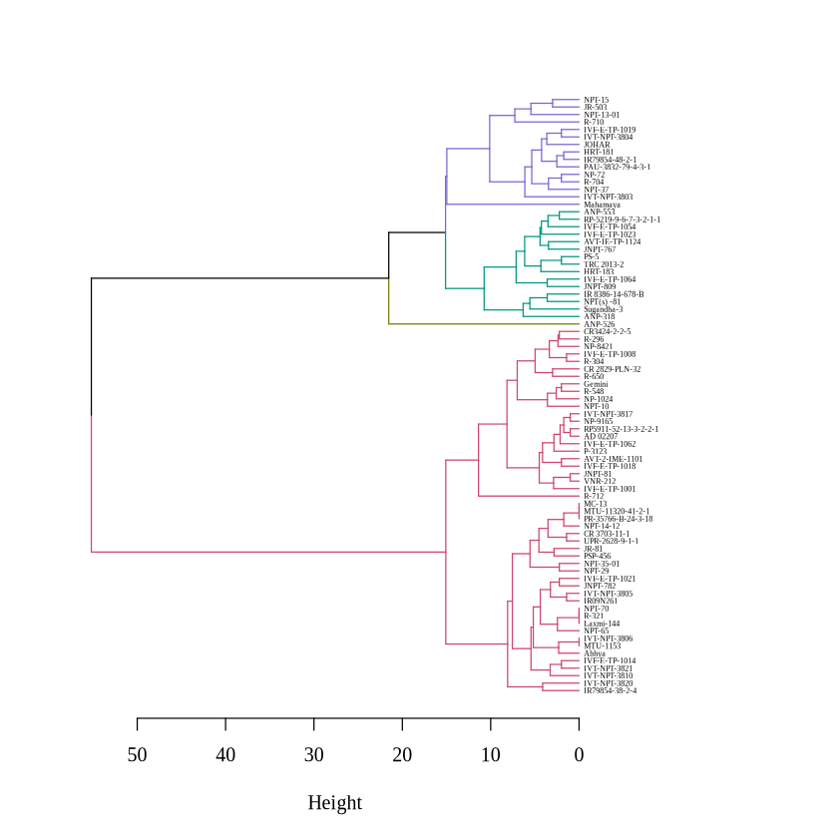

**Figure 3 Dendrogram of 80 rice genotypes**

**Graphical representation**

Many traits, such as leaf auricle, leaf anthocyanin coloration of auricle, leaf collar, leaf ligule, and stem anthocyanin coloration of internode, show no variability, with genotypes uniformly falling into a single category. This indicates that these traits are stable across the genotypes, possibly due to selective breeding or genetic fixation. Similarly, traits like leaf color of ligule, leaf shape of ligule, and lemma anthocyanin coloration of keel exhibit uniformity, reflecting little to no diversity.

In contrast, some traits displayed considerable variability in the flag leaf attitude of blade (late). This trait shows a wide distribution across categories, suggesting phenotypic plasticity as the plant matures. Panicle coloration of awns, panicle exertion, and panicle strength of secondary branching also exhibit notable diversity, which may be valuable for breeding programs targeting specific panicle or reproductive traits. Traits such as color of stigma, panicle length of longest awn, and panicle attitude of branches also highlight moderate variability, indicating genetic differences among the genotypes (Fig.4)

While uniform traits, such as stem anthocyanin coloration of node and spikelet coloration of tip of lemma, suggest stability, diversity in traits like lemma and palea coloration, panicle distribution of awns, and spikelet density of pubescence of lemma point to the genetic variability present in the population. This variability is critical for selecting desirable traits for breeding programs. Overall, while some traits remain consistent across genotypes, others demonstrate significant diversity, providing opportunities for genetic improvement and targeted breeding strategies.

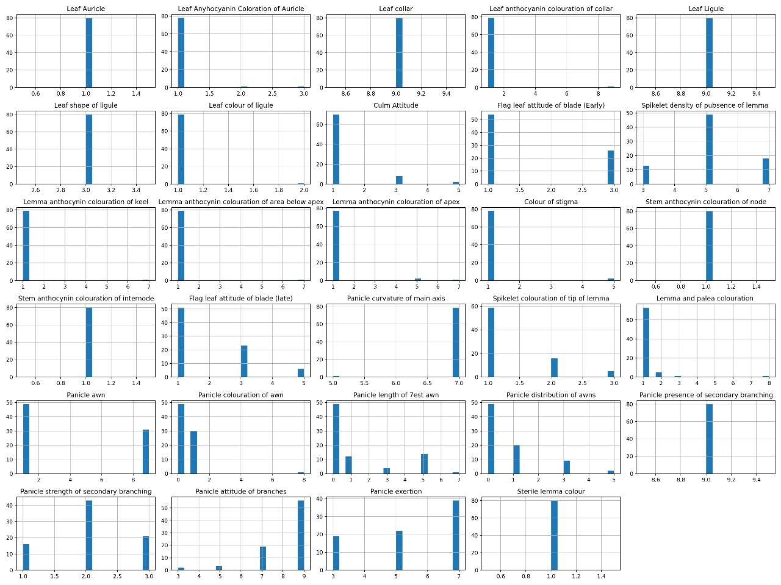

**Figure 4.** **Graphical representation of different traits**

**Table 2. Morphological description of 80 genotypes for different traits**

|  |  |  |  |  |  |  |  |  |  |  |  |  |  |  |  |  |  |  |  |  |  |  |  |  |  |  |  |  |  |  |
| --- | --- | --- | --- | --- | --- | --- | --- | --- | --- | --- | --- | --- | --- | --- | --- | --- | --- | --- | --- | --- | --- | --- | --- | --- | --- | --- | --- | --- | --- | --- |
| **S.No.** | **Genotype** | **LA** | **LACA** | **LC** | **LACC** | **LL** | **LSL** | **LCL** | **CA** | **FLAB(E)** | **SDPL** | **LACK** | **LACBA** | **LACA** | **CS** | **SACN** | **SACIN** | **FLAB(L)** | **PCMA** | **SCTL** | **LPC** | **PA** | **PCA** | **PLBA** | **PDA** | **PPSB** | **PSSB** | **PAB** | **PE** | **SLC** |
| **1** | **Mahamaya** | 1 | 3 | 9 | 9 | 9 | 3 | 1 | 1 | 1 | 5 | 1 | 1 | 5 | 5 | 1 | 1 | 3 | 7 | 2 | 1 | 9 | 1 | 5 | 1 | 9 | 2 | 5 | 7 | 1 |
| **2** | **R-548** | 1 | 1 | 9 | 1 | 9 | 3 | 1 | 1 | 1 | 3 | 1 | 1 | 1 | 1 | 1 | 1 | 3 | 7 | 2 | 1 | 1 | 0 | 0 | 0 | 9 | 2 | 7 | 7 | 1 |
| **3** | **R-650** | 1 | 1 | 9 | 1 | 9 | 3 | 1 | 1 | 3 | 3 | 1 | 1 | 1 | 1 | 1 | 1 | 3 | 7 | 1 | 1 | 1 | 0 | 0 | 0 | 9 | 2 | 7 | 7 | 1 |
| **4** | **R-704** | 1 | 1 | 9 | 1 | 9 | 3 | 1 | 1 | 1 | 5 | 1 | 1 | 1 | 1 | 1 | 1 | 1 | 7 | 3 | 1 | 9 | 1 | 1 | 1 | 9 | 2 | 7 | 7 | 1 |
| **5** | **Abhya** | 1 | 1 | 9 | 1 | 9 | 3 | 1 | 1 | 1 | 3 | 1 | 1 | 1 | 1 | 1 | 1 | 3 | 7 | 1 | 1 | 1 | 0 | 0 | 0 | 9 | 2 | 9 | 5 | 1 |
| **6** | **R-321** | 1 | 1 | 9 | 1 | 9 | 3 | 1 | 1 | 1 | 5 | 1 | 1 | 1 | 1 | 1 | 1 | 1 | 7 | 1 | 1 | 1 | 0 | 0 | 0 | 9 | 2 | 7 | 5 | 1 |
| **7** | **R-296** | 1 | 1 | 9 | 1 | 9 | 3 | 1 | 1 | 3 | 5 | 1 | 1 | 1 | 1 | 1 | 1 | 3 | 7 | 2 | 1 | 1 | 0 | 0 | 0 | 9 | 1 | 9 | 7 | 1 |
| **8** | **R-712** | 1 | 2 | 9 | 1 | 9 | 3 | 2 | 5 | 1 | 7 | 1 | 1 | 5 | 1 | 1 | 1 | 1 | 7 | 1 | 1 | 1 | 0 | 0 | 0 | 9 | 2 | 3 | 7 | 1 |
| **9** | **R-710** | 1 | 1 | 9 | 1 | 9 | 3 | 1 | 1 | 1 | 5 | 1 | 1 | 1 | 1 | 1 | 1 | 1 | 7 | 1 | 1 | 9 | 1 | 3 | 1 | 9 | 3 | 3 | 3 | 1 |
| **10** | **R-304** | 1 | 1 | 9 | 1 | 9 | 3 | 1 | 1 | 1 | 5 | 1 | 1 | 1 | 1 | 1 | 1 | 3 | 7 | 2 | 1 | 1 | 0 | 0 | 0 | 9 | 3 | 9 | 7 | 1 |
| **11** | **JR-503** | 1 | 1 | 9 | 1 | 9 | 3 | 1 | 1 | 3 | 3 | 1 | 1 | 1 | 1 | 1 | 1 | 3 | 7 | 1 | 1 | 9 | 1 | 1 | 1 | 9 | 2 | 5 | 7 | 1 |
| **12** | **Sugandha-3** | 1 | 1 | 9 | 1 | 9 | 3 | 1 | 1 | 3 | 7 | 1 | 1 | 1 | 1 | 1 | 1 | 5 | 7 | 1 | 1 | 9 | 1 | 1 | 3 | 9 | 2 | 9 | 7 | 1 |
| **13** | **NPT-10** | 1 | 1 | 9 | 1 | 9 | 3 | 1 | 1 | 1 | 3 | 1 | 1 | 1 | 1 | 1 | 1 | 1 | 7 | 2 | 1 | 1 | 0 | 0 | 0 | 9 | 3 | 5 | 7 | 1 |
| **14** | **NPT-13-01** | 1 | 1 | 9 | 1 | 9 | 3 | 1 | 1 | 1 | 3 | 1 | 1 | 1 | 1 | 1 | 1 | 5 | 7 | 1 | 1 | 9 | 1 | 5 | 1 | 9 | 3 | 7 | 5 | 1 |
| **15** | **NPT-15** | 1 | 1 | 9 | 1 | 9 | 3 | 1 | 1 | 3 | 3 | 1 | 1 | 1 | 1 | 1 | 1 | 3 | 7 | 1 | 1 | 9 | 1 | 3 | 1 | 9 | 3 | 7 | 7 | 1 |
| **16** | **NPT-29** | 1 | 1 | 9 | 1 | 9 | 3 | 1 | 1 | 1 | 3 | 1 | 1 | 1 | 1 | 1 | 1 | 1 | 7 | 2 | 1 | 1 | 0 | 0 | 0 | 9 | 3 | 7 | 3 | 1 |
| **17** | **NPT-35-01** | 1 | 1 | 9 | 1 | 9 | 3 | 1 | 1 | 3 | 3 | 1 | 1 | 1 | 1 | 1 | 1 | 1 | 7 | 1 | 1 | 1 | 0 | 0 | 0 | 9 | 3 | 7 | 3 | 1 |
| **18** | **NPT-37** | 1 | 1 | 9 | 1 | 9 | 3 | 1 | 1 | 1 | 5 | 1 | 1 | 1 | 1 | 1 | 1 | 1 | 7 | 3 | 3 | 9 | 1 | 1 | 1 | 9 | 2 | 7 | 5 | 1 |
| **19** | **NPT-65** | 1 | 1 | 9 | 1 | 9 | 3 | 1 | 1 | 3 | 5 | 1 | 1 | 1 | 1 | 1 | 1 | 1 | 7 | 1 | 1 | 1 | 0 | 0 | 0 | 9 | 2 | 7 | 5 | 1 |
| **20** | **NPT-70** | 1 | 1 | 9 | 1 | 9 | 3 | 1 | 1 | 1 | 5 | 1 | 1 | 1 | 1 | 1 | 1 | 1 | 7 | 1 | 1 | 1 | 0 | 0 | 0 | 9 | 2 | 7 | 5 | 1 |
| **21** | **NPT(s) -81** | 1 | 1 | 9 | 1 | 9 | 3 | 1 | 1 | 1 | 7 | 1 | 1 | 1 | 1 | 1 | 1 | 5 | 7 | 1 | 1 | 9 | 1 | 5 | 5 | 9 | 3 | 7 | 7 | 1 |
| **22** | **JNPT-809** | 1 | 1 | 9 | 1 | 9 | 3 | 1 | 1 | 1 | 5 | 1 | 1 | 1 | 1 | 1 | 1 | 1 | 7 | 1 | 1 | 9 | 1 | 3 | 5 | 9 | 2 | 9 | 7 | 1 |
| **23** | **NP-72** | 1 | 1 | 9 | 1 | 9 | 3 | 1 | 1 | 1 | 5 | 1 | 1 | 1 | 1 | 1 | 1 | 1 | 7 | 1 | 1 | 9 | 1 | 1 | 1 | 9 | 2 | 7 | 7 | 1 |
| **24** | **NP-1024** | 1 | 1 | 9 | 1 | 9 | 3 | 1 | 1 | 1 | 5 | 1 | 1 | 1 | 1 | 1 | 1 | 1 | 7 | 2 | 1 | 1 | 0 | 0 | 0 | 9 | 2 | 7 | 7 | 1 |
| **25** | **NP-8421** | 1 | 1 | 9 | 1 | 9 | 3 | 1 | 1 | 3 | 7 | 1 | 1 | 1 | 1 | 1 | 1 | 3 | 7 | 1 | 1 | 1 | 0 | 0 | 0 | 9 | 2 | 9 | 7 | 1 |
| **26** | **PSP-456** | 1 | 1 | 9 | 1 | 9 | 3 | 1 | 1 | 3 | 5 | 1 | 1 | 1 | 1 | 1 | 1 | 3 | 7 | 1 | 1 | 1 | 0 | 0 | 0 | 9 | 2 | 7 | 3 | 1 |
| **27** | **Gemini** | 1 | 1 | 9 | 1 | 9 | 3 | 1 | 1 | 1 | 5 | 1 | 1 | 1 | 1 | 1 | 1 | 3 | 7 | 2 | 1 | 1 | 0 | 0 | 0 | 9 | 2 | 7 | 7 | 1 |
| **28** | **Laxmi-144** | 1 | 1 | 9 | 1 | 9 | 3 | 1 | 1 | 1 | 5 | 1 | 1 | 1 | 1 | 1 | 1 | 1 | 7 | 1 | 1 | 1 | 0 | 0 | 0 | 9 | 2 | 7 | 5 | 1 |
| **29** | **IR09N261** | 1 | 1 | 9 | 1 | 9 | 3 | 1 | 1 | 3 | 5 | 1 | 1 | 1 | 1 | 1 | 1 | 1 | 7 | 1 | 1 | 1 | 0 | 0 | 0 | 9 | 2 | 9 | 5 | 1 |
| **30** | **IR79854-38-2-4** | 1 | 1 | 9 | 1 | 9 | 3 | 1 | 5 | 3 | 5 | 1 | 1 | 1 | 1 | 1 | 1 | 3 | 7 | 1 | 1 | 1 | 0 | 0 | 0 | 9 | 2 | 9 | 3 | 1 |
| **31** | **IR79854-48-2-1** | 1 | 1 | 9 | 1 | 9 | 3 | 1 | 1 | 1 | 5 | 1 | 1 | 1 | 1 | 1 | 1 | 1 | 7 | 2 | 2 | 9 | 1 | 1 | 1 | 9 | 2 | 9 | 7 | 1 |
| **32** | **AD 02207** | 1 | 1 | 9 | 1 | 9 | 3 | 1 | 1 | 1 | 5 | 1 | 1 | 1 | 1 | 1 | 1 | 1 | 7 | 2 | 1 | 1 | 0 | 0 | 0 | 9 | 2 | 9 | 7 | 1 |
| **33** | **PAU-3832-79-4-3-1** | 1 | 1 | 9 | 1 | 9 | 3 | 1 | 1 | 1 | 7 | 1 | 1 | 1 | 1 | 1 | 1 | 1 | 7 | 1 | 1 | 9 | 1 | 1 | 1 | 9 | 2 | 9 | 7 | 1 |
| **34** | **RP-5219-9-6-7-3-2-1-1** | 1 | 1 | 9 | 1 | 9 | 3 | 1 | 1 | 1 | 5 | 1 | 1 | 1 | 1 | 1 | 1 | 1 | 7 | 1 | 1 | 9 | 1 | 5 | 1 | 9 | 1 | 9 | 5 | 1 |
| **35** | **MTU-1153** | 1 | 1 | 9 | 1 | 9 | 3 | 1 | 1 | 1 | 5 | 1 | 1 | 1 | 1 | 1 | 1 | 3 | 7 | 1 | 1 | 1 | 0 | 0 | 0 | 9 | 2 | 9 | 5 | 1 |
| **36** | **UPR-2628-9-1-1** | 1 | 1 | 9 | 1 | 9 | 3 | 1 | 1 | 1 | 5 | 1 | 1 | 1 | 1 | 1 | 1 | 1 | 7 | 2 | 1 | 1 | 0 | 0 | 0 | 9 | 2 | 9 | 3 | 1 |
| **37** | **MTU-11320-41-2-1** | 1 | 1 | 9 | 1 | 9 | 3 | 1 | 1 | 3 | 5 | 1 | 1 | 1 | 1 | 1 | 1 | 1 | 7 | 2 | 1 | 1 | 0 | 0 | 0 | 9 | 2 | 9 | 3 | 1 |
| **38** | **P-3123** | 1 | 1 | 9 | 1 | 9 | 3 | 1 | 1 | 1 | 3 | 1 | 1 | 1 | 1 | 1 | 1 | 1 | 7 | 2 | 1 | 1 | 0 | 0 | 0 | 9 | 2 | 9 | 7 | 1 |
| **39** | **MC-13** | 1 | 1 | 9 | 1 | 9 | 3 | 1 | 1 | 3 | 5 | 1 | 1 | 1 | 1 | 1 | 1 | 1 | 7 | 2 | 1 | 1 | 0 | 0 | 0 | 9 | 2 | 9 | 3 | 1 |
| **40** | **TRC 2013-2** | 1 | 1 | 9 | 1 | 9 | 3 | 1 | 1 | 1 | 7 | 1 | 1 | 1 | 1 | 1 | 1 | 1 | 7 | 1 | 1 | 9 | 1 | 5 | 1 | 9 | 1 | 7 | 5 | 1 |
| **41** | **VNR-212** | 1 | 1 | 9 | 1 | 9 | 3 | 1 | 3 | 1 | 5 | 1 | 1 | 1 | 1 | 1 | 1 | 1 | 7 | 1 | 1 | 1 | 0 | 0 | 0 | 9 | 2 | 9 | 7 | 1 |
| **42** | **CR3424-2-2-5** | 1 | 1 | 9 | 1 | 9 | 3 | 1 | 1 | 3 | 5 | 1 | 1 | 1 | 1 | 1 | 1 | 3 | 7 | 1 | 1 | 1 | 0 | 0 | 0 | 9 | 3 | 9 | 7 | 1 |
| **43** | **HRT-183** | 1 | 1 | 9 | 1 | 9 | 3 | 1 | 1 | 3 | 7 | 1 | 1 | 1 | 1 | 1 | 1 | 1 | 7 | 1 | 1 | 9 | 1 | 7 | 3 | 9 | 2 | 9 | 5 | 1 |
| **44** | **NP-9165** | 1 | 1 | 9 | 1 | 9 | 3 | 1 | 1 | 1 | 5 | 1 | 1 | 1 | 1 | 1 | 1 | 1 | 7 | 1 | 1 | 1 | 0 | 0 | 0 | 9 | 3 | 9 | 7 | 1 |
| **45** | **CR 3703-11-1** | 1 | 1 | 9 | 1 | 9 | 3 | 1 | 1 | 1 | 5 | 1 | 1 | 1 | 1 | 1 | 1 | 1 | 7 | 1 | 1 | 1 | 0 | 0 | 0 | 9 | 1 | 9 | 3 | 1 |
| **46** | **RP5911-52-13-3-2-2-1** | 1 | 1 | 9 | 1 | 9 | 3 | 1 | 1 | 1 | 5 | 1 | 1 | 1 | 1 | 1 | 1 | 1 | 7 | 1 | 1 | 1 | 0 | 0 | 0 | 9 | 2 | 9 | 7 | 1 |
| **47** | **CR 2829-PLN-32** | 1 | 1 | 9 | 1 | 9 | 3 | 1 | 1 | 3 | 3 | 1 | 1 | 1 | 1 | 1 | 1 | 5 | 7 | 1 | 1 | 1 | 0 | 0 | 0 | 9 | 3 | 9 | 7 | 1 |
| **48** | **ANP-318** | 1 | 1 | 9 | 1 | 9 | 3 | 1 | 1 | 3 | 7 | 1 | 1 | 1 | 1 | 1 | 1 | 5 | 7 | 3 | 1 | 9 | 1 | 5 | 3 | 9 | 1 | 9 | 3 | 1 |
| **49** | **ANP-526** | 1 | 1 | 9 | 1 | 9 | 3 | 1 | 1 | 1 | 7 | 7 | 7 | 7 | 5 | 1 | 1 | 1 | 5 | 3 | 8 | 9 | 8 | 1 | 1 | 9 | 1 | 9 | 7 | 1 |
| **50** | **ANP-553** | 1 | 1 | 9 | 1 | 9 | 3 | 1 | 1 | 1 | 5 | 1 | 1 | 1 | 1 | 1 | 1 | 1 | 7 | 1 | 1 | 9 | 1 | 5 | 3 | 9 | 2 | 9 | 5 | 1 |
| **51** | **JOHAR** | 1 | 1 | 9 | 1 | 9 | 3 | 1 | 1 | 3 | 5 | 1 | 1 | 1 | 1 | 1 | 1 | 3 | 7 | 1 | 1 | 9 | 1 | 1 | 1 | 9 | 3 | 9 | 5 | 1 |
| **52** | **PR-35766-B-24-3-18** | 1 | 1 | 9 | 1 | 9 | 3 | 1 | 1 | 3 | 5 | 1 | 1 | 1 | 1 | 1 | 1 | 1 | 7 | 2 | 1 | 1 | 0 | 0 | 0 | 9 | 2 | 9 | 3 | 1 |
| **53** | **IR 8386-14-678-B** | 1 | 1 | 9 | 1 | 9 | 3 | 1 | 1 | 1 | 7 | 1 | 1 | 1 | 1 | 1 | 1 | 3 | 7 | 1 | 1 | 9 | 1 | 5 | 3 | 9 | 2 | 9 | 7 | 1 |
| **54** | **HRT-181** | 1 | 1 | 9 | 1 | 9 | 3 | 1 | 1 | 1 | 5 | 1 | 1 | 1 | 1 | 1 | 1 | 1 | 7 | 1 | 1 | 9 | 1 | 1 | 1 | 9 | 3 | 9 | 7 | 1 |
| **55** | **JNPT-81** | 1 | 1 | 9 | 1 | 9 | 3 | 1 | 3 | 1 | 5 | 1 | 1 | 1 | 1 | 1 | 1 | 1 | 7 | 1 | 1 | 1 | 0 | 0 | 0 | 9 | 3 | 9 | 7 | 1 |
| **56** | **JNPT-782** | 1 | 1 | 9 | 1 | 9 | 3 | 1 | 3 | 1 | 5 | 1 | 1 | 1 | 1 | 1 | 1 | 1 | 7 | 1 | 1 | 1 | 0 | 0 | 0 | 9 | 3 | 9 | 5 | 1 |
| **57** | **NPT-14-12** | 1 | 1 | 9 | 1 | 9 | 3 | 1 | 1 | 3 | 5 | 1 | 1 | 1 | 1 | 1 | 1 | 1 | 7 | 1 | 1 | 1 | 0 | 0 | 0 | 9 | 3 | 9 | 3 | 1 |
| **58** | **JNPT-767** | 1 | 1 | 9 | 1 | 9 | 3 | 1 | 1 | 3 | 3 | 1 | 1 | 1 | 1 | 1 | 1 | 1 | 7 | 1 | 1 | 9 | 1 | 5 | 3 | 9 | 3 | 9 | 3 | 1 |
| **59** | **JR-81** | 1 | 1 | 9 | 1 | 9 | 3 | 1 | 1 | 3 | 7 | 1 | 1 | 1 | 1 | 1 | 1 | 3 | 7 | 1 | 1 | 1 | 0 | 0 | 0 | 9 | 2 | 9 | 3 | 1 |
| **60** | **IVT-NPT-3803** | 1 | 1 | 9 | 1 | 9 | 3 | 1 | 3 | 1 | 5 | 1 | 1 | 1 | 1 | 1 | 1 | 3 | 7 | 1 | 1 | 9 | 1 | 1 | 1 | 9 | 1 | 9 | 3 | 1 |
| **61** | **IVT-NPT-3804** | 1 | 1 | 9 | 1 | 9 | 3 | 1 | 1 | 1 | 5 | 1 | 1 | 1 | 1 | 1 | 1 | 3 | 7 | 1 | 1 | 9 | 1 | 3 | 1 | 9 | 2 | 9 | 7 | 1 |
| **62** | **IVT-NPT-3805** | 1 | 1 | 9 | 1 | 9 | 3 | 1 | 1 | 3 | 5 | 1 | 1 | 1 | 1 | 1 | 1 | 1 | 7 | 1 | 2 | 1 | 0 | 0 | 0 | 9 | 3 | 9 | 5 | 1 |
| **63** | **IVT-NPT-3806** | 1 | 1 | 9 | 1 | 9 | 3 | 1 | 1 | 1 | 5 | 1 | 1 | 1 | 1 | 1 | 1 | 3 | 7 | 1 | 1 | 1 | 0 | 0 | 0 | 9 | 2 | 9 | 5 | 1 |
| **64** | **IVT-NPT-3810** | 1 | 1 | 9 | 1 | 9 | 3 | 1 | 1 | 1 | 7 | 1 | 1 | 1 | 1 | 1 | 1 | 3 | 7 | 2 | 2 | 1 | 0 | 0 | 0 | 9 | 3 | 9 | 5 | 1 |
| **65** | **IVT-NPT-3817** | 1 | 1 | 9 | 1 | 9 | 3 | 1 | 1 | 1 | 5 | 1 | 1 | 1 | 1 | 1 | 1 | 1 | 7 | 1 | 2 | 1 | 0 | 0 | 0 | 9 | 3 | 9 | 7 | 1 |
| **66** | **IVT-NPT-3820** | 1 | 1 | 9 | 1 | 9 | 3 | 1 | 3 | 1 | 7 | 1 | 1 | 1 | 1 | 1 | 1 | 5 | 7 | 1 | 1 | 1 | 0 | 0 | 0 | 9 | 1 | 9 | 3 | 1 |
| **67** | **IVT-NPT-3821** | 1 | 1 | 9 | 1 | 9 | 3 | 1 | 1 | 1 | 7 | 1 | 1 | 1 | 1 | 1 | 1 | 1 | 7 | 1 | 1 | 1 | 0 | 0 | 0 | 9 | 2 | 9 | 3 | 1 |
| **68** | **IVF-E-TP-1001** | 1 | 1 | 9 | 1 | 9 | 3 | 1 | 3 | 3 | 5 | 1 | 1 | 1 | 1 | 1 | 1 | 1 | 7 | 1 | 1 | 1 | 0 | 0 | 0 | 9 | 1 | 9 | 7 | 1 |
| **69** | **IVF-E-TP-1008** | 1 | 1 | 9 | 1 | 9 | 3 | 1 | 1 | 1 | 5 | 1 | 1 | 1 | 1 | 1 | 1 | 3 | 7 | 1 | 1 | 1 | 0 | 0 | 0 | 9 | 2 | 9 | 7 | 1 |
| **70** | **IVF-E-TP-1014** | 1 | 1 | 9 | 1 | 9 | 3 | 1 | 1 | 1 | 7 | 1 | 1 | 1 | 1 | 1 | 1 | 1 | 7 | 1 | 1 | 1 | 0 | 0 | 0 | 9 | 2 | 9 | 5 | 1 |
| **71** | **IVF-E-TP-1018** | 1 | 1 | 9 | 1 | 9 | 3 | 1 | 1 | 1 | 7 | 1 | 1 | 1 | 1 | 1 | 1 | 1 | 7 | 1 | 1 | 1 | 0 | 0 | 0 | 9 | 3 | 9 | 7 | 1 |
| **72** | **IVF-E-TP-1019** | 1 | 1 | 9 | 1 | 9 | 3 | 1 | 1 | 1 | 5 | 1 | 1 | 1 | 1 | 1 | 1 | 3 | 7 | 1 | 1 | 9 | 1 | 1 | 1 | 9 | 2 | 9 | 7 | 1 |
| **73** | **IVF-E-TP-1021** | 1 | 1 | 9 | 1 | 9 | 3 | 1 | 1 | 1 | 5 | 1 | 1 | 1 | 1 | 1 | 1 | 1 | 7 | 1 | 1 | 1 | 0 | 0 | 0 | 9 | 2 | 9 | 5 | 1 |
| **74** | **IVF-E-TP-1023** | 1 | 1 | 9 | 1 | 9 | 3 | 1 | 3 | 3 | 5 | 1 | 1 | 1 | 1 | 1 | 1 | 1 | 7 | 3 | 1 | 9 | 1 | 5 | 1 | 9 | 1 | 9 | 5 | 1 |
| **75** | **IVF-E-TP-1054** | 1 | 1 | 9 | 1 | 9 | 3 | 1 | 3 | 1 | 5 | 1 | 1 | 1 | 1 | 1 | 1 | 1 | 7 | 1 | 1 | 9 | 1 | 5 | 3 | 9 | 1 | 9 | 3 | 1 |
| **76** | **IVF-E-TP-1062** | 1 | 1 | 9 | 1 | 9 | 3 | 1 | 1 | 1 | 5 | 1 | 1 | 1 | 1 | 1 | 1 | 1 | 7 | 1 | 2 | 1 | 0 | 0 | 0 | 9 | 1 | 9 | 7 | 1 |
| **77** | **IVF-E-TP-1064** | 1 | 1 | 9 | 1 | 9 | 3 | 1 | 1 | 1 | 3 | 1 | 1 | 1 | 1 | 1 | 1 | 1 | 7 | 1 | 1 | 9 | 1 | 5 | 3 | 9 | 1 | 9 | 7 | 1 |
| **78** | **AVT-2-IME-1101** | 1 | 1 | 9 | 1 | 9 | 3 | 1 | 1 | 1 | 7 | 1 | 1 | 1 | 1 | 1 | 1 | 1 | 7 | 1 | 1 | 1 | 0 | 0 | 0 | 9 | 1 | 9 | 7 | 1 |
| **79** | **AVT-IE-TP-1124** | 1 | 1 | 9 | 1 | 9 | 3 | 1 | 1 | 3 | 5 | 1 | 1 | 1 | 1 | 1 | 1 | 1 | 7 | 1 | 1 | 9 | 1 | 5 | 1 | 9 | 1 | 9 | 3 | 1 |
| **80** | **PS-5** | 1 | 1 | 9 | 1 | 9 | 3 | 1 | 1 | 1 | 7 | 1 | 1 | 1 | 1 | 1 | 1 | 1 | 7 | 1 | 1 | 9 | 1 | 5 | 3 | 9 | 1 | 7 | 5 | 1 |

Here, Leaf Auricle (LA), Leaf Anthocyanin Coloration of Auricle (LACA), Leaf Collar (LC), Leaf Anthocyanin Coloration of Collar (LACC), Leaf Ligule (LL), Leaf Shape of Ligule (LSL), Leaf Color of Ligule (LCL), Culm Attitude (CA), Flag Leaf Attitude of Blade (Early) (FLAB(E)), Spikelet Density of Pubescence of Lemma (SDPL), Lemma Anthocyanin Coloration of Keel (LACK), Lemma Anthocyanin Coloration of Area Below Apex (LACBA), Lemma Anthocyanin Coloration of Apex (LACA), Color of Stigma (CS), Stem Anthocyanin Coloration of Node (SACN), Stem Anthocyanin Coloration of Internode (SACIN), Flag Leaf Attitude of Blade (Late) (FLAB(L)), Panicle Curvature of Main Axis (PCMA), Spikelet Coloration of Tip of Lemma (SCTL), Lemma and Palea Coloration (LPC), Panicle Awn (PA), Panicle Coloration of Awn (PCA), Panicle Length of Best Awn (PLBA), Panicle Distribution of Awns (PDA), Panicle Presence of Secondary Branching (PPSB), Panicle Strength of Secondary Branching (PSSB), Panicle Attitude of Branches (PAB), Panicle Exertion (PE), Sterile Lemma Color (SLC)

**Conclusion**

This study demonstrates significant relationships among morphological traits in rice, such as panicle structure, pigmentation, and flag leaf orientation. These findings offer valuable insights for breeding programs aimed at enhancing yield and adaptability. Traits with strong correlations, such as panicle curvature and panicle exertion improvement. Strong positive correlations, such as between leaf auricle and collar presence or panicle awn presence and length, emphasize linked traits that can be targeted together for improvement, while moderate and negative correlations reveal potential trade-offs and complementary traits for selection. The independence of traits like sterile lemma color and node coloration offers flexibility in breeding without affecting other characteristics. Conversely, traits with weak correlations, like sterile lemma color provide opportunities for independent selection. Hierarchical clustering analysis of 80 rice genotypes highlights the genetic diversity and distinctiveness of the groups, offering valuable insights for breeding programs. In the Cluster 1, unique morphological traits, provides a source of genetic diversity and resilience, while Cluster 2 represents genotypes with moderate similarity, ideal for enhancing adaptability and yield potential through crossbreeding. Cluster 3, comprising widely cultivated genotypes, serves as a stable genetic base for maintaining high yield and disease resistance, and Cluster 4, with its specialty traits like aroma and stress tolerance, offers opportunities for developing climate resilient and quality rice lines.

On the basis of this study, we can concluded that Genotypes with divers breeding traits might be considered for the development of specific rice varieties with its unique morphological identity. These traits must be considered as a important morphological traits for identification of pure progenies during maintenance breeding programme for the development of genetically pure crop varieties

**References**

Ashikari, M., & Matsuoka, M. (2015). Identification of QTLs for grain yield in rice. *Current Opinion in Plant Biology*, 25, 144-150.

Huang, X., et al. (2016). Genomic architecture of heterosis for yield traits in rice. *Nature*, 537, 629-633.

Barela, A., Shrivastava, M.K., Mohare, S., Rahangdale, S., Jawarkar, S., Amrate, P.K. and Singh, Y., 2022. Morphological characterization and recognition of new traits of soybean [Glycine max (L.) Merrill]. *International Journal of Environment and Climate Change*, *12*(12), pp.1497-1504.

Singh, N., et al. (2017). Genetic mapping and analysis of QTLs for grain yield under different nitrogen levels in rice. *BMC Plant Biology*, 17(1), 1-11.

Zhao, Y., et al. (2018). Fine mapping of a novel QTL for panicle architecture in rice. *Theoretical and Applied Genetics*, 131(6), 1273-1284.

Rahangdale, S., Lakhani, J.P., Singh, S.K., Sharma, S., Barela, A., Kumar, P. and Prajapati, S.S., 2023. Study of selection criteria and genetic variability in mungbean (Vigna radiata L. Wilczek) genotypes for seed yield and its contributing traits.

Li, J., et al. (2018). Genome-wide association study reveals genetic loci for heading date in rice. *BMC Genomics*, 19(1), 1-10.

Takai, T., et al. (2019). Panicle traits and their relation to grain yield in rice. *Field Crops Research*, 236, 53-59.

Wang, W., et al. (2019). Morphological diversity and genome-wide association study of panicle traits in rice. *Scientific Reports*, 9, 10077.

Zhang, Y., et al. (2020). Identification of QTLs for leaf traits in rice. *Plant Physiology and Biochemistry*, 154, 281-292.

Cui, Y., et al. (2020). Transcriptomic analysis of reproductive traits in rice. *Frontiers in Plant Science*, 11, 342.

Ma, J., et al. (2021). Genetic analysis of flowering time and yield traits in rice. *Rice Science*, 28(2), 87-95.

Yang, H., et al. (2021). Molecular regulation of panicle architecture in rice. *Journal of Experimental Botany*, 72(9), 3297-3307.

Xie, W., et al. (2021). Genomic dissection of nitrogen-use efficiency in rice. *Nature Genetics*, 53(5), 446-456.

Wu, Q., et al. (2022). Genome-wide analysis of morphological traits in rice. *Plants*, 11(3), 267.

Liu, H., et al. (2022). QTL mapping of panicle traits in rice. *Euphytica*, 218(8), 1-13.

Zhang, S., et al. (2022). Comparative analysis of panicle morphology in diverse rice genotypes. *Rice*, 15(1), 1-15.

Rao, P., et al. (2022). Morphological characterization of landrace varieties of rice. *Indian Journal of Agricultural Sciences*, 92(5), 580-586.

Fan, Z., et al. (2023). Fine mapping of a panicle-related QTL in rice. *Theoretical and Applied Genetics*, 136(1), 1-10.

Yu, H., et al. (2023). Genetic diversity and morphological traits in rice. *International Journal of Plant Sciences*, 184(5), 1-12.

Zhao, X., et al. (2023). Association mapping of agronomic traits in rice. *BMC Plant Biology*, 23(1), 1-15.

Song, C., et al. (2023). Exploring the genetic basis of panicle traits in rice. *Frontiers in Genetics*, 14, 670295.

Rahangdale, S., Singh, Y., Upadhyay, P.K. and Koutu, G.K., 2021. Principal component analysis of JNPT lines of rice for the important traits responsible for yield and quality. Indian Journal of Genetics and Plant Breeding, 81(01), pp.127-131.

Rahangdale, S., Singh, Y., Koutu, G.K. and Tiwari, S., 2019. Genetic variability, correlation and path coefficient studied for yield and quality traits in JNPT lines of rice (Oryza sativa L.). *Int J Curr Microbiol Appl Sci*, *8*(10), pp.1025-1037.

Anandan, A., Anumalla, M., Pradhan, S.K. and Ali, J., 2016. Population structure, diversity and trait association analysis in rice (Oryza sativa L.) germplasm for early seedling vigor (ESV) using trait linked SSR markers. *PloS one*, 11(3), p.e0152406.

Bisne, R. and Sarawgi, A.K., 2008. Morphological and quality characterization of Badsabhog group from aromatic rice germplasm of Chhattisgarh. *Bangladesh Journal of Agricultural Research*, 33(4), pp.479-492.

Devi, K.R., Chandra, B.S., Lingaiah, N., Hari, Y. and Venkanna, V., 2017. Analysis of variability, correlation and path coefficient studies for yield and quality traits in rice (Oryza sativa L.). *Agricultural Science Digest-A Research Journal*, 37(1), pp.1-9.

Kumar, S., Bisht, I.S. and Bhat, K.V., 2010. Population structure of rice (Oryza sativa L.) landraces under farmer management. *Annals of Applied Biology*, 156(1), pp.137-146.

Nachimuthu, V.V., Robin, S., Sudhakar, D., Raveendran, M., Rajeswari, S. and Manonmani, S., 2014. Evaluation of rice genetic diversity and variability in a population panel by principal component analysis. *Indian Journal of Science and Technology*, 7(10), pp.1555-1562.

Pandey, P., Anurag, P.J., Tiwari, D.K., Yadav, S.K. and Kumar, B., 2011. Genetic variability, diversity and association of quantitative traits with grain yield in rice (Oryza sativa L.). *Journal of Bio-Science*, 19, pp.139-144.

Roy, S.C. and Shil, P., 2020. Assessment of genetic heritability in rice breeding lines based on morphological traits and caryopsis ultrastructure. *Scientific Reports*, 10(1), pp.1-17.

Saha, S.R., Hassan, L., Haque, M.A., Islam, M.M. and Rasel, M., 2019. Genetic variability, heritability, correlation and path analyses of yield components in traditional rice (Oryza sativa L.) landraces. *Journal of Bangladesh Agricultural University*, 17(1), pp.26-32.

Singh, S.K., Singh, C.M. and Lal, G.M., 2011. Assessment of genetic variability for yield and its component characters in rice (Oryza sativa L.). *Research in Plant Biology*, 1(4).

Umarani, E., Radhika, K., Padma, V. and Subbarao, L.V., 2017. Agro-morphological characterization and genetic diversity analysis of rice (Oryza sativa L.) germplasm. *International Journal of Current Microbiology and Applied Sciences*, 6(10), pp.2810-2819.