Comparative analysis of pollen viability and in vitro germination among guava genotypes

ABSTRACT
An investigation was carried out at the Fruit Science Laboratory, College of Horticulture, Junagadh Agricultural University, Junagadh, during 2023–24 and 2024–25 to evaluate the pollen viability of five guava genotypes. The experiment was arranged in a Randomized Block Design (RBD) with five treatments and three replications. Pollen viability, an important factor in plant breeding for assessing male gamete efficiency, was tested using staining (2% acetocarmine) and in vitro pollen germination methods. Freshly opened flowers were collected from each genotype and pollen was extracted from dehisced anthers, stained and examined under a binocular microscope at 10 x magnification. Viable pollen grains were identified by their deep coloration, larger size and clear outline, while nonviable ones were lighter in color, smaller, and irregular in shape. Three slides were analyzed for each genotype. The results showed that among the tested guava genotypes, L-49 recorded the highest pollen viability (96.23%), followed by Allahabad Safeda (94.86%) and Lalit (92.99%). In contrast, the highest pollen germination was observed in Lalit (92.23%), followed by Allahabad Safeda (91.59%) and L-49 (87.99%) in the pooled analysis. Based on the findings, L-49 was the best genotype in terms of pollen viability, while Lalit showed the highest germination rate, indicating its superior reproductive potential under in vitro conditions.
Keywords: Guava, Viability and in vitro germination

- INTRODUCTION
Guava (Psidium guajava L.) is an important fruit crop from the Myrtaceae family and Magnoliopsida class. It is often called the "poor man’s apple" or "apple of the tropics." The Psidium genus has about 150 species, with common guava, Cattley guava, Pear guava, and Apple guava being the most common. Guava is a small evergreen tree that grows up to 8 meters tall, with smooth pale brown bark and large, oval green leaves that appear 6–9 days after bud break. Guava flowers are white, about 2.5 cm wide, and have both male and female parts. They grow alone or in small clusters. Flowering lasts 1–2 months, with peak bloom between 15 and 30 days. Flowers open early in the morning, and pollen is released shortly after, between 7 a.m. and 10 a.m. The stigma is most receptive on the day of flowering, especially two hours after the flower opens. Guava fruits are round or pear-shaped, 3–10 cm wide, and ripen to yellow or pink. The pulp can be white, yellow, pink or red, with many small hard seeds. Pollen is made in the anthers and released when they open. After release, pollen is affected by environmental conditions. Good pollination and fertilization are needed for fruit and seed development. In breeding, choosing parent plants with good pollen and compatible traits is important. Pollen quality affects fertility. Studying pollen shape, viability and germination is useful for both breeding and classifying guava species. Since very few investigations have been conducted on the pollen morphology of guava and owing to the increase in the area of guava, work has been carried out to examine the pollen morphology and evaluate the pollen viability and germination of guava.

2. MATERIAL AND METHODS
An investigation was carried out at the Fruit Science Laboratory, College of Horticulture, Junagadh Agricultural University, Junagadh, during 2023–24 and 2024–25 to evaluate the pollen viability of five guava genotypes. The experiment was arranged in a Randomized Block Design (RBD) with five treatments and three replications.
Pollen viability of fresh pollen from each variety was confirmed using acetocarmine test.
Pollen viability was assessed by collecting freshly opened flower from each genotype and brought to the laboratory. The pollen grains were dusted on a glass slide from freshly dehiscence anthers and 1 to 2 drops of 2 % acetocarmine solution put on these grains, covered with the cover slip and left for 4-5 minutes to allowed pollen to absorb stain completely. Slides were examined under simple binocular microscope with 10x magnification. After staining, the pollen grains were examined by size, morphology and staining capacity. Pollen grains with more coloration, larger in size, and outline clear visible were considered viable, and pollen grains with lighter or no staining, smaller in size, and outline is irregular were classified as nonviable. Three slides were evaluated for each genotypes/treatments.
Pollen viability was calculated by using following formula and expressed in percentage.
$$Pollen viability \left(\%\right)=\frac{Total no. of viable pollen grains in microscopic field}{Total no.of pollen grains in microscopic field} ×100$$
At the flowering stage, flowers were collected randomly from just dehisced anther of five different plants of each cultivar. The pollen grains from these flowers were mixed thoroughly on a glazed paper and sprinkled with the help of a camel hairbrush on the surface of semisolid germination medium contained in petri dishes. The composition of the medium was as given below:
Sucrose | = | 35 %
Boric acid | = | 100 ppm
Calcium nitrate | = | 100 ppm
Agar | = | 0.8 %
After pollen inoculation, petri plates were incubated at 25 ± 2 ºC for 24 hours in dark in a BOD incubator with three replicates per treatment. Pollen producing a tube length of a size greater than its diameter was designated as germinated and calculated in percentage.
Pollen germination was calculated by using following formula and expressed in percentage.
$$Pollen germination \left(\%\right)=\frac{\begin{aligned}Total no.of germinated pollen grains \\ in microscopic field\end{aligned}}{Total no.of pollen grains in microscopic field} ×100$$

Various characters under study were statistically analysed by using analysis of variance technique for Randomized Block Design (RBD) as described by Panse and Sukhatme (1985). All characters were studied for significance by “F” test. Standard error of mean (SEm.±) and critical differences (CD) were worked out at 5% level of significance. The statistical analysis was carried out in Computer Cell in Department of Agricultural Statistics, College of Agriculture, Junagadh Agricultural University, Junagadh.

3. RESULTS AND DISCUSSION
3.1 Pollen viability
There was significant variation observed in the influence of pollen on pollen viability percentage during both years, as well as in the pooled data of different varieties. The data were presented in Table 1.
The pollen viability percentage values ranged from 85.64 % to 95.78 % among the five studied genotypes, during the pooled analysis. The data indicated that the highest pollen viability (96.23 %) was observed in Allahabad safeda (P₁), which was found to be at par with L-49 (P₂) and Lalit (P₃) (94.86 % and 92.99 %, respectively) during the year 2023-24. The highest pollen viability (96.70 % and 95.78 %) was recorded in L-49 (P₂), during the year 2024-25 and in the pooled data, which was at par with Lalit (P₃) (94.05 % and 93.52 %) and Allahabad safeda (P₁) (93.67 % and 94.95 %), respectively. In contrast, the lowest pollen viability (86.23 %, 85.05 % and 85.64 %) was recorded in Yogi (P₅), followed by Shweta (P₄) (89.44 %, 89.05 % and 89.25%) during the years 2023-24 and 2024-25, as well as in the pooled data.
Table 1 Fresh pollen viability of guava genotypes
Treatments | Varieties/Genotypes | Fresh pollen viability ( %)
 |  | 2023-24 | 2024-25 |  | Pooled
P₁ | Allahabad safeda (Female) | 96.23 | 93.67 |  | 94.95
P₂ | L-49 (Male) | 94.86 | 96.70 |  | 95.78
P₃ | Lalit (Male) | 92.99 | 94.05 |  | 93.52
P₄ | Shweta (Male) | 89.44 | 89.05 |  | 89.25
P₅ | Yogi (Female) | 86.23 | 85.05 |  | 85.64
S.Em.+ |  | 2.059 | 1.778 |  | 1.360
C.D. at 5 % |  | 6.72 | 5.80 |  | 4.08
C.V. % |  | 3.88 | 3.36 |  | 3.63
 |  | Year |  | Y × T
S.Em.+ |  | 0.860 |  | 1.924
C.D. at 5 % |  | NS |  | NS
The variations in pollen viability among guava cultivars may be due to genetic differences and varietal traits. (Jha et al. 2020) or may be related to characteristics of the fruits and seed in the pollen donor genotypes (Silva et al. 2017). Environmental factors, especially temperature and rain fluctuations during flowering might also influence pollen viability.
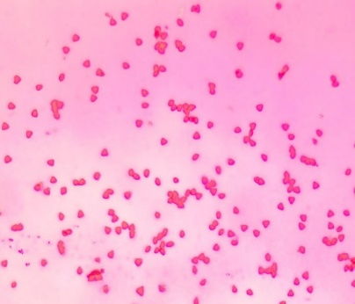 | 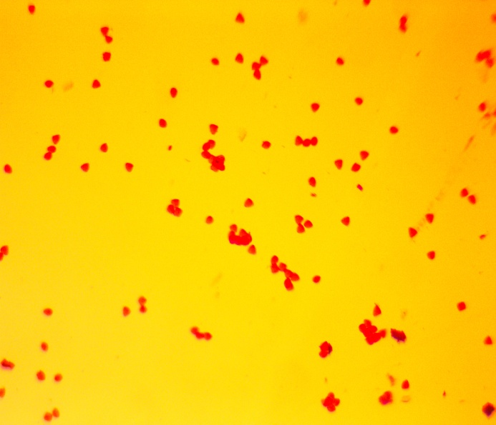 |  | 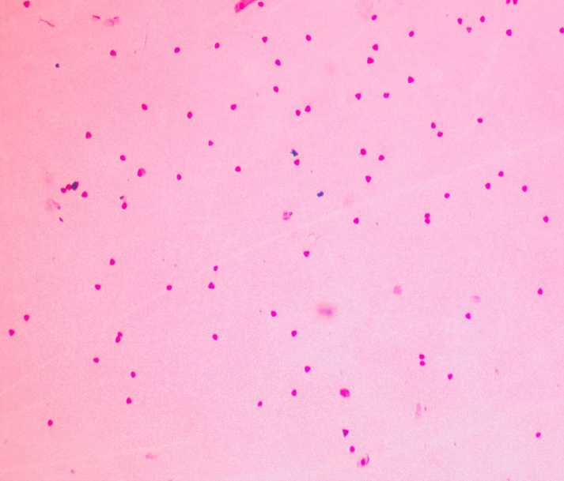
Allahabad safeda | L-49 |  | Shweta
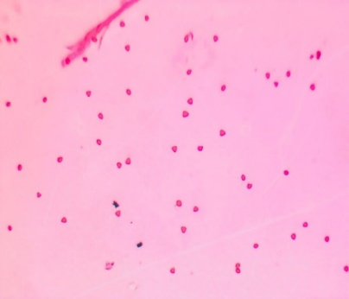 |  | 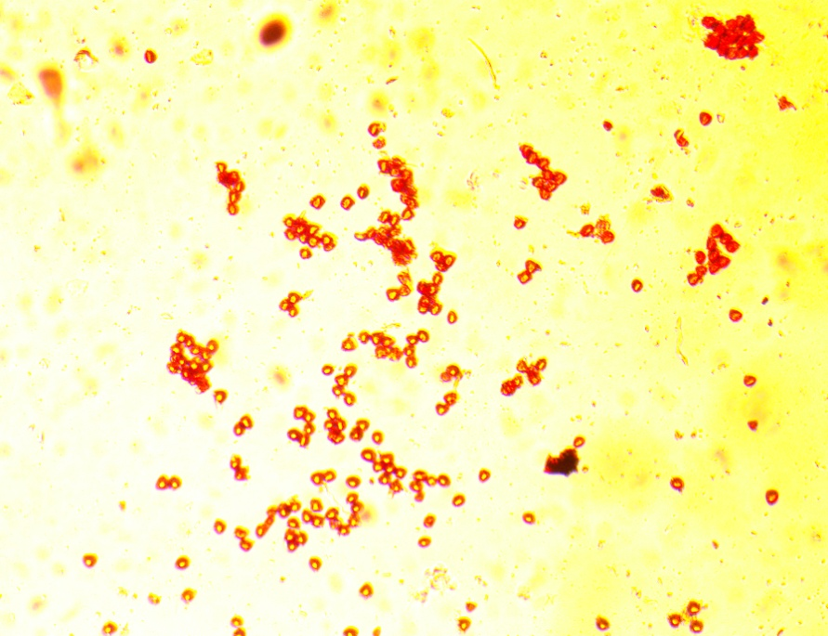
Lalit |  | Yogi
Plate 1 Fresh pollen viability of guava genotypes

Fig. 1 Fresh pollen viability of guava genotypes
Cultivars with higher pollen viability can be effectively used as donor parents in hybridization programs. There are many factors viz., fertility of soil, climatic conditions, genetic constitution etc. Kahlon et al. (1987) observed maximum viability in Sardar (98.90 %), Sarkar and Sarkar (2022) in China cultivar (93.67 %), Tandel et al. (2024) in Lalit (92.96 %) whereas, Singh and Sehgal (1968) and Kundu and Mitra (1994) found maximum viability in Chittidar (96.40 % and 94.32 %, respectively). Similar findings were reported in other fruit crops by Sharma and Bist (2003) in pomegranate, Baswal et al. (2015) in sweet orange, Baswal et al. (2017) in grapefruit, Mandal et al. (2020a) and Das et al. (2021) in mango, emphasizing the role of genetic and environmental factors in pollen viability
  - In vitro pollen germination
Significant differences in pollen germination were observed among varieties during both years, as well as in the pooled analysis. The data are presented in Table 2.
Pollen germination percentage values ranged from 81.18 % to 92.23 % among the five studied varieties/genotypes. The data indicated that the highest pollen germination (91.06 %, 93.40 % and 92.23 %) was observed in Lalit (P₃). It was found to be at par with Allahabad safeda (P₁) (90.42 %, 92.75 % and 91.59 %) and L-49 (P₂) (86.33 %, 89.66 % and 87.99 %) during both years, as well as in the pooled data. In contrast, the lowest pollen germination (79.85 %, 82.52 % and 81.18 %) was recorded in Yogi (P₅), followed by Shweta (P₄) (84.10 %, 85.77 % and 84.94 %) during the years 2023-24 and 2024-25, as well as in the pooled data, respectively. Pollen germination might be varied with the location and media used during germination study. However, Nair et al. (1964), Sarkar et al. (2018) and Tandel et al. (2024) got maximum pollen germination (90.00 %, 87.00 % and 79.52 %, respectively) in Sardar (L-49) cultivar. Singh and Sehgal (1968) and Balasubrahmanyam (1959) found maximum pollen germination (96.10 %) and (98.80 %) in Chittidar, respectively. These results are in similarity to the findings of Nalawadi et al. (1973), Ratanpal and Dhaliwal (1996) and Dhaliwal and Singla (2003), Tewari (1963) and Kahlon et al. (1987).

4. CONCLUSION
On the basis of results obtained from the present investigation, the study of pollen parameters revealed that the best pollen viability was observed in L-49, but germination was highest in Lalit.
Table 2 In vitro pollen germination of guava genotypes
Treatments | Varieties/Genotypes | In vitro pollen germination ( %)
 |  | 2023-24 | 2024-25 |  | Pooled
P₁ | Allahabad safeda (Female) | 90.42 | 92.75 |  | 91.59
P₂ | L-49 (Male) | 86.33 | 89.66 |  | 87.99
P₃ | Lalit (Male) | 91.06 | 93.40 |  | 92.23
P₄ | Shweta (Male) | 84.10 | 85.77 |  | 84.94
P₅ | Yogi (Female) | 79.85 | 82.52 |  | 81.18
S.Em.+ |  | 2.119 | 1.986 |  | 1.452
C.D. at 5 % |  | 6.91 | 6.48 |  | 4.35
C.V. % |  | 4.25 | 3.87 |  | 4.06
 |  | Year |  | Y × T
S.Em.+ |  | 0.918 |  | 2.053
C.D. at 5 % |  | NS |  | NS

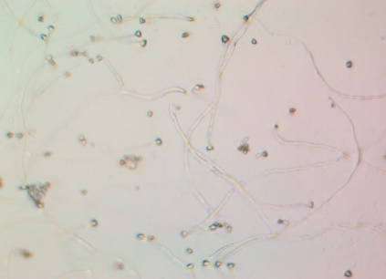 | 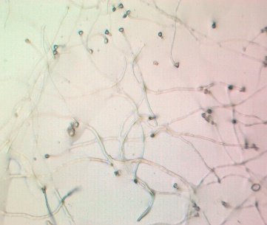 |  | 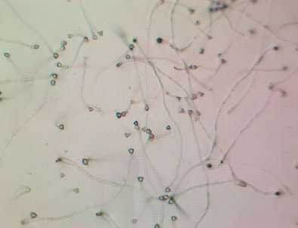
Allahabad safeda | L-49 |  | Lalit
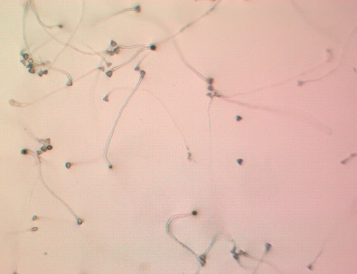 |  | 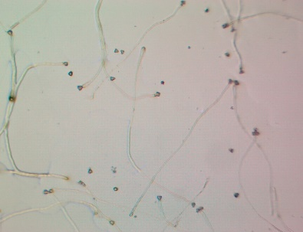
Shweta |  | Yogi
Plate 2 In-vitro pollen germination of guava genotypes

Fig. 2 In vitro pollen germination of guava genotypes

REFERENCES:
Balasubramanyam, V. R. (1959). Studies on blossom biology of guava (Psidium guajava L.). Indian J. Hort., 16: 69-75.
Baswal, A. K., Rattanpal, H. S. and Sidhu, G. S. (2015). Assessment of pollen viability and floral biology in sweet orange (Citrus sinensis Obseck) cultivars under sub-tropical conditions of Punjab. The Bioscan, 10(4): 1573-1576.
Baswal, A. K., Rattanpal, H. S., Singh, G. S. and Uppal, G. S. (2017). Studies on pollen viability and floral biology in grapefruit (Citrus paradisi Mac Fadyen) cultivars under subtropical conditions of Punjab. Ecology Environment and Conservation, 23(1): 381–384.
Das, N. K., Sengupta, S., Singh, R. S., Kumar, S. and Sahay, S. (2021). Effect of pollen viability and germination on fruit set of different mango cultivars. The Pharma Innov. J., 10(7): 1715-1717.
Dhaliwal, G. S. and Singla, R. (2003). Pollen, pollination and fruit set studies in different genotypes of guava in winter and rainy season crops under Ludhiana condition. Haryana J. Hort. Sci., 32(3&4): 159-162.
Jha, M. K., Kumari, P., Sengupta, S., Rani, R., Singh, Y. K. (2020). Study of pollen viability and pollen germination in different cultivars of litchi in sabour Bhgalpur condition. J. Pharmacogn Phytochem. 9(2):1312–1317
Kahlon, P. S., Sharma, P. K. and Rambadi, J. L. (1987). Studies on floral biology of guava (Psidium guajavaL.) cultivar Allahabad Safeda and Lucknow-49. Haryana J. Hort. Sci.,16(1-2): 65-73.
Kundu, S. and Mitra, S. K. (1994). Studies on floral biology of different guava cultivars. Crop Res., 8(1): 80-85.
Mandal, S. K., Karuna, K., Kumar, A., Mankar, A. and Sahay, S. (2020ª). Floral biology andpollen viability of some mango (Mangifera indica L.) cultivars. Int. J. of Curr. Microbiology and App. Sci.,9(6): 2390-2400.
Nair, P. K. K., Balasubrahmanyam, V. R., Khan, H. A. (1964). Palynological investigations of some guava varieties. Indian J. Hort., 21(1):79–84
Nalawadi, W. B., Farooqi, A. A., Reddy, M. A. N., Gubbiah and Nalini, A. S. (1973). Studies on floral biology of guava (Psidium guajava L.) variety Lucknow-49. Mysore J. Agric. Sci.,7: 24-37.
Panse VG, Sukhatme PV. Statistical Methods for Agricultural Workers. 3rd ed. Indian Council of Agricultural Research, New Delhi. p361; 1985.
Ratanpal, H. S. and Dhaliwal, G. S. (1996). Studies on floral biology of guava. In proc. of silver jublee national seminar on arid hort., December, 5-6, CCS HAU, Hisar, pp: 209-211.
Sarkar, T., Sarkar, S. K. and Vangaru, S. (2018). Effect of sucrose and boric acid on in-vitro pollen germination of guava (Psidium guajava) varieties. Advances in Res., 15(1): 1–9.
Sharma, V. K. and Bist, H. S. (2003). Studies on flower and pollen characteristics in some new introduction of plum. Annuals of Agric. Res., 24(1): 40–44.
Silva S. N. D., Silva, M. S., Marcal, T. D. S., Ferreira, A., Fontes, M. M. P., Ferreira, M. F. D. S. (2017). Genetic parameters of pollen viability in guava (Psidium guajava L.). Aust. J. Crop. Sci. 11(1):1–8.
Singh, R. and Sehgal, O. P. (1968). Studies on blossom biology of Psidium guajava L. II. Pollen studies, stigmatal receptivity, pollination and fruit set. Indian J. Hort., 25(1 & 2): 52-59.
Tandel, Y. N., Jadav, H. M., Patel, N., Dangariya, V. D. and Zala, V. R. (2024). Pollen morphological Res. of guava cultivar under south Gujarat condition. Cenet Resour Crop Evol.,https://doi.org/10.1007/s10722-024-02250-6
Tewari, G. N. (1963). Studies on pollen germination in guava (Psidium guajava L.). Hort. Sci., 1: 55-60.

