Original Research Article

Biochar improved physico-chemical properties of ferralitic soils under maize cultivation: case study of Wassande (Adamawa-Cameroon)

ABSTRACT

|  |
| --- |
| Biochar is a carbon-rich product obtained from thermochemical conversion of biomass mostly used for soil enrichment. This study aimed to assess soils fertilizing potential of biochar under maize cultivation in Wassande. The physico-chemical properties of the soil and biochar were analyzed. The results revealed an acidic soil (pH = 5.6) with an average cation exchange capacity (CEC = 11.68 cmol/kg), a moderate sum of exchangeable bases (SEB = 7.5 cmol/kg) and a good saturation rate (V = 64.45%). Furthermore, the analyzed biochar demonstrated a basic pH (9.5) with a moderate CEC (29.5 cmol/kg), a low SEB (2.5 cmol/kg) and a high saturation rate (V = 86.20%). The soil incubation with biochar at 10, 20 and 30% improved the nutrient release rate into the soil and performed significant improvement at 20%. Accordingly, at this optimal concentration, the pH values changed from 5.6 to 9.1, 7.8, 9.4 and 8.4, respectively within 1, 2, 4 and 6 months of incubation time. Similarly, the CEC parameter was progressed from 11.68 to 49.88, 21.14, 31.72 and 44.84 cmol/kg within the same treatment period. Thus, the saturation rate values were moved from 64.45% to 56.31%, 74.54%, 32.00% and 61.50%, while the SEB values were changed from 7.53 to 17.33, 15.68, 10.03 and 26.95 cmol/kg at the same periods of incubation. The field tests were performed on three randomized complete blocks (112.5 m2) with five different treatments: the control (TST), the treatment with chemical fertilizer (NPK 20:10:10) and urea (TNPK), the treatment with 20% of biochar at sowing (TBS), at germination (TBL) and at flowering stage (TBF). The results revealed that the soil amended with biochar was more suitable to maize growth and yield production, especially when the biochar was applied at germination step. For this treatment, after 8 weeks, the plants reached an average height of 138.61±2.44 cm, with an average of 10.47±0.39 leaves per plant. The plot treated at germination stage showed the best yield (9.64 kg), followed by the plot improved under chemical fertilizers (7.41 kg) while the control soil yield was 5.22 kg. Therefore, these findings demonstrated that biochar is an excellent soil quality regulator, improving soil fertility and could be a versatile alternative to the current use of chemical fertilizers in farming practices. |

*Keywords: soil amendment, maize biomass residues, biochar, soil nutrients, yield and growth parameters.*

1. INTRODUCTION

In tropical countries, agriculture is the main income source for the rural sector (Fopoussi *et al*., 2018). This is largely a subsistence agriculture mostly performed with traditional methods and generally with low yields (Tsafack, 2006). Responding to the demographic explosion, the need to ensure survival in tropical countries is constantly intensifying. The result is an intensive exploitation of land for agricultural purposes leading to acidification and susceptibility to erosion (Tematio and Olson, 1997). This determination has logically led, over the years, to rapid and continuous soil desaturation, with a drastic drop in agricultural yields (Tematio and Olson, 1997, FAO, 2004). Nowadays, the need to restore degraded areas and to preserve those that can be sustained represents a major challenge (Fopoussi *et al*., 2018, Tematio *et al*., 2011 and FAO, 2003). The use of petrofertilizers and biofertilizers, among others, has become an established feature of agricultural practices in tropical countries. Thus, the use of products such as biochar is increasing (Novak *et al*., 2010 and Bahouro *et al*., 2023). Due to its adsorption capacity, it constitutes an excellent habitat for microorganisms, particularly bacteria responsible of organic matter decomposition (Thies and Rillig, 2009). Recent studies reported that soil enrichment with biochar favors microorganism activities, good rhizosphere development, reduction of nutrient losses by leaching and, thereby, good plant feeding (Warnock *et al*., 2007 and Liang *et al*., 2006). Moreover, the application of biochar into agricultural soils enhances nutrient retention by improving cation exchange capacity (Lehmann, 2009). Indeed, biochar increases soils nitrogen, phosphorus, potassium and total carbon potential. The use of such materials is well suited to tropical soils, which are mostly subject to leaching processes (Tematio *et al*., 2004; Nguetnkam and Dultz, 2011). This is the case of the ferrallitic soils of Adamawa-Cameroon in general, and those of Wassande in particular. These soils are overused by agriculture and become more depleted over the years with an increasingly low pH (Boutrais, 2000). Although petrofertilizers and biofertilizers are alternatives for the enhancement of soil quality, their availability is still a problem to resolve. In the locality of Wassande, maize crops generate a lot of residues, amount 16942 kg/10 ha and after harvest, most of these remain on the land surface until the next season (Hamagourdo, 2019). It is then rightly important to valorize them, and one of the possibilities is to transform them as biochar. This study aimed to assess biochar’s potential to improve physico-chemical properties of ferralitic soils of Wassande under maize cultivation.

2. materialS and methods

**2.1 Study area**

The study was carried out in Wassande (Adamawa-Cameroon). It is located at latitudes 7°1.44' to 7°7.20' North and longitudes 13°58.32' to 14°7.68' East (**Fig. 1**) and covers almost 363.57 km2. The climate is tropical Sudanian, with two seasons: a dry season of five months, from November to March, and a rainy season of seven months, from April to October (Tchosoua *et al*., 1998). The annual rainfall is between 1500 to 1700 mm. The average interannual temperatures varied from 20 to 22.5°C. Vegetation consists of shrub savannah, herbaceous savannah and gallery forests alongside watercourses, as well as a few anthropic species. The geology is composed of a basement of metamorphic rocks and granitoids related to the Pan-African orogeny (Tchameni *et al*., 2006, cited by Nkouandou *et al*., 2010). The study area is marked by a plateau relief (Saha *et al*., 2018) on which ferralitic soils develop, also known as ferralsols according to the World Reference Base classification (WRB, 2015), more or less indurated and enriched with iron and aluminum sesquioxides (Nguetnkam *et al*., 2002; Feuzeu, 2006). These soils are usually yellowish-red, thick, loose, more or less clayey and porous, nutrient-poor, acidic and very susceptible to erosion (Barkai, 2010; Djoufack, 2011). The period between 1975 and 1989, this area was intensively used for wheat farming, but over the last thirty years, new crops have been introduced. These include peanuts, potatoes and, most notably, maize, the most widely grown crop (DDADRM, 2013).

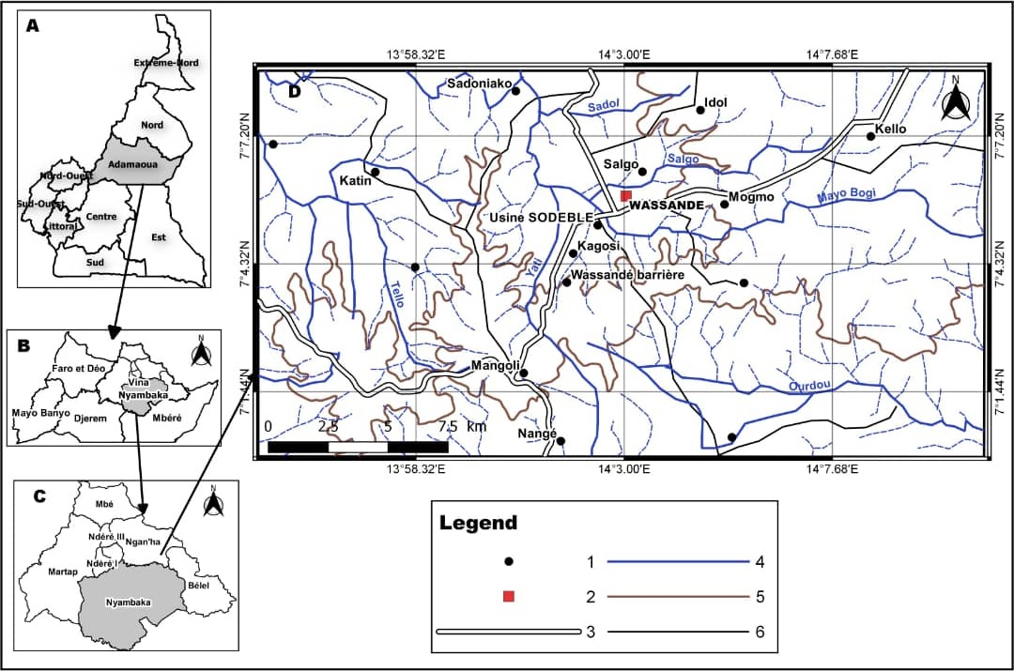

**Fig. 1**. Location of the study area. A. Administrative map of Cameroon indicating the study area in the Adamawa region, B. Administrative map of the Adamawa region showing the different divisions, C. Administrative map of Vina division indicating the study area, D. Map of the study area, 1. Localities, 2. Wassande village, 3. Main Road, 4. Main stream, 5. Curve level, 6. Secondary Road.

**2.2 Materials**

To achieve the objective, this study required: maize residues (stalks, cobs) and the furnace for producing biochar; plastic pots for incubation operations; the shovel for quartering samples, the meter tape for measuring maize growth and yield parameters. The maize seed used for experimental test is the CHH105 (ATP) variety, developed by the Institute of Agricultural Research for Development. This variety has white seeds and a vegetative cycle of 110 to 120 days. Its potential yield is estimated at 5 to 7 tones/ha. NPK fertilizer and 46%N urea were used for treatments during the field tests.

**2.3 Sampling and analytical procedures**

After selecting the study area for its agricultural potential, the work was conducted in several phases, including field investigations, producing biochar and implementing incubation and field tests. The laboratory analysis completed the work, and the findings were further utilized for the next experiment.

**2.3.1 Field investigations and experimentation design**

Following a series of field operations, depleted ferralitic soil plots were identified. A systematic sampling method was used. A total of 100 samples per plot were taken from three plots belonging to three different sites identified (**Fig. 2**). Sampling consisted of taking 1 kg of soil at a regular interval of 1 m between sampling points along the upper horizons (0-25 cm). The samples were air-dried, sieved at 2 mm and 110 kg of this fraction were used for the incubation tests.

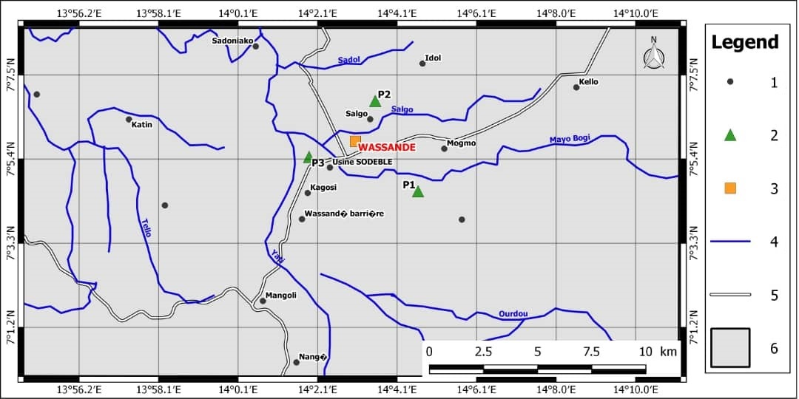

**Fig. 2**. Sampling map presenting the three sites (P1, P2 and P3). 1. Locality, 2. Sampling site, 3. Wassande village, 4. Stream, 5. Road, 6. Delimitation of the study area.

**2.3.2 Production of biochar**

The experimental system used for biochar production is a combustion furnace whose main function is to produce biochar from agricultural residues. It includes three parts: a heating chamber with primary and secondary air intakes, four pyrolysis chambers made of steel drums, and a steel roof with a chimney for smoke exhaust. Two tons of maize residues were calcined at 400°C and 24 kg of biochar removed were sieved to 2 mm for the experimental tests. The different steps of biochar production were illustrated in the **Figure 3**.

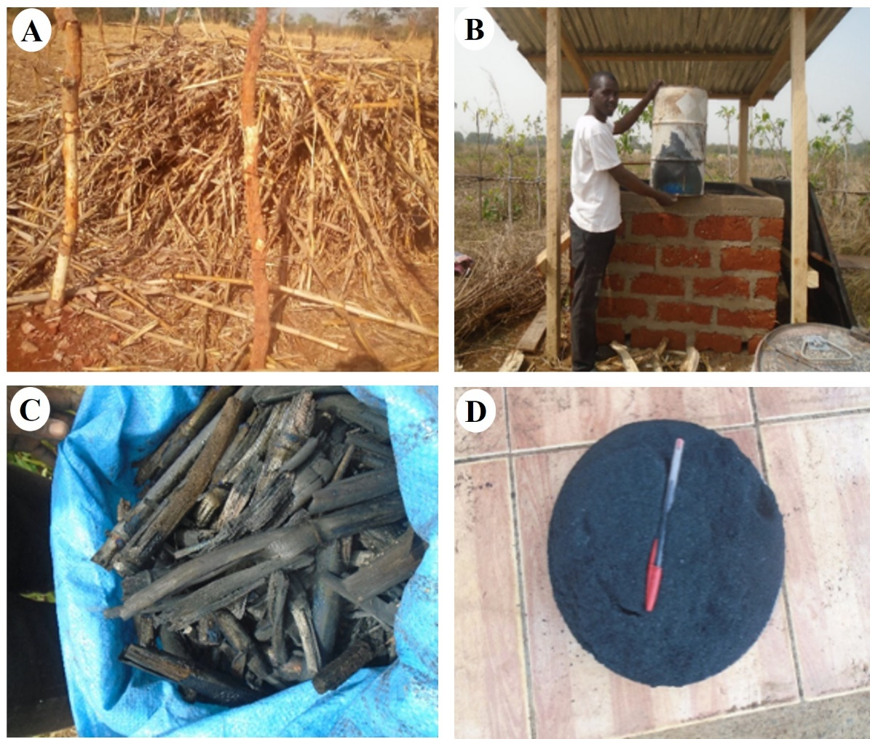

**Fig. 3**. Different steps of biochar production. A. Maize residues, B. Experimental system, C. Biochar produced, D. Fraction sieved at 2 mm to be used for the incubation.

**2.3.3 Experimentation design**

110 kg of soil collected for the incubation tests were homogenized by quartage to obtain a representative sample. 55 kg of the quartered soil are then quartered to produce two series of tests: A and B (**Fig. 4A**). Four treatments were applied to each series: the control (TST) without any addition of biochar, the treatment TB10 with 10% of biochar (100 g of biochar per 1000 g of soil), the treatment TB20 with 20% of biochar (200 g of biochar per 1000 g of soil) and the treatment TB30 with 30% of biochar (300 g of biochar per 1000 g of soil). For field experimentation (**Fig. 4B**), only the 20% biochar input was considered, as it showed the best trend in element release. Randomized complete blocks measuring 15 m x 7.5 m (112.5 m2) were used. Five treatments, each repeated three times, are applied: TST for the control soil (no inputs), TNPK for the soil amended with chemical fertilizers and TBS (at sowing), TBL (at germination) and TBF (at flowering) for the biochar incubation treatments. For the TNPK treatment, 2.4 kg of NPK 20:10:10 fertilizer was applied at germination step and 2.4 kg of urea 46%N at flowering. The maize harvest was carried out after three months.

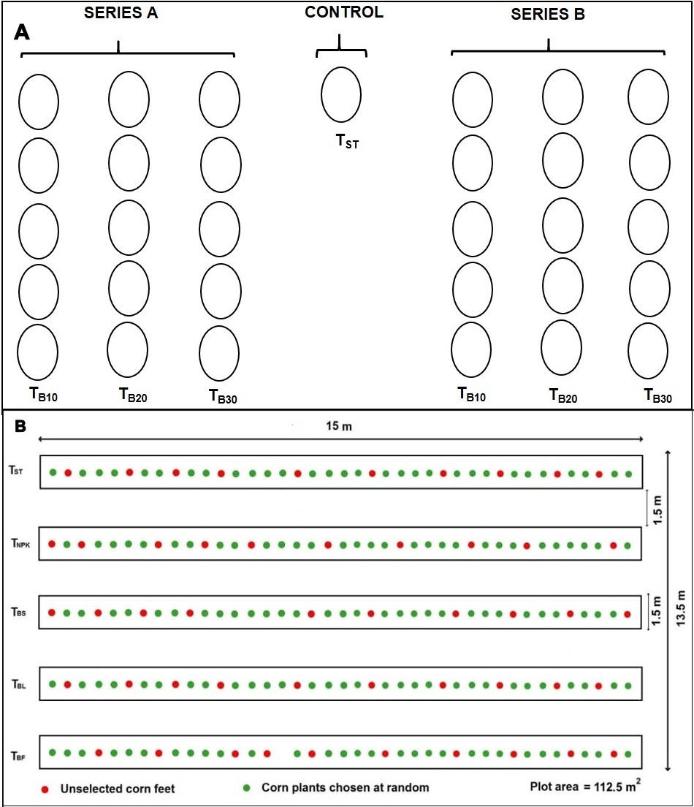

**Fig. 4**. Experimental system: A. Incubation test including two series of three treatments: the treatment with 10% (TB10), 20% (TB20) and 30% (TB30) of biochar plus a control (TST), B. Field investigations in a randomized block involving five treatments: the control (TST), the treatment with chemical fertilizers (TNPK), the treatment by applying biochar at sowing (TBS), at germination (TBL) and at flowering phases (TBF).

**2.3.4 Analytical procedures**

***2.3.4.1******Preliminary investigations***

Laboratory analyses were carried out at Soil Analysis Laboratory of the Faculty of Agronomy and Agricultural Sciences of the University of Dschang. Fourteen samples were analyzed involving a control soil sample, a biochar sample and twelve incubated soil samples obtained from three treatments (10, 20 and 30% of biochar), with one, two, four and six months of incubation. The physico-chemical parameters investigated are: pH, exchangeable bases (Ca2+, Mg2+, K+ and Na+), cation exchange capacity (CEC) and saturation rate (V).

***2.3.4.2 Determination of physico-chemical parameters***

50 g of sample sieved to 2 mm was used for analysis. pH-water is measured on a soil-water solution at a ratio of 1/2.5 using a pH meter fitted with a glass electrode. Exchangeable bases (Ca2+, Mg2+, Na+, K+) are extracted from the soil with an ammonium acetate solution at pH 7, then measured by atomic absorption spectroscopy and flame emission spectrometry (Anderson and Ingram, 1994). CEC was determined in three phases: saturation of the absorbent complex with the NH4+ ion and extraction of exchangeable bases; washing of the soil with alcohol to remove the saturating NH4+ solution filling the pores; and determination of NH4+ by Kjedahl distillation after quantitative desorption with KCl (Anderson and Ingram, 1994). The saturation rate was deduced from the sum of the bases and the total CEC (SEB/CEC* in %) (Anderson and Ingram, 1994). The coefficient of relative richness (CRR) of calcium, magnesium and potassium was calculated on the basis of the rate of each element in the sum of bases, related to the value of the optimal Ca/Mg/K balance, which is 76/18/6.

**2.3.4 Data analysis**

Programs such as Excel and XLSTAT 2022 were used to process data and generate the various graphs. Different maps were generated by using Argis 10.8 and Qgis 1.18 software. The correlation matrixes were generated using Isatis Neo 2021.

3. results

**3.1 Morphology and physico-chemistry of Wassande soils**

The studied soils belong to the ferralitic soil group, formed on basaltic materials and moderately differentiated. Their field characterization demonstrated that they are brown in color, polyhedral in structure and clayey-sandy in texture. They are generally characterized by the horizons dark brown to red in color associated with nodules and rock fragments. The results of the soil sample analyzed (**Table 1**), showed an acid pH (5.6), an average CEC (11.68 cmol/kg), a moderate SEB (7.5 cmol/kg) and an average saturation rate (64.45%). Organic matter (OM) was 3.90 cmol/kg and total nitrogen (Nt) 0.5 cmol/kg.

**Table 1**. Physico-chemical parameters analyzed.

|  |  |  |  |  |  |  |  |  |  |  |
| --- | --- | --- | --- | --- | --- | --- | --- | --- | --- | --- |
| **Parameters** | **pH** | **Ca2+** | **Mg2+** | **K+** | **Na+** | **S** | **CEC** | **OM** | **V** | **Nt** |
| **cmol/kg** | | | | | **%** | | | |
| **Biochar** | 9.50 | 0.10 | 0.01 | 2.24 | 0.15 | 2.50 | 29.50 | 77.77 | 86.20 | 0.55 |
| **Control soil** | 5.60 | 4.96 | 2.08 | 0.34 | 0.15 | 7.53 | 11.68 | 3.90 | 64.45 | 0.50 |

**3.2 Evolution of physico-chemical properties with the addition of biochar**

The input of biochar modified the physico-chemical soil properties (pH, CEC, SEB and V). Moreover, these parameters significantly changed after incubation at 10, 20 and 30% of biochar (**Table 2**).

**Table 2**. Variation of physico-chemical parameters depending for the period and the rate of biochar applied.

|  |  |  |  |  |  |  |  |
| --- | --- | --- | --- | --- | --- | --- | --- |
|  | **Incubation time in months** | **0 month** | **1 month** | **2 months** | **4 months** | **6 months** |  |
| **Treatment at 10%** | **Parameters** | **ST** | **BM1-10** | **BM2-10** | **BM4-10** | **BM6-10** | **SD** |
| Ca2+ (cmol/kg) | 4.96 | 7.76 | 8.42 | 2.58 | 9.40 | 2.80 |
| Mg2+ (cmol/kg) | 2.08 | 2.48 | 4.36 | 1.52 | 3.80 | 1.19 |
| K+ (cmol/kg) | 0.34 | 6.70 | 2.77 | 3.15 | 12.26 | 4.63 |
| Na+ (cmol/kg) | 0.15 | 1.27 | 0.46 | 1.34 | 1.43 | 0.58 |
| SEB (cmol/kg) | 7.53 | 18.21 | 16.01 | 8.59 | 26.59 | 7.77 |
| CEC (cmol/kg) | 11.68 | 38.88 | 29.84 | 29.04 | 39.62 | 11.27 |
| V (%) | 64.45 | 47.44 | 56.90 | 29.50 | 69.50 | 15.81 |
| pH | 5.60 | 7.50 | 7.90 | 7.70 | 7.50 | 0.93 |
| **Treatment at 20%** | **Parameters** | **ST** | **BM1-20** | **BM2-20** | **BM4-20** | **BM6-20** | **SD** |
| Ca2+ (cmol/kg) | 4.96 | 6.96 | 8.44 | 2.20 | 5.20 | 2.35 |
| Mg2+ (cmol/kg) | 2.08 | 2.08 | 4.12 | 1.00 | 2.40 | 1.13 |
| K+ (cmol/kg) | 0.34 | 5.66 | 2.67 | 4.84 | 17.63 | 6.70 |
| Na+ (cmol/kg) | 0.15 | 2.63 | 0.45 | 1.99 | 1.72 | 1.05 |
| SEB (cmol/kg) | 7.53 | 17.33 | 15.68 | 10.03 | 26.95 | 7.55 |
| CEC (cmol/kg) | 11.68 | 49.88 | 21.14 | 31.72 | 44.84 | 15.93 |
| V (%) | 64.45 | 56.31 | 74.54 | 32.00 | 61.50 | 15.86 |
| pH | 5.60 | 9.10 | 7.80 | 9.40 | 8.40 | 1.51 |
| **Treatment at 30%** | **Parameters** | **ST** | **BM1-30** | **BM2-30** | **BM4-30** | **BM6-30** | **SD** |
| Ca2+ (cmol/kg) | 4.96 | 4.96 | 6.36 | 2.48 | 6.40 | 1.59 |
| Mg2+ (cmol/kg) | 2.08 | 1.68 | 1.96 | 1.02 | 2.60 | 0.58 |
| K+ (cmol/kg) | 0.34 | 8.41 | 6.90 | 7.31 | 31.54 | 11.96 |
| Na+ (cmol/kg) | 0.15 | 3.48 | 0.72 | 3.31 | 3.23 | 1.61 |
| SEB (cmol/kg) | 7.53 | 18.53 | 15.95 | 14.12 | 43.77 | 13.91 |
| CEC (cmol/kg) | 11.68 | 28.68 | 24.32 | 32.72 | 64.28 | 19.52 |
| V (%) | 64.45 | 80.25 | 67.80 | 43.00 | 68.50 | 13.57 |
| pH | 5.60 | 9.60 | 9.50 | 9.80 | 9.30 | 1.78 |

ST = control, BM1-10 = incubated sample at 10% after one month, BM2-20 = incubated sample at 20% after two months, BM4-30 = incubated sample at 30% after four months, BM6-30 = incubated sample at 30% after six months, SD = Standard Deviation.

**3.2.1 Effect of biochar application on soil pH**

Studied soils displayed an acidic pH, while the biochar pH was basic. After incubation, this pH varied, depending on incubation time and the amount of biochar applied (**Fig. 5A**). Indeed, after one-month of incubation period, it was positively modified for all treatments, with pH values of 7.5±0.93 at 10%, 9.1±1.51 at 20% and 9.6±1.78 at 30% of biochar. The pH values obtained after two months of incubation were 7.9±0.93, 7.8±1.51 and 9.5±1.78 respectively for the 10, 20 and 30% assays. After 4 months incubation, soil pH values were also changed: 7.7±0.93 at 10%, 9.4±1.51 at 20% and 9.8±1.78 at 30%. Soil pH after 6 months incubation also increased for all treatments. Thus, the recorded pH values were 7.5±0.93; 8.4±1.51; and 9.3±1.78 respectively at 10, 20 and 30% of biochar applied.

**3.2.2 Effect of biochar application on cationic exchangeable capacity (CEC)**

The studied soils depicted a CEC of 11.68 cmol/kg whereas biochar had a CEC of 29.5 cmol/kg. After the incubation of biochar, CEC changed for all treatments and according to incubation time (**Fig. 5B**). After one month of incubation, all treatments showed a significant increase in CEC. For the 10% dosage, the CEC is 38.88±11.27 cmol/kg. At 20%, it increased slightly (CEC = 49.88±15.93 cmol/kg) and decreased relatively at 30% of biochar (28.86±19.52 cmol/kg). After two months of incubation, for all applied dosages, the CEC obtained was 29.84±11.27 cmol/kg for the 10% treatment, 21.14±15.93 cmol/kg for 20% and 24.32±19.52 cmol/kg for the 30% biochar treatment. After 4 months of incubation, CEC increased steadily with biochar proportion increase. For the 10% treatment, it was 29.04±11.27 cmol/kg, at 20%, 31.72±15.93 cmol/kg and at 30%, 32.72±19.52 cmol/kg. After 6 months of incubation, CEC increased significantly for all treatments, and proportionally to the amount of biochar applied. The 10% treatment recorded 39.62±11.27 cmol/kg, the 20% treatment 44.84±15.93 cmol/kg and the 30% treatment 64.28±19.52 cmol/kg.

**3.2.3 Effect of biochar application on sum of exchangeable bases (SEB)**

Analysis results revealed that the sum of exchangeable bases for the control (SEB = 7.5 cmol/kg) was three times greater than the biochar’s sum of exchangeable bases (SEB = 2.5 cmol/kg). This value varied with time and according to the dose of biochar added (**Fig. 5C**). After one month incubation, the SEB increased significantly for all treatments. At 10%, it was 18.21±7.77 cmol/kg, at 20%, 17.33±7.55 cmol/kg and at 30%, 18.53±13.91 cmol/kg. After two months, the values for the SEB recorded were 16.01±7.77 cmol/kg, 15.68±7.55 cmol/kg and 15.95±13.91 cmol/kg, respectively for 10, 20 and 30% dosages. After 4 months incubation, the SEB increased for all treatments compared with the control soil (7.53 cmol/kg). At 10%, SEB = 8.89±7.77 cmol/kg; 10.03±7.55 cmol/kg at 20% and 14.12±13.91 cmol/kg at 30%. The SEB increases significantly for all treatments at 6 months incubation. For the 10% treatment, SEB = 26.59±7.77 cmol/kg is recorded, for the 20% treatment, SEB = 26.95±7.55 cmol/kg and for the 30% treatment, SEB = 43.77±13.91 cmol/kg.

**3.2.4 Effect of biochar application on saturation rate (V)**

The saturation rate of the control soil is lower than that of the biochar (64.45% < 86.20%). The **Figure 5D** depicted the variation in saturation rate depending on the incubation time and the quantity of biochar added. After one month of incubation, high saturation rate was recorded at 30% treatment (80.25±13.57%), while 10 and 20% treatments (47.44±15.81 and 56.31±15.86% respectively) did not exceed the control values (64.45%). After two months of incubation, saturation rate increased at 20% (74.54±15.86%) and 30% (74.54±13.57%), while it did not outperform the control at 10% (56.9±15.81%). After four months of incubation, there was a significant decrease in saturation rate for all treatments: 29.77±15.81% at 10%, 49.65±15.86% at 20% and 43±13.57% at 30%. After six months, saturation rate increased significantly for all treatments: 107.83±15.81% at 10%, 95.42±15.86% at 20% and 106.28±13.57% at 30% treatment.

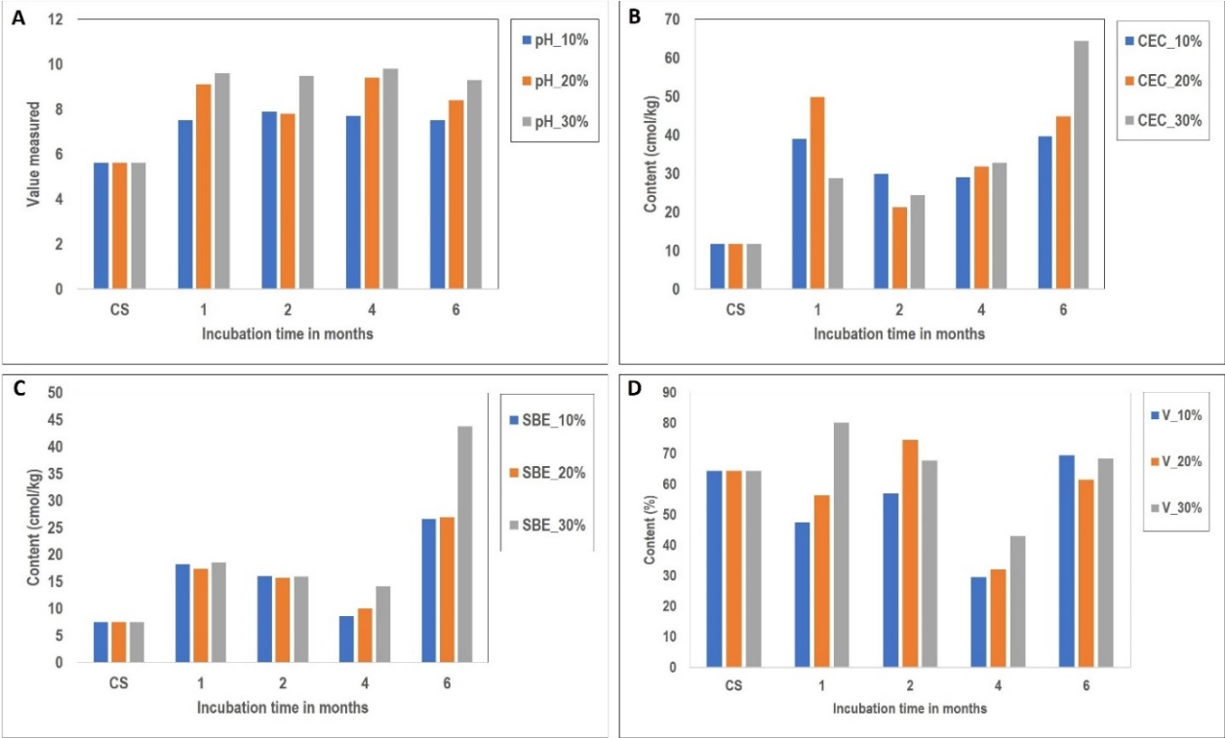

**Fig. 5**. Variation of physico-chemical parameters per treatment: A. pH; B. Cationic Exchange Capacity (CEC); C. Sum of Exchangeable Bases (SEB) and D. Saturation rate (V).

**3.2.5 Effect of biochar application on growth and yield parameters**

Two groups of parameters were studied (**Fig. 6**): growth parameters (plant height, number of leaves, collar diameter) and yield parameters (cob length, cob diameter, number of grains per cob, number of grain lines per cob, quantity of maize produced per treatment unit). Results after two, four, six and eight weeks for the five treatments (TST, TNPK, TBS, TBL and TBF) presented in **Table 5**, revealed that the TBS, TBL and TNPK treatments were more favorable to maize growth than the TST and TBF treatments. The average maximum height (Hmm) of maize plants was reached eight weeks after sowing with Hmm = 77.51±1.34 cm for TST,105±0.39 cm for TNPK, 121.28±3.29 cm for TBS,138.61±2.44 cm for TBL and 77.35±0.27 cm for TBF. Regarding the number of leaves, the average number of leaves per maize plant was 8.08±0.42 for the control (TST), 9.97±0.48 for the soil amended with chemical fertilizers (TNPK), 10.49±0.53 for the treatment of biochar at sowing (TBS), 10.47±0.39 at germination (TBL) and 8.13±0.52 at flowering (TBF). The maximum collar diameter was 2.27±0.12 cm for TST, 2.94±0.23 cm for TNPK, 3.35±0.05 cm for TBS, 3.53 ±0.16 for TBL and 2.09 ±0.16 cm for the TBF treatment. **Table 6** displayed yield parameters (cob’s length, number of grains per cob, quantity produced per plot). It showed the variable average cob length for the different treatments: 10.4±1.33 cm for TST, 16.1±1.71 cm for TNPK, 15.14±1.64 cm for TBS, 17.39±1.05 cm for TBL and 12.26±0.77 cm for TBF. The average number of lines per cob was 10±3 for TST, 12.33 ±2.33 for TNPK, 13.66±2 for TBS, 14±2.33 for TBL and 10.33±2.33 for TBF. The average number of maize grains varied from one treatment to another. The treatment of biochar at germination (TBL) revealed the best trend in terms of the number of grains per cob produced (481.97±45.33), followed by TBS treatment (369.8±56.02), TNPK treatment (324.12±54.71), TBF treatment (214.71±32.66) and finally TST treatment (205.16±33.46). The thousand grains weighted showed similar trend according to the different treatments: 241.01±40.53 g for TBL, 211.53±41.94 g for TBS, 138.81±47.63 g for TBF, 185.32±37.77 g for TNPK and 130.56±37.52 g for the control (TST). These variations in parameters had an impact on the quantity of maize produced. The yield obtained per treatment for a plot of equal surface area (112.5 m2) was 5.22 kg for the TST treatment, 7.41 kg for the TNPK, 7.40 kg for TBS treatment, 9.64 kg for TBL treatment and 5.55 kg for the TBF treatment. The treatment of biochar at germination step (TBL) was the most suitable for maize crops, as it provided for better growth and yield parameters.

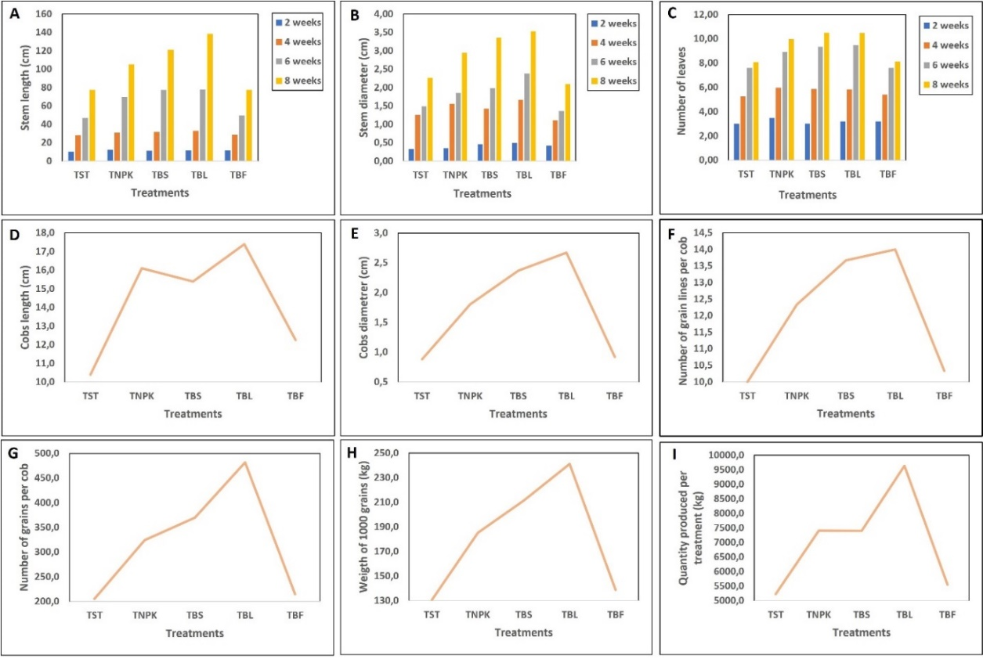

**Fig. 6**. Variation of growth: A. Stem length, B. Stem diameter, C. Number of leaves and yield parameters: D. Cobs length, E. Cobs diameter, F. Number of grain lines per cob, G. Number of grains per cob, H. Weight of thousand grains, I. Maize quantity produced per treatment.

**Table 3**. Variation of growth parameters depending from period and the applied treatment.

|  |  |  |  |  |  |  |  |  |  |  |  |  |  |
| --- | --- | --- | --- | --- | --- | --- | --- | --- | --- | --- | --- | --- | --- |
|  |  | **Plant height (cm)** | | | | **Number of leaves** | | | | **Stem diameter (cm)** | | | |
| **Blocs** | **Treatment** | **2 SAS** | **4 SAS** | **6 SAS** | **8 SAS** | **2 SAS** | **4 SAS** | **6 SAS** | **8 SAS** | **2 SAS** | **4 SAS** | **6 SAS** | **8 SAS** |
| **A** | **TST** | 10.15±1.25 | 28.65±1.34 | 48.85±0.24 | 76.65±1.24 | 3.01±0.21 | 5.61±0.36 | 7.31±0.62 | 8.02±0.56 | 0.43±0.02 | 1.30±0.05 | 1.48±0.12 | 2.08±0.11 |
| **TNPK** | 11.52±0.49 | 32.42±0.53 | 68.42±2.53 | 100.42±0.13 | 3.00±0.43 | 5.80±0.45 | 8.80±0.26 | 9.98±0.55 | 0.49±0.03 | 1.49±0.09 | 1.78±0.23 | 2.88±0.25 |
| **TBS** | 10.25±2.34 | 31.35±3.34 | 77.35±3.04 | 114.35±3.24 | 3.01±0.83 | 5.51±0.87 | 9.41±0.27 | 10.31±0.37 | 0.72±0.02 | 1.32±0.10 | 2.02±0.02 | 3.32±0.13 |
| **TBL** | 11.51±3.26 | 34.41±2.56 | 78.41±2.36 | 123.41±2.62 | 3.03±0.06 | 5.33±0.46 | 9.53±0.36 | 10.13±0.26 | 0.52±0.01 | 1.85±0.01 | 2.35±0.17 | 3.50±0.16 |
| **TBF** | 11.55±0.80 | 29.25±0.40 | 51.25±0.20 | 78.65±0.52 | 3.00±0.80 | 5.10±0.40 | 7.70±0.53 | 8.20±0.62 | 0.46±0.09 | 1.20±0.02 | 1.20±0.02 | 2.02±0.45 |
| **B** | **TST** | 10.75±2.95 | 27.85±1.25 | 45.95±1.34 | 77.25±1.44 | 2.95±0.02 | 5.31±0.26 | 7.61±0.36 | 8.01±0.36 | 0.25±0.03 | 1.03±0.01 | 1.60±0.05 | 2.25±0.12 |
| **TNPK** | 11.52±0.49 | 29.72±0.69 | 69.82±0.53 | 102.32±0.51 | 3.32±0.49 | 6.10±0.43 | 8.90±0.45 | 10.06±0.45 | 0.28±0.09 | 1.29±0.04 | 1.89±0.09 | 3.18±0.23 |
| **TBS** | 12.25±2.34 | 31.15±2.54 | 76.35±3.34 | 118.15±3.30 | 2.85±0.34 | 6.05±0.53 | 9.51±0.27 | 10.55±0.37 | 0.34±0.04 | 1.42±0.02 | 1.92±0.10 | 3.42±0.02 |
| **TBL** | 11.01±29 | 30.61±3.66 | 77.61±2.56 | 131.01±2.16 | 3.51±0.26 | 6.13±0.05 | 9.43±0.36 | 10.53±0.46 | 0.32±0.02 | 1.52±0.01 | 2.25±0.01 | 3.75±0.17 |
| **TBF** | 12.05±0.10 | 27.75±0.90 | 50.55±0.20 | 74.05±0.10 | 3.55±0.80 | 5.48±0.80 | 7.10±0.80 | 8.10±0.40 | 0.35±0.06 | 0.96±0.19 | 1.49±0.08 | 2.07±0.02 |
| **C** | **TST** | 10.45±1.55 | 28.25±1.35 | 45.65±0.34 | 78.65±1.34 | 3.05±0.10 | 4.85±0.94 | 7.88±0.36 | 8.21±0.36 | 0.29±0.02 | 1.43±0.02 | 1.39±0.09 | 2.48±0.14 |
| **TNPK** | 13.12±0.19 | 30.62±0.49 | 70.48±2.58 | 112.42±0.53 | 4.10±0.43 | 6.00±0.47 | 9.02±0.45 | 9.89±0.45 | 0.29±0.05 | 1.89±0.03 | 1.89±0.07 | 2.78±0.23 |
| **TBS** | 11.25±2.14 | 32.35±1.37 | 78.39±2.54 | 131.35±3.34 | 3.21±0.33 | 6.01±0.23 | 9.11±0.87 | 10.61±0.87 | 0.31±0.09 | 1.54±0.02 | 2.02±0.11 | 3.32±0.02 |
| **TBL** | 12.11±0.16 | 33.21±3.26 | 77.46±2.36 | 161.41±2.56 | 3.05±0.43 | 6.03±0.02 | 9.53±0.46 | 10.77±0.46 | 0.62±0.02 | 1.62±0.01 | 2.55±0.05 | 3.35±0.17 |
| **TBF** | 11.35±0.60 | 28.15±0.60 | 47.85±0.32 | 79.35±0.20 | 3.02±0.50 | 5.59±0.20 | 8.03±0.42 | 8.10±0.54 | 0.45±0.04 | 1.16±0.03 | 1.40±0.06 | 2.20±0.02 |

SAS = number of weeks after sowing.

**Table 4**. Variation of yield parameters depending from period and the applied treatment.

|  |  |  |  |  |  |  |  |
| --- | --- | --- | --- | --- | --- | --- | --- |
| **Blocs** | **Treatments** | **Cobs length (cm)** | **Lines number per cob** | **Cob diameter (cm)** | **Grains number per cob** | **Weigth of 1000 maize grains (g)** | **Maize quantity produced (g)** |
| **A** | **TST** | 10.80±0.20 | 10±3 | 0.85±2 | 215.33±45.4 | 131.43±15.50 | 5257.20 |
| **TNPK** | 16.5±0.34 | 12±2 | 1.50±2 | 298.56±55.14 | 185.83±30.07 | 7433.20 |
| **TBS** | 16.30±0.33 | 14±2 | 2.50±3 | 368.47±35.08 | 215.63±20.03 | 7331.42 |
| **TBL** | 17.50±0.27 | 14±2 | 2.75±3 | 459.65±12 | 240.65±40.00 | 9626.00 |
| **TBF** | 15.15±0.46 | 10±3 | 0.90±2 | 208.52±32 | 152.73±34.23 | 6109.20 |
| **B** | **TST** | 10.20±1.37 | 10±3 | 0.89±3 | 198.67±46 | 129.63±62.28 | 5185.20 |
| **TNPK** | 16.38±2.48 | 12±2 | 1.95±2 | 333.18±56 | 182.93±42.31 | 7317.20 |
| **TBS** | 14.47±2.26 | 13±2 | 2.62±2 | 378.39±62 | 210.31±64.45 | 7571.60 |
| **TBL** | 17.42±2.45 | 14±2 | 2.54±2 | 489.43±42 | 247.04±41.38 | 9881.60 |
| **TBF** | 11.61±1.43 | 10±2 | 0.90±3 | 216.20±51 | 130.86±68.52 | 5234.40 |
| **C** | **TST** | 10.21±2.42 | 10±3 | 0.91±3 | 201.48±49 | 130.63±34.79 | 5225.20 |
| **TNPK** | 15.43±2.31 | 13±3 | 1.96±3 | 340.62±53 | 187.21±40.94 | 7488.40 |
| **TBS** | 14.65±2.35 | 14±2 | 1.98±2 | 362.56±71 | 208.65±41.34 | 7302.75 |
| **TBL** | 17.26±0.45 | 14±3 | 2.72±3 | 496.85±82 | 235.45±40.23 | 9418.00 |
| **TBF** | 10.02±0.42 | 11±2 | 0.97±2 | 219.43±15 | 132.85±40.14 | 5314.00 |

**3.3 Statistical data analysis**

The variation generated the standard deviations (SD), used to assess the changes observed for each parameter within the soil. The Pearson test revealed linear relationship between the physico-chemical properties of the soil (**Table 5**) and the yield-growth parameters (**Table 6**). As showed in **Table 2**, analysis of the standard deviations (SD) of physico-chemical parameters revealed a differentiated variability according to elements and biochar application rates. Ca²⁺ displayed high relative SD, particularly for the 10 (2.20) and 20% treatments (2.35), indicating a progressive and variable release of this element into the soil. Mg²⁺ showed moderate variability, suggesting a more regular release due to the effect of biochar. In contrast, K⁺ displayed high SD notably at 30% (11.96), indicating great heterogeneity in its availability, probably linked to its rapid adsorption by the plants and its dynamic interactions with the soil solution. Meanwhile, Na⁺ showed low SD particularly at 10% (0.58), attesting to relative stability and a lesser influence of biochar on this element. CEC showed significant variability, particularly for the 20 (15.93) and 30% treatments (19.52), illustrating the differentiated impact of biochar on soil cation retention. Finally, SEB showed an intermediate dispersion with the high SD at 30% of biochar (13.91), indicating a progressive enrichment in exchangeable cations with biochar. These observations highlight the fact that biochar amendment modifies nutrient dynamics, with more marked effects on the cations essential to soil fertility. This variability justifies the need to optimize doses according to crop needs and intrinsic soil properties, in order to maximize agronomic benefits. Pearson test was used to investigate the correlations between the various parameters and to evaluate the change effect on each other. Variables can be positively correlated when the correlation coefficient is positive or negatively correlated when it is negative. Two correlation matrixes were then obtained: the first (**Table 5**) highlighted the physico-chemical parameters (pH, Na+, K+, Ca2+, Mg2+, CEC, SEB and V), and the second (**Table 6**) the growth [height of plant (HP), number of leaves (NF) and crown diameter (DT)] and yield parameters [cob’s length (LE), cob’s diameter (DE), number of grain lines per cob (NLPE), number of grains per cob (NGPE), thousand-grains weighed (P1000G) and total quantity of maize produced (PTP)]. Concerning the correlations between physico-chemical parameters, the results indicated high positive correlation of CEC with Na+ (r = 0.92) and a moderate positive correlation with pH (r = 0.78), SEB (r = 0.71) and K+ (r = 0.69). SEB revealed high positive relationship with K+ (r = 0.91) as well as Na+ to pH (r = 0.87) and Mg2+ to Ca2+ (r = 0.89). The saturation rate presents positive correlation with Ca2+ (r = 0.86) and Mg2+ (r = 0.88). All the growth and yield parameters present significant positive correlation. Except the correlation between NF and PTP (r = 0.88), all other parameters have their correlation coefficient between 0.9 and 1 (**Table 6**) proving that almost growth and yield parameters depend on each other.

**Table 5**. Pearson correlation showing the relationship between physico-chemical properties.

|  |  |
| --- | --- |
| Ca2+ | 1.00 |
| CEC | 0.02 | 1.00 |
| K+ | -0.11 | 0.69* | 1.00 |
| Mg2+ | 0.89* | -0.24 | -0.07 | 1.00 |
| Na+ | -0.24 | 0.92** | 0.46 | -0.52 | 1.00 |
| pH | -0.17 | 0.78* | 0.42 | -0.27 | 0.87* | 1.00 |
| SEB | 0.31 | 0.71* | 0.91** | 0.29 | 0.39 | 0.40 | 1.00 |
| V | 0.86* | -0.29 | -0.05 | 0.88* | -0.60 | -0.58 | 0.27 | 1.00 |
|  | Ca2+ | CEC | K+ | Mg2+ | Na+ | pH | SEB | V |

*Significant at 0.01 level, **significant at 0.05 level, SEB = Sum of Exchangeable Bases, CEC = Cationic Exchange Capacity, V = Saturation Rate.

**Table 6**. Pearson correlation showing the relationship between growth and yield parameters.

|  |  |
| --- | --- |
| DE | 1.00 |
| DT | 0.98** | 1.00 |
| HP | 1.00** | 0.99** | 1.00 |
| LE | 0.91** | 0.92** | 0.90** | 1.00 |
| NF | 0.97** | 0.98** | 0.95** | 0.93** | 1.00 |
| NGPE | 0.98** | 0.96** | 0.98** | 0.92** | 0.91** | 1.00 |
| NLPE | 1.00** | 0.98** | 0.99** | 0.92** | 0.98** | 0.96** | 1.00 |
| P1000G | 0.99** | 0.98** | 0.99** | 0.93** | 0.95** | 0.99** | 0.99** | 1.00 |
| PTP | 0.94** | 0.94** | 0.95** | 0.94** | 0.88* | 0.99** | 0.92** | 0.97** | 1.00 |
|  | DE | DT | HP | LE | NF | NGPE | NLPE | P1000G | PTP |

*Significant at 0.01 level, ** significant at the 0.05 level, HP = Stem length, NF = Number of leaves, DC = Stem diameter, LE = Cob’s length, DT = Cob’s diameter, NLPE = Number of grain lines per cob, NGPE = Number of grains per cob, P1000G = Thousand-grains weighted, PTP = Maize quantity produced.

4. DISCUSSION

The studied soils are very leached and nutrient-poor inducing their low fertility. This would be linked to their overexploitation with nutrients taken by the plants without restitution. They have an acid pH, average CEC and low exchangeable cations content. It should be noted that these are common properties of oxisoils in general and those of as of Ngaoundere in particular (Middelburg *et al*., 1988). The application of biochar induced a significant pH increase, supporting the conclusions of Lehmann *et al*., (2003), who reported that biochar generally improves the pH of the acid soils due to the liming effect combined with the carbonate salts in biochar ash. Thus, the application of biochar improved the availability of the soil’s nutrients (nitrogen, phosphorus, potassium) for the plant growth and improved crop yields (Glaser *et al*., 2002; Adekiya *et al*., 2022; Azuka *et al*., 2024; Masud *et al*., 2024). In fact, biochar has a high potential for fertilizing, especially in tropical soils, due to its retention capacity (Glaser *et al*., 2002) and its high nutrient content (Lehmann *et al*., 2003). In this work, it is clearly demonstrated that the application of biochar improves the chemical properties of the soils and the crop yield under maize cultivation. The application at germination phase appears to be the best period to improve elements release into the soil and therefore offer better productivity. Mayola *et al*., (2017) and Mounirou (2022) have demonstrated that the soil enrichment at germination step, provides more available nutrients for the plants. These results are in agreement with the findings of Bahouro *et al*., (2023) and Ahmadou *et al*., (2023), respectively in their works on the effect of biochar and compost under maize cultivation in the Sudanian zone of Chad on the one hand, and the influence of biochar and powdered rice straw under maize cultivation in northern Cameroon on the other hand. Indeed, biochar enhances the soil’s CEC which is an important parameter for determining the soil quality. It represents the total capacity of a soil to hold positively charged cations by electrical attraction. Overall, the CEC of the studied soils is improved in all treatments, promoting the plant’s capacity to absorb elements. However, it should be noted that CEC is a parameter closely linked to soil complexes, in particular the clay-humus complex. Thus, CEC in the present study would be specifically linked to the high initial organic matter content of biochar (Liu *et al*., 2012; Lele, 2016; Bahouro *et al*., 2023). The behavior of exchangeable bases (Ca2+, Mg2+, K+) and CEC during incubation shows an increase in both base content and CEC which does not depend on the quantity of biochar added. These results are in contrast to those of Nkouathio *et al*., (2008), who showed that an increase in both base content and CEC is proportional to the concentration of pyroclastic materials added. The most significant concentrations observed in the amended soils are those of Ca2+, followed by Mg2+ and finally K+ as showed in the works of Nkouathio *et al*., (2012) and Adoulko (2018). This indicates a significant release of Ca2+ and Mg2+ from calcined agricultural residues (Nkouathio *et al*., 2012). The low K+ concentration can be attributed to its low proportion in residues (Nkouathio *et al*., 2012; Yaya *et al*., 2015). In general, the use of biochar to amend soils induces a rapid and significant increase in alkali and alkaline-earth cations content (Ca2+, Mg2+, Na+ and K+) which can be explained by their relatively high content in agricultural residues (Nkouathio *et al*., 2012; Yaya *et al*., 2015). The increase in exchangeable bases content correlates positively with the increase in CEC, confirming the relationships between these closely related parameters (Nkouathio *et al*., 2012; Yaya *et al*., 2015; Adoulko, 2018). The SEB is also significantly improved in all biochar treatments. Overall, contents dropped steadily between the second and fourth months, then increased significantly at the sixth month incubation for all doses. This trend could be explained by external factors such as temperature and humidity. The increase in the SEB, which is a function of exchangeable bases, could be linked to the contribution of biochar containing these chemical elements. It is clearly demonstrated that organic amendments release chemical elements to the soil (Diallo, 2005; Maman and Mason, 2013). The improvement in all these soil chemical parameters is closely linked to an increase in its fertility (Tatuebu, 2018; Adoulko, 2018). The addition of biochar ameliorates the saturation rate but it depends from the incubation time and the quantity of biochar added. The CEC is moderately correlated with K+ (r = 0.69), SEB (r = 0.71), pH (r = 0.78), but strongly with Na+ (r = 0.92). It has been established that pH has a significant effect on the CEC. The lower the pH, the lower the CEC; the higher the pH, the higher the CEC with the good capacity to hold nutrients. The whole quantity of maize produced per treatment (PTP) is strongly correlated with thousand-grains weighed (P1000G) for each treatment (r = 0.97), as well as with the number of lines per cob (NLPE) (r = 0.92), cob’s length (LE) (r = 0.94), cob diameter (DE) (r = 0.94) and number of grains produced per cob (NGPE) (r = 0.99). The thousand-grains weights measured indicated that the application of biochar significantly improved grains yield in terms of weight compared to the control. This would be due to the nutrient inputs from the fertilizer materials (Diallo, 2005; Maman and Mason, 2013). It has been demonstrated that the biomass transformation into biochar enhances the plant's soluble nutrients concentration, all of which significantly contribute to the plant’s growth and production (Gangil and Wakudkar, 2013; Wang *et al*., 2028).

**5. CONCLUSION**

This study investigated the effects of biochar from calcined maize residues on soils chemical properties in Wassande (Adamawa-Cameroon). The summarized results revealed that these soils are acid (pH = 5.6) with an average CEC (11.68 cmol/kg), a moderate SEB (7.5 cmol/kg) and a good saturation rate (64.45%). The application of biochar at the concentrations of 10, 20 and 30% induces the improvement of the physico-chemical properties and nutrients status of the amended soils compared to the control. Depending of the investigation tests under maize cultivation, the study recommends the application of biochar at germination step for an optimal productivity and crops yield and enhances the use of agricultural residues in farming practices in general and in Wassande in particular. This would reduce the intensive use of chemical fertilizers which are much more harmful to the environment and people's health.

References

Adekiya, A.O., Adebiyi. O.V., Lower. A.L., Aremu. C., Ajibade. R.O. 2022. Effects of wood biochar and potassium fertilizer on soil properties. growth and yield of sweet potato (Ipomea potato). Hellion. 8(11): e11728.

Adoulko, D. 2018. Morphology and assessment of remineralization of Darang soils (Adamaoua-Cameroon) by Feldspaths. Memory Master. University of Ngaoundéré. 98 p.

Ahmadou , Y. , Simon , B.D. and Nguetnkam, J.P. 2023. Effect of biochar and rice husk powder on maize (zea mays) productivity and soils in Northern Cameroon. Afrimed AJ-Al Awamia. (139). pp. 100-1 85-1

Anderson, J.M. (1999). and Ingram , J.S.I. 1994. Tropical soil biology and fertility: a handbook of methods. Second edition. CAB International. The Cambrian News. Aberstwyth. United Kingdom. 221 p.

Azuka, Vincent, C., Ekette, Oluebube, A. 2024. Biochar particle size contributions to soil chemical properties and nutrient content of degraded Ultisols and plant growth in Nsukka. southeastern Nigeria. Discov. Soil.1. 3.

Bahouro , A. , Abderamane , H. , Djondang , K. , Mahamat , N.Z. and Nguetnkam, J.P. (1999). 2023. Study of the effect of biochar incubation on some physico-chemical properties of a tropical leached soil from south-west Chad. Int. J. Plant Soil Sci. vol. 35. Issue 19. pp. 1840-1851.

Boutrais, J. 2000. The agro-husbandry of Ngaoundéré foulbés (Cameroon Adamaoua); the evolution of relations between agriculture and livestock. Cirad. Agritrop. Cirad-Agritrop.

DDADRM. 2013. Mbéré Departmental Agriculture and Rural Development Delegation. Adamawa-Cameroon.

Diallo, M.D. 2005. Effect Of Litter Quality Of Some Sahelian Plant Species On Nitrogen Mineralization. Doctoral Thesis. Cheikh Anta Diop University of Dakar. Senegal. 168 p.

Djoufack, V. 2011. Multi-scale study of precipitation and vegetation cover in Cameroon: Spatial analyses. Temporal trends. Climatic and anthropogenic factors of NDVI variability. The ocean. Atmosphere. University of Burgundy. French. NNT : tel-00690359.

FAO. 2003. Fertilizers and their applications. 4th edition. Rabat.

FAO. 2004. Use of natural phosphates for sustainable agriculture. Bulletin FAO Fertilizer and Plant Nutrition. 13. Rome.

Feuzeu, W.M.L. 2006. Mineral status of forage plant soils of drainage waters and cattle of Wakwa pasture in Cameroon. Doctoral thesis is food science and nutrition. National Higher School of Agro-Industrial Sciences. University of Ngaoundéré. 253 p.

Fopoussi, T.J.C. 2018. Basga DS. Tematio P. and Nguetnkam JP. Effect of Trachyte Powder. Human Urine and Reserved Water from Cooked Beans on Andosols Fertility in Cameroonian Western Highlands. Asian Journal of Soil Science and Plant Nutrition. 3 (2). 17 p.

Gangil , S. and Wakudkar , H.M. 2013. Generation of biochar from crop residues. International Journal of Emerging Technology and Advanced Engineering. 3(3): 566-5

Glaser , B. , Lehmann , J. , Zech , W. 2002 . A review. Biol Fertile Soils. 35 : 219-3

Hamagourdo, B. 2019. Morphology of Mandourou kolsel soils and their fertilization by maize residue biochar (Adamaoua-Cameroon). Memory Master. University of Ngaoundéré. 91 p.

Lehmann , J. and Joseph , S. 2009 . Science and Technology. Earthscan. London. 405 p.

Lehmann , J. , Pereira da Silva J. , Steiner , C. Nehls , T. Zech , W. and Glaser , B. 2003 . manure and charcoal amendments. Plant and Soil. 249 : 343–5

Lele, N.B. 2016. Potential of Improving the Fertility of Sandy and Acidic Soils of Kinshasa (DRC) by Use of Wood Charcoal (Biochar). of Vegetable Biomass and Mineral Fertilizers. Doctoral Thesis. Regional Post-University School.

Liang , B. , Lehmann , J. , Solomon , D. , Kinyangi , J. , Grossman , J. O'Neill , B. , Skjemstad , J.O. , Thies , J. , Luizao , F.J. , Petersen , J. and Neves , E.G. 2006. Black carbon increases cation exchange capacity in soils. Soil Sci. Soc. of Am. J. 70. p. 1719-1730.

Liu , J. , Schulz , H. , Brandl , S. , Miehtke , H. , Huwe , B. , Glaser , B. 2012 . J Plant Nutr Soil Sci. 175:698-7

Maman, N., Mason, S. 2013. Poultry Manure and Inorganic Fertilizer to Improve Pearl Millet Yield in Niger. Afr. J. Plant Sci. 7 (5). 162-1

Masud, M.M., Baquy, M.A.A., Nkoh Nkoh et al., 2024. Evaluating the potential of different crop straw biochars to capture carbon dioxide and increase the growth of Zea mays L. Discov. Soil. 1. 13.

Mayola, M.M., Leyoly, J., Komanda, J.A. 2017. Effect of biochar and Acacia mangium litter application on maize cultivation in alley cropping on the Batéké Plateau / DRC. International Journal of Innovation and Applied Studies. 19 (4): 897-907.

Middelburg, J.J., Weijden, C.H.V.D. and Woittiez, J.R.W. 1988. Chemical processes affecting the mobility of major, minor and trace elements during weathering of granitic rocks. Chem. Geol. 68: 253-273.

Mounirou, M.M. 2022. Comparative effect of biochar-based fertilization, organic fertilizers and chemical fertilizers on mineral elements and onion (Allium cepa L.) production. European Scientific Journal. ESJ. 18 (24): 47-67.

Nguetnkam, J.P. and Dultz, S. 2011. Soil degradation in Central North Cameroon: Water Dispersable Clay in relation to surface charge in oxisol A and B horizons: Soil & Tillage Research. 113. pp. 38-47.

Nguetnkam, J.P., Kamgan, R., Villieras. F., Ekodeck, G.E and Yvon, J. 2002. Typology of clays in vertisols and fersialitic soils of northern Cameroon. Communication to the French Clay Group (GFA). Paris. Nov. pp. 17-28.

Nkouandou, O.F., Ngounouno, I. and Déruelle, B. 2010. Geochemistry of recent basaltic lavas from the north and east of Ngaoundéré zones (Cameroon. Adamawa Plateau. Central Africa): petrogenesis and the nature of the source. Int. J. Biol. Chem. Sci. 4. 984-1003. (In French).

Nkouathio, D., Wandji, P., Bardintzeff, J.M., Tematio, P., Kagou, Dongmo, A. and Tchoua, F. 2008. Use of volcanic rocks for the remineralization of ferrallitic soils in tropical regions. Case of basaltic pyroclastics from the Tombel graben (Cameroon Volcanic Line). Bull. Soc. Vaud. Sc. Nat. 91.1: 1-14.

Novak, J.M., Busscher, W.J., and Watts, D.W. 2010. Biochar impact on soil moisture storage in an ultisol and two aridisols. Soil Sci. 177:310-20.

Saha, F., Tchio Nkemta, D., Tchindjang, M., Voundi, E., and Mbevo, F.P. 2018. Production of so-called “natural” risks in major urban centers of Cameroon. Natures Sciences Sociétés. Vol. 26. pp. 418-433.

Tatuebu, T.F. 2018. Morphology of Bandjoum soils (West Cameroon) and evaluation of the fertilizing power of basalts in banana cultivation. Master’s thesis. University of Ngaoundéré, Cameroon. 82 p.

Tchameni, R., Pouclet, A., Penaye, J., Ganwa, A.A., and Toteu, S.F. 2006. Petrography and geochemistry of the Ngaoundere Pan-African granitoids in Central North Cameroon: implications for their sources and geological setting. J. of African Earth Sci. pp. 511–529.

Tchotsoua, M. 2008. From spatialization to aid for controlled development in tropical environments. The case of the Adamawa Highlands in Cameroon. Manuscrit Université Editions. 249 p.

Tchotsoua, M., Esoh, E., Mohamadou, G., and Ngana, J.P. 1998. Diagnosis of the state of the environment in Ngaoundéré and contribution to a management approach. In: Proceedings of the Annals of the Faculty of Arts. Letters and Human Sciences from the University of Ngaoundéré. III. pp. 99-144.

Tematio, P. and Olson, K.R. 1997. Impact of industrialized agriculture on land in Bafou. Cameroon. J. of Soil and Water Conservation. Nov-Dec. pp. 404-405.

Tematio, P., Kengni, L., Bitom, D., Hodson, M.H.G. and Tsozue, D. 2004. Soils and their distribution on Bambouto volcanic mountain. West Cameroon highland. Central Africa. Art. Elsevier. J.A.E.S. pp. 447-457.

Tematio, P., Tsafack, El., Kegni, L. 2011. Effects of tillage. Fallow and burning on selected properties and fertility status of andosols in the Mounts Bambouto. West Cameroon. Agricultural Science. 2 (3): 334-340.

Thies, J.E. and Rillig, M. 2009. Characteristics of biochar: biological properties. In: Lehmann, J. and Joseph, S. (eds.). Biochar for Environmental Management: Science and Technology. Earthscan. London. pp. 85-105.

Tsafack, E.R. 2006. Influence of Agricultural Activity (Ploughing, Slash-and-Burning, and Fallow Land) on Soil Fertility Parameters: The Case of Andosols on Trachytes in the Bambouto Mountains (Western Cameroon). Univ. Dschang. Fac. Sci.; 78 p.

Wang, L., Xue, C., Nie, X., Liu, Y., Chen, F. 2018. Effects of Biochar Application on Soil Potassium Dynamics and Crop Uptake. J. Plant Nutr. Soil Sci. 181:635-643.

Warnock, D.D., Lehmann, J., Kuyper, T.W. and Rillig, M.C. 2007. Mycorrhizal responses to biochar in soil concepts and mechanisms. Plant Soil 300. 9-20.

WRB. 2015. World reference base for soil resources. International soil classification system for naming soils and creating legends for soil maps. World Soil Resources Reports. No. 106. FAO. Rome.

Yaya, F., Nguetnkam, J.P., Tchameni, R., Basga, S.D and Penaye, J. 2015. Assessment of the Fertilizing effect of Vivianite on the Growth and yield of the Bean ‘‘phaseolus vulgaris’’ on Oxisoils from Ngaoundere (Central North Cameroon). International Research Journal of Earth Sciences. Flight. 3 (4); pp. 18-26.