Original Research Article
Soil microbial population and enzyme activities as influenced by different nutrient management practices in arecanut and black pepper cropping system of Uttara Kannada district of Karnataka, India

Abstract
A survey was carried out to study the soil microbial population and enzyme activity in arecanut and black pepper gardens at Sirsi, Siddapur and Yellapur taluks of Uttara Kannada district during 2020-21. These gardens were classified based on different nutrient management practices as INM, Organic and ZBNF gardens. The soil samples were collected from rhizosphere of a those selected groups of gardens at two depths 0-15 cm and 15-30 cm. Study revealed that soil biological properties varied significantly among different nutrient management practices and soil depths. The organic areca-black pepper garden has recorded higher bacterial, fungal and actinomycetes population which was on par with ZBNF areca-black pepper gardens. The surface soil has exhibited higher bacterial and fungal population whereas the actinomycetes population was found highest in subsurface soil. Urease activity among different nutrient management practices varied significantly in the order INM > Organic = ZBNF. Whereas dehydrogenase and acid phosphatase activities varied significantly in the order Organic = ZBNF > INM practices. The microbial biomass carbon (MBC) was recorded highest in surface soil than subsurface soil. Similarly, higher MBC was observed in organic areca-black pepper gardens than other gardens at Sirsi, Siddapur and Yellapur taluks.
Keywords: Arecanut, black pepper, nutrient management, bacteria, fungi, actinomycetes, dehydrogenase, acid phosphatase, urease, microbial biomass carbon

Introduction
Arecanut and black pepper is one of the most profitable commercial cropping systems followed in Western Ghats of Karnataka. These gardens are mainly grown in Chikmagalur, Shimoga, Uttara Kannada, Dakshina Kannada and Udupi districts (Indiastat, 2019-20). These areas are characterised by heavy rainfall, altitude variations, temperature fluctuations and other factors. the predominantly acidic laterite soils (Ultisols).
Diverse range of microorganisms live in soils and are responsible for the decomposition of organic matter and the mobilisation of nutrients. Thus, they play an important role in the cycling of nutrients in nature. Further, Soil microbial populations play an influential role in the biological management of soil fertility and productivity.
Microorganisms play an important role in nutrient cycling, as they are both source and a sink for mineral nutrition and can carry out biochemical transformations. (Jenkinson and Ladd, 1981). Microorganisms absorb a portion of nutrients and integrate them into their cells (biomass). Microorganisms control soil nutrient flow by absorbing nutrients, creating soil biomass (immobilisation), and converting carbon, nitrogen, phosphorus and sulphur to mineral forms (mineralization) (Jenkinson and Ladd, 1981; Wani and Lee, 1995).
Variations in is organic C concentration in the soil are also attributed to changes in microbial biomass carbon and biological activity. Furthermore, soil microbial biomass responds more quickly to nutrient management strategies and is frequently employed as a measure of soil quality and health (Ge et al., 2010). The addition of organic manure has a significant impact on microbial populations, which is expected to result in changes in soil organic matter content, which has a direct impact on soil microbial dynamics. (DeForest et al., 2012).
Soil enzymatic activities can be used as an index of soil fertility and functional diversity of microbes (Nannipieri et al., 2002; Maurya et al., 2011) in catalyzing several biochemical reactions which are necessary for their life processes of soil micro-organisms, organic wastes decomposition, organic matter formation and nutrients cycling (Tabatabai, 1994). Urease and phosphatase are two key enzymes in the nitrogen and phosphorus cycles, respectively. (Badiane et al., 2001).
In this background, the purpose of this research was to see how different nutrient management strategies affected soil microorganisms and enzyme activity in the arecanut and black pepper cropping systems.
Materials and methods
Location of the study area:
Uttara Kannada district is located between north latitudes 13⁰ 55’ to 15⁰ 31’ and east longitudes 74⁰ 0’ to 75⁰ 10’ with an altitude of 605 m which falls under hilly and coastal zone (9 and 10). The geographical area is about 10222 Sq. Km dominated by red sandy loam soils having acidic pH. Geographically the study area (Sirsi, Siddapur and Yellapur) lies between 14⁰ 37’ N - 74⁰ 50’ E, 14⁰ 20’ N - 74⁰ 53’ E, 14⁰ 57’ N - 74⁰ 42’ E latitude and longitude respectively. The altitude of the study area is at 611, 564, 541 m above mean sea level respectively. As the arecanut and black pepper growers were spread over large areas of Uttara Kannada, the study was restricted to only these three taluks of Uttara Kannada district.
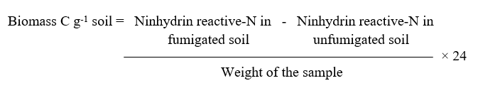
Climate:
The Uttara Kannada district experiences tropical monsoon climate and the weather is hot and humid throughout the year. It receives both South West and North West monsoons. The mean rainfall of the tract is 2500 mm with 103 rainy days in a year. Annually the day temperature averages about 25 hot days with temperature more than 35⁰ C and 124 warm days ranging 30-35⁰ C and remains below 35⁰ C during rest of the year for about 214 days (Agriculture Contingency Plan).
Selection and grouping gardens:
An initial survey was conducted to identify arecanut and black pepper growing farmers who adopted different nutrient management practices. Based on the nutrient management practices, the arecanut gardens were grouped into INM: Integrated nutrient management practices (INM areca gardens), Organic: Organic farming nutrient management practices (organic areca gardens), ZBNF: ZBNF nutrient management practices (ZBNF
areca gardens). (Table 1)

Collection and analysis of samples:
The soil samples were collected from selected three group of arecanut and black pepper gardens at two depths 0-15 cm and 15-30 cm in three taluks. All 180 soil samples (90 from 0-15 cm and 90 from 15-30 cm) were analysed for soil microbial activities. The fresh soil was analysed for microbial population and enzyme activity by standard methods.
The serial dilution plating method was followed to enumerate the microbial population. The enumeration of culturable bacteria, fungi and actinomycetes was done using soil extract agar, Martin’ rose Bengal agar and Kuster‘s agar, respectively (Allen, 1957) and the results were expressed as colony forming units (CFU) per gram dry soil.
Dehydrogenase activity in the soil samples were determined the procedure as described by Casida et al. (1964). Phosphatase activity of soil samples were determined by measuring p-nitro phenol content

(Tabatabai and Bermer, 1969). The urease activity was estimated by following the method of Tabatabai (1984). Soil microbial biomass (SMB) was estimated by fumigation-extraction method given by Carter (1991).
Statistical analysis:
Data obtained during the investigation was subjected for two factorial RCBD. By taking nutrient management practices and soil depth as factors. Statistical analysis was performed at 5 % level of significance using OPSTAT software.

Table 1: Grouping of arecanut - black pepper cropping system based on nutrients inputs

Group of areca - black pepper gardens | Types of organic nutrient sources applied | Types of fertilizers applied | Group of areca - black pepper gardens based on nutrients inputs
INM - areca + black pepper gardens | FYM-10-12 t/ha  Vermicompost- 5-6 t/ha | Urea- 300 kg/ha  Rock phosphate- 200 kg/ha  DAP- 150 kg/ha  SSP- 350 kg/ha  MOP- 300 kg/ha | Integrated nutrient management practice
Organic - areca + black pepper gardens | FYM- 20-25 t ha⁻¹  Vermicompost-10 t ha⁻¹  Green gold OM-2.5 t ha⁻¹  Gold gromin OM-3 t ha⁻¹  Sanjeevini-500 kg ha⁻¹  Sheep manure- 3-3.5 t ha⁻¹  Poultry manure- 2-2.5 t ha⁻¹  Cow dung Slurry- 500 L ha⁻¹ month⁻¹ | ----- | Organic nutrient management practice
ZBNF - areca + black pepper gardens | Jeevamrutha- 1000 L/ ha/ month  Ghanajeevamrutha- 1000kg/ha/yr  Mulching | ----- | Zero budget natural farming - nutrient management practice

Results and discussion
Microbial population of Bacteria, fungi and actinomycetes
Among the three groups of areca - black pepper gardens, organic areca- black pepper garden was recorded significantly higher bacterial population (80.61 X 10⁶ and 79.71 X10⁶) followed by ZBNF (79.34 X 10⁶ and 79.07 X 10⁶) and INM areca - black pepper garden (68.98 X 10⁶ and 73.86 X 10⁶) at Sirsi and Siddapur taluks respectively. Whereas, in Yellapur location, ZBNF areca - black pepper gardens observed higher bacterial population (80.51 X 10⁶) and it was on par with organic areca - black pepper gardens. However, Lower bacterial population was recorded in INM areca- black pepper gardens (68.98 X 10⁶, 73.86 X 10⁶, 73.47 X 10⁶) at Sirsi, Siddapur and Yellapur respectively. (Table 2).
Significantly higher fungal population (8.67 X 10⁴) was noticed under ZBNF areca- black pepper gardens at Sirsi location. Similar trend was observed in Yellapur (8.21 X 10⁴) and which was on par with organic areca - black pepper gardens. Whereas, in Siddapur higher fungal population (8.58 X 10⁴) was recorded under organic areca - black pepper gardens and it was on par with ZBNF areca - black pepper gardens. However, fungal population was lower in INM areca - black pepper gardens (5.94 X 10⁴, 6.66 X 10⁴ and 6.46 X 10⁴ respectively) at all three taluks.
The actinomycetes population was differed significantly among different nutrient management practices. Significantly higher actinomycetes population (29.78 X 10⁵) was recorded in ZBNF areca- black pepper gardens soils compared to other areca - black pepper gardens soils. However, the least population was found in INM areca- black pepper gardens (24.68 X 10⁵) at sirsi location. Similarly, Siddapur and Yellapur soils was recorded higher (30.22 X 10⁵ and 32.05 X 10⁵) actinomycetes population in organic areca - black pepper gardens.
The surface soil recorded significantly higher population of bacterial fungal and actinomycetes activity compared to subsurface soils at all the three taluks of entire study area.
The treatment which received exclusively organic manures had significantly more influence on the population of bacteria, fungi and actinomycetes than combined application of organic and inorganic application (Karikatti et al., 2020). The reason behind this could be to the enhanced organic carbon content of the soil as a result of organic manure application as compared to inorganic fertilizers. Besides this, the application of organic manure would have resulted in increased secondary and micronutrients in the soil, which might have helped to increase the microbial population. The carbon acts as a source of energy for microbes and ferments organics that results in quick build-up of microflora and fauna. This leads to activation of soil microflora viz. bacteria, actinomycetes and fungi that are present in soil. The organic manure addition would have resulted in increased secondary and micronutrients in the soil which might have helped to increase the microbial population. The results are analogous with findings of Reddy et al. (2000).
Soil enzyme activity
Soil enzyme activity is an indirect indication on the activities of microbes which is directly correlated with soil microbial population. In the present investigation, significantly increased enzyme activity of urease, dehydrogenase, and alkaline phosphatase was noticed (Table 3).
Dehydrogenase activity
The metabolic status of soil microorganisms is measured by the activity of dehydrogenase enzymes. Dehydrogenase can thus be employed as a reliable indicator of microbial activity in soil and a measure of microbial respiration. (Tejada et al., 2011). The dehydrogenase activity was found significantly higher in soils of organic areca - black pepper gardens (20.53 and 18.82 μg of TPF g⁻¹ 24 h⁻¹) at Sirsi and Yellapur respectively compared to ZBNF and INM areca- black pepper gardens. But with respect to Siddapur, ZBNF gardens soils recorded higher (20.83μg of TPF g⁻¹ 24 h⁻¹) enzyme activity.

While least activity was found in INM areca- black pepper gardens (16.46, 18.13 and 16.25 μg of TPF g⁻¹ 24 h⁻¹) at all the three taluks respectively. The dehydrogenase activity was significantly higher at surface soil (20.66 μg of TPF g⁻¹ 24 h⁻¹) compared to subsurface soils (17.57 μg of TPF g⁻¹ 24 h⁻¹) at Sirsi. Similarly, same trend was noticed at Siddapur (21.01 μg of TPF g⁻¹ 24 h⁻¹) and Yellapur (19.34 μg of TPF g⁻¹ 24 h⁻¹) taluks. The higher dehydrogenase activity after addition of organic manures could be due to increased microbial activity, which is known to stimulate the dehydrogenase activity (Watts et al., 2010).
Acid phosphatase activity
Acid phosphatase is a highly useful enzyme in agriculture because it hydrolyzes organic phosphorus molecules and converts them to inorganic phosphorus that plants can use. (Maestre et al., 2011). Among different areca- black pepper gardens practicing different nutrient management, the organic areca - black pepper gardens recorded higher (23.72 and 20.72μg PNP g⁻¹ h⁻¹ respectively) phosphatase activity at Siddapur and Yellapur taluks, whereas, ZBNF areca- black pepper gardens recorded higher (18.82 μg PNP g⁻¹ h⁻¹) acid phosphatase activity at Sirsi. However, in all three location, INM areca- black pepper gardens showed lowest activity of acid phosphatase (16.25, 19.66, 18.20 μg PNP g⁻¹ h⁻¹) respectively. The surface soil of Sirsi, Siddapur and Yellapur taluk recorded highest acid phosphatase activity (19.36, 23.28 and 20.24 μg PNP g⁻¹ h⁻¹ respectively) than the subsurface soil (16.42, 21.40 and 19.18μg PNP g⁻¹ h⁻¹ respectively).
This might be due to higher organic manure application which would have favoured more microbial populations ultimately more enzyme activity. The results of the present study were very close to the observations made by Krishnakumar et al. (2005). Sriramachandrasekharan and Ravichandran (2011) also reported that organic matter added to the soil provided a carbon supply that increased microbial biomass and phosphatase activity.
Urease activity
Urease is a key enzyme that converts urea fertiliser into NH₃ and CO₂, resulting in a rise in soil pH (Byrnes and Amberger, 1989). INM areca- black pepper garden soils recorded significantly higher urease activity (115.47, 121.29, 117.64µg NH4⁺ released g⁻¹ soil hr⁻¹) compared to other areca - black pepper garden soils at all the three taluks respectively. While, least urease activity was found in ZBNF areca- black pepper gardens (111.19, 115.37, 114.37µg NH4⁺ released g⁻¹ soil hr⁻¹) at Sirsi, Siddapur and Yellapur taluks respectively. The urease enzyme activity was found significantly higher in surface soil (115.76, 120.34, 118.17 µg NH4⁺ released g⁻¹ soil hr⁻¹) of Sirsi, Siddapur and Yellapur taluks respectively than subsurface soils. Higher urease activity in INM areca gardens may be due to high use of fertilizer inputs including urea. Thus, present study results indicated that the higher availability of substrate nitrogen (Urea) and other nutrients, which promoted the urease activity (Shen et al., 2010). The fact that organic manures and fertilisers are only applied to the surface layer may explain the lower urease activity in subsurface layers (Rao and Ghai, 1989).
Soil organic carbon and Microbial biomass carbon
Soil organic carbon content was significantly differed between different nutrient management practices was presented in Figure 1. The organic areca - black pepper gardens recorded significantly higher soil organic carbon content (1.16 %, 1.20 % and 1.19 %) compared to other nutrient management practices at Sirsi, Siddapur and Yellapur respectively. This was mainly attributed to higher amount organic input application. Such increase in SOC due to fertilizer and FYM application was reported by Nagaraja (1997). Whereas, lower soil organic carbon content was noticed in INM areca- black pepper gardens (0.90, 1.07 and 1.08 %) respectively at all three taluks of Uttara Kannada district.
Soil microbial biomass carbon (MBC) is the most active and dynamic pool of the soil organic matter, acts as transient nutrients sinks and is responsible for releasing nutrients from organic matter for use by plants. Significantly higher MBC was observed in organic areca - black pepper gardens (276.93, 285.83 and 283.51 mg kg⁻¹ respectively) at Sirsi, Siddapur and Yellapur taluks. Lower MBC (263.86, 263.81 and 263.87 mg kg⁻¹ respectively) was observed in INM areca- black pepper gardens at all three taluks. Similarly, the content of MBC was significantly higher in surface soil (279.95, 283.70 and 282.36 mg kg⁻¹ respectively) as compared to subsurface soil (263.19, 265.75 and 264.33 mg kg⁻¹ respectively) at all three taluks.
The variations in soil MBC among different nutrient management practices may be attributed to variation in soil organic matter content consequently the microbial activity. Further the variation in SOM may be attributed to variation in residue return to soil and addition of manure. The application of manure had a positive effect on soil organic matter content, which in turn decides the SMBC (Asha, 2016). Similar results have been reported by Geo Jose (2006) and Collins et al., 1992, in the FYM applied plots of long term manurial trial in Alfisol under rice pulse cropping systems.
Conclusion
It was observed from the current study that in organic areca-black pepper gardens due to higher application of organic nutrient sources resulted in higher organic carbon accumulation which resulted in higher microbial population. According to the population of microbes their enzyme activity was also recorded higher in organic gardens which was on par with ZBNF areca-black pepper gardens compared INM areca-black pepper gardens. Higher the application of organic sources, higher the accumulation of organic carbon in soil which is source of nutrients for soil microbial population this resulted in more Microbial biomass carbon in organic and ZBNF areca-black pepper gardens at entire study area. overall soil health was very well maintained in these nutrient management practice.

Table 2: Effect of different nutrient management practices on microbial population of bacteria, fungi and actinomyceters in soils of arecanut and black pepper cropping system
Group of areca - black pepper gardens | Bacterial count (10⁶)
Group of areca - black pepper gardens | Sirsi |  |  | Siddapur |  |  | Yellapur
Group of areca - black pepper gardens | 0-15 cm | 15-30 cm | Mean | 0-15 cm | 15-30 cm | Mean | 0-15 cm | 15-30 cm | Mean
INM - areca + black pepper gardens | 71.46 | 66.50 | 68.98 | 76.12 | 71.60 | 73.86 | 75.74 | 71.21 | 73.47
Organic areca + black pepper gardens | 82.43 | 78.80 | 80.61 | 81.12 | 78.30 | 79.71 | 81.65 | 77.44 | 79.55
ZBNF areca + black pepper gardens | 80.94 | 77.73 | 79.34 | 81.50 | 76.64 | 79.07 | 83.29 | 77.74 | 80.51
Mean | 78.28 | 74.34 |  | 79.58 | 75.51 |  | 80.26 | 75.49
Interaction | M | D | M x D | M | D | M x D | M | D | M x D
S. Em. ± | 0.71 | 0.58 | 1.00 | 1.22 | 1.00 | 1.73 | 0.70 | 0.57 | 0.99
CD at 5% | 2.02 | 1.65 | NS | 3.50 | 2.85 | NS | 2.00 | 1.63 | NS
 | Fungi count (10⁴)
INM - areca + black pepper gardens | 6.56 | 5.32 | 5.94 | 6.91 | 6.41 | 6.66 | 6.71 | 6.21 | 6.46
Organic areca + black pepper gardens | 8.60 | 7.54 | 8.07 | 8.90 | 8.26 | 8.58 | 8.41 | 7.96 | 8.19
ZBNF areca + black pepper gardens | 9.31 | 8.03 | 8.67 | 8.78 | 8.03 | 8.41 | 8.58 | 7.83 | 8.21
Mean | 8.16 | 6.96 |  | 8.20 | 7.57 |  | 7.90 | 7.33
Interaction | M | D | M x D | M | D | M x D | M | D | M x D
S. Em. ± | 0.12 | 0.10 | 0.17 | 0.09 | 0.08 | 0.13 | 0.08 | 0.06 | 0.11
CD at 5% | 0.35 | 0.29 | NS | 0.26 | 0.22 | NS | 0.22 | 0.18 | NS
 | Actinomycetes count (10⁵)
INM - areca + black pepper gardens | 23.68 | 25.68 | 24.68 | 24.03 | 26.10 | 25.07 | 24.12 | 29.56 | 26.84
Organic areca + black pepper gardens | 27.80 | 29.31 | 28.55 | 28.18 | 32.26 | 30.22 | 29.251 | 34.84 | 32.05
ZBNF areca + black pepper gardens | 28.94 | 30.61 | 29.78 | 29.16 | 30.22 | 29.69 | 28.396 | 32.84 | 30.62
Mean | 26.81 | 28.53 |  | 27.12 | 29.53 |  | 27.26 | 32.41
Interaction | M | D | M x D | M | D | M x D | M | D | M x D
S. Em. ± | 0.33 | 0.27 | 0.47 | 0.35 | 0.28 | 0.49 | 0.65 | 0.53 | 0.91
CD at 5% | 0.95 | 0.78 | NS | 0.99 | 0.81 | 1.41 | 1.85 | 1.51 | NS
M- Nutrient management practice D- Soil depth

Table 3: Effect of different nutrient management practices on enzyme activities in arecanut and black pepper cropping system

Group of areca - black pepper gardens | Dehydrogenase (µg TPF d⁻¹ g⁻¹)
Group of areca - black pepper gardens | Sirsi |  |  | Siddapur |  |  | Yellapur
Group of areca - black pepper gardens | 0-15 cm | 15-30 cm | Mean | 0-15 cm | 15-30 cm | Mean | 0-15 cm | 15-30 cm | Mean
INM - areca + black pepper gardens | 17.26 | 15.66 | 16.46 | 19.74 | 16.53 | 18.13 | 17.23 | 15.27 | 16.25
Organic areca + black pepper gardens | 22.98 | 18.09 | 20.53 | 21.92 | 17.88 | 19.90 | 20.70 | 16.93 | 18.82
ZBNF areca + black pepper gardens | 21.74 | 18.97 | 20.35 | 21.35 | 20.30 | 20.83 | 20.09 | 17.06 | 18.58
Mean | 20.66 | 17.57 |  | 21.01 | 18.24 |  | 19.34 | 16.42
Interaction | M | D | M x D | M | D | M x D | M | D | M x D
S. Em. ± | 0.43 | 0.35 | 0.61 | 0.51 | 0.42 | 0.72 | 0.55 | 0.45 | 0.78
CD at 5% | 1.23 | 1.00 | 1.73 | 1.46 | 1.19 | NS | 1.58 | 1.29 | NS
 | Phosphatase (µg PNP g⁻¹h⁻¹)
INM - areca + black pepper gardens | 17.23 | 15.27 | 16.25 | 20.48 | 18.84 | 19.66 | 18.86 | 17.53 | 18.20
Organic areca + black pepper gardens | 20.09 | 17.06 | 18.58 | 24.96 | 22.47 | 23.72 | 21.03 | 20.41 | 20.72
ZBNF areca + black pepper gardens | 20.70 | 16.93 | 18.82 | 24.40 | 22.89 | 23.65 | 20.85 | 19.59 | 20.22
Mean | 19.34 | 16.42 |  | 23.28 | 21.40 |  | 20.24 | 19.18
Interaction | M | D | M x D | M | D | M x D | M | D | M x D
S. Em. ± | 0.55 | 0.45 | 0.78 | 0.36 | 0.30 | 0.51 | 0.33 | 0.27 | 0.47
CD at 5% | 1.58 | 1.29 | NS | 1.04 | 0.85 | NS | 0.94 | 0.77 | NS
 | Urease (µg NH4⁺ released g⁻¹ soil hr⁻¹)
INM - areca + black pepper gardens | 119.72 | 111.21 | 115.47 | 125.87 | 116.72 | 121.29 | 119.03 | 116.24 | 117.64
Organic areca + black pepper gardens | 114.32 | 113.16 | 113.74 | 117.05 | 114.00 | 115.53 | 119.44 | 111.49 | 115.47
ZBNF areca + black pepper gardens | 113.24 | 109.14 | 111.19 | 118.10 | 112.64 | 115.37 | 116.03 | 112.70 | 114.37
Mean | 115.76 | 111.17 |  | 120.34 | 114.45 |  | 118.17 | 113.48
Interaction | M | D | M x D | M | D | M x D | M | D | M x D
S. Em. ± | 0.59 | 0.48 | 0.83 | 0.82 | 0.67 | 1.16 | 0.86 | 0.70 | 1.22
CD at 5% | 1.68 | 1.37 | 2.37 | 2.34 | 1.91 | 3.32 | 2.47 | 2.01 | NS
M- Nutrient management practice D- Soil depth

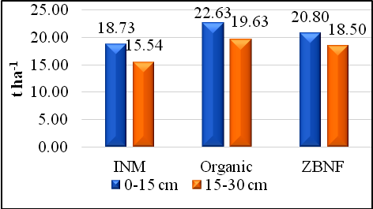
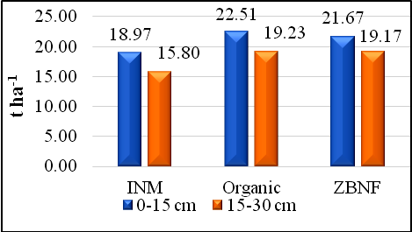
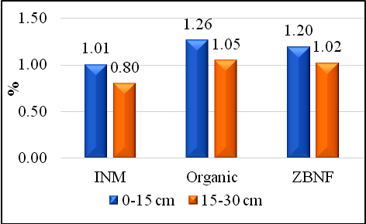
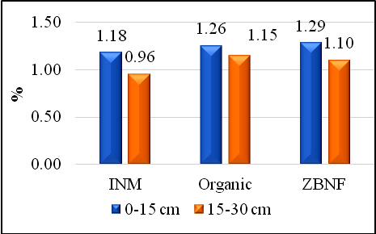
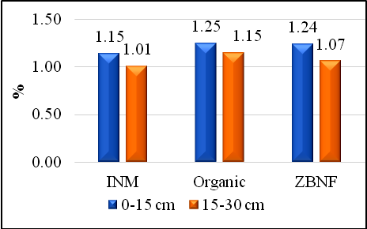
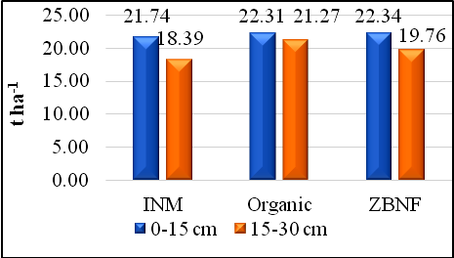

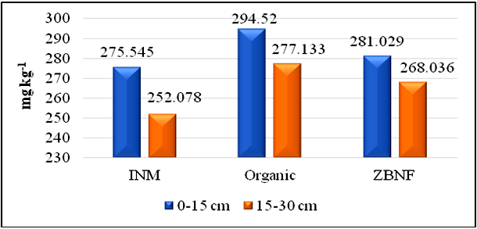
a) Soil OC at Sirsi b) Soil OC at Siddapur c) Soil OC at Yellapur
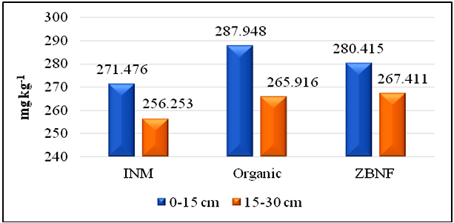
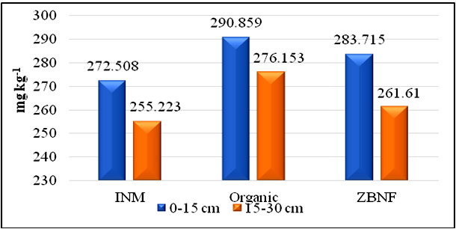

d) MBC at Sirsi e) MBC at Siddapur f) MBC at Yellapur

Figure 1: Effect of different nutrient management practices on soil organic carbon and carbon stock in arecanut and black pepper cropping system

REFERENCE
Allen, O. N. 1957, Experiments in soil bacteriology. Burgress Publication Co. Minneapolis. Minn., U.S.A: 117.
Asha, S. S., 2016, Impact of land use systems on nutrient and carbon distribution in soils of Thirthahalli Taluk, Shivamogga district. M.Sc. (Agri.) Thesis, UAHS., Shivamogga, Karnataka, India.
Badiane, N. N. Y., Chotte, L., Pate, E., Masse, D. and Rouland, C. 2001. Use of soil enzyme activities to monitor soil quality in natural and improved fallows in semi-arid tropical regions. Applied Soil Ecology. 18: 229-238.
Byrnes, B. H. and Amberger, A. 1989. Fate of broadcast urea in a flooded soil when treated with N-(n-butyl) thiophospheric triamide, a urease inhibitor. Fertil. Res. 18: 221-231.
Carter, M. R., 1991, Ninhydrin reactive –N released by the fumigation extraction method as a measure of microbial biomass under field conditions. Soil Biol. Biochem., 23: 139-143.
Casida, L. E., Klein, D. A. and Santoro, T., 1964, Soil dehydrogenase activity. Soil Sci., 98: 371-376.
Collins, H. P., Rasmussen, P. E. and Douglas, C. L., 1992, Crop rotation and residual management – effects on soil carbon and microbial dynamics. Soil Sci. Soc. Am. J., 56: 783-788.
DeForest, J. L., Smemo, K. A., Burke, D. J., Elliott, H. L. and Becker, J. C. 2012, Soil microbial responses to elevated phosphorus and pH in acidic temperate deciduous forests. Biogeochemistry. 109: 189- 202.
Ge, G., Li, Z. Fan, F., Chu, G., Hou, Z. and Liang, Y. 2010, Soil biological activity and their seasonal variations in response to longterm application of organic and inorganic fertilizers. Plant Soil. 326: 31-44.
Geo jose., 2006, Organic carbon distribution in soils under longterm rice cropping systems in coastal and southern dry zones of Karnataka, M.Sc (Agri.) Thesis, UAS., Bangalore (India).
Jenkinson, D. S. and Ladd, J. N., 1981, Microbial biomass in soil measurement and turnover. In: Paul, E.A., Ladd, J.N. (Eds.), Soil Biochemistry. Marcel Dekker, New York, USA, pp. 415–471.
Karikatti, P., Bhat, S. N., Balanagoudar, S. R., Mastanareddy, B. G., Veeresh, H., and Satyanarayana Rao, 2020, Long term effect of Organic, Integrated and Inorganic Nutrient Management Practises on Soil Properties in a Vertisol. Int. J. Curr. Microbiol. App. Sci., 9(01).
Krishnakumar, S., Saravanan, A., Natarajan, S. K., Veerabadran, V. and Mani, S. 2005, Microbial population and enzymatic activity as influenced by organic farming. Research J. Agri. Biol. Sciences. 1(1): 85-88.
Maestre, F. T., Puche, M. D., Guerrero, C. and Escudero, A. 2011, Shrub encroachment does not reduce the activity of some soil enzymes in Mediterranean semiarid grasslands. Soil Biol. & Biochem. 43: 1746- 1749.
Maurya, B. R., Vimal, S. and Dhyani, P. P. 2011, Enzymatic activities and microbial population in agri-soils of Almora district of central Himalaya as influenced by altitudes. Internat. J. Soil Science. 6: 238- 248.
Nagaraja, M. S., 1997, Biomass turnover, nutrient status and biological processes among different land use systems. Ph.D. Thesis, UAS., Bangalore.
Nannipieri, P., Kandeler, E. and Ruggiero, P. 2002, Enzyme activities and microbial and biochemical processes in soil. In: Burns, RG and Dick RP (Eds.), Enzymes in the Environment: Activity, Ecology and Applications. Marcel Dekker, New York:1-33.
Rao, D. L. N. and Ghai, S. K. 1989, Urease and dehydrogenase activity of alkali and reclaimed soils. Australian J. Soil Res., 23: 661-665.
Reddy, M. N., Devi, M. C., Sridevi, N. V., 2000, Evaluation of turmeric cultivars for VAM colonization. Indian Phytopathol. 56(4):465-466.
Shen, W., Lin, X., Shi, W., Min, J., Gao, N., Zhang, H., Yin, R. and He, X., 2010, Higher rates of nitrogen fertilization decrease soil enzyme activities, microbial functional diversity and nitrification capacity in a Chinese polytunnel greenhouse vegetable land. Plant Soil., 337: 137–150.
Sriramachandrasekharan, M. V. and Ravichandran, M. 2011. Enzyme dynamics and soil properties in paddy soil fertilized with mineral and green manure n sources. Agricultural Segment. 2(2): AGS/1558.
Tabatabai, M. A. 1994, Soil enzymes In: Weaver RW, Angle JS and Bottomley PS (Eds.) Methods of soil analysis, part 2. Microbiological and biochemical properties. SSSA Book Series No. 5. Soil Sci. Soc. Am. Madison, Wis. : 775-833.
Tabatabai, M. A. and Bremer, J. M., 1969, Use of p-nitrophenyl phosphate for assay of soil phosphatase activity. Soil Biol. Biochem., 1: 301-307.
Tabatabai, M. A., 1984, Soil Enzymes. In: Methods of Soil Analysis, part 2. (Eds.) A. L. Page, R. H. Miller and D. R. Keeney, American Society of Agronomy, Soil Science Society of America, Madison, Wisconsin, USA.: 903-947.
Tejada, M., Benítez, C., Gómez, I. and Parrado, J. 2011, Use of bio stimulants on soil restoration: Effects on soil biochemical properties and microbial community. Applied Soil Ecology. 49: 11-17.
Wani, S. P., Lee, K. K., 1995, Microorganisms as biological inputs for sustainable agriculture. In: Thampan, P.K. (Ed.), Organic Agriculture. Peekay Tree Crops Development Foundation, Cochin, India.:39–76.
Watts, D. B., Allen, T. H., Feng, Y. and Prior, S. A. 2010, Soil microbial community dynamics as influenced by composted dairy manure, soil properties, and landscape position Soil Science. 175: 474-486.

