**Assessment of morphotypes of false sesame (*Ceratotheca sesamoides* Endl.) in Burkina Faso**

**Abstract**

The aim of this study was to assess the agro-morphological diversity of Ceratotheca sesamoides accessions in Burkina Faso. A series of 49 accessions from four regions of Burkina Faso in two different climatic zones were studied. A randomised Fisher block design with three replications was used to set up the experiment. The study revealed the existence of agro-morphological variability within the Ceratotheca sesamoides species during plant development. This variability was most notable in stem colour, stem pubescence and leaf shape and margin. The difference between accessions in terms of qualitative characteristics was confirmed by the chi-2 test. Multiple Correspondence Analysis (MCA) on the basis of the qualitative and quantitative variables was used to divide the 49 accessions into four groups on the basis of their differences due to the diversity of the species in Burkina Faso. Each of the groups obtained contains accessions with specific characteristics linked to the harvesting area and performance. For example, group 1 obtained from the MCA contained variables with better leaf biomass and length performance.

**Key words:** *Ceratotheca sesamoides*, agro-morphological variability, characters, accession, Burkina Faso.

1. Introduction

In the rural environment, part of the population uses native plants as a source of medicinal, food, economic and cultural supplies (Tabuti *et al*., 2003 ; Mugisha *et al*., 2014 ; Tugume *et al*., 2016). However, in view of the vulnerability of exotic plants to climate change, an interest in native plants is gradually taking root in the farming habits of rural populations (IPGRI, 2002 ; Sauvé & Watts, 2003). In Burkina Faso, indigenous plants, particularly leafy vegetables, are used during lean periods to combat food shortages in rural areas (Rasolodimby /Millogo, 2001 ; Dansi *et al*., 2009). In addition, these leafy vegetables remedy malnutrition in children, pregnant women and the elderly (Akouehou *et al*., 2014 ; Adomou *et al*., 2018). Despite the potential of these so-called indigenous plant species, many of them remain unknown to the general public. This is the case of *Ceratotheca sesamoides*, commonly known as ‘false sesame’ in French. Yet it plays an important role in people's diets and serves an important medicinal need. The leaves, tender young shoots and fruits of this species are eaten raw or cooked (Fasakin, 2005). False sesame is generally used to treat certain illnesses such as measles and conjunctivitis (Fasakin, 2005). Although it has food and medicinal virtues, many people in Burkina Faso misunderstand the plant on the basis of morphological criteria.However, knowledge of morphological characteristics would be essential for a proper assessment of the adaptive potential of *Ceratotheca sesamoides*.In addition, this knowledge would be a tool for phenotypic characterisation.In addition, the availability of data on morphological characterisation would enable varietal breeders to be guided in their choice of genitors according to substantial needs.This is the interest of this article, the aim of which is to contribute to a better understanding of the agro-morphological diversity of Ceratotheca sesamoides in Burkina Faso.

**2. Material and methods**

**2.1. Plant material and growing area**

The plant material consists of 49 accessions. Prospecting and collection of these accessions was limited to the two climatic zones, namely the Sudanian zone and the Sudano-Sahelian zone (Plate 1). Six provinces were visited in the Sudano-Sahelian zone, compared with five in the Sudanian zone. The reasons for this uneven distribution of the provinces surveyed during the ethnobotanical study were the security crisis that Burkina Faso has been experiencing since 2016. These accessions were collected in 11 provinces spread across four regions. The species is also highly vulnerable to the use of herbicides. This farming practice is thought to be one of the reasons for the low number of accessions obtained in the areas surveyed (Kaboré *et al*., 2022). In addition, according to the same author, the low number of accessions in these collection areas is linked to animal roaming and precarious climatic conditions.

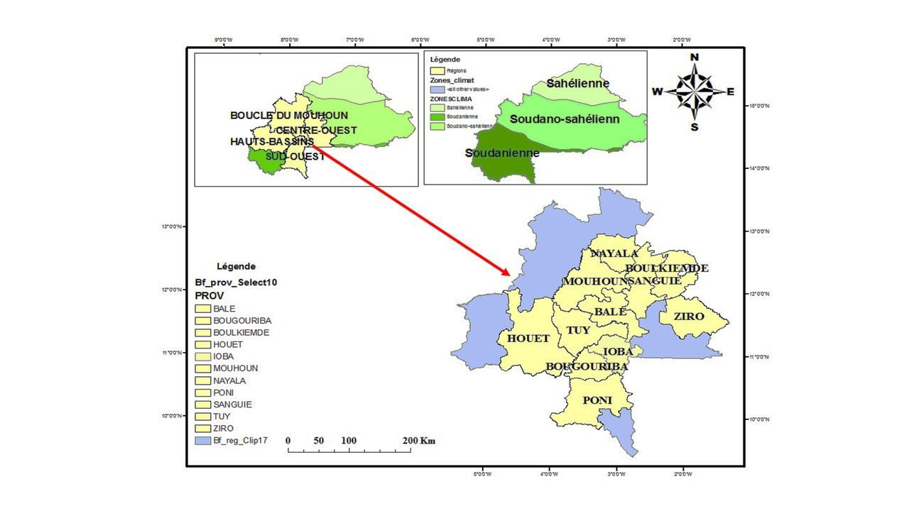

Plate 1: Map of Burkina Faso showing the locations where accessions were collected

**2.2. Collection survey**

The survey was carried out at the same time and in the same areas as the ethnobotanical survey. The areas where false sesame is present were identified with the help of the heads of the Technical Animation Zones (ZAT) of the decentralised services of the Ministry of Agriculture. Following this identification, accessions were collected along roadsides, in agricultural fields and in forests, particularly in the species' spontaneous habitats. Each sample was made up exclusively of pods or seeds belonging to the same plant. These accessions were coded according to their locality of origin (Table 1).

Table 1: Distribution of false sesame accessions from the Centre-West area of Burkina Faso

|  |  |  |  |  |  |
| --- | --- | --- | --- | --- | --- |
| Climate zone | Regions |  | Villages | Accession code | Number of accessions |
| Sudan-Sahel | Boucle du Mouhoun | Mouhoun | Douroula | DRl | 06 |
| Dedougou | DdG |
| Tcheriba | TcH |
| Safane | SF |
| Banga | BaN |
| Konan | Kn |
| Balé | Pa | Pa | 04 |
| Pa 1 | Pa 1 |
| Bagassi | BaG |
| Darsalam | DrL |
| Nayala | Gossina | GS | 04 |
| Ye | Ye |
| Yayo | Ya |
| Yaba | Yb |
| Centre-west | Boulkièmdé | Sabou | SB | 03 |
| Sabou 1 | SB 1 |
| Pella | PL |
| Sanguié | Kyon | KY | 01 |
| Ziro | Bougnounou | BGn | 03 |
| Cassou | CS |
| Payiri | PaY |
| Sudanian zone | Hauts Bassins | Tuy | Boni | Bn | 05 |
| Founzan | FZ |
| Bouzan 2 | BZ 2 |
| Bouzan 1 | BZ 1 |
| Koti | Kt |
|  | Léna | Ln | 05 |
| Satiri | SaT |
| Bama | Bm |
| Dandé | Dde |
| Mogabasso | MoG |
| South-West | Ioba | Oronkua | OR | 04 |
| Bapla | BaP |
| Kipai | Kip |
| Koper | KP |
| Bougouriba | Wangara | WaG | 07 |
| Bamako | BmK |
| Tiankoura | TiK |
| Dolo | Dl |
| Dolo 1 | Dl 1 |
| Bohero | Bor |
| Bondigui | BoD |
| Poni | Perigban | PrG | 07 |
| Bakoerena | BKr |
| Perigban 1 | PrG 1 |
| Nako | NK |
| Loropeni | Lp |
| Koutenao | KuT |
| Bonkolo | BoK |

**2.3. Experimental site**

The study was carried out at the IDR experimental station at Gampèla, about twenty kilometres from Ouagadougou. The site is identified geographically by the coordinates 1°21'96‘’ west longitude and 12°24'29‘’ north latitude. It is located in the northern Sudanian phytogeographical zone and is characterised by annual rainfall of between 600 and 900 mm (Thiombiano & Kampmann, 2010).

**2.4. Experimental design**

The experimental design adopted was the Fisher design with three replicates. The blocks (replicates) were separated from each other by a 1.5 m aisle. In each replication, each accession was transplanted onto a line (elementary plot) 4 m long, on which six seedpots were sown at a rate of seven seeds per seedpot. The row spacing and the spacing between successive seedpots were 1 m and 0.8 m respectively. The seed was removed 16 days after sowing.

**2.5. Cultural practices**

Before setting up the trial, the plot was ploughed with a tractor and levelled with a daba. Sowing took place on 13 July 2020, with six (06) seeds per plot. Two weeks after sowing, a weeding operation was carried out in the plot. Other weeding operations were carried out on the 25th and 42nd days after sowing, respectively, to reduce competition between weeds and false sesame seedlings and to aerate the soil. After the first weeding, NPK fertiliser of the 12-30-17 formulation was applied at a rate of 25 kg/ha.

**2.6. Characteristics studied**

Eight qualitative variables were observed throughout the plant's development cycle. These relate to the above-ground part of the plant, in particular stem, leaf and flower characteristics (Table 2).

Table 2: Qualitative characteristics of *Ceratotheca sesamoides*

|  |  |  |  |  |
| --- | --- | --- | --- | --- |
| **N°** | **Variables** | |  | | --- | | **Acronyms** | | **Technical collection** |
| 1 | Colour of stems | CTI | The stems of individuals from each accession were carefully observed with the naked eye, 4 and 7 weeks after sowing. |
| 2 | Degree of pubescence | DPU3. | The pubescence of the stems of the plants of each accession was carefully assessed with the naked eye, 4 weeks after sowing. |
| 3 | Stem section | STI | The section of the stems on all the individuals of each accession was carefully observed with the naked eye, 7 weeks after sowing. |
| 4 | Colour of leaves | CFE | The stems of the individuals in each accession were carefully observed with the naked eye, 4 and 7 weeks after sowing. |
| 5 | Sepal colour | CSE | The sepals of three flowers per plant were carefully observed with the naked eye on each individual of each accession, 8 weeks after sowing. |
| 6 | Colour of petals | CPE | The petals of three flowers per plant were carefully observed with the naked eye on each individual of each accession, 8 weeks after sowing. |
| 7 | Stamen colour | CET | The stamens of three flowers per plant were carefully observed with the naked eye on each individual of each accession, 8 weeks after sowing. |
| 8 | Shape and margin of  leaves | FFE | The shape and margins of the leaves of individuals from each accession were carefully observed with the naked eye, 4 and 7 weeks after sowing. |

In addition, 16 quantitative variables were assessed, all related to the above-ground part of the plant. In this study, the number of days to emergence (NJL) and the number of days to 50% flowering (NJF) were obtained respectively by observing 50% of the emerged and 50% of the flowering plants on the same elementary plot. Unlike the two variables (NJL and NJF), some variables were assessed by counting and others by measuring or weighing four individuals from the same elementary plot. An electronic balance was used for weighing. A decameter and a calliper were used for the various measurements. From sowing to flowering, the quantitative variables assessed are listed in Table 3.

Table 3: Quantitative variables for *C sesamoides*

|  |  |  |  |
| --- | --- | --- | --- |
| **N°** | **Variables** | **Acronyms** | **Description of the measure** |
| 1 | Number of days 50 % flowering | NJF | Determined by counting the number of days between sowing and flowering of at least 50% of the plants on the elementary plot. |
| 2 | Number of days to emergence | NJL | Determined by counting the number of days when 50% of the bunches have emerged on the line. |
| 3 | Height of plant | HPL | Measured from the base to the top of the terminal bud at the maturity stage. |
| 4 | Stem diameter | DTI | Measured at the level of the collar at the maturity stage, is the circumference of the stem. |
| 5 | Number of primary branches | NRP | Determined by counting the number of branches on the main stem at the mature stage. |
| 6 | Blade length | LOL | Measured from the base to the tip of the leaf blade on 4 leaves per plant at the flowering stage. |
| 7 | Blade width | LAL | Measured on the lower 1/3 (widest part) of 4 leaves per plant at flowering stage. |
| 8 | Length of petiole | LOP | Measured on 4 leaves per plant from the sheath to the base of the blade at the flowering stage. |
| 9 | Fresh leaf biomass | BMF | Assessed by weighing the leaves of each plant after harvesting at the mature stage. |
| 10 | Dry leaf biomass | BMS | Assessed by weighing the leaves of each harvested plant after drying at the maturity stage. |
| 11 | Number of sepals | NSE | Determined by counting the number of sepals per flower on 4 plants per row at the maturity stage. |
| 12 | Number of petals | NPE | Determined by counting the number of petals per flower at maturity on 4 plants per line. |
| 13 | Number of stamens | NET | Determined by counting the number of stamens per flower at maturity on 4 plants per line. |
| 14 | Fruit length | LGca | Measured longitudinally, taking into account the first 3 fruits of the plant at maturity. |
| 15 | Fruit width | LRca | Measured diametrically, taking into account the first 3 fruits of the plant at the ripening stage. |
| 16 | Height of insertion of first capsule | HIPC | Measured from the ground to the first fruit on the main stem at maturity. |

**2.7. Data analysis**

The data was collected and entered using Excel 2010. For all the accessions, the different variants of the qualitative characteristics observed were summarised for each block and for all three replicates. These values were used to calculate the frequencies of each variant within the collection. These calculations were made using Excel 2010.

The data were then analysed using R3.3.3 software to perform the Chi-2 test of independence and to highlight the Shannon diversity indices. In this respect, the Chi-2 test of independence was carried out in order to verify the existence of differences between the qualitative variants according to the place of origin of the accessions. The significance threshold for the probability P associated with the Chi-2 test statistic is 5%. The Shannon diversity indices were produced in order to estimate the specific diversity of the species as a function of the qualitative characteristics and the place of origin of the accessions. Diversity is low when the value of H' is close to 0, but otherwise it is considered high.

All the quantitative and qualitative data were subjected to an MCA using XLSTAT-Pro version 2016 software. This made it possible to assess the associations between the different variables. To do this, the quantitative data were also transformed into qualitative data.

Finally, the geographical coordinates of the various harvesting sites were processed using Arcgis 10.8 software. This software was used to produce a map of the geographical distribution of false sesame.

**3. Results**

The Shannon diversity indices (H') and the independent Chi-2 test were carried out for all the qualitative variables, except those observed on the basis of a single modality. The single-mode variables include those related to floral organs such as sepal colour, petal colour and stamen colour. Furthermore, the Chi-2 test of independence showed a significant difference for all the qualitative characteristics studied. This difference in qualitative characteristics was highest for leaf shape and margin (p = 0.001), followed by stem shape (p = 0.013). The Shannon indices showed a higher diversity of accessions from the Sudan-Sahelian zone than those from the Sudanian zone (Table 4).

**Table 4: Variability in qualitative characters of C. sesamoides**

|  |  |  |  |
| --- | --- | --- | --- |
|  | Shannon test(H') | | Chi-2 test  (p-value) |
| Sudan zone | Sudan-Sahel zone |
| Stem colour | 0,49 | 0,52 | 0,042 |
| Leaf colour | 0,55 | 0,69 | 0,031 |
| Sheet shape and margins | 0,63 | 0,82 | 0,001 |
| Pubescence of the stem | 0,57 | 0,65 | 0,039 |
| Shape of stem | 0,77 | 0,85 | 0,013 |

**3.1. Stem colour variability**

A range of qualitative characteristics was observed during the development cycle of the species. Three modalities, namely green, purple and violet, were observed on all the stems in the collection (Plate 2). Uneven variation in colour was observed between accessions from the two climatic zones (Sudanian and Sudano-Sahelian). In fact, 57.15% of accessions were green, of which 64.28% came from the Sudanian zone and 48% from the Sudano-Sahelian zone. In addition, 17.86% of the purple-coloured accessions came from the Sudan zone, compared with 16% from the Sudan-Sahel zone. For the violet colour of the stems, 26.53% of the whole collection was representative, with a rate of 17.86% for the Sudanian zone compared with 36% for the Sudan-Sahelian zone.

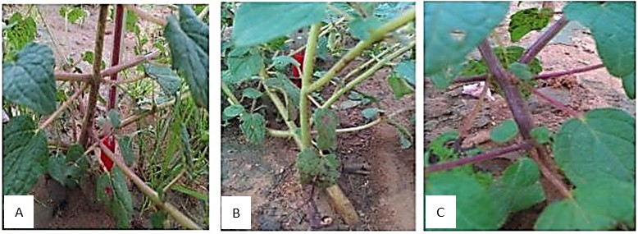

**A : Purple stem B : green stem C : Violet stem**

Plate 2: Variations in stem colour within the accessions studied

**3.2. Variability in stem pubescence**

In addition to the colour difference observed on the stem, a variation in pubescence was observed (Plate 3). Of all the accessions, 81.63% had stems with low pubescence compared with 18.37% with high pubescence. Specifically, of the number of accessions from the Sudan zone, 87.5% had stems with low pubescence compared with 12.5% of accessions with high pubescence. As for the accessions of Sudanese-Sahelian origin, 76% had stems with low pubescence compared with 24% of accessions with high pubescence.

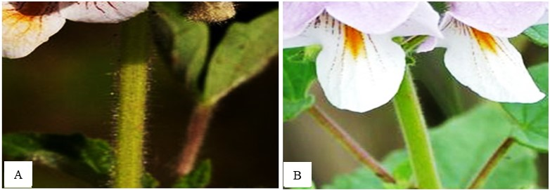

**A :** High pubescence **B :** Low pubescence

Plate 3: Variation in pubescence within the accessions studied

**3.3. Variability in leaf colour**

The leaves showed two types of colour, dark green represented by 38.78% of the accessions and light green represented by 61.22% of the accessions studied (Plate 4). Accessions from the Sudan zone are half dark green and half light green. For accessions collected in the Sudano-Sahelian zone, 24% had dark-green leaves compared with 76% of accessions with light-green leaves.

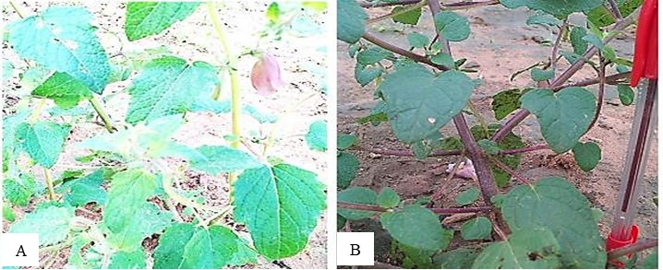

**A** : light green leaves **B** : dark green leaves

**Plate 4:** Variation in leaf colour within the accessions studied

**3.4. Variability in leaf shape and border type**

In addition to colour, the leaves showed four types of shape and two types of margin (Plate 5). Accessions with triangular leaves with toothed margins represented 44.89% of the accessions in the collection. Those with oblong leaves with smooth margins represented 8.18% of the accessions in the collection. Accessions with oval-shaped leaves with toothed margins accounted for 30% of all the accessions in the collection. Finally, those with lanceolate leaves with smooth margins represented 16.32% of the accessions in the collection.

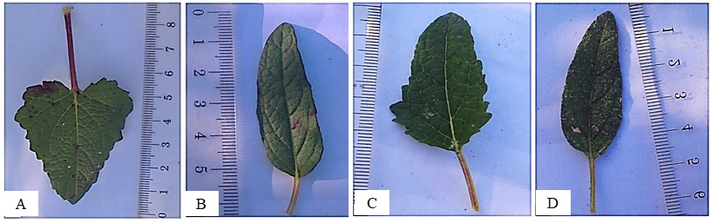

**A :** Triangular leaf **B** : Oblong leaf **C** : Ovale leaf **D** : Lancéolate leaf

toothed smooth toothed smooth

**Plate 5**: Variation in leaf shape and margin within the accessions studied

**3.5. Relationships between quantitative and qualitative variables**

The multiple correspondence analysis (MCA) carried out on the qualitative and quantitative characteristics gave four associations of characteristics (Plate 6). Axis 1 (26.10% inertia) is defined by the purple colour of the leaves and the plant's leaf biomass yield. It associates with positive values the characters purple colour of the stem (CTI-purple), the oval shape and toothed margin of the leaf blade (FAF-Ov-Dnt), the average length of the leaf blade (LOL-M-Lng) and the height of low insertion of the first capsule (HIPC-Low). This association is referred to as morphotype 1. On the opposite side of axis 1, the characters dark green colour of the leaves (CFE-V-Fce), reduced shape with toothed margin of the leaf blade (FAF-R-Dnt), very long leaf blade (LOL-T-Lng), average width of the capsule (LRcA-M-Lng) and high insertion height of the first capsule (HIPC-Hut) are associated. This association is called morphotype 4. Axis 2 (17.87%) is defined by plant height. It is associated with positive values for the traits high dry leaf biomass (BMS-elev), high number of primary branches (NRP-Trp), cylindrical stem section (STI-Cyl) and purple stem colour (CTI- viol). This association is called morphotype 2. A fourth association of characteristics with negative values on axis 2 consists of low fresh leaf biomass (BMF-Fbl), low dry leaf biomass (BMS-Fbl), short stem diameters (DTI-Crt) and triangular leaves with smooth margins (FAF-T-Liss). This association is called morphotype 3.

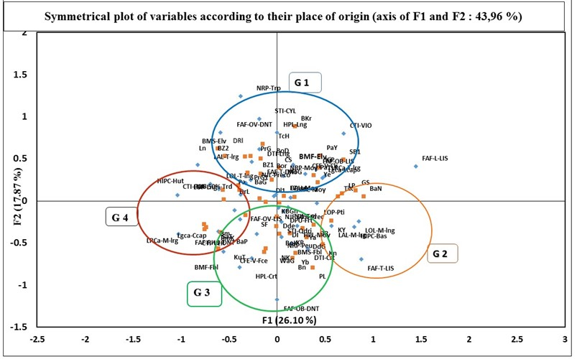

**Charactèrs accessions**

Plate 6: Representation of the different characters of Ceratotheca sesamoides (Endl.) according to the origin of the accessions.

**4. Discussion**

Analysis of the qualitative and quantitative data showed the existence of characters that discriminate between the 49 accessions. This distinction within variables reflects the existence of agromorphological variability in Ceratotheca sesamoides in Burkina Faso. For qualitative traits, this variation is observed in both leaves and stems. The high Shannon diversity indices reveal significant variability in leaves, stem pubescence, leaf shape and margin in the Sudan-Sahelian zone and in the Sudanian zone. The p-values observed from the Ch-2 analysis showed that the variability observed for qualitative traits remains different from one climatic zone to another.

Multiple correspondence analysis (MCA) was used to divide the accessions into four groups on the basis of the variability of quantitative and qualitative characteristics. In addition, the calculation of the frequencies of the qualitative variables of the accessions shows that accessions with light green leaves come mainly from the Sudanian zone of Burkina Faso. On the other hand, most of the accessions with dark green leaves come from the Sudan-Sahelian zone. Two types of leaf colouring were also identified within the species and described by farmers during the ethnobotanical survey carried out by (Kaboré *et al*., 2022 ; (Adoukonou-Sagbadja *et al*., 2006 ; Hirschfeld, 1994). This shows that the farmers surveyed do not have a good grasp of the morphological aspects of false sesame. In terms of leaf shape, accessions from Burkina differ from those from Cameroon and other countries (Westphal, 1985). In fact, the results obtained by Westphal, (1985) did not reveal the presence of rhomboidal leaf shapes. The shape of the leaves and the presence of pilosities on the stem from the two climatic zones would be linked to a form of resistance against the scarcity of rain. Similar observations have been made of certain species belonging to the same family as false sesame (Alege *et al*., 2021 ; Monteiro *et al*., 2006 ; Olawuyi *et al*., 2023). For example, the work carried out by Alege *et al*. (2021) in Nigeria showed different forms of pubescence on the stems of sesamun radiatum and sesamun indicum. In addition, all the accessions have free sepals, unlike the petals which are fused together to form violet gamopetal flowers. However, work carried out by (Sienebou et al., 2012) in Benin showed the presence of pink petals. According to (Sienebou et al., 2012), the four stamens formed are equal two by two. This difference between accessions from Burkina Faso and Benin is thought to be due to the influence of environmental factors.

The multiple correspondence analysis also showed that each association of characters was specific to the origin of the accessions (Shackleton et al., 2009). The ‘morphotype 1’ character association is observed in accessions from the localities of Tcheriba, Douroula, Perigban, Bondigui, Bouzan and Cassou. Morphotype 3 contains traits characteristic of accessions from Boni, Yaba, Wagara, Safané, Dandé, Dedougou, Koutenao, Nako and Koper. Morphotype 2 contains characters from accessions from Konan, Kyon, Dédougou, Tiankoura, Payiri, Sabou, Pa, Ye, Banga, Gossina and Kipaii. Morphotype 4 characterises accessions from Satiri, Bamako, Bapla, Bagassi, Darsalam, Perigban and Dolo. Morphotypes 1 are plants that perform well in terms of leaf biomass, height and have purple stems. They are best suited to a breeding programme if the objective of the selection is biomass yield.

**5. Conclusion**

This study revealed significant agro-morphological diversity within the accessions studied. The study revealed the presence of purple, violet and green stems. Two types of pubescence were observed: high and low pubescence. In terms of leaf shape and margin, triangular leaves with toothed margins, oblong leaves with smooth margins, oval leaves with toothed margins and lanceolate leaves with smooth margins were found. No variability was observed in the flowers in this study. The various parameters obtained from the chi-2 test of independence showed that there was a difference between the accessions. The MCA made it possible to structure the collection into four (04) groups with specific characteristics. These results could be used in a varietal improvement program.

**Ethical approval**

All authors consent to the publication of this work.

the three authors have read and approved the work.

**Ethical statement**

This study is not directed towards research involving human beings or animals, nor is it aimed at vulnerable populations.

**References**

**Adomou, C. A., Dassou, H. G., Houenon, G. H. A., Alladayè, A., & Yedomonhan, H. (2018). Understanding the plant resource needs of local populations for sustainable management of the Bahazoun forest in southern Benin (West Africa). International Journal of Biological and Chemical Sciences, 11(5), 2040. https://doi.org/10.4314/ijbcs.v11i5.9**

**Adoukonou-Sagbadja, H., Dansi, A., Vodouhè, R., & Akpagana, K. (2006). Indigenous knowledge and traditional conservation of fonio millet (Digitaria exilis, Digitaria iburua) in Togo. In D. L. Hawksworth & A. T. Bull (Eds.), Human Exploitation and Biodiversity Conservation (Vol. 3, pp. 39-55). Springer Netherlands. https://doi.org/10.1007/978-1-4020-5283-5_4**

**Akouehou, G., Goussanou, C., Idohou, R., Dissou, F., & Azokpota, P. (2014). Sociocultural importance of Artocarpus altilis (Parkinson) Fosberg (Moraceae) in southern Benin. Journal of Applied Biosciences, 75(1), 6173. https://doi.org/10.4314/jab.v75i1.5**

**Alege, G. O., Akinyele, B. O., Ayodele, S. M., & Ogbode, A. V. (2021). Characteristics of three Nigerian species of sesame in taxonomic importance of the vegetative and pod. International Scholars Journals, 001-005.**

**Dansi, A., Adjatin, A., Adoukonou-Sagbadja, H., Faladé, V., Adomou, A. C., Yedomonhan, H., Akpagana, K., & De Foucault, B. (2009). Traditional leafy vegetables in Benin: Folk nomenclature, species under threat and domestication. Acta Botanica Gallica, 156(2), 183-199. https://doi.org/10.1080/12538078.2009.10516150**

**Fasakin, K. (2005). Proximate composition of bungu (<I>Ceratotheca sesamoides</I> Endl.) leaves and seeds. Biokemistri, 16(2). https://doi.org/10.4314/biokem.v16i2.32575**

**Hirschfeld, L.A. (1994). Ethnobiological Classification: Principles of Categorization of Plants and Animals in Traditional Societies. BRENT BERLIN. American Ethnologist, 21(2), 430-431. https://doi.org/10.1525/ae.1994.21.2.02a00220**

**IPGRI. (2002). International Plant Genetic Resources Institute. Foreword.**

**Kaboré, D., TRAORE, R. E., OUOBA, A., KIEBRE, M., & BATIONO, P. K. (2022). Ethnobotanical survey on peasant diversity and the use of false sesame (Ceratotheca sesamoides Endl.) in Burkina Faso. 16 (5). https://doi.org/org/10.4314/ijbcs.v16i5.16**

**Monteiro, J. M., Albuquerque, U. P. D., Lins-Neto, E. M. D. F., Araújo, E. L. D., & Amorim, E. L. C. D. (2006). Use patterns and knowledge of medicinal species among two rural communities in Brazil’s semi-arid northeastern region. Journal of Ethnopharmacology, 105(1-2), 173-186. https://doi.org/10.1016/j.jep.2005.10.016**

**Mugisha, M. K., Asiimwe, S., Namutebi, A., Borg-Karlson, A.-K., & Kakudidi, E. K. (2014). Ethnobotanical study of indigenous knowledge on medicinal and nutritious plants used to manage opportunistic infections associated with HIV/AIDS in western Uganda. Journal of Ethnopharmacology, 155(1), 194-202. https://doi.org/10.1016/j.jep.2014.05.012**

**Olawuyi, P. O., Malgwi, M. M., Aji, P. B., Waja, S., Ogunsola, A., Kolo, J. T., Morrs, H. D., & Bako, M. Y. (2023). VARIATION IN AGRO-MORPHOLOGICAL CHARACTERISTICS OF TEN ACCESSIONS OF SESAME (Sesamum indicum L.) CULTIVATED IN NORTHERN CENTRAL STATES, NIGERIA. 27 (3).**

**Rasolodimby /Millogo, J. F. de Cballt. aJ. (2001). MAN, CLIMATE AND FOOD RESOURCES , , , PLANT RESOURCES DURING THE PERIOD OF CRISIS DESUBSISTENCE DURING THE 2ND CENTURY IN BURKINA FASO [Thesis]. UNIVERSITY OF OUAGADOUGOU.**

**Sauvé, R., & Watts, J. (2003). An analysis of IPGRI’s influence on the International Treaty on Plant Genetic Resources for Food and Agriculture. Agricultural Systems, 78(2), 307-327. https://doi.org/10.1016/S0308-521X(03)00131-8**

**Shackleton, C. M., Pasquini, M. W., & Drescher, A. W. (Eds.). (2009). African indigenous vegetables in urban agriculture. Earthscan.**

**Sienebou, V., Ahoton, L.E, Etèka, C.A, Amadji, G, Dansi, A, Ahanchédé, A, Hounhouigan, DJ, Vodouhè, SR, & Sanni, A. (2012). Floral biology of Ceratotheca sesamoides Endl., a traditional leafy vegetable undergoing domestication in Benin. 58: 4251–4261, 4251–4261.**

**Tabuti, J.R.S., Lye, K.A., & Dhillion, S.S. (2003). Traditional herbal drugs of Bulamogi, Uganda: Plants, use and administration. Journal of Ethnopharmacology, 88(1), 19-44. https://doi.org/10.1016/S0378-8741(03)00161-2**

**Thiombiano, A., & Kampmann, D. (2010). Biodiversity Atlas of West Africa (BIOTA).**

**Tugume, P., Kakudidi, E. K., Buyinza, M., Namaalwa, J., Kamatenesi, M., Mucunguzi, P., & Kalema, J. (2016). Ethnobotanical survey of medicinal plant species used by communities around Mabira Central Forest Reserve, Uganda. Journal of Ethnobiology and Ethnomedicine, 12(1), 5. https://doi.org/10.1186/s13002-015-0077-4**

**Westphal, E. (Ed.). (1985). Tropical Food Crops: With Special Reference to Cameroon (2nd impr.). Pudoc.**