Review Article

A REVIEW ON LATEST DEVELOPMENT IN DIAGNOSIS AND TREATMENT OF TUBERCULOSIS

ABSTRACT

Tuberculosis (TB), a sickness brought about by the microorganisms Mycobacterium tuberculosis which is as yet liable for the upgrade of death rate worldwide every year than some other irresistible infection, including human immunodeficiency infection (HIV) despite accessibility of successful therapy that has existed for more than a long time since the 1940s. Although genuinely significant advances that would alter tuberculosis (TB) conclusion and treatment have not been acknowledged, we are starting to see the advancements that have been incited by the acknowledgment of the monetary capability of the market for new indicative tests and medicines for TB and impressively expanded public and private financing. Regardless of the colossal worldwide weight of TB and the general low paces of case discovery around the world, ordinary ways to deal with analysis have, as of not long ago, depended on tests that have significant impediments. In this review of advances in diagnosis and treatment, we focused around qualities and constraints of more up to date tests that are accessible for the conclusion of dormant and dynamic tuberculosis and fast recognition of medication opposition, explicitly, tests that measure dischargeof IFN-in light of incitement by Mycobacterium tuberculosis antigens, nucleic corrosive enhancement for recognizable proof of M. tuberculosis complex, and quick tests for identifying drug obstruction. Standard regimens for treating TB have not changed for in excess of 30 yr. what's more, actually require at least 6 months to have a high probability of enduring fix. In this article, we center on significant changes in the theory of treatment, underlining the duty of the supplier to guarantee effective fulfillment of treatment, and on the functions of existing cause of TB specialists and more up to date medications, for example, hifalutin, rifapentine, and fluoroquinolones.
Keywords: Diagnosis; Inactivetuberculosis contamination; treatment; tuberculosis
Introduction
Tuberculosis (TB) has reliably indicated a much higher yearly death rate than HIV or some other contamination. This is because of a variety of functions that starts with the harmfulness of Mycobacterium tuberculosis, the exceptionally infectious and determined bacterium capable for TB disease. Another contributing variable is the capacity of these microorganisms to create hereditary changes that present protection from various previously powerful anti-infection agents. The World Health Organization (WHO) assessed around 480,000 instances of different medication safe (MDR-) TB identified worldwide in 2013. MDRTB and its safer kin, broadly drug safe (XDR-) TB, have gotten progressively normal since effective anti-toxin medicines of TB were found. Inauspiciously, a few specialists anticipate that MDRTB will supplant non-safe TB as the most widely recognized type of the sickness in the following 50 years ¹. Nonetheless, there has been an incredible accomplishment in creating compelling strategies for deterrent consideration, treatment, and disease control. The yearly mortality pace of TB has dropped practically half since 1990, and worldwide wellbeing associations are ready to expand upon this positive energy. It has even been expressed that after a decade of general wellbeing projects and exploration, "2015 is a turning point in the fight against tuberculosis” Demonstrated consideration and the board strategies joined with promising new methods for better discovery and treatment of TB will empower medical care experts to keep on making gigantic walks in this high-stakes fight. Regardless of this achievement, financing for TB control falls far shy of that for different irresistible sicknesses. It is obviously clear that current financing and correspondence holes are deteriorating anticipation and control endeavors; anyway, focused on speculations will pay off in tremendous profits in the worldwide mission to annihilate this weakening sickness².

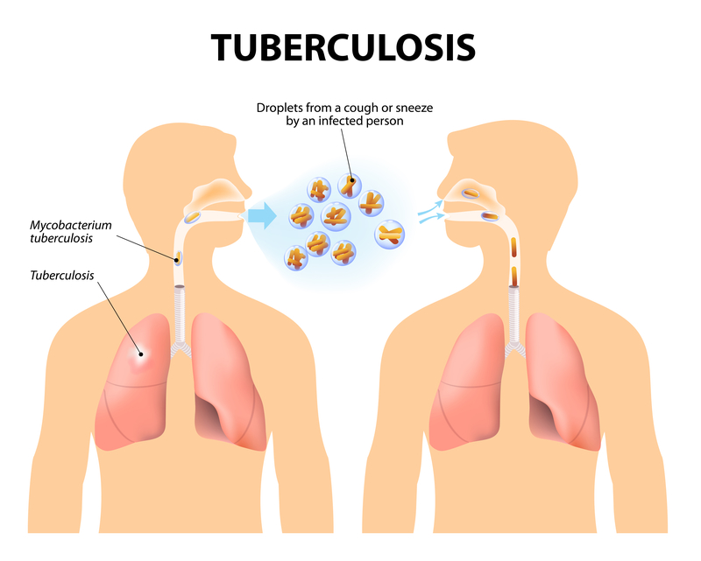
Fig. 1 Tuberculosis
After many years of scientific quiescence, tuberculosis (TB) research has undergone a renaissance. Although truly major advances that would revolutionize TB diagnosis, treatment, and prevention have not been realized, we are beginning to see the innovations that have been prompted by the recognition of the economic potential of the market for new diagnostic tests and treatments for TB and considerably increased public and private funding. Current initiatives targeting the development of (or in some cases, better application of) new diagnostic tests, new drugs, and new vaccines have increased the pace of identification and testing of a number of potentially useful innovations³.
In this article, we focus on strengths and limitations of newer tests that are available for the diagnosis of latent TB infection (LTBI), active TB, and rapid detection of drug resistance. With regard to treatment, we focus on important changes in the philosophy of treatment, emphasizing the responsibility of the provider to assure successful completion of treatment, and on the roles of existing anti-TB agents and newer drugs such as rifabutin, rifapentine, and fluoroquinolones⁴.
Etiology agent
Mycobacterium tuberculosis (M. tuberculosis) contamination has been known all through mankind’s set of experiences. The bacterium is accepted to have started from East Africa. As early people moved out of East Africa, getting comfortable Europe and Asia, TB contamination moved with them and kept on unleashing a nihilation for quite a long time all through the known world⁵. Proof of tubercular rot was seen on the spines of mummies from the Egyptian pre-dynastic period and the Peruvian pre-Columbian period, around 2400 B.C.
Old Greeks named the disease "phthisis." Later, the "Incomparable White Plague" of TB disease seethed across Europe for longer than a century. All through this time, the sickness was considered unavoidably deadly, and no successful treatment or fix existed⁶.
An achievement happened when Hermann Heinrich Robert Koch found and clarified the etiology of tuberculosis in his introduction "Bite the dust A etiologies der Tuberculosis" to the Berlin physiological society. He introduced his disclosures on March 24th, 1882, and later got the Nobel Prize in 1905. This was the beginning of a period of extraordinary advances in the treatment and anticipation of this fatal illness⁷.
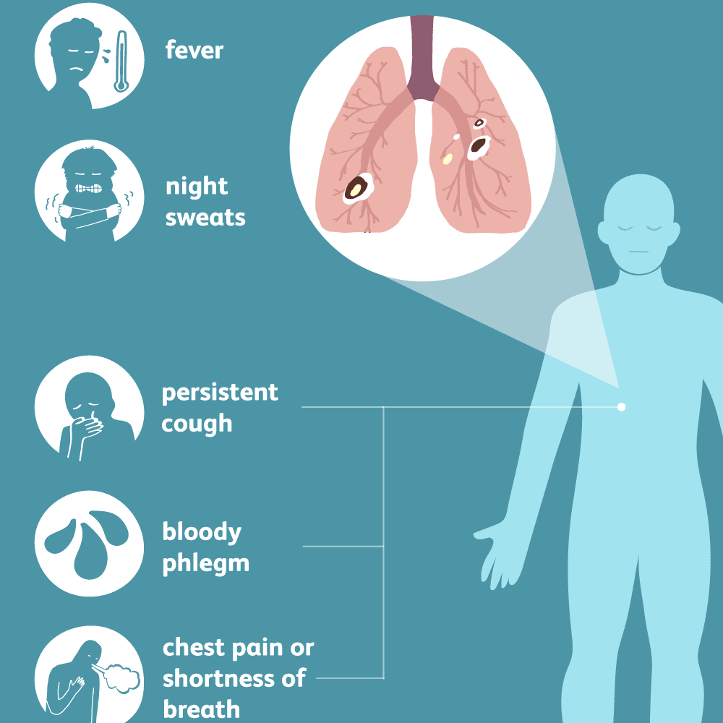
Fig.2 Treatment and anticipation of fatal illness
New Approaches to Diagnosis
Accurate and early diagnosis of TB is crucial to effective patient management and to TB control. Moreover, accurate identification of LTBI is the key to prevention of the disease among persons at risk. Despite the enormous global burden of TB and the overall low rates of case detection, conventional approaches to diagnosis continue to rely on tests that have major drawbacks For example, sputum smear microscopy is insensitive; culture is technically complex and slow; determination of drug susceptibility is even more technically complex and slower yet; chest radiography is nonspecific; and tuberculin skin testing is imprecise, and the results are often nonspecific. In view of these limitations, there is a need for less complicated and more accurate tests. We may be on the verge of major technical breakthroughs that will lead to improved diagnostic tests. In this article we focus on strengths and limitations of newer tests that are available for the diagnosis of LTBI, active TB, and rapid detection of drug resistance.

Latent TB Infection

The tuberculin skin test (TST) was, up to this point, the main apparatus accessible for recognizing LTBI. Despite the fact that the TST has demonstrated to be helpful in clinical practice, it has a few significant impediments. On account of advances in immunology and genomics, an option has risen in the structure of a group of T-cell–situated in vitro measures that distinguish IFN-γ. These measures recognize cell insusceptible reaction by estimating IFN-γ delivered by T cells after incitement by Mycobacterium tuberculosis antigens. Early forms of IFN-γ measures utilized cleaned protein subordinate (PPD) as the invigorating antigen, yet these tests have been supplanted by more up to date forms that utilization antigens (early discharged antigen target-6 [ESAT-6] and culture filtrate protein-10 [CFP-10]) that are generously more explicit for M. tuberculosis than PPD. These proteins, encoded by qualities situated inside the area of distinction 1 (RD1) fragment of the M. tuberculosis genome, are more explicit for M. tuberculosis than PPD in light of the fact that they are most certainly not common with the bacillus Calmette-Guérin (BCG) antibody strains or certain nontuberculous mycobacterial types of clinical importance.

Two IFN-γ tests, in light of RD1 antigens, are accessible as business packs: the QuantiFERON-TB Gold (Cellestis Ltd., Carnegie, Australia) test and the T SPOT-TB (Oxford Immunotec, Oxford, UK). The QuantiFERON-TB Gold test is an entire blood, ELISA-based test, though the T SPOT-TB test utilizes fringe blood mononuclear cells and ELISPOT innovation. The QuantiFERON-TB Gold test comes in two arrangements: a 24-well culture plate design (utilized in the United States and affirmed by the U.S. Food and Drug Organization [FDA]) and a more up to date, streamlined, in-tube design (not FDA endorsed). The T SPOT-TB test is CE set apart for use in Europe and is anticipating FDA endorsement. Current proof, investigated broadly somewhere else (5–10), on the exhibition of IFN-γ examines recommends that RD1-based IFN-γ tests have higher explicitness, better connection with substitute proportions of introduction to M. tuberculosis, and less cross-reactivity because of BCG inoculation than the TST. RD1-based IFN-γ measures that utilization a combination of ESAT-6 and CFP10 appear to be at any rate as touchy as the PPD-based TST in dynamic TB.
Other potential focal points incorporate accommodation; shirking of the subjectivity characteristic in estimations of cutaneous induration created by the TST; the requirement for just a single patient visit; and the capacity to perform continue testing without boosting the reaction, as may happen with sequential tuberculin testing.

Fast Detection of Drug Resistance
Molecular beacons.
Molecular beaconsreference points are oligonucleotides that transmit light when a substance response happens. As of late, a novel test that utilizes sub-atomic guides for the fast identification of changes related with drug opposition have been created. The test utilizes fluorescent-marked, clip formed DNA tests in which a fluorophore is adjoining a particle that extinguishes the light. In a continuous PCR examine, if the intensified PCR items have the ordinary, wild-type quality succession, the DNA test unfurls, bringing about distinguishable fluorescence. Safe strains with changes in the objective grouping don't hybridize with the test:

The test remains collapsed, and there is no fluorescence distinguished. Albeit barely any examinations have assessed atomic reference points, accessible information propose that these tests have high affectability (89–98%) what's more, explicitness (99–100%) for the recognition of rifampicin obstruction (21–2. Affectability for the recognition of isoniazid opposition is lower on account of the variety of changes that may lead to protection from isoniazid Sub-atomic reference points are most certainly not accessible as business packs and are not FDA endorsed. They require sophisticated technology that limits their widespread use. Their use is mostly restricted to research and reference laboratories.
Line probe assays.
Line probe assays are a group of novel DNA strip tests that utilization PCR and converse hybridization strategies for the quick identification of medication opposition. Industrially accessible units incorporate the INNO-LiPA Rif. TB unit (Inn genetics, Gent, Belgium) and the Geno Type MTBDR test (Hain Life science, Nehren, Germany). These units are not FDA affirmed. Line test measures are intended to recognize M. tuberculosis complex also, to at the same time identify hereditary transformations identified with drug obstruction. The Li PA unit, for instance, contains 10 oligonucleotide tests (one explicit for the M. tuberculosis perplexing, five covering wild-type S tests, and four R tests for distinguishing explicit changes of safe genotypes) immobilized on nitrocellulose paper strips. Li PA is performed by removing DNA from societies or legitimately from clinical examples and enhancing the rifampicin obstruction deciding area of the rpoB quality utilizing PCR. The PCR items are hybridized with the immobilized tests, and results are dictated by colorimetric turn of events.
Phage-based examines.
Phage-based examines have been assessed for the finding of TB and medication vulnerability testing the innovation utilizes mycobacteriophages to taint live M. tuberculosis and identify the bacilli utilizing a phage intensification strategy or location of light. In the previous technique, the basic standard is intensification of phages after their contamination of M. tuberculosis, trailed by identification of descendant’s phages as plaques on a grass of Smegmatis. In the last strategy, the rule is identification of light created by luciferase journalist phages after their disease of live M. tuberculosis. Amplificationbased examines are industrially accessible, while luciferase columnist phage tests (e.g., Bronx box) are being worked on.

In all, phage examines make some turnaround memories of 48–72 h andrequire a lab framework like that needed for performing mycobacterial societies. Phage-based measures are accessible as business units. For analysis, the FASTPlaque-TB (Biotech Laboratories Ltd., IpswichUK) measure can be legitimately utilized on sputum examples. A variant,the FASTPlaque-TB-MDRi pack, is intended to identify rifampicin obstruction in culture detaches. A serious form of this pack, FASTPlaque-TB-Response, has been created for the discovery of medication obstruction straightforwardly from sputum examples. Medication opposition is analyzed when M. tuberculosis is distinguished in tests that contain the medication (e.g., rifampicin). The FASTPlaque-TB packs are not FDA affirmed but rather are CE set apart for use in Europe.
An ongoing meta-examination summed up the precision of phage based measures for the discovery of rifampicin obstruction (28). This meta-examination indicated that when performed on culture disconnects, phage tests appear to have generally high affectability and explicitness. Eleven of 19 (58%) considers remembered for the survey detailed affectability and explicitness assessments of 95% or more noteworthy. Particularity gauges were marginally lower and more factor than affectability; 5 of 19 (26%) examines announced particularity of under 90%. In just two investigations were phage examines performed straightforwardly on sputum examples, and the outcomes were conflicting. Current proof, consequently, is limited to the utilization of phage measures for the location of rifampin obstruction in culture disengages. At the point when applied to secludes, these measures have moderately high affectability and explicitness. Be that as it may, the prerequisite for essential culture confinement diminishes the appropriateness of this measure and builds turnaround time. Information are missing on the precision of these measures when they are legitimately applied to sputum examples. At the point when applied legitimately to clinical examples, phage measures appear to have lower affectability, apparently in view of the lower bacillary focus.
On the off chance that phage-based measures can be straightforwardly utilized on clinical examples furthermore, on the off chance that they are demonstrated to be exact, they can possibly improve the analysis of medication safe TB Endeavors are progressing to improve their exhibition qualities, particularly for the fast-immediate discovery of rifampicin opposition in clinical examples. Primer outcomes on improved direct phage examines show guarantee however require further approval and field testing.
New Approaches to Treatment
There have been a few advances in the way to deal with treatment of LTBI and TB. To begin with, the way of thinking of thinking about patients with TB has moved in that the duty regarding finishing and effective result currently lies on the medical care supplier rather than the patient. Second, the span of treatment in the continuation stage has been reached out in select circumstances. Third, there are new operators accessible that show guarantee in the treatment of dynamic TB that are being assessed in clinical trials.

Treatment of multidrug resistant tuberculosis
Multi-drug-resistant tuberculosis - which occurs when TB viruses are less resistant to isoniazid and rifampicin - is important for the clinic because it greatly increases the risk of treatment failure, resistance to further treatment and death. Its prevalence varies widely and often reflects poorly controlled therapies. People most at risk include those with a history of TB treatment, those from high-risk areas, and patients or health care workers from facilities (hospitals, clinics, prisons, or nursing homes) where there has been a transmission of a disease-resistant epidemic. Initial treatment of patients with multidrug-resistant tuberculosis can use more aggressive methods, especially if patients have serious lung diseases or dangerous forms of tuberculosis such as warts or meningeal disease. In patients with proven infections it is important to give at least four antiretroviral drugs - usually three oral medications and one injection. Generally, an aminoglycoside injection is given three to six months after the first day of the cultural transformation of sputum from M TB test to negative test, and the patient continues to take anti-mycobacterial oral medication 15-18 months after the procedure. last sputum.

Treatment of latent infection in people exposed to drug-resistant bacilli is problematic because the only drugs considered appropriate are isoniazid and rifampicin. A Delphi study by a team of TB specialists failed to reach a definitive agreement on the most appropriate type of people exposed to multidrug-resistant tuberculosis, although a combination of pyrazinamide and ciprofloxacin is considered appropriate. In experiments, a combination of pyrazinamide and ofloxacin has been shown to have a positive effect on intrimacrophage antimycobacterial.
In light of recent cases of severe hepatotoxicity associated with preventive treatments including pyrazinamide and rifampicin or pyrazinamide and fluoroquinolone, however, fluoroquinolone immunotherapy without pyrazinamide may be considered in people with their newly modified tuberculin test bath. multidrug-resistant tuberculosis. a caveat with long-term performance data on these treatments is not available
Treatment in developing countries
Theoretically, the diagnosis and treatment of tuberculosis is similar in developing and developed countries, but economic limitations mean that significant differences exist in performance. Encouraged by the World Health Organization's short-term study policy of DOT, microscopy of sputum is the primary and most common diagnostic method in countries with limited resources. It has some very serious drawbacks: first, the diagnosis of a severe sputum is less severe than that of sputum smears (preferably) or a cough culture (preferably); secondly, a culture of bacercle bacilli is needed to quickly detect drug resistance, which may interfere with the bacterial response to conventional treatment.
Historically, most poor countries have used the most cost-effective medication containing isoniazid and thiacetazone given for 15 to 18 months, usually costing only US $ 10-15 per person. Although this type of drug is cost-effective, it is not suitable because the treatment is long lasting, effective, and ineffective where there is resistance to isoniazid. Medications containing thiacetazone also have a high risk of causing a drug reaction that may be harmful to people with AIDS. 21 more countries are now improving the standardWHO six month regimen, which includes isoniazid, rifampicin, pyrazinamide, and ethambutol. Because of the profoundly deleterious effects of resistance to.Rifampicin, strong emphasis is placed on DOT when rifampicin is used.

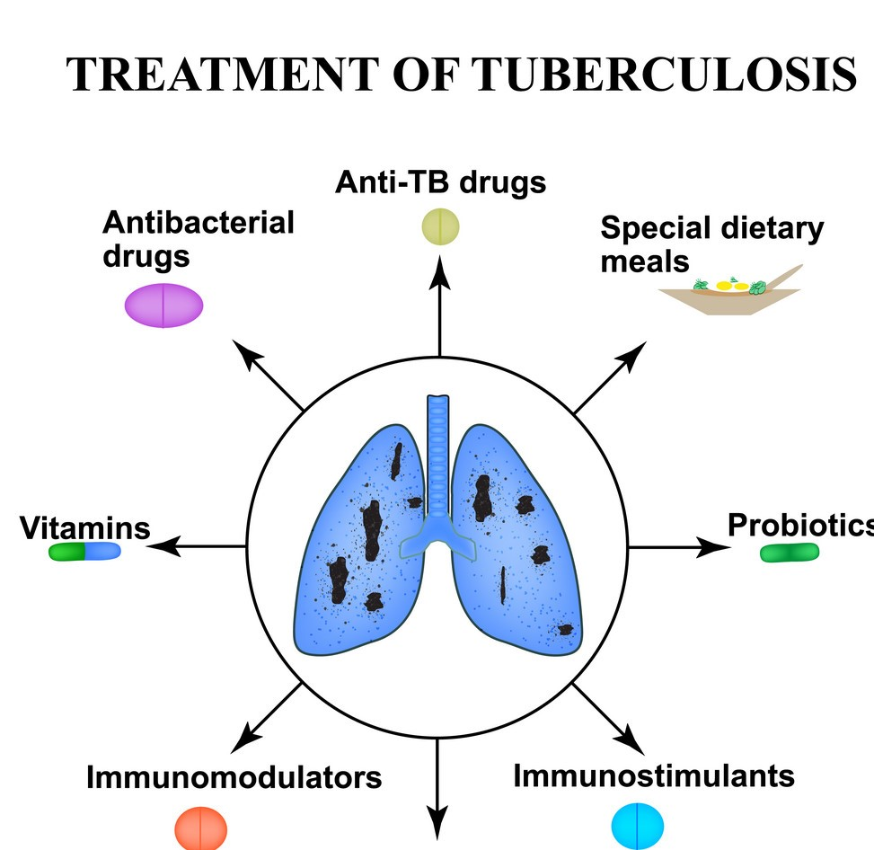

Fig.3 TREATMENT OF TUBERCULOSIS

Pathogenesis
Mycobacterium tuberculosis is an airborne microorganism. Once breathed in, beads bearing the mycobacteria settle all through the aviation routes. A large portion of the bacilli are caught in the upper pieces of the aviation routes where the mucus secreting challis cells are found. The bodily fluid gets the attacking bacilli, and the cilia on the outside of the cells continually undulate to move the bodily fluid and caught unfamiliar particles upward for evacuation. This framework furnishes the body with an underlying actual safeguard that forestalls disease in many people presented to
Tuberculosis.
The microorganisms that can pass the conciliar framework and arrive at the alveoli are immediately inundated by alveolar macrophages. This next line of guard is the natural invulnerable framework, and it gives a chance for the body to wreck the attacking mycobacteria and forestall the contamination. Numerous instruments and macrophage receptors are engaged with take-up of the mycobacteria. The supplement framework assumes a key job in the phagocytosis of the microscopic organisms. The supplement protein C3 ties to the cell divider and improves acknowledgment of the mycobacteria by macrophages. Opsonization by C3 is quick, even in the airspaces of a have with no past introduction to M. tuberculosis [10]. The phagocytosis by macrophages starts a course of functions that outcomes in either powerful control of the disease (which might be trailed by inert tuberculosis) or progression to active disease, called primary progressive tuberculosis. The result is mainly determined by the strength of the host defenses and the balance that occurs between host defenses and the invading mycobacteria.

Subsequent to being gulped by macrophages, the mycobacteria keep on duplicating gradually, with bacterial cell division happening each 25 to 32 hours. The underlying improvement includes the creation of proteolytic compounds and cytokines by macrophages in request to attempt to corrupt the microscopic organisms. The cytokines that are delivered pull in T lymphocytes to the site; T cells presently lead the cell-intervened invulnerability. Macrophages present mycobacterial antigens on their surface to the T cells. This resistant cycle proceeds for 2 to 12 weeks; the microorganisms keep on developing until they reach satisfactory numbers to completely incite the cell-intervened insusceptible reaction, which can be identified by a skin test called Tuberculin sanitized protein subordinate (PPD) [11].

For those people with unblemished cell-interceded invulnerability, the following cautious advance is the arrangement of granulomas around the M. tuberculosis living beings. These nodular sort sores, called Ghon buildings, structure from an aggregation of actuated T cells and macrophages that limits replication and the spread of the mycobacteria. This devastates the macrophages and produces rot at the focal point of the injury, yet the microorganisms can get by since M. tuberculosis can change their phenotypic articulation so as to upgrade endurance. By 2 to 3 weeks, the necrotic climate takes after delicate cheddar, frequently alluded to as caseous corruption [12].

The conditions for this corruption incorporate low pH and restricted supplements. These conditions limit further development and the sores go through fibrosis and calcification, effectively controlling the contamination and making the microscopic organisms enter a torpid structure.
For invulnerable traded off people, granuloma development is started in any case is ineffective in
Containing the microbes. The necrotic tissue goes through liquefaction and the stringy mass of the granuloma loses structure. The condensed necrotic material may at that point move into a bronchus or close by vein. On the off chance that M. tuberculosis releases into a vessel, extra-aspiratory tuberculosis is destined to happen. Bacilli can likewise channel into the lymphatic framework and gather in the windpipe bronchial lymph hubs of the influenced lung, where the creature can frame new caseous granulomas.

Conclusion
Regardless of immense upgrades in research and innovation and the advancement of numerous medication regimens to fight this tricky executioner, M. tuberculosis keeps on being a significant wellbeing concern around the world. As TB contamination keeps on being the most pervasive lethal irresistible sickness on the planet, subsidizing for research and program execution has followed worldwide venture in different sicknesses. Advances in analytic instruments, dynamic understanding management, and a worldwide concentration in distinguishing and planning strains of medication safe microbes are demonstrated techniques for controlling this infection. Notwithstanding, basic to these clinically significant procedures is a strong responsibility by the global network to at long last annihilate this overwhelming disease.

COMPETING INTERESTS DISCLAIMER:
Authors have declared that they have no known competing financial interests OR non-financial interests OR personal relationships that could have appeared to influence the work reported in this paper.

References
- World Health Organization (2010) Multidrug and extensively drug-resistant TB (M (No. WHO/HTM/TB/2010.3). Geneva: World Health
Organization.
- World Health Organization (2015) Globaltuberculosis report 2015, 20th ed. World Health Organization.
- Frith J (2014) History of tuberculosis. Part 1phthisis, consumption and the white plague. J Military Veterans Health 22(2): 29.
- Cambau E, Drancourt M (2014) Steps towards the discovery of Mycobacterium tuberculosis by Robert Koch, 1882. ClinMicrobiol Infect 20(3): 196-201.
- Daniel TM (2006) The history of tuberculosis. Respir Med 100(11): 1862-1870.
- Fox W, Ellard GA, Mitchison DA (1999) Studies on the treatment of tuberculosis undertaken by the British Medical Research Council tuberculosis units, 1946–1986, with relevant subsequent publications. Int J Tubercul Lung Dis 3(10): S231-S279.
- Keshavjee S, Farmer PE (2012) Tuberculosis, drug resistance, andthe history of modern medicine. N Engl J Med 367(10): 931-936.
- Cegielski JP (2010) Extensively drug-resistant tuberculosis: “there must be some kind of way out of here”. Clin Infect Dis 50(3): S195-S200.
- Frieden TR, Sterling TR, Munsiff SS, Watt CJ, Dye C (2003) Tuberculosis. Lancet 362(9387): 887-899.
- Van Crevel R, Ottenhoff TH, van der Meer JW (2002) Innate immunity to Mycobacterium tuberculosis. ClinMicrobiol Rev 15(2): 294-309.
- Dheda K, Booth H, Huggett JF, Johnson MA, Zumla A, et al. (2005) Lung remodeling in pulmonary tuberculosis. J Inf Dis 192(7): 1201-1209.
- Du Toit LC, Pillay V, Danckwerts MP (2006) Tuberculosis chemotherapy: current drug delivery approaches. Respir Res 7(1): 118.
- Knechel NA (2009) Tuberculosis: pathophysiology, clinical features, and diagnosis. Critical Care Nurse 29(2): 34-43.
- Levinson W (2010) Review of medical microbiology and immunology. The McGraw-Hill Companies.
- Hunter RL, Olsen MR, Jagannath C, Actor JK (2006) Multiple roles of cord factor in the pathogenesis of primary, secondary, and cavitary tuberculosis, including a revised description of the pathology of secondary disease. Ann Clin Lab Sci 36(4): 371-386.
- Julián E, Roldán M, Sánchez-Chardi A, Astola O, Agustí G, et al. (2010) Microscopic cords, a virulence-related characteristic of Mycobacterium tuberculosis, are also present in nonpathogenic mycobacteria. J Bacteriol 192(7): 1751-1760.
- Astarie-Dequeker C, Le Guyader L, Malaga W, Seaphanh FK, Chalut C, et al. (2009) Phthioceroldimycocerosates of M. tuberculosis participate in macrophage invasion by inducing changes in the organization of plasma membrane lipids. PLoSPathog 5(2): e1000289.
- Cole S, Brosch R, Parkhill J, Garnier T, Churcher C, et al. (1998) Deciphering the biology ofMycobacterium tuberculosis from the complete genome sequence. Nature 393(6685): 537-544.
- Smith I (2003) Mycobacterium tuberculosis pathogenesis and molecular determinants ofvirulence. ClinMicrobiol Rev 16(3): 463-496.
- Nikaido H, Brennan PJ (1995) The envelope of mycobacteria. Annu Rev Biochem 64: 29-63.
- CDC. Tuberculosis (TB) Testing & Diagnosis.
- Goering R, Dockrell H, Zuckerman M, Roitt I, Chiodini PL (2012) Mims' medical microbiology. Elsevier Health Sciences.
- CDC. Tuberculosis (TB) Disease: Symptoms & Risk Factors.
- Leung AN (1999) Pulmonary tuberculosis: the essentials. Radiol 210(2): 307-322.
- CDC Multidrug-Resistant Tuberculosis (MDR TB).
- Fischer B, Ferlinz R (1995) Therapy and prognosis of tuberculosis. Versicherungsmedizin 47(6): 212216.
- Brode SK, Varadi R, McNamee J, Malek N, Stewart S, et al. (2015) Multidrug-resistant tuberculosis: Treatment and outcomes of 93 patients. Can RespirJ 22(2): 97-102.
- Merle CS, Fielding K, Sow OB, Gninafon M, Lo MB, et al. (2014) A four-month gatifloxacin-containing regimen for treating tuberculosis. New Eng J Med 371(17): 1588-1598.
- Maitra A, Bates S, Kolvekar T, Devarajan PV, Guzman JD, et al. (2015) Repurposing—a ray of hope in tackling extensively drug resistance in tuberculosis. Int J Infect Dis 32: 50-55.
- Coelho T, Machado D, Couto I, Maschmann R, Ramos D, et al. (2015) Enhancement of antibiotic activity by efflux inhibitors against multidrug resistant Mycobacterium tuberculosis clinical isolates from Brazil. Frontiers Microbiol 6: 330.
- Chakraverty R, Debnath T, Ghosh A (2015) Emerging therapeutic strategies for combating drug resistance in tuberculosis: An appraisal. Creat J Pharmac Res 1(3): 108-116.
- World Health Organization (2018) ExecutiveSummary; WHO Global Tuberculosis Report 2018.
- Yamamura M, Santos-Neto M, Santos R, Garcia M, Nogueira J, et al. (2015) Epidemiologicalcharacteristics of cases of death from tuberculosis and vulnerable territories. RevistaLatinoAmericana de Enfermagem 23(5): 910-918.
- Ross J, Cattamanchi A, Miller C, Tatem A, KatambaA, et al. (2015) Investigating Barriers toTuberculosis Evaluation in Uganda UsingGeographic Information Systems. Ame J Tropical Med Hygiene 93(4): 733-738.
- Stoesslé P, González-Salazar F, Santos-Guzmán J, Sánchez-González N (2015) Risk factors andcurrent health-seeking patterns of migrants in northeastern Mexico: healthcare needs for a socially vulnerable population. Frontiers Public Health 3: 191.
- Klinkenberg E, Manissero D, Semenza JC, Verver S (2009) Migrant tuberculosis screening in the EU/EEA: yield, coverage and limitations. EurRespirJ 34(5): 1180-1189.
- Corbett EL, Watt CJ, Walker N, Maher D, Williams BG, et al. (2003) The growing burden oftuberculosis: global trends and interactions with the HIV epidemic. Archiv Inter Med 163(9): 10091021.
- Abe T, Iinuma Y, Ando M, Yokoyama T, Yamamoto T, et al. (2003) NRAMP1 polymorphisms,susceptibility and clinical features of tuberculosis. J Infec 46(4): 215-220.
- Potter JL, InamdarL, Okereke E, Collinson S, Dukes R, et al. (2015) Support of vulnerable patients throughout TB treatment in the UK. J Public Health 38(2): 391-395.
- Mulder C, Klinkenberg E, Manissero D (2009) Effectiveness of tuberculosis contact tracing among migrants and the foreign-born population. Euro Surveill 14(11): 19153.
- Hassan F (2000) The origins and development of African livestock: archaeology, genetics, linguistics and ethnography. Routledge, Abingdon, Oxford, UK.
- RIT J (2016) Tuberculosis Annual Report 2014--(1) Summary of Statistics on Tuberculosis Notification and Foreign-born Tuberculosis Patients. Kekkaku91(2): 83-90.
- Scior T, Meneses Morales I, GarcésEisele SJ, Domeyer D, Laufer S (2002) Antitubercularisoniazid and drug resistance of Mycobacterium tuberculosis—a review. Arch Pharm: Int J Pharm Med Chem 335(11‐12): 511-525.
- Vilcheze C, Jacobs Jr WR (2007) The mechanism of isoniazid killing: clarity through the scope of genetics. Annu Rev Microbiol 61: 35-50.
- Slayden RA, Barry CE (2000) The genetics and biochemistry of isoniazid resistance inMycobacterium tuberculosis. Microbes Infection 2(6): 659-669.
- Rozwarski DA, Grant GA, Barton DH, Jacobs WR, Sacchettini JC (1998) Modification of the NADH of the isoniazid target (InhA) from Mycobacterium tuberculosis. Sci 279(5347): 98-102.
- Ducasse-Cabanot S, Cohen-Gonsaud M, MarrakchiH, Nguyen M, Zerbib D, et al. (2004) In vitro inhibition of the Mycobacterium tuberculosis βketoacyl-acyl carrier protein reductaseMabA by isoniazid. Antimicrobl Agents Chemother 48(1): 242-249.
- Quemard A, Lacave C, Laneelle G (1991) Isoniazid inhibition of mycolic acid synthesis by cell extracts of sensitive and resistant strains of Mycobacterium aurum. Antimicrob Agents Chemother 35(6): 10351039.
- Wei C, Lei B, Musser J, Tu S (2003) Isoniazid Activation Defects in Recombinant Mycobacterium tuberculosis Catalase-Peroxidase (KatG) Mutants Evident in InhA Inhibitor Production. AntimicrobAgents and Chemother 47(2): 670-675.
- Rouse D, DeVito J, Li Z, Byer H, Morris S (1996) Sitedirected mutagenesis of the katG gene ofMycobacterium tuberculosis: effects on catalaseperoxidase activities and isoniazid resistance.MoleculMicrobiol 22(3): 583-592.
- Ramaswamy S, Musser J (1998) Molecular genetic basis of antimicrobial agent resistance inMycobacterium tuberculosis: 1998 update.
Tubercle Lung Dis 79(1): 3-29.
- Campbell E, Korzheva N, Mustaev A, Murakami K, Nair S, et al. (2001) Structural Mechanism for Rifampicin Inhibition of Bacterial RNA Polymerase. Cell 104(6): 901-912.
- Feklistov A, Mekler V, Jiang Q, Westblade LF, IrschikH, et al. (2008) Rifamycinsdo not function by allosteric modulation of binding of Mg2+ to the RNA polymerase active center. Proc Nat AcadSci105(39): 14820-14825.
- World Health Organization (2017) Drug-resistant TB.
- Palomino J, Martin A (2014) Drug resistance mechanisms in Mycobacterium tuberculosis.
Antibiotics 3(3): 317-340.
- Zhang Y, Yew WW (2009) Mechanisms of drug resistance in Mycobacterium tuberculosis [State of the art series. Drug-resistant tuberculosis. Edited by CY. Chiang. Number 1 in the series]. Int J Tuberculosis Lung Dis 13(11): 1320-1330.
- Velayati AA, Masjedi MR, Farnia P, Tabarsi P, Ghanavi J, et al. (2009) Emergence of new forms of totally drug-resistant tuberculosis bacilli: super extensively drug-resistant tuberculosis or totally drug-resistant strains in Iran. Chest 136(2): 420425.

- Migliori G, Centis R, D'Ambrosio L, Spanevello A, Borroni E, et al. (2012) Totally Drug-Resistant and Extremely Drug-Resistant Tuberculosis: The Same Disease?. Clin Infectious Dis 54(9): 1379-1380.
- Udwadia ZF, Amale RA, Ajbani KK, Rodrigues C (2012) Totally drug-resistant tuberculosis in India. Clinical Infectious Diseases. 54(4): 579-581.
- Catanzaro A, Rodwell TC, Catanzaro DG, Garfein RS, Jackson RL, et al. (2015) Performance comparison of three rapid tests for the diagnosis of drugresistant tuberculosis. PloS One 10(8): e0136861.
- Rabodoarivelo MS, Imperiale B, BrandaoA, Kumar P, Singh S, et al. (2015) Performance of four transport and storage systems for molecular detection of multidrug-resistant tuberculosis. PloSOne 10(10): e0139382.
- Gandhi NR, Weissman D, Moodley P, Ramathal M, Elson I, et al. (2013) Nosocomial transmission of extensively drug-resistant tuberculosis in a rural hospital in South Africa. J Infectious Dis 207(1): 917.
- Casali N, Nikolayevskyy V, Balabanova Y, Harris SR, Ignatyeva O, et al. (2014) Evolution andtransmission of drug-resistant tuberculosis in a Russian population. Nat genet 46(3): 279-286.
- Kandelaki K, Lundborg CS, Marrone G (2015) Antibiotic use and resistance: a cross-sectional study exploring knowledge and attitudes among school and institution personnel in Tbilisi, Republic of Georgia. BMC Res Notes 8(1): 495.

