***Case report***

**RIGHT SIDED EMPYEMA WITH NECROTISING PNEUMONIA: A CASE REPORT**

ABSTRACT

|  |
| --- |
| **AIM:** Empyema is a rare complication of pneumonia resulting from the accumulation of pusin the pleural space as a result of impairment of host defense and bacterial virulence. About zero.6% of children laid low with pneumonia progress to empyema as in line with research.  **CASE PRESENTATION:** Here we discussed a case of right sided empyema with necrotizing pneumonia in a one year old female pediatric patient.  **DISCUSSSION** AND CONCLUSION: Our patient case underscores the critical importance of early recognition and aggressive management of empyema and necrotizing pneumonia in children. Clinicians should maintain a high index of suspicion for these complication -compromised respiratory function, fever and bluish skin discoloration. Advanced imaging and microbiological testing are crucial in guiding diagnosis and treatment. |

*Keywords: Empyema, Necrotising pneumonia (NP), community acquired pneumonia, video-assisted thoracoscopic surgery (VATS).*

1. INTRODUCTION

Empyema is a rare complication of pneumonia resulting from the accumulation of pusin the pleural space as a result of impairment of host defense and bacterial virulence.[1]about zero.6% of children laid low with pneumonia progress to empyema as in line with research.[2] Even after growth vaccination insurance and advances in antibiotics, occurrence of empyema instances is on the upward push due to multi drug resistant pathogens, behind schedule prognosis, and comorbid situations consisting of malnutrition,poverty,tuberculosis.[3]Fever, chills, cough, shortness of breath, and chest pain are symptoms of empyema.[4]Recent studies have shown that treatments such as fibrinolytics, intercostal chest drain(ICD)videoassisted thoracoscopic surgery (VATS), and cosmetic surgery provide better outcomes as an adjunct to healthcare.[5]Necrotizing Pneumonia (NP) is a rare complication of communityacquired Pneumonia(CAP) characterized by severe disease, prolonged hospitalization, and disease duration.[6]Complications are reported in 3% of CAP cases in the UK. Although NP alone and the presence ofone or more complications of CAP, such as parapneumonic effusion, empyema, lung abscess and local complications, are still considered rare, the incidence of NP in children is increasing.[7]A recent study has shown that NP is more common in children with complex diseases and hasa higher mortality rate than in healthy children.[8]NP is associated with a higher risk of complications including parapneumonic effusion, empyema, empyema, pneumothorax, purulent pneumothorax, septic shock, respiratory failure, hemolytic uremic syndrome (HUS), and bronchopleural fistulas (BPF).[9,10]

NP may affect 0.8to7% of communityacquired pneumonia (CAP) cases11.Necrotizing pneumonia is generally considered a rare complication of pneumonia and occurs in approximately 1% of pneumonia cases.[12]In recent years, studies have raised concerns that necrotizing pneumonia may be misdiagnosed due to inadequate radiological findings.[13]None of the 351 chest Xrays showed evidence of necrotizing pneumonia, but after reevaluation this number increased to eight. Similarly, 6 of the 136 CT scans showed evidence of necrotizing pneumonia, but after reevaluation this number increased to eight.[13]

2. CASE PRESENTATION

A one-year-old female patient, weighing 9.6kg was referred from Ovem hospital and presented to the pediatric Emergency department of Aster CMI Hospital Banglore. The primary concern was intermittent high-grade fever, cough, and cold for the past week, accompanied by post-tussive vomiting. Additionally, the child had poor oral intake, hurried breathing, and reduced activity for one day prior to presentation. The patient had already been started on oxygen via nasal prongs and was receiving injectable ceftriaxone and amikacin for one day. There was no relevant past medical history.

On examination, the patient appeared ill and was noted to have pallor. There was positive increased capillary refill time, nasal flaring and grunting along with increased work of breathing. Reduced air entry was observed on the right side, with bilateral crepitation noted(right>left). Her temperature was 101.1 degree F, respiratory was 76 breaths/minute, and her heart rate was 166 beats/minute, capillary refill time CRT was<2sec. Laboratory findings revealed significantly low hemoglobin (Hb), red blood cells (RBC), packed cell volume (PCV), platelets, and lymphocytes. Neutrophil levels were elevated. Blood culture results were negative, while C-reactive protein (CRP) was markedly elevated at 306mg/L.HIV, HBsAg, and HCV tests were non-reactive. Day-1 blood test results are presented in Table1.

TABLE 1: Results blood test (Day 1)

|  |  |  |  |  |  |
| --- | --- | --- | --- | --- | --- |
| **BLOOD ANALYSIS** | **DAY -1** | **NORMAL RANGE** |  |  |  |
| Hemoglobin | 6.6 | 11.1-14.1 g/dl |  |  |  |
| RBC | 2.83 | 4-5.2 mill/mm3 |  |  |  |
| PCV | 20.1 | 30-38 % |  |  |  |
| MCV | 71.2 | 75-87% |  |  |  |
| MCH | 23.3 | 25-29 pg |  |  |  |
| NEUTROPHIL | 81.7 | 15-35% |  |  |  |
| LYMPHOCYTE | 7.0 | 45-76% |  |  |  |
| Ab.NEUTROPHIL | 10.6 | 1-7k/ul |  |  |  |
| Ab.LYMPHOCYTE | 0.9 | 3.5-11k/ul |  |  |  |
| PLATELETS | 54 | 200-550 k/ul |  |  |  |

CT thorax (P+C) revealed- The patient presented with extensive dense consolidation in the right lung , affecting the entire right lower lobe and significant portions of the middle and upper lobes, with air bronchogram, indicating infective lober pneumonia. There is moderate right pleural effusion (mean+ 20HU) with mild collapse of the basal segment of the right lower lobe, suggestive of parapneumonic effusion. Mild smooth interlobular septal thickening is noted in the apical segment of the right upper lobe, along with mediastinal lymphadenopathy.

Based on above impression diagnosed right sided-empyema stage 2 and necrotizing pneumonia. Based on CRP and CT Thorax initiated intravenous antimicrobial therapy: Piperacillin/tazobactum, Linezolid, Oseltamivir and Azithromycin.

Under general anesthesia, the patient underwent video-assisted thoracoscopic surgery (VATS) decortication. with lot of septation all over the chest cavity, Hemorrhagic with straw color fluid around 200ml.In surgery all the septation was broken then the pus flakes were removed from the apical, lateral, medial, inferior diaphragmatic surfaces, and all the pus flakes were extracted. A Thorough wash with saline was given and sealed out, Necrotizing pneumonia was seen in the middle part of the upper lobe. Post OP chest x-ray Impression - Patchy homogenous opacity noted in right lung fields, suggestive of consolidation.

Figure 1. Post-operative chest x-ray Impression

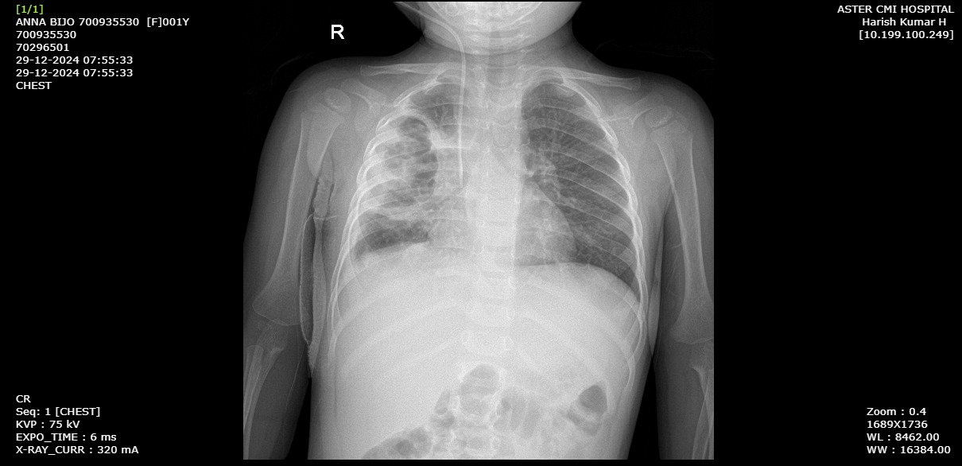

The patient was transferred to the ICU for close monitoring, respiratory support and, postoperative care. the clinical course was carefully observed, with regular evaluation of laboratory value, vital signs and respiratory status. Supportive medications were a PRBC transfusion was provided due to a significant drop in hemoglobin level. Two days later, Oseltamivir and , Azithromycin were discontinued as the CRP level decreased. The patient was subsequently transferred to the general ward.

After 14 days of treatment with Piperacillin/tazobactum, Linezolid, supportive medication and chest physiotherapy, the CRP level was 4.54mg/L and the CBC results were near normal. Table no 2.

The patient was discharged with a de-escalation to oral antibiotic therapy, including Linezolid and cefixime for 7 days along with supportive medication for 1-2 weeks. A follow-up appointment was scheduled for 5 days post-discharge.

TABLE NO 2 : Results of blood test (After 14 days of treatment)

|  |  |  |  |  |  |
| --- | --- | --- | --- | --- | --- |
| **BLOOD ANALYSIS** | **Date of discharge** | **NORMAL RANGE** |  |  |  |
| Hemoglobin | 9.0 | 11.1-14.1 g/dl |  |  |  |
| RBC | 3.06 | 4-5.2 mill/mm3 |  |  |  |
| PCV | 27.5 | 30-38 % |  |  |  |
| MCV | 89.8 | 75-87% |  |  |  |
| MCH | 29.5 | 25-29 pg |  |  |  |
| NEUTROPHIL | 43.3 | 15-35% |  |  |  |
| LYMPHOCYTE | 38.9 | 45-76% |  |  |  |
| Ab.NEUTROPHIL | 6 | 1-7k/ul |  |  |  |
| Ab.LYMPHOCYTE | 10 | 3.5-11k/ul |  |  |  |
| PLATELETS |  | 200-550 k/ul |  |  |  |

3. discussion

Our case highlights a rare manifestation of an increasingly dangerous pathogen. Empyema and necrotizing pneumonia should be considered in any patient presenting with pulmonary symptoms and suggestive imaging findings. A biopsy can also aid in the diagnosis. Successful management of necrotizing pneumonia involves appropriate antimicrobial therapy and surgical drainage of pleural pus.

Empyema is type of parapneumonic effusion characterized by the accumulation of purulent fluid and fibrin in the pleural space. Paraneumonic pleural effusion progress through two stages, each with distinct fluid characteristics and treatment approaches[14]. The first stage, known as the exudative stage is characterized by clear, straw-coloured fluid. Lactate dehydrogenase (LDH) are typically <500U/L with normal pH and glucose concentration. This stage does not required drainage and is effectively manage with antibiotic.

The second stage marked by an increase in bacteria, leukocytes, debris and fibrin results in the fluid transforming into pus, which defines empyema. In this stage, lactate dehydrogenase level exceed >1000U/L. The pH is drop below 7.2 and glucose concentration fall below 40mg/dl. Management at this stage requires both antibiotic and surgical intervention.

4. Conclusion

Our patient case underscores the critical importance of early recognition and aggressive management of empyema and necrotizing pneumonia in children. Clinicians should maintain a high index of suspicion for these complication -compromised respiratory function, fever and bluish skin discoloration. Advanced imaging and microbiological testing are crucial in guiding diagnosis and treatment. The child recovery highlight the efficacy of combined antimicrobial and surgical approach, supportive care also. Long term follow up is essential in these cases to monitor for potential complication such as bronchiectasis or restrictive lung disease so early intervention and accurate treatment strategy can improve outcome in pediatric patient.

ETHICAL APPROVAL

It is not applicable.

Consent

As per university standards or international standers, consent has been collected from the patient(s) and preserved by the author(s).

References

1. Armin S, Karimi A, Fallah F, Ghanaei RM, Tabatabaei SR, Fahimzad SA, et al.Clinical features, management and outcomes of paediatric pleural empyema:A retrospective, multicentric cross sectional study.; 9(6): 253-256

2. Thakkar PK, Shendurnikar N, Desai H, Doshi V. Empyema thoracis in children:Analysis from a tertiary care centre. Int J Contemp Pediatr 2021;8(9):1478-1482

3. Saleem AF, Shaikh AS, Khan RS, Khan F, Faruque AV, Khan MA. Empyema thoracis in children:Clinical presentation, management and complications. J Coll Physicians Surg Pak 201424(8), 573-576.

4. Ramireddy K, Siva Rama Krishna Y. A study of pediatric empyema thoracis in a tertiary care hospital. Int J Contemp Med Res 2016;3:2838–2840.

5. Albal M, Bansod PY, Mashru D. Pediatric empyema thoracis:Our surgical experience. Int Surg J 2021;8(4):1275-1279

6. De Benedictis, F.M.; Kerem, E.; Chang, A.B.; Colin, A.A.; Zar, H.J.; Bush, A.Complicated pneumonia in children. Lancet 2020, 396, 786–798

7. Masters, I.B.; Isles, A.F.; Grimwood, K. Necrotizing pneumonia: An emerging problem in children? Pneumonia 2017, 9:11,1-19

8. Ness-Cochinwala, M.; Kobaitri, K.; Totapally, B.R. Characteristics and Outcomes of Children With Necrotizing Pneumonia. Pediatr. Crit. Care Med. 2021, 22,e640–e643.

9. Krenke, K.; Sanocki, M.; Urbankowska, E.; Kraj, G.; Krawiec, M.; Urbankowski, T. et al. Necrotizing Pneumonia and Its Complications in Children. Adv. Exp. Med. Biol. 2015, 857, 9–17.

10. Ozturk, Z.; Duman Kucukkuray, M.; Ozdem, S.; Cinar, H.G.; Aytekin, C.; Caglar, O. Surfactant for a Patient with Refractory Pyopneumothorax and Acute Respiratory 12, 2256,1-14.

11. Distress Syndrome Due to Pneumococcal Necrotizing Pneumonia Complicated by a Bronchopleural Fistula. Pediatr. Allergy Immunol. Pulmonol. 2022, 35, 120–123.

12. Bender JM, Ampofo K, Korgenski K, Daly J, Pavia AT, Mason EO, et al. Pneumococcal necrotizing pneumonia in Utah: does serotype matter? Clin Infect Dis. 2008;46:1346–1352

13. Krutikov, M.; Rahman, A.; Tiberi, S. Necrotizing pneumonia (aetiology, clinical features and management). Curr. Opin. Pulm. Med. 2019, 25, 225–232 .

14. Pande, A.; Nasir, S.; Rueda, A.M.; Matejowsky, R.; Ramos, J.; Doshi, S.et al.The Incidence of Necrotizing Changes in Adults With Pneumococcal Pneumonia. Clin. Infect. Dis. 2012, 54, 10–16.

15. Kono, S. A., and T. D. Nauser. 2007. Contemporary empyema necessitatis. Am. J. Med.120:303-305.