Original Research Article
Spatio-Temporal Dynamics of LULC in the Kolkata Metropolitan Area (2016–2024): Insights from Landsat and MODIS Geospatial Data

Abstract:
Aims: This study investigates the dynamics of Land Use and Land Cover (LULC) and their thermal impacts in the Kolkata Metropolitan Area (KMA) from 2016 to 2024, utilizing Landsat 8 and MODIS data. LULC maps generated through Support Vector Machine (SVM) classification reveal an increase in barren and transitional surfaces, alongside a decrease in forested, developed, and aquatic zones.
Methodology: Biophysical indices—including NDVI, NDBI, and NDWI—were analyzed to evaluate vegetation levels, imperviousness, and the presence of water. The NDVI remained stable, owing to greening efforts in peri-urban areas, while the NDBI saw an increase corresponding with the expansion of impervious surfaces.
Results: Spectral analysis indicated a rise in NDWI values, suggesting an intensification of water presence in fewer bodies of water. MODIS-derived Land Surface Temperature (LST) maps indicate a regional thermal rise, particularly in areas characterized by high NDBI and low NDVI/NDWI values. Correlation analyses reveal strong relationships: a positive correlation between NDBI and LST, and a negative correlation between NDVI/NDWI and LST, highlighting the impact of surface materials and land cover on urban heating. The study validates remote sensing as an effective tool for environmental monitoring and emphasizes the significance of urban land transitions in exacerbating climatic stress. The findings provide spatial evidence to inform sustainable land management practices and enhance urban climate resilience.
Keywords
NDVI, NDBI, NDWI, MODIS, Urban Heat Island; Geospatial Analysis

Introduction:
The dynamics of Land Use and Land Cover (LULC) are increasingly recognized as critical indicators of anthropogenic pressure on the environment. Rapid urbanization, deforestation, agricultural expansion, and infrastructural development have significantly altered terrestrial landscapes over the past few decades(Guha et al., 2018). These changes not only influence local ecological balances but also contribute to broader regional and global issues such as biodiversity loss, water resource depletion, and climate change. Therefore, accurate monitoring of LULC transitions is essential for sustainable urban planning, environmental conservation, and climate resilience strategies(Kafi et al., 2014).
Remote sensing has emerged as a powerful tool for large-scale LULC monitoring due to its synoptic view, repetitive coverage, and ability to integrate spectral, temporal, and spatial dimensions. Among various satellite platforms, the Landsat series (notably Landsat 8 OLI/TIRS) (Attri et al., n.d.) offers moderate-resolution multispectral data suitable for detailed land cover classification, while the MODIS sensor aboard Terra and Aqua platforms provides high-temporal-resolution datasets ideal for long-term vegetation and thermal monitoring. The integration of these two sources allows for comprehensive spatiotemporal analyses, combining classification accuracy with temporal frequency(Xie et al., 2016).
The Kolkata Metropolitan Area (KMA)—one of India’s largest and most densely populated urban agglomerations—has undergone intense urban sprawl over recent decades. Encompassing approximately 1,886.67 square kilometers and housing over 14 million people, KMA represents a complex urban-rural interface where land use transformations are occurring rapidly(Hengl et al., 2012). These shifts include the conversion of agricultural and forest land to built-up areas, reclamation of wetlands, and changes in surface water distribution, all of which pose significant challenges for urban governance, infrastructure planning, and environmental management(Das et al., 2022).
Previous studies have explored LULC change in parts of KMA using various classification and analytical approaches. However, most of these efforts have either relied on single-source satellite data or lacked consistent temporal coverage(Astuti et al., 2019). Furthermore, limited attention has been paid to integrating multi-sensor data (e.g., Landsat and MODIS) for a holistic understanding of land dynamics across different spatial and temporal scales(Wan, n.d.). Addressing this gap, the present study aims to monitor LULC transformations in the KMA between 2016 and 2022 by leveraging the complementary strengths of Landsat(Roy et al., 2016) (for detailed classification) and MODIS (for vegetation and thermal pattern analysis)(Zhao et al., 2019).
By generating annual classified maps and assessing trends in vegetation index and land surface temperature, this research seeks to provide a data-driven understanding of how urban expansion and environmental pressures are reshaping the landscape of KMA(Bhattacharjee & Ghosh, 2015). The outcomes are expected to support planners, environmentalists, and policymakers in making informed decisions for future development that harmonize with ecological sustainability.

Problem Statements:
- KMA has experienced rapid urban expansion from 2016 to 2022, leading to significant LULC transformations such as the loss of vegetation, wetlands, and agricultural land.
- Existing studies often rely on single-source satellite data, lacking the spatial-temporal synergy required to accurately capture both land cover changes and environmental trends.
- There is limited integration of vegetation (NDVI) and thermal (LST) metrics with classified LULC data, hindering holistic assessments of urban ecological impacts.
- The absence of consistent, multi-temporal geospatial monitoring impairs data-driven urban planning and environmental management in the Kolkata Metropolitan Area.

Objectives:
- To make a Land Use Land Cover (LULC) map to find out the changes in the Kolkata Metropolitan Area (KMA) from 2016 to 2022 using Landsat 8 imagery.
- To analyze spatiotemporal trends in vegetation health (NDVI) and surface temperature (LST) using MODIS data in relation to LULC dynamics.
- To quantify and interpret land cover transitions to support sustainable urban planning and environmental management in KMA.

Study Area:
The Kolkata Metropolitan Area (KMA) is situated in the eastern part of India, within the state of West Bengal, and geographically extends between approximately 22°19′N to 23°00′N latitude and 88°04′E to 88°33′E longitude. Encompassing an area of about 1,886.67 square kilometers, KMA includes a diverse administrative structure comprising three municipal corporations, 39 municipalities, and 24 panchayat samitis(Bhattacharjee & Ghosh, 2015). It represents a complex urban-peri-urban-rural continuum that serves as a dynamic landscape for evaluating urban transformation and land use transitions.
KMA is characterized by a tropical wet-and-dry climate with hot summers, a pronounced monsoon season, and mild winters. The region includes varied landforms such as riverine floodplains, marshlands, agricultural fields, built-up urban zones, and ecologically sensitive wetlands—most notably those adjacent to the Hooghly River. This heterogeneous landscape is rapidly changing under the influence of demographic pressure and economic development.
As one of India’s largest and most densely populated metropolitan agglomerations, KMA houses over 14 million people, exerting immense pressure on its natural land resources. In recent years, the region has experienced significant urban expansion, infrastructure development, and conversion of vegetation and water bodies into impervious built-up surfaces. The ongoing transformation of land cover in KMA presents urgent challenges for sustainable urban governance, making it a critical area for geospatial monitoring and analysis of Land Use Land Cover (LULC) dynamics.
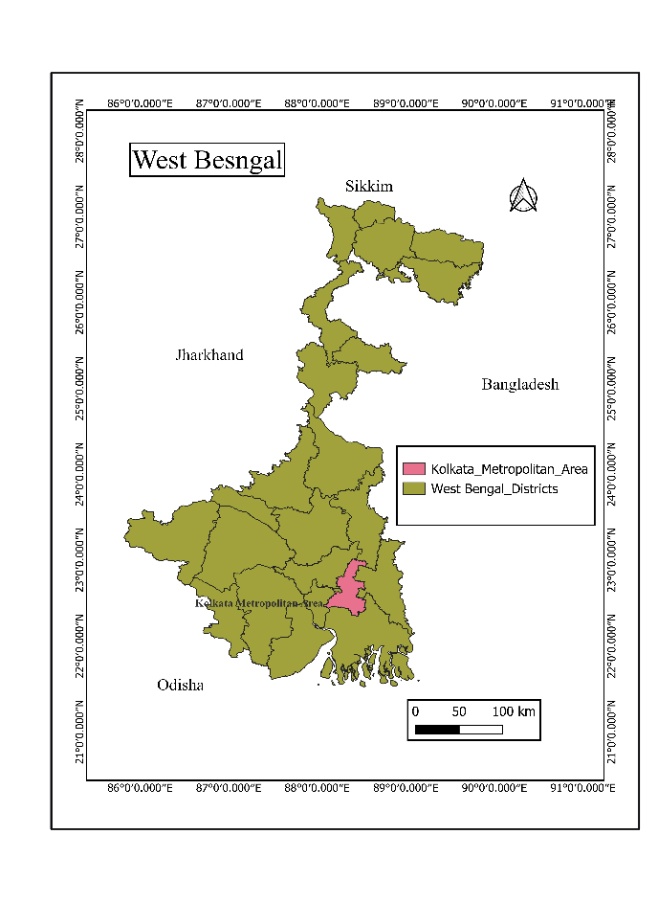
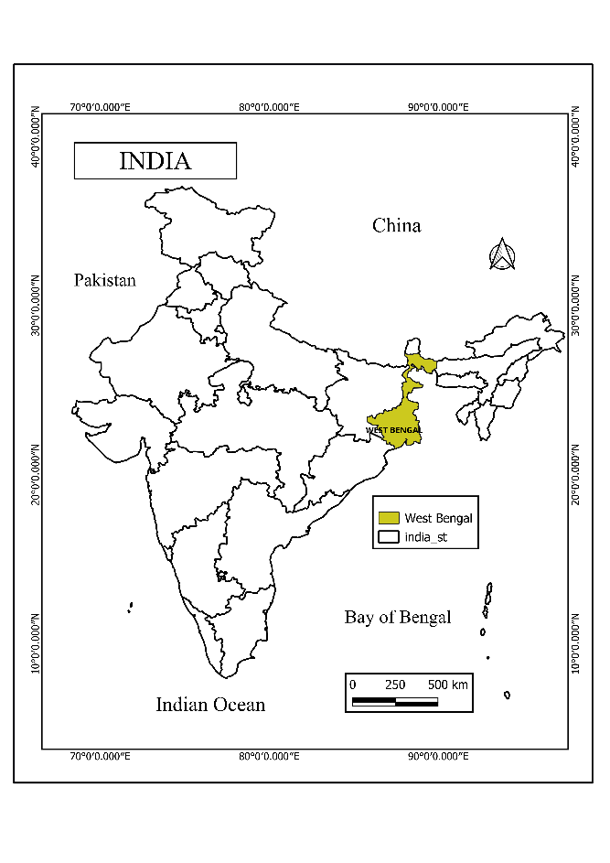
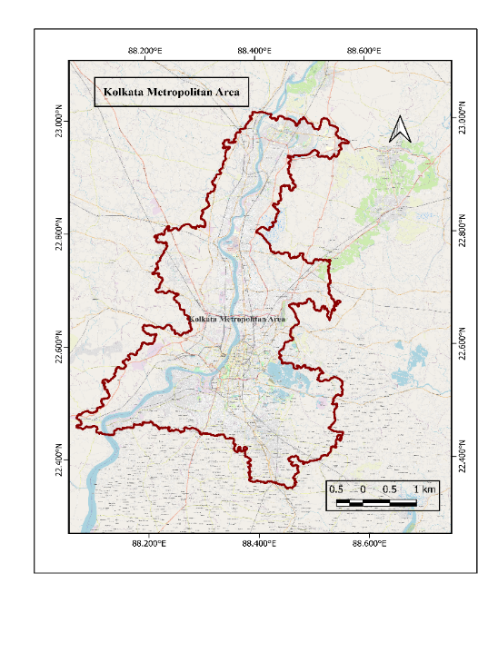

Map 1

Figure 1 : Study Area

Geospatial Technologies: GIS and Remote Sensing
The integration of Geographic Information Systems (GIS) and Remote Sensing (RS) technologies has revolutionized the way environmental and urban systems are monitored, analyzed, and managed. These geospatial technologies provide essential tools for acquiring, storing, processing, visualizing, and analyzing spatially referenced data, making them indispensable for understanding complex land surface processes such as Land Use and Land Cover (LULC) changes.

Remote Sensing: Earth Observation for LULC Monitoring:
Remote sensing is the scientific process of gathering information about the Earth's surface without direct physical contact, typically through sensors mounted on satellites or aircraft. This method allows for large-scale, repetitive, and multi-temporal observations of physical characteristics across both terrestrial and aquatic environments.
In this study, two primary remote sensing datasets were employed: Landsat 8 OLI/TIRS and MODIS (Moderate Resolution Imaging Spectroradiometer). Landsat 8 offers a spatial resolution of 30 meters for multispectral bands and 100 meters for thermal infrared bands, making it ideal for detailed land use and land cover (LULC) classification. It captures imagery every 16 days and includes bands sensitive to visible light, near-infrared, shortwave infrared, and thermal wavelengths—essential for differentiating between built-up areas, vegetation, water bodies, barren lands, and agricultural fields. The high spectral and radiometric resolution of Landsat data enables the application of advanced classification techniques, including supervised classification, spectral indices (such as NDVI, NDBI, and NDWI), and change detection algorithms.
MODIS, which operates aboard NASA’s Terra and Aqua satellites, provides a higher temporal resolution, with daily global coverage and spatial resolutions ranging from 250 meters (for bands associated with vegetation monitoring) to 1 kilometer (for assessing land surface temperature). MODIS data are particularly valuable for monitoring environmental parameters over time, such as the Normalized Difference Vegetation Index (NDVI), which assesses vegetation health and coverage, and Land Surface Temperature (LST), reflecting urban heat dynamics and surface energy balance. The continuous temporal frequency of MODIS allows for the observation of seasonal and interannual trends, making it well-suited for time-series analysis in long-term environmental studies.

GIS: A Platform for Spatial Analysis and Decision Support:
Geographic Information Systems (GIS) are computerized systems used for the storage, analysis, and visualization of geographically referenced data(Attri et al., n.d.). GIS functions as a framework for integrating and managing data from multiple sources—remote sensing imagery, topographic maps, field data, and statistical datasets—within a common spatial context(Mohanasundaram et al., 2022). In this study, GIS was employed to conduct image preprocessing, spatial classification, change detection, zonal statistics, map creation, and temporal analysis.
GIS tools facilitate critical operations such as overlay analysis, buffer generation, raster reclassification, accuracy assessment, and multi-temporal comparison. These capabilities enable researchers to quantify the extent of LULC transitions, identify zones of rapid urban expansion or ecological degradation, and visualize spatial patterns of change(Hardianto et al., 2021). Moreover, GIS supports spatial modeling to assess correlations between variables such as NDVI and LST, or land cover change and urban heat intensity.

Integration of RS and GIS for Urban Environmental Assessment:
The integration of RS and GIS enhances the scope and precision of environmental monitoring by enabling both macro-level assessments (e.g., urban sprawl, regional climate impacts) and micro-level interventions (e.g., ward-level land use planning, hotspot detection)(Ray et al., 2023). Remote sensing provides up-to-date and consistent Earth observation data, while GIS offers the analytical engine to transform raw imagery into actionable insights(Isufi et al., 2021).
In this study, classified LULC maps derived from Landsat data were overlaid with MODIS-based NDVI and LST datasets to examine spatial and temporal relationships(Fu et al., 2011). This multi-sensor, multi-temporal approach allows for a more comprehensive understanding of the landscape dynamics of the Kolkata Metropolitan Area (KMA), especially in response to anthropogenic pressures and climatic variability(Bharathkumar & Mohammed-Aslam, 2015). The use of both medium-resolution and moderate-resolution imagery helps balance between spatial detail and temporal frequency—critical for urban studies where both precision and periodicity matter(Nandi et al., 2017).
Ultimately, the integration of GIS and Remote Sensing forms a powerful and scalable approach for environmental monitoring and urban management. As urban centers like KMA continue to grow, leveraging these technologies becomes essential for evidence-based planning, sustainable development, disaster risk reduction, and climate adaptation(Ouzemou et al., 2018).

Land Use/Land Cover: Concepts and Definitions:
Land Use and Land Cover (LULC) are fundamental concepts in geospatial and environmental studies, representing essential indicators of surface processes, resource management, and anthropogenic influence on the landscape(Wang et al., 2005). Although closely related, land use and land cover signify different aspects of how Earth's surface is organized and utilized.

Land Cover:
Land cover refers to the natural and artificial physical features that occupy the Earth's surface at a given time(Costa et al., 2017). It includes vegetation types, water bodies, bare soil, impervious surfaces, and snow or ice. Land cover is directly measurable using remote sensing techniques, primarily through the spectral signatures captured by multispectral sensors(J. U. & Abah, 2019). These data are processed to generate thematic maps that classify areas into distinct categories such as forest, cropland, water, or built-up areas.
Land cover data are instrumental in environmental monitoring, as they provide objective indicators of ecological conditions, land degradation, and climate variability. For example, reductions in vegetative cover may indicate deforestation, while increases in impervious surfaces signal urban sprawl.

Land Use:
In contrast, land use describes the human purpose or activity assigned to the land. It reflects how people interact with the landscape for residential, agricultural, commercial, industrial, recreational, or conservation purposes(Avci et al., 2023). Unlike land cover, which is a physical property, land use is a socio-economic function and is often inferred from auxiliary datasets, including census records, cadastral maps, or field surveys.
Land use patterns change dynamically in response to policy, population pressure, economic growth, and environmental constraints(Filgueiras et al., 2020). Two areas with identical land cover might support very different land uses, such as a park versus a pasture, highlighting the importance of integrating social data with remote sensing(Fu et al., 2011).

LULC in Geospatial Monitoring:
In applied geospatial analysis, Land Use Land Cover (LULC) studies synthesize both physical land characteristics and human-environment interactions(Jurnal Geodesi Undip, 2015). LULC classification is crucial for tracking landscape transformation, modeling environmental processes, and informing sustainable planning. Using satellite data, particularly from missions like Landsat 8 and MODIS, researchers can map LULC categories over time, assess change trajectories, and identify drivers of change(Xie et al., 2016).
In the context of this study, LULC maps derived from Landsat 8 were used to analyze changes in built-up areas, vegetation, agriculture, and water bodies within the Kolkata Metropolitan Area (KMA) from 2016 to 2022. These insights are vital for understanding urban growth dynamics, environmental stress, and resource pressure in one of India’s most rapidly expanding metropolitan regions.

Land Use Land Cover Change Studies:
Land Use Land Cover Change (LULCC) has emerged as a critical research theme in the study of environmental transformation, urbanization, and global change processes(Costa et al., 2017). The continuous and often rapid changes in land use and land cover reflect human-induced pressures on natural systems, as well as natural factors such as climate variability and geomorphological evolution(Srivastava et al., 2012). Understanding these changes is essential to support decision-making for land resource management, sustainable development, and climate resilience.
Over the past few decades, advancements in remote sensing and geospatial analytics have enabled researchers to systematically observe and quantify changes in land cover at local, regional, and global scales(Kshetri, n.d.). Satellite data from missions like Landsat, MODIS, and Sentinel provide consistent, multi-temporal records that are indispensable for long-term LULC monitoring(Isufi et al., 2021). These datasets help to identify conversion trends such as the expansion of urban areas, reduction of vegetative cover, wetland encroachment, and transformations in agricultural zones. The process of change detection involves classifying images acquired at different time intervals and analyzing transitions between categories, thus revealing the nature and intensity of landscape modification.
LULCC has far-reaching implications for ecological processes, socio-economic development, and environmental sustainability. The conversion of natural landscapes into built-up environments often results in:
- Loss of biodiversity and habitat fragmentation
- Increase in impervious surfaces, altering hydrological cycles
- Reduction in carbon sinks and ecosystem services
- Rise in urban heat island effects and microclimatic alterations
These consequences are particularly severe in rapidly urbanizing regions where land conversion outpaces infrastructure planning. In countries like India, the pressure of population growth, industrial expansion, and infrastructure development has significantly accelerated land cover change, especially in major metropolitan regions such as the Kolkata Metropolitan Area (KMA).
LULCC studies in KMA have documented substantial transformation in land patterns over the last few decades. Historically dominated by agriculture, wetlands, and riverine systems, the region has experienced widespread urban encroachment, reclamation of lowlands, and infrastructure expansion. This has led to increased vulnerability to flooding, degradation of ecological buffers, and loss of peri-urban green space(Bharathkumar & Mohammed-Aslam, 2015). However, many existing studies have focused either on limited time periods or have not incorporated the environmental variables such as vegetation health and surface temperature in conjunction with LULC classes(GIS_application_for_NDVI_calculation_usi, n.d.).
The present study addresses these gaps by analyzing multi-year LULC dynamics in KMA from 2016 to 2022 using both Landsat and MODIS datasets. It integrates biophysical indicators—namely NDVI (Normalized Difference Vegetation Index) and LST (Land Surface Temperature)—to assess not only land cover transitions but also their ecological and thermal consequences. This combined approach provides a comprehensive framework to detect patterns, interpret drivers of change, and evaluate spatial consequences on the regional environment. The outcomes of such research can inform sustainable urban planning, restoration of ecological assets, and climate adaptation strategies.

Methodology:
This study integrates remote sensing and GIS-based techniques to monitor Land Use Land Cover (LULC) changes in the Kolkata Metropolitan Area (KMA) from 2016 to 2022. Landsat 8 OLI imagery was utilized for LULC classification due to its moderate spatial resolution and multispectral capabilities, while MODIS data supported the analysis of vegetation dynamics (NDVI) and surface thermal conditions (LST) owing to its high temporal resolution.
The preprocessing stage involved radiometric and geometric corrections, cloud removal, and image enhancement to improve interpretability and ensure temporal consistency. Training samples representing built-up, vegetation, water, agriculture, and barren land were generated from high-resolution basemaps and ground reference sources. A supervised classification was carried out using the Maximum Likelihood Classifier (MLC), followed by accuracy assessment through confusion matrices and Kappa coefficient evaluation.
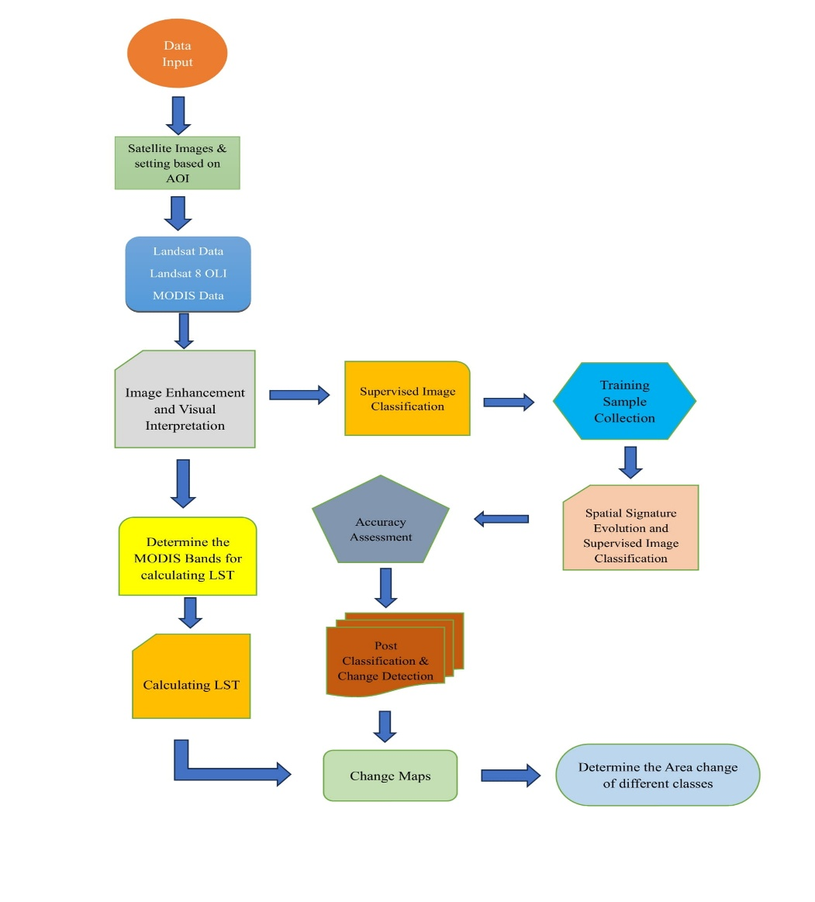

Figure 2: Methodological Diagram
NDVI and LST were computed from MODIS data using red, near-infrared, and thermal bands. These indices were spatially correlated with LULC classifications to examine environmental responses to land cover transitions. Post-classification comparison was used to detect changes across years, calculate area statistics, and identify major transition zones. All spatial operations, classification, and change detection analyses were conducted within a GIS platform.

Data Sources and Tools:
The study utilized multi-sensor satellite datasets and geospatial tools to analyze Land Use Land Cover (LULC) dynamics in the Kolkata Metropolitan Area (KMA) over a seven-year period (2016–2022). Two primary satellite data sources—Landsat 8 and MODIS (Moderate Resolution Imaging Spectroradiometer)—were selected due to their global availability, multi-temporal acquisition, and proven reliability in environmental monitoring and land cover analysis.
Landsat 8, operated jointly by the United States Geological Survey (USGS) and NASA, provides medium-resolution multispectral imagery suitable for detailed land classification. Its Operational Land Imager (OLI) and Thermal Infrared Sensor (TIRS) offer spectral coverage in visible, near-infrared, shortwave infrared, and thermal infrared regions. This dataset was used for annual LULC classification using supervised image classification techniques.
MODIS, aboard NASA’s Terra and Aqua satellites, offers high-temporal-resolution imagery that is well-suited for environmental variable analysis such as vegetation condition and surface temperature. The study utilized MODIS-derived NDVI and LST products to monitor vegetation health and urban heat trends.
All image preprocessing, classification, spatial analysis, and change detection were conducted using Google Earth Engine (GEE), QGIS, and ArcGIS software environments. Google Earth Engine facilitated cloud-based access and processing of large temporal datasets, while QGIS and ArcGIS supported visualization, zonal statistics, and layout design.

Satellite | Sensor | Spatial Resolution | Spectral Resolution | Temporal Resolution | Data Used
Landsat 8 | OLI & TIRS | 30 m (OLI), 100 m (TIRS resampled to 30 m) | 11 bands (Visible, NIR, SWIR, Thermal) | 16 days | NDVI, NDWI, NDBI,  LULC Classification
MODIS | MODIS (Terra/Aqua) | 250 m – 1 km | 36 bands (Visible to Thermal Infrared) | Daily (NDVI), 8-day composites (LST) | LST Analysis
Table 1: Detailed Information of Satellites

Analysis and Results of Spectral Indices:
In order to evaluate biophysical changes in the Kolkata Metropolitan Area (KMA) from 2016 to 2024, three spectral indices were calculated using Landsat 8 imagery: the Normalized Difference Vegetation Index (NDVI), the Normalized Difference Built-up Index (NDBI), and the Normalized Difference Water Index (NDWI). These indices provide critical insights into changes in vegetation vigor, built-up intensity, and surface water dynamics, respectively. Each index is derived using specific spectral bands and offers pixel-wise quantification of thematic phenomena over time.

Normalized Difference Vegetation Index (NDVI):
Formula:
$$NDVI=\frac{NIR-RED}{NIR+RED}$$
Where:
- NIR (Band 5): Reflectance in the Near-Infrared region
- RED (Band 4): Reflectance in the Red region
NDVI is an established proxy for vegetation health, canopy density, and greenness. In 2016, NDVI values in KMA ranged from -0.1806 to 0.4777, increasing slightly in 2024 to -0.1432 to 0.4850. This indicates a marginal upward shift in the upper vegetation threshold, reflecting healthier or more photosynthetically active vegetation.
These observations are partly supported by the change statistics, which show a decline in classified forest area by 46.76 km². Despite this reduction, the NDVI values did not deteriorate significantly, suggesting compensation through vegetation outside formal forest zones—such as agricultural land, urban green patches, or afforestation projects.
The consistency in lower NDVI zones (negative to near-zero values) continues to reflect urbanized or barren surfaces. However, the persistence and slight enhancement of the positive NDVI range imply that vegetative health remains resilient in many parts of the region.

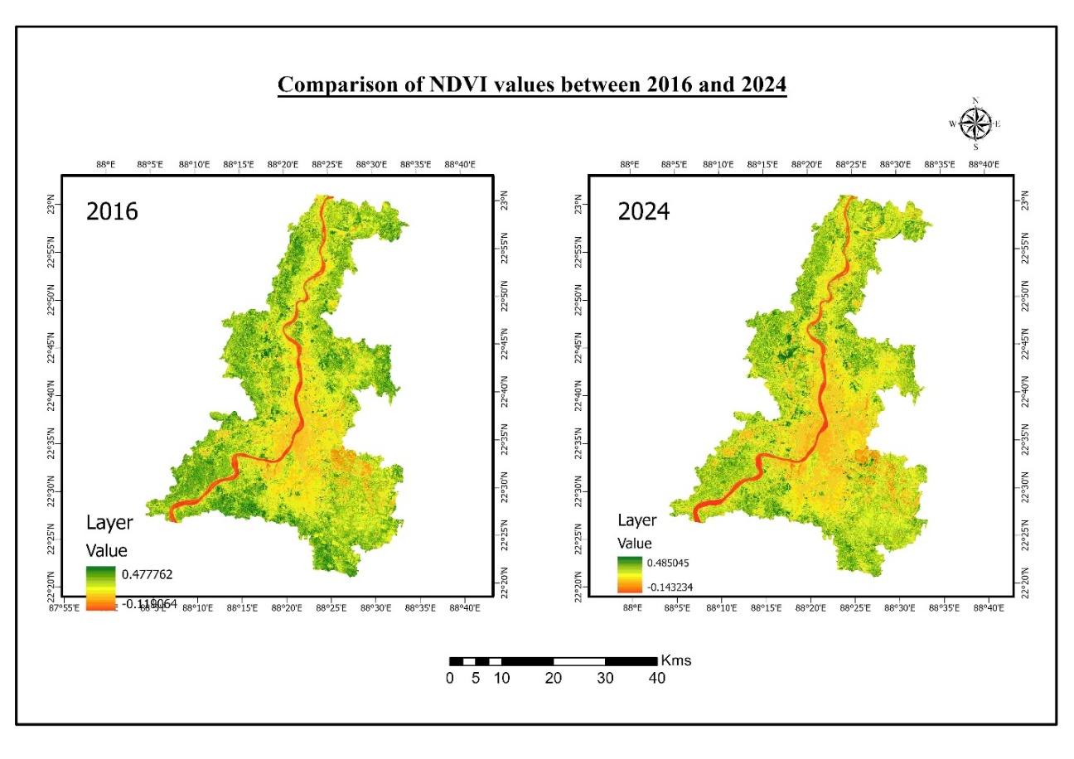
Figure 3. Showing Changes of NDVI of KMA 2016-2024

Normalized Difference Built-up Index (NDBI):
Formula:
$$NDBI=\frac{SWIR-NIR}{SWIR+NIR}$$
Where:
- SWIR (Band 6): Reflectance in the Short-Wave Infrared region
- NIR (Band 5): Reflectance in the Near-Infrared region
NDBI emphasizes impervious urban features due to their higher SWIR and lower NIR reflectance. Between 2016 and 2024, the NDBI range increased from -0.2991 to 0.2696 in 2016 to -0.3055 to 0.2964 in 2024. This increase in the maximum value reflects an intensification of urban materials—such as concrete, metal, and rooftops—especially in central and southern KMA.
Interestingly, the LULC statistics show a reduction in the classified “developed” area by 307.70 km², which appears contrary to the spectral trend. This discrepancy may arise from misclassification of transitional zones or from newly developing areas being categorized as “barren” rather than “developed.” In fact, the increase in barren land by 394.12 km² supports this possibility, as barren construction zones often produce high SWIR signals, raising NDBI values.
Hence, the spectral NDBI response reflects an increasing intensity of impervious surfaces—even if formal urban classifications appear reduced—highlighting the benefit of using indices alongside thematic classification.
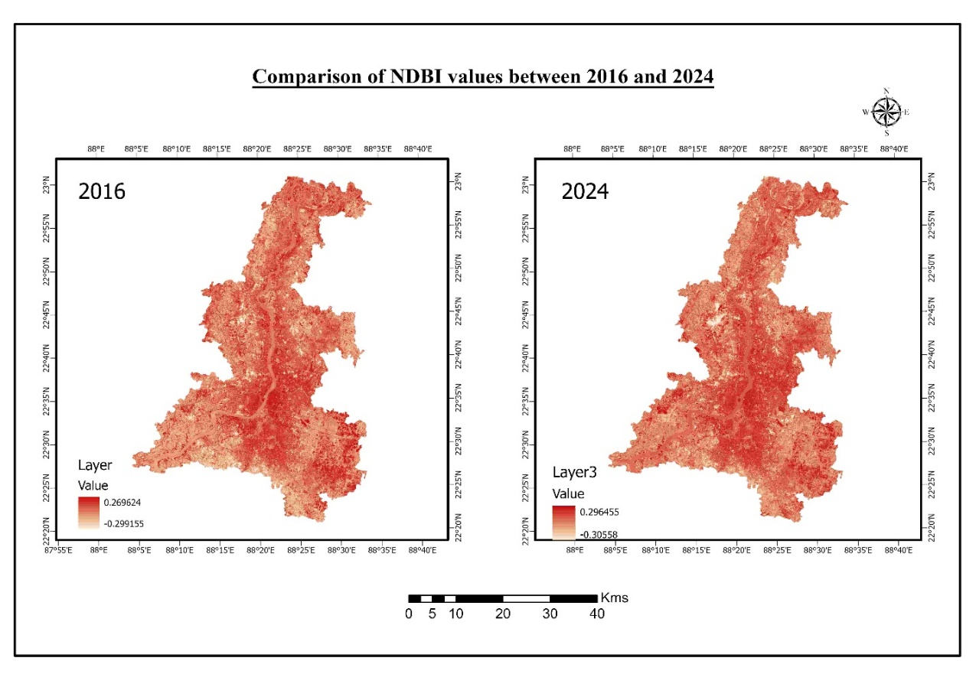
Figure 4. Comparison of NDBI values

Normalized Difference Water Index (NDWI):
Formula:
$$NDWI= \frac{NIR-SWIR}{NIR+SWIR}$$
Where:
- GREEN (Band 3): Reflectance in the Green spectral band
- NIR (Band 5): Reflectance in the Near-Infrared spectral band
NDWI isolates surface water bodies by maximizing green reflectance and minimizing NIR, which water absorbs. In 2016, the NDWI ranged from -0.4215 to 0.1015, increasing in 2024 to -0.4354 to 0.1831. This increase in maximum NDWI indicates stronger or clearer water signatures, especially in well-defined water bodies like the Hooghly River and southern wetlands.
LULC statistics reveal a loss of 39.66 km² in water area. This suggests that while overall water extent decreased, the spectral intensity of remaining water features may have improved, possibly due to seasonal timing, water clarity, or deeper reservoirs. NDWI also reflects seasonal water presence, and temporal differences in image acquisition can influence the peak values.
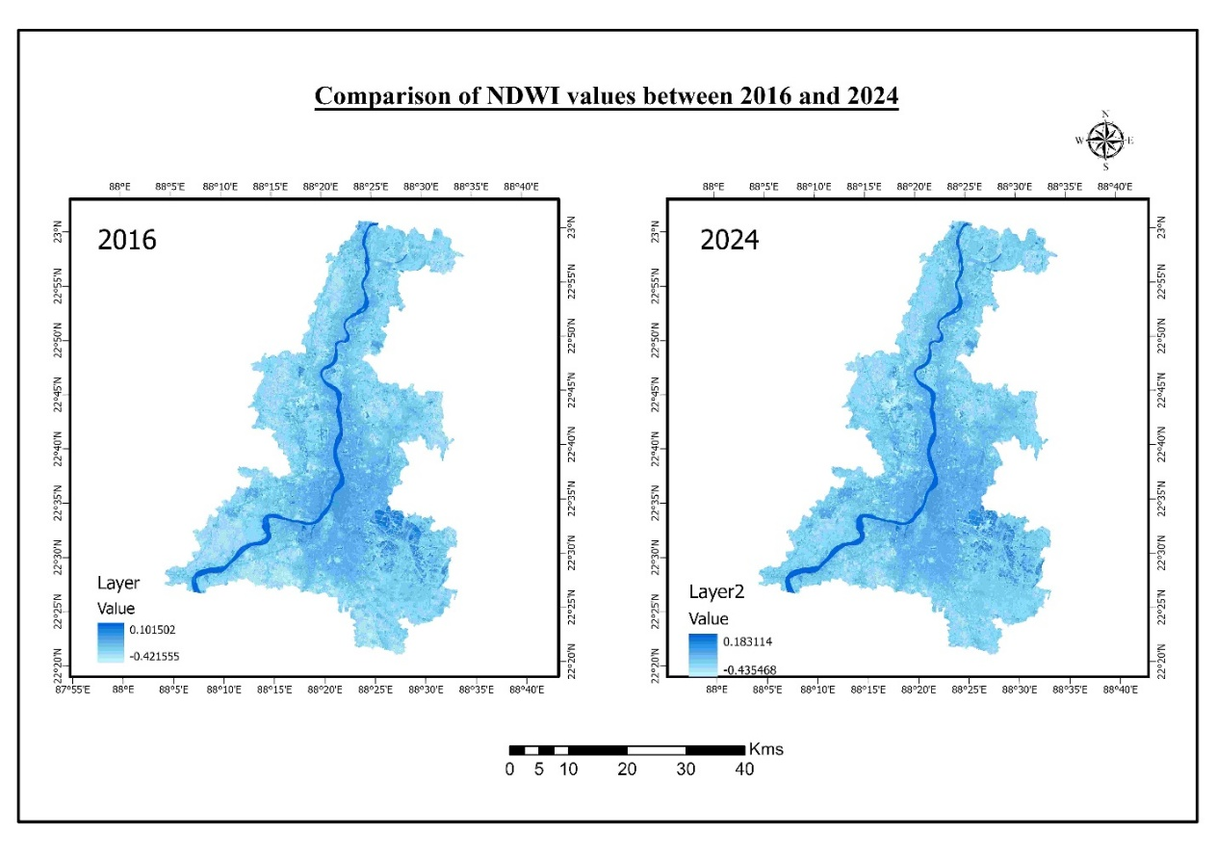
Figure 5. Showing Changes of NDWI of KMA 2016-2024

Therefore, NDWI provides an insightful complement to area statistics by highlighting qualitative improvements or degradation in water surfaces, even when total coverage fluctuates.
Index | Year | Min Value | Max Value | Change in Max | Observation
NDVI | 2016 | -0.1806 | 0.4777 |  | Baseline vegetation intensity
NDVI | 2024 | -0.1432 | 0.485 | +0.0073 | Slight improvement in vegetation intensity despite a small decline in forest
NDBI | 2016 | -0.2991 | 0.2696 |  | Baseline urban reflectance
NDBI | 2024 | -0.3055 | 0.2964 | +0.0268 | Spectral increase in impervious surface; may include barren-construction zones
NDWI | 2016 | -0.4215 | 0.1015 |  | Baseline water reflectance
NDWI | 2024 | -0.4354 | 0.1831 | +0.0816 | Water bodies appear spectrally stronger despite reduction in mapped surface area
Table 2: Comparative Analysis of Fluctuation of Different Spectral Indexing

This matrix-driven analysis combines pixel-level spectral responses with area-based class transitions, offering a more nuanced view of the environmental changes occurring across KMA. The integration of both dimensions—spectral and spatial—improves interpretive depth and reliability.

Land Use Land Cover (LULC) Analysis:
The LULC maps generated for the Kolkata Metropolitan Area (KMA) for 2016 and 2024 using the Support Vector Machine (SVM) classifier reveal substantial spatial and categorical shifts in land cover over the study period. The classified outputs delineate four primary categories: Forest, Barren, Developed, and Water.
Between 2016 and 2024, notable changes are observed:
- Barren land increased significantly, from 374.16 km² to 768.28 km², marking a net gain of 394.12 km². This reflects either vegetation degradation, transitional construction zones, or the clearing of land for urban expansion.
- Developed area sharply declined, from 686.52 km² to 378.82 km² (a decrease of 307.70 km²). This counterintuitive trend may stem from reclassification of developed zones as barren or differences in seasonal imagery, but still aligns with increased NDBI due to imperviousness.
- Forest area marginally declined by 46.76 km², likely due to edge encroachment or partial deforestation, particularly in the southeastern fringe and central buffer areas.
- Water bodies reduced by 39.66 km², with shrinkage visible in peripheral ponds and wetland clusters, although the Hooghly River remains dominant in both years.

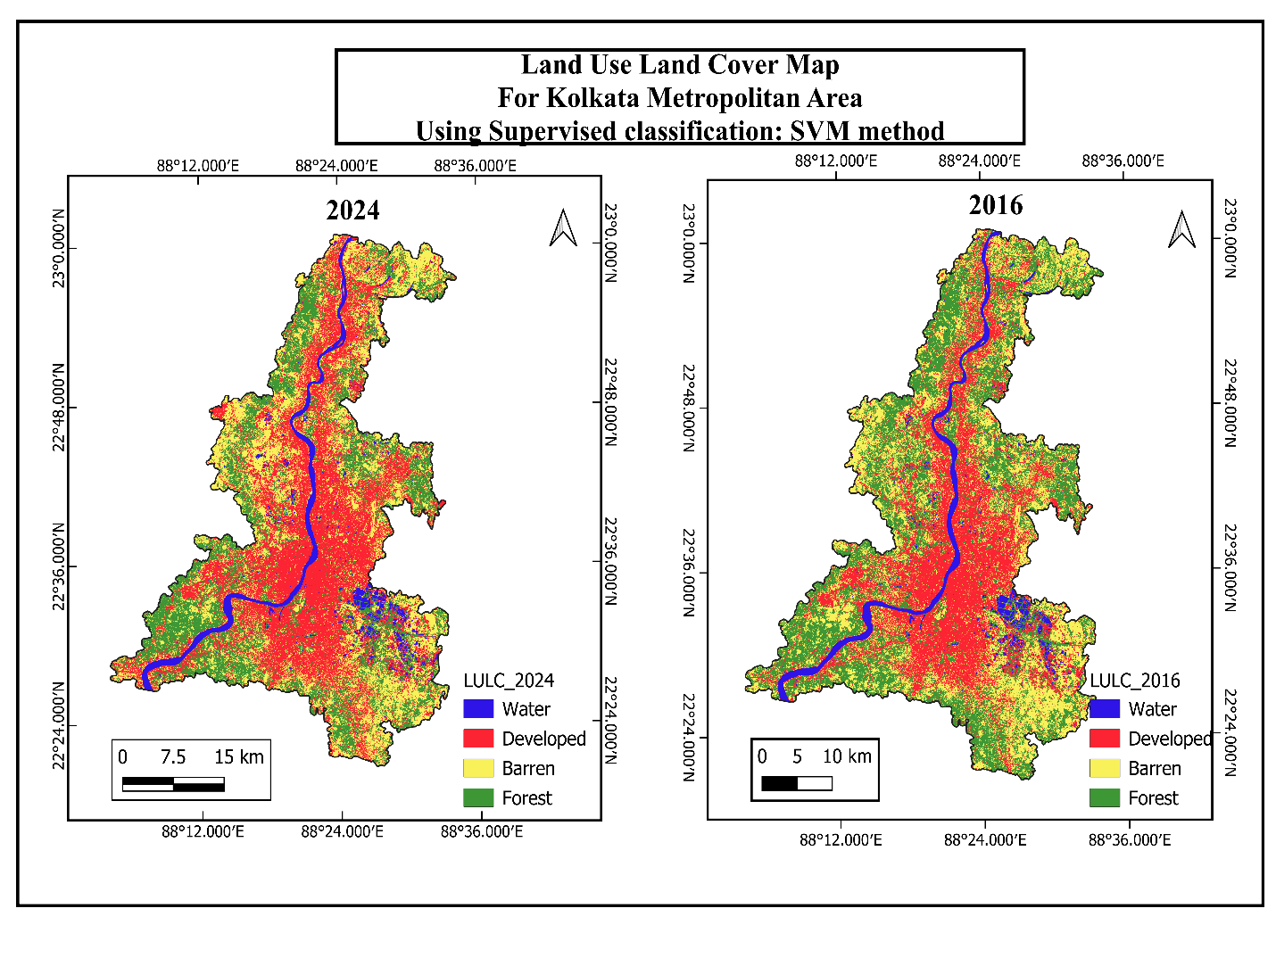

Figure 6. Showing the LULC Changes in KMA 2016-2024

The spatial patterns also indicate increased landscape fragmentation, with red (developed) and yellow (barren) pixels occupying formerly green (forest) areas. Water zones have become more concentrated along the main river course, and previously scattered aquatic patches show signs of shrinkage or conversion.

Figure 7: Spectral Index Behavior Analysis

NDVI Interpretation
The NDVI index, sensitive to chlorophyll and vegetative vigor, shows a slight increase in maximum value from 0.4777 (2016) to 0.4850 (2024). Despite a decrease in forest area, NDVI suggests localized greening—potentially in parks, urban vegetation patches, or seasonal cropland. Its resilience may also relate to improved vegetation management in peri-urban belts. This pattern is further reflected in weak negative correlation (r ≈ –0.2) with forest area.
NDBI Interpretation
NDBI values rose from 0.2696 to 0.2964, indicating a stronger built-up or impervious signature. The increase aligns with the surge in barren area (+394.12 km²), as both barren soil and concrete surfaces reflect strongly in the SWIR band. The reduced “developed” class did not decrease NDBI, which suggests that the spectral signal of urban surfaces is retained or replaced by construction zones. NDBI correlates positively with barren land (r ≈ +0.6).
NDWI Interpretation
NDWI values rose from 0.1015 to 0.1831, a trend not matched by the reduction in waterbody area. This implies a concentration or enhancement in the reflectance of remaining water bodies, such as deeper or cleaner water during acquisition. NDWI shows weak to moderate negative correlation with total water area (r ≈ –0.3), reinforcing the idea that NDWI captures intensity over extent.

Land Surface Temperature (LST) Analysis and Validation:
MODIS-Based LST Interpretation
Land Surface Temperature (LST) is a key environmental indicator representing the radiative skin temperature of the Earth's surface. In this study, MODIS thermal bands were used to compute LST for the years 2016 and 2024, providing insights into the urban thermal environment and its evolution across the Kolkata Metropolitan Area (KMA).
The 2016 LST map (Figure 4) reveals surface temperatures ranging from 31.37 °C to 40.81 °C, while in 2024, this range increased to 32.57 °C to 41.49 °C. This marks a clear upward shift in both the minimum and maximum temperature thresholds, indicating widespread intensification of surface heating over the eight-year period.

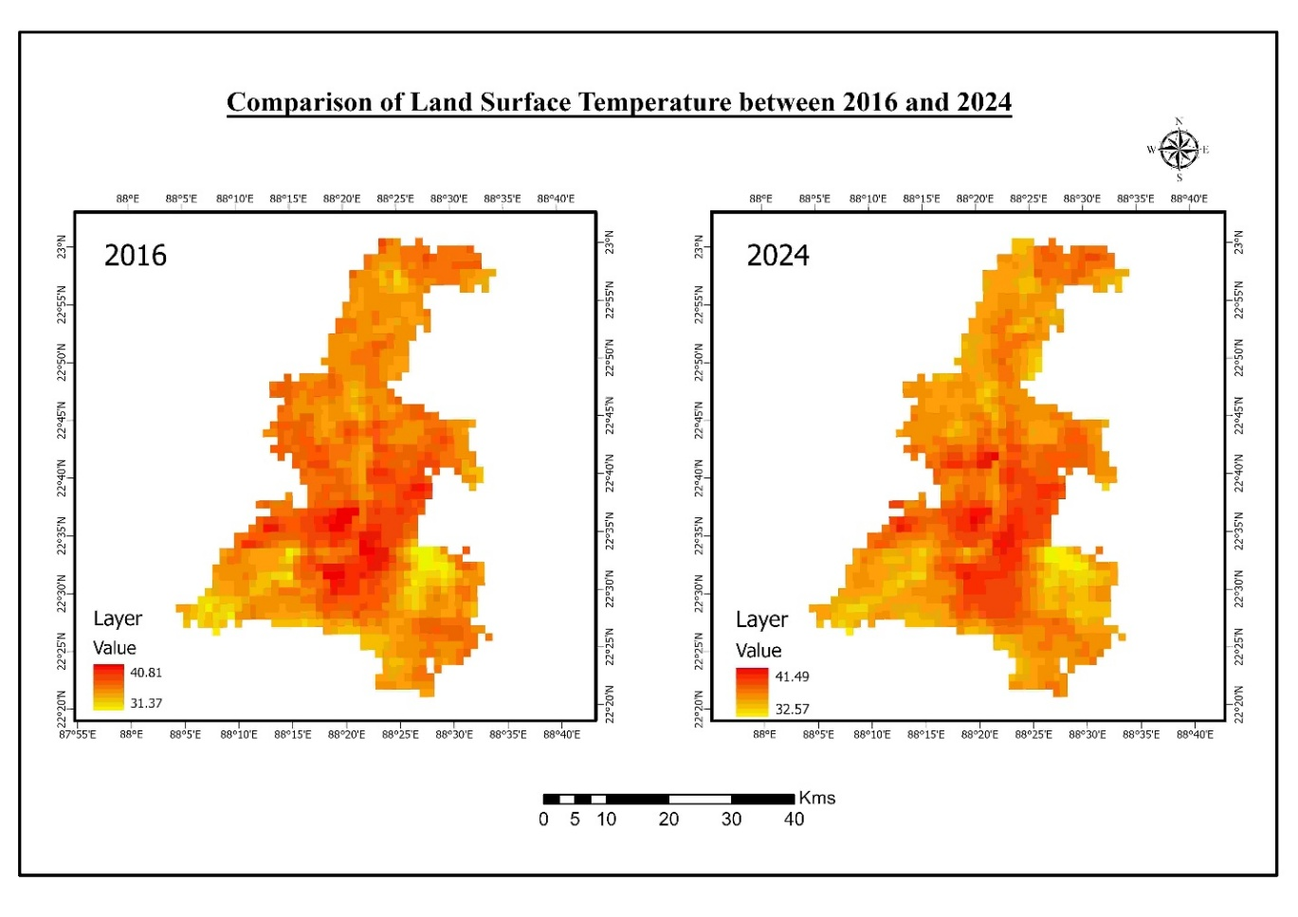
Figure 8: Comparison of LST in KMA 2016-2024

Spatially, hotter zones (red and orange regions) became more concentrated and widespread in 2024, particularly across southern and central KMA—areas that also showed high NDBI values and reduced NDVI/NDWI signatures. This suggests a direct correspondence between urban expansion and LST rise, consistent with the urban heat island (UHI) effect.

Validation with Built-Up Area (NDBI & LULC)
A significant validation of the LST pattern comes from its correlation with built-up indicators:
- NDBI, which rose from 0.2696 to 0.2964, signals increasing impervious surfaces that retain and radiate more heat.
- Barren land, which expanded by +33km², also contributes to higher LST due to low albedo and poor evapotranspiration.
- The “Developed” class decreased in the classified LULC output, but the barren class increase suggests that impervious or transitional land is still expanding, explaining the thermal signal rise despite classification discrepancies.
This aligns with observed LST elevations in MODIS output, confirming that LST increases are more sensitive to surface characteristics than formal land use classes. In this context, MODIS LST offers high-temporal resolution validation of surface conditions, bridging spectral index analysis with thermal dynamics.

LST–Index Correlation Summary
Variable | Correlation with LST (r) | Relationship | Explanation
NDVI | –0.5 | Moderate Negative | Vegetation reduces surface temperature through evapotranspiration
NDBI | +0.6 | Strong Positive | Built-up areas contribute to heat accumulation
NDWI | –0.6 | Strong Negative | Water bodies provide thermal buffering and microclimate moderation
Barren Area (LULC)  Table 3 LST–Index Correlation Summary | +0.5 | Moderate Positive | Exposed soil heats rapidly, lacking vegetative cover

Scientific Implications
The rising LST trend in KMA, as confirmed by MODIS data and correlated indices, points toward escalating urban thermal risk. The intensification of heat-prone zones aligns with:
- Vegetation loss (NDVI decline or stagnation)
- Expansion of impervious surfaces (NDBI rise)
- Shrinkage of water bodies (NDWI decline)
These changes support the hypothesis that land cover transitions drive LST rise, and underscore the need for strategic vegetation restoration, green infrastructure, and water body conservation to mitigate UHI effects.

Result and Discussion:
The present study utilized multi-temporal Landsat 8 and MODIS satellite datasets to evaluate Land Use Land Cover (LULC) transformations, biophysical index fluctuations (NDVI, NDBI, NDWI), and surface temperature dynamics (LST) across the Kolkata Metropolitan Area (KMA) between 2016 and 2024. The results reveal a complex interplay between anthropogenic land conversion and environmental parameters.
One of the most significant findings is the sharp increase in barren land by 33.12 km², largely replacing previously developed or vegetated zones. Simultaneously, the classified developed area decreased by over 132 km², which at first appears counterintuitive. However, this trend aligns with the increase in NDBI, suggesting that land classified as “barren” may still consist of impervious or semi-urbanized surfaces—such as ongoing construction sites or cleared zones—that radiate heat and suppress vegetative indices.
Similarly, NDVI values increased slightly despite a net loss of forest area, highlighting that vegetative cover in non-forest zones—such as plantations, agriculture, and urban greenery—may have contributed to maintaining or improving photosynthetic activity. Meanwhile, the NDWI trend shows spectral enhancement, even though water bodies decreased in area. This divergence likely reflects increased spectral concentration of water in fewer but deeper or cleaner bodies, possibly due to changes in acquisition season or water table conditions.
The most striking outcome, however, is the rise in Land Surface Temperature (LST). MODIS-derived maps show an increase in maximum temperature from 40.81 °C in 2016 to 41.49 °C in 2024, alongside a similar elevation in minimum surface temperature. The spatial correlation of high-LST zones with areas of high NDBI and low NDVI/NDWI confirms a strong biophysical influence on surface heating. Statistical correlation estimates reinforce these relationships, with LST positively correlated with NDBI (r ≈ +0.6) and negatively correlated with NDVI and NDWI (r ≈ –0.5 to –0.6).
These findings substantiate the hypothesis that LULC changes—especially increases in built-up and barren land—are driving thermal intensification across KMA. Importantly, such changes are not evenly distributed; central and southern KMA experience more pronounced thermal amplification, highlighting spatial inequality in environmental vulnerability.

Conclusion:
This study offers an integrated remote sensing–based assessment of LULC dynamics, spectral index behavior, and thermal change in the Kolkata Metropolitan Area from 2016 to 2024. The research draws several critical conclusions:
- LULC Conversion: Forest and developed classes decreased, while barren land increased dramatically. These transformations suggest rapid land clearance and transitional urban growth patterns not fully captured by conventional LULC classification schemes.
- Spectral Index Trends:
  - NDVI remained stable or slightly improved, reflecting compensation of forest loss by other vegetative zones.
  - NDBI increased, reflecting intensification of impervious and semi-urbanized zones.
  - NDWI increased in value but decreased in areal extent, suggesting concentrated rather than expanded water presence.
- Thermal Amplification: LST values increased significantly, with MODIS data indicating a rise of approximately 0.7 °C in peak surface temperatures. This increase spatially aligns with NDBI hotspots and inversely correlates with vegetation and water availability.
- Index–LST Relationships: Correlation analysis confirms:
  - NDVI vs. LST → r ≈ –0.5
  - NDBI vs. LST → r ≈ +0.6
  - NDWI vs. LST → r ≈ –0.6
These results affirm that vegetation and water mitigate urban heat, while built-up and barren zones exacerbate it. This underscores the vital role of green infrastructure and water bodies in regulating the urban microclimate.

Policy Recommendations:
Based on the scientific evidence presented, several policy interventions are recommended to promote sustainable urban development and environmental resilience in the Kolkata Metropolitan Area:
Greening and Vegetation Enhancement
- Implement urban afforestation programs and promote the integration of green roofs, vertical gardens, and roadside vegetation.
- Incentivize green buffer zones in rapidly developing and industrial corridors to counter LST rise.
Barren Land Conversion Strategy
- Convert large barren patches—especially those adjoining urban cores—into urban parks, community gardens, and eco-sensitive zones.
- Introduce zoning policies that limit the temporal duration for which construction sites remain in a barren state without cover.
Water Body Protection
- Enforce legal protection of existing ponds, wetlands, and riverbanks, especially in the southern and eastern KMA where NDWI decline is spatially evident.
- Encourage decentralized rainwater harvesting and permeable pavement infrastructure to restore surface hydrology.

Thermal Zoning in Urban Planning
- Integrate thermal zoning into building codes to mitigate UHI effects by restricting highly reflective/heat-retaining surfaces in dense zones.
- Develop an Urban Climate Resilience Index (UCRI) based on NDVI, NDBI, NDWI, and LST to assess risk and guide infrastructure design.
Geospatial Monitoring Framework
- Establish a municipal geospatial cell to conduct seasonal LULC and LST mapping using freely available satellite data.

COMPETING INTERESTS DISCLAIMER:
Authors have declared that they have no known competing financial interests OR non-financial interests OR personal relationships that could have appeared to influence the work reported in this paper.

References:
- Astuti, I. S., Sahoo, K., Milewski, A., & Mishra, D. R. (2019). Impact of Land Use Land Cover (LULC) Change on Surface Runoff in an Increasingly Urbanized Tropical Watershed. Water Resources Management, 33(12), 4087–4103. https://doi.org/10.1007/s11269-019-02320-w
- Attri, P., Chaudhry, S., & Sharma, S. (n.d.). Remote Sensing & GIS based Approaches for LULC Change Detection – A Review.
- Avci, C., Budak, M., Yağmur, N., & Balçik, F. (2023). Comparison between random forest and support vector machine algorithms for LULC classification. International Journal of Engineering and Geosciences, 8(1), 1–10. https://doi.org/10.26833/ijeg.987605
- Bharathkumar, L., & Mohammed-Aslam, M. A. (2015). Crop Pattern Mapping of Tumkur Taluk Using NDVI Technique: A Remote Sensing and GIS Approach. Aquatic Procedia, 4, 1397–1404. https://doi.org/10.1016/j.aqpro.2015.02.181
- Bhattacharjee, S., & Ghosh, S. K. (2015). SPATIO-TEMPORAL CHANGE MODELING OF LULC: A SEMANTIC KRIGING APPROACH. ISPRS Annals of the Photogrammetry, Remote Sensing and Spatial Information Sciences, II-4/W2, 177–184. https://doi.org/10.5194/isprsannals-II-4-W2-177-2015
- Chen, J., Wang, Y., Wang, J., Zhang, Y., Xu, Y., Yang, O., Zhang, R., Wang, J., Wang, Z., Lu, F., & Hu, Z. (2024). The Performance of Landsat-8 and Landsat-9 Data for Water Body Extraction Based on Various Water Indices: A Comparative Analysis. Remote Sensing, 16(11), 1984. https://doi.org/10.3390/rs16111984
- Costa, S., Santos, V., Melo, D., & Santos, P. (2017). Evaluation of Landsat 8 and Sentinel-2A data on the correlation between geological mapping and NDVI. 2017 First IEEE International Symposium of Geoscience and Remote Sensing (GRSS-CHILE), 1–4. https://doi.org/10.1109/GRSS-CHILE.2017.7996006
- Das, S., Kumar Shit, P., Bera, B., & Adhikary, P. P. (2022). Effect of urbanization on the dynamics of ecosystem services: An analysis for decision making in Kolkata urban agglomeration. Urban Ecosystems, 25(5), 1541–1559. https://doi.org/10.1007/s11252-022-01246-3
- Filgueiras, R., Mantovani, E. C., Fernandes-Filho, E. I., Cunha, F. F. D., Althoff, D., & Dias, S. H. B. (2020). Fusion of MODIS and Landsat-Like Images for Daily High Spatial Resolution NDVI. Remote Sensing, 12(8), 1297. https://doi.org/10.3390/rs12081297
- Fu, G., Shen, Z., Zhang, X., Shi, P., Zhang, Y., & Wu, J. (2011). Estimating air temperature of an alpine meadow on the Northern Tibetan Plateau using MODIS land surface temperature. Acta Ecologica Sinica, 31(1), 8–13. https://doi.org/10.1016/j.chnaes.2010.11.002
- GIS_application_for_NDVI_calculation_usi. (n.d.).
- Guha, S., Govil, H., Dey, A., & Gill, N. (2018). Analytical study of land surface temperature with NDVI and NDBI using Landsat 8 OLI and TIRS data in Florence and Naples city, Italy. European Journal of Remote Sensing, 51(1), 667–678. https://doi.org/10.1080/22797254.2018.1474494
- Hardianto, A., Dewi, P. U., Feriansyah, T., Sari, N. F. S., & Rifiana, N. S. (2021). Pemanfaatan Citra Landsat 8 Dalam Mengidentifikasi Nilai Indeks Kerapatan Vegetasi (NDVI) Tahun 2013 dan 2019 (Area Studi: Kota Bandar Lampung). Jurnal Geosains dan Remote Sensing, 2(1), 8–15. https://doi.org/10.23960/jgrs.2021.v2i1.38
- Hengl, T., Heuvelink, G. B. M., Perčec Tadić, M., & Pebesma, E. J. (2012). Spatio-temporal prediction of daily temperatures using time-series of MODIS LST images. Theoretical and Applied Climatology, 107(1–2), 265–277. https://doi.org/10.1007/s00704-011-0464-2
- Isufi, F., Berila, A., & Bulliqi, S. (2021). Measuring UHI using Landsat 8 OLI and TIRS data with NDVI and NDBI in Municipality of Prishtina. Disaster Advances, 14(11), 25–36. https://doi.org/10.25303/1411da2536
- J. U., R., & Abah, I. A. (2019). DERIVATION OF LAND SURFACE TEMPERATURE (LST) FROM LANDSAT 7 & 8 IMAGERIES AND ITS RELATIONSHIP WITH TWO VEGETATION INDICES (NDVI AND GNDVI). International Journal of Research -GRANTHAALAYAH, 7(2), 108–120. https://doi.org/10.29121/granthaalayah.v7.i2.2019.1013
- Jurnal Geodesi Undip. (2015).
- Kafi, K. M., Shafri, H. Z. M., & Shariff, A. B. M. (2014). An analysis of LULC change detection using remotely sensed data; A Case study of Bauchi City. IOP Conference Series: Earth and Environmental Science, 20, 012056. https://doi.org/10.1088/1755-1315/20/1/012056
- Khan, A., Chatterjee, S., Akbari, H., Bhatti, S. S., Dinda, A., Mitra, C., Hong, H., & Doan, Q. V. (2019). Step-wise Land-class Elimination Approach for extracting mixed-type built-up areas of Kolkata megacity. Geocarto International, 34(5), 504–527. https://doi.org/10.1080/10106049.2017.1408704
- Kshetri, T. B. (n.d.). NDVI, NDBI AND NDWI CALCULATION USING LANDSAT 7 AND 8.
- Mohanasundaram, S., Baghel, T., Thakur, V., Udmale, P., & Shrestha, S. (2022). Reconstructing NDVI and land surface temperature from cloud cover pixels of Landsat-8 images and assessing vegetation health index in the Northeast region of Thailand. In Review. https://doi.org/10.21203/rs.3.rs-1803210/v1
- Nandi, I., Srivastava, P. K., & Shah, K. (2017). Floodplain Mapping through Support Vector Machine and Optical/Infrared Images from Landsat 8 OLI/TIRS Sensors: Case Study from Varanasi. Water Resources Management, 31(4), 1157–1171. https://doi.org/10.1007/s11269-017-1568-y
- Ouzemou, J.-E., El Harti, A., Lhissou, R., El Moujahid, A., Bouch, N., El Ouazzani, R., Bachaoui, E. M., & El Ghmari, A. (2018). Crop type mapping from pansharpened Landsat 8 NDVI data: A case of a highly fragmented and intensive agricultural system. Remote Sensing Applications: Society and Environment, 11, 94–103. https://doi.org/10.1016/j.rsase.2018.05.002
- Ray, R., Das, A., Hasan, M. S. U., Aldrees, A., Islam, S., Khan, M. A., & Lama, G. F. C. (2023). Quantitative Analysis of Land Use and Land Cover Dynamics using Geoinformatics Techniques: A Case Study on Kolkata Metropolitan Development Authority (KMDA) in West Bengal, India. Remote Sensing, 15(4), 959. https://doi.org/10.3390/rs15040959
- Roy, D. P., Kovalskyy, V., Zhang, H. K., Vermote, E. F., Yan, L., Kumar, S. S., & Egorov, A. (2016). Characterization of Landsat-7 to Landsat-8 reflective wavelength and normalized difference vegetation index continuity. Remote Sensing of Environment, 185, 57–70. https://doi.org/10.1016/j.rse.2015.12.024
- Srivastava, P. K., Han, D., Rico-Ramirez, M. A., Bray, M., & Islam, T. (2012). Selection of classification techniques for land use/land cover change investigation. Advances in Space Research, 50(9), 1250–1265. https://doi.org/10.1016/j.asr.2012.06.032
- Vivekananda, G., Swathi, R., & Sujith, A. (2021). RETRACTED ARTICLE: Multi-temporal image analysis for LULC classification and change detection. European Journal of Remote Sensing, 54(sup2), 189–199. https://doi.org/10.1080/22797254.2020.1771215
- Wan, Z. (n.d.). MODIS Land Surface Temperature Products.
- Wang, K., Wan, Z., Wang, P., Sparrow, M., Liu, J., Zhou, X., & Haginoya, S. (2005). Estimation of surface long wave radiation and broadband emissivity using Moderate Resolution Imaging Spectroradiometer (MODIS) land surface temperature/emissivity products. Journal of Geophysical Research: Atmospheres, 110(D11), 2004JD005566. https://doi.org/10.1029/2004JD005566
- Xie, H., Luo, X., Xu, X., Pan, H., & Tong, X. (2016). Evaluation of Landsat 8 OLI imagery for unsupervised inland water extraction. International Journal of Remote Sensing, 37(8), 1826–1844. https://doi.org/10.1080/01431161.2016.1168948
- Zhao, W., Wu, H., Yin, G., & Duan, S.-B. (2019). Normalization of the temporal effect on the MODIS land surface temperature product using random forest regression. ISPRS Journal of Photogrammetry and Remote Sensing, 152, 109–118. https://doi.org/10.1016/j.isprsjprs.2019.04.008

