Review Article
Agronomic Adaptation Strategies and Economic Implications of Climate Change on Agriculture and Allied Sectors in the Northeastern Hill Regions of India

.

ABSTRACT

Background: Climate change causes an adverse impact on agriculture and its allied sectors, especially in the North Eastern Hill regions (NEHR) of India.
Objectives: This paper aims to comprehensively review existing agronomic adaptation strategies and assess the economic impacts of climate change on agriculture and allied sectors in this region.
Overview: By reviewing numerous scientific texts and official government reports, the paper primarily addresses the impact of climate change on crop production, forestry, fisheries, and livestock, then it summarizes vital agronomic strategies such as crop diversification, agroforestry practices, integrated nutrient and water management, and climate-resilient cropping systems. Besides, it looks at the economic consequences of crop failures, higher input costs, and their impact on rural livelihoods. Finally, the review summarizes the government schemes operating in India's NEHR.
Conclusion: This review highlights that it is necessary to use adaptation strategies that are both cost-effective and environmentally friendly for each region. Giving more support from institutions, enhancing knowledge transfer, and investing in tools that cope with climate change are required to build long-lasting resilience in NEHR farming.
Keywords: Agronomic adaptation, Climate change, Economic impact, Northeast India, Traditional knowledge, Livelihood vulnerability

1. INTRODUCTION

India is largely self-sufficient in food production, though regional variations persist, with some states experiencing surpluses. In contrast, hill states often face shortages (Chandrakant, 2021). Through a climate and landscape shaped by the mountains, rivers, and terraced fields of this region, the states in the North Eastern Hill Region (NEHR), such as Arunachal Pradesh, Assam, Manipur, Meghalaya, Mizoram, Nagaland, Sikkim and Tripura covering an area of 255,168 km presents a unique agro-climatic environment (Lotha et al. 2024). Mainly because of the hilly landscape, fragile soil, and fragmented land ownership, the agriculture practice in this region is very different from that of the plains (Tarolli & Straffelini, 2020). Together with economic challenges, these factors give rise to special problems for farmland that needs to be sustainable (Datta & Behera, 2022). Though climate change affects all agricultural areas of the world, the economy of NEHR depends greatly on agriculture, water supply, and forestry. Many people living there are rural and tribal and thus not well equipped to handle climate change, making this region more vulnerable to its adverse effects (Devi et al. 2020). Such weaknesses bring serious economic troubles that damage rural areas and make life less stable for farmers (Nagendiran & Sathya, 2024). Most farmers in the area are small and marginal, and they face more risks than others as they practice agriculture without irrigation and find it tough to get new technologies for fighting climate change (Bhalerao et al., 2022). There is a strong link between climate change and rural development in the NEHR, so it is important to adopt effective and sustainable plans to face these challenges (Lipper & Cavatassi, 2024). This review paper critically examines the multifaceted impacts of climate change on agriculture and allied sectors in the NEHR. It highlights context-specific adaptation approaches to mitigate risks and promote long-term economic and environmental sustainability.

2. Climate Change Impacts on Agriculture and Allied Sectors in NEHR

Over the last century, global temperatures have risen by approximately 0.078°C, with projections suggesting an increase of 0.3–4.8°C by the end of the twenty-first century (Yadav et al. 2022). This ongoing temperature rise, erratic weather patterns, and extreme climatic events profoundly affect agriculture, the primary livelihood source for much of the population in NEHR. These climatic changes are not only altering crop production but, they also disrupt allied sectors like livestock, fisheries, and forestry, essential to the region's economy and food security. Figure 1 visualizes the minimum and maximum temperatures among Arunachal Pradesh, Assam, Manipur, Meghalaya, Sikkim, and Tripura.

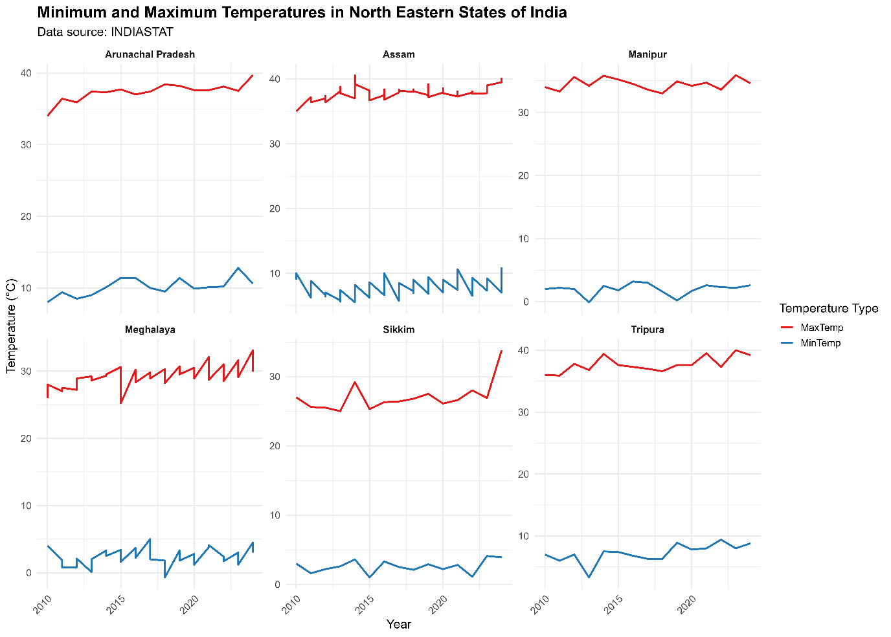
Figure 1: Minimum and Maximum temperature trends in India's Northeastern Hill Region (NEHR).
2.1 Impacts on crop production

Crop production in NEHR, particularly in its hilly and sloped areas, is susceptible to climate variations. The region's dependence on rainfed agriculture and traditional farming methods makes it vulnerable to the consequences of shifting weather patterns. These climatic shifts affect crop yields, alter pest and disease dynamics, and increase pressure on traditional farming systems. Understanding these impacts is crucial for identifying how climate change reshapes agricultural productivity and sustainability in NEHR.

2.1.1 Changes in crop yields and productivity

Climate change is leading to higher temperatures and unpredictable rainfall patterns across the country, reducing crop yields and overall food production. As temperatures rise and water availability becomes more erratic, the impacts on agriculture are becoming more evident, particularly in regions like the NEHR, where farming is highly dependent on natural climatic conditions. These changes can affect irrigated agricultural production across agroecological zones, limiting food access, availability, and quality. Staple crops like rice and maize, central to the region's food security, are especially vulnerable. According to Indian Network for Climate Change Assessment (2010), irrigated rice yields in the region may fluctuate between a 10% decrease and a 5% increase, depending on specific conditions, while rainfed rice is expected to face more severe declines, with potential yield losses of up to 35% due to erratic rainfall and rising temperatures. Maize, in particular, is projected to suffer greatly, with up to a 40% reduction in yields due to heat stress and water shortages. Mustard yields are expected to decline, while potato production could slightly increase (up to 5%) in higher-altitude areas where cooler temperatures are more favorable. However, extreme weather conditions may still cause a 4% drop in potato yields in central and southern parts of the region. Climate change is creating significant challenges for crop production in NEHR, impacting food security and farmers' livelihoods across the region (Dahal et al., 2019). The following table (Table 1) outlines the climate change impact on various crop yields in India’s NEHR.

Table 1. Impact of Climate Change Factors on Crop Yield in Northeastern States of India

NE State | Crops | Damage caused by the Climate factor | References
Assam | Rice | For every 1°C rise in temperature, the yield of the crop is reported to decline by 0.112t/ha (Approx.) | (Bordoloi & Dutta, 2025)
Assam | Tea | Tea crop yield is reported to decline if the monthly average temperature is above 26.6°C. | (Duncan et al., 2016)
Meghalaya | Rice | Deficient monsoon (<610mm) yielded lower rice yield (1.4t/ha) while sufficient monsoon (>690mm) yielded around 2.5t/ha. | (Dkhar et al., 2020)
Sikkim | Rice, Wheat | 11.33% deficient rainfall decline paddy yield by 1.52%, and further deviation of 13.48% led to a decline of 54.78% in wheat. | (Upadhyay et al., 2024)
Nagaland | Cereals | Heavy rainfall induced soil erosion resulted in cereal yield loss of around 6.5 q/ha | (Sharda & Dogra, 2013)
Tripura | Maize | For every 1°C rise in temperature the maize yield crop reduced by 9.70 units | (Chakraborty & Hazari, 2017)
Arunachal Pradesh | Cereals | Heavy rainfall induced soil erosion, resulting in cereals yield loss of around 4.1 q/ha | (Sharda & Dogra, 2013)
Manipur |  | Climate change-induced drought reduced the maize yield by 30-50%, and a 1% change in March rainfall lowered the crop yield by 5.6 units | (Laitonjam & Feroze, 2018)
Mizoram | Major crops | Erratic rainfall resulted in a decline in crop yields across most major field crops over three decades | (Rohlupuii et al., 2022)

2.1.2. Impacts on traditional farming systems

Traditional jhum land use comes from the cultural heritage of North East India. It remains a permanent feature of its regional practices. The combination of erratic rainfall patterns and increasing temperatures has severely decreased soil moisture content and destroyed soil fertility, which is essential for jhum cultivation success (Thokchom & Yadava, 2013). As the population grows and weather patterns evolve, both contribute to reduced natural fallow timing because fields receive fewer recovery periods (Khan et al., 2024). The sustainable practice of jhum cultivation faces urgent threats from intensifying severe weather patterns, which worsen soil erosion and the depletion of vital nutrients (Jaiswal et al., 2014).

2.2. Impacts on Livestock
Climate change has negatively impacted the Indian livestock sector within the northeastern hill (NEH) states through interconnected environmental and socioeconomic effects (Feroze et al. 2019). ICAR (2019) reports that increasing temperatures have decreased primary milk production from 14% to 27% during summer's peak period (ICAR ANNUAL REPORT, 2020). Temperature strains trigger a physiological stress response that negatively affects the fertility performance of livestock (Ojo et al., 2025). NICRA (2021) confirms that high temperatures force cattle populations to experience an 18% decline in their ability to conceive, showing how sensitive livestock are to external weather conditions (Becker et al., 2020). The assessment from (Pouchet et al., 2024) shows that theilerioses, a parasitic disease caused by ticks, have risen by 28% during wet weather conditions. According to the Meghalaya Agriculture Department (2021), the land designated for grazing has decreased by 40% across Meghalaya (Khan et al., 2012).The shortage of pastureland induces farmers to purchase additional feed supplements (Ramsbottom et al., 2015). Data from NEDFi (2022) shows that livestock feeding expenses have grown by approximately 23% yearly (Arunachal Pradesh report, 2020). The NEH region's livestock systems experience multiple-layered effects from climate change, proving the need for unified adaptation methods targeting animal health, secured fodder resources, and sustainable land management practices.
2.3. Impacts on Fisheries
Fisheries within the Northeastern Hill Region of India face special climate change threats because their operation depends on freshwater systems. The ecosystems are sensitive to temperature fluctuations, rainfall fluctuations, and dangerous weather patterns (Das et al. 2018). Climate change damages aquatic habitats while moving fish populations, decreasing their breeding outcomes, and having multiple socioeconomic impacts that affect local fishing communities. Concurrent with shrinking water levels in dry seasons, the amount of available fish habitats diminishes, causing fish populations to decrease (Sharma et al. 2021). Hot water conditions drive Himalayan snow trout (Schizothorax richardsonii) species to climb up mountains, which decreases their availability for fishing in typical areas (Babu et al., 2019). The alterations of environmental conditions delay spawning times for Catla catla and Labeo rohita, resulting in reduced survival rates during the juvenile stage (Kumar et al. 2017). Extended droughts and sudden flooding destroy breeding habitats, increasing threats to fish populations (Das et al. 2013). Various studies show that stressed fish with weakened immune systems are exposed to diseases such as Epizootic Ulcerative Syndrome (EUS) and columnaris disease, which results in massive fish populations dying in the NEHR wetlands (Rangappa et al., 2025). The serious socioeconomic consequences result from these observed environmental impacts. Roaming fishers and women who perform fish drying and vending activities experience decreased earnings because fish catches have decreased (Singh et al., 2019). The area's indigenous populations rely on fisheries for economic survival and food security. Food security becomes more vulnerable because declining fish populations remain (Sarkar et al., 2020).

2.4. Impacts on Forestry

India's Northeastern Hill Region (NEHR) showcases dense forests and biodiversity abundance. It stands among the most sensitive ecological regions in the country (Yadav et al. 2019). Temperature increases force numerous indigenous and vulnerable species to move toward higher elevations, thus remodeling different forest ecosystems (Ronanki & Behera, 2018). The NEHR suffers from increased forest degradation due to changing climate patterns. Forest fires and pest outbreaks have become more severe because of irregular rainfall patterns and prolonged dry conditions. Research demonstrates that regional forest fires increased by 15–20% throughout the last two decades as environmental temperatures rose, along with soil moisture reductions (Singh 2022).
The crucial carbon sequestration role played by forests in the NEHR suffers from deterioration because of climate change. (Chronicle News Service, 2022) established that elevated heat and moisture stress caused trees to die more rapidly while growing more slowly, which decreases carbon storage in these forests. Most of the population who depend on forests for survival, predominantly indigenous and tribal individuals, depend on forest resources for their income by collecting Non-Timber Forest Products (NTFPs). The timing of flowering and fruiting in critical forest species, including bamboo, wild fruits, and medicinal herbs, is changed by climate shifts (Yadav et al. 2019). The agricultural sector and its related industries, including crop cultivation, livestock breeding, fishery management, and forest-based income, connect strongly with the Northeastern Hill Region (NEHR) environment while remaining highly susceptible to climatic unpredictability and abrupt weather occurrences. The following figure (Fig.2) shows the sector-wise impact pathways of climate change in NEHR. These environmental changes pose significant economic challenges for the nearby communities. Identifying climate-related economic expenses and feasible agronomic adaptation solutions requires increased importance due to escalating climate threats.
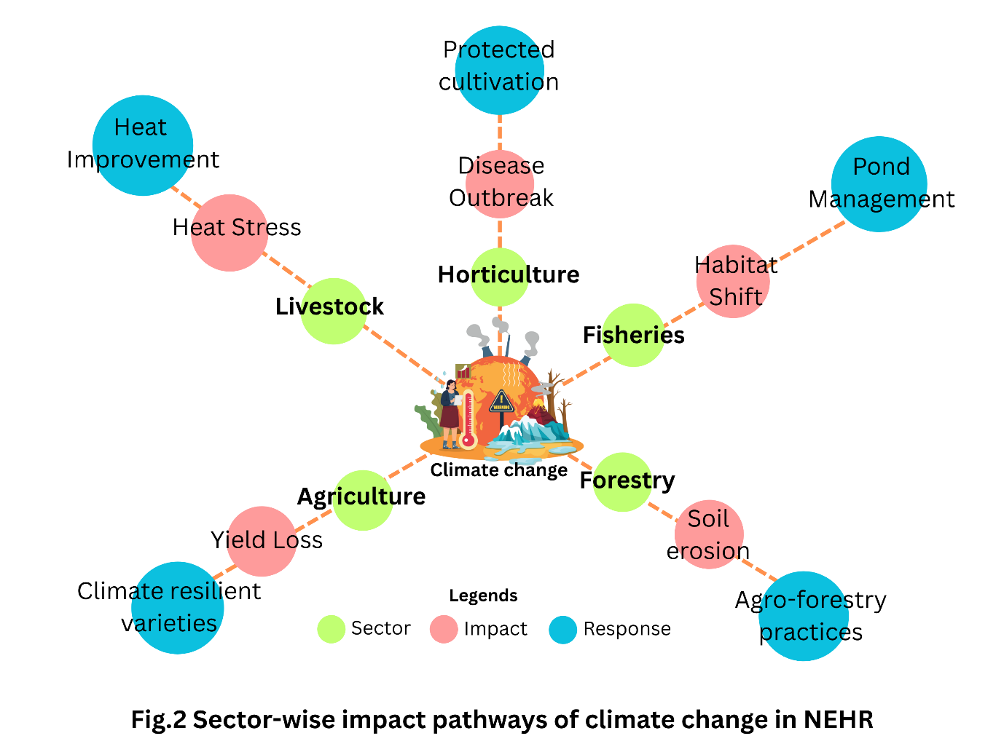
Fig.2 Sector-wise impact pathways of climate change in NEHR

3. Agronomic adaptation strategies

The NEHR in India has steep mountains, fragile ecosystems, and unpredictable climatic factors. Adopting various agronomic techniques is necessary to help agriculture withstand climate change and thrive in these regions. Advanced and traditional agronomic adaptation strategies are encompassed in five major sectors. Table 2 depicts Agronomic adaptation practices, effectiveness, and adoption rate in NEHR.

Table 2. List of adaptation practices, effectiveness, and adoption rate in the Northeastern Hill Region (NEHR) of India
Agronomic adaptation practices | Description | Effectiveness | Adoption rate | Research findings | References
Terraced cultivation | Making terraces by building bunds on sloping ground. | Ensure the stabilization of the slopes, conserve water, and improve harvest by preventing nutrients from being lost. | Very high | Many field surveys conclude that nearly everyone in Sikkim plows terraces into their steep hillsides; e.g., ~98% of Sikkim's lower-slope ridges are farmed through terraces. | (Mishra et al. 2020)
Green manuring | Growing a short-duration crop and plowing it into the soil before the main crop. | Enriches soil N and organic matter improves soil structure | Low (primarily used in experiments, not widely adopted by most farmers yet). | A 5-year NEH field trial showed that Sesbania spp. Growing increased the subsequent crop yield by 19% | (Ansari et al., 2022)
Tree-based agroforestry | Integrating trees with crops enriches the soil microclimate and boosts the understorey crop performance. | Increases total productivity and income. It also enhances soil carbon and nutrient cycling. | Medium (growing as pilot technology) | Alder (Alnus nepalensis) intercropped with turmeric significantly raised turmeric yields and overall system income. Alder–turmeric system gave output (USD 4,281 ha^{–1} year^{–1}), which is higher than the sole turmeric system (USD1,713 ha^{–1} year^{–1}) | (Rangappa et al., 2025)
Integrated paddy–fish farming | The system conserves the nutrients from runoff, including rice hull, waste, and manure, back into the field, and this helps keep fertility very high. | The Apatani's integrated agroecosystem yields high staple and protein output while sustaining soil fertility. | Localized | Traditional Apatani practice in Arunachal Pradesh raised paddy fields with fish ponds and millet planted on the bunds, and all the nutrients were recycled into the field. | (Aich et al., 2022)
Off-season forage cultivation | During the dry months, growing high-yielding feed crops ensures that animals are fed all year. | Improves resilience by buffering feed shortages. | Moderate (common among multi-enterprise farm households) | Integrated-farm surveys indicate that having off-season fodder increases milk yields and stabilizes the number of animals to be raised | (Paramesh et al., 2022)

3.1. Climate-Resilient Crop Varieties
Researchers point out that breeding and using climate-resilient crops will benefit agriculture in the NEHR of India (Das et al. 2021). Pest and stress-resistant genes found in traditional rice varieties grown in Northeast India may be used to improve modern types (Thingnam et al., 2023). Since blast disease (Magnaporthe) is an everyday stress, breeders have selected NE rice landraces resistant to it, making rice cultivars reliable and productive (Umakanth et al., 2017). Underutilized crops like buckwheat and finger millet have been found in the NEHR to tolerate drought and high stress. Buckwheat can survive throughout the year with rainfall as it has deep roots and high proline content, making it, together with finger millet (a nutrient-packed C₄ cereal), a good choice of crop that can withstand climate stress (Kaur et al. 2024; Rangappa et al. 2023).

3.2. Integrated Farming System (IFS)
Adopting different types of farming, such as IFS, is encouraged to help farmers avoid damage caused by erratic weather conditions (Das et al. 2021; Devi et al. 2022). In the NEHR, integrating agro-pastoral, animal husbandry, and farming is now considered a way to build resilience using nature (Babu et al., 2021). Animal and horticulture-based IFS models increase crop yields and net returns above traditional shifting agriculture (Das et al. 2019). IFS models yielded three to four times more rice equivalent and net revenue than monocropping or crop rotation (Chatterjee et al. 2022; Das et al. 2019)
Five farmers in Mynsain village have adopted organic farming in an IFS. In this system, they integrated rice, maize, vegetables (tomato, French bean, potato, lettuce, carrot), animals (dairy/piggery), and water harvesting (jalkund). The adopted village farmers found that the integrated organic farming system (IOFS) yielded excellent results with little external inputs (Das et al. 2018).

3.3. Water management practices
The NE hills region in India goes through prolonged monsoons and dry spells, and efficiently managing water is very important (Das and Semy 2023). Among the key actions are collecting rainwater, controlling drainage, and using micro-irrigation (Suresh & Samuel, 2020). These help reduce runoff and erosion (Saha et al. 2012).
Indigenous people in the NE hills developed effective water management systems. The "Bamboo drip irrigation" in Meghalaya (Maurya & Singh, 2021), the "Zabo system" in Nagaland (Amenla and Shuya 2021; Mohanty et al. 2023; Singh et al. 2018), "Dong irrigation" in Assam (Chetri and Kalita 2024; Saha et al. 2021), and the water conservation system by Apatanis in Arunachal Pradesh (Jayaraman and Dalal 2022; A Kumar and Madhukar 2019) are prominent examples; the systems used by these communities for water are natural, community-based, and suitable for the region (Kumar and Saizen 2023). They help ensure that water is appropriately managed and given to everyone (Devi 2018; Singh et al. 2015). Villages in Assam dig "Dong Bandhs" to channel river water to their paddy fields to save water and ensure a fair split for all areas that receive less rainfall (Bhattacharjee, 2019). In the Khasi and Jaintia regions of Meghalaya, farmers use devices made from bamboo to provide irrigation with water from nearby springs in dry times. By connecting drip pipes to rainwater catchments and adding mulches, the farm now saves up to 30% of water. It can water the vegetables yearly (Mohanty et al., 2023).
3.4. Soil Conservation and Agroforestry
In the steeply sloping areas of NEHR, soil loss is the major climatic vulnerability. The loss is caused by a variety of factors, like the region's hilly terrain (Bera, 2017), high rainfall (Jaiswal et al., 2014), and unsustainable land use practices (Choudhury et al., 2022). These consequences will lead to soil fertility loss (Kumar et al. 2016), degradation of land (Singh and Chaudhary 2023), and pose a significant threat to sustainable agriculture and livelihood (Jain et al., 2022). Farming practices like terrace and tree-based farming are promoted to stabilize these losses (Modak et al., 2024).
Bench terraces and hedgerows designed with crops assist in retaining rainfall and protect the soil against gully erosion (Feng et al., 2020). A synthesis review showed that a combination of multi-story agroforestry and contour terracing in NE India stored nearly all annual rainfall, significantly decreasing runoff (Jinger et al., 2023). Agro-horti-silvopastoral systems reduce soil erosion, enhance soil health, and ensure sustainability in hill areas. (Saha and Mishra 2007) compared to shifting cultivation, agro-horti-silvopastoral systems significantly improved soil structure by increasing the mean weight diameter (29.4%) and reducing the soil dispersion ratio (52.9%). These systems favor soil properties over other farming systems, such as increasing soil organic carbon, microbial biomass, and total nitrogen content (Saha et al. 2018). On the succession of jhum cultivation, growing improved fallow crops like Gliricidia and Sesbania rapidly restore the soil's organic matter. It increases the infiltration rate (Yadav et al. 2018).

3.5. Traditional Ecological Knowledge and Indigenous Practices
Many indigenous groups in NEHR have employed resilient agroecological methods. These methods integrate forestry, agriculture, and aquaculture in locally adaptive designs. Nagaland's Zabo system divides hillside terrain into three distinctive sections: wooded top slopes, mid-slope irrigation ponds, and lower paddy fields (Solo & Kikhi, 2021). Runoff is captured in ponds and slowly released to irrigate rice and fish ponds. At the same time, animals and fowl recycle nutrients in the forest (Murry, 2021). The Arunachal Pradesh Apatani tribe uses the "pani kheti" technique to grow rice-fish on terraced fields watered by bamboo channels from hill streams (Hussain et al., 2016). The Apatani produce rice and carp in flooded fields, producing grain and protein throughout the rainy season (Kacha, 2017). These traditional methods control water and soil while diversifying outputs (Sathoria & Roy, 2022)).

Such systems offer valuable insights for designing modern, climate-resilient agricultural strategies. In light of what is known about local conditions, a Climate-Smart Farming Model for the Northeast Hilly Region can handle current climate issues while considering the local situation and culture. Fig.3 shows the schematic representation of a Climate-Smart Farming Model for the North East Hilly Region.
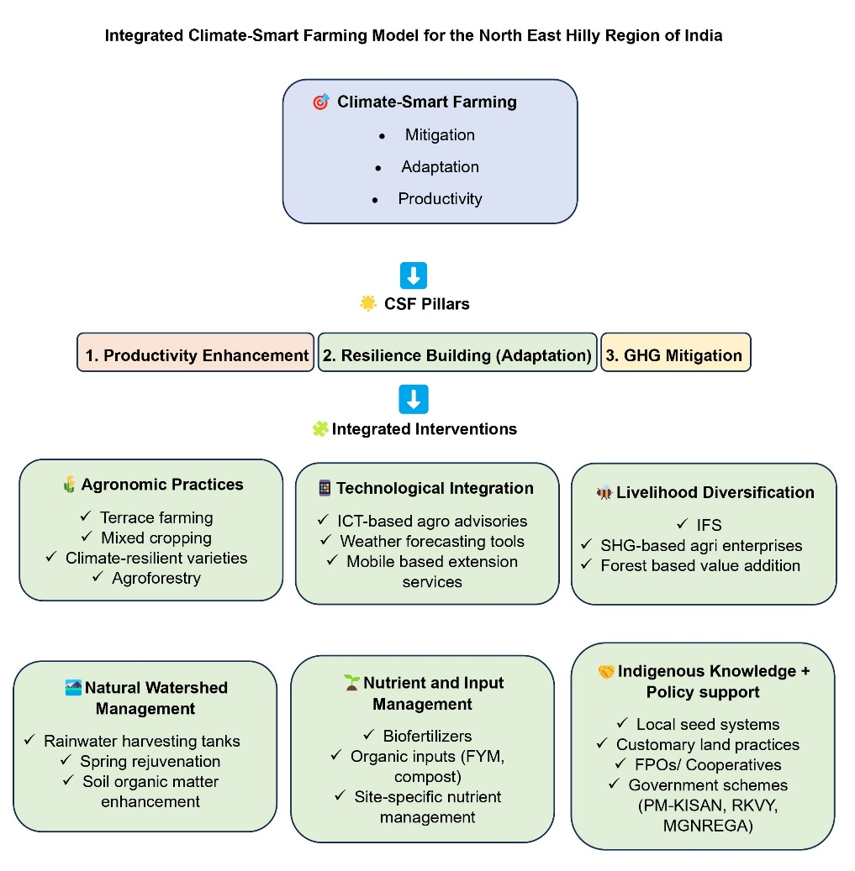
Fig.3. Integrated Climate-Smart Farming Model for the North East Hilly Region of India

4. Economic Implications of Climate Change and Adaptation

The economic consequences of climate change refer to its adverse effects, which are estimated in financial and economic aspects. In contrast, the costs and benefits of measures taken to mitigate climate change are known as climate change adaptation strategies. Production and productivity of the agricultural sectors are altered significantly by weather (Carleton & Hsiang, 2016). Climate change poses serious risks to Indian agriculture, as half of the country's agricultural land is rainfed (Pathak, 2023). North Eastern Indian agriculture is pointedly affected by climate change, disrupting crop production and food availability and quality, highlighting that climate change is crucial for sustainable agriculture, maintaining food security, and the welfare of the farm community, and the need for corrective measures (Mohapatra et al., 2022).

4.1 Economic Losses Due to Climate Variability

Climatic variability refers to sudden and discontinuous seasonal, monthly, or periodic changes in climate or its components without showing any specific trend of temporal change. An income reduction of 19% is seen in the world economy till 2050 due to climate change interventions (Kotzé, 2016). Climate change contributes to extreme weather events and climate-related disasters, posing a significant economic loss, reaching nearly $1.5 trillion (Charlton, 2023). According to the World Meteorological Organization report, the economic cause of extreme weather has grown substantially. Each rise in day-to-day temperature variability reduces economic growth by 5%, with the highest vulnerability in low-income regions (Kotz et al., 2021). The global average temperature has increased by 0.3°C to 0.6°C over the past 100 years, and it is projected to rise by 1.8°C to 4.0°C by 2100 (Forster et al., 2024).

Climate change imposes a greater economic risk on the agricultural sector, making farmers more vulnerable to adjusting farming practices to the changing climate. Among other attributes, a rise in temperature coupled with a change in frequency, precipitation intensity, and prolonged dry weather causes an increase in CO₂ levels and tends to impact agricultural productivity directly. According to the latest estimates, the average temperature will increase by 4.5°C for the entire year by 2100, ranging between 3.9°C in winter and spring, 5.4°C in summer, and 4.7°C in autumn. Average rainfall is expected to decrease by the end of the century by 17% for the entire year 2100, ranging between 16% in winter, 19% in spring, 47% in summer, and 10% in autumn (Nastis, 2012). While investigating the eastern Himalayan rainfall pattern, it is reported that rainfall has decreased by 1.0% (Sikkim), 1.3% (Manipur), and 1.4% (Meghalaya). 4.2% (Tripura), 4.8% (Arunachal Pradesh), 7.7% (Mizoram), and 14.7% (Nagaland) (Lotha et al. 2024).

4.1.1. Cost of yield loss and input cost variations

In the last 30 years, there has been a decreasing trend of rainfall by 23.7 percent from its mean annual average rainfall, which has an adverse impact on maize production in Mizoram (Saitluanga et al., 2021). Most of the crops in the NEHR region face yield losses due to the varied rainfall availability (Hnamte et al., 2016). Ravindranath et al. (2011) studied the rice crop in the near future (2021-2050) among 64 districts of the NEH region using model INFOCROP14. They concluded that yield will change in most districts in the future under the A1B scenario, with an increase in yield projected for 21 districts and a decrease in yield for 43 districts (up to 10%). Kumar & Dimri (2018) predicted that the rainfed rice yield may decrease up to 35%, with most of the area losing 10% due to climate change, and irrigated maize yields are projected to reduce by about 40% by 2030. In the case of rabi season crops, the yield loss is projected in wheat up to 20% and mustard up to 10%; alongside in the upper parts of the NEH region, potato yield is likely to increase marginally up to 5% due to climate change. However, the projected yield loss is about 4% in the central parts. In the region's southern parts, the negative impacts will be much higher (Naresh Kumar et al., 2011).

4.1.2. Impact on rural livelihoods

Climate change poses significant threats to rural livelihoods in NEHR (Matta et al., 2025). Assam's Dhemaji district exemplifies the severity of climate-induced displacement by recurrent flooding, damaging crops, and forced migration in search of alternative livelihoods, leaving behind women, children, and the elderly to manage households under challenging conditions (Krishnan, 2022). Farmers practicing shifting agriculture, a traditional agricultural practice in NEHR, are increasingly vulnerable to climate change, necessitating adaptive strategies to sustain their livelihoods (Hazarika et al., 2024). Assam floods affected 4.7 million people, severely disrupting agriculture and the rural economy (Ahmed and Rahman, 2021). Communities in Mizoram and Meghalaya are facing seasonal water shortages even in high-rainfall areas due to poor water harvesting infrastructure (Majaw, 2023).

4.2 Cost-Benefit Analysis of Adaptation Strategies

Adaptation to climate change in India's NEHR is crucial for safeguarding livelihoods, agriculture, and ecosystems (Markanday et al. 2019). Cost-benefit analysis (CBA) is a critical economic tool to assess the economic efficiency of adaptation strategies, comparing implementation costs to the monetary value of expected benefits (Li et al., 2014). Economic theory suggests that adaptations are efficient only if their benefit exceeds the cost (Watkiss et al., 2015). Table 3 outlines the economic evaluation of selected adaptation interventions followed in India's NEHR. Figure 4 presents a comparative matrix of key adaptation strategies evaluated for the NEHR.

Table 3. Economic evaluation of selected adaptation interventions in the Northeastern Hill Region (NEHR) of India
Adaptation Strategy | Location | Economic Metric | Estimated Value | Key Outcome | References
Agroforestry | Meghalaya | Benefit-Cost Ratio (BCR) | 3.16 | Increased farm income, reduced soil erosion, and enhanced carbon sequestration. | (Parida et al., 2023)
Rainwater Harvesting | Nagaland | Internal Rate of Return (IRR) | 18% | Maximizing water availability, thereby minimizing crop failure. | (The Energy and Resources Institute, 2020)
Climate-Resilient Rice Varieties | Assam | Net Present Value (NPV) | ₹ 14,000/ha over 30 yrs | Stable yield under floods and drought conditions, fostering income security. | (Dutta et al., 2023)
Change the transplanting & and harvesting time | Manipur | Benefit-Cost Ratio (BCR) | 1.25:1 | Effective synchronization between transplanting and harvesting time to mitigate risk and reduce loss by timely harvesting | (Rymbai et al., 2017)
Sustainable Forest Management | Sikkim | Benefit-Cost Ratio (BCR) | 12.05:1 | Biodiversity conservation and carbon storage | (Sharma et al. 2016)
Crop Rotation | Sikkim | Benefit-Cost Ratio (BCR) | 2.24:1 | Reduced input cost and higher returns with soil moisture conservation. | (Mishra and Rai 2014)

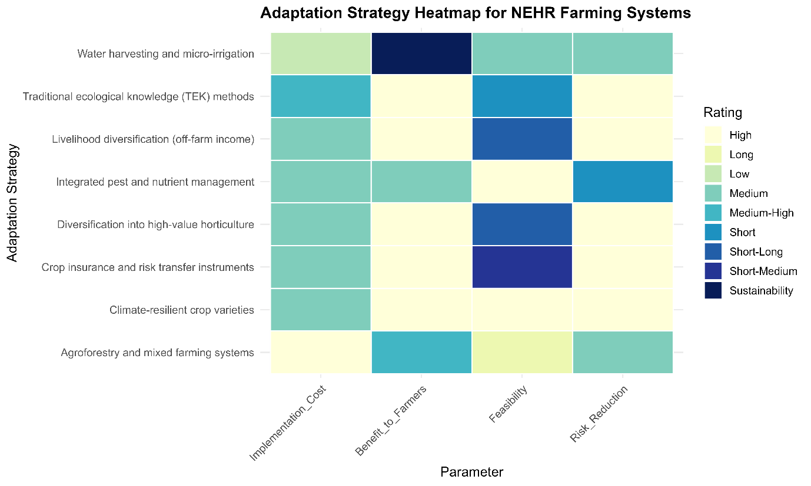
Figure 4: Adaptation cost-benefit matrix for Northeastern Hill Region (NEHR) of India farming systems

4.3 Access to Credit and Insurance

Aligning with the Paris Agreement aids financial institutions in supporting a low-carbon agricultural economy while reducing climate-related credit risks (Céu and Gaspar, 2024). Understanding the interconnection between climate change and agricultural loans with credit risk is important for the climate-resilient and sustainable agricultural sector. A direct relationship exists between extreme heat and elevated credit delinquency rates, which indicates that long-term climate changes will impact the credit quality provided to agriculture and allied sectors (Aguilar-Gomez et al. 2024). Taking loans is often an adaptation strategy for climate change (Patel et al., 2024). Insurance could serve a double function, providing signals about risks and offering an effective means of reducing the economic impact of losses reported by (Balcılar et al., 2020). Economic development and risk management are effective with only financial accessibility in India's North Eastern Hilly Region (NEHR). Significant disparities and barriers remain, particularly for small and marginal farmers and women in financial inclusion (Chaudhuri et al., 2018).

4.4 Role of Government Schemes

Under the National Adaptation Fund for Climate Change (NAFCC), Assam, Mizoram, and Sikkim projects focused on climate-resilient agriculture, water conservation, and ecosystem restoration, promoting ecosystem-based adaptation. However, funding steadily declined from INR 115.36 crore in 2017–18 to a mere INR 34 crore in 2022–23 (Pavittarbir Saggu, 2024). State Action Plans on Climate Change (SAPCCs) in Sikkim and Assam focus on glacier monitoring, water scarcity, flood, and erosion mitigation. Mission Organic Value Chain Development for North Eastern Region (MOVCDNER) promotes a climate-resilient value chain by enhancing organic farming in Mizoram and Nagaland. Studies revealed that organic farming practices led to a 22% reduction in production costs and a 20% increase in net returns for farmers, which supports the economic viability of organic farming as a climate-resilient agricultural practice (Reddy et al. 2022). Aiming to ensure water availability in climate-vulnerable areas, Jal Shakti Abhiyan and Jal Jeevan Mission engage in the development of spring-shed and rainwater harvesting in Meghalaya, Sikkim (Balamurugan et al., 2024). Table 4 presents a detailed account of the various schemes operational in the Northeastern Hill Region (NEHR).

Table 4. Relevant schemes and their coverage in India's Northeastern Hill Region (NEHR).
Schemes | Location | Relevance to climate change | Challenges | Reference
National Adaptation Fund for Climate Change (NAFCC) | Meghalaya, Arunachal Pradesh, Sikkim | Projects Funded for Agroforestry, Water Conservation, and Climate-Resilient Agriculture. | Lack of awareness, poor monitoring, and weak institutional capacity. | (National Bank for Agriculture and Rural Development, 2025)
Mission Organic Value Chain Development for Northeastern Region (MOVCDNER) | Assam, Sikkim, Manipur, Nagaland, Mizoram | Enhance climate-resilient organic farming, thereby reducing the usage of chemical inputs, thus promoting sustainability. | Poor market linkages and limited infrastructure for post-harvest practices. | (Amarender Reddy [n.d])
Meghalaya Water Harvesting Project | Districts of Meghalaya | Minimizes water scarcity risk. | Huge initial cost with poor maintenance at the grassroots level | (Asian Development Bank, 2024)
State Action Plans on Climate Change (SAPCC) | Arunachal Pradesh | Climate-resilient planning by implementing a water conservation strategy and sustainable agriculture | Lack of effective coordination fragmented departmental structures. | (Bhagawati et al., 2017)
Mahatma Gandhi National Rural Employment Guarantee Act (MGNREGA) | Tripura, Assam, Sikkim, and Meghalaya | constructing infrastructure for water conservation, farmers neglecting subsistence hill-farming activities, and strengthening people's economic and social capabilities. | No effective coordination among workers and a lack of climate-related convergence | (Das and Sarma [n.d])
Pradhan Mantri Fasal Bima Yojna (PMFBY) | Meghalaya | Provide financial support to farmers against crop loss due to climatic risks. | Lack of awareness and credibility, poor risk claim process. | (Barua et al., 2023)

5. Conclusion
The adverse climate change is becoming more difficult for people and farming in the North Eastern Hill Region (NEHR) to manage risks because it reduces the area's agricultural potential and causes rural unemployment. This review points out that it is necessary to use effective strategies in certain regions that are economically feasible and help protect the environment. Several key measures, such as using IFS, agroforestry, enhanced soil and water conservation, and developing climate-resistant farmer varieties, have made a big difference in building resistance. The best way to implement policies is to help farmers gain key capacities, ensure they can access loans and crop insurance, and foster local, community-based ways to handle climate change. It is important to enhance the functioning of current schemes, increase spending on climate-friendly infrastructure, and promote traditional knowledge with innovative ideas. Policy, research, and field activities must all be focused together to help the region's agriculture become sustainable and less vulnerable to climate change.

references

Aguilar-Gomez, S., Gutierrez, E., Heres, D., Jaume, D., & Tobal, M. (2024). Thermal stress and financial distress: Extreme temperatures and firms’ loan defaults in Mexico. Journal of Development Economics, 168, 103246. https://doi.org/10.1016/j.jdeveco.2023.103246
Ahmed, A. R., & Rahman, A. (2021). Measuring Agriculture Loss of Flood-affected Farmers in Assam with special reference to Lower Brahmaputra Valley.
Aich, A., Dey, D., & Roy, A. (2022). Climate change resilient agricultural practices: A learning experience from indigenous communities over India. PLOS Sustainability and Transformation, 1(7), e0000022. https://doi.org/10.1371/journal.pstr.0000022
Amenla, I., & Shuya, K. (2021). Zabo (Zabü) farming of kikruma village, Nagaland, India. Innovations in Agricultural Extension. National Institute of Agricultural Extension Management and Michigan State University Extension, Michigan.
Ansari, M. A., Babu, S., Choudhary, J., Ravisankar, N., & Panwar, A. S. (2022). Soil quality restoration and yield stabilization in acidic soils of northeastern Himalayas: Five years impact of green manuring and crop residue management. Frontiers in Environmental Science, 10, 940349. https://doi.org/10.3389/fenvs.2022.940349
Arunachal Pradesh report. (2020). Economic Revival Committee.
Asian Development Bank. (2024). India : Climate-Adaptative Community-Based Water-Harvesting Project in Meghalaya.
Assessment, I. N. for C. C. (2010). Climate Change and India: A 4X4 Assessment,a Sectoral and Regional Analysis for 2030s. Vol. 2.
Babu, S., Das, A., Mohapatra, K. P., Yadav, G. S., Singh, R., Tahashildar, M., Devi, M. T., Das, S., Panwar, A. S., & Prakash, N. (2019). Pond dyke utilization: An innovative means for enhancing productivity and income under Integrated Farming System in North East Hill Region of India. The Indian Journal of Agricultural Sciences, 89(1). https://doi.org/10.56093/ijas.v89i1.86190
Babu, S., Mohapatra, K. P., Das, A., Yadav, G. S., Singh, R., Chandra, P., Avasthe, R. K., Kumar, A., Devi, M. T., Singh, V. K., & Panwar, A. S. (2021). Integrated Farming Systems: Climate-Resilient Sustainable Food Production System in the Indian Himalayan Region. In V. Venkatramanan, S. Shah, & R. Prasad (Eds.), Exploring Synergies and Trade-offs between Climate Change and the Sustainable Development Goals (pp. 119–143). Springer Singapore.
Balamurugan, J., Jayanth, T. M., Jayakhar, K. R. P., & R., K. K. (2024). Community-Driven Solutions for Sustainable Water Access: An Analysis of Jal Jeevan Mission in Rural India. Journal of Social Welfare and Management, 16(1), 21–28. https://doi.org/10.21088/jswm.0975.0231.16124.3
Balcılar, M., Gupta, R., Lee, C., & Olasehinde-Williams, G. (2020). Insurance and economic policy uncertainty. Research in International Business and Finance, 54, 101253. https://doi.org/10.1016/j.ribaf.2020.101253
Barua, U., Islam, M., & Medhi, S. (2023). Awareness and Adoption of Climate Resilient Horticulture Technologies by Farmers in Ri Bhoi District of Meghalaya. International Journal of Economic Plants, 10(Nov, 4), 256–262. https://doi.org/10.23910/2/2023.4918a
Becker, C. A., Collier, R. J., & Stone, A. E. (2020). Invited review: Physiological and behavioral effects of heat stress in dairy cows. Journal of Dairy Science, 103(8), 6751–6770. https://doi.org/10.3168/jds.2019-17929
Bera, A. (2017). Assessment of soil loss by universal soil loss equation (USLE) model using GIS techniques: a case study of Gumti River Basin, Tripura, India. Modeling Earth Systems and Environment, 3(1), 29. https://doi.org/10.1007/s40808-017-0289-9
Bhagawati, R., Bhagawati, K., Jini, D., Alone, R. A., Singh, R., Chandra, A., Makdoh, B., Sen, A., & Shukla, K. K. (2017). Review on climate change and its impact on agriculture of Arunachal Pradesh in the Northeastern Himalayan region of India. Nature Environment and Pollution Technology, 16(2), 535.
Bhalerao, A. K., Rasche, L., Scheffran, J., & Schneider, U. A. (2022). Sustainable agriculture in Northeastern India: how do tribal farmers perceive and respond to climate change? International Journal of Sustainable Development & World Ecology, 29(4), 291–302. https://doi.org/10.1080/13504509.2021.1986750
Bhattacharjee, S. P. (2019). Ground Water Conservation And Management In North Eastern India Adopting Traditional Wisdom. Journal of the Geological Society of India, 93(2), 250–251. https://doi.org/10.1007/s12594-019-1134-8
Bordoloi, P., & Dutta, N. (2025). The impact of climate change on agriculture in Assam: A statistical analysis of rising temperature and changing precipitation patterns. Environmental Monitoring and Assessment, 197(4), 477. https://doi.org/10.1007/s10661-025-13930-w
Carleton, T. A., & Hsiang, S. M. (2016). Social and economic impacts of climate. Science, 353(6304), aad9837.
Céu, M. S., & Gaspar, R. M. (2024). A review on climate change, credit risk and agriculture. Rural Sustain. Res, 51, 38–49.
Chakraborty, B., & Hazari, S. (2017). Impact of climate change on yields of major agricultural crops in Tripura. Indian Journal Of Agricultural Research, Of. https://doi.org/10.18805/ijare.v51i04.8432
Chandrakant, D. B. (2021). Agricultural Production, Marketing and Food Security in India. Emperor Journal of Economics and Social Science Research, 03(05), 1–15. https://doi.org/10.35338/EJESSR.2021.3501
Charlton, E. (2023). No Title.
Chatterjee, D., Kuotsu, R., Ray, S. K., Patra, M. K., Thirugnanavel, A., Kumar, R., Borah, T. R., Chowdhury, P., Pongen, I., Satapathy, B. S., & Deka, B. C. (2022). Preventing soil degradation in shifting cultivation using integrated farming system models. Archives of Agronomy and Soil Science, 68(13), 1841–1857. https://doi.org/10.1080/03650340.2021.1937139
Chaudhuri, K., Sasidharan, S., & Raj, R. (2018). Gender, small firm ownership, and credit access: some insights from India. Small Business Economics, 54, 1165–1181. https://doi.org/10.1007/S11187-018-0124-3
Chetri, G., & Kalita, M. (2024). Innovation in Irrigation Sector of Assam: A Perspective Approach. Water and Energy International, 67(6), 10–15.
Choudhury, B. U., Nengzouzam, G., Ansari, M. A., & Islam, A. (2022). Causes and consequences of soil erosion in northeastern Himalaya, India. Current Science, 122(7), 772. https://doi.org/10.18520/cs/v122/i7/772-789
Chronicle News Service. (2022). “Loumisingi Paojel” team participates in Digital India Week. Chronicle News Service.
Dahal, K., Li, X., Tai, H., Creelman, A., & Bizimungu, B. (2019). Improving Potato Stress Tolerance and Tuber Yield Under a Climate Change Scenario – A Current Overview. Frontiers in Plant Science, 10. https://doi.org/10.3389/fpls.2019.00563
DAS, A., Ghosh, P. K., Yadav, G. S., LAYEK, J., Babu, S., Singh, R., & Ansari, M. A. (2021). Conservation agriculture in North-Eastern Hill region of India: potential and opportunities for sustainable development. Journal of Agricultural Physics, 21(1), 113–134.
Das, A., Layek, J., I, R. G., Babu, S., Devi, M. T., Dey, U., Suting, D., Yadav, G. S., Lyngdoh, D. B. D., & Prakash, N. (2019). Integrated Organic Farming System: an innovative approach for enhancing productivity and income of farmers in north eastern hill region of India. The Indian Journal of Agricultural Sciences, 89(8). https://doi.org/10.56093/ijas.v89i8.92843
Das, D., & Sarma, D. (n.d.). Climate Change Adaptation and Livelihood in the North-East India.
Das, M., & Semy, K. (2023). Monitoring the dynamics of acid mine drainage affected stream surface water hydrochemistry at Jaintia Hills, Meghalaya, India. Environmental Science and Pollution Research, 30(30), 75489–75499. https://doi.org/10.1007/s11356-023-27606-w
Das, T. K., Bhattacharyya, R., Sharma, A. R., Das, S., Saad, A. A., & Pathak, H. (2013). Impacts of conservation agriculture on total soil organic carbon retention potential under an irrigated agro-ecosystem of the western Indo-Gangetic Plains. European Journal of Agronomy, 51, 34–42. https://doi.org/https://doi.org/10.1016/j.eja.2013.07.003
Das, T. K., Saharawat, Y. S., Bhattacharyya, R., Sudhishri, S., Bandyopadhyay, K. K., Sharma, A. R., & Jat, M. L. (2018). Conservation agriculture effects on crop and water productivity, profitability and soil organic carbon accumulation under a maize-wheat cropping system in the North-western Indo-Gangetic Plains. Field Crops Research, 215, 222–231. https://doi.org/https://doi.org/10.1016/j.fcr.2017.10.021
Datta, P., & Behera, B. (2022). Factors Influencing the Feasibility, Effectiveness, and Sustainability of Farmers’ Adaptation Strategies to Climate Change in The Indian Eastern Himalayan Foothills. Environmental Management, 70(6), 911–925. https://doi.org/10.1007/s00267-022-01724-6
Devi, C. V. (2018). Participatory Management of Irrigation System in North Eastern Region of India. International Journal of Rural Management, 14(1), 69–79. https://doi.org/10.1177/0973005218765552
Devi, M. B., Chanu, L. J., Verma, V. K., Talang, H. D., Rymbai, H., & Assumi, S. R. (2022). King chilli (Capsicum chinense Jacq.): a potential species of capsicum for sustainability and income enhancement for tribal farmers of NEH region. Kisan Mela’on Empowering Tribal Farmers through Technology Led Farming at ICAR, Mizoram Centre, Kolasib during 14th to 15th November, 2022. 128 Pages, ICAR Research Complex Foe NEH Region, Umiam, Meghalaya, India. PME Publication No, 79.
Devi, M. V., Singh, R. J., Devarani, L., Hemochandra, L., Singh, R., & Sethi, B. (2020). Farmers’ Climate Change Adaptation Intention in North Eastern Hill Region of India. Current Journal of Applied Science and Technology, 9–16. https://doi.org/10.9734/cjast/2020/v39i430525
Dkhar, D. K., Feroze, S. M., Singh, R., & Ray, L. I. P. (2020). Changing climate and its effect on rice yield in Meghalaya. Pantnagar Journal of Research, 18(3), 249–256.
Duncan, J. M. A., Saikia, S. D., Gupta, N., & Biggs, E. M. (2016). Observing climate impacts on tea yield in Assam, India. Applied Geography, 77, 64–71. https://doi.org/10.1016/j.apgeog.2016.10.004
Dutta, P., Mahanta, N. J., Konwar, M. J., & Chetia, S. K. (2023). Assessing the Effectiveness of Climate-Resilient Rice Varieties in Building Adaptive Capacity for Small-Scale Farming Communities in Assam. International Journal of Environment and Climate Change. https://doi.org/10.9734/ijecc/2023/v13i123720
Feng, J., Wei, W., & Pan, D. (2020). Effects of rainfall and terracing-vegetation combinations on water erosion in a loess hilly area, China. Journal of Environmental Management, 261, 110247. https://doi.org/10.1016/j.jenvman.2020.110247
FEROZE, S. M., RAHMAN, S., SINGH, K. J., SINGH, R., & DKHAR, S. E. (2019). Climate change effect on dairy in north eastern hills of India. The Indian Journal of Animal Sciences, 89(2). https://doi.org/10.56093/ijans.v89i2.87334
Forster, P., Smith, C., Walsh, T., Lamb, W., Lamboll, R., Hall, B., Hauser, M., Ribes, A., Rosen, D., Gillett, N., Palmer, M., Rogelj, J., Von Schuckmann, K., Trewin, B., Allen, M., Andrew, R., Betts, R., Borger, A., Boyer, T., … Zhai, P. (2024). Indicators of Global Climate Change 2023: annual update of key indicators of the state of the climate system and human influence. Earth System Science Data. https://doi.org/10.5194/essd-16-2625-2024
Hazarika, A., Nath, A. J., Reang, D., Pandey, R., Sileshi, G. W., & Das, A. K. (2024). Climate change vulnerability and adaptation among farmers practicing shifting agriculture in the Indian Himalayas. Environmental and Sustainability Indicators, 23, 100430. https://doi.org/10.1016/j.indic.2024.100430
Hnamte, L., Lalrammawia, C., & Gopichand, B. (2016). No Title. Sci Vis, 16, 59-67.
Hussain, S. M., Sen, D., & Pathak, M. (2016). Integrated Rizi-Pisciculture: An approach towards livelihood and nutritional security for the tribal community of East Siang district, Arunachal Pradesh. International Journal of Agriculture, Environment and Biotechnology, 9(5), 821. https://doi.org/10.5958/2230-732X.2016.00105.4
ICAR ANNUAL REPORT. (2020). Annual Report 2020.
Jain, A., Sheekha, N. M., & Mandal, S. T. (2022). Agricultural Sustainability in the North Eastern Region of India: A Sustainable Livelihood Security Index (SLSI) Approach. 683.9-kB. https://doi.org/10.22004/AG.ECON.343147
Jaiswal, M., Thakuria, G., Borah, A., & Saikia, R. (2014). Evaluation of parametic impact on soil loss of Panchnoi river basin, North-east India, using revised universal soil loss equation (rusle). The Clarion- International Multidisciplinary Journal, 3, 51–60.
Jayaraman, S., & Dalal, R. C. (2022). No-till farming: prospects, challenges – productivity, soil health, and ecosystem services. Soil Research, 60(6), 435–441. https://doi.org/10.1071/SR22119
Jinger, D., Kaushal, R., Kumar, R., Paramesh, V., Verma, A., Shukla, M., Chavan, S. B., Kakade, V., Dobhal, S., Uthappa, A. R., Roy, T., Singhal, V., Madegowda, M., Kumar, D., Khatri, P., Dinesh, D., Singh, G., Singh, A. K., Nath, A. J., … Kumawat, S. (2023). Degraded land rehabilitation through agroforestry in India: Achievements, current understanding, and future prospectives. Frontiers in Ecology and Evolution, 11, 1088796. https://doi.org/10.3389/fevo.2023.1088796
Kacha, D. (2017). Paddy-Cum-Fish Culture in Ziro Valley: Arunachal Pradesh. Partridge Publishing.
Kaur, S., Kumari, A., Seem, K., Kaur, G., Kumar, D., Verma, S., Singh, N., Kumar, A., Kumar, M., Jaiswal, S., Bhardwaj, R., Singh, B. K., & Riar, A. (2024). Finger millet (Eleusine coracana L.): from staple to superfood—a comprehensive review on nutritional, bioactive, industrial, and climate resilience potential. Planta, 260(3), 75. https://doi.org/10.1007/s00425-024-04502-2
Khan, M. H., Kumar, S., Basumatary, R., Bharti, P. K., Kadirvel, G., & Barman, C. (2012). Livestock Development in Meghalaya: Biodiversity, Threat and Conservation. International Journal of Bio-Resource and Stress Management, 3(1), 122–127.
Kotz, M., Wenz, L., Stechemesser, A., Kalkuhl, M., & Levermann, A. (2021). Day-to-day temperature variability reduces economic growth. Nature Climate Change, 11(4), 319–325. https://doi.org/10.1038/s41558-020-00985-5
Kotzé, P. (2016). Water and agriculture: Conservation agriculture: Farming for the future. Water Wheel, 15(2), 12–15.
Krishnan, S. (2022). Adaptive capacities for women’s mobility during displacement after floods and riverbank erosion in Assam, India. Climate and Development, 15, 404–417. https://doi.org/10.1080/17565529.2022.2092052
Kumar, A., & Madhukar, A. K. (2019). Management of traditional water system and their conservation in North Eastern Region through local traditional wisdom. 2142.
Kumar, D., & Dimri, A. P. (2018). Regional climate projections for Northeast India: an appraisal from CORDEX South Asia experiment. Theoretical and Applied Climatology, 134(3–4), 1065–1081. https://doi.org/10.1007/s00704-017-2318-z
Kumar, P., de Fatima Andrade, M., Ynoue, R., Fornaro, A., Dias de Freitas, E., Martins, J., Martins, L., Albuquerque, T., Zhang, Y., & Morawska, L. (2016). New directions: From biofuels to wood stoves: The modern and ancient air quality challenges in the megacity of São Paulo. Atmospheric Environment, 140, 364–369.
Kumar, S., Smith, S. R., Fowler, G., Velis, C., Kumar, S. J., Arya, S., Rena, Kumar, R., & Cheeseman, C. (2017). Challenges and opportunities associated with waste management in India. Royal Society Open Science, 4(3), 160764.
Kumar, T., & Saizen, I. (2023). Hydrosocial territories in transition: Implications of traditional agricultural and irrigation water management practices under the effects of social, institutional, and environmental changes in Ladakh, India. Environmental Development, 47, 100880. https://doi.org/10.1016/j.envdev.2023.100880
Laitonjam, N., & Feroze, S. M. (2018). Effect of Pre-monsoon Rainfall on Maize Yield in Manipur. ECONOMIC AFFAIRS, 63(2). https://doi.org/10.30954/0424-2513.2.2018.17
Li, J., Mullan, M., & Helgeson, J. (2014). Improving the practice of economic analysis of climate change adaptation. Journal of Benefit-Cost Analysis, 5(03), 445–467. https://doi.org/10.1515/jbca-2014-9004
Lipper, L., & Cavatassi, R. (2024). The challenge climate change poses to achieving resilient and inclusive rural transformation (RITI). Global Food Security, 43, 100811. https://doi.org/10.1016/j.gfs.2024.100811
Lotha, T. N., Ketiyala, Nakro, V., & Jamir, L. (2024). Climate Impact in North East India. In Environmental Intimacies from India’s North East. Routledge India.
Lotha, T. N., Ritse, V., Nakro, V., K, K., I, I., Rudithongru, L., Hazarika, N., & Jamir, L. (2024). Climate Change Impact and Traditional Adaptation Practices in Northeast India: A Review. Current World Environment, 19(2), 558–575. https://doi.org/10.12944/CWE.19.2.5
Majaw, B. (2023). Complex and worrying questions to Meghalaya’s water crisis. Sustainable Water Resources Management, 9, 1–12. https://doi.org/10.1007/s40899-023-00823-4
MARKANDAY, A., GALARRAGA, I., & MARKANDYA, A. (2019). A CRITICAL REVIEW OF COST-BENEFIT ANALYSIS FOR CLIMATE CHANGE ADAPTATION IN CITIES. Climate Change Economics, 10(04), 1950014. https://doi.org/10.1142/S2010007819500143
Matta, G., Kumar, A., Singh Tomar, D., & Kumar, R. (2025). Climate change in the Himalayan region: susceptible impacts on environment and human settlements. Frontiers in Environmental Science, 13. https://doi.org/10.3389/fenvs.2025.1550843
Maurya, R., & Singh, P. (2021). Bamboo drip irrigation: A potential tool for increasing crop productivity in Meghalaya. The Agriculture Magazine, 1(1), 1–3.
Mishra, P. K., Rai, A., & Rai, S. C. (2020). Indigenous knowledge of terrace management for soil and water conservation in the Sikkim Himalaya, India.
Mishra, P. K., & Rai, S. C. (2014). A Cost–Benefit Analysis of Indigenous Soil and Water Conservation Measures in Sikkim Himalaya, India. Mountain Research and Development, 34(1), 27–35. https://doi.org/10.1659/MRD-JOURNAL-D-12-00013.1
Modak, K., Guru, N., Mishra, G., & Sharma, B. (2024). Role of Traditional Farming Practices of Northeast India in Soil and Water Conservation and Sustainable Nutrient Management. In G. Mishra, K. Giri, S. Singh, & M. Kumar (Eds.), Sustainable Land Management in India (pp. 167–178). Springer Nature Singapore.
Mohanty, S., Sanjay-Swami, N., Singh, A. K., & Ray, L. I. (2023). Characterization of soils under Zabo farming system of Nagaland. 15, 392–396.
Mohapatra, S., Sharp, B., & Sahoo, D. (2022). HOW CHANGES IN CLIMATE AFFECT CROP YIELDS IN EASTERN INDIA. Climate Change Economics. https://doi.org/10.1142/s2010007822500014
Murry, N. (2021). Zabo Farming System- A Sustainable Farming based on Traditional Knowledge for Natural Resource Management Practiced by Tribal in Nagaland, India. International Journal of Agriculture Environment and Biotechnology, 14(2). https://doi.org/10.30954/0974-1712.02.2021.13
Nagendiran, K., & Sathya, R. (2024). Economic Impacts of Climate Change on Indian Farmers and Rural Livelihoods. International Journal For Multidisciplinary Research, 6(6), 33839. https://doi.org/10.36948/ijfmr.2024.v06i06.33839
Naresh Kumar, S., Aggarwal, P. K., Rani, S., Jain, S., Saxena, R., & Chauhan, N. (2011). Impact of climate change on crop productivity in Western Ghats, coastal and northeastern regions of India. Current Science, 101(3), 332–341.
Nastis, A. S. (2012). Climate change and agricultural productivity. AFRICAN JOURNAL OF AGRICULTURAL RESEEARCH, 7(35). https://doi.org/10.5897/AJAR11.2395
National Bank for Agriculture and Rural Development. (2025). MGNREGA – National Rural Employment Guarantee Act. NABARD.
Ojo, T. O., Vandenplas, J., Mulder, H. A., van Pelt, M. L., & Calus, M. P. L. (2025). Genetic analysis of the impact of heat stress on fertility traits in dairy cows in the Netherlands. Journal of Dairy Science, 108(2), 1699–1713. https://doi.org/10.3168/jds.2024-25316
Paramesh, V., Kumar, P., Shamim, M., Ravisankar, N., Arunachalam, V., Nath, A. J., Mayekar, T., Singh, R., Prusty, A. K., Rajkumar, R. S., Panwar, A. S., Reddy, V. K., Pramanik, M., Das, A., Manohara, K. K., Babu, S., & Kashyap, P. (2022). Integrated Farming Systems as an Adaptation Strategy to Climate Change: Case Studies from Diverse Agro-Climatic Zones of India. Sustainability, 14(18), 11629. https://doi.org/10.3390/su141811629
Parida, P. K., Ray, L. I. P., & Shirisha, K. (2023). Effect of Organic Mulches on Yield, Water Productivity and Economy of Garden Pea Cultivars. International Journal of Environment and Climate Change, 13(8), 1773–1783. https://doi.org/10.9734/ijecc/2023/v13i82131
Patel, S. K., Mathew, B., Nanda, A., Mohanty, B., & Saggurti, N. (2024). Voices of rural people: Community-level assessment of effects and resilience to natural disasters in Odisha, India. International Journal of Population Studies, 6(1), 3. https://doi.org/10.18063/ijps.v6i1.1042
Pathak, H. (2023). Impact, adaptation, and mitigation of climate change in Indian agriculture. Environmental Monitoring and Assessment, 195(1), 52. https://doi.org/10.1007/s10661-022-10537-3
Pavittarbir Saggu. (2024). Opinion – Redefining India’s Public Expenditure for Climate Resilience.
Pouchet, C., Fernandez‐Prada, C., Dussault, C., Leclerc, M., Tremblay, J., & Côté, S. D. (2024). Linking weather conditions and winter tick abundance in moose. The Journal of Wildlife Management, 88(3). https://doi.org/10.1002/jwmg.22551
Ramsbottom, G., Horan, B., Berry, D. P., & Roche, J. R. (2015). Factors associated with the financial performance of spring-calving, pasture-based dairy farms. Journal of Dairy Science, 98(5), 3526–3540. https://doi.org/10.3168/jds.2014-8516
Rangappa, K., Rajkhowa, D., Layek, J., Das, A., Saikia, U. S., Mahanta, K., Sarma, A. K., Moirangthem, P., Mishra, V. K., Deshmukh, N. A., Rajbonshi, N., & Kandpal, B. K. (2023). Year-round growth potential and moisture stress tolerance of buckwheat (Fagopyrum esculentum L.) under fragile hill ecosystems of the Eastern Himalayas (India). Frontiers in Sustainable Food Systems, 7, 1190807. https://doi.org/10.3389/fsufs.2023.1190807
Rangappa, K., Singh, N. R., Janyanaik Joga, R., Mohapatra, K. P., Chandra, P., Choudhury, B. U., Moiranghtem, P., Debnath, S., Chanu, L. J., Devi, N. P., Singh, N. U., Hazarika, S., Kumar, Y. B., & Mishra, V. K. (2025). Tree crop interactions, productivity and physiological efficiency of understorey crops in Alnus nepalensis and Gmelina arborea based agroforestry systems in Eastern Himalayas. Frontiers in Sustainable Food Systems, 9, 1494371. https://doi.org/10.3389/fsufs.2025.1494371
Ravindranath, N. H., Rao, S., Sharma, N., Nair, M., Gopalakrishnan, R., Rao, A. S., Malaviya, S., Tiwari, R., Sagadevan, A., & Munsi, M. (2011). Climate change vulnerability profiles for North East India. Current Science, 384–394.
Reddy, A. A. (n.d.). Impact Evaluation Study of Mission Organic Value Chain Development for North Eastern Region (MOVCDNER), National Institute of Agricultural Extension Management (MANAGE), Rajendranagar, Hyderabad–500030, Telangana State, India. 70 pp.
Reddy, A. A., Melts, I., Mohan, G., Rani, C. R., Pawar, V., Singh, V., Choubey, M., Vashishtha, T., Suresh, A., & Bhattarai, M. (2022). Economic impact of organic agriculture: evidence from a Pan-India survey. Sustainability, 14(22), 15057.
Rohlupuii, Kaur, A., Kataria, P., & Priscilla, L. (2022). Assessment of Crop Production Dynamics in Mizoram. Agricultural Reviews.
Ronanki, S., & Behera, U. K. (2018). Effect of Tillage, Crop Residues and Nitrogen Management Practices on Growth Performance and Soil Microbial Parameters in Wheat.
Rymbai, D., Feroze, S., Singh, R., & Ray, L. (2017). What’s the Benefit of Adaptation to Climate Change? Application of Partial Budgeting for the Rice Growers of Eastern Himalaya in India. British Journal of Applied Science and Technology, 20, 1–8. https://doi.org/10.9734/bjast/2017/33216
Saha, R., Chaudhary, R. S., & Somasundaram, J. (2012). Soil Health Management under Hill Agroecosystem of North East India. Applied and Environmental Soil Science, 2012, 1–9. https://doi.org/10.1155/2012/696174
Saha, R., Majumdar, B., Mazumdar, S. P., Barman, D., & Bhattacharyya, P. (2018). Soil quality assessment using soil organic carbon, total nitrogen and microbial properties in hilly agro-ecosystem. Applied Biological Research, 20(1), 1. https://doi.org/10.5958/0974-4517.2018.00001.0
Saha, R., & Mishra, V. (2007). Long-term effect of various land use systems on physical properties of silty clay loam soil of N-E Hills. Journal of the Indian Society of Soil Science, 55, 112–118.
Saha, S., Yadav, D., LAYEK, J., Babu, S., Ansari, M. A., DAS, B., CHOWDHURY, S., SINGH, R., Rajkhowa, D. J., & GHOSH10, P. K. (2021). Potential of conservation agriculture in hill ecosystems: Impact on resource sustainability. Indian Journal of Agronomy, 66(516), 128–141.
Saitluanga, B. L., Lalchhandama, G., & Rinawma, P. (2021). Climate Change and Variability in the Northeastern Himalayan Region of India. Landscape & Environment, 15(2), 53–64. https://doi.org/10.21120/LE/15/2/5
Sarkar, S., Skalicky, M., Hossain, A., Brestic, M., Saha, S., Garai, S., Ray, K., & Brahmachari, K. (2020). Management of crop residues for improving input use efficiency and agricultural sustainability. Sustainability, 12(23), 9808.
Sathoria, P., & Roy, B. (2022). Sustainable food production through integrated rice-fish farming in India: a brief review. Renewable Agriculture and Food Systems, 37(5), 527–535. https://doi.org/10.1017/S1742170522000126
Sharda, V. N., & Dogra, P. (2013). Assessment of Productivity and Monetary Losses Due to Water Erosion in Rainfed Crops Across Different States of India for Prioritization and Conservation Planning. Agricultural Research, 2(4), 382–392. https://doi.org/10.1007/s40003-013-0087-1
Sharma, G., Hunsdorfer, B., & Singh, K. K. (2016). Comparative analysis on the socio-ecological and economic potentials of traditional agroforestry systems in the Sikkim Himalaya. Tropical Ecology, 57(4), 751–764.
Sharma, S., Rana, V. S., Pawar, R., Lakra, J., & Racchapannavar, V. (2021). Nanofertilizers for sustainable fruit production: a review. Environmental Chemistry Letters, 19(2), 1693–1714.
Singh, N. C. (2022). Sustainable Natural Resource Management Through Traditional Ecological Knowledge: A Perspective on the Role of Apatani Tribal Women, Arunachal Pradesh. In S. C. Rai & P. K. Mishra (Eds.), Traditional Ecological Knowledge of Resource Management in Asia (pp. 239–259). Springer International Publishing.
Singh, R. K., Asangla, A., Bharali, R., & Borkotoky, D. (2018). Zabo: a time-tested integrated farming system practiced by Chakhesang Tribe of Nagaland.
Singh, V., & Chaudhary, N. (2023). Land Degradation, Desertification, and Food Security in North-East India: Present and Future Scenarios. In S. Anand, M. Das, R. Bhattacharyya, & R. B. Singh (Eds.), Sustainable Development Goals in Northeast India (pp. 153–166). Springer Nature Singapore.
Singh, V. K., Shukla, A. K., Singh, M. P., Majumdar, K., Mishra, R. P., Rani, M., & Singh, S. K. (2015). Effect of site-specific nutrient management on yield, profit and apparent nutrient balance under pre-dominant cropping systems of Upper Gangetic Plains.
Solo, V., & Kikhi, K. (2021). An overview of the farming systems in Nagaland. Journal of Pharmacognosy and Phytochemistry, 10(1S), 238–243. https://doi.org/10.22271/phyto.2021.v10.i1Sd.13492
Suresh, A., & Samuel, M. P. (2020). Micro-irrigation development in India: challenges and strategies. Current Science, 118(8), 1163–1168.
Tarolli, P., & Straffelini, E. (2020). Agriculture in Hilly and Mountainous Landscapes: Threats, Monitoring and Sustainable Management. Geography and Sustainability, 1(1), 70–76. https://doi.org/10.1016/j.geosus.2020.03.003
The Energy and Resources Institute. (2020). Water resource management for climate resilience in Northeast India. TERI Press.The Energy and Resources Institute. (2020). New Delhi, India: Water Resource Management for Climate Resilience in Northeast India. New Delhi, India: TERI Press.
Thingnam, S., Lourembam, D., Tongbram, P., Lokya, V., Tiwari, S., Khan, M., Pandey, A., Hamurcu, M., & Thangjam, R. (2023). A Perspective Review on Understanding Drought Stress Tolerance in Wild Banana Genetic Resources of Northeast India. Genes, 14(2), 370. https://doi.org/10.3390/genes14020370
Thokchom, A., & Yadava, P. (2013). Biomass and carbon stock assessment in the sub-tropical Forests of Manipur, North-East India. International Journal of Ecology and Environmental Sciences, 39, 107–113.
Umakanth, B., Vishalakshi, B., Sathish Kumar, P., Rama Devi, S. J. S., Bhadana, V. P., Senguttuvel, P., Kumar, S., Sharma, S. K., Sharma, P. K., Prasad, M. S., & Madhav, M. S. (2017). Diverse Rice Landraces of North-East India Enables the Identification of Novel Genetic Resources for Magnaporthe Resistance. Frontiers in Plant Science, 8, 1500. https://doi.org/10.3389/fpls.2017.01500
Upadhyay, A., Nigam, N. K., Mishra, P. K., & Rai, S. C. (2024). Climatic variability and its impact on the indigenous agricultural system using panel data analysis in the Sikkim Himalaya, India. Environmental Monitoring and Assessment, 196(1), 33. https://doi.org/10.1007/s10661-023-12193-7
Watkiss, P., Hunt, A., Blyth, W., & Dyszynski, J. (2015). The use of new economic decision support tools for adaptation assessment: A review of methods and applications, towards guidance on applicability. Climatic Change, 132, 401–416. https://doi.org/10.1007/s10584-014-1250-9
Yadav, G. S., Lal, R., Meena, R. S., Babu, S., Das, A., Bhowmik, S. N., Datta, M., Layak, J., & Saha, P. (2019). Conservation tillage and nutrient management effects on productivity and soil carbon sequestration under double cropping of rice in north eastern region of India. Ecological Indicators, 105, 303–315. https://doi.org/https://doi.org/10.1016/j.ecolind.2017.08.071
Yadav, S. K., Patel, J. S., Kumar, G., Mukherjee, A., Maharshi, A., Sarma, B. K., Singh, S., & Singh, H. B. (2018). Factors affecting the fate, transport, bioavailability and toxicity of nanoparticles in the agroecosystem. Emerging Trends in Agri-Nanotechnology: Fundamental and Applied Aspects, 118.
Yadav, S., Patel, S., Killedar, D. J., Kumar, S., & Kumar, R. (2022). Eco-innovations and sustainability in solid waste management: An indian upfront in technological, organizational, start-ups and financial framework. Journal of Environmental Management, 302, 113953.

