***Original Research Article***

**DESIGN FLOOD ESTIMATION OF SWARNAMUKHI BARRAGE, NELLORE DISTRICT, ANDHRA PRADESH**

ABSTRACT

This study focuses on the re-estimation of the design flood value for the Swarna Mukhi Barrage-cum-Bridge, located near Vakadu in the SPSR Nellore district (Latitude 14° 0' 25" N, Longitude 80° 4' 11" E). The reassessment aims to enhance structural resilience and inform effective water management and flood preparedness strategies. Design storm analysis was conducted using the Hydrologic Engineering Center’s Statistical Software Package (HEC-SSP). Estimated flood discharge for 100 years return period were compared with the existing design flood capacity to evaluate its adequacy. Design storm value of 100 years T was 35.97cm. Base width of the flood hydrograph was 45 hours. Peak value of flood hydrograph obtained as 100 years T was 7451 cumecs. Based on IS specification (11223-1985), structure qualifies for 100 Year T. The estimated flood value 100 Year T was 7451 m3/sec whereas designed flood value of Swarna Mukhi barrage was 6450 m3/sec with a difference of 1001 m3/sec suggesting the provision of additional spillway for the structure to contain the flood and to ensure safety of the barrage.

*Keywords: Design flood estimation, Swarna Mukhi Barrage, flood discharge, 100-year return period, HEC-SSP, Flood hydrograph*

**1.INTRODUCTION**

Design flood estimation plays a vital role in effective flood risk management. By identifying the potential magnitude and characteristics of flood events, engineers and planners can develop infrastructure and implement strategies to minimize the negative impacts of flooding. Accurate estimation of design floods is essential to protect public safety and reduce the risk of damage to property, economic disruption, and environmental degradation. This process is especially important in regions that are vulnerable to frequent or severe flooding. With the increasing influence of climate change, extreme weather events such as intense rainfall and storms are becoming more common, making the need for precise flood estimation even more critical. Climate change affects rainfall patterns, alters watershed hydrology, and increases the frequency and severity of extreme events—all of which have a direct impact on flood prediction and management practices. Design flood estimation is crucial for ensuring the safety and functionality of hydraulic structures. By accurately predicting the maximum flood levels, we can design the barrage to withstand extreme flood events, preventing structural failure and protecting downstream communities from flooding (Engeland *et al*., 2021). This process involves analysing historical rainfall and discharge data, and incorporating guidelines from authoritative sources like the Central Water Commission (CWC) and India Meteorological Department (IMD). Ultimately, estimating design floods are important for effective water resource management. Safeguarding agricultural lands, infrastructure, and human lives against the devastating impacts of floods. But the climate change impact has caused lot of variations in the rainfall patterns and intensities. the design flood value of the barrage has to be revisited in the scenario of changing rainfall patterns and climate change. In response to these challenges, several research studies have been carried out focusing on rainfall frequency analysis. Notable contributions include those by Himanshu *et al.* (2015), DSRP Inspection Report (2022), Kumari and Goel (2015), Lall and Chavan (2023), Rath *et al*. (2019), and among others. Hence this study is proposed to re-estimate the design flood value and assess the adequacy of spillway capacity of barrage for preventing the failure and disruption of irrigation and communications that are reliant on the barrage.

**2.MATERIALS AND METHODS**

2.1 Study Area

The Swarna Mukhi Barrage-cum-Bridge was constructed across the Swarna Mukhi River near Vakadu (Village&Mandal) in the Tirupati district in 2008. The barrage has a length of 389.50 meters with 34 vertical gates. Water from the barrage is diverted through the Right Canal to 10 irrigation tanks, irrigating an area of 9,022 acres in Vakadu and Kota mandals. The total ayacut stabilized and created under this project is 9,022 acres, benefiting the mandals of Vakadu, Kota, and Chithanur. However, there has been a reduction in the ayacut due to factors such as urbanization, the formation of fish ponds, and the deletion of one canal and several tanks. The barrage is located between the longitudes 80° 4' 11" N and latitudes 14° 0' 25" E with a catchment area of 2,771.50 square kilometres. The construction work commenced in March 2005 and was completed in 2008. Fig.1 gives the location map of the study area. The climate of the Swarna Mukhi Barrage region falls under the tropical wet and dryclimate zone, also known as the semi-arid or tropical monsoon climate (Okoli *et al*., 2019). This region experiences hot summers, moderate to heavy monsoon rains, and mild winters. The southwest monsoon (June to September) brings the majority of the rainfall, while the northeast monsoon (October to December) also contributes to precipitation. The area generally has high temperatures and humidity during the summer months.

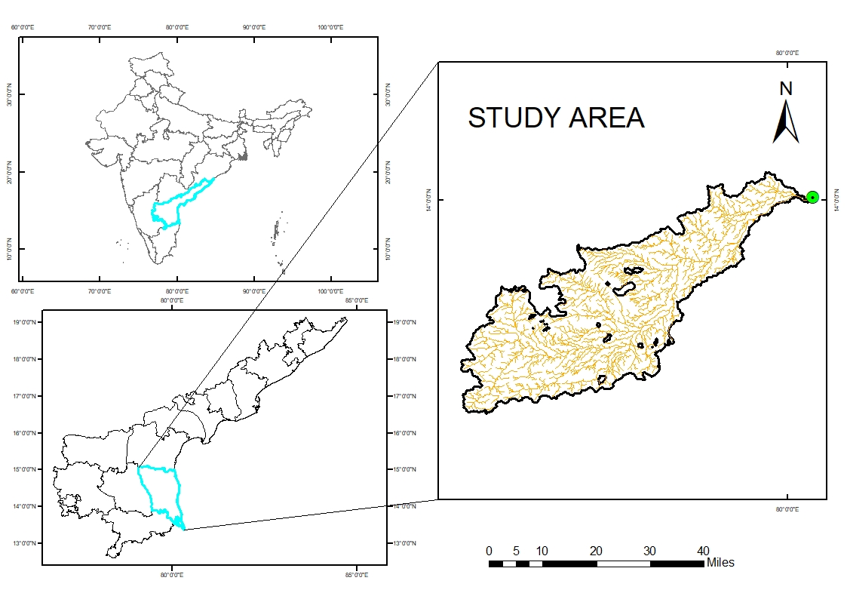

Fig 1 Location of study area

**2.2 DATA AVAILABILTY**

Catchment is considered as ungauged due to unavailability of data. Required values and procedure for study followed the PMP atlas for Cauvery and other East flowing river basin Vol.I.

**2.3 MANUALS AND SOFTWARE USED**

The software programs Arc-GIS, HEC-SSP along with MS Office, were used for data generation, analysis, and deriving results**.** Probable Maximum Precipitation (PMP) atlas for Cauvery and other East flowing river basins final report, Volume I,Flood estimation report for eastern coast region (UPPER LOWER & SOUTH) Subzones- 4(a, b &c) used for developing the SUH for Swarna Mukhi barrage catchment.

**2.4 DESIGN FLOOD ESTIMATION**

**2.4.1 Estimation of the design storm**

**2.4.1.1 Hydrological Data Used for Frequency Analysis**

Hydrological data of daily rainfall measured at Nellore station for the past 30 years (1993-2023), gathered from IMD, was employed as the fundamental input for rainfall frequency assessment.

**2.4.1.2 Rainfall Frequency Analysis Using HEC-SSP**

It was developed by the Hydrologic Engineering Center (HEC) of the U.S. Army Corps of Engineers using resources from the United States Federal Government. This software, which is used for statistical calculations, can be accessed on the HEC website ([www.hec.usace.army.mil](http://www.hec.usace.army.mil)). The software (USACE.2019) supports various frequency analyses. Initially, hydrological data is used to determine the return period through the plotting position method. This data is then compared with statistical distributions such as Gumbel and Log Pearson Type III, followed by a goodness-of-fit test to ensure accuracy (Shakirudeen and Saheed 2014). In this study, the Standard Product Moments method was chosen for analysis.

### **2.4.2 Delineation of watershed**

A thorough examination of the catchment physiography was conducted to ascertain the overall area draining into the basin up to the project site. Employing the Shuttle Radar Topography Mission (SRTM), a Digital Elevation Model (DEM) was acquired for the analysis . Arc-GIS was utilized to analyse the DEM, and all the data were projected using the UTM WGS 1984 projection system. The SUH parameters were obtained from the delineated watershed of same DEM. Parameters which are obtained by delineated of watershed are area of catchment A (ha), centroid of watershed, length of the main channel L (km), length of the main stream form centroid of the main channel Lc (km), Equivalent slope S (m/km).

**2.4.2.1 Development of Synthetic Unit Hydrograph**

Due to the lack of available data, the catchment was classified as ungauged. For such catchments, the Synthetic Unit Hydrograph (SUH) approach was applied, and the discharge ordinate values for the corresponding time intervals were determined using SUH (Sharif and Husain 2017).

To develop the SUH, geomorphological parameters were required, which were extracted from the catchment’s Digital Elevation Model (DEM) using ArcGIS. The catchment area for the barrage site was identified through DEM delineation. The SUH was formulated based on equations provided in the ‘Flood Estimation Report for the Eastern coast region (upper lower & south) Subzones- 4(a, b &c). The empirical formulas which were used for developing the SUH are given below

$t_{P}=0.376{\left(\frac{LL_{c}}{\sqrt{s}}\right)}^{0.434}$

$q_{p}=\frac{1.215}{{\left(t_{p}\right)}^{0.691}}$

$T_{B}=7.621{\left(tp\right)}^{0.623}$

$W_{50}=\frac{2.211}{{\left(q_{p}\right)}^{1.07}}$

Qp= qp * A

$W_{75}=\frac{1.312}{{\left(q_{p}\right)}^{1.003}}$

$W_{R50}=\frac{0.808}{{\left(q_{p}\right)}^{1.053}}$

$W_{R75}=\frac{0.542}{{\left(q_{p}\right)}^{0.965}}$

Tm =tp+ 0.5

Where,

A = Total catchment area in km2.

L = Length of longest main stream along the river course in km.

Sc = Equivalent stream slope in m/km.

tp= Time from the centre of effective rainfall duration to the peak in hr.

qp = Peak rate of discharge in cumec per sq. km.

Qp = Peak discharge of U.G. in m3/s.

TB = Base width of U.G. in hr.

Tm = time from the start of rise to the peak of unit hydrograph in hr.

W50 = Width of U.G. measured at 50% of peak discharge ordinate in hr.

**2.4.3 Design storm estimation using PMP atlas**

Among many PMP atlases for different basins developed by Central Water Commission (CWC), the atlas for Cauvery and other East flowing rivers was used for the present study. It was necessary to find the catchment number by using the longitude and latitude of the centroid of the watershed.

Using the rainfall frequency analysis method, rainfall estimates for 100 year return period were obtained, and the 100 year return period rainfall values were used for design flood computation. To convert the one-day rainfall into 24-hour rainfall, the following two conditions had to be met.

* ‘1-day rainfall*Clock hour correction (CHC=1.15)’, or
* ‘1-day rainfall+50mm’,

The lesser value obtained was taken as 24-hrs rainfall.

Hence IMD has recommended the CHC value of 1.15 for the entire Indian region to convert 1-day rainfall to 24-hour rainfall **(**Harihara Ayyar and Tripathi, 1973)**.**

## **2.4.4 Distribution of duration of design storm**

The duration of design storm found out by base period of SUH. The next step involved dividing the 24-hour rainfall into the first 12-hour and second 12-hour rainfall. This was achieved using the distribution coefficient (%), which was selected based on the grid catchment number provided in the PMP atlas. Then incrementing these two bells and applying the loss rate to these two bells obtained the incremental effective rainfall.

## **2.4.5 Application of Loss rate to the storm hyetograph and development of Effective rainfall hyetograph**

As the catchment is ungauged, the loss rate was taken from the Flood Estimation Report (FER) of eastern coast region (upper lower & south) Subzones- 4(a, b &c).

**2.4.6 Time adjustment of design storm and its critical sequencing**

For critical sequence the incremental hourly effective rainfall depths have been arranged in critical order for each bell separately. For this the highest of hourly incremental effective rainfall depth value had been placed against the peak of Unit Hydrograph (UH) ordinate, then the next highest value against the next largest of the UH ordinate and so on until all hourly incremental effective rainfall depths get arranged. After arranging these, incremental effective rainfall of 1st and 2nd bells were reverse sequenced. Further, the 1st and 2nd reversed sequencing bell values were arranged in a single row (called as effective rainfall values) i.e., initially 2nd reversing bell values were arranged, followed by the 1st bell values.

**2.4.7 Convolution with UH**

The SUH ordinates were multiplied by each effective rainfall hyetograph values and the resulting DRH ordinates so obtained are arranged lagging each other by one hour. The DRH’s obtained are added to get the resultant direct runoff hydrograph.

## **2.4.8 Base flow addition**

The base flow rate was taken from the Flood Estimation Report (FER) of Flood Estimation Report (FER) of eastern coast region (upper lower & south) Subzones- 4(a, b &c). After obtaining the base flow rate, it was multiplied with the catchment area that gave the base flow in the terms of cumecs.

**2.4.9 Design flood**

From convolution of UH, obtained DRH was added with base flow, finally flood ordinates were derived for every hour, the peak value was considered as design flood value determined for 100 year return period.

**2.5 Assessment of safety of the barrage based on designed value and estimated values**

The criteria for determining the design flood value of the structure were evaluated based on IS specifications (IS: 11223-1985). The critical design flood value for the structure was identified, and the estimated flood value of 100 Year T will be compared with the design values to assess the adequacy of capacity.

**3 RESULT AND DISCUSSION**

**3.1 Estimation of design storm by rainfall frequency analysis**

In the 30 years of precipitation data, the minimum and maximum rainfall values were found as 62.8 mm and 259.9 mm, respectively.

### **3.1.1 Goodness of Fit Test**

Goodness of fit test ensured the reliability of Gumbel and Log Pearson type III distributions to represent the sample. The goodness of fit summary statistics using Chi-Square test and Kolmogorov Smirnov test have been shown in Table 1.

Table 1 Test statistics of goodness of fit

|  |  |  |  |
| --- | --- | --- | --- |
| **Sl. No** | **Type of Distribution** | **Test statistics** | |
| Standard Product Moment | |
| Chi-square | Kolmogorov Smirnov |
| 1 | Log-Pearson III | 6.400 | 0.101 |
| 2 | Gumbel | 8.800 | 0.132 |
| **Standard table value** | | **42.556** | **0.253** |

The statistical table value for Chi-Square and Kolmogorov-Smirnov test were obtained as 42.55 and 0.253 respectively. The computed value, also called as the test statistic values, obtained for Chi-Square and Kolmogorov- Smirnov test were found less than that of the statistical table value. Therefore, by statistical theory, the hypothesis was accepted and it indicated the best fit of both distributions for the basin. Topaloglu (2002)

### **3.1.2 Comparison of Gumbel and Log-Pearson Type III Distribution**

A comparison of expected distribution probability of rainfall of Gumbel and Log Pearson type III Distribution has been shown in Table 2. The expected probability maximum rainfall given by Log - Pearson type III distribution were 166.76 mm, 203.36 mm, 304.10 mm, 359.75 mm, 540.28mm for the return periods 5, 10, 50, 100, 500 years, respectively, while the same showed by Gumbel distribution were 171.77 mm, 205.68 mm, 283.24 mm, 317.22 mm and 398.48 mm, respectively for the same return periods. Both the distributions showed good relation with each other and found best fitted for the catchment Wai (2015).

Table 2 Comparison of Gumbel and Log-Pearson type III distribution

|  |  |  |  |
| --- | --- | --- | --- |
| **Percent chance Exceedance** | **Return Period (year)** | **Expected probability precipitation in mm** | |
| **Log Pearson III**  **Distribution** | **Gumbel distribution** |
| 0.2 | 500 | 540.28 | 398.48 |
| 0.5 | 200 | 426.77 | 351.78 |
| 1.0 | 100 | 359.75 | 317.22 |
| 2.0 | 50 | 304.10 | 283.24 |
| 5.0 | 20 | 243.06 | 238.99 |
| 10.0 | 10 | 203.36 | 205.68 |
| 20.0 | 5 | 166.76 | 171.77 |
| 50.0 | 2 | 117.96 | 122.08 |
| 80.0 | 1.25 | 86.47 | 85.55 |
| 90.0 | 1.11 | 74.54 | 69.41 |
| 95.0 | 1.05 | 66.21 | 56.88 |
| 99.0 | 1.01 | 52.58 | 33.98 |

Fig. 2 indicates the expected probability rainfall corresponding to different return periods using Gumbel and Log-Pearson Type III distribution.

The design flood peak for the specified return period and probability of rainfall exceedance can be determined using the charted rainfall values presented in the figure. A similar methodology was employed by Riyola (2020).

Both distributions fit well but, comparing in between the two distributions, Log-Pearson III fits best than Gumbel because Log-Pearson III gave low values in both tests. From Log-Pearson III distribution, the 100 Year Return Period rainfall values were used for design flood estimation.

## **3.2 Delineation of watershed**

Parameters which are obtained by delineated of watershed are area of catchment A(km2) is 2643.69 km2, centroid of watershed is 79° 31' 33.6"E,13° 42' 57.6" N. Length of the main channel L(km) is 151.65km, equivalent slope S (m/km) is 2.1364 m/km. Above procedure for obtaining the parameters were in agreement with Himanshu *et al.* (2015), Kumari and Goel (2015), Rath *et al.* (2019).

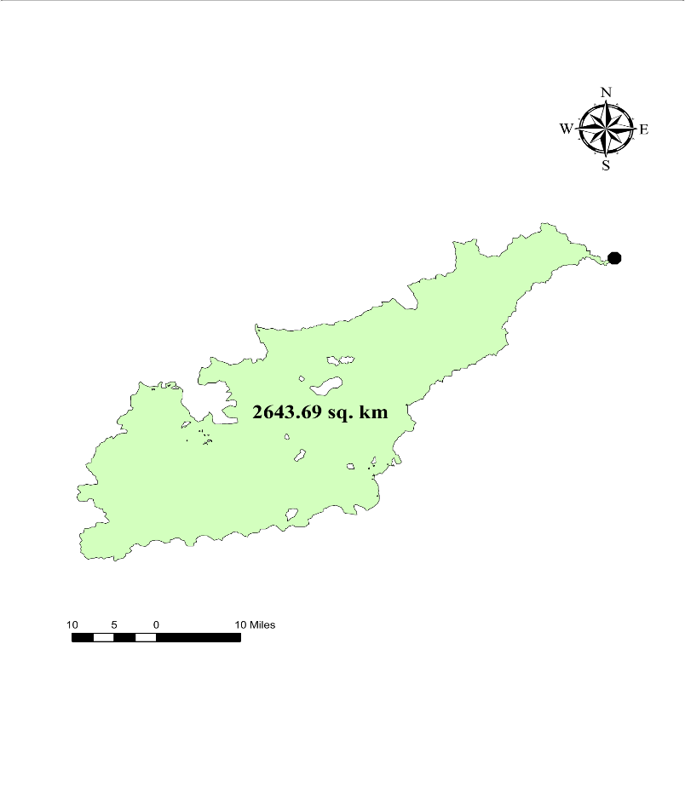

Fig.3 Delineated Swarna Mukhi barrage catchment

## **3.2.1 Derivation of parameters for SUH**

The numerical value of unit hydrograph derived from the equations which has been given in ‘Flood estimation report for the Eastern coast region (upper lower & south) Subzones- 4(a, b &c), has been listed below in Table 3 and Table 4. Derived and adopted SUH were shown in Fig. 4 and Fig. 5.

Table 3 Parameters calculated for deriving the SUH of the catchment

|  |  |
| --- | --- |
| tp | 17.46 hrs |
| qp | 0.17 Cumec/ Sq. Km |
| TB | 45.27 hrs |
| W50 | 14.87 hrs |
| Qp | 445.17 Cumec |
| W75 | 7.83 hrs |
| WR50 | 5.22 hrs |
| WR75 | 3.02 hrs |
| Tm | 17.96 hrs |

Table 4 Ordinates of derived unit hydrograph

|  |  |  |  |
| --- | --- | --- | --- |
| **Time Formula** | **Time (hr)** | **Discharge Formula** | **Discharge (Cumec)** |
| 0 | 0 | 0 | 0 |
| Tm-WR50 | 12.74 | 0.5*Qp | 222.58 |
| Tm-WR75 | 14.94 | 0.75*Qp | 333.88 |
| Tm | 17.96 | Qp | 445 |
| Tm-WR75+W75 | 22.77 | 0.75* Qp | 333.88 |
| Tm-WR50+ WR50 | 27.61 | 0.5*Qp | 222.58 |
| TB | 45.27 | 0 | 0 |

Fig.4 Synthetic Unit hydrograph for Swarna Mukhi barrage catchment

Fig.5 Smoothened SUH for Swarnamukhi barrage catchment

**3.2.2 Design storm estimation using PMP atlas**

Catchment number was identified as 304-01 with the help of latitude and longitude of centroid of the watershed.

## **3.2.3 Distribution of duration of design Storms**

It was observed from the SUH of basin that base hour of the hydrograph was 45.27 hours. Thus, storm duration of 1-day (24 hours) has been considered for further procedures of this study. Further step was to divide the 24-hours rainfall to first 12-hrs rainfall and second 12-hrs rainfall and for that the distribution co-efficient (%) in accordance to the 304-01 grid catchment number given in PMP atlas had been selected and is listed in Table 5.

Table 5 Distribution co-efficient of 12-hrs rainfall for catchment 304-01

|  |  |
| --- | --- |
| **Time (hr)** | **Distribution coefficient %** |
| 1 | 15.60 |
| 2 | 25.40 |
| 3 | 33.00 |
| 4 | 39.30 |
| 5 | 44.50 |
| 6 | 49.60 |
| 7 | 52.40 |
| 8 | 55.60 |
| 9 | 58.90 |
| 10 | 62.00 |
| 11 | 65.30 |
| 12 | 68.50 |

Design storm of 100 year return period was used for estimation of design flood. 100 year return period value was taken as one day rainfall value of respective design storm. One-day rainfall was multiplied with 1.15 (CHC) to obtain the 24- hr rainfall of 100-year T rainfall value and the value obtained was 41.36 respectively. The 24 hours rainfall values were divided into two 12-hour bells. The 1st 12-hours rainfall value of 100 years T was 28.33 cm respectively. The 2nd 12-hours rainfall value of 100 years T was 13.03 cm respectively. Desing Storm values of 100 years T are shown in Table 6.

|  |  |  |
| --- | --- | --- |
|  | **Formulas** | **100**  **years T**  **(cm)** |
| 1-day  rainfall | Design storm | 35.97 |
| 24-hr  rainfall | 1.15*1-day  rainfall | 41.36 |
| 1st 12hr  rainfall | 12th hr D.C*24hr  rainfall | 28.33 |
| 2nd 12 hr  rainfall | 24 hr rainfall-1st  12hr rainfall | 13.03 |

Table 6: Design Strom values of 100 Year return period

Distribution co-efficient for 12 hours was taken from PMP atlas. Next step was to normalize the distribution co-efficient which is listed in Table 7 and followed by obtaining the bell distribution for first 12 hr and second 12 hr rainfall.

Table 7 Normalised distribution coefficient

|  |  |  |
| --- | --- | --- |
| **Time (hr)** | **Distribution coefficient %** | **Normalised distribution coefficient %** |
| 1 | 14.60 | 22.77 |
| 2 | 24.10 | 37.08 |
| 3 | 32.10 | 48.18 |
| 4 | 38.80 | 57.37 |
| 5 | 45.50 | 64.96 |
| 6 | 51.60 | 72.41 |
| 7 | 56.00 | 76.50 |
| 8 | 59.80 | 81.17 |
| 9 | 64.10 | 85.99 |
| 10 | 68.10 | 90.51 |
| 11 | 71.60 | 95.33 |
| 12 | 74.60 | 100.00 |

Table 8 shows the distribution of 1st and 2nd 12 hours rainfall and incremental rainfall of 100 years T. 1st hour, 6th hour, 12th hour rainfall values of 1st bell distribution were 6.45 cm, 20.52 cm, 28.34 cm respectively. 1st hour, 6th hour, 12th hour rainfall values of 2nd bell distribution were 2.97 cm, 9.43 cm, 13.03 cm respectively. 1st hour, 6th hour, 12th hour of 1st bell incremental rainfalls were 6.45 cm, 2.11 cm, 1.32 cm respectively. 1st hour, 6th hour, 12th hour of 2nd bell incremental rainfalls were 2.97 cm, 0.97 cm,0.61 cm respectively. Figure 6 shows the distribution of first and second bells of 100 years T. 12th hour was having the highest value i.e., 28.34 cm among the 1st and 2nd distributions of 12 hours.

Table 8 Bell distribution and incremental rainfall values for 100 years T

storm

|  |  |  |  |
| --- | --- | --- | --- |
| **1st 12 hr bell distribution cm** | **2nd 12 hr bell distribution cm** | **Incremental rainfall 1st bell**  **cm** | **Incremental rainfall 2nd bell**  **cm** |
| 6.45 | 2.97 | 6.45 | 2.97 |
| 10.51 | 4.83 | 4.05 | 1.86 |
| 13.65 | 6.28 | 3.14 | 1.45 |
| 16.26 | 7.48 | 2.61 | 1.20 |
| 18.41 | 8.46 | 2.15 | 0.99 |
| 20.52 | 9.43 | 2.11 | 0.97 |
| 21.68 | 9.97 | 1.16 | 0.53 |
| 23.00 | 10.58 | 1.32 | 0.61 |
| 24.36 | 11.20 | 1.37 | 0.63 |
| 25.65 | 11.79 | 1.28 | 0.59 |
| 27.01 | 12.42 | 1.37 | 0.63 |
| 28.34 | 13.03 | 1.32 | 0.61 |

Fig.6 Distribution of 1st and 2nd bells of 100 years T storm

## **3.2.4 Application of Loss rate to the storm hyetograph and development of incremental effective rainfall hyetograph**

Incremental effective rainfall of 1st and 2nd bell for 100 Year T was estimated by applying loss rate of 0.75 cm/hr. Table 10 shows incremental effective rainfall for 100 years T. 1st, 6th, 12th incremental effective rainfall of 1st bell for 100 years T were 5.70 cm, 1.36 cm, 0.57 cm respectively. 1st, 6th, 12th incremental effective rainfall of 2nd bell for 100 years T were 2.22 cm, 0.22 cm, 0 cm.

Table 9 Incremental effective rainfall for different design storm values

|  |  |
| --- | --- |
| **100 years T storm** | |
| **Effective incremental rainfall 1st bell cm** | **Effective incremental rainfall 2nd bell cm** |
| 5.70 | 2.22 |
| 3.30 | 1.11 |
| 2.39 | 0.70 |
| 1.86 | 0.45 |
| 1.40 | 0.24 |
| 1.36 | 0.22 |
| 0.41 | 0.00 |
| 0.57 | 0.00 |
| 0.62 | 0.00 |
| 0.53 | 0.00 |
| 0.62 | 0.00 |
| 0.57 | 0.00 |

## **3.2.5 Time adjustment of design storm and critical sequencing**

The critical sequencing of rainfall values was done for return period storm of 100 years. Effective rainfall hyetographs were obtained for the design storm value of 100 years return period. These procedures were in agreement with Kumari and Goel (2015), Rath *et al*. (2019).

Fig.7 shows graphical representation of effective rainfall hyetograph for 100 years T. Highest effective rainfall depth (5.70 cm) was occurred at 19th hour. Effective rainfall hyetograph values obtained were used for convolution of SUH to obtain the Direct runoff hydrograph (DRH) corresponding to 100 years T.

Fig.7 Effective rainfall hyetograph for 100 years T

## **3.2.6 Convolution of SUH**

Direct Runoff Hydrograph (DRH) was obtained by convoluting rainfall excess increments with Synthetic Unit Hydrograph. The SUH ordinates were multiplied by each effective rainfall hyetograph values and the resulting DRH ordinates so obtained are arranged lagging each other by one hour. The DRH’s obtained were added to get the resultant direct runoff hydrograph. The peak value of resultant DRH was 7451 cumecs corresponding to 100 Year T. This procedure was in agreement with Kumari and Goel (2015), Rath *et al*. (2019), DSRP Inspection Report (2022), Lall and Chavan (2023).

**3.2.7 Base flow addition**

Base flow rate chosen was 0.00869 cumec/km2 which was given in flood estimation report of eastern coast region (Upper Lower & South) Subzones- 4(a, b &c). After obtaining the base flow rate, it was multiplied with the catchment area (2643.69 km2), then base flow volume obtained was 22.9736 cumec. This procedure was in agreement with Kumari and Goel (2015), Rath *et al*. (2019), DSRP Inspection Report (2022), Lall and Chavan (2023).

**3.2.8 Design flood estimation**

Flood hydrograph for each design storm values was generated by adding the base flow to the resultant DRH. The peak values of the flood hydrographs were taken as 100 Year T. The design flood value was 7451 m3/sec. Similar results are arrived by Jain et al. (2000). Figure 8 shows the flood hydrograph corresponding to 100 Year T.

Fig. 8 Flood hydrograph corresponding to 100 years return period flood

**3.3 Assessment of Safety of the Barrage based on Designed Value and Estimated Values.**

Table 11 Size classification and design flood for dams (IS: 11223- 1985: Guidelines for fixing spillway capacity)

|  |  |  |  |
| --- | --- | --- | --- |
| **Classification of dam** | **Gross Storage (Mm3)** | **Hydraulic Head (m)** | **Inflow design flood** |
| Small | Between 0.5 – 10 | Between  7.5 m – 12.5 m | 100-year flood |
| Intermediate | Between 10 – 60 | Between  12 m – 30 m | SPF |
| Large | Greater than 60 | Greater than  30 m | PMF |

As per the above guidelines the Swarna Mukhi barrage design flood falls in the category of 100 Year T. The estimated value of 100-year return period was 7451 m3/sec and the design flood value of the structure was 6450 m3/sec. The difference between these two values is 1001 m3/sec.

**4 CONCLUSION**

The accurate estimation of design flood is critical for the sustainable and safe operation of hydraulic structures, especially in the context of increasing climate variability and extreme rainfall events. This study evaluated the design flood value of the Swarna Mukhi Barrage and assessed the adequacy of its spillway capacity. The analysis revealed that while the original design flood value was 6450 m³/s, based on historical data, the updated estimation for a 100-year return period yields a flood value of 7451 m³/s. This indicates a significant shortfall of 1001 m³/s in the spillway capacity, posing a risk to the structural integrity of the barrage during extreme flood events. Although the barrage meets the 100-year return period requirement as per IS specifications, the existing infrastructure is insufficient to safely accommodate the revised flood magnitude. Therefore, to enhance resilience and ensure long-term sustainability, it is recommended that additional spillway capacity be incorporated. This proactive measure is essential not only for immediate flood management but also as a strategic investment in climate-adaptive infrastructure planning.

**REFERENCES**

AYYAR, P.H and Tripathi, N. (1973). Relationship of the clock-hour to 6o-min and the observational day to I440-min rainfall. *Mausam*, *24* (3):279-282.

DSRP [Dam Safety Review Panel]. 2022. Report 2021-2022. *Dam Safety Review Panel Inspection Report of Pazhassi Barrage,* *Kannur*,143p.

Engeland, K., Reitan, T., Stenius, S.M. and Glad, P. (2021). Design flood estimation at locations with no data or short records in a Bayesian framework (No. EGU21-13317). *Copernicus Meetings*.

Himanshu, S.K., Garg, N., Rautela, S., Anuja, K.M and Tiwari, M. (2013). Remote sensing and GIS applications in determination of geomorphological parameters and design flood for a Himalayan River basin, India. *International research journal of earth sciences*. *1* (3):11-15.

Jain, S.K., Singh, R.D. and Seth, S.M. (2000). Design flood estimation using GIS supported GIUH Approach. *Water resource Management.* 14(5):369-376.

Kumari, P. and Goel, N.K. (2015). Flood Estimation for Rivers of Saurashtra Region Contributing into Gulf of Khambhat. *Int. J. Eng. Res. Tech.* (Special Issue)- Proceedings of Emerging Trends in Water Quantity and Quality Manag. 3(3):1-5.R

Lall, R. and Chavan, S. 2023. Design Flood Estimation based on Synthetic Unit Hydrograph Method for an Indian catchment (No. EGU23-15084). *Copernicus Meetings.*

Okoli, K., Breinl, K., Mazzoleni, M. and Di Baldassarre, G. (2019). Design flood estimation: exploring the potentials and limitations of two alternative approaches. *Water.* 11(4): 729.

Rath, U., Mishra, S. and Rai, N.N. Dam safety analysis of Matatila dam from hydrologic and hydraulic consideration. In: Abstracts, *Int. Dam Safety Conference*; Fed 2019, Bhubaneswar.

Riyola, G. 2020. Flood Frequency Analysis and Modelling of Flood using HEC-HMS for a River Basin: a Case Study. M.Tech (Ag. Engg) thesis, Kelappaji Collage of Agricultural Engineering Technology, Tavanur,118p.

Shakirudeen, O. and Saheed, A.R. (2014). Flood Frequency Analysis and Inundation Mapping of Lower Ogun River Basin. *J. Water Resour. Hydraulic Eng*. 3(3): 48-59.

Sharif, M. and Husain, A. (2017). Estimation of design flood at Kol dam using hydrometeorological approach. *Int. J. Environ. Sci. Natural Resour*. 4(1): 05-10.

Topaloglu, F. (2002). Determining suitable probability distribution models for flow and precipitation series of the Seyhan river basin. *Turkish J. Agric. and For*. 26(4): 187- 194.

USACE. (2019). HEC-SSP Statistical Software Package 2.2 User’s Manual. Hydrologic Engineering Centre, Davis, California.

Wai, J.X. (2015). Comparative Study of Flood Frequency Method on Selective rivers. other thesis, INTI International University, Malaysia, 2p.