Original Research Article

The Relationship Between Climate Change and Flood Risk Factors

ABSTRACT

This study presents a bibliometric analysis of the academic literature exploring about relationship between climate change and floods. Publications from 1995 to 2024 were examined to identify prolific authors, influential institutions, collaboration networks, core research themes, and in total 2583 studies were found and analysis was performed using the Biblioshiny tool (R Studio 4.1) by taking into account the first 1000 most cited studies. The findings indicate a significant increase in research activity, particularly after 2015. Wuhan, Hohai, and Delft Technology University emerged as the most productive institutions. Xu Chong-Yu, Wasko Conrad, and Goodall Jonathan were identified as leading authors. Thematic analysis reveals that topics such as "climate change", "flood", and "flooding" form the core of the research, while emerging themes include "urban flooding", "flood risk management", and "precipitation". The most cited publications focus on climate-induced flood risk modeling and management strategies. Overall, the study highlights the growing prominence of climate change impacts on flood research and emphasizes the critical role of interdisciplinary collaboration and advanced analytical methods in this field.

This research helps to determine research trends, most influential studies, authors and collaborations by providing a quantitative evaluation of scientific publications on the subject. Thus, it is expected that this study will contribute to strategic planning and scientific decision-making processes in the fields of climate change, water management, floods and similar areas. This study also allows us to track trends in climate change and floods, identifying which topics are gaining or losing popularity. This way, researchers and institutions can use water resources more efficiently, make more informed strategic plans for water management, and increase their scientific productivity.

Keywords: Climate change; natural disasters; flood risk; bibliometric analysis; hydrological modeling; scientific collaboration

1. INTRODUCTION
Environmental problems and pollution issues are among the greatest challenges of today's world. Especially climate change is the most obvious and dangerous environmental problems because of human-induced. Environmental pollution, increase of greenhouse gases in the atmosphere, deforestation, industrial activities lead to fluctuations and long-term changes in global temperatures. This situation cause glaciers melt, rise sea level, changes precipitation regimes, weather events, seasons and changes temperature and evaporation rates. These changes lead to more frequent natural disasters and greater material and moral damages (Şen and Özer, 2018). Because of environmental pollution and global climate change; ecosystem and ecological balance are disrupted, and this situation causes other negative chain reactions. Natural disasters and climate change pose a serious threat to sustainable development and natural capital stock (Fang et al., 2019).
Climate change intensifies the risk and impact of tsunamis by contributing to interconnected geophysical changes, including sea level rise, enhanced susceptibility to submarine landslides, destabilization of ice shelves, increased volcanic activity, and seismic disturbances. Climate change is also expected to increase migration, particularly within countries, as individuals and communities move locations in order to adapt to the changing natural environment. Climate conditions affect many situations such as landforms; soil types; agriculture, biodiversity, people's livelihoods, health and quality of life. Therefore, climatic characteristics are very important in terms of the development levels of countries and societies. So, people environmental education and awareness are very important. Therefore, all people of the world should reduce activities that may cause global climate change or continue these activities in a way that does not harm the environment. Global warming has a direct effect on heavy rainfall. Because increasing warming causes more evaporation, which triggers the surface to dry out and increases the duration and severity of droughts. This affects precipitation by increasing the amount of water vapor in the atmosphere. Increased humidity feeds storms, which in turn cause more intense precipitation events. As a result, the risk of flooding increases and changes are observed in the distribution of rainy areas. Dry areas become drier, while wet areas become wetter, especially in the middle and high latitudes. With warming, more rain falls and early melting snow increases the risk of deep drought in the summer, especially on land, and brings with it the risk of flooding in the spring (Trenberth, 2005).

Climate change also seriously affects meteorological parameters and causes changes. These changes in meteorological parameters also cause significant effects on the amount, quality, distribution of water resources and the hydrological cycle, which is of critical importance for the continuation of life on earth. It is important to understand and monitor the hydrological cycle in order to develop sustainable water resources management and strategies to combat floods caused by climate change. Due to climate change, precipitation intensity and period are experienced more intensely. The total amount of precipitation that normally falls in a month, sometimes falls in a short period of time such as 2 hours. This situation causes an increase in the amount of water passing into the surface flow and therefore in flood cases. In this case, the capacities of many water structures such as flood sections of rivers, channels, infrastructure systems, spillways may be insufficient. Accordingly, floods and inundations are experienced more frequently and this issue attracts the attention of researchers even more. The most important negative situations caused by floods are that they damage residential areas, lands, living beings and ecosystems. Floods are caused by excessive rainfall, dam collapse, rapid melting of snow masses, tsunamis formed in areas close to the coast and storms caused by tropical cyclones. The most effective of these reasons is that the region receives heavy rainfall, which fills the riverbed excessively and causes water to overflow from the riverbed. Deformations such as cracks and collapses in dams and other water structures can also cause floods by changing the flow mobility abnormally. There are some studies in the literature on how changes in atmospheric diversity will affect river discharge, but this situation is still unclear. It is thought that floods are highly affected by changes in climate characteristics, it is also possible that extreme precipitation causes floods, but there is almost no direct absolute relationship between the formation of floods and extreme precipitation. Therefore, evaluating the relationship between the spatiotemporal relationship characteristics of precipitation and discharge can be one of the most interesting studies on the subject (Andersen and Shepherd, 2013). Environmental components are very important for all living organisms and the future of the earth. All organisms in the ecosystem are connected to each other with a life link. Therefore, the deterioration that occurs in a part of the system affects the whole system over time (Kılıç, 2021). Water, the primary source of life, energy, all living things; to maintain the food supply and natural environment. Water is the most important part of humans and ecosystems, and the management and efficient use of water is an indicator of the development levels of countries and societies. Therefore, it is very important to develop current policies according to the current situation regarding the use and protection of water and to take appropriate steps in this regard (Kılıç, 2020).

This study provides a quantitative overview of scientific publications on climate change, water management, and floods, revealing key trends, influential authors, and collaborations. It supports strategic planning and helps track shifting research priorities, enabling more efficient water use and improved scientific output.

2. MATERIAL AND METHOD
Main features of the method: Number of publications analysis: Measures the number of articles published on specific subject (climate change-flood). Citation analysis: More effective studies by showing which studies are cited and how many times. Author analysis: Reveals the authors who have published most and get most citations. Journal analysis: Determines the journals that have published the most or received the most citations on studied subject. Country and institution analysis: Which countries or institutions have contributed more to the studied subject. Keyword analysis: How topic titles and trends have changed. Network analysis: Visualizes the relationships between authors, institutions or concepts. Bibliometric analysis has emerged as a widely adopted, systematic, and robust methodology for retrieving, evaluating, and interpreting large volumes of scientific literature. It is a quantitative approach that facilitates the analysis of published data and dissemination of scientific knowledge using statistical and mathematical tools. This technique encompasses various metrics such as citation counts, co-citation analysis, and bibliographic mapping, offering insights into publication trends, research impact, and intellectual structure. Bibliometric methods also enable the extraction of valuable information from academic journals, including citation networks and keyword trends. In this bibliometric study rely on comprehensive bibliographic databases such as Web of Science and Scopus. Bibliometric analysis studies process a large amount of scientific data and guide future planned studies to be more efficient and not to do the same study again. It is important to compare bibliometric analysis with commonly used review alternatives such as meta-analysis and systematic literature reviews and interpret it accordingly (Kılıç, 2025).
The literature published over the past 30 years on the "effect of climate change on floods" was examined using a quantitative bibliometric methodology.The availability of open-source bibliometric software packages and convenient access to vast amounts of data from the Scopus, Web of Science, Dimensions, and PubMed database platforms have made this technique more popular in recent years across a variety of disciplines (Koyuncu and Evcil, 2025; Kalkan and Coşkun, 2025, Kılıç, 2025). Bibliometric analysis was carried out using Biblioshiny 4.1, an open-source bibliometric program from R Studio. Biblioshiny is superior to other bibliometric tools because it offers a comprehensive set of statistical methods and visualizations that facilitate performance analysis and conceptual mapping of the subject of study (Huang, 2021; Veloutsou and Liao, 2023).

2.1 Data Source
This search was conducted in Web of Science (WOS) with the keywords (Climate change or climate change impacts or climate change effects or global climate change) and (flood risk or flood or urban flood or spillway failure or flood risk factors or dam safety) and the SCIE category was taken into account to see the global effects. The effects of climate change are in many areas and are categorized as “Water Resources”, “Engineering civil”, “Urban studies” in WOS. In this research, 2583 documents from from Web of Science database on 1995-2024 were analyzed. The analysis data was created by selecting the first 1000 studies with the most citations from the 2583 studies obtained. In the first step, bibliometric analysis techniques were selected. Before collecting bibliometric data, we determined the objectives and scope of the bibliometric study. Because, unclear objectives, unclear scope, lack of careful planning can reduce the efficiency of bibliometric analysis. In the second step, bibliometric study was designed and the analysis techniques were selected to meet the purpose and scope of the study. In the third step, the data required for the appropriate bibliometric analysis techniques selected and the search terms were defined. The final step is the fourth step, in which performance analysis and science mapping were run and the findings were reported. Then, a bibliometric summary was prepared with the data obtained; discussion and conclusion section of the article was written along with the inferences of the findings.

3. RESULT AND DISCUSSION
3.1 Citations and Top Productive Journals
Among the top 10 journal; Journal of Hydrology ranked first with 174 documents and 3752 citations. Although the journal “Water” has a significant number of documents. Researchers who want to work on climate change and floods are advised to review the studies published in these two journal. Table 1, shows the academic journals that most contributed subject of this research, publication started years, and journal citations. The 15 journals in Table 1 have provided the basis for the evaluation and interpretation of bibliometric studies on the subject. Journal of Hydrology is the most influential and productive journal with an h-index of 64, 174 document and 12,833 citations. Journal of Hydrology is a basic reference source for studies on the subject, especially on topics such as water cycle, rainfall-runoff relationships, drought, and floods. Hydrology and Earth System Sciences and Natural Hazards journals stand out with their h-indexes of 43 and 37, respectively, and these journals are widely used sources on the relationship between water resources, climate change and natural disasters with their high citation rates.

Table 1. Document numbers, citations and top productive journals
Journals | h_index | Document numbers | Publication Year | Citations
Journal of Hydrology | 64 | 174 | 1995 | 12833
Hydrology and Earth System Sciences | 43 | 72 | 2000 | 5669
Natural Hazards | 37 | 78 | 2001 | 4124
Hydrological Processes | 33 | 53 | 1997 | 3220
Water | 31 | 84 | 2012 | 2699
International Journal of Disaster Risk Reduction | 28 | 50 | 2014 | 1961
Water Resources Research | 28 | 39 | 1999 | 3382
Natural Hazards and Earth System Sciences | 27 | 43 | 2008 | 2214
Journal of Flood Risk Management | 23 | 31 | 2009 | 1151
Water Resources Management | 23 | 28 | 2004 | 1391
Journal of Hydrologic Engineering | 18 | 18 | 2004 | 1078
Stochastic Env. Res. and Risk Assessment | 18 | 19 | 2010 | 919
Water Science and Technology | 17 | 17 | 2004 | 643
Advances in Water Resources | 13 | 13 | 2010 | 1322
J. of American Water Resources Association | 13 | 13 | 1997 | 1172

Fig. 1 shows the cumulative frequency (cumulative occurrence number) of articles published in different academic journals related to the topic over time. The publication trends of 11 different journals in the graph between 1995 and 2024 are seen, and some of the striking points are as follows: Journal of Hydrology has clearly reached the highest cumulative publication number on the topic. It has gained serious momentum especially after 2010 and has increased at a high rate until 2024. This situation shows the leadership and preferability of the journal in the fields related to topic. Hydrology and Earth System Sciences and Water Resources Research Journals have also shown a significant increase in the last 10 years and these two journals are at the top in terms of publication density. Journals such as Water, Natural Hazards, and Earth System Sciences have shown a steady growth in terms of including studies on the topic. It is seen that some journals such as International Journal of Disaster Risk Reduction have started to contribute to studies on the topic with a rapid increase after 2010.

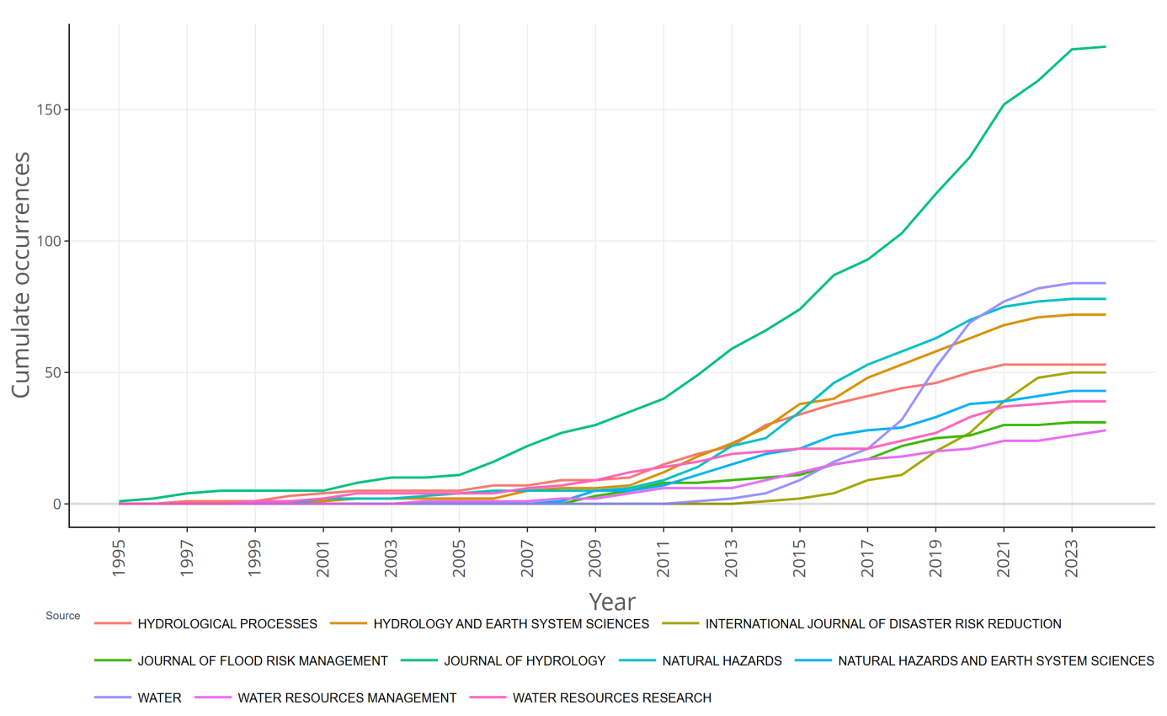
Fig. 1. Distribution topic according to the journals

The increase in journals such as Hydrological Processes and Water Resources Management has been more limited, suggesting that these journals either focus on different topics or are less preferred. Journal of Hydrology, Hydrology and Earth System Sciences, Natural Hazards, Hydrological Processes, Water are ranked high in terms of both citation and publication numbers. These are seen as prestigious journals that are frequently referenced and preferred in studies on the subject. Water Science and Technology, may be among the journals that quickly publish studies on the subject, although they have received fewer citations. This situation shows the potential of the journal on the subject. Journals that receive high citations despite low publication numbers can be platforms where specific and effective publications are made. These usually include limited but effective research. As a result, Figure 1 shows how topics such as water resources, floods, hydrology, climate change and disaster risk management have reflected the increasing scientific interest over the years. It also provides important information about which journals researchers turn to, which platforms are more productive and which publications stand out in the academic literature. Figure 1 is also a guide for researchers in bibliometric analysis. It provides strategic information such as which journals are leaders in their fields, which are cited more and which publication outlets may be more effective in the long term, especially in climate change, floods, water science and similar topics. For academics who will conduct research on their subject, such data is extremely valuable, guiding and enlightening in article submission, literature review and academic strategy determination.

3.2 Authors and Countries

In Fig. 2, it is seen that there is a China-centered density in the studies on the subject. Wuhan University, Hohai University and other Chinese universities have the largest network of connections. This situation reveals China's global effectiveness in hydrology, water resources and similar research. China, USA, Switzerland and Netherlands have many international academic collaborations. This shows the prevalence of interdisciplinary and multinational projects. Interdisciplinary and multinational studies enable more effective solutions to global and complex problems such as global warming, climate change and drought. While combining knowledge and methods from different disciplines allows for more comprehensive analyses, multinational collaborations increase knowledge sharing, enable data access from different geographies and strengthen the universal validity of research. Such studies between countries such as China, USA, Switzerland and the Netherlands accelerate scientific innovations on the subject and provide more robust and applicable suggestions, especially for water management and sustainability issues. Xu Chong-Yu, Wasko Conrad, Coulibaly Paulin stand out as the most influential scientists on the subject. These researchers have established strong collaborations both in their own countries and internationally. Strong collaborations between researchers both in their own countries and internationally can significantly increase scientific productivity, impact and access to resources on the subject. While national collaborations in areas such as water sciences, climate change and floods provide advantages in terms of developing solutions to local problems, international collaborations bring together different perspectives, data sources and technical expertise, allowing for more comprehensive and universal research on the subject.

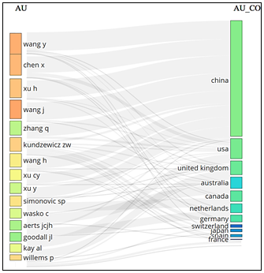
Fig. 2. Prominent countries and researchers on the subject
3.2.1 Universities
Figure 3 shows the institutions that produce the most publications (affiliations) and the number of articles they produce within the scope of the bibliometric analysis on climate change and floods. According to the analysis, Wuhan University, Hohai University and Delft University of Technology stand out as the top three institutions with the highest publication volume in the relevant field. Wuhan University and Hohai University are the leading research institutions in the field of hydrology and water resources in China. The increasing research investments on the impacts of climate change on water resources in China in recent years have directly increased the publication productivity of these universities. Delft University of Technology is especially known for its research on flood modeling, water engineering and climate adaptation strategies. Its active role in Europe's climate change adaptation strategies has made this institution one of the important scientific centers in the field (Kundzewicz et al., 2014). Texas AANDM University and Vrije Universiteit Amsterdam are leading multidisciplinary studies in flood risk management and climate-based disaster analysis in the USA and Europe. These institutions produce scientific outputs that provide policy-based recommendations to decision-makers on topics such as water resources management and flood modeling (Rosenzweig et al., 2018). In addition, institutions from different continents such as Australia (Univ. Melbourne), Belgium (KU Leuven), Japan (Kyoto Univ.), and the Netherlands (Deltares) are also active in global academic production. This situation emphasizes that flood and climate relations are a global research theme.
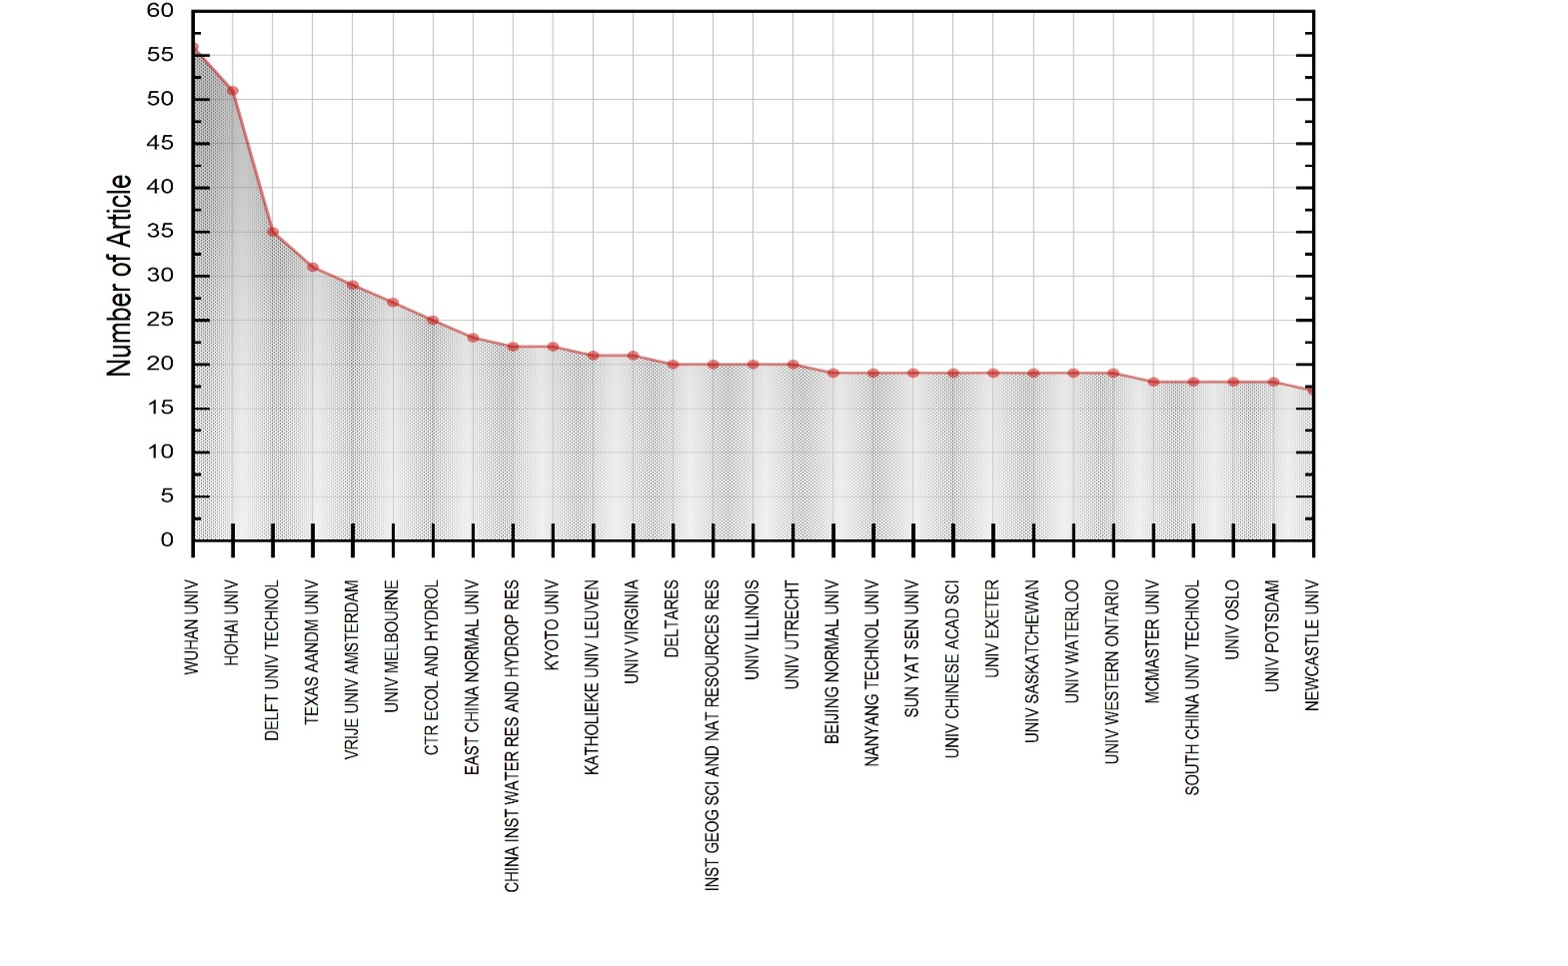
Fig. 3. Most Relevant Affiliations

3.2.2 Analysis of Most Cited Publications
Fig. 4 shows the most cited (most influential) scientific publications on climate change and flood; to identify fundamental studies, leading theories, and methodological approaches in the field. The publications at the top are studies that have led the field and are frequently cited: Kundzewicz et. al., 2014. Flood risk management is one of the cornerstones of the field in terms of hydrological regime changes and policy strategies (Kundzewicz et al., 2014). Another study, examines flood processes in urban areas and the effects of urbanization on floods, focusing on green infrastructure and sustainable urban drainage systems. It has made a significant contribution to the advancement of the subject of urban flooding (Fletcher, 2013). Erwin (2009), research is important, especially in the context of nature-based solutions; his study is pioneered research on the role of wetlands in flood prevention/reduction with climate change. In another study, details the integration of climate projections into hydrological models; they describe flood prediction models based on hydroclimatic scenarios. Alfieri et al. (2016), analyzed flood risks in Europe with advanced climate models and presented future risk projections. It is one of the main sources on European-scale flood predictions and early warning systems. The vast majority of the articles in the top 10 focus on areas such as hydrological modeling, climate change scenarios, flood prediction and urban water management. Studies with high citation numbers are generally interdisciplinary. They bring together researchers from different fields such as hydrology, climatology, environmental engineering and urban planning. Most of these publications are studies that are also referred to by policy makers, such as IPCC reports (IPCC, 2014).
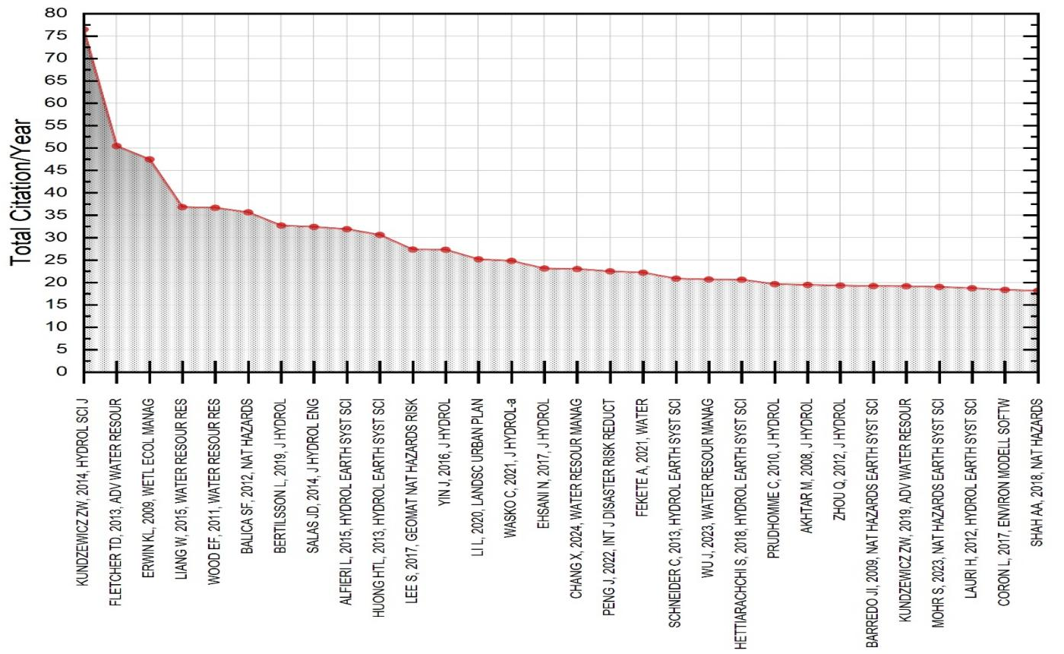
Fig. 4. Most cited documents

3.2.3 Author-Based Productivity and Impact Analysis
Fig. 5 visualizes the annual publication numbers and citation densities of prominent researchers in the literature on climate change and floods between 2007 and 2023. The size of the blue circles in the graph represents the number of publications of the authors in the relevant year; the color intensity represents the total number of citations per year. This visual reveals the changes in scientific productivity and impact levels in the field over time. Chong-Yu Xu is known for his extensive studies on the effects of climate change on hydrological modeling. In particular, his work examining the current gaps and recent research developments between climate change and hydraulic models has been frequently cited in the literature. In addition, his work discussing the factors affecting the accuracy of hydrological modeling under changing environmental conditions has also made significant contributions (Xu, 2021). Conrad Wasko is notable for his studies on the intensification of short-term rainfall extremes and flash flood risks. In particular, his review of the effects of temperature increases on flood extremes is one of the important literatures in the field (Wasko, 2021). In addition, his work on the integration of climate change into flood forecasting guidelines is also valuable in terms of applied hydraulic engineering (Wasko et al., 2021). Jonathan L. Goodall is known for his work on flood forecasting and water resources management; his work has made significant contributions to the literature in the field. Trends over yime and scientific impact: in the period 2007–2013, Chong-Yu Xu's work stands out in terms of both the number of publications and citation density. During this period, Xu's work on climate change and hydraulic modeling has found a wide resonance in the literature. In the period after 2014, Conrad Wasko's work attracts attention. In particular, Wasko's articles published between 2017–2021 show his impact on the field with high citation numbers. The work of Jonathan L. Goodall has been increasingly influential in the post 2015 period. This analysis reveals the productivity and impact levels of prominent researchers in the literature on climate change and floods over time. While the early work of Chong-Yu Xu provided the basic theoretical framework in the field, the more recent work of Conrad Wasko and Jonathan L. Goodall focuses on applied and contemporary issues, reflecting thematic and methodological evolution.
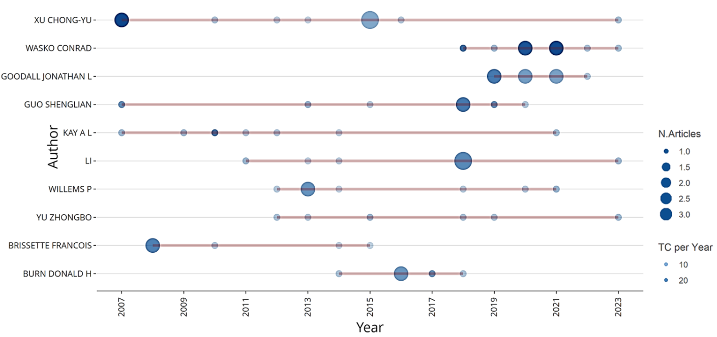
Fig. 5. Author’s production over time

3.3 Thematic Evoluation Related to the Topic
Climate change has been studied for a long time. The trend of research has evolved over time towards climate impacts and adaptation to climate change. In the first half of the 1995-2024 time series, terms related to flood protection, flood risk management, and agriculture were replaced by "flood risk management" in the second half. It is expected that the use of "GIS" methods, which emerged in the 2017-2024 time series, will become widespread in assessing the change in the intensity and frequency of floods due to climate change effects.
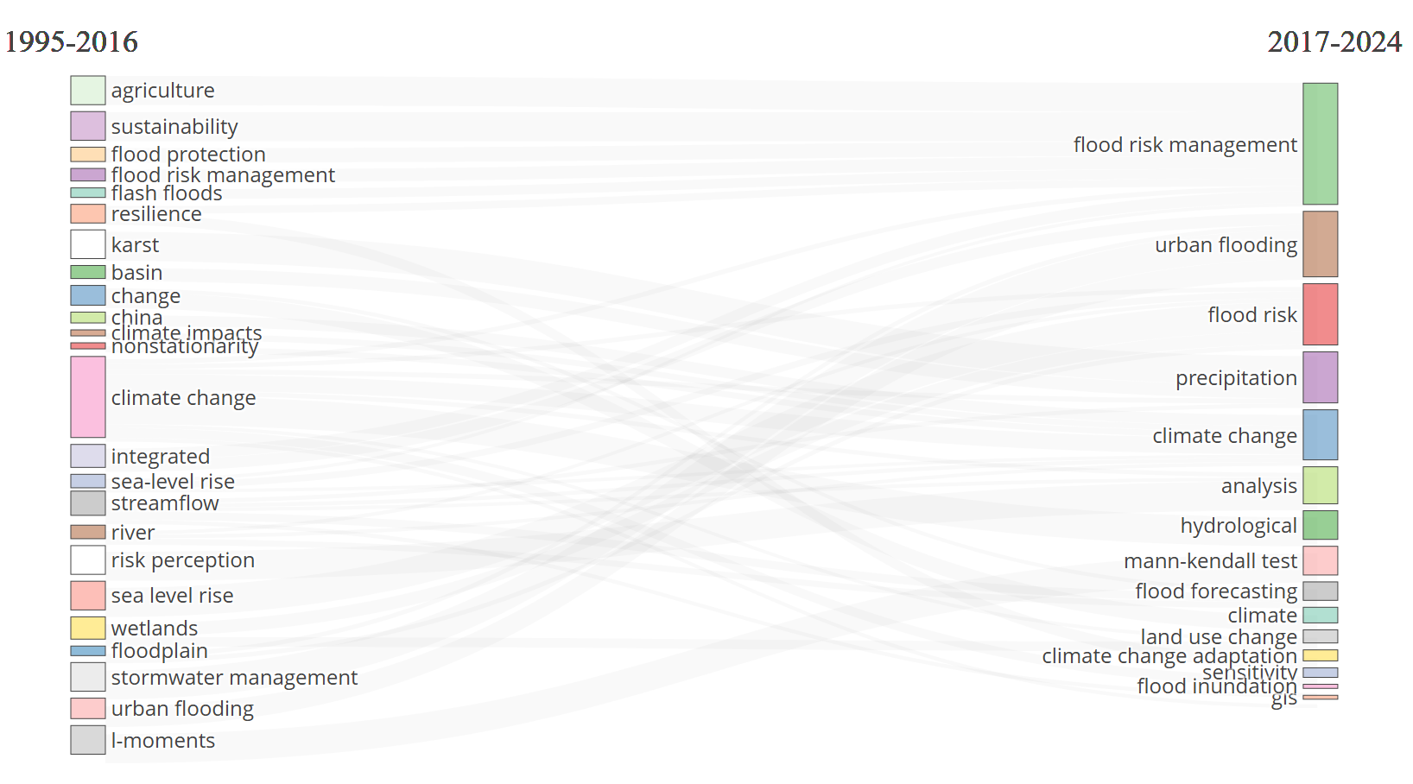
Fig. 6. Thematic evolution of related key-words

Keyword analysis is used to identify the evolution of research topics over time and emerging trends. In the period 2006–2010, keywords such as "urban stormwater" and "runoff" were prominent. In addition, water quality-related terms such as "sediment", "water quality" and "heavy metal" were frequently used. This shows that research focused more on urban water management and water quality. Figure 6 showing the evolution of keywords used in the literature on climate change and floods between 1995–2016 and 2017–2024. Thematic concepts used in academic studies on the relationship between climate change and floods have shown a remarkable change over the years. Figure 6 shows the distribution of studies published between the periods 1995-2016 and 2017-2024 based on keywords. The visual reveals academic trends in this field by visualizing which concepts have gained or lost importance over time. In the period 1995–2016, the most prominent words include general and structural concepts such as climate change, flood risk management, flood protection, resilience, flash floods and stormwater management. These terms show that flood management strategies were initially shaped on the basis of infrastructure and environmental factors. During this period, the use of keywords such as "urban flood", "management" and "model" increased. Research focused more on flood management and modeling techniques. In addition, terms related to environmental impacts such as "pollution" and "water quality" also gained importance.
In 2016-2021, climate change, urbanization, resilience and vulnerability have become prominent keywords. Research has focused on the effects of climate change on floods and resilience of urban areas. In addition, sustainable urban water management approaches such as "low impact development" and "sponge city" have also gained importance. In the 2017-2024 period, it is observed that more practical and analytical concepts have come to the fore. In this new period: "Flood risk management" (the most dominant keyword) has become the main theme of research. Concepts such as "urban flooding", "flood risk", "precipitation" and "hydrological" show that the focus is particularly on the connections between urbanization, climate change and extreme precipitation. The increase in technical and data-based analyses such as "Mann-Kendall test", "flood forecasting", "land use change" reflects that research is increasingly becoming more quantitative and model-oriented. The theme of climate change maintains its importance in both periods. This continuity shows that flood research is addressed in direct relation to climate change. Similarly, the concept of flood risk management is strongly present in both periods, but it has clearly become the most dominant concept in the period 2017-2024. More abstract and methodological concepts such as "hydrological" and "analysis" are also indicators of a shift towards modeling and data-based studies. This thematic transformation shows that scientific interest has shifted from structural flood measures (e.g. dams, levees) to urban context, climate adaptation, analytical modeling and disaster risk management. In addition, the transformation of concepts to a more localized structure (e.g. urban flooding) coincides with the fact that climate change effects respond differently in different geographies. In this context, keyword analyses are an important indicator in determining not only past trends but also future research priorities, technological orientations and political strategy focuses.
3.4. Development and Importance Levels of Research In the Literature
Fig. 7 is a thematic map type frequently used in bibliometric analyses and shows the classification of certain keywords (topics) based on their centrality and density in the field. Such analyses are used to identify scientific themes in a particular research field and to analyze the extent to which these themes are established or developing. Figure 7 is a thematic map where key themes used in the literature on climate change and floods are classified based on their centrality and density. This graph, divided into four main regions, reveals the key themes that drive the development of the conceptual structure and scientific interest (Figure 7). Motor themes include themes that have both high centrality and development and form the core of the literature: “Climate change”, “flood” and “flooding” are among the largest and most influential themes in the field. This shows that the impact of climate change on flood processes is a major focus of research (Westra et al., 2014; Kundzewicz et al., 2014). Also, streamflow, modelling and water resources are other key themes frequently investigated in the context of applied hydrometeorology and hydrological modelling (Milly et al., 2008).
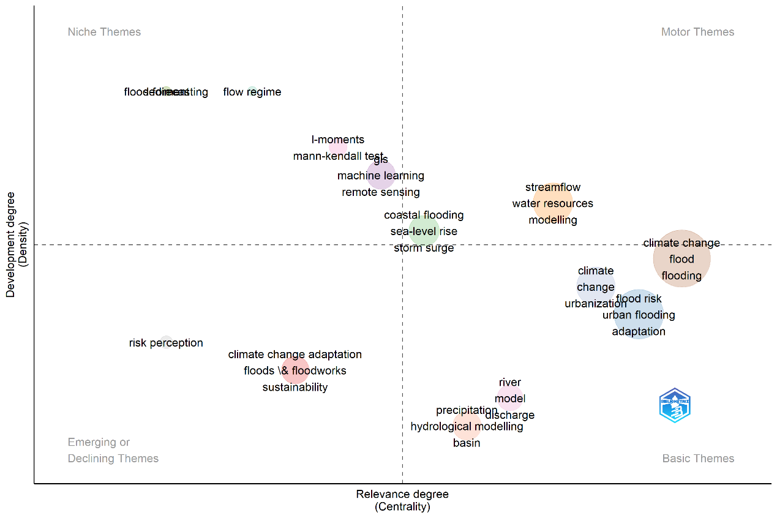
Fig. 7. Distribution of the most prominent keywords on the topic

The themes in the basic themes section have high centrality but are still underdeveloped. These themes constitute the basic building blocks of the research area: Topics such as “Urban flooding”, “flood risk”, “climate change adaptation”, “urbanization” come to the forefront, especially in the context of disaster risk assessment in urban areas and climate change adaptation strategies (Rosenzweig et al., 2018). Concepts such as “precipitation”, “hydrological modeling” and “basin” represent analytical studies on the physical causes of floods. The niche themes section includes specialized themes that are developed but less central: “Remote sensing”, “machine learning”, “I-moments” and “Mann-Kendall tests” represent advanced statistical and computational methods used in climate-data analyses. The density of these themes points to the increasing importance of technical approaches in the literature (Xie et al., 2021). In addition, marine flooding processes such as “coastal flooding”, “storm surge”, “sea-level rise” are unique themes that address the effects of global warming specific to coastal areas (Nicholls & Cazenave, 2010). Themes in the emerging or declining themes region may be topics with limited research interest or losing their importance in the literature: Concepts such as “risk perception”, “sustainability”, “floodworks” and “climate change adaptation” attract attention as multidisciplinary or socially powerful topics. Although these themes are generally less common in engineering-based literature, they are important in terms of addressing the social dimension of climate risks (Grothmann and Patt, 2005).

4. CONCLUSION
In this research, bibliometric analysis provided a comprehensive overview of the scientific landscape surrounding the relationship between climate change and floods. By analyzing publication trends, authorship patterns, institutional affiliations, thematic evolution, and citation metrics, this study offers critical insights into the intellectual structure and developmental trajectory of the research field. The findings reveal a marked increase in scholarly interest in the topic, particularly after 2015, coinciding with the Paris Agreement and growing global concerns about extreme weather events. Institutions in China (Wuhan University, Hohai University) and Europe (Delft University of Technology, Vrije Universiteit Amsterdam) emerged as the most prolific contributors. In addition, authors such as Xu Chong-Yu, Wasko Conrad, and Goodall Jonathan L. demonstrated strong influence based on both productivity and citation impact. Thematic analysis showed that “climate change,” “flood,” and “flooding” dominate the research focus as motor themes, while urban flooding, flood risk management, and precipitation have gained prominence in recent years. Advanced analytical tools such as remote sensing and machine learning are increasingly integrated into the methodology. Most cited documents, such as those by Kundzewicz et al. (2014) and Fletcher et al. (2013), underscore the field’s core interest in linking hydrological modeling with policy-relevant flood risk management under climate change scenarios. Understanding and effectively solving unexpected natural events requires an interdisciplinary approach rather than a situation that requires expertise in a single field. This study highlights the central role of climate-induced flooding in environmental and hydrological research, and underlines the need for continued international collaboration and methodological innovation to strengthen adaptive capacities against future flood risks. In this context, the coming together and collaboration of experts from different fields to cope with climate variability can be an effective strategy in the process of dealing with these complex problems. Similarly, in order to raise individuals who are prepared and resilient to disasters caused by global climate change, practical and comprehensive methods that focus on developing individuals' problem-solving skills are needed in the teaching of these subjects.
In summary, this article has shown that bibliometric analysis is a scientific method that can be useful for scientists working in the field of climate change and flood risk. The article also revealed that bibliometric methodology can be used to obtain and evaluate large and detailed scientific data with software and artificial intelligence applications that facilitate more efficient results. Thus, possible future climate change and flood-related events can be predicted and their damages can be reduced.

DISCLAIMER (ARTIFICIAL INTELLIGENCE)
Author(s) hereby declare that NO generative AItechnologies such as Large Language Models (ChatGPT, COPILOT, etc) and text-to-image generators have been used during writing or editing of this manuscript.

COMPETING INTERESTS DISCLAIMER:
Authors have declared that they have no known competing financial interests OR non-financial interests OR personal relationships that could have appeared to influence the work reported in this paper.

REFERENCES
Alfieri, L., Bisselink B., Dottor F., Naumann G., De Roo A., Salamon P., Wyser K., & Feyen, L. (2016). Global projections of river flood risk in a warmer world. Hydrology and Earth System Sciences. 20(8): 3413–3426.
Andersen, T.K., & Marshall Shepherd, J. (2013). Floods in a Changing Climate. Geography Compass. 7, 95–115
Erwin K. (2009). Wetlands and global climate change: the role of wetland restoration in a changing World. Wetlands Ecology and Management. 17: 71-84.
Fang, J., Marco Lau, C.K., Lu, Z., Wu, W., & Zhu, L. (2019). Natural disasters, climate change, and their impact on inclusive wealth in G20 countries. Environmental Science and Pollution Research. 26: 1455–1463
Fletcher, T.D. (2013). Green infrastructure and urban stormwater management. Advances in Water Resources. 51: 261–270.
Grothmann, T., & Patt, A. (2005). Adaptive capacity and human cognition: The process of individual adaptation to climate change. Global Environmental Change, 15(3), 199–213.
Huang, J.H., Duan, X.Y., He, F.F., Wang, G.J., & Hu, X.Y. (2021). A historical review and Bibliometric analysis of research on Weak measurement research over the past decades based on Biblioshiny. arXiv:2108.11375.
Kalkan, N., & Coşkun, S. (2025). Reuse of Solid Waste in Landscape Architecture: A Bibliometric Analysis. Turkish Journal of Applied Sciences and Technology. 6(1): 54-67.
Kılıç, Z. (2020). The importance of water and conscious use of water. International Journal Hydrology. 4:239–241.
Kılıç, Z. (2021). Water pollution causes, negative effects and prevent methods. İst.Szüfbd. 3 (2): 32-35.
Kılıç, Z. (2025). Bibliometric Analysis Of Computational Fluid Dynamics (Cfd) On Hydraulic Energy. Black Sea Journal of Engineering and Science. 8: 1-7.
Koyuncu, Z., & Evcil, F.Y. (2025). Child marriage in high-prevalence countries: publication trends in SCI-E and SSCI journals and future recommendations. Vulnerable Children and Youth Studies. 1-19.
Kundzewicz, Z. W., Kanae, S., Seneviratne, S. I., Handmer, J., Nicholls, N., Peduzzi, P., & Sherstyukov, B. (2014). Flood risk and climate change: global and regional perspectives. Hydrological Sciences Journal. 59(1): 1–28.
Milly, P.C.D., Sergey L.M., Elena S., Krista A.D., Kirsten, L., Findell, Tom Gleeson, Liang, Z., Peter Phillipps, Ronald J.S. (2014). Sean Swenson.An Enhanced Model of Land Water and Energy for Global Hydrologic and Earth-System Studies. Journal of Hydrometeorology. 1739-1761.

Nicholls, R. J., & Cazenave, A. (2010). Sea-level rise and its impact on coastal zones. Science, 328(5985), 1517–1520.
Rosenzweig, C., Solecki, W., Romero-Lankao, P., Mehrotra, S., Dhakal, S., & Ali Ibrahim, S. (2018). Climate Change and Cities: Second Assessment Report of the Urban Climate Change Research Network. Cambridge University Press.
Rosenzweig, C., Solecki, W., Romero-Lankao, P., Mehrotra, S., Dhakal, S., & Ibrahim, S.A. (2018). Climate Change and Cities: Second Assessment Report of the Urban Climate Change Research Network. Cambridge University Press.
Şen, G., & Özer, Y. E. (2018). Üniversite Öğrencilerinin İklim Değişikliği ve Çevre Sorunları Konusundaki Farkındalıklarının Değerlendirilmesi: Dokuz Eylül Üniversitesi Kamu Yönetimi Örneği. BEÜ SBE Dergisi. 7(1): 667-688.
Trenberth, K.E. (2005). The impact of climate change and variability on heavy precipitation, floods, and droughts. Encyclopedia of Hydrological Sciences. 17: 1-11.
Veloutsou, C., & Liao, J. (2023). Mapping brand community research from 2001 to 2021: Assessing the field′s stage of devel-opment and a research agenda. Psychological Marker. 40: 431–454.

Wasko, C. (2021). Review: Can temperature be used to inform changes to flood extremes with global warming? Philosophical Transactions of the Royal Society A: Mathematical, Physical and Engineering Sciences, 379: 2195.
Wasko, C., Westra, S., Nathan, R., Orr, H.G., Villarini, G., Villalobos Herrera, R., & Fowler, H.J. (2021). Incorporating climate change in flood estimation guidance. Philosophical Transactions of the Royal Society A: Mathematical, Physical and Engineering Sciences, 379.
Westra, S., Fowler, H. J., Evans, J. P., Alexander, L. V., Berg, P., Johnson, F., & Roberts, N.M. (2014). Future changes to the intensity and frequency of short-duration extreme rainfall. Reviews of Geophysics. 52(3): 522–555.
Xie, H., He, Y., & Yu, L. (2021). Review of machine learning applications in hydrological modelling. Environmental Modelling & Software. 143, 105109.
Xu, C.Y. (2021). Issues influencing accuracy of hydrological modeling in a changing environment. Water Science and Engineering. 14(2): 111–119.
Yaralıoğlu, İ., & Asilsoy, B. (2021). Yeşil Alt Yapı Kavramının Teorik Bir Çerçevede Değerlendirilmesi. Mimarlık Fakültesi Dergisi. 51-56.

