**CROP WATER DEMAND OF NAGARJUNA SAGAR RIGHT CANAL COMMAND AREA UNDER GUNTUR DISTRICT, ANDHARA PRADESH**

**Abstract**

The Nagarjuna Sagar Right (Jawahar) Canal Command area spans 37 mandals in Guntur. Surface water availability has been assessed using data from the Water Resources Department, specifically from the Lingamguntla and Ongole Circles within the command area of Andhra Pradesh. Groundwater levels are monitored through 300 observation wells across the command area, managed by the State Groundwater Department. The water requirements for various crops, including paddy, cotton, chilies, millet, and pulses, have been calculated. For instance, the crop water requirement for paddy in the Guntur district's NSRC command area, particularly in black soil regions, is 488.2 mm, with an irrigation water requirement of 368.9 mm. The percentage of water requirement calculated for paddy in the Guntur district of NSPRC was 72%, for chillies 74%, for cotton 65%, for pulses 61%, and for millets 65%, when compared to the entire command area. Finally, the available water supply is insufficient, necessitating the selection of alternative crops to fully cultivate the area.

*Key words: surface water, Paddy, chillies, groundwater, cropwat, canal hydraulics*

**1. Introduction**

Irrigation plays a vital role in enhancing agricultural productivity, and the Nagarjuna Sagar Project stands as a prime example of this significance. Located in Nandikonda village, Nalgonda District, this project is a cornerstone of irrigation in the region, featuring the Jawahar Canal as its right main canal. This extensive canal system branches out to several key areas, including Guntur, Zulakallu, Bellamkonda, Peddanandipadu, Addanki, Eddanapudi, Darsi, Pamidipadu, and Ongole, providing essential water resources to support local agriculture.

Multiple software models have been created to determine the water needs of individual crops or cropping patterns within a specific command area. CROPWAT facilitates the scheduling of irrigation under various management strategies, assesses water supply schemes, and evaluates rain-fed production and drought conditions.

A research study aimed at establishing optimal irrigation schedules and determining the crop water production function for cassava in Salem (Tamil Nadu), Thiruvananthapuram (Kerala), and West Godavari (Andhra Pradesh) was conducted by Pushpalatha et al. (2020). The study utilized CROPWAT to simulate irrigation schedules and assess water requirements, with the model's outcomes validated against field data collected in Thiruvananthapuram, one of the research locations. Salam et al. (2019) assessed the water needs of key crops, highlighting that agriculture is the primary water consumer in Iraq. They utilized the Food and Agriculture Organization's CROPWAT 8.0 simulation software along with the CLIMWAT 2.0 tool to evaluate crop water requirements (CWRs) and irrigation schedules for several major crops in Dhi-Qar Province, located in southern Iraq. This research demonstrated the efficacy of the CROPWAT model in calculating irrigation needs, thereby facilitating effective water resource management. Hou and Zhao (2019) performed a field experiment to assess the soil water balance within a flood-irrigated wheat-maize rotation system during the 2015–2016 growing season. They enhanced irrigation strategies by integrating the Hydrus-1D model with the CROPWAT model, utilizing evapotranspiration data derived from climatic conditions. The calibrated Hydrus-1D model facilitated the simulation of both temporal and spatial variations in evapotranspiration and deep percolation, based on the observed soil water distribution across soil profiles in the unsaturated zone.

Water productivity for maize in the Four Corners region of New Mexico estimated by Koffi *et. al.* (2018). Maize was grown under full irrigation during the 2011, 2012, 2013, 2014 and 2017 seasons at the Agricultural Science Centre at Farmington (NM). Mehanuddin *et. al.* (2018) determined the crop water requirement of few selected crops for the command area in the Shimoga Taluk in Karnataka state, India. The study showed that for both cotton and maize crops in rabi season, effective rainfall was not sufficient to fulfil the crop water requirement. Shakeel *et. al.* (2017) developed an optimal irrigation scheduling to increase crop yield under water scarcity conditions. Crop water requirement determined for few selected crops for the command area in Tarikere taluk in Karnataka state, India Nithya and Shivpur (2016). The crops included areca nut, coconut, and cotton, banana for two seasons, sweet pepper, onion, potato, rice, pulses, mango, and cotton, sugarcane and millet (ragi). Crop water requirement for each crop was determined by using 30-year climatic data in CROPWAT. The reference evapotranspiration of crop was calculated using monthly average of climatic data with the help of CROPWAT 8.0 software and then crop water requirement was computed Manasa and Anand (2016). They concluded that it will help for policy makers and planners of water resources for future planning and to save the water in satisfying crop water requirement. Also, they found that the reference evapotranspiration values were greater than before in the future period as compared to present condition due to increase in temperature.

Raju *et. al.* (2016) estimated the crop water requirements (CWR) of crops in Appapuram Channel Command under Krishna Western Delta. It was estimated that the gross water requirement for Appapuram Channel Command area to irrigate 8880 ha was registered and 4000 ha unregistered command during kharif season and 4000 ha of maize during rabi to be 124.39 M.cum.

Research on crop water demand-based canal water delivery schedule using geospatial tools Vibhute *et. al.* (2016) and CROPWAT model for the Jhajjar distributary of Western Yamuna Canal Command in Haryana, India. The geospatial data were used to work out the irrigation schedule of different crops using CROPWAT model. Neelam and Rajput (2014) determined the irrigation schedule for capsicum crop sown under poly house by CROPWAT model at IARI New Delhi. The sweet pepper *(Capsicum annum L)* was transplanted inside the poly house and crop evapotranspiration was estimated. The results showed that regular monitoring of poly house can save water at least 24.4 and 33.8% in comparison to CROPWAT and US class evaporation pan calculated amount. Analysed the rainfall data in order to estimate its contribution towards crop water requirements to overcome deficiency of crop water problems Tahir *et. al.* (2014). Rainfall and climatic data were collected from metrological stations, C.P UAF rain gauge (A), (AARI) (B), (CAA) (C) and (WAPDA) (D), Faisalabad of given region and this data was reserved for cross validation. The test station’s (A) rainfall data was subjected to double mass curve technique to check its consistency with respect to other rainfall stations (B, C and D) in that area.

Saravanan and Saravanan (2014) determined the water requirement using CROPWAT 8.0 with 15 year climatic data for main crops in the Perumal tank irrigation command area in Cuddalore district. Assessed the impact of climate change on crop water requirement in Ganga River Basin, West Bengal in India Sudip *et. al.* (2012). As a reference crop potato taken and its high response to irrigation. Field water balance method was used for measurement of ET values for potato and validated with CROPWAT model. Irrigation requirement for potato used to determine current and future (prediction years: 2020 and 2050) weather data.

Zhiming et. al. (2007) computed the crop water requirement and irrigation scheduling of spring maize using GIS and CROPWAT model in Beijng-Tianjin-Hebei region were capable of extending the crop models to a regional level. The irrigation water requirement basically representing the difference between the crop water requirement and effective precipitation Allen *et. al.* (1998). Crop evapotranspiration can be calculated from climatic data and by integrating directly the crop resistance, albedo and air resistance factors in the Penman-Monteith approach.

**EASY-FIT software**

[Vikram](https://link.springer.com/article/10.1007/s00158-002-0174-6" \l "auth-1) *[et. al.](https://link.springer.com/article/10.1007/s00158-002-0174-6" \l "auth-1)* [(2017) determined the annual series of rainfall data for the period of 1991–2002 of 13 districts of Uttarakhand for best-fit distribution. A best-fit distribution such as gen. extreme value (GEV), Chi-squared (2P), Weibull, Weibull (3P) distributions, Chi-squared, log-Pearson 3, exponential, exponential (2P), gamma, gamma (3P), was applied. Comparisons of best distributions were based on the use of goodness-of-fit tests such as Kolmogorov–Smirnov, Anderson–Darling, and Chi squared. Results showed that the Weibull distribution performed the best with 46% of the total district, while the second best distribution was Chi squared (2P) and log-Pearson. This is useful to the policy makers, water resource engineers and planners for the agricultural development and conservation of natural resources of Uttarakhand.](https://link.springer.com/article/10.1007/s00158-002-0174-6" \l "auth-1)

[Mani](https://link.springer.com/article/10.1007/s00158-002-0174-6" \l "auth-1) *[et. al.](https://link.springer.com/article/10.1007/s00158-002-0174-6" \l "auth-1)* [(2017) designed irrigation and other hydraulic structures, evaluating the magnitude of extreme rainfall for a specific probability of occurrence is of much importance. The capacity of such structures is usually designed to cater to the probability of occurrence of extreme rainfall during its lifetime. In this study, an extreme value analysis of rainfall for Tiruchirapalli in Tamil Nadu was carried out using 100 years of rainfall data. Statistical methods were used in the analysis. T](https://link.springer.com/article/10.1007/s00158-002-0174-6" \l "auth-1)

[Sanjib](https://link.springer.com/article/10.1007/s00158-002-0174-6" \l "auth-1) *[et. al.](https://link.springer.com/article/10.1007/s00158-002-0174-6" \l "auth-1)* [(2016) described the monthly rainfall data for the period of 1979 to 2013 of distantly located stations in Bangladesh such as Chittagong, Dhaka, Rajshahi and Sylhet used for best fitted distribution. The Normal, Lognormal, Gamma, Weibull, Inverse Gaussain and Generalized Extreme Value distributions are fitted for these purposes using the method of L-moment. The performances of the distributions are evaluated using three goodness of tests namely Kolmogorov-Smirnov, Anderson-Darling and Chi-Square test. Finally, goodness of fit test result was compared and generalized extreme value distribution was empirically proved to be the most appropriate distribution of the monthly rainfall data for the three selected station except Dhaka station provided good fit gamma distribution.](https://link.springer.com/article/10.1007/s00158-002-0174-6" \l "auth-1)

Schittkowski (2014) conducted experiment using easy-fit, it is an interactive software system to identify parameters in explicit model functions, steady-state systems, Laplace transformations, systems of ordinary differential equations, differential algebraic equations, or systems of one-dimensional time-dependent partial differential equations with or without algebraic equations. The software system is implemented in form of a Microsoft Access database running under MS-Windows 95/98/NT/2000. The underlying numerical algorithms are coded in Fortran and are executable independently from the interface. Model functions are either interpreted and evaluated symbolically by a Fortran-similar modeling language, that allows in addition automatic differentiation of nonlinear functions, or by user-provided Fortran subroutines.

Hossein and Alireza (2014) used software to fit the data and interpreting probability data that they were able to automatically fit data with a variety of known distribution patterns simultaneously. Data Fitting process involved using certain statistical techniques which allow us to estimate fitness parameters in accordance to data sample. Sanjeev *et. al.* (2011) identified the distributions to be fitted for collected data. Initially theoretical background of this test is explained and then entire test is applied on live data collected from online bug repositories for Linux kernel 2.6 series. As there are different sub versions of Linux Kernel, thus these records are further grouped on the basis of sub versions and different samples are constructed. On each of these samples all three important methods for goodness of fit test Kolmogorov-Smirnov, Anderson-Darling and Chi-squared Tests are used and result is analysed.

**2 Material and Methods**

**2.1 Study area**

**2.1.1 Nagarjuna Sagar Project Right Canal (Jawahar) Command**

The command area lies between the latitudes of 150 20' to 160 41' 24" N and the longitudes of 790 18' 44” to 800 25' 56" E, encompassing Guntur and Prakasam districts in the state of Andhra Pradesh. The geographical command area consists from block 1 to 22 (GA) as shown in Figure 1 and line diagram.

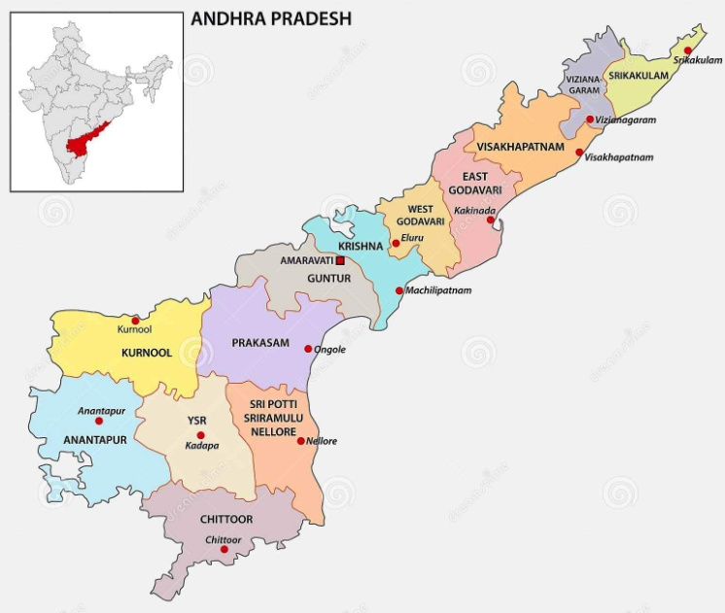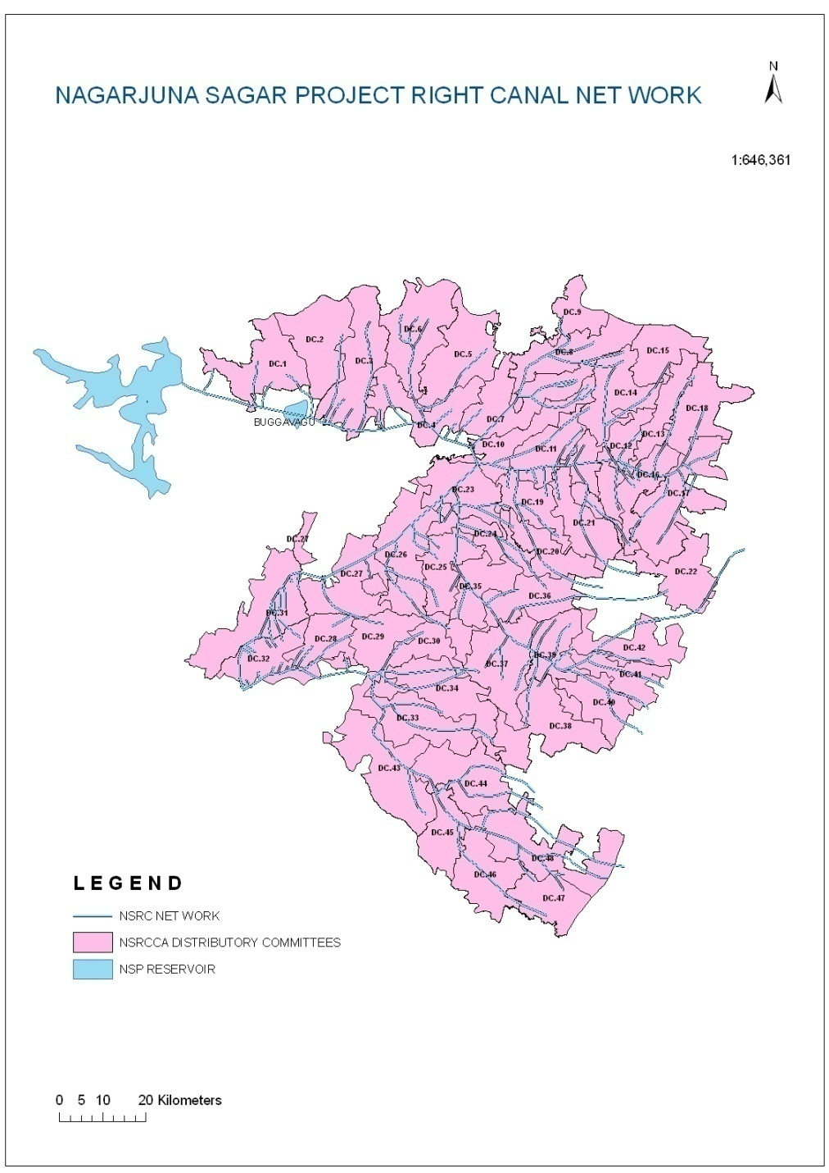

**Figure 1. Location map of study area**

**2.1.2 Jurisdiction of Nagarjuna Sagar Right Canal Command**

There are two Circles in the jurisdiction of Chief Engineer in the Nagarjuna Sagar Right Canal command as follows.

**2.1.2.1 NSJC, O & M Circle, Lingamguntla**

This Circle is in charge of Operation & Maintenance of Nagarjuna Sagar Jawahar Canal (N.S. Right Canal) from Mile 0/0 to M 85/3+150 (Km 0.000 to Km 137.28) with a designed discharge of 11,000 cusecs covering block Nos. 1 to 10, Part of 11, 11A to 14, Part of 17 to 19 of N.S.J.C., Command Area. The localized ayacut under the control of this Circle covering both the districts i.e., Guntur and Prakasam as shown in Figure 2 and 3.

**2.1.2.2 Irrigation Circle, Ongole**

This Circle is in charge of Operation & Maintenance of Nagarjuna Sagar Jawahar Canal from M 85/3+150 to M 126/0+000 (Km 137.28 to Km 202.79) covering block Nos. 15 to 22 of NSJC Command Area.

**2.3 Estimation of crop water requirement of different crops NSRC Command Area**

Estimation of crop water requirement for different crops under Nagarjuna Sagar Right Canal Command Area was computed by using CROPWAT 8.0 software.

Data required for CROPWAT 8.0 model. CROPWAT 8.0 is a program that uses Penman-Monteith method for calculating reference crop evapotranspiration.

**2.3.1 Climate Data**

The climate all over the command area is generally hot. The temperature ranges from 17.4 OC in December to about 40.9 OC in May. Humidity varies from 72% to 97% and solar radiation varies from 15.4 MJ/m2/day to 22.1 MJ/m2/day. The mean monthly air temperature and humidity, wind speed, sunshine hours and solar radiation of 18 years from 2000-2018 was collected from Agricultural Research Station, Guntur, Lam and tabulated in Table 1.

**Table 1. Monthly mean metrological data of NSP right canal from 2000-2018**

|  |  |  |  |  |  |  |  |
| --- | --- | --- | --- | --- | --- | --- | --- |
| S No. | Month | Min. Temp. OC | Max. Temp. OC | Humidity % | Wind speed Km/day | Sunshine  h/day | Solar radiation MJ/m2/d |
| 1 | January | 17.5 | 31.2 | 91.0 | 5.0 | 6.6 | 15.5 |
| 2 | February | 19.8 | 31.8 | 86.0 | 5.0 | 7.6 | 18.8 |
| 3 | March | 22.5 | 35.4 | 88.0 | 8.0 | 7.5 | 20.1 |
| 4 | April | 26.0 | 37.9 | 83.0 | 8.0 | 8.2 | 22.1 |
| 5 | May | 27.8 | 40.9 | 72.0 | 9.0 | 7.9 | 17.8 |
| 6 | June | 26.7 | 38.3 | 74.0 | 9.0 | 5.5 | 15.5 |
| 7 | July | 26.1 | 35.2 | 79.0 | 8.0 | 4.4 | 15.8 |
| 8 | August | 24.5 | 33.4 | 82.0 | 7.0 | 4.3 | 16.1 |
| 9 | September | 23.5 | 33.5 | 84.0 | 5.0 | 4.7 | 16.4 |
| 10 | October | 23.3 | 32.7 | 88.0 | 4.0 | 4.9 | 15.4 |
| 11 | November | 23.5 | 35.5 | 96.0 | 5.0 | 6.6 | 16.1 |
| 12 | December | 17.4 | 34.8 | 97.0 | 4.0 | 5.7 | 14.6 |

**2.3.2** **Rainfall data**

The rainfall contributes to a greater or lesser extent in satisfying crop water requirements, depending on the location. The precipitation data required for CROPWAT 8.0 can be daily, decade or monthly rainfall, commonly available from many climatic stations. Monthly rainfall data was collected from the Chief planning office of Guntur district, which is covered by the Nagarjuna Sagar Right Canal Command Area from 1997-2018.

**2.3.3 Easy fit software**

EasyFit software model provides an intuitive and easy to use interface making work more productive and efficient. The various components of projects are organized into categories (*Data Tables* and *Analysis Results*) for easier navigation. These components are displayed as separate windows inside the main application window, and can be saved as a single Project File. Hossein and Alireza (2014) data Fitting process involves using certain statistical techniques which allow us to estimate fitness parameters in accordance to data sample and to fit the data and interpreting probability data is that able to automatically fit data with a variety of known distribution patterns simultaneously.

## Automated and Manual Distribution Fitting

The powerful parameter estimation algorithm allows to automatically fit distributions to data in seconds. Alternatively, manually specify the distribution parameters.

## **Supported Distributions**

Easy Fit supports all the commonly used continuous distributions. Many distributions are available in two versions. The following discrete distributions are supported Bernoulli, Hypergeometric, Binomial, Discrete Uniform, Geometric, Logarithmic, Negative Binomial and Poisson.

## **Interactive Graphs**

As a result of distribution fitting, EasyFit displays a variety of graphs enabling to perform a comprehensive analysis of data

* Probability density function (PDF)
* Cumulative distribution function (CDF)
* Survival function
* Hazard function (failure rate)
* Cumulative hazard function
* P-P plot
* Q-Q plot
* Probability difference

EasyFit allows displaying several graphs of the same type on a single chart, making it easy to compare two or more distribution curves. All graphs support interactive zooming and planning.

## Excel Integration

In addition to a stand-alone application, the [Professional Edition](http://www.mathwave.com/products/easyfit_editions.html) of EasyFit works as a comprehensive Excel add-in, enabling you to perform data analysis and simulation right in Excel. EasyFitXL (EasyFit for Excel) allows to fit probability distributions of worksheet data and to random numbers, and view distribution graphs without entering the data.

EasyFitXL provides 650+ functions which can be used in Excel worksheets and VBA applications to create advanced probability models and make business decisions based on the analysis and simulation results. The sample workbook provided with EasyFitXL shows how Excel users can perform the Monte Carlo simulation of their models with basic VBA knowledge.

The worksheet and VBA functions include PDF, CDF, hazard function, inverse CDF (quantile function), mode, mean, variance, standard deviation, skewness, kurtosis, and random number generation for 55+ distributions available in EasyFit.

**Stat Assist**

StatAssist is an integrated tool allowing exploring the properties of the supported probability distributions without entering the data. Along with the distribution graphs, StatAssist displays the following values depending on the distribution parameters

* Min, max, mode, mean, variance, standard deviation
* Skewness, kurtosis, quantiles (inverse CDF values)
* Tail probabilities

This helpful tool can be used independently of the other product features.

## **Goodness of Fit Tests**

The goodness of fit (GOF) tests measures the compatibility of a random sample with a theoretical probability distribution function. There are various life data distributions which can be used for reliability and other statistical analysis according to Sanjeev et. al. (2011).

EasyFit supports the following GOF tests

* Kolmogorov-Smirnov
* Anderson-Darling
* Chi-Square

The results are displayed as interactive reports allowing to compare the fitted distributions. The Summary report lists the distributions ordered by the GOF statistics, enabling and the detail report provides additional information on a particular distribution is an appropriate model or not given the confidence level chosen.

**2.3.4. Different types of soil data**

The soil details which are used in the CROPWAT 8.0 are taken from FAO, Rome, Italy, and Paper No 24 and shown in Table 2.

**Table 2. Different types of soil data**

|  |  |  |  |  |  |
| --- | --- | --- | --- | --- | --- |
| **S. No** | **Soil description** | **Black clay** | **Red sandy loam** | **Red sandy** | **Red loam** |
| 1 | Total available soil moisture (FC-WP), mm/m | 200 | 100 | 100 | 180 |
| 2 | Maximum rain infiltration rate, mm/day | 30 | 30 | 30 | 30 |
| 3 | Maximum rooting depth, mm | 900 | 900 | 900 | 900 |
| 4 | Initial soil moisture depletion (as % TAM), % | 50 | 0 | 0 | 0 |
| 5 | Initial available soil moisture, mm/m | 100 | 100 | 100 | 180 |

***Source: FAO Irrigation drainage paper No.24)***

In general, there are two groups of soils in the command area, namely black soils and red soils. However, sandy soils also exist all along the coastal area in both the districts. The black soils (Vertisols) are extensively met in the first 11 blocks and also in Block 22 (62%), while the red soils (alfisols) which are very shallow (33%) and shallow sandy barns and gravelly soils (5%) are encountered in the remaining blocks. The block wise distribution of soils is given in the Table 3 (Anonymous, 1999) and Figure 2.

**Table 3. Block-wise distribution of soils in the command area**

|  |  |  |
| --- | --- | --- |
| **Block** | **Black cotton soils (%)** | **Red loamy soils (%)** |
| 1 to7 | 73 | 27 |
| 8&9 | 47 | 53 |
| 10 | 84 | 16 |
| 11 | 65 | 35 |
| 11A,12to14 | 31 | 69 |
| 15 | 4 | 96 |
| 16 | 12 | 88 |
| 17&18 | 21 | 79 |
| 19 | 35 | 65 |
| 20&21 | 9 | 91 |
| 22 | 60 | 40 |
| **Average** | **40.1** | **59.9** |

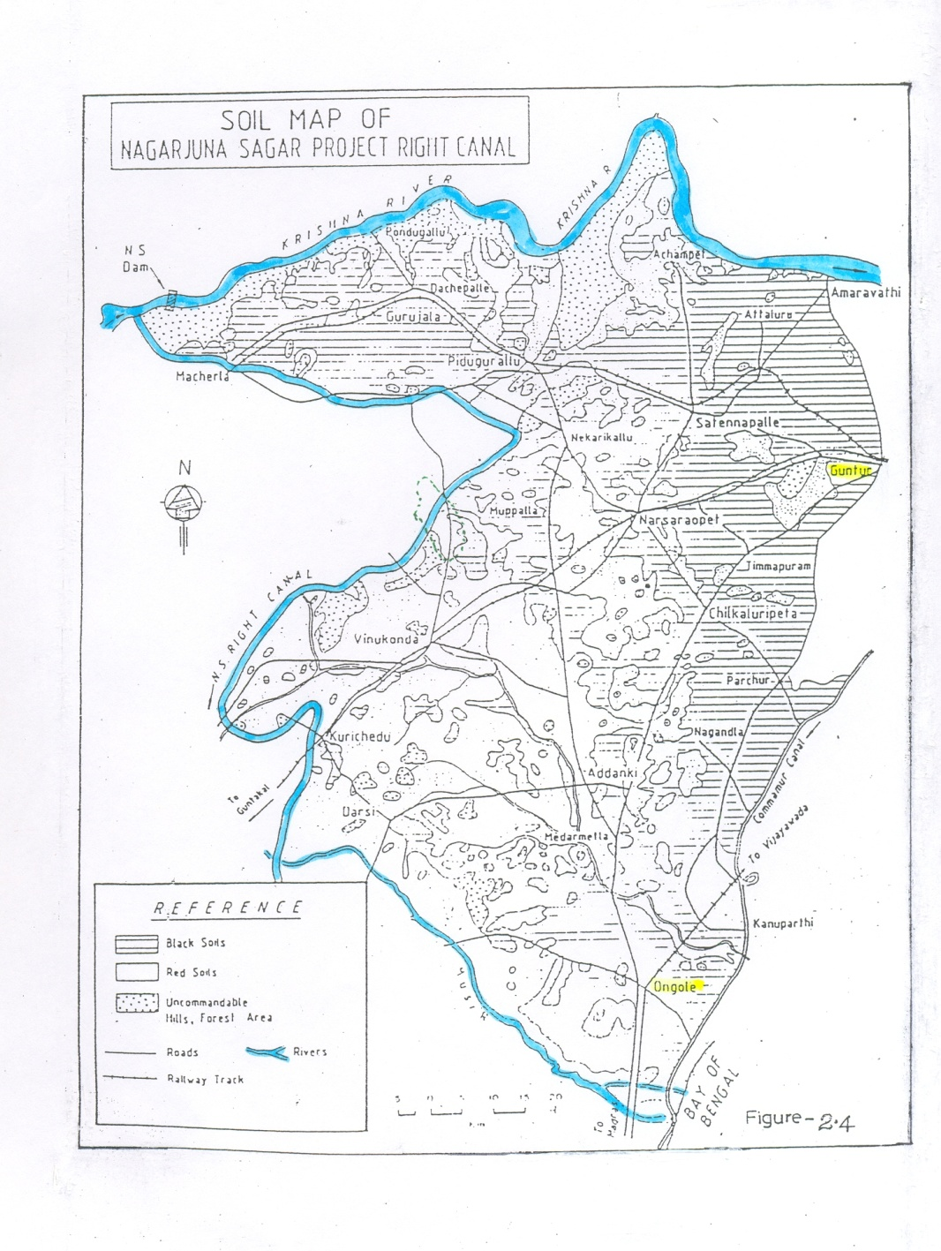

**Figure 2. Soils distributed over the NSRC Command Area**

**2.3.5 Crop data**

**Cropping Pattern**

Before inception of the canal system, only rainfed crops like chillies, jowar, bajra, groundnut, cotton used to be grown during south-west monsoon (kharif) and lands used to be kept fallow during rabi and summer. The crop data was obtained from Chief Planning Offices of respective districts. Major crops like paddy, cotton, millet, pulses and chillies are grown and their contemplated area were used for crop water requirement computation for Guntur and Prakasam districts separately.

**3. Results and Discussion**

Crop water demand was computed by using CROPWAT software. The weather parameters namely temperature (min and max), humidity, wind speed and sunshine hours were given as input to CROPWAT. Mean metrological data was taken during the years 2008 to 2018. Crop evapotranspiration was computed for different crops in the command area. CROPWAT software climate data was shown in the Figure 3.

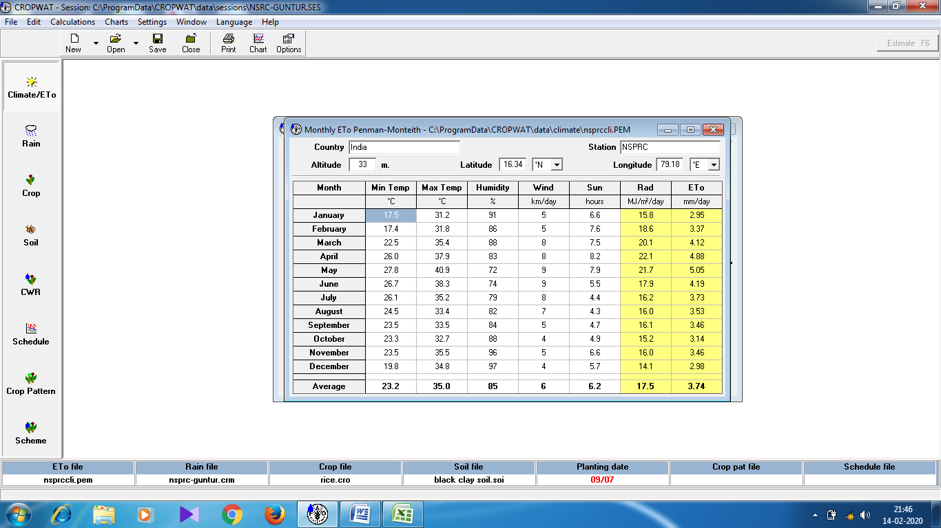

**Figure 3. Mean metrological data from 2008 to 2018 of NSPRC Command area**

**3.1 Rainfall**

The rainfall contributes to a greater or lesser extent in satisfying CWR, depending on the location. The rainfall was not evenly distributed over the entire district. SPSS software 16 was used for statical analysis of rainfall data and the results are tabulated in Table 4.

**Table 4. Statistics of rainfall data (mm) in NSPRC Command area of Guntur district from 1997 to 2018**

|  |  |  |  |  |  |  |  |  |  |  |  |  |
| --- | --- | --- | --- | --- | --- | --- | --- | --- | --- | --- | --- | --- |
| **Parameters** | **Jan** | **Feb** | **Mar** | **Apr** | **May** | **Jun** | **Jul** | **Aug** | **Sep** | **Oct** | **Nov** | **Dec** |
| Mean | 5.9 | 8.5 | 8.4 | 15.6 | 34.0 | 95.2 | 140.1 | 154.9 | 154.8 | 107.0 | 44.5 | 11.5 |
| Std. Error of Mean | 3.2 | 4.3 | 4.2 | 4.1 | 7.8 | 11.9 | 13.9 | 16.5 | 16.7 | 15.5 | 9.2 | 6.0 |
| Median | 0.2 | 0.0 | 1.1 | 7.5 | 28.0 | 83.5 | 142.0 | 160.0 | 160.8 | 100.6 | 28.5 | 0.8 |
| Mode | 0.0 | 0.0 | 0.0 | 0.0 | 0.0 | 84.0 | 26.0 | 1.2 | 35.1 | 15.3 | 0.3 | 0.0 |
| Std. Deviation | 14.8 | 20.0 | 19.5 | 19.4 | 36.7 | 55.9 | 65.1 | 77.5 | 78.4 | 72.9 | 43.3 | 28.1 |
| Variance | 218.4 | 398.2 | 379.5 | 374.9 | 1345.8 | 3128.3 | 4238.3 | 6004.7 | 6146.0 | 5311.9 | 1874.7 | 791.4 |
| Skewness | 3.6 | 2.7 | 3.3 | 1.5 | 2.2 | 0.8 | 0.8 | 0.4 | 0.4 | 1.8 | 1.3 | 3.5 |
| Std. Error of Skewness | 0.5 | 0.5 | 0.5 | 0.5 | 0.5 | 0.5 | 0.5 | 0.5 | 0.5 | 0.5 | 0.5 | 0.5 |
| Kurtosis | 13.7 | 6.7 | 11.3 | 1.4 | 6.6 | 0.6 | 1.9 | 1.1 | -0.1 | 4.7 | 1.3 | 13.5 |
| Std. Error of Kurtosis | 1.0 | 1.0 | 1.0 | 1.0 | 1.0 | 1.0 | 1.0 | 1.0 | 1.0 | 1.0 | 1.0 | 1.0 |
| Range | 65.6 | 77.0 | 83.5 | 67.0 | 163.0 | 225.0 | 300.0 | 349.4 | 299.9 | 329.0 | 158.9 | 124.9 |
| Minimum | 0.0 | 0.0 | 0.0 | 0.0 | 0.0 | 11.0 | 26.0 | 1.2 | 35.1 | 15.3 | 0.3 | 0.0 |
| Maximum | 65.6 | 77.0 | 83.5 | 67.0 | 163.0 | 236.0 | 326.0 | 350.6 | 335.1 | 344.3 | 159.1 | 124.9 |
| Sum | 128.9 | 187.9 | 183.8 | 343.0 | 747.0 | 2094.0 | 3082.0 | 3407.1 | 3404.6 | 2353.5 | 978.1 | 253.0 |

From the above table it is observed that, maximum variance in Guntur district of command area is found in the month of September as 6146 mm and minimum in the month of January as 218.4 mm. So, EasyFit software, accurate rainfall data was taken for computation of crop water requirement for different crops.

The Goodness of Fit (GOF) tests measure the compatibility of a random sample with a probability distribution function. By using EasyFit software, the monthly probable rainfall quantity at 75% level for various distributions fitted were computed.

**Table 5. Mean monthly rainfall data and easy fit software rainfall data for Guntur district under NSRC Command area**

|  |  |  |
| --- | --- | --- |
| **Month** | **Mean monthly Rainfall, mm** | **Mean monthly Rainfall, mm** |
| **Computed** | **Computed rainfall at 75% Prob** |
| January | 5.9 | 5.5 |
| February | 8.5 | 7.5 |
| March | 8.4 | 4.8 |
| April | 15.7 | 5.0 |
| May | 20.8 | 9.0 |
| June | 95.2 | 58.0 |
| July | 140.1 | 110.0 |
| August | 154.9 | 118.0 |
| September | 154.8 | 90.0 |
| October | 107.0 | 62.0 |
| November | 44.5 | 13.0 |
| December | 11.5 | 6.0 |

The rainfall data used for CROPWAT was collected in thirty-seven mandals of Guntur district covered under Nagarjuna Sagar Right Canal Command area for the years 1997 to 2018. The rainfall data of each mandal was used to estimate effective rainfall. Tahir *et. al.* (2014) studied to define the analysis of rainfall data in order to estimate its contribution towards crop water requirements to overcome crop water deficiency problems. The program estimated the effective rainfall based on the United States Department of Agriculture, Soil Conservation Service (USDS-SCS) formula. From the Table 5, it was observed that the 62.39% of total rainfall was received during monsoon months from July to September in Guntur district and it was 422.0 mm. Mean rainfall data was uploaded in the software as shown in Figure 4.

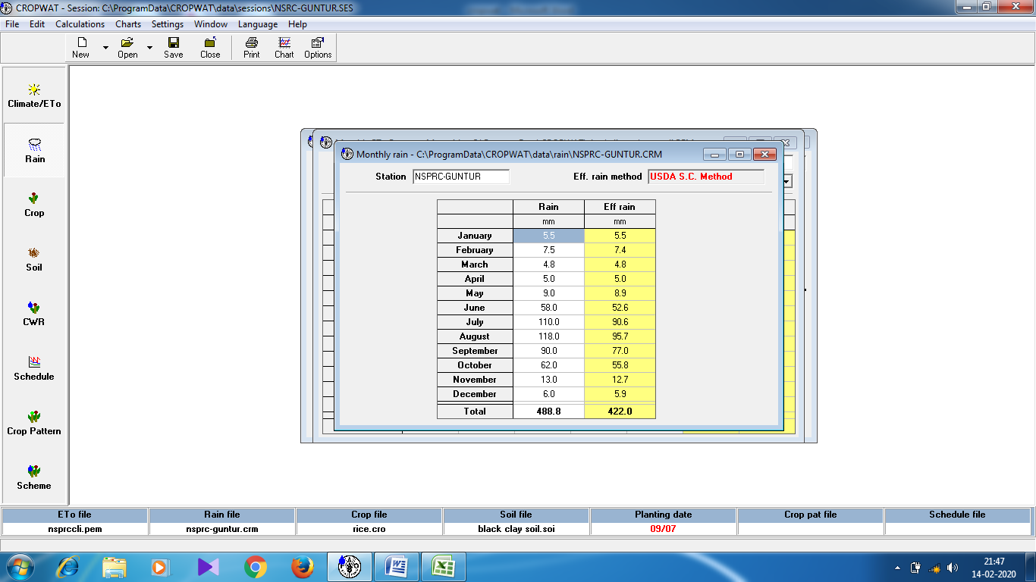

**Figure 4. Mean rainfall data of NSPRC Command area of Guntur district from 1997 to 2018**

**3.2 Crop water requirement of Guntur district under NSPRC command area**

The data on climate, rainfall, crop, cropping pattern and soil were provided as input to CROPWAT model. The crop water requirements for paddy, cotton, chillies, millet and pulses were presented in Table 6 and Figure 5.

**Table 6. Crop water requirement of Guntur district under NSPRC command area**

|  |  |  |  |  |  |
| --- | --- | --- | --- | --- | --- |
| **Year** | **Crop** | **Kharif** | | **Rabi** | |
| **Area (ha)** | **Crop water demand (MCM)** | **Area (ha)** | **Crop water demand (MCM)** |
| 2008-09 | Paddy | 235134 | 1147.92 | 218367 | 963.87 |
| Cotton | 73024 | 331.89 | 62990 | 347.45 |
| Chillies | 35404 | 185.62 | 27809 | 150.78 |
| Millets | 3158 | 8.09 | 8633 | 19.9 |
| Pulses | 5599 | 16.94 | 6267 | 19.07 |
|  | **Total** | **352319** | **1690.48** | **324066** | **1501.07** |
| 2009-10 | Paddy | 226725 | 1106.87 | 216643 | 956.26 |
| Cotton | 84477 | 383.95 | 42966 | 237 |
| Chillies | 23425 | 122.82 | 28063 | 152.16 |
| Millets | 5628 | 14.42 | 12827 | 29.57 |
| Pulses | 5226 | 15.81 | 9093 | 27.67 |
| **Total** | **345481** | **1643.88** | **309592** | **1402.66** |
| 2010-11 | Paddy | 216455 | 1056.73 | 227202 | 1002.87 |
| Cotton | 92094 | 418.57 | 72645 | 400.71 |
| Chillies | 45991 | 241.13 | 13633 | 73.92 |
| Millets | 28330 | 72.61 | 9142 | 21.07 |
| Pulses | 8359 | 25.29 | 7053 | 21.46 |
|  | **Total** | **391229** | **1814.34** | **329675** | **1520.03** |
| 2011-12 | Paddy | 217213 | 1060.43 | 218633 | 965.05 |
| Cotton | 42136 | 191.51 | 53315 | 294.09 |
| Chillies | 37631 | 197.3 | 25806 | 139.92 |
| Millets | 3435 | 8.8 | 10828 | 24.96 |
| Pulses | 6813 | 20.62 | 9093 | 27.67 |
|  | **Total** | **307228** | **1478.66** | **317675** | **1451.68** |
| 2012-13 | Paddy | 211283 | 1031.48 | 218624 | 965.01 |
| Cotton | 56633 | 257.4 | 59633 | 328.94 |
| Chillies | 40820 | 214.02 | 26399 | 143.14 |
| Millets | 5043 | 12.93 | 13837 | 31.89 |
| Pulses | 6341 | 19.19 | 6730 | 20.48 |
|  | **Total** | **320120** | **1535.01** | **325223** | **1489.45** |
| 2013-14 | Paddy | 211733 | 1033.68 | 208542 | 920.5 |
| Cotton | 51094 | 232.22 | 54315 | 299.6 |
| Chillies | 52132 | 273.33 | 38206 | 207.15 |
| Millets | 4843 | 12.41 | 12835 | 29.58 |
| Pulses | 6500 | 19.67 | 9112 | 27.73 |
|  | **Total** | **326302** | **1571.31** | **323010** | **1484.57** |
| 2014-15 | Paddy | 215082 | 1050.03 | 218542 | 964.64 |
| Cotton | 53612 | 243.67 | 56523 | 311.78 |
| Chillies | 31809 | 166.77 | 36235 | 196.47 |
| Millets | 3915 | 10.03 | 6835 | 15.75 |
| Pulses | 6448 | 19.51 | 6135 | 18.67 |
|  | **Total** | **310866** | **1490.02** | **324270** | **1507.31** |
| 2015-16 | Paddy | 208728 | 1019.01 | 219207 | 967.58 |
| Cotton | 74675 | 339.4 | 52378 | 288.92 |
| Chillies | 42105 | 220.76 | 29534 | 160.13 |
| Millets | 2128 | 5.45 | 11358 | 26.18 |
| Pulses | 4368 | 13.22 | 8932 | 27.18 |
|  | **Total** | **332004** | **1597.84** | **321409** | **1469.99** |
| 2016-17 | Paddy | 228728 | 1116.65 | 205208 | 905.79 |
| Cotton | 48895 | 222.23 | 42895 | 236.61 |
| Chillies | 26944 | 141.27 | 35658 | 193.34 |
| Millets | 3423 | 8.77 | 12206 | 28.13 |
| Pulses | 21516 | 65.11 | 8835 | 26.88 |
|  | **Total** | **329506** | **1554.03** | **304802** | **1390.75** |
| 2017-18 | Paddy | 228733 | 1116.67 | 207865 | 917.52 |
| Cotton | 53022 | 240.98 | 43913 | 242.22 |
| Chillies | 42820 | 224.51 | 35385 | 191.86 |
| Millets | 843 | 2.16 | 8835 | 20.36 |
| Pulses | 8548 | 25.87 | 9845 | 29.96 |
|  | **Total** | **333966** | **1610.19** | **305843** | **1401.92** |
| 2018-19 | Paddy | 225082 | 1098.85 | 188585 | 832.41 |
| Cotton | 48378 | 219.88 | 43669 | 240.88 |
| Chillies | 25820 | 135.37 | 47680 | 258.52 |
| Millets | 6430 | 16.48 | 11633 | 26.81 |
| Pulses | 9500 | 28.75 | 6328 | 19.26 |
|  | **Total** | **315210** | **1499.33** | **297895** | **1377.88** |
| **Grand average** | | **333112** | **1590** | **316678** | **1454** |
|  |
| **Grand Total** | | **3,044 MCM** | | | |  |
|  |

The results obtained from the above study can be used as a guide by farmers for selecting the amount and frequency of irrigation water for the main crop by Saravan and Saravan (2014). The cumulative crop water requirement for different crops in the Guntur district of NSRC command area was obtained as 3,044 MCM

**3.3 Crop water requirement of entire NSPRC command area**

The crop water requirements were estimated for all the crops grown in Nagarjuna Sagar Right Canal Command area. Crop water requirement of entire NSPRC command area for different soils shown in Table 7 and Figure 6.

**Table 7. Crop water requirement of NSPRC command area**

|  |  |  |  |  |  |
| --- | --- | --- | --- | --- | --- |
| **Year** | **Crop** | **Kharif** | | **Rabi** | |
| **Area (ha)** | **Crop water demand (MCM)** | **Area (ha)** | **Crop water demand (MCM)** |
| 2008-09 | Paddy | 322980 | 1576.92 | 311823 | 1429.87 |
| Cotton | 97304 | 447.89 | 89725 | 486.45 |
| Chillies | 38511 | 201.62 | 40381 | 218.78 |
| Millets | 4723 | 12.09 | 15423 | 36.9 |
| Pulses | 10561 | 31.94 | 14282 | 46.07 |
| **Total** | **474079** | **2269.48** | **471634** | **2218.07** |
| 2009-10 | Paddy | 311359 | 1519.87 | 308077 | 1392.26 |
| Cotton | 111858 | 527.95 | 65878 | 361 |
| Chillies | 36663 | 191.82 | 50975 | 276.16 |
| Millets | 7152 | 18.42 | 20846 | 50.57 |
| Pulses | 6399 | 18.81 | 26968 | 87.67 |
| **Total** | **473431** | **2276.88** | **472744** | **2167.66** |
| 2010-11 | Paddy | 242836 | 1185.73 | 321761 | 1473.87 |
| Cotton | 124598 | 573.57 | 99749 | 541.71 |
| Chillies | 58898 | 309.13 | 26113 | 141.92 |
| Millets | 30099 | 76.61 | 18552 | 45.07 |
| Pulses | 18078 | 54.29 | 8438 | 26.46 |
| **Total** | **474509** | **2199.34** | **474613** | **2228.03** |
| 2011-12 | Paddy | 300531 | 1467.43 | 300396 | 1372.05 |
| Cotton | 88010 | 410.51 | 84819 | 457.09 |
| Chillies | 62988 | 330.3 | 50074 | 271.92 |
| Millets | 8726 | 21.8 | 18946 | 45.96 |
| Pulses | 11213 | 33.62 | 17660 | 56.67 |
| **Total** | **471468** | **2262.66** | **471895** | **2203.68** |
| 2012-13 | Paddy | 304922 | 1488.48 | 310391 | 1422.01 |
| Cotton | 80505 | 371.4 | 91133 | 491.94 |
| Chillies | 55595 | 291.02 | 38371 | 208.14 |
| Millets | 16913 | 40.93 | 19398 | 45.89 |
| Pulses | 14575 | 43.19 | 11979 | 38.48 |
| **Total** | **472510** | **2236.01** | **471272** | **2206.45** |
| 2013-14 | Paddy | 310200 | 1514.68 | 296000 | 1356.5 |
| Cotton | 75180 | 347.22 | 77797 | 421.6 |
| Chillies | 67332 | 353.33 | 62040 | 336.15 |
| Millets | 9198 | 22.41 | 20591 | 49.58 |
| Pulses | 12349 | 36.67 | 15895 | 50.73 |
| **Total** | **474259** | **2274.31** | **472323** | **2214.57** |
| 2014-15 | Paddy | 313210 | 1529.03 | 303755 | 1389.64 |
| Cotton | 92572 | 429.67 | 88681 | 478.78 |
| Chillies | 47147 | 246.77 | 51525 | 279.47 |
| Millets | 6210 | 16.03 | 13301 | 32.75 |
| Pulses | 9053 | 27.51 | 15675 | 50.67 |
| **Total** | **468192** | **2249.02** | **472937** | **2230.31** |
| 2015-16 | Paddy | 305930 | 1494.01 | 315381 | 1446.58 |
| Cotton | 97426 | 448.4 | 76446 | 413.92 |
| Chillies | 53958 | 282.76 | 43857 | 238.13 |
| Millets | 4159 | 10.45 | 17505 | 42.18 |
| Pulses | 10481 | 31.22 | 15051 | 48.18 |
| **Total** | **471954** | **2265.84** | **468240** | **2187.99** |
| 2016-17 | Paddy | 322046 | 1572.65 | 294971 | 1352.79 |
| Cotton | 85769 | 398.23 | 89010 | 475.61 |
| Chillies | 35301 | 185.27 | 54926 | 297.34 |
| Millets | 3952 | 9.77 | 19712 | 47.13 |
| Pulses | 24983 | 75.11 | 14402 | 45.88 |
| **Total** | **472051** | **2241.03** | **473021** | **2219.75** |
| 2017-18 | Paddy | 325935 | 1591.67 | 306039 | 1406.52 |
| Cotton | 76954 | 354.98 | 75413 | 405.22 |
| Chillies | 48677 | 255.51 | 51653 | 279.86 |
| Millets | 5478 | 13.16 | 16591 | 40.36 |
| Pulses | 13561 | 40.87 | 16385 | 51.96 |
| **Total** | **470605** | **2255.19** | **466081** | **2184.92** |
| 2018-19 | Paddy | 316284 | 1543.85 | 286759 | 1321.41 |
| Cotton | 88361 | 410.88 | 79102 | 424.88 |
| Chillies | 41179 | 216.37 | 71805 | 389.52 |
| Millets | 8765 | 22.48 | 18055 | 43.81 |
| Pulses | 16923 | 50.75 | 11655 | 37.26 |
| **Total** | **471512** | **2243.33** | **467376** | **2215.88** |
| **Grand average** | | **472234** | **2253** | **471103** | **2207** |
| **Grand Total** | | | **4,459 MCM** | | |

The cumulative crop water requirement for different crops of entire NSPRC command area for different soils and different crops was 4,459 MCM.

**3.4 Comparison of Crop Water Requirement of Guntur District under NSPRC with entire command area**

The primary crops cultivated in the Guntur district of NSPRC include paddy, cotton, chillies, pulses, and millets. In the Guntur district of NSPRC, the distribution of area is as follows: 67% for paddy, 21% for cotton, 10% for chillies, 1.5% for pulses, and 1% for millets. In a similar manner, within the NSPRC command area, the distribution is 68% for paddy, 21% for cotton, 8% for chillies, 2.2% for pulses, and 1% for millets. When comparing the area allocated to crops within the command area, there is no variation in the percentage of cropped area.

However, when considering the entire cropped area, it is noted that 75% of the area in the Guntur district of NSPRC is utilized, while the remaining area is cultivated by another district specifically Prakasam.

The water requirements for various crops have been calibrated as illustrated in figures 7, 8, 9, 10, 11, and 12. The paddy crop necessitated 1076 MCM in the Guntur district of NSPRC and 1499 MCM in the NSPRC command area. In a similar manner, the water demand for chillies was determined to be 193 MCM and 260 MCM, while cotton required 280 MCM and 429 MCM, pulses 25 MCM and 40 MCM, and millets 15 MCM and 24 MCM in the Guntur district of NSPRC and the NSPRC command area, respectively.

The water requirements for paddy crops within the Guntur district of the command area were determined to be 68%, while for chillies it was 12%, cotton 18%, pulses 2%, and millets 1% respectively. The crop water demand for paddy crops across the entire Nagarjuna Sagar Project Right Canal Command area was assessed at 67%, with chillies at 12%, cotton at 19%, pulses at 2%, and millets at 1% respectively.

In conclusion, the calculated percentage of water requirement for paddy in the Guntur district of NSPRC was found to be 72%, for chillies 74%, for cotton 65%, for pulses 61%, and for millets 65%, in comparison to the overall command area.

**Figure 5. Different crops and their extent grown under the Guntur District under NSPRC and entire NSPRC command area**

**Figure 6. Crop water demand of different crops and their extent grown under the Guntur District under NSPRC and entire NSPRC command area**

**Figure 7. Crop water demand of paddy under NSPRC command area**

**Figure 8. Crop water demand of chillies under NSPRC command area**

**Figure 9. Crop water demand of cotton under NSPRC command area**

**Figure 10. Crop water demand of pulses under NSPRC command area**

**Figure 11. Crop water demand of millets under NSPRC command area**

**Figure 12. Crop water demand for different crops under Guntur District and NSPRC command area**

**3.5 Surface Water Availability**

Surface water availability of Nagarjuna Sagar Right Canal water releases for last 11 years data from 2008-09 to 2018-19 was tabulated in the Table 8. The mean available water was 128.13 TMC, which is equal to the 3,628 MCM.

**Table 8. Mean water releases data at head regulator of Nagarjuna Sagar Right Canal**

|  |  |
| --- | --- |
| **Year** | **Water releases in TMC** |
| 2008-09 | 213.74 |
| 2009-10 | 191.29 |
| 2010-11 | 194.99 |
| 2011-12 | 185.25 |
| 2012-13 | 38.63 |
| 2013-14 | 192.11 |
| 2014-15 | 151.88 |
| 2015-16 | 17.32 |
| 2016-17 | 23.82 |
| 2017-18 | 89.08 |
| 2018-19 | 111.30 |
| **Average** | **128.13 (3628 MCM)** |

Nagarjuna right canal (all together evaporation losses and seepage losses etc.,) as 61.45% recommended by the CWC, Government of India (Anonymous, 2016) and then total availability of the surface water is 2,229 MCM.

**Conveyance Efficiency of Main Canals**

|  |  |  |  |  |  |  |  |
| --- | --- | --- | --- | --- | --- | --- | --- |
| **Name of Channel** | **Discharge at Head (cumec)** | **Effective Length (m)** | **Avg. Wetted Perimeter (m)** | **Conveyance Loss Factor (cumec / M.sqm)** | **Total Loss in Channel (3x4x5)x10-6 (cumec)** | **Water Delivered (2-6) (cumec)** | **Ratio (Water Delivered / Discharge at Head) (7/2)** |
| **2** | **3** | **4** | **5** | **6** | **7** | **8** | **9** |
| Jowahar Canal | 240.285 | 25,750 | 64.27 | 4.87 | 8.06 | 231.90 | 0.9650* |
| Guntur Branch Canal | 53.48 | 12,770 | 25.20 | 12.40 | 3.99 | 49.49 | 0.9253 |
| Peddanandipadu Branch Canal | 9.57 | 3,620 | 23.77 | 16.38 | 1.41 | 8.16 | 0.8527 |

**3.6 Groundwater availability in Nagarjuna Sagar Right Canal**

The ground available is 61% of total volume (i.e. 2270 MCM) of the command area as 1385 MCM.

Conjunctive use of water at the command area = surface water volume + groundwater volume = 2229 + 1385 = 3,614 MCM.

However, the demand for water for crops alone was 4,459 MCM, excluding the needs for livestock and domestic consumption. Therefore, the available water is inadequate, and it would be advisable to select alternative crops to cultivate the entire area. Seasonal planning is essential in both districts.

**Conclusions**

The assessment of crop water requirements was conducted for various crops in the Nagarjuna Sagar Right Canal Command area, utilizing crop evapotranspiration data. Statistical analysis through SPSS revealed significant rainfall variances maximum variance in Guntur district of command area in the month of September was obtained as 6146 mm and minimum in the month of January as 218.4 mm. Similarly, in the Prakasam district maximum variance in the month of November and minimum in the month of September as 8036.2 mm and 2799.8 mm respectively, indicating a need for precise rainfall data managed by EasyFit software. Over a period from 1997 to 2018, crop water demands for paddy, cotton, chillies, millet, and pulses were calculated, totaling 3,044 MCM for Guntur District and 1,415 MCM for Prakasam District. The cumulative demand for both districts reached 4,459 MCM, excluding cattle and domestic usage, while surface water availability was reported at 2,229 MCM. Groundwater resources amount to 1385 MCM, allowing for a conjunctive water use of 3,614 MCM.

Furthermore, the study revealed that reference evapotranspiration values are projected to rise in the future compared to current conditions, primarily due to rising temperatures. The findings from this research can serve as a valuable resource for farmers in determining the appropriate quantity and frequency of irrigation water for their primary crops.

**COMPETING INTERESTS DISCLAIMER:**

Authors have declared that they have no known competing financial interests OR non-financial interests OR personal relationships that could have appeared to influence the work reported in this paper.

**References**

1. Allen, R., Pereira, D., Raes, D. and Smith, M. 1998. Crop Evapotranspiration (guidelines for computing crop water requirements). *Irrigation and Drainage,* *FAO, Paper No. 56*. 11-203.
2. Hossein, M and Alireza, P. 2014. Using easy fit software for goodness of fit test and data generation. *International Journal of Mathematical Archive.* 5(1): 118-124.
3. Koffi, D., Michael, O.N., Curtis, K.O., Daniel, S., Komlan, K., Margaret, W., Samuel, A., Kevin, L.A and Suat, I. 2018. Crop Evapotranspiration, Irrigation Water Requirement and Water Productivity of Maize from Meteorological Data under Semiarid Climate. *Water.* 10, 405, doi:10.3390/w10040405.
4. Manasa, H.G and Anand, V.S. 2016. Implications of Climate Change On Crop Water Requirements in Hukkeri Taluk of Belagavi District. *International Journal of Research in Engineering and Technology.* 236 - 241.
5. Mani, S.R., Narasimhan, R., Chandhru, A.R., Suribabu, C.R., Sudharsan, J and Nithiyanantham. S 2017. Probability analysis for consecutive-day maximum rainfall for Tiruchirapalli City (South India, Asia). *Journal of Applied Water Sciences.* 7:1033–1042.
6. Mehanuddin, H., Nikhitha, G.R., Prapthishree, K.S., Praveen, L.B and Manasa, H.G. 2018. Study on Water Requirement of Selected Crops and Irrigation Scheduling Using CROPWAT 8.0. *International Journal of Innovative Research in Science, Engineering and Technology.* 7 (4): 3431-3436.
7. Neelam, P and Rajput, T.B.S. 2014. Crop water requirement estimation under protected and open field condition. *Training manual on* *Advances in micro irrigation systems and fertigation under covered and open cultivation. ICAR –CIAE, Bhopal.*189-193.
8. Nithya, K.B and Shivpur, A.V. 2016. Study on Water Requirements of Selected Crops Under Tarikere Command Area using CROPWAT. *Journal of Irrigation Drainage Systems Engineering.* ISSN: 2168 - 9768 IDSE. 1-4.
9. Pushpalatha, R., Sunitha, S. A., George, J., Rajan, S and Gangadharan, B. 2020. Development of optimal irrigation schedules and crop water production function for cassava: study over three major growing areas in India. *Irrigation Science*. https://doi.org/10.1007/s00271-020-00669-0.
10. Raju, B.N. 2002. Water users associations in irrigation management: case of Andhra Pradesh, south India opportunities and challenges for collective action. *The 9th Biennial Conference of the International Association for the Study of Common Property Victoria Falls, Zimbabwe,* 17-12 June 2002. 1-29.
11. Raju, C. R., Yella, R.K., Satyanarayana, T. V and Yogitha, P. 2016. Estimation of crop water requirement using CROPWAT software in Appapuram channel command under Krishna Western Delta. *International Journal of Agriculture Sciences.* 8(31):1644-1649.
12. Sanjeev, K.J., Dwivedi, A.K.D and Tiwari, A. 2011. Necessity of Goodness of Fit Tests in Research and Development. *International Journal of Computer Science and Technology.* 2( 3): 135-141.
13. Sanjeev, R., Jaiswal, R. K and Galakte, R. V. 2011.Estimation of surface and ground water resources in Sagar, Madhya Pradesh, India. *Journal of Environmental Research and Development*. 5(3A): 823-829.
14. Sanjib, G., Manindra, K.R and Chowdhury, B.S. 2016. Determination of the Best Fit Probability Distribution for Monthly Rainfall Data in Bangladesh, American *Journal of Mathematics and Statistics*. 6:170-174.
15. Saravanan, K and Saravanan, R. 2014. Determination of Water Requirements of Main crops in the Tank Irrigation area using CROPWAT 8.0. *International Journal of Interdisciplinary and Multidisciplinary Studies (IJIMS)*. 1(5): 266-272.
16. [Schittkowski](https://link.springer.com/article/10.1007/s00158-002-0174-6#auth-1), K. 2014. EASY-FIT: a software system for data fitting in dynamical systems. *Journal of* [Structural and Multidisciplinary Optimization](https://www.springer.com/journal/158/)*.* 23: 153–169.
17. Shakeel, A., Bhat, B., Pundit, J.N., Khan, K.and Rehana, J. 2017. Water Requirements and Irrigation Scheduling of Maize Crop using CROPWAT Model. *International Journal of Current Microbiology and Applied Sciences.* 6 (11) :1662-1670.
18. Sudip, K.C., Banerjee, S and Mridu. 2012. Climate Change Impact on Crop Water Requirement in Ganga River Basin. *2012. 3rd International Conference On Biology, Environment And Chemistryipcbee .*46 :122-133.
19. Tahir, S.L., Abdul, K., Syed, H., Husain, S., Shaukat, A., Haroon, S and Umair, N. 2014. Analysis of Rainfall Data to Estimate Rain Contribution Towards Crop Water Requirement Using Cropwat. *Model Rjoas*. 12: 36-42.
20. Vibhute, S.D., Sarangi, A and Singh D.K. 2016. Development of crop water demand based water delivery schedule for a canal command. *Journal of Agricultural Engineering.* 53(2): 12-23.
21. Vikram, K., Shanu and Jahangeer. 2017. Statistical distribution of rainfall in Uttarakhand, India. *Journal of Applied Water Sciences*. 7:4765–4776.
22. Zhiming, F., Dengwei, L and Zang, Y. 2007. Water requirements and irrigation scheduling of spring maize using GIS and Crop Water model in Beijing-Tianjin-Hebei region. *Chinese Geographical Science.* 17: 56-63.