**Original Research Article**

**Rice Yield Simulation Using DSSAT Under Projected Climate Scenarios Across Districts of Chhattisgarh, India**

**Abstract**

This study focuses on the calibration and validation of the DSSAT crop simulation model to predict rice yield under changing climatic conditions in the Chhattisgarh Plain Zone and nearby agro-climatic regions of Chhattisgarh, India. The model was tuned to replicate rice development and yield with great accuracy across many locations using past weather and soil data. Variations in temperature, rainfall, and soil conditions affected the notable disparities in yield seen among sites. Rising temperatures and irregular rainfall patterns suggested by climate trends run possible hazards to rice output in the area. To maintain output, the research stresses the need of adaptive techniques like site-specific crop planning, effective water management, and heat-tolerant rice cultivars. These results provide insightful analysis for enhancing agricultural resilience and direction of policy choices in the face of fluctuating climate.

**Keywords:** Rice Yield Prediction, Climate Change, Chhattisgarh Plain Zone, Agro-Climatic Zones, Calibration and Validation, Sustainable Agriculture.

# Introduction:

More over half of the world's population depends on rice as a staple diet, and in Asia alone, over 2000 million people get 60–70% of their calories from rice and its derivatives. In Asia, about 80% of the population eats rice. India is the world's second-largest producer and consumer of rice. In India, rice is the main food crop. With a production of 116.42 Mt and a productivity of 2659 kg/ha, rice accounts for 22% of the nation's gross cropped area and is produced on 43.79 M ha. Taking up 35% of the nation's food grain acreage, rice accounts for 41% of all food grain output (2018–19). Due to population increase, the country's estimated need for rice by 2050 would be 137.3 Mt, with a 25.8 Mt imbalance between supply and demand at a growth rate of 0.36 percent.

The state of Chhattisgarh is located in central India and spans 137.90 lakh hectares. It is referred to be the "rice bowl of India" and is well-known for its rice farming. It is vital to assess its absolute change and forecast the state's anticipated supply of this crop as well as other cereal crops like maize and wheat (Jaiswal et al., 2024). With about 4.8 million hectares of land devoted to rice farming, the state produces around 15% of all of India's rice. Rice is the mainstay of Chhattisgarh's agricultural economy, accounting up around 70% of the state's total planted land. Rice cultivation is made possible by the region's tropical environment, which has

moderate rainfall of 1,000 to 1,500 mm per year, as well as rich clayey and loamy soils. The state of Chhattisgarh produces between 1.2 and 1.6 tonnes of rice per hectare, depending on rainfall, on an average of 3.6 million hectares of rice (Status Paper on Rice for Chhattisgarh). The state's capability to produce rice is further supported by its extensive network of irrigation canals and rain-fed agricultural systems, which provide consistent water supply. The state's economy is based mostly on agriculture, and millions of farmers and agricultural workers are employed directly or indirectly in the rice industry. Beyond its economic importance, rice's role as a staple crop is cemented by its profound integration into the state's cultural and nutritional traditions (Goswami & Verma, 2024). Given the significance of the rice crop in Chhattisgarh state and its current situation, it is essential to understand the precise changes in rice crop area, productivity, and output (Jaiswal et al., 2024).

# Overview of Climate Change and Agriculture

A worldwide concern, climate change affects human health, food security, water availability, and the general advancement of society in many nations (Liu & Masago, 2023),(Crespi et al., 2023). Because agriculture depends on temperature, rainfall, and soil conditions, climate change shows up as droughts, floods, and irregular monsoons, which have an impact on farmers' incomes and agricultural production (Change, 2001).

One of the major problems the world is now experiencing is the trend of global warming. As industrialization and human activity continue to grow, greenhouse gas emissions also rise, which causes the Earth's temperature to climb steadily. This tendency has significant effects on agriculture in addition to the Earth's climate system (XU et al., 2023), (Man-xue et al., 2024). For every degree increase in mean temperature, the adverse effects of climate change may cause a 3–7% decrease in agricultural output (Aggarwal, 2008),(Dhanya & Ramachandran, 2016), raising the possibility of hunger and undernourishment (Khan et al., 2022).

Another important aspect of climate change is the rise in the frequency of severe weather occurrences. Agricultural output is becoming more unpredictable and vulnerable as a result of the rising frequency and severity of severe weather events including hurricanes, droughts, and heavy rains (Wu HaiYan et al., 2014).

In India, the effects of climate change on agriculture range depending on the location (Rao et al., 2016). Extreme rainfall occurrences are predicted to rise in the west and south central regions (Sreenath et al., 2023). In the northwest, winter rainfall is predicted to rise while summer monsoon rainfall is predicted to decrease (Subash et al., 2023). Higher rates of drought

and flooding might result from this, impacting both the winter season crops (rabi), which are generally planted from October to December and harvested from April to June, and the rainy season crops (kharif), which are normally seeded from June to July and harvested from September to October (Joshi & Kar, 2009). The negative effects of climate change may cause India's agricultural production to decline by 4.5% to 9% a year between 2020 and 2039 (Kamdi et al., 2023). This may lead to a yearly GDP decline of 0.7% to 1.3% if converted into monetary terms (Singh, 2022).

It is clear that the agriculture sector is being impacted by climate change. One of the most significant staple crops in the world, rice, is also negatively impacted (Hong et al., 2016). Rice production and quality are directly impacted by climate change, in addition to the growing environment. Developing climate change mitigation techniques for rice agriculture is essential.

# Need for Regional Assessment: The Case of Chhattisgarh

Understanding the region-specific effects of climate change becomes essential given Chhattisgarh's great reliance on rice farming for its economic stability, food security, and employment generating power. Unlike pan-Indian assessments, localized studies offer more exact understanding of the district-wise vulnerabilities and adaptive capacities. Different agro- climatic zones found in the several districts of Chhattisgarh produce different degrees of sensitivity to climatic stresses including temperature anomalies, irregular monsoons, and extreme events.

Projected climate scenarios indicate that central India will experience rising frequency of heat waves, delayed monsoons, and rainfall pattern variability, so directly endangering rainfed rice farming. Major rice-producing districts including Raipur, Durg, and Bilaspur could see significant drop in yield should suitable adaptation measures not be followed. Further complicating the production dynamics of rice are expected to be changes in soil fertility, irrigation efficiency, pest frequency, and disease outbreak factors intrinsically linked to climatic conditions under future climate conditions.

It becomes therefore essential to assess how different Chhattisgarh's districts will react to different climate change scenarios. This covers approximating changes in area under cultivation, rice yield, and general production potential. Such study not only draws attention to areas more vulnerable but also supports evidence-based policy interventions, distribution of resources, and development of district-specific climate-resilient agricultural practices.

# Rationale of the Study

Chhattisgarh's strong dependence on rice for employment, economic stability, and food security makes it imperative to understand how the state's future climate will influence rice yield in all of its numerous districts. Chhattisgarh's many agroclimatic zones respond differently to climatic pressures like changing monsoons, increasing temperatures, and strong storms. District-level study becomes crucial to identify susceptible areas and be ready for probable output declines as projected climate scenarios show an increase in heat waves, erratic rainfall, and delayed monsoons. This study is to support evidence-based policy planning for sustainable agriculture in the region and help the development of local adaptation strategies by assessing the possible consequences of future climatic conditions on rice production in various districts.

# Objective of the Study

The study's goal is to evaluate how future climate change will affect rice production in various Chhattisgarh districts by examining how changes in temperature, precipitation, and extreme weather events affect rice yield, the area under cultivation, and total production. In light of shifting climatic circumstances, the research seeks to identify vulnerabilities unique to a given location and provide insights that might direct the creation of flexible plans and regulations to guarantee sustainable rice farming and food security.

# Organization of the Study

The paper begins with an introduction that outlines the broad impact of climate change on agriculture, particularly rice production, and emphasizes the need for regional assessments, specifically focusing on the Chhattisgarh plain zone. It highlights the rationale and objectives of the study aimed at understanding the effects of climate variability on rice yield. The study is further divided into key sections starting with the literature review, which identifies research gaps related to climate change impacts on rice yield. The methodology outlines the study area, data collection, DSSAT model calibration and validation, climate scenario development, simulations, and statistical analysis. The results present model accuracy, future climate projections, simulated rice yields, and the influence of weather parameters. This is followed by a discussion interpreting the findings in the regional context, and a conclusion summarizing major insights and implications for adaptive agricultural planning.

# Literature Review

(Psistaki et al., 2024) The goal of this study is to analyze the state-of-the-art research on trees' ability to absorb and store carbon in order to mitigate climate change. Ultimately, strategic planning, execution, and local forest conditions determine how afforestation and reforestation affect mitigating climate change. Carbon storage may be more successful over the long run if afforestation and reforestation are combined with other carbon removal strategies. In the end, developing and restoring forests is just as important as lowering greenhouse gas emissions for successful climate change mitigation.

(Dash et al., 2024) The research analyzed rainfall and R-factor trends from 1901-2020 in Chhattisgarh state, India, using monthly precipitation data from 16 sites. Multiple statistical approaches were used to determine trend and slope values, including homogeneity tests, non- parametric trend tests, and Sen's slope estimator. At a 5% significance level, the Bastar plateau showed a substantial increase in yearly rainfall, whereas the Chhattisgarh plains, Northern hills, and state showed a decline. There was no discernible pattern in pre- and post-monsoon seasons. In winter, rainfall decreased in the Bastar plateau, Northern Hills, and Chhattisgarh state, but the lowlands did not exhibit any pattern.

(Kurrey & Pathak, 2023) The influence of climate change on paddy production has been evaluated using a straightforward ordinary least square (OLS) regression analysis. It was shown that whereas monsoon rainfall had a more detrimental impact on agricultural productivity, rainfall from June to September has a beneficial impact. Since the Bastar area is largely rainfed and just 2.14 percent of land near water resources can be irrigated, any increase in rainfall during the June–August germination and booting period will promote crop growth. Rainfall in the month or two before harvesting might harm the crop and reduce yield. Increased annual maximum temperature hurts paddy crop productivity, although each percentage increase in yearly lowest temperature boosts it. As rice is a tropical and subtropical crop, the greatest temperature correlated positively with the result. Excessive rainfall may boost or hurt crop yield. The study suggests breeding low-temperature cultivars.

(Dubey et al., 2023) The research examined long-term rainfall, temperature, relative humidity, and potential evapotranspiration data in Chhattisgarh to get insight into the climate of the state. Changes were monitored using Sen's slope estimator and the Mann–Kendall trend test. With the exception of January, March, April, and September, the analysis discovered a declining trend in rainfall. With the exception of January, May, and June, temperature data indicated an upward trend. Every month saw a negligible rise in the annual relative humidity. According to

the report, these trend assessments may improve state response to natural catastrophes and assist policymakers in managing water resources initiatives.

(Aich et al., 2022) examined how agricultural techniques based on indigenous traditional knowledge (ITK) might adapt to climate change. As representatives of rainforest, cold desert, moist upland, and rain shadow landscapes, respectively, the chosen tribes live in the Eastern Himalaya (Apatani), Western Himalaya (Lahaulas), Eastern Ghat (Dongria-Gondh), and Western Ghat (Irular). Using several scenarios from the Intergovernmental Panel on Climate Change (IPCC), the impact of climate change on the various areas was determined, and climate-resilient agricultural practices were measured. Because of the remarkably adaptable ITK-based farming techniques, the primary findings showed that the tribes were prepared for and moderately to severely vulnerable to climate change. In order to attain total climate change resilience, a concise strategy has been established that suggests knowledge and technology sharing among the indigenous tribes.

(Madhukar et al., 2022) analyzed climate and wheat crop data from 1966-2015 to investigate temperature and precipitation changes and their influence on wheat production in 29 Indian states using statistical methodologies. State-level temperature and precipitation data are refined for seasonal, yearly, and monthly durations, since states are the administrative unit in India for adaptation and mitigation initiatives. The study indicates a considerable increase in temperature across all Indian states, but no significant change in precipitation. The seasonal temperature has damaged 99.85% of India's wheat harvest area (24.1 million hectares, 21 states). Seasonal precipitation has damaged about 56.26% of the wheat cropped land, or 13.6 million hectares in eight Indian states. February warmth and March precipitation have the most negative influence on wheat output. Up to 78% of wheat crop fluctuation in Indian states is due to climate variability. These findings highlight the impact of climate change on wheat output, highlighting the need for quick action and adaption techniques.

(Debnath, Mishra, Mailapalli, Raghuwanshi, et al., 2021) assessed the rice yield gap under projected climate change scenario in India at 0.25o × 0.25o spatial resolution by using the Decision Support System for Agrotechnology Transfer (DSSAT) model. The RCP 8.5 scenario predicts a decrease in rainfed yield (Ya) from 2.13 t/ha in 1981-2005 to 1.67 t/ha in the 2030s (2016-2040) and 2040s (2026-2050). However, the mean rainfed yield gap remains unchanged (≈1.49 t/ha) in the future. Temporal yield analysis predicts a 30-60% decline in Ya in the research region under future warming conditions. The yield gap is projected to remain stable

or rise in 50.6% and 48.7% of the research region in the two future decades. The study suggests establishing effective management solutions to address yield gaps in rice production in India under projected future climatic conditions.

(Yadu et al., 2021) The current research was carried out at the Department of Agrometeorology, IGKV Raipur (C.G.) between 2019 and 2021 in order to evaluate the district-level climate change sensitivity in several Chhattisgarh districts. Out of 16 districts, 2 and 12 were classified as very susceptible and highly vulnerable, respectively, based on their level of vulnerability over the years 2000–2005. However, only two districts fell under the category of vulnerability. Out of 18 districts, five, eleven, and two were deemed to be very susceptible, highly vulnerable, and vulnerable, respectively, throughout the 2006–2010 period. Nine and eighteen of the twenty-seven districts in 2011–18 fell into the very extremely susceptible and very vulnerable categories. Only two districts very susceptible and very highly vulnerable districts—were discovered between 2011 and 2018; no less or moderately vulnerable districts were discovered between 2000 and 2005 or 2006 and 2010.

(Verma & Kanwar, 2020) Particularly during the reproductive period, rice is vulnerable to high temperatures, which results in yield losses and spikelet sterility. The sustainability of rice cultivation may be threatened by the rise in the frequency and severity of high temperatures as well as their significant unpredictability. The production of rice is at risk because to the anticipated 2–4°C increase in temperature by the end of the twenty-first century. Nighttime high temperatures have a more disastrous effect than daytime or average daily temperatures. The phases most susceptible to high temperatures are booting and blooming, which may sometimes result in total sterility. The diurnal temperature is rising abnormally, according to recent research, with nighttime temperatures rising much more quickly than daytime temperatures. In the summer of 2015, 29 rice genotypes were examined in Raipur to find heat- tolerant genetic resources for next genetic research and breeding.

(Swain et al., 2019) This study investigated at temperature and precipitation variations in the Bilaspur District of Chhattisgarh, India, between 1901 and 2002. The findings indicate that precipitation patterns are growing, with annual rainfall rising by 10.65% during a 102-year period. In order to enable local stakeholders and policymakers make informed choices about water management, the average temperature increased by 1.44% between 1901 and 2002.

# Research Gap

Although several national and regional studies have assessed the wider effects of climate change on agriculture, district-level, crop-specific evaluations in the state of Chhattisgarh especially with regard to rice, its most important crop remain severely lacking. The majority of the work currently in publication focuses on broad climate trends or utilizes state-aggregated data, which leaves out the specific vulnerabilities and adaptation requirements of different districts. Furthermore, few studies combine rice yield, area, and output at the micro-regional level with environmental factors such temperature increase, rainfall variability, and severe weather events. By offering a thorough, district-by-district examination of the potential effects of climate change on Chhattisgarh's rice production, this study aims to close this gap and assist more focused and efficient policy actions.

# Materials

The study utilizes both primary and secondary data:

* + - **Primary Data**: Field trial observations from the All India Coordinated Research Project on Agrometeorology (AICRPAM) for the year 2021 and 2022, provided by the Department of Agrometeorology, Indira Gandhi Krishi Vishwavidyalaya (IGKV), Raipur.
    - **Secondary Data**: Historical weather data and future climate projections were obtained from:
      * India Meteorological Department (IMD) for baseline weather data.
      * CORDEX or CMIP5 climate models under RCP 4.5 and RCP 8.5 scenarios for future climatic projections (2030, 2050, 2070).

# Methodology

This study uses a methodical methodology to evaluate how Chhattisgarh's rice production is affected by climatic variability and change. It entails analyzing historical patterns and forecasting future results using crop simulation tools, climate models, and secondary data. A thorough and scientific knowledge of the connection between crop production and climatic conditions is guaranteed by the technique.

# Study Area

Three primary Agro Climatic Zones (ACZs) were the focus of the research, which was carried out in the state of Chhattisgarh: the Bastar Plateau Zone (BPZ), the Northern Hill Zone (NHZ), and the Chhattisgarh Plains Zone (CPZ). These regions may be used to evaluate the regional effects of climate change on rice production since they have different soil properties, cropping practices, and meteorological circumstances.

# Model Description

The DSSAT (Decision Support System for Agrotechnology Transfer) model was employed for simulating rice growth, development, and yield. This model simulates rice growth and yields by different developmental processes such as extension of development, biomass accumulation, and portioning, effects of stress, water balance, soil, and flood water nutrients. Being a process-based model, we can adjust various processes above mentioned to simulate rice production under such conditions.

# Model Calibration

Model calibration involved tuning genotype-specific parameters using field-observed data to ensure simulated outputs closely matched observed values. The key steps included:

* + - **Parameters calibrated:** Anthesis day, Physiological Maturity day, and Grain Yield (kg/ha).
    - **Year used for calibration:** 2021 AICRPAM dataset.
    - Calibration was done by iterative adjustment of genetic coefficients (e.g., P1, P2R, P5, G1, G2, G3, PHINT) until the model output aligned with the observed data.

# Statistical indicators used:

* + - * Root Mean Square Error (RMSE)
      * Coefficient of Determination (R²)
      * Index of Agreement (d-stat)

# Model Validation

Validation was conducted using independent field data from 2022 not used during calibration to assess the robustness of the model.

* + - Parameters validated: Anthesis day, Physiological Maturity, and Yield.
    - Model performance was evaluated using the same statistical metrics (RMSE, R², d- stat).

# Climate Scenario Development

To project the future impacts of climate change on rice production, two Representative Concentration Pathways (RCPs) were used RCP 4.5 and RCP 8.5 (Table 1).

***Table 1*** *Description of Representative Concentration Pathway (RCP) Scenarios*

|  |  |
| --- | --- |
| **RCP** | **Description** |
| **RCP 4.5** | This is a situation in which we aim to achieve stabilization of total radiative forcing before the year 2100 through the implementation of various technologies and strategies designed to mitigate greenhouse gas emissions. |
| **RCP 8.5** | This scenario is marked by a progressive rise in greenhouse gas emissions over  time and serves as an illustration of trajectories leading to elevated concentrations of greenhouse gases. |

Climate projections for 2030, 2050, and 2070 were generated for each RCP using downscaled data for the three ACZs. The parameters considered included:

* + - Maximum Temperature (Tx)
    - Minimum Temperature (Tn)
    - Rainfall (R)

# Simulation for Future Projections

Using the calibrated and validated DSSAT model, rice yields were simulated under both current and future climate conditions. The genetic coefficients obtained during calibration were used for consistency.

* + - The simulations were run separately for each RCP and time period.
    - Changes in yield and phenological stages were analyzed in response to variations in temperature and rainfall.
    - Seasonal as well as annual impacts were assessed.

# Statistical Analysis

The performance of the model was evaluated using the following metrics:

* + - **Root Mean Square Error (RMSE)**: Measures average error between observed and simulated values.
    - **R² (Coefficient of Determination)**: Indicates goodness of fit.
    - **d-Statistic (Willmott’s index)**: Assesses the degree to which observed and simulated data agree.

Thresholds for acceptable model performance were adopted based on (Jing et al., 2017), where d-stat > 0.7 indicates acceptable model performance.

# Result

Results of crop simulation model and how efficiently it replicates the field condition are discussed here. Along with that, the future climatic scenario and how it’s going to affect rice production was also analyzed.

# Calibration of the model

Calibration is generally training the model with observed values. Adjustments were done until outputs were close to the input values. In this model three key parameters were taken namely., Anthesis day, Physiological maturity day, and yield. The calibration process utilizes the AICRPM field trial data from 2021 which is collected from the Dept. of Agrometeorology, IGKV, Raipur. When comparing the simulated values with the measured data, the model effectively replicates the field conditions at a statistically significant level. Specifically, the Root Mean Square Error (RMSE) is three percent for both anthesis and physiological maturity, and eight percent for yield. Furthermore, the d-stat value stands at 0.6 for anthesis and physiological maturity, and an impressive 0.95 for yield, indicating a high level of accuracy in yield simulation (Table 2).

***Table 2*** *Model Calibrated Output*

|  |  |  |  |  |  |  |
| --- | --- | --- | --- | --- | --- | --- |
| **Particulars** | **Anthesis Day** | | **Physiological Maturity** | | **Yield (kg/ha)** | |
| **Simulated** | **Measured** | **Simulated** | **Measured** | **Simulated** | **Measured** |
| **2021** | 95 | 91 | 122 | 119 | 4019 | 4199 |
| **R Square** | 1 | 1 | 1 | 1 | 1 | 1 |
| **RMSE** | 3.53 | | 3.00 | | 280.64 | |
| **D- Stat** | 0.61 | | 0.60 | | 0.95 | |

# Validation of the model

Validation is cross-checking the output of trained model with another observed values which is not used during calibration. To validate the model, AICRIPAM rice crop data from the year 2022 were employed. During the validation process, the model demonstrates a remarkably high level of accuracy in simulating the anthesis day. The Root Mean Square Error (RMSE) remains less than one percent for anthesis day, while it reaches three percent for physiological maturity and eight percent for yield, which is considered quite favorable for model acceptance. Additionally, the d-stat value exceeds 0.9 for both anthesis and yield, reflecting strong accuracy, while physiological maturity achieves a d-stat value of 0.6 (Table 3).

***Table 3*** *Model Validated Output*

|  |  |  |  |  |  |  |
| --- | --- | --- | --- | --- | --- | --- |
| **Particulars** | **Anthesis Day** | | **Physiological Maturity** | | **Yield (kg/ha)** | |
| **Simulated** | **Measured** | **Simulated** | **Measured** | **Simulated** | **Measured** |
| **2022** | 95 | 94 | 122 | 117 | 3862 | 3593 |
| **R**  **Square** | 1 | 1 | 1 | 1 | 1 | 1 |
| **RMSE** | 0.7 | | 4.1 | | 224.63 | |
| **D- Stat** | 0.98 | | 0.67 | | 0.96 | |

For the selected parameters, model performance was good at calibration and validation. According to Jing et al., (2017) the d-stat value greater than 0.7 indicates an acceptable level. In case of both validation and calibration, the d-stat index was 0.95 and 0.96 respectively. Hence it can be understood that the model was able to predict the yield in an acceptable level of accuracy. So, it can be used for future projections. The final genetic coefficient used for simulation in given in Table 4.

***Table 4*** *Genetic coefficients generated after calibration and validation*

|  |  |  |  |
| --- | --- | --- | --- |
| **P Coefficient** | | **G Coefficient** | |
| P1 | 430.8 | G1 | 56.56 |
| P2R | 270.4 | G2 | 0.015 |
| P5 | 300.5 | G3 | 1.045 |
| P20 | 11.55 | PHINT | 83.00 |

# Future climatic scenario

The future trend of maximum temperature (Tx) shows consistent increases across different Agro Climatic Zones (ACZs) and seasons, at varying magnitudes. Various studies conducted during different time periods also suggested a similar increase of temperature over Chhattisgarh (Chaturvedi et al., 2011) and (Gupta & Jain, 2018). In the annual scenario, Chhattisgarh Plain Zone (CPZ) exhibit the most significant rise, ranging from 1 to 3℃ compared to the long-term average, followed by the Northern Hill Zone (NHZ) with an increase of 0.3 to 1.8℃. On the other hand, the Bastar Plateau Zone (BPZ) experiences a decrease in temperature by 1.5℃ in 2030, with a slight subsequent rise of 0.3℃ by 2070. This suggests that BPZ is not following a consistent warming trend in Tx.

During the southwest monsoon season (SW), similar temperature trends are observed, although with slight variations in values. For minimum temperature (Tn), NHZ initially witnesses a reduction of 0.8℃, followed by a subsequent increase of 0.8℃. In contrast, CPZ records the most substantial rise, ranging from 2.4 to 4.0℃. BP experiences a minor decline of 0.3℃ during this season, gradually transitioning to an increase of 1.3℃. Throughout the SW season, CPZ exhibits a similar temperature trend. Notably, the decline in Tn during SW ranges from

0.4 to 1.7℃, which is approximately twice the magnitude of the annual decline observed in NHZ. In BPZ, Tn decreases by 0.2 to 1.7℃ during SW, reflecting the annual trend to some extent.

Regarding rainfall, there are distinct patterns observed among different regions. The Northern Hill Zone (NHZ) and Bastar Plateau Zone (BPZ) exhibit increased rainfall compared to the current scenario, whereas the Chhattisgarh Plains Zone (CPZ) experiences a decrease. In NHZ, the rainfall gradually decreases from 239.1 mm to 74.9 mm. On the other hand, CPZ witnesses fluctuating rainfall levels, ranging from 20-30 mm (Table 5).

***Table 5*** *The change in annual mean of weather parameters in RCP 4.5 with respect toLong Period Average (LPA) in various Agro Climatic Zone (ACZ)*

|  |  |  |  |  |  |  |  |  |  |
| --- | --- | --- | --- | --- | --- | --- | --- | --- | --- |
| **ACZ** | **Tx** | | | **Tn** | | | **R** | | |
| **2030** | **2050** | **2070** | **2030** | **2050** | **2070** | **2030** | **2050** | **2070** |
| **NHZ** | 0.3 | 1.2 | 1.8 | -0.8 | 0.2 | 0.8 | 239.1 | 166.7 | 74.9 |
| **CPZ** | 1.3 | 2.3 | 3.0 | 2.4 | 3.3 | 4.0 | -32.3 | -37.2 | -21.4 |
| **BPZ** | -1.4 | -0.6 | 0.3 | -0.3 | 0.6 | 1.3 | 192.4 | 226.5 | 163.7 |

The deficit in BPZ reaches its maximum during 2050 at 226.5 mm and then decreases by 163.7 mm in 2070. During the southwest monsoon (SW) season, NHZ follows a somewhat similar pattern, but there is a notable increase of around 150 mm in rainfall during 2030 compared to the annual average of 240 mm. In CPZ, the SW season anticipates a deficit ranging from 40- 60 mm. BP, on the other hand, will experience significantly higher rainfall during SW, reaching

223.5 mm. This suggests that the SW season will receive intense rainfall in BPZ, while the other seasons will receive comparatively less. However, by 2070, BPZ's SW rainfall decreases to 77.4 mm, nearly half of the annual rainfall, indicating that other seasons are expected to receive more rainfall (Table 6).

***Table 6*** *The Change in Mean of Weather Parameters of SW in RCP 4.5 with Respect to Long Period Average (LPA)*

|  |  |  |  |  |  |  |  |  |  |
| --- | --- | --- | --- | --- | --- | --- | --- | --- | --- |
| **ACZ** | **Tx** | | | **Tn** | | | **R** | | |
| **2030** | **2050** | **2070** | **2030** | **2050** | **2070** | **2030** | **2050** | **2070** |
| **NHZ** | -0.4 | 0.5 | 1.0 | 0.4 | 1.2 | 1.7 | 151.8 | 165.0 | 47.7 |
| **CPZ** | 1.2 | 2.0 | 2.7 | 2.3 | 3.1 | 3.7 | -43.9 | -63.0 | -36.2 |
| **BPZ** | -1.1 | -0.4 | 0.6 | 0.2 | 1.0 | 1.7 | 223.5 | 213.4 | 77.4 |

Under the RCP 8.5 scenario, there is a gradual increase in maximum temperature (Tx) across all three Agro Climatic Zones (ACZs). Districts of the Chhattisgarh Plains Zone (CPZ) experiences the highest increase, ranging from 1.5 to 3.8℃, followed by the districts of the Bastar Plateau Zone (BPZ) with an increase of 0.5 to 2.6℃, and the districts of the Northern Hill Zone (NHZ) with a slight decrease of 0.2℃ in 2030, eventually rising to 2.0℃ by 2070. A similar pattern is observed in NHZ and CPZ during the southwest monsoon (SW) season, but BPZ shows a comparatively lower increase compared to the annual trend. In 2030, there is no change in BPZ, followed by a rise of 0.9℃ and 1.8℃ during 2050 and 2070. As for minimum temperature (Tn), there is a slight decrease of around 0.3℃ in the 2030s, which then increases to around 2.3℃ by 2070 for NHZ and BP. In contrast, CPZ experiences a substantial rise of approximately 3 to 6℃. During the SW season, NHZ exhibits a twofold increase in Tn compared to the annual trend, followed by BPZ with an increase ranging from 0.7 to 2.7℃. CPZ, on the other hand, shows minimal changes compared to the annual variation (Table 7).

***Table 7*** *The Annual Mean of Weather Parameters in RCP 8.5*

|  |  |  |  |  |  |  |  |  |  |
| --- | --- | --- | --- | --- | --- | --- | --- | --- | --- |
| **ACZ** | **Tx** | | | **Tn** | | | **R** | | |
| **2030** | **2050** | **2070** | **2030** | **2050** | **2070** | **2030** | **2050** | **2070** |
| **NHZ** | -0.2 | 0.8 | 2.0 | -0.2 | 1.0 | 2.5 | 174.5 | 216.2 | 160.0 |
| **CPZ** | 1.5 | 2.6 | 3.8 | 2.8 | 4.1 | 5.7 | 36.9 | -15.9 | 52.0 |
| **BPZ** | 0.5 | 1.5 | 2.6 | -0.4 | 0.7 | 2.0 | 105.8 | 86.4 | 83.8 |

In terms of rainfall trends, there is an increase observed in the Northern Hill Zone (NHZ) districts and Bastar Plateau Zone (BPZ) districts. The Chhattisgarh Plains Zone (CPZ) districts also exhibits a rising pattern, but there is a decrease of 16 mm in 2050. In NHZ, rainfall fluctuates around 170 mm, while in BPZ, it initiates at 106 mm and concludes at 84 mm. A similar rainfall pattern is observed during the southwest monsoon (SW) season, with only a 10% decrease compared to the annual value (Table 8).

***Table 8*** *Mean of Weather Parameters during Southwest Monsoon Season in RCP 8.5*

|  |  |  |  |  |  |  |  |  |  |
| --- | --- | --- | --- | --- | --- | --- | --- | --- | --- |
| **ACZ** | **Tx** | | | **Tn** | | | **R** | | |
| **2030** | **2050** | **2070** | **2030** | **2050** | **2070** | **2030** | **2050** | **2070** |
| **NHZ** | 0.0 | 0.9 | 2.0 | 1.0 | 2.0 | 3.2 | 159.8 | 177.4 | 128.7 |
| **CPZ** | 1.5 | 2.5 | 3.6 | 2.7 | 3.8 | 4.1 | 23.6 | -16.2 | 22.1 |
| **BPZ** | 0.0 | 0.9 | 1.8 | 0.7 | 1.6 | 2.7 | 95.8 | 39.7 | 66.8 |

In general, it can be briefed that in the study area maximum temperature and minimum temperature showed increase in future under both the scenario especially under RCP 8.5. These results are in agreement with the findings of (Birthal et al., 2014) who also revealed a significant rise of temperature in India with non-significant disparity of rainfall in the future.

# Simulated yield output in the future

The simulated yield under different reference years under different RCP scenarios are represented in Figure 1. In general, we observe a gradual decrease in crop yield from 2050 to 2070 under both RCP scenarios. However, when comparing RCP 8.5 to RCP 4.5, RCP 8.5 tends to have lower yields, with a few exceptions. These results are well supported by (Aswathi et al., 2022), who also simulated a reduced yield under future using CERES DSSAT under different RCP scenarios. Overall, Bastar Plateau Zone shows the least impact on crop yield, followed by the Northern Hill Zone, indicating minimal consequences for these areas. Conversely, the Chhattisgarh Plains face a severe negative impact on crop yield.

The reason for the minimal impact in 2030 is the exposure time. Until 2030, there won't be a significant effect from RCP, but by 2050 and 2070, there could be two to five decades of altered climate conditions. If appropriate actions aren't taken during this time, it could further affect the future. The yield reduction in future and different RCP scenarios can be further investigated by analyzing a correlation between weather parameters and yield under different RCPs and future time periods.

Districts in the NHZ such as Jashpur under RCP 4.5 and 8.5, the yield will increase by 211% and 194% followed by Koriya with 126% and 68% increase. Finally, Surguja will experience a 107% and 77% rise in yield from the current scenario. CPZ districts will have a drop in their yield. The highest drop will be in Janjigir - Champa district at 53% and 68%, then at Raipur with 27% and 35%, followed by Bilaspur district with 20% and 33% and Durg district with 19% and 35%. Korba district alone has a rise of 28% and 9.5% in the future. BPZ districts will also follow the same pattern as NHZ districts in which Jagdalpur and Bastar blocks of Bastar district will have 178% & 156% and 139% & 149% respectively. Dantewada district will have an 5.5% and 164% rise in the yield under RCP 4.5 and 8.5 scenarios (Table 9).

***Table 9*** *Average Yield of Districts in Current and Future Scenarios*

|  |  |  |  |
| --- | --- | --- | --- |
| **District** | **Current (Kg ha-1)** | **RCP 4.5 (Kg ha-1)** | **RCP 8.5 (Kg ha-1)** |
| **Bastar** | 1571 | 3760 | 3913 |
| **Bilaspur** | 1844 | 1473 | 1227 |
| **Dantewada** | 1466 | 1548 | 3878 |
| **Durg** | 2055 | 1658 | 1325 |
| **Jagdalpur** | 1571 | 4370 | 4024 |
| **Janjigir-Champa** | 2861 | 1325 | 887 |
| **Jashpur** | 1250 | 3894 | 3686 |
| **Korba** | 1367 | 1753 | 1497 |
| **Koriya** | 1462 | 3306 | 2461 |
| **Raipur** | 2128 | 1546 | 1378 |
| **Surguja** | 1549 | 3216 | 2753 |

# Impact of weather parameters on the yield

Correlation studies (Table 10 and Table 11) provide clear insights indicating that as maximum and minimum temperatures increase, there is a gradual reduction in yield. Interestingly, rainfall and solar radiation do not exhibit any significant positive or negative impact on yield in most cases. However, it's important to note that this general trend doesn't apply all the time. Specific districts like Bilaspur, Janjgir-Champa, and Korba demonstrate a notably strong positive correlation between solar radiation and yield. On the other hand, Jashpur shows a mild negative correlation in this context.

In several districts, like Bilaspur, Janjigir Champa, Jashpur, and Raipur, we observed a moderate negative relationship between rainfall and crop yield. This means that when there's more rain in these areas, the crop yields tend to be lower. Conversely, Durg showed a moderate positive connection, indicating that in Durg, more rainfall tends to result in higher crop yields. In Jagdalpur, located in Bastar Plateau there was a strong positive correlation between rainfall and crop yield, suggesting that increased rainfall in Jagdalpur leads to better crop yields.

***Table 10*** *Correlation between weather parameters and yield (Annual)*

|  |  |  |  |  |
| --- | --- | --- | --- | --- |
| **Districts** | **SRD** | **Tx** | **Tn** | **R** |
| **Bastar** | -0.07 | -0.78 | -0.71 | 0.32 |
| **Bilaspur** | 0.56 | -0.99 | -0.95 | -0.53 |
| **Durg** | 0.00 | -0.97 | -0.95 | 0.55 |
| **Dantewada** | 0.14 | -0.95 | -0.92 | 0.25 |
| **Janjigir Champa** | 0.71 | -0.89 | -0.90 | -0.45 |
| **Jashpur** | -0.32 | -0.84 | -0.77 | -0.58 |
| **Jagdalpur** | -0.01 | -0.77 | -0.73 | 0.76 |
| **Korba** | 0.77 | -0.99 | -0.99 | 0.30 |
| **Koriya** | -0.13 | -0.48 | -0.52 | 0.25 |
| **Raipur** | 0.19 | -0.98 | -0.94 | -0.39 |
| **Surguja** | 0.09 | -0.65 | -0.69 | -0.03 |
|  | **0.18** | **-0.85** | **-0.83** | **0.04** |

***Table 11*** *Correlation between weather parameters and yield (SW)*

|  |  |  |  |  |
| --- | --- | --- | --- | --- |
| **Districts** | **SRD** | **Tx** | **Tn** | **R** |
| **Bastar** | -0.07 | -0.74 | -0.69 | 0.39 |
| **Bilaspur** | 0.68 | -0.97 | -0.95 | -0.62 |
| **Durg** | 0.02 | -0.97 | -0.96 | 0.45 |
| **Dantewada** | -0.11 | -0.94 | -0.93 | 0.08 |
| **Janjigir Champa** | 0.48 | -0.94 | -0.91 | -0.38 |
| **Jashpur** | -0.54 | -0.80 | -0.77 | -0.40 |
| **Jagdalpur** | -0.11 | -0.80 | -0.74 | 0.42 |
| **Korba** | -0.43 | -0.99 | -0.98 | 0.83 |
| **Koriya** | -0.11 | -0.49 | -0.50 | -0.02 |
| **Raipur** | 0.42 | -0.97 | -0.94 | -0.54 |
| **Surguja** | 0.17 | -0.65 | -0.70 | 0.12 |
|  | **0.04** | **-0.84** | **-0.82** | **0.03** |

For the remaining districts, there wasn't a strong connection between rainfall and crop yield, suggesting that other factors may have a more significant impact on crop production. This highlights that in the future, even with assured irrigation, crop yields will largely depend on maximum and minimum temperatures. These temperature factors have a stronger influence on yields compared to factors like solar radiation and rainfall.

As mentioned earlier yield is negatively correlated with temperature. The relationship of yield and temperature experienced during growing stage under different RCP and time period is pictorially represented from (Figure 1 to 6). From the figures it is understood that, the districts with highest value of temperature are observed with lower yield. Under RCP 4.5, districts like Bastar, Dantewada, Jashpur, Jagdalpur, and Surguja are expected to receive much more rainfall than they do now. However, this could potentially lead to severe soil erosion and landslides in the Northern Hill Zone due to its steep slopes. Rainfall in the other districts in the study varies, with fluctuations between 200 mm in the three reference years. This could result in an increasing trend, a decreasing trend, or maintaining a similar range compared to the current scenario.

In general, the reduction in yield in future under various climate change scenarios may be due to the increase in maximum and minimum temperature and changes in rainfall. Various literature has proposed the similar findings. According to (Amgain et al., 2006) increasing

maximum temperature reduce rice yield. Increase in minimum temperature also reduces rice yield according to (Pathak et al., 2003). The reason for declined yield due to increased temperature as due to various detrimental effects of high temperature on rice such as accelerated crop growth cycle, pollen sterility, and reduced fertilization (Debnath, Mishra, Mailapalli, & Raghuwanshi, 2021).

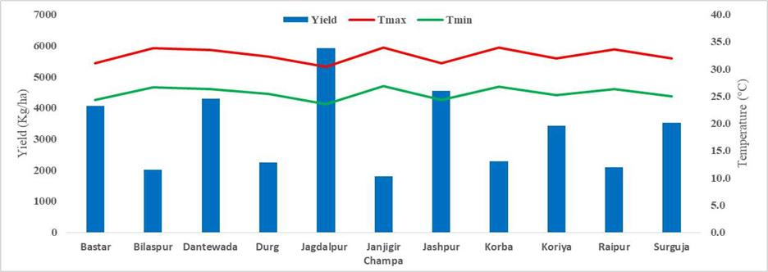

***Figure 1*** *Variation of yield under RCP 4.5 during 2030 with Temperature in different district*

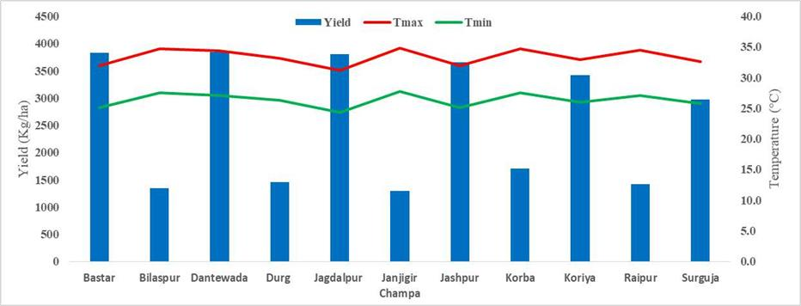

***Figure 2*** *Variation of yield under RCP 4.5 during 2050 with Temperature in different district*

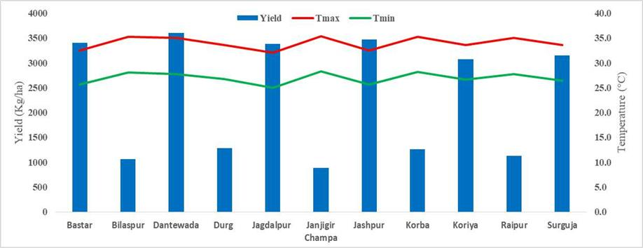

***Figure 3*** *Variation of yield under RCP 4.5 during 2070 with Temperature in different district*

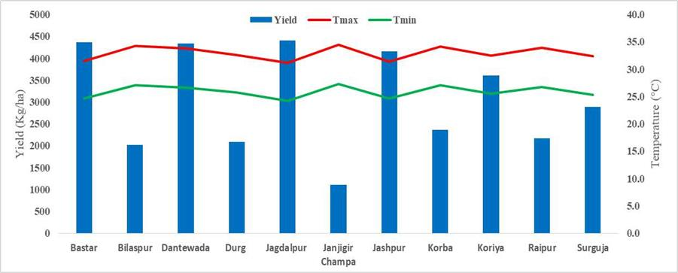

***Figure 4*** *Variation of yield under RCP 8.5 during 2030 with Temperature in different district*

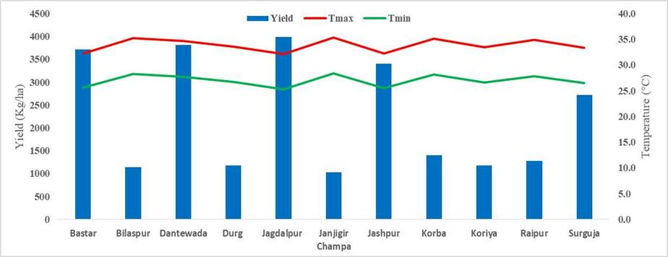

***Figure 5*** *Variation of yield under RCP 8.5 during 2050 with Temperature in different district*

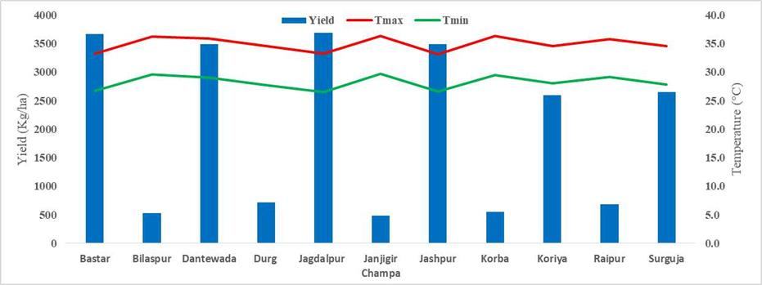

***Figure 6*** *Variation of yield under RCP 8.5 during 2070 with Temperature in different district*

# Discussion

The simulation results utilizing the DSSAT model, calibrated with 2021 and verified with 2022 AICRPM rice trial data, showed good accuracy in projecting rice phenology and yield throughout Chhattisgarh's agro-climatic zones (ACZs), hence verifying the model's dependability for climate impact assessment. Significant rises in both maximum and minimum temperatures are expected under future climate scenarios RCP 4.5 and RCP 8.5, especially in the Chhattisgarh Plain Zone (CPZ), where temperature rise could reach up to 3.8°C (Tx) and

5.7°C (Tn), so causing heat stress, shortened crop duration, and reduced yield. While Northern Hills Zone (NHZ) and Bastar Plateau Zone (BPZ) may see increasing yearly rainfall, CPZ is anticipated to get less rainfall during the vital Southwest monsoon season, therefore aggravating water stress problems. Rainfall estimates indicated varying patterns. Furthermore displaying non-linear climatic trends, BPZ complicated attempts for response. These climatic changes imply that although NHZ and BPZ may gain from more water availability, heavy rainfall and heat surges might provide new difficulties for rice output in CPZ without adaptation. The findings highlight the necessity of region-specific policies like the acceptance of heat-tolerant rice cultivars, enhanced irrigation management, and changed planting dates to minimize the negative consequences of climate change. Confirming the regional sensitivity of Chhattisgarh to climate change, the expected warming trends and rainfall changes line with past studies by (Chaturvedi et al., 2011) and (Gupta & Jain, 2018). The consistency across many research emphasizes the need of region-specific climate resilience planning and helps to increase the reliability of the present simulation results.

# Conclusion

The study successfully calibrated and validated the DSSAT model for rice yield prediction in Chhattisgarh’s diverse agro-climatic zones, demonstrating its effectiveness in simulating crop response under varying climatic conditions. With the Chhattisgarh Plain Zone most at danger of heat stress and water shortages possibly lowering rice output, climate forecasts show significant temperature rises and changed rainfall patterns by 2070. On the other hand, certain areas could get more rain, which presents both possibilities and problems. These results underline how urgently tailored adaptation strategies such as heat-tolerant cultivars, improved irrigation, and changed cropping calendars are needed to maintain rice output in the face of climate change. All things considered, this study offers legislators and farmers important new ideas to create climate-resilient rice farming methods in Chhattisgarh.

**COMPETING INTERESTS DISCLAIMER:**

Authors have declared that they have no known competing financial interests OR non-financial interests OR personal relationships that could have appeared to influence the work reported in this paper.

# References

Aggarwal, P. K. (2008). Global climate change and Indian agriculture: impacts, adaptation and mitigation. *Indian Journal of Agricultural Sciences*, *78*(11), 911.

Aich, A., Dey, D., & Roy, A. (2022). Climate change resilient agricultural practices: A learning experience from indigenous communities over India. *PLOS Sustainability and Transformation*, *1*(7), e0000022.

Amgain, L. P., Devkota, N. R., Timsina, J., & Bijay-Singh, B. (2006). Effect of climate change and CO 2 concentration on growth and yield of rice and wheat in punjab: simulations using CSM-CERES-Rice and CSM-CERES-Wheat models. *Journal of the Institute of Agriculture and Animal Science*, *27*, 103–110.

Aswathi, K. P., Ajith, K., Ajithkumar, B., & Abida, P. S. (2022). Impact of climate change on rice yield under projected scenarios in central zone of Kerala. *Journal of Agrometeorology*, *24*(3), 280–285.

Birthal, P. S., Khan, T., Negi, D. S., & Agarwal, S. (2014). Impact of climate change on yields of major food crops in India: Implications for food security. *Agricultural Economics Research Review*, *27*(2), 145–155.

Change, I. P. O. C. (2001). Climate change 2007: Impacts, adaptation and vulnerability.

*Genebra, Suíça*.

Chaturvedi, R. K., Gopalakrishnan, R., Jayaraman, M., Bala, G., Joshi, N. V, Sukumar, R., &

Ravindranath, N. H. (2011). Impact of climate change on Indian forests: a dynamic vegetation modeling approach. *Mitigation and Adaptation Strategies for Global Change*, *16*, 119–142.

Crespi, A., Renner, K., Zebisch, M., Schauser, I., Leps, N., & Walter, A. (2023). Analysing spatial patterns of climate change: Climate clusters, hotspots and analogues to support climate risk assessment and communication in Germany. *Climate Services*, *30*, 100373.

Dash, C. J., Yadav, P., Kumar, R., Patra, S. S., Hombegowda, H. C., & Adhikary, P. P. (2024). Assessing rainfall patterns, erosivity dynamics, and sustainable soil and water management strategies across agro-climatic zones of Chhattisgarh, India. *Indian Journal of Soil Conservation*, *52*(2), 147–159.

Debnath, S., Mishra, A., Mailapalli, D. R., & Raghuwanshi, N. S. (2021). Identifying most promising agronomic adaptation strategies to close rainfed rice yield gap in future: a model-based assessment. *Journal of Water and Climate Change*, *12*(6), 2854–2874.

Debnath, S., Mishra, A., Mailapalli, D. R., Raghuwanshi, N. S., & Sridhar, V. (2021). Assessment of rice yield gap under a changing climate in India. *Journal of Water and Climate Change*, *12*(4), 1245–1267.

Dhanya, P., & Ramachandran, A. (2016). Farmers’ perceptions of climate change and the proposed agriculture adaptation strategies in a semi arid region of south India. *Journal of Integrative Environmental Sciences*, *13*(1), 1–18.

Dubey, V., Panigrahi, S., & Vidyarthi, V. K. (2023). Statistical trend analysis of major climatic factors over Chhattisgarh State, India. *Earth Systems and Environment*, *7*(3), 629–648.

Goswami, P., & Verma, A. (2024). *The Role of Renewable Energy in Rice Production in the Rice Bowl of Chhattisgarh*.

Gupta, V., & Jain, M. K. (2018). Investigation of multi-model spatiotemporal mesoscale drought projections over India under climate change scenario. *Journal of Hydrology*, *567*, 489–509.

Hong, Z., Runyuan, W., Yan, S., Heling, W., Kai, Z., Funian, Z., Yue, Q. I., & Fei, C. (2016). Progress and perspectives in studies on responses and thresholds of major food crops to high temperature and drought stress. *Journal of Arid Meteorology*, *34*(1), 1.

Jaiswal, N., Soni, S., Nayak, S., & Sarawgi, A. K. (2024). *To measures absolute change in*

*area, production and productivity of rice crop in different agro-climatic zone of Chhattisgarh state*.

Jing, Q., Shang, J., Huffman, T., Qian, B., Pattey, E., Liu, J., Dong, T., Drury, C. F., & Tremblay, N. (2017). Using the CSM–CERES–Maize model to assess the gap between actual and potential yields of grain maize. *The Journal of Agricultural Science*, *155*(2), 239–260.

Joshi, N. L., & Kar, A. (2009). Contingency crop planning for dryland areas in relation to climate change. *Indian Journal of Agronomy*, *54*(2), 237–243.

Kamdi, P. J., Swain, D. K., & Wani, S. P. (2023). Developing climate change agro-adaptation strategies through field experiments and simulation analyses for sustainable sorghum production in semi-arid tropics of India. *Agricultural Water Management*, *286*, 108399.

Khan, S. A. R., Razzaq, A., Yu, Z., Shah, A., Sharif, A., & Janjua, L. (2022). Disruption in food supply chain and undernourishment challenges: An empirical study in the context of Asian countries. *Socio-Economic Planning Sciences*, *82*, 101033.

Kurrey, D. K., & Pathak, H. (2023). Impact of Climate Change on Paddy Yield in Bastar District of Chhattisgarh. *Journal of Ravishankar University, Part-B Science*, *36*(1).

Liu, F., & Masago, Y. (2023). An analysis of the spatial heterogeneity of future climate change impacts in support of cross-sectoral adaptation strategies in Japan. *Climate Risk Management*, *41*, 100528.

Madhukar, A., Kumar, V., & Dashora, K. (2022). Temperature and precipitation are adversely affecting wheat yield in India. *Journal of Water and Climate Change*, *13*(4), 1631–1656.

Man-xue, R. A. N., Jun-jun, D., Dong-bao, S. U. N., & Feng-xue, G. U. (2024). A review of the response characteristics of soil respiration to temperature and moisture changes under global climate change. *Chinese Journal of Agrometeorology*, *45*(01), 1.

Pathak, H., Ladha, J. K., Aggarwal, P. K., Peng, S., Das, S., Singh, Y., Singh, B., Kamra, S. K., Mishra, B., & Sastri, A. (2003). Trends of climatic potential and on-farm yields of rice and wheat in the Indo-Gangetic Plains. *Field Crops Research*, *80*(3), 223–234.

Psistaki, K., Tsantopoulos, G., & Paschalidou, A. K. (2024). An overview of the role of forests in climate change mitigation. *Sustainability*, *16*(14), 6089.

Rao, C. A. R., Raju, B. M. K., Rao, A. V. M. S., Rao, K. V, Rao, V. U. M., Ramachandran, K., Venkateswarlu, B., Sikka, A. K., Rao, M. S., & Maheswari, M. (2016). A district level assessment of vulnerability of Indian agriculture to climate change. *Current Science*, 1939–1946.

Singh, T. (2022). Economic growth and the state of poverty in India: sectoral and provincial perspectives. *Economic Change and Restructuring*, *55*(3), 1251–1302.

Sreenath, A. V, Abhilash, S., & Ajilesh, P. P. (2023). Changes in the dynamical, thermodynamical and hydrometeor characteristics prior to extreme rainfall events along the southwest coast of India in recent decades. *Atmospheric Research*, *289*, 106752.

Subash, N., Dutta, D., Ghasal, P. C., Punia, P., Mandal, V. P., & Chaudhary, V. P. (2023). Relevance of climatological information on spatial and temporal variability of Indian Summer monsoon rainfall (ISMR) in recent El Niño years and its impact on four important kharif crops over India. *Climate Services*, *30*, 100370.

Swain, S., Dayal, D., Pandey, A., & Mishra, S. K. (2019). Trend analysis of precipitation and temperature for Bilaspur District, Chhattisgarh, India. *World Environmental and Water Resources Congress 2019*, 193–204.

Verma, R. K., & Kanwar, M. K. (2020). Assessment of Temperature Stress on Rice at Grain Filling Stage in Raipur District of Chattisgarh, India. *Int. J. Curr. Microbiol. Appl. Sci*, *9*, 253–259.

Wu HaiYan, W. H., Sun TianTian, S. T., Fan ZuoWei, F. Z., & Zhao LanPo, Z. L. (2014). *The major food crops in response to climate change and its yield effect in Northeast of China.*

XU, Y., ZHAO, M., LI, K., ZHAO, Y., & WANG, C. (2023). Review on the research progress of agricultural adaptation to climate change and perspectives. *Chinese Journal of Eco- Agriculture*, *31*(8), 1155–1170.

Yadu, A., Das, G. K., Puranik, H. V, Lakhera, M. L., & Pathak, H. (2021). *Assessment of Vulnerability in Different Districts of Chhattisgarh with Reference to Climate Change*.